A WEB PORTAL AND ANDROID APPS FOR FARMING INFORMATION SUPPORT SYSTEM IN BANGLADESH
By
Md. Humayon Kabir
ID: 142-15-3498

Md. Salahin Kabir
ID: 142-15-3546
And
Md. Shafayet Islam Shaffet
ID: 142-15-3599

This Report Presented in Partial Fulfillment of the Requirements for the Degree of Bachelor of Science in Computer Science and Engineering.

Supervised By
Md. Riazur Rahman
Lecturer
Department of CSE
Daffodil International University



DAFFODIL INTERNATIONAL UNIVERSITY
Dhaka, Bangladesh
MAY 2018

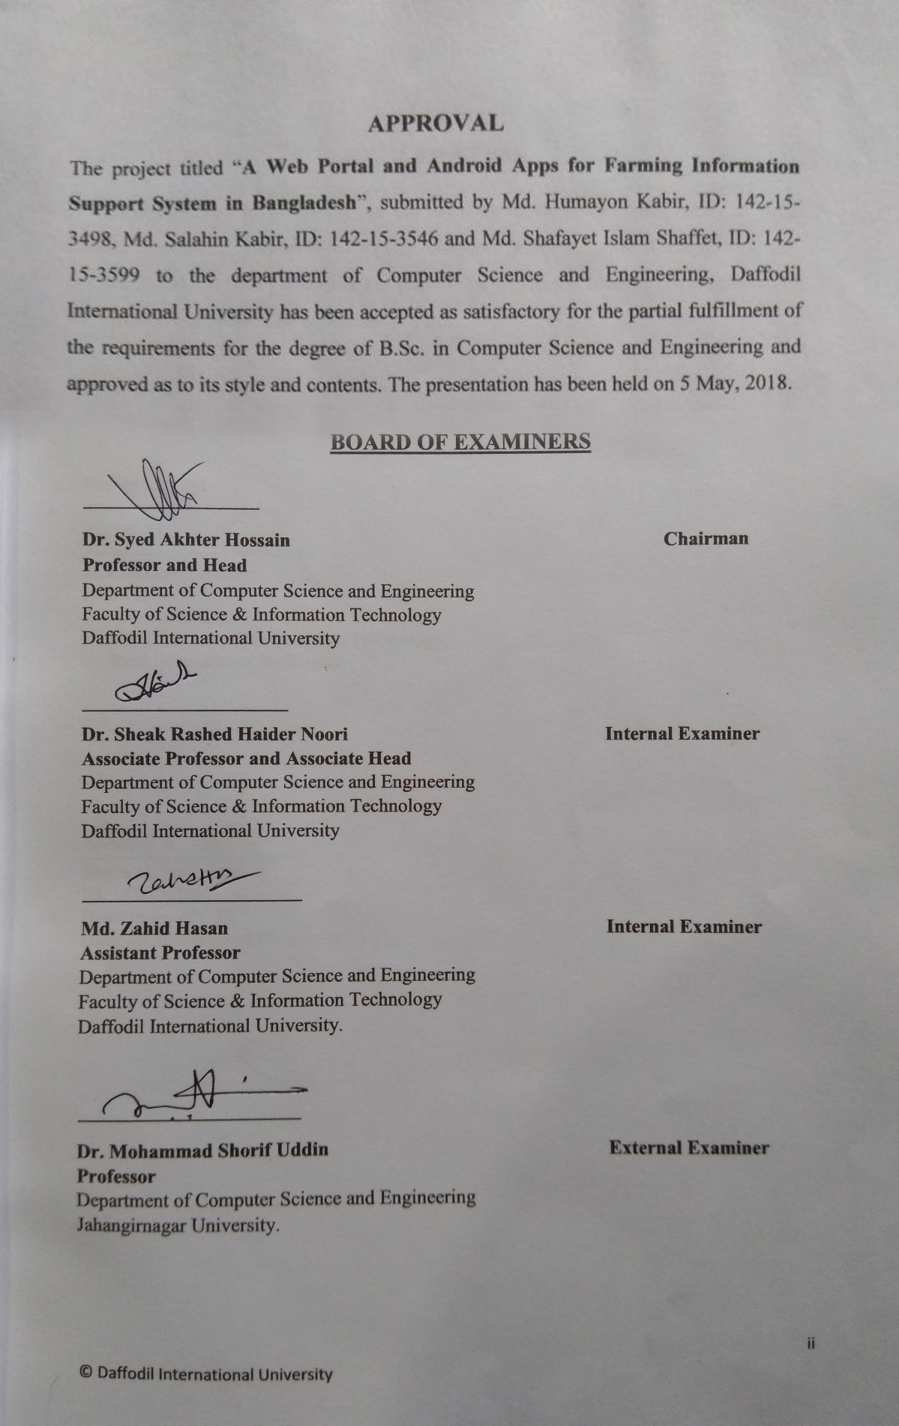
APPROVAL
The project titled “A Web Portal and Android Apps for Farming Information Support System in Bangladesh”, submitted by Md. Humayon Kabir, ID: 142-15-3498, Md. Salahin Kabir, ID: 142-15-3546 and Md. Shafayet Islam Shaffet, ID: 142-15-3599 to the department of Computer Science and Engineering, Daffodil International University has been accepted as satisfactory for the partial fulfillment of the requirements for the degree of B.Sc. in Computer Science and Engineering and approved as to its style and contents. The presentation has been held on 5 May, 2018.

Board of Examiners

Dr. Syed Akhter Hossain Chairman
Professor and Head
Department of Computer Science & Engineering
Faculty of Science & Information Technology
Daffodil International University

Dr. Sheak Rashed Haider Noori Internal Examiner
Associate Professor and Associate Head
Department of Computer Science & Engineering
Faculty of Science & Information Technology
Daffodil International University

Md. Zahid Hasan Internal Examiner
Assistant Professor
Department of Computer Science & Engineering
Faculty of Science & Information Technology
Daffodil International University

Dr. Mohammad Shorif Uddin External Examiner
Professor
Department of Computer Science & Engineering
Jahangirnagar University

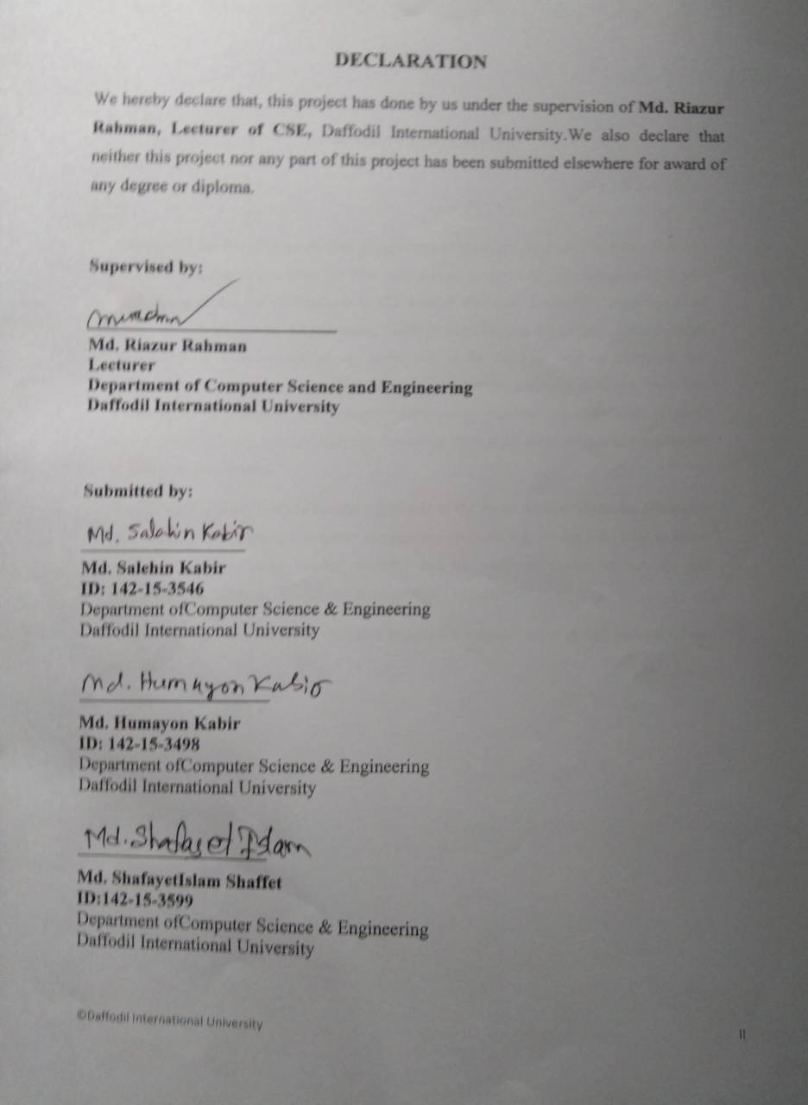

DECLARATION

We hereby declare that, this project has done by us under the supervision of Md. Riazur Rahman, Lecturer of CSE, Daffodil International University. We also declare that neither this project nor any part of this project has been submitted elsewhere for award of any degree or diploma.

Supervised by:

Md. Riazur Rahman
Lecturer
Department of Computer Science and Engineering
Daffodil International University
Submitted by:

Md. Humayon Kabir
ID: 142-15-3498
Department of Computer Science & Engineering
Daffodil International University

Md. Salahin Kabir
ID: 142-15-3546
Department of Computer Science & Engineering
Daffodil International University

Md. Shafayet Islam Shaffet
ID: 142-15-3599
Department of Computer Science & Engineering
Daffodil International University

ACKNOWLEDGEMENT

We express our heartiest thanks and gratefulness to almighty Allah as His divine blessing makes us possible to complete the final year project successfully. We felt grateful to and wish our profound our indebtedness to Md. Riazur Rahman, Lecturer, Department of Computer Science and Engineering, Daffodil International University, Dhaka. Deep Knowledge & keen interest of our supervisor in the field of web development has influenced us to carry out this project. His endless patience, scholarly guidance, continual encouragement, constant and energetic supervision, constructive criticism, valuable advice, reading many inferior draft and correcting them at all stage have made it possible to complete this project.
We would like to express our heartiest gratitude to Dr. Syed Akhter Hossain, Professor and Head, Department of Computer Science and Engineering, for his kind help to finish our project and to other faculty members and the staffs of Computer Science and Engineering department of Daffodil International University.
Finally, we must acknowledge with due respect the constant support and patients of our parents.

Abstract

The aim of the project is to disseminate ideas and scopes of new business among young and enthusiastic entrepreneurs about farm or have already farm of the country to promote them to take the challenges ahead. By using this web application, a new entrepreneur can get all necessary information about business and agriculture. The application deals with beginner and professional entrepreneur and also educated people who are interested in entrepreneurship. A person can get all kind of information about business and agriculture from this web site. In Bangladesh, there is a dearth of quality people in industry, which demands high level of entrepreneurship development program throughout the country for the growth of our economy. We have different seasons in our country and different cattle are cultivated based on season. In this website there is ideas and details for seasonal based cattle farming information. Many business ideas and details are also added here. We have done this project by using is HTML, HTML5, CSS, CSS3, PHP, Ajax, JavaScript and MySQL for database. After implementation, the system is tested in different stages and it works successfully as prototype.

TABLE OF CONTENTS
CONTENTS | PAGE NO
Board of Examiners | i
Declaration | ii
Acknowledgements | iii
Abstract | iv
CHAPTER
CHAPTER 1: INTRODUCTION | 1-3
- Introduction | 1
- Motivation of Work | 1
- Objectives | 2
- Expected Outcome | 2
1.5 Report Layout | 3
CHAPTER 2: BACKGROUND | 4-6
- Introduction | 4
- Related Works | 4
2.3 Comparative Studies | 5
- Scope of the Problem | 5
- Challenges | 6
CHAPTER 3: REQUIREMENT AND SPECIFICATION | 7-11
- Introduction | 7
- Requirement Collection and Analysis | 7
- Use Case Modeling and Description | 8
3.4 Logical Data Model | 11
3.5 Design Requirements | 11
CHAPTER 4: DESIGN SPECIFICATION | 12-13
- Front-end Design specification | 12
- Back-end Design specification | 12
- Implementation Requirements | 13
CHAPTER 5: IMPLEMENTATION AND TESTING | 14-37
- Implementation of Database | 14
- Implementation of Front-end Design | 14
CHAPTER 6: CONCLUSION AND FUTURE SCOPE | 38
- Discussion and Conclusion | 38
- Scope for Further Developments | 38
REFERENCES | 39
APPENDIX | 40
PLAGIARISM REPORT | 41
LIST OF FIGURES
FIGURES | PAGE NO
Figure 2.1: http://www.blri.gov.bd | 4
Figure 2.2: http://uddoktarkhoje.com | 5
Figure 3.1: Use case model for farmer or entrepreneur | 8
Figure 3.2: Use case model for person interested in entrepreneurship | 8
Figure 3.3: Use Case Diagram for admin | 9
Figure 3.4: E-R diagram of the proposed system | 11
Figure 5.1.1: Admin Login | 15
Figure 5.1.2: Show and delete users account | 15
Figure 5.2.1: Web Homepage | 16
Figure 5.2.2: Android Homepage | 16
Figure 5.3: Our Service | 17
Figure 5.4: Basic of Farming | 18
Figure 5.5: Our Project | 18
Figure 5.6: Shelter for Farm Animal | 19
Figure 5.7: Idea of Feeding | 19
Figure 5.8: Hybrid Grass | 20
Figure 5.9: Hybrid Animal | 21
Figure 5.10: Diseases and Syndromes | 22
Figure 5.11: Modern Equipment | 23
Figure 5.12: Cattle Weight Calculator | 23
Figure 5.13: Fish Diseases Detector | 24
Figure 5.14: Doctor Contact Guide | 24
Figure 5.15: Expert Advice | 25
Figure 5.16: Veterinary Medicine Guide | 25
Figure 5.17: Basic of Entrepreneurship | 26
Figure 5.18: Idea Choice | 26
Figure 5.19: Marketing Research | 27
Figure 5.20: Planning of Entrepreneurship | 27
Figure 5.21: Personal Qualities of an Entrepreneur | 28
Figure 5.22: Some Success News | 28
Figure 5.23: Some Successful Persons Stories | 29
Figure 5.24: Some Farming Ideas | 30
Figure 5.25: Categories of License for Small Business | 30
Figure 5.26: Categories of License for Medium Business | 31
Figure 5.27: Categories of License for Large Business | 31
Figure 5.28: Product Marketing | 32
Figure 5.29: Steps of Product Marketing | 32
Figure 5.30: Some Strategy for Product Marketing | 33
Figure 5.31: Some Strategy for Product Marketing | 34
Figure 5.32: Activities | 34
Figure 5.33: Photo Gallery | 35
Figure 5.34: Contact Form | 35
Figure 5.35: About Us | 36
Figure 5.36: Register User | 36
Figure 5.37: Footer | 37
LIST OF TABLES
TABLES | PAGE NO
Table 3.1: Description of Use Case Diagram of Users | 9
Table 3.2: Description of Use Case Diagram of Admin | 10

CHAPTER 1
INTRODUCTION
  - Introduction
Farming business is gaining popularity day by day and cattle farming in Bangladesh is already an established and profitable business model. cattle are livestock animal and it is very easy to raise some animal. Even the woman and children can also raise and take care of them easily along with their regular work. Nowadays the popularity of commercial cattle farming business in Bangladesh is increasing and more and more people are engaging with this business. Bangladesh has resulted in growing frustration among youth. In addition, there is always problem of unemployment. As a result, increasing the entrepreneurial activities in the country is the only solace. We build this web application to motivate them for entrepreneurship and also provide help and support.
The scope of entrepreneurship development in country like Bangladesh is tremendous. Especially since there is widespread concern that the acceleration in GDP growth in the post reforms period has not been accompanied by a commensurate expansion in employment.

1.2 Motivation of Work
To promote sustainable agro-based strategies in order to improve the livelihood of rural poor peoples in general and resource poor farmers in particular. To increase the rural income through improvement of: Agricultural development, Better Veterinary service, Animal husbandry productivity, Aquaculture and fisheries management and production, Providing training to unemployed youth and women in particular.
Often, when entrepreneurs make the bold leap from employee of a corporation to leader of their own business, one of the first challenges they face is no longer having a person or group of people above them to set goals, deadlines and incentives. The responsibility of inspiration becomes a task of self-motivation.
This can be a challenge for many, especially when the experience is new and the entrepreneur is consumed with working in the business rather than being working on it. Any lack of self-discipline and organization can also affect personal development and family, which are often the first to be put on the back burner.
Our web application is to build for those challenging people who want to be an entrepreneur and who have a farm.

1.3 Objectives:
The web application is designed for those, who wish to learn about Farming &entrepreneurship, its role and importance in our society, and how to bring new ideas to marketplace both in the startup and corporate setting. This is an introductory web resource intended to provide people with a solid foundation on how entrepreneurs and entrepreneurship play a key role in our countries economy.

  - Expected Outcome
- Cattle are livestock animal. They require less space and care than cattle.
- Care and management process are very easy and simple. Woman can easily raise some animal along with their regular household activities. And the children can also raise them perfectly with their studies.
- cattle are multipurpose livestock animal and they are suitable for commercial milk, meat, fiber, skin and manure production.
- Many highly productive local and foreign goat breeds are available and suitable for commercial production.
- The Government of Bangladesh is continuously inspiring the people for setting up small scale goat farm and creating many opportunities necessary for goat farming business.
- Commercial cattle farming in Bangladesh can be a great source of income and employment for the unemployed educated people of Bangladesh.
- Develop and strengthen entrepreneurial quality.
- Motivating for entrepreneurship to removing unemployment.
- Helping entrepreneur and also who want to be an entrepreneur.
- To analyze environmental set up relating to starting entrepreneurship.
- Enhancing industrial development.
- Helping the unemployed person to understand environmental changes and opportunities.
- Providing product marketing ideas.
- Providing product podcasting ideas.
- Providing startups, a technology idea.
1.5 Report Layout
In this report, we have organized the rest of parts as follows: we have discussed about this websites background with related works. Comparative studies, scope of the problems and challenges in Chapter 2. Then, in chapter 3, we described about requirement specification including business process modeling, requirement collection and analysis, case modeling and description, Logical data model, design requirements. we have conversed about design and implementation. In this section, we have deliberated about front-end design as well as back-end design with interaction design web viewing and implementation requirements in chapter 4. After that in chapter 5, we have discussed about implementation and testing part in implementation of interactions, testing implementation, test results and reports. Finally, we have concluded the report with future scopes in chapter 6.

CHAPTER 2
BACKGROUND
2.1 Introduction
In Bangladesh, there is a major problem of unemployment. As a result, increasing the entrepreneurial activities in the country is the only solace. We build this web application to motivate them for entrepreneurship and farmer also provide help and support.
Most of the people in our country are live in rural area and farmers. But due to lack of help they are lacking behind. Our aim is to guide the people with all kind of agriculture information including Dairy, Poultry and fish farm.

2.2 Related Works
In Our country same type of work does not exist. But some similar kind of work exists in our country. Some of government website provide agricultural support like us. www.blri.gov.bdis one of them. But the only provide some of agricultural information.[1]

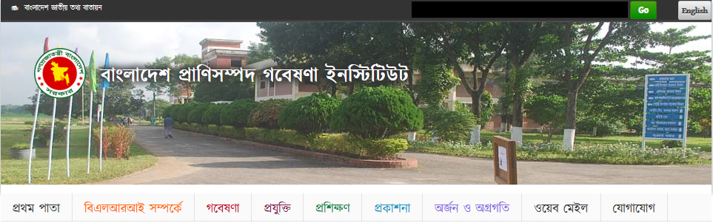
Figure 2.1: www.blri.gov.bd
A website named “Uddoktarkhoje” is provide some information but not completely.[2]
Figure 2.2: uddoktarkhoje.com
We work very different way and try to completely provide each and every support to our user.

2.3 Comparative Studies
Our implemented application is different from other existing software because some of the we band android application provide agricultural information, some of provide business information and other. But we are totally work with our own concept and provide a huge information support in one website like agricultural information, business information, difference between business and entrepreneurship, step of entrepreneurship, marketing process, business license information, bank loan information, e-commerce site etc.

2.4 Scope of the Problem
- Bangladesh has resulted in growing frustration among youth. In addition, there is always problem of unemployment. As a result, increasing the entrepreneurial activities in the country is the only solace. We build this web application to motivate them for entrepreneurship and also provide help and support.

2.5 Challenges
- Providing our users full support for their field work.
- We just give them information, but in real work it’s very difficult to gain success.
- Motivating is also so difficult to us. It’s a big challenge of our project.
- To feedback them by their message, it’s hard to give them proper counsel in all time.

CHAPTER 3
REQUIREMENT SPECIFICATION

3.1 Introduction
This chapter covered the whole requirements analysis. It’s the most important because of it shows how the requirements are interacted with the system application. It focuses on the business processes that are taking place and how these requirements can be fulfilled more efficiently to accomplish the project.

3.2 Requirement Collection & Analysis
We have collected basic requirements from field level and internet. Some are following

- Modern farming method.
- Shelter, feed, growth
- Hybrid animal
- Fish farming process
- Diseases & treatment
- Modern equipment & use manual
- Doctor contact guide
- Vet advises
- Marketing policy and details.
- Farming product details.
- Bank loan details.
- Business License details.
- About new technology details.[6]

3.3 Use Case Modeling and Description
Basically, two types of user in this site. One is who are entrepreneur and the others are who want to be entrepreneurs.

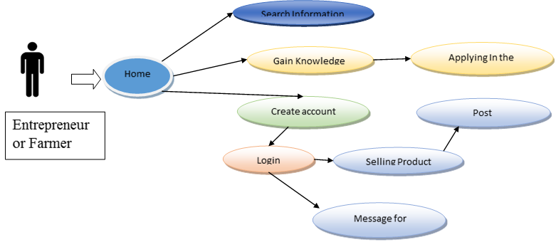
Figure 3.1: Use Case Model for Entrepreneur or Farmer
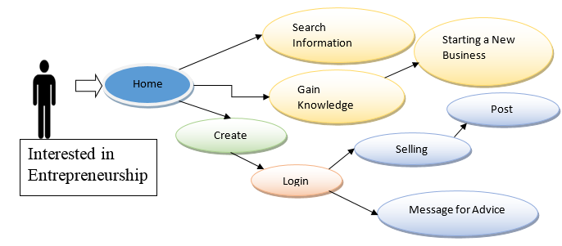
Figure 3.2: Use Case Model for Person Interested in Entrepreneurship
And the admin was maintenance the application.
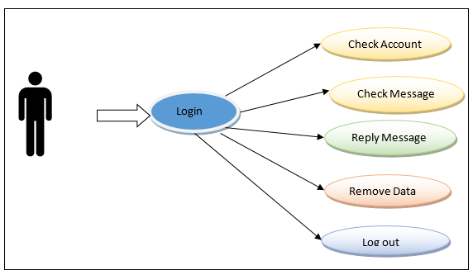
Figure 3.3: Use Case Diagram for Admin

Table 3.1 Illustrates the idea of use cases of different users.

Use Case Name | User of The System
Primary Actor | User
Secondary Actor | Null
Pre-Condition | User Must have an Account for Log In. User need to Give all the correct information for create an account.
Description | Normally User can browse or system and see all the services. If he/she have an account, he will get all listed services. He/she can take advice from the admin. He/she can also post advertisement to sale there product.
Post-Condition | Show an acknowledgement to user “You have Successfully Log In”. Then he/she will be able to take all the services.

Table 3.2: Description of Use Case Diagram of Admin

Use Case Name | Admin of the System
Primary Actor | Admin
Secondary Actor | Null
Pre-Condition | Admin Must have an account to Login and manage the system. The admin account is pre-defined by developer.
Description | Admin can edit and delete the design of the application. Admin can remove a profile. He will be able to control or manage the whole system.
Post-Condition | No one will be able to login into admin panel. If he/she don’t have a user id and password.

3.4 Logical Data Model
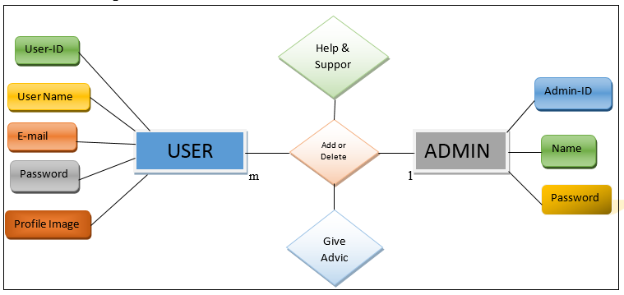Figure 3.4: E-R Diagram of The Proposed System
3.5 Design Requirements
- The system will use by two types of users, those are System Admin, and users who are want to take advice from us and also sale their product in our farming blog.
- System admin will setup basic settings of the system.
- User will create account and login.
- User will give some information like phone name, number, email so that admin can help them anyway.
- To sale product users use their photo in registration form. So that the identity will be more facilitate.
- For advice from admin, users can send message.
- The message stored in database. Admin try to give them solution.
- For marketing product in our website, at first user login with their account and can post their product details with photo.
- Admin can remove any post or account if its needed.

CHAPTER 4
DESIGN SPECIFICATION
4.1 Front-end Design Specification
- The system will use by two types of users, those are System Admin, and users who are want to take advice from us and also sale their product in our farming blog.
- Every user will login using simple login form. Login field are email address and password.
- Will include forgot password option for recovery or generate new password.
- We include session where the user of the system can save login information through browser cookies.
4.2 Back-end Design Specification
- System admin will setup basic settings of the system.
- User will create account and login.
- User will give some information like phone name, number, email so that admin can help them anyway.
- To sale product users use their photo in registration form. So that the identity will be more facilitate.
- For advice from admin, users can send message.
- The message stored in database. Admin try to give them solution.
- For marketing product in our website, at first user login with their account and can post their product details with photo.
- Admin can remove any post or account if its needed.
4.3 Interaction Design and UX
Interaction Design in essential for make a system easy. He done lots of things to make our system easy. We use buttons and icons for that people can easily interact with the system. We implement many options for select. User don’t need to input text manually in areas instead of he/she can choose options.
4.3 Implementation of Requirements
Technology used to develop the are as follows:
Markup Language: HTML 5
Design: CSS 3
Programming/Scripting Languages: Java Scripts, PHP, jQuery, Ajax
Database: MySQL
Framework: Bootstrap

CHAPTER 5
IMPLEMENTATION AND TESTING

5.1 Implementation of Database
- Group wise SQL queries should be block with a single transaction to maintain integrity.
- Needed to create Database user by role.
- According to role of user, DBA will assign the permission for tables individually (If needed).
- DBMS system follows sequential process to handle a DB request. Process demonstrated bellow (Execution and Parsing Process):
- SQL request goes to SQL Parser and stores it into code cache.
- The parsed code goes to SQL executer.
- Then the request checks the user permission for respective table.
- User feedback request are stored in DB.

5.2 Implementation of Front-end Design
Admin Login
This is the home page of our developed system. In our system have five types of users and every user can login using this login form. And after login they can perform action based on the defined role and user type.
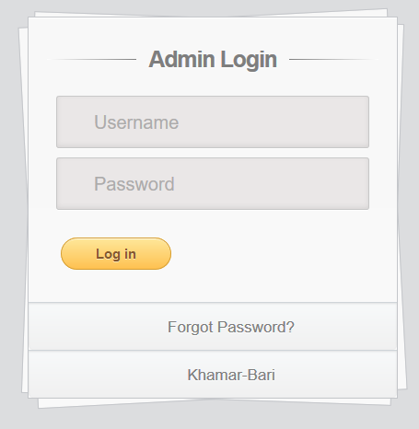

Figure 5.1.1: Admin Login

Figure 5.1.2 Show the admin page where admin can show users details and delete users account if needed.

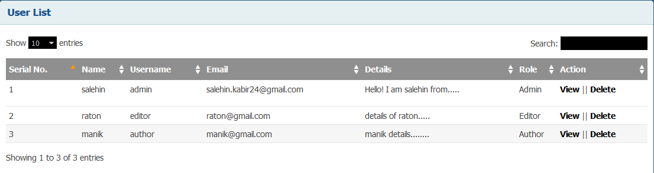

Figure 5.1.2: Show and Delete Users Account
Homepage
The index of our website was figure 5.2 given below:

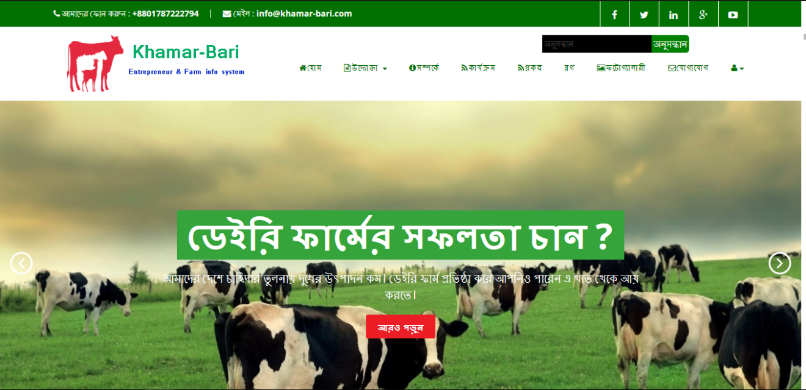

Figure 5.2.1: Homepage on website

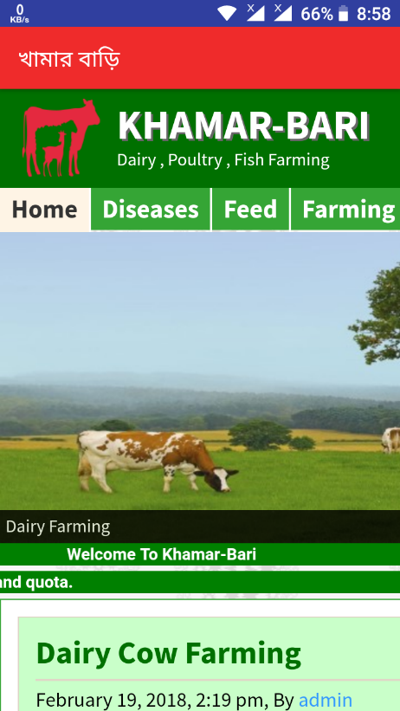

Figure 5.2.2: Homepage on app

In header, there was our website logo and a menu bar. The current menu is “Homepage”. In below of the menu bar, there is image slider bloc with banner.
Our Services

Given below a figure 5.3 show a list of our services which is we provide in our website. And it’s also provide some important government websites link which is useful to a entrepreneur

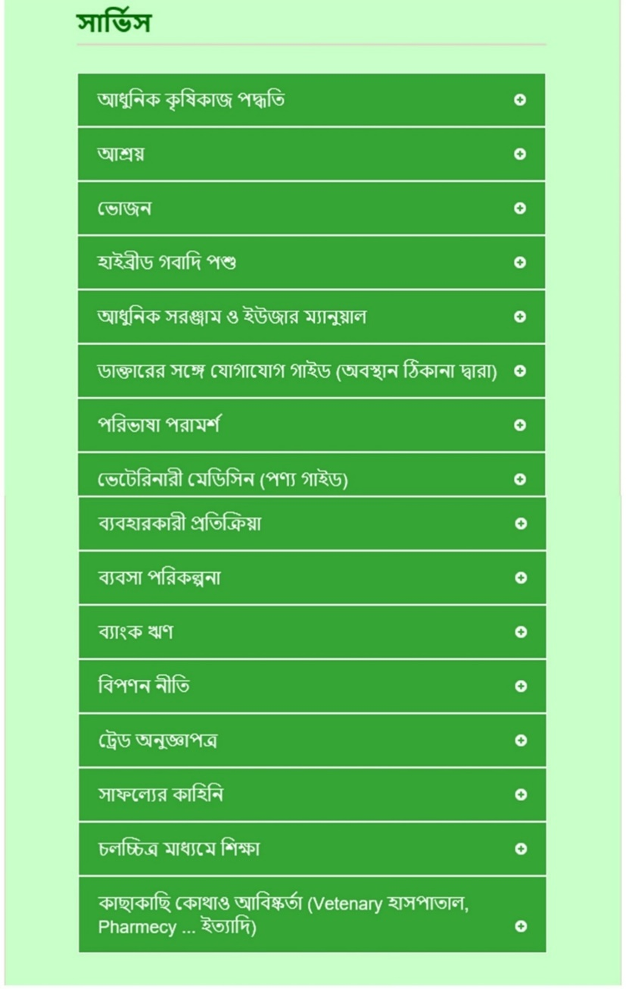

Figure 5.3: Our Service

Basic of Farming
Given below figure 5.4 show the basic of farming. What you can see how to start a farm.

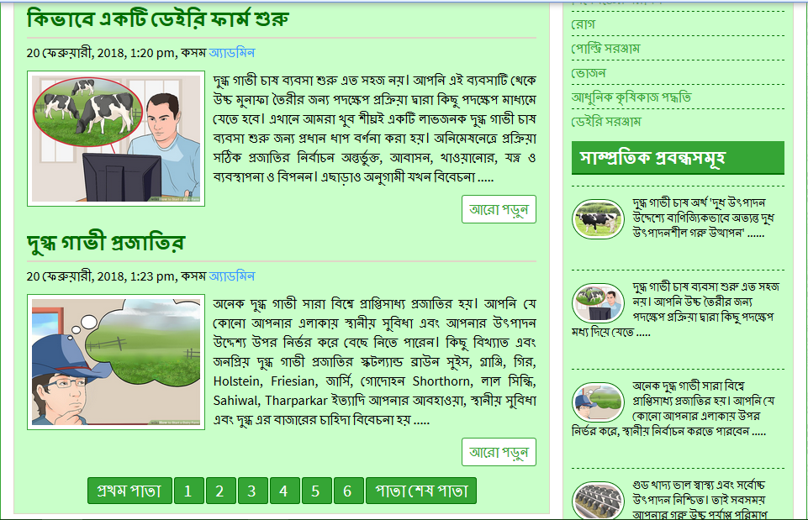

Figure 5.4: Basic of Farming

Project
Given below figure 5.5 show the project of our site. What you can see this-
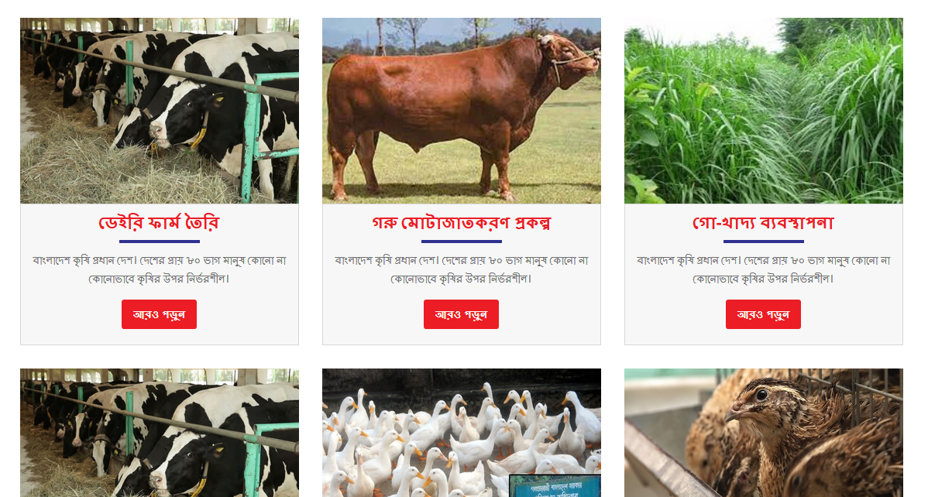
Figure 5.5: Our Project

Idea of Shelter, Farm Management
Given below figure 5.6 show the basic idea of making shelter for farm animal. What you can see how to made shelter.
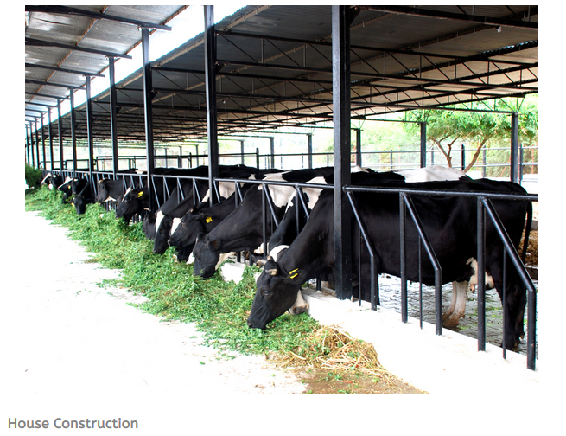

Figure 5.6: Shelter for Farm Animal

Idea of Feed, Growth
Given below figure 5.7 show the basic idea of feed for farm animal. What you can see how to feed for farm animal.[3]
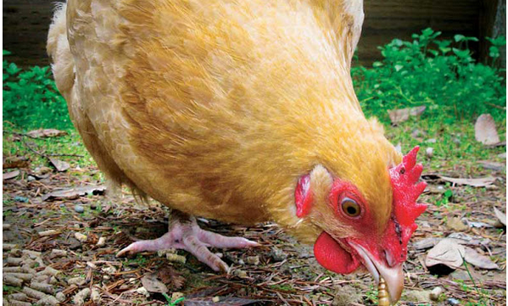

Figure 5.7: Idea of Feeding

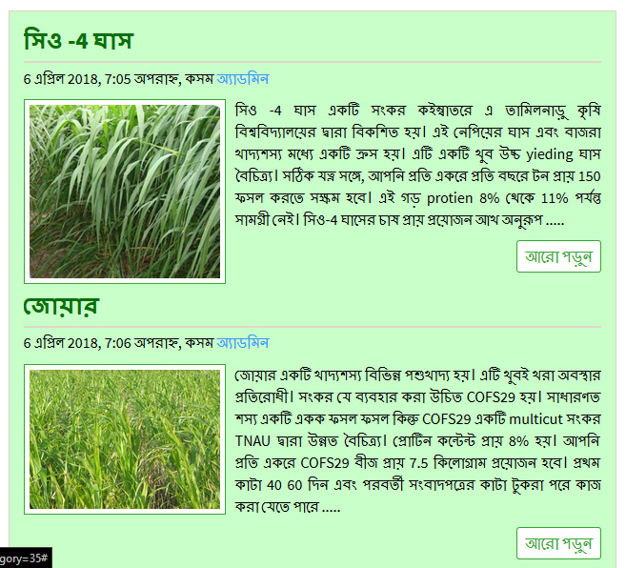

Figure 5.8: Example Shows Hybrid Grass [5]

Hybrid Animal / Justify
Given below figure 5.9 show the hybrid animal for farm. What you can see how to justify hybrid animal for farm.

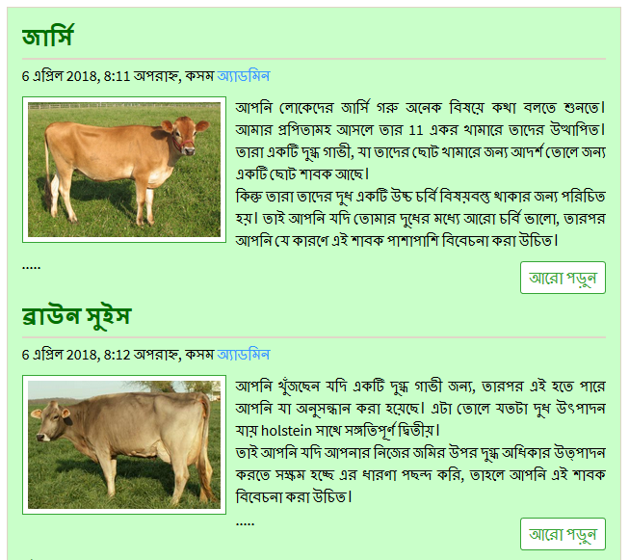

Figure 5.9: Hybrid Animal

Animal Health - Common Diseases & Treatment
Given below figure 5.10 show the common diseases & treatment animal for farm. What you can see how to justify hybrid animal for farm.

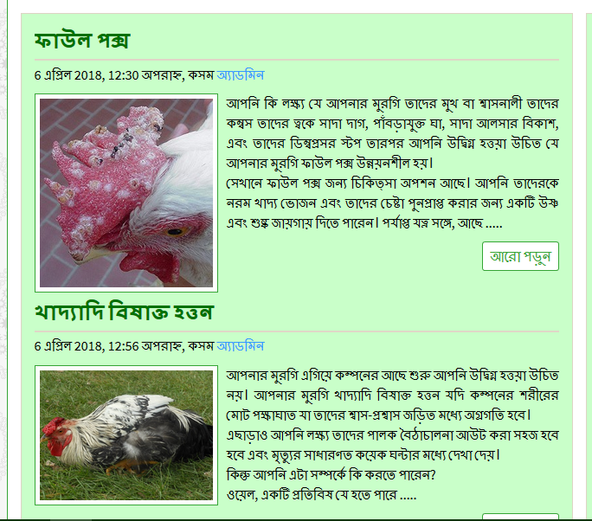

Figure 5.10: Diseases & Syndromes

Modern Equipment & Use Manual - Poultry Equipment, Dairy Equipment
Given below figure 5.11 show the modern equipment & user manual for farm. What you can see how to use modern equipment & technology for farm.
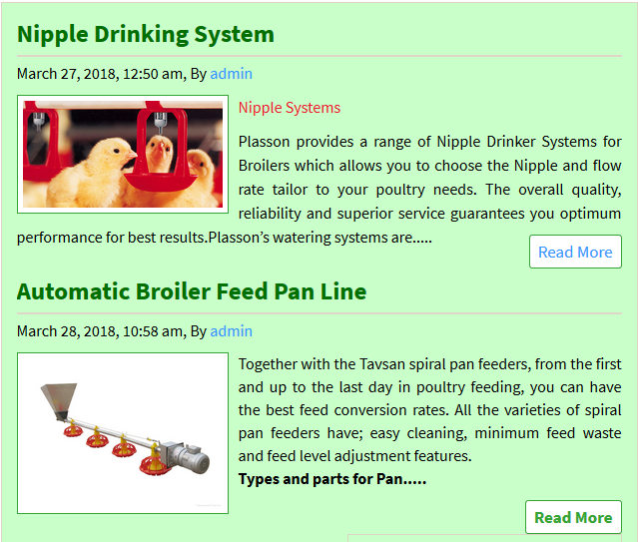

Figure 5.11: Modern Equipment

Cattle Weight Calculator
Given below figure 5.12 show the cattle weight using tap & input heart girth & length .it will automatically calculate weight kg/ pound. What you can calculate weight for cattle.
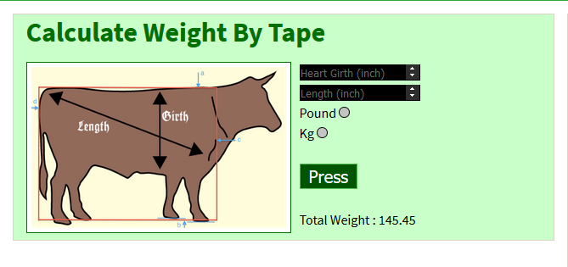
Figure 5.12: Cattle Weight Calculator

Fish Diseases Detector
Given below figure 5.13 show the fish diseases detector by camera diagnostic tools.[7]
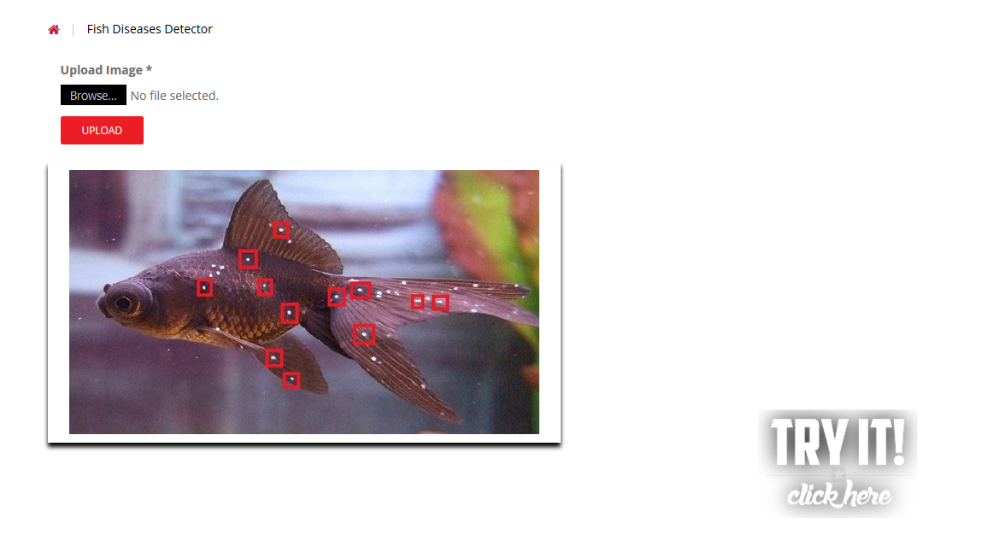
Figure 5.13: Fish Diseases Detector

Doctor Contact Guide (Address By Location)
Given below figure 5.14 show the cattle weight using tap & input heart girth & length .it will automatically calculate weight kg/ pound. What you can calculate weight for cattle.

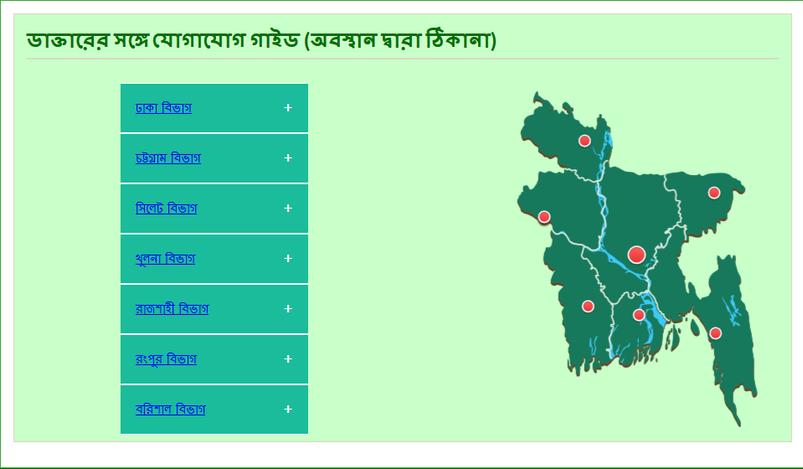

Figure 5.14: Doctor Contact Guide
Vet Advises
Given below figure 5.15 show the vet advices for farm animal. What you know good result for farming solution.
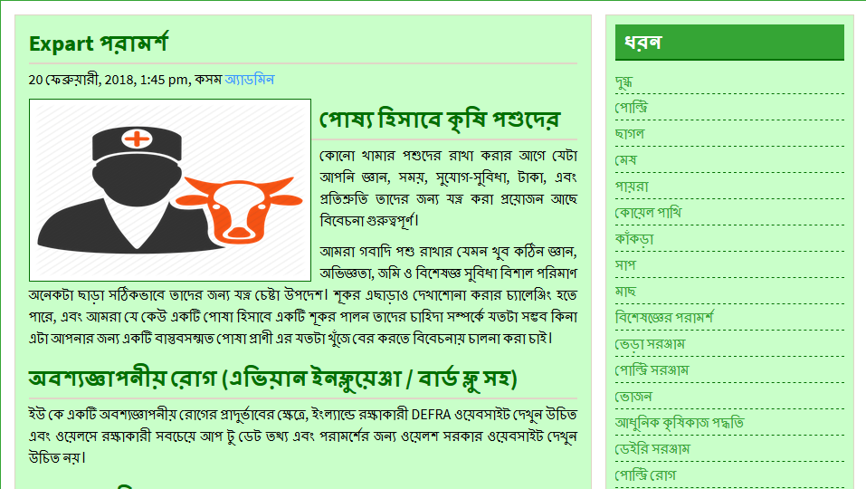

Figure 5.15: Expert Advice

Veterinary medicine (product guide)
Given below figure 5.16 show the veterinary medicine guide for farm animal. What you know good result for farming solution.
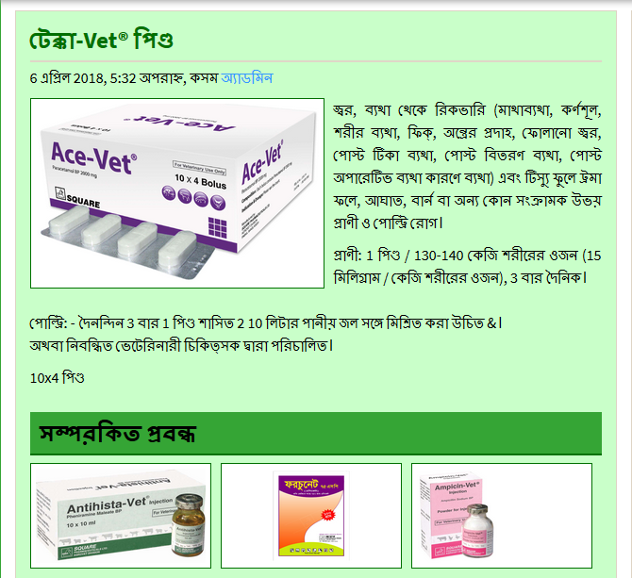

Figure 5.16: Veterinary Medicine Guide

Basic of Entrepreneur
Given below figure 5.17 show the four-basic structure of an entrepreneur. What you can see to be an entrepreneur.
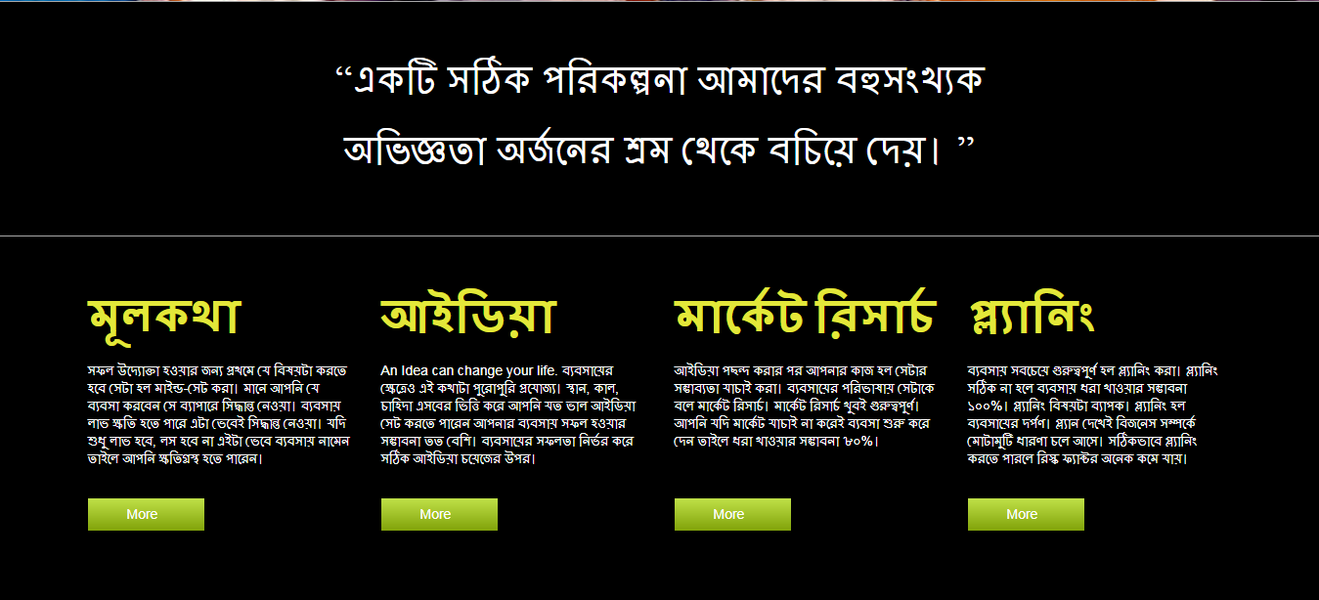

Figure 5.17: Basic of Entrepreneurship

2nd is describe some idea that u can do to be an entrepreneur.

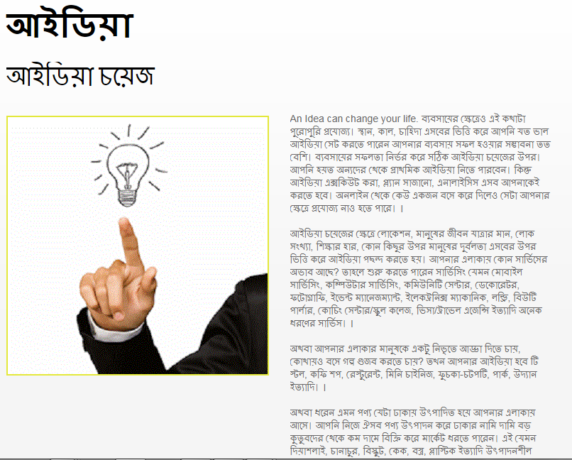

Figure 5.18: Idea Choice
3rd is describe about product marketing. 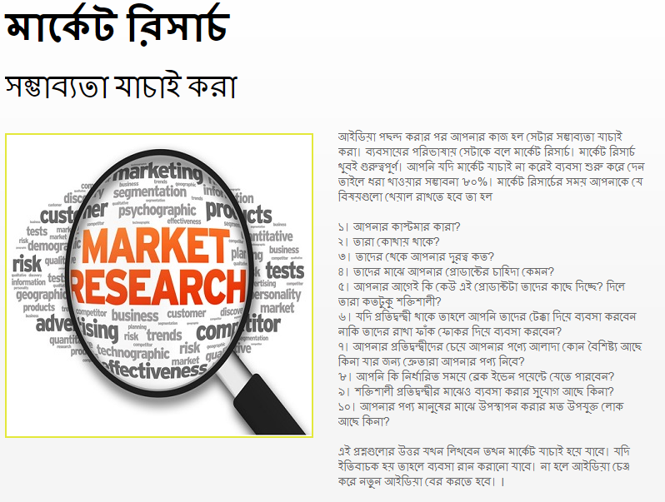

Figure 5.19: Marketing Research

And 4th is describe about planning.
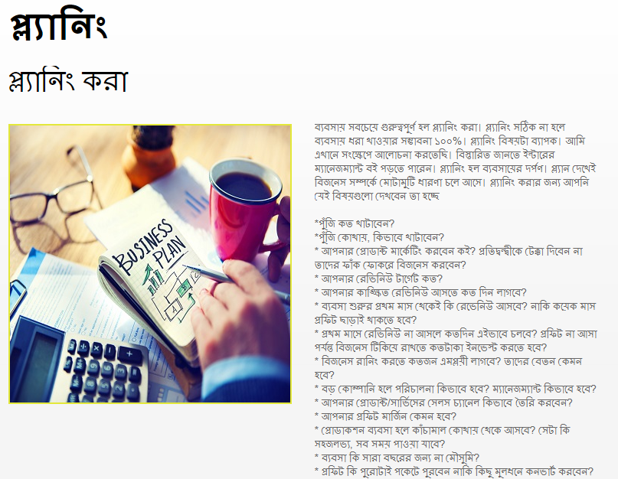

Figure 5.20: Planning of Entrepreneurship

Discussion

2nd discussion is about what is the personal qualities of an ideal entrepreneur.[4] 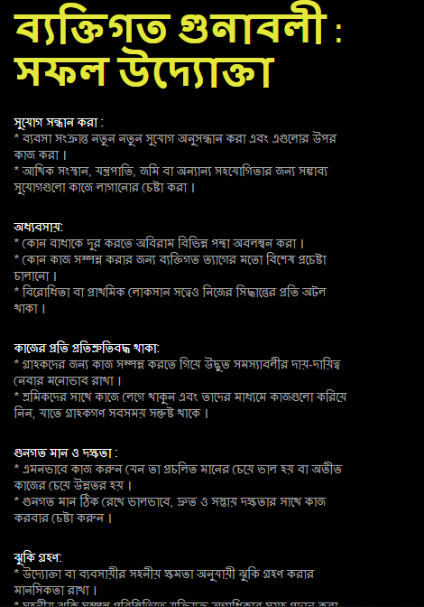

Figure 5.21: Personal Qualities of An Entrepreneur

Success News
Given below a figure 5.22 is about some success news in our countries entrepreneur:
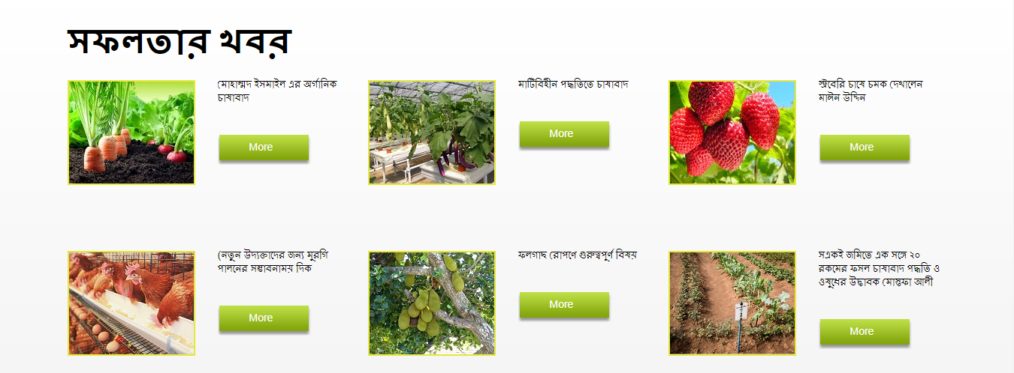

Figure 5.22: Some Success News

Success Stories
Given below a figure 5.23 is about some successful persons success stories which is inspire you to be an entrepreneur:
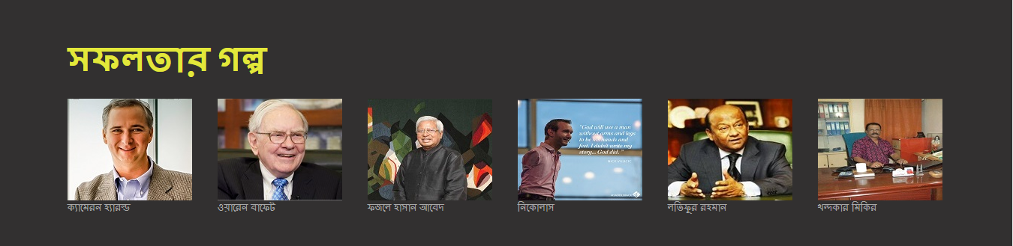

Figure 5.23: Some Successful Persons Stories

Farming Idea

The current menu is “Idea”. Figure 5.24 shows some agricultural ideas.

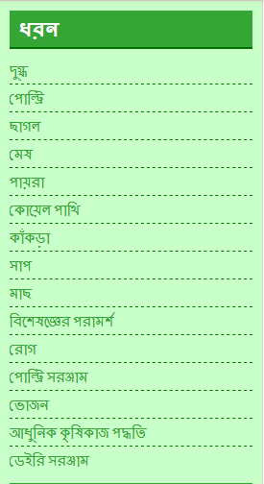

Figure 5.24: Some Farming Ideas.

License for Small Business

The current menu is “License”. The content is why are you need a license and how to get a license . There are three categories of license. Figure 5.25 shows categories of license for small business.

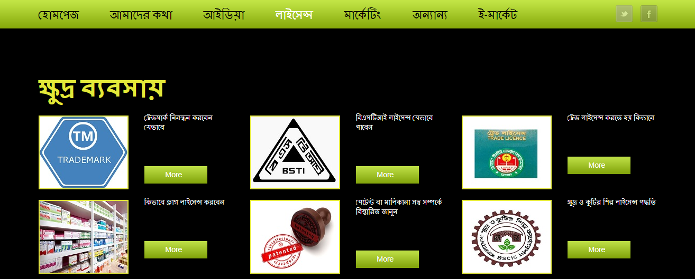

Figure 5.25: Categories of License for Small Business.

License for Medium Business

The current menu is “License”. Figure 5.26 shows categories of license for medium business.

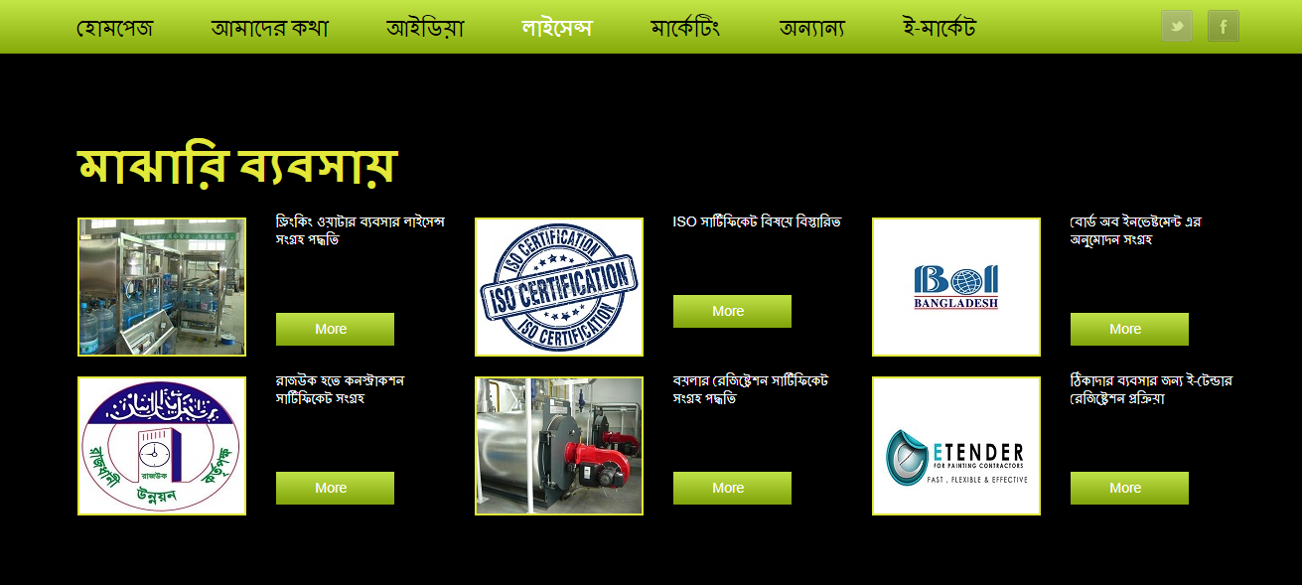

Figure 5.26: Categories of License for Medium Business.

License for Large Business

The current menu is “License”. Figure 5.27 shows categories of license for large business.

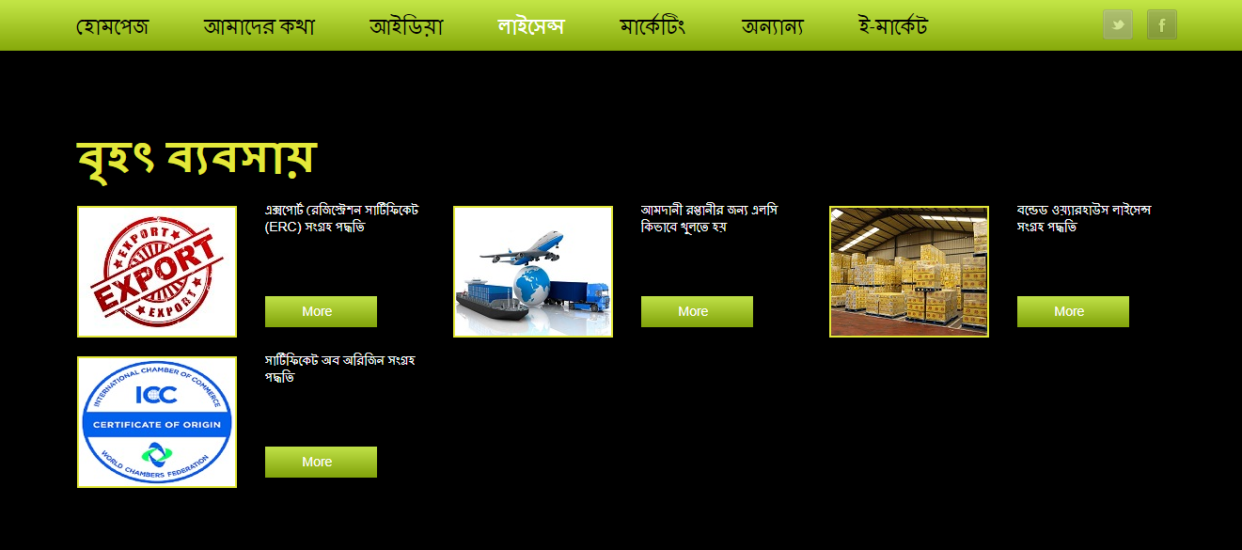

Figure 5.27: Categories of License for Large Business

Product Marketing

The current menu is “Marketing”, Figure 5.28 shows the steps of product marketing and how could you be marketing your product.

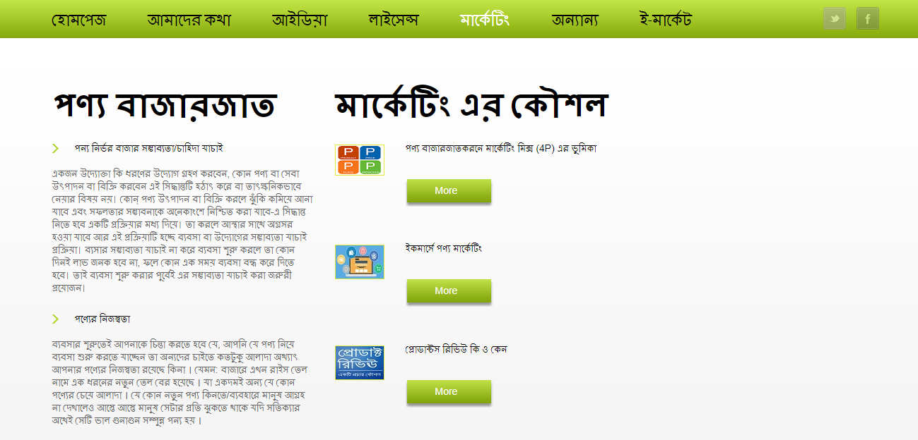

Figure 5.28: Product Marketing

Steps of Product Marketing

Figure 5.29 shows the steps of product marketing.

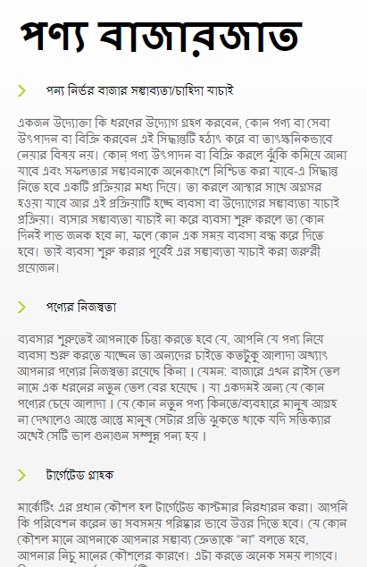

Figure 5.29: Steps of Product Marketing.

Marketing Strategy
- Figure 5.30 shows some strategy for product marketing.

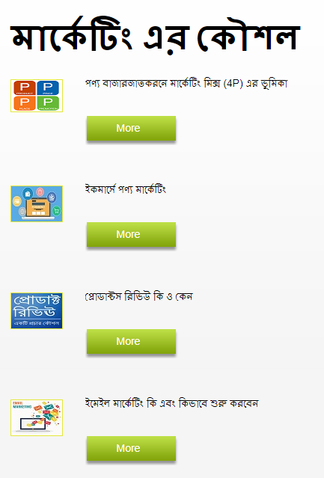

Figure 5.30: Some Strategy for Product Marketing.

Example:

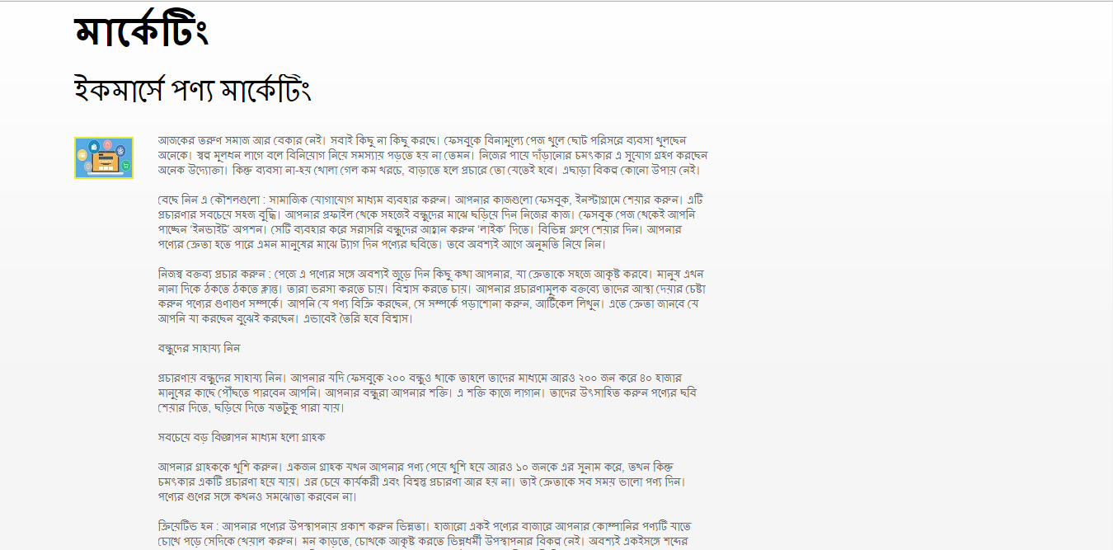

Figure 5.31: Example of Strategy for Product Marketing.

Activities:

Figure 5.32 shows our activities.

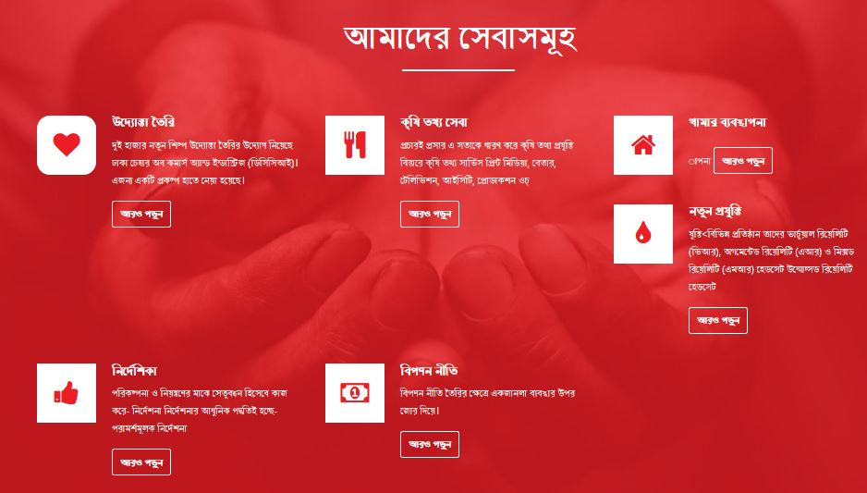

Figure 5.32: Activities

Photo Gallery

Figure 5.33 shows photo Gallery.

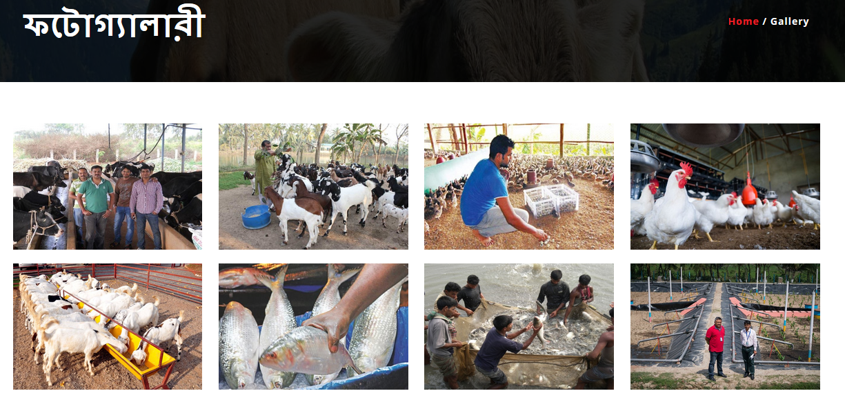

Figure 5.33: Photo Gallery

Figure 5.34 shows a table where you can send your massage to the admin for help.

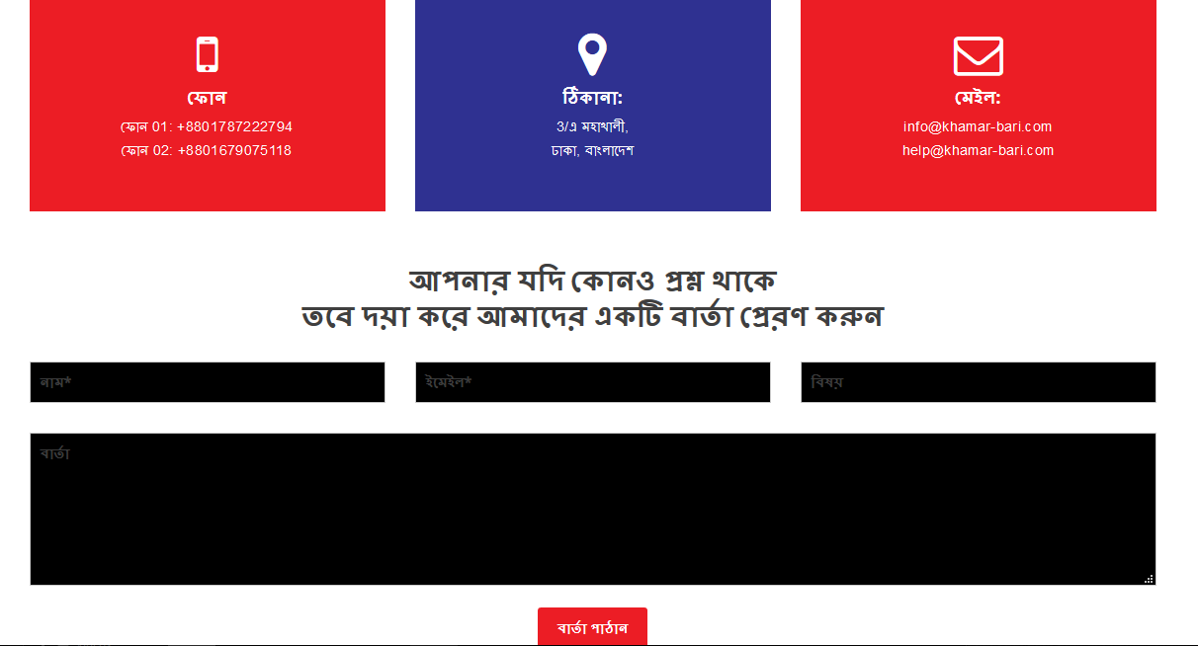

Figure 5.34: Contact Form

About Us

Figure 5.35 shows about our team.

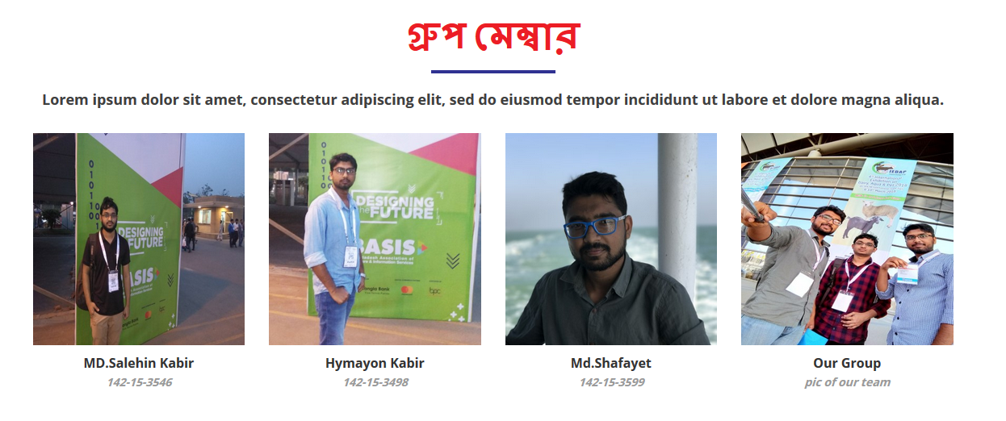

Figure 5.35: About Us

Sign Up

Figure 5.36 show the register page to create a user account.

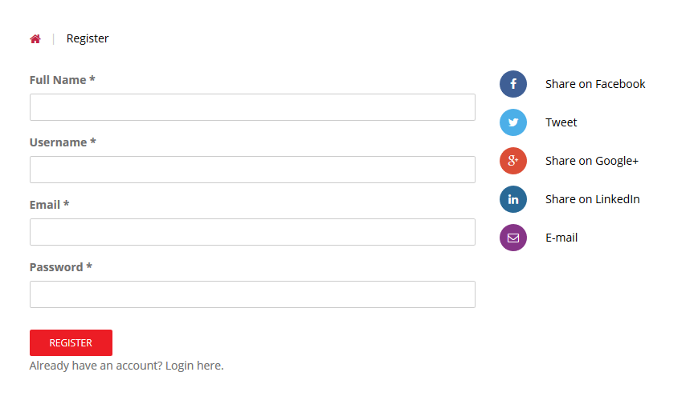

Figure 5.36: Register user

Footer

Figure 5.37 shows the footer part of our website.

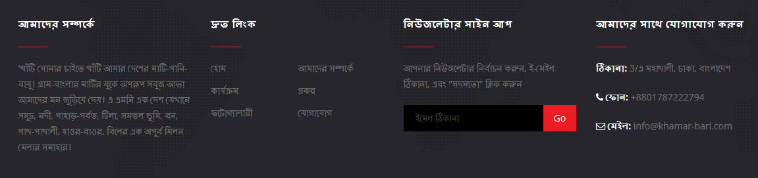

Figure 5.37: Footer
5.3 Implementation of Interactions
To make our system we have implemented interactive UI for better user experience. In many cases we have used interactive icon rather than text link or button. T

CHAPTER 6
CONCLUSION AND FUTURE SCOPES
6.1 Discussion and Conclusion
Whether you're just contemplating starting a business or have been in the trenches for a while, the sheer amount of web material available to help you start and grow a business can seem completely overwhelming. So, to save you the time and headache of sorting through all of it, here are the entrepreneur websites consistently ranked best by the entrepreneurs we know, including great resources on:
- Passive income.
- Startups and technology.
- Starting a small business.
- Marketing.
- Farming.
  - Scope for Further Developments
We will use the newer features with the changing communication technology. We will implement video conference. We would also like to implement smart treatment machine, where doctor can get patient's physical condition as like how generally doctor read the patient's physical condition.

REFERENCES

[1] Related Similar Website https://www.blri.gov.bd, last accessed on 02-03-2018 at 10.00AM
[2] Related Entrepreneur Information https://www.uddokterkhoje.com, Received information at 1.03PM on 02-03-2018
[3] Cattle bird information https://www.bard.gov.bd, Collect information on 23-03-2018
[4] Related Agricultural base Website https://agrobangla.com, Business Standard. Retrieved 18 March ,2018

[5] Service information Website https://bari.gov.bd, Received service on 25-03-2018

[6] Requirement collection and analysis: https://searchsoftwarequality.techtarget.com/definition/requrementsanaly, last accessed on 22-03-2018 at 12.32 AM

[7] Diseases Detector : http://algorithmia.com/algorithms last accessed on 27-03-2018 at 12.32 AM

APPENDIX

Project Reflection: From Fall-2016 semester we had started our journey for make a very interactive and attractive platform, where an entrepreneur was helped and also our farmers can learn about harvest. We followed the model for improvement to implement and monitor our interventions and were able to reach our aim.
The Project will be very helpful for the poor farmers and young entrepreneurs who want to do something new. As well as all kind of people want to shine in life. And it will be very useful for comfortably people. People will get all kind of entrepreneurship information and details by our web application called “khamar-bari.info”.
So, we believe that our “khamar-bari.info” will help our people to be an entrepreneur. It could be removing unemployment problem a little bit.

PLAGIARISM REPORT
