

Internship Report
On
The Present Scenario of English Language Teaching in a Bangladeshi School

Submitted by :
Sumya Anwar Noboni
ID-152-10-1197
Batch-35th (A)
Semester-Fall 2018
Course Title-Project Paper
Course Code-ENG-334
This Report is Submitted in Partial Fulfillment of the Requirement for the
Degree of B.A (Honours) in English

Submitted to :
Ms. Irina Ishrat
Assistant Professor
Department of English
Daffodil International University
Dhaka, Bangladesh.

Submission Date
November 2018

Declaration

I do hereby, declare that the Internship report submitted to the department of English, Daffodil International University is an original work for completion of my course “Project paper” (Course code-Eng 334) in the program of B.A (Honors) in English. The internship report on “The Present Scenario of English language Teaching in a Bangladeshi School” was written under the supervision of Ms. Irina Ishrat. This report has not been submitted to any other organization for any other degree or award. And I would like to affirm that this report is an original work based on practical experience.

Sumya Anwar Noboni
ID-152-10-1197
Batch-35​^{th}​ (A)
Program B.A(Honors) in English
Department of English
Daffodil International University.

i



Certificate
I am satisfied to certify that the Internship report on “The Present Scenario of English Language
Teaching in a Bangladeshi School” carried out by Sumya Anwar Noboni holding
ID-152-10-1197 of the English Department is an original record of her work on the basis of her practical experience. She has successfully completed her project under my supervision during the Fall semester 2018.
I am glad for the authenticity of her work and I strongly recommend this work for viva-voce and academic commendation.
I wish her every attainment in life.
......................................................
Ms. Irina Ishrat
Assistant Professor
Department of English
Daffodil International University.
ii

Acknowledgement
Any kind of work in the world gets inspired by something. Like this way, each person has few acknowledgements regarding each task. Therefore, I would like to acknowledge my father & mother at first. Because they really motivated me in different ways. Next I am grateful to my respected supervisor and other teachers. They truly inspired me and showed their utmost support for the report. And lastly, I am thankful to the school teachers & Headmaster for giving me this opportunity and their warm behavior.

iii

Abstract
This report actually portrays the current scenario of English Language teaching of a Bangladeshi school with veritable data and field survey. For this work, a school was a must and I chosed Harbinger School, Tajmahal road, Mohammadpur, Dhaka-1207. It took me a lot of dedication patience and diligence to make this survey done perfectly. But it would not be possible without the health of my teachers and few other people. In the process, I had to take three classes and also observed three classes with the help of the school teachers. Firstly, I observed three classes of class 6, class 7 and class 8 so that I could take some practical experience from those teachers. After that I mixed up the experience with my own competence and took three classes of class 8, class 9 and class 7. This report contains the possible outcome of the work and the feedback that I have learnt. Through this internship, I literally got to know that there should be more grounding liberty and practise for the teachers. Thus the upcoming generation will meet some experienced and flawless teachers.

iv

 | Table of Contents
Contents |  | Page no.
Declaration |  | i
Certificate |  | ii
Acknowledgement |  | iii
Abstract |  | iv
Contents |  | v
Chapter -1 : Preface |  | 1
Chapter -2 : Objectives |  | 2
Chapter -3 : Methodology |  | 3
Chapter - 4 : Institution details |  | 4-5
Chapter -5 : Reports​ of  Observation | Classroom | 6-7
Chapter - 6: Teaching experiences |  | 8-11
Chapter - 7 : Overall findings |  | 12
Chapter - 8 : Recommendations |  | 13
Chapter - 9 : Conclusion |  | 14
 | Appendices
Class observation checklist |  | 15-23
Photographs |  | 24-25
Letter of certification |  | 26

v

Chapter-1

Preface

I am Sumya Anwar Noboni holding ID-152-10-1197 from Daffodil International University. I was asked to make a field survey on the scenario of English language teaching in a Bangladeshi school. We know that English Language Teaching (ELT) has been a great method for us that we learnt in our academic syllabus and also introduced with the modern theories of it to ensure the learners better learning. And eventually in our final semester of Fall 2018, I got a chance of observing and taking classes of a school and for that I went to Harbinger School, Tajmahal road, Mohammadpur, Dhaka-1207. Therefore, I got a chance to observe the local teachers classes and gained a lot of knowledge. I got a chance to calculate their method of teaching that enhanced my skill better to teach others. So, as a whole this work was a great opportunity for me to measure and ensure others skills of teaching as well as mine.

Chapter-2

Objectives

The broad objective of the study is to observe the role of “The Present Scenario of English language teaching in a Bangladeshi School”.

I also tried to find out the following specific objectives :

- To find out the way of teaching English in the school.
- To check out the atmosphere of the classes as well as the method of teaching and learning the language.
- To determine the relationship between the teachers and students.
- To find out the usage of technology in the classroom.
- To explore the overall infrastructure of the school to understand its worthiness.

Chapter-3

Methodology

To attain my objectives, I had to go through few methods. As I was asked for the field work in a school, I took the recommendation letter from the Head of the English Department. And with that letter, I went to the school which I have chosed earlier that is Harbinger School, Tajmahal road, Mohammadpur, Dhaka-1207. I was very quite nervous at the beginning but observing other classes, I found some confidence in me. I observed three different classes that helped me to get inspiration for taking classes. After observing, I made up my mind to take 3 classes and for that I made 3 lesson plans. One of the teacher of the school helped me a lot in this regard. Finally, I finished my work and took a certificate from the headmaster along with a great farewell from them. It was a worth remembering experience indeed.

Chapter-4
Institution Details :
Harbinger school is one of the most well known school in Mohammadpur area.

Establishment and location :
It was established in 2008. The main branch is situated in 22/8 Tajmahal road, Mohammapur,Dhaka-1207. It has another branch in Arshinagar (Main road), Keraniganj, Dhaka.

School code and web address :
The code is 136282 and address is ​www.hs.org​.

Present information :
The school is not so extended. It has one gate to enter and leave. The building is two storied with two sections of each class. The most disappointing part is that it doesn’t have any playground or an open field for the students. The ambience of the school is good but the classroom is really congested. The school has two shifts-one is morning that is playgroup to class 3 and the another is from class 4 to class 10.There are lackings of proper air and ventilation. Another very sorrowful and crestfallen fact is that there is no library and even not a canteen. There is a common room for teachers. Also I would like to mention that the school has no laboratoty.

Number of teachers and their qualifications :
There are 20 teachers in the school. Most of the teachers are well qualified with a higher degree like M.A.

Number of students :
There are 400 students in total in the school.

Other informations ;

The passing rate of the school is 92% in the PSC, JSC, SSC. The uniform of the school is navy blue and sky blue for boys and sky blue and white for girls. The school arranges cultural programs on different occasions like Pahela Baishakh and 21​^{st}​ February every year.

Noboni 5

Chapter-5

Reports of Classroom Observation

Class 1:
The first class I observed was of class 6 and the teacher’s name was Mohiuddin Hossain. They were practising model questions. Well, the teachers objective was to acquint with the students on writing answers without memorizing. There was a warm-up session and the teacher was friendly enough with students. But I found the students were sitting quite in a scattered way and were very talkative. Some followed the instructions given by their teachers and some were talking themselves. The teacher ended the class by giving a homework. The students noted down their homework. The school provides a regular diary to the students. His projection was good but the English language was not that much standard which I felt.

Class 2:
​The second class I monitored was class 8.It was English second paper class. The main objective was to provide proficency and about Tense. My first impresion of that class was a bit awkward because of the environment of that class. So far I have seen the teacher was trying hard by providing realistic examples. He also tried to grab the attention of the students but failed. The pronunciation level of him was poor and he took the whole class in Bengali language. The students were not concentrating at all and the whole class was really boring. The main flaw which I figured out was reciprocal action.

Noboni 6

Class 3:
The third class I observed was of class seven. This time it was a female teacher and her name was Jannat Khatun.. Her objective was to introduce the sentences with the students. She started the class directly with the topic. So, there was no warm up. She was very respectful towards the students but the interaction level was not much high. She focused only on subject matter and didn’t hold the interests of students. Her voice and projection was very good. End of the class, she didn’t give an overview of the class or asked for any query from the students but she finished her lesson on time. Overall this observation was not much satisfactory.

Noboni 7

Chapter-6

Teaching Experiences

Well, experience is the best teacher we know that. Any new experience teaches us contradictory things. As it was my first experience of teaching I have thought about a lot of stuffs. Few teachers also helped me. So, before teaching the students I thought of a lesson plan for them.
Because a lesson plan is really beneficial and it divides the classroom activities nicely.

Class 1:

With the help and support of Mr. Mashuk Alam sir, I chosed a topic for the students of class 9. I thought to teach them some free hand writing so that I could figure out their skills in free writing. Almost 90% of the students couldn’t write properly. Many of them were very inattentive and were not concentrating in the class. I could feel the immense lacking of proper guidance. They were only engaegd in memorizing so they were unable to write anything creative. Overall, I can say it was a disappointing experience.

Noboni 8

Class-1 : (English IX 2​^{nd}​ paper)
- Topic : Narration / paragraph on childhood memories.
- Time : 40 minutes
- Number ofstudents : 30

Lesson plan | Time | Teacher’s role |  | Student’s role
Warm up | 5 minutes | Start class by introducing and asking questions. |  | Response to the teacher.
Basic rules of free hand writing | 10 minutes | Give real  examples encourage to creatively. | life and write | Listen cautiously.
Task | 15 minutes | Givetask on book. | copy | Write on your own.
Feedback | 10 minutes | Give feedback and ask if the students have any problem regarding the topic. |  | Listen cautiously.

Noboni9
Class 2 :
With the assist of the teacher Mrs. Jahanara khatun, I assembled the lesson for class 8 on English model question. When I entered the classroom, the students stood up and I was introduced warmly. After the warming up session which I learnt from my ELT course, I started to teach them. I gave some MCQ and ask them to make WH questions from the passage as a task.T hey have some problems but I tried to give my best to solve those. I taught them some technics on how to find question answers from the passsage in a short time. The students seemed quite enthusiastic as a new teacher was teaching them. Overall it was quite a unique experience to me.

Class-2 : VIII (English 1​^{st}​ paper)
- Topic : solving model questions.
- Time : 40 minutes
- Number of students : 33

Lesson plan |  | Time | Teacher’s role | Student’s role
Warm up |  | 5 minutes | Start class by introducing and asking questions. | Response to the teacher.
To make  questions from passage. | WH the | 10 minutes | Give exact idea on the topic with effective examples. | Listen atttentively.
Task |  | 15 minutes | Give task on the copy and questions. | Write the accurate answers.
Feedback |  | 10 minutes | Give if students have any difficulty. | Listen atttentively.
Noboni 10

Class 3 :

My respected Sir Moinul Islam introduced me to the students of class 7 in a pleasant manner. And they were delighted to see me as their new teacher instead of their new teacher. Some of them seemed to be shy and afraid but my convival attitude made classroom environment comfortable. They could answer many of my questions correctly. I was successful to grab their attention. Later I wrote some examples on the board and told them to write the accurate answers.
And the last part was an assessment. It was an enjoyable experience for me.

Class-2 : VII (English 2​^{nd}​ paper) * Topic : Tense.
- Time : 40 minutes
- Number of students : 36

Lesson plan | Time | Teacher’s role | Student’s role
Warm up | 5 minutes | Start class with a good introduction. | Response to the teacher.
Basic or fundamental rules and ideas about the topic. | 10 minutes | Elaborately discuss about the topic with examples. | Listen atttentively.
Task | 15 minutes | Give task on the board or any hand made sheet. | Write the accurate answers.
Feedback | 10 minutes | Give feedback or opinion to know if the students are clear about the topic. | Listen atttentively.

Noboni 11

Chapter- 7

Overall Findings

This field work really helped me in various aspects. I got a clear, definite idea about teachers’ weaknesses and strengths. And that indeed helped me to find out and scrutinize my limitations and eagerness about teaching the students. An essential fact that I understood is the lack of teaching methods. Another fact is about the self enjoyment. Any kind of teaching can be joyful if it doesn’t only confined to textual stuffs only. My another finding is about the projection and pronunciation which I think should be developed.

Noboni 12

Chapter -8

Recommendations

The entire surroundings of the school was not really up to the mark. First one is the use of computer should become mandatory. Next comes the entertainment section. I strongly The entire surroundings of the school was not really up to the mark. So, I would really like to recommend some important computers. I recommend for a playground for the students. Otherwise the regular classes will surely become monotonous. The length of the classrooms should be much broader than the current size. Lastly I want to recommend for a common room and a canteen so that the students can pass their leisure hours.

Noboni 13

Chapter-9
Conclusion

Surely it was a remarkable field work for me. It is because I got to know about so many things that were unknown to me. It was a prominent chance to observe my abilities, limitations and so on. I would like to do such kind of work in future. It actually not only helped me to improve my efficiency but also inspired me to work on my deficiencies. It was indeed and evocative experience of mine because itreminded of my school days. This work was both informative and delightful.

Noboni 14

Chapter 10
Appendices
- Class observation checklist
- Photographs
- Letter of Certification

Noboni 15

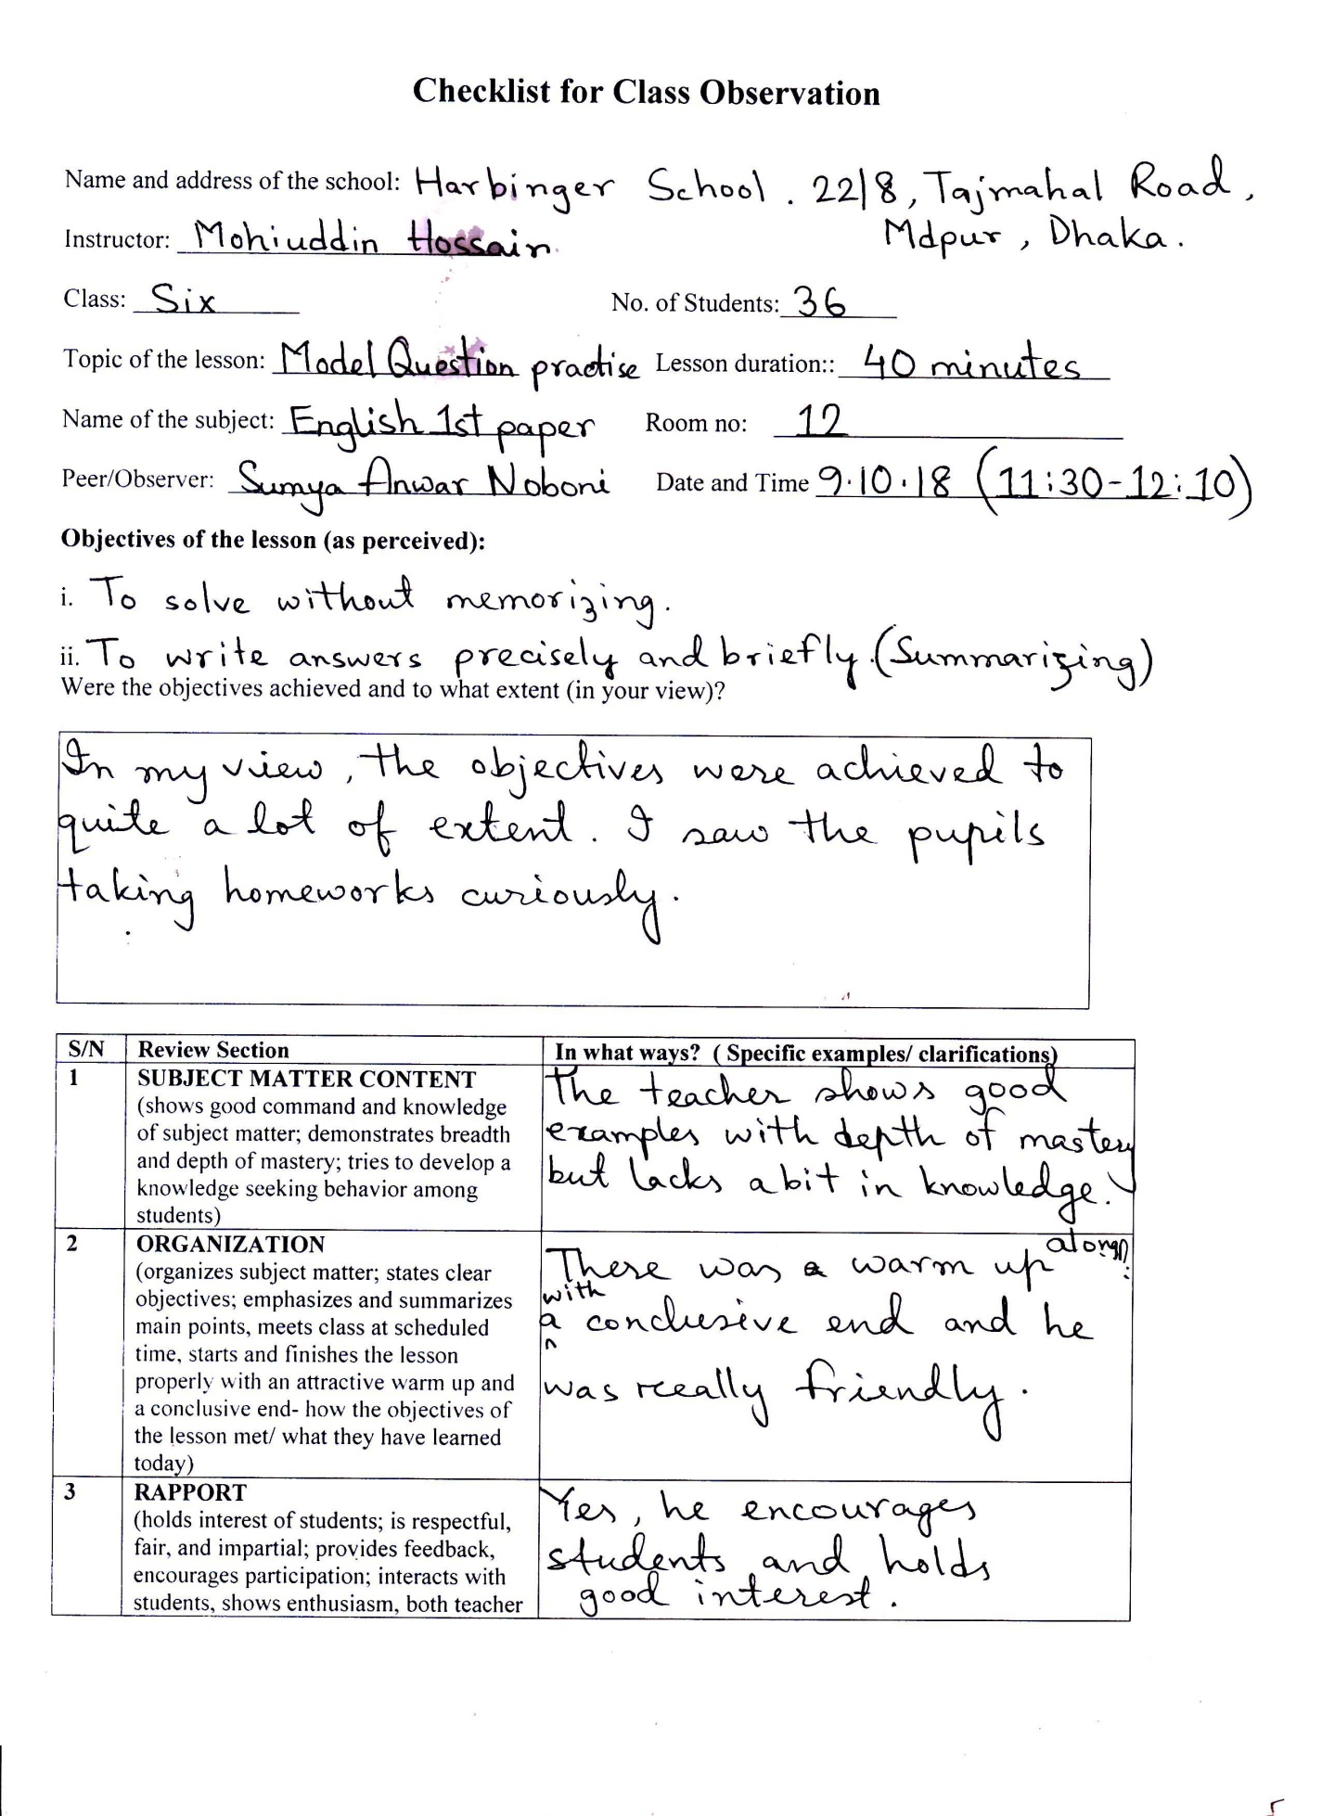
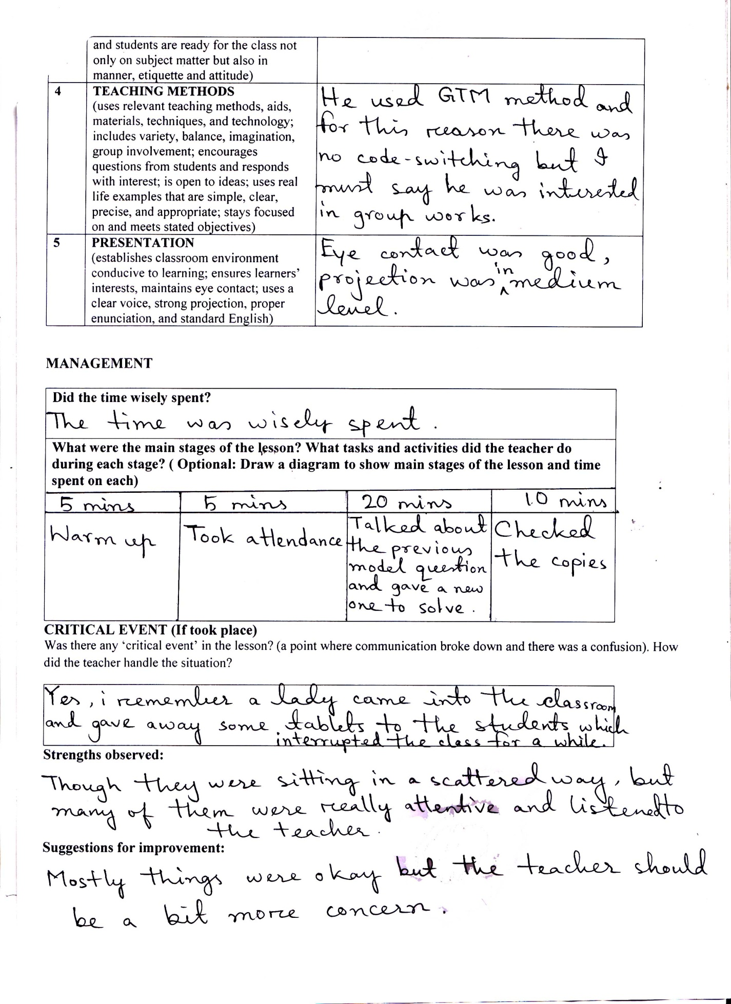
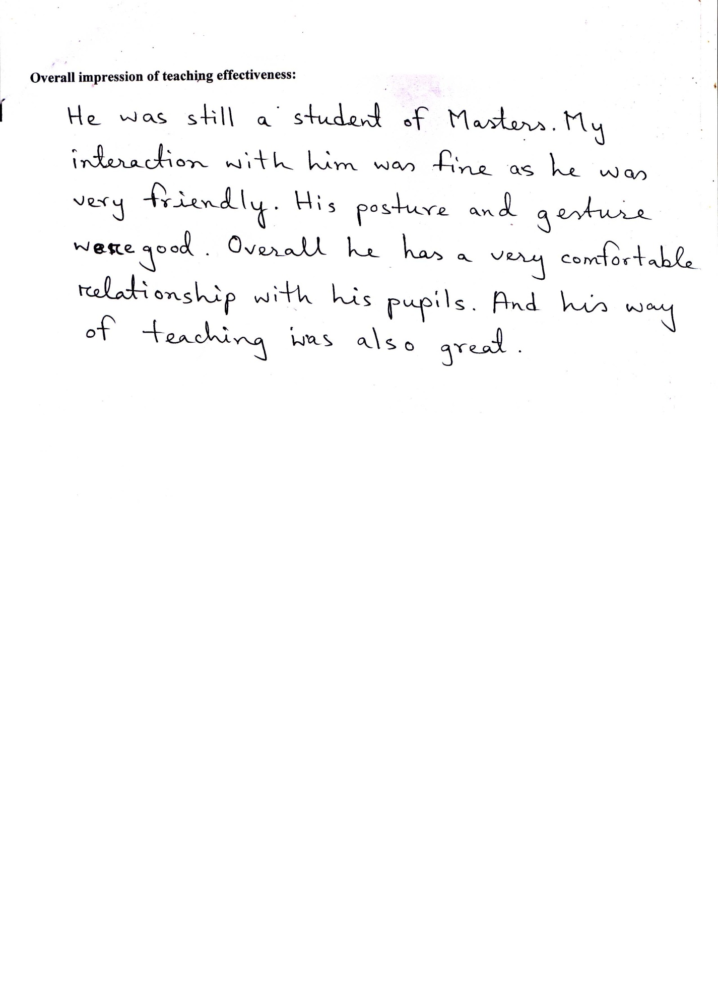
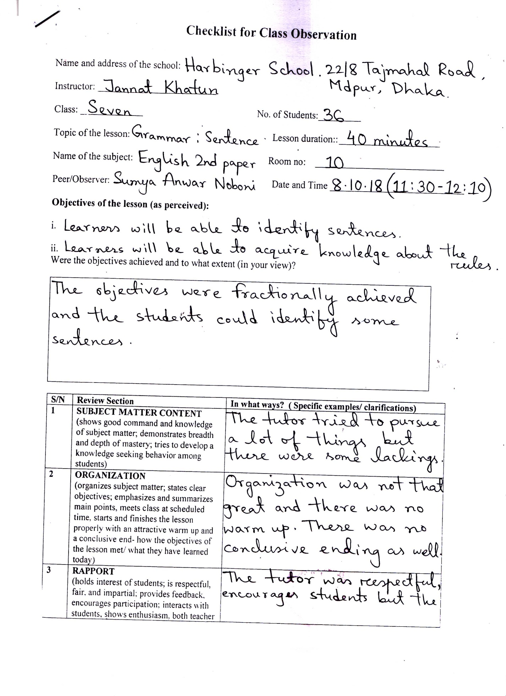
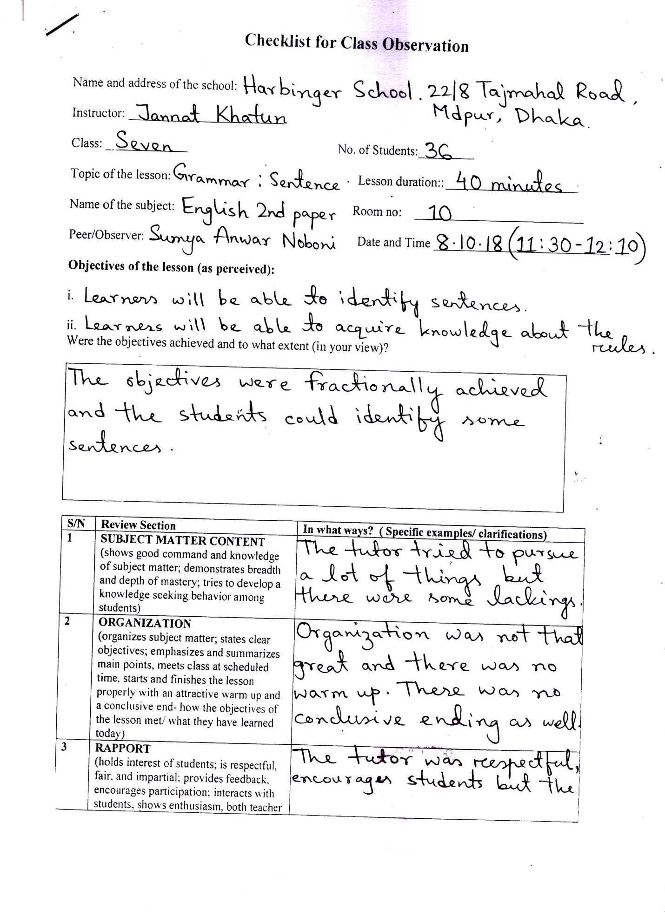
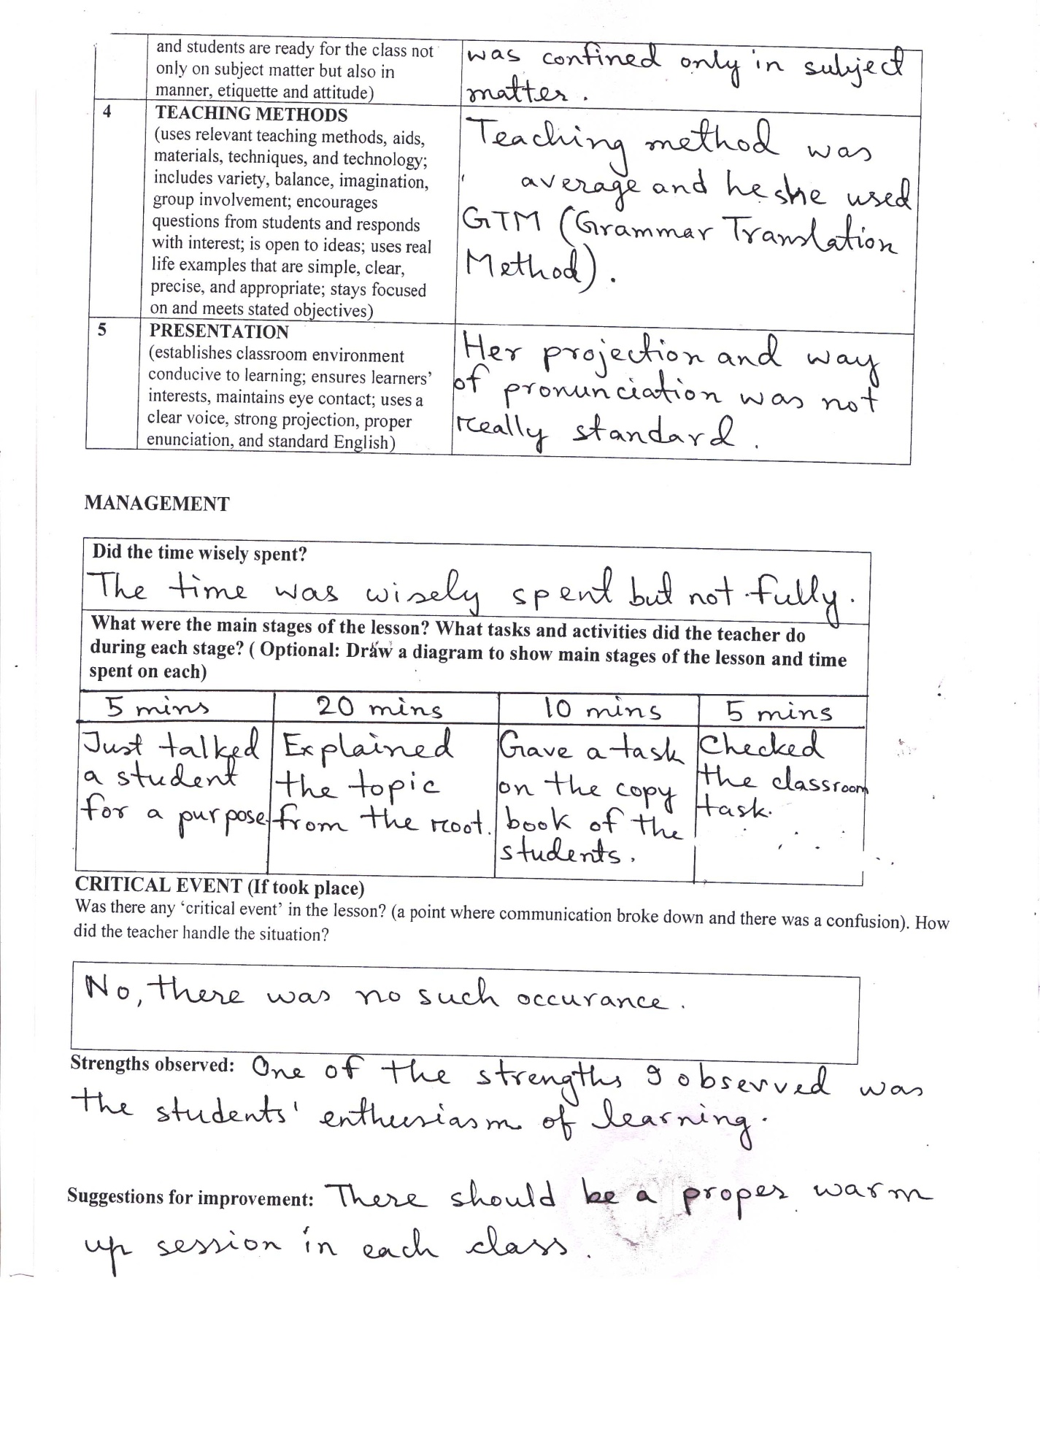
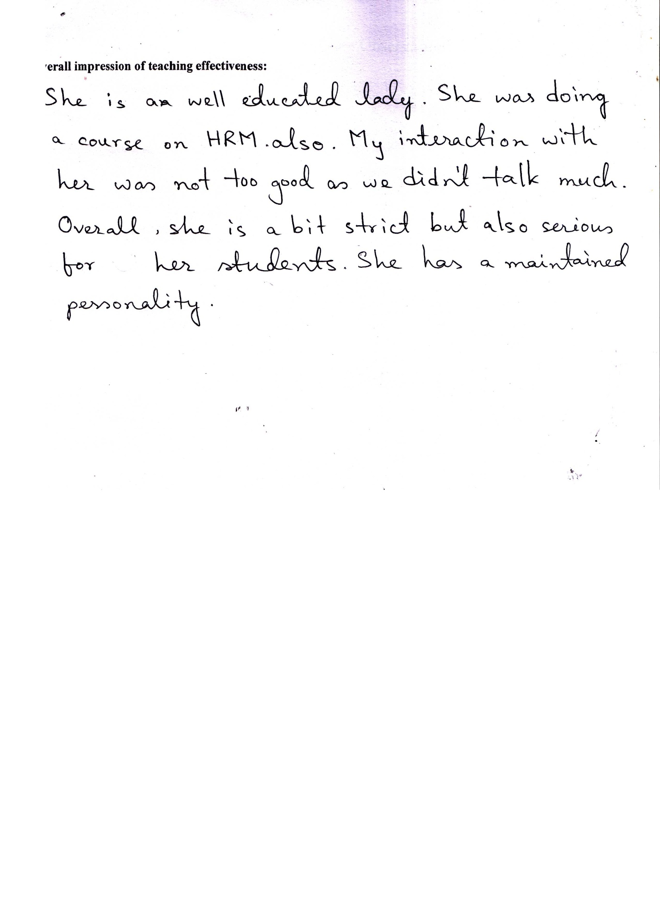
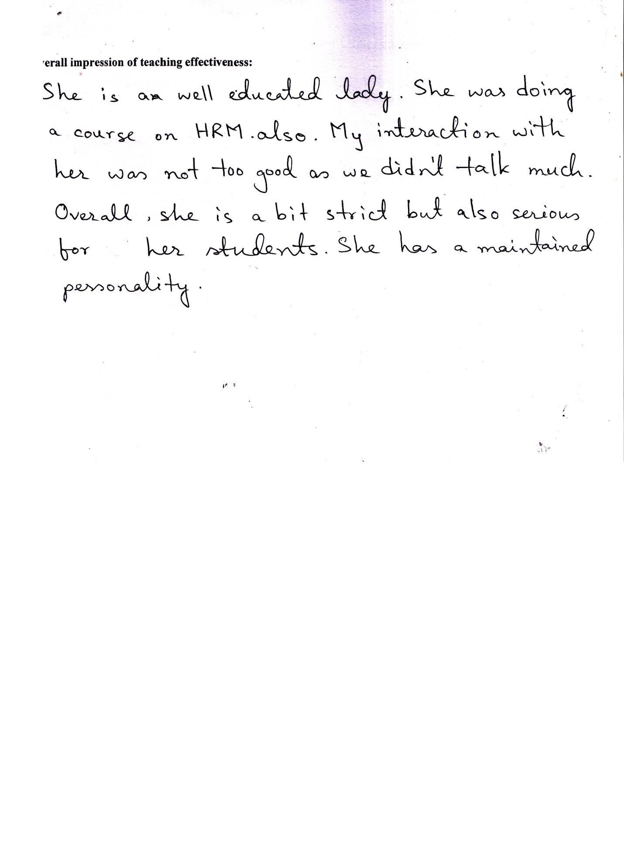
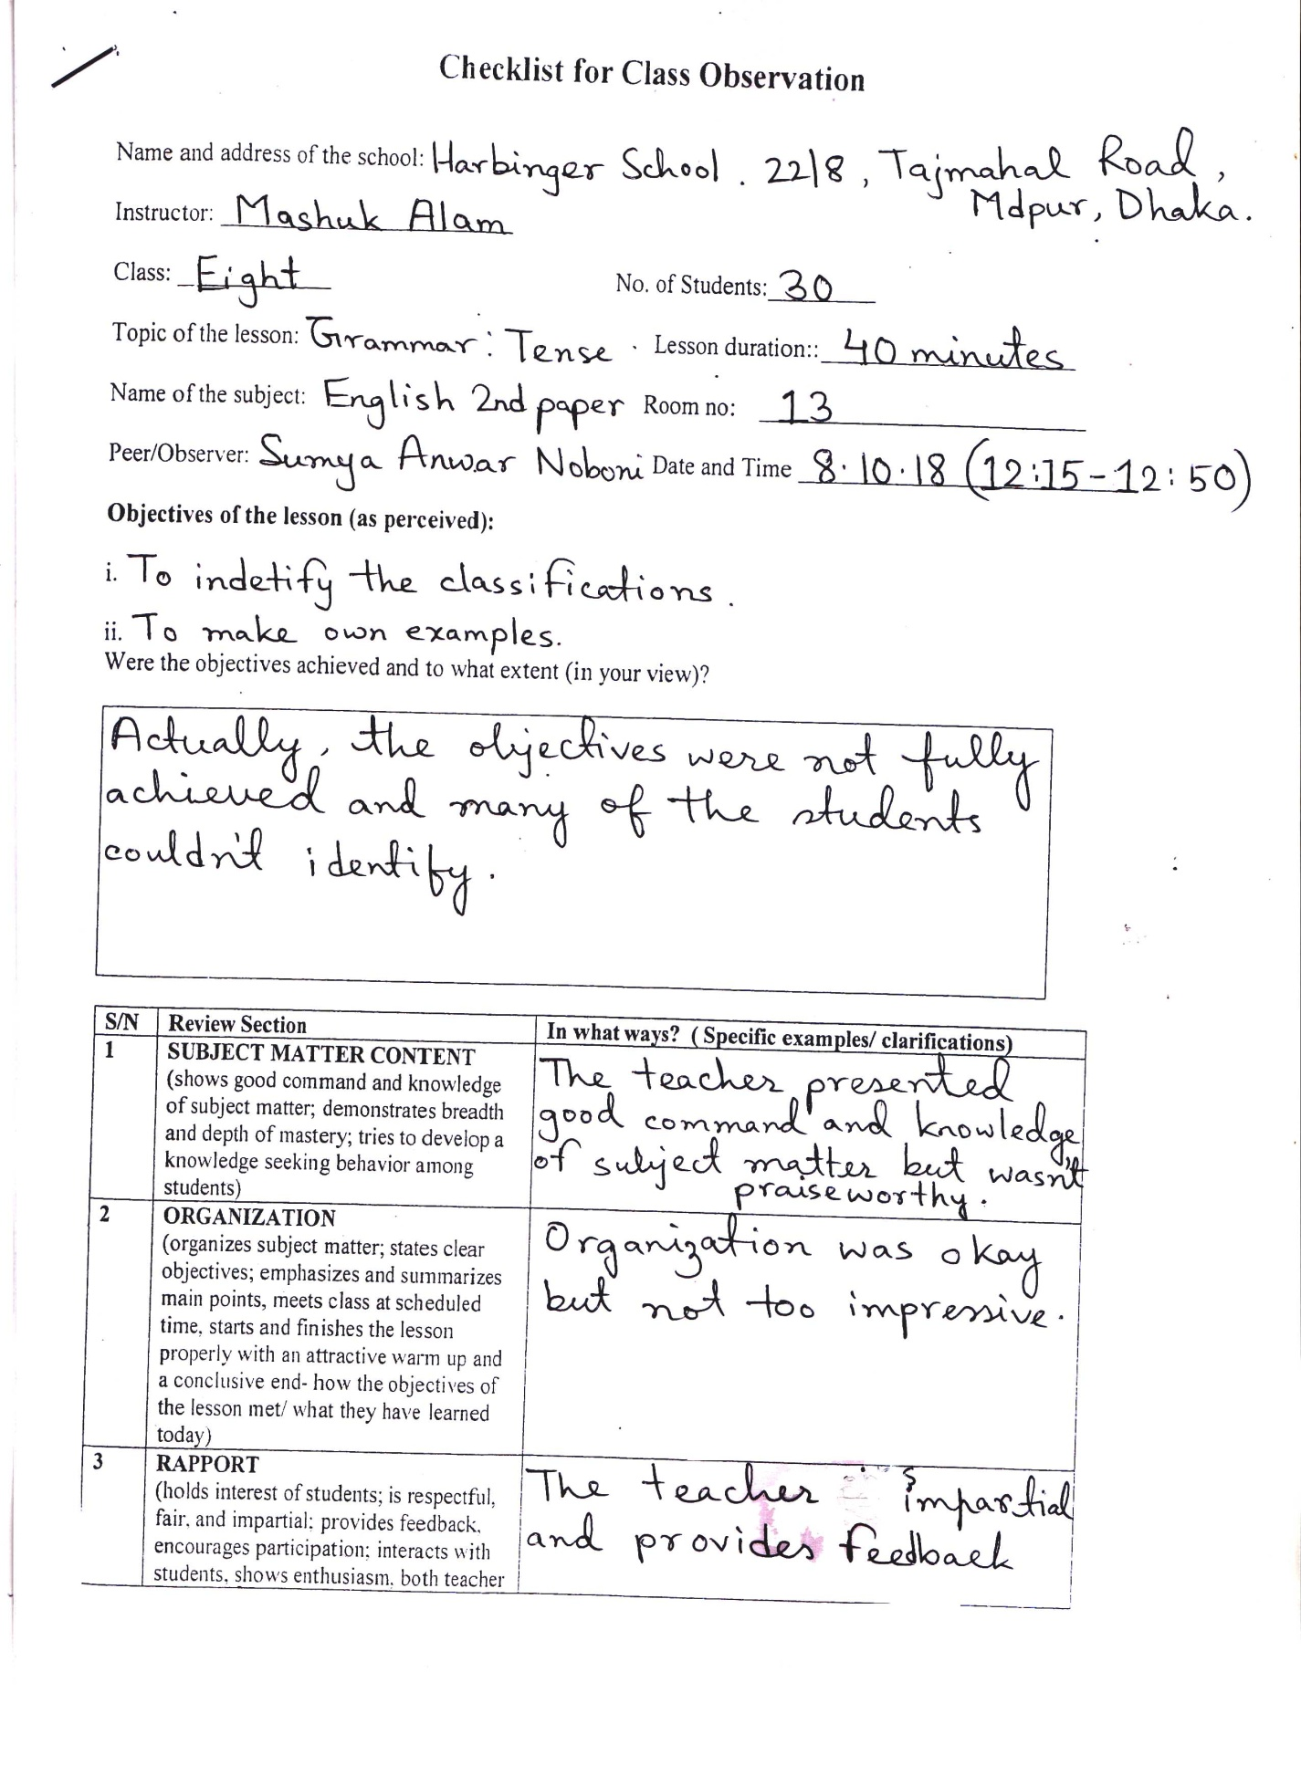
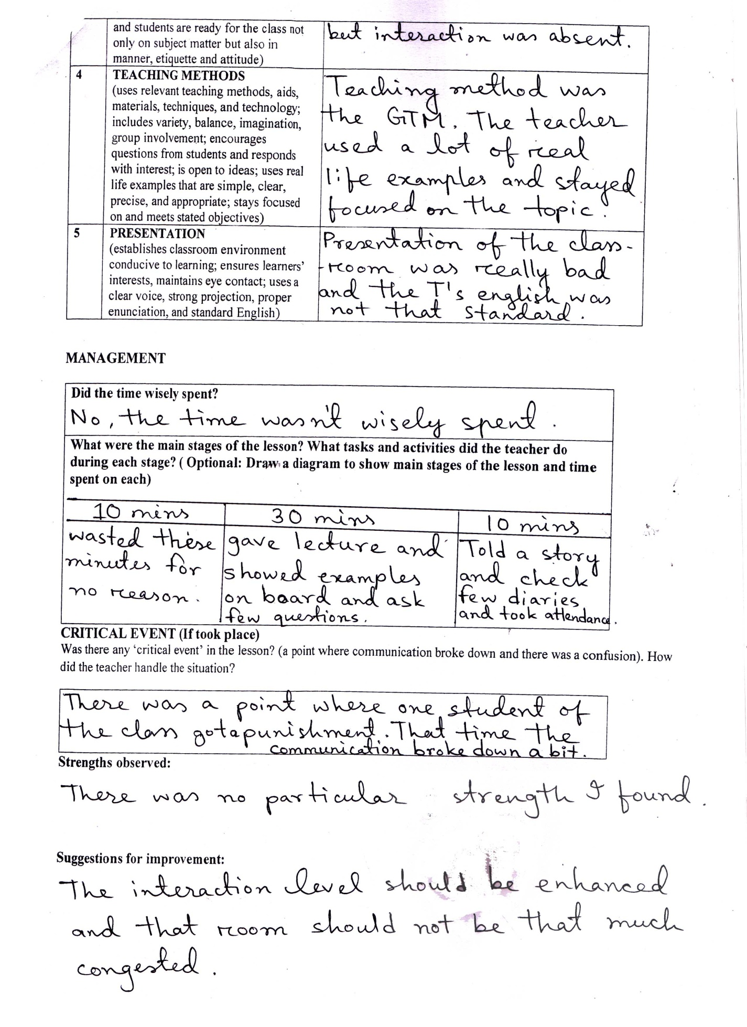
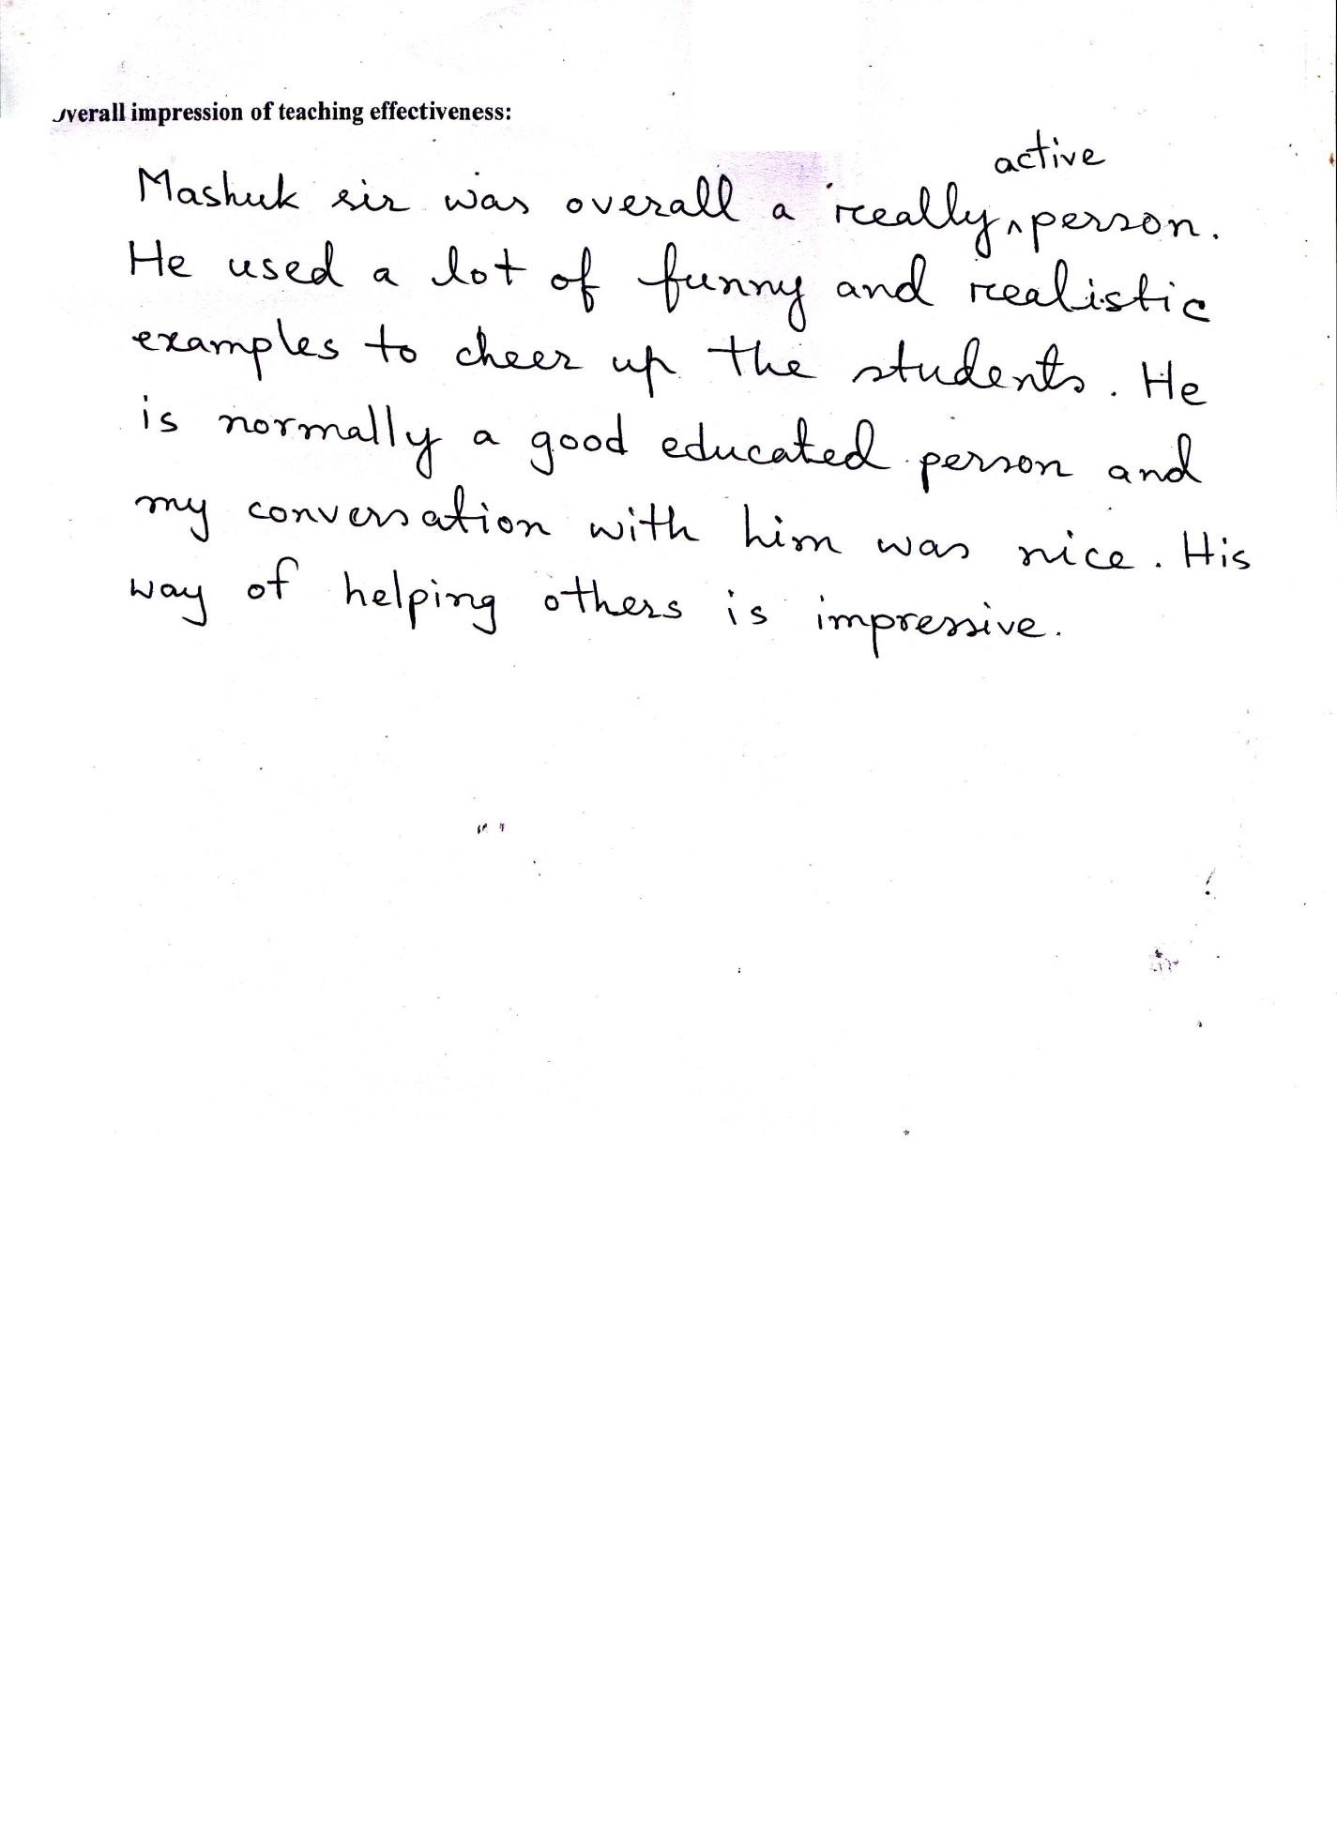
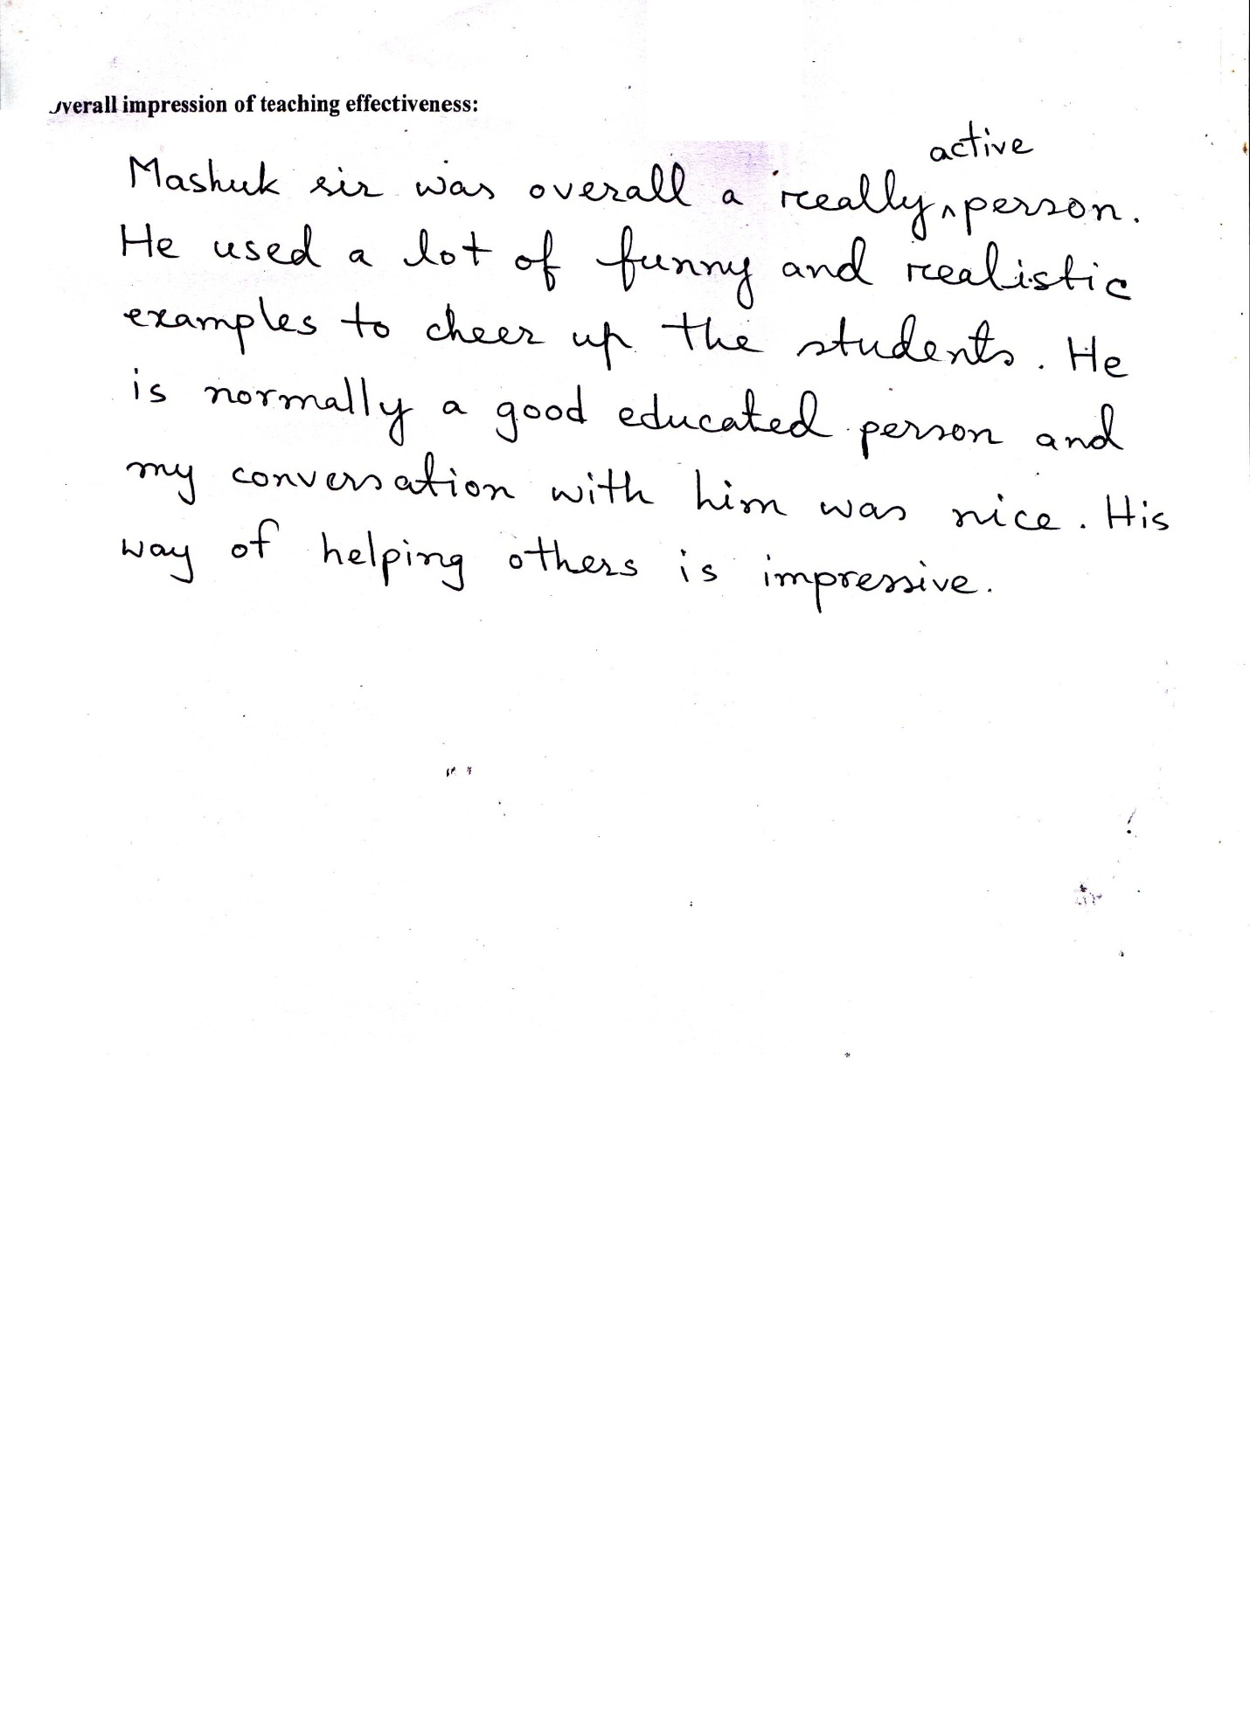
Class Observation
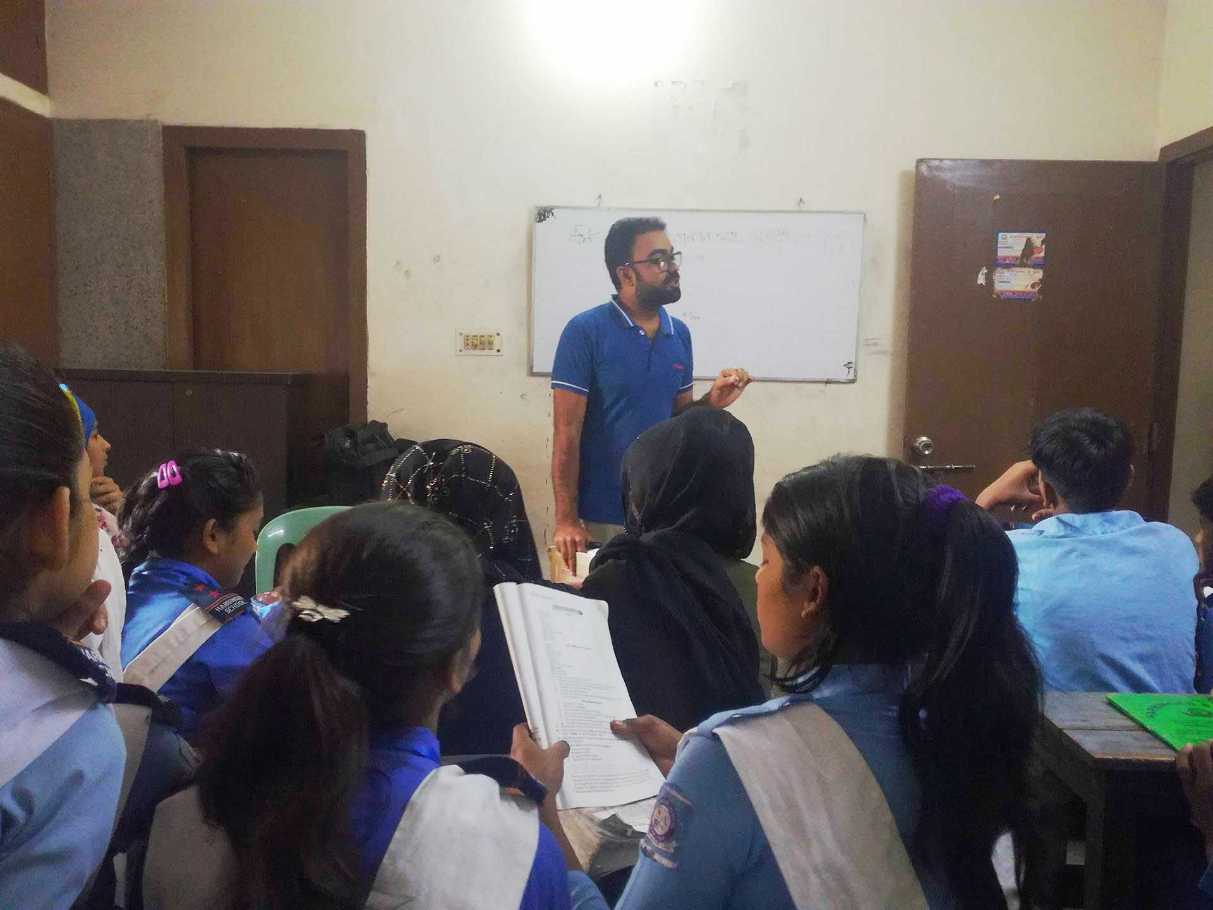
Teaching Experience
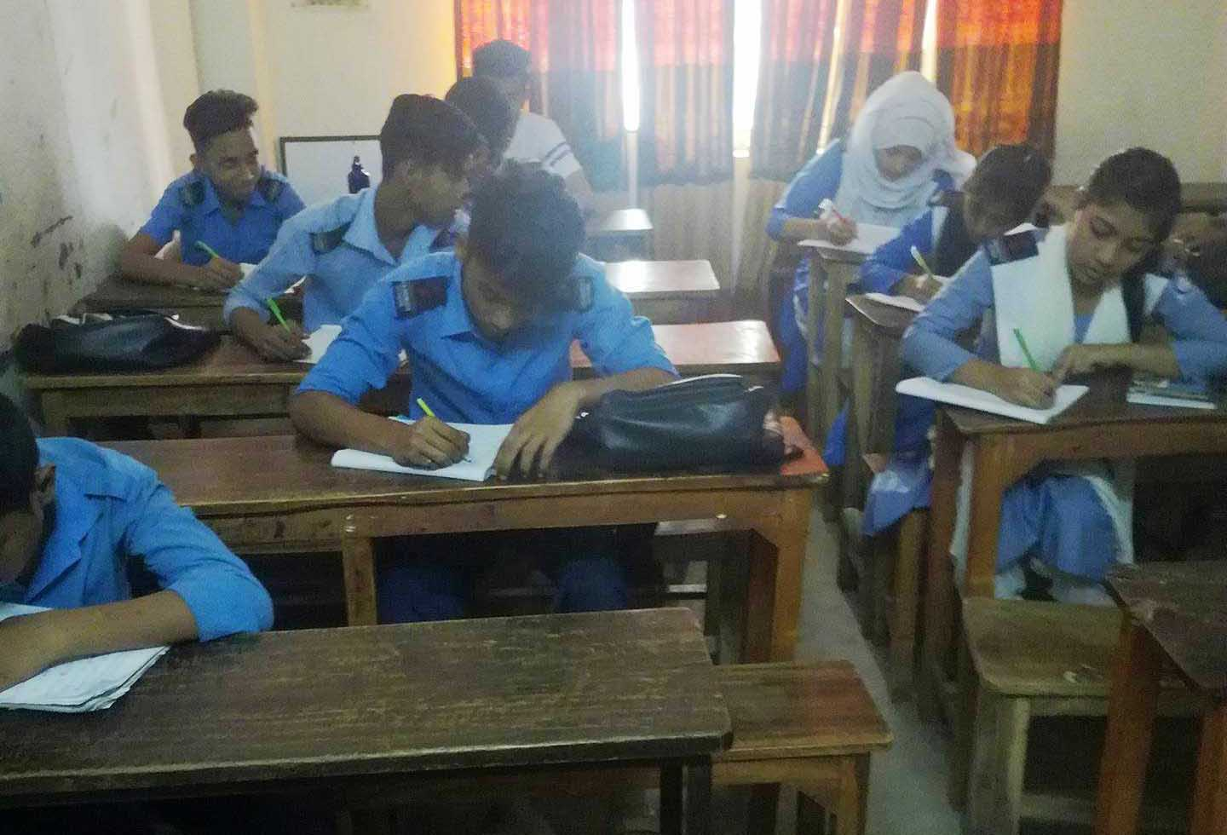
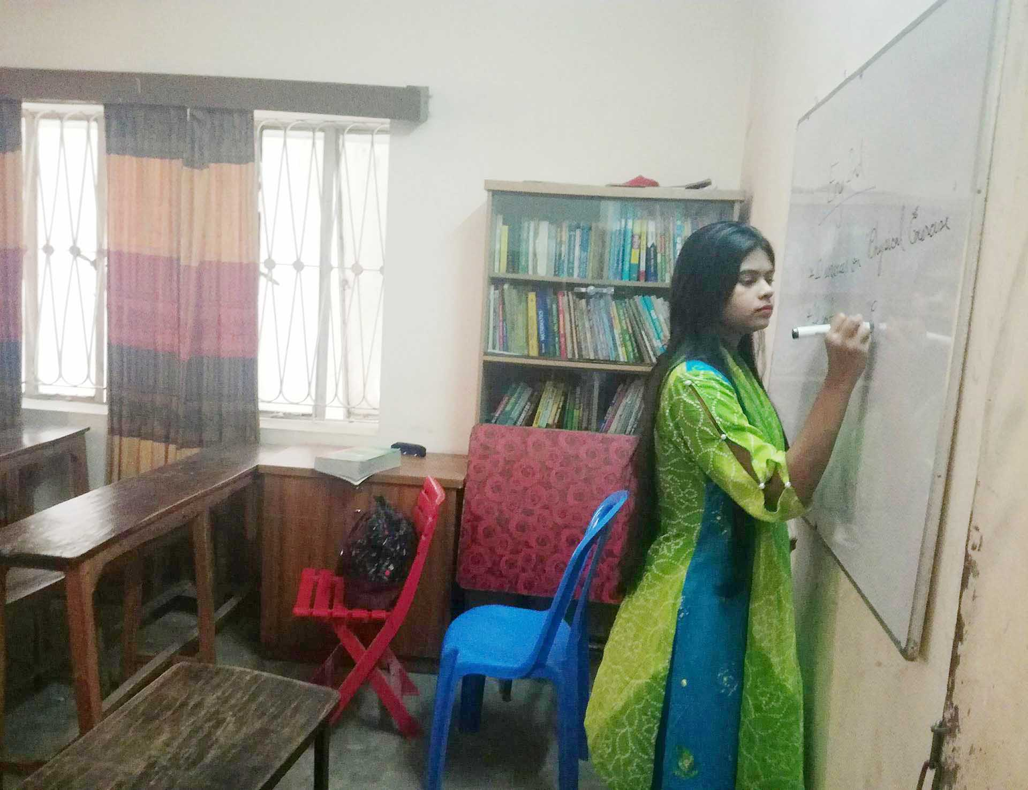

Harbinger School
Est. 2008
EIIN No : 136282
Main Branch : 22/8, Tajmahal Road,
Mohammadpur, Dhaka.
Phone : 8151852 (Off), 01851596800

Date : 11-10-2018
To Whom It May Concern

This is to certify that Sumya Anwar Noboni bearing ID No : 152-10-1197, Department of English, Daffodil Internationals University has successfully completed her internship under taking method from 8th to 10th October 2018. We are satisfied & glad with her work and behaviour.
We wish her every success in her future.



Headmaster
Harbinger School

