

Internship Report
On
The present scenario of English Language Teaching in Bangladesh

Submitted by-
Reaz Ahmed
ID: 152-10-1186
Batch: 35th
Semester: Fall 2018
Course title: Project paper
Course code: Eng – 334

Submitted to –
Afroza Akhter Tina
Senior lecturer
Department of English
Daffodil International University
Dhaka, Bangladesh.

Date of Submission:
Declaration

I do hereby declare that the Internship report submitted to the Department of English, Daffodil International University is an original work for the completion of my course “Project Paper with Internship” (Course Code: ENG-334) in the program of B.A (Hons) in English. The internship report on “The Scenario of English Language Teaching in Bangladesh” was written under the supervision of Ms. Afroza Akhter Tina.


--------------------------------------
Name: Reaz Ahmed
Program: BA (Hons) in English
Batch: 35th
ID: 152-10-1186
Department of English
Daffodil International University

II
Certificate

It is my pleasure to certify that the Internship Report submitted to the Department of English, Daffodil International University by Reaz Ahmed for the completion of the course “Project Paper with Internship” (Course Code: ENG- 334) in the program of B.A. (Hons) in English is an original piece of work done under my supervision.

This Internship Report is recommended for submission to the Department of English, Daffodil International University.


----------------------
Afroza Akhter Tina
Senior Lecturer
Department of English
Daffodil International University

III
Acknowledgements

I would like to express my deep gratitude to my supervisor Afroza Akhter Tina for her patient guidance, enthusiastic encouragement and useful critiques for this project.

And I would also like to express my gratitude to the Department of English of Daffodil International University for the advice and assistance in keeping my progress on schedule.

My grateful thanks to the teachers of Farakkabad High School, Mr. MD Mozammel Haque, Mr. Jasimuddin Khan and Mr. Palash Chandra Majumdar, for their valuable support on this internship report. Moreover, I am grateful to the Head teacher of Farakkabad High School, Mr. Ruhul Amin Howlader who has assisted me to fulfil my project.

IV
Abstract

My internship report contains three section where I explained my three-day experience at Farakkabad High School. In the first section, I have described in detail about the institution’s background, location, number of students, number of teachers etc. In the second section, I explained the overall class observation experiences of my internship. Finally, in the third section I have described my own teaching experiences. In short, my internship report conveys “The Scenario of English Language Teaching in a Bangladeshi School”.

V
Table of Contents
Contents | Page No.
Declaration by the Student | ii
Certificate | iii
Acknowledgments | iv
Abstract | v
Table of Contents | vi
Chapter – I: Introduction | 1
Chapter – II: Objectives | 2
Chapter – III: Methodology | 3
Chapter – IV: Institution Details | 4
Chapter – V: Class Observation Report | 5 to 7
Chapter – VI: Teaching Experience | 8 to 10
Chapter – VII: Overall Findings | 11
Chapter – VIII: Recommendations | 12
Chapter – IX: Conclusion | 13
Appendices
Appendix 1: Class Observation Check List | 15-23
Appendix 2: Certificate of Internship | 24
Appendix 3: Photographs | 25-26

VI

Chapter – I
Introduction

The internship is an integral platform for anyone to gain experience in an actual workplace. Thus, the internship on “The Scenario of English Language Teaching in Bangladesh” was a good opportunity for me to learn, to gain experiences. It is also not something that I simply create, but I had to undergo through it. By doing my internship in a practical workplace helped me to know and discover myself from different perspectives. It also helped me to control and develop my attitude and behavior in dealing with different kinds of people and situation. I learned about theories and knowledge that I will need in my future working life. I learned the practical approach on dealing with a real word. Internship helps me identify my weaknesses and also my strengths.

In this semester (Fall-2018), I got the opportunity to complete the compulsory course ENG-334, Project Paper. I was asked by my supervisor Ms. Afroza Akter Tina to visit a school and compile an internship report on the “Scenario of English language Teaching in Bangladesh”. I have completed my internship report based course: ENG-334 Project Paper at Farakkabad High School undertaking method from 27th October 2018 to 30th October 2018.

1
Chapter-II
Objectives

The followings are the objectives of this internship.

- To choose a school.
- To learn about the school.
- To observe three classes of three different teachers.
- To plan three lessons with the help of class teachers.
- To teach students with permission of the Head Teacher.

2
Chapter-III
Methodology

I have followed the following methodology in completing my project:
- According to the instruction of my supervisor I chose to visit Farakkabad High School for completing my internship. I wasn’t a student of that school but that school is close to my house and most of the teachers of that school know me very well, that is why the permission was bit easier to complete my internship.
- Another reason of choosing that school was for its location which was close to my house so I didn’t face any problems during my internship.
- The Head Teacher suggested me to observe the class of VII, IX, VI. So I had the opportunity to observe three classes of three different teachers.
- In the first observation class I met with MD Mozammel Haque. I know him personally and we had a good communication before the class as well.
- I learned that how teachers were talking in the classroom with their students. The English classroom was not fully in English. Teachers used Bengali more than English. Students were also very much comfortable with Bengali.
- I observed three classes and filled the checklist that was given by my supervisor as a form for collecting data.
- After observing three classes, I conducted three classes. I tried to speak English in the classroom but they felt uncomfortable, that is why I used both Bangla and English languages during my lectures.

3
Chapter – IV
Institution Details
Institution Name | Farakkabad High School
Established | 1934
Location | Farakkabad Degree college Road, Farakkabad, Chandpur Sadar, Chandpur.
Shape of the Institution | English letter ‘U’
Number of Buildings | 3
Buildings Ownership | Own
Number of Students | 2500
Number of teachers | 55
Teachers Experience | 01 year- 05 years: 7  06 years- 10 years: 14  11 years- 20 years: 22  21 years- 30 years: 8  Over 30 years: 4
Teachers Qualification | B.com/ M.com: 19  B.sc/ M.sc: 22  B.A/ M.A 14
Economic Issues | The school is a Quasi-government school, so most of the financial support comes from the government, And students also provide both tuition and examination fees.
Social Issues | As this institution is in village so most the students belong to lower middle-class family, and most of the teachers belong to Middle class group.
Cultural Issues | The school arranges annual sports in almost every year. The students of this school have to strictly maintain the dress code.
Other Factors | Playground: Yes.  Library: Yes.  Canteen: No  Transportation: No.  Laboratory: Yes.  Tiffin provided: No.  CCTV security: Yes.  Multimedia Facility: Yes.

4
Chapter V
Class Observation report
Class – 1
I went to the school on 27th October 2018 to observe a class of MD. Mozammel Haque at 09:30 AM. He introduced me with his students of class VII. The course was English 1st paper in Room no 111. The course teacher divided his class lesson into three parts. The first part was reading the passage to learn the unknown words from the text book by the teacher. The second part was group work and solving questions. And the last part was providing feedback by the teacher.
In my point of view, I can say that these techniques have been achieved in a great extent. The teacher applied his ability in his lesson properly and finished his class timely. The teacher had good ability to make the class interesting. He had a good relationship with his students. The class organization was very good. He defined all the unknown words in his class and helped his students to make correct sentences through examples. The teacher was very friendly, had a friendly communication with his students, and for these students paid attention in the classroom. His teaching method was very interactive. Teacher gave the opportunity to his students to ask him questions about any confusion/problem which was not clear to the students. His class presentation was good. He maintained eye contact with his students, his voice was clear, and students enjoyed the class with him. He used his time in a proper way.
The main stage of his lesson was to read the passage carefully and define all the difficult words/terms. And the task and activities were to ask his students whether they understood or not. There was no critical event during his lesson. The class was silent when the teacher was reading the passage, then when he arranged group work it became a little bit noisy. The teacher seems to be an expert, but he needs to add one more thing which is homework. If he gives homework to his students, they will be more engaged with the lesson.
Then in the end of his lesson, I asked him if he would allow me, I could give them a lesson plan for the next day. He permitted and told me that they will surely enjoy the class with me.

5
Class Observation report

Class – 2.
After first class observation I went to the class of Jashimuddin Khan at 11:00 AM. He introduced me with his students of class IX. The course was English 2nd paper in room no 203. I sat on the last bench with the students. The class focused on the use of Tenses. In the beginning of his lesson he talked about Tense. He taught them the definition of tense and types of tenses with examples.
The teacher had a very clear idea about tense and he taught his students about various kinds through examples. He wrote some sentences on the board and asked students to correct them if they could. His class performance was good, but few of the students responded in the classroom. He had good communication with almost all his students. There was a friendly environment in the classroom. He provided some sentences with blanks, and asked students to fill them correctly. His teaching method was interesting. His class presentation was also effective and he was confident during his lesson. He spent his time wisely.
The main stage of his lesson was to develop some sentences by using appropriate tense structure. He helped his students to learn the structures interestingly. But the teacher was not fully confident in the whole session because of my presence. But he handled it smartly at the end. His class was silent and his effort was good during the session. His weakness is his soft attitude towards his students. He just used simple sentences and that’s why he needs to concentrate on his lesson plan. My overall impression about his lesson was very satisfactory. He worked hard in the classroom, I think his confidence level can be increased more.
In the end of his class lecture, he told his students that their new instructor would teach them about Tag questions on the next class. The teacher wished me luck for the next class.

6
Class Observation report

Class – 3.
After two classes, I joined with Palash Chandra Majumdar to observe my third class of the day at 02:30 PM. He introduced me with his students of class VI. He was taking English 2nd paper class with them. I sat on the middle with the students. I saw some students started gossiping about me. In that class, he prepared his lesson with the use of Articles. He divided his class lesson into three parts. In the first part, he introduced his students with two types of articles. Then in the second part the teacher talked about the rules of using articles and provided with some worksheets in the class to practice. Finally, there was peer feedback.
In my viewpoint, I can say that, his teaching method was quite average and he achieved success to a certain extent. The teacher was able to introduce his students with article and the usage through different activities. Therefore, students learned quickly, but few of them was not paying attention during the class. The teacher came to the class 10 minutes later. The classroom was a bit noisy. The teacher finished his class timely. Most of the students were very serious about their grammar class. The teacher followed grammar book and all the students came to the class with that grammar book. He followed rules and activities from the book and provided some examples. His class presentation was not satisfactory to me, but he was able to make his class interactive to a certain extent. The teacher needs to concentrate more on providing examples during his class lesson. In addition, his pronunciation was not very good. He was new but his effort was good enough.
In the end, I asked the teacher if he could give me his approval to take their class on Conditionals in the next day. The teacher smiled and told me he would be pleased if I could make them learn the topic.

7
Chapter VI
My Teaching Experience
Class – 1
On the second day of my internship on 28th October 2018, I went to the teacher room at 09:20 AM. Then I discussed the class lesson with Mozammel Sir, which I made for the students. I directly entered in to the classroom at 09:30 AM, which was a class of VII. After 5 minutes, Mozammel Sir came and took the attendance. About 39 students were present in that classroom. Then the teacher welcomed and introduced me to conduct the class. I was prepared for taking their English 1st paper class.
At first I told everyone not to treat me as a teacher as I am not, some of the students were my neighbor. That’s why I did not feel fear at all. I told them to open their book, then I selected a story to read. Before going to start, I tried to explain the summary of the story in Bangla. Then I started to read the story with Bangla meaning. I tried to tell them the meaning of every unknown words. After completing the story reading part I told them to find whether they understood or not. Few of the students asked me about some word meaning and few of them requested me to explain some complex sentences, as they could not understand them clearly. I explained them repeatedly. Mozammel Sir also helped me and suggested me some points which I added in my lesson plan.
After completing the passage reading part I asked them to turn the next page, where there were some multiple choice questions related with the passage. Then I asked students to choose the correct answers. I was surprised to know that their feedback was not satisfactory at all although they mentioned that they understood the passage really well.
In the end, the teacher told me that I had done a very good job. He wished me luck for my bright future and I left the campus that day.

8
My Teaching Experience
Class – 2
It was the last day of my internship at Farakkabad High School. On 29th October 2018 I reached the school at 10:50 to take the 2nd class with class IX. At 11:30 AM the bell rang for the class. Jashim Sir and I entered in to the room no. 203. Jashim Sir took the attendance and told his students that their new instructor would teach them Tag question in today’s class. I was prepared but felt nervous because they were much elder than class VII.
I divided my lesson into three parts. In first part, there was the introductory idea of tag questions, second part was making assumptions and the last part was practicing tag questions. In first part, the best way I have found to introduce is to first start with sentences and then display how to incorporate questions into the statements. I wanted to use variety of examples (with a variety of helping verbs) and wanted to discuss orally to practice a little bit English.
In the second part when I explained tag questions, few of the student asked me some further questions to have better understanding. For example, what is the purpose of using a tag question? In addition, when it is appropriate to use a tag question over a regular question? In order to answer those questions, I told them, when you use a tag question you are essentially making sure that you are correct about something by confirming what you think or assume to be true. I told them, we are using tag question to confirm our idea. I provided several examples about this usage.
The third part of my lesson was practicing tag question. I made them sit in pairs and provided prompts instead of questions so that the students could feel the authority to ask the questions. Once they have gone through the Q and A, discussed each prompt in the class. They created a tally of questions so that they can practice by making assumptions and drawing conclusions.
During my lesson few of the students asked me some funny questions which really did not make any sense with the lesson. Thus, the class ended and Sir left. The students came towards me and apologized for their unintentional behavior. I told them it’s okay and also left the classroom.

9
My Teaching Experience
Class -3
On 29 October at 02:30 PM, I heard the bell and went to class of VI with Palash Sir. Sir took the attendance first. About 59 students were present in the class. Sir announced that I was going to take their class that day and the class suddenly became too noisy. Suddenly Sir shouted to make the students silent. Before going to start my class lesson, I saw many of the students sat on the last bench although the first two benches were empty. I told them to come forward, they came and I started my lesson.
For this class I followed the same teaching method, which I used with class IX. In the first section, I introduced them with conditionals and its different types. I told them, we use conditionals for situation that might happen in the future, or situation that might never happen. I used Bangla language in the whole class because they are not comfortable with English. After that, I told them about the types of conditional.
I wrote the rules with examples for the students. I saw many of the students were not cooperative and were not attentive in my class. I tried my level best but was not happy about their efforts. Then the teacher stopped me and told me to take a seat. Sir told them they made him disappointed with their arrogance attitude towards me.
That was the last practical part of my internship.

10
Chapter VII
Overall Findings

In overall findings, my internship suggests that the fieldwork not only helped me to find out other teacher’s weaknesses or strengths, rather it also helped me to explore my teaching experience, weaknesses or strengths.

I can say that teaching profession is not an easy one. A teacher needs to concentrate more on himself/herself than the students. One thing that I want to include here is the pronunciation of the teachers of our country. The pronunciation of all the teachers whom I met in the school was very poor. They have to work on that. They just used entirely Bangla language in the English classes. The other good thing was the behavior of the teachers and students. I made a very good relationship with them in the couple of days. The students were very obedient and respectful towards me.

Academic facilities were quite good. But 50% students were absent in everyday classes. Also, few of the students performed in the class. I saw Multimedia was available there, but teachers did not use it throughout. There was a big library in the school, but none of the students usually to the library.

11
Chapter VIII
Recommendations

The whole environment was good but I want to add that teachers need to speak and communicate in English to ensure proper teaching learning of the English language. They need to use English to communicate both inside and outside the classroom. The projector can be used effectively and engage learners in a meaningful way. Teachers may take help from internet or other resources to develop worksheets for the students. Also the size of the classroom is too big, that's why students couldn’t hear me who were at the back. Therefore, I have faced that problem. Teachers may add homework as it can help students develop better understanding of the content. In addition, the teachers need to enrich their confidence levels as well.

12
Chapter IX
Conclusion

In conclusion, I am very glad that during my internship I was able to get a real view of the scenario of English Language Teaching in Bangladesh. It really helped me to learn a lot. It was a great opportunity to observe three classes, and it was an opportunity to find out my strengths and weaknesses. I would like to do this type of work further for my own development. This inspired me a lot. It is a different experience at a different level. It was educative and effective too. The teachers and the head teacher helped me to complete my internship. I have not enough words to express my gratitude towards them for their support.

13
Appendices

Appendix 1: Class Observation Check List
Appendix 2: Certificate of Internship
Appendix 3: Photographs

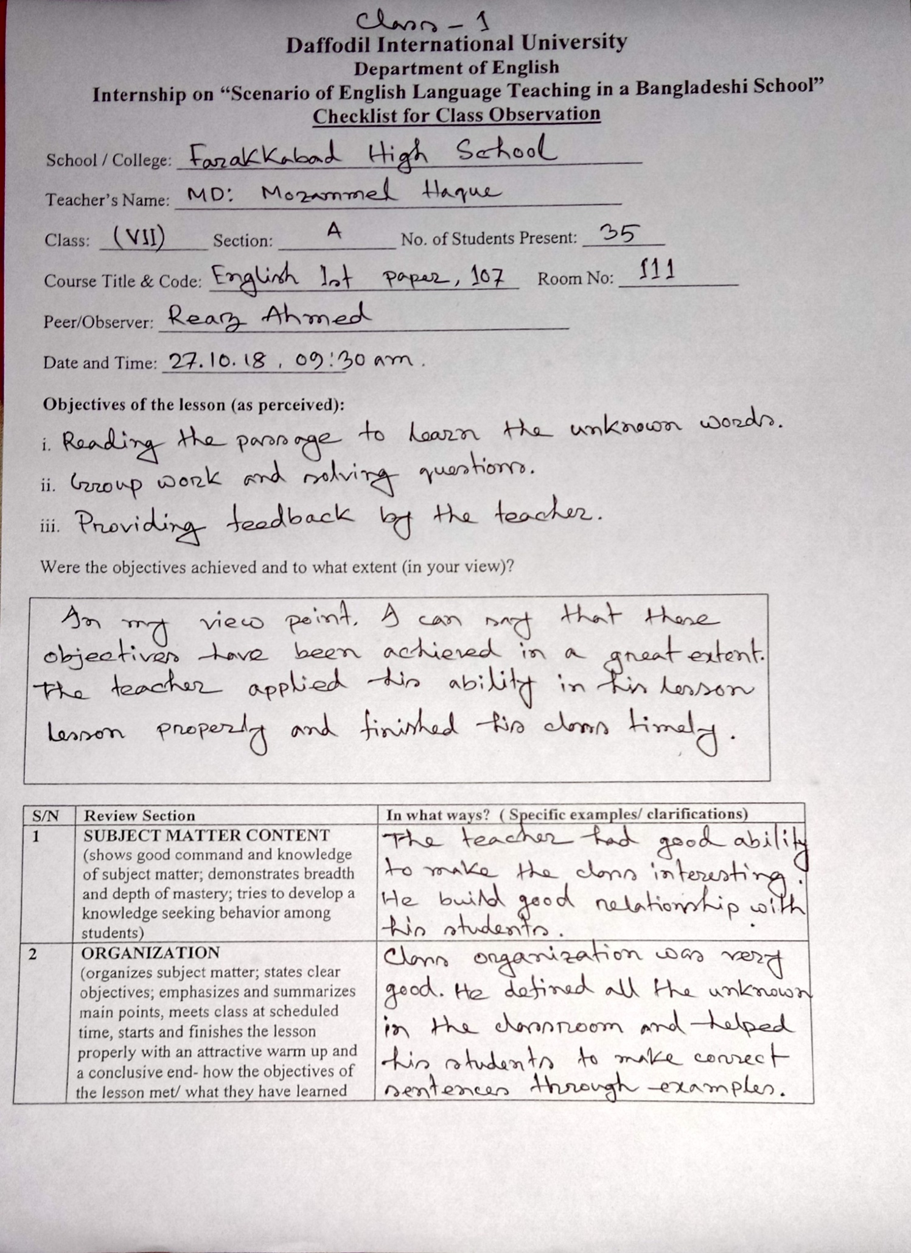
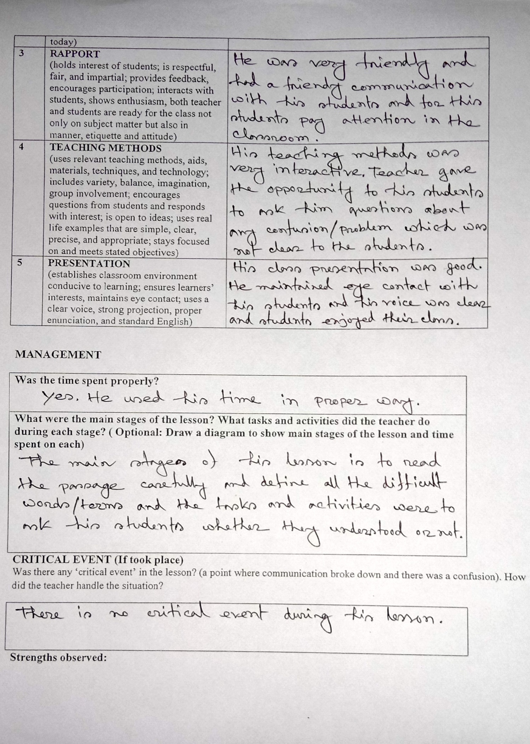
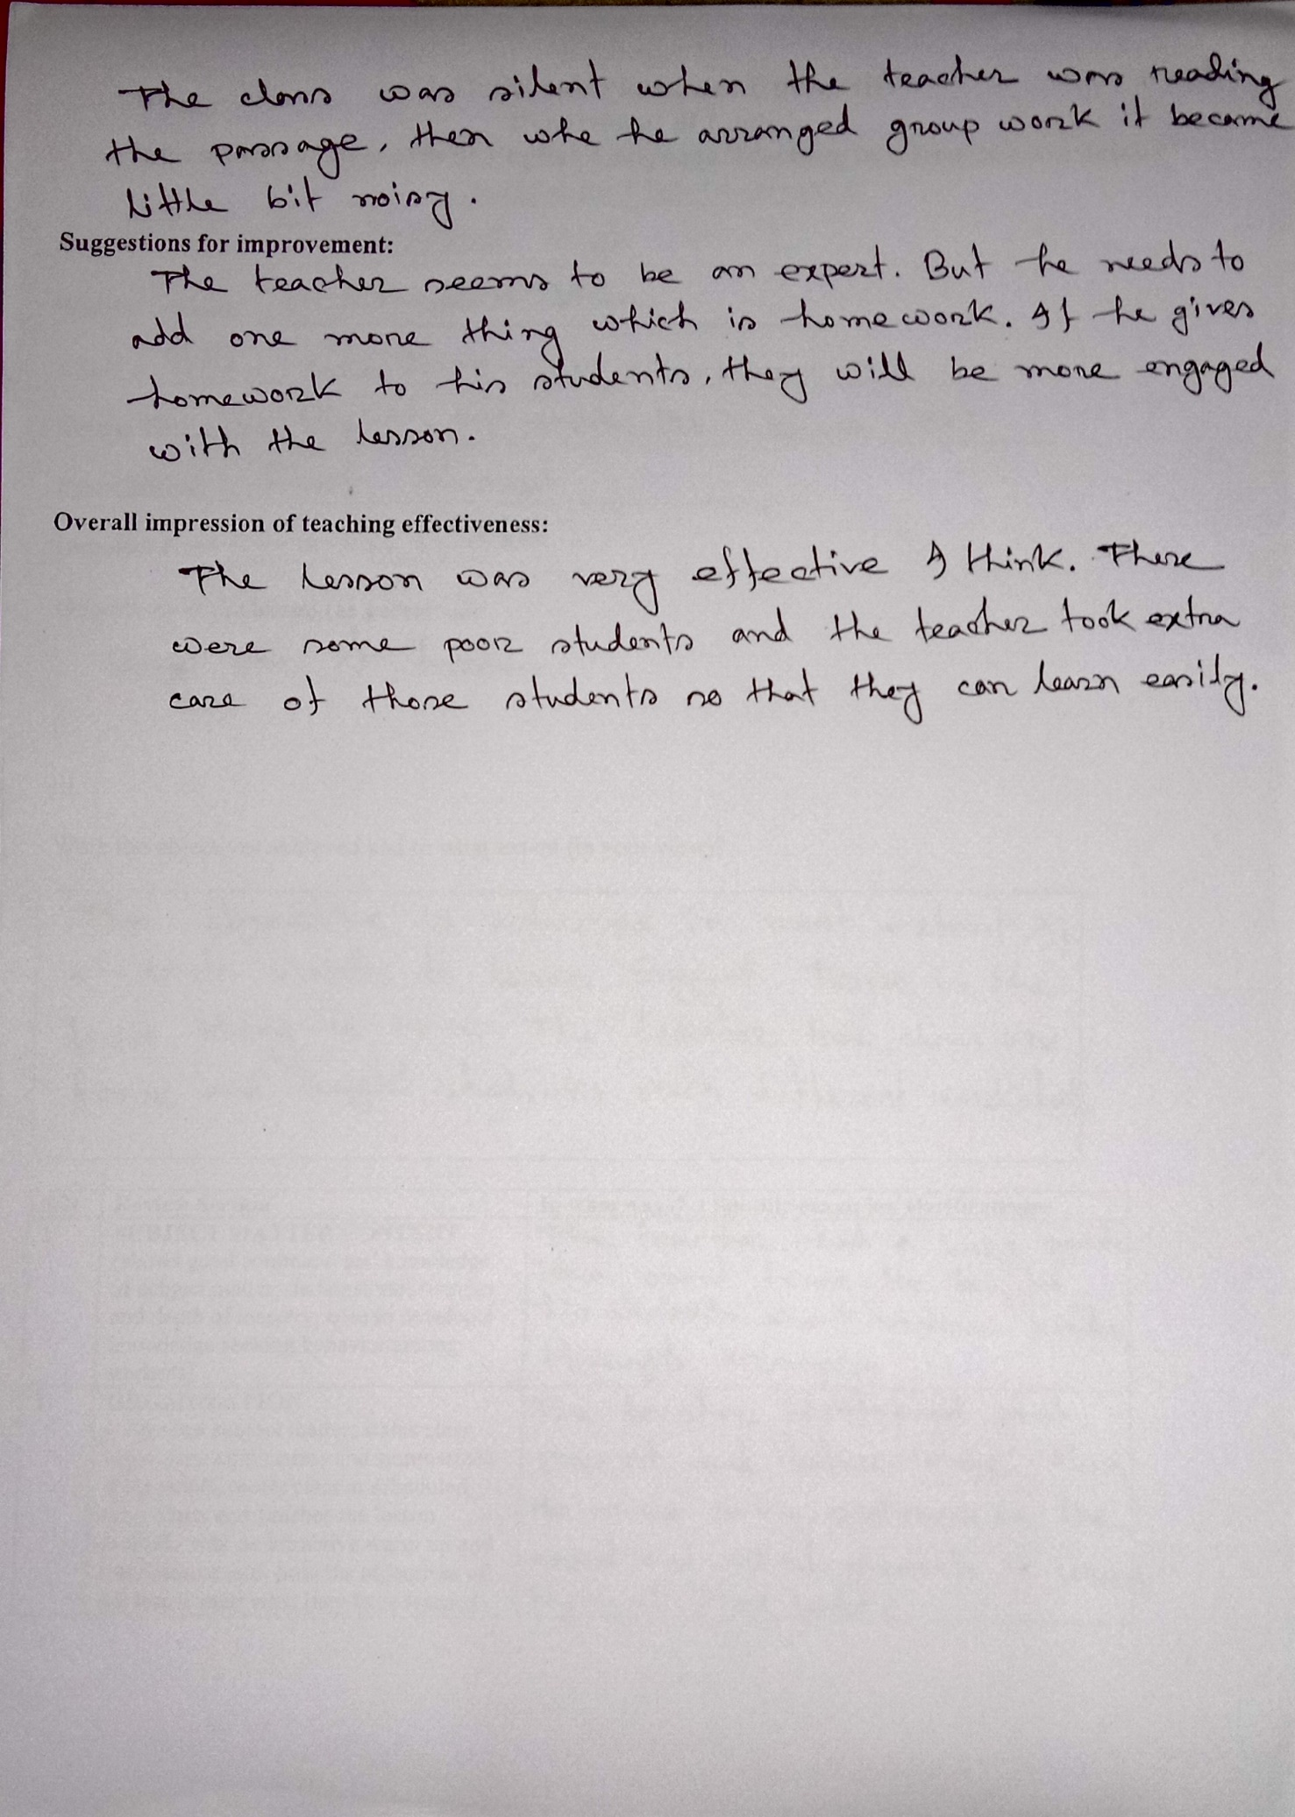
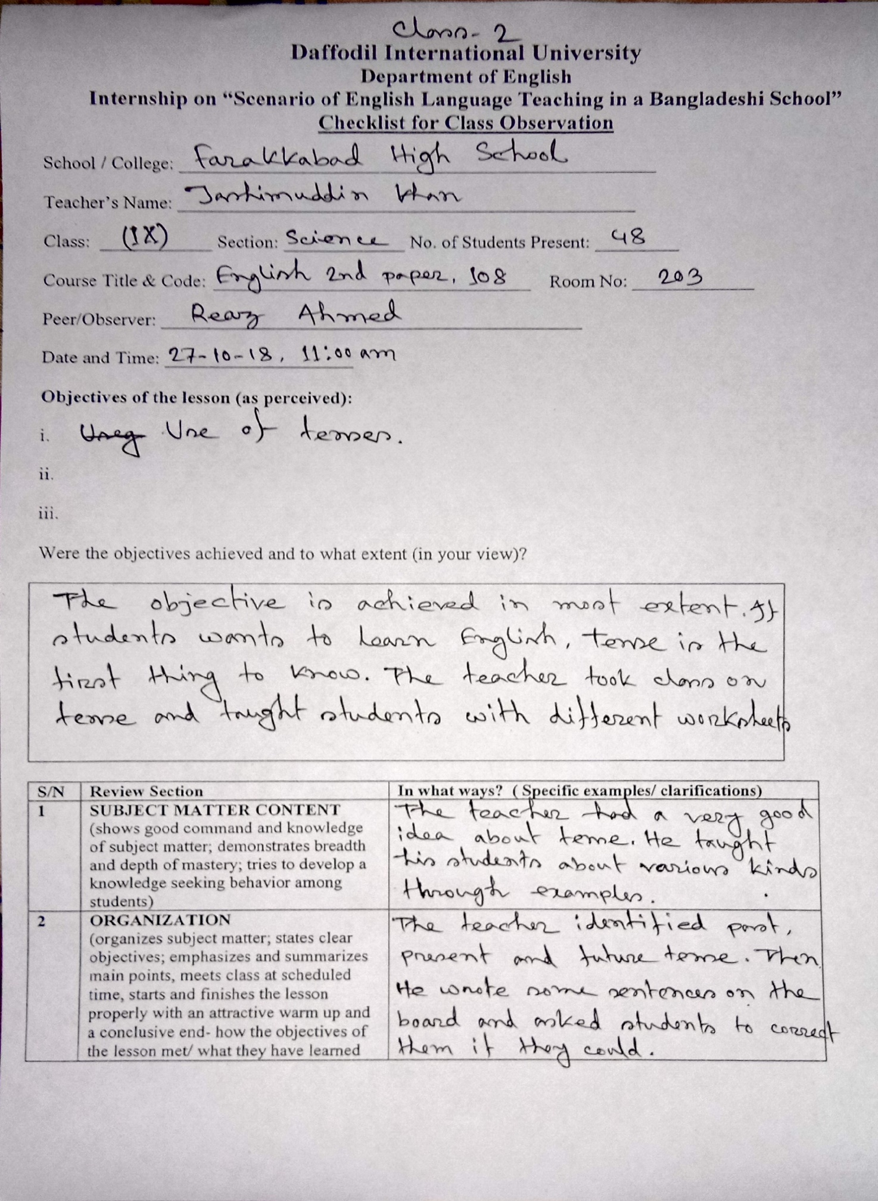
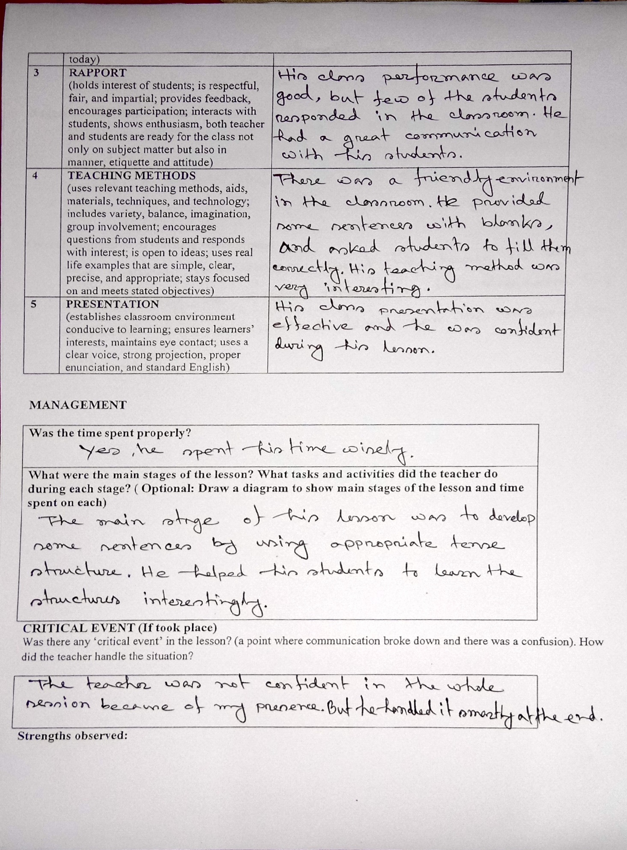
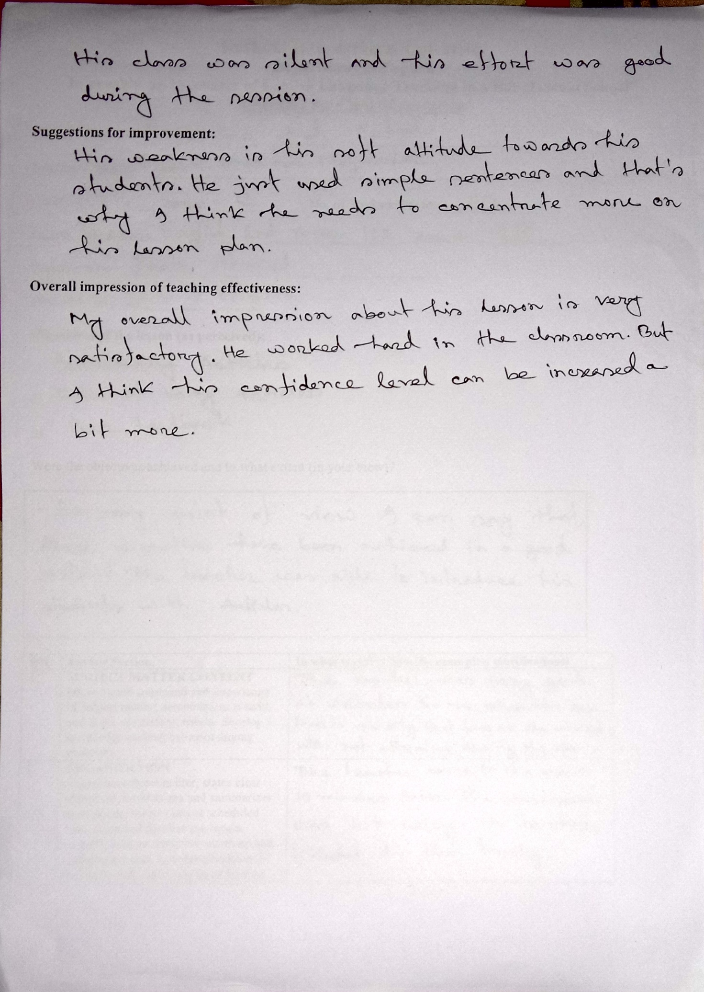
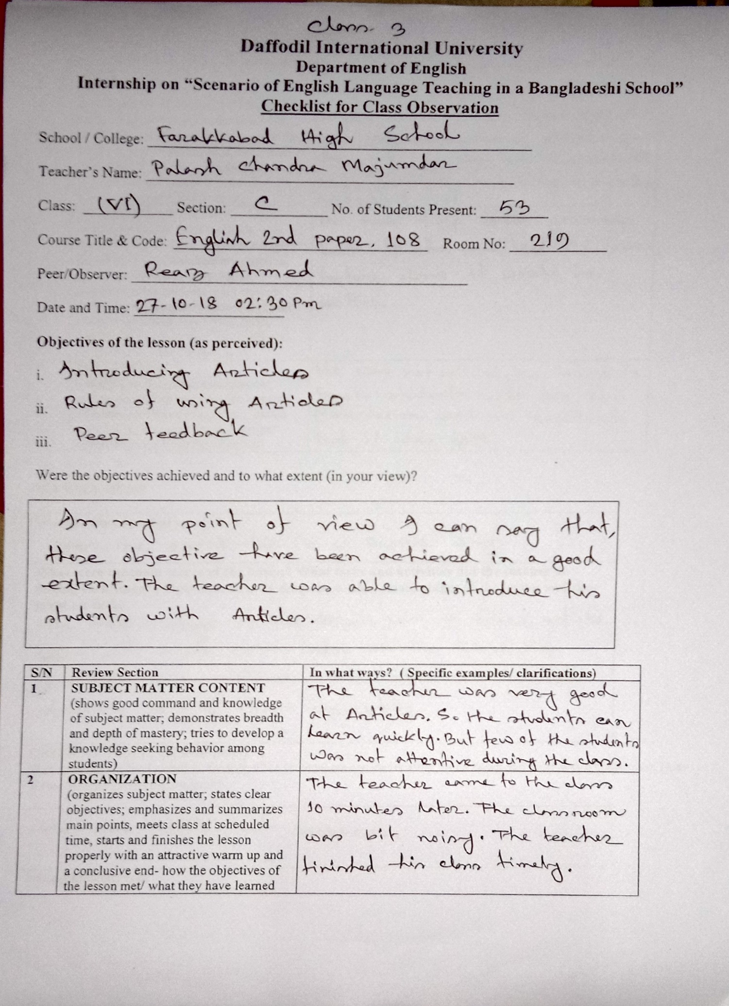
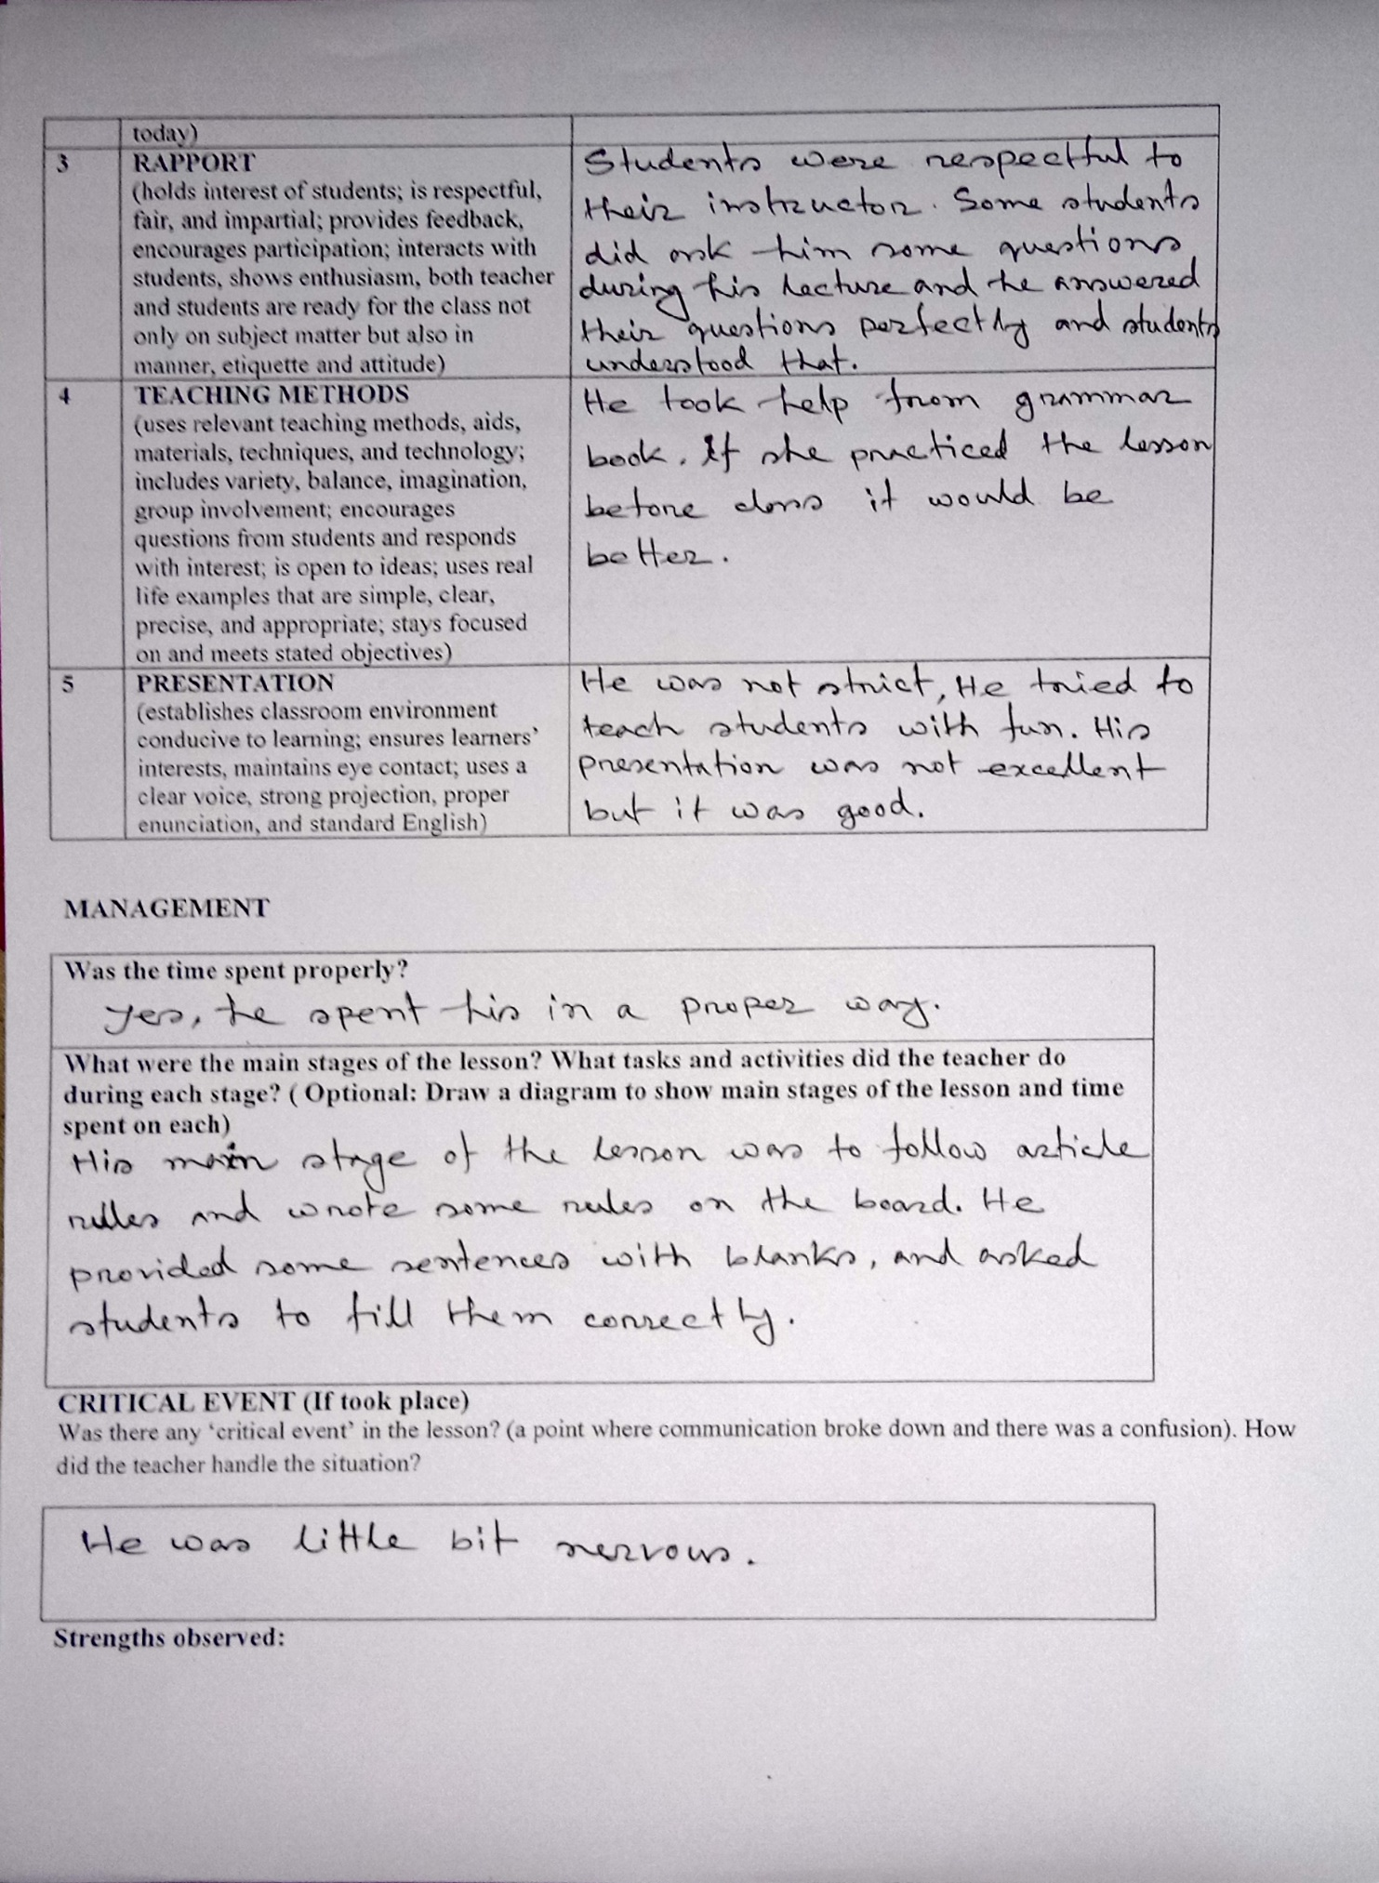
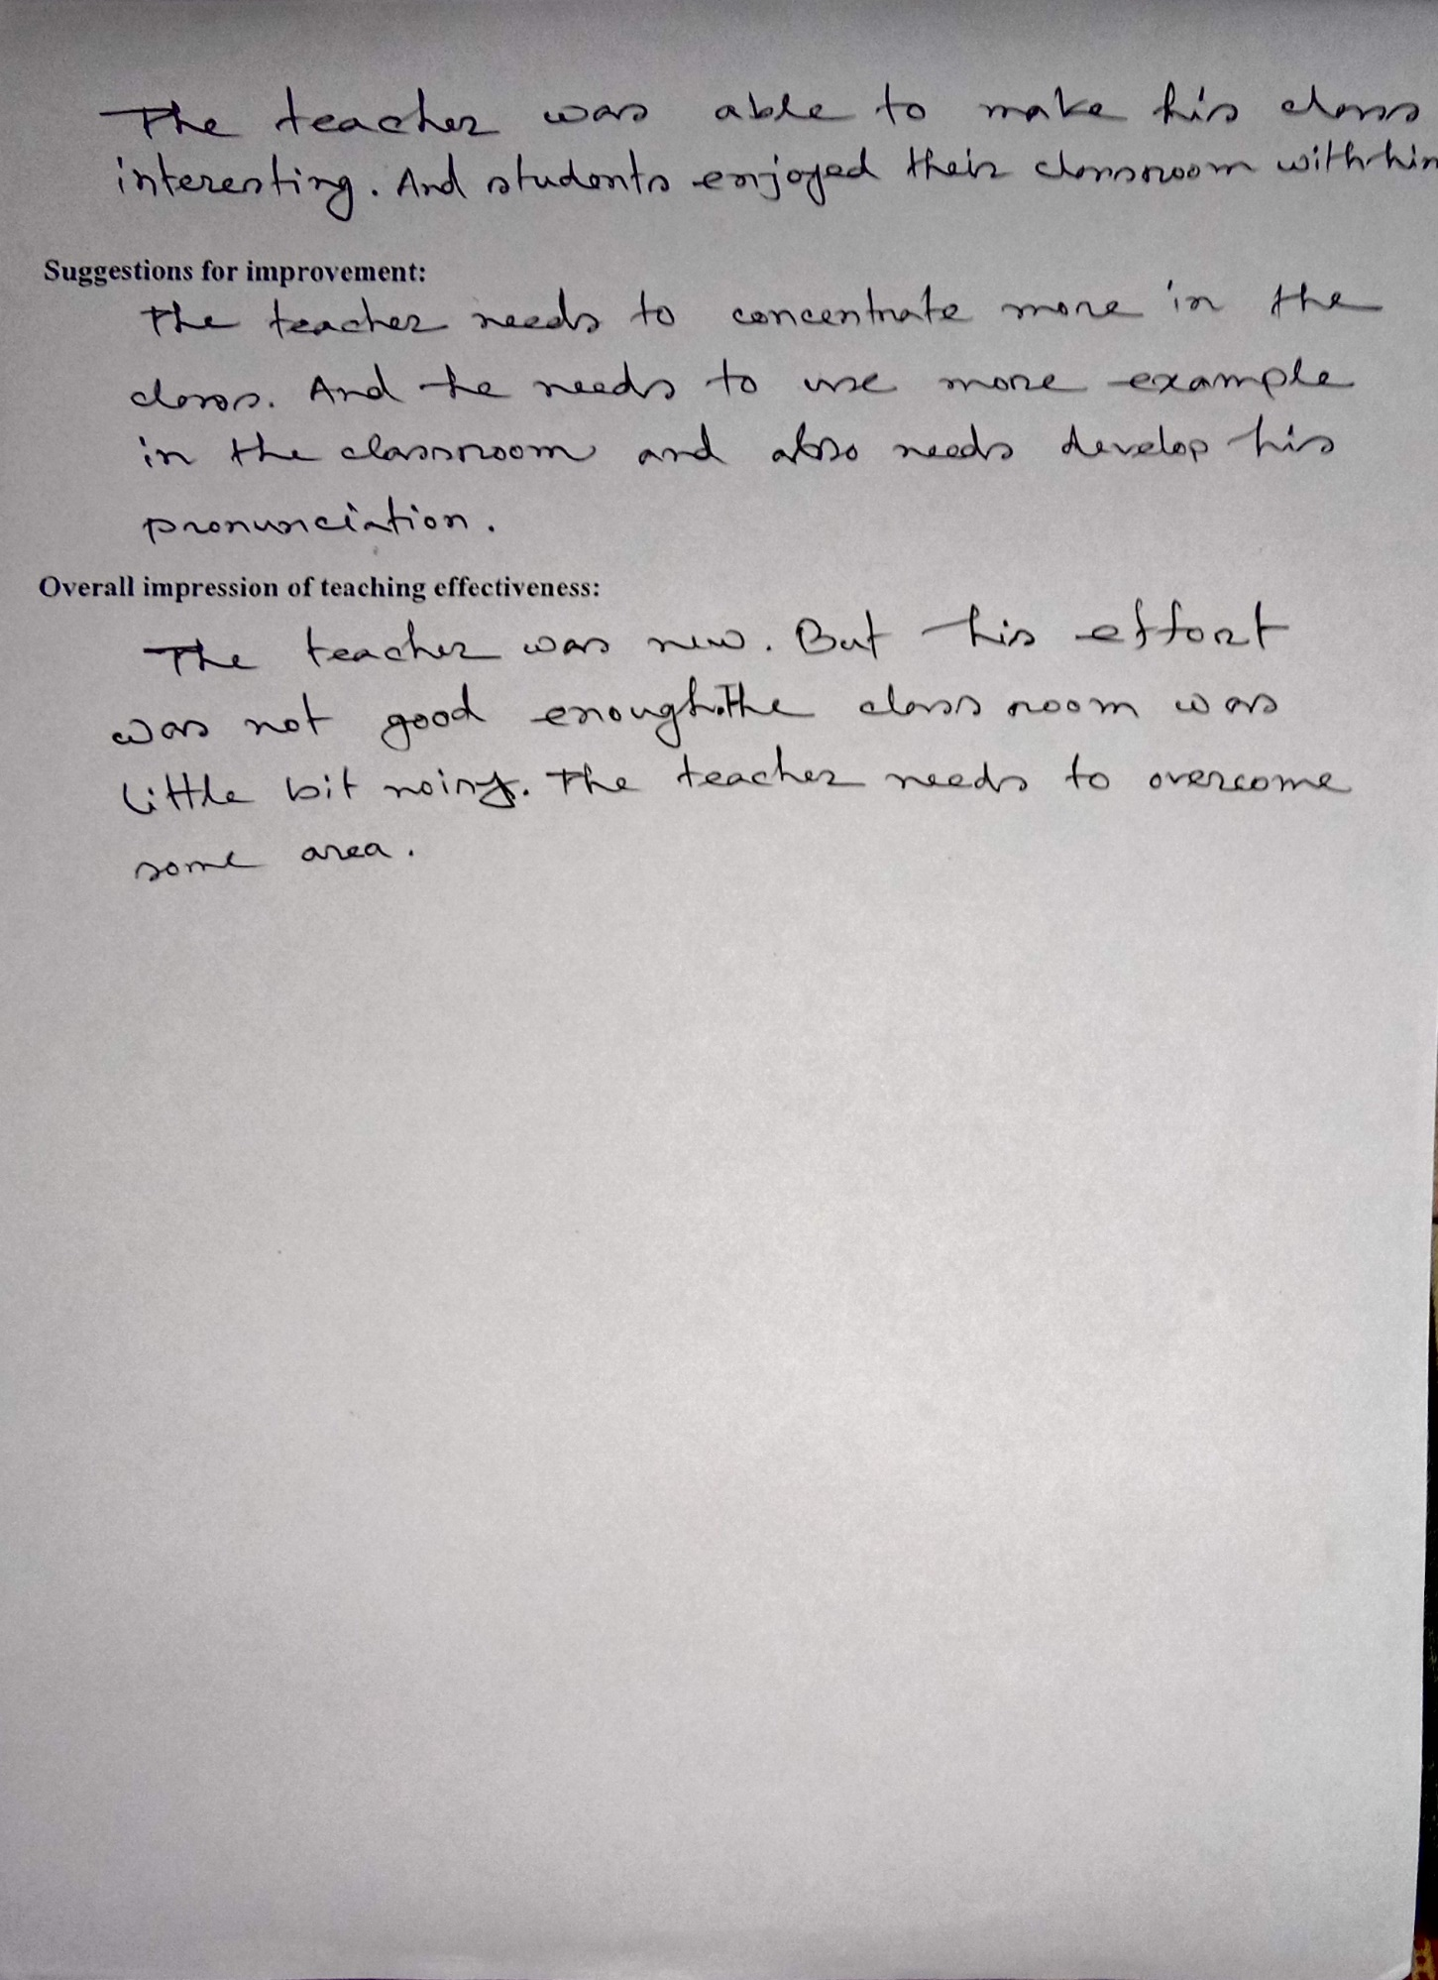
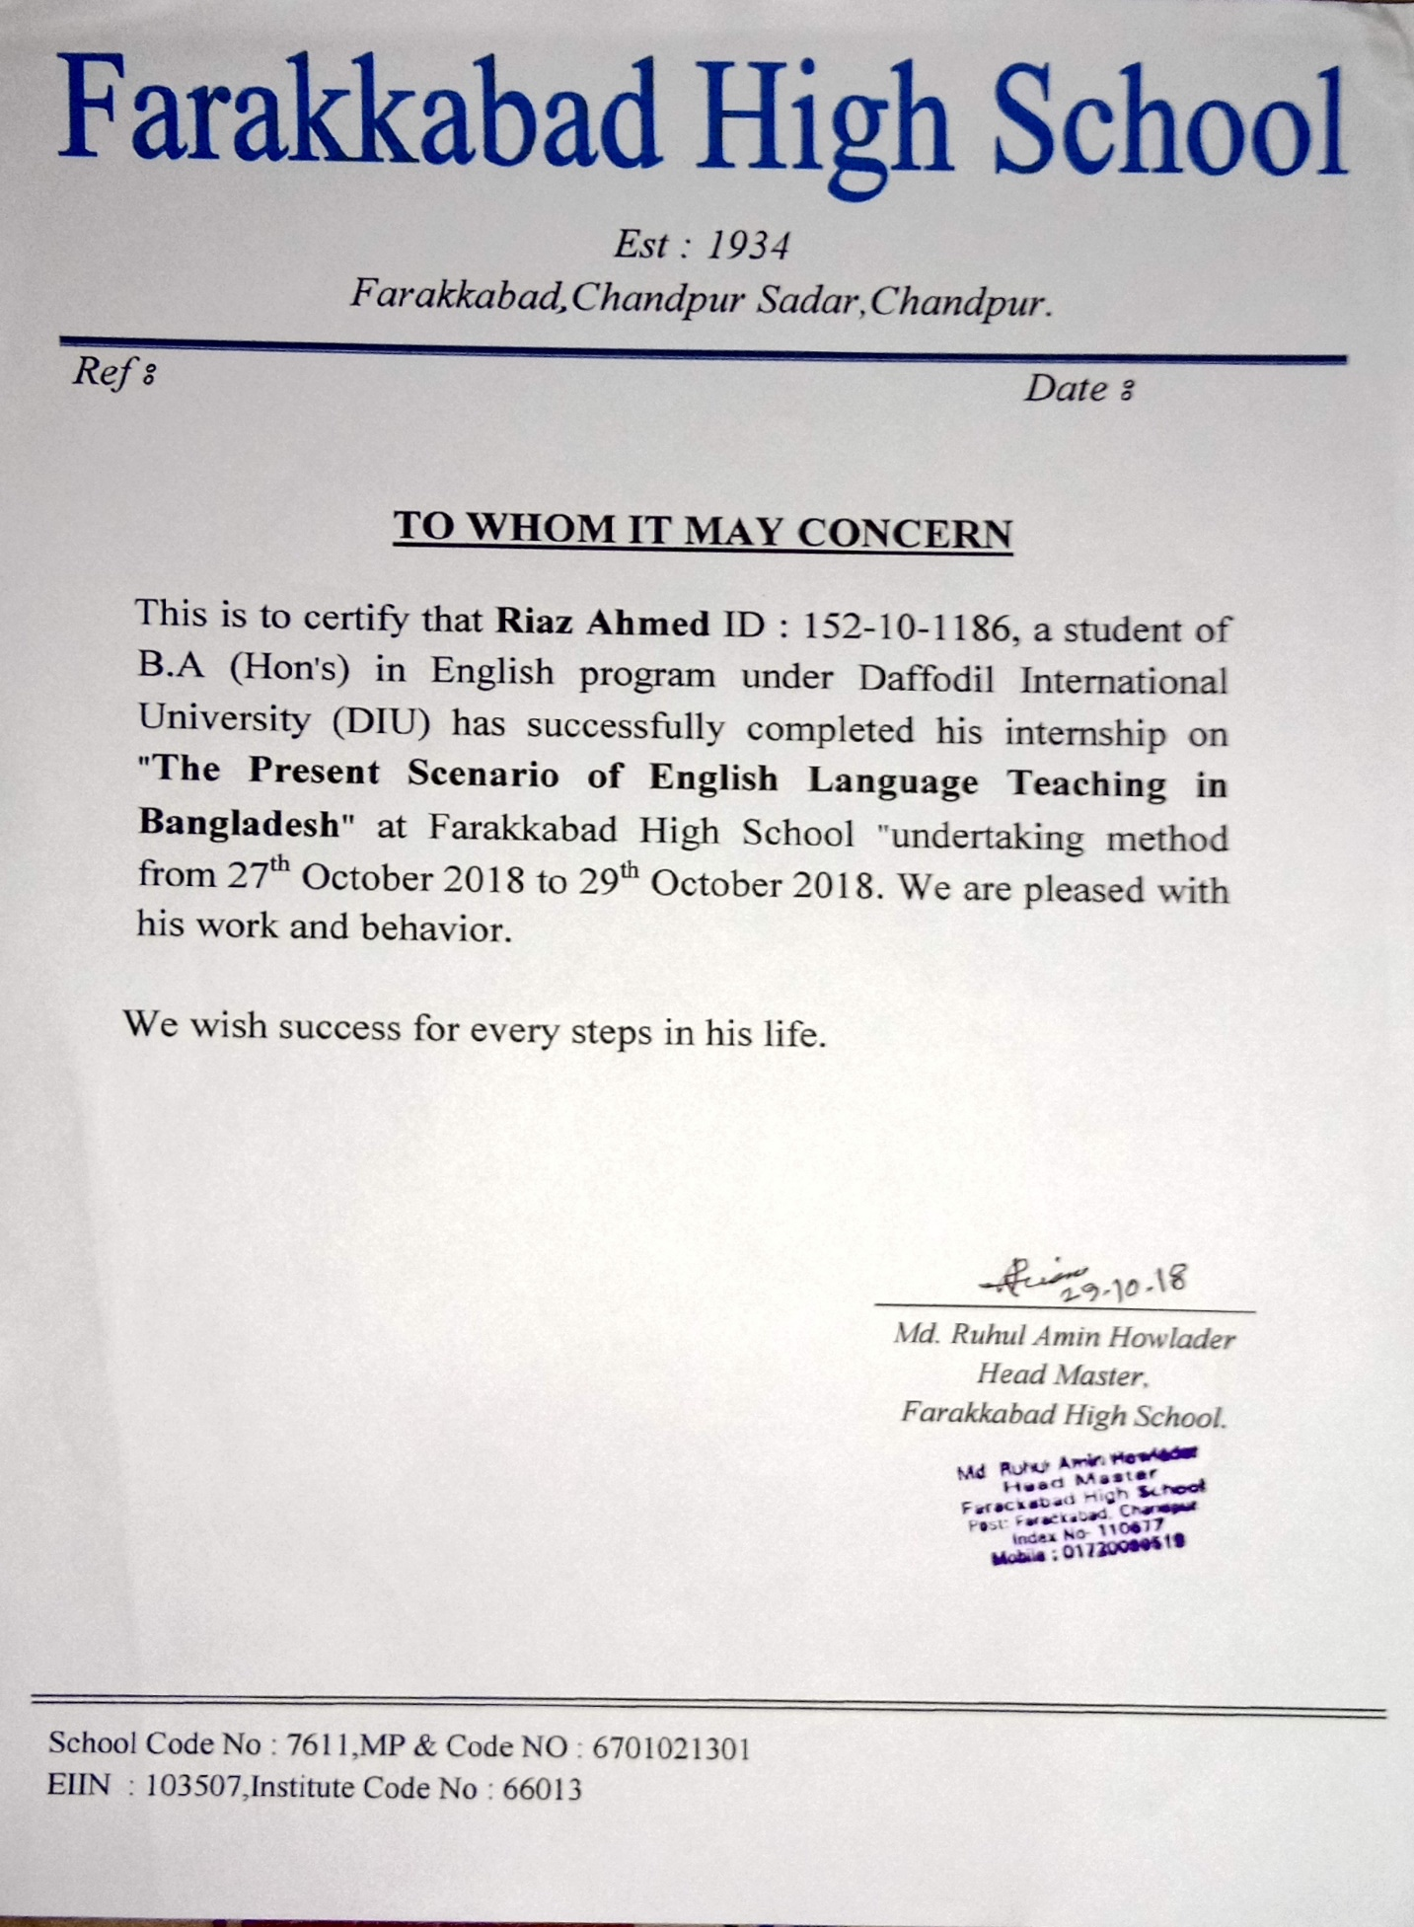
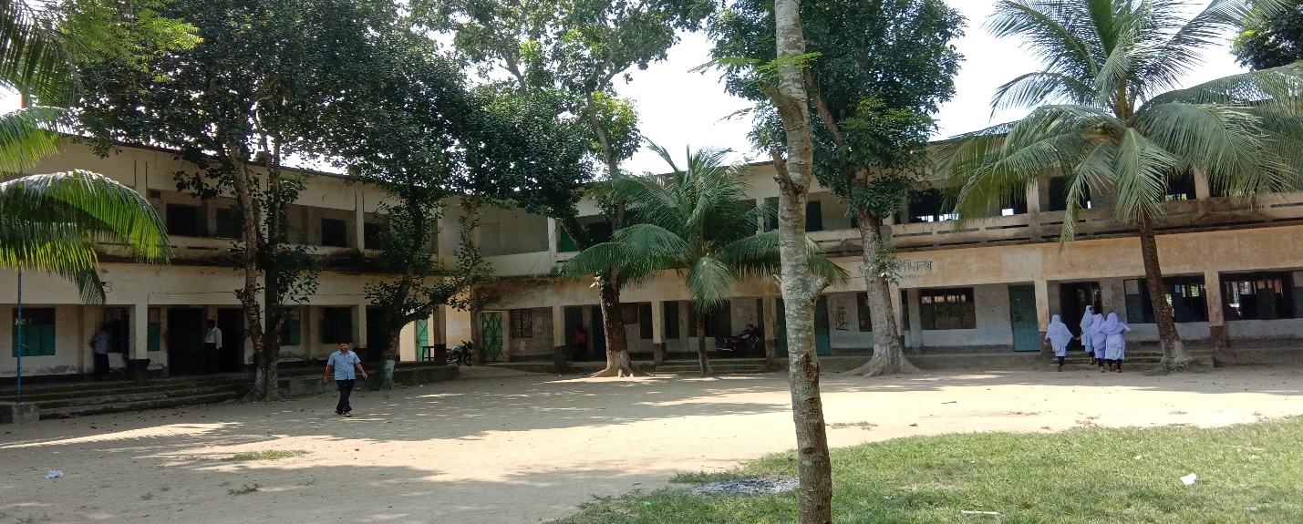
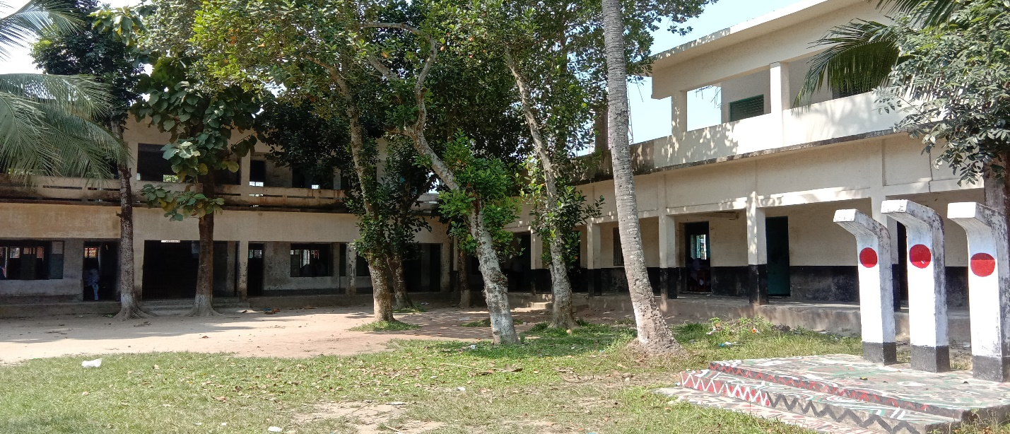
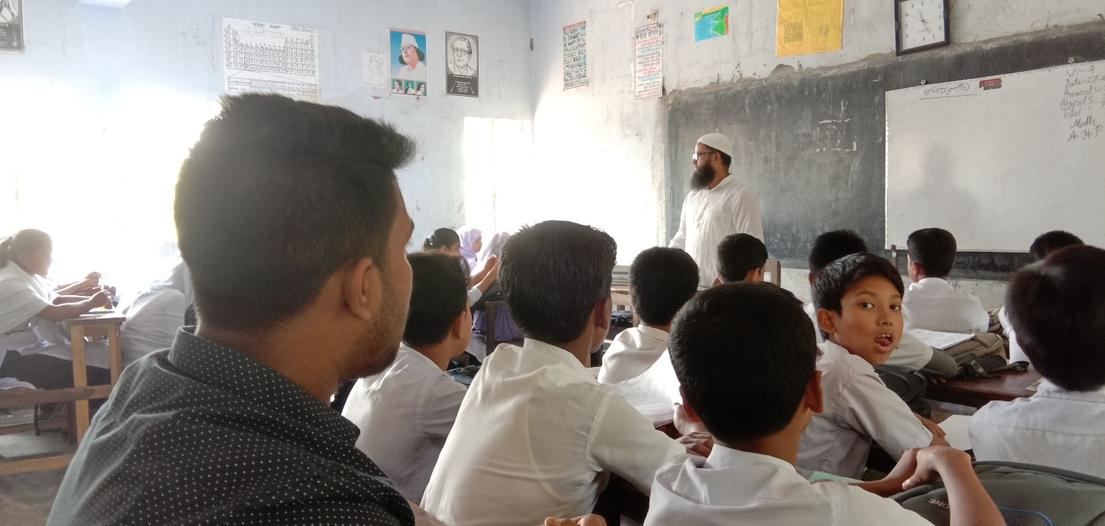I was observing the class VII which was taking by MD Mozammel haque.
