

“An Evaluation of the Students’ Satisfaction with the Services of Daffodil International University (DIU)”



“An Evaluation of the Students’ Satisfaction with the Services of Daffodil International University (DIU)”

Supervised To:
Mohammed Masum Iqbal, PhD
Professor & Dean
Faculty of Business & Entrepreneurship
Daffodil International University

Prepared By:
Md. Tarekol Islam
ID: 151-11-4321
Program: BBA
Department of Business Administration
Faculty of Business & Entrepreneurship
Daffodil International University

Submission Date:
November 28, 2018

Letter of Transmittal
November 28, 2018
Mohammed Masum Iqbal, PhD
Professor & Dean
Faculty of Business & Entrepreneurship
Daffodil International University

Subject: Letter of Transmittal.
Dear Sir,
With the honor, I would like to inform you that I have completed my internship report on “An Evaluation of the Students’ Satisfaction with the Services of Daffodil International University (DIU)”. I have tried my best to focus on how DIU different activities mostly focuses on marketing though Students complying with the tools of managing activities including evaluation of the performance. I also tried to prepare this internship report for consistency with the optimal standard under your valuable direction.
I express my gratitude to you for your kind supervision and I hope that you will consider all my mistakes generously.

________________
Md. Tarekol Islam
ID: 151-11-4321
BBA Program 40th Batch
Department of Business Administration
Faculty of Business & Entrepreneurship
Daffodil International University

Student’s Declaration

I do hereby solemnly declare that the work present in the internship named “An Evaluation of the Students’ Satisfaction with the Services of Daffodil International University (DIU)”has been carried out by me and has not been previously submitted to any university/college/ organization for an academic qualification / certificate / degree.
The work i have presented does not breach any existing copyrighting and no portion of this report is copied from any work earlier for a degree or otherwise.

Signature

…………………...
Md. Tarekol Islam
ID: 151-11-4321
BBA Program 40th Batch
Department of Business Administration
Daffodil INternational University (DIU)

The Letter of Acceptance

This is to certify that Md. Tarekol Islam, ID: 151-11-4321, Program: BBA, Major in Marketing, is regular student of Bachelor of Business Administration, Daffodil International University (DIU). He has successfully completed his internship program at Daffodil International University (DIU) and has prepared his internship report under my direct supervision. His topic is “An Evaluation of the Students’ Satisfaction with the Services of Daffodil International University (DIU)”.

This report is recommended for submission.

I wish his every success in life.

…………………………………
Mohammed Masum Iqbal, PhD
Professor & Dean
Faculty of Business & Entrepreneurship
Daffodil International University (DIU)

v

Acknowledgment
At the very beginning, I would like to express my deepest gratitude to Almighty Allah for giving me this kind and the composure to complete the internship report, words actually will never be enough to express how grateful I am, but never the less I shall try my level best to express my gratefulness the word some people.

It's a pleasure to convey my heartiest gratitude and greeting to my honorable supervisor Mohammed Masum Iqbal, Ph.D., professor and Dean, Department of Business Administration, Faculty of Business & Entrepreneurship, Daffodil International University. I deeply appreciate his cooperation, advice, and guidance in preparing this report.
I would like to express my heart in thanks to Daffodil International University (DIU). for allowing me to complete my internship. By extending, my heartiest thanks to those Daffodil International University (DIU) officials who gave their heartiest cooperation to complete my Internship Report. I am grateful to of the people mentioned above for their cooperation in every step to prepare my report successfully.

Table of Contents
SL No. | TITLE | Page
 | Title fly  Inner Cover  Letter of Transmittal  Student’s Declaration  The Letter of Acceptance  Acknowledgment  Table of Contents | i-vi
 | Chapter: 01 (Introduction) | 1
1.1 | Introduction | 2
1.2 | Origin of the Study | 2
1.3 | Objectives of the Study | 3
1.4 | Methodology of the Study | 3
 | Chapter: 02 Organizational Part | 4
2.1 | DIU | 7
2.2 | DIU Campuses | 8
2.3 | Goals of DIU | 8
2.4 | Mission of DIU | 9
2.5 | Vision of DIU | 9
2.6 | Teaching Method and Medium | 9
2.7 | Virtual University | 9
2.8 | Extra-Curricular Activities | 9
2.9 | Career Development Center | 10
2.10 | Board of Trustees (BoT) of DIU | 11
2.11 | Management of DIU | 12
2.12 | Membership of Other International Organizations | 13
2.13 | Other Activities | 14-16
 | Chapter: 03 Faculties and Departments | 17
3.1 | Faculties and Departments | 18
3.1.1 | Faculty of Science & Information Technology | “
3.1.2 | Faculty of Business & Entrepreneurship | “
3.1.3 | Faculty of Engineering | “
3.1.4 | Faculty of Applied Health Science | “
3.1.5 | Faculty of Humanities & Social Science | “
 | Chapter: 04 Learning Part | 19
4.1 | Department of Business Administration | 20
4.2 | Mission, Vision, Core values of Business Administration Department | 21
4.3 | Coordination Office of the Department of Business Administration | 22
4.4 | Academic Programs | 22-23
4.5 | Workshop/Event/ Programs | 24
4.6 | Deans & Heads of The Department | 24-26
4.7 | Admission criteria for the students of any Department | 26
4.8 | Teacher and Student Relationship | 27
4.9 | Duties and Responsibilities | 27-29
4.10 | DIU Services | 29-30
4.11 | Career Counselling | 30
4.12 | Exam Committee | 31
4.13 | Quality of Education | 32
4.14 | Industry Linkage | 32-33
 | Chapter-5 Research on Daffodil International University about Student feedback | 34
5.1 | SWOT Analysis | 35-36
5.2 | Research | 36-40
 | Chapter: 06 Findings, Recommendations and  Conclusion | 41
6.1 | Findings | 42
6.2 | Recommendations | 43
6.3 | Conclusion | 44
 | Reference & Websites | 45

Chapter - 1

Introduction

1.1. Introduction:
Daffodil International University (DIU) is recognized in independent government assessments as one of top graded universities in Bangladesh. The university has been founded by Daffodil Group with the approval of the Ministry of Education under the Private University Act of 1992 and its amendment in 1998 and Daffodil International University came into being on 24th January 2002, the University today combines impressive modern facilities and a dynamic approach to teaching and research with its proud heritage of service and achievement.
Features of the setup vision and mission are striving for excellence, integrity and innovation in every aspect of activity; a strong collaborative approach; open and effective communications and an inclusive culture based on dignity, courtesy and respect.
Daffodil International University one of the university of top Ten ranked Private university of Bangladesh (Ref: https://www.4icu.org/bd/private/&https://www.ontaheen.com/top-private-university-ranking-bangladesh/ )
DIU has three campus in Dhaka City. Daffodil Has a largest Green Campus (Permanent Campus) at Ashulia in Private University of Bangladesh.
Daffodil International University have international linkage with all around the world as much 270+ renowned Universities. (Ref: https://daffodilvarsity.edu.bd/international-linkage/ ). DIU arranging exchange program with those university like UniMAp, Summer Program, Course Exchange, Cultural Program and many other international activities.

1.2 Origin of the Study
Each professional degree needs practical knowledge of the respective field of discipline to be fruitful. The report entitled “An Evaluation of the Activities of the Daffodil International University (DIU) originated from the requirement of partial fulfilment of the internship program. The main purpose of the preparation of the report is the partial fulfilment of the internship program. During the internship program, my supervisor was,Dr. Mohammed Masum Iqbal, Professor &Dean, Faculty of Business & Entrepreneurship, Daffodil International University (DIU) and I followed his guidance.

1.3 Objectives of the Study
The study has been carried out with the following objective:
- To identify the services provided by different departments of DIU;
- To measure students’ satisfaction with the services offered by different departments of DIU;
- To identify problems that cause students’ dissatisfaction if any;
- To make some recommendations to solve the problems;

1.4 Methodology of the Study
Research design: The research has been conducted based on exploratory research method.
Data source: About information collection I use two sources. That is:
1. Primary source
2. Secondary source

Primary sources:
- I tried to gather information from the accounts executive and personnel.
- I studied different files and reports and try to get some idea about their working procedure.
- I tried to be intimate with the officers and informally I got some extra information.
Secondary sources: In secondary source: -
- I tried to get information from relevant text books.
- From the website of Daffodil International University.
- Published materials: i.e. (Previous Reports of University).
- Annual reports of Daffodil International University.

Chapter -2
Organizational Part



N:B: Planned Design

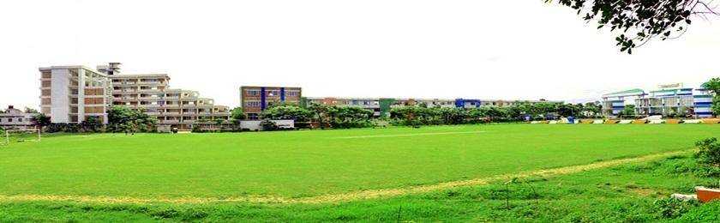

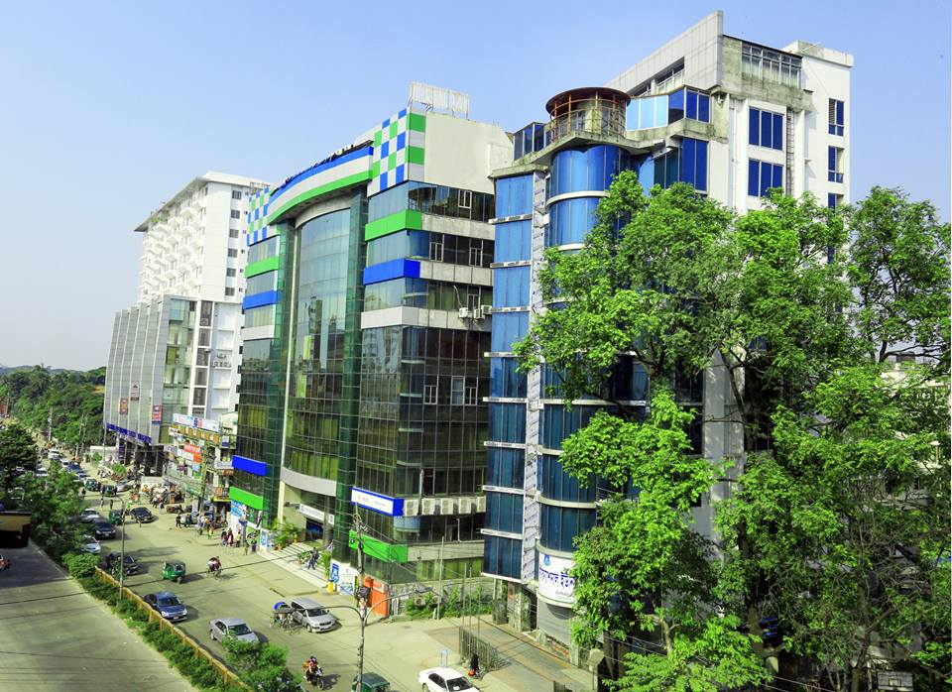

2.1 Daffodil International University (DIU)
Daffodil International University (DIU) is recognized in independent government assessments as most top graded university in Bangladesh, Daffodil International University (DIU) is recognized in independent government assessments as one of top graded universities in Bangladesh. The university has been founded by Daffodil Group with the approval of the Ministry of Education under the Private University Act of 1992 and its amendment in 1998 and Daffodil International University came into being on 24th January 2002, the University today combines impressive modern facilities and a dynamic approach to teaching and research with its proud heritage of service and achievement.
Features of the setup vision and mission are striving for excellence, integrity and innovation in every aspect of activity; a strong collaborative approach; open and effective communications and an inclusive culture based on dignity, courtesy and respect.
Daffodil International University's mission is defined by its IT-based traditions of service and access. The University is serving the citizens of the country through its instructions, research, and outreach programs and preparing Bangladesh to respond successfully to the challenges of global economy. The University has proved that it provides students broad access to the institution's educational resources.
The University provides Masters Programs in the areas of need and importance to the State and beyond. Graduate programs offer students opportunities for specialized advanced education in their chosen field and are important components of the services of the university.
This is a noticeable encouragement for the university observing the rapid growth of the university. The university has been started with 67 students registering in the first batch and more than 15,000 students have been enrolled till date. DIU is committed to provide standard education with all sorts of facilities to the students. Since the inception, the university is maintaining the commitment and it creates inspiration to the students and this is the key of the continuous increasing of the number of students.
Daffodil International University (DIU) Achieved world’s best Ranking category “QS University Rankings 2019”. DIU is one of the Top 500 universities in Asia.

2.2 DIU Campuses

Main Campus:102, Shukrabad, Dhanmondi, Dhaka-1207 4/2, Shobhanbag, Daffodil Tower-05, Dhanmondi, Dhaka-1207

Uttara Campus:House: 04, Road: 07, Daffodil Tower-06, Uttara Model Town, Sector: 03, Uttara, Dhaka-1230

Permanent Campus:Daffodil International University, Chou Baria, Datta Para, Ashulia Model Town, Savar, Dhaka.

2.3 Goals of DIU

- Establishing a Joint Venture University in Bangladesh with USA, Australia & UK.

- Developing the degrees of the university up to (GSE) level through getting accreditation of internationally recognized accreditation bodies like ACBSP, AACSB.

- Providing quality education for the development of human resource with the competency of the contemporary market.

- Conducting and supporting research for advancement of socio-economic development of the country through the use of technology oriented knowledge.

- Contribution in the moral and ethical development of the common people.

- Creating congenial academic environment for the youth which will be free from political and other disturbances for their intellectual advancement.

- Disseminating knowledge under the coverage of ethical, human and rational approach reflecting national heritage, values and principles of Bangladesh with a view to producing graduates.

- Creating opportunities to have education for all groups of people through the campus, online and distance learning education.

● Developing students to meet the demand for efficient marketing executives and IT personnel in Bangladesh.

2.4 Mission of DIU

The mission is to excel in providing higher education in Bangladesh to the context of the twenty-first century and to become a top ranked university in the region of South Asian. Establishing a center of excellence to attract students from all countries of the region.

2.5 Vision of DIU

Daffodil International University established with the commitment of services to all as the country becomes a part of a global society with the challenges and opportunities and it assure the quality of its programs though the supervision of its resources in the areas of institutional strengths. At DIU one constant will remain unchanged that intangible quality of Daffodil men and women call the ‘Daffodil Spirit’. That’s why students called it, “A Distinguished Land Mark in Higher Education”.

2.6 Teaching Method and Medium

Modern teaching methods including call lectures, interactive discussion, simulation, lab work, case analysis, add field study are followed by the University. A special feature of DIU is the Tutorial/workshop/lab sessions designed to assist students in learning application of concepts and theories. The medium of instruction in Daffodil International University is English.

2.7 Virtual University

Among all the private universities Daffodil International University is going to develop the fastest and most user-friendly virtual university with the aim to serve students the most prompt academic and administrative activities. A test version of virtual university is running over internally by ‘briteworks’.

- Extra-Curricular Activities

DIU is the collection of various clubs with various social & development activities. More than 32 clubs are working for the educational & cultural development. Most of them are:

- English Club
- Cultural Club
- Sports Club
- DIU Photographic Society
- DIU Social Business Students’ Forum (SBSF)
- DIU Prothom- aloBondhuShova
- Nature Study Club (NSC) of DIU
- Health Club (HC) of DIU
- Daffodil Communication Club
- DIU Pharmacia Club
- DIU Creative Park (Dept. of MTCA)
- DIU MUNA (Model United Nations Association)
- Career Club
- Entrepreneurship Club
- School of Entrepreneurs
- Business & Education Club
- Real Estate Association
- DIU Software Engineering Club (SEC)
- DIU Volunteer Service Club
- Air Rover Wing
- Robotics Club
- All Stars Daffodil
- Adventure Club
- DIU Film Society
- Business Round Up & Motivational Cell (BRMC)
- Change Together

2.9 Career Development Center

It's a grooming centre from DIU. Students join to change their life and for living positively. It works for the career development of DIU graduates in nationally and international.

Activities:

- Career Counselling with the existing students & graduates.
- Strong Industry Linkage
- Arranging training programs, workshops, seminar, symposium and fair for the professional development of the existing students and graduates.
- Taking necessary steps regarding student’s participation in different national and international competition and programs and events.
- Communicating with Industries and send student’s CV regarding recruitment as internship.
- Sending request letter too many institutions and organizations regarding job placement and internship placement.
- Monitoring the entire students and their activities.
- Preparing necessary plan and projects regarding professional relationship between industry and University.
- Communication with most valuable & Industrial Successful person.

2.10 Board of Trustees (BoT) of DIU

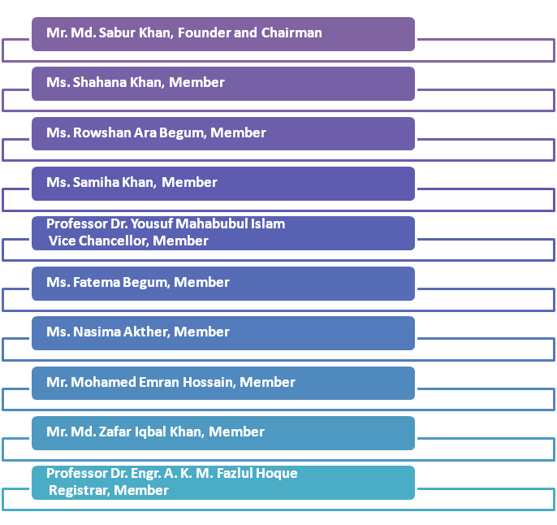

2.11 Management of DIU

Name | Position
Mr. Md. Sabur Khan | Founder & Chairman
Mr. Md. Abdul Hamid | Hon’ble President of the People’s Republic of Bangladesh  and  Hon’ble Chancellor, Daffodil International University
Professor Dr. YousufMahbubul Islam | Vice Chancellor
Professor Dr. S.M. Mahbub Ul Haque Majumder | Pro-Vice Chancellor
Mr. HamidulHaque Khan | Treasurer
Professor Dr. Engr. A. K. M. FazlulHoque | Registrar
Professor Dr. Md. GolamMowlaChoudhury | Controller of Examinations

2.12 Membership of Other International Organizations



Corporate Linkages

We have corporate linkages with most of the leading institutions of Bangladesh. Here’s the link-http://bba.daffodilvarsity.edu.bd/index.php/about-bba/industrial-linkage

International Linkages

We have collaboration with more than 150 universities from over 40 countries such as USA, UK, Germany, France, Spain, Turkey, Thailand, Sweden, Switzerland, Sri Lanka, Poland, Philippines, Romania, Russia, New Zealand, Malaysia, South Korea, China, Japan, Ireland, Indonesia, India, Cambodia, Australia, and Austria.

List of Partner Universities of Daffodil International University:
Link:https://daffodilvarsity.edu.bd/international-linkage/

2.13 Other Activities

Daffodil Business Incubator: A Hub of Generating Young Entrepreneurs

Daffodil International University is the first in Bangladesh to have a business incubator jointly with Bangladesh Venture Capital Ltd. With a view to creating new entrepreneurs, Daffodil Business Incubator (DBI) has initiated its journey in September, 2012 and is implemented in May, 2014 through rigorous entrepreneurial guidance and evaluation process under Daffodil International University. It imparts different types of entrepreneurial initiatives, business skills development training and workshops to the students aspiring to be entrepreneurs. It has already achieved the trust and reputation for the quality, standard and success of its students. The objective of DBI is to develop a supplemental business process that fosters a strong sense of self-worth, self-confidence, and self-reliance, reduces unemployment problem and creates job opportunities.

Startup Market

The ‘Daffodil Startup Market’ is a student-run bazaar, hosted by the Daffodil International University (DIU) and operated by Office of the Director of Students’ Affairs (DSA Office).
The concept of ‘Daffodil Startup Market’ is being initiated to promote entrepreneurial potentials of students and create more buzz in university life. It is a platform for students to run small businesses and learn from those experiences.

DIU Alumni Association

The Daffodil International University Alumni Association works to bring all the graduates under one community. This network of graduates acts as a strong platform to uphold and share the noble objective to foster the professional and intellectual growth of DIU graduates. This Association establishes Unity, Compassion and Brotherhood among the graduates in a ground full of assistance and cooperation.

Transport

DIU has a large transport pool, which is used by students, faculty members, and officials. Students, faculty members, and employees can move from different distant areas to their respective campuses through this transport facility. Students can use transport facilities for industry tour, study tour, and annual picnic etc.

Accommodation

DIU has arranged a spacious, secured and nearby residence for male & female students, where students reside in comfort, intensive care and in the lap of a study environment. The serene atmosphere of these accommodation is provided upon requirements of the students.
- Male Hostels of Daffodil Internatioanal University
- Md. Younus Khan Scholars Garden, Permanent Campus, Ashulia
- Prof. Aminul Islam Hall -1, 5/3 Shobahanbag, Dhanmondi, Dhaka
- Prof. Aminul Islam Hall -2, 51/A West Razabazar, Dhanmondi, Dhaka

- Female Hostel of Daffodil Internatioanal University
- Begum Rokeya Female Hostel, 25/13, Tallahbag, Sukrabad, Dhaka
- Uttara Female Hostel, Uttara, Dhaka
- Female Hostel, Permanent Campus Ashulia

One Student One Laptop

We are living in a world of information technology where education is increasingly being dependent on the use of computer and internet. It has now been a prime responsibility of the university to equip its students with proper technical knowledge so that they can survive and secure respectable place in society.
Considering the present situation, DIU is distributing laptops among students to use on personal basis and thus help them to face the challenges of a globalized world.

Students’ Affairs

Office of the Director of Students’ Affairs is a professional body who are dedicated to the social, psychological, ethical and cognitive development and well-being of all DIU students. It also works collaboratively with respected faculty members to implement the university’s educational and developmental mission. In addition to it, the Office of the DSA looks after all club activities, foundation classes, orientation of newly admitted students and so on. It also organizes trainings on positive behavioral changes, national-international collaboration programs, award programs, and deans’ lecture series and coordinates the basic course named ‘Art of Living’.

Chapter-3

Faculties and Departments

3.1 Faculties and Departments

Bachelors, masters and doctoral degrees offered by DIU through its 23 departments; these departments are divided under Five (5) Faculties:

Faculty of Science & Information Technology
- Computer Science and Engineering Department
- Environmental Science and Disaster Management Department

- Software Engineering Department
- Multimedia and Creative Technology Department

- Natural Sciences Department

Faculty of Business & Entrepreneurship
- Business Administration Department
- Department of Commerce

- Real Estate Department
- Tourism & Hospitality Management Department
- Entrepreneurship Development Department

Faculty of Engineering
- Electronics and Telecommunication Engineering Department
- Textile Engineering Department
- Electrical and Electronic Engineering Department

- Architecture Department
- Civil Engineering Department

Faculty of Applied Health Science
- Pharmacy Department
- Nutrition and Food Engineering Department

- Public Health Department
- Life Science Department
- Genetic and Biotechnology Department

Faculty of Humanities & Social Science
- English Department
- Law Department

- Journalism & Mass Communication Department
- Development Studies Department (Master’s Program)

Chapter-4

Learning Part

4.1 Department of Business Administration

DIU established a unique department named; The Department of Business Administration under the faculty of Business & Entrepreneurship. The Department of Business Administration is one of the largest departments at DIU with more than 3000 students currently studying for BBA and MBA degrees. In BBA and MBA programs, a student can do major in a wide range of fields such as Finance, Marketing, Human Resource Management (HRM), Management Information System (MIS), Accounting, Banking, Textile and Apparel Management and Merchandising and so on.
One of the special features of the Department is that it has a blend of well-experienced teachers with foreign exposure and a galaxy of young, energetic faculty members, quite a good number of nationally and globally renowned teachers of University of Dhaka, Bangladesh University of Engineering and Technology (BUET) and Jahangirnagar University, all of whom are passionately dedicated to teach the students of Business Administration at DIU. In addition, quite a handful of legendary corporate personalities are also teaching DIU students and helping them gather practical knowledge about the corporate world.
To keep pace with ever-changing global needs, the Department has also introduced a blend of state-of-the-art courses in different areas such as financial derivatives, corporate law and secretarial practices, securities analysis and portfolio management, leasing and investment, e-marketing, brand management, CRM, rural marketing, AIS, accounting ethics and professionalism, conflict management and so on. At DIU, each student has to do an internship and/or term paper, prepare assignments, and participate in presentations; hence, each and every student grows with practical knowledge that enables him/her to compete with other graduates both nationally and internationally.
After completing the coursework, BBA students go for internship with the leading Reputed companies, Bank and Financial institutions and other corporate houses of the country. All the alumni of this department are employed successfully due to the increasing demand of Real Estate graduates. Our alumni are working and holding prestigious positions of different organizations like- teacher at university, government organization, bank etc. Some of our alumni have become successful entrepreneurs also. Internal Quality Assurance Cell (InQAC) is continuously working to ensure the quality of education at DIU. BBA Graduates have ample opportunity in the following sectors –

- Govt. / Private Banks
- City Corporation
- Entrepreneur
- Ministry of Housing and Public Works
- Bangladesh Civil Service (BCS) Jobs
- Insurance Companies
- Mega projects
- Oil Companies (Land & Offshore)
- Multinational Companies
- Consultancy Firms (Building & Construction)
- And Many Other Related Organizations

4.2 Mission, Vision, Core values of Business Administration Department.

Vision Statement
Department of Business Administration (DBA) aspires to be the center of excellence in the field of business education by focusing on entrepreneurial mindset. We desire to be an internationally renowned educational center nurturing committed entrepreneurial leader’s sensitive to the sustainable future.

Mission Statement
The mission of the Department of Business Administration (DBA) is to develop responsive business leaders who can create economic and social value by discovering, imparting and applying the knowledge of business.

Value Statement
1. Academic Excellence
2. 100% Job Placement
3. Ethical Conduct
4. Practices of Good Governance
5. Development real world knowledge
6. Teamwork
7. Academic Freedom
8. Respect for the dignity of others
9. Research & Innovation
10. Integrity & Honesty
11. Mentorship
12. Collaboration & Trust
13. Skill & Confidence Development

4.3 Coordination Office of the Department of Business Administration

Coordinator | Department | Program | Contact
Mr. Zakir Hossain  Coordination Officer | Department of  Business Administration | BBA | Daffodil International University (DIU)  4/2, Shobhanbag, 7th floor-DT, Mirpur road, Dhanmondi, Dhaka-1207  Web: https://www.daffodilvarsity.edu.bd/  Cell: +8801847140028 (Ext. 302)  E-Mail: zakir.bbaoffice@daffodilvarsity.edu.bd

4.4 Academic Programs

The Department of Business Administration under the Faculty of Business and Entrepreneurship (FBE) is offering the following programs.

The program consists of 12 (twelve) semesters with 126 (one hundred and twenty-six) credits spread over 04 (four) academic years (levels) and 41 (forty-one) courses with one semester internship; 42 (forty-two) in total.

- Bachelor of Business Administration (BBA).
- Masters of Business Administration (MBA), Regular & Executive

Bachelor of Business Administration (BBA)

A student can do BBA majoring in different areas as mentioned below:
- Major in Finance
- Major in Marketing
- Major in Accounting
- Major in Human Resource Management
- Major in Management Information Systems
- Major in Banking and Insurance
- Major in Supply Chain Management
- Major in Entrepreneurship

Masters of Business Administration (MBA), Regular & Executive

A student can do MBA majoring in different areas as mentioned below:

1.Finance | 2. Marketing
3. Human Resource Management (HRM) | 4. Management Information System (MIS)
5. Real Estate | 6. Textile & Apparel Management & Merchandising
7. Accounting | 8. Banking
9. International Business | 10. Islamic Finance
11. Insurance | 12. Entrepreneurship
13. Project Management | 14. Engineering Management
15. Supply Chain Management | 16. Tourism and Hospitality Management
17. Digital Marketing

NB: Star-marked program has been sent to UGC for approval after due recommendations from Path cram Committee (Syllabus Committee) of the Department.

4.5 Workshop/Event/ Programs

The following workshop/seminars were organized by the Department of Business Administration on (2018):

- DIU Marketing Club organized a unique Personal Branding Competition titled “Mr. & Miss Marketing 2018” for the students of Daffodil International University on February 13, 2018 at 71 Milonayoton, DIU
- ‘Medisure’ a team of Bangladesh from the Department of Business Administration of Daffodil International University (DIU) became 2nd Runner-up of Global Final of Social Business Creation Competition 2018 held on September 18, 2018 in HEC MontrealCanada.
- 3 day ‘Mr. Mango Candy-DIU Marketing Fest-2018’ began today on 22 July 2018 at 71 Milonayoton of Daffodil International University. Department of Business Administration and DIU Marketing Club of Daffodil International University jointly organized the program
- Institutional Quality Assurance Cell of Department of Business Administration, DIU organized a workshop on Development of Course Curricula on February 28, 2018 at the Digital Classroom, Daffodil Tower

4.6 Deans & Heads of The Department

Name | Designation | Faculty
Dr. Mohammed Masum Iqbal | Professor & Dean | Faculty of Business & Entrepreneurship
Prof. Dr. S.M. Mahbub Ul Haque Majumder | Dean | Faculty of Science and Information Technology
Professor Dr. M. ShamsulAlam | Dean | Faculty of Engineering
Professor Dr. Ahmad Ismail Mustafa | Dean | Faculty of Allied Health Science
Professor A. M.M. HamidurRahman | Professor & Dean | Faculty of Humanities & Social Science
Professor Dr. Mostafa Kamal | Professor & Dean (Permanent Campus)

Name | Designation | Department
Mr. Gouranga Chandra Debnath | Head | Department of Business Administration
Md. Ali Imran | Head | Department of Business Studies
Mahbub Parvez | Head | Department of Tourism & Hospitality Management
Mohammad Shibli Shahriar | Head | Department of Innovation & Entrepreneurship
Prof. Dr. Syed Akhter Hossain, | Head | Department of Computer Science and Engineering
Md. TaslimArefin | Head | Department of Electronics and Telecommunication Engineering
Professor Md. KhairulEnam, | Head | Department of Architecture
Dr. Md. BellalHossain, | Head | Department of Nutrition and Food Engineering
Professor Dr. TouhidBhuiyan | Head | Department of Software Engineering
Dr. Shaikh Muhammad Allayear | Head | Department of Multimedia & Creative Technology (MCT)
Professor Dr. Md. Shahid Ullah | Head | Department of Electrical and Electronic Engineering
Nurul Mohammad Zayed | Head | Department of Real Estate
Mr. Syed MizanurRahman | Head | Department of General Educational Development
Dr. Miah. M. Hossainuzzaman, | Head | Department of Civil Engineering
Dr. Sharif Mohammad Shaheen | Head | Department of Pharmacy
Professor Dr. Harun-Ar-Rashid | Head | Department of Public Health
Dr. Md. MahbubulHaque | Head | Department of Textile Engineering
Md. FouadHossainSarker | Head | Department of Development Studies
Dr. A.B.M. Kamal Pasha, | Head | Department of Environmental Science and Disaster Management
Md. RakibulHasan Khan | Head In-Charge | Department of English
Md. Riaduzzaman |  | Department of Law
Mr. Sheikh Mohammad Shafiul Islam | Head In-Charge | Department of Journalism & Mass Communication
Dr. Md. Milan Khan | Head | Department of Information Science and Library Management

4.7 Admission criteria for the students of any Department

The students who have total GPA 8.50 or more than 8.50 (SSC+HSC), they can take admission directly for BRE in the university but the student must come from business studies or science section. The students that bearing GPA below 8.50, they must have to sit for admission test. Not only this High GPA bearing students get waiver. The waiver list is given below.

GPA | WAIVER (%) | CGPA
 |  | (The students will have to
 |  | maintain in every semesters)
5.00 | 75% | 3.50
4.90 | 30% | 3.50
4.80 | 20% | 3.00
4.00 - 4.70 | 10% | 3.00
For All Female Students | 10% | 3.00

All female students will get 10% waiver for tuition fees but they must have to maintain her result CGPA 3.00 in every semester. If any male and female student cannot maintain the required result, he/she will not get the waiver facilities for next semester.

4.8 Teacher and Student Relationship

Effective teaching and learning varies on sound relationship between teachers and students. Both teachers and student’s contribution are needed in the process of learning. Best interaction among teachers, admin officers and students can ensure the success in quality education.

The job of the teachers of DIU is like a mother- to guide for the wellbeing of the students. A teacher is a guide to help the student reach the new place. A teacher must know the needs of the students and arrange the teaching materials accordingly. A teacher must create urge among the students to know the unknown. He must motivate them at different levels of the learning process. He must evaluate the performance of them and appraise them from time to time.

A good teacher with sound knowledge and rich personality can highly inspire the students, who may take him as role model and can work hard to be a person like him. A teacher not only teaches the lessons prescribed in the syllabus but also trains them many things required for practical life. He teaches them manner and behaviour, helps them develop their taste for good things and makes them fit for society. So a good attachment and understanding between a teacher and a student is a must.

4.9 Duties and Responsibilities

Teachers of Daffodil International University always try to follow their duties and responsibilities sincerely.

Works directly related to classroom teaching:
- Prepare lectures for classes
- Prepare syllabus for classes
- Prepare labs for classes
- Grade class assignments
- Presentation
- Prepare exams
- Give make-up exams
- Grading
- Calculating grades
- Meeting with students through ERP (Google Classroom & E-Learn)
- Integrating new learning into new way
- Developing new classes in alternative way
- Organizing field Visit
- Organizing Refreshment Tour

Other works related to teaching:
- Supervising and evaluating graduate student
- Evaluating teaching and sharing knowledge by peers ]
- Leading in practical field trips

Services to students:
- Advising during course Registration
- Counselling Students on career opportunities
- Writing recommendation letters for students seeking jobs and internship
- Writing recommendation letters for students to apply for anotheruniversity.
- Supervising for student research
- Helping graduate students for their research
- Reading and making suggestions to evaluate and improve graduate student’s thesis proposals
- Participating in graduate student’s defences

Research Activities:
- Writing proposals for the submission to funding agencies
- Ground-breaking verifiable and publishable scholarly research

- Monitoring and spending from grants obtained from funding agencies
- Maintaining laboratories for faculty members and student’s research

- Writing papers for publishing in academic journals
- Presenting research at academic meetings to promote the University

- Presenting themselves at other institutions of higher education
- Reading scholarly journals for new developments

Services to one's area of study:
- Editing academic journals

- Reviewing papers submitted to academic journals

- Reviewing proposals submitted to funding agencies
- Serving on committee of funding agencies

- Serving on committees and in elected sections of scholarly societies

Services to university:
- Participating in departmental meetings
- Serving on departmental committees

- Participating in departmental retreats
- Serving in departmental admin positions

- Participating in host faculty searches
- Serving in Faculty Senate

- Serving in University Academic Council
- Responding to requests from administrators

- Serving on university committee
- Participating in University convocation

- Participating in Commencement exercise

Services to the public:
- Responding to public queries in the areas of specialization

- Performing public services in the areas of specialization
- Giving public lectures

4.10 DIU Services:

Admission Office:

The Admission office of DIU providing service to students while students take admission in DIU. They facilitated with service to students & Parents to giving all admission information, tuitions fees, Subjects, all departments information & Facilities, Benefits for DIU admissions & linkage of internally & externally.

Office of the Registrar:

The office of the Registrar major area in the university to facilitating with service to students. Students gets all kind of information, problem-solution & other types of Supports from here. The office of the Registrar work on students Supports & Service.

Office of Directors’ of Students Affairs:

Office of the Director of Students’ Affairs is a professional body who are dedicated to the social, psychological, ethical and cognitive development and well-being of all DIU students. It also works collaboratively with respected faculty members to implement the university’s educational and developmental mission. It also organizes trainings on positive behavioral changes, national-international collaboration programs, award programs, and deans’ lecture series and coordinates the basic course named ‘Art of Living’, arranging individual counseling is one to one counseling process of a client and a trained psychologist, and another effective process of counseling that helps people to increase personal growth with group counseling

Accounts Section:

The Accounts section of DIU is the largest area for providing service to DIU Students & Parents. Here all of the employees are giving support to students politely. Students doing all kind of academic transection here & they collecting clearance from Accounts.

International Affairs:

DIU has biggest number of International students. The InternationalAffairs of DIU communicated with international linkage for admitting student here. Now DIU have lost of international linkage &many of students from Somalia, Nazarian, Philippians and Others. The International Affairs of DIU always working for give support and any kind of service providing to International Students of DIU.

Transport:

DIU transport facilitated with transport to Students, Faculties & Administration. DIU transport has around 50+ Bus & 20+ Cars. DIU students take facility from DIU transport to all campus as Permanent Campus, Main Campus & Uttara Campus of DIU.

Career Development Center (CDC):

Career Development Center (CDC), it has regularly undertaken the following activities as key components of its mission& facilitated with service to DIU students on Counseling for career planning, conducting training on career related topics, Job placements, Internship placements, Industry visits for career development, Arranging the Industry Academia Lecture Series, arranginginterview sessions, organizing international conferences, seminars, summer programs, Job searching for creating opportunities for DIU Graduates through networking, etc.,

4.11 Career Counselling

It is a process which helps to students understand themselves and to the world of work to make career. Career development is not only deciding but also taking a major and what job they want to get when they will be graduate. The teachers of Daffodil International University always try to do a counselling with those students who is running his life a ship without a rudder. Teachers of Daffodil International University always try to apply their skills for the delivery of career learning.

4.12 Exam Committee

Department of Real Estate has a strong exam committee. They strongly follow the rules and regulation of DIU.

Exam Rules and Regulations for Students of DIU:

- Must follow the sitting arrangement provided by the examination committee.

- ID card must be hanged with DIU ribbon.

- Admit Card/Accounts clearance must be carried during the examination.

- No one is allowed to enter exam hall after 30 minutes of exam starts.

- Write “Teacher Initial” accurately in top right corner of the answer script.

- Use own resources (calculator, pencil, eraser etc). Sharing is strictly prohibited.

- Cell Phone is strictly prohibited in the exam hall. It must be switched off and stored at your own responsibility.

Violation of any of the above rules may lead to cancellation of Exam.

DIU Graduates have ample opportunity in the following sectors – DIU graduates have lots of opportunity on different sectors inhose, hole over Bangladesh & abroad.
- Real Estate Companies (Local & International)
- Specialized Housing Banks (DBH, BHBFC, NHFIL)
- RajdhaniUnnayanKartipakkha (RAJUK)
- Govt./ Private Banks
- City Corporation
- Ministry of Housing and Public Works
- National Housing Authority
- Housing and Building research Institute (HBRI)
- Ministry of Land
- Different Municipalities
- Bangladesh Civil Service (BCS) Jobs
- Insurance Companies
- Private Land Development Companies
- International Real Estate Companies
- Mega projects
- Oil Companies (Land & Offshore)
- Consultancy Firms (Building & Construction)
- Estate Development Authority (Seaport)
- And Many Other Organizations Related to Real estate Business

4.13 Quality of Education

Daffodil International University believes in genuine education and aware of the phenomenon of quality education. DIU ensured experienced faculties, updated syllabus and modern environment. At present the students of DIU are working in Banking sector, Business sector, Teaching or Educational sector, Garments Sector, IT & Telecommunication sector etc. and some become entrepreneurs. So it proves that DIU is providing genuine education so the students can find suitable job in any other sectors to build up his/her career.
At present a huge number of students working in the different sectors at home and abroad.
Total Student Database

Total Admitted Students | 214
Existing Students | 45
Alumni | 106
Dropout | 63

4.14 Industry Linkage

DIU always try to be connected with the alumni and makes a friendly relationship with the organizations. Currently the BRE Graduates are working in the following re-known local & international merchandising, manufacturing and real estate companies:

      - Holy Hajj Group
      - Home Land Real Estate Ltd.
      - Export-Import Ltd.
      - Ambit Holdings Ltd.
      - Borak Real Estate (pvt.) Ltd.
      - Aman Brick Field Ltd.
      - Rahul Group
      - Noman Group
      - Alien Holdings Ltd.
      - Rakeen Development Co. (BD) Ltd.
      - Govt. Primary School
      - Rasel Industry
      - Amin Mohammad Lands Development Ltd.
      - Navana Properties Ltd.
      - Rohan Pharma Ltd.
      - RHEL
      - RAK Ceramics BD Ltd.
      - DOM-INNO
      - Development
      - Nitol Tata
      - High Street Ltd.
      - Delta Brac Housing
      - Rupayan City Uttara
      - b.kash
      - Banglalink
      - Arifs Bangladesh Ltd.
      - Brainstorm Associate Ltd.
      - Sonargao University
      - Estern Bank Ltd.
      - PRAN group
      - Majestic Technology Ltd.
      - Rupali Bank Ltd.
      - Runner Group
      - bti
      - Navana Real Estate
      - Southern Auto Mobiles Ltd.
      - BTI/ Build Safe Real Estate Consultancy Firm
      - Runner Properties Ltd.
      - British American Tobacco
      - Nagar Holdings Ltd.
      - China Garden City
      - Cooneen, Buying House
      - Orion Pharmaceuticals
      - Daffodil International University
      - Real steel Co.
      - Baomaa Mosquito Coil
      - Daffodil International University
      - Chowdhury Builders Ltd.
      - Taj Knitting & Textile Ltd.
      - Daffodil Online Ltd.
      - BRAC Bank Ltd.
      - DBH Finance Ltd.
      - G4S Secure Solutions Bangladesh
      - Asset Development Holdings Ltd.
      - Foster Companies, Baridhara
      - Compact Ltd.
      - CGDL (Cina Garden City Developments Ltd.)
      - INFORT Ltd.
      - Samsung Bangladesh Ltd.
      - Apartment Properties Ltd.

Chapter-5

Research on Daffodil International University about Student feedback

5.1 SWOT Analysis

The Following SWOT analysis capture the key strengths & weakness of DIU and identifies the opportunities & threats facing it.

Strength

- International Ranking (QS University Ranking)
- Students' orientation-oriented study system.
- IT based quality education.
- Eco-friendly largest Permanent Campus at Ashulia (100+ acres).
- Location of City campus
- High media promotion budget
- International networks
- Strong administrative personnel.
- High qualified academic faculties.
- Transportation facilities for students.
- One of the top revenue earners among private universities
- Creating huge field for job seekers of Bangladesh.
- On campus job facilities
- Apprenticeship program
- Unique program offering
- Successful alumni all over the world.
- Corporate linkage,
- Government support.
- High number of Memorandum of Understanding with international universities.
- Corporate social responsibilities such as, street beautification, drug campaign, tree plantation, firefighting

Weakness

- Easy admission test and criteria
- Low quality or background of students
- Poor internal marketing
- Unplanned media promotion
- Too many events
- Lack of proper grooming of students and staffs

Opportunity

- Re-branding opportunities
- Growing pressure on existing organizations to professionalize, and the need of new entrants for quality and hand-holding.
- Large number, of future students to the campus.
- International students
- Entrepreneurial initiatives
- Enhancing visibility and improving brand awareness and perception.
- How lecturers can use social media marketing to improve course delivery.
- Improving student retention through engagement and "feed forward ''.
- Increasing communication with distance learners

Threats

- Growing number of private universities
- Existing, entrenched universities with strong networking strength.
- Growing competition
- Shifting of private universities from Dhaka
- Advancing of Students' demand
- High expectation of corporate employee

5.2 Research

Research Aims:
- Identifying the students’ feedback on DIU and finding the solution.
Research Objectives:
- Identified the Students’ feedback about DIU Service
- Finding the solution to the problems.

Research Methodology:

The research is based on secondary data. The analysis is based on various statistical techniques. There are some objectives to lead this research. Measurement Scaling by quantitative research because of its use statistical data. That survey is fully created by ethically. Every single subject is collected by our own research. So, it’s fully ensuring the validity. It is often used to measure respondents’ opinions by asking the area to which they agree or disagree with a particular question.
Field word/ Data Collection
The source of Data is people who are already take admission in Daffodil International University. I personally went to them and asked them to cooperate with us and help us get the data.

Appendix

Student’s Survey on DIU
Name :
ID :
Department :
Age :
Gender :

Instructions
Please indicate how do you agree and disagree with each of the following scale
1 = Not well at all
2 = Not so Well
3 = Well
4 = Very Well
5 = Extremely Well
1 2 3 4 5
SL# | Questions | Not at all well | Not so Well | Well | Very Well | Extremely Well
 | How well do the Professors/Teachers teach at this university?
 | How do you get proper support and help from your Departmental Coordination Officers?
 | How effective is the teaching outside of your major in this university?
 | Are you getting proper support from the office of International Affairs in this university and How do you feel about it?
 | How well are the facilitiesmaintained of this university?
 | How much helpful are the Admission counselors of this university?
 | How much helpful is your academic advisor?
 | How easy is it to register for courses at this university?
 | How much safe do you feel at campus?
 | How support do you get from theRegistrar Office?
 | How much helpful is the Administrative Employees of this university?
 | How useful are the services provided by Career Development Center (CDC)?
 | How easy is it to obtain resources you need from the University Library?
 | How healthy is the food is served at the university?
 | How happy you are with the choice of university sponsored extracurricular activities by the Director of Students Affairs (DSA) at this university?
 | How satisfied are you with the policies of this university?
 | How much happy are you with the Transportation system of this university?
 | How likely do you recommend this university to other?
 | Do you get any hassle for the academic transection at Banks & DIU Accounts?
 | How much support do you get from the Accounts Section of your university?

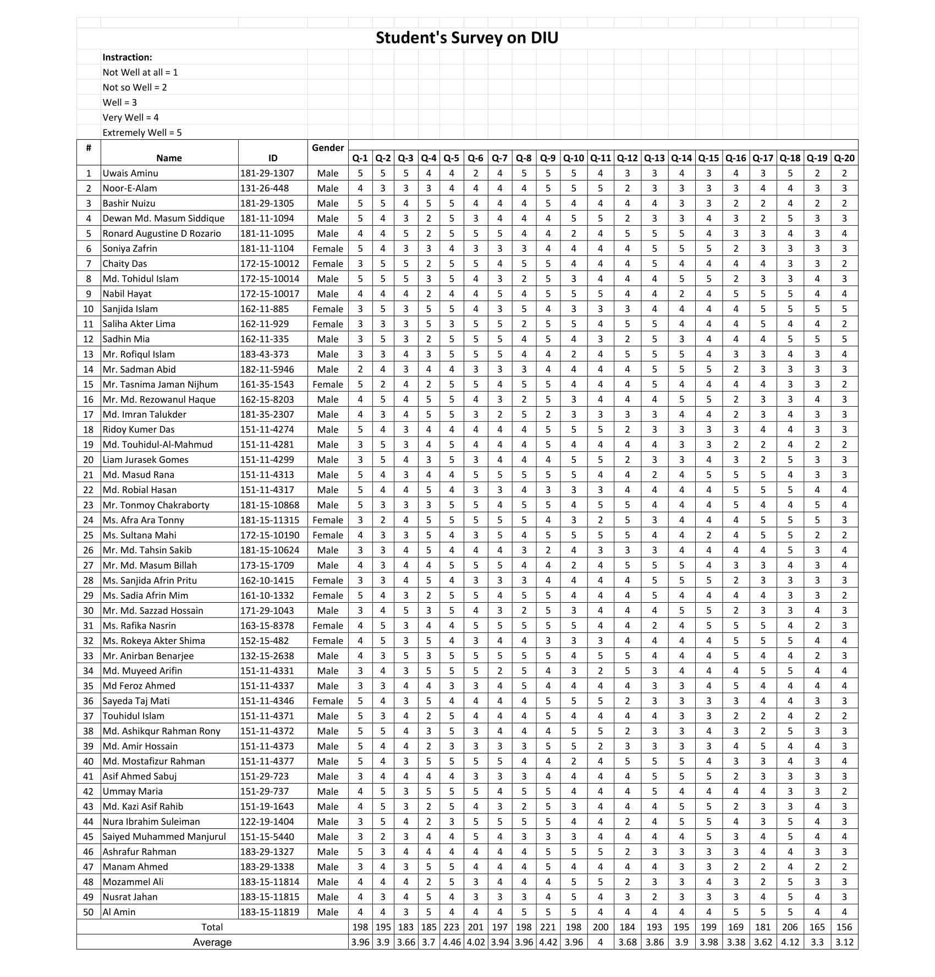

Chapter - 6

Findings, Recommendation and

Conclusion

6.1 Findings

- Teachers of DIU are very helpful and caring to the students.

- Seminar and workshops are organized frequently by DIU for students and faculty members.

- The department helps students for internship and job placement.

- The departments Coordination Officers are very cooperative with students

- Study materials, guidelines and training are provided for the interns to help them get a job and do well in their professional life.

- The all department of DIU has linkage with different local and multinational real estate companies, banks & abroad.

- Innovation and research of the teachers enhances the reputation of DIU.

- The DIU Library building is near about all academic buildings.

- The DIU have a Career Development Center (CDC) for giving career guidelines to students.

- The DSA Office of the university much involve of the university students in many academic activities.

- DIU is best, Because of tuition fee is affordable for lower class to higher class people.

- The university is following the admission rules and regulation but there is lack of quality.

- There are many of spacious counselling room for the students so that they can sit for group study.

- The Office of the Registrar always helps to students’ problems & gave solutions them which is the best way.

- The DIU creating opportunity for DIU Students for appointment as a lecturer,

- Job opportunity is high & student gets job easily DIU Faculties, Administration & Daffodil Family Sister Concern

- Smart One Card Solutions for Student, Teacher & Admins.

6.2 Recommendations

- DIU should admit good quality students.

- DIU should include more activeness in website, online activities& social media.

- Daffodil International University need to highlight students’ activities.

- DIU need to more marketing & activeness in online &off lines

- DIU should increase enough transport facility.

- DIU can focus on online services for Admission.

- The faculty members of DIU should provide not only theoretical knowledge but also practical knowledge.

- Teachers should provide case study related questions to test the student’s theoretical knowledge.

- The DIU should try to make all curriculums up to-date online & offline.

- All Teacher of the DIU may provide to student on real life & practical works for their betterment on marketplace.

- Daffodil International University should not increase the tuition fees any more.

- DIU may easier to obtain resource for the students form the universitylibrary.

- DIU may implement an online solution for students take book from university library.

- DIU accounts should more helpful for students’ supports.

- DIU may take initiatives for improve their university polices.

- There is possibility to create more leaders from the students by giving them proper guidelines.

6.3 Conclusion

Daffodil international University is well-known to everyone because students are performing well. The students of Daffodil International University successful in every ware. They have quality because DIU providing to students a quality Education. DIU is a QS ranked University in Bangladesh. DIU is the one of the University of 6 Universities in Bangladesh & one of the 500 Universities in ASIA.

References:

- https://daffodilvarsity.edu.bd
- https://daffodilvarsity.edu.bd/page/show_page_detail/history
- https://cdc.daffodilvarsity.edu.bd
- http://dba.daffodilvarsity.edu.bd/
- https://www.facebook.com/diucampus/
- Previous Reports
- Mr. Md. Abdul Alim
Administrative Officer
Dean Office, FBE
deanoffice-fbe@daffodilvarsity.edu.bd
Cell: 01991195593, Ext: 340
Daffodil Tower-05, 6th Floor
(Main Campus)

- Mr. Al Safayat
Administrative Officer (CDC)
safayat.a@daffodilvarsity.edu.bd
Cell: 0​1991195579​ Ext: 400
Daffodil Tower (Main Campus))

