

Internship Report
On
Financial Performance Analysis
Of
LafargeHolcim Bangladesh Limited

Prepared For
Nusrat Nargis
Assistant Professor
Department of Business Administration
Faculty of Business & Entrepreneurship
Daffodil International University

Prepared By
Md. Shahin Alam
ID: 163-14-2207
Major: Finance, Batch: 45th
Program: M.B.A
Department of Business Administration

Date of Submission:
November 25, 2018
Daffodil International University

“Financial Performance Analysis of
LafargeHolcim Bangladesh Limited at Head Office Dhaka”

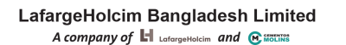

Letter of Transmittal
November 25, 2018

Nusrat Nargis
Assistant Professor
Department of Business Administration
Faculty of Business & Entrepreneurship
Daffodil International University

Subject: Submission of Internship Report on “Financial Performance Analysis of LafargeHolcim Bangladesh Limited”.

Dear Sir,
With great joy, I am presenting my Internship Report “Financial Performance Analysis of LafargeHolcim Bangladesh Limited”. This has appointed me as part of my MBA program. With the necessary information and the proposed personal, you have tried my best to complete this report which you have provided me as your best.

I hope the report will be as complete as you expected.
Thank you

Sincerely yours,

………………………….
Md. Shahin Alam
ID NO: 163-14-2207
MBA Program, Batch - 45th
Department of Business Administration
Daffodil International University

Certificate of Approval


I am pleased to certify that the Internship Report on “Financial Performance Analysis of LafargeHocim Bangladesh Limited” prepared by Mr. Shahin Alam bearing ID NO #163-14-2207 of the Department of Business Administration (Major in Finance) is approved for Presentation and Defense. Shahin Alam worked with “LafargeHocim Bangladesh Limited” as a Job holder under my supervision. He completed the work during the fall - 2018 semester. I am also pleased to certify that the data and the findings presented in the report seen to be authentic.

Shahin Alam carries a good moral character and a very delightful personality. It really has a great pleasure to work with him. I wish him all the success of life.

Supervisor,

………………………..
Nusrat Nargis
Assistant Professor
Faculty of Business & Entrepreneurship
Daffodil International University

Acknowledgement

In the preparation of this internship report, I acknowledge the encouragement and assistance given by a number of people from LafargeHolcim Bangladesh Limited. I am grateful to Mr. Rabiul Hasan “Credit Control Manager” of Lafarge Holcim Bangladesh Limited at Head Office Dhaka and also like to thank all the Department staffs for their valuable suggestions giving me helpful support and assurance.

I would like to express gratitude to my respected supervisor, Nusrat Nargis, Department of Finance, Faculty of Business Administration, Daffodil International University, for approving me to prepare this report and I would also like to express my sincere gratefulness to him for her whole hearted support and guidance.

…………………………………………
Md. Shahin Alam
ID NO: 163-14-2207
MBA Program, Batch - 45th
Department of Business Administration
Daffodil International University

Executive Summary

Under The guidance of Rabiul Islam (Credit Manager) and Mrs. Nusrat Nargis (Assistant Professor- Daffodil International University), this report was prepared for analyzing the financial performance analysis of LafargeHolcim Bangladesh Ltd. which is a joint venture of Lafarge of France and Cementos Molins of Spain and Holcim Cement Bangladesh.

At chapter 1, I have mentioned the purpose of creating this report, which describes the actual corporate experience and present it. Few objectives, methodology and some limitation.

In Chapter 2, I mention the purpose of company details summary, describe about company mission, vision and shareholder details. Than describe about company activity and company operation. I have to complete company some of ration analysis and mention its interpretation.
Than I have to make this company some of finding and recommendation. To prepare this report I had to prepare a questionnaire for the serve purpose and go through a research. I had to talk with the employees especially Credit control Unit of the company and some customers of this company as well.

Table of Contents
Table of Contents Entry
Serial No | Title | Page No
 | Letter of Transmittal | 3
 | Certificate of Approval | 4
 | Acknowledgement | 5
 | Executive Summary | 6
Chapter - 01 : Introduction |  | 10
1.1 | Introductory | 11
1.2 | Significance of the study | 11
1.3 | Objective of the Study | 11
1.4 | Methodology | 12
1.5 | Limitation | 13
Chapter - 02 : Company Profile |  | 14
2.1 | History of Lafarge in Bangladesh | 15
2.2 | Nature of Business | 15
2.3 | Shareholders: | 15
2.4 | Mission | 16
2.5 | Vision | 16
2.6 | Commitments | 17
2.7 | Value | 16
2.8 | Corporate Slogan | 17
2.9 | Industry Outlook | 17
Chapter - 03: Activities of the Company |  | 18
3.1 | Product and Services | 19
3.2 | Bulk Carrier Services | 20
3.3 | Clinker | 20
3.4 | Health & Safety | 21
3.5 | Corporate Social Responsibility | 21
Chapter - 04: Operation Process Of the Company |  | 22
4.1 | Organogram | 23
4.2 | LHBL Plant | 24
4.3 | Production Process | 24
4.4 | Packaging | 24
4.5 | Supply Chain and Logistics | 25
4.6 | Human Resources Management | 25
4.7 | Legal and Compliance | 25
4.8 | Sales and Marketing | 26
4.9 | Internal Control System | 26
 | Chapter - 05: Financial Performance Evaluation of the company | 27
5.1 | Qualitative Analysis | 28
5.2 | Quantitative Analysis | 28
5.3 | Financial Highlights | 28
5.4 | Ratio Analysis | 29-37
 | Chapter - 06: Finding, Recommendation & Conclusion | 38
6.1 | Findings | 39
6.2 | Recommendations | 39
6.3 | Conclusion | 40

Chapter - 01:Introductory

1.1 Introductory:
This internship is a part of the Masters of Business Administration (MBA) program that provides students with a job experience. I placed at LafargeHolcim Bangladesh Limited as a Job holder officer April 15, 2016 to till now. This work was my first job exposure and provided learning and knowledge of experience in different areas. During the first few month of my job period, I was able to get accustomed to the working environment of LHBL. As the job continued, I not only learned about the activities and operations of correspondent Company, but I also gathered some knowledge about the basic business activities of cement in first three-month of my Job period. Indeed, this opinion is accepted by the students joining an organization after the department has finished the theoretical part of the MBA program. Professor Nusrat Nargis of my department gave me the project for the report. The topic of the report is “Financial Performance analyze of the company. This report will definitely increase my knowledge in the practical life.

1.2 Significance of the study:
This internship program can establish student communication and networking. Contracts can help get jobs in real life. Students can train and prepare themselves for the market. There are unemployment educated graduate numbers in a developing country like Bangladesh. They do not have any internship experience; they are not able to achieve the usual professional experience of establishing a networking system, which is important to get jobs. Therefore, it is clear that the importance of internship is clearly justified as one year MBA post-graduate important requirement.

1.3 Objective of the Study:
The main goals of the report are to summarize the Financial Performance Analysis of LafargeHolcim Bangladesh Limited. In addition, the study seeks to achieve the following objectives:
- To analyze the activity of company
- To analyze the operation process of LHBL.
- To evaluate the performance of the company from 2013 to 2017.
- To find out the problems of the company

1.4 Methodology:
Interview was the basic technique complied to collect primary data from any people within the organization. Information about various types of activities of the reporter’s finance and sales department was collected in the interview. The types of products offered by the clients and details for each of these products were collected through data interviews. Besides, on-the-job experience has also helped me learn quite a few things about the Correspondent Finance and Sales the organization as well. On the other hand, secondary sources were used to collect data regarding the company's performance over the past five years, Publications, Database, Annual report of LafargeHolcim Bangladesh Ltd. (2013 to 2017), Different papers of LafargeHolcim Bangladesh Ltd, Different text Books, Term papers of LHBL Training manuals.

Sources of Data collection:
- Primary Sources:
  - Discussion with Credit Control Officer.
  - Personal observation.
  - Desk work in different sections/departments.
- Secondary Sources:
- Annual report of the LHBL
- Related books and publications advice
- Different Statements.
- Data Processing:
The collected information is processed using the computer system. Detailed analysis, working variables and working definitions are tied to the report

Chapter - 02: Company Profile

2.1 History of Lafarge in Bangladesh:
For the fourth consecutive year in a row, your Company has successfully exported two (2) million tones of limestone from Nongtrai Limestone Mine (the “Mine”) to the cement plant at Chhatak, Bangladesh (the “Plant”) of Lafarge Surma Cement Ltd. (LSC), the parent company of your Company. The uninterrupted supply of limestone from the Mine ensured the production at Plant, for both clinker and cement, was at maximum capacity. The changes in the regulatory framework have had an impact on your Company. It is largely due to introduction of “own mining” using world class equipment owned by the Company. The mining cost reduced significantly in 2015 as compared to 2014. Own mining initiatives resulted into enhancing safety standards, high reliability of equipment and performance level as well as smooth and efficient limestone production. On July 10, 2015, the merger between Lafarge Group and Holcim Group in the global level was complete and the new group called LafargeHolcim emerged. With a well-balanced presence in 90 countries and a focus on cement, aggregates and concrete, LafargeHolcim is the world leader in the building materials industry. The Group has 100,000 employees around the world and combined net sales of CHF 29.5 billion in 2015. Your Company is a 100% subsidiary of LSC. LafargeHolcim Group is having shareholding interests LSC. The Group is also having shareholding interest in Holcim Bangladesh Ltd. (HBL). Possible combination in Bangladesh between LSC and HBL has been delayed mainly arising out of the complex shareholding structures in LSC and HBL. Works are ongoing at Group level to sort out these issues.

2.2 Nature of Business:
Under the sunamganj district, the company has established the country’s only modern, integrated and sophisticated cement manufacturing plant by establishing the company. The company gathers and processes the limestone raw material from its own canals in Meghalaya. 17 kilometer cross border conveyor belt excavator with cement plant for transporting raw materials. The company involved manufacturing and marketing of cement and clinker in the local market.
2.3 Shareholders:

Following are the shareholders of the company. The list shows the names and percentage of share hold.
- Surma Holdings: 58.87% (Jointly hold by Lafarge S.A and Cementos Molins)
- Sinha Fashions Ltd. : 3.02%
  - Islam Cement Ltd.: 2.75%
  - Other Shareholders: 35.36%

2.4 Mission:
- The LafargeHolcim foundation supports the selection and support that integrates sustainable construction solution with the superiority of architectural architecture and advanced quality beyond the technical solution.

- The construction of the foundation promotes national, regional, regional and international sustainable responses to the affected technical, environmental, socio-economic and cultural issues

- It encourages new practices for the development of sustainable building solutions to lasting building solution, and encourages the next generation of architects, engineers, planner, developers and contractors.

2.5 Vision:
To be the leader of building materials through Bangladesh regardless of building materials
- Excellence in all areas of operation with world standard values
- Strengthen our power as the only cement producer of Bangladesh.
- The sustainable increase in respect for the environment and the community.

2.7 Value:
- Trustworthy
- Dependable
- Reliable
- Professional
- Dynamic

2.8 Corporate Slogan:
“Stronger Together”
The Company completed the acquisition of 100% of the shares of Holcim Cement (Bangladesh) Limited (HBL) on January 07, 2018. Since then HBL is a wholly owned subsidiary of your Company. The combination has created ideal business opportunities. The Surma plant of your Company is producing more clicker than it can grind and HBL is having underutilized grinding capacity – complementing each other. The combined company assets reflect a pan Bangladesh presence. The Company is now perfectly positioned to produce cement near to the markets all over Bangladesh, which gives significant advantages to deliver products of high and consistent quality to the doorsteps of every customer with optimized logistics. The consolidation of the two companies is expected to generate very good returns for the shareholders.

2.9 Industry Outlook:

Bangladesh’s GDP growth is now more than 7%. Increasing population, low labor cost, rapid urbanization, fast industrialization and infrastructure projects will continue to support the country’s growth which is expected to remain on a high level for the foreseeable future.
The country's strategic location on the Indian Ocean has led to increasing levels of infrastructure investment from China, India and Japan as they seek to gain market share and influence.
The Bangladesh cement market grew more than 10% on average for the last 5 years and it is expected that high growth rates will continue on the backdrop of the positive GDP development as well as of the significant infrastructure investments. However, this positive outlook is also leading to significant investments in the country’s cement production capacity expansion which may result in continued price pressure in the market.

Chapter - 03: Activities of the Company

Housing and infrastructure development are the two main driving forces behind demand in Bangladesh. There is a great need for a significant increase in development on infrastructure building including highways, roads, bridges, culverts, power stations and ports,

3.1 Product and Services:

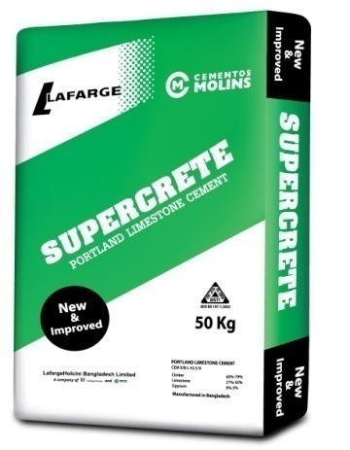
- Supercrete: Quality concrete is critical for durability of structures. Consistent high quality cement like “Supercrete” is a must to achieve excellence in concrete. Supercrete ensures the strength early and makes the construction cost effective. Supercrete has become symbol of strength, quality and reliability to the customers.

Integrity of Supercrete Cement:

- Its own clinker production facility & modern quality control system ensures consistent quality of cement.
- The use of limestone provides the distribution of a uniform particle size resulting in maximum bonding strength.

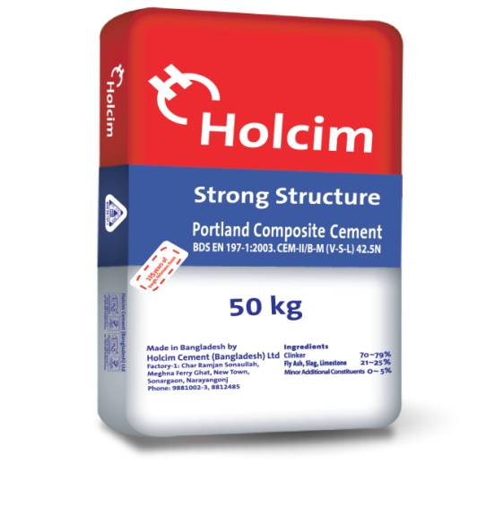
- Holcim Strong Structure: Holcim supplies a wide range of value-added products, innovative services and comprehensive building solutions to the largest and most complex projects from R & D’s industrial benchmark and independent home builder. With commitment to run sustainable solution for improved building and infrastructure and to contribute to high quality life. Its complies with CEM II/B-M (S-V-L), 42.5N standard.

3.2 Bulk Carrier Services:
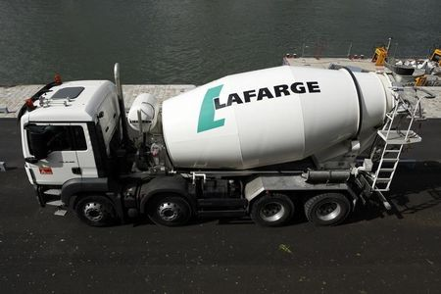
Your Company expanded its distribution and retail network through adding more distributors and retailers all over the country. This year, your Company expanded its distribution facility through addition of bulk cement carrier. As part of capability enhancement, Sales Force Effectiveness (SFE) project was launched to enhance agility, value development and more customer satisfaction.

3.3 Clinker:

LafargeHolcim Bangladesh Ltd. (LHBL) earns million US dollars from clinker sales to other cement companies in the country. The Bangladesh-based auxiliary of Lafarge imports limestone from a mine in Meghalaya, India via a 17km belt conveyor to its cement plant at Chhatak, Bangladesh. According to the Financial Express, setup is the only border industry initiative between india & Bangladesh

3.4 Health & Safety:

Health and Safety is a core value of your Company. Your Company is taking the necessary measures to ensure that its employees and the employees of the third party contractors work safely on the Company’s sites as well as in the distribution of its products. This commitment is embedded in the personal objectives of every employee. We had no Lost Time Injury in 2017 and managed to reduce the number of the injuries requiring medical treatment by 50% from 2016 to 2017.

3.5 Corporate Social Responsibility:

The Company continues to contribute to the welfare of the local communities through its CSR projects. We are proud of the fact that since the initiation of the project of the Company, the economy and livelihood of the communities in which we operate has experienced positive changes. The focus of the CSR activities of your Company continues to be healthcare, education, livelihood skill development trainings and infrastructure developments.

Chapter - 04: Operation Process
Of the Company

4.1 Organogram:

Chief executive officer
Executive Assistant
Finance Director
Company Secretary and Legal
Sales Director
Head of Health and Safety
Chief executive officer
Marketing Director
Head of Strategy and Planning

Supply Chain Director
Head of Internal Audit
HR Director
Head of Communications
SVP Operation
Head of Risk Management and Administration
VP & Director

4.5 Supply Chain and Logistics

Ensure time delivery and delivery throughout strong supply. The packing supplier company maintains coordination with the navy of packing, production and head office.
- If the sales order is set in the head office, fleet team manages the barges, trucks and transporters and transports details of the transporter to the plant logistics team through the JDE system.
- The vehicle plant is reached and it is given a card where all its data (ID, transporter, destination, freight rate etc.) is inserted.
- Empty trucks are loaded with the first weight cement bag automatic loaders.
- Two workers stack those trucks and make manual calculations for cross checks.
- Barges are loaded automatically for cement and clinker.

4.6 Human Resources Management:
In the Head Office, all the four subordinates directly report to HR director. In plant, Plant HR Manager is reporting to HR director. Senior Manager of Human Resources plays multiple roles, including leader, negotiator and communicator. He supervises other executives, sets objectives for them and establishes the goals that they need to reach. The manager is also responsible for organizing tasks and arranging the right roles for the right people. Motivating and communicating with the team in order to achieve the desired objectives is also the duty of the manager. In plant, under plant HR Manager, there are Executive-Employee Relations and Executive-Learning and Development. Executive-Employee Relations supervises relations with labors, since there is huge number of workers employed in the cement manufacturing plant in Chattak, Sunamganj. On the other hand, Executive- Learning and Development is accountable for facilitating educational process which involves the sharpening of skills, concepts, changing of attitude and gaining more knowledge to enhance the performance of workforce

4.8 Sales and Marketing:

The sales performance of the Company in 2017 has been impacted by the external reasons as highlighted in the Overview of Financial Performance above. In order to regain the lost grounds, your Company successfully implemented and is still implementing various initiatives in all regions of the country. The efforts of 2017 have yielded positive results from the beginning of 2018: The sales volume is increasing and the Company is regaining market share. Bangladesh is a fast growing economy and the Government is supporting this growth with investments in infrastructure. There is a significant growth of cement demand originating from Large Infrastructure Projects. In 2017, your Company established a dedicated and specialized LIP Team. The LIP Team managed to gain contracts for cement supplies and related services for Rooppur Nuclear Power Plant project, Rampal Coal based Power Plant project and Ghorashal Power Plant Unit 4.

4.9 Internal Control System:

The Company has well-documented Policies, Directives and Work Instructions which are periodically reviewed. Implementation and compliance with the Policies, Directives and Work Instructions are monitored and reported to the Audit Committee. The Audit Committee consists of five (5) members from the Board of Directors. The Chairman of the Audit Committee is an Independent Director.

Chapter - 05: Financial Performance
Evaluation of the company

5.1 Qualitative Analysis:
    - SWOT Analysis of LafargeHolcim:

- Strength:
- One of the market Leaders in cement industry worldwide
- Strong supply chain makes its operations effective
- Product includes portfolio cement, construction aggregation, pulses production and concrete.
- Reshuffling top management has resulted in a more focused and strategic business approach.
- Successfully enhancing business trends has boosted business operations.

- Weaknesses:
- Strong competition means to increase the market share of limited market.
- The facts of legal case and alleged violations have hit the brand name a bit.

- Opportunities:
- The acquisition of small players will make them a strong brand.
- Other rivals can target customer base.
- Strategic marketing and advertising will help to increase brand recall and increase credibility.

- Treats:
- Challenge in post-merging operations can affect business
- To be Strong competition in all operating countries.
- Increasing costs, lung price etc. will be increasingly under threat.

5.2: Quantitative Analysis:
5.3 Financial Highlights:
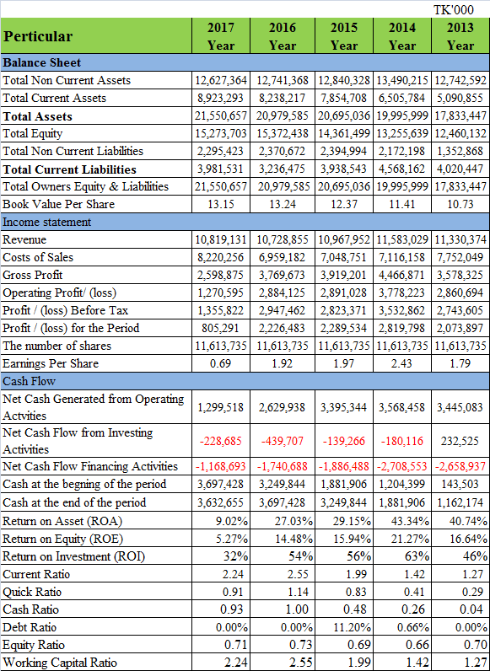
5.4 Ratio Analysis:
- Return on Asset (ROA):
In 2013 Return on Asset of LafargeHolcim Bangladesh is 40.74%, in 2014 it was 43.034%, in 2015 it was 29.15%, in 2016 it was 27.15% and in 2017 it was 9.02%.

Figure: Return on Asset

Interpretation:
The total Return on Asset of LafargeHolcim stood at 9.02% as on December 2017 against 27.03% of the year 2016; in 2015 it was 29.15%; in2014 it was 43.34% and in 2013 it was 40.74%. The return of wealth is better. Money was higher than the money that was able to utilize its resources in high return on wealth. In the above figure, even if company in 2016 generated 2226 million and in 2017 generated 805 million taka only, in the year 2017 the company was more efficient because it earned more in each of its assets.

- Return on Equity (ROE):
In 2013 Return on Equity of LafargeHolcim Bangladesh is 16.64%, in 2014 it was 21.27%, in 2015 it was 15.94%, in 2016 it was 14.48% and in 2017 it was 5.27%.

Figure: Return on Equity

Interpretation:
The total Return on Equity of LafargeHolcim stood at 5.27% as on December 2017 against 14.48% of the year 2016; in 2015 it was 15.94%; in 2014 it was 21.27%.The return on equity is similar to the ‘return on asset’. Assets come from two sources, debt and equity. The low return on assets, just like any other financial ratio, the ROE is more useful if it is compared to a benchmark such as the average ROE in industry where the company operate or the company ROE in the past years.

- Return on Investment (ROI):
In 2013 Return on Investment of LafargeHolcim Bangladesh is 46%, in 2014 it was 63%, in 2015 it was 56%, in 2016 it was 54% and in 2017 it was 32%.

Figure: Return on Investment

Interpretation:
The total Return on Investment of LafargeHolcim stood at 32% as on December 2017 against 54% of the year 2016; in 2015 it was 56%; in2014 it was 63% and in 2013 it was 46%. Return on Investment goes down in the year 2015 to 2017 because of the effect of less investment and return on Investment goes up in 2014 because of the effect of getter investment. The investment opportunity was taken by the Company due to the fear Achieve.

- Earning Per Shares (EPS):
In 2013 Earning per Shares of LafargeHolcim Bangladesh is 1.79 Taka, in 2014 it was 2.43 Taka, in 2015 it was 1.97 Taka, in 2016 it was 1.92 Taka and in 2017 it was 0.69 Taka per Share.

Figure: Earning Per Shares

Interpretation:
The total Earning per Shares of LafargeHolcim stood at 0.69 Taka as on December 2017 against 1.92 Taka of the year 2016; in 2015 it was 1.97 Taka; in2014 it was 2.43 Taka and in 2013 it was 1.79 Taka. Earning per Shares goes down in the year 2015 to 2017

- Current Ratio:
In 2013 Current Ratio of LafargeHolcim Bangladesh is 1.27 time, in 2014 it was 1.42 time, in 2015 it was 1.99 time, in 2016 it was 2.55 time and in 2017 it was 2.24 time.

Figure: Current Ratio

Interpretation:
The Current Ratio of LafargeHolcim stood at 2.24 times as on December 2017 against 2.55 times of the year 2016; if the current ratio is a result of more than 1 result, it means that there are current assets to determine current liabilities of the current organization. In the above figure, LHBL current assets are 2.24 times higher than current liabilities. This shows that LafargeHolcim are low leveraged and no risk.

- Quick Ratio:
In 2013 Quick Ratio of LafargeHolcim Bangladesh is 0.29 time, in 2014 it was 0.41 time, in 2015 it was 0.83 time, in 2016 it was 1.14 time and in 2017 it was 0.91 time.

Figure: Quick Ratio

Interpretation:
The Quick Ratio of LafargeHolcim stood at 0.91 times as on December 2017 but standard ratio is greater than 1. That means the country has enough resources to pay for its current liability. As mentioned above, the quick ratio of 1.14 in 2014 shows that the company has substantial current assets, but another year in 2017 shows that the company has a relatively low ratio.

- Debt Ratio:
In 2015 Debt Ratio of LafargeHolcim Bangladesh is 11.20% and in 2014 it was 0.66%.

Figure: Debt Ratio

Interpretation:
The Debt Ratio of LafargeHolcim stood at 11.20% as on December 2015 and in 2014 it was 0.66%. The debt ratio is measure of financial leverage. Debt ratio is measure more than 50% is known as a leveraged company. Its debt ratio is higher than its equity ratio. So above the graphically we say, LafargeHolcim aren’t a leveraged company.

- Cash Ratio:
In 2013 Cash Ratio of LafargeHolcim Bangladesh is 0.04 in 2014 it was 0.26, in 2015 it was 0.48, in 2016 it was 1.00 and in 2017 it was 0.93.

Figure: Cash Ratio

Interpretation:
The Cash Ratio of LafargeHolcim stood at 0.93 times as on December 2017 and it’s below to 1.Another year in 2016 it was 1.00 time, in 2013 to 2015 it’s less than to 1. In the above figure, the total cash & cash equivalents and marketable securities of LHBL is not enough to cover for all current liabilities. In each of the current filed cases, the company has been paid TK 0.93 in cash and securities marketable securities.

Chapter - 06: Finding, Recommendation & Conclusion

6.1 Findings:
I analysis the financial statement of LafarageHolcim Bangladesh Limited and some findings;
- This company’s earnings per share price in day by day decrease.
- This company Return on Equity is low.
- This company Return on Investment goes down.
- This company’s current ratio is larger than current liabilities but not enough for covering liabilities or any worst situations.
- This company has enough current assts but that company quick ratio is low.
- This company dept portion is higher than equity which shows weaker position.

6.2 Recommendations:
LafargeHolcim Bangladesh Limited may consider the following suggestions:
- LafargeHolcim Bangladesh can increase the amount of its current assets to a more well-paid account and reduce its current liabilities by reducing its bank overdraft and short-term debt.

- This company can reduce inventory to improve its inventory turnover ratio.
- The company’s management should be more effective in using the company’s capital to produce sales.

- In order to expedite the sales of the company, it should try to use more of its fixed assets.
- In addition to reducing the debt capital of this company financially, the financial capital of its total asset should be achieved by increasing the equity capital
.
- The company can manage its operating cost efficiency and improve its sales.
- To gain sufficient profits, the company’s efficiency should be increased using the company’s capital.

6.3 Conclusion:
LafargeHolcim Bangladesh Limited (LHBL) is a frontline cement producer in Bangladesh. The cement industry is the new one but a commitment country. In the near future, three is huge space for heating these industry industries in Bangladesh. As a result; I think many students can think of building their carrier with the cement companies of the country. Although this industry is not only committed to building the base, I would be happy to contribute even if I have the opportunity to contribute to over all development of the company

Bibliography
- Managerial Finance, Text Book
- LafargeHolcim Bangladesh Limited, Annul Report 2013
- LafargeHolcim Bangladesh Limited, Annul Report 2014
- LafargeHolcim Bangladesh Limited, Annul Report 2015
- LafargeHolcim Bangladesh Limited, Annul Report 2016
- LafargeHolcim Bangladesh Limited, Annul Report 2017

