IMPACT OF SOCIAL MEDIA ON ACADEMIC PERFORMANCE OF THE STUDENT DAFFODIL INTERNATIONAL UNIVERSITY
Prepared by
Abdiwahab Osman Siad
ID: 181-25-648

This Report Presented in Partial Fulfillment of the Requirements for the Degree of Masters of Science in Computer Science and Engineering
Supervised by
Md. Tarek Habib
Associate Professor
Department of CSE
Daffodil International University



DAFFODIL INTERNATIONAL UNIVERSITY
Dhaka, Bangladesh

DECEMBER 2018

APPROVAL
This Thesis titled “Impact of social media on academic performance of the students in Daffodil International University (DIU)” submitted by Abdiwahab Osman Siad to the Department of Computer Science and Engineering, Daffodil International University, has been accepted as satisfactory for the partial fulfillment of the requirements for the degree of Master of Science in Computer Science and Engineering and approved as to its style and contents. The presentation has been held on 28 Dec 2018.
Board of Examiners

Dr. Syed Akhter Hossain Chairman
Professor and Head
Department of Computer Science and Engineering
Faculty of Science & Information Technology
Daffodil International University

Dr. Sheak Rashed Haider Noori Internal Examiner
Associate Professor and Associate Head
Department of Computer Science and Engineering
Faculty of Science & Information Technology
Daffodil International University

Md. Zahid Hasan Internal Examiner
Assistant Professor & Coordinator of MIS
Department of Computer Science and Engineering
Faculty of Science & Information Technology
Daffodil International University

Dr. Mohammad Shorif Uddin External Examiner
Professor and Chairman
Department of Computer Science and Engineering Jahangirnagar University
DECLARATION
I hereby acknowledged that, this thesis has been done by me under the supervision of Md. Tarek Habib Associate Professor, Department of CSE Daffodil International University. I also assert that neither this thesis nor any part of this thesis has been submitted away for award of any degree.
Prepared by
------------------------
Abdiwahab Osman Siad
ID: 181-25-648
Program: M.Sc in CSE
Department of Computer Science Engineering
Faculty of Science and Information Technology
Daffodil International University

Supervised by
------------------------
Md. Tarek Habib,
Associate Professor
Department of CSE
Daffodil International University

ACKNOWLEDGEMENTS

I heartiest thanks this work to ALLAH Almighty who gave me knowledge, understanding and strength to successfully carry out this research without any hindrance; I appreciate and will forever be thankful to Him.
My deepest appreciation and thanks go to my respected supervisor Md. Tarek Habib, Associate Professor, Department of CSE, Daffodil International University, Dhaka. His guidance and encouragement that helped me stays focused and complete from the beginning of this work up to the end. Without his effort this thesis would not have been made possible. It was his persistency and consistency which kept me on track. Thank you sir for your remarkable efforts.
Special thanks to express my heartiest gratitude to Dr. Syed Akhter Hossain, Professor and Head, and also Dr. Sheak Rashed Haider Noori, Associate professor, Associate Head Department of CSE, for this kind help to complete my study and also other faculty members and the staff of CSE Department of Daffodil International University.
Special gratitude to my beloved parents firstly my beloved mother Amino Mohamed Abdi, my beloved father Osman Siad Shuriye and my beloved brother’s special Kafiyo. Barlin, kowsar, shukri and my beloved brothers Mohamed, Siyad, Abdixakin, Abdirahim and beloved other family brothers and sisters. I love for all and am thankful to have me as my great family.
Finally, special thanks to my classmate who give me support during my program to become successful and all other students of Daffodil International University.

TABLE OF CONTENTS
Contents
APPROVAL……….. i
ABSTRACT………… iv
LIST OF FIGURES….. ix
LIST OF Tables…….. xi
CHAPTER…………. 1
1.1 INTRODUCTION 1
1.2 Statement of the problem 1
1.3 Rationale of the Study 2
Research Questions…. 3
1.5 Expected Output… 3
1.6 Report Layout…… 3
CHAPTER TWO…… 4
2.1 INTRODUCTION 4
2.2 Related Works…… 4
2.3 Research Summary 6
2.4 Scope of the Problem 6
2.5 Challenges………. 6
CHAPTER 3……….. 8
RESEARCH METHODOLOGY 8
3.1. INTRODUCTION 8
3.2. Research design……. 8
3.3 Research population 8
3.4. Sample size…….. 9
3.5. Sample procedure 9
3.6. Research instrument 9
3.7. Validity and reliability 10
3.8 Data gathering procedure 10
3.9 Data Analysis……. 10
3.10 Ethical Considerations 10
3.11 limitation of study 11
CHAPTER FOUR…….. 12
EXPERIMENTAL RESULTS AND DISCUSSION 12
4.1 INTRODUCTION 12
4.2 Experimental Results 12
4.3 Descriptive Analysis 12
4.3.1 Sex Response……….. 13
4.3.2 Age of respondents 14
4.3.3 Educational Level of respondents 15
.3.4 marital status respondents 16
4.3.5 Social networking site mostly use of respondents 17
4.3.6 Years using social media respondents 18
4.3.7 Hours a day do you spend on social media respondents 19
4.3.8 Purpose you using social media respondents 20
4.3.9 Social media gives a useful platform for academic group work respondents 21
4.3.10 social media to communicate with lecturers for academic purposes respondents 22
4.3.11 Lectures should increase and encourage the use of social networking sites in the classroom respondents 23
4.3.12 Sharing notes or information about lectures via social media leads to many students thinking they do not have to attend lectures respondents 24
4.3.13. Using social media while doing assignments negatively affects the quality of your work respondents…….. 25
4.3.14 relationship between student’s academic performance and social media adoption and use respondents……… 26
4.3.15 social media has affected your academic performance negatively respondents 27
4.3.16 social media is a distraction to your academic learning activities respondents 28
4.3.17 social media sites affect your study timings respondents 29
4.3.18 you think social networks is important respondents 30
4.4 Summary……………… 31
CHAPTER FIVE…………. 32
SUMMARY OF THE STUDY, CONCLUSION ANDRECOMMENDATIONS 32
5.1 INTRODUCTION 32
5.2 Summary of the Study 32
5.2.1 Social networking site mostly use of respondents 32
5.2.2 How long have you been using social media? 33
5.2.3 How many hours a day do you spend on social networking activities? 33
5.2.4 you use social media to communicate with lecturers for academic purposes? 33
5.2.5 Lectures should increase and encourage the use of social networking sites in the classroo………………………… 33
5.3 Conclusion……………… 34
5.4 Recommendation ……………………………………………………………………………………………………………34
References…………………………………………….. 35
Questionnaires…… ……………………………………………………………………………………………………………..36

LIST OF FIGURES
FIGURE NAME PAGENO.
Figure 4.3.1 Sex Response 13
Figure 4.3.2 Age of respondents 14
Figure 4.3.3 Educational Level of respondents 15
Figure 4.3.4 marital status respondents 16
Figure 4.3.5 Social media site mostly use of respondents 17
Figure 4.3.6 Years using social media respondents 18
Figure 4.3.7 Times a day do you spend on social media respondents 19
Figure 4.3.8 Purpose you using social media respondents 20
Figure 4.3.9 Social media gives a useful platform for academic group work respondents 21
Figure 4.3.10 social media to connect with lecturers for academic purposes respondents 22
Figure 4.3.11 Lectures should growth and encourage the use of social networking sites in the classroom respondents 23
Figure 4.3.12 Sharing records or information about lectures via social media leads to many students thinking they do not have to attend lectures respondents 24
Figure 4.3.13. Using social media while doing assignments negatively affects the quality of your work respondents 25
Figure 4.3.14 relationship between student’s academic performance and social media adoption and use respondents 26
Figure 4.3.15 social media has impact your academic performance negatively respondents 27
Figure 4.3.16 social media is a disruption to your academic learning activities respondents 28
Figure 4.3.17 social media sites affect your study timings respondents 29
Figure 4.3.18 you think social networks is important respondents 30

LIST OF Tables
Table NAME PAGENO.
Table 4.3.1 Sex Response 13
Table 4.3.2 Age of respondents 14
Table 4.3.3 Educational Level of respondents 15
Table 4.3.4 marital status respondents 16
Table 4.3.5 Social media site regularly use of respondents 17
Table 4.3.6 Years using social media respondents 18
Table 4.3.7 Times a day do you spend on social media respondents 19
Table 4.3.8 Purpose you using social media respondents 20
Table 4.3.9 Social media gives a useful platform for academic group work respondents 21
Table 4.3.10 social media to connect with lecturers for academic purposes respondents 22
Table 4.3.11 Lectures should growth and encourage the use of social networking sites in the classroom respondents 23
Table 4.3.12 Sharing records or information about lectures via social media leads to many students thinking they do not have to attend lectures respondents 24
Table 4.3.13. Using social media while doing assignments negatively affects the quality of your work respondents 25
Table 4.3.14 relationship between student’s academic performance and social media implementation and use respondents 26
Table 4.3.15 social media has impact your academic performance negatively respondents 27
Table 4.3.16 social media is a interference to your academic learning activities respondents 28
Table 4.3.17 social media sites affect your study timings respondents 29
Table 4.3.18 you think social networks is important respondents 30

CHAPTER ONE

1.1 INTRODUCTION
As we are living in a networking years, the remarkable growth of the social media has a high effect on the development of the students in which they interact and socialize. During this era, communication is the most common term. Today, communication uprising brought us together regardless of geographical boundaries. The internet offers a wide variety of communication tools. Billions of people use services like search engines, web pages, e-mails, Really Simple syndication (RSS), electronic-journals, electronic- newspapers, E-banking, conferencing, multi-media sharing, online news, social media etc. Today internet is an essential communication medium in professional as well as individual life. This research will detailed the impact of social media on student academic performance. Literature analyzed that the social networking websites are not designed for negative impact but we noticed in our daily life that students become addicted to social media websites. This research involvement will analyze the advantage and disadvantage aspects of social media on academic. The general use of social media among university students from texting to chatting on telephones to posting status updates on Facebook could be taking an educational

1.2 Statement of the problem
The internet is today the most important source of information and the growing dimensions of the use of social media by students cannot be underestimated. It has been observed that students devote more attention and time to social media than they do for their studies and they cannot pass their examinations well if they do not learn (1). Also, the study conducted by Maya (2015), revealed that media use contribute to lower academic performance, low self perceptions and less interest in college oriented carriers. Academic excellence plays an important role in an individual’s life; be it in the family, at social gatherings, at workplace, in an institution or even among peers. Much emphasis is placed on academic excellence because of the role it plays in an individual’s life as far as a successful life and respect is concerned in every part of the world. Due to this, many people are concerned with the ways that they can improve their academic performance (2). Studies have also revealed that social media affects students’ use of English. They tend to use short- handwriting to chat with friends and get used to it thereby replicating the same errors during examinations (3). Today students at all levels especially tertiary level have been engaged in the use of social networking sites (SNSs). This research therefore seeks to investigate the level of engagement of students of the University of daffodil international into social networking sites and also determine the effect of their use on the academic work.

1.3 Rationale of the Study
As Social Media was very general among the youth, they donate the popular percentage of the users of the media. So the researcher wanted to study the impact of social media on student academic performance. Social media was got to have both Effects of Social Media on the Academic Performance positive and negative impact on students and teenagers. Affording to the finding during the literature review, most of the students engaged in social media just to communicate with friends and it was distracting them from their studies. The present study will helps in detecting whether social media is really sidetracking students from their education or not

Research Questions
- Do you think using social media impact your academic performance?
- How student’s using of social media effect academic performance?
- What is effect of social media usage on Academic performance of student?
- What are the encounters faced by the students by using social media?

1.5 Expected Output
To define how social media websites impact student’s academic performance.
To know the impact of social media sites on academic system.
To discover the consequences of social media sites in academic system.

1.6 Report Layout
The remainder of this thesis is organized into the following chapters:
Chapter 1: presents an overview the Impact of social media use on academic performance among students in daffodil international university, Motivation and expected output
Chapter 2: background discusses the benefits and drawbacks, Research Summary and Scope of the Problem
Chapter 3: research methodology will discusses Research Subject and Instrumentation, Data Collection Procedure, Statistical Analysis and Implementation Requirements
Chapter 4: experimental results and discussion Experimental Results and Descriptive Analysis
Chapter 5: presents a short conclusion. And list of reference

CHAPTER TWO

2.1 INTRODUCTION
In this chapter, I will discuss related work or the literatures related to the Impact of social media on students in daffodil international university. The first section is the prior studies, the second section is definition, benefits and drawbacks and conclusion.

2.2 Related Works
Social media unceasingly keeps changing and as such it is difficult to assign a fixed definition to it as Jacka and Scott (4), argued that ‘’there is no single recognized definition for social media’’. However some scholars have defined it in different perspectives over the past years. Kaplan and Haenlein (5), defined social media as a group of internet- based applications that build on the ideological and technological foundations of Web 2.0 and allow the creation and exchange of user-generated content. The Oxford dictionary (6), also defined social media as “websites and applications used for social networking”. Another definition of social media is that it is a ‘’communication channel which is very popular, extremely fast and broad, has proven to
be highly effective, as well as trusted by billions of people , to share and discover

2.3 Research Summary
Anybody using the social media is likely to use Facebook and anybody using Facebook is likely to use it just about every day

2.4 Scope of the Problem
The focus of this research work is to primarily study the Impact of social media on the academic performance of students.
Time scope
The study was conducted between on July 2018 to Oct 2018
Geographical Scope
The study was conducted in Dhaka, Bangladesh

2.5 Challenges
Decrease in productivity: Social media networking sites decline output as so many students end up spending the better part of their study hours checking those sites. Rather than get their assignments done, they spend the whole time either cheeping or posting messages on facebook. There is bound to be a saving in students focus of attention when they are studying and at the same time trying to get difficult in activities on these social sites. This often time causes a drastic reduction in their academic performance
Addiction: Constant visitation to social sites can become very addictive and this is not a good thing because it is sure to affect one’s academic performance. A greater part of students’ time is finished on the social sites and they do not even have time for themselves let alone their studies. Organism addicted to social sites will turn students mind from important things like studies to trivial ones and this will tell on their grades as they are most likely to experience a drastic drop in their grades. And it will certainly lead to bad academic performance.
Reduction in real human contact: Students spend so much time on social sites that they begin to spend little or no time at all charming in person. As a product of this, students are not able to effectively join in person.

CHAPTER 3

RESEARCH METHODOLOGY

3.1. INTRODUCTION
This study specifies the impact social media on academic performance of the students daffodil international university. This chapter focuses on research methodologies adopted during this study, which involves data collection methods, procedures, sampling techniques used, target population, sample size and the administration of methodologies in this regard the research was conducted learning towards obtaining the required data in a systematic manner so as to further analyzed it to came up with actionable information

3.2. Research design
A cross-sectional study was conducted from Diffodil International University .This study may include special data collection, in which the researcher will use both open ended and close ended questions to get further information from the respondent.

3.3 Research population
The population is the complete collection of all the elements (units) that are of interest in a particular investigation. The population of the study in this research will encompassed of 260 people we focus on student.

3.4. Sample size
Since the target population of this study was 260 of administrations office the sample size will be 157
Where by n = N
N= total population 1+N (e) ²
n= number of sample
e= level of significance (0.05)

n=260/1+260*(0.05)2= 157

3.5. Sample procedure
This study will employ simple random sampling to select the key of respondents and the researcher will use simple random sampling since the research is targeting the impact of social media use on academic performance among students in daffodil international university

3.6. Research instrument
This research will use the following techniques to collect data and the researcher will use close ended questioner method and will distributed to the target of respondents.

3.7. Validity and reliability
Validity and reliabilities are instruments that the researchers used to measure the validity and reliability appropriateness and consistency of the instruments used to the researcher.
The study is repeated under the same conditions Validity and reliability thus measures the extent to which there may be an error in measurements.

3.8 Data gathering procedure
After the research questioner is approved the researcher will distribute the questioner with attached a letter of introduction from the respondents.
After receiving the questioners back, the researcher will analyze the collected data using by the SPSS data analyzing package.

3.9 Data Analysis
Such data will be used to analysis in the computer using by the program of statistical packaging for social science (SPSS). Once the data has been collected the questionnaire data was administered.

3.10 Ethical Considerations
This will mainly be involve seeking permission from administration that allocated to conducted this study .It will also important to highlight for the researcher that his/ her respondent will not meet any harassments from his research because the respondent may be suspect from your study and should clearly describe what your research paper is all about.
Another important thing which the researcher will require to use appropriate technique in order to make sure that the standard of his data collection interpretation was valid.
The research will also consider confidentially all his information that he received will fit the objectives mentioned above.

3.11 limitation of study
The limitation of this study may be varying for one to another and includes:
- Limited Source of Information: The research in this area was few therefore was limitation of information on the study/research topic, however the researchers limitation is primary source with this study entitled the impact of social media use on academic performance among students in Daffodil international university
- Scarcity of time:The limitation of time factor to complete the research, however the researchers tried to budget time properly to see that the report was finished in time.
- Language barrier: This barrier was faced the respondents .

CHAPTER FOUR

EXPERIMENTAL RESULTS AND DISCUSSION
This chapters will cover the performance of data analysis and explanation of survey results. The data analysis and interpretation were based on the research objectives. Arrangement and analysis of the collected data was computed using frequency and percentages

4.3

 |  | Frequency | Percent | Valid Percent | Cumulative Percent
Valid | Male | 90 | 57.3 | 57.3 | 57.3
Valid | Female | 67 | 42.7 | 42.7 | 100.0
Valid | Total | 157 | 100.0 | 100.0

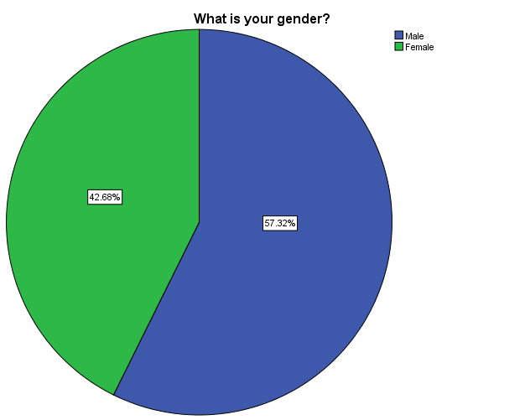
Figure 4.1Sex of respondents

4.3.2 Age of respondents
Table 4.2 Age of respondents
 |  | Frequency | Percent | Valid Percent | Cumulative Percent
Valid | 20-30 | 80 | 51.0 | 51.0 | 51.0
Valid | 31-40 | 40 | 25.5 | 25.5 | 76.4
Valid | 41-50 | 37 | 23.6 | 23.6 | 100.0
Valid | Total | 157 | 100.0 | 100.0
The above Table 4.2 shows 14 (7%) of the respondents are at the age between Under 20, the next responses are the 139 (69.5%) are at age between 20-25 years, the next response are the 39 (19.5%) are at the age between 25-35 years, and last response are the 8 (4%) are at the age of 35 above years. The following figure 4.2 shows the graph of table 4.2.

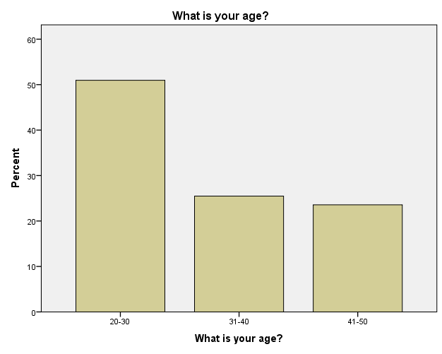
Figure 4.2Age of respondents

4.3.3 Educational Level of respondents
Table 4. 1 Educational Level of respondents
 |  | Frequency | Percent | Valid Percent | Cumulative Percent
Valid | Degree level | 60 | 38.2 | 38.2 | 38.2
Valid | Master level | 90 | 57.3 | 57.3 | 95.5
Valid | Others | 7 | 4.5 | 4.5 | 100.0
Valid | Total | 157 | 100.0 | 100.0
The above table 4.3 shows 109 (54.5%) respondents have bachelor degree, and 91 (45.5%) respondents are the mater degree. The majorities are the bachelor students. The following figure 4.3 shows the graph of table 4.3.
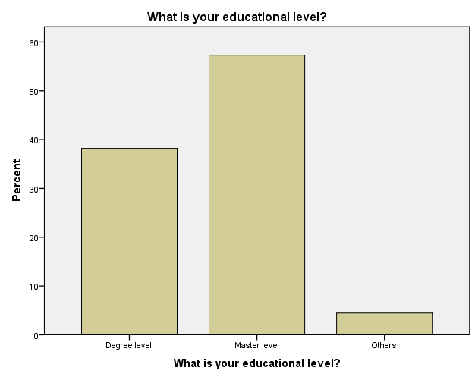

Figure 4.3Educational Level of respondents

4.3.4 marital status respondents
Table 4.4 marital status respondents

 |  | Frequency | Percent | Valid Percent | Cumulative Percent
Valid | Single | 110 | 70.1 | 70.1 | 70.1
Valid | Married | 47 | 29.9 | 29.9 | 100.0
Valid | Total | 157 | 100.0 | 100.0
The above Table 4.1 indicates that the marital status distribution were 110 (70.1%) single and 47(29.9%) married. this indicates the majority of respondents are single. The following figure 4.1 shows the graph of table 4.1

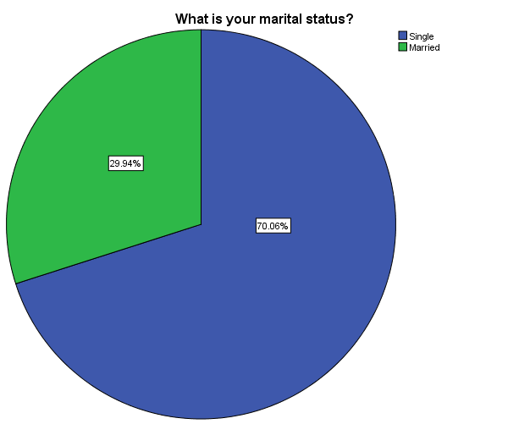
Figure 4. Marital status respondents

4.3.5 Social media site mostly use of respondents
Table 4.5 Social media site mostly use of respondents
 |  | Frequency | Percent | Valid Percent | Cumulative Percent
Valid | Facebook | 37 | 23.6 | 23.6 | 23.6
Valid | Twitter | 10 | 6.4 | 6.4 | 29.9
Valid | Whattsapp | 40 | 25.5 | 25.5 | 55.4
Valid | Viber | 19 | 12.1 | 12.1 | 67.5
Valid | All | 51 | 32.5 | 32.5 | 100.0
Valid | Total | 157 | 100.0 | 100.0
The above table 4.5 shows 37 (23.6%) respondents use Facebook, and next respondents are the 10 (6.4%) response use Twitter, the next respondents are the 40 (25.5%) response use Whattsapp, the next respondents are the 19 (12.1%) response use Viber+ and the last respondents are 51(32.5%) respondents use all social networking sites. The following figure 4.4 shows the graph of table 4.4.

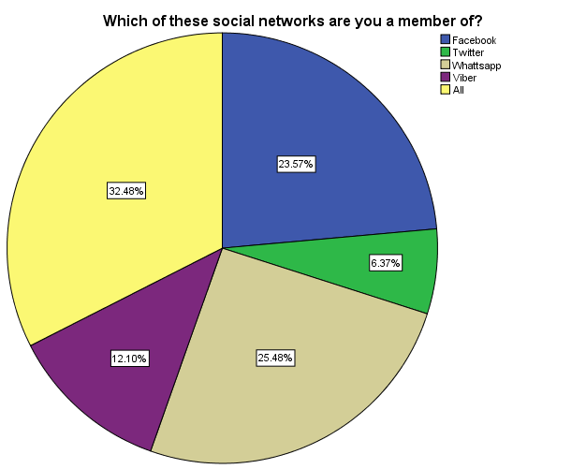
Figure 4.5 Social networking site mostly use of respondents

4.3.6 Years using social media respondents
Table 4.6 years using social media respondents

 |  | Frequency | Percent | Valid Percent | Cumulative Percent
Valid | Less than 2 years | 30 | 19.1 | 19.1 | 19.1
Valid | 3-4 years | 79 | 50.3 | 50.3 | 69.4
Valid | +5years | 48 | 30.6 | 30.6 | 100.0
Valid | Total | 157 | 100.0 | 100.0
Table 4.6 shows 30(19.1%) they use less than 2 years on the social media , and 79(50.3%) they use 3-4years on the social media, and 48(30.6 %) they use +5 years on the social media.

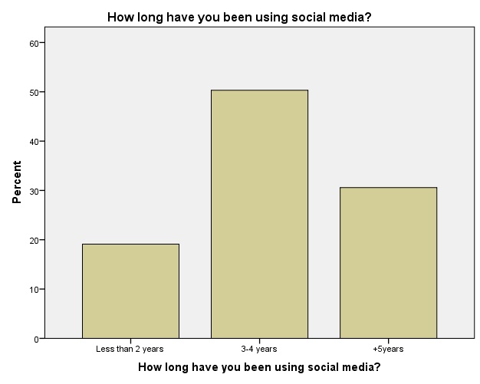

Figure 4.6 years using social media respondents

4.3.7 Times a day do you spend on social media respondents
Table 4.7 Times a day do you spend on social media respondents
 |  | Frequency | Percent | Valid Percent | Cumulative Percent
Valid | 1 hour | 10 | 6.4 | 6.4 | 6.4
Valid | 2-3 hours | 27 | 17.2 | 17.2 | 23.6
Valid | 4-5 hours | 80 | 51.0 | 51.0 | 74.5
Valid | More than 6 hours | 40 | 25.5 | 25.5 | 100.0
Valid | Total | 157 | 100.0 | 100.0

able 4.7 shows 10(6.4%) students spends 1 hours on the social media, and 27(17.2%) students spends 2-3 hours on the social media, and 80(51.0%) spends 4-5 hours on the social media, and 40(25.5%) spends more than 6 hours on the social media

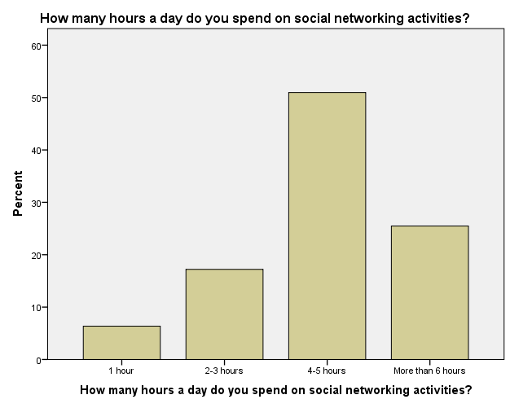
Figure 4.7 Hours a day do you spend on social media respondents

4.3.8 Purpose you using social media respondents
Table 4.8 Purpose you using social media respondents
 |  | Frequency | Percent | Valid Percent | Cumulative Percent
Valid | Social | 70 | 44.6 | 44.6 | 44.6
Valid | Academic | 61 | 38.9 | 38.9 | 83.4
Valid | Games | 26 | 16.6 | 16.6 | 100.0
Valid | Total | 157 | 100.0 | 100.0
Table 4.8 shows 70 (44.6) students use social media for social, and 61(38.9) students’ uses for academic, and 26(16.6) students uses social media games.

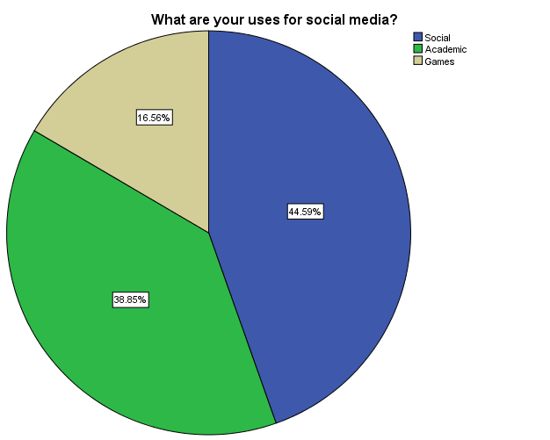
Figure 4.8 Purpose you using social media respondents

4.3.9 Social media gives a useful platform for education group work respondents
Table 4.9 Social media gives a useful platform for education group work respondents
 |  | Frequency | Percent | Valid Percent | Cumulative Percent
Valid | Strongly agree | 70 | 44.6 | 44.6 | 44.6
Valid | Agree | 50 | 31.8 | 31.8 | 76.4
Valid | Strongly disagree | 10 | 6.4 | 6.4 | 82.8
Valid | Disagree | 27 | 17.2 | 17.2 | 100.0
Valid | Total | 157 | 100.0 | 100.0
The above Table 4.9 shows 70(44.6%) of students strongly agree using social media provides a useful platform for academic group work, and 50(31.8%) of students agree, and 10(6.4%) of studentsstrangle disagree, and 27(17.2%) of students disagree

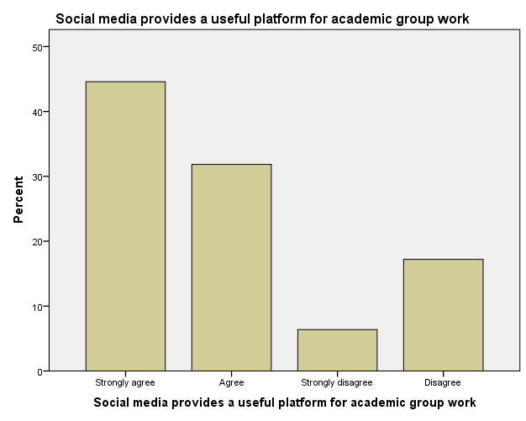
Figure 4.9 Social media gives a useful platform for academic group work respondents

4.3.10 social media to connect with presenters for education purposes respondents
Table 4.10 social media to connect with lecturers for education purposes respondents
 |  | Frequency | Percent | Valid Percent | Cumulative Percent
Valid | Strongly agree | 80 | 51.0 | 51.0 | 51.0
Valid | Agree | 40 | 25.5 | 25.5 | 76.4
Valid | Strongly disagree | 10 | 6.4 | 6.4 | 82.8
Valid | Disagree | 27 | 17.2 | 17.2 | 100.0
Valid | Total | 157 | 100.0 | 100.0

The above Table 4.10 shows 80(51.0%) of students strongly agree usesocial media to communicate with lectures for academic purpose, and 40(25.5%) of students agree, and 10(6.4%) of students strangle disagree, and 27(17.2%) of students disagree

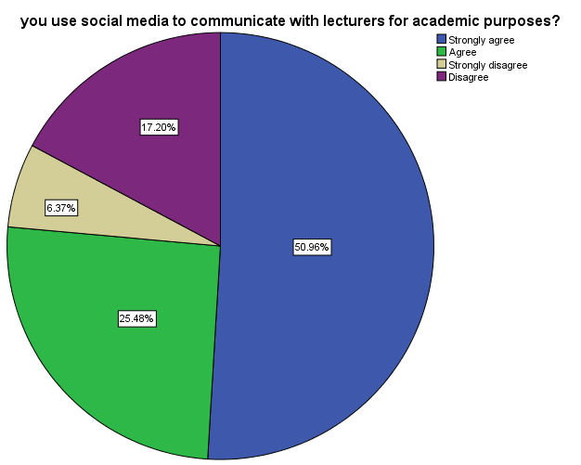
Figure 4.10 social media to communicate with lecturers for academic purposes respondents

4.3.11 Lectures should growth and encourage the use of social media sites in the classroom respondents
Table 4.11 Lectures should growth and encourage the use of social media sites in the classroom respondents
 |  | Frequency | Percent | Valid Percent | Cumulative Percent
Valid | Strongly agree | 10 | 6.4 | 6.4 | 6.4
Valid | Agree | 7 | 4.5 | 4.5 | 10.8
Valid | Strongly disagree | 80 | 51.0 | 51.0 | 61.8
Valid | Disagree | 60 | 38.2 | 38.2 | 100.0
Valid | Total | 157 | 100.0 | 100.0

The above Table 4.11 shows 10(6.4%) of students strongly agree, and 7(4.5%) of students agree, and 80(51.0%) of students strangle disagree, and 60(38.2%) of students disagree

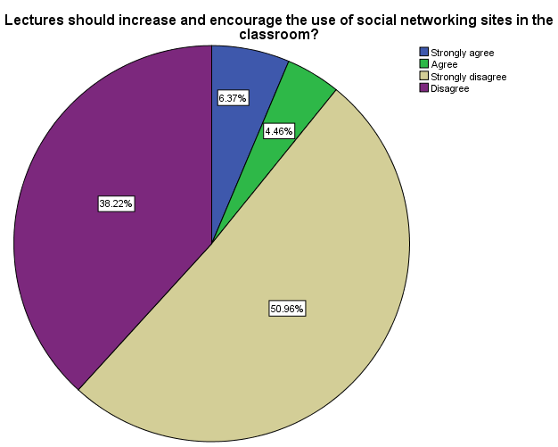
Figure 4.11 Lectures should increase and encourage the use of social networking sites in the classroom respondents

4.3.12 Sharing notes or information about lectures via social media leads to many students thinking they do not have to attend lectures respondents
Table 4.12 Sharing notes or information about lectures via social media leads to many students thinking they do not have to attend lectures respondents
 |  | Frequency | Percent | Valid Percent | Cumulative Percent
Valid | Strongly agree | 50 | 31.8 | 31.8 | 31.8
Valid | Agree | 60 | 38.2 | 38.2 | 70.1
Valid | Strongly disagree | 20 | 12.7 | 12.7 | 82.8
Valid | Disagree | 27 | 17.2 | 17.2 | 100.0
Valid | Total | 157 | 100.0 | 100.0

The above Table 4.12 shows 50(31.8%) of students strongly agree, and 60(38.2%) of students agree, and 20(12.7%) of students strangle disagree, and 27(17.2%) of students disagree

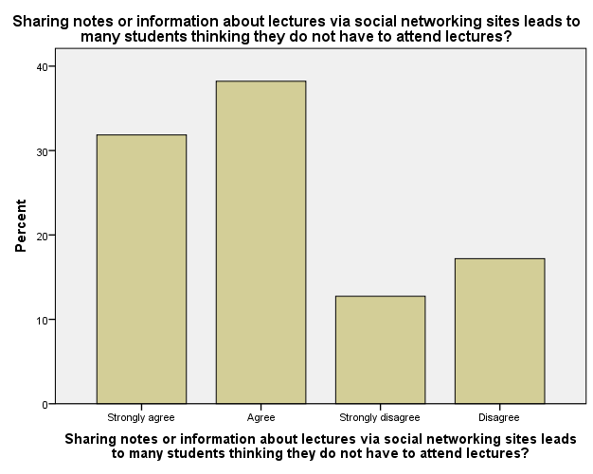
Figure 4.12 Sharing notes or information about lectures via social media leads to many students thinking they do not have to attend lectures respondents

4.3.13. Using social media while doing assignments harmfully impact the quality of your work respondents
Table 4.13 Using social media while doing assignments harmfully impact the quality of your work respondents
 |  | Frequency | Percent | Valid Percent | Cumulative Percent
Valid | Strongly agree | 70 | 44.6 | 44.6 | 44.6
Valid | Agree | 50 | 31.8 | 31.8 | 76.4
Valid | Strongly disagree | 27 | 17.2 | 17.2 | 93.6
Valid | Disagree | 10 | 6.4 | 6.4 | 100.0
Valid | Total | 157 | 100.0 | 100.0

The above Table 4.13 shows 70(44.6%) of students strongly, and 50(31.8%) of students agree, and 27(17.2%) of students strangle disagree, and 10(6.4%) of students disagree

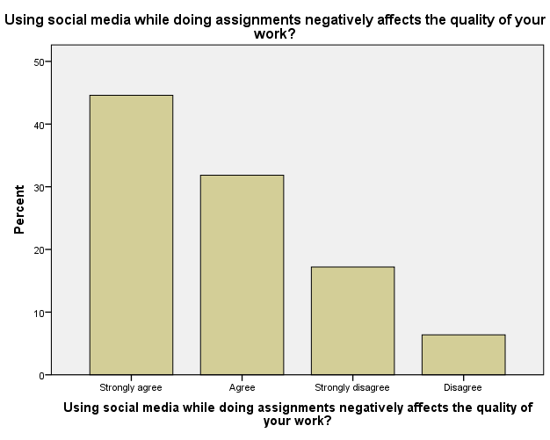
Figure 4.13 Using social media while doing assignments negatively affects the quality of your work respondents

4.3.14 relationship between student’s education performance and social media implementation and use respondents
Table 4.14 relationship between student’s education performance and social media implementation and use respondents
 |  | Frequency | Percent | Valid Percent | Cumulative Percent
Valid | Strongly agree | 70 | 44.6 | 44.6 | 44.6
Valid | Agree | 40 | 25.5 | 25.5 | 70.1
Valid | Strongly disagree | 20 | 12.7 | 12.7 | 82.8
Valid | Disagree | 27 | 17.2 | 17.2 | 100.0
Valid | Total | 157 | 100.0 | 100.0

The above Table 4.14 shows 70(44.6%) of students strongly agree, and 50(31.8%) of students agree, and 20(12.7%) of students strangle disagree, and 27(17.2%) of students disagree
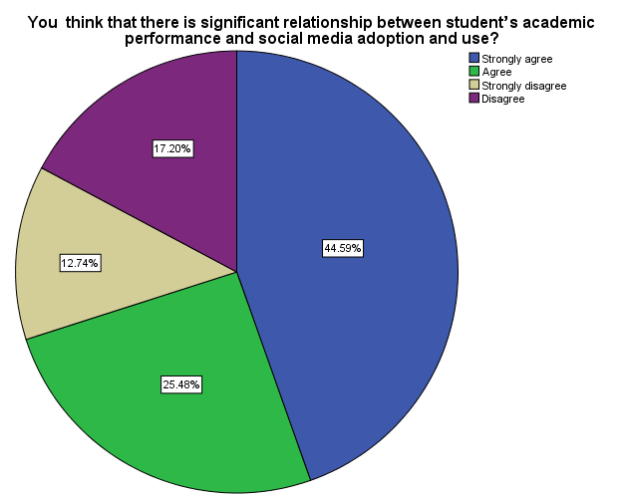
Figure 4.14 relationships between student’s academic performance and social media adoption and use respondents

4.3.15 social media has impact your academic performance harmfully respondents
Table 4.15 social media has affected your academic performance negatively respondents
 |  | Frequency | Percent | Valid Percent | Cumulative Percent
Valid | Strongly agree | 80 | 51.0 | 51.0 | 51.0
Valid | Agree | 30 | 19.1 | 19.1 | 70.1
Valid | Strongly disagree | 20 | 12.7 | 12.7 | 82.8
Valid | Disagree | 27 | 17.2 | 17.2 | 100.0
Valid | Total | 157 | 100.0 | 100.0
The above Table 4.10 shows 80(51.0%) of students strongly agree, and 30(19.1%) of students agree, and 20(12.7%) of students strangle disagree, and 27(17.2%) of students disagree

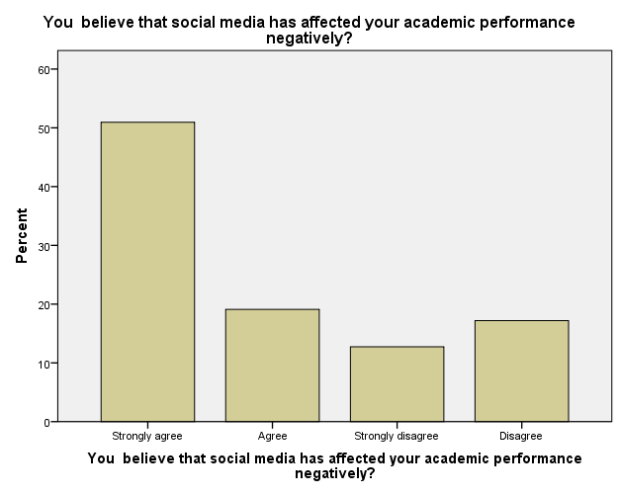

Figure 4.15 social media has affected your academic performance negatively respondents

4.3.16 social media is a disruption to your academic learning actions respondents
Table 4.16 social media is a distraction to your academic learning activities respondents
 |  | Frequency | Percent | Valid Percent | Cumulative Percent
Valid | Strongly agree | 70 | 44.6 | 44.6 | 44.6
Valid | Agree | 60 | 38.2 | 38.2 | 82.8
Valid | Strongly disagree | 17 | 10.8 | 10.8 | 93.6
Valid | Disagree | 10 | 6.4 | 6.4 | 100.0
Valid | Total | 157 | 100.0 | 100.0

The above Table 4.16 shows 70(44.6%) of students strongly agree, and 60(38.2%) of students agree, and 17(10.8%) of students strangle disagree, and 10(6.4%) of students disagree
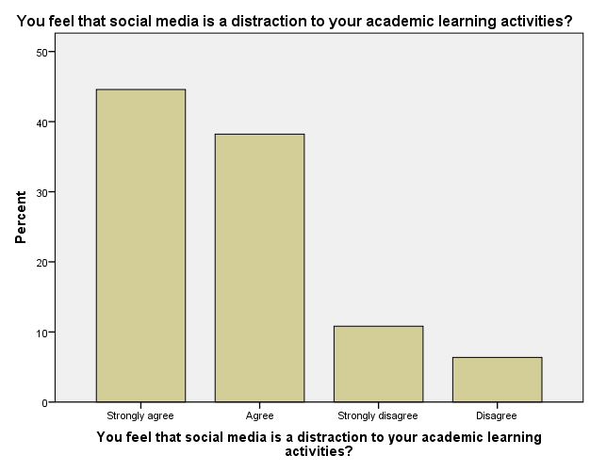

Figure 4.16 social media is a distraction to your academic learning activities respondents

4.3.17 social media sites impact your study timings respondents
Table 4.17 social media sites affect your study timings respondents
 |  | Frequency | Percent | Valid Percent | Cumulative Percent
Valid | Yes | 120 | 76.4 | 76.4 | 76.4
Valid | No | 37 | 23.6 | 23.6 | 100.0
Valid | Total | 157 | 100.0 | 100.0

Table 4.17 shows 120(76.4) students have effects on their study time using social media they say yes, and 37(23.6) have no effects on their study time using social media they say no.
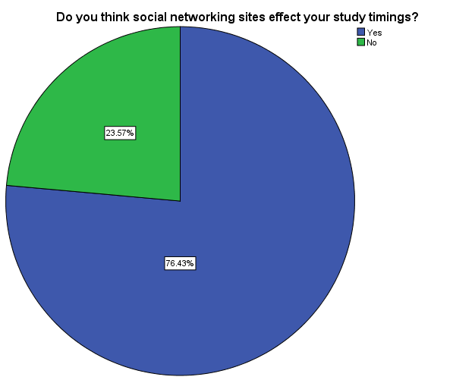

Figure 4.117 social media sites affect your study timings respondents

4.3.18 you think social media is important respondents
Table 4.18 you think social networks is important respondents
 |  | Frequency | Percent | Valid Percent | Cumulative Percent
Valid | Yes | 100 | 63.7 | 63.7 | 63.7
Valid | No | 57 | 36.3 | 36.3 | 100.0
Valid | Total | 157 | 100.0 | 100.0
Table 4.17 shows 100(63.7) yes, and 37(23.6) no

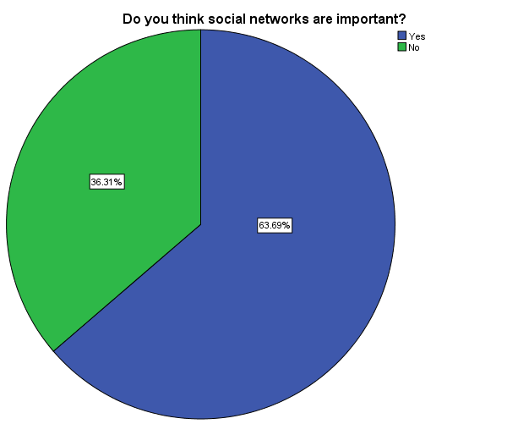

Figure 4. 18 you think social networks is important respondents
.

CHAPTER FIVE

SUMMARY OF THE STUDY, CONCLUSION ANDRECOMMENDATIONS

5.1 INTRODUCTION
This chapter includes discussion on outcome and research finding in previous chapter. Also recommendation will be given in this chapter to launch a superior study in advance study or research and conclusion about the impact of social media on academic performance students in Daffodil international university(DIU) from the findings lastly I will suggest recommendation of this study and areas future research.

5.2 Summary of the Study
Events on the Internet do not mean single period of playing online game but examining homework material and other information about almost anything in mere moments. Also Internet activities, teenagers involve in other activities such as leisure events, family happenings, public activities, university activities, outside activities and etc

5.2.1 Social media site regularly use of respondents
shows 37 (23.6%) respondents use Facebook, and next respondents are the 10 (6.4%) response use Twitter, the next respondents are the 40 (25.5%) response use Whattsapp, the next respondents are the 19 (12.1%) response use Viber + and the last respondents are 51(32.5%) respondents use all social networking sites

5.2.2 How extended have you been using social media?
Table 4.6 shows 30(19.1%) they use less than 2 years on the social media , and 79(50.3%) they use 3-4years hours on the social media, and 48(30.6 %) they use 5+years or more on the social media.

5.2.3 How many hours a day do you spend on social media doings?
able 4.7 shows 10(6.4%) students spends 1 hours on the social media, and 27(17.2%) students spends 2-3 hours on the social media, and 80(51.0%) spends 4-5 hours on the social media, and 40(25.5%) spends more than 6 hours on the social media

5.2.4 you use social media to connect with presenters for academic purposes?
The above Table 4.10 shows 80(51.0%) of students strongly agree usesocial media to communicate with lectures for academic purpose, and 40(25.5%) of students agree, and 10(6.4%) of students strangle disagree, and 27(17.2%) of students disagree

5.2.5 Lectures should growth and encourage the use of social networking sites in the classroom?
The above Table 4.11 shows 10(6.4%) of students strongly agree, and 7(4.5%) of students agree, and 80(51.0%) of students strangle disagree, and 60(38.2%) of students disagree

5.3 Conclusion
This research displayed that, using social media have negative effects on students, sidetracking students from their academic work, taking most of their productive time, and such like, they also have benefits and can be used suitably.

5.4 Recommendation
In the light of the findings of this study, the following recommendations are made
1. Students should be cultured using of social media overtime can influence their academic performance.
2. Teachers should give more advice every time to the students to reduce the amount of time spending in social media
3. Lecturers should confirm they use the social media as a tool to increase the education

References
{1 )Kuppuswamy, S., & Narayan, P. (2010). The Impact of Social Networking Websites on the Education of Youth. International Journal of Virtual Communities and Social Networking (IJVCSN), 2(1), 67-79.
2 Brydolf, C. (2007). Minding My Space: Balancing the benefits and risks of students’ online social networks. Education Digest, 73(2), 4
3 Ferdig, R. E. (2007). Editorial: Examining Social Software in Teacher Education. Journal of Technology and Teacher Education, 15(1), 5.
[4] Joseph oye oyetunde, Influence of Facebooking and Social Media Use on Academic Performance among Nigerian Undergraduate Social Sciences Students, February 2017.
[5] Md. Armanul Haque, social and academic use of internet by the graduate students in Finland and Bangladesh, November 2015.
[6] Heffner, Tara, the effects of social media use in undergraduate students, 2016.
[7] Aida Abdulahi, a Study on the Negative Effects of Social Networking Sites Such as Facebook among Asia Pacific University Scholars in Malaysia, September 2014.
[8] Peter Osharive, social media and academic performance of students, January 2015.
[9] Wan Roslina Wan Othman, Ziti Fariha Mohd Apandi, Nurul Haslinda Ngah, Impact of Social Media Usage on Students Academic Performance in Terengganu, Malaysia, 2017.
[10] Isaac m. morallo the effects of social networking sites on students’ academic performance in lyceum of the Philippines – laguna, 2014.
[11] Adebiyi Ayodele, Akinbode Mosunmola, Social Networking and Students' Academic Performance: the Role of Attention Deficit,Predictors of Behavior and Academic Competence, 2015.

APPENDIX

QUESTIONNAIRES
- What is your sex?
- Male
- Female
- What is your age?
- 20__30year
- 31__40 years
- 41__50years
- Above 51 years
- What is your educational level?
- Degree level
- Master level
- Others
- What is your marital status?
- Single
- Married
Section B: Questions related the adoption of cloud computing on higher education

- Which of these social media are you a fellow of?
A: Facebook
B: Twitter
C: whattsapp
D: viber
E: All

How extensive have you been using social media?

A: under 2 year

B: 3-4 year

C: 5+ year

How many times a day do you apply on social media doings?

A: 1 hours

B: 2-3 hours

C: 4-5 hours

D: more than 6 hours

8 which purpose are your uses for social media?
- social
- academic
- games

9 Social media offers a useful stage for academic group work?
A: Strongly Agree
B: Agree
C: Strongly Disagree
D: Disagree

10 you use social media to connect with lecturers for education purposes?

A: Strongly Agree
B: Agree
C: Strongly Disagree
D: Disagree

11 Lectures should growth and encourage the use of social media sites in the classroom?
A: Strongly Agree
B: Agree
C: Strongly Disagree
D: Disagree

12 Sharing records or information about lectures via social media sites leads to many students thinking they do not have to attend lectures?

A: Strongly Agree
B: Agree
C: Strongly Disagree
D: Disagree

13. Spending social media while doing assignments harmfully affects the quality of your work?

A: Strongly Agree
B: Agree
C: Strongly Disagree
D: Disagree

14.you think that there is important relationship between student’s academic performance and social media adoption and use?

A: Strongly Agree
B: Agree
C: Strongly Disagree
D: Disagree

15. you trust that social media has impact your academic performance harmfully?

A: Strongly Agree
B: Agree
C: Strongly Disagree
D: Disagree

16. You feel that social media is a disturbance to your academic learning activities?
A: Strongly Agree
B: Agree
C: Strongly Disagree
D: Disagree

17 Do you think social networking sites impact your study timings?
A: Yes
B: No

18 Do you think social networks are important?
A: Yes
B: No

