

Internship report on
The Present Scenario of English Language Teaching in Bangladeshi School

Submitted by:
Name: Tashnuva Khanom Nishat
ID: 151-10-1160
Batch: 34th
Course Title: Project paper
Course Code: ENG- 334

Submitted to:
Asma Alam
Assistant Professor
Department of English
Faculty of Human and Social Science
Daffodil International University
Date of Submission:

Terms of Reference

For completion of the course Project Paper ENG-334, I was asked by supervisor Asma Alam Ma’am to visit a school and compile an internship report on the present scenario of English language teaching in Bangladesh.

….…………………………….

Name: Tashnuva Khanom Nishat
Programme : B.A (Hon’s) in English
ID : 151-10-1160
Batch : 34th
Department of English
Daffodil International University.

ii

Daffodil International University

Certificate to Approval

I am pleased to certify the Internship Report on “The present scenario of English language teaching in Bangladesh” conducted by Tashnuva Khanom Nishat, ID: 151-10-1160 of the department of English has been approved for viva-voce. She completed her tasks under my supervision during the Fall Semester 2018. I am pleased to certify that her work is an authentic work. I strongly recommend her work for viva-voce. It was indeed a great pleasure working with her. I wish her every success in life.

….……………………….

Asma Alam,
Assistant Professor,
Daffodil International University.

iii
Acknowledgement

I would like to express my special thanks and gratitude to my supervisor Asma Alom Ma’am, who helped me a lot to do this project. Obviously I am thankful to the Headmaster A.S.M. FEROZ of New Model Multilateral High School to give me the golden opportunity to take class in his school. I would like to give thanks others three English teachers Osman Bin, Mamunur Rashid and Md Mahmudul Hasan , who permitted me to observe and take their class. I also thankful to my parents, for whom today I am here and they are too much supportive to do this task and every sphere of my life.

Iv

Abstract

The topic of my internship was on “The Present Scenario of English Language Teaching in Bangladeshi School”. To complete or fulfill the internship I had to take permission from a school where I observed and took three classes of the different teachers. My supervisor gave me all the important instructions. Most of the information had been taken by Helal Uddin Chawdhury, TR of that school. I observed three classes and they helped me to make my lesson plan. They also supported me take the classes without being nervous. From my observation I found that in every classes English is using for academic purpose rather than a language. For that reason, most of the students continue memorization and can’t adopt the language. English is also a matter of fear for them. The system should be changed for the betterment of the students. However I have done my internship with honesty to find out the present scenario of English Language Teaching in Bangladeshi School.

V
Table of Content
Contents | Page
Deceleration by students | II
Certificate | III
Acknowledgement | IV
Abstract | V
Table of contents | vi
Chapter-1: Introduction | 1
Chapter-2: Objectives | 2
Chapter-3: Methodology | 2
Chapter-4: Institution details. | 3
Chapter-5: Class Observation Report | 4-6
Chapter-6: Teaching Experience | 7-9
Chapter-7: Recommendations | 10
Chapter-8: Conclusion | 11

Appendices

Appendix-1: Class Observation Checklist | 13-21
Appendix-2: Certificate of Internship | 22
Appendix-3: Photographs | 23-24

vi
Nishat-1
Introduction

The English language has great reach and English is taught all over the world. Language teaching practice often assumes that most of the difficulties that learners face in the study of English are consequence of the degree to which their native language differs from English. Teaching English properly as a second language is very important. Teaching English is not only helping the students to use the form of English but also exposure to regional forms and cultural styles. In this way, students will be able to discern meaning even when words, grammar or pronunciation are different from the form of English they are being taught to speak. In our country, Bengali is our mother tongue. English is not spoken language but it is an official language in Bangladesh. For that reason learners find difficulty in using English language fluently. Teacher try to help learners to improve their English but most of the cases learners can’t overcome this fear. That’s why many of the students memorize and get good marks but they cannot use English in a proper way. If we can change the system a little bit of English language teaching I think learners will be more benefitted.

Nishat-2

Objectives:

The objectives of the proposed internship are:

- To know the current scenario of language teaching in a Bangladeshi school.
- To learn and apply methods and techniques in actual classroom.
- To identify the impacts among the students of applying methods and techniques.

Methodology:

The methods I have followed, given below step by step:
- First of all I selected a school named New Model Multilateral High School.
- Then I selected three classes which are class six, seven and nine.
- After that I observed three English classes of three different teachers and followed how they use techniques and methods.
- By defining their checklist I made three lesson plan for three classes.
- I tried to take the whole class in English.
- I gave time for warm up, student participation, group discussion.
- Finally I made correction their task.
- I asked about their problem and if they find any difficulty then I gave feedback.
- I also took some comments from both students and teachers about my performance.

Nishat-3
Background of the school:

New Model Multilateral High School is a well known and traditional educational institution. The school was established in 1968 and EIIN-108234. The educational institution is situated in a pleasant environment on the East side of Russell Square adjacent to the center of Dhaanmondi lake in Dhaka-1207. According to the 2011 the establishment has been upgraded to (A) grade educational institute. In the year 1968 it started it’s journey in the seminar of Green Road, on the occasion of “Noakhali Samity” in Dhaka. It later emerged as a full-time school in a rented house adjacent to the Green Road Stuff Quarter.

This school has three beautiful buildings, one of which is currently designated by Director of Educational Engineer. Each class of the institution is suitable for orbital, attractive and well decorated. In addition to this, there is a modern computer lab equipped with laptops and multimedia projects. In the light of current education system, an advanced an advanced institution to make students suitable for modern methods. There is well-equipped multimedia class room with information and technology to make learning time-consuming and modern. The school operated on two shifts. The morning shift is for both boys and girls from class Nursery the five and only for girls from class VI to X. The day shift is only for boys of class Six to ten. The dress color for the girls is pink and for the boys is white.

Nishat-4

Class observation 1

At the begging of my class observation, I went to class-9 ( Section - Shoptodinga ) on 6 October 2018. It was a class on English I and teacher was Osman Bin. He was very kind hearted person and obviously knowledgeable person. First of all he introduced me with the students and students also welcomed me. Then he called roll of the students. The class started at 10 am. On that day his topic was dialogue. He started his class with the definition of dialogue. Then he gave his lesson on dialogue about food adulteration and importance of reading newspaper. After that he engaged students in pair work for practicing dialogues and to present their work before others. Students were enjoying their class because teacher was giving examples from our practical life. Some students are naughty and classroom was big. So it was tough to maintain the classroom. But Sir had extra-ordinary controlling power and so he could manage this issue very easily. He didn’t feel disturbed for students attitude rather he was very friendly. There was a good rapport between the teacher and the students. As it was a Bengali medium school teacher used Bangla in the classroom for better understanding of the students. Teacher's voice is clear and sharp. He could give a complete sense about the topic and gave various tasks to the students. Students also achieved the knowledge about the topic and successfully completed their tasks. Finally he gave homework and thus finished the class.

Teacher Name | Osman Bin
Class | Nine
Number of Students | 32
Class duration | 35 minutes
Class time | 10:00am-10:35am
Room Number | 323
Subject | English 1st paper
Topic of lesson | Dialogue

Nishat-5

Class observation-2

The second class was on English second paper and the name of the section was ‘Dhumketu’ of class six and it was October 6, 2018. Total number of students was 34 and the room number was 306. This class started at 11a.m. The teacher Mamunur Rashid taught conditional sentence in this class. The teacher has very strong personality. He is very famous in his classroom as well as in the school. He has excellent communicative skill. He entered into his class saying Good Morning to all his students. Then he asked them some personal questions to make them easy and to grab their attention. After that informal conversation, he started his lecture on conditional sentence. He started his discussion with the definition of different types of conditional sentences. He started with zero conditional sentence then first, second and third conditional sentences. He gave all the examples which are connected to our practical life, like: When we heat ice, it melts. Then he gave tasks of writing examples of different types of conditional sentences. They wrote down. Teacher checked answer scripts and gave feedback. At the time of his delivering lecture, he focuses not only on writing but also speaking and others skills. Thus he ended his class. He delivered his lecture mostly in English and used Bangla very often. From the activities, interaction and attitude it is very clear that his knowledge of English Grammar is very rich. He teaches in such a lucid way that students hardly faced any difficulty to understand his lecture. He is very friendly and free with his students and they also respect him from their heart.

Teacher Name | Mamunur Rashid
Class | Six
Number of Students | 34
Class duration | 35 minutes
Class time | 11:00am-11:35am
Room Number | 306
Subject | English 2nd paper
Topic of lesson | Condition Sentence

Nishat-6

Class observation-3

On 6 October 2018 I went to class-seven (section- Niharika). Room number was 309 and number of students was 44. It was a class of English 1st part and teacher was Md. Mahmudul Hasan. His knowledge and skill was clearly reflected through his lecture. He taught Unit one , Lesson 1: Prize-giving day at school. He started his class at 2pm. He started his class wishing the students good afternoon. Then he started his lecture on his topic prize giving day. His use of English was up to the mark He read line by line of the whole passage and then translated it to Bengali. He summarized the main idea of the lesson. His eye contact was good but voice was not so loud to reach all students. There was not any strong interaction with students. He did not ask any question to the students and students did not ask him anything. The last 5minutes was spent connecting the practical instance of prize giving day of their school. Thus the teacher finished his class.

Teacher Name | MD. Mahmudul Hasan
Class | Seven
Number of Students | 44
Class duration | 35 minutes
Class time | 2:00pm-2:35pm
Room Number | 309
Subject | English 1st paper
Topic of lesson | Prize giving day at school

Nishat-7
Time | Task | My activities | Students activities | Evaluation
5 minutes | Warm up | I asked about their hobbies. | Listen and respond to the questions. | We got information about ourselves.
5minutes | Demo | I used textbook to read passage | Students listen and asked questions | Students took notes on vocabulary.
10 minutes | Practicing dialogue | I gave hints to write a dialogue | Students wrote dialogues | Students analyzed &I checked it
10 minutes | Writing short notes | Showing video | They discussed and made short notes. | Student examined & I checked it.
5 minutes | Review | I asked students if they had any questions? | Students had respond | Students spoke and I made the correction

Class experience-1
First of all I would like to share my lesson plan:

On 7th October 2018, I went to class-seven (section-Niharika). The room number was 309 and number of students was 40. First of all I went to the school to meet with the class teacher Md Mahmudul Hasan. He gave me permission to take his class. The class started at 11am. Both of us entered into the classroom and the students stood up and wished us “Good Morning”. The class teacher introduced me to the students and said I would take his class as a teacher. Then he took the attendance of that day. First of all I introduced myself. To create a friendly environment I asked them about their hobbies and received varieties of answers. Usually they like to play outdoor games, reading, painting and many other things. Then I took the text book English for today and opened Unit-3. The topic was “What are friends for?” Before starting the topic I asked about their friends. After that I read out the text loudly and gave easy English synonyms of difficult English words. Students took notes on vocabulary. Then I gave them task of making conversation between two friends then I gave corrections. Then I showed a short video including this topic. After that I asked some short questions and I corrected their answers. By giving thanks I finished my class at 11:35am.

Nishat-8
Class experience-2

The lesson plan of my second class was:
Time | Task | My activities | Students activities | Evaluation
5 minutes | Warm up | I asked about their name, place of origin etc. | They respond to the questions. | Teacher & students interaction.
5minutes | Tense | I asked them what they know about tense. | Students respond. | They had basic idea about tense.
10 minutes | Practicing | I gave some examples of different kinds of tense. | Students listen and also gave some examples. | They got more idea about tense.
10 minutes | Writing part | Writing down 10 sentences. | They wrote down. | It helped to develop their writing skill.
5 minutes | Review | I checked script and askedstudents if they had any questions. | Students are respond | Students spoke and I made the correction

After completing first class, I went to Mamunur Rashid Sir. He permitted me to take his class. My second class was on English 2nd paper. It was with the students of class-9, section: Shoptodinga. The date was October 7, 2018 and total number of students was 40. Just like the first class we entered into the class at 11:45am. He introduced me as their teacher of that day and he took the attendance. Then I asked their name, birth place etc. I got their information then I started the topic “Tense”. Then I asked some questions like definition and examples of tense. They have the basic idea about tense. Then I discussed about different kinds of tense. I also gave some practical examples. That’s why they got more idea about the topic. After that I gave them the task of writing ten sentences. They wrote it down. Then I told them one by one to speak out their answers and then I made their correction. Last of all I asked them that if they had any questions? By giving the answers I left the class and said “Good Bye” to all of them at 12:20pm.

Nishat-9
Class experience-3

The lesson plan of my third class was:
Time | Task | My activities | Students activities | Evaluation
5 minutes | Warm up | I asked about their aim in life. | They respond to the questions. | Teacher& students interaction.
5minutes | Article | Asked them what they know about article. | Students respond. | They had very little idea about article.
10 minutes | Practicing | I gave some clues of different use of articles.. | Students listen. | They got more idea about article.
10 minutes | Group discussion | I made six groups and gave them task of giving examples. | They wrote down and made discussion. | It will help to develop their writing and speaking skill.
5 minutes | Review | I checked scripts and asked every groups if they had any questions. | Students had respond | Students spoke and I made the correction

It was my last class. I took permission from Osman Bin Sir. I went to class-6 (section- Dhumketu). He introduced me with his students and called roll of the students. Total number of the students were 44 and room number was 309. The date was 7th October 2018. I started my class at 12:30pm. First of all I asked about themselves and their aim in life. I found different types of answers from them for example- they wanted to become teacher, doctor, scientist and many other things. Then I asked them what they know about article? Actually they have very little idea about article. Then I gave definition and some practical examples about article. After that dividing them into six groups I asked each group to write down 10 examples of article. All the groups wrote down after discussion. Then I checked all the scripts and gave back them. I left the classroom giving thanks to them. They also invited me to go to their class again.
Nishat-10

Overall findings:
To have an internship in a school I find a great opportunity to see the present scenario of English language teaching. When I observed classes I found that in the way students were learning English, was a long process of speaking fluently as a language. Not only that but also our educational system depends on memorization. Teaching language in a practical way is very rare. However here I am introducing my opinion what overall I have found:
- Teachers only focus on text books not language learning.
- They have hurry to complete the syllabus only before exam.
- Student also worried about how to get more marks.
- For getting marks they select the way of memorization.
- Teachers gives less focus on listening and speaking skills.
- In an English class most of the time they use Bengali.
- Teachers use Grammar Translation Methods in actual classroom.
- Weak students feel shy and never participates in the classroom.
- Most of the classes’ teachers only give lecture and students just listen.
- Teachers sometimes cannot keep the attention of the students.

Nishat-11

Recommendation / Scope for further improvement:
The environment of the school is good. The school is well organized and teachers are well educated. They are very co operative to the students. They are trying their best to maintain quality of study give proper education to the students. From my point of view a little bit improvement is needed and my suggestions have been given below:

- Teachers should emphasis more on learning English as a language rather than a subject.
- Teachers should give practical knowledge.
- They should create friendlier environment for not feeling shy to the students.
- They should increase language learning programme like debating, reading newspaper, practicing listening, participating writing competitions etc.
- They should show the students video and pictures for better understanding.
- Student should given scopes for participating in classroom.
Sometimes teacher should teach outside of the texts, that’s why students can think out
of the box.

Conclusion:

Education is an essential part to develop a country. Bengali is our mother tongue. For that reason we use less English for our everyday communication. But, as a foreign and second language English plays an important role. There is no alternative way of learning English for worldwide communication. So if we continue teaching and learning English in a traditional way, we can’t use this language in a proper way. So, by using updated ways, methods and techniques it will be more effective.

Nishat-12
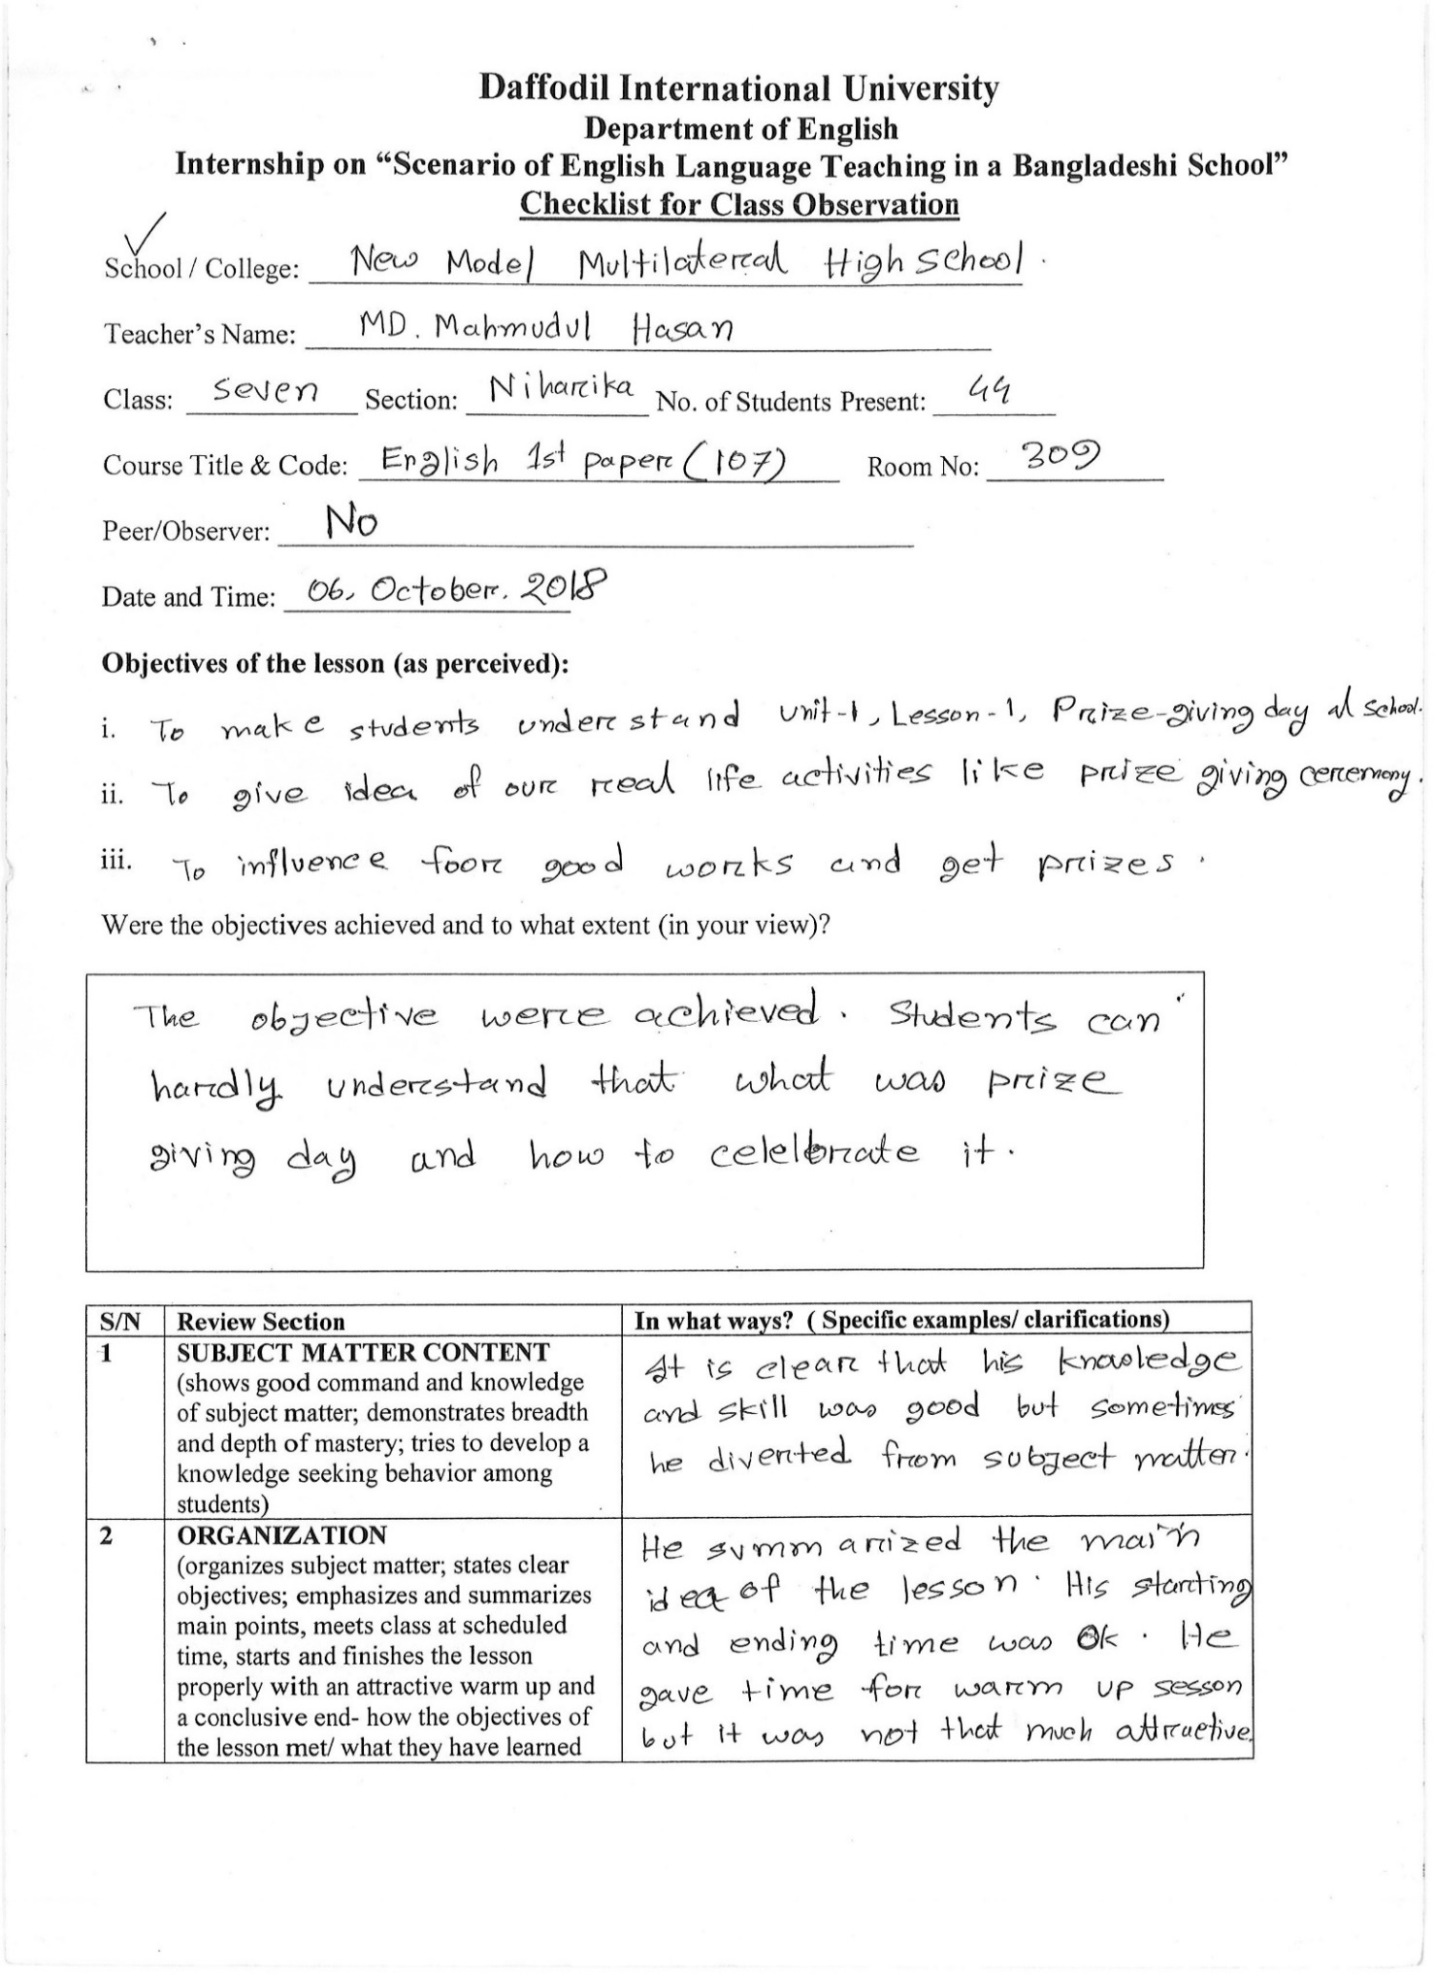

Nishat-13
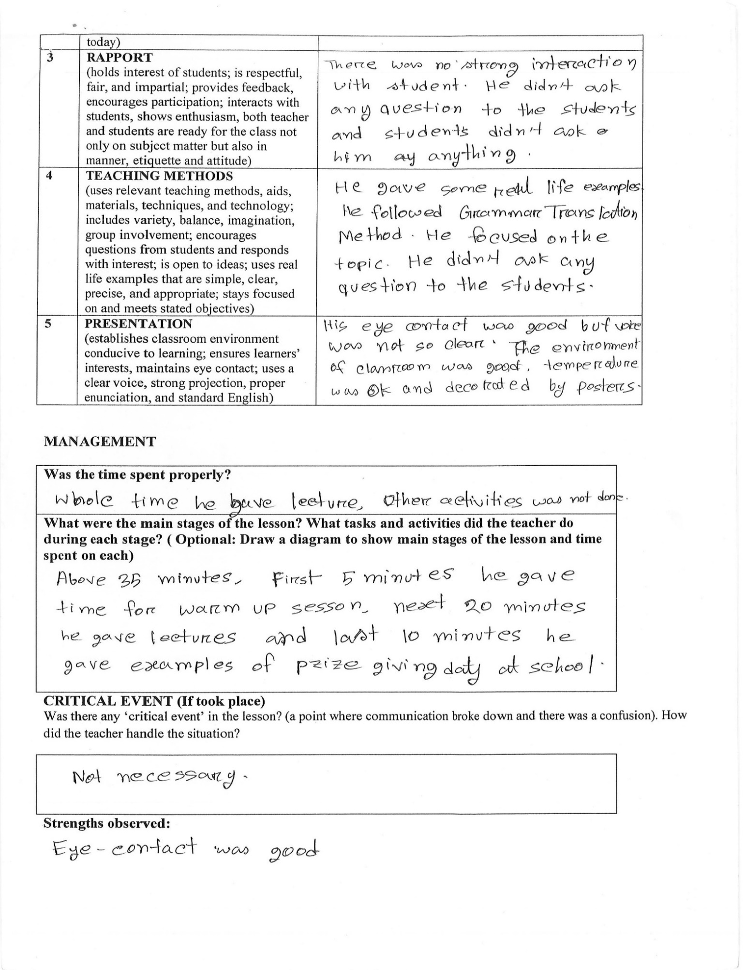

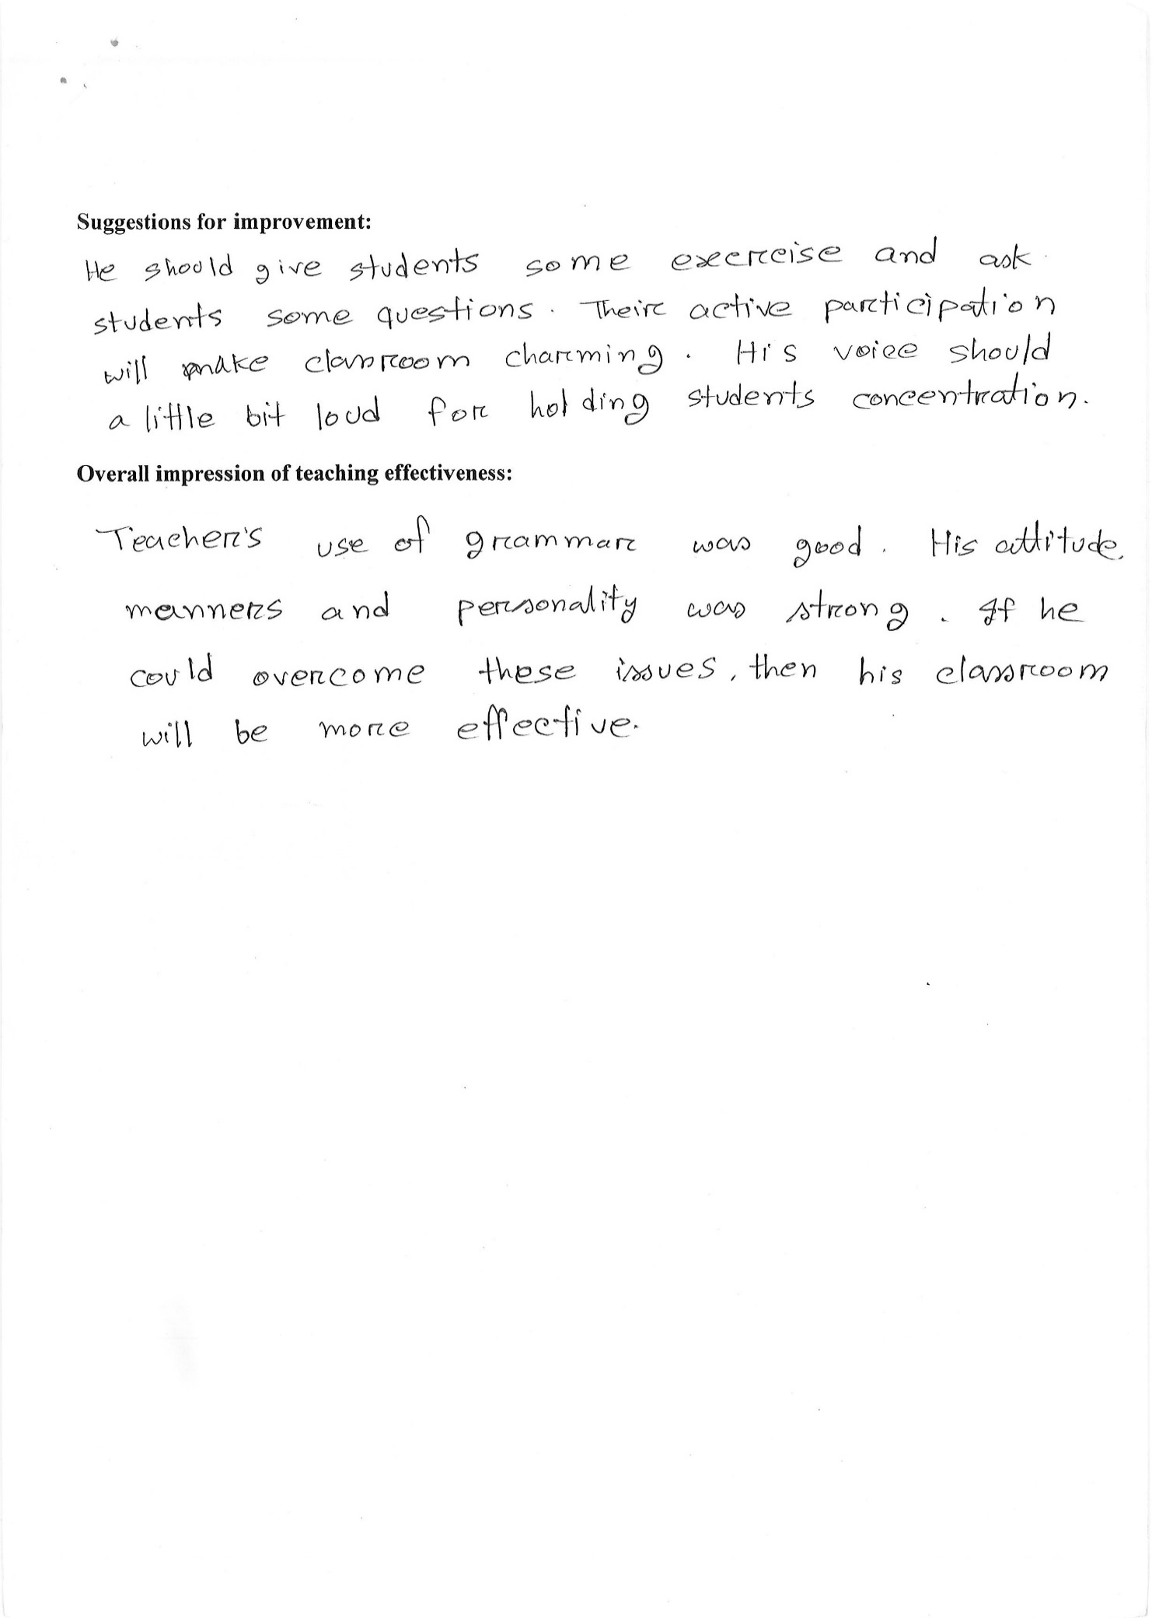
Nishat-14

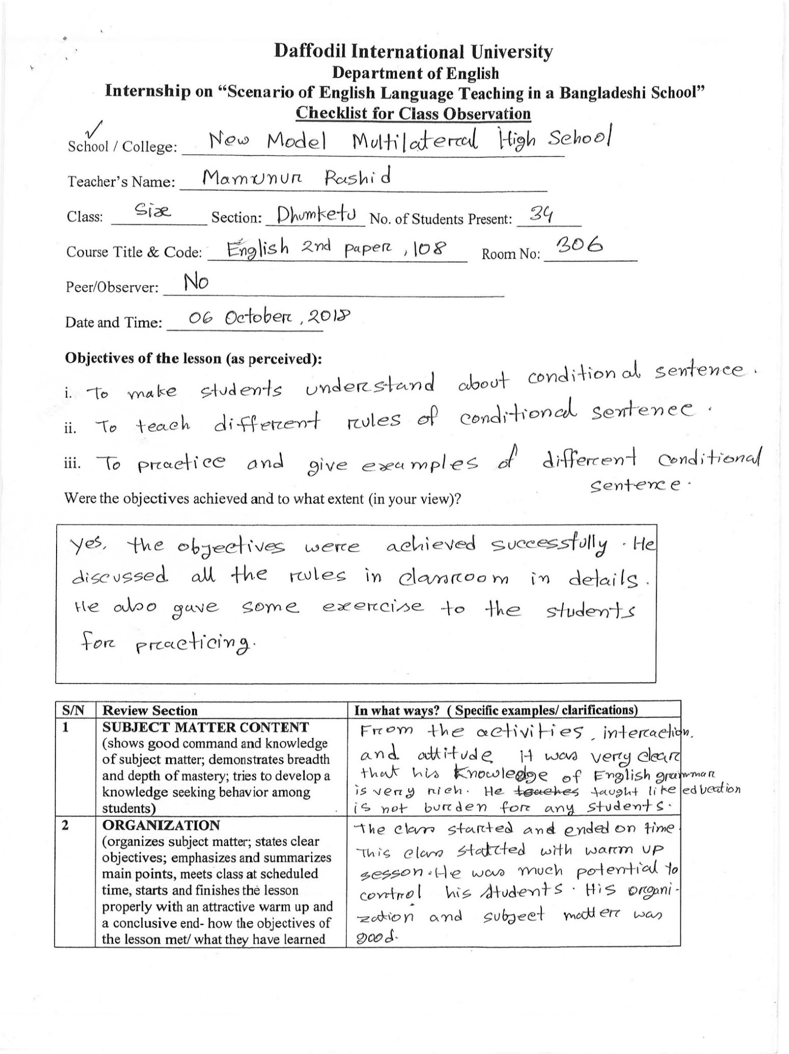
Nishat-15

Nishat-16
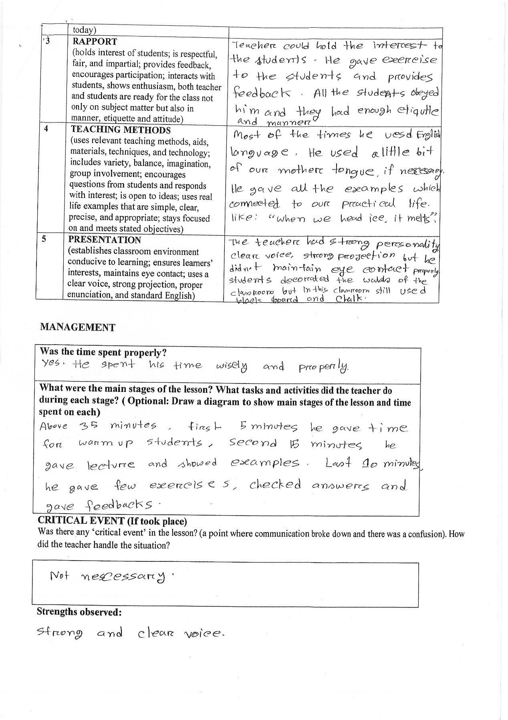

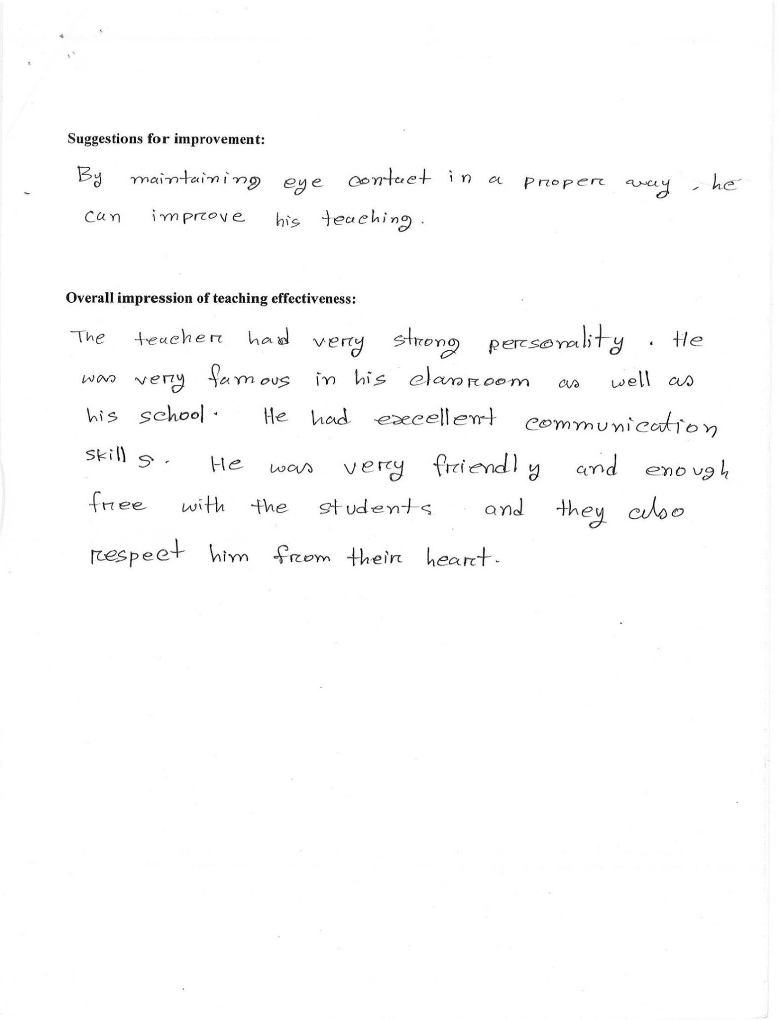
Nishat-17

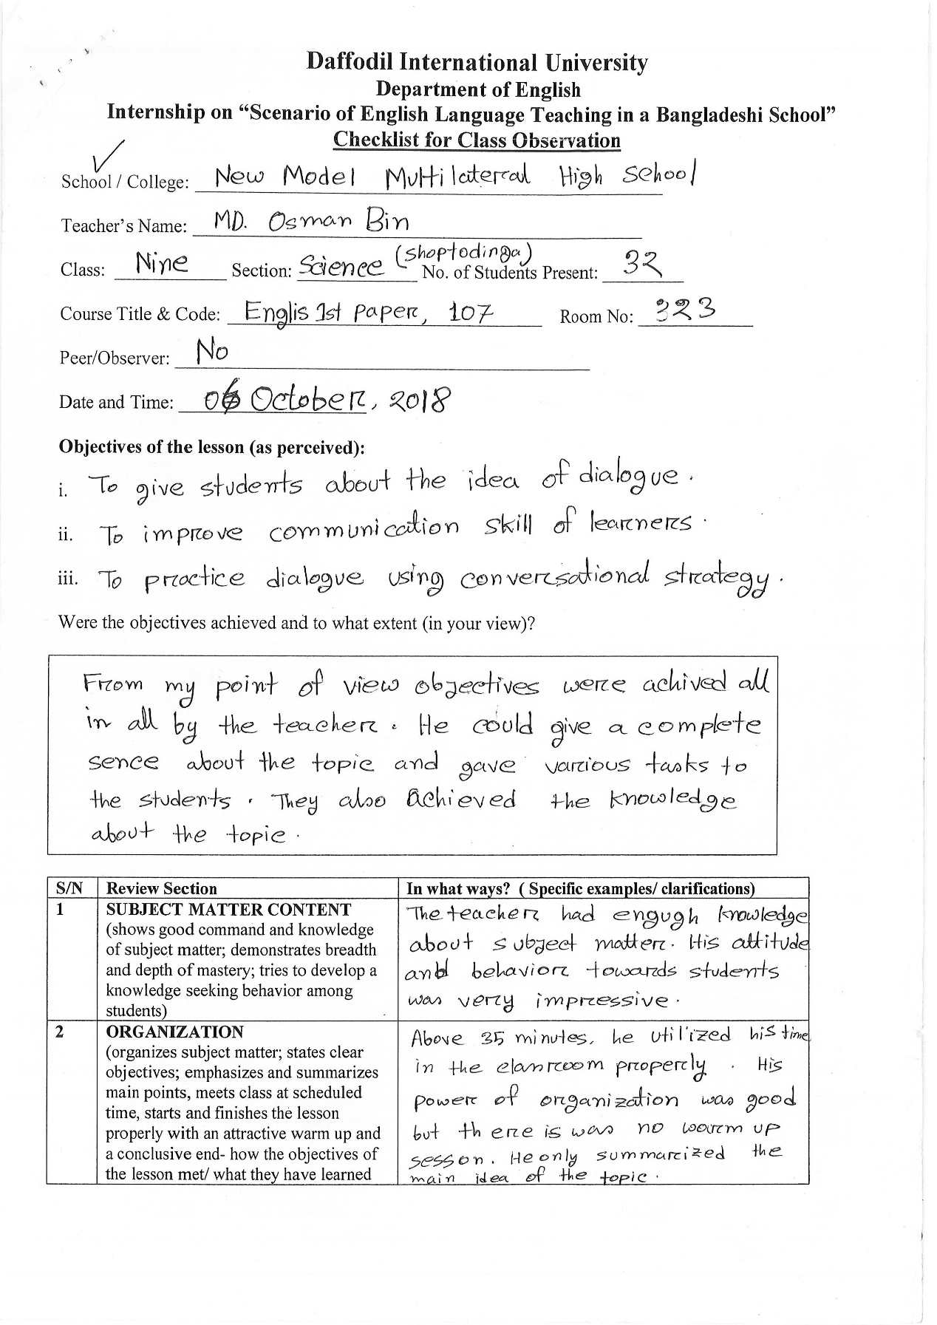
Nishat-18

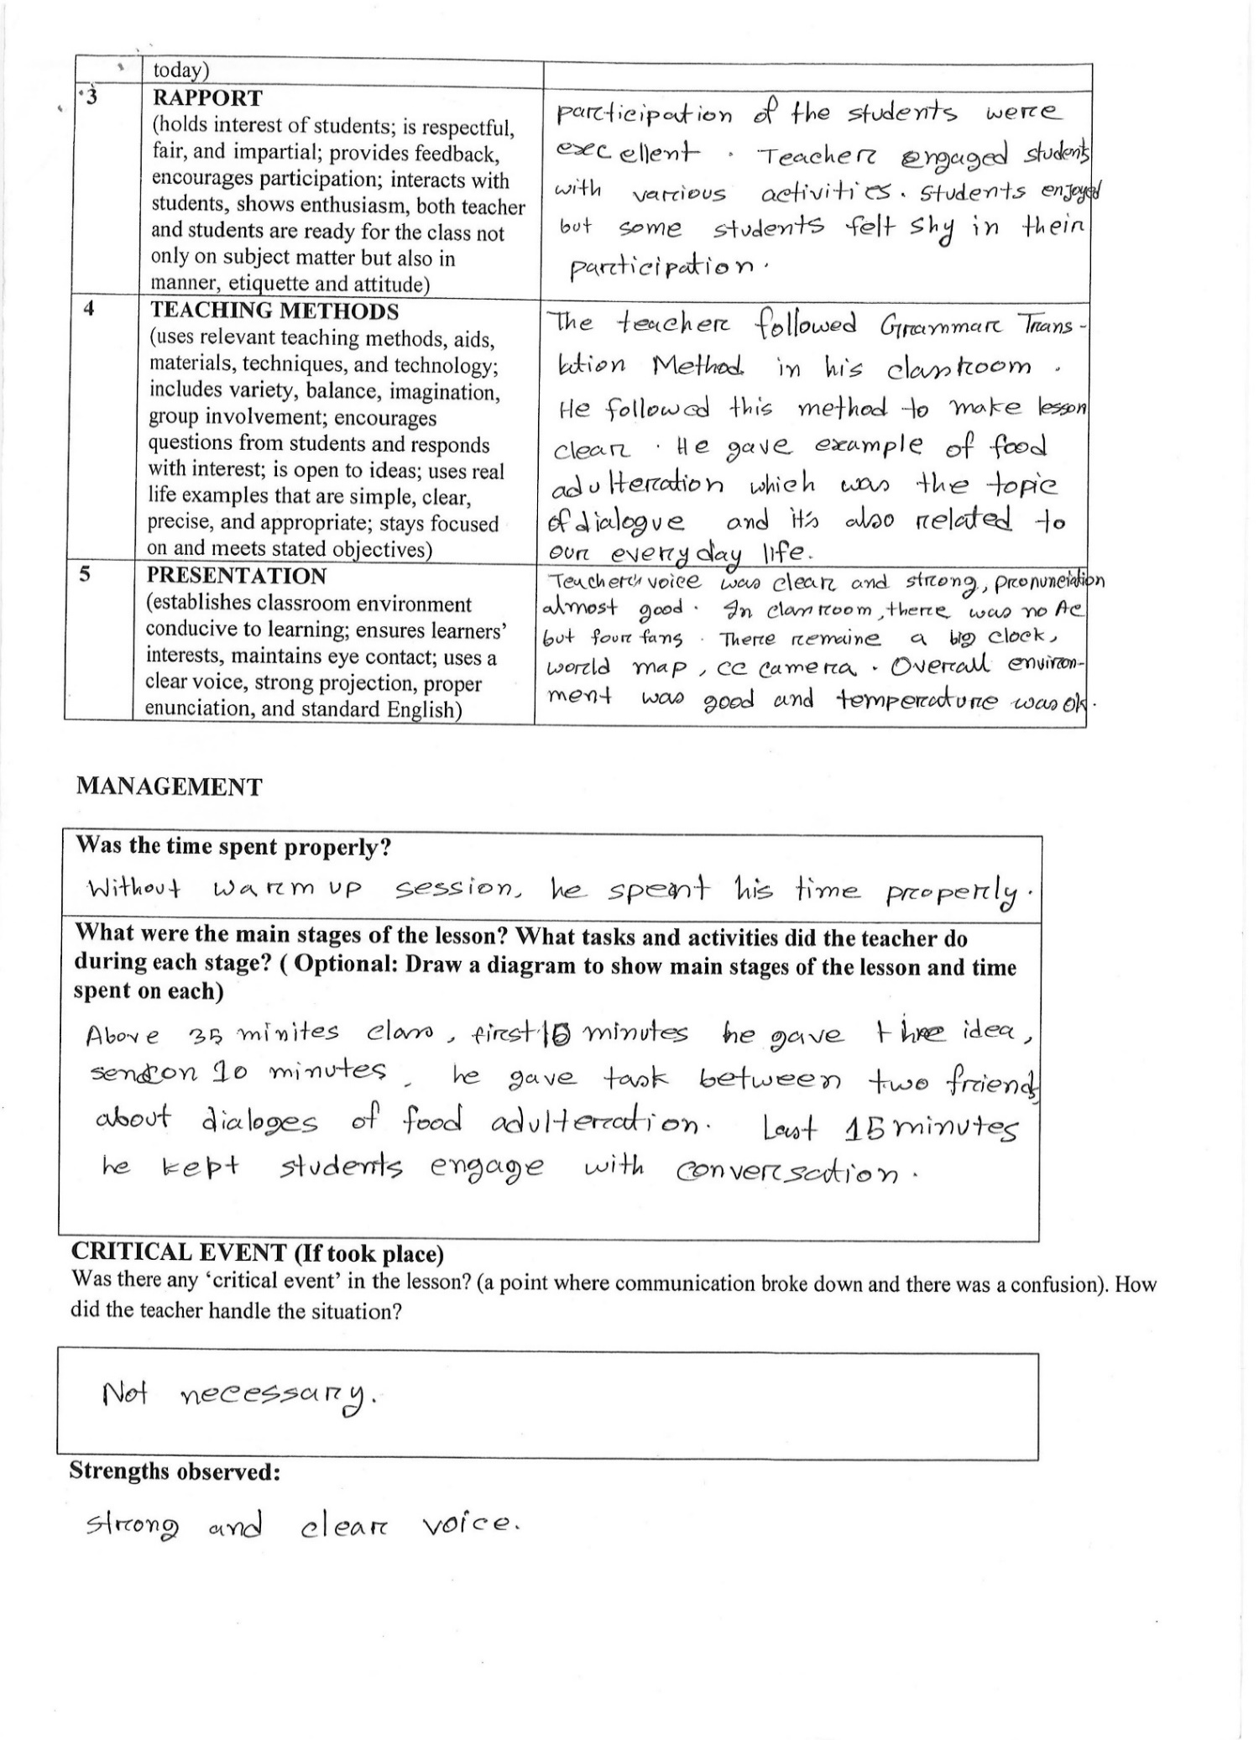
Nishat-19

Nishat-20
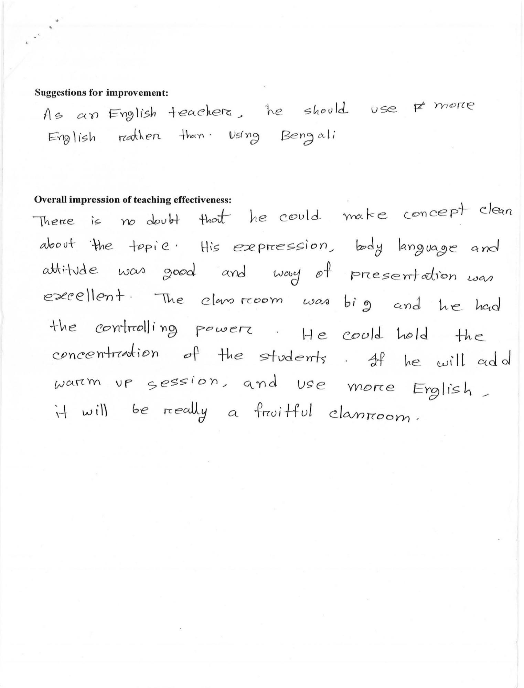

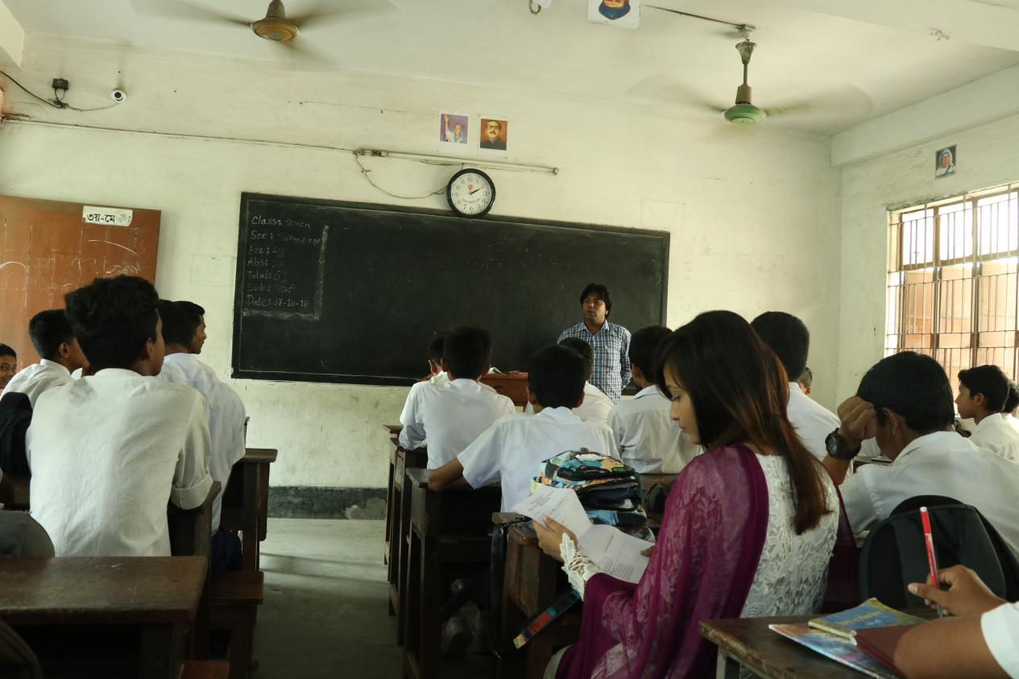
Nishat-21

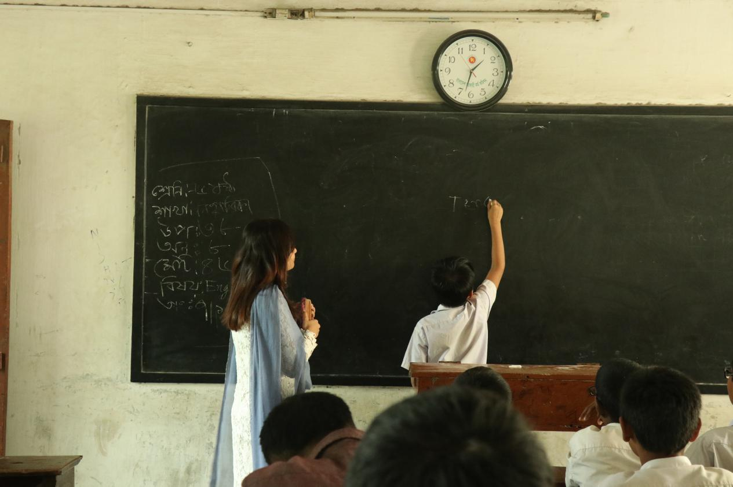

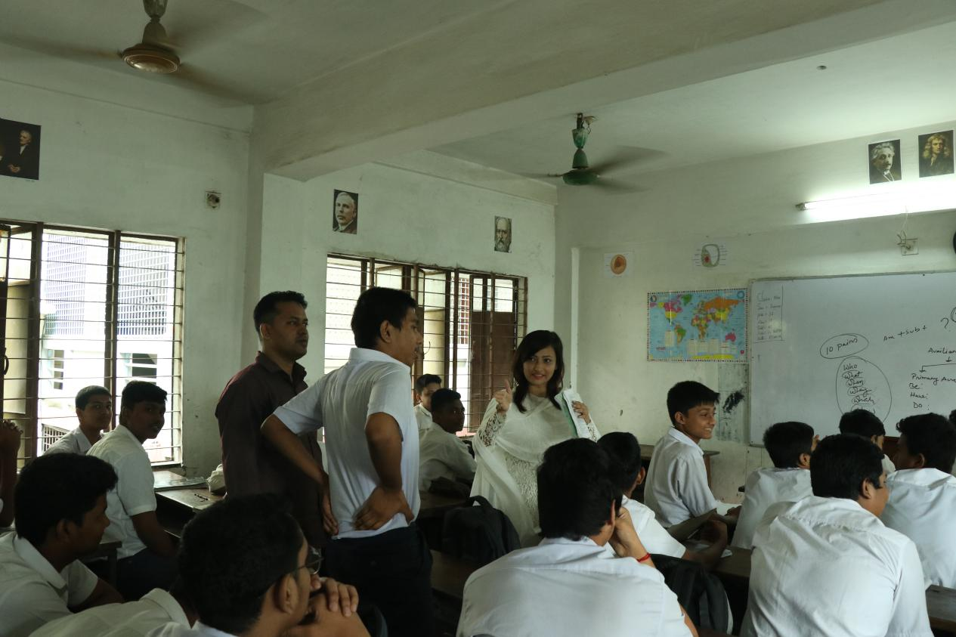
Nishat-22
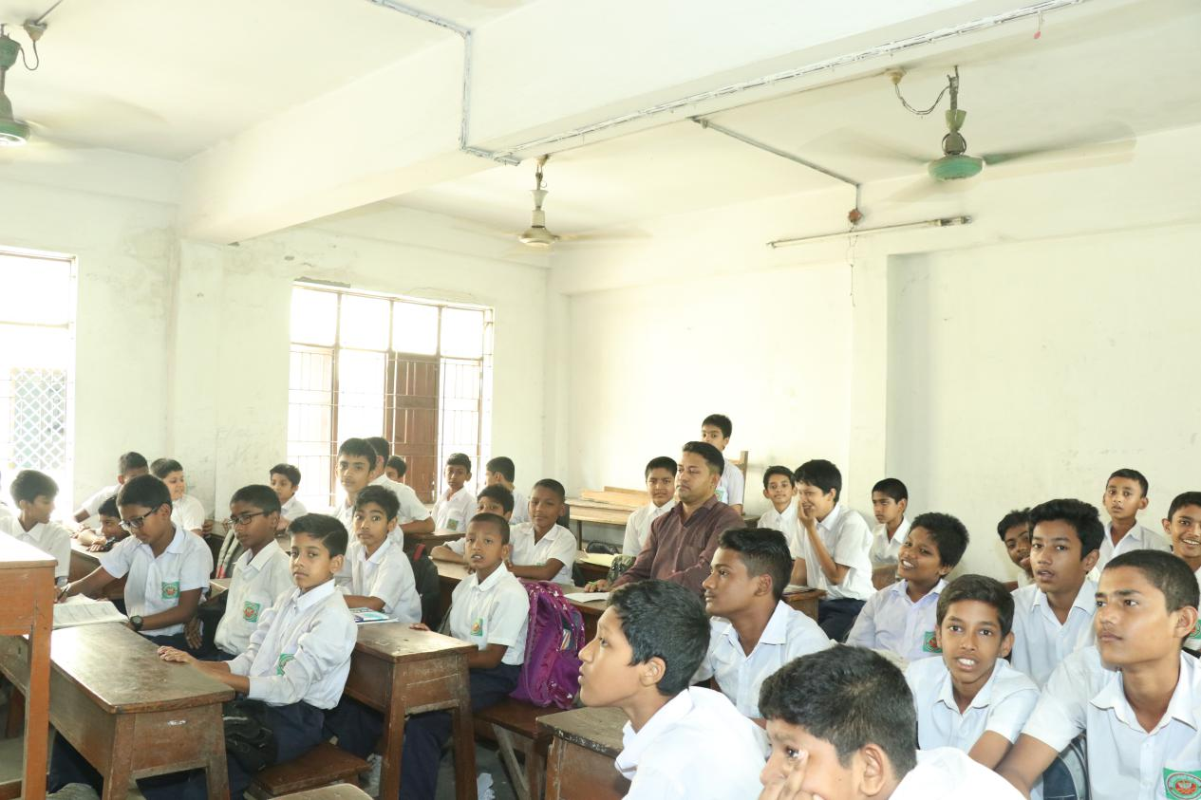
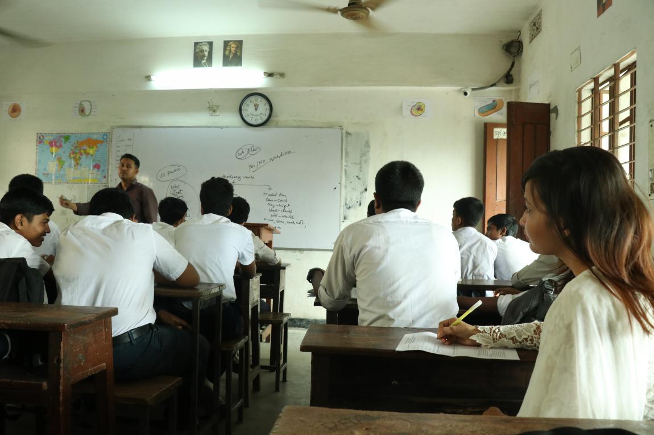

Nishat-22
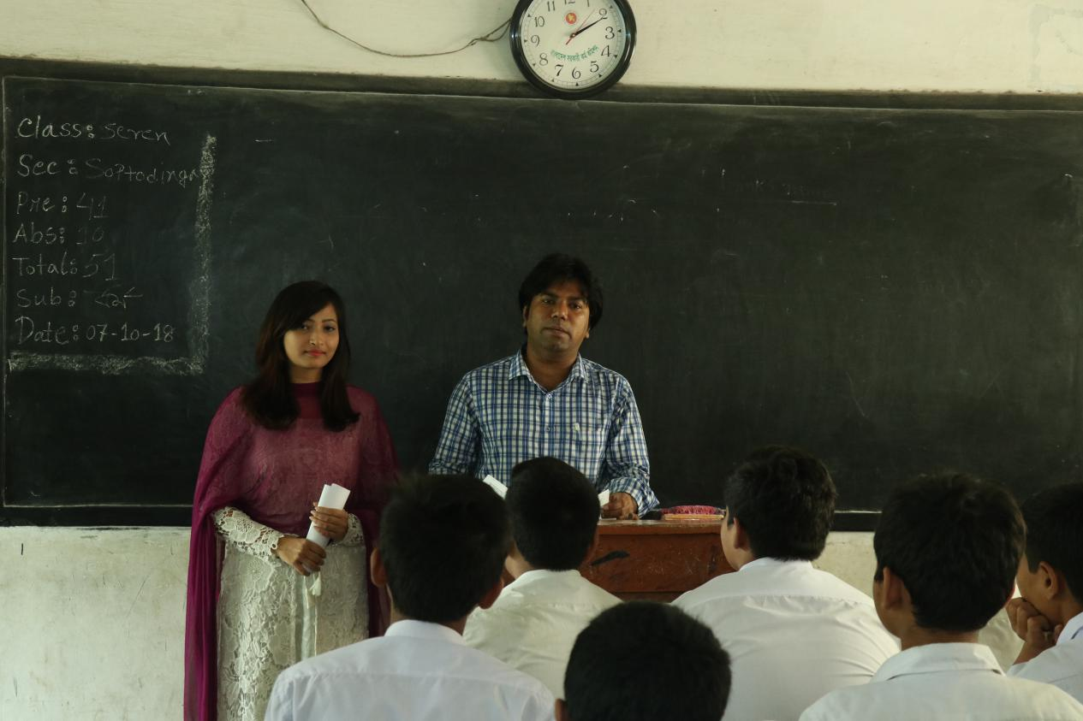
Nishat-23
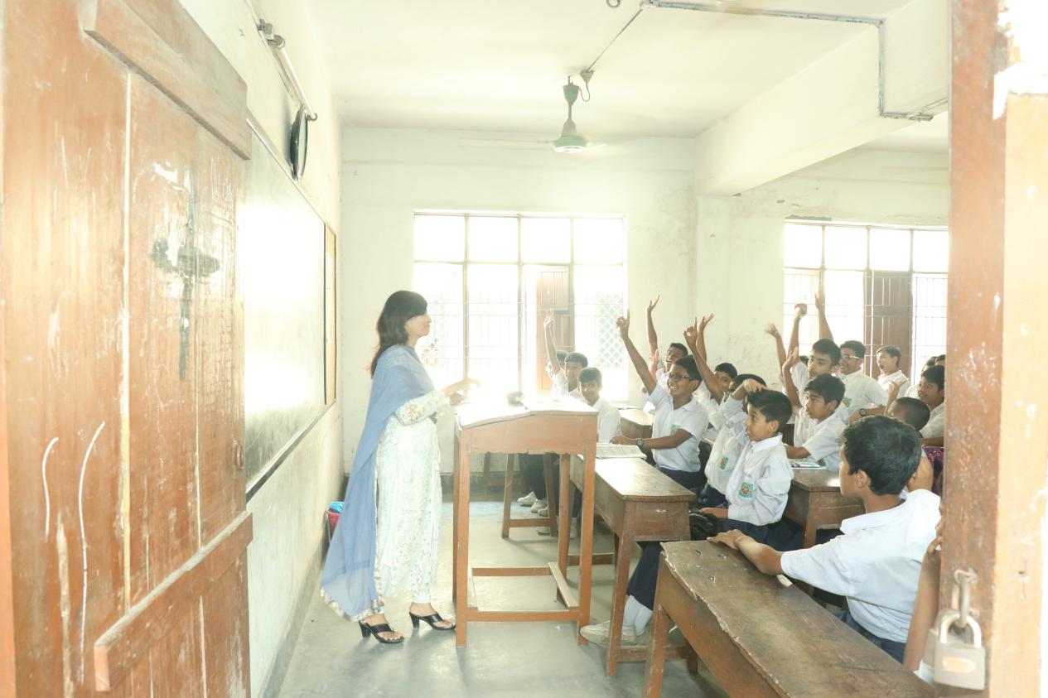
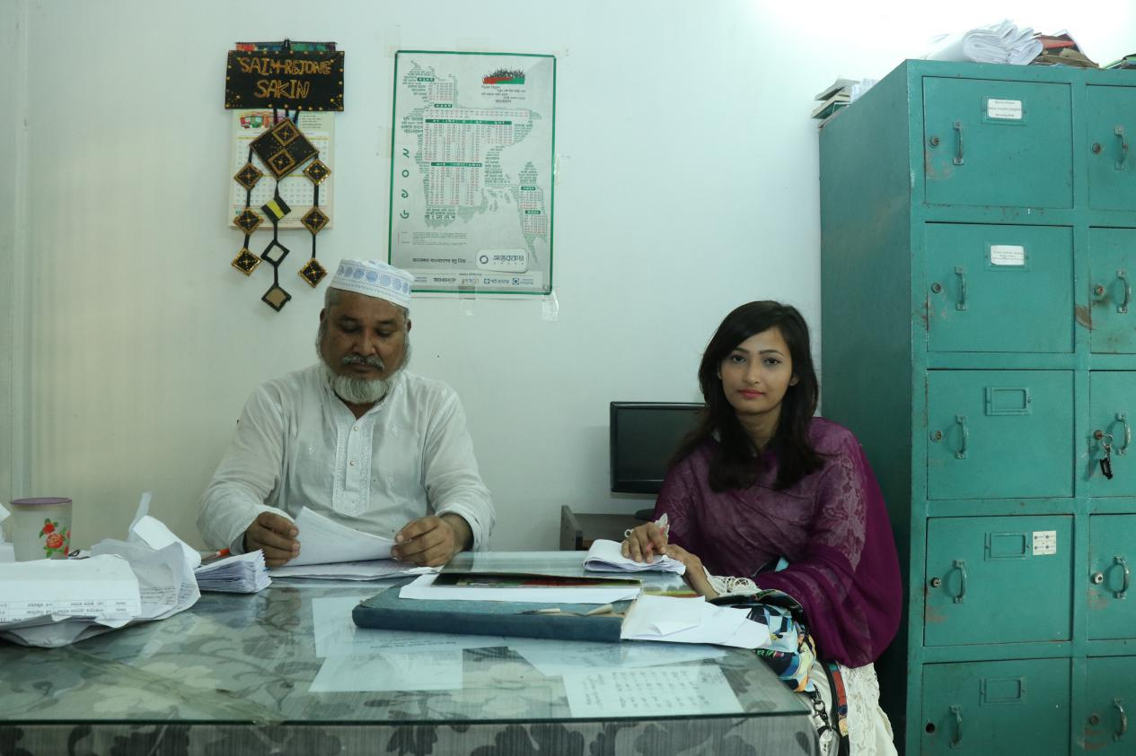
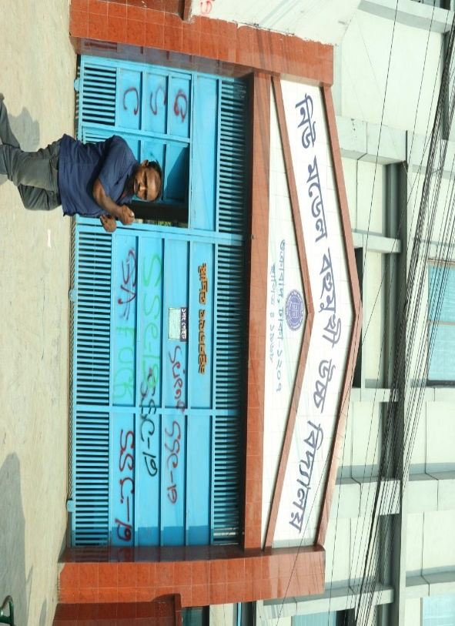
Nishat-24
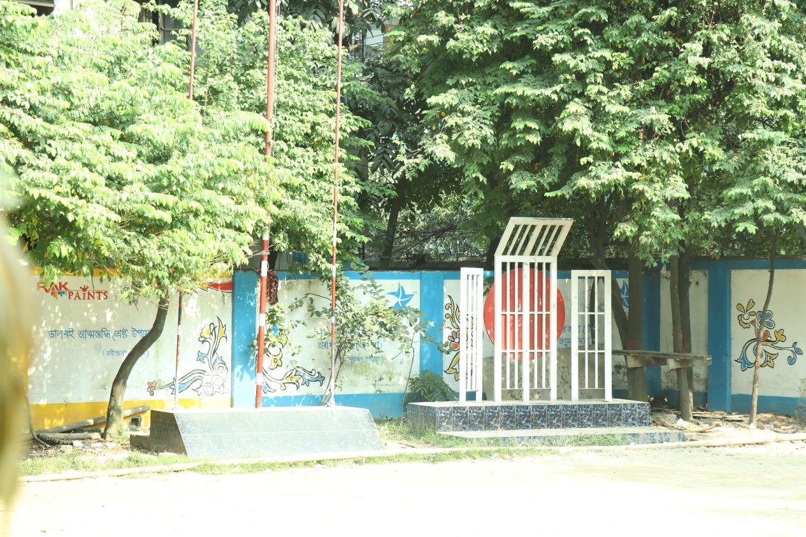
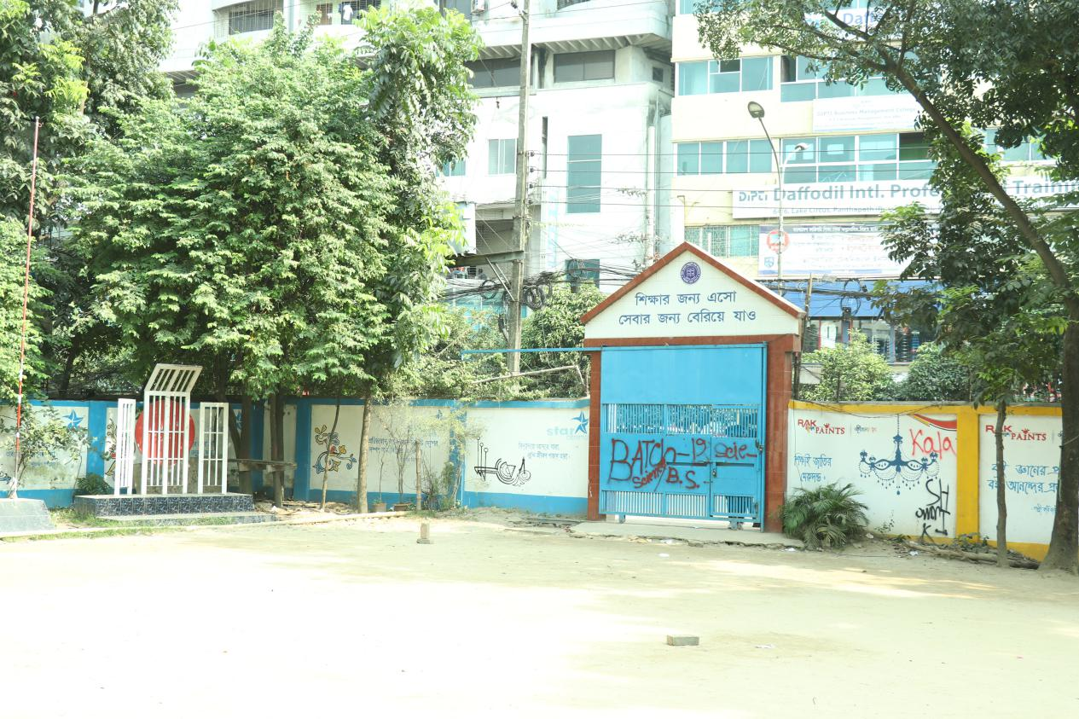
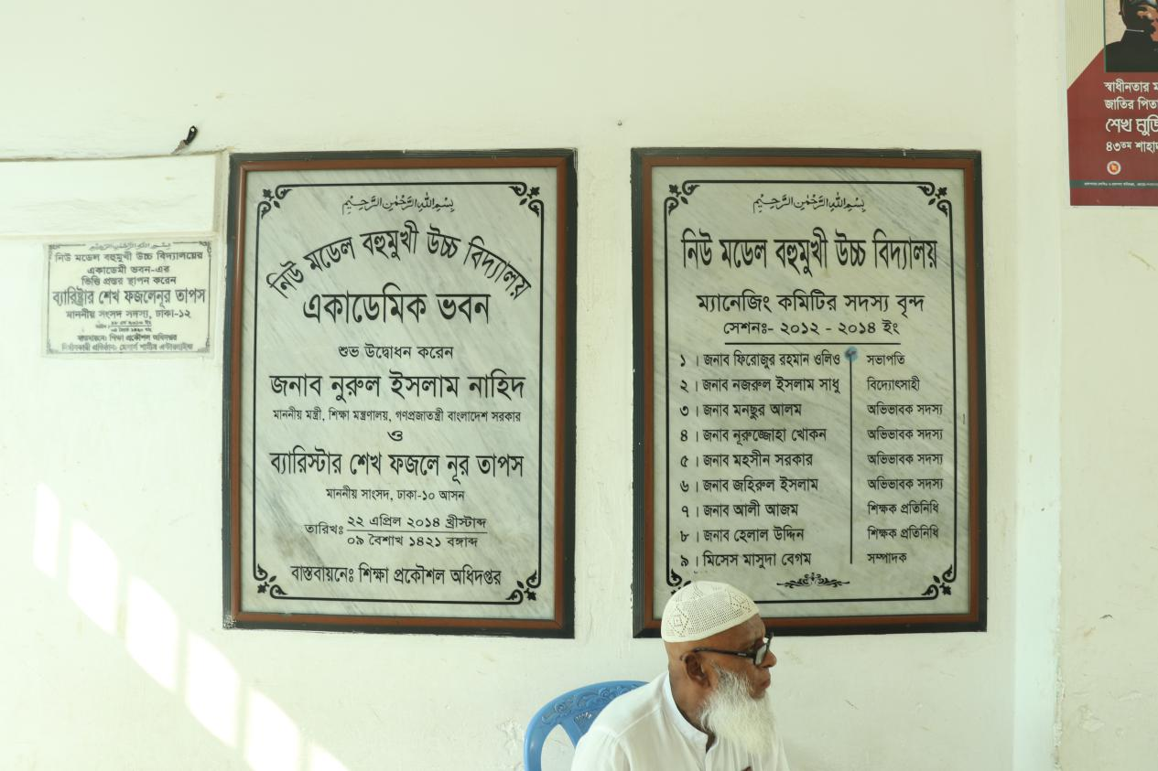
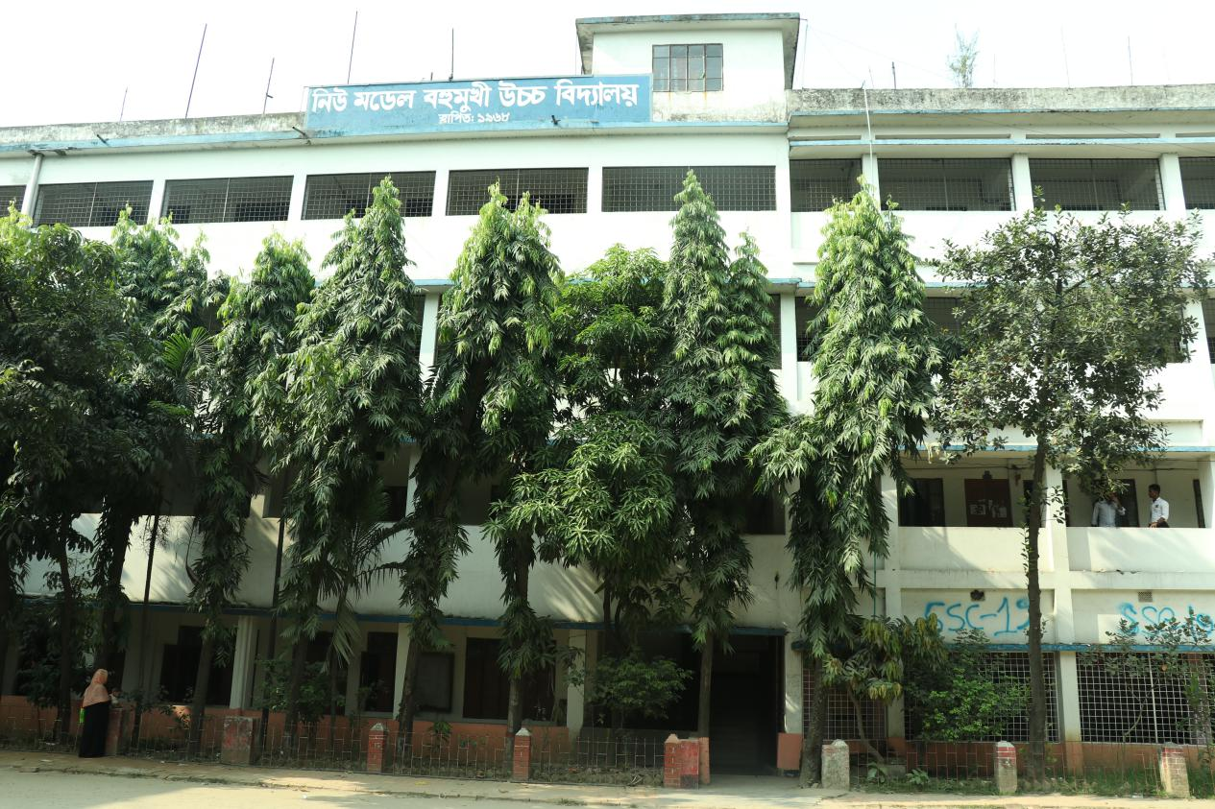
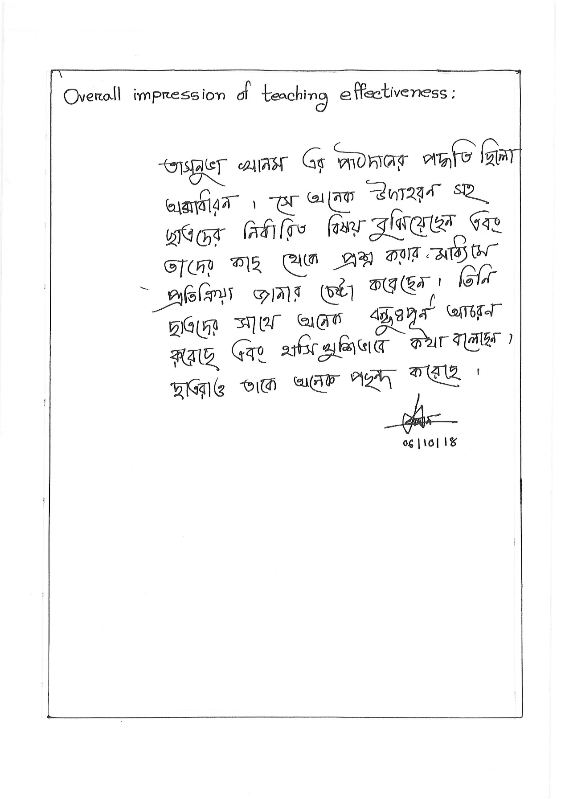
Nishat-25

Nishat-26
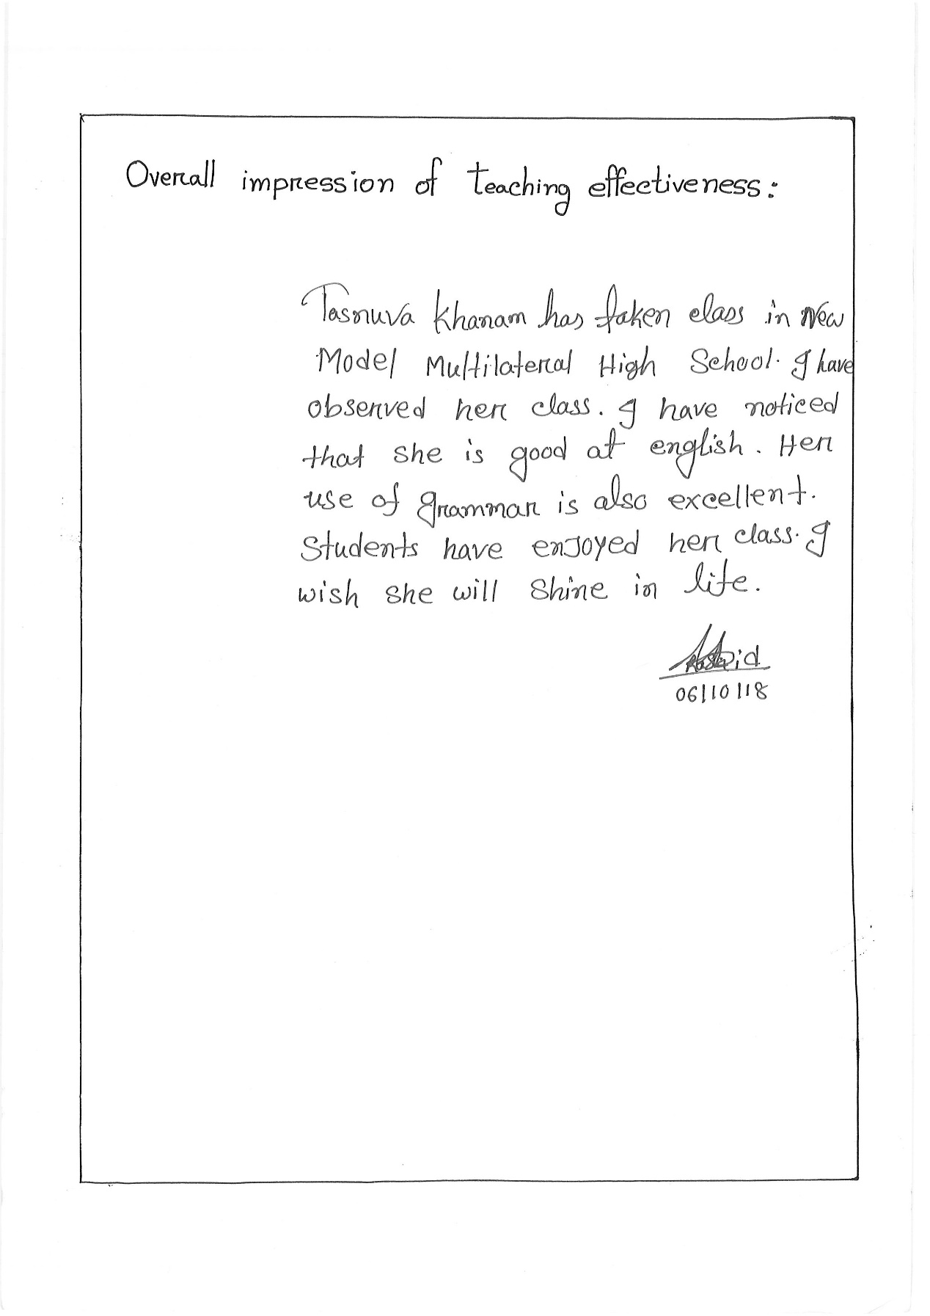

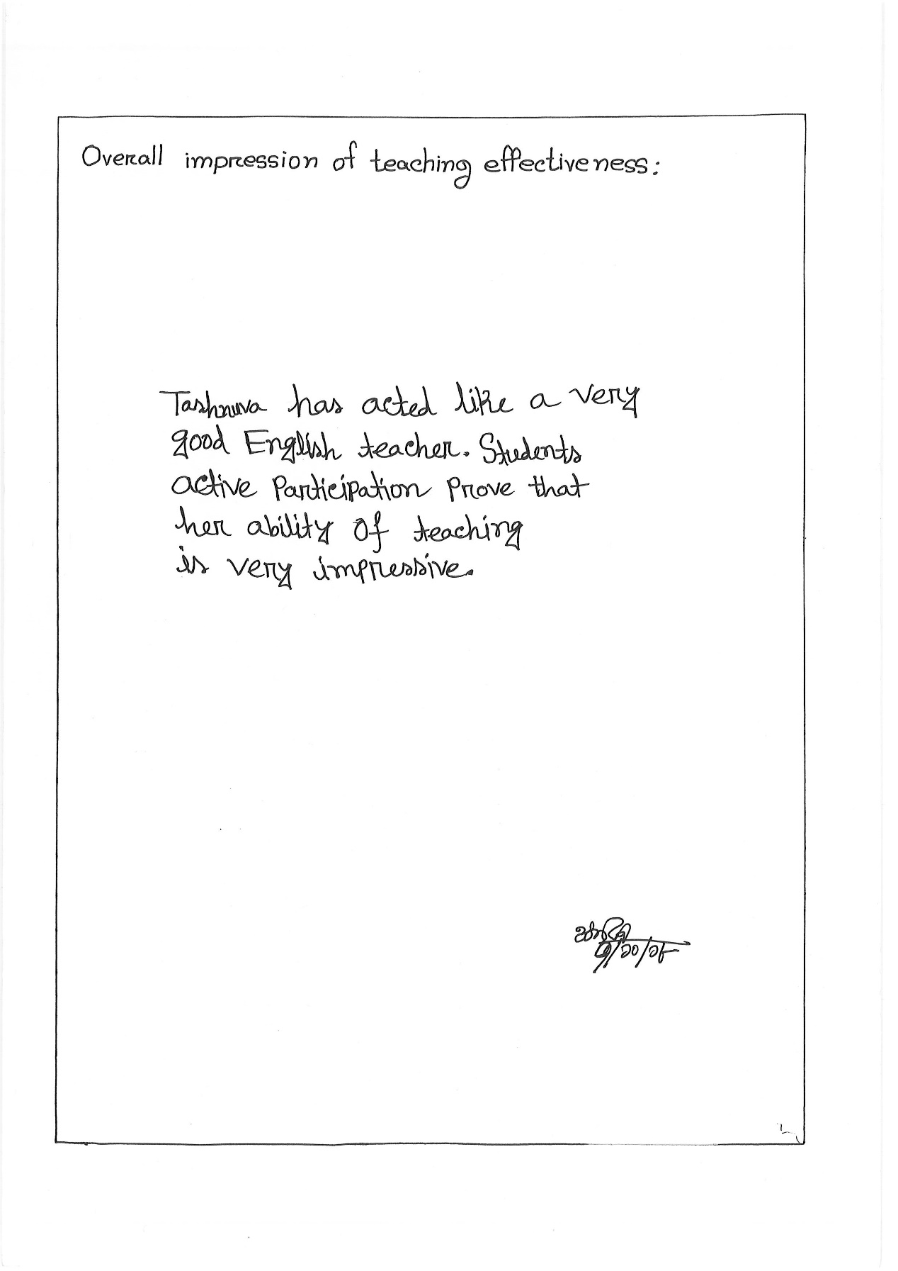
Nishat-27

Nishat-28
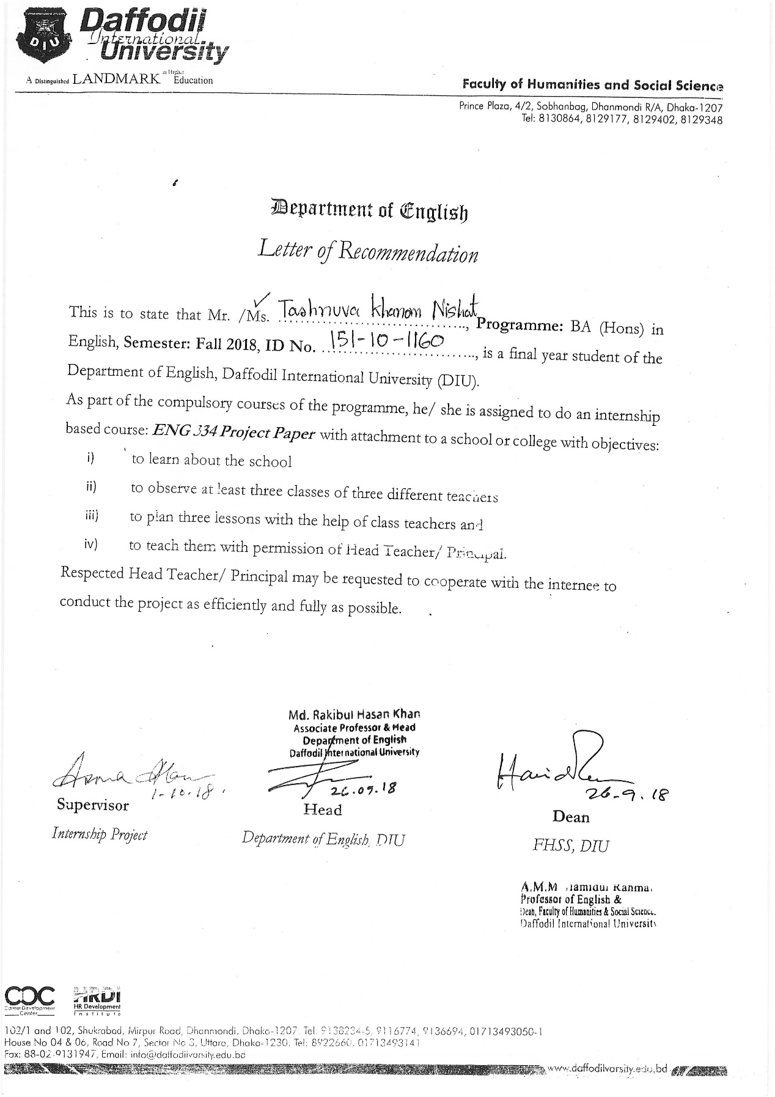

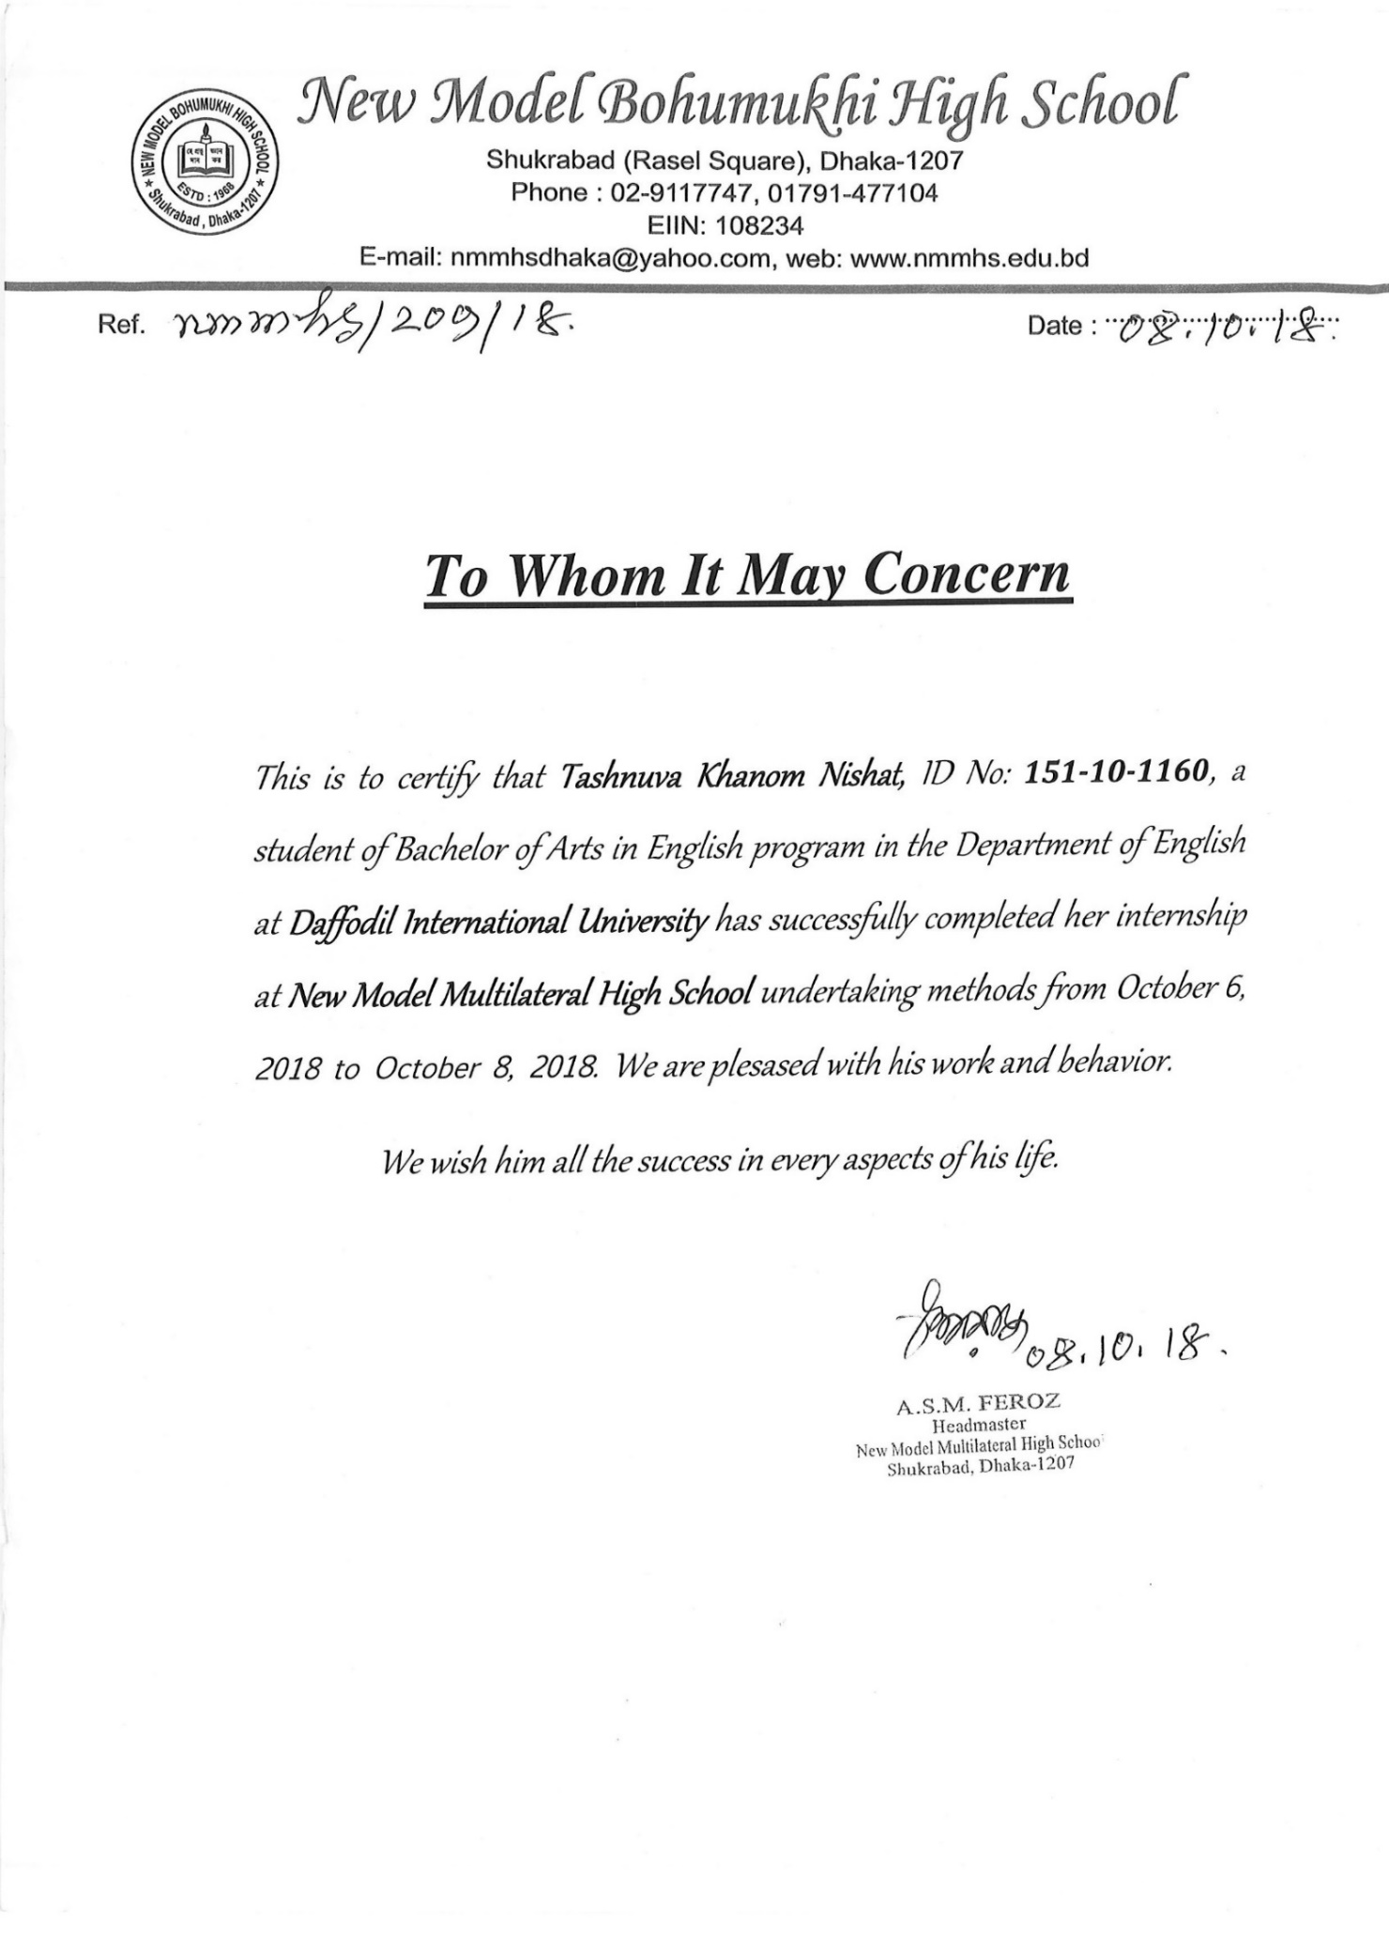
Nishat-29

