OBJECT OR HUMAN FOLLOWER ROBOT

A Project submitted in partial fulfillment of the requirements for the Award of Degree of
Bachelor of Science in Electrical and Electronic Engineering

by
Name: Md. Saleh Ahmed
(ID#: 152-33-2747)

Name: Md. Rafsanul Alom
(ID#: 152-33-2746)

Supervised by
Professor Dr. M. Shamsul Alam
Dean

Department of EEE

DEPARTMENT OF ELECTRICAL AND ELECTRONIC ENGINEERING
FACULTY OF ENGINEERING
DAFFODIL INTERNATIONAL UNIVERSITY

November 2018

Certification
This is to certify that the work embodied in this project and thesis entitled “OBJECT FOLLOWER ROBOT” is done by Md. Saleh Ahmed, ID No: 152-33-2747 and Md. Rafsanul Alom, ID No: 152-33-2746, under my direct supervision and this work has been carried out by them in the laboratories of the Department of Electrical and Electronic Engineering under the Faculty of Engineering of Daffodil International University in partial fulfillment of the requirements for the degree of Bachelor of Science in Electrical and Electronic Engineering. The presentation of the work was held on November 2018.

Signature of the Supervisor

Professor Dr. M. Shamsul Alam
Dean
Department of EEE, DIU

Signature of the Candidates

Name: Md. Saleh Ahmed
ID #:152-33-2747

_____________________
Name: Md.Rafsanul Alom
ID #: 152-33-2746

CONTENTS

List of Figures |  | V
List of Tables |  | Vi
List of Abbreviations |  | vii
Acknowledgment |  | viii
Abstract |  | ix
Chapter 1: | INTRODUCTION | 1-4
1.1 | Introduction | 1-2
1.2 | Problem Statement | 2
1.3 | Objectives | 2
1.4 | Application of this Project | 3
1.5 | Research Methodology | 3
1.6 | Project Outline | 4
Chapter 2: | LITERATURE REVIEWS | 5-9
2.1 | Introduction | 5
2.2 | How Robot System Works | 5
2.3 | Sensor | 6
2.4 | Project Overview | 7
2.5 | System Block Diagram | 7
2.5.1 | Hardware System Block Diagram | 7-8
2.5.2 | Software System Block Diagram | 8-9
2.6 | Summary | 9
Chapter 3: | Analysis of the System Components | 10-23
3.1 | Introduction | 10
3.2 | Components | 10
3.2.1 | Arduino Board | 10-11
3.2.2 | Arduino Pro Mini Board | 11-13
3.2.3 | IC L293D | 13-14
3.2.3.a | L293D Pin Configuration | 14-15
3.2.4 | Ultrasonic Sensor(HC-SR04) | 15
3.2.4.a | HC-SR04 Ultrasonic Sensor Pin Configuration | 16
3.2.4.b | Working process of ultrasonic sensor (HC-SR04) | 16-17
3.2.5 | DC Gear Motor | 17-18
3.2.6 | Wheel | 18
3.2.6.a | Specification of wheel | 19
3.2.7 | Ball Caster | 19
3.2.7.a | Specifications ball caster | 19-20
3.2.8 | Robot Chassis | 20
3.2.9 | Jumper wire | 20-21
3.2.10 | PCB Board | 21
3.2.10.a | Construction of a PCB Board | 22
3.2.11 | Tools Needed | 22-23
3.3 | Summary | 23
Chapter 4: | HARDWARE DEVELOPMENT | 24-26
4.1 | Introduction | 24
4.2 | Project Flow Chart | 24
4.3 | Project Algorithm | 25
4.4 | Hardware Connection | 25
4.4.1 | Descriptions of Hardware Connection | 25-26
4.5 | Summary | 26
Chapter 5: | DISCUSSIONS | 27-29
5.1 | Introduction | 27
5.2 | Final Result | 27-28
5.3 | Cost Analysis | 29
5.4 | Summary | 29
Chapter 6: | CONCLUSIONS | 30-40
6.1 | Conclusion | 30
6.2 | Limitations of the Work | 30
6.3 | Future Improvements & Future Scope | 30-31
 | References | 32
 | Appendix | 33-34
LIST OF FIGURES

Figure # | Figure Caption | Page #
2.1 | System block diagram | 5
2.2 | Ultrasonic distance sensor | 6
2.3 | Hardware System Block Diagram | 8
2.4 | Software System Block Diagram | 9
3.1 | Front side of Arduino UNO board | 11
3.2 | Arduino UNO board breakdown | 12
3.3 | IC L293D | 13
3.4 | Connection diagram of L293D | 14
3.5 | HC-SR04 Ultrasonic Sensor | 16
3.6 | Ultrasonic sensor working principle | 17
3.7 | DC Gear motor | 18
3.8 | Wheel of Object Follower | 18
3.9 | Ball caster | 19
3.10 | Chassis for Object Follower | 20
3.11 | Jumper wire | 21
3.12 | PCB Board | 21
3.13 | Some tools | 22
4.1 | Flowchart of the object follower robot | 24
4.2 | Block diagram of object following Robot | 25
5.1 | Final project (Top view) | 27
5.2 | Final project (Down view) | 28
5.3 | Final project on white surface | 28

LIST OF TABLES

Table # | Table Caption | Page #
3.1 | The logical truth table of the motor driver (L293D) | 14
3.2 | Pin configuration table of the motor driver (L293D) | 15
3.3 | Pin configuration table of ultrasonic sensor (HC-SR04) | 16
5.1 | Cost analysis of the project | 29

LIST OF ABBREVIATIONS

NSF |  | National Science Foundation
CPU |  | Central Processing Unit
EMI |  | Immune to Electromagnetic Interference
PWM |  | Pulse width modulation
FWHM |  | Full Width at Half Maximum
LED |  | Light Emitting Diodes
AREF |  | Analog Reference
USB |  | Universal Serial Port
TX/RX |  | Transmit and Receive
IC |  | Integrated Circuit
RMS |  | Root Mean Square
US |  | Ultrasonic Sensor
MC |  | Multipoint Control Unit
UV |  | Ultraviolet
WD |  | Waveguide Dispersion

ACKNOWLEDGEMENT

First of all, we give thanks to Allah. It is a great pleasure for authors to express their unfettered gratification, sincere appreciation and profound respect to our respective co-supervisor Nusrat Chowdhury, Lecturer, Department of Electrical & Electronic Engineering Daffodil International University for his constructive suggestion, scholastic guidance, constant inspiration, valuable advices and kind cooperation for the successful completion of work on “Object follower Robot”. This could not be possible without his help.We also wish to complement all our respective concern teachers & staffs of our department of their direct and indirect assistance at different times.

ABSTRACT

In today’s world robotics is an expeditious growing and fascinating field. The robot has ample astuteness to cover the maximum area of provided space. It has ultrasonic sensors which are habituated to sense the obstacles coming in between the path of the robot. Autonomous perspicacious robots are robots that can perform desired tasks in unstructured environments without perpetual human guidance. The minimum number of gear motor sanctions the ambulating robot to minimize the potency consumption while construct a program that can engender coordination of multi-degree of liberation for the kinetics of the robot. It is found that the two formats are adequate to engender the rudimental ambulating robot and one voltage regulators are needed to control the load where it is capable of supplying enough current to drive two gear motors for each wheel.

CHAPTER 1
INTERODUCTION
1.1 Introduction
Robotic technology has incremented appreciably in the past couple of years. Such innovations were only a dream for some people a couple of years back. But in this rapidly moving world now there is a desideratum of the robot such as an object following robot that can interact and co-subsist with them supplying enough current to drive two gear motors for each wheel.[1]
Unmanned robots are of sign cannot interest currently. There is a push from the NSF to accelerate the development of robots that can work inside or cooperatively with people. In the past, several different approaches have been used to achieve unmanned control. These approaches are summarized in the following sections. The goal of this work is to develop a personality-following method that will work in many settings, where obstacles and equipment are always changing.[2]
The robot becomes widely utilized in industrial due to their characteristics. The robot able to work in 24 hours perpetually without feeling tired, unlike human that confine to a certain time. The cost to setup the robot nowadays becomes more affordable and their long-term prospect is effulgent judging from their capacity to perform. But in authenticity, there is no robot able to function impeccably and still making errors. a better controller needed here to sanction the robot to perform efficiently and make less error.
Usingobject follower robot doing specific task, is less expensive, more reliable and it can reach the same aims of one robot. Some examples of applications are in manufacturing, medicine, space exploration and home. The nature of work environment requires the robotic systems be fully autonomously in achieving human supplied goals. Nowadays robotics is an element of today's communication. Communication is an element of the advancement of technology so we decided to work in the robotics field and design something which will make human life today's aspect. There are variants of mobile robots which can be divided into several categories consists of the wheeled robot crawling robot and legged robot. This project deals with a wheeled autonomous robot. It is the component of automation. The robot has the adequate perspicacity to cover the maximum area. This robot uses an infrared sensor to detect the impediment in between the path and then evade them to consummate its objective. Their transmitter perpetually engenders an infrared signal of 38KHZ when an obstruction comes in the path the infrared signal reflected back from the object and is received by the ultrasonic sensor HC-sr04 and then engender a positive, high signal with the avail of the receiver circuit that is there is an obstruction in the path. In such a way the robot is able to detect obstacles of providing space and able to evade obstacles coming to between the path of the robot with the avail microcontroller board and consummate its journey. The main motto of designing such type of robot or the technology is that technology can be utilized in today's very expeditious conveyance to eschew the contingency generally transpire in congested or the metro Politian areas by applying the emergency brake. If we utilize this technology in the car or any conveyance it will automatically sense the obstacles, then it will take a side of the available free space. An obstruction may be a living thing or an object. Autonomous perspicacious robots are robots that can perform desired tasks in unstructured environments without perpetual human guidance. Thus by utilizing this technology in the conveyances, we make the drive safer. [3]

1.2 Problem statement
The classical object following robot is a slow reply to the error occurs will simply leave its track that drawn on the floor. This Obstacle will cause the mention of the robot to be unsmooth. Although this robot can follow the human and object, its movement still needs to be developed.

1.3 Objectives
The capability of a robot to track and follow a moving object can be used for several purposes. To design a low cost device in order to use general purpose.
- To save time.
- To help humans.
- To create easier for people.
- Can be used for defense purpose.

1.4 Applications of this project
- Industrial automation
- Tour guide in a museum
- Deliver the mail in office buildings
- It can be used in place of crane in various lifting and carriage applications
- Can assist in carrying loads of people working in hospitals, libraries, airports, etc.
- Can service people at shopping centers or public areas
- Can assist elderly people, special children and babies
- Can follow a particular Vehicle.

1.5 Research Methodology
A systematic research methodology is adopted keeping in mind the ultimate goal of a fully functional and autonomous human and object following robot. A decentralized top-down approach is utilized for this project. The project is divided into five modules. Each module is independent of one another. Different phases were carried out step by step starting from initial sensor testing and proceeding towards obstruction avoidance, object detection, object tracking and data transmission.Due to the decentralized approach, all modules and sensors act independently. Data obtained by different sensors and modules is collectively analyzed and an intelligent decision on the basis of information obtained is made that instruct the robot to follow a particular direction. Two separate units are utilized, i.e. Microprocessor and a controller. The processing is carried out by the microprocessor and the information obtained by the sensors is controlled by a controller i.e. Arduino board. A serial communication between the microprocessor and controller is established to exchange the visual sensing information. This approach was more suitable because if there is a fault in any one of the modules then it would not affect the entire system. Hence this provides the best possible results by maintaining accuracy. Human tracing, maintaining a specific distance from the object and establishing a communication link between microprocessor and controller are the main aspects of this project. [4&16]

1.6 Project Outline
This project is organized as follows:
Chapter 1 Introduction of the project
Chapter 2 Reviews the literature knowledge of live object follower robots
Chapter 3 Analysis of the system components of the project
Chapter 4 Describes all the Hardware Development parts
Chapter 5 Discussion
Chapter 6 Concludes with some recommendations

CHAPTER 2
LITERATURE REVIEWS

2.1 Introduction
Creating of making Robots, we might come up with conceptions such as object tracking, impediment eschewed, anti-drop robot, environment monitoring Robots etc. But what we are going to make today is a robot that follows an object relentlessly. The primary function of this robot is simple, it follows you. It goes forward as you go forward when you stop moving, it ceases as well.
2.2 How Robot Systems works
We utilized an ultrasonic range sensor to identify the moving direction of the object. You can additionally integrate the number. The minimum number that will do the job is one. Hereby quantifying the pulse width of the echo pulse from the ultrasonic sensor we can get the range of the object in front of the robot. Here we have produced an algorithm which will move the robot forward when the object is moving forward within the programmed range and rearward in the same manner. Here we will implement software pulse width modulation which can convert mundane digital outputs to the PWM output pins of the Arduino. [14]

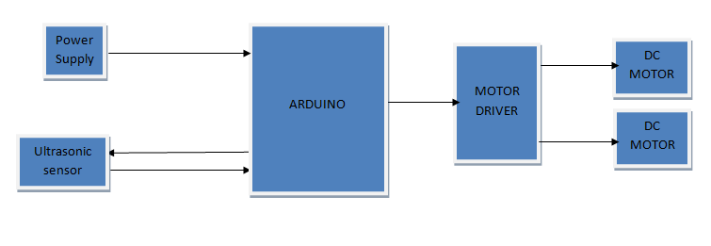
Fig.2.1 System block diagram
2.3 Sensor
Ultrasonic distance sensor defines the distance to an object by quantifying the time needed by the sound to reflect back from that object. The frequency of the sound is around in the range of ultrasound, this confirms the more concentrated direction of the sound wave because sound at higher frequency spends less on the environment. A typical ultrasonic distance sensor consists of two membranes. One membrane engenders sound another catch reflected echo. Initially, they are a verbalizer and microphone. The sound engendered engenders short the length is a couple of periods ultrasonic impulses and triggers the timer. The second membrane registers the approach of the sound impulse and terminates the timer from the timer’s time it is possible to calculate the distance peregrinated by the sound. The distance to the object is a moiety of the distance peregrinated by the sound wave. [8]
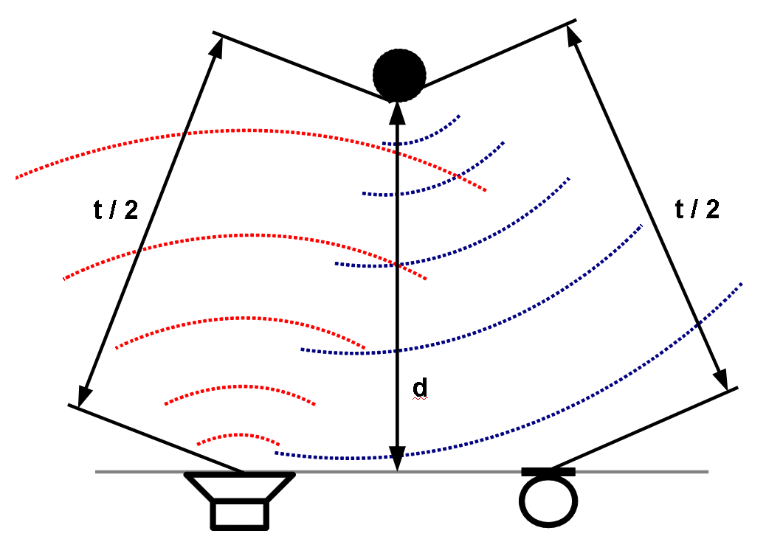
Fig. 2.2 Ultrasonic distance sensor

2.4 Project overview
Robots are broadly utilized the industries because of their properties. Robots are capable to operate 24 hours continually without feeling bored, unlike human that limited to specific times. Nowadays the cost of robot setup becomes cheaper and their long-term scheme is the glowing judgment from their abilities to function. But in fact, there is no robot capable to function automatically and are still getting errors. The best controller is needed to approve the robot to perform accurately and gain less error. This project attempts to implement a microcontroller on the self-governing robot to observe whether the robot operates accurately. This self-governing robot consists of an object tracking module where it will follow the track formed from objects. This is the field where the microcontroller is implemented the robot will be capable to follow the object efficiently and running along the track easily. A good and stable autonomous robot is needed in order to solve the object follower smoothly. Object follower robot is used in programming by Arduino to set the microcontroller as the CPU. This prepared CPU is used to the object follower robot in order to test the functionality of each electronic component such as DC motor driver sensors etc. If the hardware system and the software system should be completed. The project will be ready to run. Where depending upon the sensor output the microcontroller work will be performed according to the program.

2.5 System Block Diagram
This Project can be described with the two types of system block diagram are
- Hardware system block diagram
- Software system block diagram

2.5.1 Hardware System Block Diagram
This block diagram describes which operating first to implement the object following solving robots work. From the below the figure 2.3 we can assume the work of the hardware system. Where from the input of infrared sensor going to the processing unit microcontroller and from the microcontroller output is going to the motor control driver which controlling motor operation.[12]
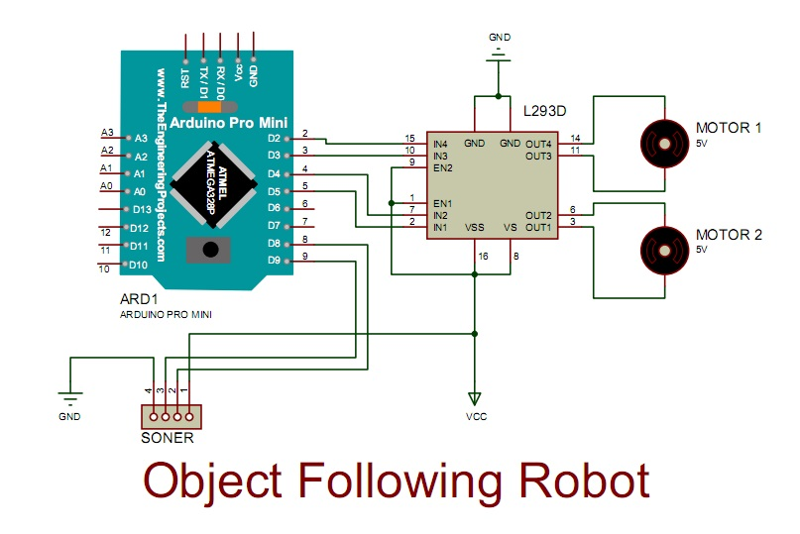
Fig. 2.3 Hardware System Block Diagram

2.5.2 Software System Block Diagram
From the hardware layer software section takes the output of hardware devices basically from the sensor and by analysis the output software section gives the possible input for the hardware layer section. Mainly software section has three sections as we are seeing from the Fig. 2.4 All three are giving and taking information to implement the task. Sensor module section normalized sensing data and giving it to the microcontroller. Microcontroller sections software taking the normalized data from the sensor module and saving the corrected path. According to the data input microcontroller section giving necessary input for the motor control section to guiding the motors.

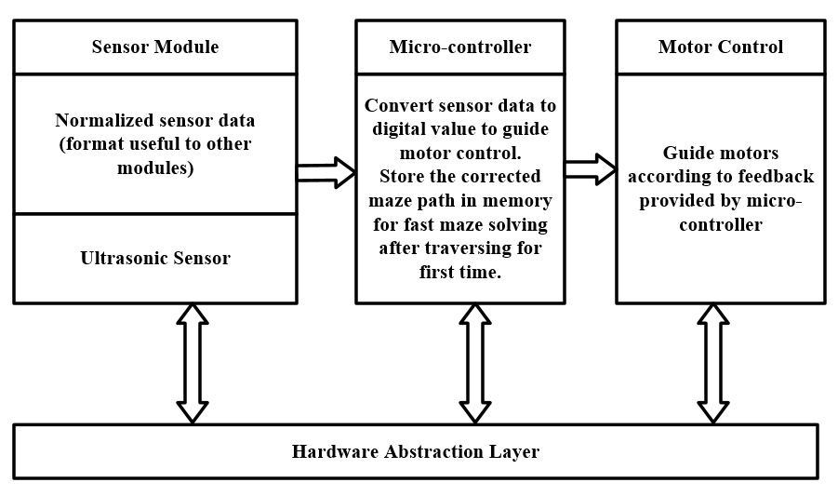
Fig. 2.4 Software System Block Diagram

2.7 Summary
In this chapter, we have discussed literature review of this object following robot. The robot isn't a new idea the classical Greeks were imagining robotics. But the sector of this robot is sorted out into another part or robot one of them is an object follower robot. It is one of the most popular autonomous robots. The use of autonomous robot was beginning introduced since the 1960s. Its market into automated work is rising day by day.

CHAPTER 3
Analysis of the system component

3.1 Introduction
In this chapter, we have discussed various components that will be needed to make this human and object follower robot.
3.2 Components
The Object follower robot has the following main components are
- Arduino.
- Ultrasonic sensor
- L293D IC
- Two DC Gear Motor
- Power Supply (9 volt battery)
- Wheel
- Ball Caster
- Robot Chassis
- Jumper Wire
- Bread Board
- Tools Needed

3.2.1 Arduino Board
Arduino is a programmable electronic circuit broad that can integrate into a wide variety of projects both easy and difficult. It has a microcontroller which is capable to write a program for sensing and controlling objects in the real world. The Arduino is fit to communicate with an astronomically immense array of outputs such as motors, LED and displays by reacting to sensors and inputs. Arduino becomes a very popular compiler for inventors looking to design interactive hardware projects because of its versatility and affordable. Arduino was presented in 2005 by Massimo banzi in Italy as a plan for non-engineers to access for implementing a low-cost simple hardware project. As the Arduino board is open-source it is published under an inventive commons license which approves anyone to design their own board. [16]

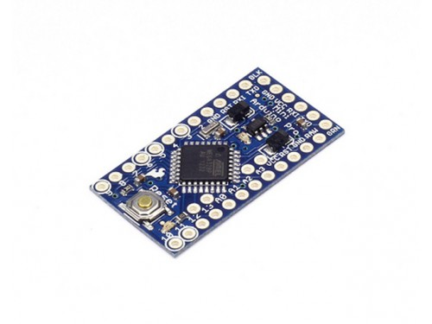
Fig. 3.1 Front side of Arduino Pro Mini board
3.2.2 Arduino Pro Mini Board
The Arduino Pro Miniis one of the most popular Arduino board. Although it was not actually first board to be renounced, It remains the most actively used and most broadly documented in the marketplace because of its greatest demand.[16]

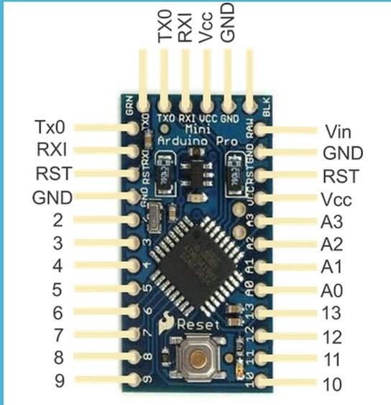
Fig. 3.2 Arduino Pro Mini Board Breakdown

Here we are discussed about the function of the component of the Arduino board. That is
- Reset Button – This button is used for restarting the code that is stored to the Arduino board.
- AREF – That's meant Analog Reference and utilized to set an outer reference voltage.
- Ground Pin – There are several ground pins on the Arduino board and they all do the same thing.
- Digital Input/output – Pins 0-13 utilize for digital input/output.
- PWM – Stands for Pulse Width Modulation. This pin mark with the symbol(~) that can reproduce the analog output.
- USB Port – works on uploading code and power supply on the Arduino board.
- TX/RX – These LEDs are betokening data transmit or receive.
- AT-mega Microcontroller – This is called brain where the program is stored.
- Power Indicator – When the board plugs into a potency source, the LED lights up anytime.
- Voltage Regulator – This regulator is used to control the amount of voltage passing into the Arduino board.
- DC Power Jack – This is utilized for powering your Arduino with a puissance supply.
- 3.3V Pin – Get 3.3v from this pin for our project.
- 5V Pin – Get 5v from this pin for our project.
- Ground Pin – There are several ground pins on the Arduino board and they all do the same thing.
- Analog Pin – This pin can read the signal from the analog sensor and convert it to the digital.

3.2.3 IC L293D
The L293D is a dual H-bridge motor driver IC (Integrated Circuit). This motor driver IC acts as a current amplifier as it takes low current control signals and provides higher current signals. This higher current signal is utilized to run the motor.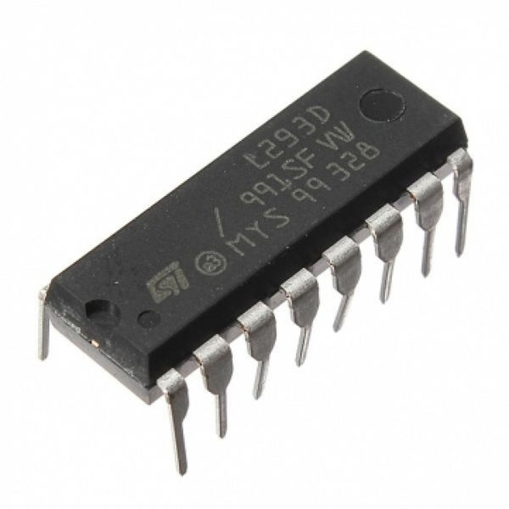
Fig. 3.3 IC L293D

The IC L293D consists of two built-in H-bridge driver circuits. The common mode of in its operation, two DC motors can be operated concurrently both in forwards and backward direction. The operation of the two motors can be regulated by input logic pin 2,7 and 10,15. The input logic 00 or 11 will pull up the corresponding motor. The input logic 01 and 10 will rotate the motor in clockwise and anticlockwise directions sequentially. The enable pin 1 and 9 (similar to 36 for two motors) must be high for two motors to start working. When the enable input pin is high, the correlated driver becomes enabled. As a result, the output gets activated and work in phase with its input. When the enable input pin is low, the driver is disabled and its output is off and in the high impedance state.

Table 3.1 The logical truth table of the motor driver (L293D)
Enable-1  Pin-1 | In-1  Pin-2 | In-2  Pin-7 | Out-1  Pin-3 | Out-2  Pin-6 | Result  Motor
High | Low | Low | Low | Low | Stop (No rotation)
High | High | Low | High | Low | Forward (Clockwise)
High | Low | High | Low | High | Reverse (Anticlockwise)
High | High | High | High | High | Break
Low | X | X | Z | Z | Stop

3.2.3.a L293D Pin Configuration
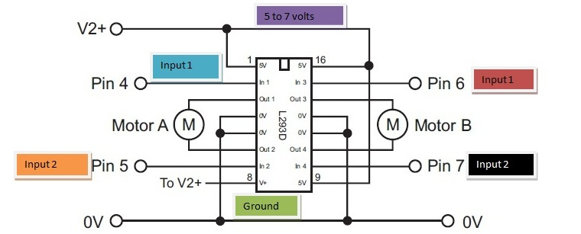

Fig. 3.4 Connection diagram of L293D
Table 3.2 Pin configuration table of motor driver (L293D)

Pin Number | Pin Name | Description
1 | Enable 1 &2 | This pin enables the input pin input-1(2) and input-2(7).
2 | Input 1 | Straightly controls the Output-1 pin that Controlled by digital circuits.
3 | Output 1 | Connected to one terminal of the motor-1.
4& 5 | Ground | Connected to the ground of circuit (0V).
6 | Output 2 | Connected to another terminal of the motor-1.
7 | Input 2 | Straightly controls the Output-2 pin that controlled by digital circuits.
8 | Vcc1 (Vss) | Connect to the voltage pin for driving the motor (4.5V to 36V).
9 | Enable 3 &4 | This pin enables the input pin Input-3 (10) and Input-4 (15).
10 | Input 3 | Straightly controls the Output-3 pin that Controlled by digital circuits.
11 | Output 3 | Connected to one terminal of the motor-2.
12& 13 | Ground | Connected to the ground of the circuit (0V).
14 | Output 4 | Connected to another terminal of the motor-2.
15 | Input 4 | Straightly controls the Output-4 pin that controlled by digital circuits.
16 | Vcc2 (Vss) | To enable the IC function is connected to + 5V.

3.2.4 Ultrasonic Sensor (HC-SR04)
The ultrasonic sensor is called for quantifying the characteristics of sound waves with the frequency above the audible range of human. It is working on three basic principles: Flight time, Doppler Effect, and the decrease of sound waves. The ultrasonic sensor is non-intrusive in that it has no need for physical connection with its target and it can identify specific shiny or clear targets Otherwise, it is unclear from some vision-oriented sensors. Otherwise, its measurement is highly sensitive to temperature and the angle of targets.[9]

3.2.4.a HC-SR04 Ultrasonic Sensor Pin Configuration
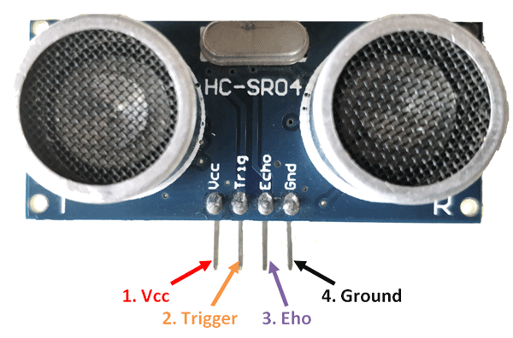
Fig. 3.5 HC-SR04 Ultrasonic Sensor

Table 3.3 Pin configuration tableof ultrasonic sensor (HC-SR04)

Pin Number | Pin Name | Description
1 | Vcc pin | The Vcc pin is typically working for input power supply with +5v
2 | Trigger pin | The trigger pin is used to take input. This pin has to keep high for 10µs to initialize measurement by transmitting the ultrasonic wave.
3 | Echo pin | The echo pin is an output pin. This echo pin becomes higher for a period of time which is equal to the time needed for the ultrasonic wave to reverse back toward the sensor.
4 | Ground pin | This pin is connected to the system's ground pins.

3.2.4.bWorking process of ultrasonic sensor(HC-SR04)
The ultrasonic sensor (HC SR04) is a four pins module as shown in Fig 3.5 above whose pin names are Vcc pin, Trigger pin, Echo pin, and Ground pin sequentially. This sensor is the most famous sensor applied to various purposes where distance measurements or sensing elements are needed. This sensor (HC SR04) has two devices like a human eye which acts as an ultrasonic transmitter and receiver. This sensor acts with easy high school formulas that are
Distance = Speed × Time
The ultrasonic transmitter sends an ultrasonic wave which moves in the air. When this wave finds an object by any fields it becomes returned back to the sensor and this returned wave is received by the ultrasonic receiver module as given in below the picture.
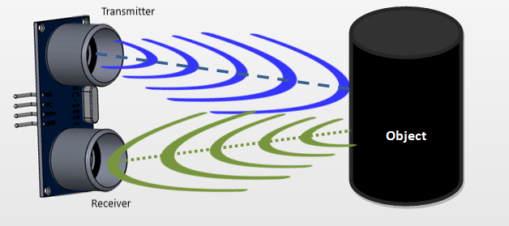
Fig. 3.6 An ultrasonic sensors working process

Now, we measure the distance by utilizing the formula above and have to know the speed and time. Whereas we are utilizing the ultrasonic wave we know the general speed of the ultrasonic wave at room conditions that is 330 m/s. The device built-in on the module that will measure the time taken for the ultrasonic wave to get back and witch on the echo pin high for that equal certain amount of time. In this way, we can also realize the time taken. Now we can easily measure the distance by utilizing a microcontroller or microprocessor. [10]
3.2.5DC Gear Motor
DC gear motors can be determined as an extension of the DC motor which meantime had its insight. A dc gear motor has a gear part affixed to the motor. The speed of the motor is computed in terms of revolutions of the shaft per minute and is called RPM. The gear system employs in incrementing the revolution and decreasing the speed. In a DC gear motor, the gear connects the motor and the Gearhead is quite minute. Hence it adds more speed to the immensely colossal teeth and makes it rotated. The more sizable voluminous portion of the gear additional turns the more minuscule twice port. The compressed twice port receives the torque but not the haste of its ancestor which shifts to a more sizable voluminous part of other gear and so on. The third gears twice part has more teeth than others and so it adds extra torque to the gear that is attached to the shaft. [18]
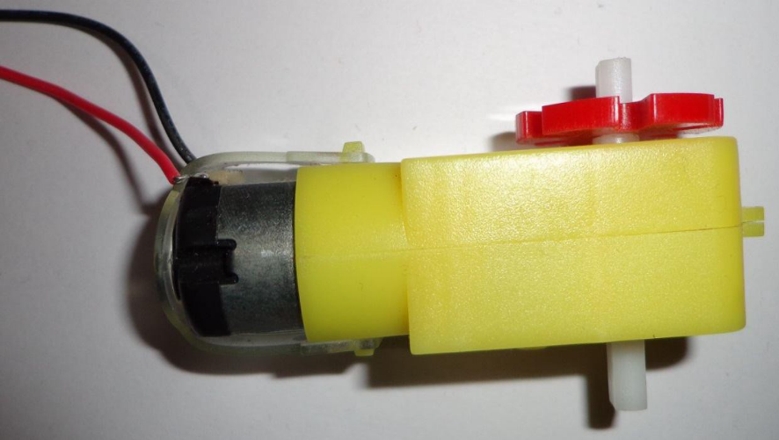
Fig. 3.7DC Gear motor

3.2.6 Wheel
A wheel is the main components to move an object adherent robot. Here we utilize plastic wheel covered by quantifying rubber tire whose diameter is 1.65" (42 mm) and it is set the output shafts on our gear motors. Those gear motors should mount on the side of the hub with the overhanging teeth. The output shaft will shift into the socket easily at first but achieve a snug fit when pushed through the other side of the hub.[18] 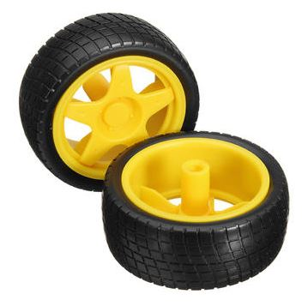
Fig 3.8: Wheel of object follower robot
3.2.6.a Specifications of wheels
Wheel weight: 0.66 ounce (19g)
Wheel diameter: 1.65 inch (42mm)
Tire width: 0.75 inch (19mm)

3.2.7 Ball Caster
Ball caster is full metal and it supports object follower robot to move easily and smoothly, it has a 1 mm thick steel plate for stamping the machine and the capacity to carry 15 kg. The ball caster is lightweight and strong. It has a 20 mm circular body with a weight of 37g which make the robot run in a more softly and easy way. [18]

+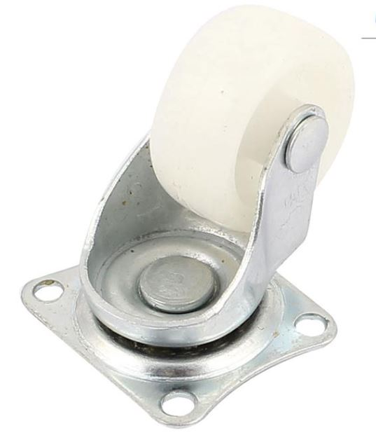
Fig. 3.9 Ball caster

3.2.7.1 Specifications ball caster
- Specific hole: 4 mm
- The distance of centre fixed holes: 40 mm
- Ball Extruding Height: 4 mm
- Ball Body Height: 20 mm
- Weight: 37 g
- Max Load: 15 kg
- Ball Diameter: 15 mm
- Bearing Ball Number: 40
3.2.8 Robot Chassis
Chassis play a vital role to hold all hardware of Object follower such as microcontroller, power unit, motor, motor driver, etc.For this project, there used chassis which is known as magician chassis because it is suitable for all types of mobile robot hardware. The Chassis is the latest robot platform from Dagu. It can hold a couple of gear motors with 65 mm wheels and a ball caster. The chassis plate is made of acrylic with a spacious range of mounting slots or holes for controllers, sensors, motor drivers, battery, camera etc. We can easily bolt the two pre-cut platforms mutually and possible to attach some desired robotics controller. This chassis can hold 4xAA battery holder and have sufficient space to keep any other DC battery

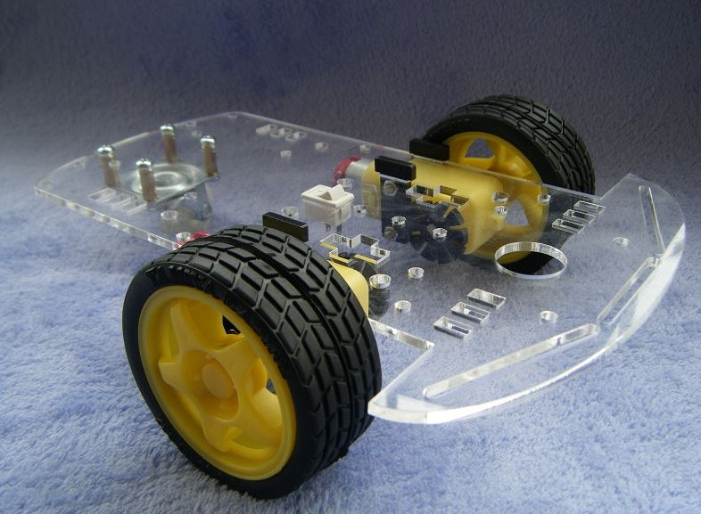
Fig. 3.10 Chassis for object follower robot

3.2.9 Jumper Wire
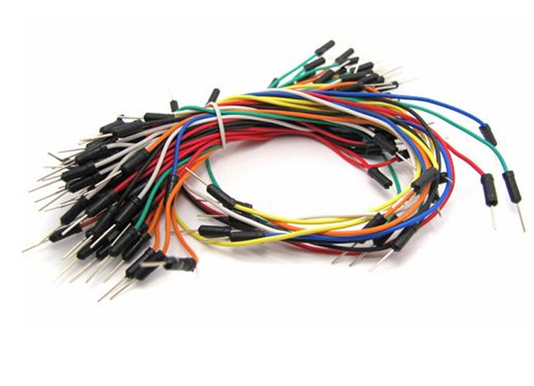
A jump wire, is a short electrical wire with a solid tip at each end (or sometimes without them, simply "tinned"), which is normally used to interconnect the components in a breadboard. Depending up on its two end tip or tip hole jumper wire has several types Male- Female, Female- male, Male-Male etc. In our project we used male to female jumper wire which is connected to the robots MCU to the sensor. And in bread board for different connection other simple jumper wire was used. The picture of several jumpers is given below

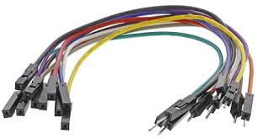

Fig.3.11 Jumper wire

3.2.10 PCB Board
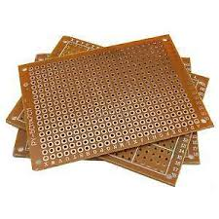
A printed circuit board (PCB) mechanically supports and electrically connects electronic components or electrical components using conductive tracks, pads and other features etched from one or more sheet layers of copper laminated onto and/or between sheet layers of a non-conductive substrate. [11]
Fig. 3.12 PCB Boar
3.2.10. Construction of a PCB Board
We assemble prototype circuits with SMT, THT components at very competitive prices and we will proceed with your quotation for PCB fabrication, assembly and components and cabling assembly in a single operation for all your project requirements.
In here we provide one-stop PCB Assembly Services
We are capable of providing full turn-key and partial turn-key for circuits board assembly services. For full turn-key, we take care of the entire process, including preparation of Printed Circuit Boards, procurement of components, online order tracking, continuous monitoring of quality and final assembly. Whereas for partial turn-key, the customer can provide the PCBs and certain components, and the remaining parts will be handled by us.[17]

3.2.11 Tools Needed

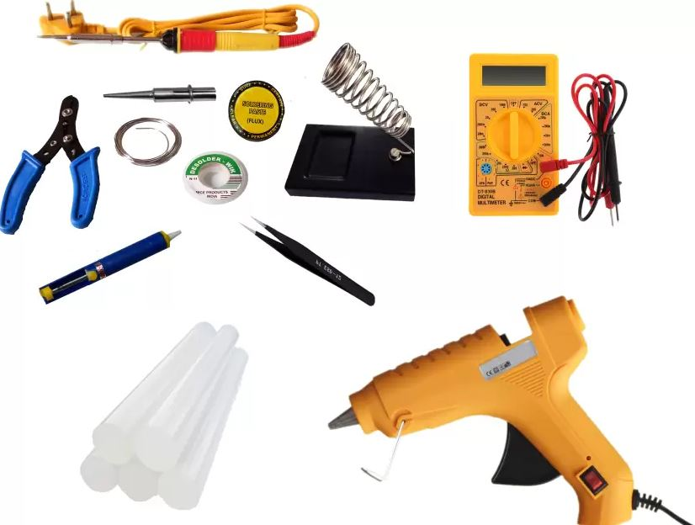
Fig. 3.13 Some tools

Some tools name are given below
- Soldering Iron
- Glue gun
- Cutter
- Knife
- Digital Multimeter
- Screwdriver
- Tweezer
- Panavisejr
- Wire Strippers
- Needle nose Pliers

3.14 Summary
This chapter is about those used hardware in this project maze solving robot. All the hardware that has been used in this project are in good shape and working properly and for that the robot car should work properly. In this chapter, we are trying to discuss details about the used each individual hardware working description and their works.

CHAPTER 4
HARDWARE DEVELOPMENT

4.1 Introduction
This chapter describes the methods implemented in an object follower robot solving algorithms. The main topics discussed in this chapter are how this project flowing software. The description hardware connection information.

4.2 Project Flowchart

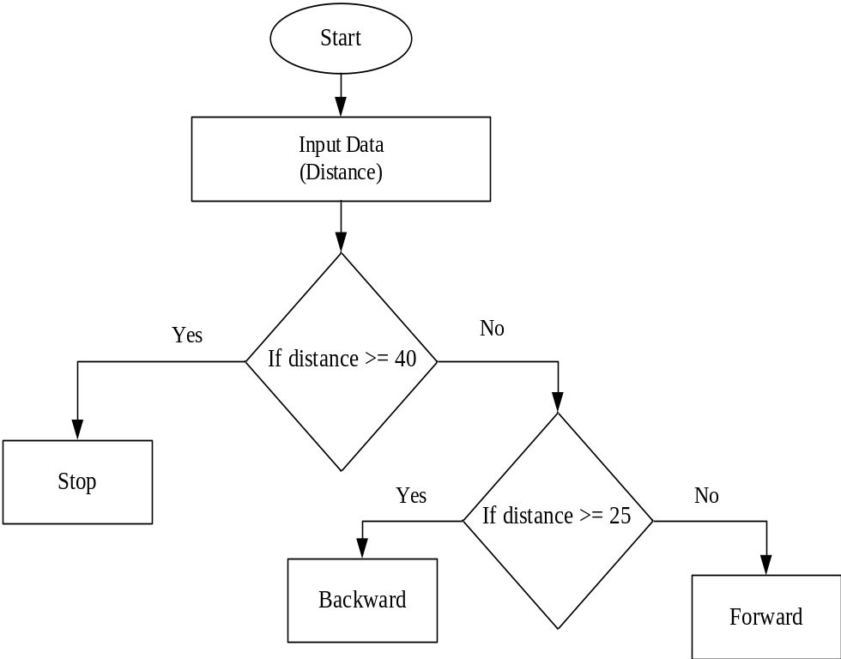

Fig. 4.1 Flowchart of the object follower robot

4.3 Algorithm of the object follower robot
Step 1: Start
Step 2: Take input from the sensor (Distance)
Step 3: If distance >= 40, motors are stop
Step 4: If distance >= 25, motors run forward otherwise backward
Step 5: End

4.4 Hardware Connection
Fig. 4.2 Block diagram of object following Robot

4.4.1 Descriptions of Hardware Connection
Here is the simple circuit diagram in the figure 4.3
• The trigger pin connect to Arduino 2 number of pin
• Echo pin connect to Arduino 3 number of pin
• The motor driver (L293D) has 16 pin
• 1, 8,9 and16 pins of the motor driver are connected to +5v pin
• 4,5,10 and 11 pins of the motor driver are connected to Ground pin
• 2 pin of the motor driver connect to 4pin of Arduino
• 7 pin of Arduino connect to 10pin of the motor driver
• 8 pin of Arduino connect 15pin of the motor driver
• Motor1 connect to 11and14 pins of the motor driver
• Motor2 connect to 3 and 6 pins of the motor driver
That’s done. Now connect the power supply. [12]

4.5 Summary
After completing all the stuffs according to this chapter the Autonomous object or Human Follower robot will be ready to perform. The main difficult thing about this chapter was to build an algorithm on which working behavior of this robot depending. So the main object of this chapter was to understand the algorithm and the connection diagram.

CHAPTER 5
DISCUSSIONS

5.1 Introduction
This chapter will present all the results and calculation and relevant discussions.

5.2 Final Result
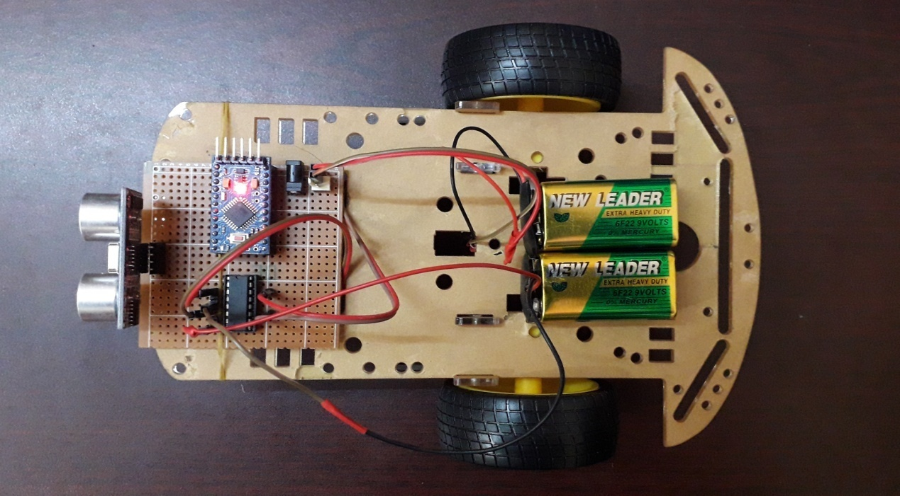
In this project, the object following robot has been made to follow the object or human. This robot has an ultrasonic sensor which detects the object and sends the information to the comparator (L293D) and H-bridge which controls the process of the wheels and microcontroller controls the whole operation. The object following robot was lastly finished by a lot of effort. For this robot, we spent a lot of time in designing, implementing, writing and debugging the code sitting in front of the computer. The robot was eventually working with a little error hither and thither. which were sorted in the later reviews of the firmware. The object following robot has a few weaknesses yet but gains most of the purposes.

Fig. 5.1 Final projects (Top view)

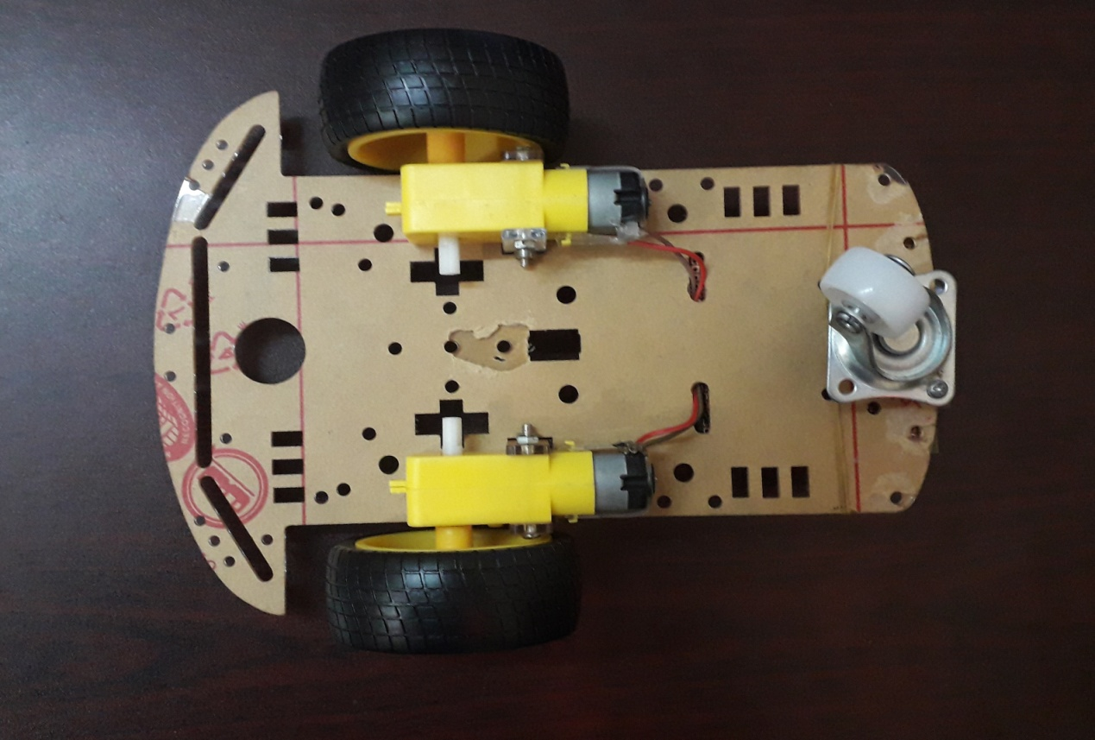

Fig. 5.3 Final projects (Down view)

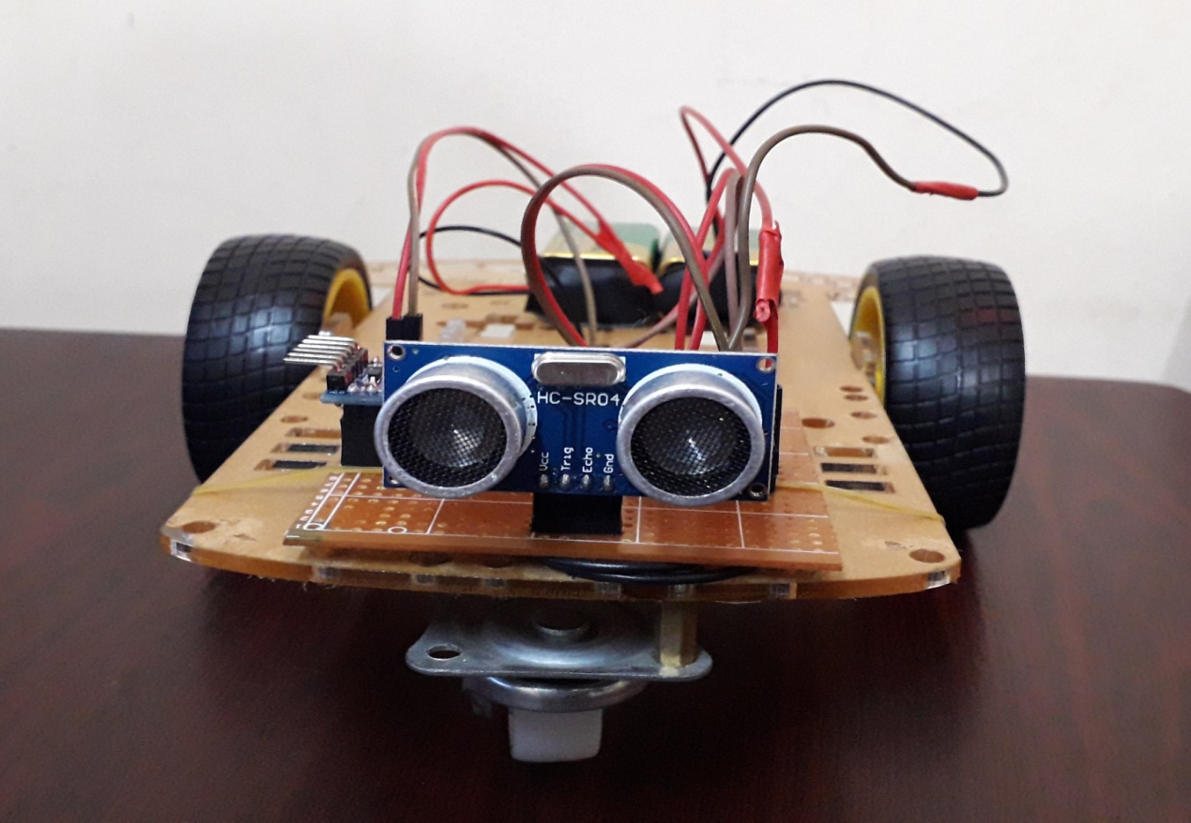

Fig. 5.4 Final project on white surface
5.3 Cost Analysis
Table 5.1 Costanalysis of the project

Serial No. | Name | Quantity | Price (BDT)
 | Arduino Pro Mini | 1 | 500
 | Microcontroller (ATMEGA328P) | 1 | 300
 | 2 Cell Lipo Battery DC Motor | 1 | 900
 | Ultrasonic Sensor | 1 | 230
 | Robot Chassis | 1 | 530
 | Metal Gear DC Motor (800rpm) | 2 | 900
 | Rubber Wheel | 2 | 180
 | Caster Ball | 1 | 95
 | L293D IC | 1 | 120
 | U-clamp motor holder | 2 | 40
 | Male-Female jumper wire |  | 150
 | Others |  | 300
 | Total |  | 4395

5.4 Summary
At last completing this chapter and the project is ready to use.

CHAPTER 6
CONCLUSIONS

6.1 Conclusions
Today we are in the world of robotics. Knowingly or unknowingly, we have been using different types of robots in our daily life. In this project, we have planned an object follower robot. This robot does not require any remote controller like GSM, Wi-Fi, Bluetooth, driver etc. It will automatically be run with tracking an object or human. This robot is affordable but highly effective for the different purpose. Our project can be utilized in many areas like delivering medicine in hospitals, delivering products in several places, spying, and inspection and so on. In the future, we can attach various sensors and cameras to get more features. In this way, we believe that our project will be helpful for many purposes & hence our purpose will be successful.

6.2 Limitations of the Project
Since we use three wheels to move the robot, Robot moves left or right that can’t be done. If we use four wheels, the robot can move forward and backward precisely. We faced difficulty to supply source by battery. When we run the robot, battery power reduces quickly. The steering mechanism is not simply accomplished in enormous vehicles and difficult for non-electric vehicles as like petrol powered. Lack of a three wheel drive, makes it not suitable for a rough terrain. Lack of speed control makes the robot unstable at times.

6.3 Further Improvements & Future Scope
There are huge beneficial uses of this project in various fields whether medical or military purpose. A wireless communicating system can be added with the robot to make it more manifold and control it from an exceptionally large distance. This ability of a robot could be appropriated for military purposes. We can observe the circumstances by simply sitting in our rooms by attaching a real-time video recorder. We can change some corrections in the algorithm and the construction as well to suit it for any other purpose e.g. a vehicle follower. Similarly, it can use the public in shopping malls. So it can behave as a luggage carrier hence no requirement to carry up the loads and pull that. The robot will automatically be followed that person using this algorithm. [15]

REFERENCES

- K. Morioka, J.-H. Lee, and H. Hashimoto, “Human-following mobile robot in a distributed intelligent sensor network,” IEEE Trans. IND. Electron., Vol. 51, no. 1, pp. 229–237, Feb. 2004
- N. S. Foundation. “National robotics initiative”,2014
- International Journal of Advanced Research in Electrical, Electronics and Instrumentation EngineeringVol. 2, Issue 4, April 2013
- Student Research Paper Conference Vol-2, No-15, July 2015
- http://www.sensorwiki.org/doku.php/sensors/ultrasound,, retrieved on 20/06/2018
- https://components101.com/ultrasonic-sensor-working-pinout-datasheet,, retrieved on 15/06/2018
- https://www.engineersgarage.com/insight/how-breadboard-works, retrieved on 15/06/2018
- http://home.roboticlab.eu/en/examples/sensor/ultrasonic_distance, retrieved on 20/06/2018
- http://www.sensorwiki.org/doku.php/sensors/ultrasound, retrieved on 20/06/2018
- https://components101.com/ultrasonic-sensor-working-pinout-datasheetretrieved on 25/06/2018
- https://en.wikipedia.org/wiki/Printed_circuit_board October ,2016
- https://www.instructables.com/id/HUMAN-and-OBJECT-Following-Arduino-Robot retrieved on 15/07/2018
- https://www.electromaker.io/project/view/object-and-human-following-robot retrieved on 16/07/2018
- https://www.engineersgarage.com/contribution/object-following-robotretrieved on 16/07/2018
- https://www.ist.edu.pk/Process.aspx?CTRL=19e62cc6-08e7-45d2-a3c7-95051b8479ed&CDF_ID=23f23f23-4960-4a97-b7d5-d795af62ca88&DL=Y,retrieved on 25/07/2018
- https://www.engineersgarage.com/insight/how-geared-dc-motor-worksretrieved on 05/08/2018
- https://www.pcb-welsa.com/assembly-services?gclid=Cj0KCQiA_s7fBRDrARIsAGEvF8QPOSHBQfV_NfQfQdBI-nXX4RdaLsRacVETSpe3QMbfOciEY0JzQPIaAkgtEALw_wcB

APPENDIX

//Original Code

//Object following Robot.

inttrigPin = 2; //Sonar Sensor - Trig Pin

intechoPin = 3; //Sonar Sensor - Echo Pin

int Motor1A = 5; //Motor 1 (+)

int Motor1B = 6; //Motor 1 (-)

int Motor2A = 7; //Motor 2 (+)

int Motor2B = 8; //Motor 2 (-)

void setup(){

pinMode(Motor1A, OUTPUT);

pinMode(Motor1B, OUTPUT);

pinMode(Motor2A, OUTPUT);

pinMode(Motor2B, OUTPUT);

pinMode(trigPin, OUTPUT);

pinMode(echoPin, INPUT);

}

void loop(){

int duration, distance;

digitalWrite(trigPin, HIGH);

delayMicroseconds(1000);

digitalWrite(trigPin, LOW);

duration=pulseIn(echoPin, HIGH);

distance=(duration/2)/29.1;

if(distance>=40){

digitalWrite(Motor1A, LOW);

digitalWrite(Motor1B, LOW);

digitalWrite(Motor2A, LOW);

digitalWrite(Motor2B, LOW);

delay(500);

}

else{

if(distance>=25){

digitalWrite(Motor1A, HIGH);

digitalWrite(Motor1B, LOW);

digitalWrite(Motor2A, HIGH);

digitalWrite(Motor2B, LOW);

delay(400);

}

else{

digitalWrite(Motor1A, LOW);

digitalWrite(Motor1B, HIGH);

digitalWrite(Motor2A, LOW);

digitalWrite(Motor2B, HIGH);

delay(400);

}

}

}

