PERFOMANCE ANALYSIS OF ROUTINE PROTOCOLS

BY

SANI AHMAD MUHAMMAD
ID: 181-25-668

Department of Computer Science and Engineering (CSE)

This Research Presented in Partial Fulfillments of the Requirements for the Degree of Master of computer Science and Engineering

Supervised By:

Dr. Fernaz Narin Nur
(Assistant Professor)

Department of Computer Science and Engineering Daffodil International University



DAFFODIL INTERNATIONAL UNIVERSITY DHAKA, BANGLADESH

DECEMBER, 2018.

APPROVAL

This research thesis “ PERFOMANCE ANALYSIS OF ROUTINE PROTOCOLS “
Submitted by Sani Ahmad Muhammad to the Department of Computer Science and Engineering, Daffodil International University(DIU), has been accepted as satisfactory for the partial fulfillment of the requirements for the degree of M.Sc. in computer science and engineering.
BOARD OF EXAMINERS

Dr. Syed Akhter Hossain Chairman
Professor and Head
Department of Computer Science and Engineering
Faculty of Science & Information Technology
Daffodil International University,

Dr. Sheak Rashed Haider Noori Internal Examiner
Associate Professor and Associate Head
Department of Computer Science and Engineering
Faculty of Science & Information Technology
Daffodil International University.

Md. Zahid Hasan Internal Examiner
Assistant Professor
Department of Computer Science and Engineering
Faculty of Science & Information Technology
Daffodil International University

Dr. Mohammad Shorif Uddin External Examiner Professor
Department of Computer Science and Engineering
Jahangirnagar University

DECLARATION
This is to certify that the work presented in this thesis is the outcome of the analysis and experiments carried out by me under the supervision of Dr. Fernaz Narin Nur, (Assistant Professor), in the Department of computer science and engineering(CSE), Daffodil International University (DIU), Dhaka, Bangladesh.
SUBMITTED BY:

Sani Ahmad Muhammad
ID: 181-25-668
Department of Computer Science and Engineering (CSE)
Daffodil International University.

SUPERVISED BY:

Dr. Fernaz Narin Nur
(Assistant Professor)
Department of Computer Science and Engineering (CSE)
Daffodil International University.

ACKNOWLEDGMENTS

Let me express my profound thanks and gratefulness to almighty Allah for making it possible to complete this thesis research successfully.
Let me also extend my profound gratitude to my respected and kind supervisor Dr. Fernaz Narin Nur (Assistant Professor), Department of Computer Science and Engineering, Daffodil International University, Dhaka. For her guidance, support, encouragement, advices, and above all prayers, as well as having time to read, correct and update this research until its completion.
Nonstop appreciation goes to Dr. Syed Akhter Hossain, Head, Department of Computer Science and Engineering, for his kindness, courage words, until my dream has been realized, i will not forget the staff of CSE department,like Dr. Sheak Rashed Haider Noori, Md. Zahid Hasan, and those I could not mention their names due to time frame, from CSE department daffodil International University (DIU).thanks you all.
My parents are at the forefront for making these achievements, their support, prayers and courage can never be over emphasized. my very sincere gratitude goes my role model, Malam Ahmad Garba, Malama Rahma Dauda and Malama Aisha Ahmad for their support and assistance through my entire life.
I would like to acknowledge and appreciate my relatives, prayers more especially brothers, and those I could not mention their names all, but I really appreciate your kindness. Appreciation goes to Alh. Bashir nura alkali (yaya minister), for his financial support throughout my studies. Special thanks to all my brothers, Abubakar Ahmad, sadiya ahmad, rabiu ahmad, hamisu ahmad sisters, uncles, aunties, cousins, friends, nieces, and nephew.
Finally my profound gratitude and appreciation to all those in any way helped me whose names do not specifically appear here. Thank you all.

ABSTRACT
Wireless Sensor networks (WSNs) are dense wireless networks of small, low-cost sensors, which collect and disseminate environmental data. WSNs facilitate monitoring and controlling of physical environments from remote locations with better accuracy. They have applications in a variety of fields such as environmental monitoring; military purposes and gathering sensing information in hospitable locations. Sensor nodes have various energy and computational constraints because of their inexpensive nature and ad hoc method of deployment, considerable research has been focused at overcoming these deficiencies through more energy efficient routing, localization algorithms and system design. The efficiency of sensor networks strongly depends on the routing protocol used. In this research, three different types of routing protocols are analyzed: LEACH, DD, and VGA. These routing protocols are implemented and simulated using Sensoria simulator. Several simulations are conducted to analyze the performance of different protocols including the power consumption, delay and throughput to measure the performance of the overall network. The simulation results, show that VGA technique has a better network lifetime performance than that of LEACH and DD as the percentage of energy consumption decreases while LEACH has a better network lifetime performance than that of VGA and DD as the percentage of energy consumption increases,. Furthermore, hence the result shows that DD has low performance compared to LEACH and VGA; this is because query is flooded throughout the network to draw data satisfying the query toward the requesting node.

CHAPTER 1: INTRODUCTION
  - OVERVIEW OF WIRELESS SENSOR NETWORKS
Generally a Wireless Sensor Network (WSN) is self-possessed of a large amount of wireless sensors with low dispensation power and energy utilization for monitoring a certain environment. Hundreds and thousands of sensors are deployed in wireless sensor network according to the situation of network demand. Wireless sensor network (WSN) is one of the developing technologies. Sensor nodes are able to examine physical surroundings, calculate and broadcast this information to central part network. These sensors can communicate to each other and also to some exterior Base station [8]. Wireless sensor network are used for both armed and civil applications[9]. A wide-range of applications offered by WSN; some of these are environmental monitoring, industrial sensing, infrastructure protection, battleground consciousness and hotness sensing.
    - WIRELESS SENSOR NETWORKS CHARACTERISTICS
WSN is currently used in a physical environment without real-world monitoring to measure many parameters. Therefore, the characteristics of the WSN must be taken into account for efficient network deployment. The significant features of WSN are described below:
- Dynamic network topology: in general, WSN are dynamic networks. The sensor node may not function due to battery depletion or in other circumstances, the communication channel may be interrupted and the additional sensor node may be added to the network, resulting in frequent changes in the network topology. Therefore, the WSN nodes must be incorporated with the reconfiguration auto-adjustment function.
- Self-organization: nodes of network sensors must have the ability to organize themselves as they are not used in an unguarded and hostile environment, the sensor nodes work together to adapt to the distributed algorithm and automatically form the network.
- Multi-hop communication: a large number of sensor nodes are distributed in the WSN. Therefore, the possible way to communicate with the receiver or base station is to take the help of an intermediate node via a routing path. If it is necessary to communicate with the other node or base station beyond its radio frequency, it must follow the route of the intermediate multi-hop node.
- Application oriented: the WSN is different from the conventional network by its nature; It is heavily dependent on the areas of application of the military, environmental and health sectors. The nodes are distributed randomly and distributed according to the type of use.
- Distributed detection and processing: the high number of sensor nodes is distributed uniformly or randomly. WSN each node is able to collect, sort, process, aggregate and send data to the recipient. Therefore, distributed detection offers the robustness of the system.
- Security and privacy: each sensor node must have sufficient security mechanisms to prevent unauthorized access, attacks and inadvertent damage to information within the sensor node. Furthermore, additional privacy mechanisms must also be included.
- Communication functions: the WSN network generally communicates via radio waves via a wireless channel. It has the ability to communicate in short range, with a narrow and dynamic bandwidth. The communication channel can be bidirectional or unidirectional. In this hostile and unmanaged operating environment, it is difficult to execute WSN correctly. Therefore, communication hardware and software must take into account robustness, security and resilience.
- Low cost: in the WSN normally hundreds or thousands of sensor nodes are deployed to measure any physical environment. In order to reduce the overall cost of the whole network the cost of the sensor node must be kept as low as possible.
1.1.2 APPLICATIONS OF WIRELESS SENSOR NETWORKS
Recently, wireless sensor networks have been used in a wide variety of applications and systems with very different requirements and characteristics. Surveillance, health care, environmental monitoring, home networks, detection of chemical, biological, radiological, nuclear and explosive materials. In addition to the above applications, self configurable WSNs can be used in many other application areas, for example, disaster relief, traffic control, warehouse management, and civil engineering. Table 1 describes the different types of applications of WSNs.
Table 1: Applications of WSN for Some distinct areas
Area | Purpose | Application
Environmental Monitoring | Monitoring environmental parameters or conditions | - Habitat monitoring  - Air or water quality monitoring  - Hazard monitoring  - Disaster monitoring
Military Applications | Military command, control communication and intelligence (C3I) system
  - Battlefield monitoring
  - Object protection
  - Intelligent guiding
  - Remote sensing
Health Care Applications | To monitor and track elders and patients for health care purposes. | - Behavior monitoring  - Medical monitoring
Industrial Process Control
  Reducing maintenance cost, and increasing machine lifetime.
  - Monitoring and control of production processes
  - Condition monitoring
Security and Surveillance | For surveillance of buildings. | - Identifying and tracking intruders
Home Networks | To provide more convenient and intelligent living environments. | - Smart home  - Remote monitoring
Emergency situation | Providing prompt information | - Disaster management  - Fire/water detectors  - Hazardous chemical level and fires

  - BACKGROUND OF THE STUDY
The sensor nodes are able of being used for large-scale sensing operations to observe physical phenomena in the surroundings given the restricted energy, dispensation and communication resources of the sensor nodes. Current advances in science and technology have made the technological improvements of tiny size, low-cost, scattered and low-power devices, which are competent of local signal processing and wireless data communication achievable, such devices are called sensor nodes. In order to communicate the desired information to the base station, the sensor nodes team up together by forming an ad hoc wireless network called wireless sensor network (WSN). WSN has a mixture of applications which falls into three classes, namely ;(a) event discovery and reporting, (b) data congregation and periodic reporting, and (c) sink initiated querying [1] The aim of the WSN is to observe physical or environmental situation, such as light, sound, pressure, temperature, motion and to helpfully collect and broadcast environmental data to the base station. Research challenges arose due to the factors pertaining to WSN plan, such factors are namely; (a) nodes deployment, (b) unattended operation, (c) limited source of energy, and (d) active changes in the WSN condition. On the other hand, wireless sensor technology has led to the evolvement of new protocols particularly designed for WSNs condition. [2] Due to the energy constraints in sensor nodes, energy consumption has to be measured when developing energy-efficient routing algorithms, which has been a challenging subject in the area of WSNs, numerous researchers’ efforts aim at improving the energy efficiency from diverse aspects to extend battery life as well as network lifetime. LEACH was proposed to form clusters of the sensor nodes based on the received signal power and one node acting as local cluster head supply as router to the sink in order to accumulate energy. Furthermore, PEGASIS was proposed as an improvement over LEACH protocol to expand network lifetime and it outperforms LEACH by about 100–300% for diverse network sizes and topologies. Though, PEGASIS introduces extreme delay; all sensor nodes have the same level of energy and are probable to die at the same time. The plan of this research is to examine the performance of LEACH, DD, and VGA routing protocols.
DD stand for direct diffusion is a well recognized protocol, only path packet through a single pathway which barely meets the throughput condition of multimedia data [3]. Direct diffusion is a data centric which enables sensor data to be distributed from data sources to sinks with low delay. Adding up to low delay, multimedia broadcasting also requires high bandwidth and delivery ratio. This throughput condition cannot be certain by a single path reinforced in essential directed diffusion. Directed diffusion uses [3].a publish/subscribe communication model whereby a sink node requests data by interests distribution for a named data. As the interest is flooded throughout the network, each middle node establishes a gradient with its neighbors and enables data that match the interest to be drawn towards the sink.
Virtual Grid Architecture (VGA) is an energy-efficient routing pattern proposed in [4] .The protocol utilizes data aggregation and in-network processing to maximize the network life time. Due to the node stationary and very low mobility in numerous applications in WSNs, a logical approach is to position nodes in a fixed topology. Data aggregation is performed at two levels: local and then global. The set of CHs, also called Local Aggregators (LAs), perform local aggregation, while a subset of these LAs are used to perform global aggregation. it maintain mobility.
    - PROTOCOL STACK OF WIRELESS SENSOR NETWORKS
A protocol stack for WSNs must support their typical features and singularities. According to [33], the sensor network protocol stack is much like the traditional protocol stack, with the following layers: figure 1 describe different protocols stack.

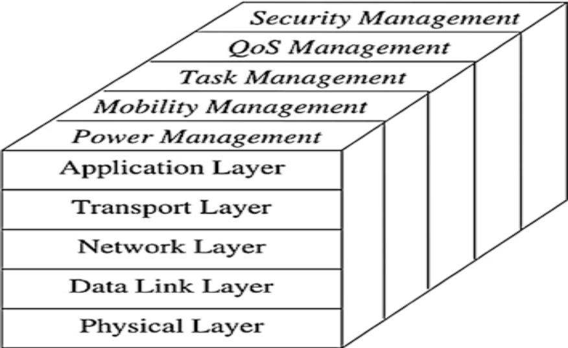
Fig.1.1Protocol stack of WSNs [34]

- The Application Layer includes a variety of application-level protocols that run various sensor network applications, such as query diffusion, node location, time synchronization, and network security. For example, the Sensor Management Protocol (SMP) is an application level management protocol that provides software operations to perform various tasks, such as exchanging location data, synchronizing sensor nodes, moving the sensor nodes, the nodes of the plane sensors and interrogating the state of the sensor nodes.
- The Transport Layer: In general, is responsible for the reliable transmission of end-to-end data between the sensor nodes and the well (s). Due to the energy, limitations of processing and storage of sensor nodes, traditional transport protocols cannot be applied directly to sensor networks without modification. For example, conventional error control based on end-to-end retransmission and window-based congestion control mechanisms used in the transport control protocol (TCP) cannot be used directly for transport networks, Sensors because they do not allow efficient use of resources.

- The Network Layer: is responsible for routing the data collected from the source sensor nodes to one or more data wells. In a sensor array, sensor nodes are distributed in a sensing region to observe a phenomenon of interest. The phenomenon or data observed must be transmitted to the data receiver. In general, a source node can transmit the data collected to the receiver directly via single-hop long-range wireless communication or through multi-hop short-range wireless communication. However, long-range wireless communications are expensive in terms of energy consumption and implementation complexity for sensor nodes. In contrast, short-range multi-step communication can not only significantly reduce the energy consumption of sensor nodes, but also effectively reduce signal propagation and fade effects of channels inherent in long-range wireless communications. Since the sensor nodes are densely distributed and the neighboring nodes are close to each other, short range distance communication can be used.
- The Data Link Layer: is responsible for multiplexing data streams, creating and detecting data frames, media access, and error checking to provide reliable point-to-point and point-to-multipoint transmissions. One of the most important features of the data link layer is Media Access Control (MAC). The main goal of MAC is to share communication in a fair and efficient way, resources or media across multiple sensor nodes to achieve good network performance in terms of power consumption, network throughput and delivery latency.
- The Physical Layer: is responsible for converting the bit streams of the data link layer into suitable signals for transmission on the communication medium. To this end, it has to address various related issues, such as transmission medium selection and frequency selection, carrier frequency generation, signal modulation and detection, and data encryption. In addition, it must also deal with the design of the underlying hardware and various electrical and mechanical interfaces.
1.3 MOTIVATIONS FOR THE STUDY
Although numerous routing protocols have been designed in WSNs, many issues still survive and there are still many challenges that need to be solved and enhanced in the sensor networks, those challenges motivated us of their searchers to conduct a research in this field in order to contribute to the knowledge. The subsequent parts explain some of the motivation:
- Nodes deployment: sensor nodes are deployed in region by tossing or scattering them from an airplane in a forest, which have no infrastructure at all. It is up to the nodes to recognize its connectivity and distribution.
- Unattended operation: the nodes themselves are accountable for recognition and reconfiguration of connectivity in case of any changes. Sensor networks have no human involvement.
- Finite source of energy: The sensor nodes are not linked to any energy source. There is only restricted energy stored in a sensor battery.
- Dynamic changes in the WSN condition: Sensor network system has to be flexible to change in connectivity, due to addition or failure of nodes and other ecological changes, to expand the system life span.
1.4 SCOPE OF THE RESEARCH
This research is restricted to investigate the performance and recognize the key features in the existing routing protocols. Such as LEACH, DD, VGA. But the benchmarks to be used in analyzing the performance are: Head node selection, energy utilization of the entire network, improving data aggregation. The dissertation was restricted on cluster-based approached technology for LEACH, DD; VGA based routing protocol family in the field of WSNs. Finally, the assessment of the performance metrics of the abovementioned routing protocol being used are the total network energy dissipated, network life time and number round per node.
1.5 PROBLEM STATEMENT
Sensor network nodes are limited with respect to communication bandwidth, limited computational ability and energy supply. As a result of energy constraints in sensor nodes, energy utilization has to be considered when developing energy-efficient routing algorithms, which has been a difficult issue in the field of WSNs. because WSNs might vary depending on the request and network structural design, prolonging the life span of the network by designing proficient routing protocols is critical. The majority of the concentration has been given to the routing protocols with frequent objectives of trying to prolong the lifetime of the sensor networks, while not compromising data delivery. LEACH [5] performs local data mixture to “compress” the sum of data being sent from the clusters to the base station, to condensed energy dissipation and improve system life span. Since one node in Leach cannot send the sensing data direct to the base station except with the help of nearest node (transmissions will only be complete by such cluster heads rather than all sensor nodes) not like in the case of PEGASIS. LEACH assumes that all nodes can broadcast with sufficient power to arrive at the base station; it also assumes that nodes for all time have data to send. In [3] DD the query is flooded throughout the network (the problems found in DD interest message is flooded through the entire sensor networks), as a result, many needless nodes in the networks are involved in this communication therefore, energy utilization has to be considered when developing energy-efficient routing algorithms, which has been a demanding issue in the field of WSNs. In directed diffusion, data is named using attribute-value pairs. A sensing task is distributed throughout the sensor network as an interest for named data [6] [3]. This distribution sets up gradients within the network designed to draw events. Particularly, a gradient is direction state created in each node that receives an interest. The local heads are permitted to communicate vertically and horizontally only. Each node within the grid that has the required data will send its data to the local head. Then the local head will aggregate the data and send it to its linked global head that will also aggregate the data again and send it to the BS via other global heads. If a local head or global head dies, a new local/global head is chosen after the election [7].
1.6 OBJECTIVES OF THE STUDY
The Aim of this research is to investigate the performance of three Routing Protocol techniques (LEACH, DD, and VGA) for WSN_{S}. The exact objectives are to:
- Find out the limitations and key features of DD, VGA, and LEACH routing protocol for WSNs respectively.
- Analyze and evaluate the performance of three different routing protocols LEACH, DD and VGA in terms of energy Consumption.
- Present a simulation model for LEACH, DD, and VGA hierarchical routing protocols, as well as comparing their performance using sensoria simulator.
1.7 RESEARCH CHALLENGES
The major issues that affect the design and performance of a wireless sensor network are many here are some of the challenges:

- Security is one of the biggest challenges of virtual storage networks. Most WSN attacks involve entering false information from compromised nodes within networks. The development of security systems for WSN also addresses challenges related to a limited environment.
- Real-world protocols: protocols must be developed for real-world problems, taking into account theoretical concepts and synthesizing new solutions in a complete system protocol for real-world application.
- System architecture: WSN domain searches are in progress all over the world, but there is not yet a network and unified architecture. You can then create an application at the top of this application.
- Power: power has always been a challenge for WSN projects. One way to extend network life is to design energy-efficient algorithms and hardware that intelligently use power.
- Hardware cost: one of the biggest challenges is to produce small, low-cost sensor nodes. The current sensor nodes are mainly prototypes with respect to these objectives. Recent and future advances in the field of micro-electromechanical systems allow obtaining a low cost in sensor nodes.
- Self-management: once implemented, wireless sensor networks should be able to function without human intervention. It should be able to manage the configuration, adaptation, maintenance and repair of the network itself.
- Fault Tolerance: the sensor network must remain functional even if a node fails while it is operating. The network should be able to adapt by changing its connectivity in case of failure, In this case, an efficient routing algorithm is applied to modify the general configuration of the network.
1.8 REPORT LAYOUT
This study focuses on analyzing the performance of three Routing Protocol techniques (LEACH, DD, and VGA) in Wireless Sensor Networks, and was organized in to five chapters. Chapter one is the research general introduction. It introduces the dissertation in six sub-headings that comprises background of the dissertation, motivation for the study, scope of the research, problems statement, research objectives to be achieved, research methodology and research organization.
Chapter two present literature review of related routing protocols for WSNs. Contains challenges and survey focus of wireless sensor networks and factors to be consider when design a routing protocol, brief history and characteristics of WSNs routing protocols, features and limitation of some reviewed protocols.
Chapter three contains the implementation and simulation parameters of LEACH, DD and VGA routing protocols. Chapter four contains the simulation phase and performance analysis of the simulated result. The result were simulated using network simulator SENSORIA. Finally, chapter five concludes this research with the summary of the achieved research work, and research contributions and future direction.

CHAPTER TWO
2.1 OVERVIEW OF ROUTING PROTOCOLS
This chapter presents the review of related works of routing protocols for WSNs. It contains challenges and survey focus of wireless sensor networks and factors to be considered when designing a routing protocol. A large number of routing protocols have been recently developed for WSNs, which provide energy efficiency in order to sustain as well as increase network lifetime. In general, WSNs can be divided into flat-based routing protocols, hierarchical-based routing protocols, location-based routing protocols and data-centric based routing protocols, depending on the network structure.
In flat-based routing protocols, all nodes in the network are treated equally, each node typically plays the same role and sensor nodes collaborate together to perform the sensing task with the help of meta-data for query, that is why all flat-based routing protocols are query-based. When node needs to sends data, it may find a route consisting of several hops to the sink. Due to the large number of such nodes, it is not feasible to assign a global identifier to each node.
Location-aided based routing, sensor nodes are addressed by means of their locations. Location information can be used to improve the performance of routing and provide new types of services. The distance between neighboring nodes can be estimated on the basis of incoming signal strengths. Relative coordinates of neighboring nodes can be obtained by exchanging such information between neighbors. Alternatively, the location of nodes may be available directly by communicating with a satellite, using GPS (Global Positioning System), if nodes are equipped with a small low power GPS receiver. To save energy, some location based schemes demand that nodes to sleep if there is no activity. More energy savings can be obtained by having as many sleeping nodes in the network as possible.
Data-Centric based routing protocols (DC), the sinks send queries to certain region and wait for data from the sensors located in the selected regions. Since data is being requested through queries, attribute based naming is necessary to specify the properties of data. DC performs in-network aggregation of data to yield energy-efficient data delivery. The main idea of the DC paradigm is to combine the data coming from different sources and route to eliminating redundancy, minimizing the number of transmissions, and thus saving network energy and prolonging its lifetime.
Hierarchical or cluster-based routing, originally proposed in wired networks, comprises well-known techniques with special advantages related to scalability and efficient communication. As such, the concept of hierarchical routing is also utilized to perform energy-efficient routing in WSNs. In a hierarchical architecture, higher energy nodes can be used to process and send the information, while low energy nodes can be used to perform the sensing in the proximity of the target. This means that creation of clusters and assigning special tasks to cluster heads can greatly contribute to overall system scalability, lifetime, and energy efficiency. As a result of the above challenging factors of wireless sensor networks, several problems in the process of designing a network must be taken into consideration, for example, localization, energy efficiency, routine, media access control, security and privacy.
Heterogeneity based routing protocols: It is a group in which all the nodes are not identical and do not have same capability i.e. some node are more powerful than others. Example of heterogeneous group is cluster architecture in which node form a cluster head and gather data from less powerful node. Heterogeneity [32] arises when two completely different WSNs need to communicate with each other. Unified communication interfaces will be required to enable efficient information exchange across diverse systems and nodes.
2.2 HIERARCHICAL BASED ROUTING PROTOCOL
In hierarchical based routing system of network design, nodes play dissimilar roles in the network and are prearranged into a group of sensors or clusters. Clustering is the technique by which sensor nodes in a network arrange themselves into groups according to precise requirements or metrics. Each group or cluster has a head referred to as cluster head (CH) and other normal member nodes (MNs). The cluster heads can be organized into more hierarchical levels such as first level and second level cluster head as shown in Figure 2.1. In a hierarchical structural design, superior energy nodes can be used to process and send the information while low energy nodes can be used to carry out the sensing in the nearness of the target. This means that formation of clusters and assigning particular tasks to cluster heads can very much contribute to improve system scalability, lifetime, and energy efficiency. These create hierarchical routing protocols to be more scalable and energy-aware in the background of WSN.
Figure 2.1: describe the Hierarchical levels of cluster head formation.

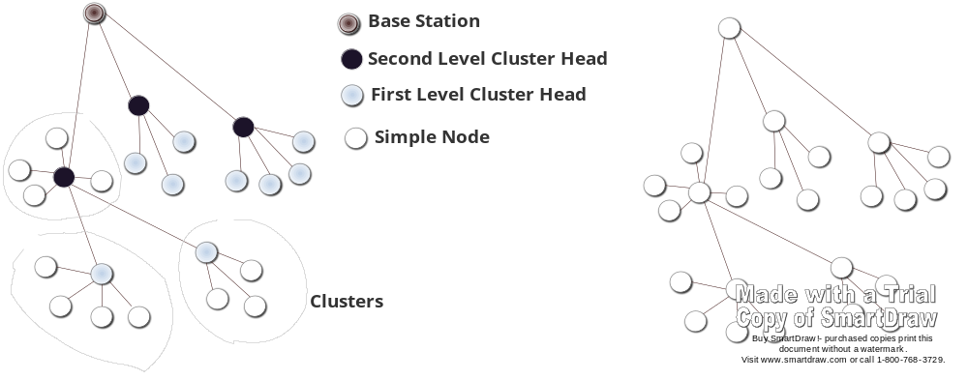
Figure 2.1: Hierarchical levels of cluster head [19]
From a routing point of view, Clustering permit intra-cluster and inter-cluster routing which reduces the number of nodes taking part in a long distance communication, therefore permitting important energy saving in addition to smaller distribution latency. Intra-cluster inside a cluster circle and inter-cluster that is, between cluster heads and sink as shown in Figure 2.2 describe the
Structural view of a leach protocol before cluster formation

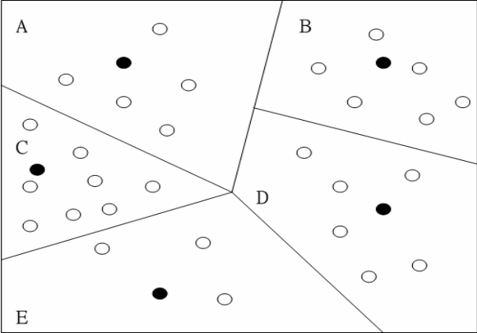
Figure 2.2: Structural view of a leach protocol before cluster formation.
This division leads to important energy saving since the radio unit is the main energy consumer in a sensor node. In fact, member nodes are only permitted to communicate with their own cluster head, which is accountable for relaying the data to the sink with promising aggregation and mixture operations. In such applications, data aggregation at the cluster heads aids to ease congestion and save energy. Furthermore, this division of dissimilar clusters permits reducing routing tables at both member nodes and use again for communication bandwidth.
2.2.1 Low-Energy Adaptive Clustering Hierarchy (LEACH)
Low-energy adaptive clustering hierarchy (LEACH) is a self-organizing clustering protocol that uses randomization to allocate the energy weight between the sensors in the network [19]. The idea of LEACH is to form clusters of the sensor nodes based on the established signal power, and one node acting as local cluster head serve as router to the sink. This will keep energy since the broadcasting will only be complete by such cluster heads rather than all sensor nodes. Thus LEACH involves randomized rotation of the high-energy cluster-head location such that it rotates between the various sensors in order not to exhaust the battery of a single sensor.
Adding together, LEACH performs local data fusion to “squeeze” the quantity of data being sent from the clusters to the base station, further summarized energy waste and improve system lifetime. best number of cluster heads is predicted to be 5% of the total figure of nodes.[19][21][10]. Sensors select themselves to be local cluster-heads at any specified time with a convinced probability. The cluster head nodes transmit their position to the other sensors in the network. Each sensor node determines to which cluster it wants to fit in by choosing the cluster-head that requires the smallest amount communication of energy, once all the nodes are prepared into clusters, each cluster head creates a schedule for the nodes in its cluster. This permit the radio mechanism of each non-cluster-head node to be turned off at all times apart from during its transmission time, `thus minimizing the energy dissipated in the individual sensors. The Moment cluster-head has all the data from the nodes in its cluster, the cluster-head node aggregates the data and then transmits the condensed data to the base station. The nodes die arbitrarily and active clustering increases lifetime of the system. LEACH is able to increase the network lifetime, LEACH is totally dispersed and requires no global information of network [19]. Due to energy boundary of sensors, life span maximization of wireless sensor network is one of the motivating issues for designing a protocol. Low Energy Adaptive Clustering Hierarchy (LEACH) is a well-known hierarchical routing protocol in WSN, but its performance reduces sharply with increase of the network level. To resolve this difficulty, an enhanced LEACH routing protocol was future to balance energy use among the whole network which is called LEACH-MF [23].
2.2.2 Low-energy adaptive clustering hierarchy mf (LEACH-MF)
LEACH-MF adopts the methods of multi-layer clustering and eliminates unnecessary information. The performance of the LEACH-MF protocol shows that, the survival time of the network was comprehensive and performs much better than LEACH protocol. Based on some investigation on the fault in LEACH as well as the variation of the figure of cluster heads and the unawareness of the node's remaining energy, some protocols was proposed to improve and provide efficient energy sharing and better cluster head selection between the sensor nodes. A novel protocol called LEACH-B (LEACH-Balanced) was proposed [25].
At every round, after first selection of cluster head according to LEACH protocol, a second selection was introduced to adapt the number of cluster head in consideration of node's residual energy. As a consequence of that, the number of cluster head is steady and near optimal per round. The result shows that the enhanced protocol has balanced the system energy utilization and has better performance of prolonging the network lifetime than LEACH protocol. I-LEACH (Improved LEACH) was proposed with two significant changes, first residual energy is used to select the cluster head instead of probability used in the LEACH for selection of cluster head, so that it can be used for the sensor nodes with dissimilar initial energy and other its coordinates are used to form clusters so that there must have a CH close to every sensor node, as there is no confidence in LEACH about the position of CHs. The I-LEACH do better than LEACH with 171 more rounds which estimated around 15% more energy efficient with 1J/Node energy over a network area of a 100m × 100 m [23].
However, LEACH uses single hop routing where each node can broadcast directly to the cluster-head and the sink. as a result, it is not appropriate to networks deployed in large regions with huge number of nodes. in addition, the idea of dynamic clustering brings additional overhead, such as head changes and advertisements, which may reduce the gain in energy utilization. Moreover, there are a lot of assumptions used in this protocol which are not always true. LEACH assumes that all nodes can broadcast with sufficient power to reach the base station. It also assumes that nodes always have data to send, and nodes situated near each other have connected data [21]. It is not clear how the number of the prearranged cluster heads is going to be consistently dispersed through the network. Because it is likely that the elected cluster heads will be concentrated in one part of the network, some nodes will not have any cluster heads in their surrounding area. Finally, the protocol assumes that all nodes start with the same amount of energy ability.

2.2.3 Power Efficient Gathering in Sensor Information Systems (PEGASIS)
PEGASIS was proposed to improve over LEACH protocol [26]. The protocol, called Power Efficient Gathering in Sensor Information Systems (PEGASIS), is a near optimal chain-based protocol. The essential idea of the protocol is to expand network life span, nodes require only to communicate with their nearby neighbors and they take turns in communicating with the base-station [26][21]. Rather than forming several clusters, PEGASIS forms chains from sensor nodes so that each node transmits and receives from a neighbor and only one node is selected from that chain to broadcast to the base station (sink). Gathered data moves from node to node, accumulated and finally sent to the base station. The chain construction is performed in a gluttonous way. PEGASIS has two major objectives. Initially, to boost the lifetime of each node by using joint techniques, secondly, permit only local organization between nodes that are closer so that the bandwidth consumed in communication is reduced.
PEGASIS do better than LEACH by about 100–300% [26][21] for dissimilar network sizes and topologies. Such performance gain is achieved through the removal of the overhead caused by dynamic cluster arrangement in LEACH and through decreasing the amount of transmissions and reception by using data accumulation. The greedy algorithm used to construct the chain in the original PEGASIS only achieves a local optimization. However, PEGASIS introduces extreme delay for far-away node on the chain also assumes that each sensor node is able to communicate with the BS straight and all sensor nodes have similar level of energy and are possible to die at the same time. Furthermore, the single head can turn into a blockage. It regularly does not operate 30 exhaustively on all the data, so it frequently fails to discover the worldwide best solution. Furthermore, in view of that data will be transmitted along the formed chain, and energy provide is the key limit of WSN, concentration ought to be given to the energy crisis.
2.2.4 Energy Efficiency PEGASIS Algorithm
Numerous protocols was proposed by researchers presently improved algorithms based on PEGASIS such as PEG-Ant [27][19] and PCC[20]. Among them, Energy Efficiency PEGASIS Based protocol (EEPB) was proposed to adopt threshold when constructing chain to reduce the configuration of long link, selects the head by considering both the residual energy of nodes and the distance between node and BS, and adjusts the reselection incidence of head according to residual nodes in the network [21]. Though, EEPB overcomes more than a few problems over PEGASIS but still has deficiencies. When EEPB builds a chain, the threshold adopted is uncertain and complex to make a decision, which causes the inevitability of long link if valued unsuitably. When EEPB selects the head, it ignores the suitable amount of nodes energy and space between node and BS which optimizes the head selection according to various application environments [21].
2.2.5 improved energy efficiency PEGASIS algorithm
The enhancement of energy-efficient PEGASIS-based routing protocol (EEPB) was proposed to resolve the problems stated above, which is called IEEPB [24]. The major idea of IEEPB is to compares the distance between nodes double and finds the shortest path to link the two neighboring nodes. IEEPB is an enhanced chain-based routing algorithm over EEPB. It is operating by rounds which contain 3 stages: (i) chain construction phase, (ii) head selection phase, (iii) data transmission phase.
Chain Construction Phase: To form a chain, the algorithm determines the number of nodes, first energy, and BS position information. Then chain construction begin with broadcasts the whole network with a hello message by BS to gain basic network information such as ID of nodes alive and distance from each node to BS. Then set the node which is farthest from BS as end node, it joins the chain first and is labeled as node 1. End node of the chain obtains the information of distance between itself and other nodes which have not connected the chain yet, finds the nearby node and sets it as node i waiting to join the chain, i represents the i-^{th} node joined. Node i gets the information of distance between itself and i-1 nodes which are on the chain, finds the nearby node j (1 ≤ j ≤ i −1) and directly connects with it to join the chain. At this tip node i becomes the new end node of the chain, it reprocess and connect node i+1, i+2…The process continues till all sensor nodes have joined the chain, so that there forms a branching chain finally [24].
Head Selection Phase: IEEPB chooses the head using weighting method which considers both the residual energy of nodes and the distance from node to BS. IEEPB will select the new head according to the combined weight in each round by estimating distance to BS, which is distance between sensor node and BS. As sensor nodes are location unaware, they have no idea about their geographic location. At first stage, BS broadcasts information message to the whole network and node i can estimate its distance from BS by the received signal strength. Then it calculates the energy portion and jointed weight for each node. And lastly contrast the dissimilar weights of each node and the node with least amount weight is chosen as the head in this round. The coefficient flexibility optimizes the head selection and enables the algorithm to be suitable to a variety of network situations with diverse requirements [24].
Data Transmission Phase: After the IEEPB protocol performs the process of the first two phases, the head initiates a token transitory approach to start the data transmission from the end node of the chain. The chain formed in IEEPB has more than two end nodes. Each node delivers own sensing data to its neighbor node in their time slots assigned by TDMA device, then the neighbor nodes fuse them with their own data and transmit these data to their other neighbor nodes. One round will end until BS receives the data from the head [24].However, IEEPB used greedy algorithm for chain construction, extreme delay may be introduced for distant node by using greedy algorithm, and any node can send data direct to the base station. So energy utilization would be high.
2.2.6 Improved PEGASIS using concentric clustering scheme
The idea of proposing enhanced PEGASIS protocol using concentric clustering system was proposed by[20] due to the redundant data transmission causes by original PEGASIS protocol because one of nodes on the chain is selected as the head node despite of the base station's position. Enhanced PEGASIS protocol based on the concentric clustering scheme was proposed to solve this problem. The word "concentric clustering" means that the form of a cluster is concentric circles, when the sensor networks are separated into several clusters level. It is appropriate to use the concentric clustering scheme to avoid the data transmission attended with the unnecessary energy utilization. When the PEGASIS protocol constructs the chain, wireless sensor networks are divided into several numbers of the concentric shaped clusters to give the flow of the data broadcast. The enhanced PEGASIS protocol consists of four processes (i) level assignment, (ii) chain construction in the level area, (iii) data transmission and (iv) head node construction in chain.
Level Assignment: Each node in the sensor networks is assigned to its own level from the base station. The level is given as the form like a concentric circle using the signal power as shown in Figure 2.3. The interval of level may varies according to setting values in the base station. Moreover, the number of these levels depended on various parameters such as the density of the sensor networks, the figure of nodes, or the position of the base station [20].
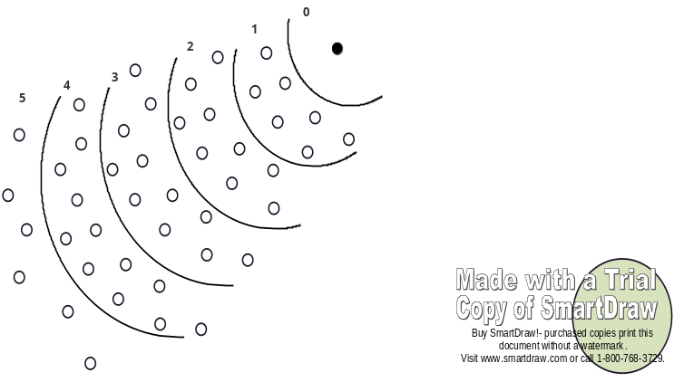
Figure 2.3: Level Assignment [20]

Chain Construction in the Level Area: In each level area, the chain building is started at the farthest node from the base station using the greedy algorithm as shown in Figure 2.4. This process of the chain construction is the same with the present PEGASIS protocol. In the improved PEASIS protocol, the high level means that the node is situated at the farther distance from the base station [20].
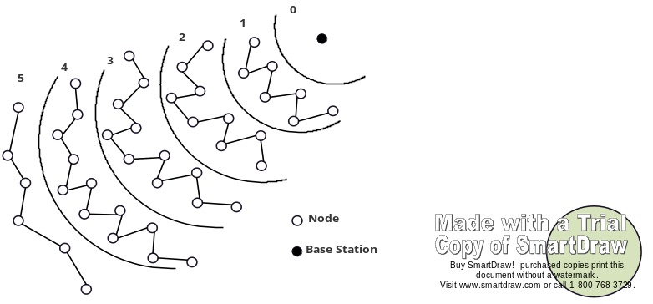
Figure 2.4: Chain Construction [20]

Head node selection in chain: One of nodes on the chain at every level area is chosen as a head node as shown in Figure 2.5. A head node in L level is chosen node number i mod ML (ML presents the number of nodes which have the same level) in i round. After it selects head nodes, each head node informs its own position information to the higher level head node and lower level head node in one grade. In the procedure of the data broadcast, a head node is received the data from all nodes in the same level and the head node in the higher level. Lastly, the head node will broadcast these data to the head node in lower level by one rank [20]
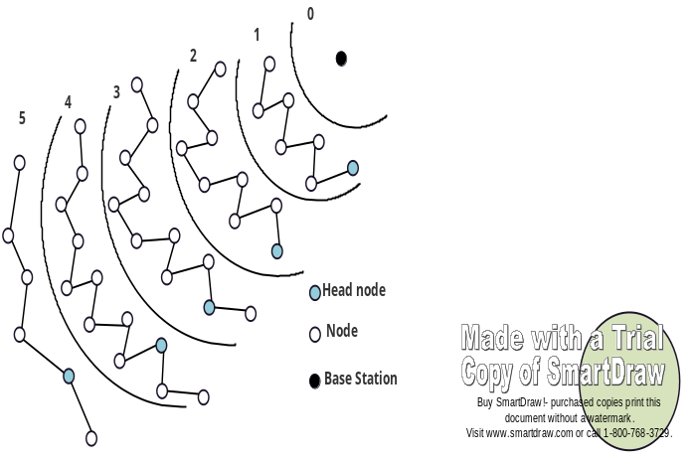
Figure 2.5: Selection of Head Node [20]

Data Transmission: The data broadcast is based on the process of the present PEGASIS protocol. All nodes in each level broadcast the data along the chain to the nearby node from themselves. The node receives the data and fuses its own data and transmits these data to the subsequent node. The head node in every stage transmits the data to the lower head node. Finally, level 1 head node transmits these data to the base location as shown in Figure 2.6. The head node in each level is accountable for receiving the data from node in same level and the head node in higher level. Also, the head node is responsible for transmitting the accumulated data to head node in lower level by one grade [20].

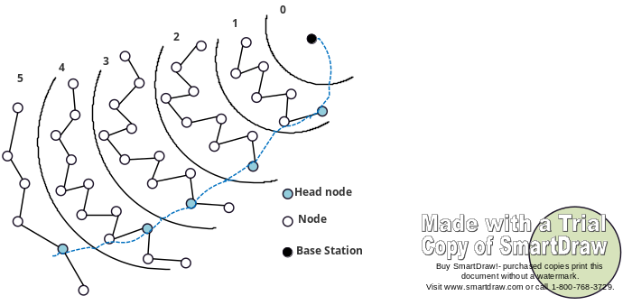
Figure 2.6: Data Transmission [20]

Figure 2.7 shows the data transmissions from the head node in 3, 4, and 5 levels to the base position. In Figure 2.7, the sensor network is separated into five levels considering the position of the base station. the entire data flow is headed to the base station and it is obvious that the concentric clustering scheme makes the sensor networks to shun a unnecessary data broadcast. Therefore, the energy can be save transmit from each node to the base station and the life time of the wireless sensor networks can be extend. The improved PEGASIS protocol uses the concentric clustering scheme and the data flow always onward to the base station, to shun the disused transmission of the data and it save the energy about 35°0 in contrast with the original PEGASIS protocol as the performance assessment shows[20]. However the protocol does not consider energy for level assignment and the selection of a head node, which can also maximize the network life. as well by using greedy algorithm to build a chain extreme delay may be introduced for distant node at each and each level chain construction.

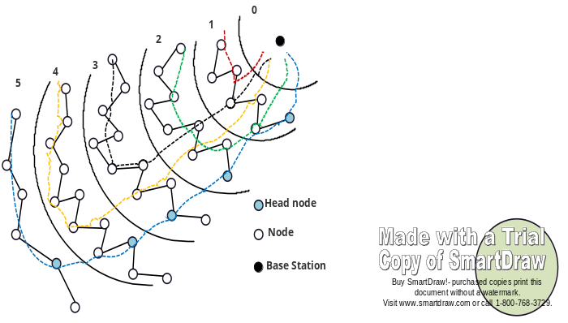
Figure 2.7: Data Transmission from Each Level [20]
2.2.7 Virtual Grid Architecture (VGA): this protocol was suggested, is a hierarchical clustering protocol network area. GPS-free technique that split network topology into logically balanced, side by side, equal and overlapping frames (grids) [24] [25] [26]. The broadcasting is done grid by grid [27]. VGA provides the ability to accumulate the data and in-network dispensation to boost the life span of the network. Data aggregation is made in two steps i.e. first at local level (in grid) and then globally. The nodes that are responsible to aggregate data locally are ‘local heads’ (grid heads) and the nodes ‘global heads’ have to aggregate data received from local heads [26] [27]. Following the configuration of logical grids, selection is commenced in each grid to decide for the local head of the grid based on node the energy and how many times it has been selected as local head. And then the global heads are also selected arbitrarily from the selected local heads. Numerous local heads may join the global head [26] [24]. The local heads are permitted to communicate vertically and horizontally only. Each node inside the grid that has the necessary data will send its data to the local head. Local head will condense the data and send it to its linked worldwide head that will also aggregate the data once more and send it to the BS by means of other global heads [25]. If a local head or global head dies, a new local/global head is chosen following the election [27].
2.3 DATA CENTRIC BASED ROUTING PROTOCOLS
In Data-Centric (DC), the sink sends queries to certain regions and waits for data from the sensors positioned in the chosen regions. Because data is being requested through queries, attribute based naming is necessary to identify the properties of data. DC performs in-network aggregation of data to produce energy-efficient data release. The major idea of the DC example is to unite the data coming from dissimilar sources and route to eliminate redundancy, minimizing the number of transmissions, and thus saving network energy and prolonging its life span.
2.3.1 Directed Diffusion (DD)
Directed Diffusion was suggested, which is a data-centric network. It is not the same from the traditional paradigm, termed address centric (AC) [20]. In AC routing, the difficulty is to find short path between pairs of addressable movable nodes, but DC finds routes from numerous sources to a single target to shun duplicate of data in the network. Directed diffusion contains some elements, such as, interests, data messages, gradients, and reinforcements [20].
An interest message is a query or an interrogation which specifies what a user needs. Each interest involves a description of a sensing job that is supported by a sensor network for acquiring data. In directed diffusion, data is named using attribute-value pairs. A sensing task is spread all over the sensors network as an interest for named data [21]. Then the broadcasting sets up gradients inside the network designed to sketch events. Purposely, a gradient is a path state created in each node that receives an interest. The query is flooded all over the network and gradients are set up to draw data pleasing the query toward the requesting node; it means, a sink can query for data by sending interests for named data and middle nodes to spread these interests.
2.3.2 Sequential Assignment Routing (SAR)
Sequential assignment routing (SAR) was suggested, as a first routing protocol for sensor networks which involves the notion of QoS in its routing decisions [22]. It can be considered as a table-driven multi-path approach determined to attain energy efficiency and fault tolerance. Routing decision in SAR is dependent on three factors: energy resources, QoS on each path, and the priority level of each small package. The SAR protocol creates trees rooted at one-hop neighbors of the sink by captivating QoS metric, energy reserve on every path and priority level of every packet into consideration[22]. Using these created trees, numerous paths from sink to sensors are created. Individual paths are then selected according to the energy resources and QoS on the path. Breakdown recovery is done by enforcing routing table consistency between upstream and downstream nodes on each path. Every local failure can causes an automatic path return procedure locally. It has been noticed that Simulation outcome shows that SAR offers fewer power utilization than the minimum-energy metric algorithm, which focuses just on the energy utilization of each packet without bearing in mind its priority [22]. though, SAR maintains numerous paths from nodes to sink that ensures fault-tolerance and easy recovery, the protocol suffers from the overhead of maintaining the tables and states at each sensor node especially when the number of nodes is enormous.
2.4 FLAT BASED ROUTING PROTOCOLS
In flat-based routing protocols, all nodes in the network are treated equally, each node typically plays the same role and sensor nodes collaborate together to perform the sensing task with the help of meta-data for query, that is why all Flat-base routing protocols are query-based. When node needs to sends data, it may find a route consisting of several hopes to the sink. Due to the large number of such nodes, it is not feasible to assign a global identifier to each node.

2.4.1 Sensor protocols for information via negotiation (spin)
SPIN (Sensor protocols for information via negotiation) was suggested, it obsessed flat-based and data-centric uniqueness where sensor nodes use three types of messages, that is, ADV, REQ, and DATA to converse [23][21]. ADV to advertise new data, REQ to requests data, and DATA is the real message to be broadcasted. The protocol begins when a SPIN node obtains new data that it is eager to share. This happens by broadcasting an ADV message consisting metadata. If a neighbor is in need of the data, it sends a REQ message for the DATA and the DATA is sent to this neighbor node. The neighbor sensors node keeps on repeating this process with its neighbors. Until, the whole nearby sensors receives a message copy. SPIN protocol included two keys innovations that resolve some deficiencies such as resource adaptation and negotiation [23][21].
2.4.2 Rumor routing (RR): Rumor Routing (RR) is completely flat-based routing protocols proposed by David Braginsky and Deborah Estrin to bridge the gap between query flooding and event flooding [36]. A Rumor Routine network is set of densely distributed wireless sensor nodes; each node maintains a list of its neighbors as well as an events table with forwarding information to all the events it knows. The list can be generated and maintained by broadcasting a request or through listening for other node broadcast [36]. Nodes are capable of witnessing an event, add it to the event table, generate query that should be routed to a particular event, and nodes can retransmit, give up or flood query if node that originate query realized that the query did not reach a destination [36]. The RR algorithm uses set of AGENTS, each agent informs nodes it encounter of any events it has witnessed along the route, then agents create paths directed towards the events they encounter [36][37]. Whenever an agent crosses path leading to an event that it has not encountered, it adapts its behavior thus creating a path state which leads to both the events. Finally agent optimizes shorter paths that come across in the network by updating the routing tables to have more efficient path in the network. The agent also contains an events table like that of the nodes which it synchronizes with every node that it encounters. RR uses an agent, query and event table to optimize routine in the network. However, node that generates a query will transmit the query if it has a route to the event, otherwise it will flood in random direction. This makes the number of events smaller than the number of query, and if the number of queries is high the energy consumption will be high.
2.5 LOCATION-AIDED ROUTING PROTOCOLS
In location-based routing, sensor nodes are addressed by means of their locations, location information can be used to improve the performance of routing and provide new types of services. The distance between neighboring nodes can be estimated on the basis of incoming signal strengths. Relative coordinates of neighboring nodes can be obtained by exchanging such information between neighbors. Alternatively, the location of nodes may be available directly by communicating with a satellite, using GPS (Global Positioning System), if nodes are equipped with a small low power GPS receiver. To save energy, some location based schemes demand that nodes have to sleep if there is no activity. More energy savings can be obtained by having as many sleeping nodes in the network as possible.
2.5.1 Geographic and Energy Aware Routing (GEAR)
Geographic and Energy Aware Routing (GEAR) algorithm was proposed to uses energy aware neighbor selection to route a packets toward the target region. In GEAR, each node keeps an estimated cost and a learning cost of reaching the destination through its neighbors. The estimated cost is a combination of residual energy and distance to destination. The learned cost is a refinement of the estimated cost that accounts for routing around holes in the network. A hole occurs when a node does not have any closer neighbor to the target region than itself. If there are no holes, the estimated cost is equal to the learned cost. The learned cost is propagated one hop back every time a packet reaches the destination so that route setup for next packet will be adjusted. The process of forwarding a packet to all the nodes in the target region consists of two phases that is, Forwarding packets towards the target region and Forwarding the packets within the region.
Forwarding the packets towards the target region: GEAR uses a geographical and energy aware neighbor selection heuristic to route the packet towards the target region. There are two cases to consider: (a) When a closer neighbor to the destination exists: GEAR picks a next hop node among all neighbors that are closer to the destination. (b) When all neighbors are further away: GEAR picks a next-hop node that minimizes some cost value of this neighbor. In this case there is a hole [35].
Disseminating the packet within the region: Under some conditions recursive geographic forwarding algorithm was used to disseminate the packet within the region, However under some low density conditions recursive geographic forwarding sometimes does not terminate routing uselessly around an empty target region before the packet’s hop-count exceeds some bound. In these cases restricted flooding is used [35].
2.6 HETEROGENEITY BASED ROUTING PROTOCOLS
It is a group in which all the nodes are not identical and do not have the same capacity, i.e some nodes are more powerful than others. An example of a heterogeneous group is the cluster architecture in which the node forms a cluster head and collects data from a less powerful node. Heterogeneity [32] occurs when two completely different network numbers must communicate with each other. Unified communications interfaces will be required to allow an efficient exchange of information between various systems and nodes.
2.6.1 Adaptive Threshold Sensitive Energy Efficient Sensor Network Protocol (APTEEN)
APTEEN is an extension to TEEN developed for hybrid network and aims at both capturing periodic data collections and reacting to time critical events, that not in need of delay interruption. The architecture is same as in TEEN [38]. When the base station forms the clusters, the cluster heads broadcast the attributes, the threshold values, and the transmission schedule to all nodes. Cluster heads also perform data aggregation in order to save energy. In APTEEN, the cluster-heads broadcasts the following parameters: Attributes (A), this is a set of physical parameters which the user is interested in obtaining information about. Thresholds, this parameter consists of the Hard Threshold (HT) and the Soft Threshold (ST). Schedule, this is a TDMA schedule, assigning a slot to each node. Count Time (CT), it is the maximum time period between two successive reports sent by a node can be a multiple of the TDMA schedule length and it accounts for the proactive component[38][39][40]. Figure 2.8 shows TDMA time line for APTEEN. APTEEN supports three different query types: i) Historical query, to analyze past data values; ii) One-time Query, to take a snapshot view of the network; and iii) Persistent query to monitor an event for a period of time.

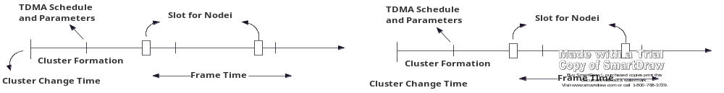

Figure 2.8: Time Line for APTEEN
2.6.2 Hybrid Energy Efficiency Protocol (HEEP)
HEEP [41] is an energy efficient routing method in which a series of SNs in an identical cluster is created with their closest neighbors and to increase energy dissipation. CH in each cluster sends their collected information to sink or BS via the nearest CH based on multi-hop technique, which reduces the energy consumption. Figure 2.9 which is redrawn from [41] shows the node organization within clusters. The first node transmits it to nearest neighbor, until reaches its CH that communicates to their sink or BS. Therefore, in this formation, the communication range and the total number of SNs interconnecting with the CH is decreased. It suggests enhanced energy saving and extends CHs lifespan.
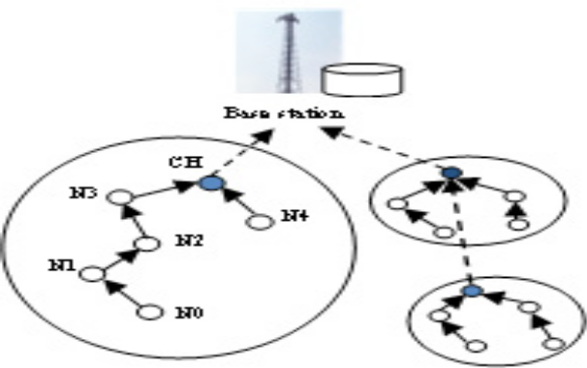
Figure 2.9 Chains cluster organization in HEEP [41]

2.7 COMPARISON OF ROUTING PROTOCOLS IN WSN
Routing  Protocols | Classification | Power  Usage | Data  Aggregation | Scalability | Query  Based | Over head | Data  delivery  model | QoS
LEACH | Hierarchical /  Node-centric | High | Yes | Good | Good | High | Cluster head | No
DD | Flat/ Data centric | Ltd | Yes | Ltd | Yes | Low | Demand  driven | No
VGA | Hierarchical | Low | Yes | Good | No | High | Good | No
SPIN | Flat / Srcinitiated/  Data-centric | Ltd | Yes | Ltd | Yes | Low | Event driven | No
RR | Flat | Low | yes | Good | Yes | Low | Demand Driven | No
TEEN &  APTEEN | Hierarchical | High | Yes | Good | No | High | Active Threshold | No
PEGASIS | Hierarchical | Max | No | Good | No | Low | Chain based | No
GEAR | Location | Ltd | No | Ltd | No | Mod | Demand driven | No
GEAR | Data centric | High | Yes | Ltd | Yes | High | Continuously | Yes
SPEED | Location/Data  centric | Low | No | Ltd | Yes | Less | Geographic | Yes
GBR | Flat | Low | Yes | Ltd | Yes | Low | Hybrid | No
GAF | Hierarchical /  Location | Ltd | No | Good | No | Mod | Virtual grid | No

CHAPTER THREE
PROTOCOL IMPLEMENTATION
The third chapter discusses the implementation and performance analysis mechanism of (a) the adaptive energy efficiency clustering hierarchy (LEACH),(b)Directed Diffusion(DD) and (c)Virtual grid(VGA).Think about each of the three protocols mentioned above and determine its structure network , data broadcasting, data diffusion (aggregation / union), as well as a data transmission redundancy problem that can lead to high energy use due to inappropriate selection of a node.
3.1. LOW-ENERGY ADAPTIVE CLUSTERING HIERARCHY (LEACH)
This protocol was suggested to form clusters of the sensor nodes, based on the received signal power and one node performing as local cluster head serve as router to the sink in order to save energy, is a popular hierarchical routing protocol in WSN. LEACH is considered as cluster-based protocol that uses randomization to allocate the energy load evenly among the sensors in the network. In LEACH, the nodes arranges themselves into local clusters, and one node is chosen to act as the local base station or cluster-head (CH), the selection of CH depends on decision made by the node by choosing a random number between 0 and 1.if the number is less than a threshold the node becomes a cluster-head for the current round. Low-Energy Adaptive Clustering Hierarchy is capable of performing a local calculation in each cluster to decrease the quantity of data that must be broadcast to the base station. This achieves a vast decrease in the energy dissipation; this protocol is able to carry out local calculation in every cluster to decrease the quantity of data that ought to be transmitted to the base station.
3.2 LEACH PROTOCOL IMPLEMENTATION
Apply single hop routing where each node can transmit directly to the cluster-head and the sink. Therefore, it is not applicable to networks deployed in large regions with large number of nodes. In LEACH the nodes are organized into clusters, each cluster head creates a schedule for the nodes in its cluster. This allows the radio mechanism of every non-cluster-head node to be turned off at all times except throughout its broadcast time, therefore minimizing the energy dissipated in the individual sensors.
3.2.1 LINKAGES/CONNECTION OF LEACH
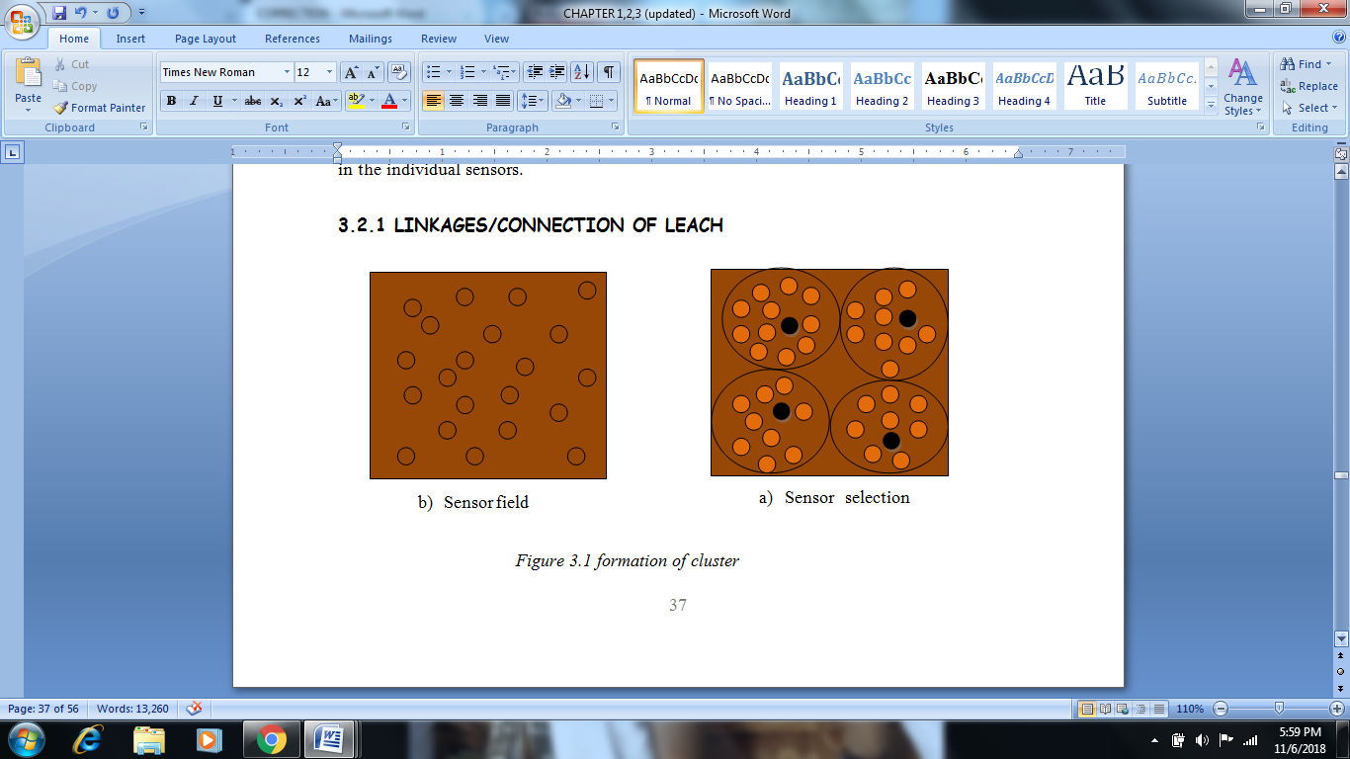
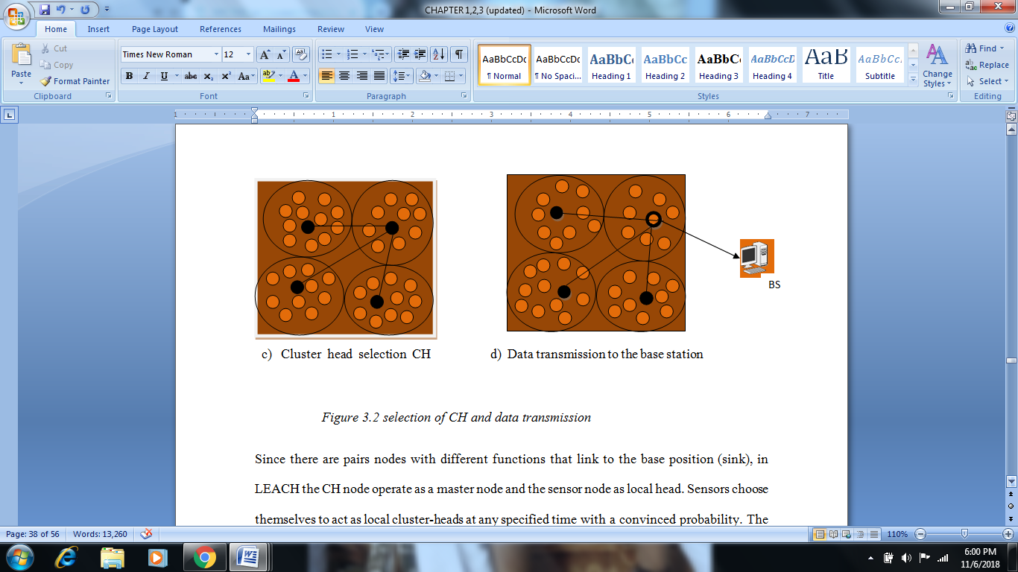

Since there are pairs nodes with different functions that link to the base position (sink), in LEACH the CH node operate as a master node and the sensor node as local head. Sensors choose themselves to act as local cluster-heads at any specified time with a convinced probability. The cluster head nodes transmit their position to the other sensors in the network. Each sensor node determines to which cluster it needs to be with by choosing the cluster-head that requires the smallest amount of communication power. On one occasion the cluster-head has all the data from the nodes in its cluster, the cluster-head node aggregates the data and then sends the condensed data to the base station. The nodes die arbitrarily and lively clustering increases life span of the system. The nodes die arbitrarily and dynamic clustering (dynamic clustering brings additional overhead, such as head changes and advertisements, which may decrease the gain in energy utilization) increases life span of the system. At every one round, after initial choice of cluster head according to LEACH protocol, a next selection was introduced to modify the number of cluster head in reflection of node's residual energy. As a result of that, the number of cluster head is steady and near optimal per round.
3.2.2 Data transmission in LEACH
In LEACH, data dissemination occurs once the clusters have been formed and the TDMA agenda is set, data dissemination can begin. Assuming that the nodes are still ready to send data, they send them during the transmission time assigned to the cluster leader. The transmission uses a negligible amount of energy (selected based on the strength received from the announcement of the cluster header). The radio of each node without a cluster head can be disabled waiting for the transmission time of the assigned node, thus minimizing the dissipation of energy in these nodes. The cluster head node must keep the receiver enabled to accept all data from the cluster nodes. After the data has been provided, the cluster's root node performs signal distribution functions to condense the data into a single signal. Finally, send the data to the base. This is the stationary process of LEACH networks. After a certain time, determined a priori, the next turn begins with each node that determines if it should be a leader for this turn and publish this information,
3.2.3 Cluster formation in LEACH
Clustering is the process in which sensor nodes of a network cluster in groups based on specific requirements or metrics. Each group or cluster has a head called the cluster head (CH) and other normal member nodes (MNs). Cluster heads can be arranged in other hierarchical levels, such as the head of the upper level and that of the next level, as shown in Figure 3.3. In a hierarchical architecture, the nodes with the highest energy can be used to process and send information, while near detection can be done at low energy to achieve the goal, which means cluster formation and the assigning special tasks to cluster heads can greatly contribute to the overall scalability, durability and energy efficiency of the system. A combination of nodes to form a group of related nodes is called a cluster.

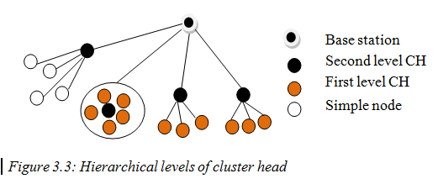

3.2.4 Features of LEACH

- LEACH performs local data fusion to “compress” the amount of data being sent from the clusters to the base location, this lead to energy decrease dissipation and improve system life span.
- Growing the network life span by LEACH, does not need a global knowledge been dispersed [28].
- Arbitrary rotation of the cluster “base stations” or cluster-heads.

3.2.5 Limitations of LEACH
- Single hop routing is used where each node can broadcast directly to the cluster-head and the sink, which is not appropriate to networks deployed in huge regions with big number of nodes.
- The thought of dynamic clustering brings additional overhead, such as head changes and advertisements, which may reduce the gain in energy utilization.
- Furthermore, there are so many assumptions used in this protocol which are not all time true [28].
3.4 IMPLEMENTATION OF DIRECTED DIFFUSION (DD)
Directed Diffusion (DD) considered to be data centric protocol for sensor networks, a routing instrument for gathering data in which consumer (sink) search for the data sources by sending interest packets and discover the best route to receive the data, but DD cannot support time-sensitive traffic nor perform equilibrium of energy utilization to boost network life span.DD consider Gradient to be an important part of it. It is intended to direct the data dissemination with the smallest amount of cost. Setting up a gradient values of each node, make the sink node to broadcast an interest message to its neighbors. Limiting flooding is compulsory by Directed Diffusion to maintain a data cache.
3.4.1 Data transmission of directed diffusion
Directed diffusion works in the following way: First, the operator sends a demand to the sink for information concerning an event in a specific region for a period of time. Then, then neighbor receives a request from the sink; this request is called an interest. When the neighboring nodes receive an interest, it is then add to their interest cache, and a gradient is set up among the two nodes. A gradient is a direction state formed among the sending and receiving nodes, from the recipient back to the dispatcher with a particular data rate for information flow. At first, this data speed will be low; the purpose is to discover the network and set up a path to the nodes. Instinctively, these gradients are known as exploratory gradients.

3.4.2. Phases of directed diffusion (DD)
The direct transmission works in three phases, a) the propagation of interests, b) the configuration of the initial gradients and c) the data transmission path improved, the sink node sends its request every time it needs to look for information from nodes of the sensor. This request is accepted by a small package of interest. When a node receives a packet of interest, the packet is cached and transmitted to other neighbors to ensure that each node in the network receives it. The propagation of the packages of interest also configures the gradient on the network for the transmission of data to the receiver. The gradient is a response link to a neighbor from whom the interest has been received. When a node is of interest, it generates a sample of detected data, called exploration data, which is sent individually to neighbors from which the gradient was previously established. When these exploration data reach the wells of some neighbors, many paths are recognized between the well and the source. The receiver strengthens one of these paths by increasing the speed of data in the package of interest. Regularly, this path is the one that has the least delay, So only one path remains while others are demolished. Finally, the actual data will be sent from the source, following the chosen path.
3.4.3 Interest Propagation phase
Attention messages are broadcasted by sink to all cluster heads. Every cluster head transmit interest communicate to its cluster connect after it receives interest message. each cluster will record a time stamp and the associate cluster head which interest message is sent from.
3.4.4 Initial gradients setup
One of the important terms in DD is Gradient. It is intended at directing the data propagation route with the minimum cost. In order to setup gradient values of each node, all the neighbor’s nodes will receive the broadcasted interest message from the sink node. Even though, an initial slope is the next phase of directed diffusion responsible for dissemination, sets up gradients inside the network planned to draw events. In a nutshell, a gradient is direction state created in each node that receives an interest. The query is flooded throughout the network and gradients are set up to draw data satisfying the query toward the requesting node; meaning, a sink may query for data by sending interests for named data and middle nodes propagate these interests.

3.4.5 Data delivery reinforced path
Clusters means, cluster members receive interest message from their cluster head. If cluster members discover a data corresponding to the interest message, the exploratory will send data to its cluster head. Then Cluster head will total them and then send to nearby cluster head in its neighboring or sink, if the sink node were nearest node to it. In this phase gradient are recognized. After the sink starts receiving these exploratory data it reinforces one particular neighbor. The cluster head sink will choose that from which it initially received the last event corresponding the interest and send reinforcement message throughout selected node. Once a source receives the reinforcement message, it sends out actual data.
3.4.6 Connectivity of Directed Diffusion
The sink floods interest’s packets, that is, it communicates the actions in which it is interested to the sensor nodes. While the interest packets are spread, sensor nodes set up a gradient to every neighbor from which they established an interest. Upon sensing an event matching a sink’s interest, the sensor generates a data packet and sends it to the sink via the neighbors for which it has a gradient. This process is repeated by each node receiving the data packet. These data packets are called exploratory packets, because they are sent to the sink beside numerous paths. Lastly, the sink reinforces the path from which it received the initial exploratory data packet. This means that only one path is chosen from the sink to the packet source and this is the route that will be used by the sensor to release data to the sink.
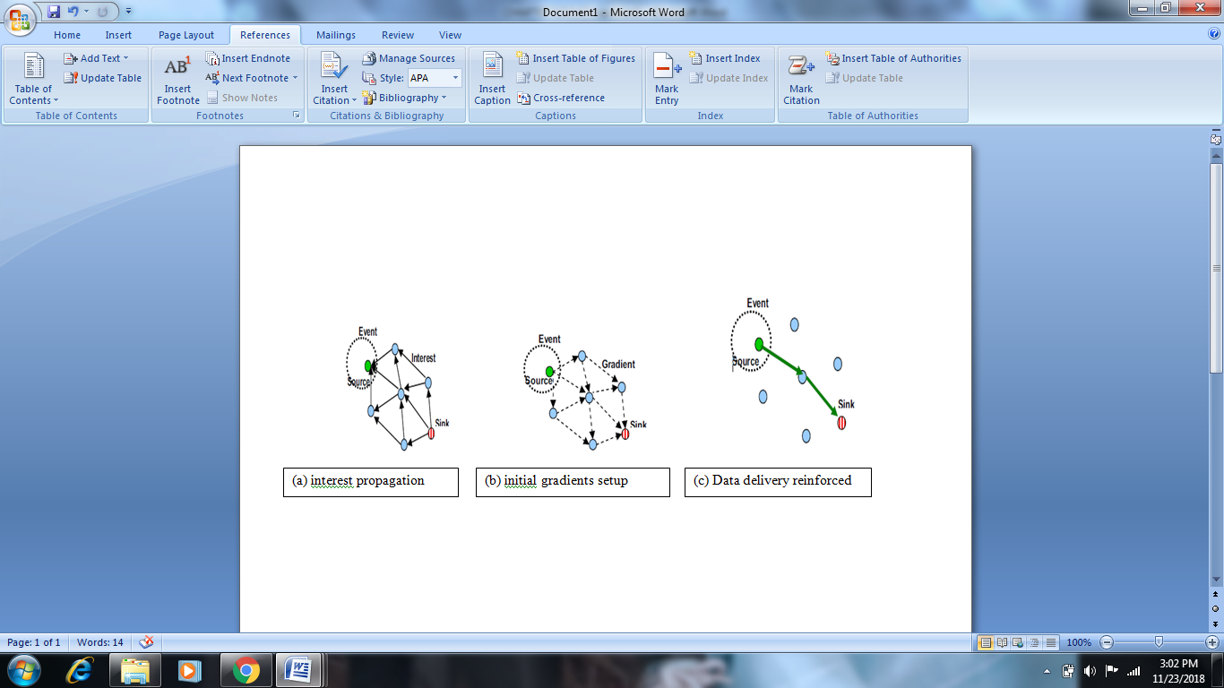 Figure 3.4: three phases of data transmission to the base station
3.4.7 FEATURES OF DIRECTED DIFFUSION
- data-centric broadcasting,
- reinforcement based adaptation to the best pathway,
- data aggregation and
- Caching
- It aims at dealing with scalability issues
- Communication is neighbor-to-neighbor with no need for a node addressing mechanism.
- The protocol eliminates duplicate of data and minimizes the number of transmissions
3.4.8 LIMITATIONS OF DIRECTED DIFFUSION
- It is threatened by numerous attack models,
- Cannot sustain time-sensitive traffic
- Cannot execute energy-balancing to boost network life span.[29]

3.4.5 VIRTUAL GRID ARCHITECTURE (VGA) IMMPLEMENTAION
Virtual Grid Architecture (VGA) support mobility is energy efficient routing that uses data aggregation to maximize the network life. the positions of the nodes in the network area. The tessellation scheme maps the physical topology of the network into a virtual (straight) grid topology. The VGAs contain a set of nodes, i.e cluster heads (CH), chosen periodically according to an eligibility criterion, which takes into account many variable parameters in the network.
3.4.6 ROUTING/CONNECTIVITY OVER VGA
The VGA shares some similarities with wired network networks, an important feature of a routing protocol, its ability to acclimate to topological changes. When a zone becomes empty in VGA due to node scheduling, the routing protocol should be able to route packets in the empty area. The VGA can be used to perform the routing in MANET in a competent way due to its stable configuration. However, you can use two methods to run packages on VGA. The initial technique is based on the well-known routing-on-demand techniques; the spread of packets is limited to a maximum of four neighbors order. Another method is a new approach based on the idea of ​​transitive closure from discrete mathematics.
3.4.7 APPROACH TO VGA CLUSTERING
The main goal of the VGA clustering approach is to create a simple and stable virtual topology on which the routing and network management functions can be executed easily and efficiently. The architecture of the virtual grid consists of two main phases: (a) zoning the network and (b) the election of CH in the zones.
- clustering (network zoning) of VGA
The network area is divided into areas such as disjoined, adjacent areas of fixed size and regular shape in the VGA classification. Therefore, in order to produce a simple straight virtual topology, it is possible to choose a square-shaped region with the possibility of extension to other virtual topologies such as hexagon, line or triangle, with equivalent compromises. officially, the network region, defined by the coordinates, (0.0, 0.0) (MAX_{x}, MAX_{y}) is separated into fixed-size and correspondent to square regions. consider that the B is the set of such regions, Let B_{k} ∈ B be the k^{th} region, and indicate its first (bottom left) and final (top right) coordinates by (Xi ^{(k)}, Yi ^{(k)}) and (X f ^{(k)}, Y f ^{(k)}), respectively. Every region B_{k} has a sole address or (Zone ID) which can be the ordered couple consisting of the zone’s row and column numbers, respectively. each mobile node is a member of one region and its region membership is strong-minded based on its location in the network area.
- VGA CH election/selection
After the zoning operation is complete; a CH electoral method is performed in each region. Nodes in each region gain access to the network only through the elected CH. The responsibility of the CH itself does not change, but CH changes in each region. Three important scenarios deserve to be considered in the evolution of the cluster leader (a) periodic (b) dynamic and (c) on demand.
- Periodic CH election:
With a periodic approach, the node in each region plays the role of CH for a certain period. The most qualified mobile node will be a CH for the current period based on an eligibility factor (EF).The idea of EF is to select a node that will operate as CH for the paramount ever time possible in order to fix the virtual backbone. each node i will calculate its eligibility factor, EF_{i,} at time t as:
EFi (t) = a1^{e−vi(t)} + a2^{(1 − Qi(t))} + a3^{Bi(t)} + a4^{(1 − Ei(t))} ………………………… (1)
where v_{i}(t) is the velocity of node i at time t, B_{i}(t) is the residual energy at i^{th} node battery at time t, Q_{i}(t) is the division of time node i served as CH in a big window of time that reflects the energy level distinction among the previous period and the current period of that node, E_{i}(t) is the distance from node i to the center of its region relative to the utmost distance inside the region at time t, and a1, a2, a3, a4 are scaling factors. The node that has the uppermost value of EF will be chosen as the CH in its region for the present period. That is, if a zone z ∈ Z has a nonempty set of m nodes, the CH is chosen as follows:
CH = arg max (EFi) i∈ m …………………………………………………….. (2)

- Dynamic CH election:
At the beginning, CH is chosen in each region on the basis of equation (1), and not as a periodic CH election, the eligibility factor is recalculated only in a given region when it wishes. A new CH is launched when the current CH is about to leave its zone or its battery energy falls below a certain threshold. If all nodes have the same energy level, the CH role will then be circulated between nodes based on their identifiers in ascending order. A higher ID will take over when his descendant goes out of service due to the deterioration of the battery charge.
- on-Demand CH Election:
According to this approach, a CH node can request to be replaced on demand for different reasons (for example, overload or simply disabled).

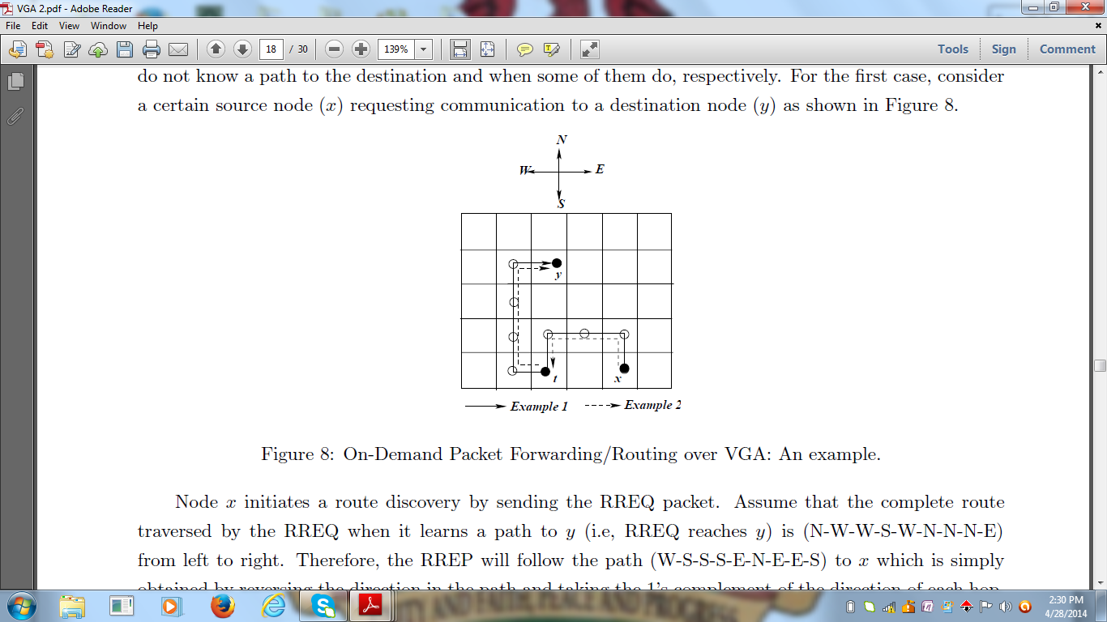
Figure 3.7: Operation of OD-PFS: Routing over VGA
3.4.8 Features of VGA
i) Extremely supports poor mobility of sensor nodes
ii) Data aggregation is on two levels: local and global.
iii) Well-organized stable structure.

3.4.9 Limitations of VGA
i) Route packages on demand (package delivery is limited to a maximum of four neighbors)
ii) It is based on transitive closure (from discrete mathematics).

TABLE3.5 SYSTEM MODEL NOTATION
Notation | Meaning
A | The network service area (m²)
N | The number of mobile nodes in the network area A.
T | A window of time sufficient to capture cluster dynamics.
Yi(t) | A binary indicator, which is 1 if node i is a CH at time t.
Qi(t) | The fraction of time node i remains as a cluster head during  The time window T ending at time t, 0 ≤ Qi(t) ≤1.
Bi(t) | The remaining energy in node’s i battery at time t.
C(t) | Cluster heads cardinality at time t (size of virtual backbone)
vi(t) | Average speed of node i at time t (m/s)
Ei(t) | The relative distance between the ith mobile node and the center of the zone at time t.

CHAPTER FOUR
4.1 SIMULATION RESULT AND PERFORMANCE ANALYSIS
This chapter presents the configuration of the simulation and the analysis of the results, as well as the performance of the LEACH, DD and VGA protocols, in order to demonstrate that the objective of this research has been achieved. The chapters began with the general presentation of the simulation carried out in this research, with some motivations and justifications for using the simulation to test the performance of the above mentioned protocols, as well as a brief explanation of the simulator used and some advantages over other simulators. . Furthermore, simulation parameters and performance measures are specified to test and analyze protocol performance. Lastly, the performance analysis of the protocols was performed by comparing the three protocols.
4.2 OVERVIEW OF SIMULATION
The advent of wireless sensor networks has generated many unresolved problems in network design. These problems are tested and evaluated using techniques called performance analysis techniques. The three main traditional techniques for analyzing the performance of wired and wireless networks were analytical methods, computer simulation, and physical measurements. However, many constraints imposed on sensor networks, such as power consumption limitation, decentralized collaboration and fault tolerance, require the use of complex algorithms for sensor networks, which generally ignore methods. analytically Furthermore, few sensor networks have been created because many research, design and implementation problems have not been solved. For the time being, it is therefore impossible to evaluate these protocols on the test bench. It seems that simulation is currently the main viable approach for quantitative analysis of sensor networks. The most appropriate way to deal with hardware test problems with good results is simulation work, which is currently essential for many researchers in the field of WSN [1].
A simulation is a computer model that simulates the operation of a real or proposed system and takes into account all the resources and constraints involved, as well as the way in which these elements interact with each other over time.

4.3 SIMULATORS AND SIMULATION ENVIROMENT
The simulator is commonly used to develop and test network storage network protocols to minimize costs and delays, as opposed to practical analysis. The cost of simulating thousands of node networks is very low and the simulation can be completed in a very short time. Many WSN simulators have been developed, such as Sensoria, NS-2, OPNET, J-Sim, OMNET ++, GlomoSim, etc.
Sensoria are a full-fledged simulator that differs greatly from all other existing simulators. Sensoria is very powerful in simulating a range of small and large scale WSN networks based on a simple and complete graphical user interface. Sensoria is the first simulator to support generic algorithms and protocols developed by users on the same WSN. As such, Sensoria become a simple and effective simulator for WSN research. The main objective of the construction of Sensoria is to create an efficient, powerful and easy to use simulator. Sensoria can easily be adapted by many users as high-level users, network builders and component designers. Sensoria is a fully graphical interface (GUI) simulator that helps users create the desired WSN scenario and test its performance easily and efficiently.
Currently, Sensoria do not require any programming functionality on the part of the user. The user can choose from the available choices that best describe the scenario imagined using the versatile graphic interface of Sensoria. Several Sensory modules will interact to produce the desired results. Sensoria will also be able to accept new user-programmed modules and easily connect them to the rest of the simulator modules.
NS-2 is a discrete event simulator that provides extensive support for simulating TCP/IP, routing and multicast protocols over wired and wireless networks and its developed in C++. NS-2 is the paradigm of reusability. It provides the most complete support of communication protocol models, among non-commercial packages. Regarding WSN, NS-2 includes ad-hoc and WSN specific protocols such as directed diffusion. However, this simulator has some limitations. For researchers to used NS-2, there is need to be familiar with writing scripting language and modeling technique; the TCL is somehow difficult to understand and it has no GUI. NS-2 is more complex and time-consuming than other simulators to model a desired job. NS-2 is designed as a general network simulator; it does not consider some unique characteristics such as bandwidth problem, power consumption or energy saving in WSN. It has scalability problem and trouble to simulate more than 100 nodes.
J-Sim is a discrete event network simulator built in Java. This simulator provides a graphical library that allows users to model or compile the mathematical modeling language, a "text language" written in J-Sim models. J-Sim provides open source models and documents online. This simulator is commonly used in the fields of physiology and biomedicine, but it can also be used in the WSN simulation. J-Sim models have a good re-use capability and the possibility to exchange models during the WSN simulation; it also contains a large number of protocols. This simulator can also support data dissemination, routing and position simulations; can simulate radio channels and power consumption using detailed models in the J-Sim protocols. Compared to NS-2, J-Sim can simulate a greater number of sensor nodes and J-Sim can save a lot of memory size. However, the execution time is much longer than that of NS-2. Because J-Sim was not originally designed to simulate WSN, its fundamental design prevents users from adding new protocols or node components.
OMNeT++ (Objective Modular Network Test-bed in C++) is a public-source, component-based, modular simulation framework. It has been used to simulate communication networks and other distributed systems [2]. OMNeT++ is a discrete event network simulator built in C++. It provides both a noncommercial license used at academic institutions or non-profit research organizations, and a commercial license. This simulator supports module programming model and most of the frameworks and simulation models in OMNeT++ are open sources. OMNeT++ provides a powerful GUI, which makes the tracing and debugging much easier than using other simulators in WSNs environments. It has a mobility framework, can support MAC protocols as well as some localized protocols in WSN. It can simulate channel controls, power consumption problems in WSNs. However, in OMNeT++ simulator, there is no availability of protocols in the simulator. In addition, the compatibility problem will arise since individual researching groups developed the models separately, this makes the combination of models difficult and programs may have high probability report bugs. To take the advantage of the above features, OMNeT++ was choosing as the framework for Simulation of this research work.
GloMoSim: Global Mobile Information Systems SIMulator is a scalable simulation environment for wireless and wired network systems. It is written in both C and Parsec. It is able to simulate discrete events in parallel. GloMoSim currently supports protocols for a purely wireless network. Parsec's basic knowledge and in-depth knowledge of C are sufficient for simulations.
To evaluate the performance of LEACH, DD, and VGA protocols, some related protocols were simulated using several random 100 numbers of nodes in the network. The BS is located at (0, 0) coordinate in a 100m x 100m field. The simulation started with each node having the same initial energy level at 0.5J. Once a node dies it is considered dead for the rest of the simulation. The simulations were run to determine the number of rounds of communication and the number of dead node in each and every round, for some certain criteria. That is, when the node mortality is 1%, 5 %, 10%, 25 %, 50% and 100% respectively, to determine appropriate practical area of application for this protocol, and the result would be recorded. It also determine the amount of energy dissipated or energy remain in the network, when the node mortality is 1%, 5 %, 10%, 25 %, 50% and 100% respectively.
4.4 SIMULATION AND SIMULATION PARAMETERS
The primary objective of the simulation in this research is to analyze the performance of LEACH, DD, and VGA protocols and benchmark their performance, with respect to energy consumption and network lifetime. The simulation begins with the configuration of the network area in which a WSN number is defined consisting of a predefined number of sensor nodes, network energy, sensor field size and many other parameters (see Table 4.1). ). The x and y positions are assigned to the sensor nodes, and the routing protocols must be selected by importing the protocol files into the Sensory simulator directory. Then describe the network by creating a topology file. A topology file is a text file that describes the network nodes and the links that merge them. The simplest method is to create two nodes files, one for each simple module and one for the network, which includes all simple modules. The simulation in sensory must have 4 files: (1) sensoria.ini that specifies the network, simulation speed, scalar output file, network area (x, y), number of nodes and other parameters. (2) Module.Ned defining the network and the modules it contains. (3) Module.cc and (4) module.h, which define the functionality of each module, mainly include: initialize, message manager and terminate. These recorded results include critical information about the network, including the total energy dissipated on the network and the number of revolutions. The data transmission phase continues until the authorized transmission number is reached. The simulation checks whether a certain number of sensor nodes is still active before moving on to the next scenario. The simulation stops if the number of sensor nodes dies at a specified percentage of knot mortality. And all three routing protocols were simulated in parallel with the same parameters with BS on the coordinate (0, 0). The simulator output is in two forms, graphs and trace files. In the assignments to have a clear evaluation of the performance results of the LEACH, DD and VGA protocols. The main simulation parameters are described in Table 4.1.
Table 4.1: Simulation Parameters
Parameters | Value
Wireless sensor Network area | 100 m x 100 m
Number of nodes | 100
Transmission range | 15 m
Sensing range | 8 m
Data packet size | 2000 bits
Control packet size | 248 bits
Initial Energy of the network | 50 J
Energy for Aggregation | 5 nJ/bit
Transmitter/Receiver electronics | 50 nJ/bit
Amplifier electronics | 100 pJ/bit/m²
Initial energy of the nodes | 0.5 J
Throughput | 5pbs
Latency delay | 5ms

4.5 Performance Metrics
The designed protocols should be simulated, analyze and compare their performance base on the following, the metrics used for performance evaluation and benchmarking are total network energy dissipated, network life-time, and number of rounds.
Total Network Energy Dissipated: This metric shows the total dissipation of energy in the network. Low power consumption and limited processing are the characteristics of nodes in wireless sensor networks. Therefore, the optimal power consumption for wireless sensor network protocols gives the impression that it is essential to take this into account. In a series of WSN applications, sensor nodes periodically detect environmental data and transfer it to the BS via intermediate nodes and a primary node. Due to the energy limitation and the choice of the minimum energy consumption path, a node with the highest energy level will be used for data transmission in order to increase the remaining energy of the network. Most of the energy in the nodes is wasted on radio transmission; therefore, the decrease in the number of packets transferred to the network will cause an increase in the energy of the node and of the entire network. The graph should be plotted as the total energy of the network relative to the transmission rounds.
Number of Rounds: The round corresponds to the duration of a network cycle from the network configuration, the channel construction and the transmission of data from the source to the destination. In practical simulation scenarios, the lathe is a relative amount that depends on the complexity of the algorithm and on the processing power of the computer to execute the algorithm. Based on the experience gained from this research, a projectile with average processing speed typically takes between 40 and 65 seconds for a spin and it takes up to 2 days to completely simulate a certain network scenario. On the other hand, a projectile with an excellent processing speed typically requires 10 to 15 seconds for one revolution and approximately 10 hours to complete the simulation of a specific network scenario.
4.6 PERFORMANCE ANALYSIS AND BENCHMARKING
The performances of LEACH, DD and VGA are evaluated and compared
4.6.1 Total Network Energy Dissipation Analysis
The first unit that has been considered the most important in network storage networks is energy efficiency and network life. To balance the energy consumption in the network, it is necessary to analyze the energy dissipation to demonstrate the indispensability of the WSN protocol. Therefore, related comparisons were carried out to measure the performance of LEACH, DD and VGA in terms of energy dissipation of the network by measuring amount of energy per round. The total network energy was measured when the node mortality is 1%, 5 %, 10%, 25 %, 50% and 100% respectively. But only the graph of 5%, 25%, 50% and 100% were plotted respectively in order to minimize the number graphs expected.
4.6.2 Total Network Energy Dissipation Analysis of 5%, 25%, 50%, 100% Node Mortality.
The Tables below present summaries with round intervals and result of energy dissipation of the aforementioned percentages of node mortality for LEACH, DD, and VGA. Also graphical representation of the result of 5%, 25%, 50%, and 100% for the node mortality was shown or presented in the subsequent figure.

Table 4.2: Total Network Energy Remain when 5% Nodes Death
No of Rounds | NETWORK ENERGY (J)
No of Rounds | LEACH | DD | VGA
1 | 49.92439 | 49.98042 | 49.7509
101 | 46.4764 | 47.98183
201 | 42.92383 | 45.98568
301 | 39.34391 | 43.99224
401 | 35.62994 | 41.99496
501 | 31.90199 | 39.99754
601 | 28.24119 | 38.00002
701 |  | 36.00582
801 |  | 34.01219
901 |  | 32.038
1001 |  | 30.15407

Figure 4.1: Comparative Plot of Energy Dissipation for 5% Nodes Death
Observation: In Figure 4.1 and Table 4.2, it is observed that when 5% of node dead, the sum of energy remain in LEACH was 28.24 J, DD was 30.15 and for VGA was 49.75 J, respectively. That is, average remaining energy of all nodes per round in VGA is higher than LEACH and DD. Therefore, VGA technique has better energy utilization performance compared to the LEACH and DD protocols when the number of nodes increases. However, when numbers of nodes decreases, the LEACH and DD protocols, consumes lesser energy than the VGA protocol respectively.

Table 4.3: Total Network Energy Remain when 25% Nodes Death
No of Rounds | NETWORK ENERGY (J)
No of Rounds | LEACH | DD | VGA
1 | 49.93618 | 49.98604 | 49.99869
201 | 43.09713 | 47.23144 | 31.43124
401 | 35.88545 | 44.48085
601 | 28.59167 | 41.72832
801 |  | 38.97793
1001 |  | 36.22746
1201 |  | 33.54238
1401 |  | 31.04232
1601 |  | 28.81673
1801 |  | 26.90835
2001 |  | 25.36405
2201 |  | 23.89418
2401 |  | 22.6257
2601 |  | 21.56747
2801 |  | 20.77586

Figure 4.2: Comparative Plot of Energy Dissipation for 25% Nodes Death
Observation: In Figure 4.2 and Table 4.3, it is observed that when 25% of node dead, the amount of energy remain in LEACH was 28.59 J, DD was 20.77 and for VGA was 31.43 J, respectively. That is, average remaining energy of all nodes per round in VGA is higher than LEACH and DD. Therefore, VGA technique has better energy consumption performance compared to the LEACH and DD protocols when the number of nodes increases. However when numbers of nodes decreases. The DD and LEACH protocols consume lesser energy than the VGA protocol respectively.

Table 4.4: Total Network Energy Remain when 50% Nodes Death
No of Rounds | NETWORK ENERGY (J)
No of Rounds | LEACH | DD | VGA
1 | 49.95075 | 49.98482 | 49.999
501 | 29.02115 | 42.16726 | 21.38548
1001 |  | 34.35496
1501 |  | 26.90276
2001 |  | 20.56937
2501 |  | 16.90323
3001 |  | 15.84732
3501 |  | 15.38062
4001 |  | 14.91438
4501 |  | 14.43241
5001 |  | 13.96267

Figure 4.3: Comparative Plot of Energy Dissipation for 50% Nodes Death
Observation: In Figure 4.3 and Table 4.4, it is observed that when 50% of node dead, the amount of energy remain in LEACH was 29.02 J, DD was 13.96J and for VGA was 21.38 J, respectively. That is, average remaining energy of all nodes per round in LEACH is higher than DD and VGA. Therefore, LEACH technique has better energy consumption performance at 50% node mortality compared to the VGA and DD protocols when the number of nodes increases. However, when numbers of nodes decreases, the VGA and DD protocol consumes lesser energy than the LEACH protocol respectively.

Table 4.5: Total Network Energy Remain when 100% Nodes Death
No of Rounds | NETWORK ENERGY (J)
No of Rounds | LEACH | DD | VGA
1 | 49.90276 | 49.98178 | 49.99884
1001 |  | 31.74138 | 6.644214
2001 |  | 19.44223 | 0.513149
3001 |  | 18.39541 | 0.001858
4001 |  | 17.52574
5001 |  | 16.72958
6001 |  | 15.91744
7001 |  | 15.07281
8001 |  | 14.1808

Figure 4.4: Comparative Plot of Energy Dissipation for 100% Nodes Death
Observation: In Figure 4.4 and Table 4.5, it is observed that when 100% of node dead, the amount of energy remain in LEACH was 49.90 J, DD was 14.18J and for VGA was 0.001 J, respectively. That is, average remaining energy of all nodes per round in LEACH is higher than DD and VGA. Therefore, LEACH technique has better energy consumption performance at 100% node mortality compared to the DD and VGA protocols when the number of nodes increases. However, when numbers of nodes decreases, the VGA and DD protocol consumes lesser energy than the LEACH protocol respectively.

4.7 SUMMARY OF TOTAL NETWORK ENERGY DISSIPATION ANALYSIS
The table 4.6 shows the summary of the result obtained for total energy consumption analysis based on certain number of node death, such as 5, 25, 50 and 100 respectively. Note that 1, and 10 percentages of nodes mortality were not involved in the result obtained to minimize the numbers of tables and graphs.
Table 4.6: Summary Result of Total Energy Dissipations Analysis
Number of dead nodes | Energy(J)
Number of dead nodes | LEACH | DD | VGA
5 | 28.24 | 30.15 | 49.75
25 | 28.59 | 20.77 | 31.43
50 | 29.02 | 13.96 | 21.38
100 | 49.90 | 14.18 | 0.001
Figure 4.5 illustrate the overall result of three protocols
OBSERVATION: From The Table 4.6 It has been observed that the remaining energy when 5%,25%,50% and 100% of node dead, the amount of energy remain in VGA were 49.75J, 31.43J, 21.38J,and 0.001J respectively. However, in LEACH the amount of energy remain were 28.24J, 28.59J, 29.02J, and 49.90J respectively. Finally in DD the amount of energy remain were 30.15J, 20.77J, 13.96J, and 14.18J respectively.
OVERALL INFERENCE: compared Therefore, It can be inferred that VGA technique has a better network lifetime performance than that of LEACH and DD at 5% and 25% as the percentage of energy consumption decreases. While LEACH, has a better network lifetime performance than that of VGA and DD at 50% and 100%. As the percentage of energy consumption increases, Hence the result shows that DD has low performance to LEACH and VGA, except at 5% the energy consumed is higher than that of LEAH and DD, this is because query is flooded throughout the network to draw data satisfying the query toward the requesting node.

CHAPTER FIVE
SUMMARY, CONCLUSION, RECOMMENDATION AND FUTURE DIRECTIONS
5.1 summary of the study
It is clear that energy-efficient routing protocols save energy in wireless sensor networks and should be used in scenarios where the energy consumption of sensors is a limitation. This research work has analyzed and compared the performance of the routine protocols LEACH, DD and VGA. The experimental result showed that the VGA technique offers better performance in terms of network life compared to that of LEACH and DD at 5% and 25% as the percentage of energy consumption decreases, While LEACH has better network life performance than 50% and 100% VGA and DD. With the increase in the percentage of energy consumption, the experimental result shows that the performance of DD is low compared to LEACH and VGA, except that the energy consumed is greater than that of LEACH and DD, which explains that the request is flooded in the network to draw data that satisfy the request to the requesting node.
5.2 Conclusions
In this investigation, three classifications of protocols were discussed, including hierarchical and data-centric routing protocols, such as LEACH, DD and VGA for a wireless sensor network. The major concern of this survey is to examine mobility, data aggregation, power utilization, multipath, scalability and compare the performance of all protocols. The clustering construction of LEACH reduces the transmission of data aggregation, minimizing the number of packets to be transmitted. It was also concluded that the VGA has enormous overhead costs and that areas of the high-speed network are causing an increase in the transmission path and a decrease in network life.
However, simulation model for routing protocols focused on hierarchical data and LEACH, DD and VGA. The Sensory simulator is used to compare the performance of the three routing protocols. The simulation results show that LEACH can significantly extend the life of the sensor network when the transmission range decreases. VGA saves extra power than other protocols when the transmission interval increases because the premature death of the nodes significantly reduces network coverage.

5.3 RECOMMENDATION
For future research, the same protocols could also be analyzed using a different simulator to obtain the different performance results in order to be compared, although simulators like NS-2 or OMNET ++ are difficult because they require programming skills. Furthermore, few sensor networks have emerged. There are many unresolved problems of research, design and implementation. Although the performance of these protocols is promising in terms of routing and energy efficiency, further research would be needed to solve problems such as:
- Using a strong and high-performance PC to carry out simulation in a scenario with huge number of sensor nodes (around 1000 to 5000), with broad network coverage, would help in verifying the suitable performance of the three protocols in a heavily populated WSN.
- Considering node mobility, most current protocols assume that sensor nodes and receiver are not mobile.
- Integration of sensor networks with Internet. Most of the applications in security and environmental monitoring require the data collected from the sensor nodes to be transmitted to a server so that further analysis can be done.
- Quality of Service posed by video, audio and imaging sensors and real-time applications. Energy-aware QoS routing in sensor networks will ensure guaranteed bandwidth (or delay) through the duration of connection as well as providing the use of most energy efficient path.
5.4 FUTURE DIRECTIONS

Despite the efforts made so far on the problem of routing in the WSN, there are still some problems that need to be solved to find effective solutions to the problem of routing.
1) The sensors are characterized by a small footprint and, as such, the nodes have strict energy constraints because they have a reduced and finite energy source. This is also different from traditional fixed but reusable resources
2) Most wireless applications use real sensor nodes. For remote applications, the sensors are integrated. This differs from traditional Internet, PDA and mobility applications that primarily and directly interact with human users.
3) Communication is the main consumer of energy in this environment where sending just over 10 or 100 meters consumes as much energy as thousands of millions of operations. The performance of these protocols is promising in terms of energy efficiency.
Further research would be needed to address issues such as quality of service (QoS) posed by real-time applications. Energy-efficient QoS routing in sensor networks will guarantee the guaranteed bandwidth for the duration of the connection and the use of the most energy-efficient route. New routing algorithms are needed to manage the overall costs of mobility and topology changes in low-energy environments. Future trends in routing techniques in WSN focus on different directions and share the same goal of extending network life, service quality and network overhead.

REFERENCES
[1] Li, Yingshu; Thai, My T. and Weili Wu, “Wireless Sensor Networks and Applications” Signal and Communication Technology 2008, ISBN: 978-0-387-49591-0
[2] A. Bharat1hidasas and V. Anand,“Sensor networks: An overview”. Technical Report Department of Computer Science, University of California at Davis, 2002.
[3] Intanagonwiwat, R. Govindan, and D. Estrin, “Directed Diffusion for Wireless Sensor Networks”, IEEE/ACM Transactions on Networking. Vol 11No.1 2003.
[4]Kulik, W. R. Heinzelman, and H. Balakrishnan, "Negotiation-Based Protocols for Disseminating Information in Wireless Sensor Networks," Wireless Networks, Volume: 8, 2002.
[5]W. Heinzelman, H. Balakrishnan and A. Chandrakasan, “Energy Efficient Communication Protocol for Wireless Microsensor Networks”, Proc. 33rd Hawaii Int. Conf. Syst. Sci. (HICSS ’00), January 2000.
[6] Mohammad Ilyas (Editor) and Imad Mahgoub (Editor), Handbook of Sensor Networks: Compact Wireless and Wired Sensing Systems, CRC Press, LLC, pp. 116-138, 2005, ISBN: 0-8493-1968-4.

[7] Ting-Hung Chiu and Shyh-In Hwang “Efficient Fisheye State Routing Protocol using Virtual Grid in High-Density Ad-Hoc Networks”, National Science Council, Taiwan, R.O.C, 2006.

[8] Jun, W. A. N. G., Zhang Xin, XieJunyuan, and MiZhengkun. "A distance-based clustering routing protocol in wireless sensor networks."In Communication Technology (ICCT), 2010 12th IEEE International Conference on, pp. 648-651.IEEE, 2010.
[9] Wu Xinhua and Huang Li ”Research and Improvement of the LEACH Protocol to Reduce The Marginalization of Cluster Head”Journal of Wuhan University of Technology Vol. 35, No. 1, Feb.2011, pp. 79-82,doi:10.3963/j.issn.1006-2823.2011.01.019 (in Chinese).
[10] Kulik, J., Heinzelman, and H. Balakrishnan, H. (2002).Negotiation-Based Protocols for Disseminating Information in Wireless Sensor Networks, Wireless Networks, Volume: 8.
[11] Intanagonwiwat, C., Govindan, R. and Estrin D. (2003).Directed Diffusion for Wireless Sensor Networks, IEEE/ACM Transactions on Networking.Vol 11, No. 1.
[12] Ilyas, M. and Mahgoub I. (2005), Handbook of Sensor Networks: Compact Wireless and Wired Sensing Systems, CRC Press, LLC, pp. 116-138, 2005, ISBN: 0-8493-1968-4.
[13] Li, S., Neelisetti, R. K., Liu, C. and Lim, A. (2010, February).Efficient Multi-path Protocol for Wireless Sensor Network, International Journal of Wireless & Mobile Network (IJWMN) Vol. 2 No. 1.

[14] Kumar, N. and Kaur, J. (2011).Improved LEACH for Wireless Sensor Network, 7th International Conference on Wireless Communications, Networking and Mobile Computing (WiCOM), Page(s): 1 – 5.
[15] Chen, Y., Wang, N., Chen, C. and Lin Y. (2011).A Coverage Algorithm to Improve the Performance of PEGASIS in Wireless Sensor Networks.12th ACIS International Conference on Software Engineering, Artificial Intelligence, Networking and Parallel/Distributed Computing, IEEE
[16] Cui, Y. and Qin, H. (2010).A Novel Rumor Routing for Wireless Sensor Network, Fourth International Conference on Genetic and Evolutionary Computing.
. [17] Lindsey, S. and Raghavendra, C. S. (2001).PEGASIS: Power-Efficient Gathering in Sensor Information Systems, Aerospace Conference Proceedings, 2002. IEEE,page1125 - 1130 vol.3.
[18] Guo, W., Zhang, W. and Lu, G. (2010).PEGASIS Protocol in Wireless Sensor Network Based on an Improved Ant Colony Algorithm. Second International Workshop on Education Technology and Computer Science IEEE Volume: 3, Page(s): 64 – 67.
[19] Linping, W. and Zhen, C. (2010).Improved algorithm of PEGASIS protocol introducing double cluster heads in wireless sensor network.International Conference on Computer, Mechatronics, Control and Electronic Engineering (CMCE) IEEE

[20] Jung, S., Han, Y. and Chung T. (2007).The Concentric Clustering Scheme for Efficient Energy Consumption in the PEGASIS.The 9th International Conference onAdvanced Communication Technology. Volume: 1, Page(s): 260 – 26.
[21] Haider, R., Younus, M. J. and Naveed S. K. (2008).Design and Implementation of Energy Aware Algorithm using Greedy Routing for Sensor Networks.International Journal of Security and its Applications. Vol. 2, No. 2, April, 2008
[22] Heinzelman, W., Balakrishnan, H. and Chandrakasan, A. (2000, January).Energy Efficient Communication Protocol for Wireless Microsensor Networks, Proc. 33rd Hawaii Int. Conf. Syst. Sci. (HICSS ’00).
[23]Chen, B., Jamieson, K., Balakrishnan, H. and Morris, R. (2002).SPAN: An Energy-Efficient Coordination Algorithm for Topology Maintenance in Ad Hoc Wireless Networks, Wireless Networks, Vol. 8, No. 5.
[24] LaialiAlmazaydeh, EmanAbdelfattah, Manal Al- Bzoor, and Amer Al- Rahayfeh “performance evaluation of routing protocols in wireless sensor networks”, International Journal of Computer Science and Information Technology, Volume 2, Number 2, April 2010, 64-73.
[25] Jamal N. Al-Karaki and Ahmed E. Kamal, “End-to-end support for statistical quality of service in heterogeneous mobile ad hoc networks”, Journal, Computer Communications archive Volume 28 Issue 18, November, 2005.

[26] Al-Karaki, J. N. and A. E. Kamal, “Routing techniques in wireless sensor networks: A survey," IEEE Trans. Wireless Communications, Vol. 11, No. 6, 6-28, 2004
[27] Ting-Hung Chiu and Shyh-In Hwang “Efficient Fisheye State Routing Protocol using Virtual Grid in High-Density Ad-Hoc Networks”, National Science Council, Taiwan, R.O.C, 2006.
[28] W. Heinzelman, H. Balakrishnan and A. Chandrakasan, “Energy Efficient Communication Protocol for Wireless Microsensor Networks”, Proc. 33rd Hawaii Int. Conf. Syst. Sci. (HICSS ’00), January 2000.
[29] Intanagonwiwat, R. Govindan, and D. Estrin, “Directed Diffusion for Wireless Sensor Networks”, IEEE/ACM Transactions on Networking. Vol 11No.1 2003.
[30] J. N. Al-Karaki, A. E. Kamal, “End-to-End Support for Statistical Quality of Service in Heterogeneous Mobile Ad hoc Networks”, Computer Communications. Vol. 28, No. 18, Nov. 2005, pp. 2119-2132.
[31] Deborah Estrin et al. Directed Diffusion for Wireless Sensor Networking[C]. IEEE/ACM TRANSACTIONS ON NETWORKING,Februray 2003
[32] Yun Li, Shuangquan Xiong, Qianbin Chen，Fei Fang. Grid-based directed diffusion for wireless sensor networks. Second International Conference on Communications and Networking in China.2007.
[33] Akyildiz, I., Su, W., Sankarasubramaniam, Y., & Cayirci, E. (2002). A Survey on Sensor Networks. Communications Magazine, 40 (8), 102–114.
[34] Wang, Q., & Balasingham, I. (2010). Wireless Sensor Networks - An Introduction. In Y. K. Tan,Wireless Sensor Networks: Application-Centric Design (pp. 1–13). InTech
[35] Yu, Y., Estrin, D. and Govindan, R. (2001, May).Geographical and Energy-Aware Routing: A Recursive Data Dissemination Protocol for Wireless Sensor Networks, UCLA Computer Science Department Technical Report, UCLA-CSD TR-01-0023.
[36] Braginsky, D. and Estrin, D. (2002, October).Rumor Routing Algorithm for Sensor Networks, Proceedings of the First Workshop on Sensor Networks and Applications (WSNA), Atlanta, GA
[37] Bharathidasas, A. and Anand, V. (2002).Sensor networks: An overview, Technical Report Department of Computer Science, University of California at Davis, 2002.
[38] Manjeshwar A. and Agarwal, D. P. (2002).APTEEN: A Hybrid Protocol for Efficient Routing and Comprehensive Information Retrieval in Wireless Sensor Networks, Parallel Distributed Process. Symp., Proc. Int., (IPDPS).
[39] Ilyas, M. and Mahgoub I. (2005), Handbook of Sensor Networks: Compact Wireless and Wired Sensing Systems, CRC Press, LLC, pp. 116-138, 2005, ISBN: 0-8493-1968-4.

[40] Abdulazeez, F. S., Farhat, A. and Akhmad, U. P. (2009, July).An Investigation into Clustering Routing Protocols for Wireless Sensor Networks, Sensors & Transducers Journal, Vol. 106, Issue 7.
[41] Boubiche DE, Bilami A. HEEP: Hybrid Energy Efficiency Protocol based on chain clustering. International Journal of Sensor Networks. 2011; 10:25–35.

.

.

.

APPENDIX
SIMULATOR SNAP SHOTS

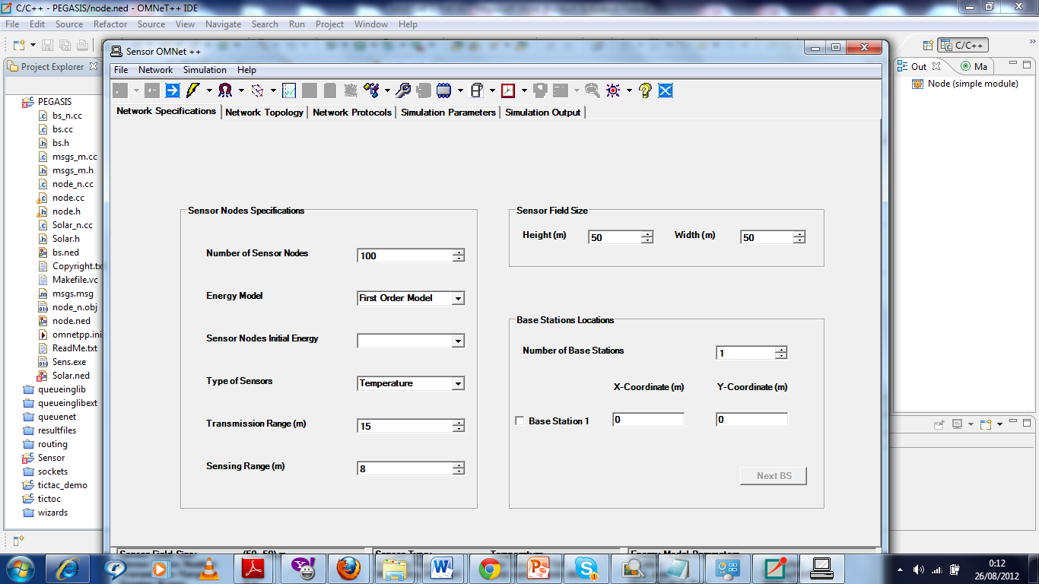

Figure A1: Sensoria Simulator ID
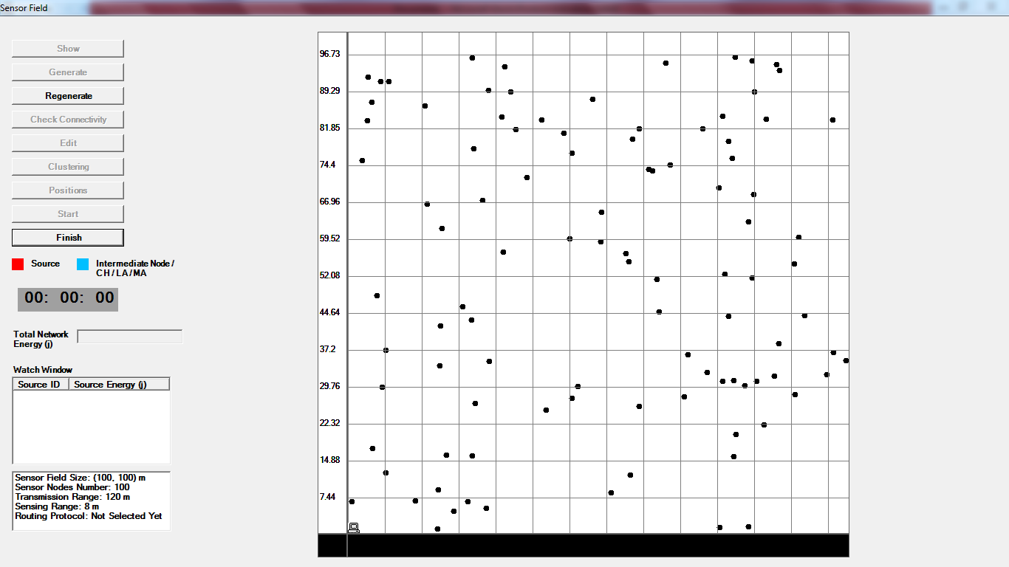

Figure B2: Network Topology Settings
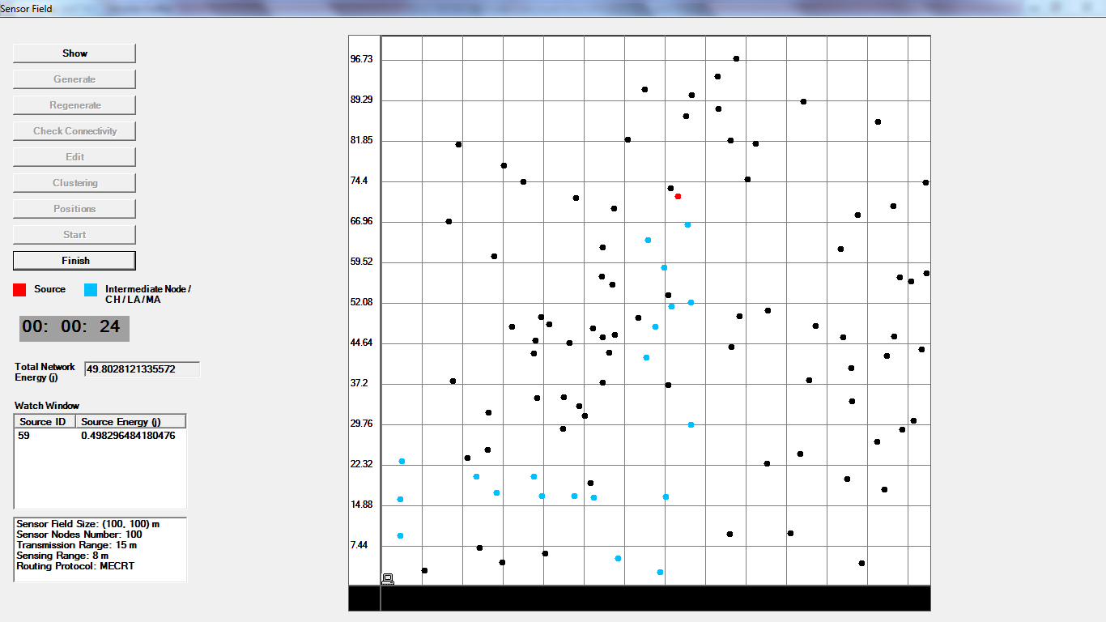

Figure C3: Chain Construction and Data transmission Settings

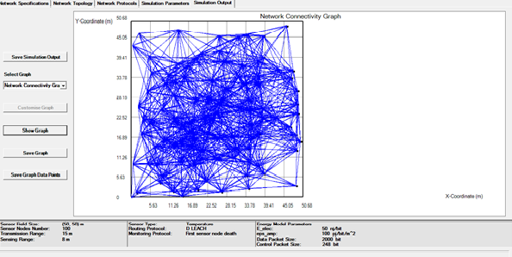

Figure D4: Network Connectivity Graph

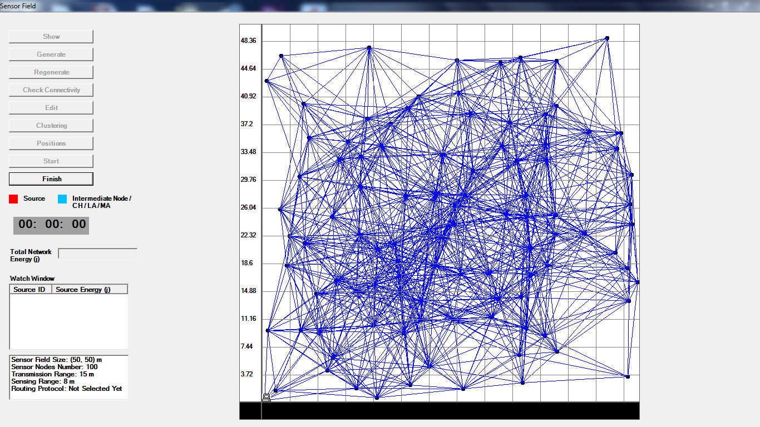
Figure E5: Network Field Connectivity

LIST OF TABLES

S/N | NAME | PAGE NO:
Table 1 | Applications of WSN for Some distinct areas. | 8,9
Table 2.7 | Comparison of routing protocols in WSN | 40
Table 3.5 | System Model Notation | 54
Table 4.1 | Simulation Parameters | 60
Table 4.2 | Total Network Energy Remain when 5% Nodes Death | 63
Table 4.3 | Total Network Energy Remain when 25% Nodes Death | 65
Table 4.4 | Total Network Energy Remain when 50% Nodes Death | 67
Table 4.5 | Total Network Energy Remain when 100% Nodes Death | 69
Table 4.6 | Summary Result of Total Energy Dissipations Analysis | 71

LIST OF FIGURES
S/N | NAME | PAGE NUMBER
Figure 1.1 | Protocol stack of WSNs | 10
Figure 2.1 | Hierarchical levels of cluster head | 18
Figure 2.2 | Structural view of a leach protocol before cluster formation. | 19
Figure 2.3 | Level Assignment | 24
Figure 2.4 | Chain Construction | 25
Figure 2.5 | Selection of Head Node | 26
Figure 2.6 | Data Transmission | 26
Figure 2.7 | Data Transmission from Each Level | 27
Figure 2.8 | Time Line for APTEEN | 33
Figure 2.9 | Chains cluster organization in HEEP | 33
Figure 3.1 | Formation of cluster | 36
Figure 3.2 | Selection of cluster head CH and transmission | 36
Figure 3.3 | Hierarchical levels of cluster head | 38
Figure 3.4 | Three phases of data transmission to the base station | 42
Figure 3.7 | Operation of OD-PFS: Routing over VGA | 45
Figure 4.1 | Comparative Plot of Energy Dissipation for 5% Nodes Death | 54
Figure 4.2 | Comparative Plot of Energy Dissipation for 25% Nodes Death | 56
Figure 4.3 | Comparative Plot of Energy Dissipation for 50% Nodes Death | 58
Figure 4.4 | Comparative Plot of Energy Dissipation for 100% Nodes Death | 60
Figure 4.5 | Illustrate the overall result of three protocols | 61
Figure A1 | Sensoria Simulator ID | 69
Figure B2 | Network Topology Settings | 69
Figure C3 | Chain Construction and Data transmission Settings | 70
Figure D4 | Network Connectivity Graph | 70
Figure E5 | Network Field Connectivity | 71

