

Internship Report
On
The Scenario of English Language Teaching School & College in Bangladesh

Submitted by
Md. Ashiqur Rahman Rajib
ID: 152-10-1202
Batch: 35th
Department of English

This report is submitted in partial fulfillment of the requirements for degree of
BA (Honors) in English

Daffodil International University
Dhaka, Bangladesh
November, 2018

Submitted to 8
Md. Ariful Islam Laskar
Assistant Professor
Department of English
Daffodil International University

Course Title : Project Paper
Course Code : Eng 334
Semester : Fall 2018

Project Supervisor
Md. Ariful Islam Laskar
Assistant Professor
Department of English
Daffodil International University

Submitted By
Md. Ashiqur Rahman Rajib
ID: 152-10-1202
Batch:35th
Department of English
Daffodil International University

Date of Internship : 27th October to 29th October

Table of Content

Content | Page No.
Term of Reference
Certificate Approval
Acknowledgement
Introduction
Abstract
Objectives
Methodology
Details of Institution
Class Observation ( Class 1)
Class Observation ( Class 2)
Class Observation ( Class 3)
My Teaching Experience (Class 1)
My Teaching Experience (Class 1)
My Teaching Experience (Class 1)
Overall Finding
Conclusion
Appendices

November,2018

Md. Ariful Islam Laskar
Assistant Professor
Department of English
Daffodil International University

Subject : Letter of transmittal

Respected Sir,
I have the honor to state that I have the submitted internship Report for completing my course Project Paper (Course code: Eng-334) in the program of B.A. (Honours) in English. The internship report on "The Present Scenario of English Language Teaching in Bangladeshi School and college" is an authentic work based on my practical experience and has not been submitted to any other institution. I have tried to follow all the instructions that you have given to me to complete my internship report duly .

I am hopeful that you will like my internship report and approve it .

Yours Sincerely

.........................................
Md. Ashiqur Rahman Rajib
ID: 152-10-1202
Batch:35th
Department of English
Daffodil International University

Certificate of Approval

I am pleased to certify that the submitted internship report for the completion of the course Project Paper (Course Code: Eng-334), conducted by Md. Ashiqur Rahman Rajib ,ID: 152-10-1202 , a student of the Department of English, Daffodil International University , has been approved for presentation and viva-voce. The internship report has been completed under my supervision during the Fall 2018 semester .

................................
Md.Ariful Islam Laskar
Assistant Professor
Department of English
Daffodil International University

Acknowledgement

While preparing my internship report, I have taken help from many people . I am thankful to them as without their help it would not be possible to prepare my internship report properly.

At first I would like to thank my supervisor Md. Ariful Islam Laskar ,Assistant Professor, Daffodil International University, for his help and guidance to complete my internship properly . I also would like to thank Abdul Mannan ,the Headmaster of Tejgaon Adarsha School and College, Dhaka, who allowed me to take three classes after observing some classes to complete my internship report on 'The Present Scenario of English Language Teaching in Bangladeshi School and College". I am also thankful to the the teachers of the school and college named Shujit Kumar Podder, Zainul Abedin , Masud Parvej who really behaved beautifully and cooperated with me positively to complete my internship report.

Finally , I would like to thank my parents Late. Atower Rahman and Jharna Rahman . My father was a teacher so he always inspired me about teaching . My mother never let me understand the absence of my father and also inspires me to complete the internship very carefully.
May my father's soul rest in peace and i pray to Allah for my mother's long live .

Introduction

In this 21st century , it is quiet impossible to think of our graduation without knowing English as most of the books are written in English. Now a days we can not think of our modern life without English . English has become part and parcel of our day to day life . It has made the world closer . For one person, it will be a tough work to learn so many languages . People all over the world can make a communication through English as it is an international language . In our country , poor number of people know English properly and language teaching is one of the finest reasons of that problems . Teaching is a noble and honorable profession which can lead a nation to the highest peak of prosperity . To know about the current scenario of our language teaching system , I was asked by my supervisor Md. Ariful Islam Laskar to go to school to make an internship report after proper analyzing . By following all the instruction given by my supervisor , i make my internship report .

I have completed my internship report at Tejgaon Adarsha School and College from 27th October to 29th October .There should be no confusion that i have a learnt a lot about present system of teaching which will be helpful in my career .

Abstract

The internship report depicts the experience of three days in Tejgaon Adarsha School and College. The internship report is made on The Present Scenario of English Language Teaching in a Bangladeshi School and College. All the information in the report is collected after observing three English classes conducted by three different teachers of the school and College . The report carries the detail of school and college, class observations, presentations, cooperation, photographs etc. The report also describes discussion with the teachers individually about the teaching system which they follow usually . A class is controlled by both students and teacher certainly. A clear image of our school and college level education has been portrayed in this report . And off course there are some possibilities of improving their language teaching system . All the data has been included in the report from teaching experiences .In brief the report shows the proper Scenario of English Language Teaching in Bangladeshi School and college .

Objectives
The objectives of the internship are given below
- To get accurate view of the present scenario of English language teaching in Bangladesh equally in school and college.
- To know how to establish the techniques of English language teaching in a classroom
- To know how to get the students attention in a classroom
- To know how to build up relation among the teacher and the students
- To know about the importance of learning English language
- To establish English as the finest way of communication

In order to obtain the objectives, I had to:
- ask permission from the Head master of the Tejgaon Adarsha School and College for doing my internship in his reputed institution
- to follow the instruction of my supervisor
- to observe classes and find how they apply the techniques of teaching
- to take classes properly with the instruction i have been given by my supervisor
to cooperate with my supervisor and the teachers of the institution in order to gain my goal

Methodology

In order to complete my internship , I had to find a school where I could observe three classes of three different teachers as well as take three classes . I did not waste too much time for choosing a school as I decided it earlier. I had been a student of Tejgaon Adarsha High School and College and my father was a teacher of this school. I was very much excited to do my internship there as I am going to take classes in my school where i was a student .So I went to the school and met with the Head master but the institution was closed for religious purposes .And i had to wait for a week as it was a long vacation . Then made another appointment with the Headmaster and met with him . I faced difficulties to maintain schedule between the school routine and my own classes routine as i had to do my classes in the university .
Though i knew all the teachers of the institution once , now there are so many newly appointed teachers . Headmaster introduced me with them and requests them to co operate with me . Assistant Head master dealt with me about the schedule . The school has two shifts and these are morning shift which starts at 7:OO am to 11:30 am and day shift which starts at 12:00 pm to 4:30 pm and College starts at 10:00 am to 2:00 pm. Assistant Headmaster gave me three classes and they are class 9, class 10, class 12 . I requested him to allow me in the morning shift as i had to do classes in university at noon . He agreed with me .Then i observed three classes of three different teachers and i was informed about the topics . I took note on how the teachers took classes , applied the techniques of teachings. I also asked about the opinion of teacher and students for developing teaching system .
Finally i took three classes on tense , voice ,narration and I am very happy to say that i was able to get the attention of most of the students . They asked me question when they failed to understand anything .After giving lectures on specific topics , students are told to solve problems in the book . And they gave a good feedback . I really enjoyed teaching them. And specially I am honored to work in an educational institution .

Institution details
Tejgaon Adarsha School and College is one of the famous institutions in the Tejgaon I/A, Dhaka-1208. This institution was established in 1965 . The code(EIIN) of the institution is108527 and web address is http://tascam.edu.bd/Home/Contact

Present Information :
The school has 2 gates and there is a large compound for the students. Three buildings of the school and college are very old and with proper air , light and another building is under construction . There is an open space for assembly and play ground . There are two shifts in the school . ONE is morning shift and another one is day shift for school section . But the college section starts in an another shift which starts from 10:00 am to 2:00 pm .

It has a library , canteen ,common room , science laboratory . But the food quality of the food is not hygienic so it should be improved soon . The facilities of the library , common room specially science laboratory are not sufficient.

Number of teachers and their qualification :
There are 46 teachers in the school and college . Most of the teachers are graduated from public and National university . Some of them are from private university .Al most all the teachers have done their post graduation .

Number of the students :
There are 1000 students in the school and 200 students in the college .

Other Information :
The passing rate of the institution is 86.51% in the PSC, JSC, SSC,HSC . There are two types of uniform for day shift and morning shit . Girls in the morning shift wear navy blue color uniform and the boys in the day shift wear sky blue uniform . The students of college wear white colors dress as their uniform . Every Year the institution organizes prize giving ceremony with cultural event as well as study tour .

Class Observation
Class 1:
At first I observed class nine and the name of the teacher was Zainul Abedin . His objectives were to make the students understood about a passage named "Hason RaJa" . At first he asked the students how they were and made some fun before starting class as a warm up session . Then he started to read the passage and discussed the new words to them . He interacted the students beautifully . He used almost 70% English in the classroom and rest of the 30% was Bengali. His teaching was understanding and reachable to all the students. But he did not introduced the topic to them and was discussing only the passage. The teaching method was standard and the his spoken English was fluent and understandable. Overall the teaching was influential and communicative as the teacher was constantly involving students by asking questions, giving them tasks to solve.

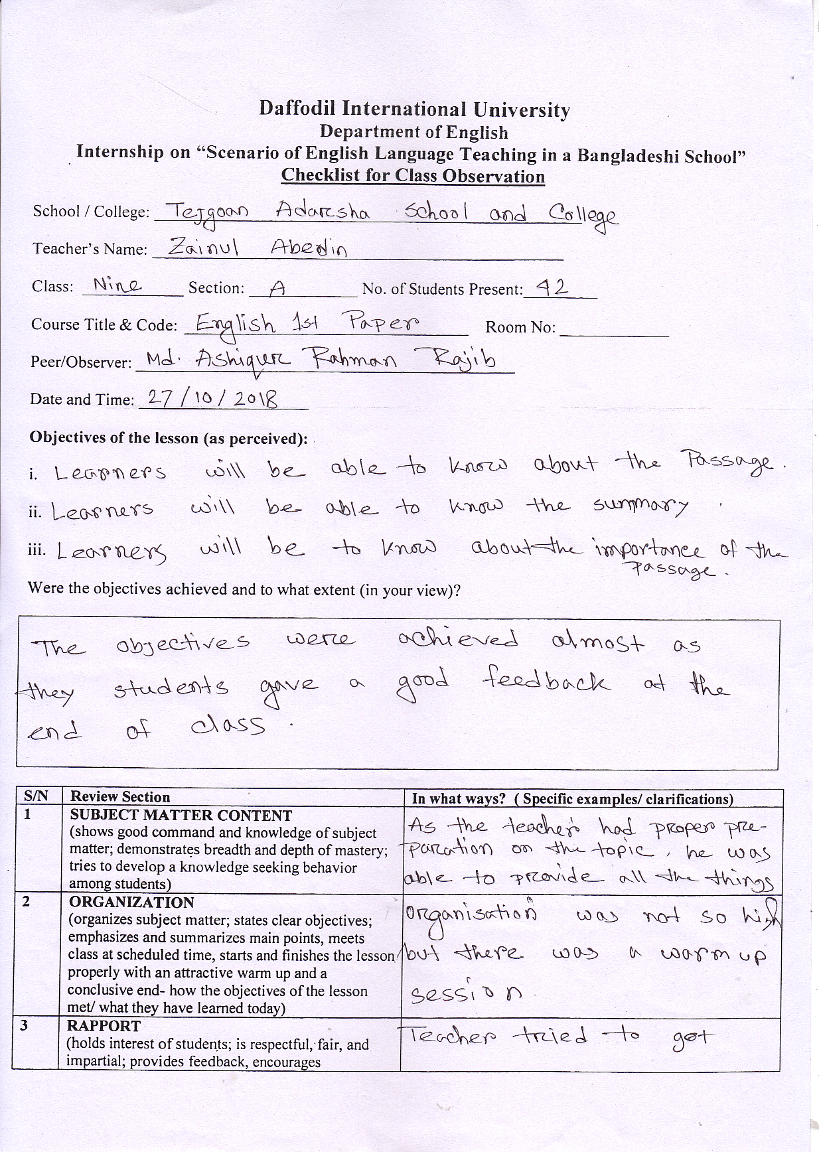

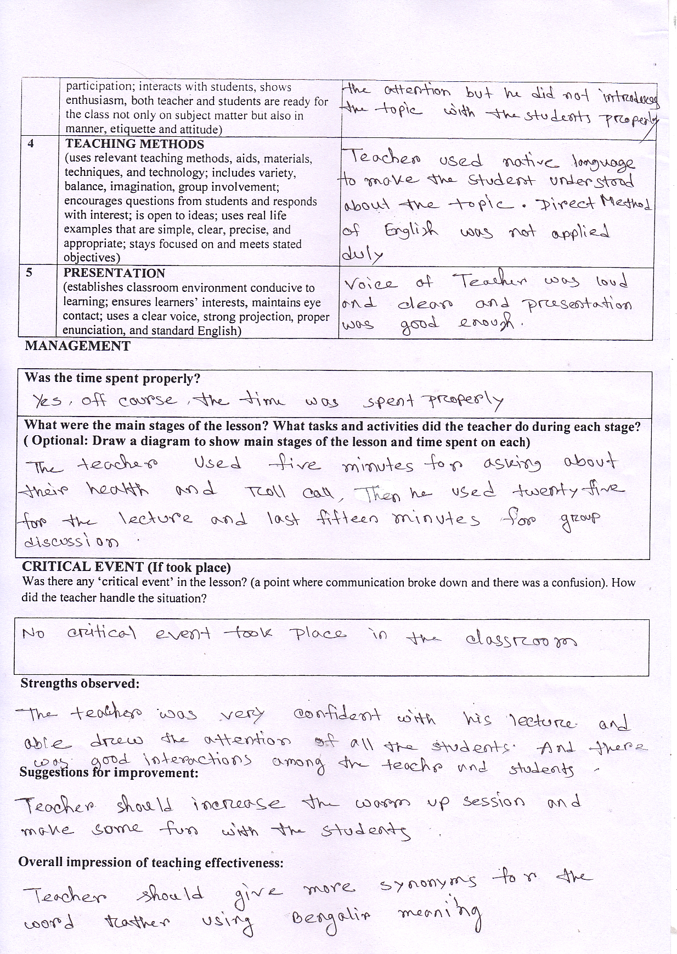

Class 2:
My second class observation was of class 10 and the name of the teacher was Shujit Kumer Podder . He started his class without any warm up session . After entering into the classroom , he asked the students about home work . Then he started to teach a grammar topic named "narration" . At first he told the students before teaching narration about Tense as it is so much important for this topic. The he taught the Rules of narration . He used only 40% English and 60% Bengali . He failed to communicate with the students and the students were afraid of him . He was just focusing on his lecture as well as he was not communicative towards the students. He did not finish his class in a proper way even he did not ask any question to the students if the have understood or not .

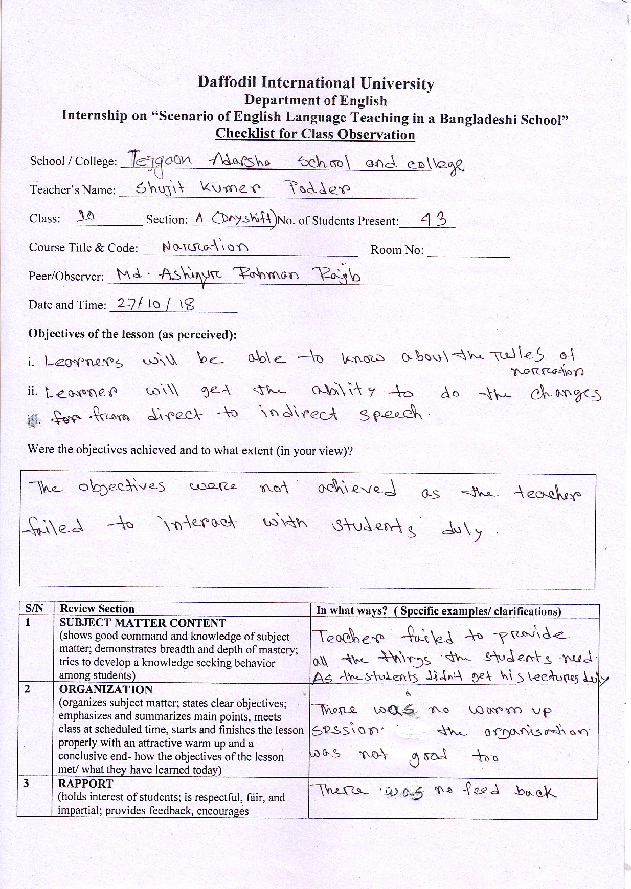

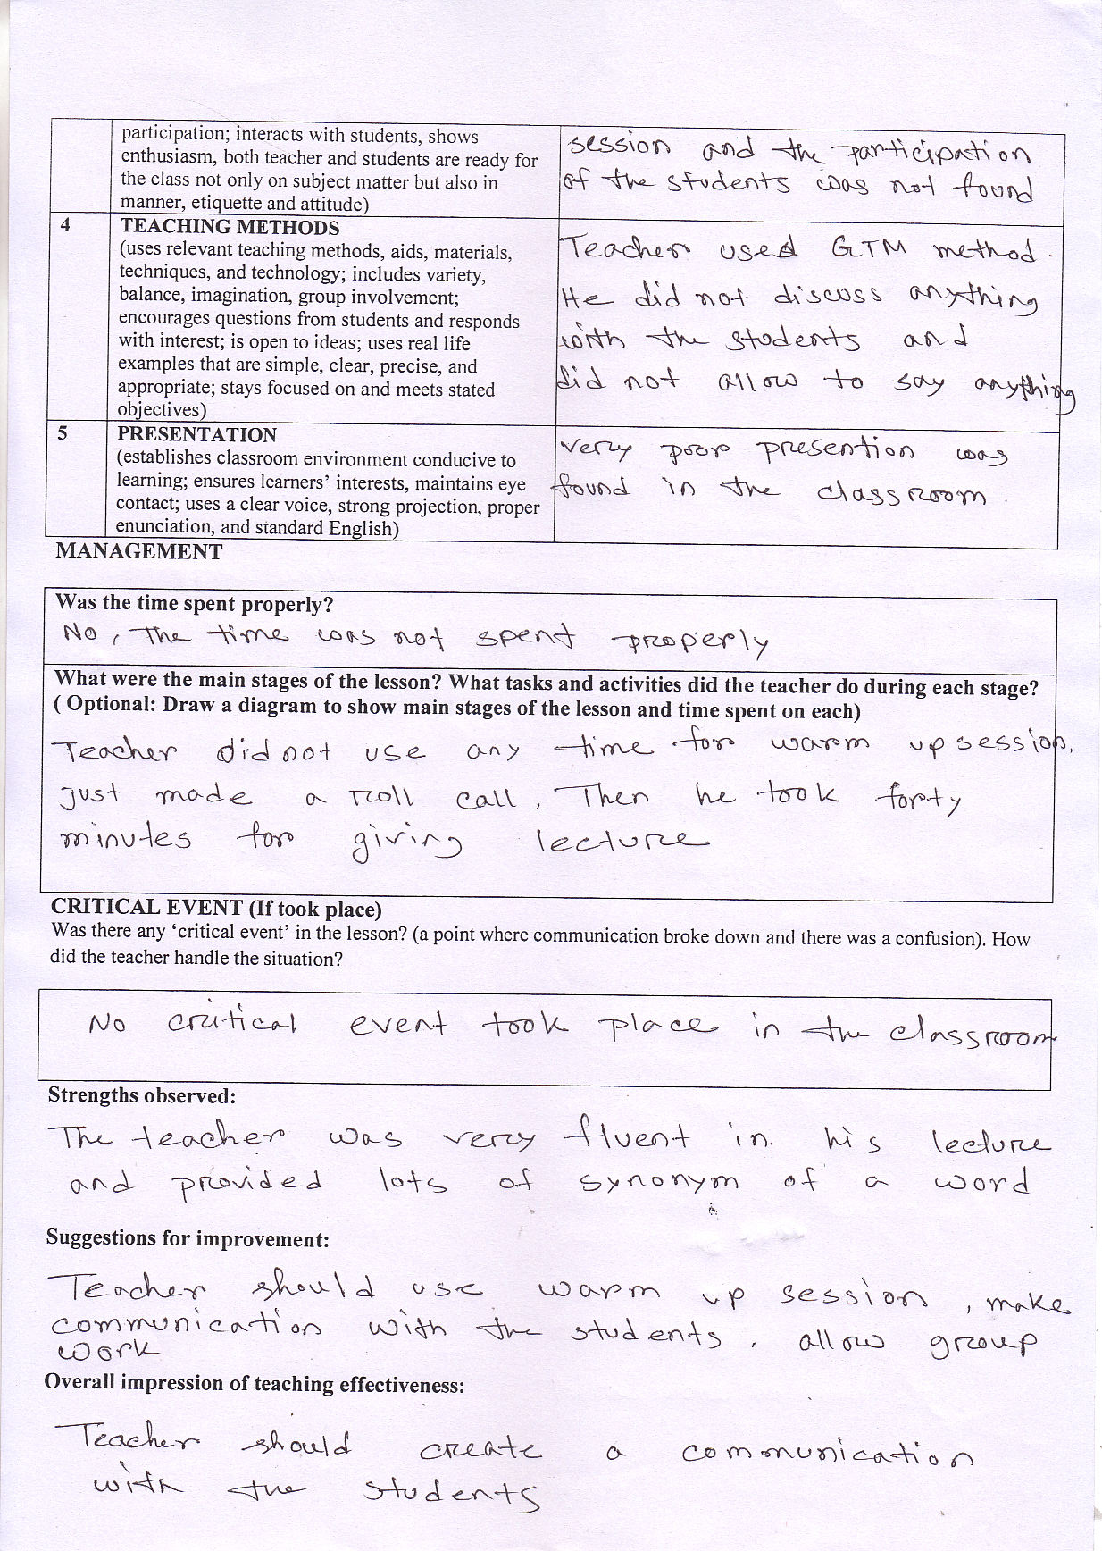

Class 3:
My third class observation was with class 12 and the name of the Teacher was Masud Parvej . His objectives were to introduce and make the students understood about a topic a named Transformation . He started his class without any warm up session and told the students to open up their grammar book .With the help of a grammar book , he wrote rules of transformation on the white board without any discussion about the rules . His spoken English was not good and he used only 30% English in the classroom . He was not communicative towards the students . One of the students asked him a question and he could not answer it and ignored it . He finished his class abruptly and did not give any tasks in class .

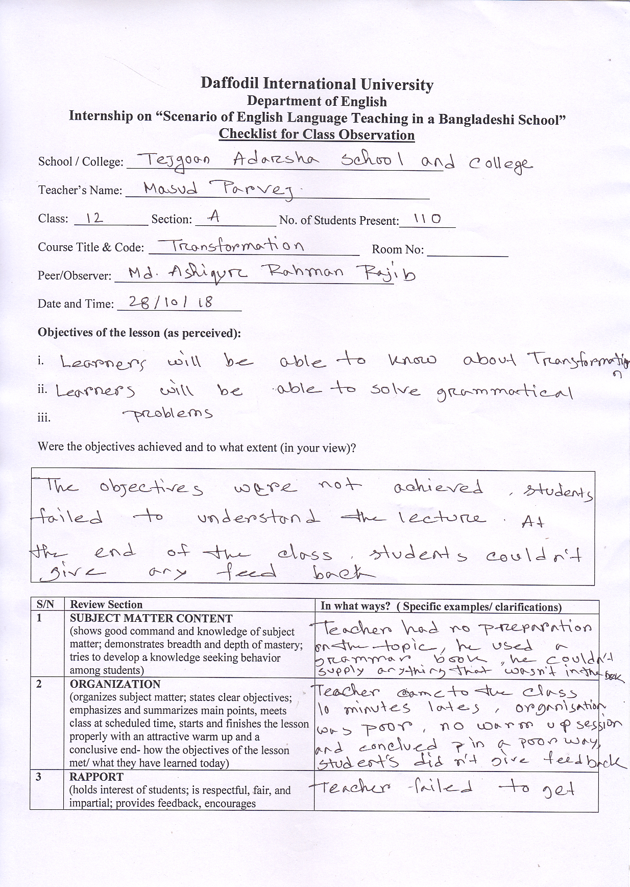

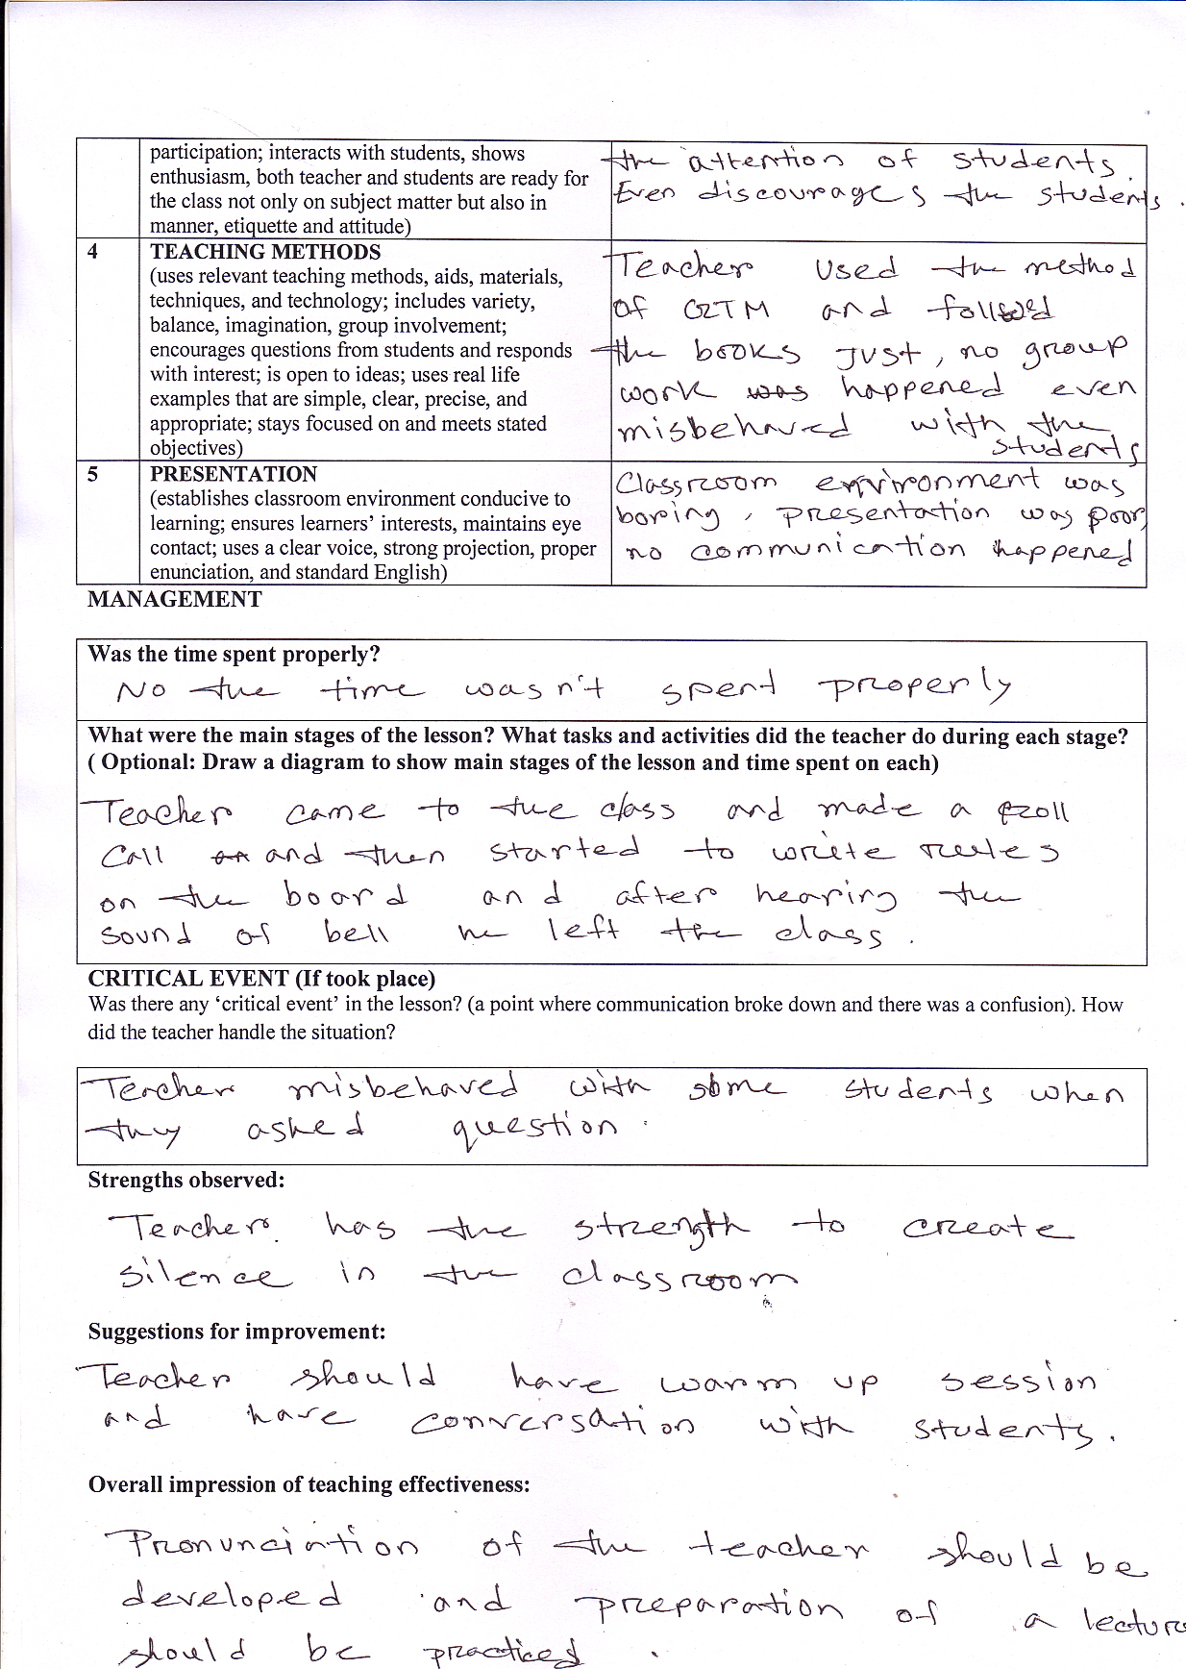/

Teaching experiences

Class 1:
At first I took the first class of 9 in morning shift . I mentioned earlier that there were two shifts in the school. Assistant Headmaster came with me with a view to introducing me with the students as well as he described why I entered into the classroom . Then he left the classroom. Then I started to take my class. But before starting the class , I introduced myself again properly . I wanted to communicate with the students properly and also wanted their total attention . I took their attendance in a paper and got to know about their name . I talked with them for a few minutes about their life style and made some fun as a warm up session . There were 47 students present in the classroom and the class time was 45 minutes .My objectives were to make them understood about Tense as it is very much important for everyone who wants to know English properly . I asked them what they know about tense and how many types of tense are . Some of the students could answer a little bit . Then I started to teach about Tense and drew a chart of Tense in the white board . I described the categories of tense with proper example .I used only one sentence in all the forms of tense for their better understanding . I also asked the students to share examples of different tense .The students interacted with me very beautifully . I allowed the students to discuss among them silently .I used almost 70% English in the classroom and the rest of the 30% was Bengali . Students were capable to understand me as they asked some question where they faced difficulties and talked with me in English .They enjoyed the class as there was good interaction among us . The class was communicative certainly . Before finishing the class I told them how to improve today's learning by reading in home . At last i took a fare well from them with lots of love and experiences .

Class: 2

After taking first class I got a break for 45 minutes . Then i went to the class 10 with Assistant Headmaster and again he introduced me shortly with the students .While leaving the classroom , he requested the students not to disturb me . Then I repeated my introducing and warm up session like previous class .There were 52 students present in the classroom and I got again 45 minutes . I made a roll call as it was counted for 5 marks . Then i told them about the topics named Voice change that would discussed in the classroom . At first i wanted to know what they know about voice change . Some of the students raised their hands and shared what they know and where they faced difficulties . I assured them that there should be no change of tense while converting active to passive or passive to active . I Used almost 70% English and used 30% Bengali in the classroom and the students did face difficulties to cope with me as we had a good interaction .I taught the rules of voice change but in one class it was not possible to complete it fully . Then i gave some sentences to convert from active to passive that was possible to solve by my lecture . I allowed the students to do pair work as it would be helpful for them . I got enough good response as they were able to solve the problems .Finally the bell rang so I had to leave the class . Overall the class was communicative and the students learnt something by my lecture . I must the quality of the students were quiet impressive .

Class: 3
I went to the Class 12 to take my third and final class . Masud parvej sir who takes this class usually went with me to tell the students that i would take the class on that day . He did not leave the class rather he asked my permission to enjoy my teaching . I allowed him to sit in the classroom and he sat on the last bench of the classroom .111 students were present in the classroom and I got 50 minutes in that time. At first I introduced myself with the students and made some fun for removing boredom in the classroom . Then I made a roll call and talked with them individually in a very short time . I praised them to get their proper attention . Then I told them that I would like to teach them Narration . They liked the topic as they had problems in that topic . My objectives were to make them understood about the narration with proper interaction with the students . I wanted to know if they knew about narration . Only a few students could answer it correctly . But they told they know about all the tenses . I assured them it was all about tenses . Then I wrote examples in the white board and requested them to take note . I used one sentence of different tenses and made it direct to indirect . For example , He said ," I write a letter." ,He said, "I am writing a letter.", He said, "he has written a letter." . So that the students could understand easily .I used almost 55% English and the rest was Bengali as the quality of the students were not good . I just completed assertive part of the narration . I asked if they knew about passage narration . They answered positively so I asked to give me test paper which provided previous years question of different boards . In the book, i tried to find one passage narration which can be done by my lecture. Fortunately , i found one and told the students to read the passage again and again and also told them to solve . I told them to do pair work so that they could discuss . I told them to find out the speaker and the gender of the speaker as it was very important in Narration . At last they gave me a surprise as they were successful to solve the problems almost 90% . I was very happy to find it out. Then the teacher came in front of the students and praised me about my teaching style . The students were happy also . I Left the class with full of satisfaction and experience. There should be no confusion that the class was communicative .

Overall Discovery

At first I want to assure that I have learnt so many things while doing this internship repot. This report depicts a experience of field work that helps to know about strength and weakness of the teachers who are teaching in the school and college . I get to know about my limitations and problems in the teaching .

Moreover , I got to know the quality of our teachers who are teaching in school and college . I met with some teachers who are really very qualified but they are not guided properly . They some qualities and new methods of teaching . In our school and college , teacher still follows the method of GTM and they do not follow DM . They depend on Bengali while teaching English. They create a boring environment in the classroom as they do not make any fun and interaction with the students .Students do not feel free to cope with the teachers. Teacher should the use the term" brainstorming".

Teacher can make a class enjoyable if he does not discuss only the subject matter . The pronunciation and presentation of a teacher should be developed more . If these things are applied , then we can hope to have an improvement in our teaching system.

Recommendation

The overall environment is quiet good but I think that for proper presentation in the classroom , they should use project paper . There are no language clubs in the school and college , it can be added . There is no computer facilities , it also can be added . Common room facilities should be improved . The painted wall and the quality of the benches were not so good . Online teaching can be added as now a days people used to use internet usually . Generator system should be improved in the school and college .

Conclusion

This field work has helped me to achieve my objective for better teaching experiences .It has also helped me to learn about the current English teaching system which inspired me to work on applied teaching method . I got my limitations and which I have overcome through practical field work .I also observed the limitations and qualification of the teachers in the institution . The field work was enjoyable and i became nostalgic .

Appendices

Some documents that related to my internship report has given below -
- Related Photographs
- Certificate

