Marketing Activities
of
B&T Group

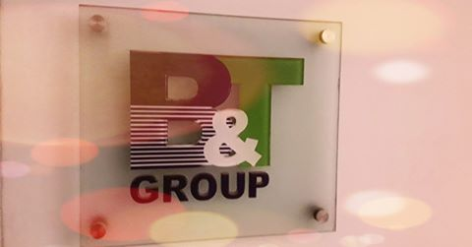

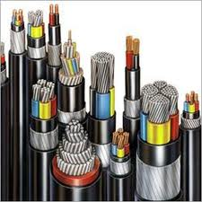
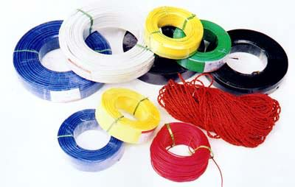
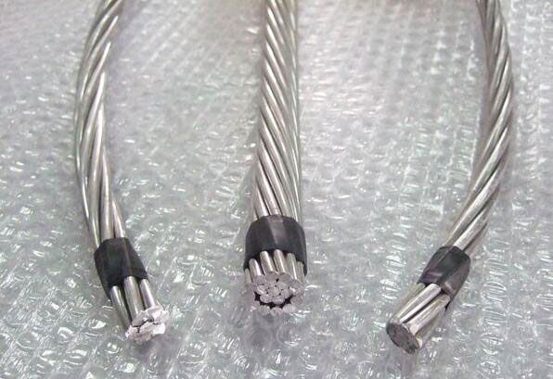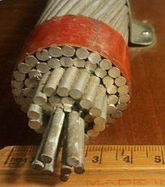
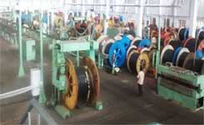

INTERNSHIP REPORT

ON

Marketing Activities of B&T Group

Prepared For

Mahbub Parvez
Associate Professor
Department of Business Administration
Daffodil International University

Prepared By

Md. Razib ull Islam
ID: 141-14-1315
Major- Finance
Batch: 37th
Program: MBA Department of Business Administration Faculty of Business and Economics





Date of Submission: 30th November 2018

LETTER OF TRANSMITTAL
30 November, 2018
Mahbub Parvez
Associate Professor
Department of Business Administration
Daffodil International University

Subject: Submission of internship report.

Dear Sir,

With due respect and great pleasure I submit my Report titled “Marketing Activities of B&T Group” which has been prepared as a part of my degree requirement. I have tried my level best to follow the methods and ethics to prepare this Report. Hereby, I hope that you would be kind and generous enough to accept my sincere effort and oblige thereby.

While preparing this report I had to go through with a survey to Products of B&T Cables, Marketing activities and the Marketing Process.

Sincerely yours,

___________________
MD. Razib Ull Islam
ID: 141-14-1315
Batch: 37th
FACULTY OF BUSINESS ADMINISTRATION
Daffodil International University

Certificate of Approval

This is to certify that Md. Razib Ull Islam is a student of MBA, ID: 141-14-1315, Batch: 37th
Successfully completed his internship report titled “Marketing Activities of B&T Group” under my supervision as the partial fulfillment for the award of MBA program.

He has tried his best to do this successfully, which is accepted in terms of quality and form. I
wish his success and prosperity.

………………………
Mahbub Parvez
Associate Professor
Department of Business Administration
Daffodil International University

Acknowledgement

In the preparation of this internship report, I acknowledge the encouragement and assistance given by a number of people from B&T Group. I am grateful to the honorable following for being so cordial to me for their help during my internship period

Mr. Ranjit Paul Head of Commercial & Marketing,
Md. Masud Rana Marketing Manager
Mr. Sushanto Das Business Analysis for suggestions and assurance.
Md. Masud Perves Sumon Deputy Manager (Marketing & Development)
Md. Ismail Khan Maintenance Engineer
Also like to thank all the Department staffs of B&T Group for giving me helpful support.

I would like to express my gratitude to my supervisor Mahbub Parvez, Associate Professor Department of Business Administration, Daffodil International University, for sharing his ideas and interests with me about my study. His contribution boosted my confidence and helped me finish my study on time.

EXECUTIVE SUMMARY
B&T Group is one of the reputed organization that operating in Bangladesh. B&T Group is one of the largest Manufacturers in Bangladesh with experienced work force, which ensures that its products meet the high standards of quality expected by the customers.

The topic is “Marketing Activities of B&T Group”. I have tried to cover the complete serviceable aspects of B&T Group. I have worked in Commercial & Marketing Department of this company. We carry an extensive variety of Wire, cable & SPC Pole products for all the major government organization like BREB, BPDB. B&T Group were established in 2004 as a B&T Cables private limited company. It is an ISO 9001: 2000 accredited company having its own factory located at Factory: Village- Purondpur, P. O. Khalishpur, P.S.- Moheshpur, Dist.- Jhenidah, Bangladesh. B&T Group targeted work on BREB & BPDB Since its inception in 2004 as a sister concern of B&T Group, B&T Cables Ltd, B&T Transformers, Digital Meters (B&T Meters), Overhead Conductors, Copper conductors (bare and insulated) And SPC Pole which are widely accepted and used in different government, semi-government and allied agencies, has steadily & impressively grown up to become a leading producer of Pole, Wire & Cable in the electrical area of Bangladesh.

With this scenario and prospects in view, B&T Cables Ltd, floor space of 85,000 sft. Amongst a total area of 250,000 sft of its own modern Copper plant for producing 99.99% pure 5,6,7,8,9 mm dia HTS Wire, Copper Rod, SPC Pole & Conductor available modern machineries for production line. Our objective is to produce Pole, Copper wire and cables with highest possible precision and service the Customer with unparallel customer service support. We have QC Lab to check and ensure the quality parameters as per concern standards, thus ensure total 100% quality product with safety.

Table of Contents

SL. No | Chapter 1: Introduction | Page No
1.1 | Introduction | 2
1.2 | Background of the Report | 2
1.3 | Objective of the Report | 2
1.4 | Methodology | 3
1.5 | Limitations of the Study | 4

SL. NO | Chapter 02: Organization Overview | Page No
2.1 | B&T Group Address | 6
2.2 | History of The Company | 6
2.3 | Organization chart(Head Office) | 7
2.4 | Organization chart(Factory) | 8
2.5 | B&T Group Factory Picture | 9
2.6 | B&T Group Lab Picture | 10
2.7 | Mission & Vision | 10
2.8 | Market Share | 11
2.9 | Sister Company & Product | 11
2.10 | B&T Group Products | 12
2.11 | Financial Position | 22
2.12 | SWOT Analysis | 23

SL. No | Chapter 03: Learning Part | Page No
3.1 | Definition of Marketing | 26
3.2 | Market Structure | 26
3.3 | Market Strategy | 27
3.4 | Marketing Mix | 28
3.5 | Tender Process | 39
3.6 | Financial Position 2015 to 2017 | 40
3.7 | Income Statement 2015 to 2017 | 41
3.8 | Sales /Turnover from 2013 to 2017 | 42
3.9 | New Product Development | 43
3.10 | Findings | 44
3.11 | Recommendations | 44
3.12 | Conclusion | 44

PART-1

Topic

Introduction
Background of the Report
Objective of the Report
Methodology
Limitations of the Study

1.1 INTRODUCTION

B&T Group is one of the reputed organization that operating in Bangladesh. B&T Group is one of the largest Conductor& Poles Manufacturer in Bangladesh, which ensure that its products meet the high standards of quality expected by the customers. The Head Office is in Banani, Chairmenbari. The products manufactured meets National and International Standards such as ANSI, ASTM; IEC; BS & DIN. The employee of B&T Group (Head office & Factory) over 300 Hundred people work there.
The contribution of B&T group has an outstanding record of all around excellent in growth in the different business activities like pole manufacturer company named Contech Construction Ltd, Pre – Stressed Pole Ltd, B&T Cables limited, B&T Meter Ltd, etc.
1.2 Background of the Study
The prerequisite of every Post Graduate student from business study has to do the Internship with the aim of learning how to work practically from the knowledge gained so far as a business student. It is a massive experience for every student to get practical experiences of the theoretical knowledge that we have collected in our graduation life. I have done my internship in the Marketing Activities of B&T Group.
During this internship program I would like to express my gratitude to my supervisor Mahbub Parvez, Associate Professor Department of Business Administration, Daffodil International University, for sharing his ideas and interests with me about my study which should be relevant to my practical knowledge.
1.3 Objectives of the study
1. To give an overview of B&T Group
2. To identify the Marketing Mix of B&T Group
3. To analyse the Tender Process of B&T Group
4. To find out some problems related to marketing activities
5. To make some recommendation to overcome those problem

1.4. METHODOLOGY OF THE STUDY
For smooth and accurate study everyone have to follow some rules & regulation. The study follows some methodology.

Type of Report
Description: This is Description Type Report.
Sources of Data
- Primary sources

This report has prepared of primary data. It is collected from group of people who are work with this Company. I used in collecting primary data. These are

- Direct interviewing: I have collected data from the officers, executives & manager

- Personal communication: I have collected data through personal communication with …officers, executives, and managers of the Company.

- Observation method: I went to Commercial & Marketing department and observe their ..activities.

- Secondary sources
- Annual report of B&T Group.
- Sheet of work in progress (Expenses)
- Files & Folders.
- Memos & Circulars.
- Daily notes various publications on Company.
- Websites.
- Various research journals of different research organizations.

Population Size Sample:
- All officers of the Commercial & Marketing Department of B&T Group.

Sample size:
- Twenty officers

Sample Techniques:
Judgmental sampling technique has been used on the officers of B&T Group for data collection. Data have been collected on different days within my internship period though conversation and discussion.

Method of data collection:
Face to face interview

1.5 LIMITATIONS
Every report has its limitation. There were several limitations in preparing this report. The main limitations were --
- Limited in time and resources
- There are shortages of data for information cause of data collection is secret.
- Learning all the company’s functions about project within just three months was really tough.
- Another limitation of this report is Company’s policy of not disclosing some data and information for obvious reason, which could be very much useful.
- As, I had more dependence on the primary sources, so there might be some levels of inaccuracy with those collected information.

PART-2

TOPIC

Address
History of The Company
Organization chart(Head Office)
Organization chart(Factory)
B&T Group Factory Picture
B&T Group Lab Picture
Mission & Vision
Market Share
Sister Company & Product
Product Range
Financial Position
Income Statement
SWOT Analysis

2.1 B&T Group ADDRESS

B&T Group was established in 2004 as a private limited company which integrates developing, manufacturing & marketing of copper, SPC Pole, Aluminum wires and cables. It is an ISO 9001: 2000 accredited company. Head Office: House # 78, Road # 2, Banani, Dhaka-1213, Bangladesh. Phone: 0-88-02-55040904, Fax: 880-2-55040905 and having own factory located at Village- Purondpur, P. O. Khalishpur, P.S.- Moheshpur, Dist.- Jhenidah, Bangladesh
2.2 HISTORY OF THE COMPANY
B&T Group was established in 2004 as a B&T Cables private limited company which integrates developing, manufacturing & marketing of both SPC Pole, copper, Aluminum wires and cables. It is an ISO 9001: 2000 accredited company having own factory located at Village- Purondpur, P. O. Khalishpur, P.S.- Moheshpur, Dist.- Jhenidah, Bangladesh

Since its inception in 2004 as a sister concern of B&T Group, B&T Cables has steadily & impressively grown up to become a leading producer of wire & cable in the electrical area of Bangladesh supplying product to different government and allied organization.

Bangladesh is a developing country; electricity plays an important role for ensuring proper development of a nation. Day by day gradually need to capacity utilization and growth, there is a rapid increase of demand of electricity and vice versa electrical cables for flow of electricity.

With this scenario and prospects in view B&T Cables Ltd., floor space of 85,000 sft. Amongst a total area of 250,000 sft of its own modern Copper plant for producing 99.99% pure 5,6,7,8,9 mm dia HTS Wire, Copper Rod, SPC Pole & Conductor available modern machineries for production line. Our objective is to produce Pole, Copper wire and cables with highest possible precision and service the Customer with unparallel customer service support. We have QC Lab to check and ensure the quality parameters as per concern standards, thus ensure total 100% quality product with safety

2.3 BRIEF ORGANIZATION CHART OF B&T GROUP (HEAD OFFICE)

Figure: Organizational Chart

CCL: Contech Construction Ltd
PPL: Pre-Stressed Pole Ltd
B&T Cables: B&T Cables Ltd
B&T Meter B&T Meter Ltd
B&T Poles: B&T Poles Ltd
B&T Transformer: B&T Transformer
B&T Coldstorage : B&T Coldstorage
Tushar Knittex : Tushar Knittex

2.4 BRIEF ORGANIZATION CHART OF B&T GROUP (Factory)

2.5 B&T Group FACTORY
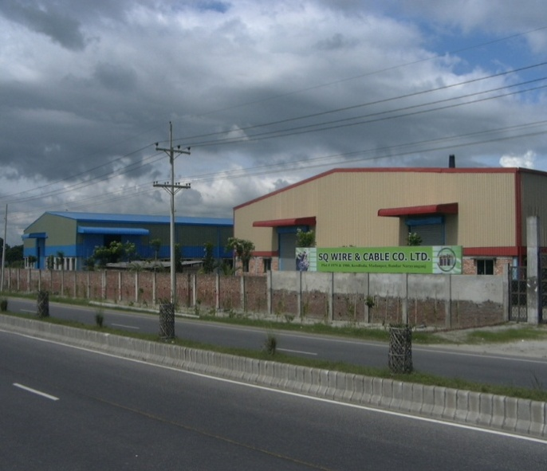
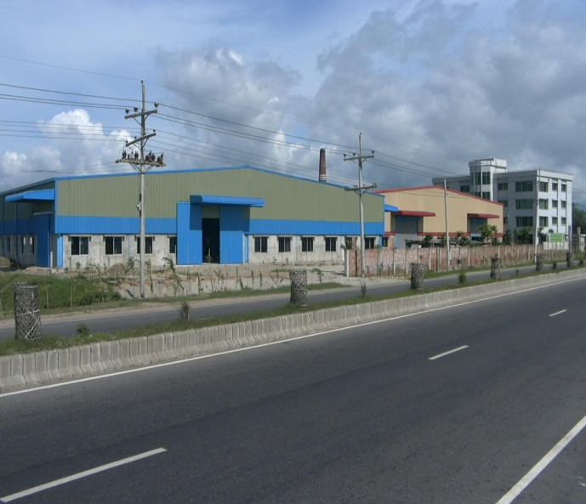

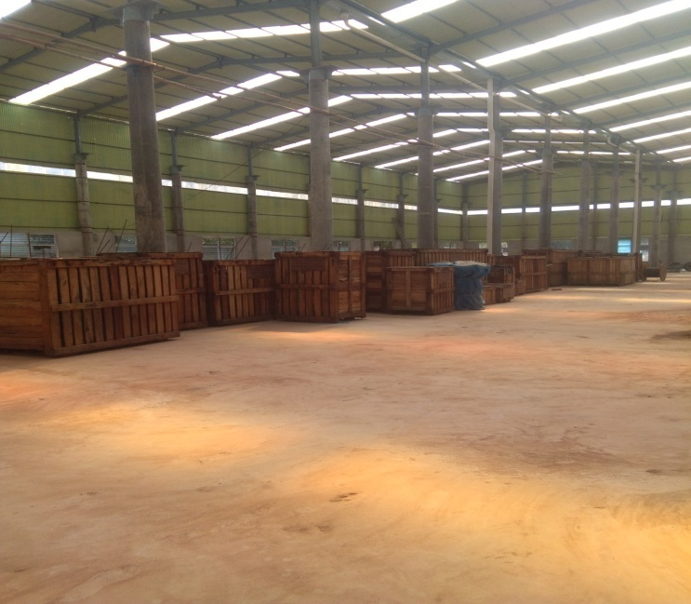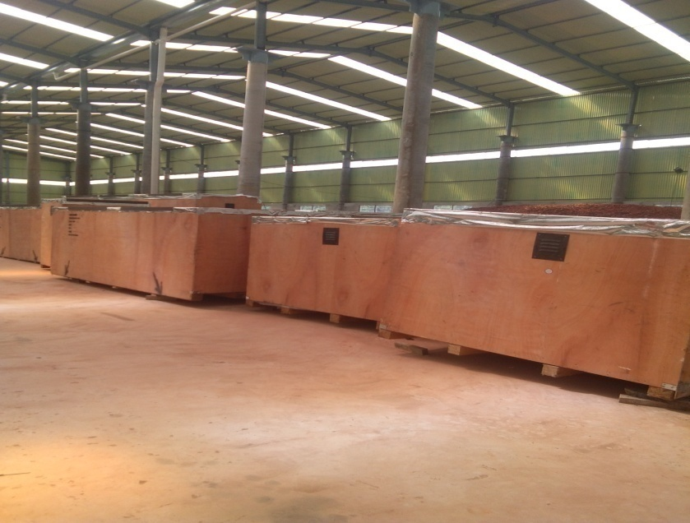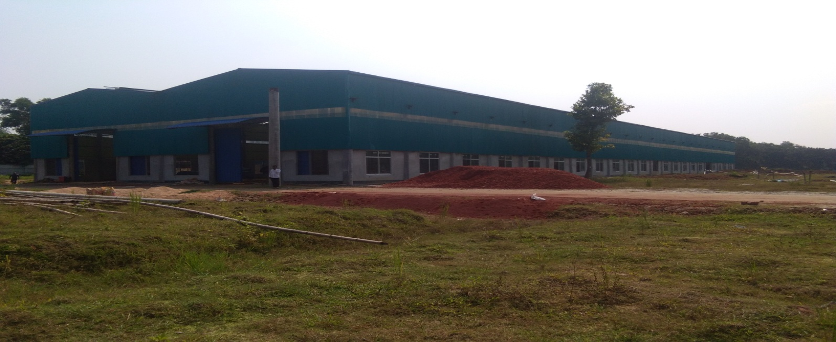
FACTORY PREMISES OF B&T Cables LIMITED

2.6 B&T Group FACTORY & LAB
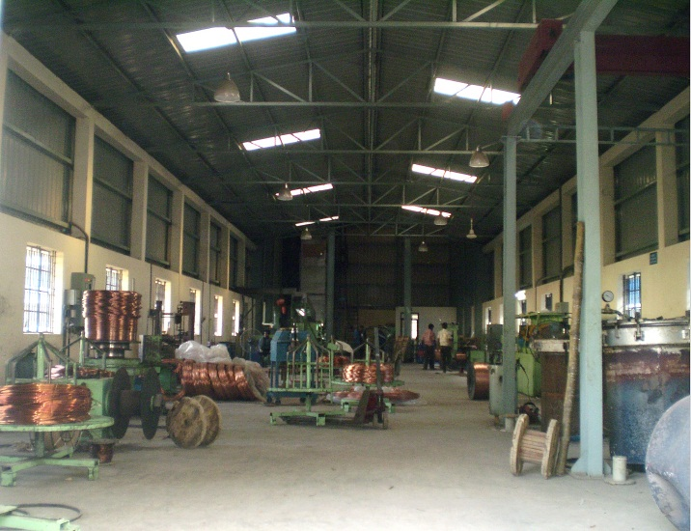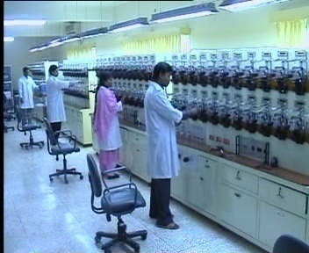

B&T Group FACTORY & LAB
2.7 MISSION & VISION OF B&T Group
Mission
B&T Group mission is to provide quality product and good service to customers professionally and exclusively. B&T Group strive to innovation for eco-friendly products and try to make environmentally hazardous raw materials redundant. We maintain high standards of technology by providing safe, reliable, and comfortable and value-fro money products.
Vision:
Our vision is to be a leading electrical company in Bangladesh and a global player.
The vision of B&T Cables limited is to be the leading manufacturer in the cable & Pole industry. By Having-

- Outstanding Reputation.
- Healthy financial standing.
- Healthy work environment.
- Continually improving.

2.8 Market Share of B&T Cables with Different Company

2.9 Some of Sister Companies & Their Product
B&T Transformer Ltd. | Super Enameled Copper wire Transformers
B&T Lights | Compact Fluorescent Lamp.
B&T meter | Electro-mechanical And Electronic Meter.
Contech Construction Ltd.  Pre-Stressed Pole Ltd | SPC Poles.  SPC Poles.
B&T Development Ltd. | Real Estate.

2.10 B&T Group Products:

- SPC Pole

Conductor
- Meter

2.10.1.SPC Pole



Utilizing the features such as safety resulting from high rigidity and semi-permanent product life with superior weather resistance, since its development, it has supported the electric power company’s overhead power distribution line equipment and NTT’s communication line network.

Features of B&T Pole

Safety
- They are extremely safe because each one is a precast concrete product produced with complete design and quality control.
- Because they are concrete poles that make full use of our philosophy of safety in design, they are products with high rigidity, they have very little deformation, and they are hard to crack.
- We guarantee more consistent quality through our proprietary technology and manufacturing methods.4. We have undertaken strict quality control tests, which are provided to users.

Economic efficiency
1. They are very precise products with excellent weather resistance, so they have semi-permanent life spans. There is almost no cost for maintenance after posting.
2. Using a wide range of materials has enabled economical design.
Beauty

1. They are products with smooth surfaces formed through centrifugal molding.
2. With unique coloring technology and excellent weather resistance, you can also use color poles to match the surrounding landscape.
3. We respond to requests for economical color poles by applying paint coating with excellent weather resistance.

Quality control
Ensure and guarantee that our PC poles are of very high quality through various tests.

Material testing’’’
Concrete compression test

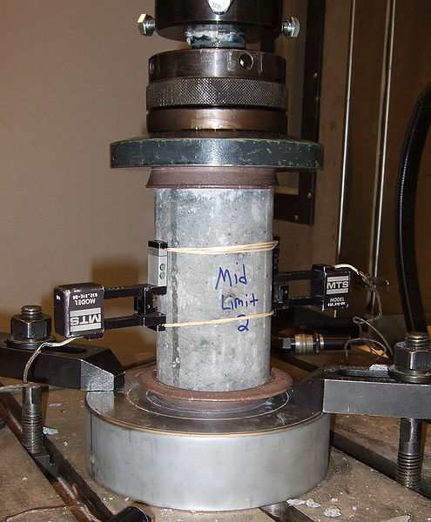

The concrete used in our poles is the product of the experience we have accumulated and our technology, and we strive day and night for quality management, research, and development.

PC Steel Rod Strength Test

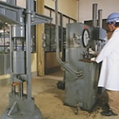

Because our PC steel rods are manufactured with induction heat treatment, they have high dimensional accuracy and uniform cross sections. Their weight can be secured, and the performance can fully satisfy.

Product testing

Pole bending test

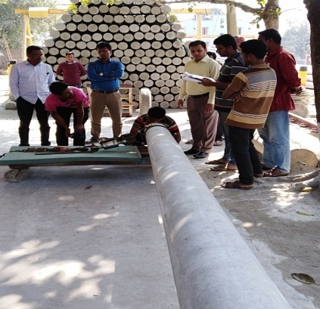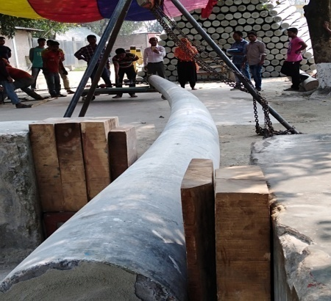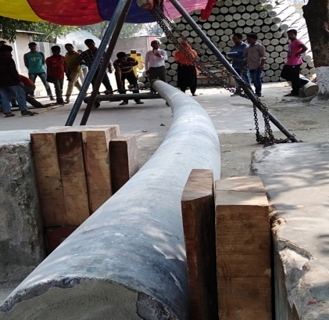

Step Bolt Socket Test

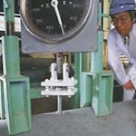
The strength of the (step bolt socket) is an important matter related to the lives of those who work, so we are carrying out stricter quality control.

2.10.2 B&T Poles
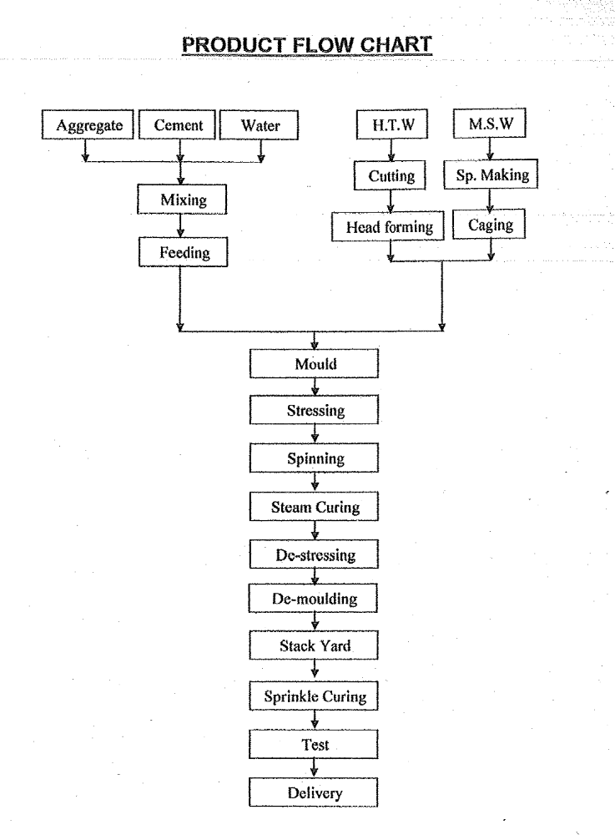

2.10.3 AAC Conductor
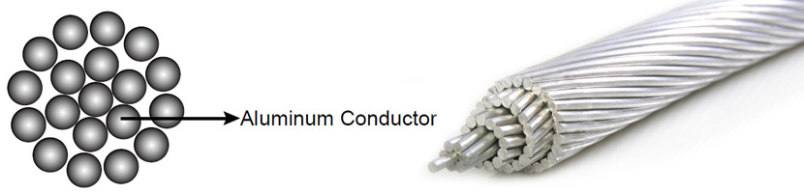

AAC conductor specifications and structure

We manufacture this conductor from electrolytically refined aluminium with the purity of minimum 99% aluminium. As we can see, the material and structure of aac conductor are very simple. That means you can spend less time on installation. We usually use this conductor as the general line in the substation, and mainly use it in the urban areas with shorter span and closer support. These conductors are used in low, medium and high voltage overhead lines. AAC has seen extensive use in urban areas where spans are usually short but high conductivity required. The excellent corrosion resistance of aluminium has made AAC a conductor of choice in coastal areas. Because of its relatively poor strength to weight ratio, AAC had limited use in transmission lines and rural distribution because of long spans utilized.

Features
- Capacity of High Current Carrying
- Excellent Resistance to corrosion
- Very Much Use to coastal area
- Low & medium voltage lines in urban area are mostly use
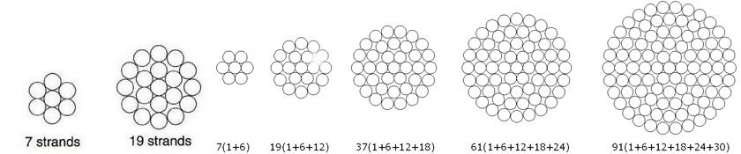

2.10.4 AAC ANT CONDUCTOR

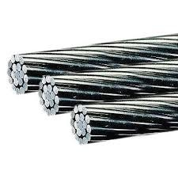
AAC Ant Conductor:
- AAC (Aluminum Alloy Conductors) Ant Conductor. These AAC Conductors are made from good quality aluminum wire strands. These are stringently tested on various positions, before dispatch. The short spacing and corrosion resistance property of AAC conductors. Best for in coastal area for use this type of AAC ANT Conductor.
Specification of AAC Ant Conductor:
  - Area : 50 sq mm
  - Construction: 7 x 3.10
  - Weight Approx : 145 kg Per km

2.10.5 AAC WASP Conductor

AAC WASP Conductor: This Conductor is widely used in the overhead power transmission lines and distribution system of main line from transformer. It is one of the main products to form electrified wire network. Generally use in Industrial Area where electricity load are high.
Standards
We manufacture AAC conductor as per following standards:-
- BS 215 Part 1
- IEC 207
- DIN 48201-5
- ASTM B231 : 1981
- IS 398 Part 1

2.10.6 ACSR Dog Conductors

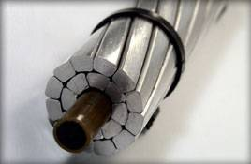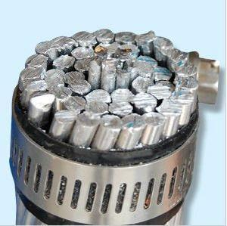

Product Description

Wide range of client we offer to use ACSR Dog Conductors. These products are manufactured using high grade raw material which is sourced from the most reliable vendors of the market. Offered products are made as per the needs and requirements of pour clients. These products are made as per the set international norms. The products offered by us are in huge demand and are widely appreciated.
Listed below is the main feature of these products:
- High-efficiency
- Durability
- High-strength

2.10.7 ACSR Grosbeak Conductor

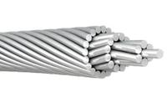

Product Description:
Similar to All Aluminum Conductor achieve the desired durability and conductor strength. The outer layers of this conductor are made of aluminum, providing a corrosion-resistant, long-lasting product.
Applications:
This Conductor is Like to AAC, ACSR. ACSR Grosbeak is primarily used as an overhead transmission cable and can also be used for primary and secondary distribution. This conductor is typically preferred in a heavy construction area because of its reinforced steel core. Although it is heavier than AAC, it can be moved in and out of a construction area relatively easily. This cable is also useful in areas with high winds or frequent storms.
Specifications:
- This product is composed of a variety of aluminum conductors.
- Steel reinforced core is coated with B-341 aluminum, B-498 Zinc, and B-802 Zinc-5% Misch Metal alloy.

2.10.8 Guy-wire/Warth Wire

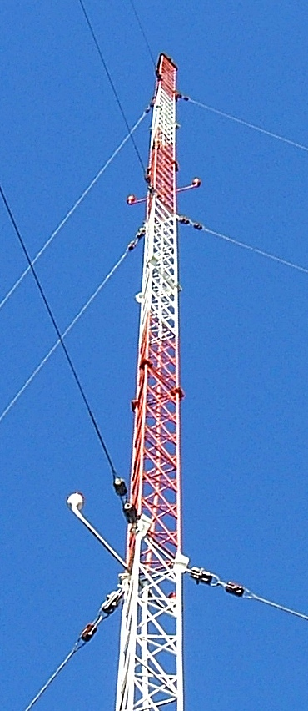

Guy Wire is also known as guyed wire, guy cable, guy strand, guy anchors, or even mistakenly called ''guide wire,''. Alum weld strand provides non-rusting, high-strength guys for electrical distribution and transmission lines, communications and signal lines, antenna towers, masts, stacks, and other structures. The high tensile strength of this light-weight strand is permanently protected against corrosion by a thick cladding of aluminum. Guy wire provides high break strengths, without resulting in an overly heavy wire. It also allows users to easily and safely add big grip dead ends to create a strong, secure termination point.

2.10.9 B&T Meter

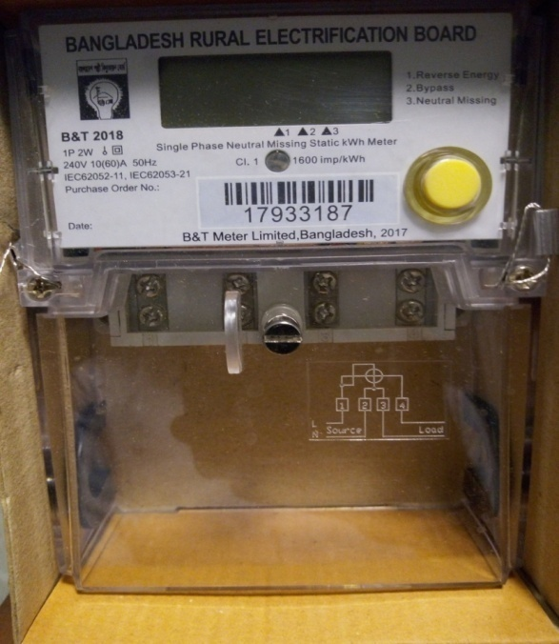

B&T Meter Services can provide a wide range of these brand new single phase electric meters, often known as the watt-hour meter. Two Different Meter Serve wide rang.

1. Single Phase Meter
2. Three Phase Meter

Financial Position of B&T Group

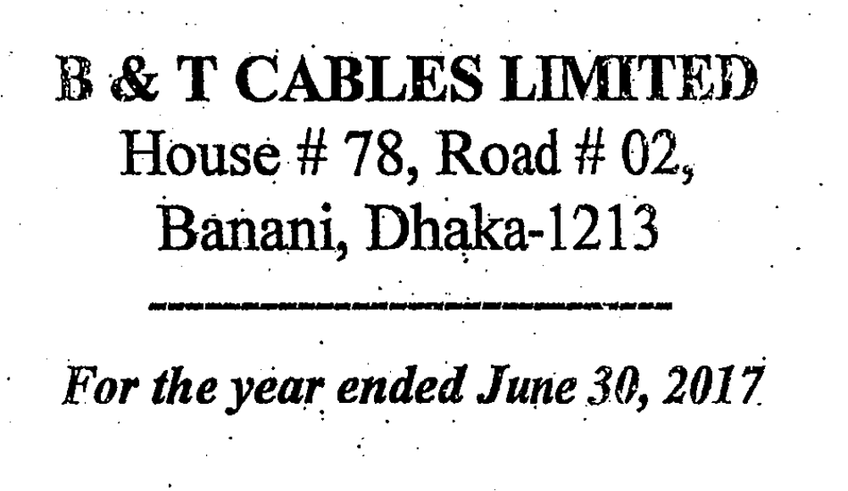

2.12 SWOT Analysis of B&T Group:

SWOT Analysis is a useful technique for understanding Companies Strengths and Weaknesses, and for identifying both the Opportunities open to you and the Threats you face. SWOT analyse in a business context, it helps you to carve a sustainable niche in your market.

Figure: SWOT Analysis of B&T Group

2.12.1 Strengths:
- Own manufacturing plant
- Strong Financial Backup
- Large customer base
- Faster production
- Demand & Supply Planning
- Cost optimization with price

2.12.2 Weaknesses:
- Low marketing activities.
- Low advertising activities.
- Low promotional activities.
- Tender Based
- Long procedure ( 24 month maximum opening to closing)

2.11.3 Opportunities:
- Full line expansions of BREB & BPDB
- Has lot of ideal market to expand business.
- This time The World turn to globalization so, B&T Group can step to export rapidly to other country.
- B&T Group can more concentrate with corporate sales.

2.12.4 Threats:

- Existing Competitors
- No Development program or seminar for employee
- Tender Based pricing
- Loss of market share due to low marketing activities

PART-3

TOPIC

Definition of Marketing
Market Structure
Market Strategy
Marketing Mix
Tender Process
Income Statement
Sales /Turnover
Findings
Recommendations
Conclusion

3.1 Marketing:
Marketing is the social process by which individuals and organizations obtain what they need and want through creating and exchanging value with others. “Kotler and Armstrong (2010)”
The Four Factors are determining in marketing.
(1) Identification, selection and development of a product.
(2) Determination of its price.
(3) Selection of a distribution channel to reach the customer's place, and
(4) Development and implementation of a promotional strategy.

3.2 Marketing Structure:

B&T Group Marketing Structure is like below:

3.3 Marketing Strategies:

Marketing strategy is the goal of increasing sales. An organization's strategy that combines all of its marketing goals Based On Demand & Supply. A good marketing strategy should be drawn from market research and focus on the right product mix in order to achieve the maximum profit for the business. The marketing strategy is the foundation of a marketing plan.

Wire and Cable Market has been segmented as follows:

3.4 Marketing Mix:

The marketing mix refers to the set of actions, or tactics, that a company uses to promote its product in the market. The 4Ps make up a typical marketing mix - Product, Price, Place and Promotion

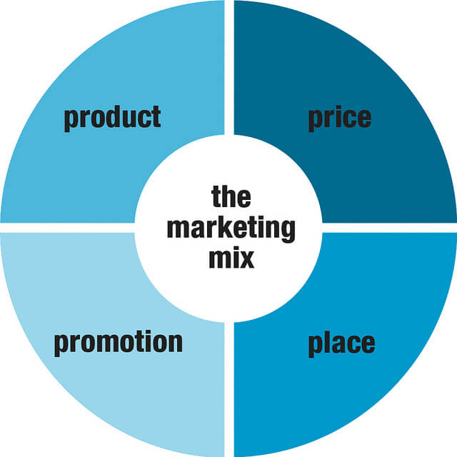

Marketing Mix 4P's

Marketing Mix

3.4.1 Products:

Product is the core of all marketing activities. There are two types of organizations according
their product. Some organization’s core product is goods on the other hand some organization’s core product is service. B&T Groups core product is goods.

Product is an item produced by the business to satisfy the needs of the customer. Product is the actual item which is held for sale in the market. The product can be tangible or intangible (it can be a good or a service). It is not necessary that the business produce the product. It can also procure it from somewhere else. Product mix refers to the mix of all the products present in the company for sale.

Figure: Products of B&T Group

    - Range of Products:

Range of products here represents different types of items of products. B&T Group divide their Product into three categories- Conductor, Pole and Meter.

Figure: Conductors of B&T Group

B&T Poles

Figure: Poles of B&T Group

Figure: Meter of B&T Group
Single Phase Meter
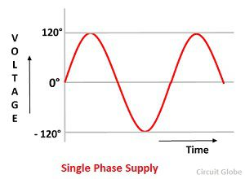
- 230 volts – 50 htz
- High 80mm / 3.1/8″
- Proven design and reliability
- Low power consumption
- For house hold activity. Single phase will do the best job.
- Suitable For Billing Inc PV/Wind Turbines & Heat Pumps
- Each meter complete with own Calibration Certificate (‘FREE’ OF CHARGE)
Three Phase Meter
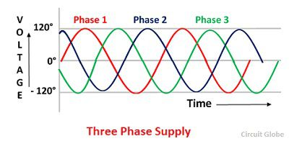
- Three phases is generally used for heavy machinery.
- 230 volts- 415 Volts – 100 htz
- Three Phase motors run more smoothly.
- Three phase are released from power house to your colony. Then all the house are divided equally ( as per there load requirements). And then load is equally distributed on three phase and provided to your house

3.4.3 Product Decisions:

The term “product” refers to tangible, physical products as well as services. Here are some
Examples of the product decisions to be made:
-  Brand name
-  Functionality
-  Styling
-  Quality
-  Safety
-  Packaging
-  Repairs and Support
-  Warranty

3.4.4 Price:
Price should reflect your product’s positioning in the market and the resulting price should cover the cost per item and the profit margin. Price is the actual amount which the customer pays for the product. It is a result of various factors which include profits of the company, segment targeted, subsidies, discounts, supply-demand, and the cost of other three P’s of the marketing mix.
Hence price has a great effect on the entire marketing mix.
Price mix influence the positioning of the product among competition. Hence businesses usually use two strategies for pricing –
- Penetration Pricing (low price kept to capture market share)
- Competition Pricing (pricing at par of competition)

In the Cables & Pole market of Bangladesh, there is not much price differentiation, in general, among the different companies due to the highly competitive nature of the industry Price is not a very important factor due to the nature of the product. Quality is more important. However, the purchasing capacity of the customer is also an important consideration. According the survey, most of perceives B&T Group as offering reasonable pricing for their product. B&T Group hold the second position among their group of company.

3.4.5 Price Decisions:

Some examples of pricing decisions to be made include:
➢ Pricing strategy
➢ Exchange Rate of Dollar
➢ Factory Overhead cost
➢ Packaging
➢ Vat
➢ Delivery

3.4.6 Pricing Approach:

The government determined the prices of products under their controlled. The manufacturing companies are allowed to propose the prices of the products that are under decontrolled category and the approvals of these proposed prices are given by the government. Since the local government strictly controls price of manufacturing products, there is a very negligible price difference. The selling price of a product shall be just added tax at 15% VAT. But, the price of raw materials is competitive which is fixed based on international market situation. As Conductor & Pole manufacturers have to depend on imported raw materials, increase in prices of raw materials internationally impact directly to the cost of production.

Pricing Factors
- Fixed and variable costs
- Competition
- Company objectives
- Proposed positioning strategies

Figure: Pricing Factors

3.4.7 Place:

The market where the product is sold is known as place. The markets should be convenient for the consumers to access. Distribution network for a product determines its availability. The customer cannot take product until it well place. Target market should be clear for business to reach the same Place constitute strategies of where the product will be available for the customers for the actual sale.
B&T Group of Companies all product like Pole, Conductor, Meter, Transformer all the Distribution place is government organization. There is no retailer for sell. We directly sell single Lot with in delivery time to Government.

Distribution Strategies include
- Intensive Distribution (Cover as much market as you can like SPC Pole)
- Selective Distribution (For premium products like HTS wire)
- Exclusive Distribution (For more exclusive products. Very less Company is produce. E.g. Transformer)
- Franchise system (Small companies distribute on your behalf. E.g. Joint venture)

In the Cables & Pole market, distribution is very important. Having made all decisions of marketing properly, a company will not be successful if it cannot distribute its products well. With its government distribution center, it maintains a proper distribution of Conductor, SPC Pole in all through the country. B&T holds the second position. It’s required maintains a moderate network.

3.4.8 Promotion:
Other P’s of the mix Promotion leads and follows the marketing Mix. This aspect is how the business let know customers about their product. Promotion leads to brand recognition.
Promotion includes
- Advertising
- Branding
- Sales Volume
- Public Relations
- Social Media Out reach
- Publicity
- Program tune-in

Due to high competition in the industry among the different players in the market, aggressive marketing have been adopted by the different companies. In this regard, promotion has become a useful tool to fight competition. Moreover, promotional materials of companies have an impact on Product, sell & profit. Therefore, different companies have set out different promotional tools to increase market share.

3.4.9 Competitors of B&T Group in cables sector

- BRB Cables Industries Ltd
- BBS Cables Ltd
- SQ Wire & Cables Ltd
- Supersign Industries (Electrical) Ltd.
- Poly Cables Ltd
- Paradise Cables Ltd.

3.5 Tender Process of B&T Group

Tender is also part of Marketing to create opportunity to work & earn profit. The Process of tender are below :

Figure: Tender Process

3.6 Statement of Financial Position 2015 to 2017
B&T Cables Ltd

Figure: Capital Statement

Statement of Financial Position 2015 to 2017
 | B&T Cables Ltd
SL No | Financial Year |  | Amount(Taka)
1 | 2017 |  | 2,395,965,408.00
2 | 2016 |  | 1,318,796020.00
3 | 2015 |  | 1,857,455,087.00

3.7 Income Statement 2015 to 2017
B&T Cables Ltd

Figure: Income Statement

Statement of Financial Position 2015 to 2017
 | B&T Cables Ltd
SL No | Financial Year |  | Amount(Taka)
1 | 2017 |  | 883,193,526.00
2 | 2016 |  | 673,221,671.00
3 | 2015 |  | 482,014,484.00

3.8 Statement of Sales /Turnover from 2013 to 2017
B&T Cables Ltd

Statement of Sales /Turnover from 2013 to 2017
 | B&T Cables Ltd
As per enclosed financial Limited
SL No | Financial Year |  | Amount(Taka)
1 | 2017 |  | 160,81,86,891
2 | 2016 |  | 133,52,52,203
3 | 2015 |  | 116,32,87,354
4 | 2014 |  | 69,37,09,350
5 | 2013 |  | 77,34,56,535

3.9 New Product Development
B&T Group try to develop new products for economic contribution & profit making. There is huge compaction in this sector. So new product development should increase to compete others.

- Pre-Paid Meter Ltd
There are two types of prepaid meters that are generally used. (a) Keypad type has a technology for both "unit transfer system" & "currency transfer system" and (b) Smart Card type has a technology only for "currency transfer system”. The customers interviewed in the pilot area pointed that they were satisfied using prepaid meters. The overall customer services had considerably improved in the areas where prepaid meters had been introduced.
Customers benefit is:
- New system like customer
- Control their own consumption by self
- Control their budget
- No deposit Require
- There is no more disputed bills
- Users receive a 2% discount on the standard electricity billing rate.
- Low credit alarming
- Abnormal voltage protection

- Tushar Knittex
Main products: Knit/Woven/Sweater
- B&T Transformer Ltd
- Tushar Ceramics

3.10 Findings:
- There is some upcoming project of B&T Group, which investment is very high, like Tushar Ceramics, Transformer, Pre-Paid Meter, etc. That’s why most of working capital already invests for the upcoming projects. For this reason B&T are facing some financial problem to purchase raw materials or clear the supplier payment.
- B&T Group use to deliver their product by Truck, Crane, etc which is hired. In this case delivery time may be delay and suffer from cost of LD (Late Delivery).
- Most of the raw materials for HTW wire are imported from china, which facing timely production problem. (Order to factory entrance)
- Marketing Mix Concept is not properly maintained by B&T Group.
- Product line of B&T Group is limited. Only they produce Pole, Cable & Meter.

3.11 Recommendations

- To mitigate the fund of B&T Group, they can take loan to complete the upcoming or new project
- For Smooth operation of Marketing Department, the management of the B&T Group needs to delegate the approval authority to the head of the department.
- B&T Group needs to decrease lead time for import the raw materials by negotiation with international supplier.
- The company should properly tied up the elements of marketing mix based on the demand & Supply of target.
- B&T Group should explore new markets and generate new business ideas. They may implement direct marketing method to reach their target.

3.12 CONCLUSION

After analysis the whole report I can conclude that B&T Group contribute in Bangladesh by its product. Recently Pre paid meter is new project in BREB. Or Company participate this project to deliver pre-Paid meter all over our country.
So, at the end I can conclude that B&T Group is one of the finest companies in Bangladesh. They provide high quality of product and consumers are satisfied with Cable products they bought, especially in cable & Pole segment. Consumers are satisfied by B&T Cables, B&T Pole & B&T Meter.

