AN INTERNSHIP REPORT
On
CREDIT RISK MANAGEMENT OF CITY BANK LIMITED

Submitted To

Md. Anhar Sharif Mollah
Assistant Professor
Program MBA
Faculty of Business & Entrepreneurship

Submitted By:

Syed Asadujjaman Bijoy
ID: 181-14-056
Program MBA
Faculty of Business & Entrepreneurship

Date of Submission: 15th April, 2019

Credit Risk Management of City Bank Limited



Faculty of Business & Entrepreneurship
Daffodil International University
Ashulia, Savar, Dhaka

LETTER OF TRANSMITTAL

25th April, 2019
To,
Md. Anhar Sharif Mollah
Assistant Professor
Department of Business Administration
Faculty of Business & Entrepreneurship
Daffodil International University

Subject: Submission of internship report on “Credit Risk Management of City Bank Limited”.

Dear Sir,

With due respect, I would like to inform you that, I have completed my internship report on topic: “Credit risk management of City Bank Limited” in City Bank Limited of Bangladesh. I have collected information from all available sources in a realistic way. While preparing report, I have tried to follow your instruction based on systematic manner.
I sincerely hope that this report meets your approval and also expects that I will get your kind consideration regarding acceptance of this report.

Sincerely Yours,

........................
Syed Asadujjaman Bijoy
ID: 181-14-056
Major: Finance
Program MBA
Faculty of Business & Entrepreneurship
Daffodil International University

SUPERVISOR’S DECLARATION

It offers me immense delight to certify that the projected record titled has been finished by Syed Asadujjaman Bijoy ID: 181-14-056, scholar of MBA program, Faculty of Business & Entrepreneurship, Daffodil International University, Ashulia, Savar, Dhaka underneath my supervision and steering. As some distance as I know, this is an authentic work, which has not been published in any journal or submitted to any group or branch for any diploma or degree.

I do hereby accept it a fully recommend Internship report for evaluation.

…………………………..
Md. Anhar Sharif Mollah
Assistant Professor
Department of Business Administration
Faculty of Business & Entrepreneurship
Daffodil International University

STUDENT’S DECLARATION

Here by I declare that the work submitted in that Internship Report was done by me and was not previously submitted for academic qualification to any other University / organization. The pieces I have submitted do not violate existing copyrights and no part of this report has been copied from work done previously.

I also undertake to compensate the Ministry for all losses and damages caused by violation of previous duties.

……………………
Syed Asadujjaman Bijoy
ID: 181-14-056
Major: Finance
Program MBA
Faculty of Business & Entrepreneurship

ACKNOWLEDGEMENT

The opportunity has already come and gone to offer my most profound thanks and humble accommodation to the all-powerful Allah yet for whose help I would not have the capacity to finish an immense undertaking of setting up this report.
I would like to explicit my deep sense of appreciation towards one of my Supervisor Md. Anhar Sharif Mollah Assistant Professor, Department of Business Administration, Faculty of Business & Entrepreneurship, Daffodil International University for giving me an opportunity to complete my internship report on fact, no devotee can achieve perfectness without the help of a scholar. Similarly, a student can never be perfect without the help of a good teacher. A good teacher may be a landmark for any student. I am greatly indebted to I would like to explicit my deep sense of appreciation towards one of my Supervisor Md. Anhar Sharif Mollah Assistant Professor, Department of Business Administration, Faculty of Business & Entrepreneurship, Daffodil International University for giving me an opportunity to Complete my internship report and his suggestions and guidelines Were really a great help to me.
Especially, I am also thankful to who gave me the opportunity to allow me in this organizational arena. I would also like to express my heart full thanks to all officers and also my friends and Elder Brother for their excellent support and proper guidance in completing my internship report.

DEDICATION

There must be somebody behind each extraordinary work. In Similar manner, this time it was none other than my Parents. Their reliable help and care pushed me to a degree where I achieved only this report and some more. Remembering these contemplations, I need to devote this report to the people who are in the situation of top need in my life, my dad and my mom and overall my family. In the mean of time I need to state that it was them who gotten me this world and I am obliged towards them at that point, presently and everlastingly for even a littlest thing that I have ever and will accomplish in my life.

May Allah bless them to live longer.

Executive Summary

City bank confined (CBL) is a standout amongst the maximum prepared assumed economic institutions in Bangladesh set up within the year 1983. for the reason that earliest reference point of the enterprise banking enterprise in Bangladesh, it's been controlling and adding to the USA.'s economy. The situation of my transitory position file is "credit score danger management of The city bank constrained", which has done the trendy highlighted component in the money related commercial enterprise in Bangladesh. because of the extended take a look at among each the enterprise and the Gov. Banks in Bangladesh, this credit the board problems have improved wide notion. The basic goal of my record is to have an absolute information of the sports finished in credit score danger control of city bank confined. This file before everything portrays the when all is stated in accomplished cash related markers of The town financial institution limited, and the way they may be getting along on this engaged commercial enterprise banking enterprise in Bangladesh. Their economic exceptional, the board, credit score and assembling methods and their disaster the administrator’s stands are depicted on this record. This report carries with the credit offices that City Bank Limited gives to its clients. in this file, I've endeavored to talk about City Bank Limited's credit score workplaces beneath retail, company and SME units. I've based on the retail increase of City Bank Limited in mild of drawback of the examination. I discussed credit offices that retail workplace offers like home loan, automobile mortgage, non-public mortgage, and Secured loan. In the wake of discussing all the components, I've evolved sure disclosures and demanding situations they face even as coping with the credit peril of their customers. In revelations I found issues like unyielding credit evaluation and peril exploring technique, Inefficient third-birthday party pro, Inefficient information the board and numerous others that impact the financial institution's credit risk enterprise.
Eventually, I have made more than one proposals difficulty to the revelations and issues of the file. If City Bank Limited restrained can exchange over its demanding situations into situation, by way of then they can without a whole lot of a stretch and capably manage their credit peril.

Table of Contents
LETTER OF TRANSMITTAL iii
SUPERVISOR’S DECLARATION iv
STUDENT’S DECLARATION v
ACKNOWLEDGEMENT vi
DEDICATION vii
Executive Summary viii
Chapter One 1
Introduction 1
1.1 Introduction 1
1.2 Background of the Study 1
1.3 Objective 2
Chapter Two 3
Organizational overview 3
2.1 Background of City Bank Limited 3
2.2 Vision: 3
2.3 Mission: 4
2.8 Values 4
2.9 Organogram 5
Chapter Three 6
Literature review 6
Chapter Four 7
Activities Undertaken 7
4.1 Interest Rate Re-pricing Project 7
4.2 Documentation 8
4.3 Company Categorization 8
Chapter Five 9
Credit Facilities 9
5.1Credit Rating 9
5.2 Key Performance Indicators 9
5.3 Retail Credit 9
5.4 Profit After Tax 9
5.6 Loans and Advances 10
5.7 ROA & ROE 11
2.6 Non-Performing Loans (NPL) 11
5.8 Personal Loan 12
5.9 Home Loan 13
5.10 Secured Loan 15
5.11 Corporate 16
5.12 Small and Medium Enterprise (SME) 16
Chapter Six 18
Credit Risk Management (CRM) 18
6.1 Possible Risks in the Personal Loan Application & Mitigation Process- 18
6.2 KYC & Contact point Verification (CPV) requirements 19
6.3 Maintenance of Documents & Securities 19
6.4 Internal Audit 19
6.5 Credit Principles 19
6.6 Product Management Parameters- Terms and conditions Program 20
6.7 Repayment Terms, Frequency, and Tenor- 21
6.8 Other Key Features- 21
6.9 Other Facilities 22
Chapter Four 23
Fraud Management 23
Chapter Eight 24
Collections 24
8.1 Responsibilities 24
8.2 Flowchart of Collection Process- 25
8.3 Collection Action Plan 25
8.4 Process description 27
Chapter Nine 28
Recovery 28
9.1 Responsibilities 28
9.2 Flowchart of Recovery Process 28
9.3 Process descriptions 29
9.4 Limitations of the study 31
9.5 Findings & Challenges 32
9.6 Recommendations 34
Conclusion 35
References 36
Appendices 37

Chapter One

Introduction

Introduction

Reserve is complete one of the captivating fields of having a observe. Budgetary physical activities assist a relationship to make, circulate and use the cash. Coins are made by way of exhibiting and preparations gathering, on the identical time because the entire money circulate is directed through manner of the Finance amassing. As I completed my Bachelor's degree in Finance, I usually anticipated running in any price range basis where I may want to make complete use of me understand how coins related foundations accept a key career with a view to adjusting the financial device of a rustic. For the motive that very method of Bangladesh, the budgetary institutions are diligently including to its financial gadget. The metropolis bank limited is in like manner running as one of the compelling center people within the united states of America, which offers its customers the maximum outrageous protection with appreciate to their coins related trades.

However, all business banks beginning from the past are reputation as an awful lot as many issues with admiring Non-performing Loans (NPL) or the default fee of customers. As such, I was truly intrigued to analyze the actual condition of a financial institution's threat to this credit score default trouble via dependable measures. Everybody may additionally have a conspicuous idea of the measures or sports of a business monetary group to supervise credit Risktrouble via this record.

Further, I would really like to flow into this file by using summing it up for each industrial financial institution in Bangladesh, now not focusing on the town financial institution itself now. Proper here on this report one will, to the exclusion of everything else, reap a preferred idea in regards to the restrained city monetary institution, then reap a blueprint for the development of the economic institution and then how the metropolis bank Limited manages the customer's risk of default. In the end, the revelations and the concept that I intend to increase this record's estimate.

Background of the Study

Internship always presents a new horizon for a scholar as it gives them the opportunity to return toward the real international by means of exploring a company and knowing its lifestyle and operations.
even as doing this record on “Credit Risk control of the City Banks limited”, my academic information, manager’s guidelines, and the regular aid of my faculty supervisor helped me to complete the report in a based and effective way.

1.3 Objective

The fundamental focus of this report is to successfully complete the authentication of My MBA Program at Daffodil International University. I have distinctive purposes to manage my topic other than the focus of my degree culmination. These Include-City Bank's overall performance analyzing financial indicators. To explore what credit facilities are provided by CBL
- To learn the process of credit together with the process of risk management.
- Exploring the working environment of the commercial bank.
- To be more widely exposed to real-life work

Chapter Two

Organizational overview

2.1 Background of City Bank Limited

City Bank Limited is one of the most established individual business Banks running in Bangladesh. it's miles an apex bank a large number of the most seasoned 5 business Banks inside the USA which began their activities in 1983. The money related organization began its adventure on twenty-seventh March 1983 by means of opening its first division at B. B. road branch inside the capital, Dhaka town. It becomes the visionary enterprise of cycle 13 adjacent agents who conquered the massive vulnerabilities and dangers with boldness and enthusiasm that made business as the usual and forward walk of the monetary foundation practical. the ones support managers started the experience with least difficult Taka three.4 crore extremely worth of Capital, which currently is a better than average Taka 330.77 crore as capital and saves. city bank is the difference just a couple of adjacent banks which do never again watch the ordinary, decentralized, topographically oversaw, division based business or benefit adaptation.

Under a real-time web-based financial stage, four business divisions are upheld at the returned by means of a hearty administration conveyance or activities set up and furthermore a keen IT spine. Such brought together business venture area based absolutely business and working form ensure particular cure and contributions to the bank's unique client sections.

The City Bank Limited restricted was one of the 12 Banks of Bangladesh some of the 500 money-related establishments in Asia for its advantage, store and benefit as assessed by means of "Asia Week" inside the yrs. 2000. besides that, the city bank limited got the "main Ten undertaking" grant from the high clergyman of the general population's Republic of Bangladesh.

2.2 Vision:

To be the leading bank in the country with best practices and highest social commitment

2.3 Mission:
- To add to the financial improvement of the nation.
- To accomplish the most elevated amount of consumer loyalty through augmentation of administrations by committed and persuaded a group of experts.
- To keep up constant development of a piece of the overall industry guaranteeing quality.
- To amplify the bank's benefit by guaranteeing its enduring development.
- To guarantee a participative administration framework and strengthening of HR.
- To keep up the high good and moral standard.
- To support an empowering domain where ingenuity and execution are compensated.
2.4 Branches of CBL:
CBL is one of the fastest growing banks in Bangladesh. Now Finacle 87 branches are operating all over Bangladesh.
Finacle Branches | : 87
Islamic Branch | : 01
SME Service Center | : 10
SME Branch | : 30
ATMs | : 83

The system of CBL draws in itself for giving best quality financial administration in retail, business, corporate and Islamic financial fragments. The nation's top endeavors, global and nearby partnerships, and budgetary establishments are served by CBL. With a complete resource of BDT 48,755 million, CBL is among the top performing nearby banks in Bangladesh.

2.8 Values

- Result Driven
- Accountable & Transparent
- Courageous & Respectful
- Engaged & Inspired
- Focused & Customer delight

2.9 Organogram

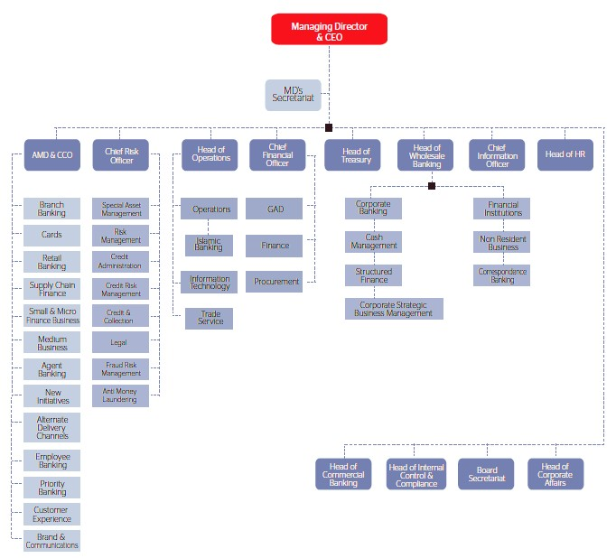

Chapter Three

Literature review

Credit Risk threat is a popular type of danger that each non-economic and economic institutions need to deal with. Credit score hazard takes vicinity while a debtor or borrower fails to satisfy his obligations to pay back the loans to the lender. In banking commercial enterprise, it takes place when payments can both be behind schedule or now not made at all which could purpose cash’ go with the flow issues and feature an impact on a monetary institution’s liquidity. (Greening & Bratanovic 2009, 161). Credit rating hazard is through some distance the hugest hazard confronted with the aid of banks and the success in their employer is predicated upon on correct measurement and green management of this danger to an extra volume then each other dangers. In our united states, the financial sector stays inside the developing and masses of banks have now not been able to set up a firm hazard manage framework, especially credit chance manipulates, in case you want to prevent destructive occasions. This is risky whilst banks customer services are still in their infancy and banks sales rely upon heavily on lending sports activities and credit growth is vital to any banking businesses earnings. Further, the control artwork from the imperative economic institution, although gambling a growing characteristic, has no longer been defensive enough. Get right of access to credit records and facts may be very constrained. The small financial institution is documenting for financial disaster because of horrific credit score assessment practices added a massive loss to the monetary group. “Smoke cannot be launched without a hearth”. There ought to have been something wrong in that bank’s credit score techniques. The principal substances of credit threat encompass restrained institutional capability, beside the point credit score rating guidelines, risky hobby prices, bad control, low capital and liquidity levels, direct lending, awful mortgage underwriting, laxity in credit score rating assessment, terrible lending practices, authority’s interference and inadequate supervision through the foremost financial institution. For banks, coping with credit rating threat isn't a smooth venture considering the reality that comprehensive concerns and practices are wished for identifying, measuring, controlling and minimizing credit score risk.

Chapter Four

Activities Undertaken

As a long way returned as I joined The city bank restrained (CBL), I used to be sufficiently blessed to find the opportunity to work with individuals from numerous divisions wherein diverse economic exercises had been completed. As a consequence, I discovered the opportunity to gain from distinct individuals in various divisions.

4.1 Interest Rate Re-pricing Project

In mild of the advancing top class, modifications see from Bangladesh financial institution, the majority of the banks are depended upon to adjust them renowned power as established through the overhauled one. As appeared by the brand new development price, it's miles 12.5%, besides beforehand of time it changed into 11.5%. On this way, much like every single other financial institution, CBL anticipated exchanging their new fervor as confirmed with the aid of Bangladesh bank's announcement. As proven by BAFTA (Bangladesh digital Fund transfer Authority), Banks want to uncover the moves as much as EMIs (equal monthly Installments) in their clients. There may be a shape called EFTN structure, which turned into dispatched to lone customers of the CBL, and that I myself adjoining different five companions expected to trade the shape as proven by way of new balanced EMI. In which we anticipated to test the full for so meticulously which contained three document numbers and a bank organizing range. I predicted to test if there were any bumble or not. Except, I predicted to hold up an entire professional document of the undertaking in which around thirteen,000 customers' data had been there. CBL through its CPV (contact point Verification) managers get the structures set aside by using their customers to have an effect on them to concur that beginning now and into the now not all that removed they'll begin paying according to new EMI. Through then update once more sooner or later in the surpass dreams record. Thru this whole challenge, I truly ended up familiar with distinctive money associated phrases which are used as frequently as manageable in banks. Like CASA (modern-day and savings) account, Banks Routing variety, that is made at the settles up with the banks. Different distinguished takeaways that I was given from this entire technique are-
- Precision- All through the entire task time frame I must be extremely cautious with each progression as I needed to keep up an enormous exceed expectations document. I needed to crosscheck both the CBL account number alongside the other banks' number with most extreme consideration. In such a case that I had committed any kind of single error in this procedure this would have caused an immense issue all in all.
- Efficiency -As I needed to attempt about 100 structures each day, therefore I must be extremely effective to refresh every one of the clients' status all the time. I needed to take a ton of strain to manage such an immense number of structures.

4.2 Documentation

At the same time as operating underneath Asset exercises (Asset sports.) division wherein I had gotten some answers concerning the whole Documentation process. There I got myself acquainted with all of the required and charged documents that the two clients and financial institution need to present as a need of a financial institution develop execution. Every credit file has a few charged reports where Bangladesh financial institution thru all the banks takes the money whole from the clients. The charged reviews range subject to credit score sorts. This incorporate Letter of guarantee (LOG)Demand Promissory Note (DP Note)
- Irrevocable power of attorney
- Letter of Undertaking
- General Loan Agreement

4.3 Company Categorization

I've learned how company class is being completed in a financial institution. Capability enhances candidates, association, that request an advance to back their enterprise, are organized in various sections (as an instance classification A, B, C). Preliminary 2-three weeks of my transient position I had seen how my director did the order of any status quo. By and big dependent on an opportunity as a long way as the present market and the destiny prospect of the commercial enterprise and furthermore dependent on budgetary soundness, the institutions had been labeled. At remaining, I used to be given an incomplete errand for the duration of the time spent doing the whole order

Chapter Five

Credit Facilities

5.1Credit Rating

Highly well-known organization of the FICO score, Moody's granted for the second time to the town financial institution restrained as Ba3. Even as Bangladesh's FICO place of work score, CRAB (Bangladesh credit score rating enterprise) has assessed Bangladesh as an AA2-rated bank. CBL is Bangladesh's pioneer in credit cards.

5.2 Key Performance Indicators

PAT of The town monetary group demonstrates that it has been constant at some stage in the previous 5 years except for 2016. In correlation with beyond 2016, it verified a drop of 8.3% over this 365 day. Due to the disrupting situation in the financial industrial company with respect to the NPL hassle, it turned out to be difficult to preserve up a steady advantage for each one of the banks.
These advances are set in a way that meets every body's motivation for taking an improve from banks. CBL advance workplaces are reachable in the accompanying classifications

5.3 Retail Credit

Within the path of the most recent couple of years, there has been a noteworthy change inside the attitude of our purchasers. Retail credit score once considered as inaccessible is today a way for pleasant the growing dreams of Bangladeshi running magnificence, specifically the developing populace of the 25-44 age gatherings. At town financial institution, we offer the pinnacle tier administrations, creative loaning items and money-related solutions for customers to satisfy their own budgetary prerequisite. To fulfill the character desires of any financially sound human beings, we have propelled town solution in 2008, any reason unbound man or woman strengthen.

5.4 Profit After Tax
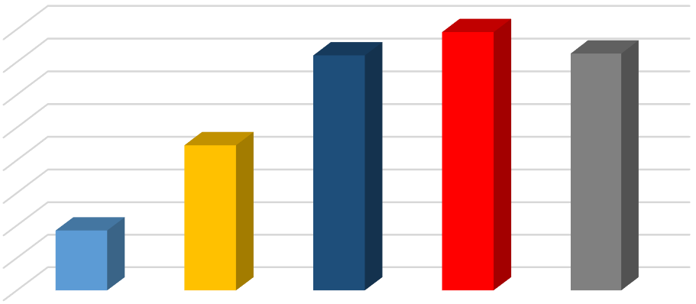
0
500
1000
1500
2000
2500
3000
3500
4000
2013
2014
2015
2016
2017
Profit After Tax
922
2227
3600
3956
3628
Profit After Tax (PAT)

Regardless, CBL's dependable and focused frameworks helped them ended up with an appealing presentation differentiating and different business banks in Bangladesh. There was a great deal of risk in 2017 as NPL extent had gone up. Regardless, CBL's credit the board had the ability to manage their credit portfolio so effectively, in this way, NPL has dropped in the main quarter in 2018.

5.6 Loans and Advances

It had seen a not too bad development in the course of the most recent one year. It remained at about BDT 200 m in 2017, though in the year 2016 it was BDT 175,025 m. There was a development of about 13% over that one year. The development of Loan is slanting higher as beforehand it had a development of 22.3% from 2016 to 2017. CBL's ceaseless enhancement as far as their Loan allowing made them exceptionally fruitful in this parameter.
0  20000  40000  60000  80000  100000  120000  140000  160000  180000  200000  2013  2014  2015  2016  2017 | 89879  116621  143088  175025  196596  2013  2014  2015  2016  2017

Moreover, in the event that we see the Deposit sum, it was at BDT 183,493 of every 2017 wherein 2016 it was BDT 174,695. It had a development of 5% over the one year because of Government's choice of making the loan fee lower. It had influenced the development of the store sum and generally speaking the development of Banking Sector.

5.7 ROA & ROE

Productiveness estimates proportions incorporate go back on assets (ROA) and go back on fairness (ROE) of CBL verified a predictable stable position as much as 2016 and remained at 1.70% and 19% for my part because of development in advances and boom lists. In 2017, go back on Asset and return on fairness remained at 1.40% and 15.Ninety%, one after the other. At the off threat that we see from 2013 to 2015, the go back on equity and go back on Asset have been in expanding sample and in 2015 the return on Asset become the most expanded amongst the ones years this is 1.90%. So we will say that the financial institution achieved all around relentlessly for the reason that 2013 to 2016.

%
6.30
%
13.40
18.30
%
19
%
%
5.90
1
%
1.30
%
1.40
%
1.90
%
1.70
%
1.40
0.00
%
2.00
%
4.00
%
6.00
%
%
8.00
%
10.00
12.00
%
%
14.00
%
16.00
%
18.00
20.00
%
2013
2014
2015
2016
2017
ROE & ROA
ROE
ROA

5.8 Non-Performing Loans (NPL)

The percentage for personal commercial enterprise banks is the most reduced most of the numerous bank gatherings, rising unobtrusively from five.8% to 6% with arrangements staying sufficient, as on September 2017. In September 2017, complete NPLs remained at BDT 803.07 billion or 10.67% of the absolute enhance sum, as in step with measurements of Bangladesh financial institution. Right here the Non-acting loan of CBL in 2017 turned into 10.678 million that is five.40% of the entire credit sum. It is obviously an advanced act evaluation
%
8.10
%
5.90
%
7.60
%
.00
6
%
5.40
0.00
%
%
1.00
%
2.00
3.00
%
4.00
%
%
5.00
%
6.00
%
7.00
8.00
%
%
9.00
2013
2014
2015
2016
2017
NPL (%)
7.251
6.859
10.845
10.582
10.678
0
2
4
6
8
10
12
2013
2014
2015
2016
2017
NPL (MN)

In the event that we contrast 2017 and the past multi year's we can see that city bank performing to gather their loan sum from the client. That is the reason the non-performing loan was 5.40% in 2017.

5.9 Personal Loan

Personal Loan (PL) basically covers the keenness of people' particular desires. The improvement aggregate for PL is extending from BDT 50 thousand to BDT 20 lac. The maximum standard purpose in the back of accepting this commendation is residence remake and marriage. Regardless, the town financial institution constrained (CBL) accreditations to offer their personal one in every of a kind improvement affiliation on any occasion or the requirements in their customers. They've some potential criteria to whom they supply those credit score work environments. CBL in a general sense offers these to salaried executives, professional and uninhibitedly utilized individuals. These individuals can request a credit score of 12 to 60 months' residency with a drew in advance rate. Right here's are the previous five-yr component's diagram under very close credit score amassing near-via the extent of Non-performing Advances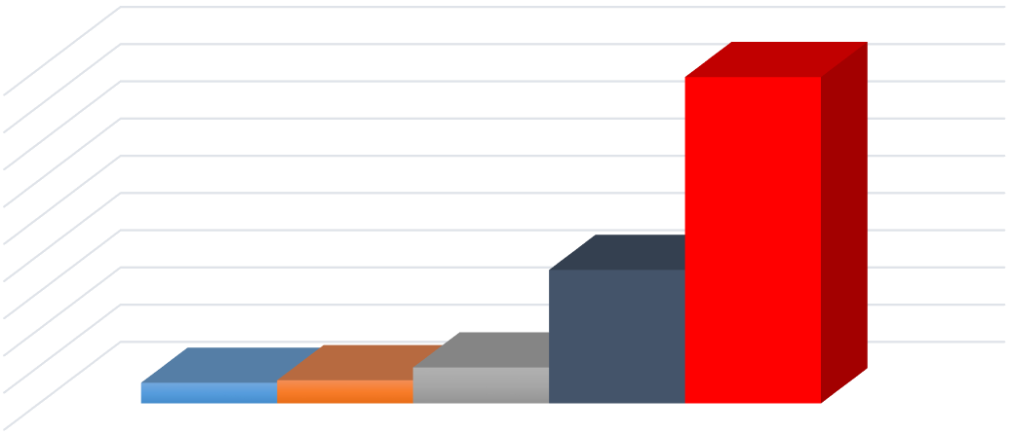
0
100
200
300
400
500
600
700
800
900
55.4
62.24
96.61
358.92
876.93
Loan Amount of Personal Loan
2013
2014
2015
2016
2017

In case we see the latest 5 years’ credit score administering entirety in close to and dear development, we are able to see it has changed constantly. From 2013 to 2016, it was in a bit at a time developing instance while we will see an enthusiastic augmentation within the character development inside the year 2017. The purpose being, because the lifestyle of the clients, has modified and those are gradually disposed to taking advances for individual purpose, for example, marriage, home rebuild, and so forth. Besides, the credit score mortgage rate was sincerely extraordinary, 10.5% for salaried and eleven.5% for dealers. Thusly, the renowned whole extended for that reason.

By way of and via if we see the Non-acting mortgage (NPL) entire, it was, in reality, high inside the yrs. 2014. By way of then from 2015 on, it dropped fundamentally in which the credit mixture had extended on the equal time.

Year Loan Amount (Cr) NPL (%) NPL Amount (Cr)
2013 | 55.4 | 8.6% | 4.76
2014 | 62.24 | 32.05 | 19.9479
2015 | 96.61 | 11.47 | 11.0812
2016 | 358.92 | 1.62 | 5.8145
2017 | 876.92 | 0.29 | 2.54307

From that factor forward, from 2016 to till date CBL has been taking remedial measures to display their NPL. Additionally, it very well can be definitely located in their money-associated pointers. There NPL price over the most current 3 years was in the declining pattern and it came to under 1% as of past due. It's far certainly a solid sign as a way as growing extra earnings.

5.10 Home Loan

At the factor, while a man or woman has a fantasy to assert his own home then the home advance (HL) encourages those human beings to make its blessing from heaven. The advance sum for an automobile credit is running from BDT five lac to BDT 1.2 crore. The most incessant reason for taking this boost is to construct a house.
In any case, the town financial institution confined (CBL) guarantees to give their home enhance the management on any event or the necessities of their customers.
They have got a few qualification standards to whom they provide these enhance places of work. CBL mainly supply these to salaried directors, consultant, and expert people. These people can request a credit score of 1 12 months to 25 years' residency with a competitive financing cost.
Within the domestic credit score, best 5 degree's fee is taken into consideration the humans and people can take a 70% to enhance his/her property estimation. This credit score agreement system is straightforward and there's no hid value related to the advance holder. The credit score procedure is incredibly little that is 1% of boost sum but there's no making ready fee for takeover and improvement offices.
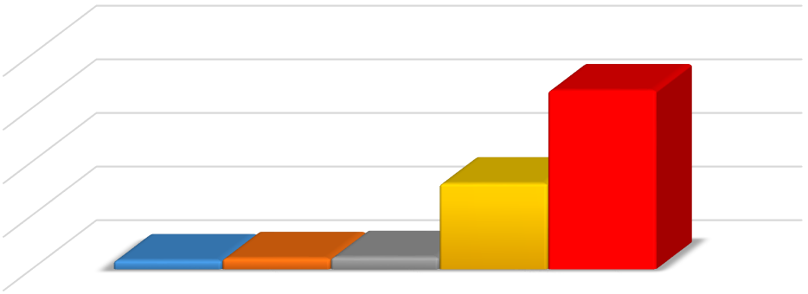
0.00
100.00
200.00
300.00
400.00
16.63
20.56
22.63
159.87
333.74
All amount are in crore
Loan amount of Home Loan
2013
2014
2015
2016
2017

On the factor, while a person has a delusion to say his personal home then the house advance (HL) encourages the ones, people, to make its blessing from heaven. The development sum for a vehicle credit is running from BDT 5 lac to BDT 1.2 crore. The most incessant reason for taking this development is to construct a residence.
Anyhow, the metropolis financial institution restrained (CBL) ensures to give their home improve management on any event or the necessities of their clients.
They've some qualification standards to whom they give those develop places of work. CBL basically provide those to salaried directors, consultant, and professional humans. These humans can request a credit of 1 yr to 25 years' residency with a competitive financing cost.
Within the home credit score, the best five level's price is taken into consideration the people and those can take a 70% advance of his/her property estimation. This credit score settlement manner is simple and there's no concealed cost connected to the advance holder. The credit score manner is exceptionally little this is 1% of advance sum but there is no making ready charge for takeover and improvement places of work.
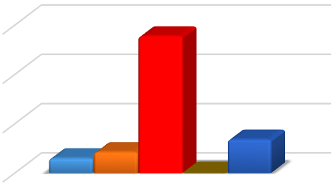
0.00
2.00
4.00
6.00
0.60
0.85
5.55
0.00
1.36
All amount are in crore
Non performing of Home Loan
2013
2014
2015
2016
2017
3.56
%
4.14
%
%
23.08
0
%
0.41
%
0.00
%
5.00
%
10.00
%
15.00
%
20.00
%
25.00
%
2013
2014
2015
2016
2017
NPL of Home Loan (%)
At the off hazard that we see maximum recent 5 years’ credit fee sum in the home improvement, we are able to see it has vacillated at some point of the years. From 2013 to 2015, it has been in a step by step increasing pattern at the same time as we are able to see an emotional increment inside the individual advance in the 12 months 2016 and 2017. The cause being that the patron turned into notably involved to fabricate their very very own home and the improvement hobby rate could be very advantageous, subsequently the sum accelerated thusly. Also, 2017 demonstrates a similar scenario of reaching the credit score sum past higher than the earlier 12 months. Currently inside the event that we see the Non-performing (NPL) boost degree of home credit score, in 2015 and the nonperforming boost sum turned into big this is 23.08% and this is extra than the others years. Anyways, within the following years 2016, the non-performing credit of the home advance was zero. Rabbit bank takes remedial activities dependent on their earlier year. And 2017 we can see that the non-performing credit is 3.56% of the all-out advance in home advance.

5.11 Secured Loan

At the point when a person has a delusion to possess his very personal domestic then the house credit score (HL) causes those people to make its blessing from heaven. The credit score sum for an automobile improve is extending from BDT five lac to BDT 1.2 crore. The maximum successive motivation at the back of taking this boost is to fabricate a house. Be that as it can, the metropolis bank restrained (CBL) ensures to present their domestic develop management on any occasion or the conditions in their clients.
They have a few qualification criteria to whom they supply these credit score offices. CBL basically give these to salaried administrators, businessman, and expert people. Those human beings can request an advance of 1 12 months to 25 years’ residency with an exceptionally centered interest fee.
Within the domestic boost, best 5 degree's price is considered the humans and people can take 70% credit of his/her belongings estimation. This boost settlement procedure is simple and there is no shrouded cost related to the improvement holder. The development procedure is minor that is 1% of developing sum but there's no processing charge for takeover and improve places of work.
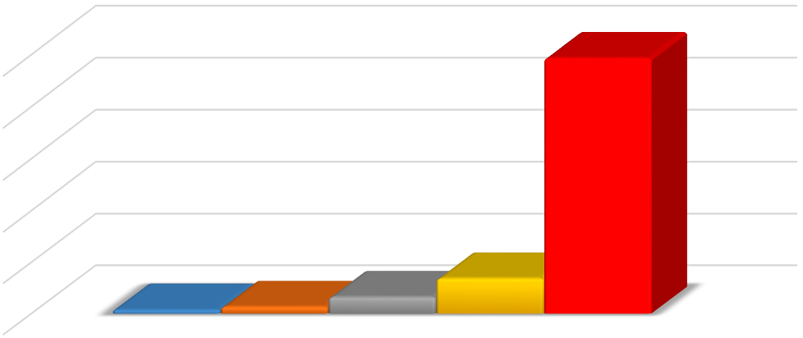
^{0.00}
50.00
100.00
150.00
200.00
250.00
3.50
6.60
16.22
34.21
246.58
All amount are in crore
Loan amount of secured loan
2013
2014
2015
2016
2017

In the occasion that we see most current 5 years boost payment sum in validated enhance, we will see it has varied throughout the years. From 2013 to 2016, it has been in a constantly increasing pattern at the same time as we are able to see a sensational increment in the character boost within the year 2017. The purpose is that the patron became extremely interested to take a tested advance in light of the reality that the technique of verified boost is straightforward and the development hobby rate is totally exact, as a result, the sum extended as such.

5.12 Small and Medium Enterprise (SME)

Metropolis financial institution started its responsibilities as the principle non-public enterprise bank of Bangladesh. Expertise the noteworthy open door that existed in beginning up to the formal monetary component to SMEs, a fragment that changed into earlier than viewed as unreliable, city financial institution left on the adventure to attach this partition and catalyze the development and exchange of the segment. Constantly, beneath the landmark "economic region Reform task", the bank moreover rebuilt the division to guarantee greater focus on the SME part. As in line with the course of and orders from the controller, the financial institution has been effectively engaging in feature price targets, which changed into the set in the beginning in the 12 months 2010.
29.40
%
12.60
%
13.90
%
0.00
%
5.00
%
%
10.00
%
15.00
%
20.00
%
25.00
%
30.00
%
35.00
2015
2016
2017
SME Growth Portfolio
Growth

On this diagram performing maximum current three years SME portfolio development fee. Bunny in 2015 the SME credit sum was 29.40% of an entire enhance allotting degree of city financial institution restricted. At that point, this rate diminishes to twelve.60%. Within the event that we examine 2017 and 2016, at that factor, we are able to see that the SME credit sum is accelerated in 2017 than in 2016.

Chapter Six

Credit Risk Management (CRM)

Each financial institution has a strong amassing to manipulate the credit peril. The crucial concept driving the credit score peril the officers is to develop the chance adjusted the charge of return by means of keeping up the credit hazard advent. It is big for each bank to preserve up credit hazard in this kind of case, that the bank has better credit score threat then the price of capital of the financial institution will augment and the obtaining of the financial institution will reduce. That is really not higher than the common signal for any bank.
Then again, if the financial institution maintains up the credit chance sincerely, by means of then the fee of capital will be the premium rate of the stores. Thusly, the financial institution will produce greater profit and this is the superb sign for each bank. In a successful marketplace, a bigger measure of having price rises in mild of an increasingly raised measure of credit score opportunity.
All of the credit score offices' execution shapes are practically the same. The personal business banks need to are seeking after Bangladesh financial institution's fashionable of getting ready a development application. Subsequently, I've considered the most engaging aftereffect of The metropolis financial institution limited, personal loan (PL), to research the whole credit system and the risk the officer's steps which are taken by means of CBL.

6.1 Possible Risks in the Personal Loan Application & Mitigation Process

- Channel Risk-The sales channel consists of branches and direct sales team. Direct Marketing team contributes to 40% of the sales while branch staff contributes to the rest 60%. It is to be mentioned here that all direct sales force is directly employed and there is no outsourced staff for sales and channel risk is relatively low here. However, the risk consists of a gap in product knowledge and customer identification for the front lines, which may result in selling products to the wrong customer segment. In the asset portfolio, more than 67% of the portfolio is being contributed by Personal Loan (PL).

- Fraud Risk- There is an inherent fraud risk in any retail asset business. The most common fraud risks are-

Transaction Fraud- For resource items, trade misrepresentation introduction may additionally emerge from the made-up financial balance exchanges to get the development with extortion expectation. Guarantors are mindful in CBL for identifying the alternate layout, credibility of the economic exchange and so on.

Software Fraud- there is dependably the probability of usage extortion by way of the method for growing original reports. The candidate's man or woman is affirmed by means of technique for the exam of distinguishing proof and other documentation. A contact factor Verification (CPV) office is installation to affirm the candidate's residing association, workplace, and call telephone numbers. Considering the prevailing market rehearses and operational barriers, it isn't always plausible to approve the validness of all documentation. Be that as it could, CBL thinks approximately approving the bank proclamation (the most extensive and commonly given pay record), earnings testimony, exchange License and TIN (Tax identification range), condo deed and so forth through CPV operator.

6.2 KYC & Contact point Verification (CPV) requirements

Singular nuances of a competitor inclusive of present and paintings/work environment nearby all contact numbers may be checked by means of credit score affirmation bunch earlier than an underwriting have concurred. After the confirmation, the worried character(s) will introduce a report on their revelations in the embraced structure.

6.3 Maintenance of Documents & Securities

The packages and diverse facts related to asset things are held in safe consideration with the aid of credit and Collections (C&C) Operations Unit. All of these statistics will cross beneath a single development record for each purchaser. The bodily securities and the security documents are held some other place interior fireplace secure organizers with C&C undertaking's role. The twofold key structure for a cozy function and restoration is directed through C&C.

6.4 Internal Audit

CBL has an isolated inner Audit department who's in the rate of appearing critiques the whole lot being same. Reviews are performed on a preferred or intermittently as concurred by using the control to evaluate different dangers and possible shortcomings and to assure consistence with administrative rules, inner strategies, and Lending recommendations and Bangladesh financial institution requirements.

6.5 Credit Principles

CBL trusts credit arrangements and strategies can never adequately catch every one of the complexities of individual advances. Along these lines, the accompanying credit standards are a definitive reference focuses for all City Bank staff settling on loaning choices about close to home advances
- Investigate the consumer's man or woman for uprightness and eagerness to reimburse
- Handiest loan to the purchaser who has a place with a long-lasting pay collecting most effective mortgage to the staff of the rumored companies having an plain business tune record
- Best loan to the workforce of such groups, that have proficient expert success stage for its kin
- Determine cautiously the relationship between the underwriter and ability to reimburse
- Verify cautiously the honesty and advance compensation restriction of the underwriter
- Plan for the likelihood of default
- Use sound judgment and involvement related to careful evaluation and credit score exam. Ought not to prepare alternatives solely with admire to client's notoriety, mentioned practice, other mortgage expert's threat assessment or the tips of different officials
- Behave morally in all credit sports
- Be proactive in recognizing, overseeing and offering credit danger
- Be persevering in guaranteeing that credit score exposures and physical activities conform to the need set out on this Product application

6.7 Repayment Terms, Frequency, and Tenor-

CBL offers regularly scheduled payment workplace to reimburse the advance sum along with interest to its customers. There's a framework that linked with consumer given file. The machine will evidently fee same monthly Installment (EMI) from patron's employable report or through EFTN. Reimbursement begins date is 30 days after the price. There are a few conditions connected preceding charge, credit to consumer cutting-edge and financial institution account with CBL. Further, the endorsement date should no longer surpass one month on the season of the fee.

6.8 Other Features-

- Priority Customer- Interest rate, processing fee, partial and early settlement fee and other criteria will be pursued according to PPG (Product Program Guideline). CPV won't be finished by the outsider. Separate need Center in recommended CPV configuration will affirm check in all cases (according to SLA/Existing CPV process for need)
- Loan Application Booking on Campaign period- Advance proposition Booking on any Campaign for a specific period/occasion with unwinding of PPG parameter for example least pay, Multiplier, loan fee, handling expense and so forth or target fragment/CCEP and so on. which is endorsed by Head of Business, Branch Banking/DMD and Head of Branch Banking/MD and CEO at that point credit endorsement expert will fall under Level-1
- Geographies- Advances are offered just to that candidate whose office or living arrangement is situated inside the branch or SME administration Center direction territory (at urban areas where we have portrayal). Be that as it may, this might be postponed for salaried administrators (whose compensation a/c is with us, yet office and home are situated outside urban areas with our portrayal).

6.9 Other Facilities

- Top-up Loan: A top-up advance is another credit stretched out to the current Limit under same item nature. While applying for top up, the accompanying criteria will apply-
- Customer must pay least 6 portions of existing credit to benefit top-up advance
- Income evaluation, other credit criteria, and required records will be comparable as another application
- A preparing expense will be charged just over the extra advance sum, not over the current credit sum..
- Quick Loan: Existing individual Loan benefiting client (Took a credit for over a year and continuously paid last 12 portions with no 30+DPD) are qualified to get Quick Loan up-tothe real advance sum.

Chapter Four

Fraud Management

Without any framework assist for extortion discovery, credit and series (C&C) makes use of management records system (MIS) checking, in-house archive checking by endorsement officials and outsider confirmation businesses to understand and counteract faux physical activities.
C&C MIS has MS-Excel/web primarily based client basis checking instrument installation to test if the consumer has any beyond poor sporting activities or potentially terrible reimbursement history with CBL. The person verification can likewise recognize one-of-a-kind fruitless candidates who don't but control an account with CBL. Within the wake of getting any nonconsumers to improve the utility, client call, father's call, mom's call, enterprise names are coordinated with the MIS database to test if the customer at any factor connected for an advance in CBL previously. This statistics is moreover coordinated with the C&C MIS Blacklist table to check if the customer has any bad history (as an example given false records, poor repayment in unique banks and so on.). However, inside the event that the customer has a past loaning record with CBL, at that factor, the report is checked for compensation records in his beyond credit.
Loaning extortion related information is gathered from the C&C series Unit to understand any screw-ups inside the test/KYC process. An extortion aversion rule is created and linked for in addition reference. An infinite supply of extortion in any A/C, C&C ahead the duplicate of the utility to ICC/Fraud supervisor for in addition exam and essential interest against the fakeness demonstration. Step by step preventative estimates might be taken and other affirmed advance facts of the equivalent RM/ST body of workers in whose file misrepresentation prominent have to be regarded into right away.
Certainly, even in the wake of taking such measures by way of CBL, but a few customers are unfit to make their customary installments sometimes. On the point whilst a consumer neglects to make a require bills on time's he/she is taken into consideration as a reprobate. The round then CBL's healing organization comes enthusiastically and assume a noteworthy activity to acquire coins from the discount A/C of customers.

Chapter Eight

Collections

Series crew helps each day operational activities of delinquent portfolio control. This procedure especially covers making sure collection from an antisocial portfolio of the retail mortgage, SMEs PPG based loan via antisocial account allocation to in-residence series authorities for client comply with up, supervision of collection government, the overall performance of assessment, giving fee and incentives to creditors, enterprise intention, and performance size.

Responsibilities

- Approval stage- Head of credit & series has authority to approve the monthly Key overall performance Indicator (KPI), commission, waiver for loan agreement, stationeries and many others.
- Encouraged level- Head of the collection advocated to go of credit score & collection for approving month-to-month KPI, fee, stationeries and so forth. it is also mentionable that the top of the collection has authority as well as pass for a waiver in loan account for a complete and final agreement based on waiver amount.
- Purposed degree- There are four-unit heads playing a function to lead these gadgets. They cause to go of series for citing above

8.2 Flowchart of Collection Process-

MIS, C&C receives delinquent list
of accounts

Hand over files/account to
supervisor of
retail collection,
specialized collection and offshore
collection

With approval of UH, supervisor
allocates the files to their team
members as per allocation policy

Bucket
wise allocation & action
taken as par RCM

Makes
Payment

Non payment

Full payment

Partial payment

Next bucket, allocation and
collection action keeps
continuing till write
-
off

DPD = ATE = 0 =
REGULAR

8.3 Collection Action Plan
N.B. DPD- Days Past Due
DPD | Collection Steps for  Unsecured EMI loans/ OD | Action Calendar | Secured Loans
DPD 1 - 29 | Soft phone call/SMS | All through the month | First reminder letter
DPD 1 - 29 | First reminder  (Letter/SMS/Call etc.) | DPD 1 - 29 | First reminder letter
DPD 30 - 59 | Phone call | All through the month | Second reminder  letter
DPD 30 - 59 | 2nd reminder letter | DPD 30 – 59 | Second reminder  letter
DPD 30 - 59 | A single visit from a collection | As & when required | Second reminder  letter
DPD 30 - 59 | Calling reference/ Guarantor for assistance | As & when required | Second reminder  letter
DPD 60 - 89 | Final reminder letter | DPD 60 - 89 | Final reminder letter for adjusts the security with the credit facility.
DPD 60 - 89 | Continue physical visit/ group visit | As & when required
DPD 60 - 89 | Appoint recovery agent for selected early warning accounts | As & when required
DPD 90 - 119 | Letter of assistance to the employer (if applicable) | As & when required | Force encashment of deposit help as security with the facility
DPD 90 - 119 | Facility call up letter | As & when required
DPD 90 - 119 | Lien off (if any) on deposit balance and exercise the general right of lien over any security, deposits or payables | As & when required
DPD 90 - 119 | Vigorous phone calls | All through the month
DPD 90 - 119 | Single/group visits to office/business & home | As & when required
DPD 90 - 119 | Appoint recovery agents with approval | As & when required
DPD 90 - 119 | Dishonor of cheque & legal notice under NI act | As & when required
DPD 120 - 179 | Rigorous phone calls | All through the month | N/A
DPD 120 - 179 | Single/group visits | As & when required | N/A
DPD 120 - 179 | Case proceeding | DPD 120 + DPD | N/A
DPD 120 - 179 | GD with PS & letter to BRTA not to renew the car fitness/tax token etc. and appoint recovery agent for car repossession | As & when required | N/A
 | Case file Under ARAI | As & when required
DPD 180 +  Till write off | Case proceedings | All through the period | N/A
DPD 180 +  Till write off | Pursue police station for arresting the defaulter if arrest warrant issued | Where applicable | N/A
DPD 180 +  Till write off | Simultaneous out of court settlement / alternative dispute resolution (ADR) | Continuous process | N/A

8.4 Process description

Relating to the flowchart series, retail, and small business lies within the step as flow chart noted.

- MIS, C&C get hold of list of delinquent account for allocation to respective supervisors.
- With taking approval/ consent from the unit head, manager allocation buckets clever antisocial account to series executive for regularizing account.
- When price fall in past due series movement is taken as par bucket action plan stated as above.
- If the total amount of late is paid, the account is going to bucket zero (“zero”). when the partial quantity is paid, the account will record to either equal bucket or role again to the lower bucket. alternatively, no quantity in opposition to overdue is paid, the account will file to next/better bucket. collection action will maintain persevering with as par motion plan stated in the RCM until writing off.

Chapter Nine

Recovery

Recuperation branch works to get over a written-off patron of this financial institution. It also fosters a lifestyle of duty and obligation within the manipulate of the restoration department. The same antique Operations method (SOP) of restoration applies to the sports to be finished for all written off clients in the course of the products. It serves to define the duty of every employee inside the coverage, technique, and manner regarding recovery manage and goals to make sure uniformity in its packages. It will moreover function as a reference device for training and schooling capabilities.

9.1 Responsibilities

The core duty of the restoration department is to maximise healing from the writtenoff portfolio with the intention to make contributions banks’ profits

9.2 Flowchart of Recovery Process

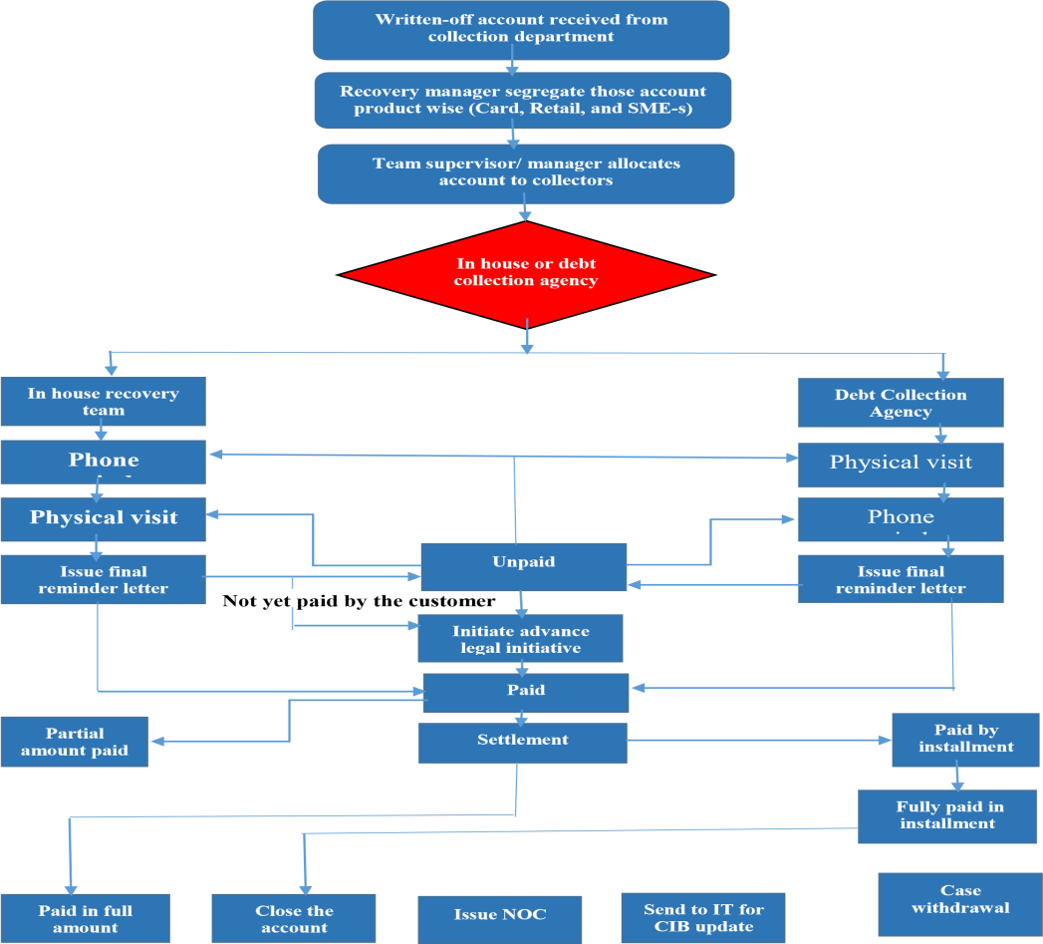

9.3 Process descriptions

Written-off account allocation system: After execution of written-off (playing cards, Retail loan, SMS-s PPG primarily based) recovery group gets written-off account from the collection department via relevant MIS team. After receiving the one's monies owed, it's miles segregated and allocated product sensibly. Manager/unit head recovery distributes those bills to in-house healing staff and debt collection business enterprise.

- In-house recovery team

group director handover the document in exceed expectations document just as the print replica.
- the manager offers application statistics (playing cards, Retail increase, SMS-s credit) which he gathers from Asset activities/playing cards tasks/CAD and accumulation group.
- Collector readies their won undertaking database from the ace allotment report. After the element is executed, a gatherer starts offevolved their recuperation sporting activities by smartphone inspiration to every unmarried report.
- If the gatherer cannot achieve the patron through cellphone od SMS, at that point he/she name the underwriter (If any)
- Communications are refreshed in exceed expectations record for future reference.
- If the purchaser does not attempt, gatherers bodily visit customers place (office/house/everlasting vicinity) so as to influence them to settle the duty. Government passes on the blessings of installment likewise similarly end result of the default.
- If the customer nonetheless remains reluctant to pay, director/unit head recuperation difficulty last update letter adapting underwriter previous improvement the valid hobby.
- Head of Retail surveys the closing update letter before sending it to the client.
- Debt collection agency:
- Manager/Unit head recuperation distinguish account where support from obligation gathering office is required. The rundown of record is submitted to the Head of Retail (HoR) for his audit.
- Manager/Unit head recuperation send the rundown with fundamental data of the client to organization designated individual. Office chief gather extra data from the recuperation office whenever required.
- Agency authority at first visits the client's office or home to seek after installment.
- If they unfit to meet/find the client when they visit the client's lasting location just as underwriters address (if relevant)
- If they ready to contact them or discover anyplace of the client, they seek after them to settle the issue without issue.
- After an effective exchange with the client in regards to installment/settlement, they proceed with telephone follow-up till installment is made according to responsibility.
- Issue last update letter period to propel the lawful activity. Head of Retail (HOR) audits the last update letter before sending to the client.
iii. Payment and settlement: Restoration group normally purpose to recover the entire written-off amount and purchaser is pursued in step with that. but purchaser chooses exclusive charge alternatives in line with their financial functionality. different payment alternatives are as follows:
- One cross agreement: purchaser will pay the complete amount in one short (which include hobby/ costs/ charges/ criminal value and many others.)
- Agreement with the aid of installment: client pay complete quantity (which includes hobby/ costs/ charges/ legal fee and so forth.) via installment that's agreed with the aid of the financial institution.
- The agreement with waiver facility: client settle the account at one cross or installment upon getting waiver facility. the quantity of waiver is decided via management thinking about financial and other situation of the client. Waiver quantity is exercised as in step with waiver matrix of RCM and SCM.
- Abnormal fee: consumer can pay on occasion. If customer will pay partial quantity/ from time to time then preserve recovery attempt until the full amount is recovered. After recovered the entire amount recovery team declared the account as closed.
- Account closure: whilst purchaser pay complete quantity together with prison prices (if any) officer recuperation/ supervisor recuperation or unit head restoration ship the account to the asset operation/CAD/card operation for an amount nearer. After close of the account NOC issued in prefer of the purchaser. The listing of account despatched to IT department/ card operations for CIB up gradation.
- Case withdrawal: After the entire and final agreement of the account officer/ manager/ unit head recovery send the account to the felony division to withdrawal litigation towards the patron taking an endorsement from Head of Retail (HOR).
- Unpaid account: To accumulate the unpaid quantity, the priority branch places keep healing attempt.

9.4 Limitations of the study

- Time Constraints- The internship software period turn out to be the best 12 weeks (3 Months). This time is not sufficient for me to explore every operation of a financial institution and acquire knowledge & statistics approximately it. This predicament hindered me to make a concrete study on the corporation and make a comprehensive document. It modified into one of the fundamental barriers that affected protecting all additives of the take a look at.
- Loss of Secondary statistics because of the bank’s internal coverage- The facts provided through The town financial institution Limitedconfined become no longer sufficient and that affected me to prepare this document masking all the components of the corporation. Most of the statistics become no longer disclosed by using the manner of respective personnel of the branch due to protection trouble.
- Unique Departmental attention- As I used to paintings in the Retail department of the bank, I have to manage to gather all the required data from this department honestly. For that reason, I ordinarily focused on the credit score risk control of Retail branch and gave an outline for every company and SME unit. Other obstacles are as follows-
- Lack of my realistic information, a few inadequacies can be to be had in the report paper.
- The financial institution has naturally established us a few irrelevances connecting its maximum non-public facts.
- The executives of The city bank restricted had been too busy to extra time for the hostage.

9.5 Findings & Challenges

As a standout among the maximum settled acclaimed private business banks in Bangladesh, The town bank Limited restricted reliably offers its most incredible effort to provide excellent companies to its clients in a quicker and impeccable manner. In any case, while affecting the file I to have long gone over some noteworthy challenges that they have been famous as a great deal as even as in the intervening time dealing with the credit chance of the economic institution. The ones are:
- Inflexible credit score assessment and risk grading policy- All of the enterprise banks will clearly are be searching for after Bangladesh monetary group's steadfast credit evaluation form. Thusly, every so often, it finally ends up being difficult for them to manipulate and manipulate this well-known chance as their capability in such manner in restrained. So CBL can't regulate the tips paying little mind to whether they experience any similar appraisal in their clients to the quantity credit score danger may want to deliver them gradually crucial attestation.
- Unavailability of customers' nitty gritty statistics: CBL assets their improvement applications to the credit score branch thru three certainly one of a type manner – Direct sales group (DST), branch, and Payroll. Part of the time those belongings are unfit to offer the required information on calendar. Alongside those traces the records named as deferral documents, where credit is standard with a certification of giving all the missing reviews later. This genuinely grows the affinity of the well-known chance, as the advances are being given without earlier than fitting defend.
- Inefficient third -birthday party agent (CPV sellers): CBL implements outsider operator named as touch point Verification (CPV) to confirm the statistics of the client. These specialists bodily go to the spots, for example, customers' habitation, administer clients' commercial enterprise location, confirm the presence of the residences, and so forth. These CPV operators sometimes are not incited to test each one of the records statistics on schedule or they do verify the ones improperly. At that aspect, the investigators pick out a choice primarily based on CPV experts' low affirmation and authorization the development. Consequently, the credit score risk of the customers goes up thusly.
- Inefficient facts control: The functionality to securely shop, kind and inquiry statistics dependent on awesome standards are needed to apprehend credit score chance the executives. In the city financial organization Ltd., the customers' statistics aren't effectively overseen, and the people aren't sufficiently talented to cope with clients' statistics all the time. Ultimately the specified data on the way to technique the advances aren't constantly accessible, and therefore, the credit score danger plausibility receives higher.
- Missing danger control equipment: A complete hazard assessment scorecard needs a good way to discover the power and susceptible factor related to the mortgage. There have a few lacking inside the city economic group’s control tool wherein up to date threat evaluation system aren't used to find out the strength and susceptible factor of the mortgage.
- Wrong documentation: The Documentation group is not very scrupulous while reviewing the documents of the loan candidates, consequently, many fraudulent clients are being left out providing forged files which eventually decorate the hazard of being the default.
- Common failure of community machine: CBL uses various banking software so that it will facilitate the mortgage sanction procedure, e.G. Oracle, Finical, Lotus, and so forth. Every now and then at the equal time as processing the loans, the software gets down, for that reason it turns into tough for the analyst to gadget the credit score of the clients on time. They ought to wait 10 to 30 minutes to recuperation the community device, because of this it makes an analyst proceed the loan software without giving utmost interest to each software program, and the chance of having default receives better for this.
- Lack of proper schooling for the personnel: A well-educated employee can deliver the first-rate a good way to mitigate the credit score risk of a client via way of analyzing the mortgage utility files. But, now not all the employees in CBL who paintings in the credit score rating branch are not further professional. They lack a first-rate deal useful information of the software program they use to hold client statistics and method the loan. Therefore, the credit danger manipulate is hampered.
- Restrained organization massive danger modeling infrastructure- once in a while it isn't enough for a single entity to have a look at the danger features. On the town bank restrained, there has a few missing group-enormous hazard modeling infrastructure. As an instance, for executing both documentation and stamping there may be a most effective one worker who manages a whole load of loan packages, therefore it's miles normally difficult to be very vigilant at the identical time as reviewing the documents all the time. Therefore, the risk of the client of being default will also boom.

9.6 Recommendations

As I go together with my small tenure of being with them and searching on the complete manner of control of credit score threats, I need to provide them some hints that can also increase the charge to make sure the bank's right to control of the credit score risk. They're-
Make a prepared and effortlessly understandable “credit score guide” for each the loan applicants and the employee of the CBL just so they each of them may want to make them conscious regarding the credit score guidelines of the economic institution.
The documentation crew needs to be more numerous and have to ensure that they perform their responsibilities certainly and proper away. CBL have to screen and flawlessly show the exceptional of this unit's work. Sturdy enforcement at the CPV agent is important because it has a totally vital role to play in the physical verification of statistics for customers. In the event that they supply misleading proof, the manner of the CPV marketer’s desires to be right and obvious, in any other case the economic group evaluation method could be hindered. CBL should, therefore, be extremely careful even as the marketer’s artwork nicely for them. Right and based schooling is wanted for the personnel of CBL to purpose them to deliver them an easy concept about all the capabilities of banking software irrespective of their departments and task roles. Even though they are capable of making themselves aware of all of the features and could assist them in paintings correctly and with any luck.
- The supply teams (DST, department, & Payroll) should deliver the loan software program documents to the credit rating department collectively with each and each file that are important to investigate the software. CBL must do not forget this hassle critically so that it will mitigate the opportunities of sanctioning a loan even as no longer having right files in it.
- A strong uninterrupted network device should be introduced to decrease the risk of being not on time in loan processing. Plus, more potent control of all software program usage has been ensured to get better normal overall performance from the ones.
- Updated risk management tools need for use so that it will determine the loans extra flawlessly and effectively. By way of using hazard control tool, the analysts can assessment a loan report thoroughly and flawlessly.

Conclusion

Financial institutions count on a pivotal process in the national economy. Lately, the banking division is not just relied upon the normal strategy for banking but additionally modern-day and advanced approach for banking. In Bangladesh, the banking industry has been dealt with as a drawing close money related department and it has an actual commitment within the economic system of the nation. Nevertheless, this enterprise of Bangladesh is as of late critically encouraged by means of horrible credits. Sooner or later, banks are confronting difficulties to hold up liquidity to provide advances to their customers. Consequently, the development of the economy is in a query. One key issue is banks insufficiency in assessing credit chance of its customers. This specific trouble is getting more and more tremendous as the day passes by using.
Bangladesh financial institution has created set standards and widespread regulations to help the banks in comparing threat and diminish their credit hazard. Indeed, even within the wake of having such rules, numerous banks nevertheless neglect to boom high-quality credit score chance the executives and run gainfully. Thus, it doesn't always best the direction given via the Bangladesh financial institution that all of the banks need, a business loaning basis desires to accumulate its very own loaning preparations that should be set up to assure most excessive proficiency of adequacy of credit score chance the executives.
The town bank restrained is solid and constant to satisfy the need for a huge scope of banking administrations in Bangladesh. Its exceptional assets both as a way as human and physical are dependably there to supply clients with the maximum perfect administrations. CBL has successfully created altruism amongst its purchaser via supplying its considerable administrations within the monetary business. Furthermore, it has first rate notoriety within the monetary enterprise to cope with the credit score danger as opposed to distinctive banks in Bangladesh. This fulfillment did not come medium-time period, it has come approximately because of the diligent work, devotion, responsibility and dynamic authority of its administration over the duration. Be that as it can, they must listen extra on client’s orientation blessings and provide higher innovative progression identifying with banking sports.

References

- Banks NPL a curse for sustainable growth (April 2, 2018), The Daily Star. Retrieved from- https://www.thedailystar.net/businessChowdhury, M. (2018, May 27). Causes of Non-Performing Loan and effects on banking sector. The Daily Sun, Retrieved fromhttps://www.daily-sun.com
- SOP: Personal loan documentation & disbursement, version-1.0 (Nov 23, 2017), The City Bank Limited.
- Jamal, E. (2018, Feb 20). Banking sector and its impact on our economy. The Daily Star,
- Retrieved from-https://www.thedailystar.net
- Islam, M (2017). Standard Operating Procedure, The City Bank limited
- The City Bank: Making Sense of Money, Retrieved from-
https://www.thecitybank.com/annual_reports.php
https://www.thecitybank.com/vision.php
https://www.thecitybank.com/highlights.php

- Sarkar, N. (2018, April 7). Strong central bank needed to revive banking sector. Dhaka
- Tribune, Retrieved form-https://www.dhakatribune.com/business/banks

- Guidelines of Credit Risk Management (2016, March 16), Retrieved from- https://www.bb.org.bd/mediaroom/circulars/brpd/mar082016brpd04.pdfhttps://en.wikipedia.org/wiki/Credit_risk

Appendices

Abbreviation

CBL- The City Bank Limited | CPV- Contact Point Verification
FINACLE- Core Banking Software | PPG- Product Program Guideline
LAP- Loan Application Pack | TIN- Tax Identification Number
UDC- Undated Cheque | RFC- Retail Finance Center
PDC- Post Dated Cheques | SOP- Standard Operating Procedure
BA Letter- Banking Arrangement Letter | DP- Demand Promissory
DST- Direct Sales Team | CASA- Current & Savings
LOG- Letter of Guarantor | HOR- Head of Retail
LOTUS- Banking Software | HOR- Head of Retail
C&C- Credit and Collections

