
Internship Report
ON
Research works on different types of analysis method by using organic, inorganic, chemicals and herbals at the Industrial Chemical Section.
At
Bangladesh Council of Scientific and Industrial Research (BCSIR),Dhaka

Submitted BY:
Tarzina Hoque Onnana
ID: 152-34-400
Depatment Nutrition and Food Engineering
Daffodil International University
Supervised by:
Effat Ara Jahan
Lecture
Department of Nutrition & Food Engineering
Daffodil International University
Date of Submission:24/06/2019

LETTER OF TRANSMITTAL
Date:24 th June,2019
To,
Prof . Dr. Md. Bellal Hossain
Head
Department of Nutrition & Food Engineering
Daffodil International University.
Subject: Submission of Internship Report.
Dear Sir,
With due respect, I might want to educate you that, it is an extraordinary joy for me to present the task report on " Studies on Spondias Mombin leaves for Its Poximate Analysis,Physico-Chemical and Phyto-Chemical Analysis in immature leaves ". It is a fulfilment of the requirement to achieve BSc Engineering from Daffodil International University. I have put my best effort to make this report specific and intelligent.
To prepare the report I collected what I believe to be most relevant information to make my report as analytical and reliable as possible. I have concentrated my best effort to achieve the objectives of the report and hope that my endeavor will serve the purpose. The practical knowledge and experience gathered during report preparation will help me in my future professional life. I request you to excuse me for any mistake that may occour in the report despite of my best effort.
I would really appreciate if you enlighten me with your thourghts and views regarding the report.
I therefore,would like to place this report to your judgment and suggestion. You kind advice will encourage me to perform better planning in future.
Sincerely Yours,
------------------------------------------------------
Tarzina Hoque Onnana
ID:152-34-400
Department of Nutrition & Food Engineering
Daffodil International University
LETTER OF APPROVAL
This is certify that the Internship entitled “Research works on different types of analysis by using organic, inorganic, chemicals and herbals at the Industrial Chemical Section” sumitted by Tarzina Hoque Onnana , ID No: 152-34-400 of the department of Nutrition and Food Engineering has been carried out under our supervision. This is further to certify it is our original work and suitable in partial fulfilment for the degree of bachelor of Science(B.SC) in Nutrition & Food Engineering,Daffodil International University,Dhaka.



----------------------------------------------------- ---------------------------------------------------
Supervisor Co-Supervisor
Effat Ara Jahan Dr.Shahin Aziz
Lecturer Senior Scientific Officer
Department of Nutrition & Food Engineering Chemical Research Division
Faculty of Allied Health Science Industrial Chemical Section
Daffodil International University (DIU) Bangladesh Council of Scientific &Industrial
Research(BCSIR)

ACKNOWLEDMENT

First of all I would like to express my gratitude to almighty Allah for giving me the strength and opportunity to complete the report in the schedule time successfully. In the preparation of this report, I would like to acknowledge the encouragement and assistance give to me by a number of people .I am taking the privilege to deliver my gratefulness to each and every people who are involved with me in every phase of my lives. I am grateful to my parents without whom I could not here. Without the support of my parents I could not be able to achieve my objectives and goals.
My deep gratitude and sincere thanks to the honorable Head, Department of Nutrition and Food Engineering, Professor Dr. Bellal Hossain, for this kind cooperation and encouragement to accept this degree.
My deep gratitude and sincere thanks to my supervisor, Effat Ara Jahan Lecturer of Department Nutrition and food Engineering , for his whole-hearted supervision during the research time. I am very glad to deliver my gratefulness to each and every person who involved with me in every phase of my life.
I am also thankful to my great teachers Dr. Md Rezaul Karim,Assistant Professor, Fouzia Akter, Senior Lecturer, Tasmia Tasneem, Senior Lecturer, Nasima Akter Mukta, Lecturerour Batch Advisor, Syeeda Shiraj-Um-Monira, Lecturer and Najia Kamrul, Lecturer for their countless inspiration and encouragement during my student life.
I would like to express my warmest thanks MD Emran Hossain, Co-ordination Officer and lab technician Emdad Hossain. Iexpress my deep gratitude to the office/labs stuff of the Department of Nutrition & Food Engineering under faculty of Allied Health Sciences, Daffodil International University.

EXECUTIVE SUMMARY

This report is prepared on the basis of my two-month practical experience at theBangladesh Council of Scientific and Industrial Research (BCSIR),Dhaka. This internship program helps me to learn about the practical knowledge of different types of product in Institute of BCSIR and it is one of the largest laboratories in our country. This laboratories plays an active role in transferring technologies developed by your Scientist to the commercial entrepreneurs of our country.

BCSIR is one of the leading private organization countrywide. This report has been presented based on my observation and experience gathered from this lab. The organization has many divisions and departments but I only got the opportunity to gain experienced.I have done some experiments on chemical activity of identify possible hazards and acceptence of consumption.

Dedicated
To
My beloved parents

Table of Contents

Particular | Page no
Chapter-1 :Introduction | 1-3
1.1.Vision | 3
1.2.Mission | 4
1.3.Innovation Gallery | 4
1.4.Establishment of Central Laboratory | 4
1.5.International and National Memorandum of Understanding (MoU) of BCSIR | 4-5
1.6.BCSIR Laboratories, Dhaka | 5
1.7.Biological Research Division (BRD) | 6-7
1.8.Chemical Research Division (CRD) | 8-9
1.9. Fiber and Polymer Research Division( F & PRD) | 9-10
1.10. Industrial Physics Division ( IPD) | 10
1.11.Pharmaceutical Sciences Research Division | 10-11
1.12. Physical Instrumentation Division ( PID) | 11
1.13. Pulp and Paper Research Division( PPRD) | 11-12
Chapter 2:Metarials and methods | 13
2.1.Soxhlet extraction instrument | 14
2.2.Desiccators | 14-15
2.3.Ultrasonic bath | 15-16
2.4.Rotary evaporator | 17-18
2.5.Furnace | 18-19
2.6.Water Bath | 19-20
2.7.Oven dryer | 20
2.8.Binder | 21
2.9.Experiment in Chemical Research Division (Industrial Chemical Section) | 21-23

List of Figure
Figure no | Titel of figure | Page no
1 | Fat extraction by Soxhlet method | 15
2 | Desiccators | 16
3 | Ultrasonic bath | 16
4 | Rotary evaporator | 18
5 | Furnace | 19
6 | Water Bath | 20
7 | Oven dryer | 21
8 | Binder | 21
9 | Experiment in Chemical Research Division ( Industrial Chemical Section) | 22-23

CHAPTER:01

Introduction
Bangladesh’s Scientific and Industrial Research Council(BCSIR) is the county’s largest and diverse multi-faceted science and industrial research organization .BCSIR helps to developthe industrilization of our country and it also creates skilled manpower. The Eastern Laboratory Dhaka which was established in 1955. It’s helps to achieve the socio-economic development of the country.BCSIR laboratory in Chittagong was established in 1965. Later,the BCSIR a laboratory was established in 1967.Our Father of the nation Bangabandhu Sheikh Mujibar Rahman who established the Bangladesh Council of Scientific and Industrial Research (BCSIR) in 1973.It is a from of knowledge based ,developed to Bangladesh implementation of sustainable and appropriate technology.Bangladesh science and industrial researc h council Act were approved on October 10,2013 by the Parliament. BCSIR has increased its domain to five mono disciplinary institutes,three full-fledged multi displinary regional laboratories and one pilot plant stydies centre which are carrying out research and development (R & D) programs in different fields of science and technology to develop and transfer of new technology.

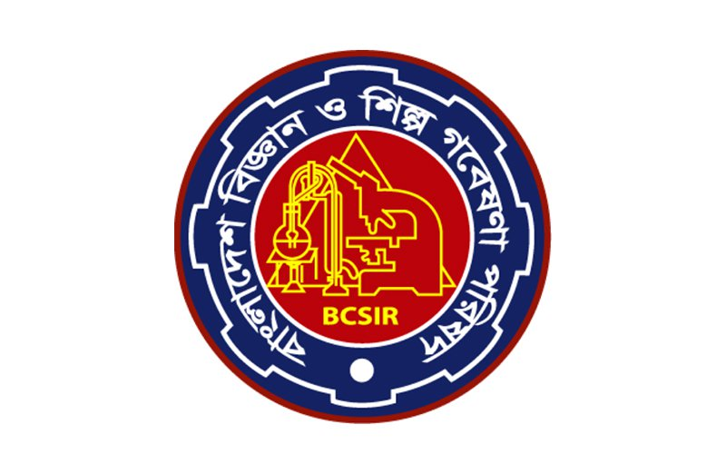

BCSIR has a network of 12 laboratories, institutes and centers.BCSIR units:BCSIR Labortories,Dhaka.BCSIR Labortories,Chittagong.BCSIR Labortories,Rajshahi.Institute of Fuel Research & Development (IFRD),Dhaka.Institute of Food Science & Technology (IFST),Dhaka.Pilot Plant & Process Development Center (PP & PDC ),Dhaka.Institute of Glass and Ceramic Research & Testingn(IGCRT),Dhaka.Leather Research Institute( LRI),Savar,Dhaka.Institute of Mining,Mineralogy and metallury (IMMM),Joypurhat.Desingated Reference Institute for Chemical Measurements (DRICM),Dhaka. Institute of National Analytical Research and services(LNARS),Dhaka. Institute of Technology Transfer and Innovation (ITTI),Dhaka.

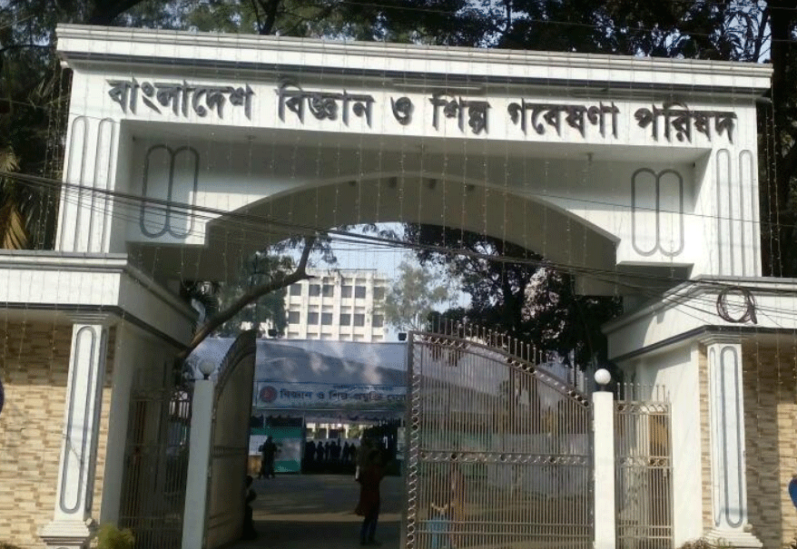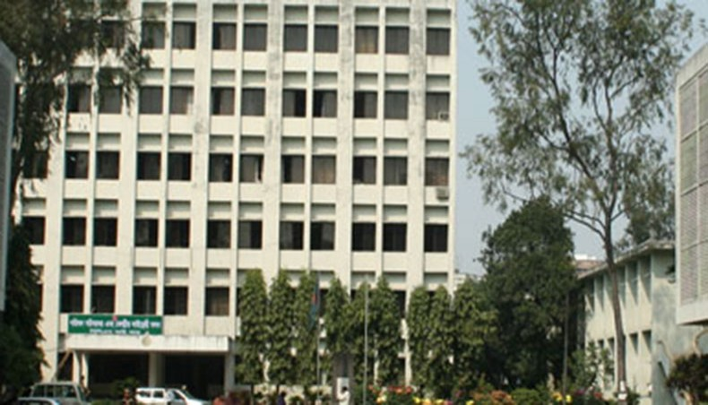

BCSIR laboratories which was established in Dhaka bearing the name of East Regional Laboratories under the erstwhile PCSIR as a multidisciplinary research establishment . The BCSIR laboratory in Dhaka which is devoted to conduct both basic and applied research to foster scientific and industrial development through innovation. The BCSIR laboratory in Dhaka’s Research and Division expertise and experience is embodies in about 62 active scientists covert by 74 administrative and technical personnel.
Biology, Chemistry, Fiber and polymer ,industrial physics ,pulp and paper ,physical instrumentation, pharmaceutical are focused its research and development by areas. Engaged in provide for analytical and testing services to various public and private bodies, entrepreneurs and individuals are also the scientists in addition to Research and Division. The students of different Universities to learn more about science and scientific research through thesis guidance and fellowship program of BCSIR Laboratories, Dhaka also provides opportunities. BCSIR is mandated and its science and technology competences that is aligned with the country’s priorities along this unit plays a key role to supported by the government’s programmes through proper research direction.
BCSIR laboratories, Dhaka which conducts research and development activities in the field of Biological research division is the largest division of Biological science in the following sections: Applied Botany, Soil and Environment, Tissue Culture, Plant Pathology, Plant Physiology, Zoology.

I have worked at BCSIR Laboratories in Chemical Research Division(Industrial Chemical Section ).I have started my experiment on 28April,2019.The name of my experiment is research topic . I am continuing my experiment work.
The experiment was done inChemical Research Division as Herbal Hand Wash( used :Moisturizing hand cleanser), Aloe Gel( used: Men & Women), Herbal Shaving Foam( used: Saloon & Parlor), Neem Based Cream (used: Antibacterial skin care cream), Baby Liquid Laundry Detergent (used: Liquid detergent specialized for baby skin),Ultrasound gel(used: Hospital and Clinic), Baby Oil Scale of Development Major Raw Material (Health looking skin), Herbal Face Wash(used: Clean, clear and healthy looking skin), Chitin from shrimp industry waste (used: Several medicinal, industrial and biotechnological purposes), Chitosan from shrimp shell waste (used: Agriculture, Food preservative ,Drug delivery, Cosmetics etc),Cotton seed oil ( used: Soaps, facial wash, shampoo),Ripe mango peel (used: stabilizing),Ripe jackfruit waste(used: thickening,stabilizing), Ripe mango seed ( used: food additives ),Mango seed oil( used: soap, shampoo, cream ect).Anhydrous Aluminum Chloride( used: isomerization), Lead Acetate( used: textile printing and dyeing), Phosphate based fire extinguishing(used: Extinguish the ABC type fire),Zinc Acetate(used: dietary supplement and in lozenges ), Carbonate based fire extinguishing(used: Extinguish the BC type fire) etc.
Chemistry Research Division Execute in the different field of Natural and Synthetic chemistry. Its Formation of seven research sections: Chemical from Indigenous Sources section, Fine organic chemicals section, Carbohydrate section, Essential oil soap and detergent section, Chemical industrial waste and Industrial inorganic chemical section. Engaged to provide for analytical services and also supervise the research work of B Sc,M Sc, M phil and Ph D student’s thesis of different university along with Research and Development works.
1.1.Vision:
Acheivement of the status of focus of brilliance continuously 2021 for market driven logical, mechanical and mechanical research and development in the field of cowhide, footwear and calfskin items research and foundation of present day labs, give specialized and explanatory administrations.

1.2.Mission:
Doing, advancing and controlling logical, mechanical and innovative research on cowhide division to give green innovation to contributing green economy and backing SMEs.
1.3.Innovation Gallery:
In order to exhibit the goods and processes of BCSIR, the most important multidisciplinary studies enterprise in the us of a, an innovation gallery has installed at its primary campus in Dhaka. Through this imitative, a facility has been created to illustrate the discovery and innovation of scientists and engineers of BCSIR to entrepreneurs, college students and mass people of the country. Entrepreneurs may have an easy access to the technology from distinct laboratories of the groups in a single point and collect the technical and technological assist for helping industrialization and activity advent within the USA.
1.4.Establishment of Central Laboratory:
A focal research center all around furnished with ICPMS, AAS, GCMS, PCR, DNA Sequencer and numerous other world standard and cutting edge types of gear has been set up in the fundamental grounds of BCSIR in Dhaka. Practically all the important hardware for giving concoction examination and testing administrations are available in the research facility. Subsequently, customers who look for such administration from
BCSIR can get them from a solitary point effectively. In addition, researchers from various labs can share these valuable instrument and get their example tried from this focal lab. To guarantee the best utilization of the instruments and decrease the wastages of time, cost and synthetic substances, this lab will assume an essential job. Duplication of test instruments at various research facilities will likewise be diminished through this activity.
1.5.International and National Memorandum of Understanding (MoU) of BCSIR:
As a part of its hazard to create mutual cooperation in the field of research and development which BCSIR has signed letter of understanding with different national and international organization. With in, the international organizations, The commonwealth Scientific and Industrial Research Organization (CSIRO),Australia. The Council of Scientific and Industrial Research (CSIR),India and Japan Development Corporation (JDC) are mentionable. The benefit of the people of the country have signed MoU with BCSIR for mutual cooperation to promote and disseminate technology developed by BCSIR for National pertinent organizations like Small and Medium Entrepreneurs Foundation (SMEF). The people have been created through these MoU within and outside the country in the field of technology development and exchange for their effective application for the wellbeing of partnerships with international and national organizations.
Collaboration with worldwide research businesses has created a scope for BCSIR to do studies, era development, transfer and apply the evolved technologies for industrialization in our us of a. Additionally, following home windows of cooperation were spread out through those MoU:
• Conduct joint studies
• Technology transfer
• Manpower improvement through subject-unique schooling
• Exchange and percentage understanding through organizing and attending to medical seminar, workshop etc.
1.6.BCSIR Laboratories in Dhaka
This laboratory is dedicated to conduct both basic and applied research to foster scientific and industrial development through innovation. BCSIR Laboratories, Dhaka’s R&D expertise and experience is embodied in about 62 active scientists supported by about 74 administrative and technical personnel. The laboratory focuses its research and development in the areas of Biology, Chemistry, Fiber and polymer, Industrial physics, Pulp and paper, Physical instrumentation as well as Pharmaceutical by seven research divisions. In addition to R&D activities, the scientists are also engaged in providing analytical and testing services to various public and private bodies, entrepreneurs and individuals. BCSIR Laboratories, Dhaka also provides opportunities for the students of different universities to learn more about science and scientific research through thesis guidance and fellowship program. This unit plays a key role to support government’s programmes through proper research direction that is aligned with the country’s priorities along with BCSIR mandate and its science and technology competences.
There are 7 research division and I I have worked at BCSIR Laboratories in Chemical Research Division( Industrial Chemical Section ).

1.7.Biological Research Division (BRD)

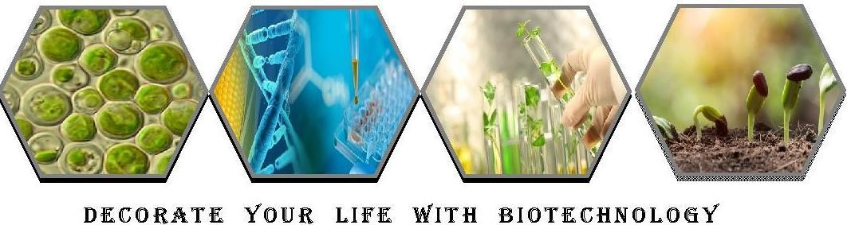

Organic research division is the biggest division in BCSIR labs, Dhaka which behaviors innovative work exercises in the field of Biological science in the accompanying segments:
Applied Botany: Research on monetarily significant green growth, organism, restorative, agricultural and blooming plants culture and continually serving the rent business visionaries which are financially creating and promoting Spirulina as tablet, case, powder, drinks and so on.
Soil and Environment: Conduct look into on soil wellbeing improvement, compost item advancement, manure quality control, computerized soil data framework improvement through GIS innovation, air contamination observing and alleviation, recovery of debased soil and waste water, natural effect appraisal of various mechanical zone and financial zones and so on.

Tissue Culture: vitro plant recovery and increase of significant therapeutic, organic product, blossom, common color delivering and timber plants. To carry on genom and sub-atomic research for infection free on various plants.
Plant Pathology: Isolation, distinguishing proof and portrayal of bioactive metabolites from endophytic organisms and discover the plant infections brought about by parasite and microorganisms and their cure by natural methods.
Plant Physiology: conducts explore on plant hormones, various dimensions of full scale and small scale components and biochemical exercises of various vegetables.
Zoology: connected research on entomology (creepy crawly scientific categorization and bug the executives) and fisheries (decorative fish, live fish feed culture and fake fish feed definition and assessment).
Research & Development (R & D) Activities:
- Cultivation of Different Species of Algae with High Lipid Content to Produce Bio-fuel in Commercial Scale.

- Industrial contamination: levels and kinds of substantial metals going into evolved way of life (soil-water-plant continuum) from various ventures in and around Dhaka city.

- Creation of humic substances (humic corrosive, fulvic corrosive) from indigenous hotspots for the recovery of polluted soil and waste water.

- Normal Design and Synthesis of different morphology of titanium di oxide (TiO2) and its application on Environment.

- Improvement of biochar items to lessen ozone depleting substance emanation and abatement arsenic and overwhelming metals phytoavailability in polluted soil.

Objectives:
- Using biodiesel instead of fuel lessens CO2 outflows by a normal of 34%.
- Biodiesel generation from green growth has drawn the most consideration in view of its ecofriendly capability of high profitability.
- The prospect of delivering biodiesel from green growth has been developing, since it yields multiple times more vitality per section of land than land crops as soybeans.
- To decide &quantify the measure of overwhelming metals in squanders released from various businesses in and around Dhaka city and their individual passageway into evolved way of life through the dirt water-plant continuum.
- To discover the reaction of various plants (vegetables) on the take-up of various overwhelming metals from plant development media (soil).

1.8.Chemical Research Division (CRD)
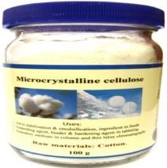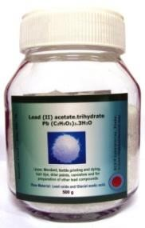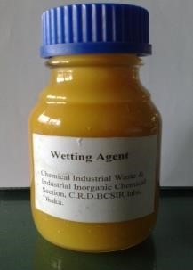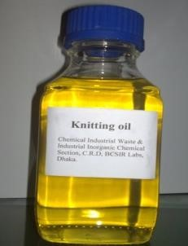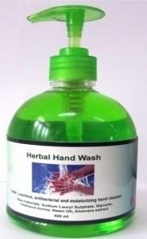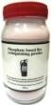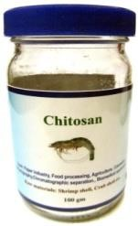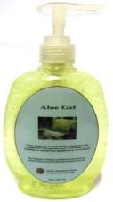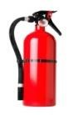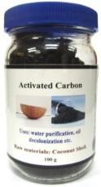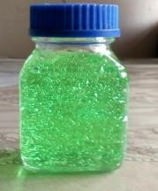

Chemistry for
Life

Chemical Research Division conveys R and D works in the diverse field of Natural and Synthetic science. It comprises of seven research areas: Chemical from Indigenous Sources segment, Fine natural synthetic compounds segment, Gum and glue segment, Industrial substance segment, Carbohydrate segment, Essential oil cleanser and cleanser segment, Chemical modern waste and Industrial inorganic concoction segment. Alongside the R and D works, researchers of this division are locked in to give logical administrations and furthermore oversee the examination work of M Sc, M Phil and Ph D understudy's postulation of various university.
Research & Development (R & D) Activities:
- Characteristic cell reinforcement from indegenous sources and assessment of their calming, against nociceptive, anti-betic and other bioactive properties .
- Streamlining of techniques for readiness of low sub-atomic weight chitosan and distinctive sort of chitosan subsidiaries for use as normal sustenance additives.

Objectives:
- Preparation of low sub-atomic weight chitosan and chitosan subordinates from shrimp waste and use as regular additive on products of the soil.
- The fundamental object of this task is to build up the procedure for the generation of said synthetic compounds.
- This will decrease the reliance on outside nations and spare a large number of remote cash .
- To create process for the generation of high proficiency, savvy and import substitute fluid and protein based froth concentrates.
1.9.Fiber and Polymer Research Division( F & PRD)
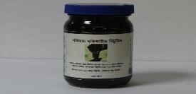
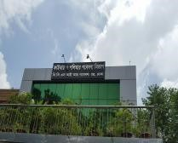
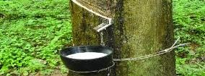
Fiber and Polymer Research Division is one of the biggest divisions of BCSIR Laboratories, Dhaka. It is an exceptionally specific research lab leading R&D chips away at various parts of Polymer Chemistry and giving administrations to the enormous scale polymer-based ventures of Bangladesh by creating information based logical methods. The progressed and completely practical Fiber and Polymer Research Division has been created under an ADP Project titled "Advancement of Fiber and Polymer Laboratory of BCSIR (July2012 to June-2016)" and proposed for accreditation according to ISO-17025 standard. Research and development exercises of the division are fundamentally centered around Textiles, Jute, Wood, Rubber, Plastic, Bitumen, Paint, Dyes and Pigments, Plastic and Rubber Waste Management and Utilization System, Textile Effluent Treatment, and so forth. This division is bit by bit expanding its ability to lessen the reliance on remote labs in the field of polymer examinations. A definitive target is to guarantee reasonable improvement of the nation applying Polymer Science and Technology.
Research & Development (R & D) Activities:
- Use of Plastic/Rubber Wastes in Road/Pavement Construction.
- Amalgamation of lignin subsidiaries and their usage in Paint, Adhesive, Cement, Agriculture, Food and Cosmetic Industries. Advancement of "Utilitarian Polymer-joined Cellulose Powder" to be utilized in Textile ETPs.
Objectives:
- Preparation of specialized lignin subsidiaries and their applications in huge scale enterprises.
- Development of eco-accommodating creation innovations through green synthetic methodology.
- Utilization of lignocellulosic biomasses to get ready successful polymeric spongy.
- Development of successful "Material Effluent Treatment Technology" to control surface water contamination.
1.10. Industrial Physics Division ( IPD)
Industrial Physics Division (IPD) has been occupied with the bleeding edge R&D exercises in the field of materials and vitality for economical advancement. Researchers and Researchers of this division assume a crucial job to take care of issues rapidly in a wide scope of scholastic and mechanical regions, formulating uniquely crafted devices and utilizing whimsical procedures for better comprehension the incorporated just as imported items. Fitting material properties at the nanoscale just as embracing progressed and high precision estimations methods is the center of IPD exercises to satisfy the requirements of various partners just as for maintaining the nation's logical improvement methodology.
Research & Development (R & D) Activities:
- Procedure for creation of heater internal (silica) block from waste materials.
- Blend and portrayal of co doped dielectric material for earthenware capacitor.
- Blend and Application of Magnetic nanoparticles (Fe3O4) for waste water treatment.
Objectives:
- To orchestrate dielectric material as import substitute.
- To describe the examples by XRD, SEM/EDS, Impedance analyzer .
- To think about the physical, electrical and dielectric properties of the examples .
- To reuse paper plants ooze: Pulp and buildup.
- To produce worth included item (tailor chalk) from paper plants squander and describe.
1.11.Pharmaceutical Sciences Research Division
Research & Development (R & D) Activities:
Union of some ordinarily utilized antiulcerants:
Effective execution of this venture will help our Pharma Sector to lessen reliance on imported crude materials and consequently, spare outside money.
Objectives:
- Advancement of improved earth good engineered courses of some antiulcerant APIs, for example, Pantoprazole, Omeprazole, Esomeprazole and so forth and their manufactured middle people.
- Improvement and approval of explanatory procedure for the integrated medications and their related debasements.
- To move innovation from R&D to real assembling offices.
Pharmaceutical Sciences Research Division is ceaselessly attempting to improve R&D offices in various areas of pharmaceutical research including API and Pharmaceutical Excipients, Quality Assurance of Modern and Herbal Medicines, Drug Discovery and Bioassay, Dosage Form Design and Bioequivalence Study/Testing so as to help pharmaceutical segment of Bangladesh.

1.12. Physical Instrumentation Division ( PID)
The fundamental works of PID are:
- Maintenance, fixing, adjusting and establishment of logical gear and electronic instrument. 
- Conduct look into for improvement of Laboratory hardware locally.
- Provide PC preparing (programming and equipment).
Research & Development (R & D) Activities:
- Plan and advancement of Microcontroller based Automatic Voltage Stabilizer.
- Advancement of Smart Control and Monitoring System for Electrical and Electronic gear utilizing Internet of Things (IoT).
Objectives:
- To create Automatic Voltage Stabilizer utilizing locally accessible crude materials.
- To think about and build up the control methods of customary Voltage Stabilizer.
- To build up gear's control and checking framework to give adaptable and versatile design to robotization.
- To create android and web application to control and screen gear from all over the place.

1.13.Pulp and Paper Research Division( PPRD)
Pulp and Paper Research Division (PPRD) is one of the most established divisions in BCSIR Laboratories Dhaka which assumes a pivotal job in the advancement of pulping innovation for the mash and paper ventures in Bangladesh from its start. Numerous endeavors have been given over the previous decades to discover high return biomass for mash generation just as simple spread for ranger service. This examination division is commanded to use locally accessible bioresouces in delivering mash, paper and synthetic substances. Researchers of PPRD will build up a green pulping process for nonwood farming buildups. In addition, PPRD is creating HR through managing PhD and MS understudies of various colleges of Bangladesh.
Research & Development (R & D) Activities:
- Biorefinery activity in creating rayon evaluation mash from jute cutting and caddis.
- Quick Determination Method of Dissolving Pulp properties by Spectroscopic Data and Chemometrics.
Objective:
- Prehydrolysis improvement of jute cutting, jute caddis and cutting-caddis blend by changing time and temperature.
- Separation, portrayed of Lignin from rice straw .
- Utilization of AA/FA/H2Olignin in lignin-phenol-formaldehyde(LPE) saps planning and Characterization of LPF gums.

CHAPTER:02

Materials and methods

I have worked at BCSIR Laboratories in Chemical Research Division( Industrial Chemical Section ).I have started my experiment on 28April,2019.The name of my experiment is research topic . I am continuing my experiment work.we have seen many types of equipment in the lab and we have studies them, the instruments are reported.

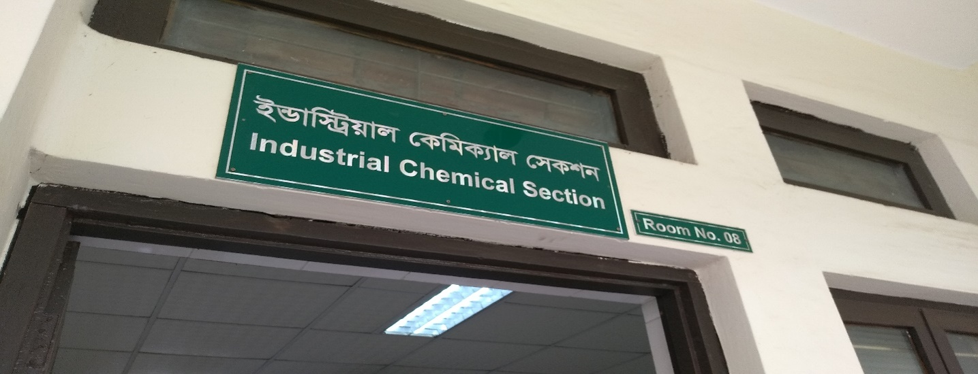

Apparatus:
2.1.Soxhlet extraction instrument:
A Soxhlet extractor is a bit of research facility mechanical assembly developed in 1879 by Franz von Soxhlet. It was initially intended for the extraction of a lipid from a strong material. Regularly, Soxhlet extraction is utilized when the ideal compound has a restricted dissolvability in a dissolvable, and the polluting influence is insoluble in that dissolvable. It takes into account unmonitored and unmanaged activity while productively reusing a modest quantity of dissolvable to break up a bigger measure of material.

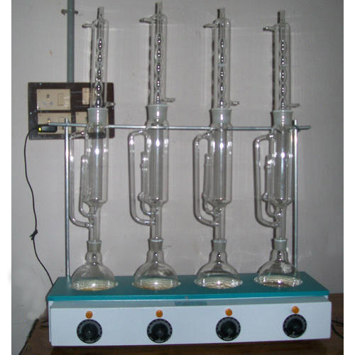

Figure 1 : Fat extraction by Soxhlet method
A Soxhlet extractor has three primary segments: a percolator (kettle and reflux) which circles the dissolvable, a thimble (typically made of thick channel paper) which holds the strong to be separated, and a siphon instrument, which occasionally discharges the thimble.
Uses:
- The source material containing the compound to be separated is set inside the thimble.
- The thimble is stacked into the fundamental council of the Soxhlet extractor.
- The extraction dissolvable to be utilized is set in a refining carafe.
- The carafe is set on the warming component.
- The Soxhlet extractor is set on the carafe.
- A reflux condenser is set on the extractor.
2.2.Desiccators :
Desiccators are sealable walled in areas containing desiccants utilized for safeguarding dampness delicate things, for example, cobalt chloride paper for another utilization. A typical use for desiccators is to ensure synthetic compounds which are hygroscopic or which respond with water from mugginess.
The substance of desiccators are presented to climatic dampness at whatever point the desiccators are opened. It likewise requires some an opportunity to accomplish a low moistness. Subsequently they are not proper for putting away synthetic concoctions which respond rapidly or brutally with barometrical dampness, for example, the soluble base metals; a glovebox or Schlenk-type contraption might be increasingly reasonable for these reasons.
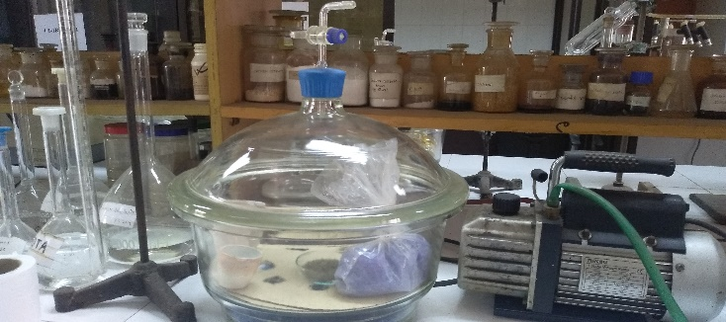
Figure2: Desiccator
Uses:
Desiccators are at times used to expel hints of water from a nearly dry example. Where a desiccator alone is unsuitable, the example might be dried at raised temperature utilizing Abderhalden's drying gun.

2.3.Ultrasonic bath:
Ultrasonic cleaning is a procedure that utilizations ultrasound (normally from 20–40 kHz) to unsettle a liquid. The ultrasound can be utilized with simply water, however utilization of a dissolvable proper for the thing to be cleaned and the sort of ruining present upgrades the impact. Cleaning ordinarily keeps going somewhere in the range of three and six minutes, yet can likewise surpass 20 minutes, contingent upon the article to be cleaned.
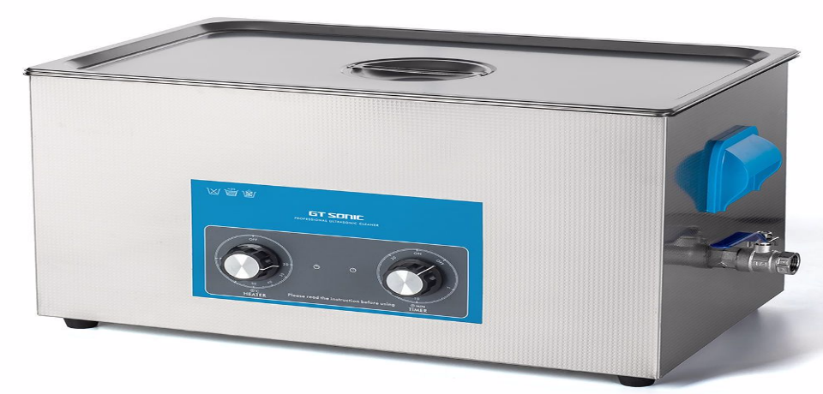

Figure3: Ultrasonic bath

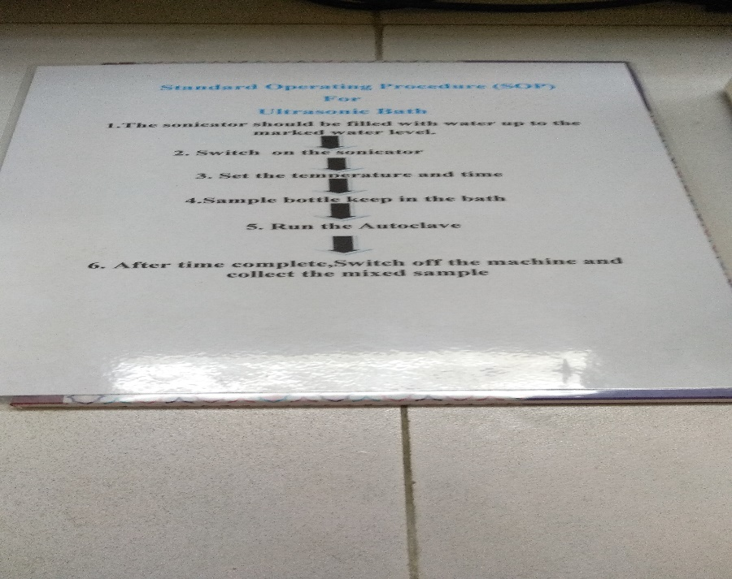
Uses:
Ultrasonic cleaners are utilized to clean various sorts of articles, including gems, focal points and other optical parts, watches, dental and careful instruments, apparatuses, coins, wellspring pens, golf clubs, angling reels, window blinds, guns, vehicle fuel injectors, melodic instruments, gramophone records, mechanical parts and electronic hardware. They are utilized in numerous adornments workshops, watchmakers' foundations, and electronic fix workshops.
2.4.Rotary evaporator:
A rotational evaporator (or rotavap/rotovap) is a gadget utilized in compound research centers for the productive and delicate expulsion of solvents from tests by dissipation. At the point when referenced in the science inquire about writing, portrayal of the utilization of this strategy and gear may incorporate the expression "turning evaporator", however use is frequently rather motioned by other language (e.g., "the example was vanished under diminished weight").

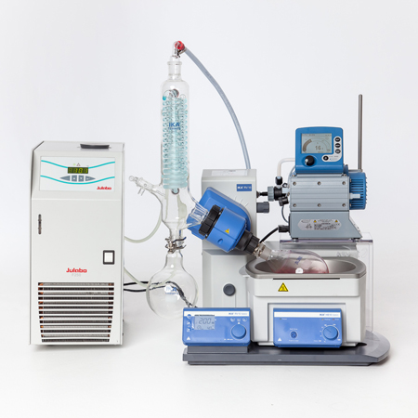
Figure 4:Rotary evaporator

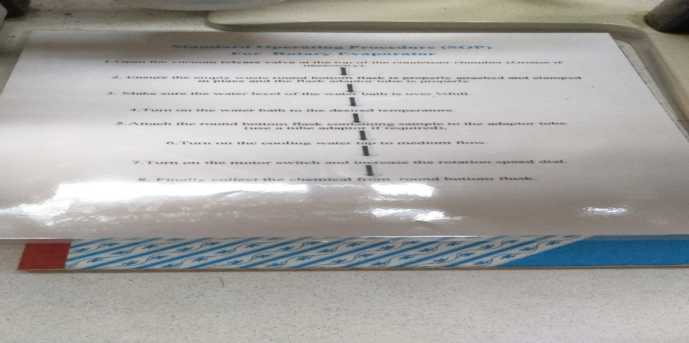
Uses:
Rotational evaporators are additionally utilized in atomic cooking for the readiness of distillates and concentrates.
2.5.Furnace:
A heater is a gadget utilized for high-temperature warming. The name gets from Latin word fornax, which means stove. The warmth vitality to fuel a heater might be provided straightforwardly by fuel burning, by power, for example, the electric circular segment heater, or through acceptance warming enlistment heater .

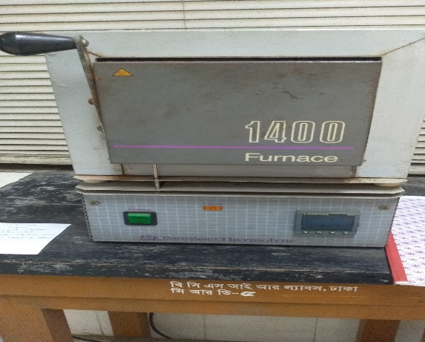
Figure 5: Furnance

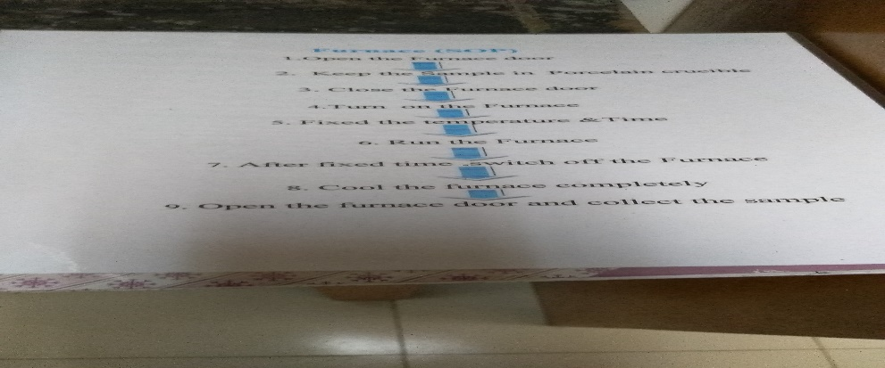

Uses:
A heater is a mechanical heater utilized for some things, for example, the extraction of metal from mineral (purifying) or in petroleum treatment facilities and other concoction plants, for instance as the warmth hotspot for fragmentary refining segments. The term heater can likewise allude to a direct terminated warmer, utilized in evaporator applications in compound businesses or for giving warmth to synthetic responses to procedures like breaking, and is a piece of the standard English names for some metallurgical heaters around the world.
2.6.Water Bath:
A water shower is research facility hardware produced using a holder loaded up with warmed water. It is utilized to brood tests in water at a consistent temperature over an extensive stretch of time. All water showers have an advanced or a simple interface to enable clients to set an ideal temperature. Utilisations incorporate warming of reagents, dissolving of substrates or brooding of cell societies. It is likewise used to empower certain synthetic responses to happen at high temperature. Water shower is a favored warmth hotspot for warming combustible synthetics rather than an open fire to avert ignition.
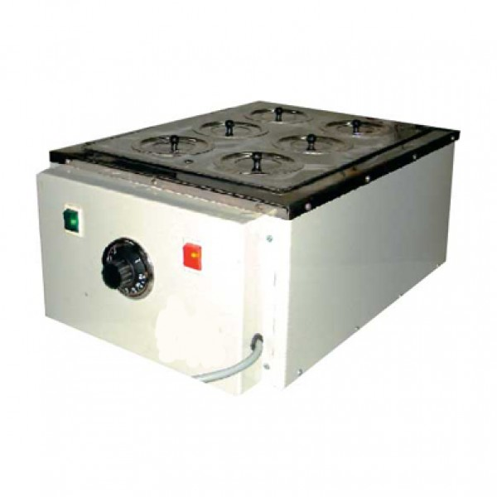
Figure 6:Water Bath:

Uses:
Different kinds of water showers are utilized relying upon application. For all water showers, it very well may be utilized something like 99.9 °C.When temperature is over 100 °C, elective strategies, for example, oil shower, silicone shower or sand shower might be utilized.
2.7.Oven dryer:
Drying stoves are gadgets used to expel water and different solvents from the things put inside them. Regardless of whether utilized in the home to dry things, for example, blossoms rapidly and securely, or on a mechanical scale with transport lines sustaining staples into the broilers throughout the day, the fundamental elements of the drying stove continue as before. These stoves expel dampness through a convection procedure, gathering it somewhere else so the article winds up got dried out.
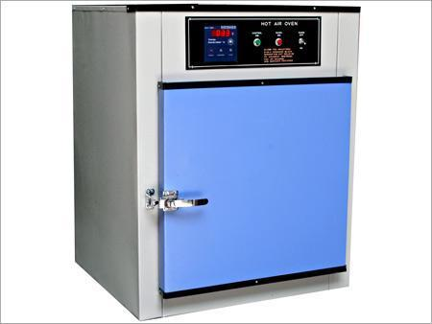
Figure 7: oven dryer

2.8.Binder:
A folio or restricting operator is any material or substance that holds or attracts different materials together to shape a durable entire precisely, synthetically, by bond or attachment.
In an increasingly limited sense, fasteners are fluid or mixture like substances that solidify by a concoction or physical procedure and tie strands, filler powder and different particles included into it.

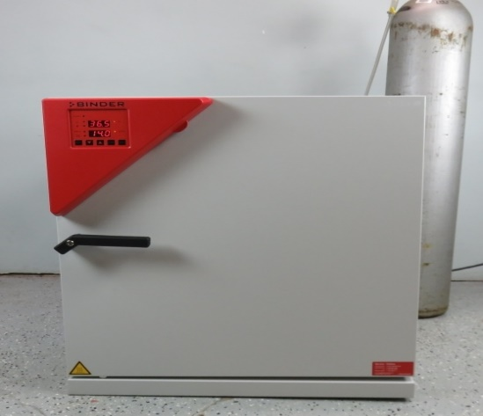
Figure 8:Binder
Uses:
Examples include glue, adhesive and thickening. Examples of mechanical binders are bond stones in masonry and tie beams in timber framing.
2.9.Experiment in Chemical Research Division ( Industrial Chemical Section):
The experiment was done in Chemical Research Division (Industrial Chemical Section)as Herbal Hand Wash( used :Moisturizing hand cleanser), Aloe Gel( used: Men & Women), Herbal Shaving Foam( used: Saloon & Parlor), Neem Based Cream (used: Antibacterial skin care cream), Baby Liquid Laundry Detergent (used: Liquid detergent specialized for baby skin),Ultrasound gel(used: Hospital and Clinic), Baby Oil Scale of Development Major Raw Material (Health looking skin), Herbal Face Wash(used: Clean, clear and healthy looking skin), Chitin from shrimp industry waste (used: Several medicinal, industrial and biotechnological purposes), Chitosan from shrimp shell waste (used: Agriculture, Food preservative ,Drug delivery, Cosmetics etc),Cotton seed oil ( used: Soaps, facial wash, shampoo),Ripe mango peel (used: stabilizing),Ripe jackfruit waste(used: thickening, stabilizing), Ripe mango seed ( used: food additives ),Mango seed oil( used: soap, shampoo, cream ect).Anhydrous Aluminum Chloride( used: isomerization), Lead Acetate( used: textile printing and dyeing), Phosphate based fire extinguishing(used: Extinguish the ABC type fire),Zinc Acetate(used: dietary supplement and in lozenges ), Carbonate based fire extinguishing(used: Extinguish the BC type fire) etc.
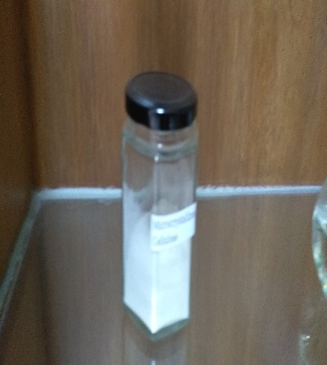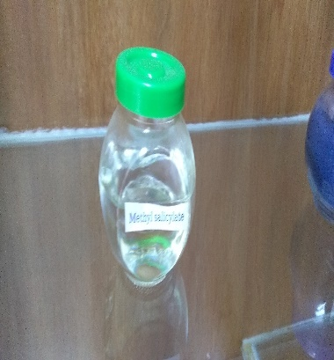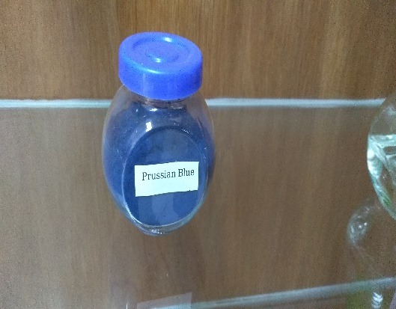
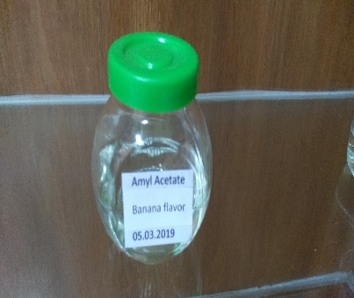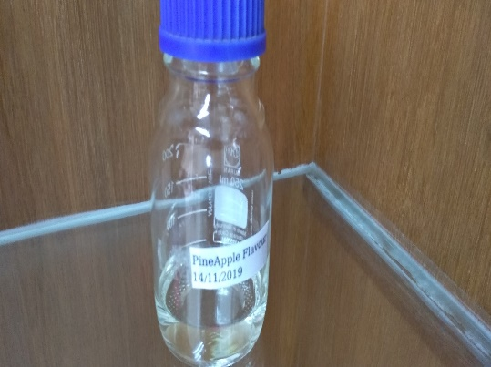

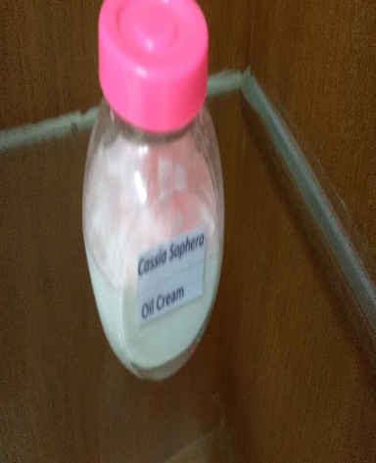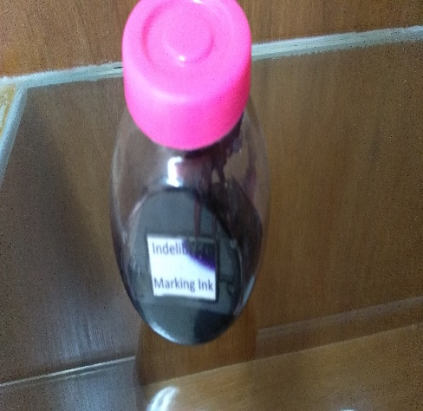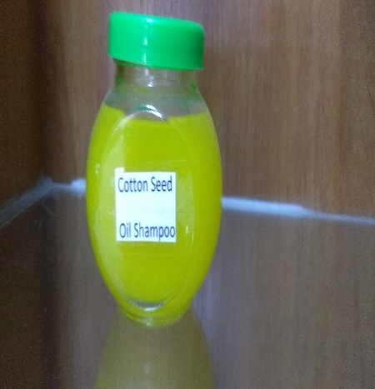
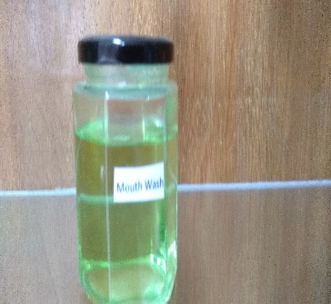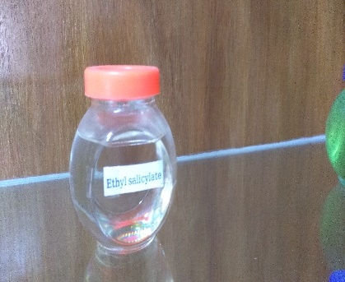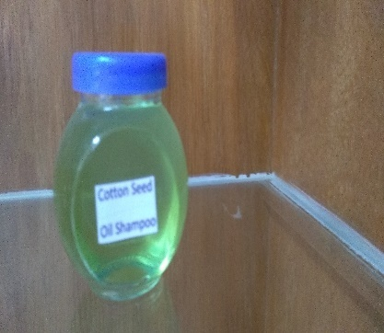
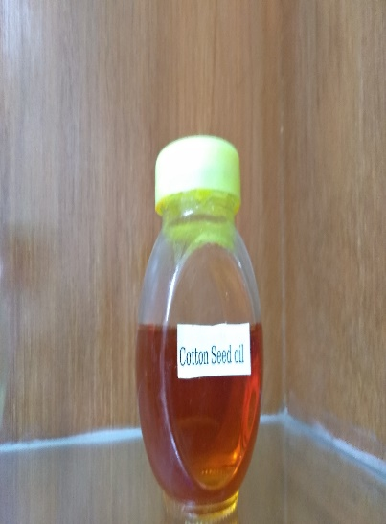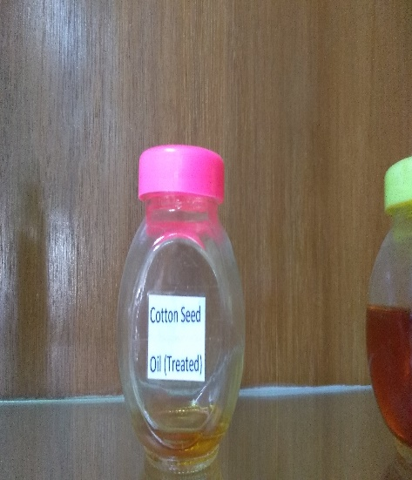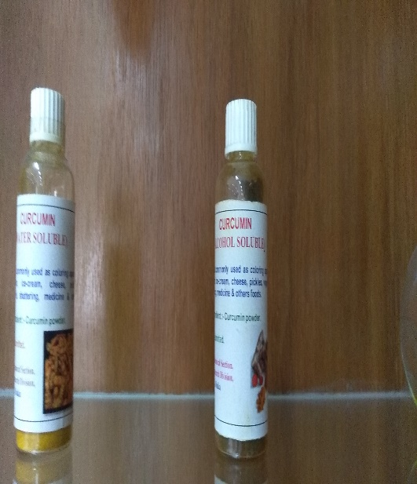
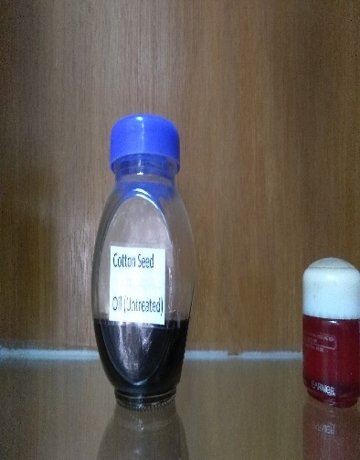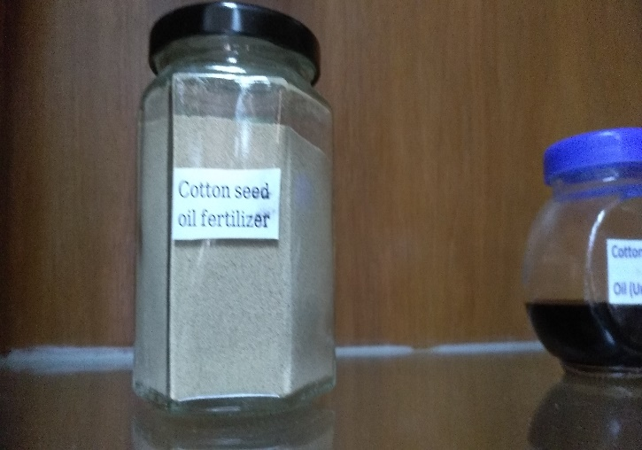

Figure: 9:Experiment in Chemical Research Division ( Industrial Chemical Section)

