THE SURVIVOR

BY

MD. REDWAN AHAMMED
ID: 152-15-611

AND

SYEDA SAIMA RAHMAN
ID: 152-15-426

This Report Presented in Partial Fulfillment of the Requirements for the Degree of Bachelor of Science in Computer Science and Engineering

Supervised By

TASLIMA FERDAUS SHUVA
Lecturer (Senior Scale)
Department of CSE
Daffodil International University


DAFFODIL INTERNATIONAL UNIVERSITY

DHAKA, BANGLADESH

August 2019

APPROVAL

This Project titled “THE SURVIVOR“, submitted by Md Redwan Ahammed (ID:152-15-611), Syeda Saima Rahman (ID:152-15-426) to the Department of Computer Science and Engineering, Daffodil International University, has been accepted as satisfactory for the partial fulfillment of the requirements for the degree of B.Sc. in Computer Science and Engineering (BSc) and approved as to its style and contents. The presentation has been held on 16-09-2019.

Board of Examiners


Dr. Syed Akhter Hossain Chairman
Professor and Head
Department of Computer Science and Engineering
Faculty of Science & Information Technology
Daffodil International University
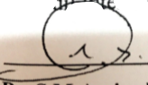

Dr. S M Aminul Haque Internal Examiner
Associate Professor and Associate Head
Department of Computer Science and Engineering
Faculty of Science & Information Technology
Daffodil International University


Saif Mahmud Parvez Internal Examiner
Lecturer
Department of Computer Science and Engineering
Faculty of Science & Information Technology
Daffodil International University
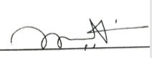
Dr. Mohammad Shorif Uddin External Examiner
Professor
Department of Computer Science and Engineering
Jahangirnagar University

DECLARATION

We hereby declare that, this project has been done by us under the supervision of Taslima Ferdaus Shuva, Senior Lecturer, and Department of CSE Daffodil International University. We also declare that neither this project nor any part of this project has been submitted elsewhere for award of any degree or diploma.

Supervised by:


…………………………….
Taslima Ferdaus Shuva
Senior Lecturer
Department of CSE
Daffodil International University

Submitted by:


………………………..
(Syeda Saima Rahman)
ID: 152-15-426
Department of CSE
Daffodil International University


………………………..
(Md Redwan Ahammed)
ID: 152-15-611
Department of CSE
Daffodil International University

ACKNOWLEDGEMENT

We really grateful and wish our profound our indebtedness to Taslima Ferdaus Shuva,
Senior Lecturer, Department of CSE Daffodil International University, Dhaka. Deep Knowledge & keen interest of our supervisor in the field of learning model structure to carry out this project. His endless patience, scholarly guidance, continual encouragement, constant and energetic supervision, constructive criticism, valuable advice, reading many inferior draft and correcting them at all stage have made it possible to complete this project

We would like to express our heartiest gratitude to Prof. Dr. Syed Akhter Hossain, Head, Department of CSE, for his kind help to finish our project and also to other faculty member and the staff of CSE department of Daffodil International University.

We would like to thank our entire course mate in Daffodil International University, who took part in this discuss while completing the course work.

At last, we should recognize with due regard the consistent help and patients of our Works.

ABSTRACT

First Person Shooter (FPS) games are one of the most popular game genres and have a history of over 2 decades. “The Survivor” is the name of our game that is developed for the project in Computer Science & Engineering Department at Daffodil International University. The game is a 3D single player first-person shooter game created using C# in Unity game development studio. First Person Shooters are 3D combat styled games where the player acts as the leading character, which is carrying multiple weapons and kill its opponents while playing the game. In this game, there are several environments, classic opponents and a great graphical view is available for the players.

TABLE OF CONTENTS
CONTENTS | PAGE
Board of Examiners | i
Declaration | ii
Acknowledgement | iii
Abstract | iv
Table of contents | v-vi
List of figures | vii-viii
CHAPTER | PAGE
CHAPTER 1: Introduction | 1- 2
1.1 Introduction | 1
1.2 Motivation | 1
1.3 Objectives | 2
1.4 Expected Outcome | 2

CHAPTER 2: Background | 3–4
2.1 Introduction | 3
2.2 Related work | 3
2.3 Comparative Studies | 3
2.6 Challenges | 4

CONTENT |  | PAGE
CHAPTER 3: Requirement Specification |  | 5-8
3.1 | Requirement Collection and Analysis | 5
3.2 | Use Case Modeling and Description | 7
3.3 | Use Case Model | 7
3.4 | Design Requirements | 8

CHAPTER 4: Design Specification |  | 9-18
4.1 | Player view | 9
4.2 | Enemy | 10
4.3 | Tree | 10
4.4 | Guns | 12
4.5 | Ammo Box | 13
4.6 | Crates | 13
4.7 | Houses | 14
4.8 | Others | 15

CHAPTER 5: Working Procedure |  | 19-25
5.1 | Main Menu | 19
5.2 | Light | 24
5.3 | Sound Effect | 24

CHAPTER 6: Conclusion and Future Scope |  | 25-26
6.1 | Conclusion | 25
6.2 | Future Scope | 26
References |  | 27
Plagiarism Result |  | 28-29

LIST OF FIGURES

FIGURES | PAGE NO
Figure 3.3.1: Use case model for Player | 8
Figure 3.3.2: Use case model for Player and the game | 8
Figure 4.1: Player | 10
Figure 4.2: Enemy | 11
Figure 4.3.1: Tree 1 | 11
Figure 4.3.2: Tree 2 | 12
Figure 4.3.3: Tree 3 | 12
Figure 4.4.1: Hand cannon | 13
Figure 4.4.2: SMG | 13
Figure 4.5: Ammo Box | 14
Figure 4.6: Crates | 14
Figure 4.7.1: House 1 | 15
Figure 4.7.2: House 2 | 15
Figure 4.8.1: Container | 16
Figure 4.8.2 : Bridge | 17
Figure 4.8.3: Tires | 17
Figure 4.8.4: Generator | 18

Figure 4.8.5: Pressure Tank | 18
Figure 4.8.4: Small Ladder | 19
Figure 4.8.4: Concrete Barrier | 19
Figure 5.1: Main Menu | 20
Figure 5.1.2: Credits | 21
Figure 5.1.3: Game Over | 21
Figure 5.1.4: Terrain | 22
Figure 5.1.5: The Jungle | 22
Figure 5.1.6: The Desert | 23
Figure 5.1.7: The River | 23
Figure 5.1.8: Dynamic Minimap | 24
Figure 5.1.9: Grass | 24

CHAPTER 1

Introduction

  - Introduction

The gaming Industry is a multi-billion dollar industry. In 1971, the Arcade game - Computer Space was build. Some of the famous gaming companies have delivered an amazing range of video games and continuing their production are– Electronic Arts (EA) games, Bungie, Nintendo, id Software Ltd., Ubisoft etc(1). There are several genres of games, like Shooter games (first and third person), Survival games, Action adventure games, Role-playing games, Simulation games and Strategy games. Out of all genres, First Person Shooter (FPS) is one of the most popular. First Person Shooters are 3D combat styled games where the player acts as the leading character, which is carrying multiple weapons and kill its opponents while playing the game. In this Chapter, we will discuss why we were motivated to build this project, and the contribution we will make towards the sector of design recovery of first person shooter games.

  - Motivation.

We play games to have fun and sometimes we play to take some time off from our real life.
Now a day’s almost 2.2 billion people play games every day(2). Even many people play games as their full time job. But in our country, many people play games just to kill time not to earn money. Because we don’t have the opportunity to do so. Developed countries have produced so many large gaming companies and so many popular games. That’s why they can earn so much money from it. In our country, we don’t have this kind of thing. So, we decided to work in the gaming field and develop a wonderful game and maybe open a big company someday, so that, our people can plays our game and earn from it. That’s a nice theme we think. Just play to have fun and earn for living.

1.3 Objectives

1.3.1 Improved Player Satisfaction

Our first objective is to give players the privilege to feel they have best control over their gameplay. By providing unique features, we aim to make the player satisfied with our game.

1.3.2 Player Experience

The main goal of our game is to attract the gamers of our country. With an amazing 3D map we think players will be more interested to play our game.

1.4 Expected Outcome

After passing maximum part of feasibility case study, we are in a stage that we could imagine

Player Sign Up: Since we are creating an offline game, so anyone who download the game will be able to play the game without sign up or sign in.

Players: Players are the main target of a game. All the design and implementations are only to interacting players and make the game interesting and attractive to play.

CHAPTER 2

Background

2.1 Introduction:

In this chapter, we try to give an overall idea about the background work of the project ―”The Survivor”. To develop a game, a huge amount of knowledge is required to predict and discover all the expectation that may occur. Players play a lot of games. To like our game we have to make sure that we put the best of our work so that players like our game more than any other game. For example, players interact with the map of the game, how cool the map is, how cool the animation looks. So we have to do tons of research about all of this stuff and put our best work on our game.

2.2 Related Works:

There are a lot of First person shooting games. Since it is the most popular genre of the games, so many people and gaming companies produce FPS games.
Like The Survivor, Into the Woods etc.

2.3 Comparative Studies:
Our game has some advantage and disadvantage. The following advantage and disadvantage are:

Advantage:
- Our game is offline. So you don’t need internet to play the game. Just download the game and you are good to go.
- The game is user friendly.

Disadvantage:

1. Since we are creating our first game, so there can be a lot of mistakes and bugs in the game.

2.6 Challenges:
We face a few challenges when we are developing our project as this concept was unknown to us but at last we able to complete our project successfully by the grace of Almighty “Allah”
- To use 3D models in our game.
- Making perfect scripts for AI.
- Skills for this project.

CHAPTER 3

Requirement Specification

3.1 Requirement Collection and Analysis

This part covers the prerequisites explicit of our game "The Survivor". It incorporates the particular of this documentation with general portrayal, specific requirements and investigation of models. It additionally incorporates changes the executives of this prerequisite detail if there should arise an occurrence of any change.

3.1.1 Server Requirement

Windows Operating System, Unity 3D, C#, Visual Studio, JavaScript

3.1.2 Operating System

Windows
Windows ten could be a laptop bundle created and released by Microsoft Corporation as a piece of the Windows NT group of usable frameworks. It was officially opened in September 2014 after a short demo at Build 2014. The essential variant of the product bundle entered an open beta testing technique in October 2014, paving the way to its customer discharge on July 29, 2015 (3).

Linux
Linux might be a Unix-like and primarily POSIX-compliant portable computer OS (Operating System) which is assembled below the model of free and American Standard Code for Information Interchange document package development and distribution. The method part of OS is that the OS kernel, associate OS kernel initial discharged on a day, 1991 by Linus Torvalds (3).

Web Server:
A Web server is a program that utilizations Hypertext Transfer Protocol to serve the documents to clients. Committed PCs and machines could likewise be referenced as web servers furthermore. In light of their solicitations, that is sent by their PC’s HTTP customers (3).

3.1.3 Game Developing Tools

Unity 3D
Unity 3D is a cross-stage game engine with an inherent IDE created by Unity advances. It is commonly used to create computer games for PC stages, for example, web and work area, consoles and cell phones, and is connected by a few million designers on the planet. Unity is basically used to make versatile and web games, yet there are different games to be produced for PC. The game motor was customized in C/C++, and can bolster codes written in C#, JavaScript or Boo. It developed from an operating system X bolstered game improvement apparatus in 2005 to the multi-stage game engine that it is today (3).

C# (Programming Language)
C# (articulated "C-sharp") is an article situated programming language from Microsoft that intends to join the processing intensity of C++ without any difficulty of Visual Essential. C# depends on C++ and contains highlights like those of Java. C# is intended to work with Microsoft's .Net stage. Microsoft's point is to encourage the trading of data and administrations over the Internet, and to empower designers to assemble exceptionally convenient applications. C# rearranges programming through its utilization of Extensible Markup Language (XML) and Basic Item Access Convention (Cleanser) which enable access to a programming article or technique without requiring the software engineer to compose extra code for each progression. Since software engineers can expand on existing code, as opposed to over and again copying it, C# is relied upon to make it quicker and more affordable to get new items and administrations to advertise (3).

Visual Studio
Microsoft Visual Studio is a coordinated advancement condition (IDE) from Microsoft. It is utilized to create PC programs, just as sites, web applications, web administrations and versatile applications. Visual Studio utilizes Microsoft programming improvement stages, for example, Windows Programming interface, Windows Structures, Windows Introduction Establishment, Windows Store and Microsoft Silverlight. It can create both local code and oversaw code. Visual Studio incorporates a code editorial manager supporting IntelliSense (the code fruition part) just as code refactoring. The coordinated debugger works both as a source-level debugger and a machine-level debugger. Other inherent apparatuses incorporate a code profiler, structures originator for structure GUI applications, website specialist, class planner, and database construction fashioner (3).

3.2 Use Case Modeling and Description

UML use case diagrams can be used to describe the functionality or process of a system in a horizontal way and representing the details of individual features of a system.

3.3 Use Case Model

Use case chart is the essential type of framework necessities for another product program immature. Use cases indicate the normal conduct (what), and not the definite strategy for getting it going (how). Use cases once indicated can be meant both literary and visual portrayal, (for example, UML). A key idea of utilization case demonstrating is that it causes us plan a framework from the end client's point of view.

The Survivor
System
Player
Fig 3.3.1: Use case model for Player
Play
Player

Option

Scoreboard

Quit

Action
Objective

Fig 3.3.2: Use case model for Player and the game

3.4 Design Requirements

Design requirement means how friendly our game is to the player and how to easily implement this design to the players view or front end. While developing our game we have kept in mind to reach our goals with designing system following criteria:
- Make the game simple and flexible for the players.
- Make the game compatible.
- Efficiency.
- Easy to play.
- Optimize game performance.

CHAPTER 4

Design Specification

There are few three dimensional models and sound effects we imported from outside in making of this game. There are also some objects we used from Unity. Those models and objects are listed below.

4.1 Player view
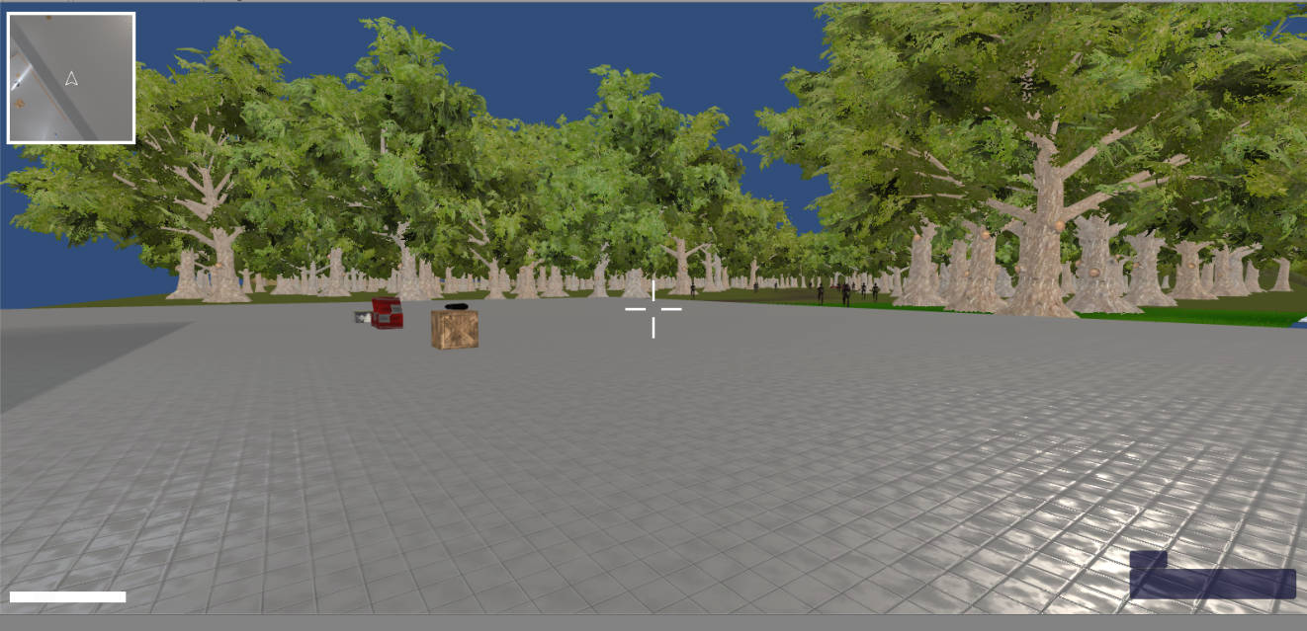
Fig 4.1: Player

4.2 Enemy
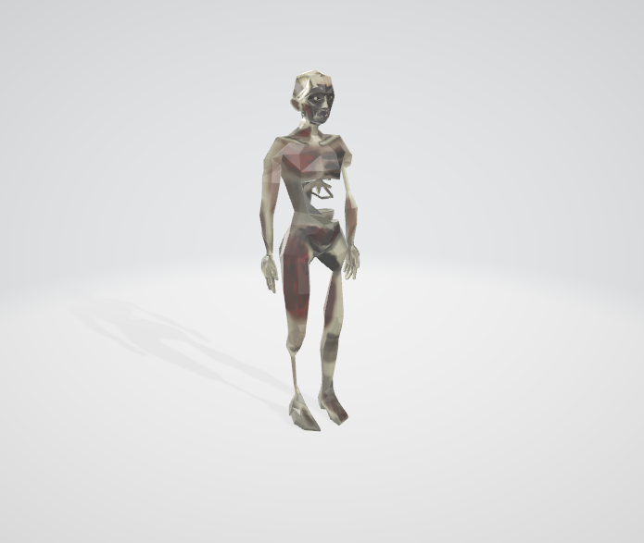
Fig 4.2: Enemy

4.3 Tree
We added some tree from Unity. Some trees are also collected from outside source.
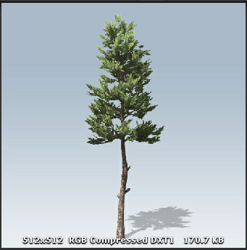
Fig 4.3.1: Tree 1

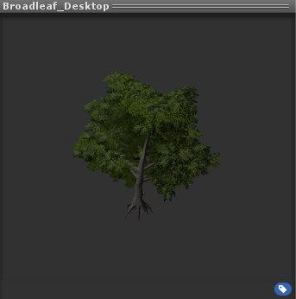
Fig 4.3.2: Tree 2

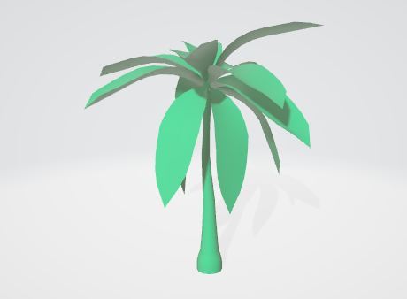
Fig 4.3.3: Tree 3
We collected this tree and modified it in game.

4.4 Guns
We added only two guns for this game. A Hand cannon and a SMG.
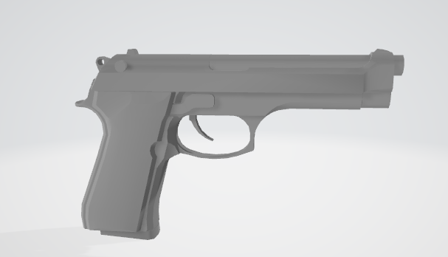
Fig 4.4.1: Hand cannon
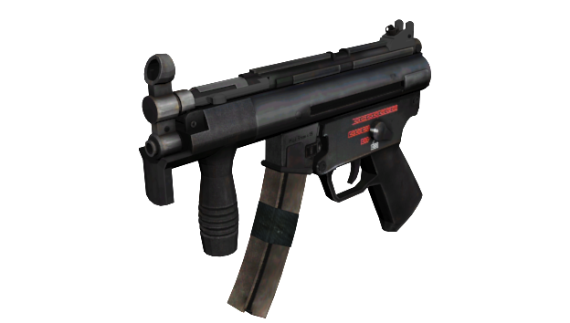
Fig 4.4.2: SMG

4.5 Ammo Box
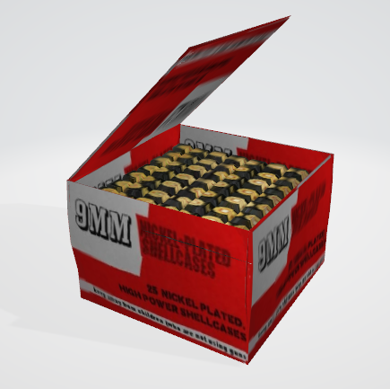
Fig 4.5: Ammo Box

4.6 Crates
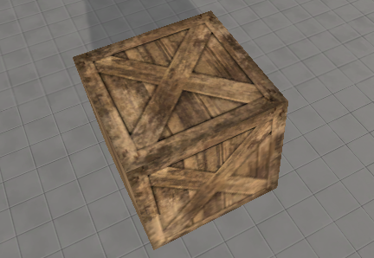
Fig 4.6: Crate

4.7 Houses
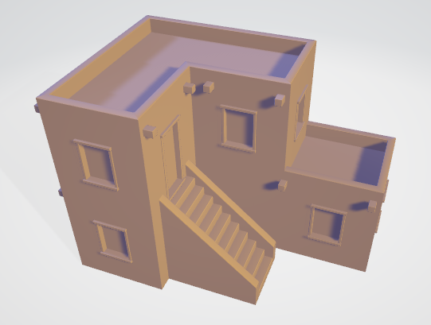
Fig 4.7.1: House 1
We implemented and used this house in our game.

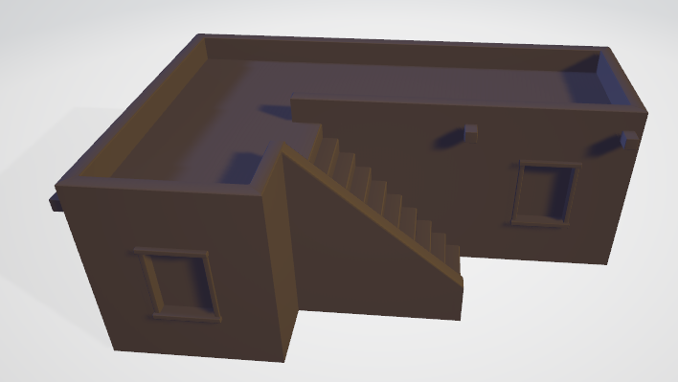
Fig 4.7.2: House 2

4.8 Others

We have used some other small and big models in our game. Those are listed below,
- Container
- Bridge
- Tires
- Generator
- Pressure Tank
- Small Ladder
- Concrete Barrier

4.8.1 Container
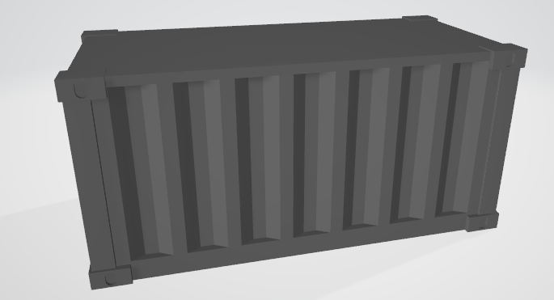
Fig 4.8.1: Container
We implemented and used this model as a Container in our game.

4.8.2 Bridge
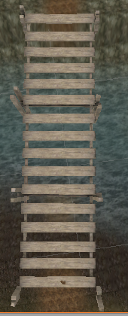
Fig 4.8.2: Bridge
We implemented and used this model as a Bridge in our game.

4.8.3 Tires
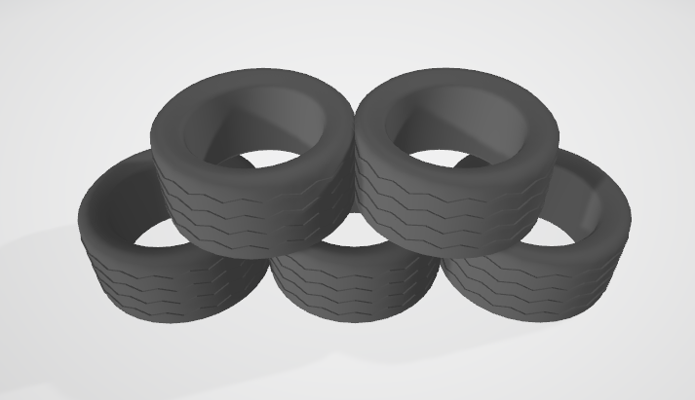
Fig 4.8.3: Tires
We implemented and used this model as Tires in our game.

4.8.4 Generator
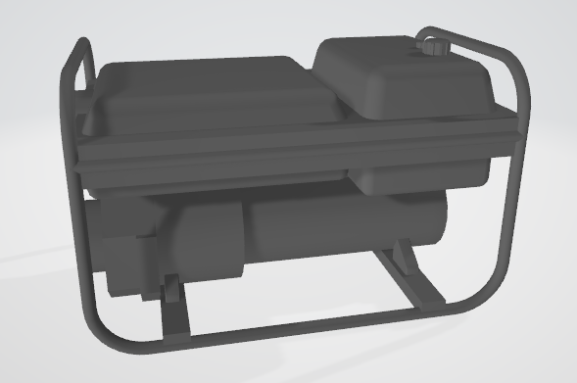
Fig 4.8.4: Generator
We implemented and used this model as a Generator in our game.

4.8.5 Pressure Tank
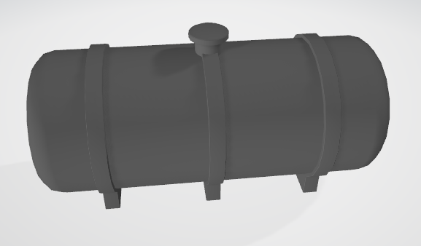
Fig 4.8.5: Pressure Tank
We implemented and used this model as a Pressure Tank in our game.

4.8.6 Small Ladder
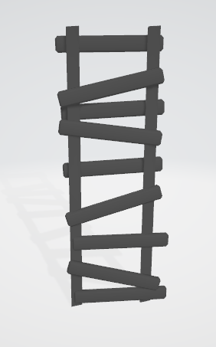
Fig 4.8.6: Small ladder
We implemented and used this model as a small Ladder in our game.

4.8.7 Concrete Barrier
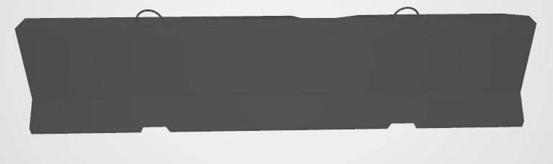
Fig 4.8.7: Concrete Barrier
We implemented and used this model as a Concrete Barrier in our game.

CHAPTER 5

WORKING PROCEDURE

5.1 Main Menu
If we open the game, this scene will appear on the display.
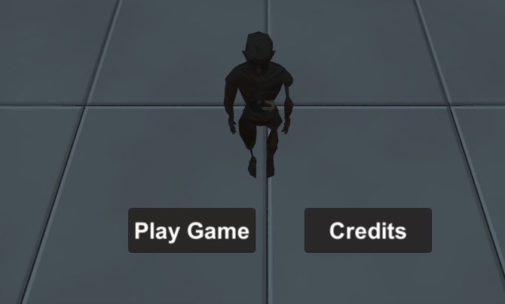
Fig 5.1

    - Play Game
By pressing the play game button we can start our game from the beginning. The script is on the button options script where it enables the button function of the play game button.

    - Credits
By pressing the credit button a new interface will appear. This interface is shown below.
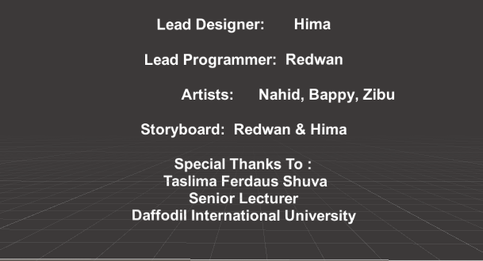
Fig 5.1.2: Credits

5.1.3 Game Over
If the player is dead or the player finish the game, then this scene will appear on the screen.
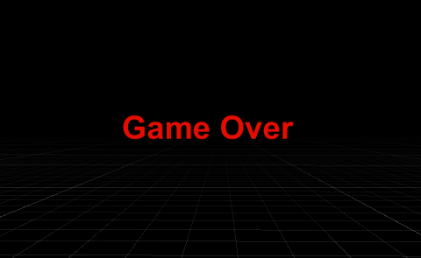
Fig 5.1.3: Game Over

5.1.4 Terrain
We have added a bigger terrain for the game. Different environments and town are available in the terrain.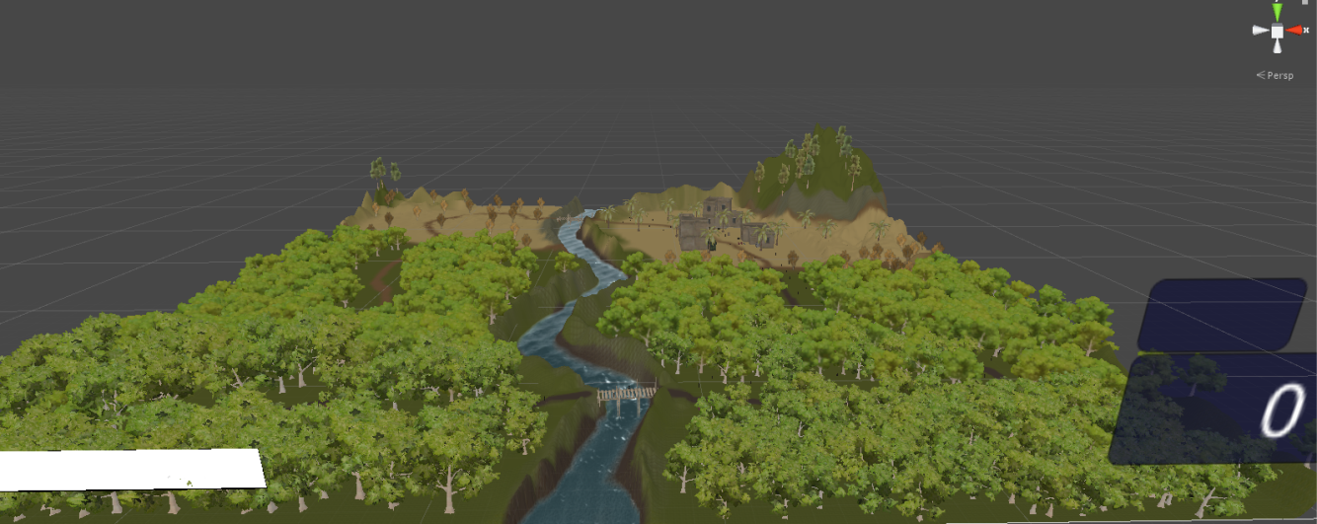
Fig 5.1.4: Terrain

5.1.5 The Jungle
Most part of the terrain is Jungle. Player will run through the Jungle and eliminate zombies to gain higher score.
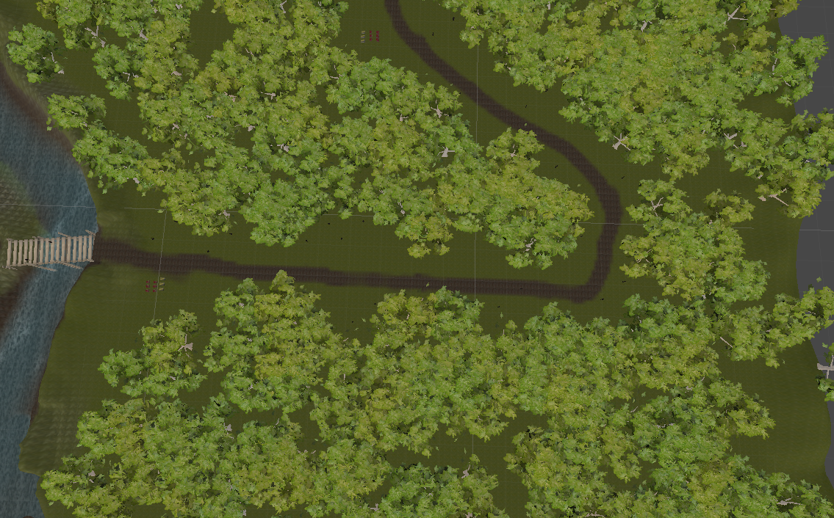
Fig 5.1.5: The Jungle

5.1.6 The Desert

The other part of the terrain is the Desert.
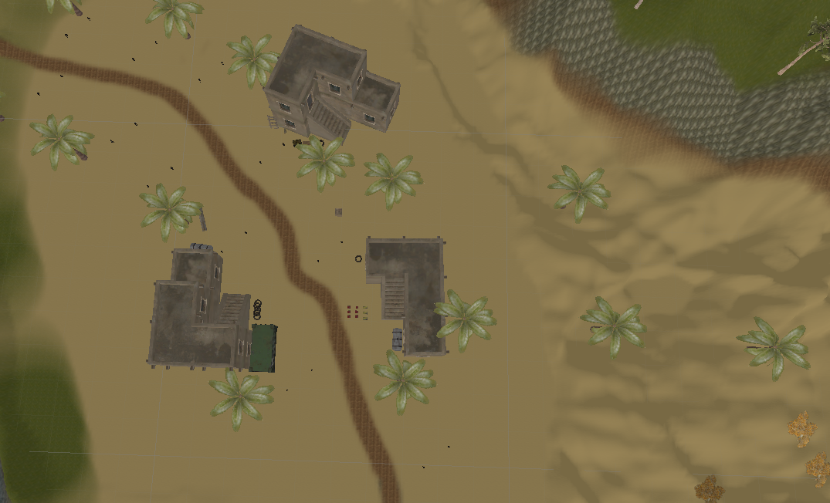
Fig 5.1.6: The Desert

5.1.7 The River

There is a river in the middle of the terrain.
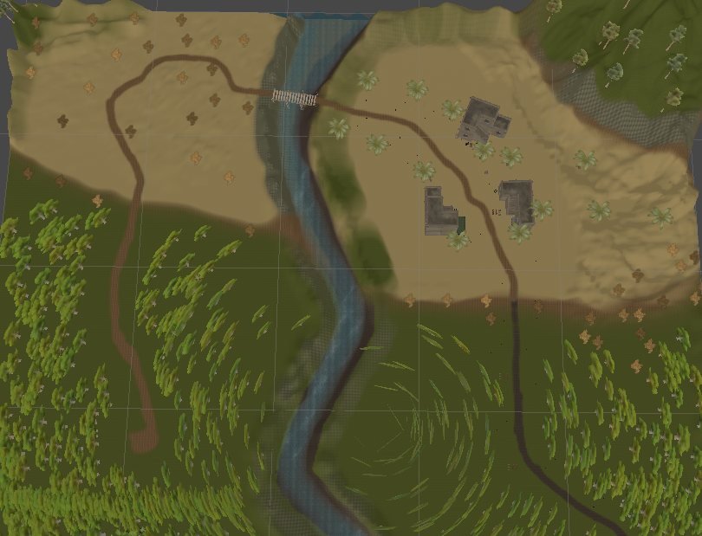
Fig 5.1.7: The River

5.1.8 Dynamic Minimap
Dynamic mini map is made with one camera that is attached to our player, located very high from player.
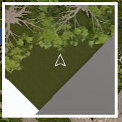

5.1.9 Grass
We added some grass to the terrain for decoration.

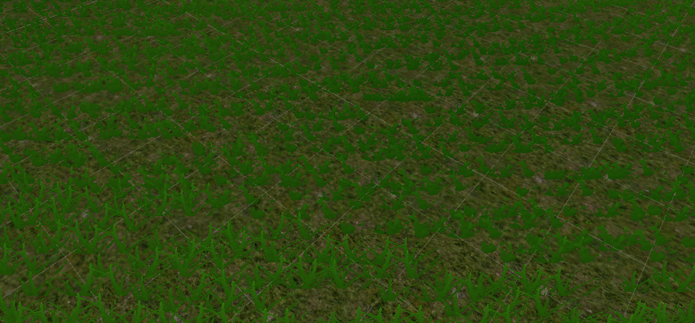
Fig 5.1.9: Grass

5.2 Light
We used one directional light from unity engine to make sun. This light will also give us shadow function.

5.3 Sound Effect

We added different sound effects on each of the events, like different sound for different weapons while shooting, different reload sound, player run sound, enemy attack sound,
Player get hurt sound.

CHAPTER 6

Conclusion and Future Scope

6.1 Conclusion
We tried to make this game as good as possible. And it kind of met our expectations. We wanted to make a good quality video game in low budget so that we can give this to players in a lower price. Our budget was not that much either. Although it was hard to find models or tools because of their high cost, we tried our best and hopefully delivered a good game project.
Another obstacle in our path was lack of time. Making a video game requires a lot of time and research. We had to work even at mid nights to finish our work. Our supervisor also pushed us and encouraged us to work hard. Some functions of this video game were quite easy to make while many function took a lot of work behind it.
It took us from two to three months of research and three months of hard work to finish this video game project.
We chose FPS game genre for our game because this kind of game is quite popular now-a-days. We don’t have many game developers or game companies and there are not a lot of games developed in our country. This is an achievement for us as a CSE student to add a FPS game among the few in our country. This project was a dream for us. We are really happy that while studying in Daffodil International University we made it possible. This project also built our game developing skills which will help us to make more games in near future.
After a long work in this video game project we accomplished many things. Those are as follows:
This game gives players a brand new virtual world to explore. Almost all age people will enjoy while playing this game. As this is our first game project, we will provide it to the players for free. Players can play this game without any internet connections and relax on his own.

6.2 Future Scope

We tried our best to make a better game but because of our limited resources and experience we couldn’t do everything we hope for. There are many things we will try to do in the future for this game. We will create more level for the players to play our game more and more. Add more weapons. We want to add another game mode, which will be online where players will battle each other instead of the zombies. We will update the game every month and add new exciting features so that the players spend more time on our game and have fun. We are hoping to create a competitive scene through our game so that players can earn while having fun, so that won’t be killing time. There are a lot of possibilities for game developing. We believe we can do lot better in near future for game developing.

REFERENCES

[1] An exploration of the architecture of first person shooter games, available at<< file:///E:/Unity/Project_Report/Samples/Prashar_Charu_201401_MSC.pdf >> last accessed date: 11-07-2019 at 11.00pm.

[2] https://gaimin.io/how-many-gamers-are-there/ last accessed date: 17-07-2019 at 10.00am.

[3] https://en.wikipedia.org/wiki/ last accessed date: 04-08-2019 at 3.00pm

[4] Learn about making FPS game, available at << https://www.youtube.com/watch?v=0fGB2H1AGP8&list=PLZ1b66Z1KFKh-auyvzNkOBFLWf6dH6iEH&index=2&t=0s >> last accessed date: 05-03-2019 at 11.00pm.

[5] Learn about creating mini map, available at << https://www.youtube.com/watch?v=28JTTXqMvOU >> last accessed date: 20-07-2019 at 8.00pm

Plagiarism Report

