“E-Census Information Management System”

BY

Name & ID

Shifat Ul Ferdoush Ayon : 151-15-483

Sumon Ahmed : 152-15-515

Arjun Baidya : 151-15-471

This Report Presented in Partial Fulfillment of the Requirements for the Degree of Bachelor of Science in Computer Science and Engineering.

Supervised By

Ms. Fatema Tuj Johora

Lecturer

Department of CSE
Daffodil International University

Co-Supervised By

MD. Ohidujjaman Tuhin
Lecturer

Department of CSE

Daffodil International University


DAFFODIL INTERNATIONAL UNIVERSITY

DHAKA, BANGLADESH

APPROVAL

This Report titled is “E-Census Information Management System,” submitted by Shfat Ul Ferdoush Ayon, Arjun Baidya and Sumon Ahmed to the Department of Computer Science and Engineering, Daffodil International University, has been accepted as satisfactory for the partial fulfillment of the requirements for the degree of Bachelor of Science in Computer Science and Engineering (BSc) and approved as to its style and contents. The presentation has been held on 19 January 2018.

BOARD OF EXAMINERS

 | Dr. Syed Akhter Hossain
 | Professor and Head |  | Chairman
Department of CSE
Faculty of Science & Information Technology
Daffodil International University
 | Dr. S. M. Aminul Haque |  | Internal Examiner
 | Associate Professor and Associate Head
 | Department of CSE
 | Faculty of Science & Information Technology
 | Daffodil International University
 | Saif Mahmud Parvez |  | Internal Examiner
 | Lecturer
 | Department of CSE
 | Faculty of Science & Information Technology
 | Daffodil International University
 | Dr. Mohammad Shorif Uddin |  | External Examiner
 | Professor
 | Department of CSE
 | Jahangirnagar University

i

DECLARATION

I hereby declare that, this project has been done by us Shfat Ul Ferdoush Ayon, Arjun Baidya and Sumon Ahmed under the supervision of Ms. Fatema Tuj Johora, Lecturer and Department of CSE Daffodil International University. We also declare that neither this project nor any part of this project has been submitted elsewhere for award of any degree or diploma.

Supervised by:

Fatema Tuzzohora
Ms. Fatema Tuj Johora
Lecturer

Department of CSE

Daffodil International University

Co-Supervised by:

MD. Ohidujjaman Tuhin

Lecturer

Department of CSE

Daffodil International University
Submitted by:

Shfat Ul Ferdoush Ayon

ID: 151-15-483

Department of CSE

Daffodil International University

Arjun Baidya

ID: 151-15-471

Department of CSE

Daffodil International University

______________________
Sumon Ahmed

ID: 152-15-515

Department of CSE

Daffodil International University

ACKNOWLEDGEMENT

First, we express heartiest thanks and gratefulness to the almighty for His divine blessing makes me possible to complete the final year project successfully.

We really grateful and wish my profound our indebtedness to Ms. Fatema Tuj Johora, Lecturer, Department of CSE, Daffodil International University, Dhaka. Deep Knowledge & keen interest of our supervisor in the field of “E-Census Information Management System” to carry out this project. His endless patience, scholarly guidance, continual encouragement, constant and energetic supervision, constructive criticism, valuable advice , reading many inferior drafts and correcting them at all stage have made it possible to complete this project.

We would like to express our heartiest gratitude to Dr. S. M. Aminul Haque, Associate Professor and Associate Head, Department of CSE Daffodil International University, Permanent Campus and Dr. Syed Akhter Hossain, Professor and Head of the Department of CSE, for his kind help to finish our project and also to another faculty member and the staff of CSE department of Daffodil International University.

We would like to thank our entire course mate in Daffodil International University, who took part in this discuss while completing the course work.

Finally, we must acknowledge with due respect the constant support and patience of our parents.

iii

ABSTRACT

The report presents the development of an online census application as a service. In this project, we developed a website which can help the general people to go under the govt. based census system as well. An E-Census Information Management System is the online census web application. It will help the people to find them get registered in the govt. web portal of BANBEIS. On the other hand they can easily track down through it. This application has been developed by content management system (CMS) using framework and written in PHP, MySQL, AJax, Javascript, Bootstrap4 and CSS3 function. The application has been designed as a web based program to those users’, who are the citizen of the Peoples Republic of Bangladesh.

Keywords: PHP, MySQL, XAMPP, Html, CSS3, Java Script, JQuery, Bootstrap4

iv

 | TABLE OF CONTENTS
CONTENTS | PAGE
Approval | I
Declaration | II
Acknowledgement | III
Abstract | IV

CHAPTER 1: Introduction

1.1 | Introduction | 1
1.2 | Motivation | 2
1.3 | Objectives | 2
1.4 | Expected Outcome | 3
CHAPTER 2: Background
2.1 | Introduction | 4
2.2 | Related Work | 4
CHAPTER 3: Requirement Specification
3.1 | Business Process Model | 6
3.2 | System Requirements | 7
3.2.1 User Requirement |  | 7
3.2.2 Requirement Components |  | 7
3.2.2.1 Hardware Requirement |  | 7
3.2.2.2 Software Requirement |  | 8
3.3 | Use case Diagram | 9
3.3.1 Use case description |  | 10
3.4 | Logical Data Model | 12

v

CHAPTER 4: Design Specification

4.1 | Front-End Design |  | 13
4.2 | Back-End Design |  | 13
4.3 | Description |  | 13
4.3.1 |  | Website page Information | 14
4.4 | Project Flowchart |  | 15
4.5 | Smart E-Health System |  | 16
4.5.1 |  | Home page | 16
4.5.2 |  | Doctor’s Login | 17
4.5.3 Location |  |  | 18
4.5.4. Types of Symptom |  |  | 19
4.5.5 |  | Select Your Symptom | 20
4.5.6 |  | Doctor suggestion | 21
4.5.7 |  | Online Appointment | 22
4.5.8 |  | Booking Selection | 23
4.5.9 |  | Booking information | 24
4.5.10 Contact us |  |  | 25

CHAPTER 5: Implementation and Testing

5.1 | Database Management | 26
5.1.1 Database illustration |  | 26
5.1.2. Database Objects |  | 26
5.2 | Entity Relationship Diagram | 27
5.4 Implementation of Front-end Design |  | 31

vi

CHAPTER 6: Conclusion and Future scope

6.1 | Discussion | 32
6.2 | Conclusion | 32
6.3 | Future scope | 33
References |  | 34

LIST OF FIGURES

FIGURES

Figure 1: Business Process Model | 5
Figure 2: Use case Diagram E-health | 9
Figure 3: Logical data model | 12
Figure 4: Project Flowchart | 15
Figure 5: Home page | 16
Figure 6: Doctor’s Login | 17
Figure 7: Location | 18
Figure 8: Types of Symptom | 19
Figure 9: Select Your Symptoms | 20
Figure 10: Doctor Suggestion | 21
Figure 11: Online Appointment | 22
Figure 12: Booking Selection | 23
Figure 13: Booking Selection table | 25
Figure 14: Contact Us | 25
Figure 15: ER Diagram | 28

vii

Data Base Figure
Figure 16: Doctor Details | 29
Figure 17: District Information | 30
Figure 18: Specialist type Details | 30
Figure 19: Symptom Details | 31
Figure 20: Symptom Doctor Details | 32

 | LIST OF TABLES
TABLES NAME
Table 1: Software Requirement | 8
Table 2: Hardware Requirement | 7
Table 3: Use Case 1 | 10
Table 4: use case 2 | 10
Table 5: Use Case 3 | 11
Table 6: use case 4 | 11

viii

CHAPTER 1

Introduction

1.1 Introduction:
An E-Census Information Management System is very necessary and a crying need project for an IT developing countries like Bangladesh. Information Technology is a wonderful finding of present day’s technological development. This is in fact influencing even our day to day activities. When we come to some specialized forms of work, Information Technology’s part is even more important and it comes handy. For our paper too it is playing a major role. In our paper we are using Information Technology methods to collect census data. The term Census implies that the each individual and each set of individual characters are enumerated separately and that the characteristics thereof separately recorded. Census organization has experimented with new IT innovations since the beginning. Technology is required particularly for data capture/processing mainly due to large volume and for speedier tabulation & release of Census results. It is a small country and growing up with a lots of hope and possibilities in IT sectors. Now-a-days every government privileges are been given through IT system. But though we have a large population we don’t have still an online based system of census. This causes a hamper to bureau of statistics to calculate the exact number of population and give the necessary help to the people who exactly need this. As result, the vision fails. This increases the efficiency of the work and a great time is saved. They obtain help from revenue department to list the census houses. The obtained census data is commonly is used for research, business marketing, and for preparing the five-year plan. We calculate the path and designed a system called E-Census Information Management System to eradicate the problem as well.

1.2 Motivation:

Nowadays, most of the people of our country are not getting different services that are rendering by the govt. Most of the people don’t know about their rights. Firstly, govt. expenses a lot to calculate the exact amount of population. Thus it is a very time consuming and costly process often it shows the worst result. For example if I ask someone what is the exact number of population right now in Bangladesh, no correct answer should be found. Because in the traditional system of census there is lot of problems to count the real number of people. Here we planned for digitalized the census system.

1.3 Objectives:

This project is mainly working on the people who are the regular citizen of Bangladesh having their Birth ID, and National ID as well. We designed a website where people of different area of our country have no need to survey all in every 10 years. Which is very costly for the government. Every time it create problem to find the exact number of population. Thus the different services from the government is still missing in different respects. Nowadays most of the people are neglected by the rich men whereas everyone is equal to the eye of law. So we designed a website where people can get his service by his own under the supervision on an admin.
1.4 Expected Outcome:

- Calculate the number of overall population
- The ratio of birth and death rate.
- Retrieving the actual number of voters.
- The ratio of male and female
- The number of employed in every category and unemployed and yet student.
- The number of homeless people
- The number of senior citizens

CHAPTER 2

Background

2.1 Introduction:

Nowadays, most of the people of our country are not getting different services that are rendering by the govt. Most of the people don’t know about their rights. Firstly, govt. expenses a lot to calculate the exact amount of population. We designed a website where people of different area of our country have no need to survey all in every 10 years. Which is very costly for the government. Every time it create problem to find the exact number of population. Thus the different services from the government is still missing in different respects. Most of the people are neglected by the rich men whereas everyone is equal to the eye of law. So we designed a website where people can get his service by his own under the supervision on an admin.

2.2 Related works:

In India the census data collection be held by these following steps. At first identifies the houses like, dwelling places and places that are occasionally used for living that are used by nomads. To get census 2001 data online provided by the Office of Registrar General and Census Commissioner of India. Access to details related to towns, their population, language, mother tongue and census reference tables. Registered users can login to get census data online. The National Statistics Center tabulates census and survey returns, including the Population Census, concerning the fundamental matters of the nation as well as maintaining the reliability of statistics and improving statistics technology through conducting research related to the activities.
The Canada 2011 Census is a detailed enumeration of the Canadian population on May 10, 2011. Statistics Canada, an agency of the Canadian government, conducts a nationwide census every five years. This Census of Population 2010 Administrative Report provides a comprehensive record of the Census 2010 operations. It outlines the major milestones including formation of the planning committee, evaluation of the Census approach and data items, planning and preparations for the sample enumeration and implementation of IT application system. The report also documents the collection, processing and administrative activities as well as resources utilized to conduct Census 2010.
The Department of Statistics Malaysia (DOSM) will introduce an online population census known as E-Census in the census programmed implementation year in 2020. The census in Malaysia, or officially, the Population and Housing Census, is a descriptive count of everyone who is in Malaysia on the Census Day, and of their dwellings. The decennial Malaysian census has been conducted six times, as of 2010. It has been conducted every 10 years, beginning in 1960.With this information in hand they go to the census houses and collect data. The collected data would be used for analysis of the population in various aspects like finding population ratio, employment reports, and facilities available to people etc. Now by this system we can collect data easily and we can calculate any difference or ratio easily.
Then again, it is a major concern of the management of Statistics South Africa to constantly revise and improve the business processes that pertain to the undertaking of population and housing censuses. This revision can follow several different approaches. The focus may be on the improvement of the design or implementation of activities. Management may structure and reconfigure process flows. The information flow or the knowledge management around processes may be changed. Another area of focus may be the configuration of role around processes. All such innovations are bound to have an effect on the quality of the results and the cost-effectiveness of the operations. It is the aim of census research to ensure that rational decision-making is adhered to in this regard. The component: Research and Methodology was established as part of the permanent Population Census structure to focus on pertinent census research issues. This plan aims to establish a comprehensive and sound strategic basis for operational planning for this component that is in line with the strategic imperatives determined and communicated by the Population Census structure and the broader organization.

CHAPTER 3

Requirement Specification

3.1 Business Process Model:
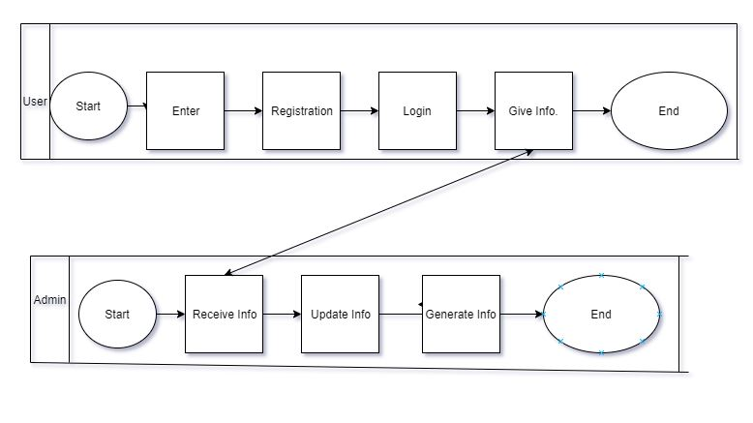

Fig: Business Process Model

3.2 System Requirements:

This is an online census service application. This application is made and created by the necessity. The necessity of a system characterized in two classes: Software and Hardware prerequisites. We got all the data in this system .We likewise ensure that this framework is good with the PC equipment.

3.2.1 User Requirement:

Client prerequisite to deliver a precise necessity particular for an undertaking is mentioned through investigation and objective fact of tasks and exercises of a whole system with a unique reference to the accompanying.
- Overview of the website.

- Search for a user.

- Search for District.

- Search for Thana/Upazila.

- Search for Dine.

- Information about other services by govt.

- How to create online ID.

3.2.2 Requirement Components:

To carry out the project we need hardware and software those are given below:

3.2.2.1 Hardware Requirement:

If we want to run this project, we need minimum one pc and internet connection.

Processor | Intel Pentium/AMD processor(500 MHZ)
Motherboard | Any
Ram | 512 or more
Lane | Any
AGP Card | Any
Hard Disk | 60GB
Floppy Disk(not mandatory) | 1.44 MB
Casing | ATX
Monitor | Any Color Monitor
Keyboard | Any
Mouse | Any
CD ROM | 52X

Table 1: Hardware Requirement

3.2.2.2 Software Requirement:

Different type of software need to developing and maintaining projected website. Details Given below:
Software | Usage
Any version of windows operating system | To start up computer and coordinate all
 | hardware components, application and
 | Customized software.
Xamp | To provide the service for the project
Brackets | For server side scripting
Phpmyadmin | For Database Server
Antivirus software if working on windows | To protect Data from Virus
operating system

Table 2: Software Requirement

3.3 Use case Diagram:
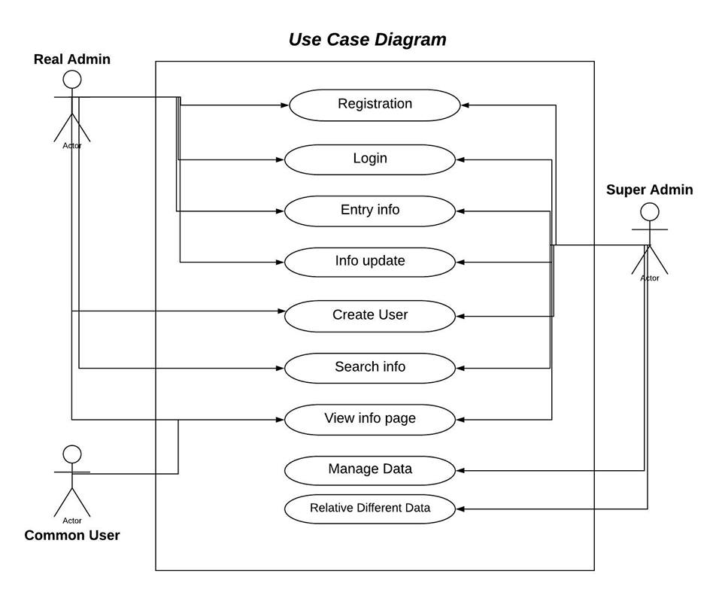

Fig: Use Case Diagram

3.3.1 Use Case Description:

Use Case Id: |  | 1
Use Case Name: |  | Enter
Created By: |  | Shfat Ul ferdoush
Date Of Creation: |  | 15-8-2018
Description: |  | This utilization case will enable the client to
 |  | enter the framework. The client can without
 |  | much of a stretch enter the framework and
 |  | see whatever needs to see.
Primary Actor: |  | User
Secondary Actor: |  | None
Precondition: |  | None
Post condition: |  | The system will display the home page
 | Table 3: Use Case 1
Use Case Id: |  | 2
Use Case Name: |  | Edit Profile
Created By: |  | Shfat Ul ferdoush
Date Of Creation: |  | 15-8-2018
Description: |  | User can easily edit his profile and pend a request.
Primary Actor: |  | User
Secondary Actor: |  | None
Precondition: |  | None
Post condition: |  | Finding the search result
 | Table 4: Use case 2

Use Case Id: |  | 3
Use Case Name: |  | Make an ID
Created By: |  | Sumon Ahmed
Date Of Creation: |  | 10-7-2018
Description: |  | This made an ID from system
Primary Actor: |  | User
Secondary Actor: |  | System
Precondition: |  | None
Post condition: |  | The system will notify the user.
 | Table 5: Use Case 3
Use Case Id: |  | 4
Use Case Name: |  | Get Information
Created By: |  | Shanto Islam
Date Of Creation: |  | 10-7-2018
Description: |  | The system will give him information.
 |  | .
Primary Actor: |  | Admin
Secondary Actor: |  | user
Precondition: |  | None
Post condition: |  | None
 | Table 6: Use case 4

3.4 Logical Data Model:

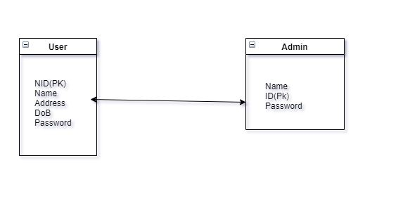

Fig: Logical Data Model.

CHAPTER 4

Design Specification

4.1 Front-end Design:

For complete front-end development, we've used some programming language in my project such as:
- HTML

- CSS3

- Bootstrap4

- JavaScript

- JQuery libraries

4.2 Back-end Design

For front-end development, we've used:

- Server-side languages- PHP

- MySQL Server for Database management.

4.3 Description:

- A user can register our site and create their profile.

- User can search the NID.

- A user can request to update his profile.

- After analysing the request admin can update it.

- Admin can view, update, delete, and create information of user.

- Other govt. sites are linked with it.

4.3.1 Website page Information:

  - Home page

- User login

- Create ID

- Input Information

- Waiting to confirmation by user.

- Update information

- Online problem solving

- Count voter list

- Contact us

4.4 Project Flowchart:

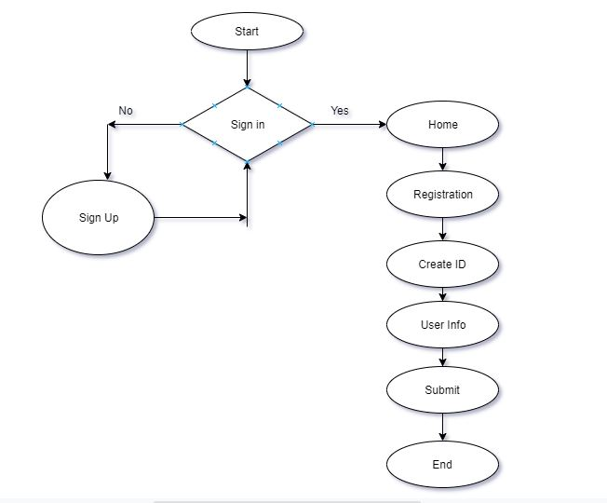

Fig: Flow Chart of the Project.

4.5 E-Census Information Management System:

4.5.1 Home page:

The home page will provide all basic details on our website and by which doctor and patient can interact with this. As an online medical service in has some special features that have shown on this page

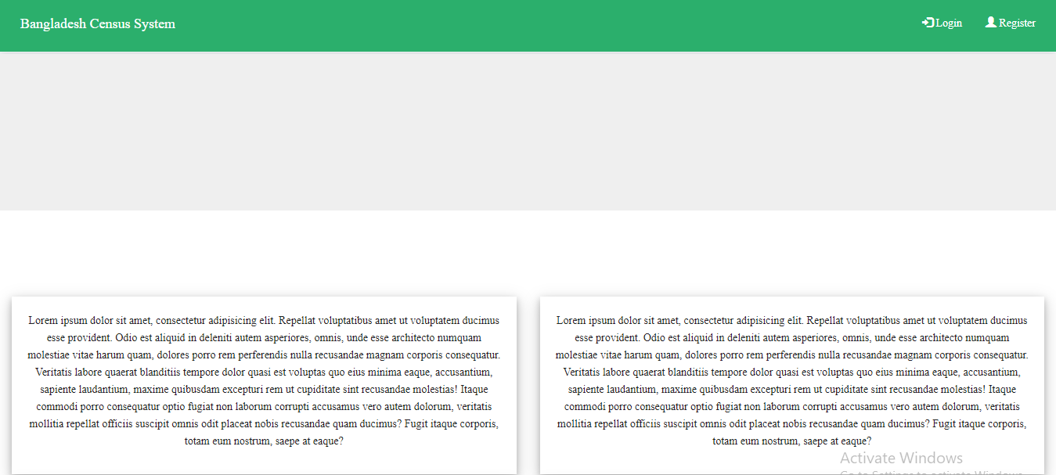

Registration Page:
A user need to registration first in order to log in an account. Here is the sample of the registration page.
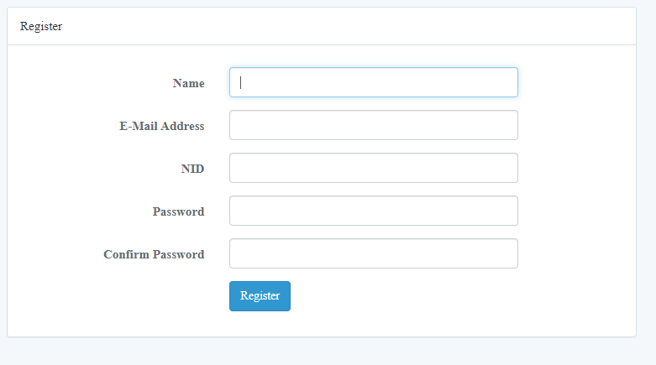

Fig: Registration Page
4.5.2 Login Page:

Firstly, the user will register our site with their personal details. After complete their registration user can login our site.

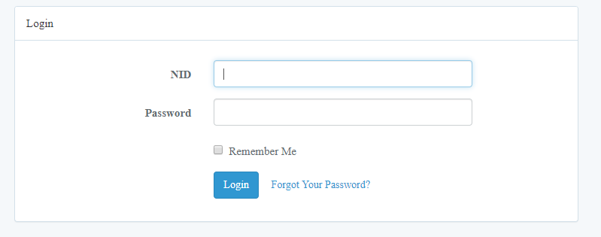

Fig: Log in Page

4.5.2 After Login:

After login a user sees about this page and gives his information.
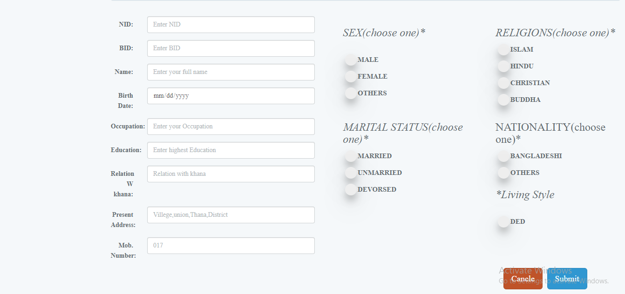

Fig: User Provided Information.

House Hold:
Users’ house hold information should be given by the user as well.
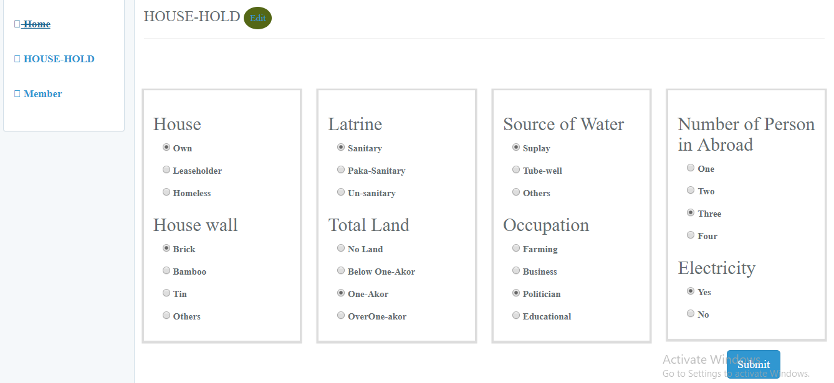
Fig: House Hold of User.

Admin:
An admin can view, change, update and delete the information given by the user.
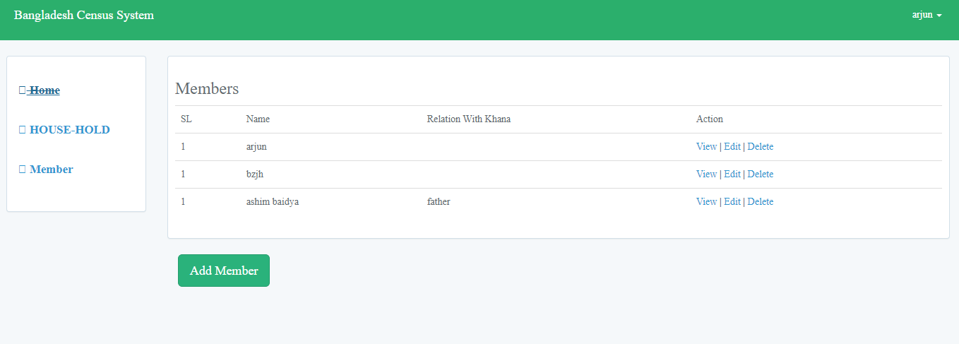

Fig: Admin page.
CHAPTER 5

Implementation and Testing

5.1 Database Management:

Data management is very important for storing and retrieving data from the database. For this project, try to make a good database management by using My SQL database.

5.1.1 Database illustration:

Location: A district has a unique id, has a name when user search by location.

User info: A user has a unique NID, has a name, contact number, degree, location and job location name in the database that have been shown on the website.

Admin: An admin has a unique id, name and a password in the database.

5.1.2 Database Objects:

Location: id, name

User info: doctor id, name, contact number, degree, organization name, location

Admin: admin id, admin name, admin password.

5.1.3 Entity Relationship Diagram:

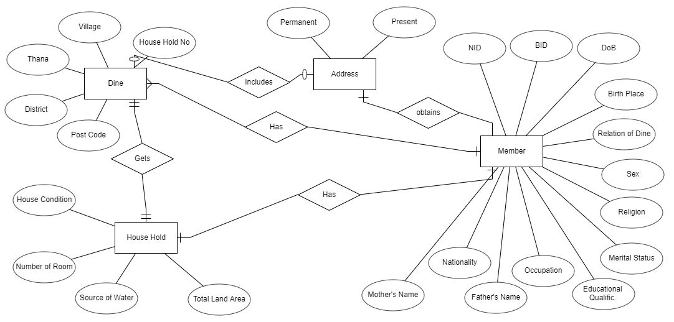
Fig: Entity Relationship Diagram.
5.2 Database table Figure:

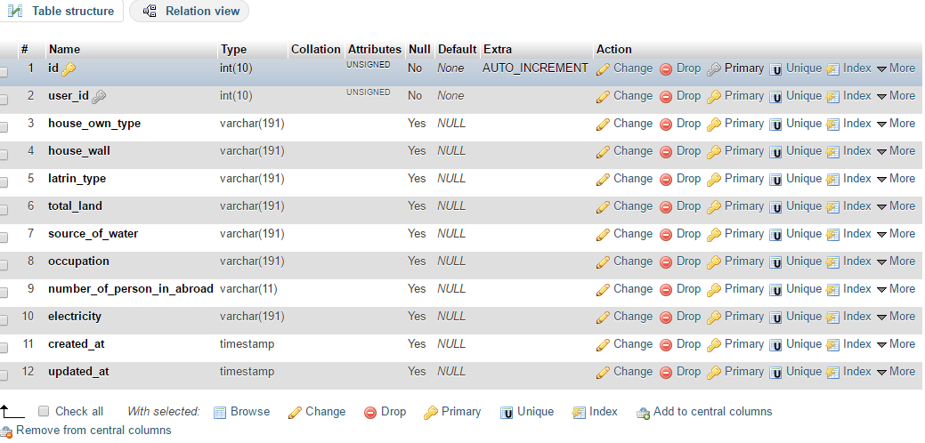

Fig: Database.

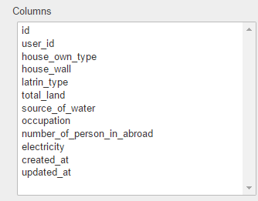

Fig: Database Entities.

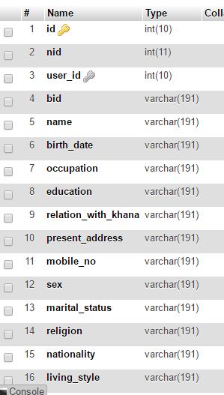

Fig: Database Tuples.

5.3 Implementation of Front-end Design:

Advancement of customer side of WA is called front-end improvement and front-end (FE) itself is then acknowledged as each substance client can see and can cooperate within a program. It is typically a blend of Hypertext Mark-up Language (HTML), Cascading Style Sheet (CSS) and JavaScript (JS). These dialects are composed and managed by an internet browser, bringing about a website page - interface client can collaborate with. The set of all accessible website pages is called a site.

CHAPTER 6

Conclusion and Future scope

6.1 Discussion:

An E-Census Information Management System is an online census service based website. Nowadays it is very essential for the fastest growing country like ours. It can decrease govt. cost and make easier our life in many ways. Most of the people don’t know which service are rendering by govt. to them. For this reason our website will help to find out and enlist as a citizen of Bangladesh.

6.2 Conclusion:

This task gives a wide range of facility that a people need to fulfil. By this project a man can effortless life from this site. The site give of this by its handle all patient requests and ease of use. At long last rundown of view. Our future hope is to build up a nation which is technically and educationally sound. Most of the people of our country is illiterate. Good service of education is needed to every person. Through this website all people of our country can be come to acknowledgement of the responsible.

  - Future scope:

- We will add user log in system and also add user profile

- Spread this division wise

- In future we will build it mobile application

- We will be add doctor category and many other symptoms

References:

[1] Bangladesh Bureau of Statistics (www.bbs.gov.bd) (5AM 12-07-2018)
[2] https://www.nstac.go.jp/en/release/index.html (2.30AM 12-07-2018)
[3]https://www.utpjournals.press/doi/full/10.3138/cpp.36.3.383 (3AM 12-07-2018)
[4] COP-2010 administrative report (https://www.singstat.gov.sg/publications/cop2010/cop2010-administrative-report) (3AM 12-07-2018)
[5] Wikipedia https://en.wikipedia.org/wiki/Census_in Malaysia (4AM 12-07-2018)
[6] Bureau of Census, India https://www.india.gov.in/census-2001-data-online (2AM 12-07-2018)

[7] Automated Census System for Densely Inhabited Districts; Tadashi Ooishi, Takashi Nanaumi, Yoshiyuki Takei and Akihito Yamauci. (6AM 12-07-2018)

[8] Instructions and Guidelines to enumerators to collect census manuals (Government of India). (6.30AM 12-07-2018)

[9] Usability Study on the use Handheld Devices to Collect Census Data; Erica L.Olmsted. (7 AM 12-07-2018)

[10] Design and Implementation of Census Data Collection System using PDA (https://pdfs.semanticscholar.org/3aa6/1a529aa960791fa71c7f265740073511bfeb.pdf) (7AM 12-07-2018)

[11] Bureau of Census India (www.censusindia.gov.in) (7.30AM 12-07-2018)

[12] Manual on Census Evaluation by DEMOGRAPHIC AND SOCIAL STATISTICS BRANCH, UNITED NATIONS STATISTICS DIVISION
(https://unstats.un.org/unsd/demographic/meetings/wshops/Ethiopia_14_Sept_09/Manuals/PES_Manual.pdf) (9.44PM 16-07-2018)

[13] Development of a National Policy Framework for Census Data dissemination utilizing a Geographic Data Management Systems (GDMS) by Harold Wall (http://www.caricomstats.org/Files/Meetings/1stResearchSeminar/NPFforCensusDissemination.pdf) (11PM 15-07-2018)

[15] Literature Review on Reconciling Data from Agricultural Censuses and Surveys (http://gsars.org/wp-content/uploads/2016/07/Literature-Review-on-Reconciling-Data-from-Agricultural-Censuses-and-Surveys-200716.pdf) (7.40AM 14-07-2018)

[16] Census 2011 Strategic Plan –– Research and Methodology (http://www.statssa.gov.za/census/census_2011/documents/CensusResearch-StrategicPlan.pdf) (11.44PM 16-07-2018)
[17] DESIGN AND IMPLEMENTATION OF A COMPUTERISED POPULATION CENSUS MONITORING SYSTEM, A CASE STUDY OF NATIONAL POPULATION COMMISSION
(https://www.grossarchive.com/upload/1416897202.htm) (4.30AM 16-07-2018)

[18] Tabulation and Processing of USA
(https://www.census.gov/history/www/innovations/technology/tabulation_and_processing.html) (12.40AM 11-07-2018)

