A STANDARD AND SECURE E-COMMERCE TRANSACTION FRAMEWORK
BY
SHAZZAD KHAN ARNOB
ID: 152-15-548

Here This Report Presented in Partial Fulfillment of the Requirements for The Degree of Bachelor of Science in Computer Science and Engineering

Supervised By

Ms. Amatul Bushra Akhi
Lecturer
Department of CSE
Daffodil International University

Co-Supervised By

Ms. Tania Khatun Lecturer
Department of CSE
Daffodil International University



DAFFODIL INTERNATIONAL UNIVERSITY DHAKA, BANGLADESH AUGUST 2019

i

APPROVAL

This Project Titled “A Standard And Secure E-Commerce Transaction Framework”, Submitted by Shazzad Khan Arnob, ID No: 152-15-548 to the Department of Computer Science and Engineering, Daffodil International University, has been accepted as allright for the Partial Fulfillment of the Requirements for the Degree of B.Sc. in Computer Science and Engineering (BSc) and Approved as to Its Style and Contents. The Presentation has been held on 5 MAY 2019

BOARD OF EXAMINATIONS

Dr. Sayed Akhter Hossain Chairman
Professor and Head
Department of Computer Science and Engineering
Faculity of Science and Information Technology
Daffodil International University

Dr. S M Aminul Haque  Associate Professor and Associate Head  Department of Computer Science and Engineering  Faculity of Science and Information Technology  Daffodil International University |  | Internal Examiner
Saif Mahmud Parvez  Lecturer  Department of Computer Science and Engineering  Faculity of Science and Information Technology  Daffodil International University |  | Internal Examiner
Dr. Mohammad Shorif Uddin |  | External Examiner

Professor,Department of Computer Science and Engineering
Jahangirnagar University

DECLARATION

I hereby declare that, this paper has been done by me under the supervision of Ms. Amatul Bushra Akhi, Lecturer, Department of CSE Daffodil International University. I also declare that neither this paper nor any part of this paper has been submitted elsewhere for award of any degree or diploma.

Supervised by:

Ms. Amatul Bushra Akhi
Lecturer
Department of CSE
Daffodil International University

Co-Supervised by:

Ms. Tania Khatun
Lecturer
Department of CSE
Daffodil International University

Submitted by:

Shazzad khan Arnob
ID: 152-15-548
Department of CSE
Daffodil International University

ACKNOWLEDGEMENT

First I express my heartiest thanks and gratefulness to almighty God for His divine blessing makes me possible to complete the final year Project successfully.

I really grateful and wish my profound our indebtedness to Ms. Amatul Bushra, Lecturer, Department of CSE Daffodil International, Dhaka. Deep knowledge and keen interest of my supervisor in the field of “A Standard and Secure E-Commerce Transaction Framework Using EbXML” to carry out this project. Now I regard to her infinite patience, scholarly guidance, continuous encouragement, energetic supervision, constructive criticism, valuable advice and correcting them at all stage have made it possible to complete this project.

I would like to express my heartiest gratitude to Saif Mahmud Parvez, Lecturer, Department of CSE Daffodil International University and Dr. S.M Aminul Haque, Assistant Professor and Associate Head, Department of CSE, for his kind help to finish my project and also to other faculty member and the staff of CSE Department of Daffodil International University.

Finally, I must acknowledge with due respect the constant support of my presents.

ABSTRACT
In this modern world electronic business is growing rapidly. While there is excellent e-business value in the ebXML. But security problem remains an unsolved problem and one of the largest obstacles to assumption. ebXML (Electronic Business Using eXtensible Markup Language) is an e-business standard which qualifies enterprises to exchange business messages, conduct trading relationships, communicate data in common terms and define and register business processes. XML security technologies have that kind of suitable power for security implementation such as encryption, digital signature, access control and authentication.
In this paper we have proposed ebXML business transaction models that grant trading partners to securely exchange XML based business transactions by applying XML security technologies.

TABLE OF CONTENTS

CONTENTS PAGES
Approval i
Declaration ii
Acknowledgement iii
Abstract iv
Table of Contents v v
List of Figures vi
List of Abbreviations viii

CHAPTER 1: INTRODUCTION 1-5
1.1 Introduction 1
1.2 Motivation 2
1.3 Overview 2
1.4 Expected Outcome 4

CHAPTER 2: BACKGROUND 6-9
2.1 Introduction 6
2.2 Privacy and Security 6
2.3 Research Summary 8

2.4 Challenges 9 CHAPTER 3: RESEARCH METHODOLOGY 10-12
3.1 Introduction 10
3.2 Research Subject 10
3.3 Implementation Requirements 10-12
3.3.1 Information Process 10
3.3.2 Registration 12
3.3.3 Business Partner Information 12

CHAPTER 4: EXPERIMENTAL RESULTS AND DISCUSSION 13-19
4.1 Introduction 13
4.1.1 Business Process Specification Schema (BPSS) 13
4.2 Experimental Results 14

CHAPTER 5: CONCLUSION AND IMLICATION FOR FUTURE 20
5.1 Conclusions 20
5.2 Implication of Future 20

REFERENCES 21

LIST OF FIGURES

FIGURES TITLE PAGES
2.1.1 Structure of XML digital signature 7 3.3.1.1 Overview of EbXML communication between 11
two companies
4.2.1 Company A-CEO Information 15
4.2.2 Company A Contact Information 15
4.2.3 Company B-CEO Information 16
4.2.4 Company B Contact Information 16
4.2.5 Digital Signature 1 17
4.2.6 Digital Signature 2 17
4.2.7 Digital Signature 3 18
4.2.8 Digital Signature 4 18
4.2.9 Digital Signature 5 19
4.2.10 Digital Signature 6 19

LIST OF ABBREVIATIONS

WORDS | ABBREVIATIONS
EBXML |  | Electronic Business Using Extensible Markup Language
XML |  | Extensible Markup Language
CPP |  | Collaboration Protocol Profile
CPA |  | Collaboration Protocol Agreement
OASIS |  | Observations of the American Society for Information Science
UN/CEFACT |  | UN/CEFACT stands for United Nation Centre for Trade Facilitation
 |  | and Electronic Business
XKMS |  | XML Key Management Specification
SAML |  | Security Assertion Markup Language
XACML |  | XML Access Control Markup Language
SSL |  | Security Socket Layer
S/MINE |  | Secure Multi-Purpose Internet Mail Extensions
SOAP |  | Simple Object Access Protocol
©Daffodil International University

CHAPTER 1
INTRODUCTION

1.1 Introduction
In the last few years, XML ( eXtensible Markup Language ) has quickly become the first choice for identifying data exchange formats in new e-business applications and the base for e-business framework such as ebXML, Rosetta Net and web services.
ebXML is an e-business framework for XML based global transactions. It qualifies enterprises of any size and in any geographical location to exchange business messages, conduct trading relationships, communicate data in common terms and define and register business processes. Now a days, ebXML is considered as an e-business web service where web services are a standard proposed by W3C (World Wide Web Consortium).In web services, great things are offered to the use of XML.
Each web service can be more secure, faster and reliable. While there is excellent e-business value in the ebXML. But security problem remains an unsolved problem and one of the largest obstacles to assumption. A model for security is very much needed to ensure security and trust between business entities.
The main challenge of ebXML security is to understand and count the risk involved in securing web framework. List of key risks for ebXML is identified as follows.
- Unauthorized transaction and fraud: business might be more at risk when unauthorized access or fraud could be allowed because of the increased automation of transaction.
- Loss of Confidentiality: business might be more at risk when transactions or specific information may be carelessly or knowingly opened on the network.
- Error detection: application errors can provide in the transmission of incorrect trading information.
- Potential loss of management and audit: If appropriate management and auditing are not implemented then there will be a great loss of potential data.

In this paper, we propose ebXML business transaction models include web services to solve the risks that grant trading partners to securely exchange XML based business transactions by applying XML security technologies.

1.2 Motivation
We want to secure business transaction systems. Because we want to develop the system and launch this system in the market. That’s why we have research on it.

1.3 Expected Outcome
Some of the expected key list for outcome is given below.
- Provide a good security for ebXML.
- Provide a good framework for business transactions.
- Locking for Strong and safe security models.
- Provide for using digital sign feature of the XML security standards.
- To propose SAML is the most important security in business transactions.
- To use XML Security technologies for implementations ebXML security transactions.
There are many security or technologies in the modern world but we think XML security is the best security part for business security in modern technologies. We have shown two companies business connections and transactions. The registration in the main database of items that support doing business communication with each other companies. Any other applications connect with the registry service interfaces and different types of information is applying in the registration Technology.
In this part XML is the main security for any other business transaction model. It is help for business trading partner agreements. Security is very most popular for business technology in the global world. This population is being growing day by day. Transaction is the most essential part for business partners. There are many kinds of security is being discovering day to day. But, XML security is the most popular in the whole world. XML security is the main part for business transactions system technologies. XML security is describing by digital signature, encryption, access control etc. But a good framework is the most essential part for XML security technology. Generally, a company give their information to another company and every company can access their security control. If XML security is not strong then any company can access control by others company in anytime. It is very harmful for business companies. So, XML security is the good effective part for ebXML. A good business model or framework is fundamental part for XML business security. In the modern technology, security is the more powerful by good business technology and modern frame working. XML security technologies is the most essential part for business transactions. We designed a business transaction model which is very efficient to safely exchange business transactions by utilizing XML security technologies. There are many security or technologies in the modern world but we think XML security is the best security part for business security for modern technologies. We have shown two companies business connections and transactions.

CHAPTER 2
BACKGROUND

2.1 Introduction
ebXML security team is provided XML security technologies to be used in ebXML implementation. There are many XML security standards at currently. We will shortly summarize the ebXML standard and along with the XML security standards.

2.2 Overview of ebxml
ebXML is an e-business framework for XML based global transactions that qualifies enterprises of any size and any geographical location to conduct business over the Internet. ebXML is a standard method to exchange business message, conduct trading relationship, communicate data and define and register business processes.
The vision of ebXML is to facilitate global trade in applying XML security technologies to allow trading partners to securely exchange XML based business transactions.

2.3 Privacy and security
There are so many well-known familiar security technologies that can be used by ebXML implementers to solve the risks. In electronic business many of the existing technologies such as user-id and password, PKI(Public Key Infrastructure) and token that can provide user identification and authentication to solve the unauthorized transactions fraud problems.
SSL (Secure Socket Layer) and S/MIME (Secure multi-purpose Internet Mail Extensions) are used to solve secrecy and authentication problem. To solve error detection problem, we can be used typical tools such as anti-virus software and intrusion detection software. To resolve potential loss of management and audit problems, we can be used PKI. To solve the potential legal liability problem, we can be applied policies and procedures including audits and controls.
XML security technologies have that kind of suitable power for security implementation such as encryption, digital signature, access control and authentication.XML digital signatures and SAML (Security Assertion Markup Language) can be absorbed to solve the unauthorized transactions and fraud problems in electronic business systems.XML digital signatures are used in ebXML to provide data integrity on messages. SAML is used to provide identification, authentication and authorization.
Besides, XACML (XML Access Control Markup language) is used to allow or deny access to an XML resource. XML encryption is used to solve the loss of confidentiality problem. XKMS (XML Key Management Specification) is used for key management as a substitute for PKI.

2.3.1 XML security standards
This section deal with security issues and explains five proposed XML standards.

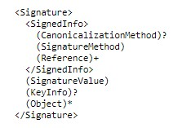
1.XML Signature Basic Structure:

Figure 2.2.1: Structure of XML Digital Signature

2. XML Encryption:
The W3C and IETF established a standard for encrypting data. So by using this standard method of encryption, XML documents will be transmitted.
3. XKMS (XML key Management Specification):
XKMS has two parts.XML Key Registration Service Specification (X-KRSS) and XML Key Information Service Specification (X-KISS).X-KRSS is used to register public keys and X-KISS is used to resolve the keys provided in an XML signature.
4. SAML (Security Assertion Markup Language):
SAML can be absorbed to solve the unauthorized transactions and fraud problems in electronic business systems. SAML is used to provide identification, authentication and authorization.
5. XACML (XML Access Control Markup Language)
XACML is used to allow or deny access to an XML resource.

2.3.1 Unique Key Password
We have used unique key password which will be automatically generated from database. By this unique key password one company can find their trading partner easily from our database. Then they can start their transaction easily and very securely.

2.4 Research Summary
In this modern world electronic business growing rapidely.While there is excellent e-business value in the ebXML.But security problem remains an unsolved problem and one of the largest obstacles to assumption.So we have decided to work on that particular case. ebXML (Electronic Business Using eXtensible Markup Language) is an e-business standard which qualifies enterprises to exchange business messages, conduct trading relationships, communicate data in common terms and define and register business processes. XML security technologies have that kind of suitable power for security implementation such as encryption, digital signature, access control and authentication.So we have decided to apply XML security standards for solving the security problem of business transactions. In this this regards we have read thoroughly some of the papers which is based on XML security.
We can use different types of security layer for safe and strong security model for the business transactions. XML security technologies is the most essential part for business transactions. We have designed a business transaction model which is very efficient to safely exchange business transactions.
We have used XML digital signatures, SAML, XACML, XKMS, Single Sign-On, CPP, CPA for securing the business transactions based on XML.
Moreover, we have implemented this transaction system by applying unique key password. This password will be automatically generated from the database. By this unique key password one company can find their trading partner easily from our database. Then they can start their transaction easily and very securely. In this regards we have used Angular 8, Node.js, Express.js, MongoDB, HTML, CSS.

2.5 Challenges
- Ensure proper XML security for business transactions.
- Challenges for good business transactions model.
- Dependable on internet access.
- Fully Dependable on any other business companies.
ebXML is very important framework for business security technology. Mainly XML is the security part for ebXML. Generally, we can be used XML security technology such as XML digital signature, Single Sign-On, CPP, CPA etc. Mainly we can be used jQuery, Ajax method, PHP for connections, HTML and CSS for design. We think digital signature is very good security for ebXML.
In day by day, XML security is growing popular for business technology in the global world. Transaction is the most essential part for business partners. There are many kinds of security is being discovered. But, XML security is very popular and secure in the whole world. XML security is the main part for business transactions. XML security is describing by digital signature, encryption, access control etc. But a good framework is the most essential part for XML security technology. Generally, a company give their information to the company and every company can access their security control. If XML security won’t be strong then any company can access control by others companies information. So, XML security is the good effective solution using ebXML.

CHAPTER 3
RESEARCH METHODOLOGY

3.1 Introduction
ebXML is an e-business framework for XML based global transactions. It qualifies enterprises of any size and in any geographical location to exchange business messages, conduct trading relationships, communicate data in common terms and define and register business processes. Now a days, ebXML is considered as an e-business web service where web services are a standard proposed by W3C (World Wide Web Consortium).In web services, great things are offered to the use of XML.
Each web service can be more secure, faster and reliable. While there is excellent e-business value in the ebXML. But security problem remains an unsolved problem and one of the largest obstacles to assumption. A model for security is very much needed to ensure security and trust between business entities.

3.2 Research Subject
ebXML is an e-business framework for XML based global transactions. Mainly XML is the security part for ebXML. Generally we can be used XML security technologies such as XML digital signature, Single Sign-On feature, CPP, CPA etc. Mainly we can be used jQuery, Ajax method, PHP for connections, HTML and CSS for design. We think digital signature will be a standard security for ebXML.
Besides, we have designed and implemented web based framework which is based on JavaSript language. In the frontend we have used Angular8.js and in the backend we have used Express.js and Node.js. In that case, when a company will be registered by fulfilling the requirements, then a unique key password will be generated automatically. This unique will be encrypted into database and stored into database. So any registered company can find his agreement company by this secret unique key password. Then they can start their business transaction.

3.3 Implementation Requirements

3.3.1 Information Process
This is very important part for a business transaction. Generally, information communication is the main part of the business transaction systems. For kinds of message there will be many layers. Actually outside layer is the main part for business transaction model and another layer is the basic part for ebXML. Mainly we must be used SOAP (Simple Object Access Protocol) for main communication layer. We think it is very efficient process. Generally, it provides some specifications. They are mainly CPP (Collaboration Protocol Profile) and CPA (Collaboration Protocol Agreement). In this part mainly two or many others business partners share their personal information. This information is very important for business partner. We store the business partner information in this part and we use XML for high business transaction security. We can use CPP and CPA as a software application. This is the safe and strong security in this whole system. Generally, it creates very good relationship between BPSS and CPP or CPA. In this part mainly two or many others business partners share their personal information. This information is very important for business partner. We store the business partner information in this part and we use XML for high business transaction security
Now we create business transaction process model between two companies is given below.
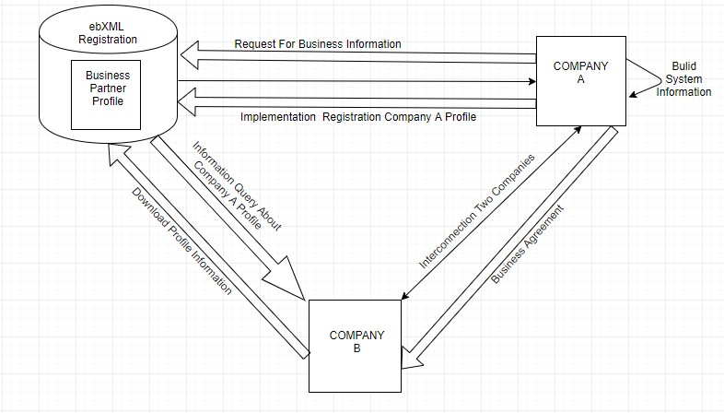

Figure 3.3.1.1: Overview of ebXML communication between two companies

There are two companies in this part. First both company have to fulfill the registration process. In that case, company have to sign in first. That means, company A have to send request to the ebXML registration panel for getting business information form. Then ebXML will accept the request and send the feedback. Then company A have to submit the business information and send request for implementing business profile. Then company A will be able to build the system information. Same pattern have to follow company B. They can also download their profile information. Then company B have to send request for gaining information query about company A. After accepting the request they interconnected with each other. Then they can start their transaction or agreement.

3.3.2 Registration
Registry is an item of database that support to complete registration process of a company and start doing business electronically. In this registration process, a company have to input essential information of that company to fulfill the registration process. This item of information will be stored into database.

3.3.3 Messaging Service
The actual information communicated just as a part of business transaction. An actual communication protocol must be used such as HTTP or SMTP on the outside layer. SOAP (Simple Object Access Protocol) is recommended by ebXML as an envelope for a message “payload”. Other layers may deal with encryption or authentication in this system.

3.3.4 Business Partner Information
Generally, it provides some specifications. They are mainly CPP (Collaboration Protocol Profile) and CPA (Collaboration Protocol Agreement). In this part mainly two or many others business partners share their personal information. This information is very important for business partner. We store the business partner information in this part and we use XML for high business transaction security. We can use CPP and CPA as a software application.
CHAPTER 4
EXPERIMENTAL RESULTS AND DISCUSSION

4.1 Introduction
The ebXML infrastructure components may be used independently. Generally, it is very important for business technique. We explain a use case for high-level transaction between two companies or business partners. This use case is very good effective for business or trading partners.
Main components for ebXML communication between two companies. There are many standard "parts" in this system. Generally, we use the main system for large ebXML elements. As an example, we think core process is the main process for any others big business process. It is very helpful for any big business transactions. ebXML is the very good effects for business transactions. We think large elements may be Good effects for many industries and businesses but ebXML is the main elements for business transactions security.

4.1.1 Business Process Specification Schema (BPSS)
In this part we provide how an organization conducts its business for communication of business partners. We created a modern business model in this part. Generally, it creates very good relationship between BPSS and CPP or CPA. In this part mainly two or many others business partners share their personal information. This information is very important for business partner. We store the business partner information in this part and we use XML for high business transaction security. We can use CPP and CPA as a software application.
There are two companies in this part. Such that Company A and Company B. Firstly, Company A and Company B has been done by their registration in the system. They give their business information’s and profile in the registration part. This information is save in the system database. Company A and Company B sign-in or log-in to the system anytime and see their business information. Company A build-in their system information’s. Company A is request to the ebXML registration system for business information and also request for implementing the registration of company A profile. They download their profile information in anytime. Company A and Company B they are also interconnected between two companies. They also build-up their business agreement and good relationship. In this part any other third party company do not know this two companies’ business information. This is the safe and strong security in this whole system.

4.2 Experimental Results
Firstly, we discuss "What Is ebXML and XML Security" in our paper. We mainly describe XML security for business transactions. We use PHP connection for two business partner’s information and for strong security use digital signature in the ebXML. Now we show our expected outcome and output is showed that in this part. Generally, it creates very good relationship between BPSS and CPP or CPA. In this part mainly two or many others business partners share their personal information. This information is very important for business partner. We store the business partner information in this part and we use XML for high business transaction security. We can use CPP and CPA as a software application.
There are two companies in this part. Such that Company A and Company B. Firstly, Company A and Company B has been done by their registration in the system. They give their business information’s and profile in the registration part. This information is save in the system database. Company A and Company B sign-in or log-in to the system anytime and see their business information. Company A build-in their system information’s. Company A is request to the ebXML registration system for business information and also request for the registration of Company A profile. They download their profile information in anytime. Company A and Company B they are also interconnected between two companies. They also build-up their business agreement and good relationship. In this part any other third party company do not know this two companies’ business information. This is the safe and strong security in this whole system.

Now we show in our output is given below.
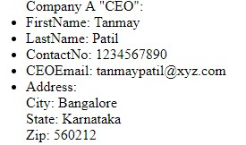
Company A
-
CEO Information

output:

Figure 4.
2.
1:
Company A
-
CEO

Information

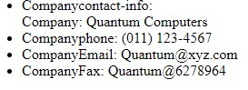
Company A Contact Information

output:

Figure

4
.2
.2
:
Company A Contact
Information

Company B-CEO Information output:
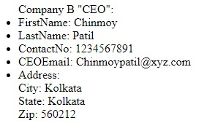

Figure 4.
2.
3
:

Company B
-
CEO Information

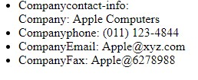
Company B Contact Information output:

Figure 4
.
2.
4
:

Company B Contact Information

Digital Signature output 1:


Figure

4
.
2.
5
:
Digital Signature
1


Digital
Signature output 2:

Figure

4.
2.
6
:

Digital Signature 2

Digital Signature output 3:


Figure

4.
2.
7
:

Digital Signature 3


Digital Signature output 4:

Figure

4.
2.
8
:
Digital Signature
4

Digital Signature output 5:


Figure

4.
2.
9
:
Digital Signature
5


Digital Signature output 6:

Figure

4.
2.
10
:
Digital Signature
6

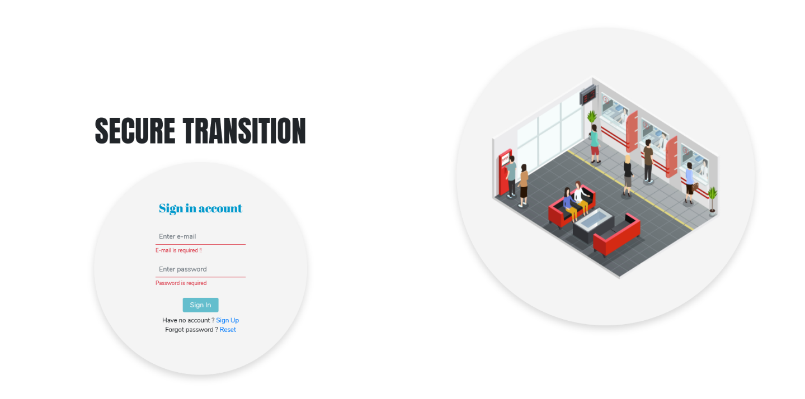
Figure 4.2.11: web applications(sign in panel)
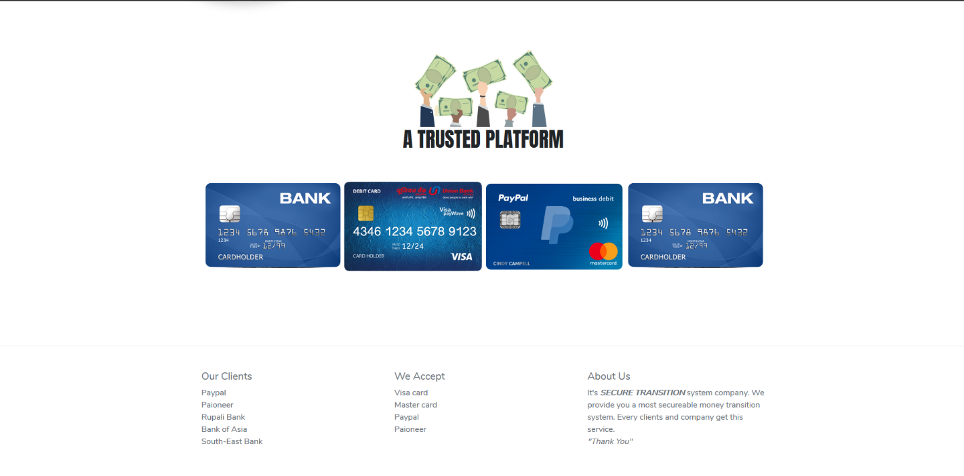
Figure 4.2.12: payment gateway
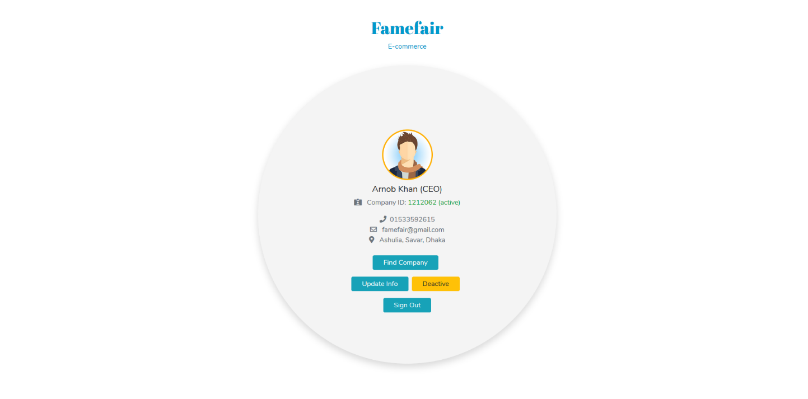
Figure 4.2.13: Company profile when active

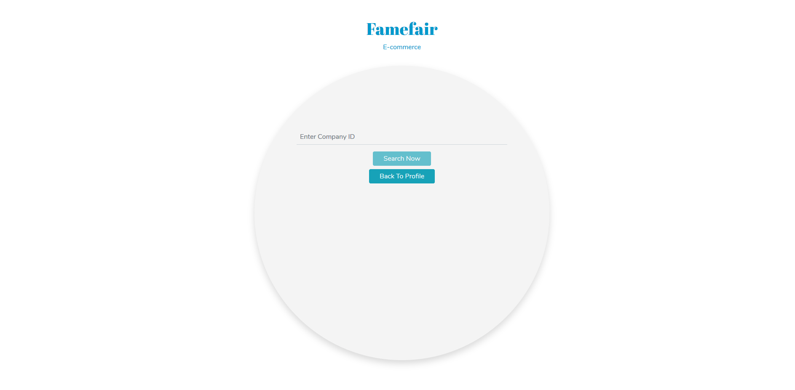Figure 4.2.14: searching company with unique id
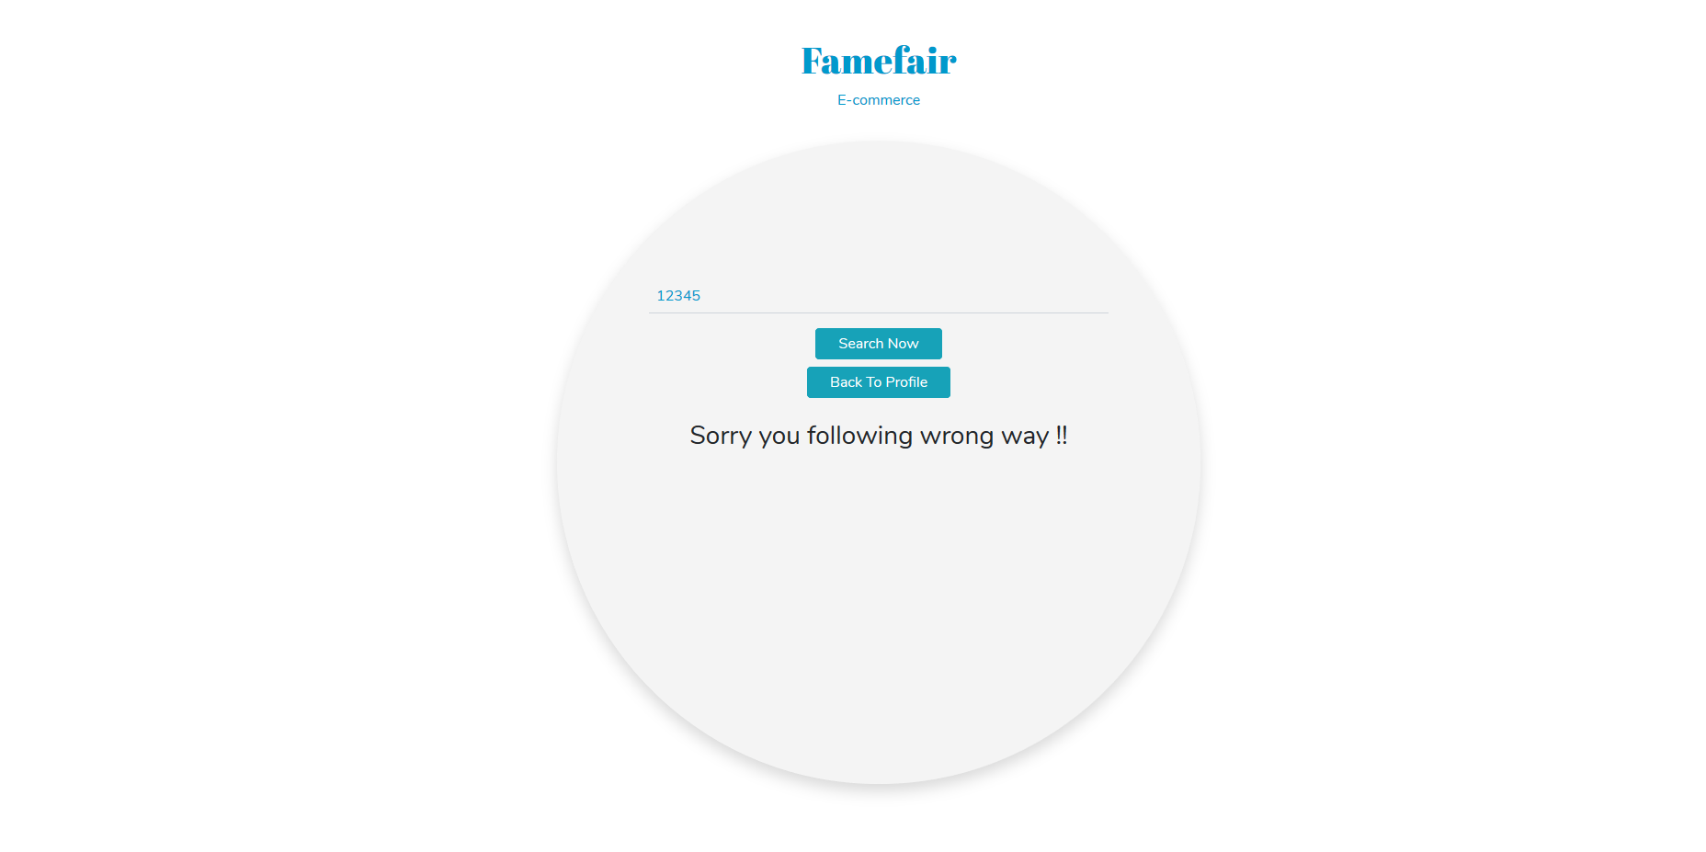
Figure 4.2.15: search result when id deactivated
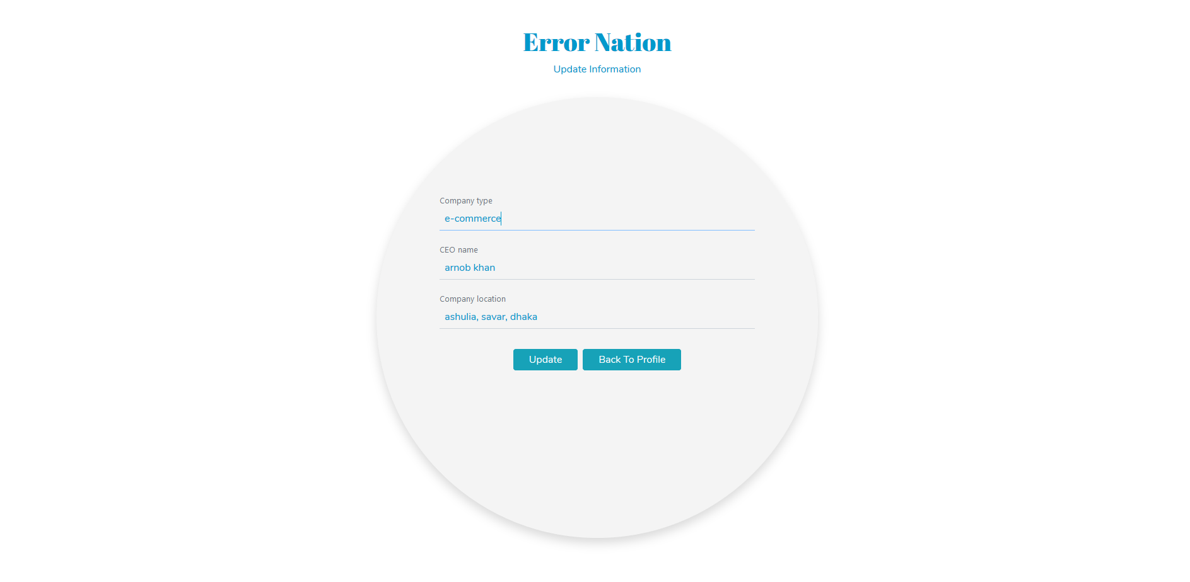

Figure 4.2.16: company’s profile update
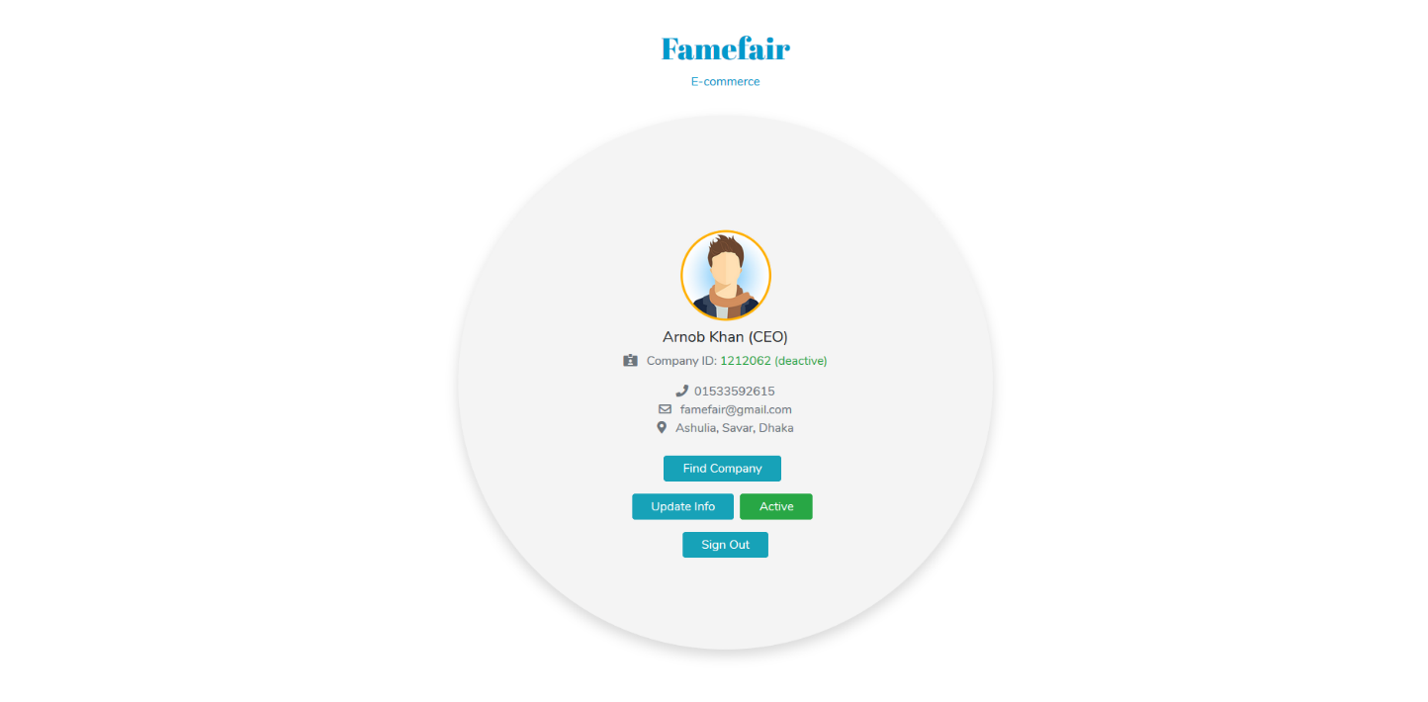
Figure 4.2.17: company profile when deactivate
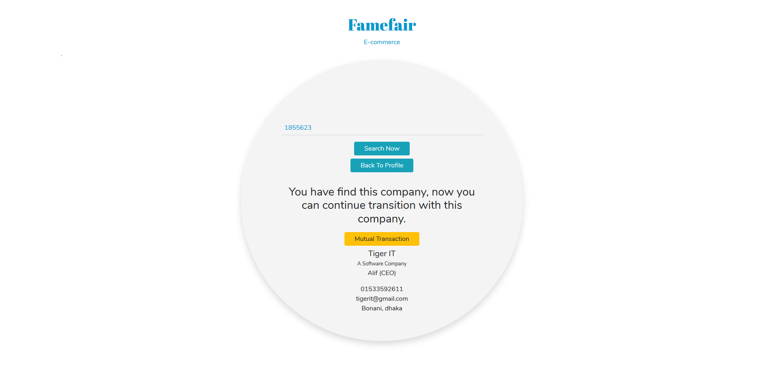
Figure 4.2.18: searching result found
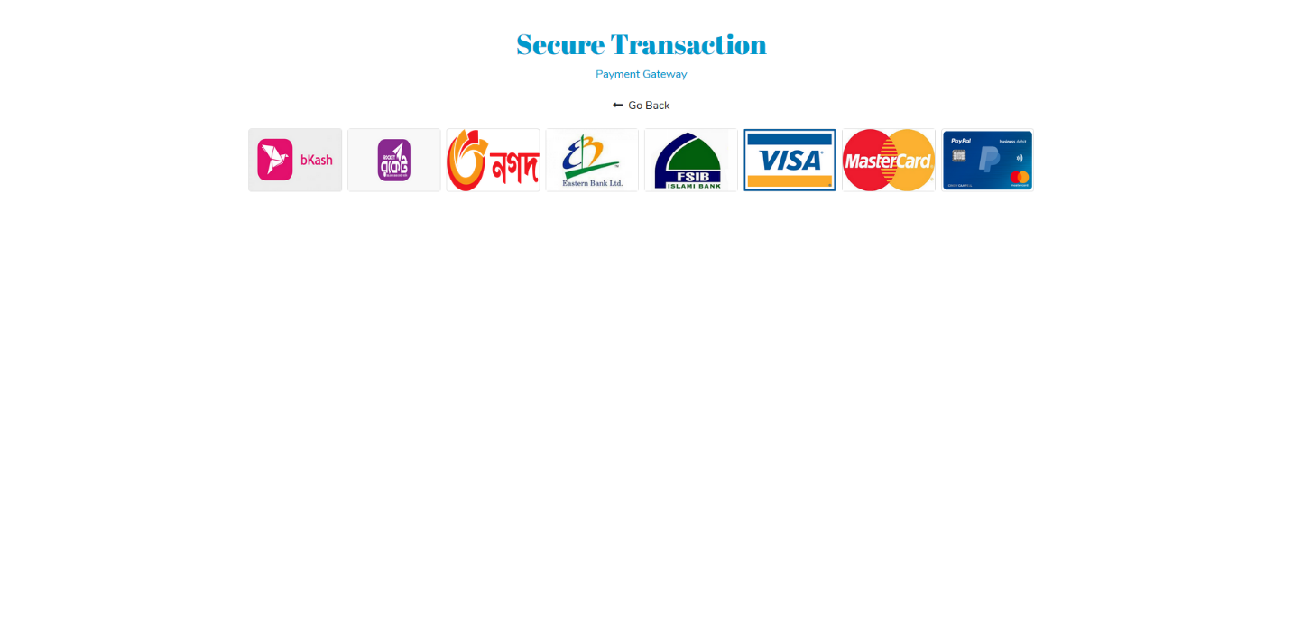
Figure 4.2.19: payement gateway

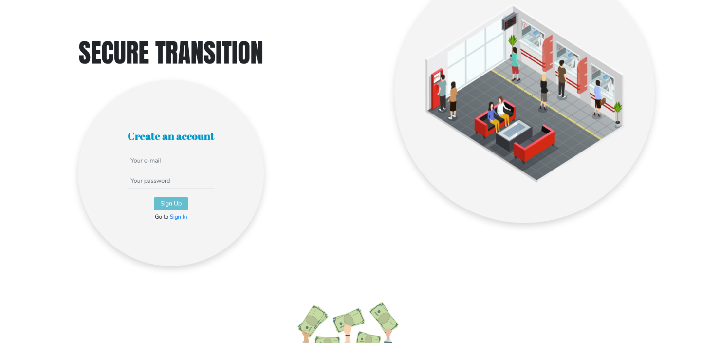

Figure 4.2.20: account create
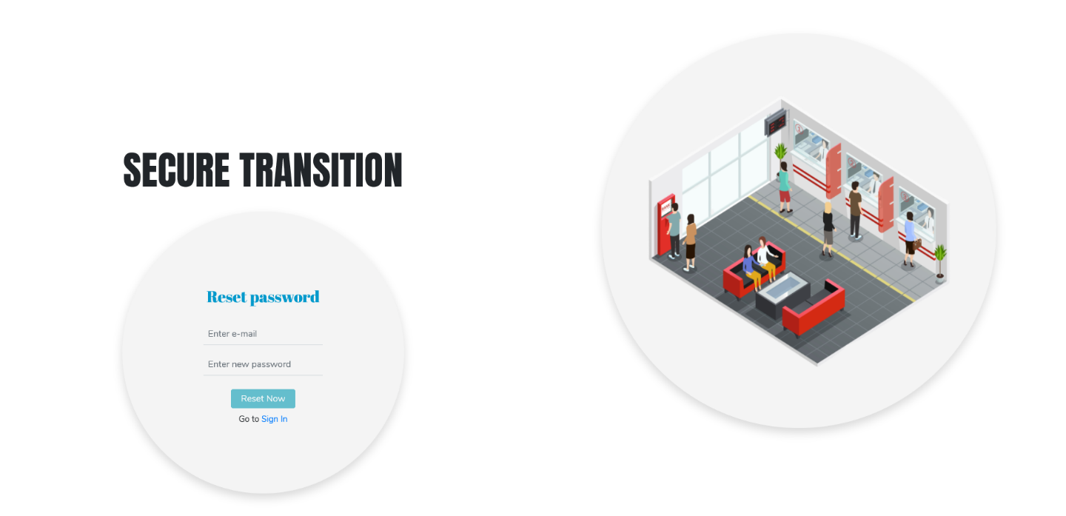

Figure 4.2.21: password reset

CHAPTER 5
CONCLUSION AND IMLICATION FOR FUTURE

5.1 Conclusions
At last we can realize that XML security technologies is the most essential part for business transactions. We have designed a business transaction model which is very efficient to safely exchange business transactions by utilizing XML security technologies. There are many security or technologies in the modern world but we think XML security is the best security part for business security for modern technologies. We have shown two companies business connections and transactions.

5.2 Implication of Future
We want to implement finger print, eye detection, face recognition in the XML security in future.

References:

- D. S. S. C. a. S. K. Dongkyoo Shin, "A Study on the Secure ebXML Transaction Models," International Journal of Computer and Information Engineering, vol. 2, p. 10, 2008.
- D. S. S. C. a. S. K. Dongkyoo Shin, "A Study on the Secure ebXML Transaction Models," International Journal of Computer and Information Engineering, vol. 2, p. 10, 2008.
- D. S. S. C. a. S. K. Dongkyoo Shin, "A Study on the Secure ebXML Transaction Models," International Journal of Computer and Information Engineering, vol. 2, p. 10, 2008.
- D. F. H. C. T. C. L.-J. Z. F. W. J.-J. J. Rama Akkiraju, "A Framework for Facilitating Dynamic e-Business Via Web Services," IBM T.J. Watson Research Center.
- A. G. Khan, "Electronic Commerce: A Study on Benefits and Challenges in an Emerging Economy," Global Journals Inc. (USA), vol. 16, no. 1, 2016.
- Z. O. Y. Kenneth Longo Mlelwa, "Requirement’s for Proposed Frameworks for Secure Ecommerce Transactions," Communications on Applied Electronics (CAE) , vol. 6, p. 9, 2017.
- D. F. H. C. T. C. L.-J. Z. F. W. J.-J. J. Rama Akkiraju, "A Framework for Facilitating Dynamic e-Business Via Web Services," IBM T.J. Watson Research Cente.
- D. S. S. C. a. S. K. Dongkyoo Shin, "A Study on the Secure ebXML Transaction Models," International Journal of Computer and Information Engineering, vol. 2, p. 10, 2008.

