SWIFT HOME AUTOMATION SYSTEM
(Using Google Assistant and Android application)

BY

MD IQBAL HOSSAIN SUNNY ID: 143-15-225

This Report Presented in Partial Fulfillment of the Requirements for the Degree of Bachelor of Science in Computer Science and Engineering

Supervised By

MR.ARIF MAHMUD
Assistant Professor
Department of Computer Science and Engineering Daffodil International University



DAFFODIL INTERNATIONAL UNIVERSITY
DHAKA, BANGLADESH NOVEMBER 2018

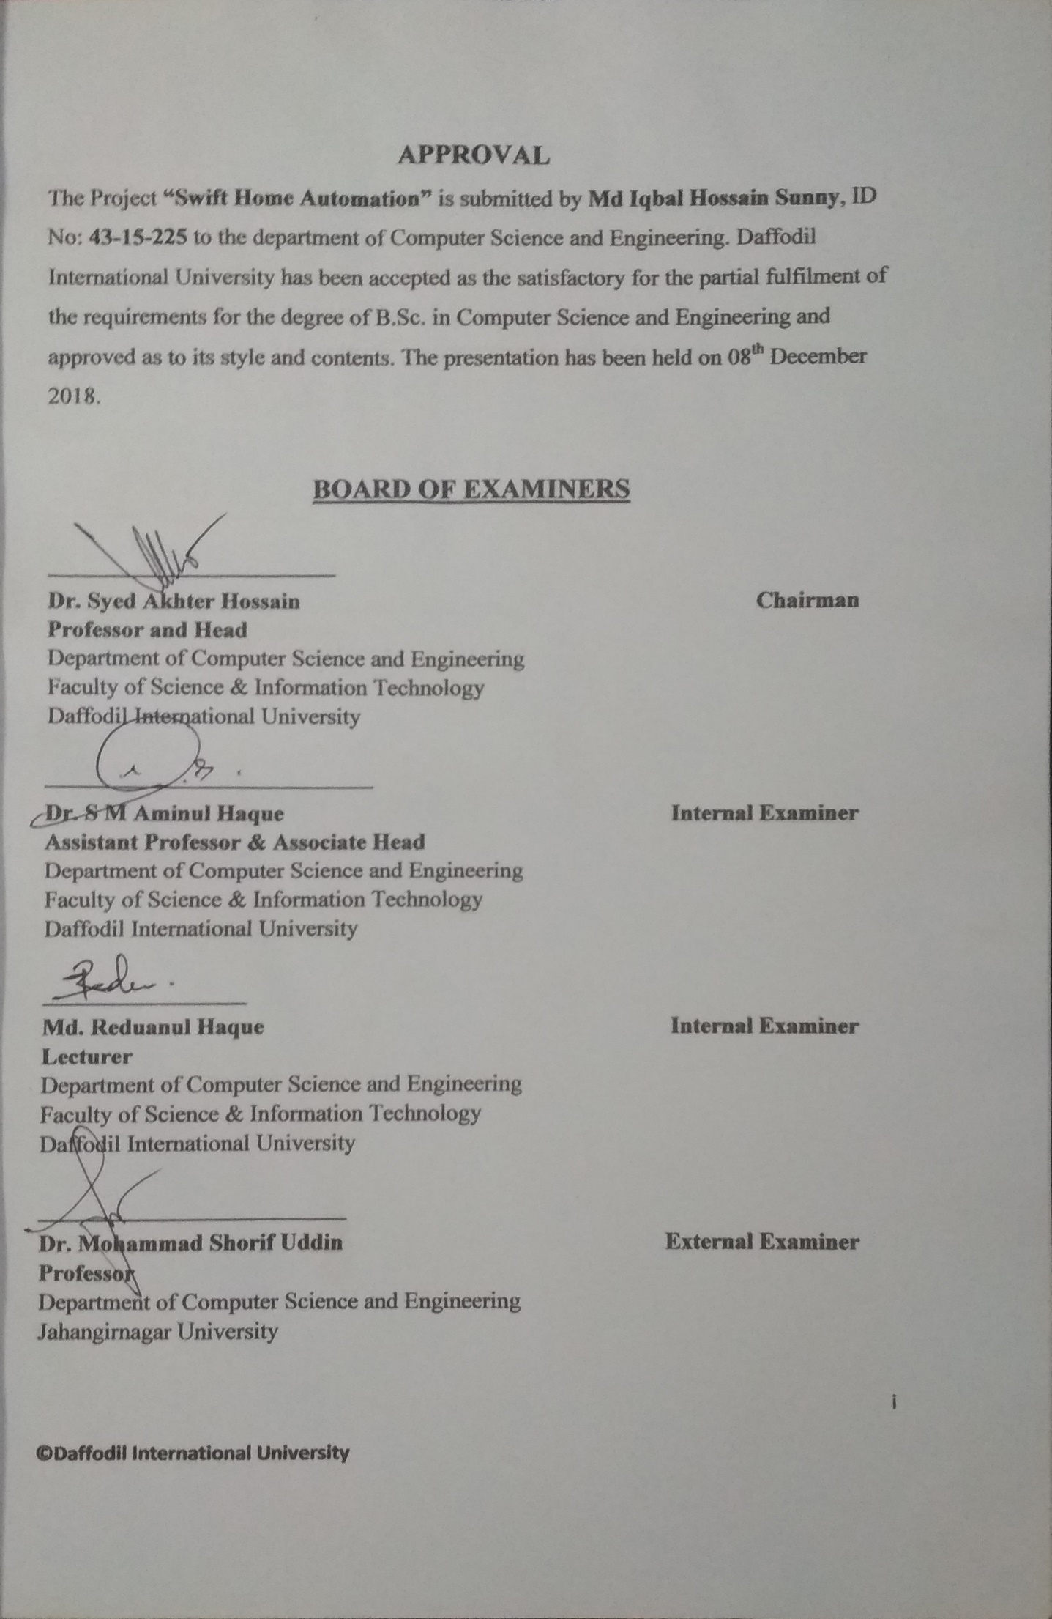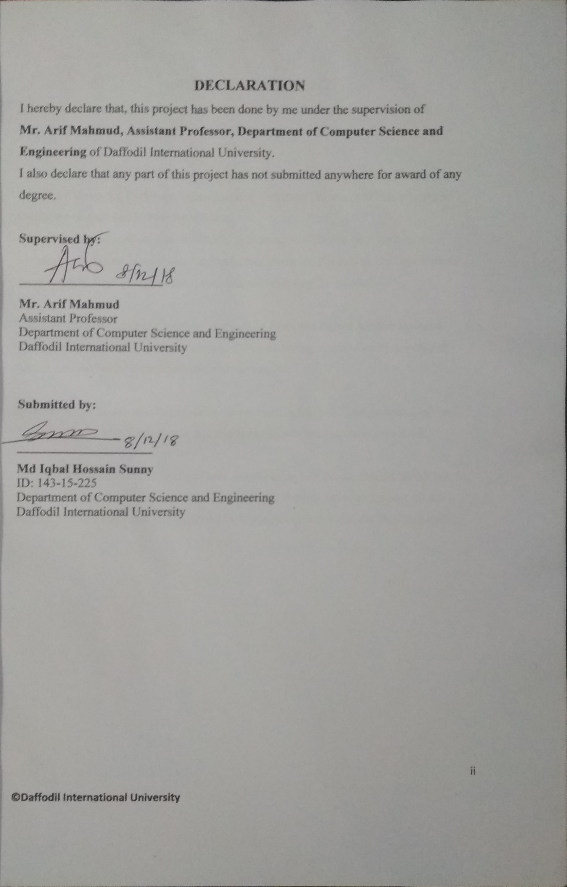

ACKNOWLEDGEMENT
In the beginning, Thanks to almighty Allah to give me the capability to complete this project successfully.

I am really grateful and wish my profound inheritance to my Supervisor Mr. Arif Mahmud, Assistant Professor, Department of Computer Science and Engineering of Daffodil International University, Dhaka.
His soft behavior, endless patient, advice, guidance, his valuable time for me and instruction of this project step by step made this project perfectly. He help me in many ways to solve those problems that I face when completing the project.

I also would like to express heartiest gratitude to Prof. Dr. Sayed Akther Hossain, Head, Department of Computer Science and Engineering, All the faculty member of Uttara campus for their kind help to finish my project.

I would like to thanks also to our entire course mate in Daffodil International University, Uttara Campus, who Took part in this discuss while completing the course work.

Finally I would like to profound gratitude to my Father Md. Abdur Rashid Shekh and My mother Mst. Hazera Begum, my sisters and a friend Sanjida Misty to support me for reaching on this stage and also to my all family member and friend for their Inspiration.

ABSTRACT
The technology of 21st century has become more advance then before. This is the time to make machine more advance for mankind. For this purpose automation system have come to take some task to reduce work of our daily needed. Swift Home Automation system is an automation system that can control home appliances and ensure the security of our home. This system is connected with a database that contain all relevant information of devices and status of home appliances so we can control them from anywhere trough Google Assistant or Mobile application. As this system takes command from Google assistant so this system is rely efficient for those people who are physically disable and all children who need to keep distance from electrical circuit and switches.
The Mobile application part of this system help to control appliances and get devices status by friendly user interface for family members.
In this busy life of ours “Swift Home Automation system” will be a popular concept of automation market.

TABLE OF CONTENTS
CONTENS PAGE
Board of examiners i
Declaration ii
Acknowledgements iii
Abstract iv
CHAPTER
CHAPTER 1: INTRODUCTION 1-3
1.1 Introduction 1
1.2 Objective 1
1.3 Methodology 2
1.4 Organization of the report 2
1.5 Project justification 3
CHAPTER 2: HARDWARE DESIGN 4-21
2.1 Introduction 4
2.2 Arduino DUE R3 4
2.3 ESP8266-01 Wi-Fi module 6
2.4 16x2 LCD display with I2C Display Adapter 9
2.5 Multiple Channel Relay Module 11
2.6 PIR Motion Sensor 12
2.7 Servo 13
2.8 Block Diagram of entire system | 15
2.9 Circuit Diagram of entire system | 16
2.10 Connections and Communication of Component | 18
2.11 Cost Analysis of The Hardware | 20
CHAPTER 3: VIRTUAL AGENT (Google Assistant) | 22-34
3.1 Introduction | 22
3.2 Agent Setup | 22
3.3 Actions on Google Console | 22
3.4 Dialog flow Console | 25
3.5 Firebase Cloud Function | 30
3.6 Firebase Real-time Database | 33
CHAPTER 4: MOBILE APPLICATION DESIGN | 35-41
4.1 Introduction | 35
4.2 Application Details | 35
4.3 Uses Instruction | 36
CHAPTER 5: SYSTEM DEPLOY AND TEST | 42-46
5.1 Introduction | 42
5.2 System Deployment | 42
5.3 System Testing | 42
5.4 Summery | 46

CHAPTER 6: CONCLUSION | 47-48
6.1 Conclusion | 47
6.2 Limitation Of The Proposed System | 47
6.3 Future Development | 47
References | 49
Appendix A1 | 50-51
Sketch for ESP8266-01 | 50
Appendix A2 | 51-59
Sketch for Arduino DUE | 51

LIST OF FIGURES AND TABLE
FIGURES/Table PAGE NO
Figure 2.2: Arduino DUE Microcontroller 5
Figure 2.3: ESP8266-0 Wi-Fi module 7
Figure 2.4.1: 16X2 LCD Display 9
Figure 2.4.2: I2C Display Module 10
Figure 2.5: 8 Chanel Relay Module 11
Figure 2.6: PIR Motion Sensor 12
Figure 2.7: Servo Motor 14
Figure 2.8: Block diagram of Swift Home Automation 16
Figure 2.9: Circuit diagram of swift home automation system 17
Figure 2.10: ESP8266-01 Pinout 19
Figure 3.3.1: Actions on Google Console create New Project 23
Figure 3.3.2: Actions on Google Console invocation settings 23
Figure 3.3.3: Actions on Google Actions 24
Figure 3.3.4: Built Custom Intent on Actions 24
Figure 3.4.1: Dialog Flow Setup 25
Figure 3.4.2: Dialog Flow Intent 26
Figure 3.4.3: “control_appliances” Intent Statement 27
Figure 3.4.4: Dialog Flow Entities 27
Figure 3.4.5: Room Entities 28
Figure 3.4.6: Device Entities 28
Figure 3.4.7: Status Entities 29
Figure 3.4.8: Fulfilment web hook URL 30
Figure 3.5.1: Script for Firebase Cloud Functions Webhook 32
Figure 3.5.2: Firebase Function deployment 33
Figure 3.6: Firebase Real-time Database 34
Figure 4.2: Firebase Authentication 36
Figure 4.3.1: Sign in/Sign out or forget password interface of application 37
Figure 4.3.2: Reset password interface of application | 38
Figure 4.3.3: Room selection Interface | 39
Figure 4.3.4: Switch on/off button of devices | 40
Figure 4.3.5: User Profile Interface | 41
Table 5.3.1: Result of the Google Assistant command system test | 43
Table 5.3.2 Result of the Mobile Application system test | 44

CHAPTER 1 Introduction

1.1 Introduction
Automation system is use for controlling the appliances or the industrial machinery by using Information Technology and Computer. This generation is the generation of Mobile and Computer. Everyone of a family use mobile or computer for their won purpose. Automated home system is a system that can connect your home appliances with your mobile and computer and people can control those appliances from their mobile, Tab, Computer. People can turn on or off the light, fan, television from their mobile and computer and also can lock or unlock the door or windows of home.
Swift House Automation is an automation system for a home as a smart home. It involves the control of home appliances such as light, Fan, ventilation, air conditioning, Door lock, TV etc. The systems generally consist of switches and sensors connected with internet so you can control via its Mobile application or telling a command to your google assistant of your mobile. The system will also able to give the security of your house such as door lock, Window break alert, Fire alert and Locker alert.
Swift House Automation System is able to give you the security of your house and remotely monitoring your house from anywhere.

1.2 Objective
The aim of this project is to design and construct a home automation system that can take command from mobile assistant like Google Assistant, Alexa, and Siri etc.The hardware part of this system is connected to internet via Wi-Fi module with a Real-time Database (Here we use Google Firebase database). The database store each and every appliances state value that are functionally changeable.

Getting the command from user mobile assistant the database send signal of changeable value to Microcontroller. The system is able to read signal from sensor for security purpose and make various decision. The system can also be controlled from its own mobile application with friendly interface.

1.3 Methodology
The system consist of a central controlling unit which is a single chip computer. In this case I am using Arduino DUE. Arduino DUE is a microcontroller that capable of doing a lot of computing process and able to store long size of firmware and all controlling appliances are connected with this microcontroller directly or through another module.
The microcontroller is connected to a Wi-Fi module (ESP8266-01) which help to give Internet access to my system and communicate with database. This Wi-Fi module also receive and transmit data signal to microcontroller.
This system has a database which contain the information of devices and the current state of those devices. As this database is the main control unite of my system the database is connected with Google Assistant and an Android application with friendly user interface.
From the Google assistant and the mobile application user can change the state of appliances by voice command or clicking on the button of mobile application.

1.4 Organization of the Report
The report is organized as follow: chapter 2 describes about the component of hardware are use in this system, Block diagram and circuit diagram with all connections and communication.
Chapter 3 describes about the Virtual agent that I using to control this system by voice controlling. This chapter contain Agent setup, Training, Cloud functions and Database content of this system. Chapter 4 describes about the Mobile Application Design, Features and uses instructions. Chapter 5 describes the Deployment and Testing report of this system. And Chapter 6 is the Conclusion of this project.

1.5 Project Justification
The availability component in Bangladesh to develop the Home automation system we are using here Arduino Microcontroller, various sensor, Wi-Fi module etc.
The system provide some extend futures are listed bellow
- Controlling room light using Google Assistant.
- Controlling door lock/unlock using Google assistant anywhere from the world.
- Monitoring home appliances using Google assistant and mobile application.
- Remotely control home appliances using Mobile application.
- Connect home appliances to a database and control them. • Getting Real-time status of electrical appliances of home.
- Voice command home automation that can control home appliances using user voice command.
- Connect electrical appliances with API.

CHAPTER 2 Hardware Design

2.1 Introduction
Hardware design is one of the most important part of any system. Before getting into the technical details of block diagram its connections should be studied. After planning the entire designing of the system every part of the circuit component will be discussed.
In this chapter we will discuss about the hardware design and every component of the circuit and their connections. Then the design cost analyzed to study its feasibility of application in real life. All component are using in this system are describe bellow.

2.2 Arduino DUE R3
The Arduino Due is the first Arduino board based on a 32-bit ARM core microcontroller.
This board have 54 digital input/output pins (of which 12 can be used as PWM outputs), 12 analog inputs, 4 UARTs (hardware serial ports).
Unlike many other Arduino boards, the Arduino Due board runs at 3.3 V. The maximum voltage that the I/O pins can tolerate is 3.3 V. Connecting higher voltages, like 5 V, directly to an I/O pin could damage the board.
In Fig 2.2 an Arduino DUE board has been shown.
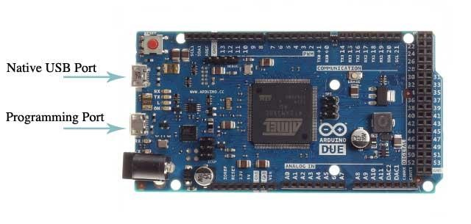
Fig 2.2: Arduino DUE Microcontroller
A power jack, an SPI header, a JTAG header, a reset button and an erase button. The Due is compliant with the Arduino 1.0 pin out, it has SDA and SCL pins near the AREF pin and an IOREF pin, which can be used by shields to detect the microcontroller board voltage. The board run in 7V-12V and 2000mA power supply which can be an Adopter or a full-wave rectifier.
It is the perfect board for powerful larger scale Arduino projects.
Specification of Arduino DUE:
Microcontroller | AT91SAM3X8E
Operating Voltage | 3.3V
Input Voltage (recommended) | 7-12V
Input Voltage (limits) | 6-16V
Digital I/O Pins | 54 (of which 12 provide PWM output)
Analog Input Pins | 12
Analog Output Pins | 2 (DAC)
Total DC Output Current on all I/O lines 130 mA
DC Current for 3.3V Pin 800 mA
DC Current for 5V Pin | 800 mA
Flash Memory | 512 KB all available for the user applications
SRAM | 96 KB (two banks: 64KB and 32KB)
Clock Speed | 84 MHz
Length | 101.52 mm
Width | 53.3 mm
Weight | 36

2.3 ESP8266-01 Wi-Fi module
The ESP8266 Wi-Fi Module is a self-contained SOC with integrated TCP/IP protocol stack that can give any microcontroller access to Wi-Fi network.
This module is a self-contained SOC (System on a Chip) that doesn’t necessarily need a microcontroller to manipulate inputs and outputs as we would normally do with an Arduino, for example, because the ESP8266-01 acts as a small computer. Depending on the version of the ESP8266, it is possible to have up to 9 GPIOs (General Purpose Input Output).In ESP8266-01 we have 2 GPIO pin.
Thus, we can give a microcontroller internet access like the Wi-Fi shield does to the Arduino, or we can simply program the ESP8266 to not only have access to a Wi-Fi network, but to act as a microcontroller as well. This makes the ESP8266 very versatile, and it can save some money and space in projects. Normally ESP8266-01 have 8 I/O pin.
TX and Rx pin to Transmission and Receive signal and it communicate with Arduino.
In Fig 2.3 an ESP8266-01 Wi-Fi module has been shown.
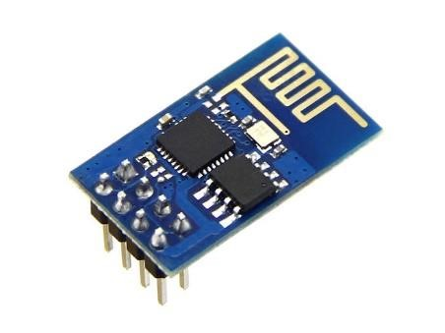
Fig 2.3: ESP8266-0 Wi-Fi module
It has a VCC pin which contain 3.3v input voltage and a GND pin is connected with Ground. The CH-PD pin is c also need connected with positive voltage which is 3.3v input voltage.
It has 2 GPIO pin (GPIO 0 and GPIO 2).This module work in two different part. One is programming part that is when GPIO 0 is connected to GND we can upload program into it and another part is to run the program in this module. In that case we need to disconnect GPIO 0 to GND. After disconnect GPIO 0 from GND the module will run as the firmware.
The ESP8266 ESP-01 module has three operation modes:
- Access Point (AP)
- Station (STA)
- Both
In AP the Wi-Fi module acts as a Wi-Fi network, or access point (hence the name), allowing other devices to connect to it. This does not mean that you will be able to check your Facebook from your device while the ESP-01 module is operating in the AP mode. It simply establishes a two way communication between the ESP8266 and the device that is connected to it via Wi-Fi.
In STA mode, the ESP-01 can connect to an AP such as the Wi-Fi network from your house. This allows any device connected to that network to communicate with the module.
The third mode of operation permits the module to act as both an AP and a STA.
The ESP8266 is capable of either hosting an application or offloading all Wi-Fi networking functions from another application processor. Each ESP8266 module comes pre-programmed with an AT command set firmware, meaning, we can simply hook this up to our Arduino device and get about as much Wi-Fi-ability as a Wi-Fi Shield offers The ESP8266 module is an extremely cost effective board with a huge, and ever growing, community. There is an almost limitless fountain of information available for the ESP8266, all of which has been provided by amazing community support.
Note: The ESP8266 Module is not capable of 5-3V logic shifting and will require an external Logic Level Converter. Please do not power it directly from your 5V dev board in case of 3.3v.
Specification of Arduino DUE:
- 802.11 b/g/n
- Wi-Fi Direct (P2P), soft-AP
- Integrated TCP/IP protocol stack
- Integrated TR switch, balun, LNA, power amplifier and matching network
- Integrated PLLs, regulators, DCXO and power management units
- +19.5dBm output power in 802.11b mode
- Power down leakage current of <10uA
- 1MB Flash Memory
- Integrated low power 32-bit CPU could be used as application processor
- SDIO 1.1 / 2.0, SPI, UART
- STBC, 1×1 MIMO, 2×1 MIMO
- A-MPDU & A-MSDU aggregation & 0.4ms guard interval
- Wake up and transmit packets in < 2ms
- Standby power consumption of < 1.0mW (DTIM3)

2.4 16x2 LCD display with I2C display Adaptor
CD (Liquid Crystal Display) screen is an electronic display module and find a wide range of applications. A 16x2 LCD display is very basic module and is very commonly used in various devices and circuits. These modules are preferred over seven segments and other multi segment LEDs. The reasons being: LCDs are economical; easily programmable; have no limitation of displaying special & even custom characters (unlike in seven segments), animations and so on.
A 16x2 LCD means it can display 16 characters per line and there are 2 such lines. In this LCD each character is displayed in 5x7 pixel matrix. This LCD has two registers, namely, Command and Data. The command register stores the command instructions given to the LCD. A command is an instruction given to LCD to do a predefined task like initializing it, clearing its screen, setting the cursor position, controlling display etc.
The data register stores the data to be displayed on the LCD. The data is the ASCII value of the character to be displayed on the LCD. Click to learn more about internal structure of a LCD. In Fig 2.4.1 a 16X2 LCD Display has been shown.
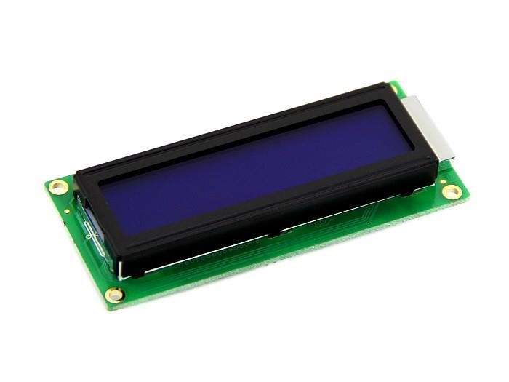
Fig 2.4.1: 16X2 LCD Display
Serial I2C LCD display adapter converts parallel based 16 x 2 character LCD display into a serial i2C LCD that can be controlled through just 2 wires. Adapter uses PCF8574 chip that serves as I/O expander that communicates with Arduino or any other microcontroller by using I2C protocol.
A total of 8 LCD displays can be connected to the same two wire I2C bus with each board having a different address. The default i2C address is 0X27 and may be changed to any of the following 0X20~0X27 via soldering A0 A1 A2 pins. In Fig 2.4.2 an I2C Display Adapter has been shown.
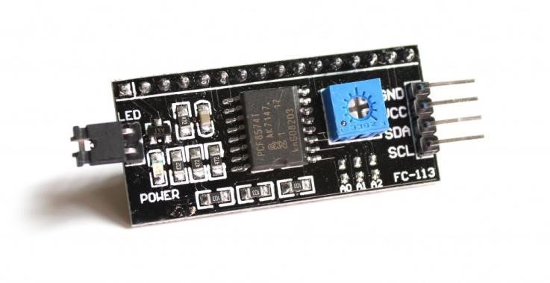
Fig 2.4.2: I2C Display Adapter
Specification of I2C Display Adapter:
- 16 x 2 Character LCD display is controlled via just two wires
- Up to 8 LCD displays with adapters can be connected and controlled by the same two wire I2C bus
- Easy to control using Arduino board
- Compatible with 16 x 2 character LCD displays
- Adapter includes 16-PIN male header connector for soldering to LCD display
- Contrast is adjusted via onboard potentiometer
- Backlight may be turned on/off via jumper
- Standard 5V voltage supply

2.5 Multiple Channel Relay Module
A relay is an electrically operated switch. Many relays use an electromagnet to mechanically operate a switch, but other operation principals are also used, such as solidstate relays. Relay are used where it is necessary to control a circuit by a separate lowpower signal, or where several circuits must be control by one signal. The first relay ware used in long distance telegraph circuit as amplifier, they repeated the signal coming from one circuit and re-transmitted it on other circuit. Relay ware also used in telephone exchange and early computer to perfume logical operations. In Fig 2.5 a 8 channel Relay has been showed.

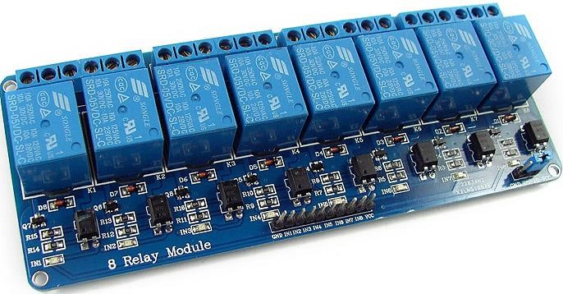
Fig 2.5: 8 Chanel Relay Module
A type of relay that can handle high power required to directly control an electrical component or other load is called contractor. Solis-state relays control power circuit with no moving parts, instant using a semiconductor device to perfume switching.
Relays with calibrated operating characteristics and sometime multiple operating coils are used to protect electrical circuit from overloaded or faults. In modern electric power system these functions are performed by digital instrument still called protective-relays
Magnetic latching relays required one plus of coil power to move their contacts in one direction and another redirected pulls to move them back. Repeated pulls from the same input have no effect. Magnetic latching relays are useful in applications where interrupted power should not be able to transition the contacts.
In this automation system we are using relays to control home appliances by getting signal from Arduino. The relay will connected with Light, Fan, Ac, Television, Computer and other electrical appliances as a digital switch.

2.6 PIR Motion Sensor
PIR (Passive Infrared Detection) are used to detect motion of human movement. This version has a large lens that can support long range and wide angle. The PIR motion sensor has 2.54mm standard connector is easy to fix it anywhere. In Fig 2.6 a PIR Motion Sensor has been showed.
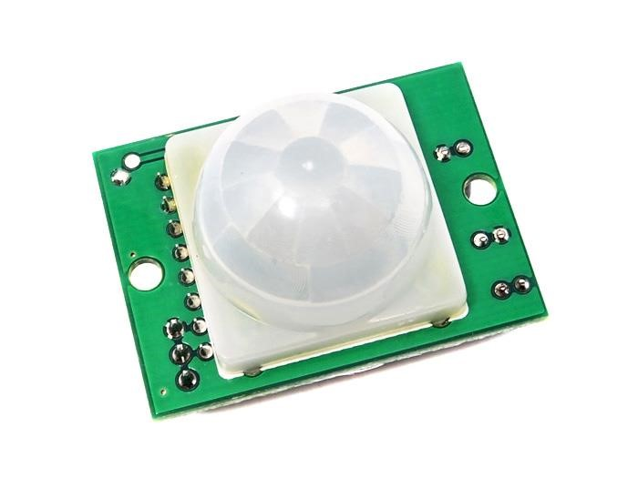
Fig 2.6: PIR Motion Sensor
In our project the work of PIR sensor is to detect human movement and if found any then send signal to Arduino and Arduino send a signal to Database.
After getting signal from this system we able to get notification in our mobile as security purpose. If any thief or any unaccepted person get into our home then the system will send the feedback so easily we can monitor our house from our mobile. It’s a small size device that we can fix it any corner of our home.
As it is a wide range motion detector we can fix it to main gate of our home so that it can cover full area in front of our house. The system design for this sensor in two individual part.
One is that, if any unexpected motion will detect then it will send a notification to our mobile application and other is it will activate an alarm.
Features
- Long range
- Wide angle
- Low consumption
- DC 3.0-5.5V power supplier

Specification
- Input Voltage: DC3.0-5.5V
- Current: 100uA(max)
- Detecting distance: 9m(max)
- Output signal: 0,3 VCC (Output high when motion detected)
- Sentry Angle: 120°
- Connector:3Pin 2.54mm pitch
- Size： L36*W26*H21(mm)

2.7 Servo
A Servo is a small device that incorporates a two wire DC motor, a gear train, a potentiometer, an integrated circuit, and an output shaft. It has three wires that stick out from the motor casing, one is for VCC, one is for GND, and one is a control input line that connect to microcontroller I/O port. The shaft of the servo can be positioned to specific angular positions by sending a coded signal. As long as the coded signal exists on the input line, the servo will maintain the angular position of the shaft. If the coded signal changes, then the angular position of the shaft changes as every angular movement is define in program.
Servos come in different sizes but use similar control schemes and are extremely useful in robotics or any moving functional machine. The motors are small and are extremely powerful for their size. It also draws power proportional to the mechanical load. A lightly loaded servo, therefore, doesn’t consume much energy. Normally a robotic servo run in 5v.
A Servo can used in powerful heavy-duty sail boats. Servos are rated for Speed and
Torque. Normally there are two servos of the same kind, one geared towards speed (sacrificing torque), and the other towards torque. In Fig 2.7 a Servo motor has been showed.

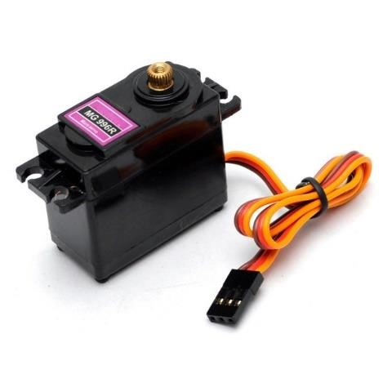
Fig 2.7: Servo Motor
We are using Servo for two different activity. One is as in our county the door or window lock is no available in daily budget we are using Servo to make a door locker for our system. In our program we define a fixed angular forward and reverse rotation that will pull and push a trigger to lock and unlock the door.
And the work of a servo is to make a fixed forward and reverse rotation to open and close the window. The Window closure will connect with a servo by gear so that the servo can open or close the window in fixed measurement.

2.8 Block Diagram of entire system
The simple block diagram of the system are shown in Fig 2.8. The diagram describe basic connections and data flow across the system. In this system The Arduino have a microcontroller (AT91SAM3X8E) host the relay module for switching ON/OFF and other necessary sensor.
The Arduino is also connected with a Wi-Fi module (ESP8266-01) with Serial communication port. This Wi-Fi module is connected directly to database with privet network through a router. This Wi-Fi module read data from the connected database and send the status to Arduino. After getting the status from WI-FI module Arduino make decision what to do. The Arduino also able to communicate with the Wi-Fi module and send input data from sensors to Wi-Fi module and the Wi-Fi module send this incoming sensor data to the database for many purpose.
On other hand the database is also connected to a simple mobile application. Now we can control the appliances is connected with the Arduino. Actually we are not controlling the Arduino from this application, we are sending the status value to database from this application. The details of this application will be describe in chapter 6.
The main part of this system is Google assistant which is complete with three component Actions on google, Dialog flow and Cloud functions. All component are connected to each other to fulfill its goal. Google assistant take user voice command from mobile and choose actions from user and send to Dialog flow to find the defined intents and entities.
Dialog flow compare those entities that are defined in intent and send it to Firebase Cloud Functions. The functions help to update the value of the appliances in database are saved.
In Fig 2.8 the Block Diagram has been given.
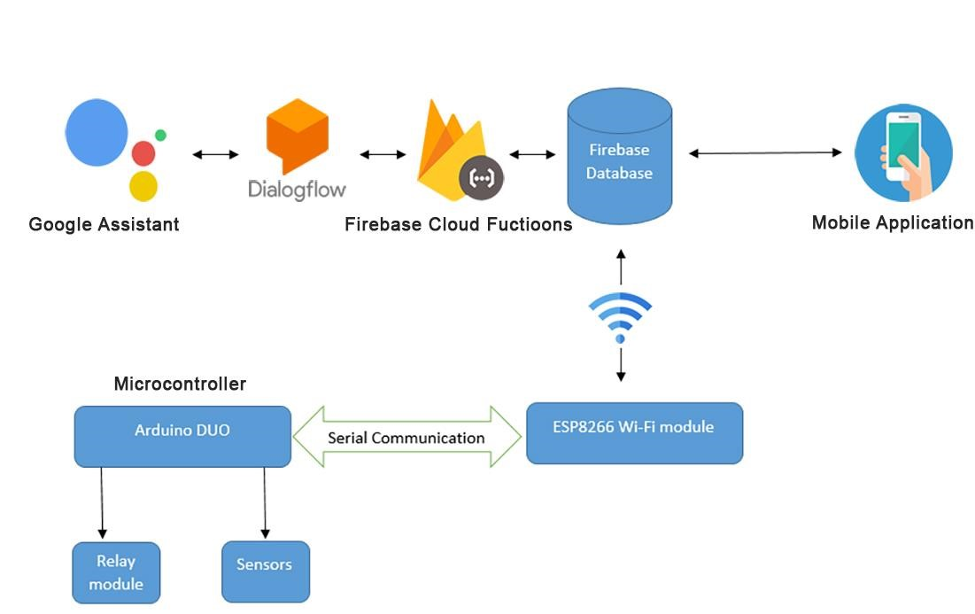
Fig 2.8: Block diagram of Swift Home Automation
So we can say the Database is the main via to connect each and every component of this system. In that case we don’t need to think about any Wi-Fi range limitation.
If our mobile have internet or connected with any Wi-Fi then we can run this whole system from anywhere. The circuit diagram of this system are describe bellow.

2.9 Circuit diagram of entire system
Now let’s go to a little deep into the system’s hardware configuration with all the major component. Circuit diagram explain the connectivity of the whole system. This is an important part to connect all component to run entire system perfectly.
In Fig 2.9 shows the circuit diagram of this system.

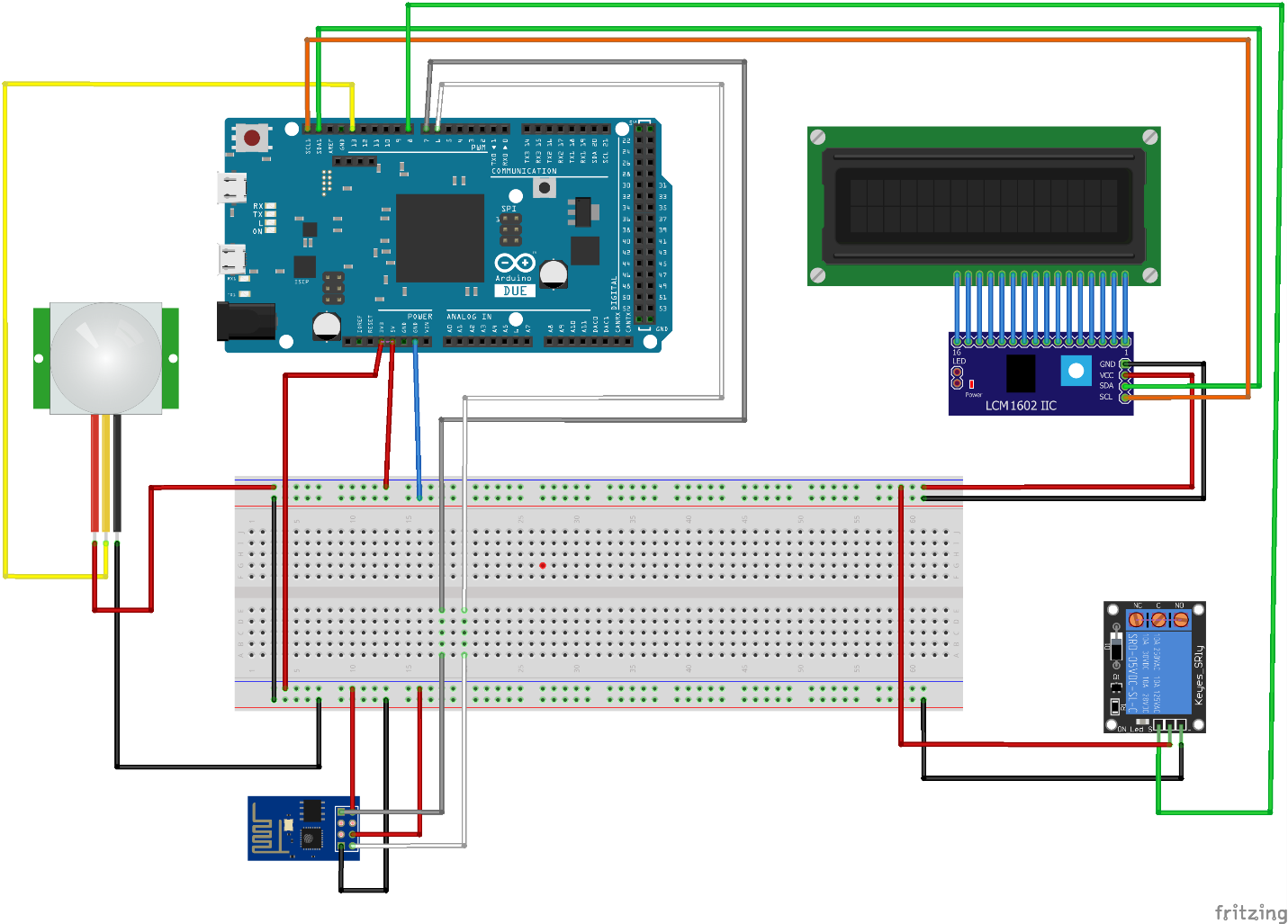
Fig 2.9: Circuit diagram of swift home automation system
As the Arduino DUE have a voltage input center and also provide 3.3volt and 5volt so we don’t need any external power supply.
We can use a 12v/200mA adaptor or USB power to run this microcontroller board.
Other component of this system will get power from Arduino.
In that case ESP8266-01 Wi-Fi module run in 3.3v from Arduino, The PIR sensor
(Motion sensor) run in 5v, the 16x2 LCD display run in 5v and the Key-Relay run in 5v.
All module have 3.3v output pin.
The 16x2 LCD Display is connected to an IIC display adapter module. This module can read printed data from SCL an SDA port from Arduino. The reason is to use this adapter, LCD display have 16 I/O port and using this port directly with Arduino is reduce the availability of I/O port of Arduino. So using this Display adapter, we can work with only 2 I/O pin (SDA/SCL) in case of using 16 pin of Arduino.

2.10 Connections and Communication of Components
Connections:
• Connections of Arduino
To complete the system we need to connect each I/O pin of hardware component correctly. As in my system I am using Arduino DUE and it have so many I/O pin so we separate a number of pin for separate operation.
In Arduino 5v is power supply for 5v component as Relay. Servo, and Display. And the
3.3v power supply is for ESP8266-01 Wi-Fi module. The analog pin A4 and A0 of Arduino is SDA and SCL pin that I am using fro I2C display adaptor to print data to LCD Display.
The digital pin 8 to 13 are using for take farther sensor read as input pin. Digital pin 2 to 7 are using for communication with other component as we use pin 7 as TX and pin 6 as RX to get communicate with ESP8266 Wi-Fi module.
Digital pin 22 to 40 are using for Relay module output pin and from 41 to rest of the pin are used for Servo and other output component.
• Connections of ESP8266-01
Connection of ESP826-01 has very simple connection. In Fig 2.10 ESP8266-01 Pin has been given.
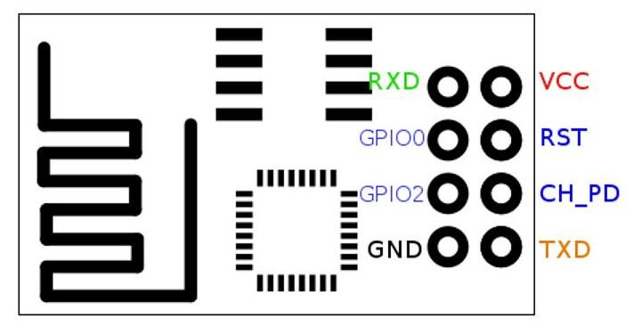
Fig 2.10: ESP8266-01 Pinout
We can see from Fig 2.11 that ESP8266-01 have 8 pin. VCC connect to 3.3v of Arduino provide and GND is connected to the GND of Arduino. CH_PD pin of ESP8266-01 have to connect with VCC as 3.3v.
When we need to program this module we need to connect TXD pin to TX of Arduino and RXD pin to RX pin of Arduino. That means Arduino sending Program in ESP826601. In that case GPIO 0 pin of ESP8266-01 have to connect with the GND of Arduino to make ESP8266-01 programmable mode. In that case Arduino should act as a bypass module by connection RESET pin with GND in Arduino. If RESET is not connect to GND then the program will not upload in EP8266-01 but upload in Arduino.
After programming ESP8266-01 we need to change the Transmission (TX) and Receive (RX) pin. In that case TXD pin of ESP8266-01 will be connect to pin 7 of Arduino and the RX pin of ESP8266-01 will be connect to pin 6 of Arduino because I define this 2 pin as TX and RX pin in program and in that mode ESP8266-01 is sending data to Arduino and Arduino receiving data from ESP8266-01.
Communication
The Arduino hardware has built-in support for serial communication on pins 0 and 1 (which also goes to the computer via the USB connection). The native serial support happens via a piece of hardware (built into the chip) called a UART. This hardware allows the at mega chip to receive serial communication even while working on other tasks, as long as there room in the 64 byte serial buffer.
The Software Serial library has been developed to allow serial communication on other digital pins of the Arduino, using software to replicate the functionality (hence the name
"Software Serial"). It is possible to have multiple software serial ports with speeds up to 115200 bps. A parameter enables inverted signaling for devices which require that protocol. In communication section ESP8266-01 will communicate with Arduino to send Database update available value to control Arduino pin.
The ESP8266-01 have a sender program that send signal trough TX pin and The Arduino have a program that receive signal from pin 6 as RX pin.
Both signal will send and receive under a define channel is 115200bps.

2.11 Cost Analysis of the hardware
To design the hardware, the following component are required:
- Arduino DUE R3 (China)
Quantity: 1 piece
Cost: 1580.00 BDT

- ESP8266-01 Wi-Fi Module
Quantity: 1 piece
Cost: 300.00 BDT

- PIR motion Sensor
Quantity: 1 Piece
Cost: 1050.00 BDT

- 16X2 LCD Display
Quantity: 1 Piece
Cost: 160.00 BDT

- I2C Display Adapter
Quantity: 1 piece
Cost” 140.00 BDT

- 8 Channel Relay
Quantity: 1 Piece
Cost: 1000.00 BDT

- Others Cost: 500.00 BDT
So, Total cost of this system is 4730.00 BDT (Four thousand seven hundred thirty taka only). This cost is very reasonable.

CHAPTER 3 Virtual Agent (Google Assistant)

3.1 Introduction
Virtual Agent is a conversational bot platform for providing user assistance through conversations within a messaging interface. Use Virtual Agent to build automated agents (bots) and design bot conversations that help users quickly obtain information, make decisions, and perform common work tasks. A Virtual agent normally talks with usher as a service agent. Anyone can normally talks with an Agent to get some information or making any decision with voice command.
In our daily life we are using Virtual agent daily. In any call center we make a call a virtual agent takes our call first the make decisions by our command. We can also control our mobile by our mobile assistant like Google Assistant, Alexa or Siri.
In or System we are using a Virtual agent based on Google platform for Android mobile. Google have a Virtual gent called Google assistant and this Assistant are normally available in all Android mobile now a days. We will create our personal Agent under Google Assistant that help us to control our system. The Name of our Personal Agent is “Agent Swift”.
To prepare and communicate this Google Assistant for our system we need some simple work to do. So let’s start the procedure. Every step of work are describe bellow.

3.2 Agent Setup
- Setting up a Google Assistant app in Actions On Google Console
- Setting up Agent in Dialog flow Console
- Write a web hook using Firebase cloud function HTTP Trigger

3.3 Actions On Google Console
Actions on Google is the platform for developers to extend the Google Assistant. Join this emerging ecosystem by developing actions to engage users on Google Home, Pixel, and many other surfaces where the Google Assistant will be available.
Procedure:
- Go to actions on google console and click on Add/import project are showed in Fig 3.3.1.
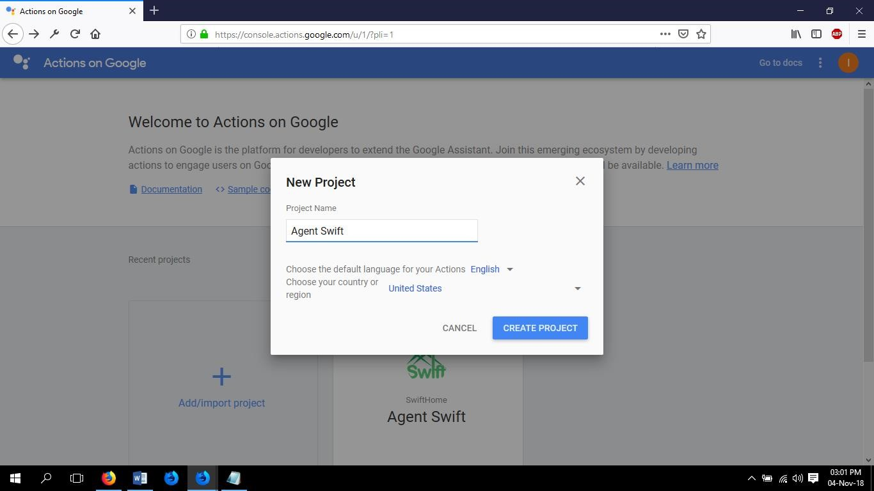
Fig 3.3.1: Actions on Google Console create New Project
- Give a suitable name to your project and choose your country. Click Create Project after all the details are filled. After we will get as showed in Fig 3.3.2.
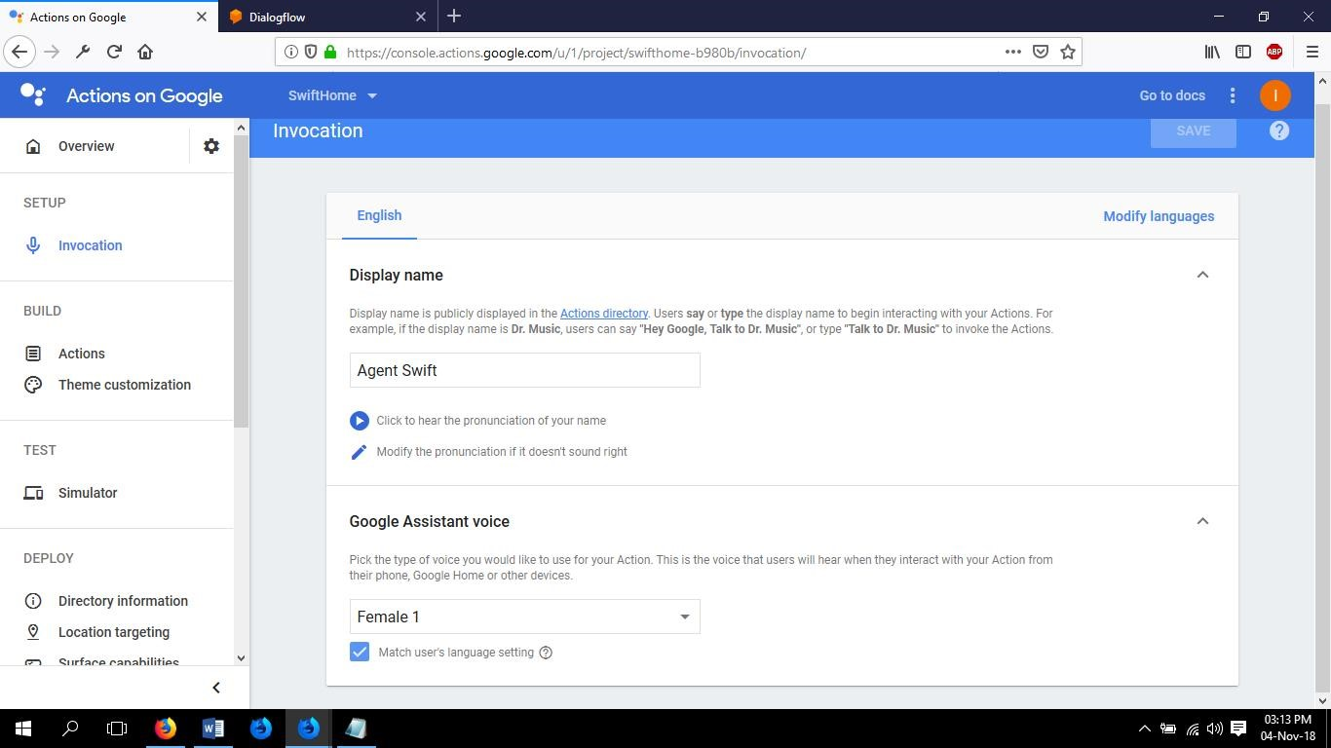
Fig 3.3.2 Actions on Google Console invocation settings
- After that it will ask for First action from Actions section in Fig 3.3.3.
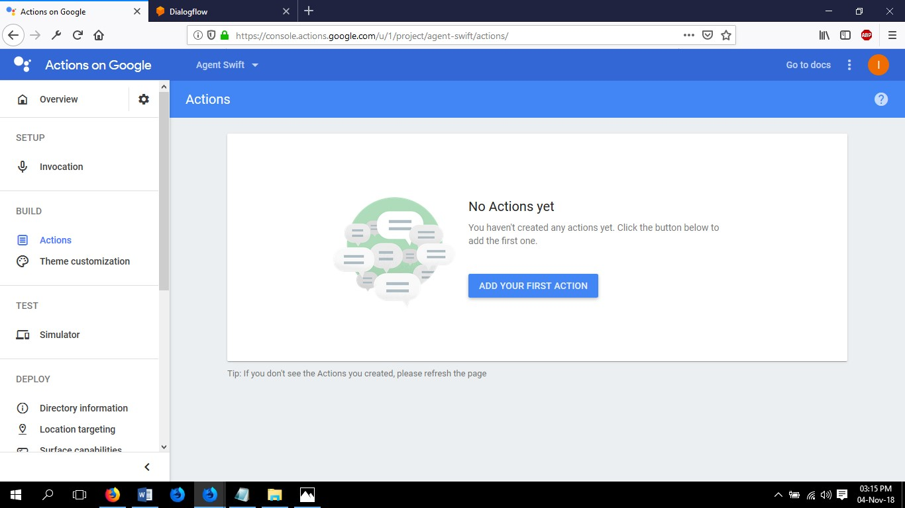
Fig 3.3.3: Actions on Google Actions
- Click on “Add Your First Action” to choose the action we want.
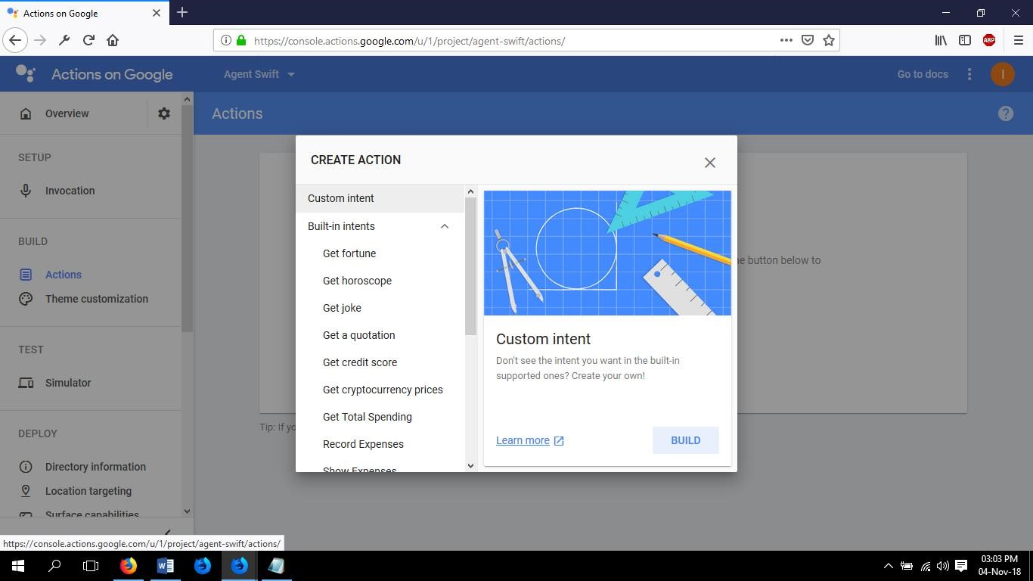
Fig 3.3.4: Built Custom Intent on Actions
- Click on “BUILT” under Custom Intent and This will redirect us to Dialog flow
Console with same user login from Action on Google Console. In Fig 3.4.1 Our next progress in Dialog Flow are described below.

3.4 Dialog Flow Console
Dialog Flow give users new ways to interact with your product by building engaging voice and text-based conversational interfaces, such as voice apps and catbots, powered by AI. Connect with users on website, mobile app, the Google Assistant, Amazon Alexa, Facebook Messenger, and other popular platforms and devices.
Procedure:
- In the Dialog flow console, we need to give our agent a name, add a description about what it does, keep language as English — en and select your desired time zone. SAVE the details showed in Fig 3.4.1.
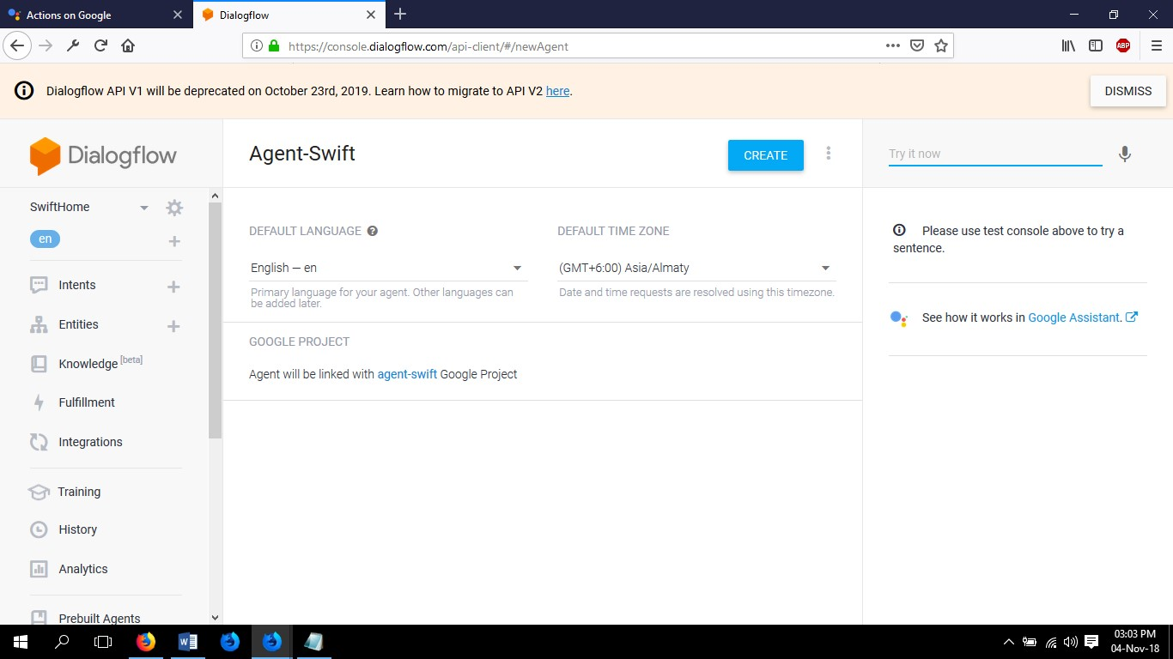
Fig 3.4.1: Dialog Flow Setup
- Once the details are saved, you need to redirect to the Intents section. In Intent section we need to set the commanded sentence that we will use to control our system or any other information that we will ask to do our Agent later. As example we define here
& intent and this are control_appliances, Default Welcome Intent, help,
input_welcome and quit. This intents contain different type of information. The control_appliances intent are mainly use to control our system in Fig 3.4.2.
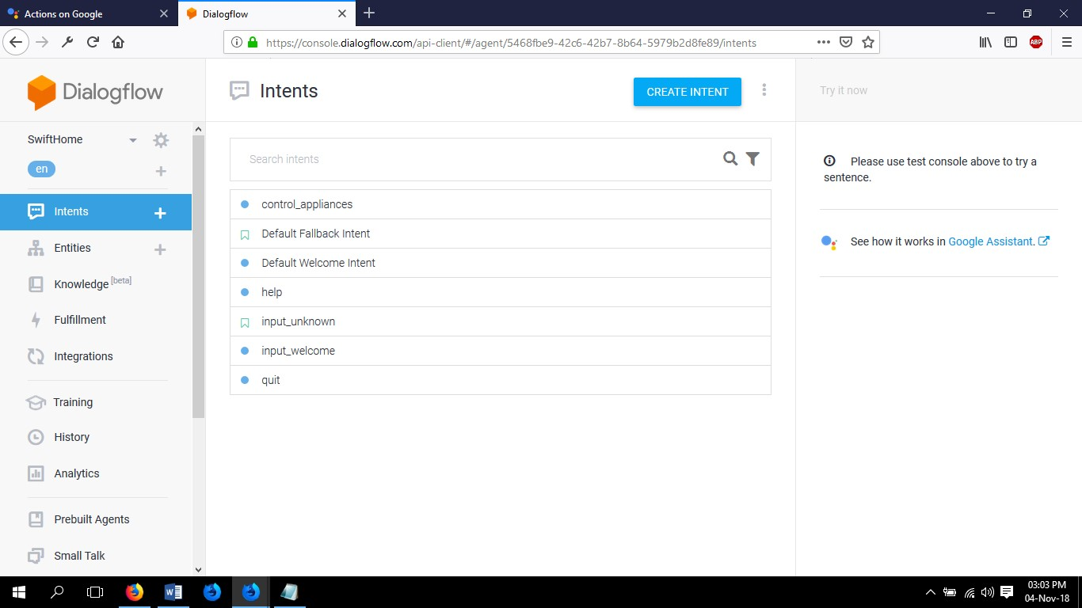
Fig 3.4.2: Dialog Flow Intent
- That command we say in “control_appliances” we define the statement of commands that our agent will work, if you say “Turn on Bedroom light off”, it now understands that the light has to be turn off. Next, we have to write a webhook which will push this on/off data on Firebase Real-time Database. Our hardware is listening for changes in data in the Real-time Database and switches on/off the light based on the state are showed in Fig 3.4.3.
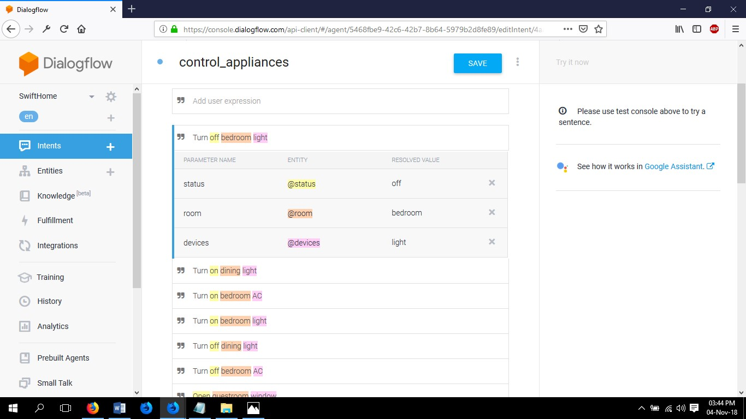
Fig 3.4.3: “control_appliances” Intent Statements
- In Entities we need to define the element we are using on our system.
We define three entities, the Room name, Device name and available status of our home appliances. This will help to compare the status of the device under all room are define on entities. Fig 3.4.4 is showing the Entities of our Dialogflow.
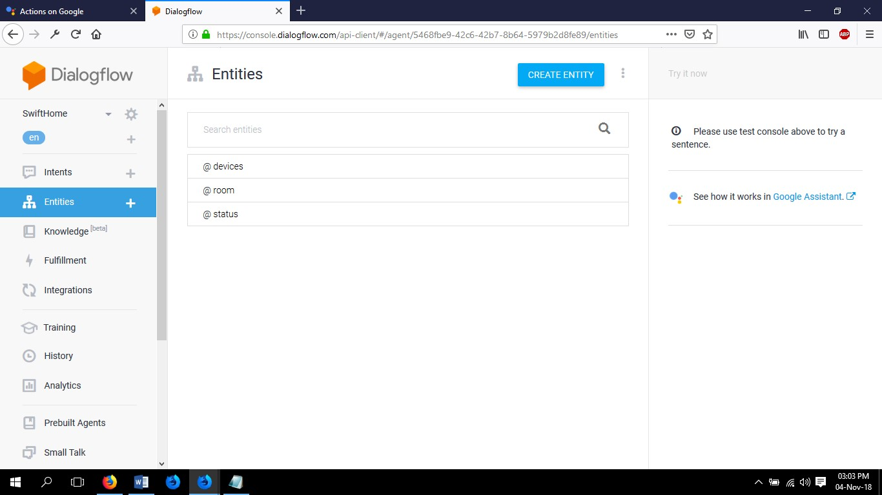
Fig 3.4.4: Entities
Room entities hold all the room name of our home to detect which room appliances we want to control in Fig 3.4.5.
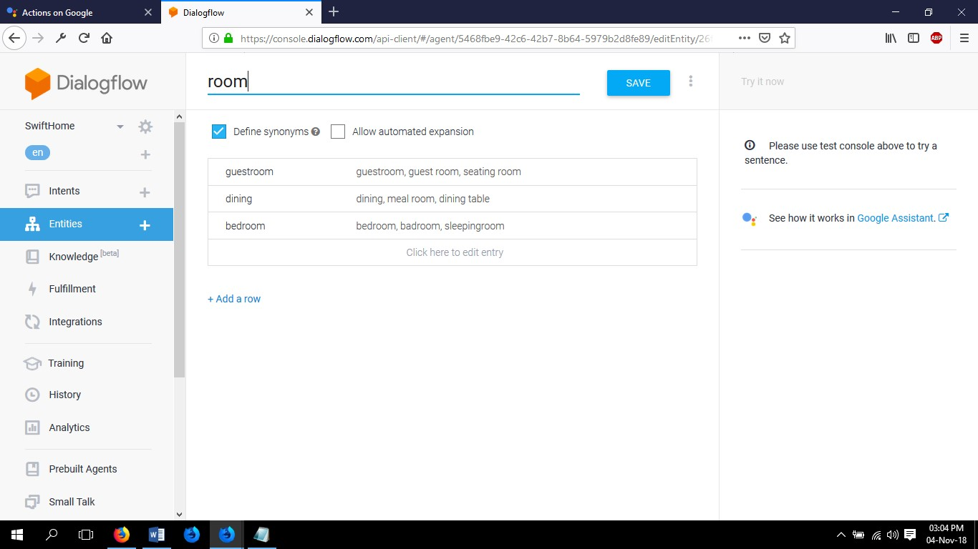
Fig 3.4.5: Room Entities
Devices intent hold the information of all device/appliances that we want to control that are showing in Fig 3.4.6.
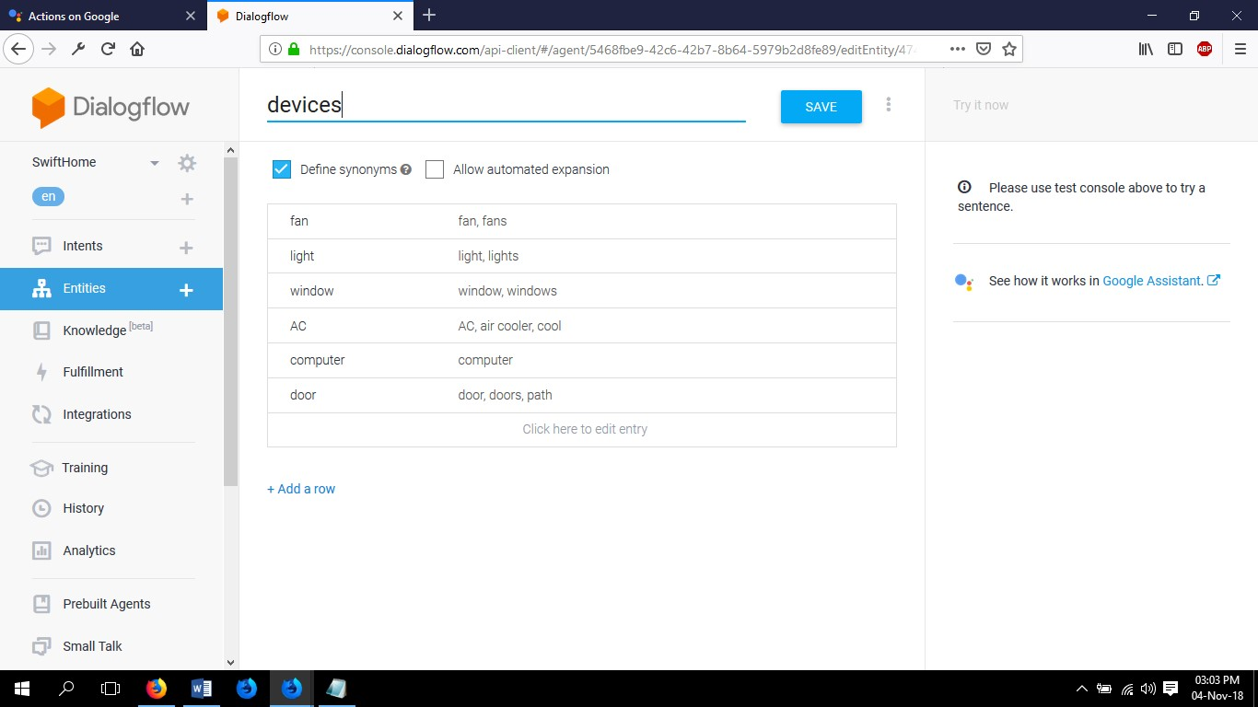
Fig 3.4.6: Device Entities
Status intent hold the status of our device that able to turn on/off, open/close, lock/unlock and activate/deactivate our devices in Fig 3.4.7.
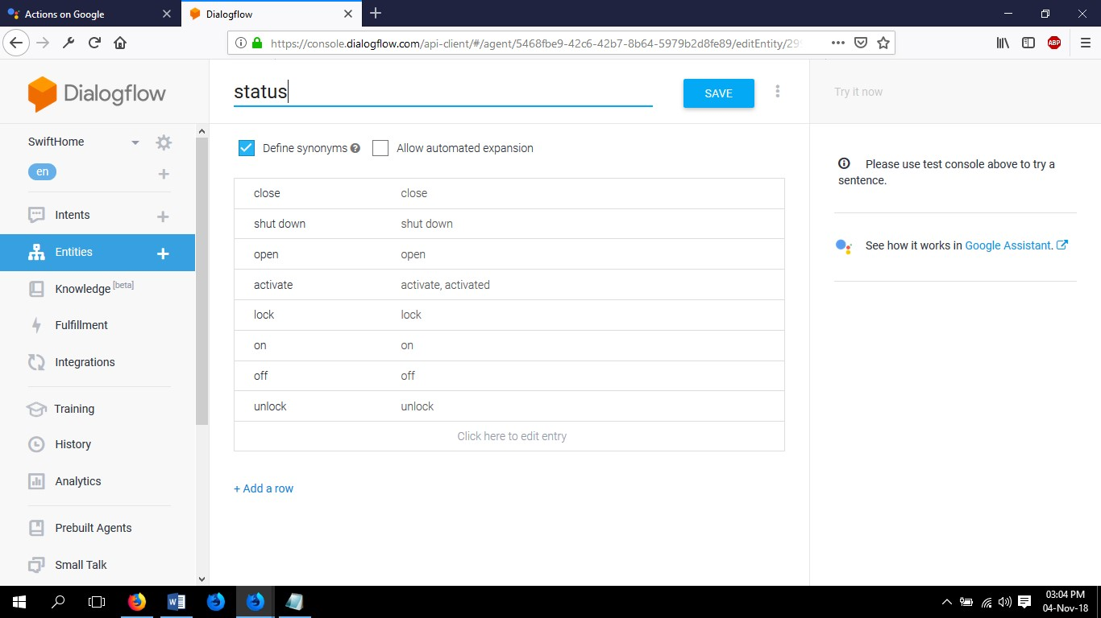
Fig 3.4.7: Status Entities
5 In fulfilment section we need to link up webhook URL from Firebase Cloud
Functions deployment. After deploy our cloud functions we will get a webhook URL. We need to just copy and paste the URL to fulfilment URL box and save it. The fulfillment section are showing in Fig 3.4.8.
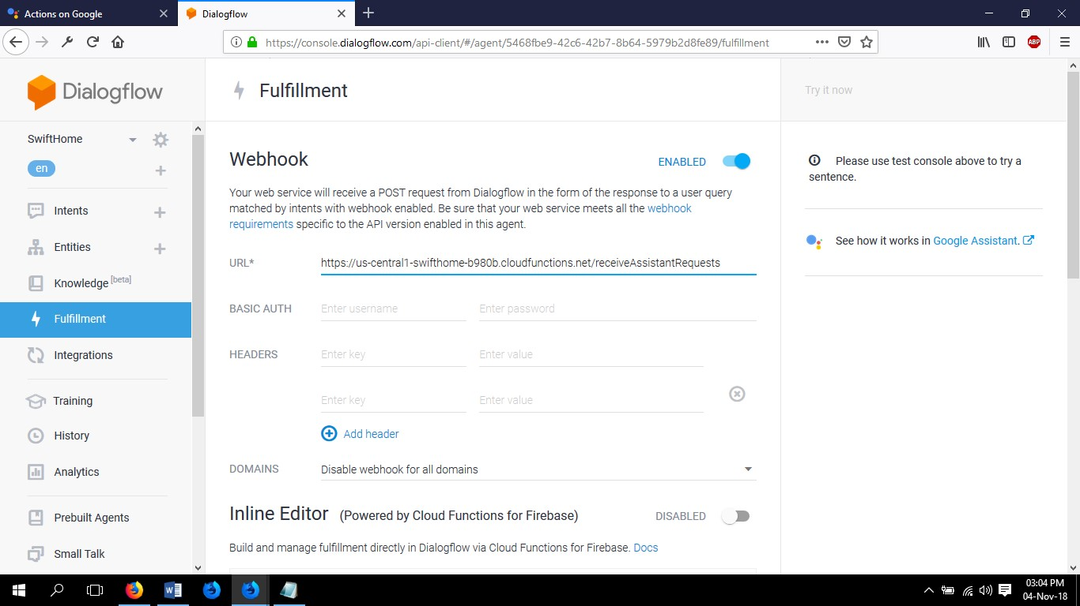
Fig 3.4.8: Fulfilment web hook URL
After deploying Firebase Cloud Functions it will create a database under Firebase Real-time Database of all entities we define before. Deployment of Firebase Cloud Functions are described below.

3.5 Firebase Cloud Functions
To deploy a web hook in Firebase Cloud Function we will use Firebase CLI.
We are going to write a Firebase cloud function HTTP Trigger. Data is posted from Dialog flow to our HTTP endpoint of this cloud function where you can make use of the information available in the request. We will be using Firebase CLI to initiate our cloud function and deploy it.
- First we need to Install NodeJS.exe on our computer.
- Then we start with installing firebase tools using NPM in our computer Command Prompt. Cloud functions are simple JS functions running independently in Node.js environment.
- Authenticate firebase tools by signing in with the same email used in actions on google app setup.
- Setup initial project structure.
- Write command on Command Prompt:
npm install -g firebase-tools #Install firebase tool firebase login
mkdir swifthome-cf #Including -cf after project name is mandetory cd swifthome-cf firebase init functions

After these commands are run successfully, your project directory should look like this:
swifthome-cf +- .firebaserc
|
+-firenase.json
|
+-functions/
|
+-package.json
|
+-index.js
|
+-node_modules/
- Now we need to install actions on google nodejs client library.write command under functions folder
cd swifthome-cf/functions
npm install --save actions-on-google firebase-admin
- Now our code for the webhook goes in index.js. Open index.js and write the JS code that we want to deploy in Firebase Cloud Functions. In Fig 3.5.1 our JS code has been showed.
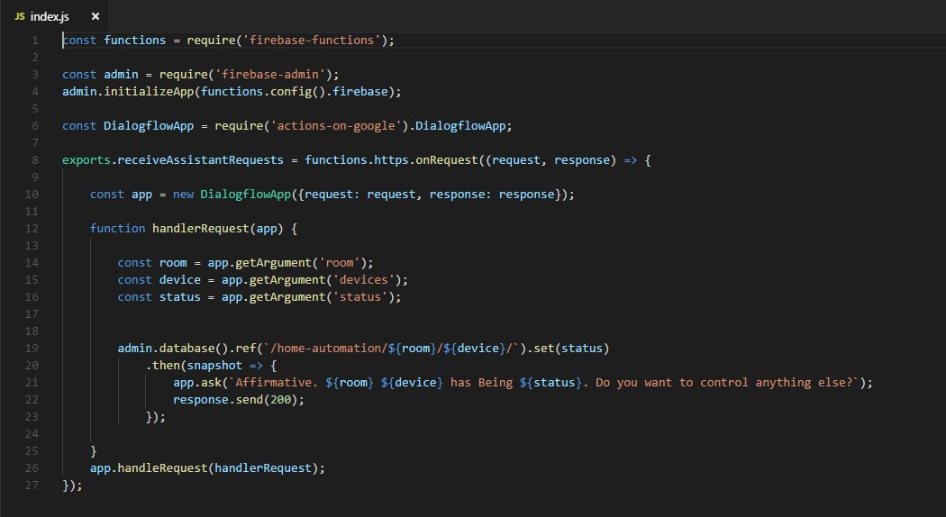
Fig 3.5.1: Script for Firebase Cloud Functions Webhook
- Now we have our code for the webhook ready to deploy our cloud function. Now write on Command Prompt.
firebase deploy
- Once the deployment is complete, a link is generated which acts as our webhook HTTP endpoint.
Fig 3.5.2 are showing the deployment has been successfully complete.
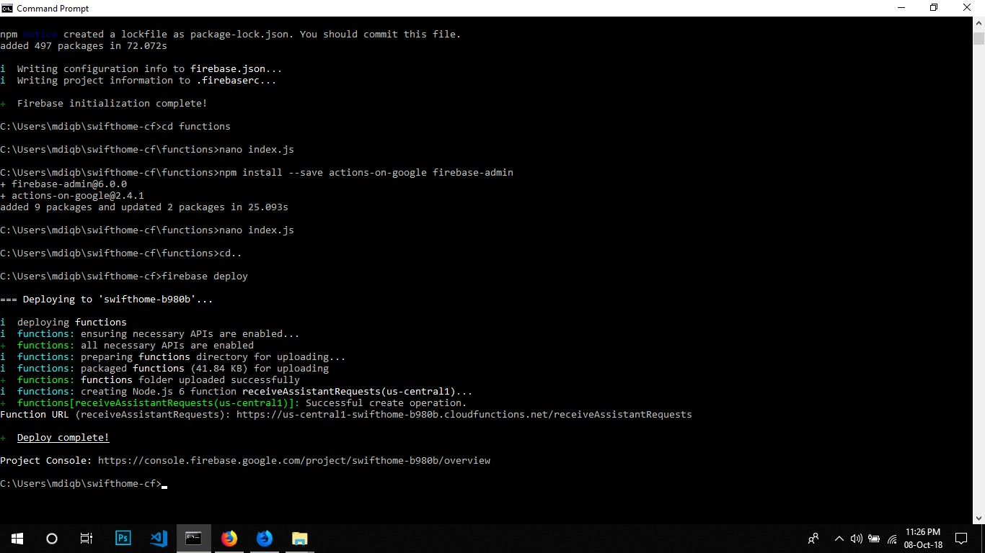
Fig 3.5.2: Firebase Function deployment
- Copy the Function URL and paste it to fulfillment section URL section by enabling web hook.
Now our Agent will work successfully in Google Assistant.

3.6 Firebase Real-time Database
The Firebase Real-time Database is a cloud-hosted database. Data is stored as JSON and synchronized in real time to every connected client. When you build cross-platform apps with our iOS, Android, and JavaScript SDKs, all of your clients share one Real-time Database instance and automatically receive updates with the newest data.
In our system Firebase Database carry the state value of Dialog Flow entities under intent by Firebase Functions we define before.
Swift Agent take command from user and update the value of entities in Database. Here is the snapshot of our Real-time database are given in Fig 3.6.
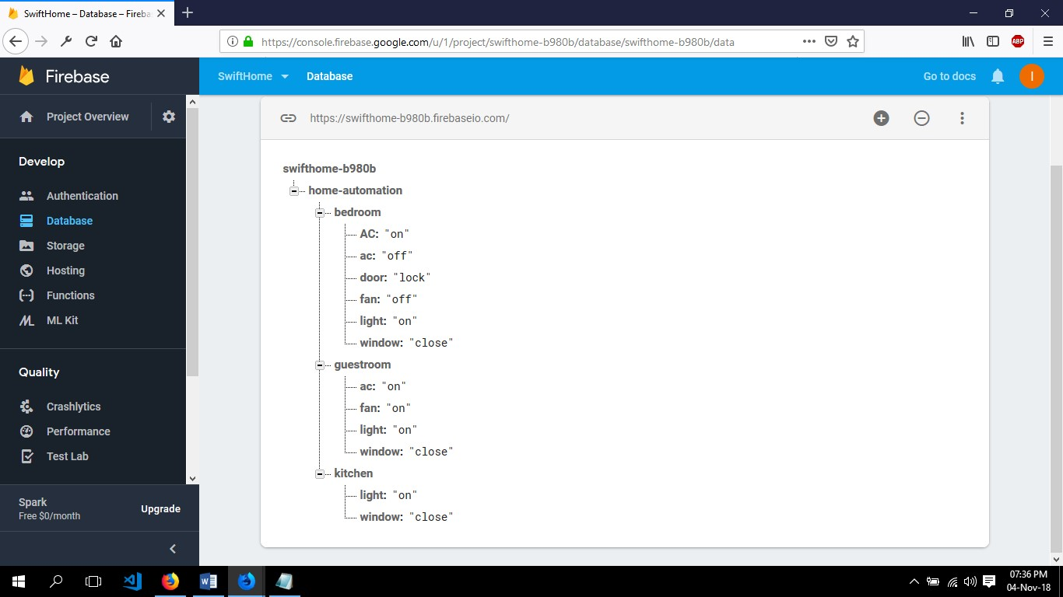
Fig 3.6: Firebase Real-time Database
The same database we will use for Mobile application to change values of entities in different way. The Mobile application section is described below in Chapter 5: Mobile Application Design.

CHAPTER 4 Mobile Application Design (Android)

4.1 Introduction
A mobile application, most commonly referred to as an app, is a type of application software designed to run on a mobile device, such as a smartphone or tablet computer. Mobile applications frequently serve to provide users with similar services to those accessed on PCs.
I Design a Mobile application to control my system remotely by pressing a button on this application besides the voice command controlling based on Android Platform and built on Android Studio.

4.2 Application Details
The name of our mobile application is Swift Home that have a simple user interface to understand by any user.
Normally the application do a simple work. This application have no direct relation with my hardware section but it is connected with the database. First there is an Authentication part when we open the application.
First of all we need to register an ID by using Email and Password. After that every time we can login to this application by using this Email and Password.
The user Email and Password are saved in Firebase Authentication are showed in Fig 4.2.
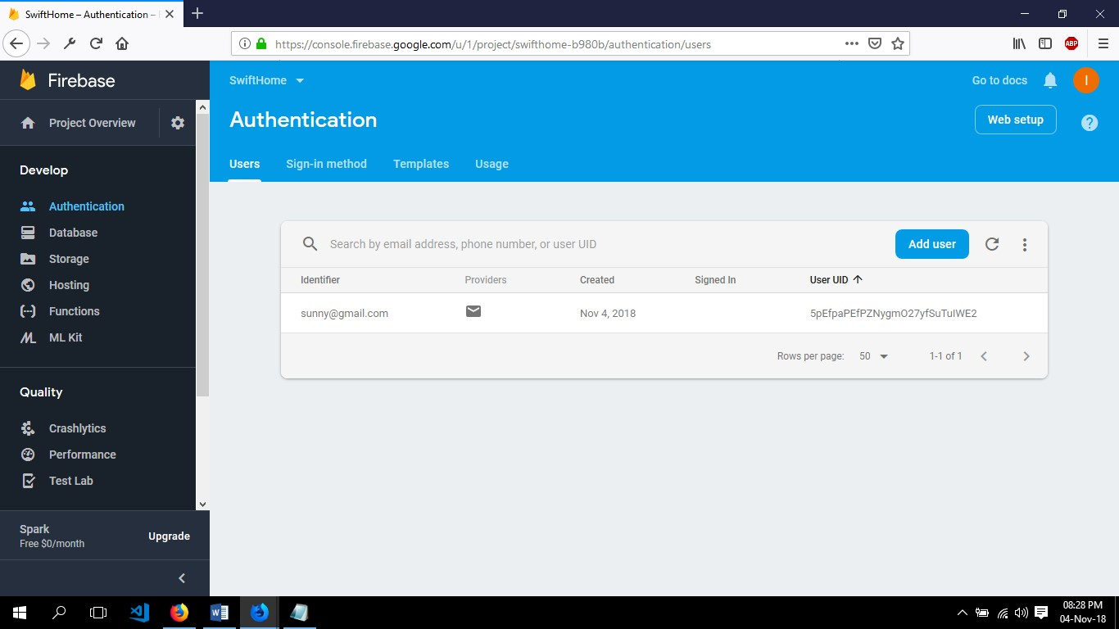
Fig 4.2: Firebase Authentication
The application read data from the Firebase Real-time database and update value of data from user. The application are functional that it make room section by counting room’s data from database. So we will get room’s selection option in application as much room our database have strode. By clicking on the room selection it will jump to device section of that room. From there we can update value by pressing of device button. The buttons of devices are functional that it have a fixed value that update true or false value in database.

4.3 User Instruction
For user Instruction I am adding some snapshot of application and describe step by step.
1. In starting we will find Sign In, Sign Up and Forget password option in interface.
From here we can sign into the application by entering Sign in Email and
Password or Sign up for new ID for access in Fig 4.3.1
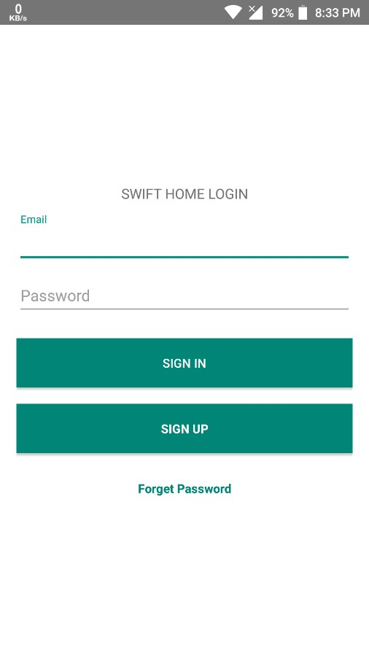

Fig 4.3.1: Sign in/Sign out or forget password interface of application 2. We can also reset our password from Forget Password section in Fig 4.3.2.
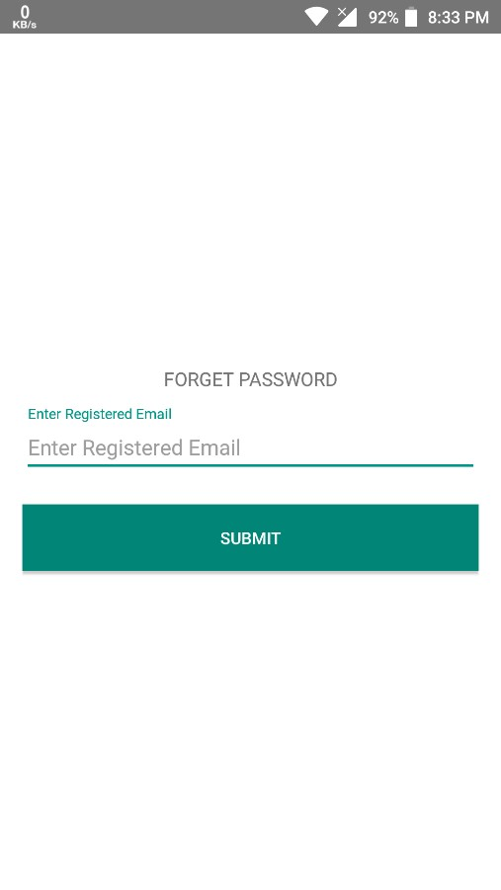

Fig 4.3.2: Reset password interface of application
- After Sign in we will find the room’s selection interface that are saved in our database. In Fig 4.3.3 are showing the room selection page in our application.
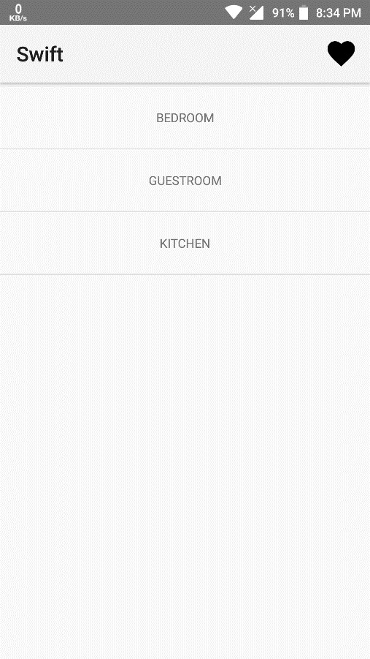

Fig 4.3.3: Save room selection Interface
- By pressing on room section button we will find the device name that are connected with the database through the system under that room.
Every devices have a switch that functionally on or off the device by updating true or false value in database are showing in Fig 4.3.4.
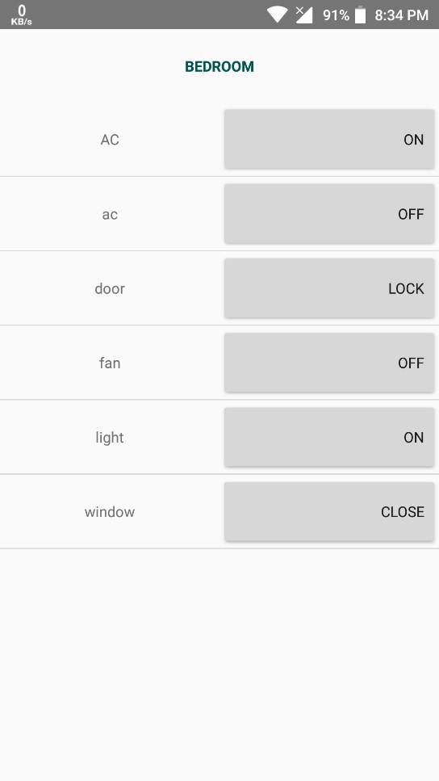

Fig 4.3.4: Switch on/off button of devices
- By going back to rooms section we will find a menu button on the top of the right corner. By pressing this button we can find the user profile where we can change user Mail, Password and delete user and Sign out from the application. Fig 4.3.5 contain the user profile of the mobile application.
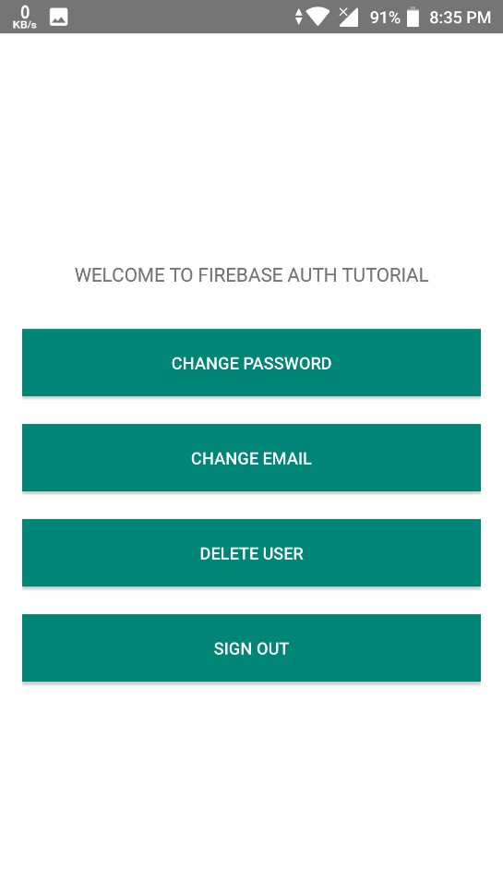

Fig 4.3.5: User Profile Interface

CHAPTER 5 System Deployment and Test

5.1 Introduction
This is the chapter I will discuss about the deployment of the system and the test result that generate in the system testing phase of the whole system in different case scenario.

5.2 System Deployment
I have installed Arduino DUE, ESP8266-01 Wi-Fi module, Relay, PIR Sensor and Servo as described in chapter 2.The main power supply is a 12v/2000mA adaptor that will supply power for 2 different phase.
On is to run the hardware component. It means the adaptor will supply power to Arduino and the Arduino will supply 5v and 3.3v to another component of hardware. The other power supply phase is to supply power for light, fan and other devices prototype.
This prototype devices are connected with relay to digitalize there switches.

5.3 System Testing
For the testing purpose I connected all possibly appliances prototype with relay which will get signal from Arduino I/O pin to switching on or off.
Now I will activate our Google assistant and make a communication with Agent Swift to sending command. All actions after commanding will visual in Google Assistant console.
Table 5.3.1 and 5.3.2 will show that the system is working properly according to its operation described earlier chapter.

Table 5.3.1: Result of the Google Assistant command system test
Test  Number | User  Command | Swift Agent replay | Actions on  Database | Relay Status | Servo | Status
1 | Talk to  Agent Swift | Sure. Here's the test version of Agent Swift.  Hay, (User Name). What so you want to control me? | NULL | NULL | NULL | Asking For  Actions
2 | Turn on Bedroom  light | Affirmative. Bedroom light has Being on. Do you want to control anything else? | UPDATE  ../bedroom/ light: on | ON | NULL | Bedroom  light turned  ON
3 | Turn off Bedroom  light | Affirmative. Bedroom light has Being off. Do you want to control anything else? | UPDATE  ../bedroom/ light: off | OFF | NULL | Bedroom  light turned  OFF
4 | Lock bedroom door | Affirmative. Bedroom door has Being lock. Do you want to control anything else? | UPDATE  ../bedroom/  Door: lock | NULL | Servo rotate 90 degree | Door has been lock
5 | Unlock bedroom door | Affirmative. Bedroom door has Being unlock. Do you | UPDATE  ../bedroom/ | NULL | Servo rotate 90 degree | Door has been unlock
 |  | want to control anything else? | door: unlock
6 | Open Bedroom window | Affirmative. Bedroom window has Being open. Do you want to control anything else? | UPDATE  ../bedroom/  Window: open | NULL | Positive rotation for opening window | Window is open
7 | Close  Bedroom window | Affirmative. Bedroom window has Being close. Do you want to control anything else? | UPDATE  ../bedroom/  Window: close | NULL | Negative rotation for closing  window | Window is closed

Table 5.3.2: Result of the Mobile Application system test
Test number | User activity | Application activity | Actions on  Database | Relay | Servo | Status
1 | Open  Application. | Sing in  Requirement. | NULL | NULL | NULL | Please Sign in
2 | Sign in to App with correct email and password. | Successfully sign in Open Users room list. | Match with User email and password. | NULL | NULL | Sign in successfully
3 | Sign in to App with incorrect email and password. | Email and password is wrong please sign in. | User email and password is not found. | NULL | NULL | Sign in Failed
4 | Click on bedroom from room list. | Devices list are open under this room. | Write room devices name and status. | NULL | NULL | Open devices  list
5 | Tap to switch button on of light. | Send update value to database and shows opposite value. | Update light value under room. | ON | NULL | Bedroom light is on.
6 | Tap to switch button off of light. | Send update value to database and shows opposite value. | Update light value under room. | OFF | NULL | Bedroom light is off.
7 | Tap to Open window switch. | Send update value to database and shows opposite value. | Update Window value under room. | NULL | Positive rotation for open window. | Window is open.
8 | Tap to Close window switch. | Send update value to database and shows opposite value. | Update Window value under room. | NULL | Negative rotation for open window. | Window is close.
9 | Tap to door lock switch | Send update value to database and shows opposite value. | Update Window value under room. | NULL | Rotate servo 90 degree to lock the door. | Door in lock.
10 | Tap to door unlock switch | Send update value to database and shows opposite value. | Update Window value under room. | NULL | Rotate servo -90 degree to unlock the door | Door is unlock.

5.4 Summery
In this chapter I have described how the hardware implementation is done and the testing result of the system.
Test result are summarized in tabular from also. The tabular data shows that the system is working correctly from both phase Google Assistant and Mobile application.

CHAPTER 6 Conclusion

6.1 Conclusion
In this project I have develop a Swift Home Automation System with Google Assistant that can be driven from both application and also voice command. Voice control system futures will greatly help those people who are physically disable, handicap or old people.
This system is also a safety for family member as they can avoid to use electrical switches. And also this system is a safety for home to harm by other or any thief.

6.2 Limitation of the proposed system
This system limitation is from Google Assistant application we can only control the appliances of our home but this media could not help us to detect any damage in electrical inner or outer part of this system. May be farther development could be possible in this system to make this system more advance.

6.3 Recommendation for future work
The possibility features of Home Automation system are endless. We can integrate almost everything of our life so this system work more efficiently and to make them integrate to carry out their task by won.
I have planned to work under in this project to develop this system to make it more advance. Some of possibly development are described below.
- Update in security purpose for home like Anti thief alert, Image detecting main door lock, automated water pump a water supply can be develop in this system.
- Electrical supply of home can be read and send feedback to database to monitor the reading of uses electricity.
- Automated gas supply for secure home from gas lick or blasting.
- Anti-security for fire detection and if detect fire then activate fire Extinguishers and send feedback to nearly Fire Service office.
- Voice command also taken by using built in Microphone and work voice command without Google assistant.
- Make reminder for gas burning, wasted electricity and water.
- Monitored home from CC camera with system mobile application from anywhere.
- Make both mode for Analog and automated uses of home appliances.
- Give feedback of all necessary status of home appliances and safety in bulletin speaker.

References

- D. H, Why Are There Still So Many Jobs? The History and Future of Workplace Automation, Journal of Economic Perspectives, 2015.
- Wikipedia, "Home automation," 25 03 2017. [Online]. Available: https://en.wikipedia.org/wiki/Home_automation.
- Wikipedia, "Wikipedia," 20 08 2018. [Online]. Available:
https://en.wikipedia.org/wiki/Home_automation.
- Wikipedia, "Relay," 15 08 2018. [Online]. Available: https://en.wikipedia.org/wiki/Relay.
- Arduino, "Arduino Due," 26 07 2018. [Online]. Available: https://store.arduino.cc/usa/arduino-due.
- I. Grokhotkov, "ESP8266 Arduino Core Documentation," 17 05 2017. [Online]. Available: https://media.readthedocs.org/pdf/arduino-esp8266/docs_to_readthedocs/arduino-esp8266.pdf.
- F. Wouterlood, "Using the I2C expander for 16×2 and 20×4 LCD displays," 04 07 2017. [Online]. Available: http://www.zonnepanelen.wouterlood.com/arduino-bare-basics/2-using-the-i2c-expanderfor-16x2-and-20x4-lcd-displays/.
- electronics-lab, "8 Channel Relay Board," 2016. [Online].
- V. Dubey, "Home Automation using Google Assistant + Dialogflow + Firebase + ESP8266," 28 10 2017. [Online]. Available: https://codeburst.io/home-automation-using-google-assistant-dialogflowfirebase-esp8266-wemos-part-1-800c4dc15ad9.
- Arduino, "SoftwareSerial Library," 11 03 2018. [Online]. Available: https://www.arduino.cc/en/Reference/SoftwareSerial.
- A. o. Google, "Create an Action," 25 02 2018. [Online]. Available:
https://developers.google.com/actions/dialogflow/project-agent.
- Dialogflow, "Create and query your first agent," 10 04 2018. [Online]. Available: https://dialogflow.com/docs/getting-started/first-agent.
- G. Firebase, "Cloud Functions for Firebase," 10 04 2018. [Online]. Available: https://firebase.google.com/docs/functions/.
- G. Firebase, "Firebase Authentication," 12 04 2018. [Online]. Available:
https://firebase.google.com/docs/auth/.

Appendix A1

Sketch for ESP8266-01
#include <SoftwareSerial.h>
#include <FirebaseArduino.h>
#include <ESP8266WiFi.h>

// Set these to run example.
#define WIFI_SSID "ID"
#define WIFI_PASSWORD "PASSWORD"
#define FIREBASE_HOST "swifthome-b980b.firebaseio.com"
#define FIREBASE_AUTH "3x2U2uqkMOAEiqBS7yuvpwdPvJHpd5xz0tCAMgPw"

int GPI0=2; void setup() { Serial.begin(9600);

pinMode(GPI0, OUTPUT);
WiFi.begin(WIFI_SSID, WIFI_PASSWORD);
Serial.print("connecting");
while (WiFi.status() != WL_CONNECTED) {
Serial.print("."); delay(500);
}

Serial.println();
Serial.print("connected: ");
Serial.println(WiFi.localIP());

Firebase.begin(FIREBASE_HOST, FIREBASE_AUTH);
Firebase.stream("/home-automation");
}

void loop() { if (Firebase.failed()) { Serial.println("streaming error");
Serial.println(Firebase.error());
}

if (Firebase.available()) {
FirebaseObject event = Firebase.readEvent(); String eventType = event.getString("type"); eventType.toLowerCase(); //Serial.print(eventType); if (eventType == "put") { String path = event.getString("path");
String data = event.getString("data");
Serial.print(path);
Serial.print(data);
}

Appendix A2

Sketch for Arduino DUE
#include <SPI.h>
#include <Wire.h>
#include <Stepper.h>
#include<Servo.h>

//Relay int Relay1=30; int Relay2=32; int Relay3=34; int Relay4=36; int Relay5=38; int Relay6=40; int Relay7=42; int Relay8=44;

//Steper const float STEPS_PER_REV = 32; const float GEAR_RED = 152; const float STEPS_PER_OUT_REV = STEPS_PER_REV * GEAR_RED; int StepsRequired;
Stepper steppermotor(STEPS_PER_REV, 8, 10, 9, 11);

//servo
Servo garageservo; int pos = 0;
Servo doorservo;

void setup() { pinMode(Relay1,OUTPUT); pinMode(Relay2,OUTPUT); pinMode(Relay3,OUTPUT); pinMode(Relay4,OUTPUT); pinMode(Relay5,OUTPUT); pinMode(Relay6,OUTPUT); pinMode(Relay7,OUTPUT); pinMode(Relay8,OUTPUT);

//servo garageservo.attach(23); garageservo.write(0); doorservo.attach(22); doorservo.write(0);

Serial.begin(9600); // USB serial port of Due (PROGRAMMING)
Serial1.begin(9600); // ESP8266 on Serial Port 1 of Due (UART 1)

digitalWrite(Relay1,HIGH); digitalWrite(Relay2,HIGH); digitalWrite(Relay3,HIGH); digitalWrite(Relay4,HIGH); digitalWrite(Relay5,HIGH); digitalWrite(Relay6,HIGH); digitalWrite(Relay7,HIGH); digitalWrite(Relay8,HIGH);
} void loop() {
String IncommingString=""; boolean StringReady = false;

if (Serial1.available()){
IncommingString = Serial1.readString();
StringReady= true;
} if (StringReady){
Serial.println(IncommingString);
//Bedroom //AC if (IncommingString == "/bedroom/acon"){
//Relay
}
if (IncommingString == "/bedroom/acoff"){
//Relay
}
//Door if (IncommingString == "/bedroom/doorunlock"){
//Servo
}
if (IncommingString == "/bedroom/doorlock"){
//Servo
}
//Fan if (IncommingString == "/bedroom/fanon"){ digitalWrite(Relay1,HIGH);
}
if (IncommingString == "/bedroom/fanoff"){ digitalWrite(Relay1,LOW);
}
//Light if (IncommingString == "/bedroom/lighton"){ digitalWrite(Relay2,HIGH);
}
if (IncommingString == "/bedroom/lightoff"){ digitalWrite(Relay2,LOW);
}
//Bathroom
if (IncommingString == "/bedroom/bathroomlighton"){ digitalWrite(Relay3,HIGH);
}
if (IncommingString == "/bedroom/bathroomlightoff"){

digitalWrite(Relay3,LOW);

//Television if (IncommingString == "/bedroom/televisionon"){
//Relay
}
if (IncommingString == "/bedroom/televisionoff"){
//Relay

}
//Window if (IncommingString == "/bedroom/windowopen"){
//steper
}
if (IncommingString == "/bedroom/windowclose"){
//steper
}
//Drawing Room //AC if (IncommingString == "/drawingroom/acon"){
//Relay
}
if (IncommingString == "/drawingroom/acoff"){
//Relay
}
//Door
if (IncommingString == "/drawingroom/doorunlock"){ doorservo.write(-180);
}
if (IncommingString == "/drawingroom/doorlock"){ doorservo.write(180);

//Fan if (IncommingString == "/drawingroom/fanon"){
//Relay
}
if (IncommingString == "/drawingroom/fanoff"){
//Relay
}
//Light if (IncommingString == "/drawingroom/lighton"){ digitalWrite(Relay4,HIGH);
}
if (IncommingString == "/drawingroom/lightoff"){ digitalWrite(Relay4,LOW);
}
//Television if (IncommingString == "/drawingroom/televisionon"){ digitalWrite(Relay5,HIGH);
}
if (IncommingString == "/drawingroom/televisionoff"){ digitalWrite(Relay5,LOW);
}
//Window
if (IncommingString == "/drawingroom/windowopen"){
//Steper
// Rotate CW 1/2 turn slowly
StepsRequired = - STEPS_PER_OUT_REV / 2; steppermotor.setSpeed(700); steppermotor.step(StepsRequired);
delay(2000);

if (IncommingString == "/drawingroom/windowclose"){
// Rotate CCW 1/2 turn quickly
StepsRequired = STEPS_PER_OUT_REV / 2; steppermotor.setSpeed(700); steppermotor.step(StepsRequired); delay(2000);
}
//Grage //Door if (IncommingString == "/garage/dooropen"){
//Servo for (pos = 0; pos <= 180; pos += 1) { // goes from 0 degrees to 180 degrees
// in steps of 1 degree garageservo.write(pos); // tell servo to go to position in variable 'pos' delay(15); // waits 15ms for the servo to reach the position }
}
if (IncommingString == "/garage/doorclose"){
//Servo for (pos = 180; pos >= 0; pos -= 1) { // goes from 180 degrees to 0 degrees garageservo.write(pos); // tell servo to go to position in variable 'pos' delay(15); // waits 15ms for the servo to reach the position }
}
//Light
if (IncommingString == "/garage/lighton"){ digitalWrite(Relay8,HIGH);
}

if (IncommingString == "/garage/lightoff"){ digitalWrite(Relay8,LOW);
}
//Guest room //AC if (IncommingString == "/guestroom/acon"){
//relay
}
if (IncommingString == "/guestroom/acoff"){
//relay
}
//Light if (IncommingString == "/guestroom/lighton"){ digitalWrite(Relay6,HIGH);
}
if (IncommingString == "/guestroom/lightoff"){ digitalWrite(Relay6,LOW);
}
//Fan if (IncommingString == "/guestroom/fanon"){
//relay
}
if (IncommingString == "/guestroom/fanoff"){
//Relay
}
//Window
if (IncommingString == "/guestroom/windowopen"){
//steper
}
if (IncommingString == "/guestroom/windowclose"){ //steper
}
//Kitchen //Light if (IncommingString == "/kitchen/lighton"){ digitalWrite(Relay7,HIGH);
}
if (IncommingString == "/kitchen/lightoff"){ digitalWrite(Relay7,LOW);
}
//Window if (IncommingString == "/kitchen/windowopen"){
//steper
}
if (IncommingString == "/kitchen/windowclose"){
//steper
}
//Ventilation if (IncommingString == "/kitchen/ventilationstart"){
//steper
}
if (IncommingString == "/kitchen/ventilationstop"){
//steper
}
}
}

Plagiarism Report
