DESIGN AND DEVELOPMENT OF WEB APPLICATION
ON POINT OF SALE (POS) SYSTEM

BY

Md. Jahidul Islam Khan
ID- 143-15-252

This Report Presented in Partial Fulfillment of the Requirements for the Degree of Bachelor of Science in Computer Science and Engineering

Supervised By
Nadira Anjum Nipa
Lecturer
Department of CSE
Daffodil International University


Daffodil International University
Dhaka, Bangladesh
November 2019


ACKNOWLEDGEMENT

At first, I exhibition heartiest thanks and thankfulness to Almighty ALLAH. Because of His divine blessing makes me possible to complete my final year project successfully.

I am really grateful and indebtedness to my Supervisor Nadira Anjum Nipa, Lecturer, Department of CSE Daffodil International University, Dhaka. Her deep Knowledge & keen interest in the field of “Information Technology” to carry out my project. Her infinite patience, authoritative guidance, continuous encouragement, constant and active supervision, formative criticism, valuable advice, reading many inferior drafts and correcting them at all stage have made it possible to complete this project.

I would like to express heartiest thankfulness to my Head, Department of CSE, for his kind help to finish my project and also to my faculty member and the staff of CSE department of Daffodil International University.

I would like to thank entire course mate in Daffodil International University, who took part in this discuss while completing the course work.

Finally, I would like to express heartiest thankfulness to my parents, without their support I can’t complete my final year project.

ABSTRACT

In the modern world we always need modern technology. Now all technology and task are getting computerized day by day and as a result web application are also increasing. Everyone wants easier technology and everything wants in their hands. Base on this reason my full project is built. This Point of Sell System is a web-based application. By using this system restaurant owner can set the food menu and set their prices based on category of food of the restaurant, they can also book restaurant table for the customers & took the bill from the customers. Restaurant owner also can check the amount of food available in all stores & also the list of employee in all the restaurants. By using this application restaurant owners also can check the daily, monthly & yearly selling & expense report of the restaurant.

Table of Content

CONTENTS PAGE
Declaration | i
Acknowledgements | ii
Abstract | iii
Table of content | iv-vii
CHAPTER 1: INTRODUCTION | 01-03
1.1 Introduction | 01
1.2 Motivation | 01
1.3 Objectives | 01
1.4 Expected Outcome | 02
1.5 Report Layout | 02
1.6 Summary | 03
CHAPTER 2: BACKGROUND | 04-06
2.1 Introduction | 04
2.2 Related Work | 04
2.3 Figures of related work | 04
2.4 Comparative Studies | 05
2.5 Challenges | 05
2.6 Summary | 06
CHAPTER 3: REQUIREMENT AND SPECIFICATION | 07-10
3.1 UML Diagram | 07
3.1.1 Use case diagram | 07
3.1.2 Description Use case diagram | 08
3.1.3 System flow diagram | 08
3.2 Design Requirements | 10
3.3 Summary | 10
CHAPTER 4: SYSTEM DETAILS | 11-30
- Introduction | 11
4.2 Application Feature 11

CONTENTS PAGE
4.2.1 Registration 12
4.2.2 Log in 12
4.2.3 Add product 12
4.2.4 Add store 12
4.2.5 Add categories 12
4.2.6 Add waiters 12
4.2.7 Add customers 12
4.2.8 Add suppliers 13
4.2.9 Add warehouse 13
4.2.10 Stoke management 13
4.2.11 Expense 13
4.2.12 Product with tax 13
4.2.13 Discount 13
4.2.14 Reports 14
4.2.15 Print receipt 14
4.2.16 On screen keyboard 14
4.3 Front end design 14-28
4.4 Backend design 29
4.5 Implementation requirements 29
4.6 Hardware requirement 30
4.7 Software requirement 30
4.8 Summary 30
CHAPTER 5: IMPLEMENTATION & TESTING 31-35
5.1 Introduction 31
5.2 Implementation of database 31
5.3 Testing Implementation 32
5.3.1 Unit testing 33
5.3.2 Integration testing 33
5.3.3 Functional testing 33
CONTENTS PAGE
5.3.4 System testing 33
5.3.5 Usability testing 33
5.4 Test result 33
5.4.1 Result of unit testing 34
5.4.2 Result of integration testing 34
5.4.3 Result of functional testing 44
5.4.4 Result of system testing 34
5.5 Summary 35
CHAPTER 6: CONCLUSION & FUTURE SCOPE 36
6.1 Discussion & conclusion 36
6.2 Limitation 36
6.3 Scope for further development 36
REFERENCES 37
PLAGIRISM REPORT 38-39
LIST OF FIGURES 04-32
Figure 2.3.1 Reference site 1 04
Figure 2.3.2 Reference site 2 05
Figure 3.1 Use case diagram of Admin & Sales Manager. 07
Figure 3.2 Use case diagram of Waiter. 08
Figure 3.3 System Flow Diagram. 09
Figure 4.3.1 Home page for admin. 15
Figure 4.3.2 & 4.3.3 User Registration 15
Figure 4.3.4 User login 16
Figure 4.3.5 & 4.3.6 Add product 17
Figure 4.3.7 & 4.3.8 Add store 18
Figure 4.3.9 & 4.3.10 Add waiters 19
Figure 4.3.11 & 4.2.12 Add customers 20
Figure 4.3.13 & 4.3.14 Add suppliers 21
Figure 4.3.15 & 4.3.16 check daily sales report 22
Figure 4.3.17 & 4.3.18 Add the expenses 23
Figure 4.3.19 Add expense category 24
Figure 4.3.20 Add product category 24
Figure 4.3.21 & 4.3.22 Add warehouse 25
Figure 4.3.23 Settings for the restaurant 26
Figure 4.3.24 Report of the restaurant 26
Figure 4.3.25 & 4.3.26 Waiter can check the order 27
Figure 4.3.27 Sailing option 28
Figure 4.3.28 Receipt for the customers 28
Figure 4.4.1 Database table 29
Figure 5.2.1 Database Connection 31
Figure 5.2.2 Query of insert data into database 32
Figure 5.2.3 Query of edit data 32
Figure 5.2.4 Query of delete data 32
Chapter 1
Introduction

Introduction
Today we are living in a universe of innovation. We are utilizing innovation in our day to day needs. Accordingly, as a piece of innovation web has turned out to be most critical thing. It is because now-a-days every single sort of gadgets is associated with cloud. Accordingly, a significant number of our day by day errands are turned out to be reliant on online.

Furthermore, today whatever we need at first, we seek it on the Google utilizing web. At that point we gather the essential material or data what we needed. Primary concern is we would prefer not to squander our profitable time and consequently we do it.
Now-a-days many people want to start restaurant. But there is a common problem for start a restaurant they don’t have the proper software for maintain & taking care of the restaurant.

On the basis of it I have taken a step to solve these kinds of problem by making a web- based Point of Sale system for all the restaurant owners.
In this management system I tried to solve all kinds of problem what are faced at the time of run the restaurant. It will help the owners to run the restaurant. It will help the owners to everything in one place, so that they can access everything easily.

Motivation
Point of sale is a common application in our country, I have searched all over the internet for finding out a better web application for Point of Sale (POS) System. But I have found there is nearly no application that can help a restaurant owner. Then I discussed it with our honorable ma’am Nadira Anjum Nipa (Lecturer, DIU-UC). After Discussion she told me to do a project on Point of Sale system where user will get the easiest way to run a restaurant. After listening the full idea, she also appreciates me to do this project and gave direction how I can start.

Objectives
I have chosen to make my web application about Point of Sale system. At that point there are a few goals that I have to satisfy. Here are a portion of the objectives of destinations that can be picked up by my system.
- To make this application user friendly.
- To finding necessary resource.
- To set the store and profile management system.
- To set order, payment and table booking system.
- To set the sells, expense, category & report management system.
- To do necessary coding and build up an Application.

Expected Outcome
This Point of Sale system will express some outcome. Here I will discuss about it:
    - Making a full furnish web application.
    - Easy to use our system.
    - System can add, update & delete stock.
    - System can show the sales report.
    - System can register new staff.
    - System can search the product from the stock according to customers demand.
    - System can update password (Admin & Staff).
    - System can took the bill from customers.
    - System can show the expanse report.

1.5 Report Layout
Here is the report format that used to make this report on web application of Point of Sale (POS) system.
- All the topics are covered with related information.
- All topics are divided with some paragraph thus it can be easy to understand.
- Figures and images are used to get the topics content more easily.
- Required font and size is used to organize all the contents of the report.
- Specific margins and spaces are used to format the content.
- Bullet point are used to describe the content value more exact.
- Required format and menus are used to get all the contents more easily.

Summary
In this cutting-edge age how might we maintain a strategic distance from an innovation. Since innovation is quicker than everything. Along these lines, subsequent to arriving this advanced age we don't have to rely upon anybody for anything. The main target of making this point of sell system is that it makes the life easier and comfortable for the restaurant owner. So, then they can do the work easily & they can monitor every necessary thing of the restaurant. So, I decided to make point of sell system that will be more friendly and effective to the restaurant owners.

CHAPTER 2
BACKGROUND

Introduction
The main target of making this Point of Sale system is that it makes the life easier and comfortable for the restaurant owners. So, then I am trying to search something that has not moved into this type of system. Then I found some web application about Point of system but that’s are not good enough. So, I decided to make a Point of Sale (POS) system that will be more friendly and effective to the restaurant owners.

Related Work
There is some related system like my system. I have tried to do something better and unique in my system. Some systems are more attractive like Inveto, Shopno, Abacre but I don’t find any good Point of Sale system in our country. I am trying to compare those systems to my system is primarily not too much attractive but it is user friendly and unique.

Figures of related work

- Figure 2.3.1 shows a Point of Sale system.

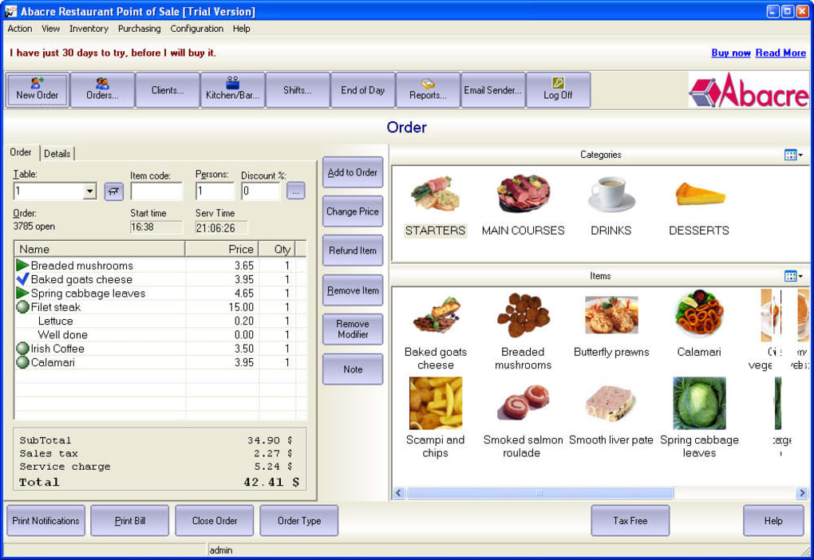
Figure 2.3.1: Reference site 1
- Here, figure 2.3.2 shows a food delivery system.
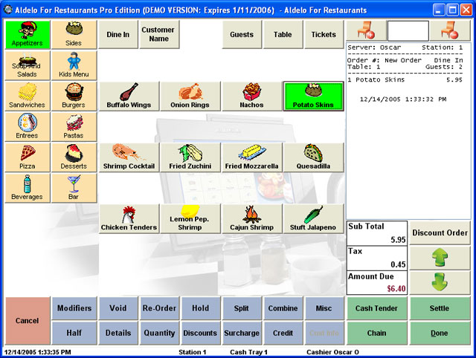
Figure 2.3.2: Reference site 2

Comparative Studies
As we can see there are some similar system like my system but obviously there are some differences between them and my system. First of all, they do not have the stuff add option, stoke check, report check option. On the other hand, my project has stuff adder system, stoke and report check option and some unique features which meet user’s goal and user will be benefited. That’s why my project is different. In existing systems information is poor type. But it is helpful for making a good system. So, I kept these in my mind I have created this system.

Challenges
In this Point of Sell system I have faced so many challenges. Some challenges are too difficult to meet goal and some are totally new to me to find the solution like,
Create the relation to all the tables in database: To make database tables are too much difficult job to do, I tried my best to normalize the database table for my project.
A standout among the most essential test was gathering proper information for this system and give an easy to understand look the system and make this system dependable.

Summary
Before making a system or build up a system it is important to break down the related work of that system. Without great and appropriate examining no work can't get its culmination and can't likewise make the objective. So, after lengthy timespan breaking down, I have chosen to make it and I fixed my objective which will evacuate the lacking of existing system.

CHAPTER 3

REQUIREMENT AND SPECIFICATION

UML Diagram
In this section I will examine about UML chart. There are numerous sorts of UML outline. I will talk about two of them. By utilizing what I will talk about my whole framework.

Use Case Diagram
Use case diagram represent all the actor whose are related to the system and then show them how they can participate to the system. Figure-3.1 is the use case diagram of my system.
Below the figure shows use case diagram of Admin & Sales Manager
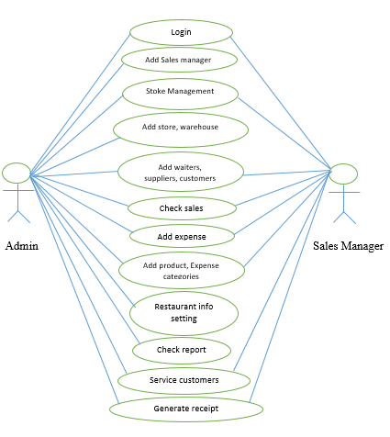
Figure 3.1: Use case diagram of Admin & Sales Manager.

Below the figure shows use case diagram of Waiter.
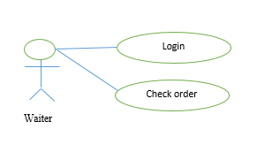
Figure 3.2: Use case diagram of Waiter.
    - Description of Use Case Model
In Use case diagram we can see there is three actors and they are (1) Admin (2) Sales Manager and (3) Waiter. In this application Admin, Sales Managers & Waiters can log in. Admin can add the users (sales managers, waiters), stores, manager stokes, check sales, add categories of food & expense, add expenses, add warehouses, can change info settings, check reports, service customers & generate receipts. Sales Manager can add the users (waiter), manager stokes, check sales, add categories of food & expense, add expenses, service customers & generate receipts. And Waiters can check the orders.
Cases | Details
Actors | Admin, Sales Managers and Waiters
Pre-Condition | Registration is needed.
Post-Condition | After Successful log in Admin will get Admin panel, Sales Managers will get Sales Manager panel and Waiters will get waiter profile.

System Flow Diagram
Now I am going to show my working flow diagram in figure-3.3. The whole system has three main actors Admin, Sales manager and Waiter. Registration is must be needed for two actors Sales manager and Waiter. First, I will talk about Admin. Admin must to log in into the system with the valid username & password, if he login he can run the system. System will take the admin in the home page. He can manage food categories and food menus. He also can manage opening and closing of his restaurant. And other features of admin that I will discuss in (3.1.2).
Next Sales Managers. Sales managers must needed registration. If the registered in the system then he can login with the valid username & password. Then he can access the system and all other features of sales managers that I will discuss in (3.1.2).
Next Waiters. Waiters must needed registration. If the registered in the system then he can login with the valid username & password. Then he can access the system and all other features of waiters that I will discuss in (3.1.2).

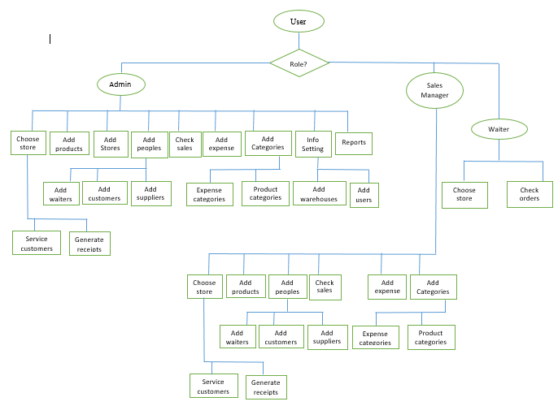
Figure 3.3: System Flow Diagram.

Design Requirements
To build up this project, I have to do a few structures to make this system all the simpler and more dependable to client. Thus, this has two sorts of structure and they are frontend and backend.
To do the frontend plan should have been sketching the designs into paper first. At that point when the coding starts of the frontend, at that point it should be incorporate bootstrap and some jQuery code for complete the plan. At that point I have to structure the undertaking as the documentation prerequisites and get done with coding.
Presently for the backend plan I have to think about the database structure. There is likewise need to pick up the connection between the tables in the database and furthermore need to mind repetition things. With the goal that I have to do some standardization to maintain a strategic distance from this sort of things. What's more, for backend coding I endeavoring to pursue the item arranged coding design. At that point discover the record structure for the code storehouse. Hence, I get everything the prerequisite on backend structure.
So that’s all the design requirement that needed in this project.

Summary
In this chapter I discussed about the full project using use case diagram and system flow chart. I also described them elaborately.
CHAPTER 4
SYSTEM DETAILS

Introduction
In this part I will talk about quickly about my system. After totally reading this section anyone who has read this part will get the 70% thought regarding my application. In this part I will talk about my system highlights, front-end configuration, back-end database and execution prerequisite.

Application Feature
There are various kind of features in my system. At first, I am going to show my features list and I will describe them later. So, the features of this systems are-
- Registration – This is for user and admin to access this system.
- Login into system – Without logging in nobody can use this system.
- Add product – Admin can add product for the restaurant.
- Add store – User can handle multiple store.
- Add categories – User can add categories of the foods.
- Add waiter – User can handle multiple waiters.
- Add customer - User can handle multiple customers.
- Add suppliers - User can handle multiple suppliers.
- Add warehouse – User can add warehouses.
- Stoke management – User can manage stokes easily.
- Expense – User can add the expenses.
- Product with tax – User can add the product with taxes.
- Discount – User can give the discount to the customers.
- Reports – User can see the reports of monthly & yearly sale.
- Print receipt – System can print the receipts for the customers.
- On screen keyboard – System have on screen keyboard.

Registration:
At first user needs to registration to enter the system. Admin register the stuffs after that stuffs can access on the system. Without any registration it is simply impossible. Every users need to get registered first. And registration method is too easy.

Log in:
After complete the registration user can enter into the system using their email/user name and password that was given at the time of registration. If user put wrong email or password, user will fail to enter into the system. So, it is very necessary to remember email and password. Admin can change the user name & password of the stuffs.

    - Add product:
Admin can add the product of the restaurant. After that the user (admin/sales manager) can check the product, search the product for the customers. User (admin/sells manager) can also check how much product remaining.

    - Add store:
Sometime a user (admin) have multiple restaurant so that user (admin) can add multiple stores in the system. Admin can access multiple stores & check everything with the help of the system.

    - Add categories
In the restaurant have many categories foods. So that admin can set the multiple categories & after that admin can add the foods in those categories. When stuffs will search the foods for billing they can find the foods in the individual categories.

    - Add waiter:
In the restaurant have waiters. So the user (admin/sales manager) can add multiple waiters in the multiple restaurants. It’s a very easy process to add the waiters.

    - Add customer:
Many restaurant have some permanent customers. So the user can add the multiple customers in the system. And user can give the discount to that customers.
    - Add suppliers:
A restaurant have many suppliers. Restaurant owners take different food from different suppliers. So that in this system have a feature to add there supplier list in the system. So that owner can check the suppliers easily.

    - Add warehouse:
A restaurant must have a warehouse. They stoke the foods in the warehouses. Owner can also add the multiple warehouses in the system with the address of the warehouse.

Stoke management:

Stoke management is important topic for a restaurant. Without proper stoke management no restaurant can do their business properly. So that in this have stoke management feature. Owner can easily add the stoke list & check stoke.

Expense:

Expense is also an important topic of any business. In this system have feature to record the expenses. Owner can add expenses with the specific reason. It’s an easy process to add & check the expenses.

Product with tax:

Tax is an important element for the business. User (admin) can add the tax that is including with the foods. When user (admin/sales manager) add the food in chart for the customer’s tax will automatic include with the foods.

Discount:

Sometimes restaurants give the offer/discount for the customers. So that an important feature & that is remain in this system. Owner can give discount on the foods for the customers.

Reports:

Report is also an important feature. User (admin/sales manager) can get the report of food, expenses & sale. User (admin/sales manager) can get the report monthly & yearly.

Print receipt:

After took the bill restaurant need the give the receipt of bill to the customers. This system can print the receipt also for the customers with list of food and there price, vat & discount (if exists). This helpful feature for the owner.

On screen keyboard:
The on screen keyboard is one where user do not have to click the keys but can see them on the computer screen. User can use mouse to type something. If keyboard is not working then user also use the on screen keyboard.

Front End Design

This is the home page for all users. After giving the valid username and password user (admin/sales manager) can enter the system.

Below the figure 4.3.1 shows user can login to the system.

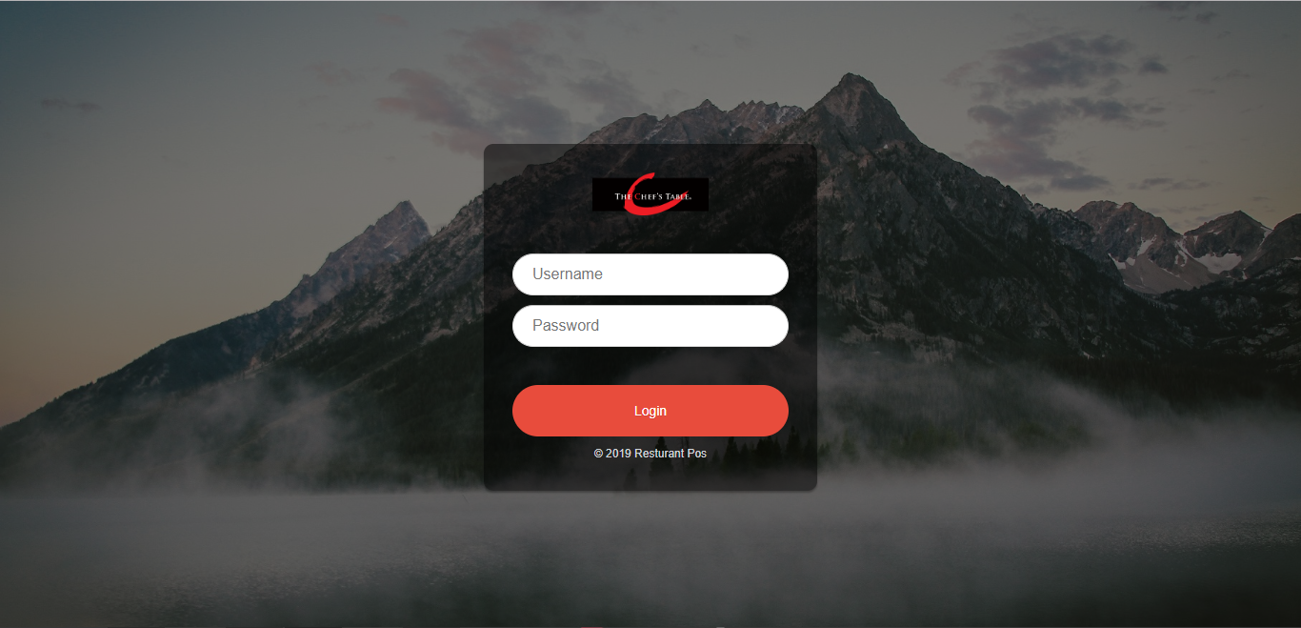

Figure 4.3.1: User login

Below the figure 4.3.2 shows home page for admin

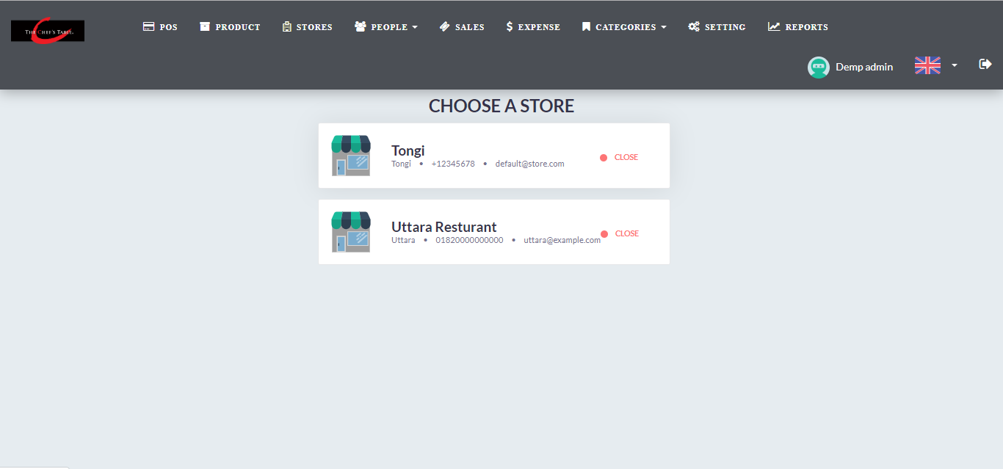
Figure 4.3.2: Home page for admin.

Below the figures 4.3.3 & 4.3.4 shows admin can register & remove the user.

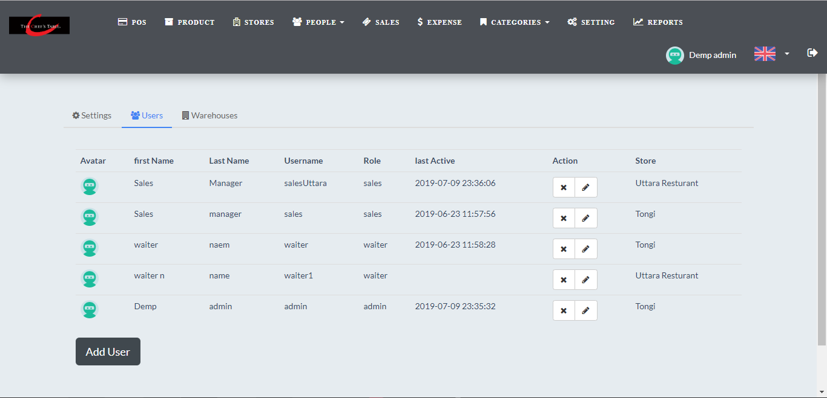

Figure 4.3.3: User Registration

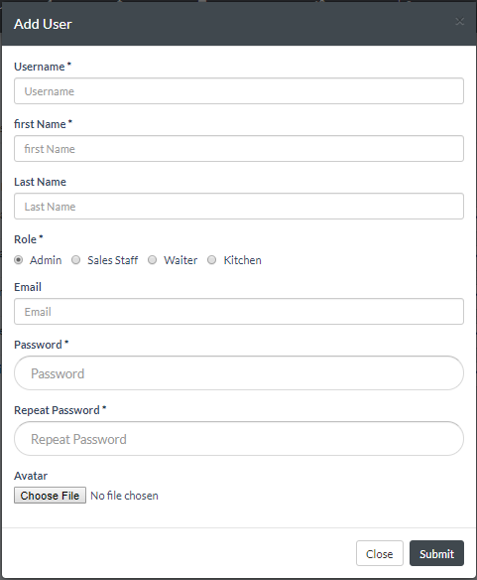
Figure 4.3.4: User Registration
Below the figures 4.3.5 & 4.3.6 shows admin can add & remove the product of the restaurant.

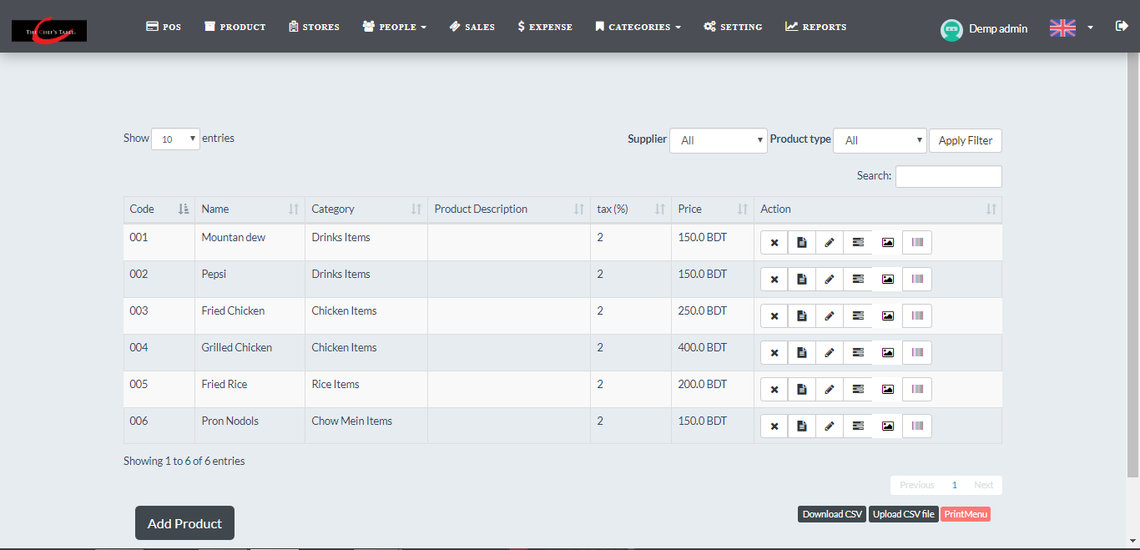
Figure 4.3.5: Add product

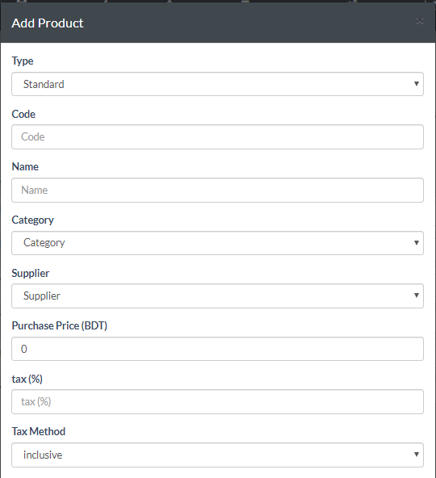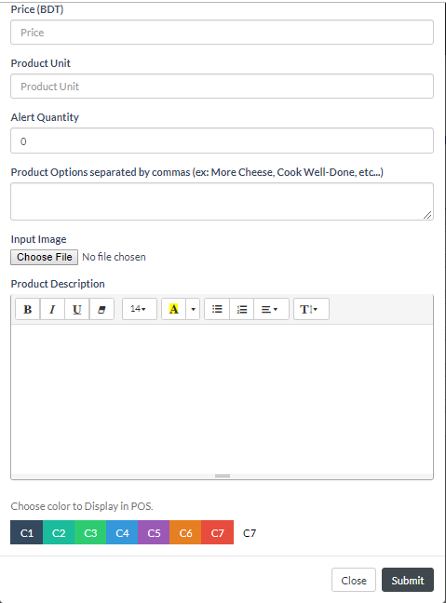
Figure 4.3.6: Add product

Below the figures 4.3.7 & 4.3.8 shows admin can add & remove stores.

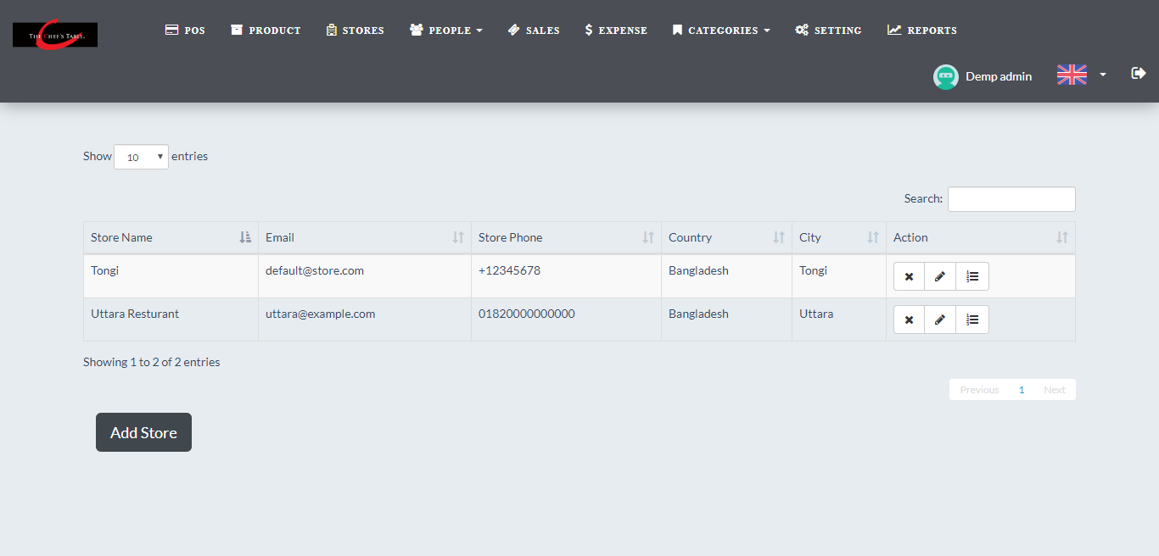
Figure 4.3.7: Add store

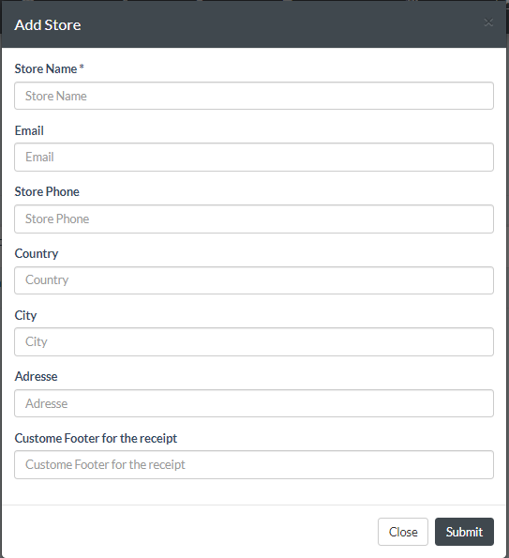
Figure 4.3.8: Add Store

Below the figures 4.3.9 & 4.3.10 show admin/sales manager can add & remove waiters.

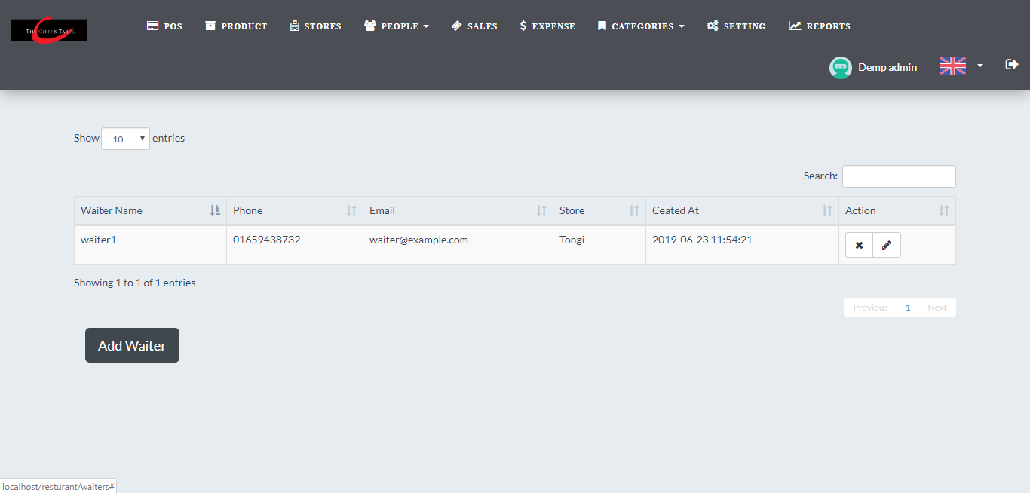
Figure 4.3.9: Add waiters

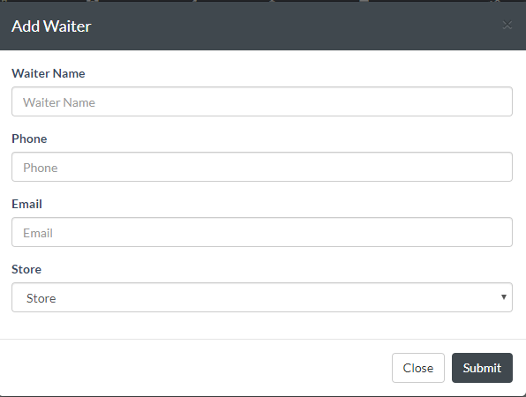
Figure 4.3.10: Add waiters

Below the figures 4.3.11 & 4.3.12 shows admin/sales manager can add & remove customers.
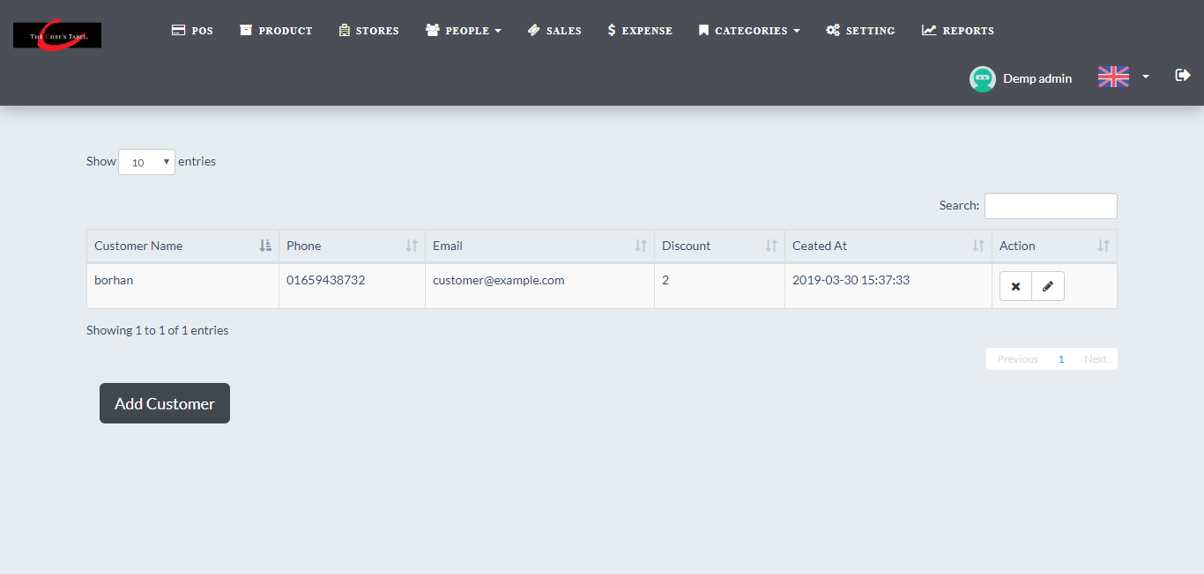
Figure 4.3.11: Add customers

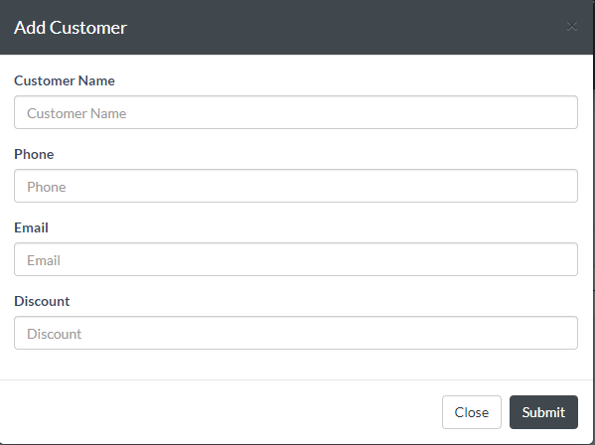
Figure 4.3.12: Add customers
Below the figures 4.3.13 & 4.3.14 show admin/sales manager can add & remove suppliers.

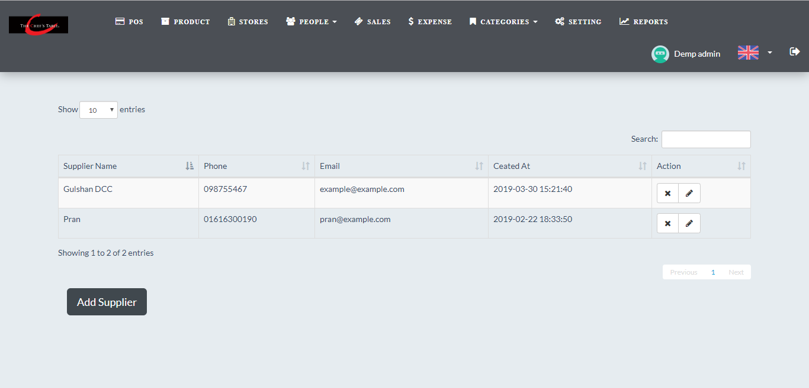
Figure 4.3.13: Add suppliers

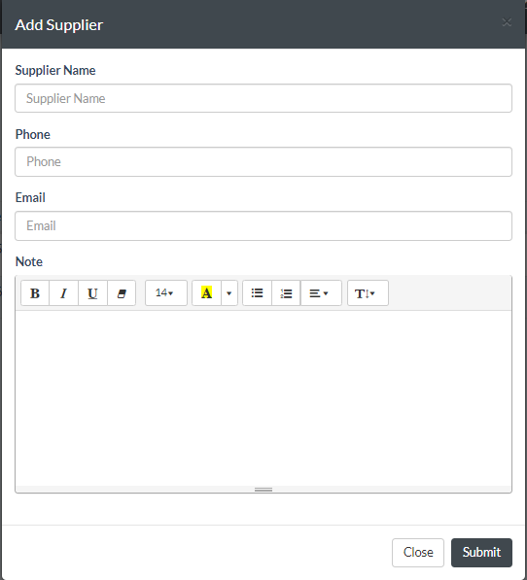
Figure 4.3.14: Add suppliers

Below the figures 4.3.15 & 4.3.16 shows admin/sales manager can check daily sales report.
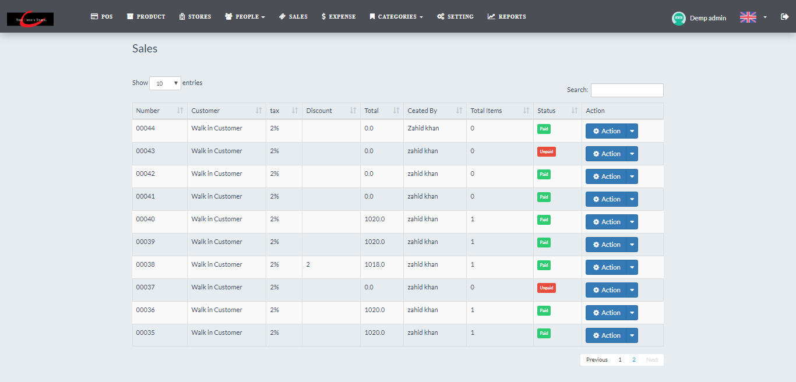
Figure 4.3.15: Check daily sales report

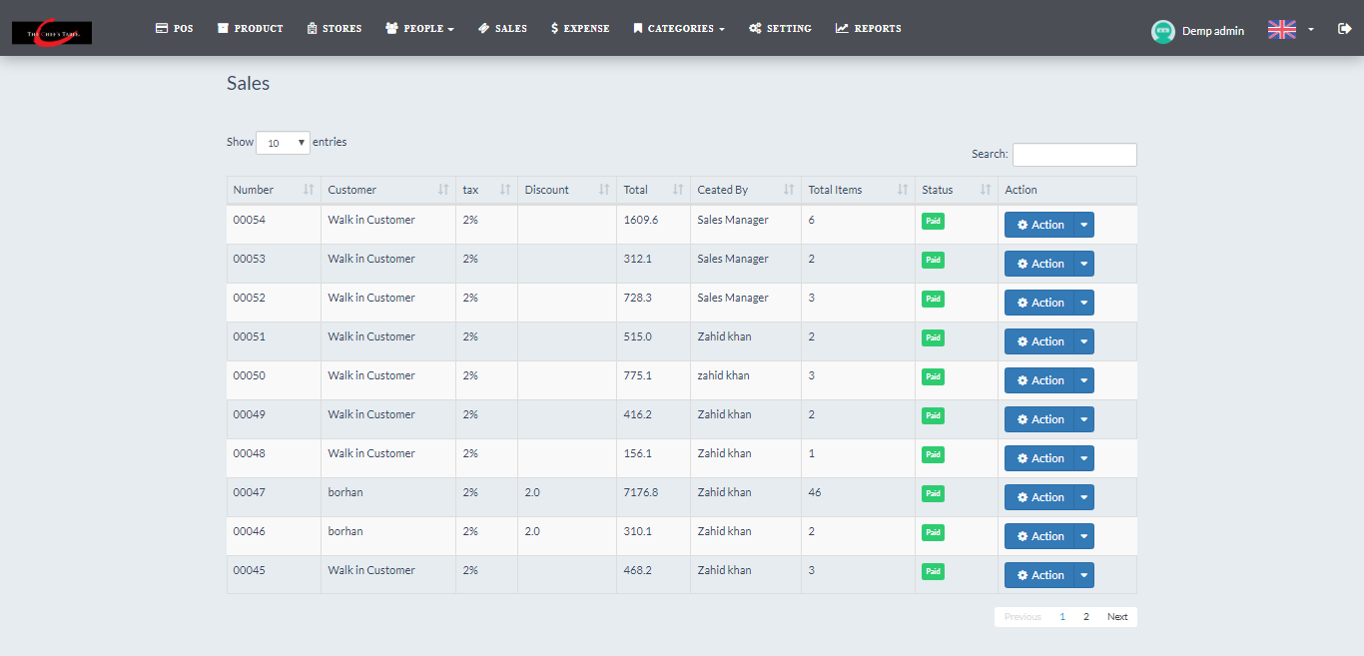
Figure 4.3.16: Check daily sales report

Below the figures 4.3.17 & 4.3.18 show admin can add the expenses.

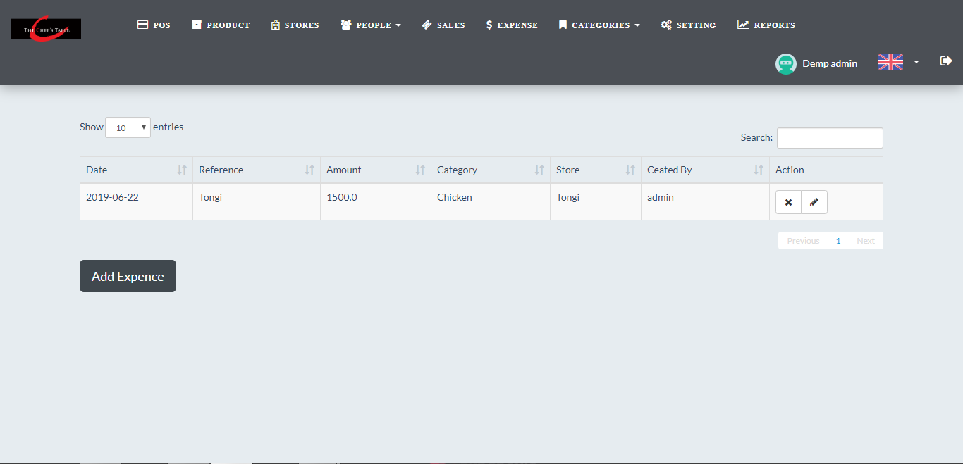
Figure 4.3.17: Add the expenses.

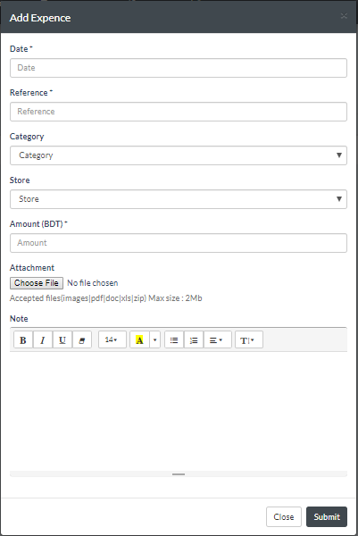
Figure 4.3.18: Add the expenses.
Below the figure 4.3.19 show admin/sales manager can add expense category.

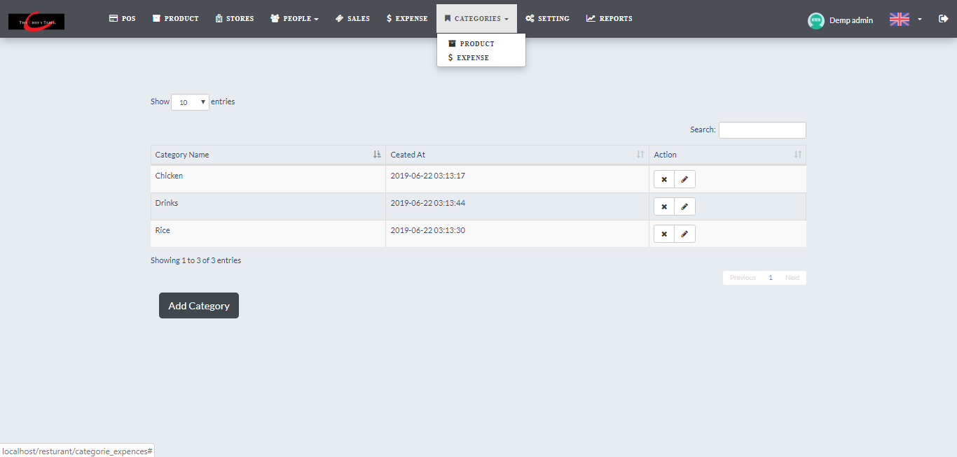
Figure 4.3.19: Add expense category

Below the figure 4.3.20 show admin/sales manager can add product category

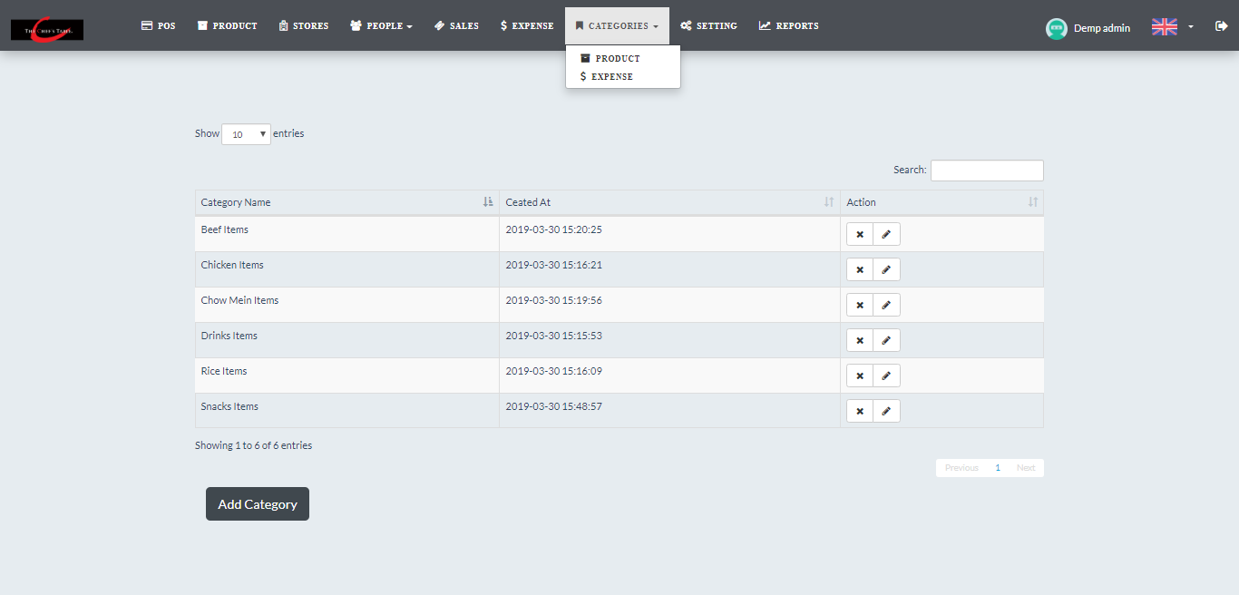
Figure 4.3.20: Add product category
Below the figures 4.3.21 & 4.3.22 shows admin can warehouses.
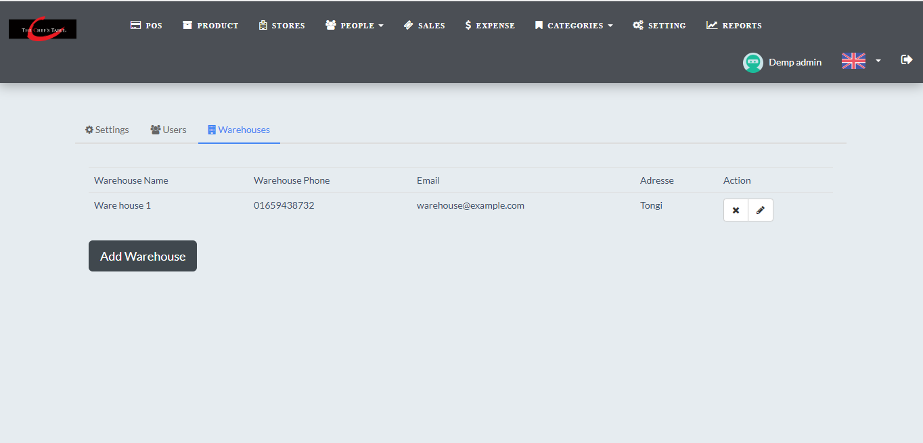
Figure 4.3.21: Add warehouse

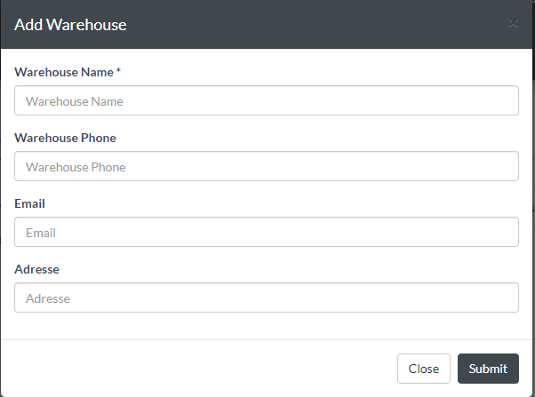
Figure 4.3.22: Add warehouse
Below the figure 4.3.23 show admin can set the settings for the restaurant.

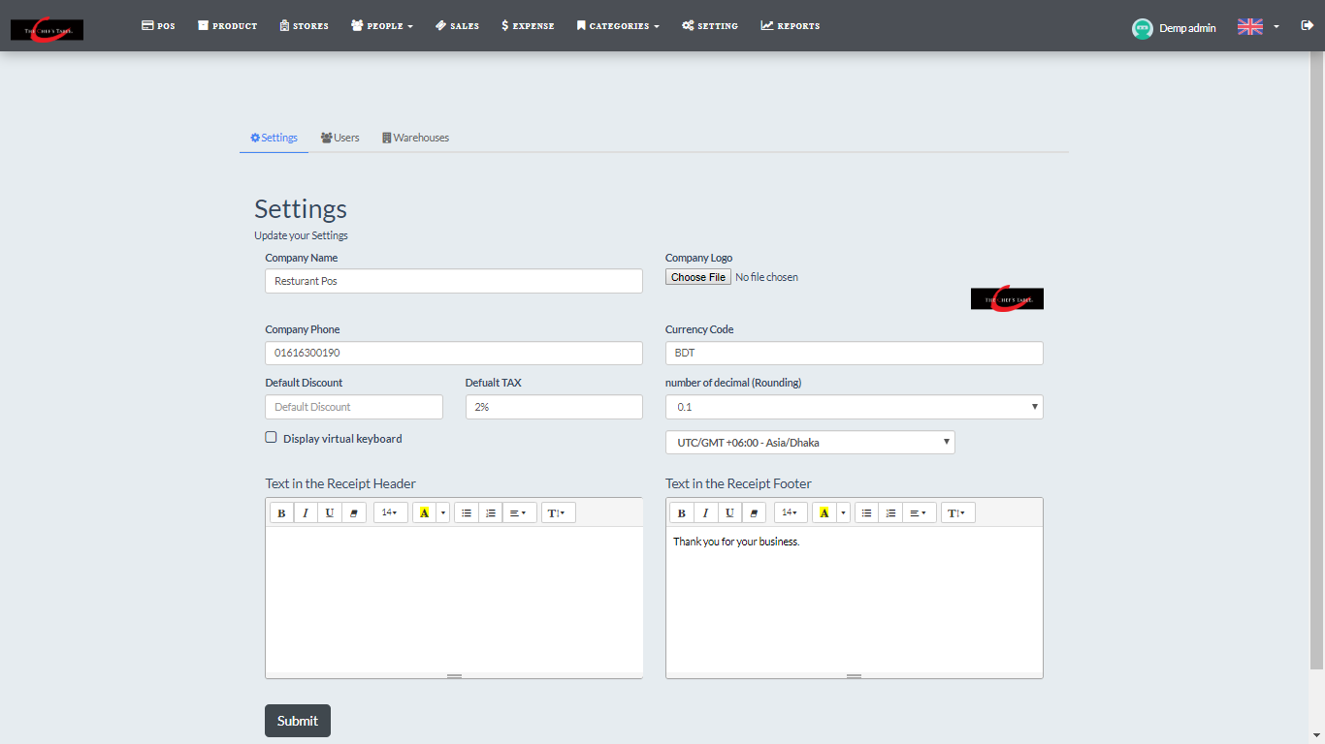
Figure 4.3.23: Settings for the restaurant

Below the figure 4.3.24 show admin/sales manager can check the report

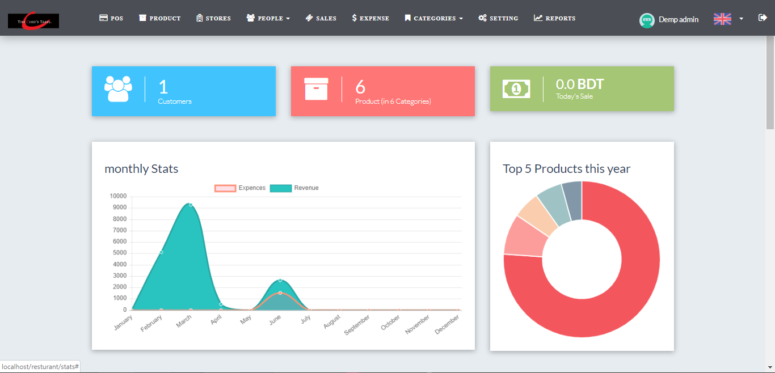
Figure 4.3.24: Report of the restaurant

Below the figures 4.3.25 & 4.3.26 show waiter can check which table have order.
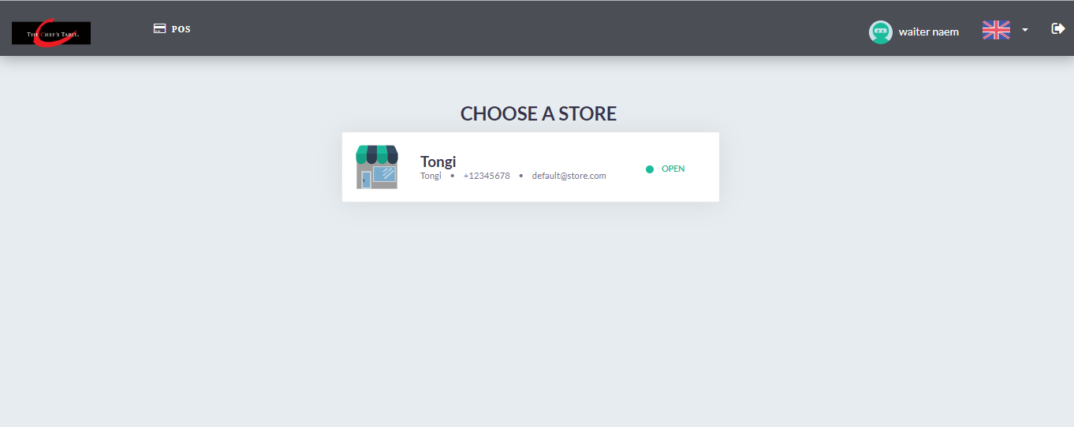
Figure 4.3.25: Waiter can check the order

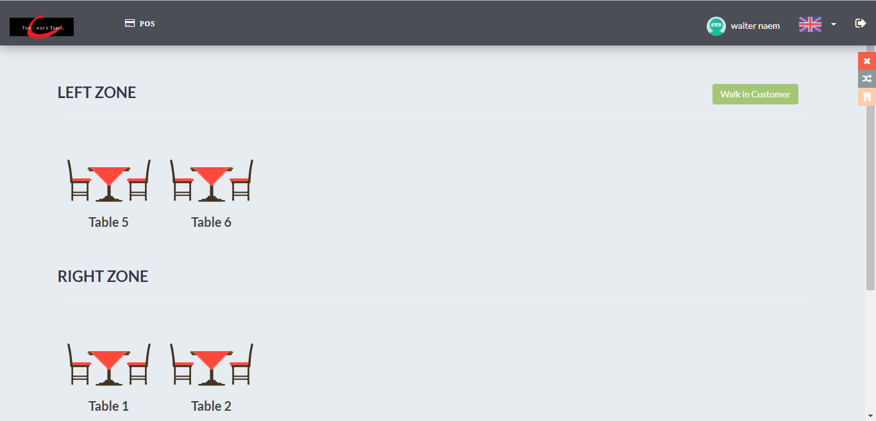
Figure 4.3.26: Waiter can check the order

Below the figure 4.3.27 admin/sales manager can select the food for customers & took the bills from them.

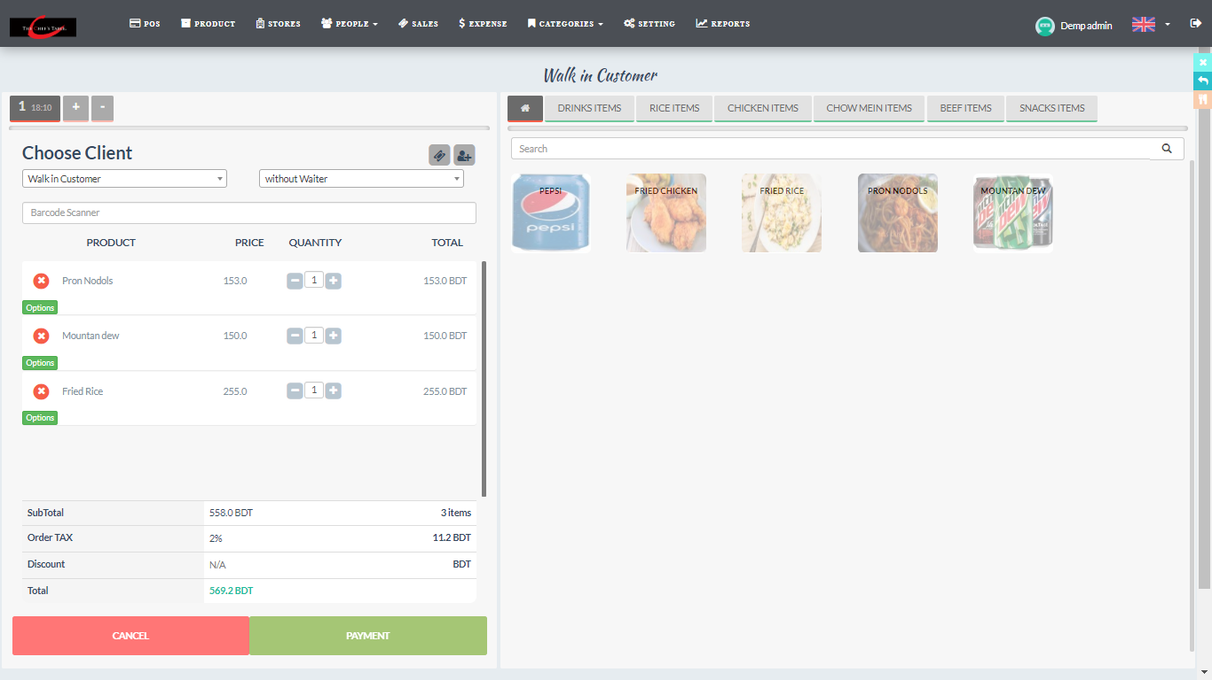
Figure 4.3.27: Selling option

Below the figure 4.3.28 show receipt for the customers.
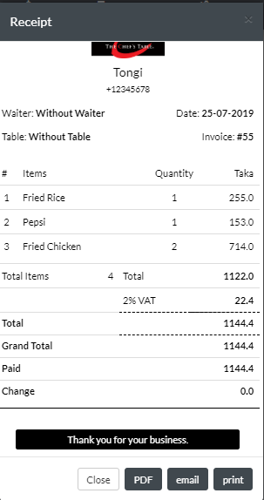
Figure 4.3.28: Receipt for the customers

Backend Design

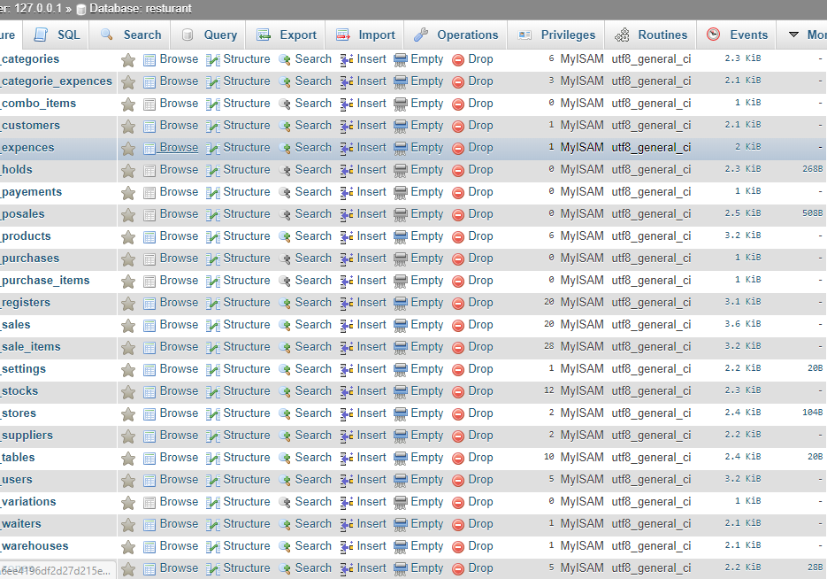
Figure 4.4.1: Database table

Implementation Requirements
These are following things and technology that we need to implement this project. Here is the list below:
    - Internet Browser
    - Xampp Server
    - Text Editor (ex: Atoms, sublime Text, Visual Studio Code)
    - PHP 5.6
    - Html 5
    - CSS
    - Codeigniter Framework.
    - Bootstrap 3.3.6
    - jQuery 3.0+

Hardware Requirement

- Operating System (Windows, Linux, Mac OS, Android)
- Ram 1 GB or higher
- HDD 256 GB

Software Requirement

- Internet Browser (Google chrome v60 or above)
- Internet Browser (Firefox v50 or above)

Summary

This system is very effective for the Restaurants owners. It will be the best web application for the restaurant owners. This will be the first application for Bangladesh from where user can maintain their restaurant properly.

CHAPTER 5
IMPLEMENTATION AND TESTING

Introduction
I will discuss how we execute this undertaking. As it is an online venture so it will incorporate front-end and back-end usage. All the usage will appear with a few figures.
  - Implementation of database
This part will demonstrate how I execute the database. This will cover how I make association this database with how it responds with the clients. Additionally, the connections execution process.
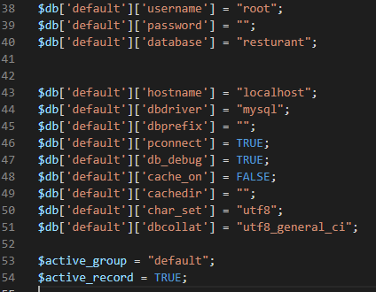
Figure 5.2.1: Database Connection

Presently here is the figure of database association process. It is extremely simple to interface database as I have worked in Codeigniter framework. The full venture is finished by Codeigniter framework. As I have utilized simple establishment process for the client so I utilized pre- characterized strategy for getting to the database name, username and secret word. At that point after get every one of the information from administrator every one of the information are utilized to set up secure database association with item arranged organization.

Presently after the database association usage I will discuss how every one of the tables are executed. In reality, I made every one of the tables legitimately utilizing xampp [1] server physically. At that point I just moved the table. In the wake of finishing movement there is no other errand to do. At that point just need is do coding for information inclusion.
Now I am going to talk about various types of query like insert, delete, edit. In Codeigniter framework it is very easy to do. Some screenshots of such coding is given below:
Query of insert data into database.
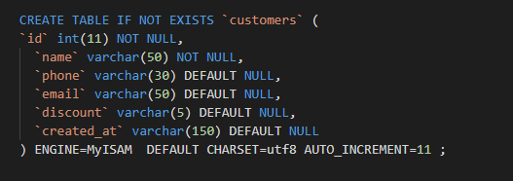
Figure 5.2.2: Query of insert data into database.

Query of edit data.

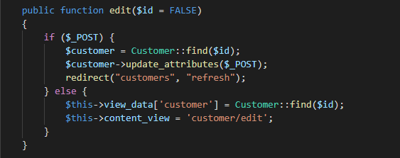
Figure 5.2.3: Query of edit data.

Query of delete data.
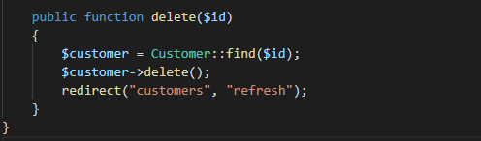
Figure 5.2.4: Query of delete data.

Testing Implementation

As this is an online venture that is the reason testing is especially required for this framework before send the application. Cause it will gauge the general execution and can get the information that application information and yield estimation. Then again, a test can give the input that how much time it can figure out how to run and can give definite execution. There are such a large number of testing that should be possible for application. For this application I have done some testing. They are given here:

Unit Testing

Unit testing is utilized for when the coding is executing then the engineer checked for his very own underlying errors. Along these lines, for our situation I have checked when I am coding and attempted to discover the underlying mistakes. It happens when I coding and after that test right away.

Integration Testing

I have right off the bat done the front-end plan. At that point I have incorporated all the back-end code. At that point I have watched that if any sorts of design is broken or not. And furthermore, watched that all the interface works splendidly or not.

Functional Testing

All the capacity that I have chosen for my application at first. I have completed all the underlying prerequisite of this task should be. And every one of the capacities are tried independently. Since capacities are the fundamental vital part for a framework. On the off chance that work does not work legitimately, at that point the framework will be esteem less.

System Testing

System testing estimates that if the application is dealing with another system condition. I have checked every one of the programs and other working framework and furthermore on various pc.

Usability Testing

The ease of use testing estimates the client association advertisement how well disposed the UI is. Along these lines, to do that I have testing on a few clients and get their experience on the UI and the amount they can explore effectively.

Test Result
I completed a few sorts of test just for a few reasons. In the wake of doing all the test there are some outcome. Based on these outcomes I can get affirm about my framework and its great side and terrible side. Results are given bellow:

Result of Unit Testing

The full task depends on coding. There are thousands line of code what I did here. In this colossal measure of line coding it is totally conceivable to foul up or botches. For discovering this sort of missteps I did unit testing. Furthermore, when I did unit testing I got some blunder in my coding and that was my accomplishment of unit testing. In the wake of getting the blunders and misstep I got another opportunity to fix them. Furthermore, I did as such. I illuminated them quickly then no further issue was found.

Result of Integration Testing

Integrating testing was for reasons unknown and reasons are what code I composed for front-end and back-end configuration, are those lines of code working precisely. Since the two plans are a lot of critical factor for any sort of venture. Assume I made an extremely attractive front-end plan yet there are a few errors in back-end program and front-end and back-end configuration isn't coordinating, in that time what will be said by clients. Along these lines, to evade this sort of issue I did combination test. What's more, there was no mistake found amid this test.

Result of Functional Testing

Function testing was a lot of imperative. Since I did great front-end and back-end plan however I mistook in utilitarian coding. Thus, what is the estimation of all out coding, it is pointless. Practical testing was the best approach to realize that is each capacity working legitimately or not. One by one I checked each capacity. Amid this testing I got some awful conduct for signing in. when I got to signed in the following methodology was taking me to misguided course. And furthermore, got some terrible practices in setting profile page when I transfer pictures and presented that. There was some sensible mistake. And after that I fixed them. Another front-end site the executives there was a reserve issue on the program. This issue was defeated additionally by evacuating more seasoned documents and info new one. Therefore, I have finished my practical testing.

Result of System Testing

It was additionally important to test since I know huge numbers of the general population use windows working framework. Be that as it may, this does not mean no one uses others working framework like MAC, Linux and so on. Along these lines, I additionally taken care of them. Along these lines, I did framework testing. Furthermore, in the wake of testing what I see is our application has effectively kept running on other frameworks and condition. So there was no blunder found.

Summary

In this part I have finished some critical execution and testing. Here I found out about execution of database in Codeigniter [3] structure. I made sense of it here in light of the fact that without database execution demonstrating it is intense for one to acknowledge and comprehend the program in Codeigniter [3] structure. Since here I worked with different thing. At that point for security reason I did different sorts of testing what are vital for an undertaking. At that point w additionally demonstrated the outcome and talked about it.

CHAPTER 6
CONCLUSION AND FUTURE SCOPE

Discussion and Conclusion

I have attempted to cover every one of the things for the client to Point of Sale system. I have additionally make this report as a genuine programming improvement like feel. Presently I need to share what I have looked in doing this task and what I have gained from it.

From the absolute starting period of my undertaking I have confronted different sort of issues and got the opportunity to know numerous new things by experimentation premise. This voyage was an extraordinary accomplishment for me since I have tremendous thought regarding an exceptionally advanced and easy to use and vigorous system like Codeigniter [3]. At first, I have begun our task utilizing Codeigniter [3] outline work what was new for me. I took the difficulties lastly carried out my responsibility with some great supplements from my regarded resources. I made them intrigue experience as well. Amid my short voyage, I got an understanding of php[8], jquery[7], bootstrap[6], and Codeigniter[3].

Most critical thing is that I have adapted genuine programming. I likewise have figured out how to form programming learning into the advancement part. There was a critical part subterranean insect that was a database plan. I got a decent thought on how to build up a database as per the database model and styles.

Limitation

There are some limitations in my project because of the time limit. As I am beginner in Codeigniter, I couldn’t add some functions like time management to prepare foods, android app. But I tried my best to set up my project more user friendly.

Scope for Further Development

On account of the constrained measure of time, I couldn't able to work on some aspects in my system. I have the intension to include some more highlights features like time management to prepare foods, android app, in my system. In future, I would like to expand every features previously mentioned.

REFERENCES

[1] Xampp Server available at: https://www.apachefriends.org/download.html,October, 2019
[2] Sublime text editor available at: https://www.sublimetext.com, October 2019
[3] Codeigniter available at: https//www.codeigniter.com, October 2019
[4] HTML available at: https://www.w3schools.com/htm, October 2019
[5] CSS available at: https://www.w3schools.com/css/default .asp, October 2019
[6] Bootstrap available at: https://getbootstrap, October 2019
[7] jQuery available at: https://stackoverflow.com. , October 2019
[8]PhP available at: https://php.net, October 2019

Plagiarism Report

