“AUTOMATED ATTENDANCE SYSTEM USING DEEP LEARNING”

BY
Hafiz Mahdi Hasan
ID:162-15-1078
AND
Md. Al-Amin Khan
ID:162-15-1097

This Report Presented in Partial Fulfillment of the wants for the
Degree of Bachelor of Science in computer science and engineering.

Supervised By
Md. Mahfujur Rahman
Lecturer
Department of CSE
Daffodil International University

Co-Supervised By
Tania Khatun
Sr. Lecturer
Department of CSE

Daffodil International University

DAFFODIL INTERNATIONAL UNIVERSITY
Dhaka, Bangladesh
DATE: 8th JUNE, 2020

APPROVAL
This Project/internship titled “AUTOMATED ATTENDANCE SYSTEM USING DEEP LEARNING”, submitted by Hafiz Mahdi Hasan, ID No:162-15-1078 and Md.Al-Amin Khan, ID No: 162-15-1097 student of the department of Computer Science and Engineering, Daffodil International University has been accepted as appeasement owing to accomplished of the wants for the degree of Bachelor of Science in Computer Science and Engineering and approved on its style and contents. The presentation has been persisted 12 July, 2020.
BOARD OF EXAMINERS

---------------------------------------
Dr. Syed Akhter Hossain Chairman
Professor and Head
Department of Computer Science and Engineering
Faculty of Science & Information Technology
Daffodil International University

---------------------------------------
Dr. S M Aminul Haque Internal Examiner
Associate Professor & Associate Head
Department of Computer Science and Engineering
Faculty of Science & Information Technology
Daffodil International University

---------------------------------------
Mr. Ohidujjaman Internal Examiner
Lecturer
Department of Computer Science and Engineering
Faculty of Science & Information Technology
Daffodil International University

---------------------------------------
Dr. Mohammad Shorif Uddin External Examiner
Professor
Department of Computer Science and Engineering
Jahangirnagar University

DECLARATION

We hereby declare that, this project has been done by us under the supervision of Md. Mahfujur Rahman, Lecturer, Department of CSE Daffodil International University. We also declare that neither this project nor any part of this project has been submitted elsewhere for award of any degree or diploma.

Supervised by:

---------------------------------------
Md. Mahfujur Rahman
Lecturer
Department of CSE, Daffodil International University

Co-Supervised by:

--------------------------------------
Tania Khatun
Lecturer
Department of CSE, Daffodil International University

Submitted by:
---------------------------------------
Hafiz Mahdi Hasan
ID: 162-15-1078
Department of CSE
Daffodil International University

---------------------------------------
Md. Al-Amin Khan
ID: 162-15-1097
Department of CSE
Daffodil International University

ACKNOWLEDGEMENT

First, we express our heartiest thanks and gratefulness to almighty God for His divine blessing makes us possible to finish the ultimate year project/internship successfully.
We are considerably thankful to our advisor Md. Mahfujur Rahman, Lecturer, Department of CSE, Daffodil International University who guide us nicely to try to to this work. His patience and mentality always give us a spirit that how can we complete this work. He provides all sort of resource associated with this. So, we will get the particular theme to satisfy our work. We also thank to our Co- advisor Tania Khatun, Sr. Lecturer, Department of CSE Daffodil International University who always suggest us about our research. wish to thank Dr. S.M. Aminul Haque, professor and Associate Head, Department of CSE he's one among the great people and guide us nicely for doing research-oriented work.
We would wish to express our heartiest gratitude to Dr. Sayed Akther Hossain, Professor and Head, Department of CSE, for his kind help to end our project and also to other academician and therefore the staff of CSE department of Daffodil International University. we might wish to special because of our team members always co-operated with this work. Finally, we thank our family for his or her guidance and provides us support to finish this work.

Thanks to all of you!

ABSTRACT

In this modern age Attendance System becomes automated thanks to time saving, efficient and useful method decreasing administration’s and organization’s strain. Attendance system is important to classroom evaluation, population and workforce management. Caused by the event of technology, computer scientists are share a keen interest during this area. Currently there are several technologies based attendance system but we always discuss more sufficient system saving time and toil. during this case, the deep learning approach is far more convenient than others. In naive words, it's a computer aided system for automatically identifying an individual from a true time image or video frame. during this paper we proposed an automatic attendance system using Deep Learning Algorithm(s). This approach can help to reduce the complexity of taking attendance for the teachers as the procedure is fully automated and algorithms dependent.

In this report we explain an automatic attendance procedure with the collaboration of two deep learning algorithms Faster R-CNN and seetaFace. Output brings four short similarity situation of classroom like absence, delayed appearances, early leave, unauthorized entry during course session and passes the knowledge to attendance sheet which will evaluate the students/persons. A high definition camera setup capturing real time to identify/recognize the authorized person.

INDEX

CONTENTS Page No.
Board of examiner i
Declaration ii
Acknowledgment iii
Abstract iv
Index v
List of figures vi
List of Abbreviation vii

CHAPTER
CHAPTER 1: PREFACE 8-10
1.1 Introduction 8-9
1.2 Motivation 9
1.3 Objective 10
1.4 Expected Outcome 10
1.5 Thesis Orientation 10

CHAPTER 2: LITERATURE SERVEY 11-17
2.1 Introduction 11
2.2 Machine Learning 11-12
2.3 Deep Learning 12
2.3.1 Deep Learning Algorithms 12-15
2.4 Deep Neural Network 15-17
CHAPTER 3: INTRODUCE SYSTEM 18-20
3.1 What actually we want to do? 18-19
3.2 Algorithm Overview 19
3.3 System Flowchart 20

CHAPTER 4: METHODOLOGY 21-27
4.1 Preparing Face Image Dataset 21
4.2 Train Dataset with Faster R-CNN 22-25
4.3 Image Comparison/Recognition with seetaFace 25-26
4.4 Attendance Collecting 26
4.5 Evaluation of Attendance 27

CHAPTER 5: TERMINATION 28-30
5.1 Output 28
5.2 Confusion Matrix 29
5.3 Limitations 30
5.4 Future Plan 30
CONCLUSION 30
REFERENCES 31

LIST OF FIGURES PAGE
Figure 1: CNN working structure 13
Figure 2: neural-network 14
Figure 3: RNN 15
Figure 4: backpropagation-deep-learning 16
Figure 5: relationship between AI, ML, DL and Neural Network 17
Figure 6: system flowchart 20
Figure 7: subfolder of dataset 21
Figure 8: features matching through the neural network 26
Figure 9: Output_Image_Identification 28

LIST OF ABBREVIATION
ML Machine Learning
AI Artificial Intelligence
DB Database
PCA Principle Component Analysis
CNN Convolutional Neural Network
RNN Recurrent Neural Network
R-CNN Regions with Convolutional Neural Networks

CHAPTER 1
PREFACE

  - Introduction
As a crucial a part of class teaching, attendance plays a crucial role within the weighing up teaching. At the start and ending of sophistication, it's usually checked by the teacher, but it's going to support by high-definition monitor video, the way to come out a significant solution to accept data about student for an institute and persons for various organization with the assist of biometric and facial mapping for attendance may be an effective experiment.
Firstly, we use Faster R-CNN [1] for face detection to work out the amount of scholars, then using an algorithm named SeetaFace to identify the scholars to hide absence, later arrival, leave early, free access these four attendance functions automatically. The ability of face recognition and detection for SeetaFace is less than faster R-CNN, so we use the difference to realize carelessness this new attendance function, when faster-RCNN can detect person's facial geomatry, but setaface unable to detect that explains the scholar is sitting during a particular way and not listen carefully. We measure this attendance system within the classroom, and use 720P, 1080P camera, 4K HD camcorder to conduct tests; the classroom camera is nearly of 720P at the present. We design an experiment to verity the minimum resolution required for our analysis initially. then we use the image from 4K camera for recognition, the dimensions of one picture is 3840 × 2160.

The contributions of our work are: (1) with comparative experiment, we obtain that in real classroom scene, the resolution of the camera should be a minimum of 1080P to detect the classroom-wide faces. (2) The face recognition system SeetaFace is successfully applied to classroom evaluation, which combined with Faster R-CNN face detection are able to do classroom automatic attendance.

Face detection may be a fundamental technique of person-machine(computer) interaction or relevant communication. The method takes the particular facts deal with the faces in images or real time capturing. Detection technique trials the facial graph to essence the facial geometric features, the attempt of tracing the specific region. Major event of DL approach moreover develops exactness of the facial identification [3]. DL approach from CNNs cab be made important role in image classification. The model with deep learning Deep-ID forwarded from the organization CVRG, they gained a recognition exactness of almost 99% on L.F.W cloud, as above that of person’s eyes across at least 97.47%.

Faster R-CNN is that the great method for the R-CNN algorithm series for detecting things and target, during this paper face detection training is performed on the faster R-CNN network using the face identification benchmark data set Wider Face. the info set is ten times larger than the prevailing data set.
SeetaFace approach for face recognition structures of three of core modules, counting face authentication, some featuring points placement module and face authenticate module. It uses generally used ‘shallow_network’ for face identification and have sign positioning to enhance the processing time, and uses the DN for face identification to make sure the exactness of face recognition within the last step.

  - Motivation
To ensure human authenticity with their biometrical components using modern technology always saves our time and it’s are often more hassle free rather than general manual processes. Although Face Recognition technology are familiar to us in several fields of human authentication system but we attempt to integrate Face Recognition Algorithm with deep learning approach. Deep Learning algorithms can make the attendance system fully automated, highly secured, easier and faster than other approach. during this paper we'll discuss that how we will build an automatic attendance system with the assistance of deep learning, a branch of ML within a sensible sight of technology.

  - Objective

▪ To make the system fully automated.
▪ To ensure human Authenticity attending system.
▪ To reduce time and make the method easier.
▪ To obstruct fake or proxy attendance by unauthorized person.
▪ Dynamic dataset modification.

  - Expected Outcome

▪ Teachers don't need to call attendees during the category time.
▪ It will play a useful role in preventing duplicate attendance by another student.
▪ The system will help to calculate the attendance mark automatically.

1.5 Thesis Orientation
In the overall thesis, Chapter-1: Introduction, Chapter-2: Literature Survey, Chapter-3: Introduce System, Chapter-4: Methodology, Chapter-5: Limitations, Chapter-6: Future plan, Chapter-7: Conclusion.

CHAPTER 2
LITERATURE SERVEY

2.1 Introduction
Machine learning may be a subset of AI (AI) during those algorithms knowledge gathers from previous information achieving sequels and unwrapped sampling doesn’t easily maculate by humans. for instance, middle of the 19th century, recent innovations in cost reducing method processes readable arrangements like cloud data storage, easier data ingathering, thus the rapid increase of data science have made it considerably in biometric data analytics.
To become it easier, delimit relevance, and make predictions about future trends. in the technological industry the partial relations have been placing by machine learning technology, likes financial technology, insurance, healthcare, marketing, energy, manufacturing and more. When accomplished properly, it grants and premised for industries to unpacked unique solvency to real life issues.
Nowadays it's hugely utilized in automation like automatic car control, automated control, real time translation etc. but there are many other research fields works on deep learning.
In this modern age unprecedented revolution has been achieved within the study of artificial sensations by machine learning and deep learning.

2.2 Machine Learning
Machine Learning at its most elementary is that the practice of using algorithms to parse data, learn from it, then make a determination or prediction about something within the world. ML research is subset of research on AI (AI), seeking to supply knowledge to computers through data, observations and interacting with the planet. That acquired knowledge allows computers to properly generalize to new settings. There are different approaches to getting machines to find out, from using basic decision trees to clustering to layers of artificial neural networks (the latter of which has given thanks to deep learning), counting on what task you’re trying to accomplish and therefore the type and amount of knowledge that you simply have available. This dynamic sees itself played call at applications as varying as medical diagnostics or self-driving cars.
While emphasis is usually placed on choosing the simplest learning algorithm, researchers have found that a number of the foremost utilized in automation like automatic car control, real time translation etc. but there are many other research fields works on deep learning.

2.3 Deep Learning
Deep learning may be a appointed sub element of ML, such that it can be a fixed subset of AI. For separate classification:
• The modern AI technology is that the specious decree of making machines which will think brilliantly and can make decision as like human being.
• DL is a method of making task by using some specific machine learning algorithms to obtain discrimination from related data.
• DL is a scheme of employing a specific solution method known as Convolutional Neural Network.
We should do not stray within the systematic classification – DL is simply a kind of programmable procedure that might be figure rather for predictions. Deep neural network and Neural Nets, for many purposes, are practically conterminous.

2.3.1 Deep Learning Algorithms
CNN (Convolutional Neural Networks): In computer vision technology known as CNN or ConvNet. It's a deep, feed-forward deep neural network. that feed-forward neural networks are which the consummate deep learning models. CNN performs better than traditional computer vision. CNN is mainly used to classify, detect, recognize of a face or image. CNN algorithm helps machine to detect the fiducial (the cell types of part of the body that compared directly) points of human or animal faces. CNN reduce the classification errors and helps to achieve higher accuracy on several visual recognition tasks.
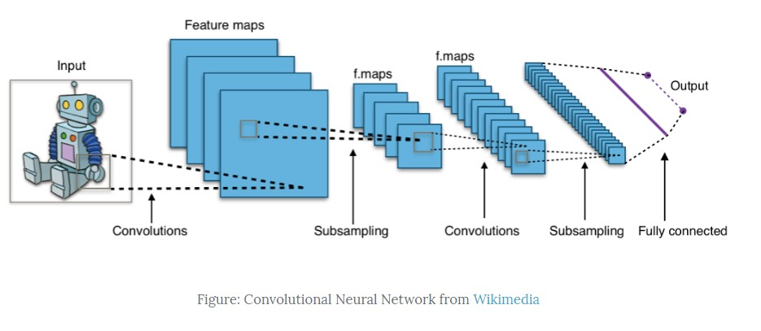
Take a look at the following picture:

Figure-1: CNN working structure
The way that CNN works:
- The convolution layer reckons the neurons which are connected to local regions or approachable fields in the input, each computing a scalar product between their weights and little approachable field to which they're connected to within the input image. Each calculations helps to derive of a feature map from the input image.
- Now let’s know about that how features are mapping from the input image. Suppose an image represents as 5X5 matrix but you take a 3X3 matrix valued image for the window. Then you need adjust the input image from 5X5 into 3X3. There have some filtering methods and techniques which are multiplied by the values outputted by the convolution. It can also happen from 6X6 to 2X2 region.
- Every input image converted from higher to smaller region and compared the features into stored data set and justify the recognition from detected features.

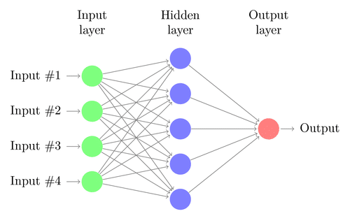

Figure-2: neural-network
RNN: RNN (Recurrent Neural Network) is also pretty similar to CNN but it’s used to identify the text or voice within a recurrent network not beneficial for detection from images or videos. Recurrent Neural Network(RNN) in machine learning is a kind of layer of some networks connected layers to each other with such like neurons from past procedure to the present. In the purpose of general neural networks, each and every key-in and key-out are individualistic one from others, a mere event like so that it's requisite to compute approximate data, the past information is requisite, therefore another requirement recollects the data before mentioned. Thus recurrent neural network turn-up among existence, which detached this error along the support of Hidden Layer. the most crucial feature of recurrent neural network is Hidden State or you can say Hidden Layer, which remembers some information in a few sequences.

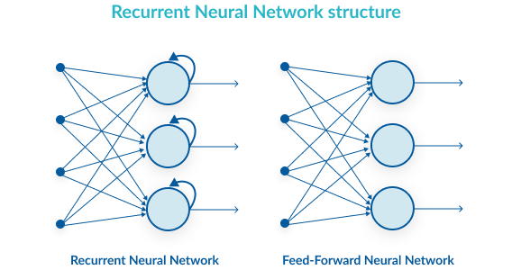

Figure-3: RNN

2.4 Deep Neural Network
Neural networks are inspired by the structure of the cerebral cortex . At the essential level is that the perceptron, the mathematical representation of a biological neuron. Like within the cerebral cortex , there are often various layers of inter-involved perceptron. Input values, or in other words our placed-down data, get skilled this “network” of hidden layers until they eventually converge to the output layer. The output layer is our prediction: it would be one node if the model just outputs variety , or a few of nodes if it’s a multiclass classification problem.
The hidden layers of a Neural Net-perform modifies on the data to in due course inspect what its relationship with the target variable is. Each node features a weight, and it multiplies its input value by that weight. do that over a few of various layers, and thus internet is during a position to essentially manipulate the data into something meaningful. to figure out what these tinny weights should be, we generally use an algorithm named BackPropagation.
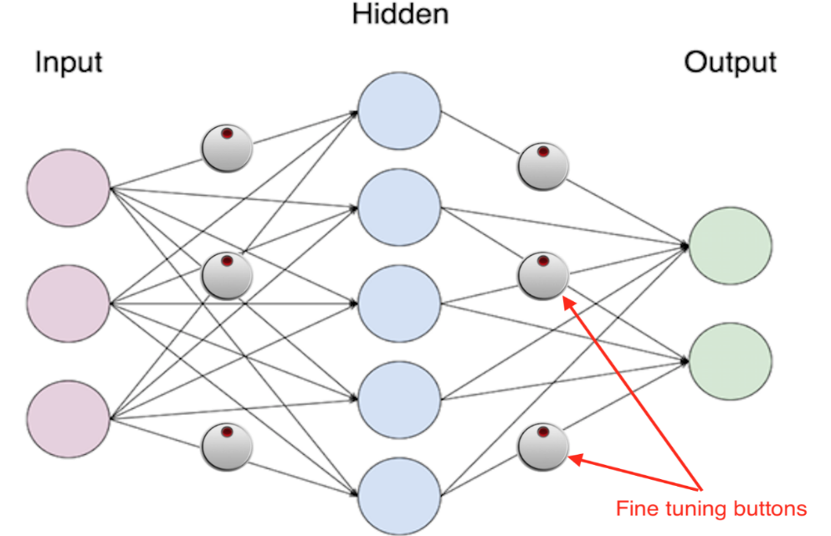

Figure-4: backpropagation-deep-learning
The Neurons that take one key-in parameter devised by the Neural Networks. As a pixel in image frame we'll take into account that it should be classified. When training process have done, they get weighted amplifying or inducting key-out of neurons. They are connected by a part of network of neurons so that grant trained data to regular basic weighted synapses, therefore the researchers on Artificial Intelligence synthesize the structure and shape because of fine tuning of Back Propagation.
The established relationship between AI , Machine Learning, Deep Learning and neural network are given within the following figure…
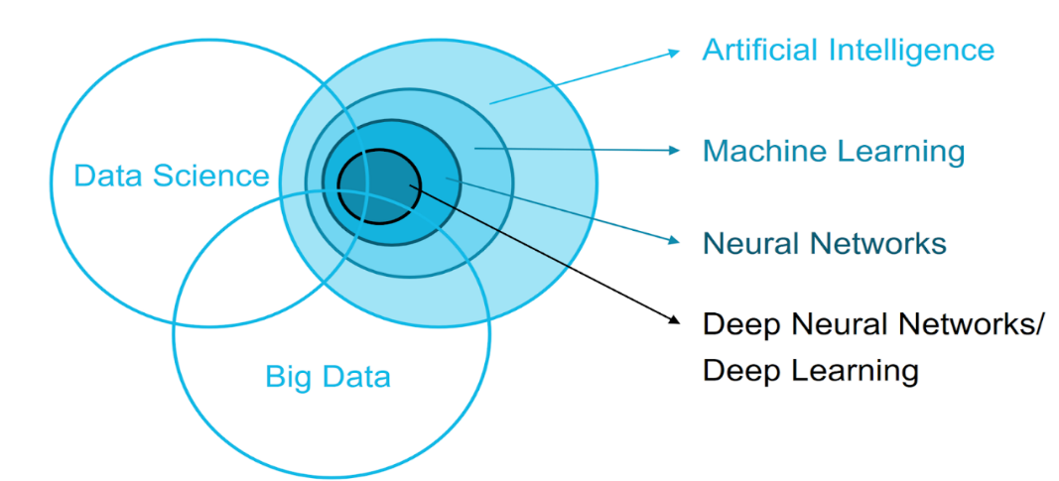

Figure-5: relationship between AI, ML, DL and Neural Network

CHAPTER 3
INTRODUCE SYSTEM
3.1 What actually we want to do?
As an important of sophistication teaching, human resource management or for a corporation attendance takes a crucial role within the evaluation of teaching. At the start and ending of sophistication , it's usually checked by the teacher, but it's going to appear that miss someone or some students answer multiple times. supported high-definition monitor video, the way to come out a significant solution to accept data according to the strength of case testing and properly trained to the system.
Firstly, we use Faster R-CNN [1] for face detection to work out the amount of scholars , then use face recognition algorithm SeetaFace to automatically identify the scholars to hide absence, later arrival, leave early, free access these four attendance functions. The face detection ability of SeetaFace is less than Faster R-CNN, so we use the difference to realize carelessness this new attendance function, that is, when Faster R-CNN can detect a student's face, but SeetaFace cannot detect that explains the scholar is sitting during a particular way and not listen carefully. We measure this attendance system within the classroom, and use 720P, 1080P camera, 4K HD camcorder to conduct tests; the classroom camera is nearly of 720P at the present . We design an experiment to verity the minimum resolution required for our analysis initially . then we use the image from 4K camera for recognition, the dimensions of one picture is 3840 × 2160.

The contributions of our work are:
(i) with comparative experiment, we obtain that in real classroom scene, the resolution of the camera should be a minimum of 1080P to detect the classroom-wide faces.
(ii) The face recognition system SeetaFace is successfully applied to classroom evaluation, which combined with Faster R-CNN face detection are able to do classroom automatic attendance.

3.2 Algorithm Overview
the attendance system staffed face detection algorithm Faster R-CNN and face recognition algorithm SeetaFace. to making this this project, we propose an automated attendance providing system, which incorporates few functions.
• Taking real-time video module. Record a video to make sure that each students are appeared within the video.
• Image isolate module. Separate a frame(s) per minute for sophistication marking.
• Faster R-CNN face identification module. Identifies all student(s) and evaluate coordinates .
• SeetaFace identifies the face module for student activities on the basis of RCNN exactness.
• Automated attendance analysis module. The references of scholars are fixed so it will match their face(s) coordinate, and determine the identity of every student get the attendance.

3.3 System Flowchart
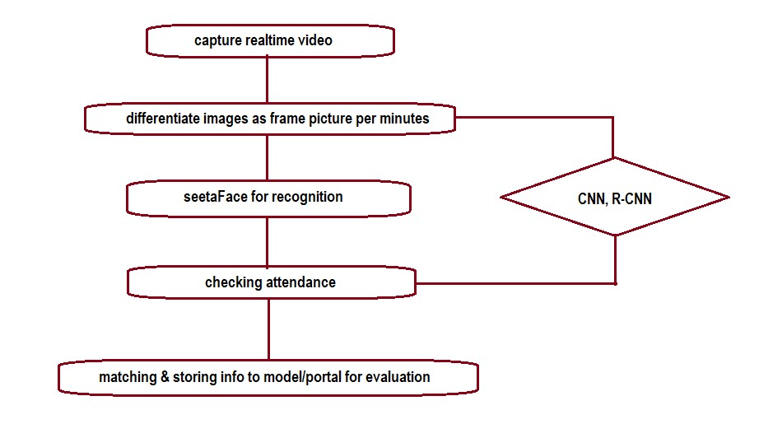

Figure-6: system flowchart

CHAPTER 4
METHODOLOGY

4.1 Preparing Face Image Dataset

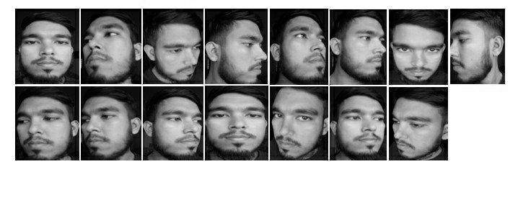
if we aimed to detect a face at rear-time computer vision then openCV may be a library of programming functions (including deep learning algorithms) which will help to create a Machine Learning project. OpenCV may be a completely optimistic computer vision library with specialise in real-time applications. In our project openCV (python) is use for create a dataset. for every student 12 to fifteen images are going to be captured at different angles with a feature to require random still images for person’s faces by execute the program. the pictures are cropped and resize automatically has been fixed on the model to 110*90 pixels to scale back time complexity and converted from RGB to grayscale. Dataset containing individual subfolders for each person which contains multiple faces of one person. Accuracy will certainly increase thanks to more images in person’s individual subfolders contains dataset.
Figure-7: subfolder of dataset

4.2 Train Dataset with Faster R-CNN:

Regions with convolutional neural networks (R-CNN) trained dataset supported assigned class and attributes. Images into small connected regions called cells. Gradient orientation discretized each cell into angular bins. Pixel values are contributed as weighted gradients to their corresponding bin. Spatial region is made with a gaggle of adjacent cells. then normalize this group of adjacent cells as histogram. 80 percent of the info is for training; the remaining 30 percent is for testing.

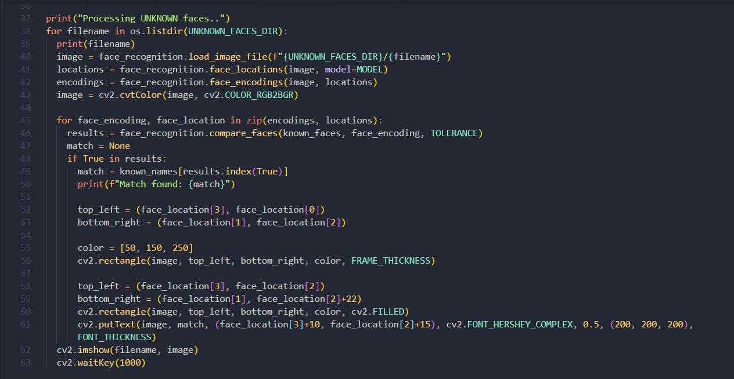
faces-train.py

After faces-train.py file system train the dataset and transform images into grayscale matrix like bellow….

[[13 14 13 ... 10 12 9]
[13 13 12 ... 9 10 10]
[14 13 14 ... 13 10 11]
...
[23 23 23 ... 16 15 17]
[23 22 21 ... 16 16 16]
[25 24 22 ... 14 15 15]]
[[10 8 7 ... 7 6 7]
[10 8 9 ... 7 7 7]
[ 9 9 9 ... 7 6 7]
...
[19 22 23 ... 12 9 9]
[20 21 21 ... 11 13 12]
[22 23 22 ... 12 11 11]]
[[12 13 12 ... 13 11 12]
[13 12 12 ... 13 12 12]
[14 12 13 ... 12 13 11]
...
[26 27 25 ... 15 16 16]
[29 28 29 ... 17 16 14]
[29 29 29 ... 17 15 16]]
[[ 8 8 8 ... 7 5 7]
[ 8 9 9 ... 7 7 8]
[ 8 7 9 ... 8 7 7]
...
[15 15 17 ... 10 12 10]
[16 16 17 ... 10 13 11]
[15 17 18 ... 11 10 11]]
[[10 11 12 ... 9 8 7]
[12 12 11 ... 6 8 8]
[11 12 10 ... 8 7 6]
...
[17 15 16 ... 13 11 12]
[17 16 17 ... 11 12 11]
[17 17 18 ... 12 13 11]]
[[14 15 15 ... 9 7 7]
[13 14 13 ... 6 6 7]
[11 10 11 ... 5 8 8]
...
[11 11 11 ... 7 8 11]
[10 10 12 ... 11 10 9]
[10 10 11 ... 11 10 8]]
[[19 20 19 ... 10 9 8]
[18 20 20 ... 9 9 9]
[20 20 21 ... 9 9 8]
...
[16 15 15 ... 14 16 14]
[16 15 15 ... 16 16 15]
[15 15 15 ... 15 15 15]]
[[18 18 18 ... 9 9 7]
[18 16 19 ... 9 9 8]
[18 16 18 ... 8 10 8]
...
[22 21 24 ... 15 15 16]
[19 21 24 ... 15 15 13]
[21 22 23 ... 14 15 15]]
[[16 16 17 ... 9 11 11]
[13 15 16 ... 11 9 11]
[15 14 14 ... 10 11 11]
...
[20 22 19 ... 14 16 17]
[18 20 17 ... 16 18 19]
[18 17 18 ... 16 16 15]]
[[14 16 15 ... 8 10 8]
[14 14 16 ... 11 10 7]
[14 13 14 ... 8 12 10]
...
[15 17 16 ... 15 16 17]
[16 19 15 ... 18 17 16]
[15 18 16 ... 17 16 15]]
[[29 31 33 ... 15 13 15]
[31 30 32 ... 14 13 13]
[32 30 34 ... 13 14 13]
...
[45 43 41 ... 12 12 13]
[44 41 41 ... 12 12 13]
[44 46 46 ... 13 13 14]]
[[11 10 7 ... 21 22 22]
[ 7 9 8 ... 21 21 18]
[ 5 5 6 ... 18 18 19]
...
[12 12 14 ... 11 10 10]
[13 13 14 ... 9 11 11]
[15 13 14 ... 10 10 10]]
[[22 23 27 ... 21 20 19]
[22 23 27 ... 18 16 14]
[22 26 30 ... 17 16 15]
...
[22 23 23 ... 10 19 26]
[25 24 23 ... 14 23 26]
[25 24 24 ... 24 27 26]]
[[16 19 16 ... 10 10 10]
[17 18 16 ... 10 9 9]
[18 18 19 ... 9 9 8]
...
[10 9 11 ... 16 16 16]
[10 9 9 ... 14 15 15]
[11 10 10 ... 15 16 16]]

This is for only one-person dataset contains 15 photos.

4.3 Image Comparison/Recognition with seetaFace

As most state-of-the-art face recognition technologies, SeetaFace Identification is predicated on deep convolutional neural network (DCNN). Specifically, it's an implementation of the VIPLFaceNet, which consists of seven convolutional layers and a couple of fully-connected layers with input size of 256x256x3. Simply speaking, it's tailored from AlexNet for fast and accurate face recognition within the wild supported the cutting-edge findings in deep learning research. Compared with AlexNet, VIPLFaceNet is deeper by replacing the 5x5 convolutional kernel layer with two 3x3 kernel layers, and it also reduces the amount of kernels in each layer. Additionally, VIPLFaceNet introduces the Fast Normalization Layer for faster convergence of the network optimization. Evaluation shows that, compared with original AlexNet, the error rate of VIPLFaceNet is reduced by 40% just in case of an equivalent training set, while its training time is reduced by 80% and its computational cost for feature extraction is reduced by 40%.
The class for face identification is included in seeta namespace. To use the function of SeetaFace Identification, one should first instantiate an object of seeta::FaceIdentification with path of the model file.
The model file seeta_fr_v1.0.bin are often achieved by unzipping the files "seeta_fr_v1.0.part1.rar" and "seeta_fr_v1.0.part2.rar" in subdirectory model.
After a face image is read, one must pack the image data with seeta::ImageData. Note that the pixel values should store during a continuous 1D array in row-major style.

seeta::ImageData img_data(width, height, channels);
img_data.data = img_data_buf;

float* feats = new float[face_recognizer.feature_size()];
FacialLandmark pt5[5];
face_recognizer.ExtractFeatureWithCrop(img_data, pt5, feats);

To calculate the similarity between two faces, call CalcSimilarity() with the corresponding feature vectors.

float sim = face_recognizer.CalcSimilarity(feats1, feats2);

4.4 Attendance collecting
Faster Region with Convolutional Neural Network (Faster R-CNN) matches attributes and finding trained region of an individual with the dataset by neural networking mechanism and temporarily stored the attributes for the person before sending to the models of portal or administration server. If attributes don't find the info from trained dataset it can’t recognize an individual from capturing video.

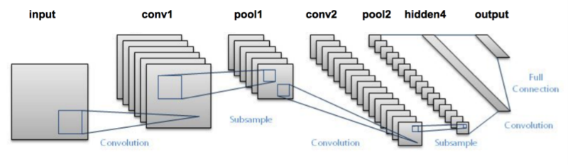

Figure-8: features matching through the neural network

4.5 Evaluation of Attendance
We assume that in a full duration class students are appearing in the classroom. A video camera setup is installed in the room in front of the students. before starting the classes video capturing will be start by the teacher. according to our methodology R-CNN and seetaFace will be started their operation with the starting of video capturing. The camera captures the present student faces, R-CNN recognize the faces with trained dataset and seetaFace trace the student activities with their movement.
When found information about students appearance in the class room the system sends an information message to ERP database '162-15-1078 is present' and similarly for the students who does not appear in the classroom system through a message that '162-15-1080 is absent'.
The R-CNN cannot recognize the student for the savior faire. for the early departure or late arrival of student a bad impact (or ratings) will be provided by seetaFace method.



CHAPTER 5
TERMINATION

5.1 Output
After successfully run the program a window will be open with camera setup. If the person whose images already stored in the image dataset sit in front of the camera, the information of identification/recognition will be given through a text with bordered box.
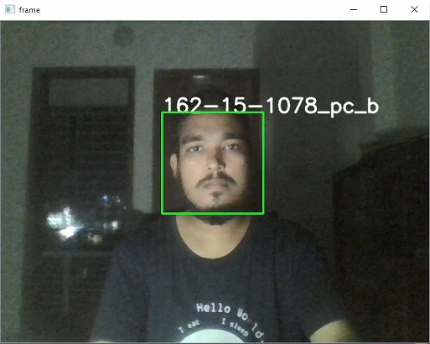
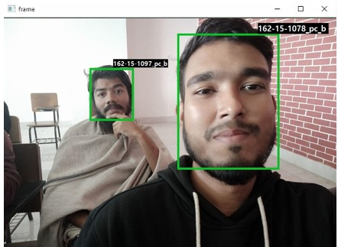
Figure-9: Output_Image_identification

5.2 Confusion Matrix
There are 20 images for every single student in their individual folder named subfolder. Main dataset contains these subfolders. Subfolders are named with student ID and section name. R-CNN matches the person’s facial region from real time capturing along with 20 images stored in subfolders. We have 5 class attributes were setting up to recognize the face in R-CNN algorithm. These class attributes are frontal, top, right, bottom & left. The confusion matrix along with these class attributes with precision, recall, F-1 Score and at last accuracy are mentioned in the following.

 |  | Predict Class |  |  |  |  | Actual
 |  | front | top | right | bottom | left | Actual
Actual Class | front | 4 | 0 | 0 | 1 | 0 | 5
Actual Class | top | 0 | 4 | 0 | 0 | 0 | 4
Actual Class | right | 0 | 4 | 3 | 0 | 0 | 3
Actual Class | bottom | 0 | 4 | 0 | 4 | 0 | 4
Actual Class | left | 0 | 4 | 0 | 0 | 4 | 4
Actual Class | Predict | 4 | 4 | 3 | 5 | 4 | 20

Recall: [{(4/5) +(4/4) +(3/3) +(4/4) +(4/4)} / 5] = 0.96
Precision: [{(4/4) +(4/4) +(3/3) +(5/5) +(4/5)} / 5] = 1
F-1 score: (2 * Precision * Recall) / (Precision + Recall) = 0.979
Accuracy: Total Correctly Classified / Total = 19/20 = 0.95*100% = 95%

5.3 Limitations

• This problem also raises on thanks to wearing hijab in classroom. We can’t integrate Iris-Recognition with face recognition on an identical model. The Iris-Recognition has built with fully different algorithms not exactly similar as this one.

• due to wearing mask as like present situation within the classroom or production line face can’t be recognized.
5.4 Future Plan

We are keep continuing our concentration of study that how we will integrate both iris and face recognition at a time or the way to develop the model implementation which may detect human iris region and face together to settle our proposal limitations.

Conclusion
based on the model provided in DL, SeetaFace and faster Neural Network have a potent ability in the shake of facial recognition with detection. To affect the matter of low-light video capturing there could be some difficulties to get proper accuracy, though we try to capture high resolution real time video for better performance on this type of projects because who knows as technology advances, it may be possible to overcome this limitation in the near future. This paper we embedded two algorithms to acquire the attendance information and make the process easier to the organizer with an optimal result and evaluation. Based on this, the attendance system will be more modern and smarter.
At the same time, permanent solutions can be found from a number of problems, such as giving one's attendance to another, identifying someone who is not a student of the institution, saving time, etc.
References:
[1] Wagh, Priyanka, Roshani Thakare, Jagruti Chaudhari, and Shweta Patil. "Attendance system supported face recognition using eigen face and PCA algorithms." In 2015 International Conference on Green Computing and Internet of Things (ICGCIoT), pp. 303-308. IEEE, 2015.
[2] Jha, Abhishek. "Class room attendance system using face recognition system." The International Journal of Mathematics, Science, Technology and Management 2, no. 3 (2007):
[3] Balcoh, Naveed Khan, M. Haroon Yousaf, Waqar Ahmad, and M. Iram Baig. "Algorithm for efficient attendance management: Face recognition based approach." International Journal of computing Issues (IJCSI) 9, no. 4 (2012): 146.
[4] Chintalapati, Shireesha, and M. V. Raghunadh. "Automated attendance management system supported face recognition algorithms." In 2013 IEEE International Conference on Computational Intelligence and Computing Research, pp. 1-5. IEEE, 2013.
[5] Kar, Nirmalya, Mrinal Kanti Debbarma, Ashim Saha, and Dwijen Rudra Pal. "Study of implementing automated attendance system using face recognition technique." International Journal of computer and communication engineering 1, no. 2 (2012): 100.
[6] R. Girshick, “Fast R-CNN,” in IEEE International Conference on Computer Vision (ICCV), 2015
[7] Yang B, Yan J, Lei Z, et al. Convolutional Channel Features for Pedestrian, Face and Edge Detection [J]. computing , 2015:82-90.
[8] Michał Dolecki, Paweł Karczmarek, Adam Kiersztyn, Witold Pedrycz, "Face recognition by humans performed on basis of linguistic descriptors and neural networks", Neural Networks (IJCNN) 2016 International Joint Conference on, pp. 5135-5140, 2016, ISSN 2161-4407.

