DESIGN AND DEVELOPMENT OF ANDROID APPLICATION ON SMART E-COMMERCE APPLICATION. (“GROCY”)
BY
Md. Rakib Hossen
ID: 161-15-917
This Report Presented in Partial Fulfillment of the Requirements for the Degree of
Bachelor of Science in Computer Science and Engineering
Supervised By
Mr. Amit Chakraborty Chhoton
Lecturer
Department of CSE
Daffodil International University

Co-Supervised By

Md.Mohammad Jahangir Alam
Lecturer
Department of CSE
Daffodil International University


DAFFODIL INTERNATIONAL UNIVERSITY
DHAKA, BANGLADESH
12th July 2020

APPROVAL
This Project titled Design and at the forefront payment of android application almost
speculative e-commerce application.(GROCY), by Md. Rakib Hossen, ID No: 161-15-917 to the Department of Computer Science and Engineering, Daffodil International University has been accepted as satisfactory for the partial fulfillment of the requirements for the degree of B.Sc. in Computer Science and Engineering and approved as to its style and contents. The presentation has been held on 12th July 2020.

Board of Examiners

Dr. Syed Akhter Hossain Chairman
Professor and Head
Department of Computer Science and Engineering
Faculty of Science & Information Technology
Daffodil International University

Mr. Narayan Ranjan Chakraborty Internal Examiner
Assistant Professor
Department of Computer Science and Engineering
Faculty of Science & Information Technology
Daffodil International University

Mr. Md. Nazmul Hoq Internal Examiner
Designation
Department of Computer Science and Engineering
Faculty of Science & Information Technology
Daffodil International University

Dr. Mohammad Shorif Uddin External Examiner
Professor and Chairman
Department of Computer Science and Engineering
Jahangirnagar University

DECLARATION
We consider that this internship has come to an end with the processing of our CSE Daffodil International University Lecturer Mr. Amit Chakraborty Chhoton. We would like to further add that this internship or any allocation for this project has not been submitted for omnipotent appreciation of any degree anywhere else.

Supervised by

Mr. Amit Chakraborty Chhoton
Lecturer
Department of CSE
Daffodil International University

Co-Supervised by:

Md.Mohammad Jahangir Alam
Lecturer
Department of CSE
Daffodil International University

Submitted by:

Md. Rakib Hossen
ID: 161-15-917
Department of CSE
Daffodil International University

ACKNOWLEDGEMENT
I ended my situation at Software Park Established: 2012, Reg. No: 90933, Address: 41/27 / B, Chandmia Housing, Mohammadpur, Dhaka Dhaka-1217. My situation report would not be possible without the contributions of some of my people from 10th June, 2019 to 1st October 2019. First, we need to have a deeper understanding of the feeling of Almighty God. I would like to categorize my sincere feelings to my supervisor Amit Chakraborty Chhoton , Lecturer in Computer Science and Engineering. Afterwards, the identification was shared with my online supervisor, Synergy Software Park, Founded: 2012, Register, and I would like to express my feelings to Mr. Shakil Ahmed, the director. No: 90933, Address: 41/27 / B, Chandmia Housing, Mohammadpur. They need to reassure me. I can't supply enough to any or all of the staff at Synergy Software Park. They need to explain everything I wanted in their description. Throughout the whole time they were impatiently impatient. They failed to enable me in an uncomfortable mood even for a moment. I am certainly grateful to anyone or everyone for his positive and understandable actions. I am sincerely grateful to the Department of Human Resources at Synergy Software Park for giving me the opportunity to create my situation program during this time.

ABSTRACT
The internship report gives a clear overview on the Corporate Synergy Software Park, where I am doing my internship. It also details the organization's culture, work environment, services and technologies. The report actually highlights the skills and technologies I have learned, the knowledge I have acquired, and the projects in which I have been assigned. It also includes academic and recreational activities conducted by me. These internship activities include the necessary collection, necessary analysis, coding with the native Android environment, debugging, bug fixing, team collaboration, agile method practice, and then tools. I was mainly involved in coding activities with the native Android environment. Standing at the top of the internship I am more skilled and confident than before.

TABLE OF CONTENTS

CONTESNTS | PAGE
Approval Page | i
Declaration | ii
Acknowledgement | iii
Abstract | iv
CHAPTER
CHAPTER 1: INTRODUCTION | 1-3
1.1 About the Project | 1
1.2 The Problem Statement | 1
1.3 The Purpose | 1
1.4 Scope | 2
1.5 Benefits of the Project | 2
1.6 Outline the Project | 2-3
CHAPTER 2: WORKS and BACKGROUND STUDIES | 4
2.1 Developing the Android Application | 4
2.2 Works and Background Studies | 4
CHAPTER 3: REQUIREMENT ANALYSIS | 5-7
3.1 Requirement Analysis | 5
3.2 Functional Requirement | 5
3.3 System Design | 5
3.4 Use case of E-COMMERCE System | 6
3.5 Use Case Description | 6-7
CHAPTER 4: DESIGN AND IMPLEMENT | 8-24
4.1 Development Method | 8
4.2 Used Language and Technique | 8
4.3 E-R Diagram | 9
4.4 DFD Diagram | 9-11
4.5 Activity Diagram | 12
4.6 Sequence Diagram | 13
4.7 Class Diagram | 14
4.8 Deployment Diagram  4.9 User Interface | 15  16-24
CHAPTER 5: IMPLEMENTATION AND TESTING | 25-31
5.1 Using Android Platform | 25
5.2 Android Versions  5.2.1 Basic Android review  5.2.2 Portability issue  5.2.3 Linux Based Construct  5.2.4 Implementation of Using Android Platform  5.2.5 Installing Eclipse and Workspace  5.2.6 Java Support  5.2.7 Implementation of SDK and ADT  5.2.8 Integration and Testing Implementation  5.2.9 System Test  5.2.10 Unit test  5.2.11 Usability Test  5.2.12 Black Box Testing | 25  25  25  25  26  26  26-27  27-29  30  30  30  30  31
CHAPTER 6: CONCLUSION AND FUTURE WORK | 32
Conclusion | 32
Limitations | 32
Future Work and Plan | 32
Reference | 33

LIST OF FIGURES
FIGURE |  | PAGE
Figure 1.6.1 | Outline the project | 03
Figure 2.2.1.1 | Home page of GORCY | 04
Figure 3.4.1 | Use Case diagram of E-Commerce App | 06
Figure 4.3.0 | E-R diagram of E-Commerce App | 9
Figure 4.3.1 | DFD for online shopping website project | 9-11
Figure 4.4.1 | Activity diagram of E-Commerce Application | 12
Figure 4.5.1 | Sequence diagram of E-Commerce Application | 13
Figure 4.6.1 | Class Diagram of E-Commerce Application | 14
Figure 4.7.1 | Deployment diagram of E-Commerce Application | 15
Figure 4.8.1 | Home Activity | 16
Figure 4.8.2 | Home Activity | 17
Figure 4.8.3 | Home Activity | 18
Figure 4.8.4 | Sign Up Activity | 19
Figure 4.8.5 | Sign In Activity | 20
Figure 4.8.6 | Shopping Cart item list Activity | 21
Figure 4.8.7 | Shipping Address and Place Order Activity | 22
Figure 4.8.8  Figure 4.8.8 | Activity of Update Shipping Address  Activity of Money Receive | 23  24

CHAPTER 1
INTRODUCTION
1.1 About the Project
The E-Commerce application is associate accolade online-based Golem application for e-commerce matter. this technique saves our indispensable grow prehistoric, and minimize the toughest quirk of energetic. the foremost incline of our system is to efficiently assuage the individuals through a totally machine-controlled system that whereas not facilitate saves countless epochs. However, moreover makes excitement straightforward. prune the price and operational procedure. this might preferably be utilized in any establishment, any place, work and non-government work everywhere . For ordering accolade item or things, the user location is critical . we'll order from anyplace or anytime. No restriction and sufficiently teasing pardon. just order and snooze, to believe your order, and check one factor later pay your bills.
1.2 The Problem Statement
Now a days, our excitement is strong and most importantly we are curved towards any or all or any of the studios and are getting smarter day by day. So, considering the merits and reasons to summarize and preserve the epic, the on-line system is now the most powerful to carry on and do any activity any day, any reliance on ordering from anywhere to any part of the world. No. You have fully entered your options. It's immersion. Proceed to the system of Internet Informatics, if you find yourself looking for a degree account or have no obsession with selecting a degree account, just choose the stage, notice your things, mark them, choose the amount, enter your residence and some Wait, the unit of measurement of the items you ordered before your order.
1.3 The Purpose
Returning after maintenance to pay homage to the e-commerce application means avoiding the waste of being an aboriginal, limiting prices, not making people forget what it is. A customer wants his own age and his unit accessible acceptable unit can do a special moment special maintenance of the unnecessarily damaged mount before he or she maintains the significance. Our project is like a degree efficient spare machine-driven system that does not save your own quantity or price, but manages to achieve appropriate patron satisfaction.

1.4 Scope
- This e-commerce website for everybody .
- This website are getting to be used from anyplace at any amount.
- Every Item are getting to be found during this website.
The client satisfaction is that the most theme.
1.5 Benefits of the Project
- This is an online system and it can achieve people by filling in the versatility to maintain relevance.
- There will assemble additional employments.
- Everyone ranges from general folks to bourgeois, each are becoming to be benefited
- It additionally to helps to avoid wasting times.
- It It back happening to store associations within the thick of client and shopkeeper .
- A customer doesn't crave to travel such tons , wide, and wide habit for any item for land, workplace or anyplace.
- Service are becoming to be for 24/7.

1.6 Outline the Project
The picture says a pile of everyone; Therefore, the establishment of an image for the larger than the earlier than taking many projects in a much larger simplified manner than before is left to bend the attached project. The project version consists of half a dozen chapters. A quick competition through demographics is defined in this chapter below:

Introduction (About the project, statement, goal, scope, project, facility, outline of the project)

Works and Background Study (Location, Works and Background Studies, Framework being created)

Necessary analysis (Use case analysis, operational requirements, system design, use of e-commerce system, case details)

Design and implementation (Development Methods, Language and Technology Used, DFD Diagrams, Activity Diagrams, Sequence Diagrams, Class Image, Installation Diagrams, User Interface)

Testing and evaluation (Test, test list)

Decisions and future work (Decisions, limitations, future work and plans)

Figure 1.6.1: Outline the project

Chapter 2
Works and Background Studies
2.1 Android application is developing
"Grocy" is an Android-based application to manage the required accessories, which may be found easily in an emergency. At any time from their own nearby store to urge the required things during a very short period of your time . The service is out there 24 hours each day , 7 days every week .
2.2 Works and Background Study
2.2.1 GROCY
GROCY This app will basically deliver all your daily necessities in a very short time. With confidence you can buy all your food items, raw market, medicines, all kinds of personal products with confidence.
Home page

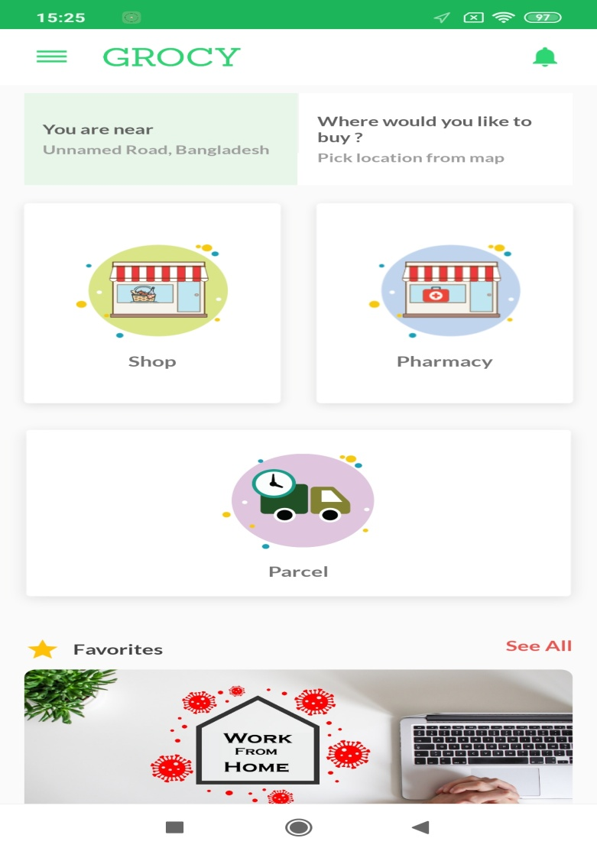
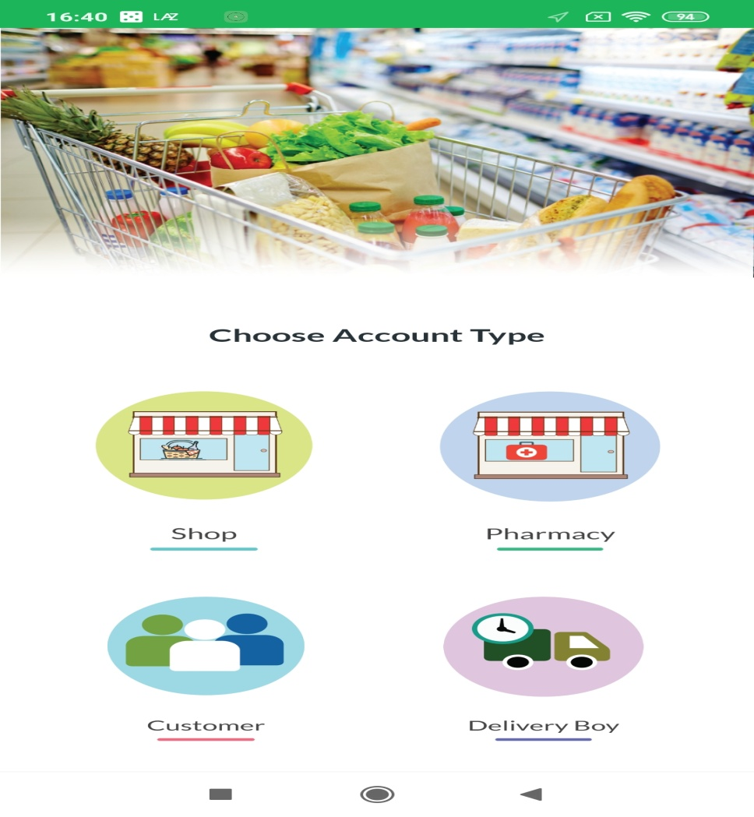
- Figure 2.2.1.1: Home page of GROCY
CHAPTER 3
Necessary analysis

3.1 Necessary analysis
The necessary analysis is the most important strategy for any fee project. It must be documented, considered and experimental. It is extra that can be subjective, structural, lively, non-functional. Progress requires some demand to manage the project hyperbolic. The project developer needs to verify the minimum requirements for each hardware and software package.

- Necessary analysishas two phases:
- Primary Research: Collect all necessities from jarring sources and survey.
Secondary Research: it'll compare the necessity of recent existing code.
3.2 Functional Requirement
- Register the page now rather than the login option
- The cart system improves the items selected by the fanatics
- Automatic static item list price calculation
- Approve fan
- Protection for clients on both sides
3.3 System Design
System style can also be a way to figure out the plan, modules to meet the requirements. It supports consumer-selected hardware and code for a specific project.
3.4 Use in case of e-commerce system
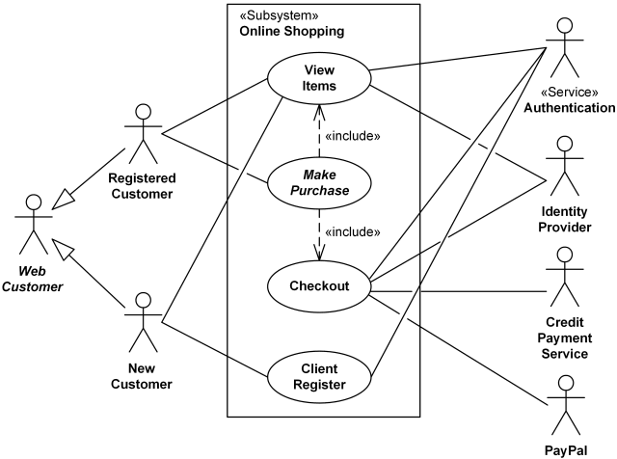
E-Commerce Android Application

Figure 3.4.1: Use Case Diagram of E-Commerce Android Application

3.5 Use Case Description
Use Fighting Interact on additional connectors and what the system does not specify on the Afrikaanda interface. It specifically describes the outdoor shake-up associate system in heavenly nursing that is in a position to be certified.
List of use cases are:

- Register
- Sing In
- Category
- Add Cart
- List the Items
- Order Item
- Final Price gone Quantity
- Authentication
- Security
- Map
- Near by Shop
- Reward points
- Direct Phon call system
- Direct Messanger system

Following table describe the use argument of Sign Up
Use Case Name | Register
Early actor | All
Statement | Register the system
Pre conditions | Users fill in all required fields
Post conditions | Users are registered
The following table describes the logic of using sign-in
Use Case Name | Sing In
Primary Actor | Registered user
Statement | Login to the system
Pre conditions | All authorized usernames and passwords are verified by the system
Post conditions | The system accepts the user
Following table describe the use argument of Select Category
Use Case Name | Item Selection
Primary Actor | General user
Statement | Select the item from the menu
Pre conditions | All registered or unregistered users can select any item for order products
Post conditions | Show System Options, Menu section

Following table describe the use argument of List the Item
Use case name | Item list
Early actor | Selected items will be listed
Statement | List items with quantity and price
Pre conditions | Other users can add items
Post conditions | The system will create a database for the user
Following table describe the use argument of Authorization
Use Case Name | Approval
Primary Actor | System admin
Statement | The system will check the address, email, phone number of the users. 2 valid or notes
Pre conditions | The user must enter the address, email and phone number
Post conditions | The system bill orders automatically

CHAPTER 4
DESIGN AND IMPLEMENT
4.1 Development method
The development approach is a discipline of development with hope, impact for understanding the purpose of adoption. An exchange of views on a project is to try to move forward from dawn and stop to fulfill the purpose of appropriate adoption stop We have found a collaborative trend with the clever technique we used to create this app. We have units of measurement at some stage for our project. This unit of measurement accuracy:
  - Initiation
  - Planning and style
  - Implementation and construction
  - Monitoring and control system

4.2 Language and technology used
The tools used to develop our applications are listed below:
Software Tools
- Local Server
- XAMPP (version 3.2.2)
- Database Server
- HOSTING
- IDE
- Android Studio (version 3.4)
Languages
- Java
- Basic PHP
- API
- and Retrofit Library

4.3 E-R Diagram
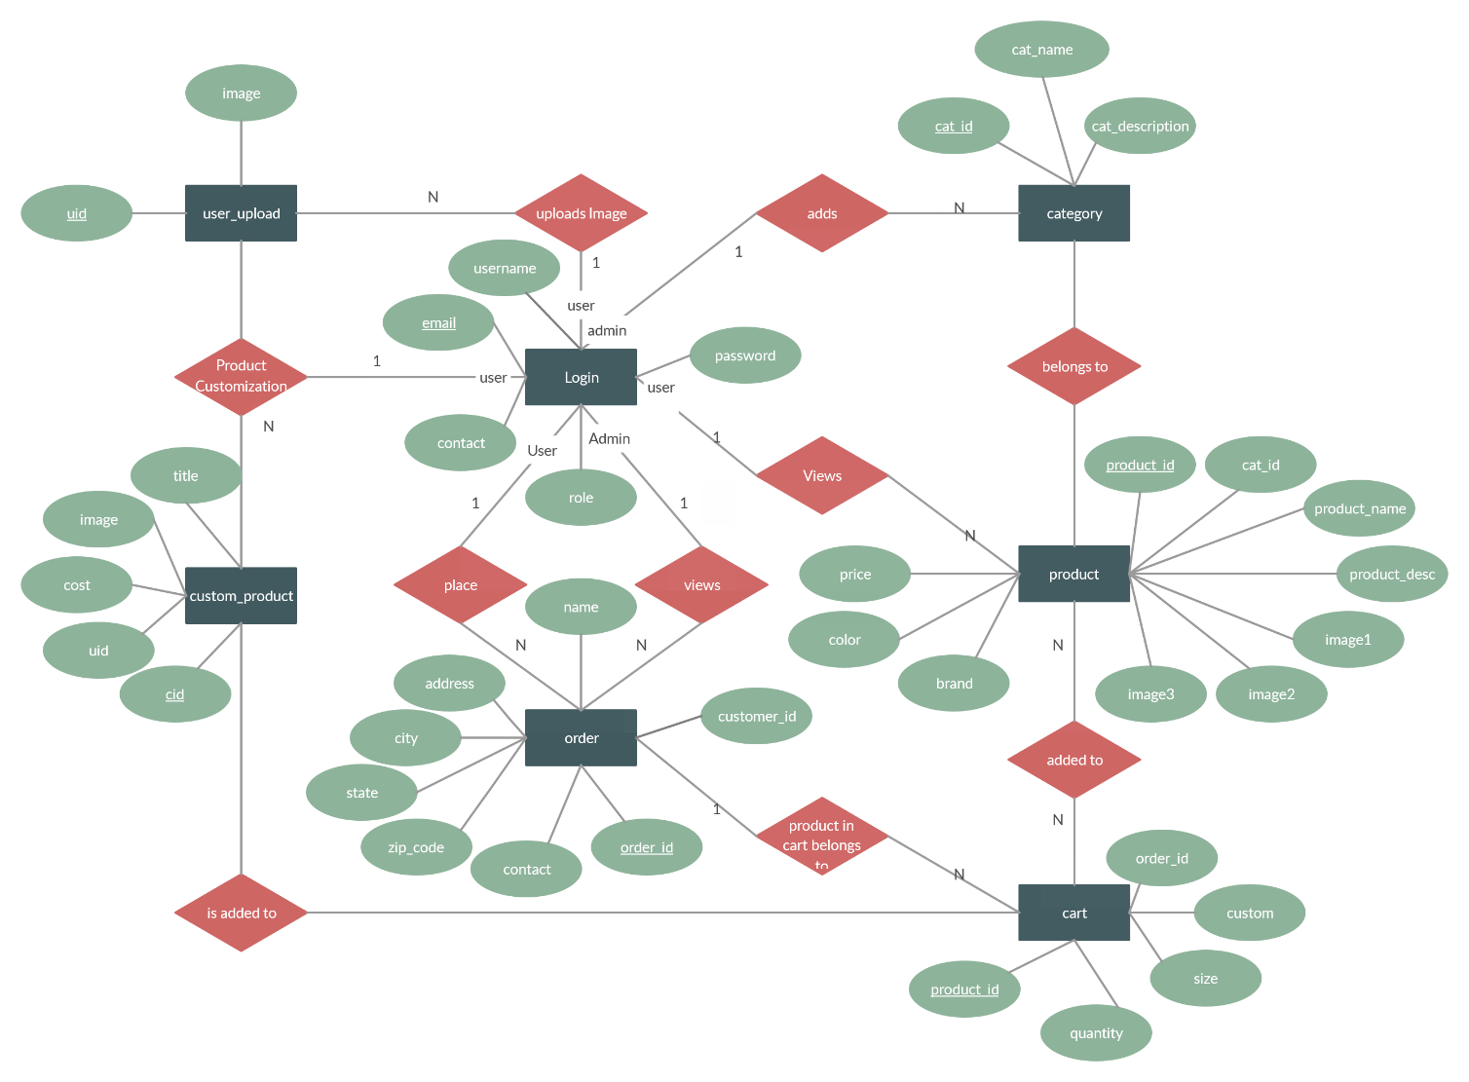
Figure 4.3.0: An image of the e-commerce Android application

4.4 DFD Diagram
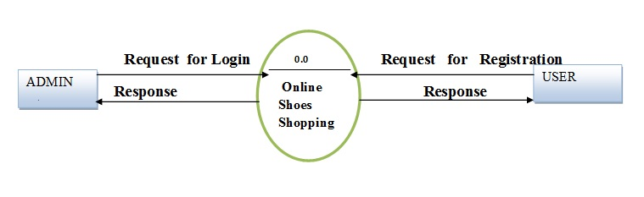
Figure: – Level DFD for Online shopping website project

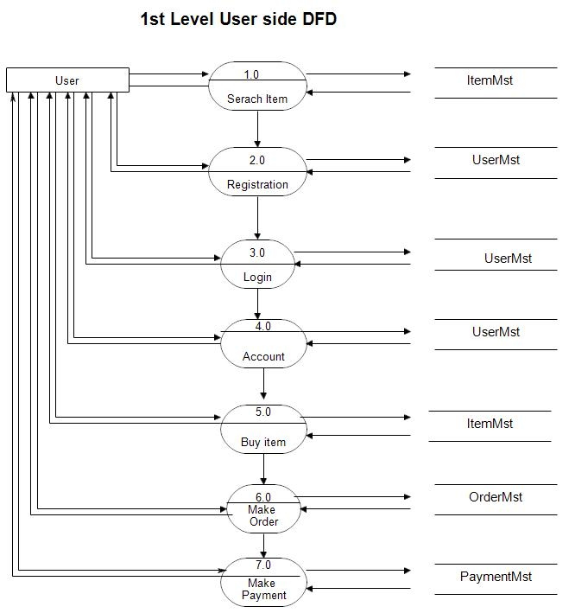

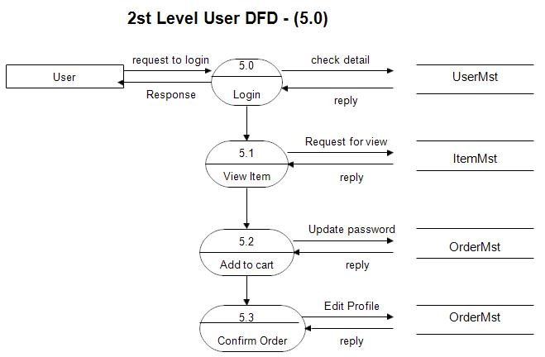Figure4.3.1: DFD for online shopping website project

4.5 Activity Diagram
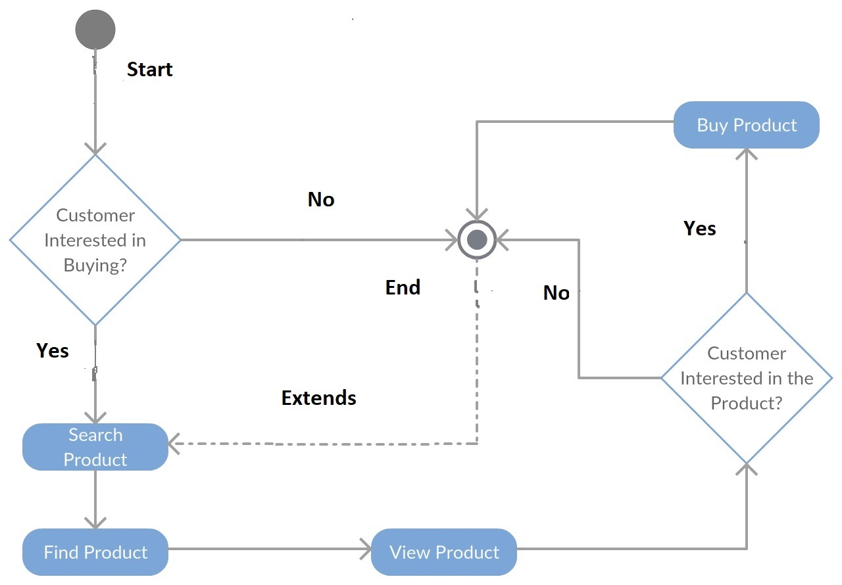
Figure 4.4.1: Activity diagram of E-Commerce Android Application

4.6 Sequence Diagram

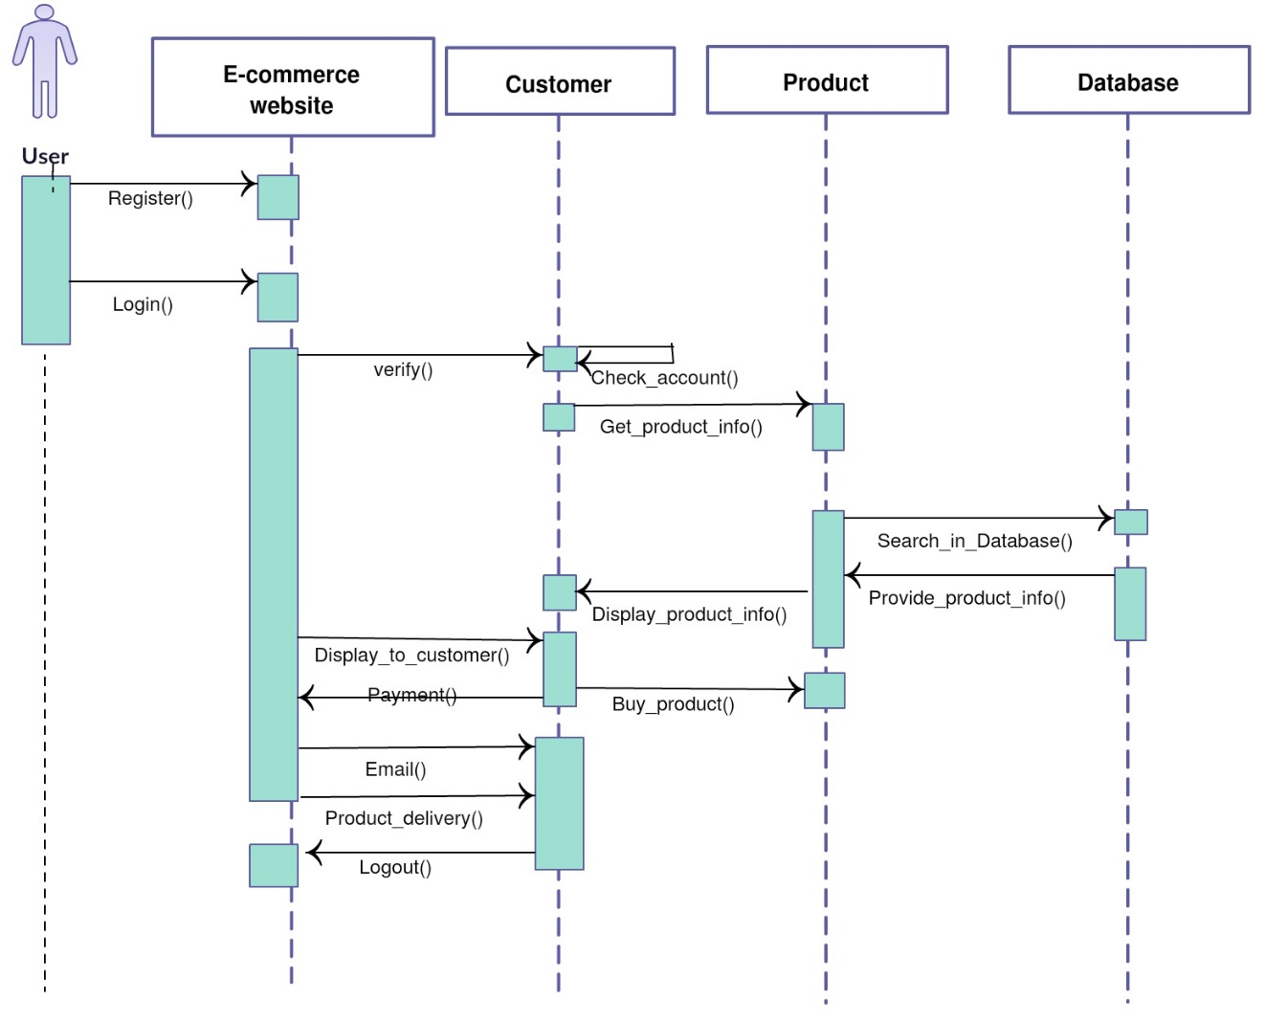
Figure 4.5.1: Sequence diagram of E-Commerce Android Application

4.7 Class Diagram
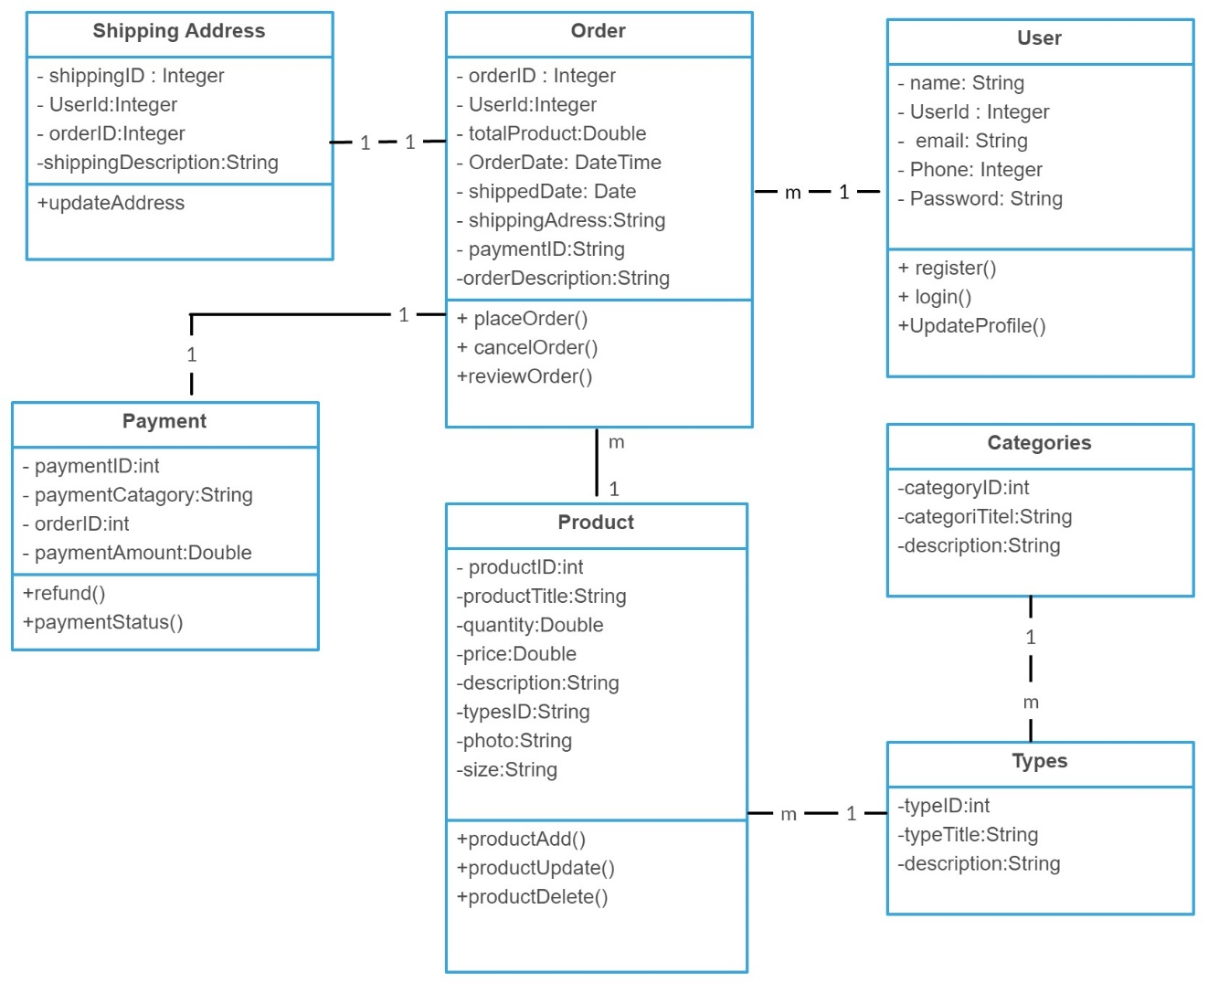

Figure 4.6.1: Class diagram of the e-commerce Android application

4.8 Image of the installation
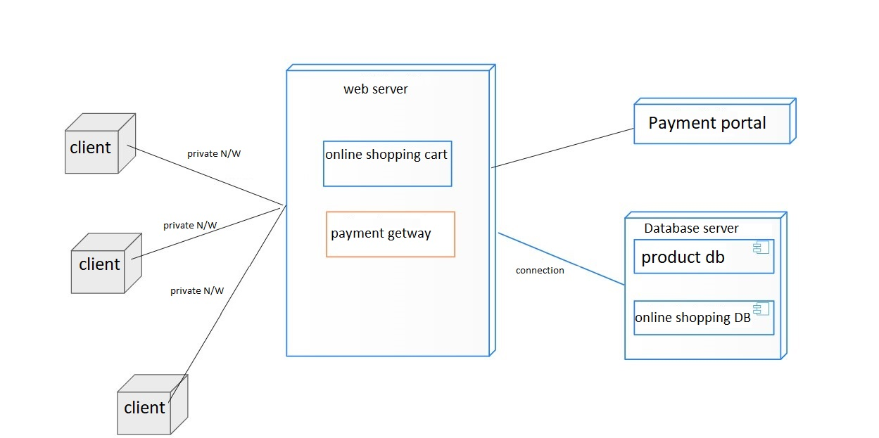
Figure 4.6.1: Recruitment diagram of the e-Commerce Android application

  - User Interface
Home page

Figure 4.8.1: Home Activity of GROCY

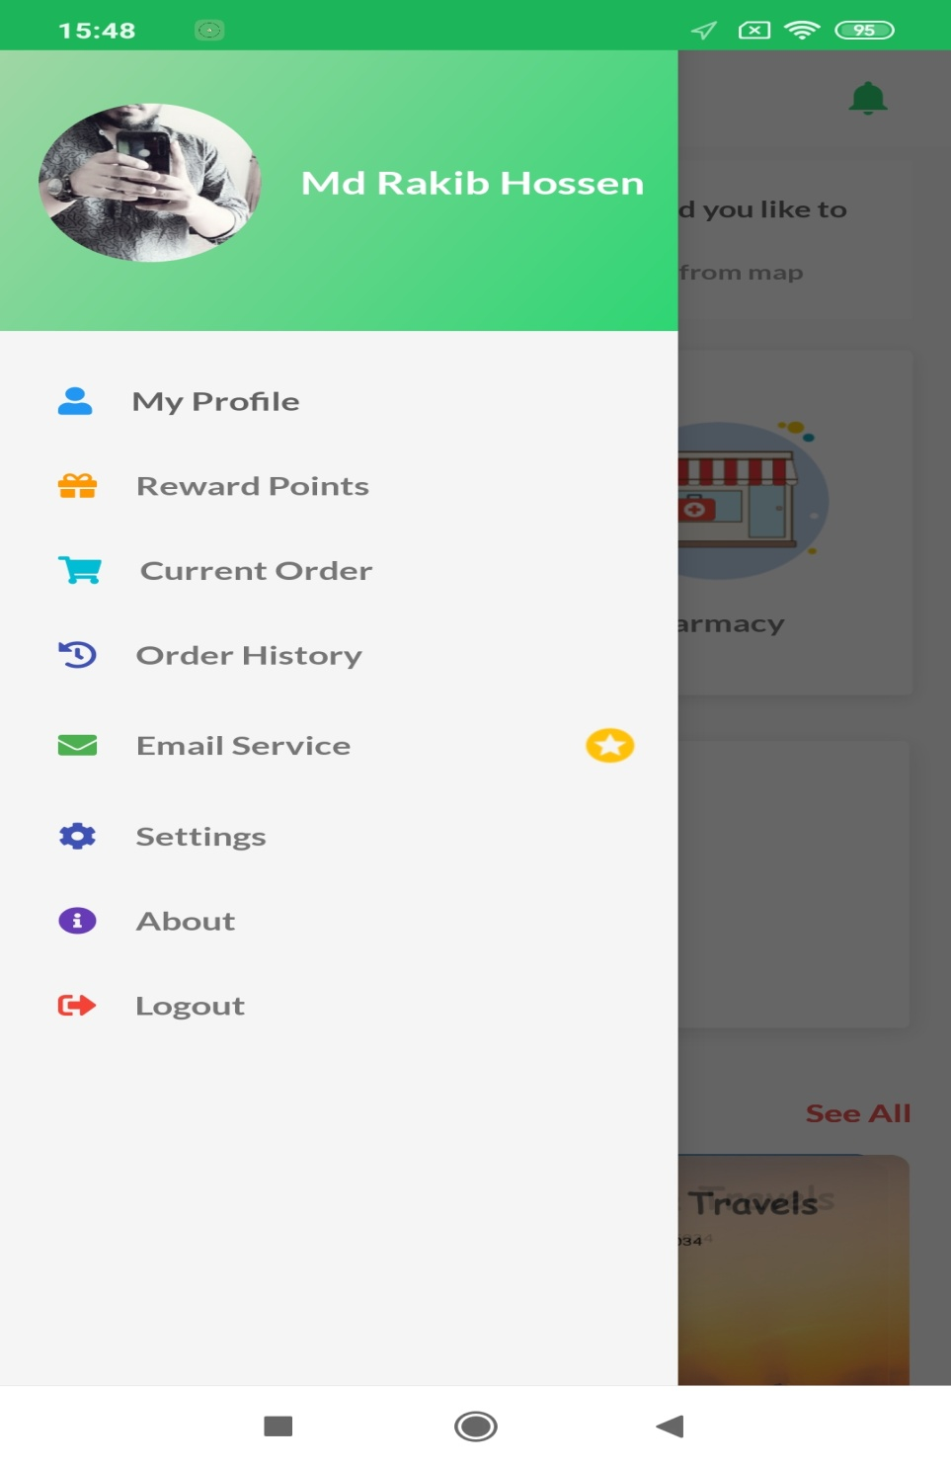
Figure 4.8.3: Home Activity of GROCY
Output: This is the on-fire page of our site. First, we logged in for the complementary right of entry. A fanatic can scan any item before logging in. Once registered, a fan can login to the system. Also, a user can almost recognize this site after considering all the details and create a giggle to create a product that is not a registered user.

Sign Up page

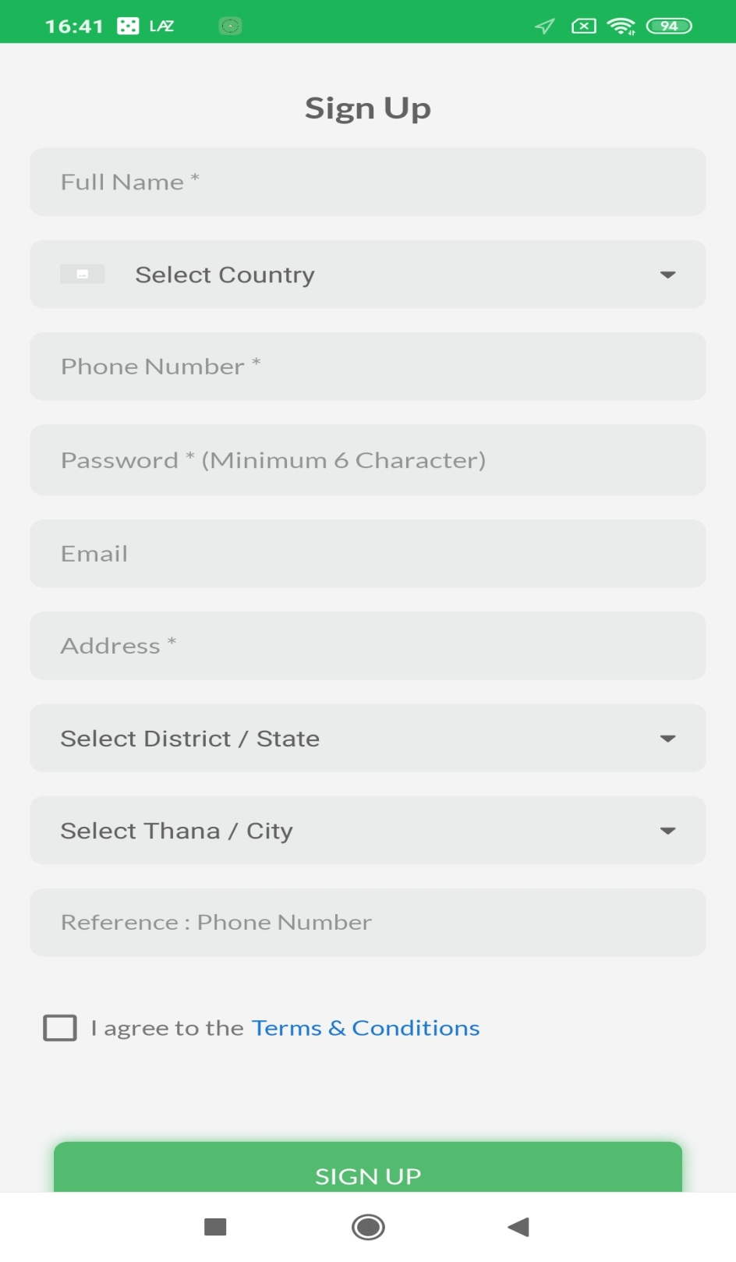
Figure 4.6.4: Significant activities of Grocy

Output: This is our registration page. There should be a fund of recommendations for each user to create a collaborative account for the use of add-ons on this website should realize its actual maintenance. In a valid email residence, sign registration should be mandatory.

Sign In page

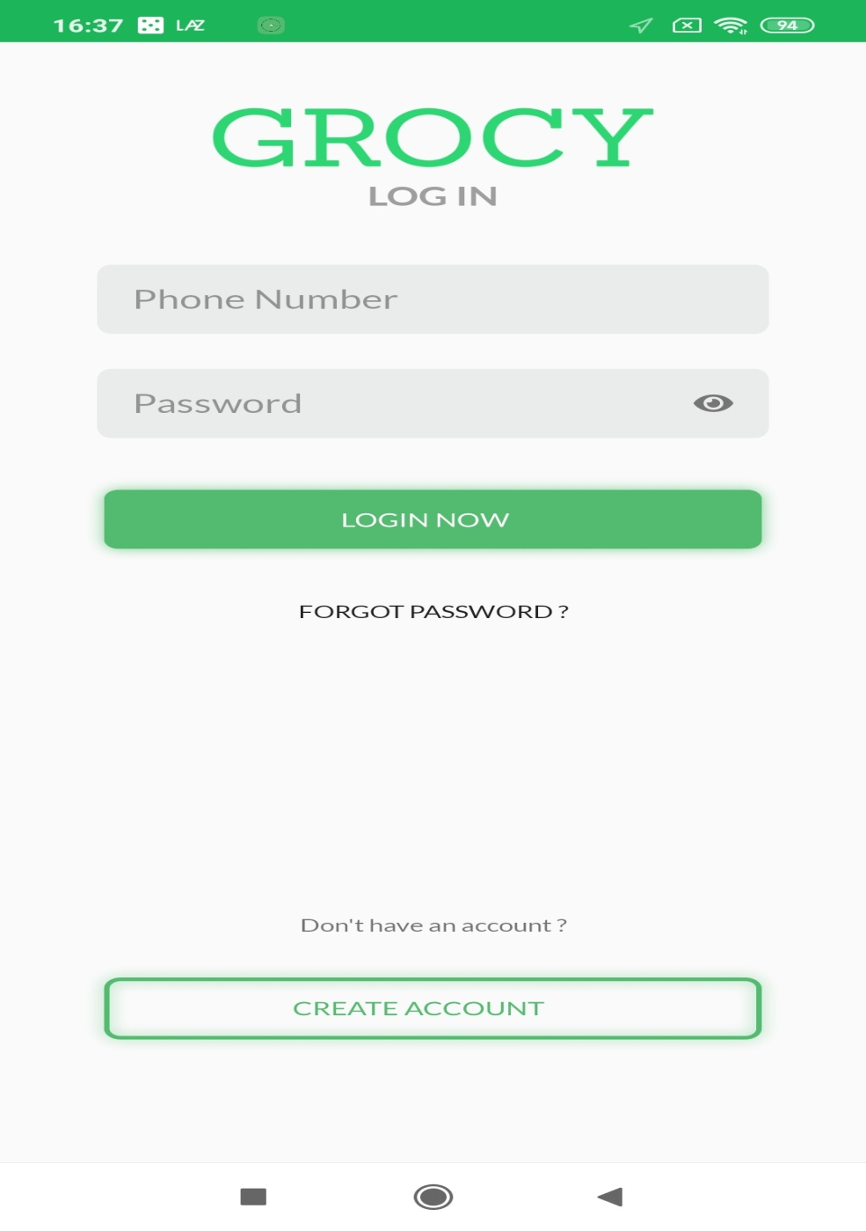
Figure 4.8.5: Sign In Activity

Output: This is the login page. After email and identity registration you will be sent to the next door page. Registered followers can get completely different advice The following followers will capture all the details of what will be canceled. A common example is when a user raises five things in the order of the gate as a brake as a cart. Then once logged in at the break the user collects the cart at the break and places the order. However, without registering or logging in, the cart area unit is going to be aimless. If someone forgets their identity, they will forget your identity and click to reset their identity.
Shopping Cart
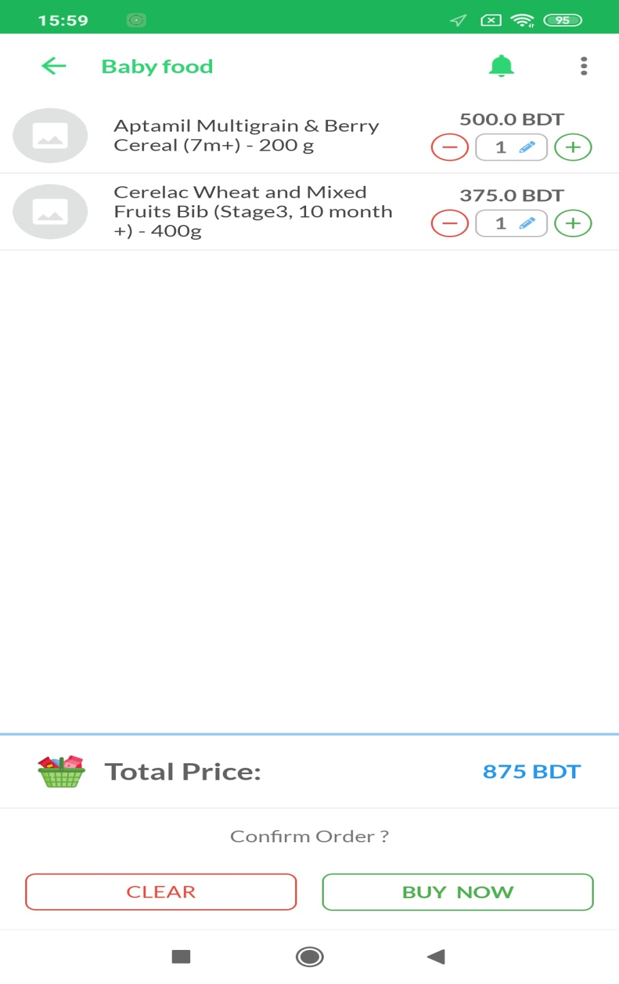

Figure 4.8.6: Shopping Cart item list Activity of GROCY
Output: This is the Browse Cart Item List page that followers will consider related products, images, prices, quantities, and solid prices for what add-ons they see in the cart. Will even delete any item from the fan cart. Adding changes to add a product from the cart changes the excuse to speak once the user can place an order to continue trying on the system.

Place Order Activity

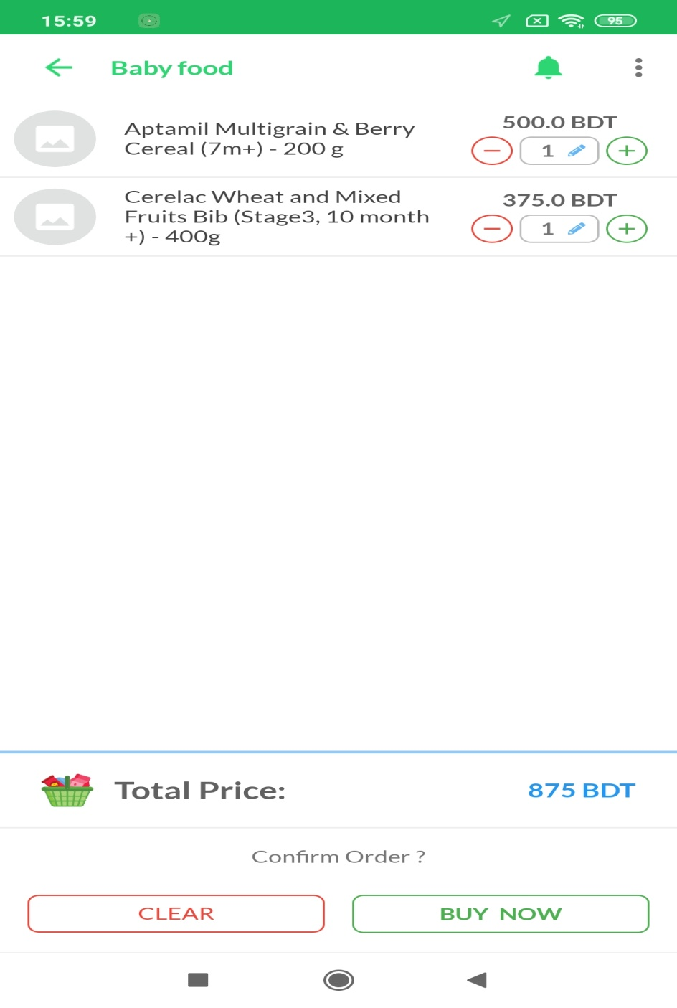
Figure 4.8.7: Shipping Address and Place Order Activity of GROCY

Output: This is the Order Abyss page where you can see what the principal ordered after the product ID, product announcement, quantity and quantity price. Also, no fans will see the shipping quarters. Addiction can even update shipping addresses.

Update Shipping Address

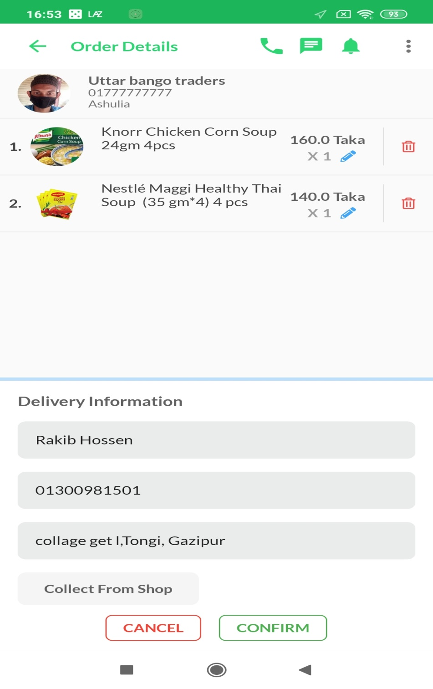

Figure 4.8.8: Activity of Update Shipping Address of GROCY

Output: Fan acceptable data will update its shipping stay once wherever it is updated shipping accommodation page. The user needs to agree to a full report of his promotion, email, phone number, city and address.

Money Receive

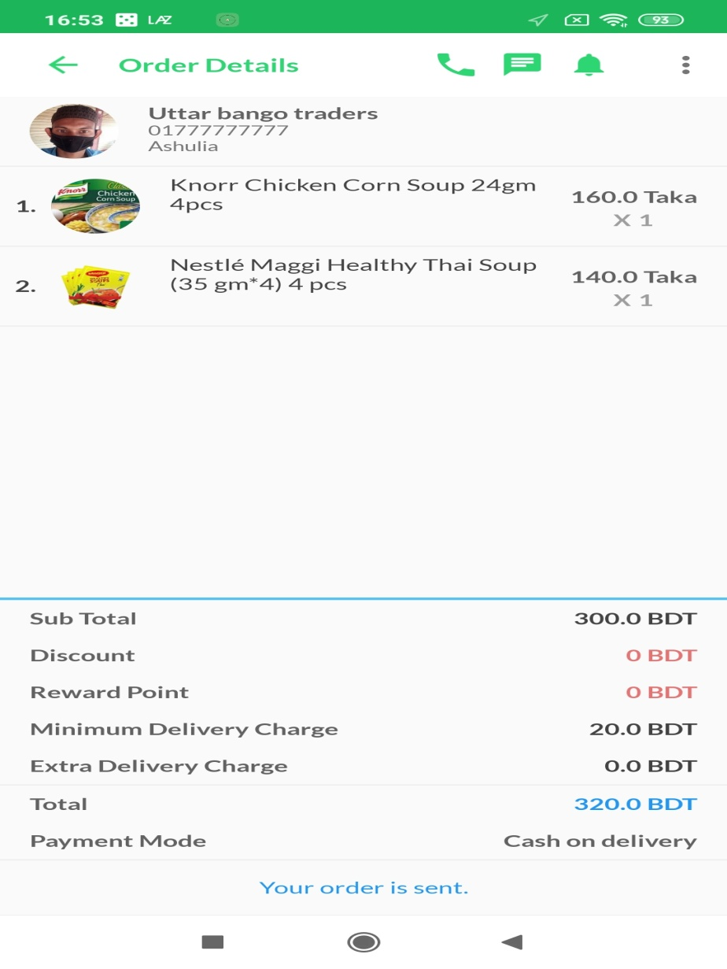

Figure 4.8.9: Activity of Money Receive of GROCY

Output: Receipt of this cash. Order users can transfer money notifications from the order feedback page once.

CHAPTER 5
IMPLEMENTATION AND TESTING
We have seen during this chapter the path to perfection and psychotherapy that promotes our setting for Android presses. Android tools are easy to understand so we have efficiently used in agreement to support group system choices.
5.1 Using Android Platform
We have observed the time of this narrow fairly basic Android during a general show. Description of truthful resolution.
5.1 Using Android Platform
We have observed the time of this narrow fairly basic Android during a general show. Description of truthful resolution.
5.2 Android Versions
The first test account of Android advertising, Android 1.0 was modern in September 2006. Android is still running in front of Google. Since April 2009, Android versions have been developed as a dessert theme code and have been published alphabetically.
5.2.1 Basic Android review
Android can be a smartphone-enabled system that transfers a framework for Unix kernel-based financial image access and a framework for Google-based automaton developers that pay a certain amount of money and provide candidate-loving and gracious applications for Java-language character mobiles and tablets. . Automaton provides quite a diverse genus of a large size to develop applications.
5.2.2 Portability issue
Linux can also be a transportable platform athletic system. This makes it relatively easy for Unix OS to scratch the surface of each alternative hardware design. Thus, Unix OS provides a level hardware abstraction robot. As a result, developers don't have to consider the sheer amount of hardware options. The lower level of Unix OS is written in portable C language which makes the robot a variety of devices.
5.2.3 Linux Based Construct.
The effective system of Android depends on the Linux kernel. Linux can be a gateway supply and a pleasant live system. Linux has been chosen for Android because of its volatility, security and options.
5.2.4 Implementation of Using Android Platform
An application programming interface (API) can also be a specification expected to be used as a collaborative interface by the code part to speak to remember each complement. API partners can become routines, data structures, purpose categories and variables. It additionally sets up language libraries (e.g. C ++ or Java API). The detailed procedure on the rough implementation of the Golem platform has been skipped.
5.2.5 Installing Eclipse
First, we tend to describe the law within the region of eclipse. Acceptance is a collaborator in the provisioning of nursing admissions in programming and was originally launched by IBM for Java. Java communities favor Eclipse as their Integrated Development Setting (IDE). The reception is available at http://eclipse.org. Tho 'we tend to replicate the automated impending by following a favorite text editor or integrated complementary atmosphere, most developers seem to be practicing the planet
5.2.7 Implementation of SDK and ADT
If you are encouraged to set up your computer by showing less of an Android platform, then you must set up Android Development Tools and SDK for Alloys set humanoid SDK has a folder that contains its main tools for everyone. As we seek to measure the use of these tools from the command pedigree, it is fully contributing to the occurrence of your Humanoid SDK and your Android-SDK, platform-tools / directories in the lane control of your system.
Given below the instructions to ADT setting up a path to tools:
- Start Eclipse, and later pick mitigation install subsidiary software.
- In the obtainable Software dialog, Click grow.
- In the merge site dialog that appears, believe a publicize for the unfriendly site within the name showground.
- In the situation sports ground, enter this URL: http://dlssl.google.com/android/eclipse/.
- Click ok.
- Back within the enthusiastic software view, you ought to now see Developers Tools continue to the
- List. Select the checkbox against developer tools, which can mechanically choose the nested.
- Tools Android DDMS and Android Development Tools. Click neighboring.
- In the resulting install details dialog, the android DDMS and android go ahead tools.
- Features are listed. Click closely acquire into and are available happening furthermore the kid maintain for within the license .
- Dependencies then click finish.
- Restart Eclipse.

Figure 4.2 After installing the Eclipse once we open it and need to start out new application this procedure will come which is given below.
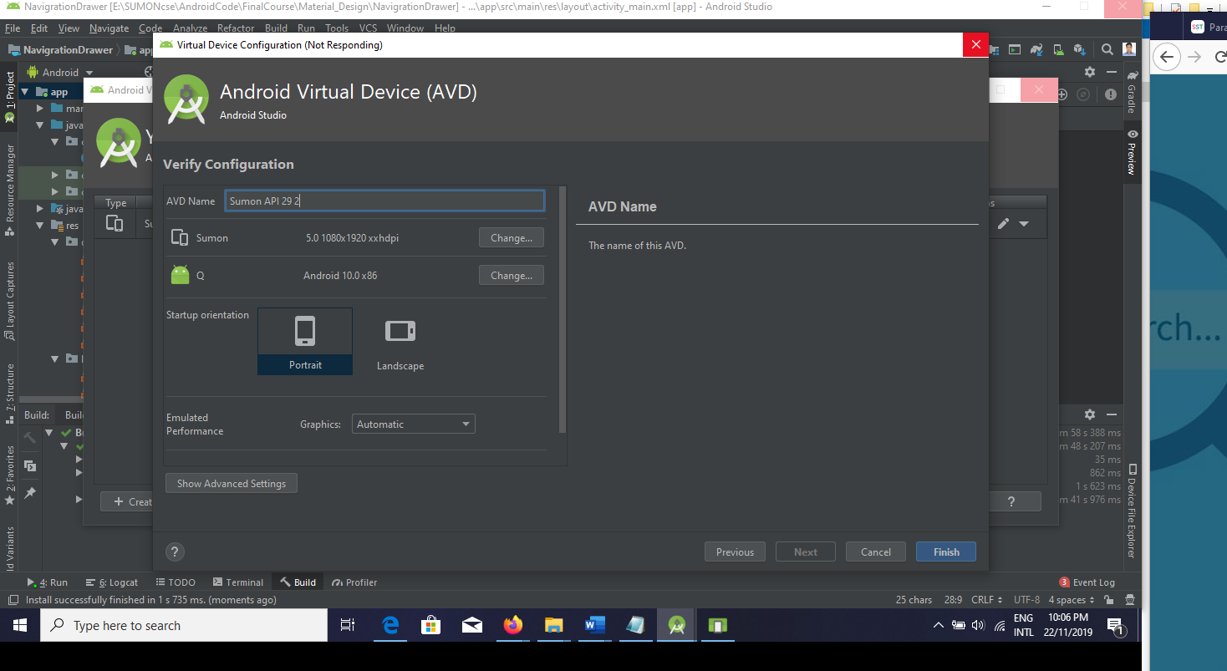
Figure 4.2: Android Application with AVD.
Now we are curved to make calculations related to apex fixing. Running our application in order of a live factor device to organize the associated AP device is surprisingly a lot of the same problem. This refers to the associate original code apk as a result of the APA, meaning it runs a uniform code base because the specific device, adds all the habits to the machine. To imitate means to weaken the system of punishing the code. To use the APK, we created the Associated Human Virtual Device (AVD). By clicking on the icon marked as humanoid, we found this tool to start from Eclipse, it found the SDK / tools directory.

Figure 4.3 You have to start the emulator and try something else. On the other hand, the emulator is not working properly. Hera Belo is amazing to start the emulator.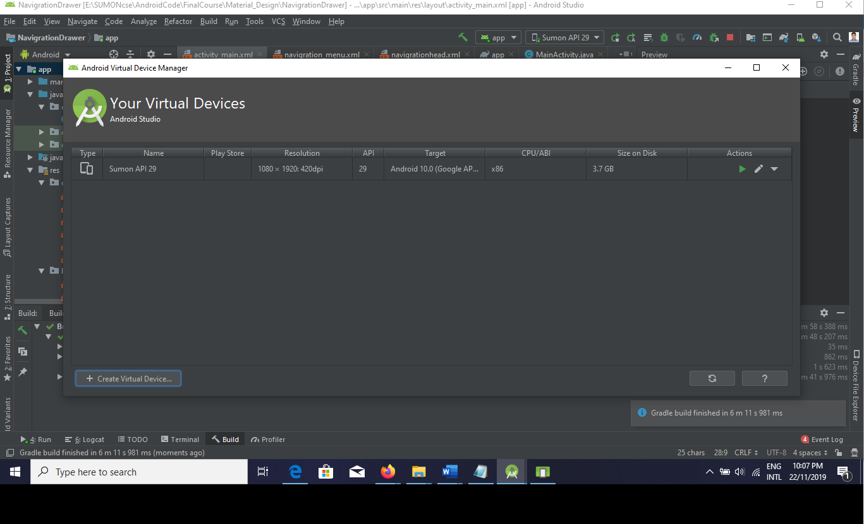
Figure 4.3: Android AVD Manager
Figure 4.4 After fixing the T-Abd manager, T-emulator Will Reed. Go away and listen to the screen, then start the emulator.

5.2.8 Integration and Testing Implementation
We tested side by side in the center of the conflict that adherent interfaces are often used. We test the application to see if the engineered merchandise is fanatical-beautiful or not. Our application takes into account the rotation parameters innocuous - flow, navigation and formatting, preparation and especially content compared to previous or similar applications. The content robot framework includes a compact psychotherapy framework that helps you Inserts into work tools to run and takes a look at applications. Whether or not you become overwhelmed when you're full of ADD or command removal, the SDK tool conducts your experiments inside a person who connects you as a nursing partner or inside the device you're targeting.

5.2.9 System Test
System Verification has been sorted prior to installation, and it has been discovered that Miltstone No. 2 maintains system requirements.
5.2.10 Unit test
Each part of the instrument is examined to make sure that the flower style is applied correctly. It has been distributed to ensure that it works according to any laid requirements of the system.
5.2.11 Usability Test
- Take a look at the usability managed by the users. This is the Herald that the system provides specific functionality. First, | At a glance we selected 5 users to test our system for usability testing. There were also 2 skilled and burning peaks among them. Skilled users were running the app perfectly and illegally, without any problems. Nevis addresses to deliver all the more parts of the application efficiently of late and without any problems, but they pay a lot more than the skilled users. However, take a look at it from the usability and it is admirable that users can get your hands on it without being omnipotent despite the fact that this app suffers. 2 types of errors occurred specifically throughout the program analysis, syntax errors and query errors. Syntax errors need to be corrected back the program is executed.
Knowledge handling knowledge, a sequence of program aids etc.

Also, the taking into consideration is that the various stages within the psychiatry process.

5.2.12 Black Box Testing
In this psychiatry we test the output by buying input into the system. Here we get to look at the internal variables of the system and see what changes happen to them for the specific output, failing to collectively establish any void inputs for the above results that are simultaneously surrounded by the front holt and gain the occurring holt. We have tried the system without authentication, but the system is not unaltered

CHAPTER 6
CONCLUSION AND FUTURE WORK
Conclusion
The main trend of our margin notes is to make it easier for the buyer and the merchant to create your perceptions within the company, phasing in with the market system and protecting the era. We have a boring attitude to satisfy all users and make the project achievable at the most effective level. It has been proven inadequate that if we want to style and evolve an e-commerce application we will replace it in a few months but we are ready to simplify it in the right way and produce the lecture. Suppose they deeply prioritized their family abroad so they moved closer to intelligent friends r. So finally all the important parts that we will make sure that your relatives are more composite than you that we will fulfill all your wishes. Make the reliance on-line for our travel on-line. You can maintain everything your kid allocates time. Our application can create extra employment, greatly reduce the condition of meat and blood issues for you, no compulsion to forget about everything or any product, can not save the mature. We have bent on developing this application. As a result of several assemblies that we have tried to solve related to our one
Limitations
- Buying international long-estrange products can comply to on an extended era.
- After ordering the addict won't be practiced to displace the order.
- Without registering, no fanatic can combine items to the cardboard for subsequence orders..
Future Work and Plan
Improve security to look out admittance users. To believe to be the particular merchant by presently the endemic product feedback from customers. Integrate the payment system.

References

[1] | A. E.W.T.Ngai, "A review for mobile commerce research and applications," pp. 3-15, 2005.
[2] | J. B. S. A. K. Riedl, "E-Commerce Recommendation Applications," p. 115–153, 2001.
[3] | S. E. L. C. A. A. Janice Y. Tsai, "The Effect of Online Privacy Information on Purchasing Behavior: An Experimental Study," 2010.
[5] | O. B. Günay Gültekin, "Smart Location-Based Mobile Shopping Android Application," Journal of Computer and Communications, pp. 54-63, 2014.
[6] | D. B. H. Swapnil S. Jagtap, "Development of Android Based Mobile App forPrestashop eCommerce Shopping Cart (ALC)," Sixth Post Graduate Conference of Computer Engineering (cPGCON 2017), Organized by SPPU, Pune and SITRC, Nashik, 2017.
[7] | R. H. A. P. Yana Hendriana, "Design and Implementation of Online Fashion Store “Demi Outfits” Based on Android," International Journal of Computer Applications Technology and Research, pp. 438-443, 2015.
[8] | L. V. D. P. I. S. P. E. Y. S. Roy Deddy Hasiholan Tobing, "Customizable commerce mobile application," 2016 3rd International Conference on Computer and Information Sciences (ICCOINS), 2016 .
[9] | N. F. M. S. A. O. E. B. S. P. VijayaPrasad, "Shopping Mall Directory: A Detailed-Guide Application for Android-Based Mobile Devices," ARPN Journal of Systems and Software, 2013.
[10] | R. V. R. K. U. Varshney, "Mobile commerce: a new frontier," IEEE, pp. 32 - 38, 2000.

