DEVELOPMENT OF HOME SERVICE APPLICATION

by
MD Mehedi Hasan Sobuj
ID: 162-15-1047

MD Mahedi Hasan Suvo
ID:162-15-1053

MD Shapon Molla
ID:162-15-1039

Our Project is “Development of Home Service Application” and this report is about the partial fulfillment of our Bachelor Degree in Computer Science and Engineering from Daffodil International University.

Supervised By

Dr S M Aminul Haque
Associate Professor
Department of CSE
Daffodil International University
Co-Supervised By

MD Reduanul Haque
Senior Lecturer
Department of CSE
Daffodil International University



DAFFODIL INTERNATIONAL UNIVERSITY
Dhaka, Bangladesh

Semester: Summer 2020

Date of Submission: 17th October, 2020

APPROVAL

This project is a web application titled “Development of Home Service Application” developed by MD Mehedi Hasan Sobuj bearing ID:162-15-1047, MD Mahedi Hasan Suvo bearing ID:162-15-1053 and MD Shapon Molla bearing ID:162-15-1039.This project is for the partial fulfillment of our Bachelor Degree from Daffodil International University, Department of Computer Science and Engineering. Our project is supervised by our respective teacher Dr S M Aminul Haque, Associate Professor and co supervised by MD Reduanul Haque, Senior Lecturer. The presentation has been held on 22 September 2020.

ACKNOWLEDGEMENT

At first, we would like to thanks our creator Almighty Allah who grace us to complete this project in time.
Secondly, we are really thankful and wish our profound to Dr SM Aminul Haque Associate professor, Department of CSE Daffodil International University, Ashulia, Dhaka.
Once again, we would like to give thanks to our honorable Dr Syed Akhter Hossain Sir, Professor and Head of the Department with all the respective teacher and staffs who are related with Daffodil International University.

Our supervisors help us a lot to complete this project Development of Home Service Application and their guideline was excellent in a word. Their capability and the supervising power make us possible to complete this project. Their leadership, recommendation, right direction and their energetic speech help us to conclude this work.

Finally, we are feeling heartiest gratitude to parents who always support us in every situation of our life.

Dedication

We hereby announce that this project is completely done by MD Mehedi Hasan Sobuj, MD Mahedi Hasan Suvo and MD Shapon Molla with the supervising of Dr S M Aminul Haque, Associate Professor, Department of Computer Science and Engineering, Daffodil International University. This project is a web application and any part of this project is not submitted anywhere for the purpose of any reward or anything like that.

Supervised by:

Dr S M Aminul Haque
Professor and Head
Department of CSE
Faculty of Science & Information Technology
Daffodil International University

Co-Supervised by:

MD Reduanul Haque
Senior Lecturer
Department of CSE
Daffodil International University

Submitted by:

MD Mehedi Hasan Sobuj
ID: -162-15-15-47
Department of CSE
Daffodil International University

MD Shapon Molla
ID: -162-1-1039
Department of CSE
Daffodil International University

Mahedi Hasan Suvo
ID: -162-15-1053
Department of CSE
Daffodil International University

Abstract

A few years ago, we were not familiar with technology. But now we cannot move without technology. In every sphere of life, we depend on technology. Once all need to work hard for communication but now it is so much easy. In that sense for taking a service we needed to find out the service provider. They were rare to find out. But it is so much easy with our project. For removing the sufferings of our users, we are here to serve the users according to our ability. We are in the era of modern science and gradually we move on a digital word. So, we need to cope up with that. As we are living in Dhaka city, we are facing a lot of problems. Especially for find out a better residence we face huge problems. But somehow if we can manage a residence then we have face different problems to fulfill our all criteria. To fulfill these criteria, we are managing a hardcore project. From this project the users can find out their residence easily and he is able to solve all the problems related to residence through this web application. They will get all the services also according to their need. Important notices given by the residence owner and the Government will be shown through the notification. The payment system is also available in this web application. The users can pay their residence fair as well as service charge they need. It will reduce the time and complexity of the user. They are able to contact with the service provider which will be very friendly for the users. Users just need to contact with the service provider and the service providers are always ready to provide you better services. We are hoping that this web application will be very effective and it will able to minimize the sufferings of the users.

TABLE OF CONTENTS

CONTENTS PAGE
Title i
Approval ii
Acknowledgement iii
Dedication iii
Abstract v

CHAPTER 1: INTRODUCTION 1-2
1.1: Introduction 1
1.2: Motivation 1
1.3: Objective 2
1.4: Expected Outcome 2

CHAPTER 2: BACKGROUND STUDY 2-4
2.1: Introduction to Background Study 2
2.2: Consorted Work 3
2.3: Project Scope Area 3
2.4: Relative Studies 3
2.5: Challenges 4

CHAPTER 3: EXECUTED REQUIREMENTS 4-12
3.1: Business Process Model 4
3.2: Functional Requirements 5
3.3: Admin Requirements 5
3.4: Service Provider Requirements 5
3.5: User Requirements 6
3.6: Technical and Legal Requirement 6
3.7: Hardware Requirement 6
3.8: Software Requirement 7
3.9: Use Case Model 8
3.10: Use Case Description 9
3.11: Admin Page Requirement 12

CHAPTER 4: DESIGN PARTICULARIZATION 13-14
4.1: Front End Development 13
4.2: HTML 13
4.3: CSS 13
4.4: JavaScript 14
4.5: HTTP 14

CHAPTER 5: IMPLEMENTATION AND TESTING 15-32
5.1: Implementation 15
5.2: Entity Relationship Diagram 16
5.3: Data Flow Diagram- Level 0 16
5.4: Data Flow Diagram- Level 1 17
5.5: Implementation of Front-End Design 18
5.6: Project Interfaces 18
5.7: Implementation on Interaction 31
5.8: Main System Testing 31
5.9: Database Testing 32
5.10: Test Results and Reports 32

CHAPTER 6: Impact on Society, Environment & Sustainability 33-34
6.1: Impact on Society 33
6.2: Impact on Environment 33
6.3: Ethical Aspects 33
6.4: Sustainability Plan 34

CHAPTER 7: Conclusion and Future Work 34-35
7.1: Conclusion 34
7.2: Future Works 35
7.3: References 35

LIST OF FIGURES

FIGURES | PAGE NO
Fig 3.1: Business Process Model | 5
Fig 3.2: Use Case Diagram | 8
Fig 5.1: Entity Relationship Diagram | 16
Fig 5.2: Data Flow Diagram-Level 0 | 17
Fig 5.3 Data Flow Diagram-Level 1 | 17
Fig 5.4: Home Page | 18
Fig 5.5: Login Page | 19
Fig 5.6: Seller Registration | 20
Fig 5.7: User Registration | 20
Fig 5.8: Take Service | 21
Fig 5.9: Add to Cart | 22
Fig 5.10: Order Proceed | 22
Fig 5.11: Order Details | 23
Fig 5.12: Payment System | 23
Fig 5.13: Gateway Payment System | 24
Fig 5.14: OTP | 25
Fig 5.15: Payment Confirmation | 26
Fig 5.16: Order Confirmation | 27
Fig 5.17: Service Shipped | 28
Fig 5.18: User Review | 28
Fig 5.19: Home Rent Service | 29
Fig 5.20: Home Details | 29

LIST OF TABLES
TABLES | PAGE NO
Table 3.1: Hardware Requirement | 6
Table 3.2: Software Requirement | 7
Table 3.3: Login | 9
Table 3.4: Add Service | 9
Table 3.5: Search Service | 9
Table 3.6: Hire Service Provider | 10
Table 3.7: Order Confirm | 9
Table 3.8: Pay for Service | 11
Table 3.9: Manage | 11
Table 3.10: Verification | 11
Table 3.11: Notice Approval | 12

CHAPTER 1

INTRODUCTION

1.1: Introduction

Our project title is “Development of Home Service Application”. This is a web-based application. Our motive is to provide a digitalize system to our users. The users can use this application easily because it’s so much user friendly. This application is related with home service that means the users are able to receive services according to their need through this application. This web application is basically developed for minimizing the sufferings of people. This will not only minimize the suffering but also reduces the time of the users. As a friendly user interface, the user can take a service in a very short time. So, we are thinking that it will be beneficial for the users. On the other hand we are estimating our future plan about this project and we are trying to have a blast with this project in future.

1.2: Motivation

We are living in the modern era. All the things beside us are digitalize. We the human beings are also becoming digitalize using technology.
From the early morning to till night we are dependent on technology. Computer and Mobile phone seem like friends. Now a days we want everything in our hand. It is only possible with using technology. That’s why we have developed a web application. From this application users are able to take services according to their need. They are also able to pay the service charge using this system from his home. No need to go outside and find out the service provider for a service. Just need to visit this system and grab the services they need. That’s why this system is developed to reduce the time and minimize the sufferings.

1.3: Objectives

- To provide an easy solution for the new people in city
- To minimize time to solve a problem
- User friendly notices for different purposes
- To increase the collaboration between the customer and the service provider
- To digitalize the whole system

1.4: Expected Outcome
- A complete digital management system for home service with home rent
- All the services under one roof
- Maintained by all user requirements
- Digitalize and secure communication between customer and service provider
- Automated support facility
This project is developed for the purpose of minimize the time and cost of a user. More and more features will be added gradually in future.

CHAPTER 2
BACKGROUND STUDY

2.1: Introduction to Background Study
The world is becoming digitalize day by day. Everything is happening automatically in front of our eyes with the power of technology. A few years ago, the people have to go out and search for the person from whom he can get a service. But now the time has changed. Human being also becomes digitalize as they use technology. Now they want to get all facilities from their home sitting on his drawing room. Most of the jobs are done through online. Here the most important thing is it reduce the time and minimize the sufferings. Now people are using mobile phone and computer all the time. They also do not go for shopping as they order their favorite things through online. Then we think is it possible to provide home service with the home rent facilities. From this idea we have developed a web application project related to home service application.

2.2: Consorted Work

There are lot of companies have completed many web-based applications. They really tried to provide full support to the users. Their motive is undoubtedly honest and the all the projects are made for minimizing the problems. They offer a lot of facilities to the users so that the users can easily rely on them. In Bangladesh a company created a project named sheba.xyz which is really excellent. The idea of our project taken from
them but we are trying hard and soul to make it more advance and user friendly than them. Our target or motive is honest to provide services to the user, not for the business purpose. So we hope that we will be successful in our motive.

2.3: Project Scope Area

Our project has a vast area as we are providing a lot of services to the users. All the users are able to receive their required services sitting on home through us. They need just to SignUp and visit our web application for the services. It’s very easy process and user friendly interfaces so we hope that all the user will like to use it.
Some of the area of our project are
- Maintain the user requirements
- Maintain user friendly interface
- Maintain low cost
- Reducing the time

As our life is getting closer to machine and we become autonomous so that we have to maintain these formalities

2.4: Relative Studies

Our purpose is to provide a better service to the users. We want minimize their sufferings as well as we need to save their time also. We always keep in mind that if we can provide something special to users then we can really achieve our goal. We designed our project very user friendly so all the users can be able to use this easily. With the help of our project the users will be benefited. We are trying so that we can lead the others application related to us.

- Automated Work
- Manage time and costing
- Easily handleable

2.5: Challenges

For completing any project, a lot of problems arise and all need to overcome these problems to achieve success. We also have to face some challenges. Some of them are

- Maintain a good relationship between users and customers
- The most challenging issue was maintaining a good usability
- Update and construct all the data were a big challenge
- English is used as a language in this web application
- Utilizing the database
- English is used as official language in this project so some user will face some problems to use it. But the interfaces of this project will help them to understand

CHAPTER 3
EXECUTED REQUIREMENTS

3.1: Business Process Model

Business Process Modeling is a representation of a company’s business process. It maps out the current process and sets a baseline for improvement. Business Process Modeling usually used interchangeably with business process making. It deals with both high level and low level mapping.

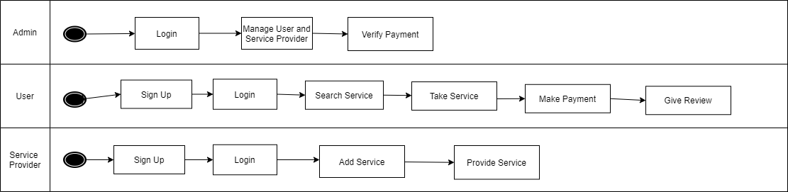
Fig 3.1: Business Process Model

3.2: Functional Requirements

Each and every project are completed with functional requirements as well as we have some functional requirements in our project. We have discussed a lot of things to provide services from our projects and then added some features in this. These features are really useful to the users. We want to develop a mobile app in future. We have admin panel in our project who is assigned for maintain the project.

3.3: Admin Requirements

Admin is the main actor in this project. He is authorized by the system and able to add service, delete service, add user, delete user, add service provider, delete service provider etc. He is nucleus of this project. All authority is given to him.
Admin requirements are.
- Admin needs to login first
- For login admin has to provide a correct email and password
- Admin manages the requirements of the user

3.4: Service Provider Requirements

Service provider will provide the services to the users. So, they need some requirements
- Must have ability to provide service
- Ability to collaborate with his job
- Ability to provide service in time
- Must have maintain relationship with admin and customers

3.5: User Requirements

Users are the persons who will receive services from our web application. They are the main actor in this project. All the facilities are ready for them. The admin and the service provider are ready to make happy to them.
- Must have to provide proper service charge
- Maintain a good relationship with the service provider
- Create a profile proper in the system for taking services
- Must have to follow the rules and regulation of the system

3.6: Technical and Legal Requirement:
The System Should be designed as to ensure that it will work efficiently and without any error that the observation with relevant legislation and to check that they are safe guarded from threads such as virus and hackers.
The requirements are listed below

- Data protection facilities and security data transmission facilities
- Much protection facilities against hacker and cracker and protection against virus
- Protection company or candidate data from hacker

3.7: Hardware Requirements
To run this project internet connection and a pc is needed.

Table 3.1: Hardware requirements
Processor | Intel Pentium/AMD (500 MHZ)
Motherboard | Any
Ram | 1 GB or more
Lan | Any
HDD | 100 GB or more
AGP card | Any
Monitor | Any
Keyboard | Any
Mouse | Any

3.8: Software Requirements

Our web application is developed to needed some types of software and tools.

Table 3.2: Software requirements
Windows operating system | Any version of windows operating system to run this program
Browser | Any

3.9: Use Case Model

A Use Case Model is a model of how different types of users interact with the system for solving a problem in an easy way. As such it describes the goals of the users, the interaction between the users and the system and the required behavior of the system in satisfying the goals. In software and system engineering Use Case is a list of action or events steps typically defining the interaction between the user and the system. The actor can be human or other external system.

Our project is about “Development of Home Service Application”
Use case diagram is given below.

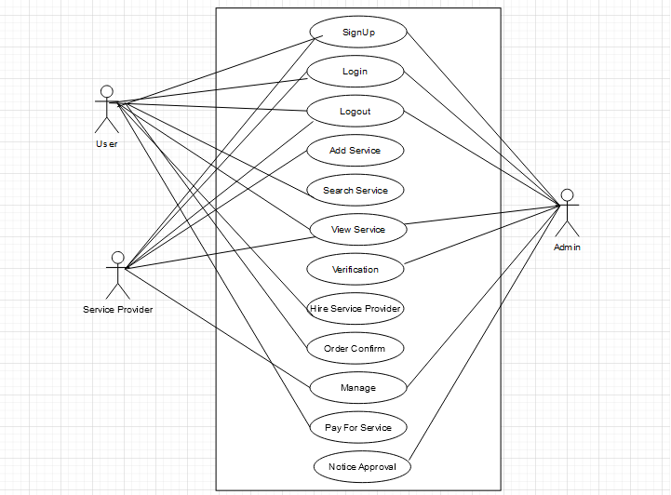
Fig 3.2: Use Case Diagram

3.10: Use Case Description

Table 3.3: Log In
Use Case Id | 1
Use Case Name | Login
Created By | Mehedi Hasan Sobuj
Description | It will permit user; Service provide and Admin to Login in the system
Actor | Admin, Service provider, User
Pre-Condition | Must Have to provide user email and password
Post Condition | User Will able to take service, Order for service

Table 3.4: Add Service

Use Case Id | 2
Use Case Name | Add Service
Created By | Mehedi Hasan Sobuj
Description | Service provider will able to add service
Actor | Service provider
Pre-Condition | Must Have to login by using a valid user email and password of service provider
Post Condition | Service will be added for the users

Table: 3.5: Search Service

Use Case Id | 3
Use Case Name | Search for service
Created By | Mehedi Hasan Sobuj
Description | It will permit user to search for the services
Actor | User
Pre-Condition | None
Post Condition | User Will able to search services and see the available services

Table: 3.6: Hire Service Provider

Use Case Id | 4
Use Case Name | Hire Service Provider
Created By | Mehedi Hasan Sobuj
Description | Through this user is able to hire a service provider for taking services
Actor | User
Pre-Condition | Must Have to login using a valid user’s email and password
Post Condition | User Will able to hire a service provide

Table: 3.7: Order Confirm

Use Case Id | 5
Use Case Name | Order Confirm
Created By | Mehedi Hasan Sobuj
Description | User is able to confirm his order
Actor | User
Pre-Condition | Must Have to login by using a valid user email and password
Post Condition | User has to go for payments if he chose online payment system

Table: 3.8: Pay for service

Use Case Id | 6
Use Case Name | Pay for Service
Created By | Mehedi Hasan Sobuj
Description | User will pay for the services taken by him
Actor | User
Pre-Condition | Must have hire a service provider for service
Post Condition | None

Table: 3.9: Manage

Use Case Id | 7
Use Case Name | Manage
Created By | Mehedi Hasan Sobuj
Description | Admin and service provider manage this system by updating, adding services in this system
Actor | Admin, Service provider
Pre-Condition | Must Have to provide user email and password for login
Post Condition | None

Table: 3.10: Verification

Use Case Id | 8
Use Case Name | Verification
Created By | Mehedi Hasan Sobuj
Description | Admin will verify the service provider and the user
Actor | Admin
Pre-Condition | Must Have to provide user email and password for login and see the service providers
Post Condition | Admin will give service provider approval.

Table: 3.11: Notice Approval

Use Case Id | 9
Use Case Name | Notice Approval
Created By | Mehedi Hasan Sobuj
Description | Admin will approve all the notices given by the got or any
Actor | Admin
Pre-Condition | Must Have to provide user email and password for login
Post Condition | None

3.11: Admin Page Requirements

- Add service, edit and delete
- Add service provider, edit and delete
- Add user, edit and delete
- Manage all notices

CHAPTER 4
DESIGN PARTICULARIZATION

4.1: Front-End Development
Our project is designed user friendly. We use a lot of tools with a view to complete our front-end development. We use
- HTML
- CSS
- JavaScript
- Bootstrap structure
- jQuery

4.2: HTML

HTML stands for Hypertext Markup Language. It’s not a programing language. It’s just a markup language. It gives us the permission to develop the structure of our project. Sections, Headings, Connections are used to stand up the structure in an easy and friendly way. The components of HTML are written and known as tags and measured diagrammatically.

4.3: CSS

CSS stands for Cascading Style Sheet. CSS is a style sheet language used for describing the presentation of a document written in markup language such as HTML. It’s a cornerstone technology of the World Wide Web alongside HTML and JavaScript. We designed CSS to enable the separation of presentation and content, including layouts, colors and fonts. The CSS specifications are maintained by World Wide Web Consortium (W3C). The W3C operates a free CSS validation service for CSS documents.

4.4: JavaScript
JavaScript is the most popular programming language. It is the programming language of web. JS is a lightweight, interpreted or just in time compiled programming language with first class function. JS conforms to the ECMAScript specification. It’s a high-level language. It’s very easy to implement because it is integrated with HTML. It is an open and cross platform. There are many useful JS framework

- Angular
- React
- jQuery
- Vue.js
- Meteor
- Polymer

4.5 HTTP

Hypertext transfer protocol is an application layer protocol for distributed, collaborative, hypermedia information system. HTTP is the foundation of data communication for the World Wide Web, where hypertext documents include hyperlinks to other resources that the user can easily access. It is a generic, stateless protocol which can be used for many tasks beyond its use for hypertext, such as name servers and distributed object management system, through extension of its request method, error code and headers. A feature of HTTP is the typing and negotiation of data representation allowing system to be built independently of the data being transferred.
Some HTTP methods are

- GET
- POST
- PUT
- HEAD
- DELETE
- PATCH
- OPTIONS

CHAPTER 5
IMPLEMENTATION AND TESTING

5.1: Implementation

Implementation is the scientific study of barriers to and methods of promoting the system application of research finding in practice, including in public policy. Implementation research is the afford to understand the pathway from scientific findings to practical benefits.
Different stages and process of implementation are

- Entity Relationship Diagram
- Data flow Diagram

5.2: Entity Relationship Diagram

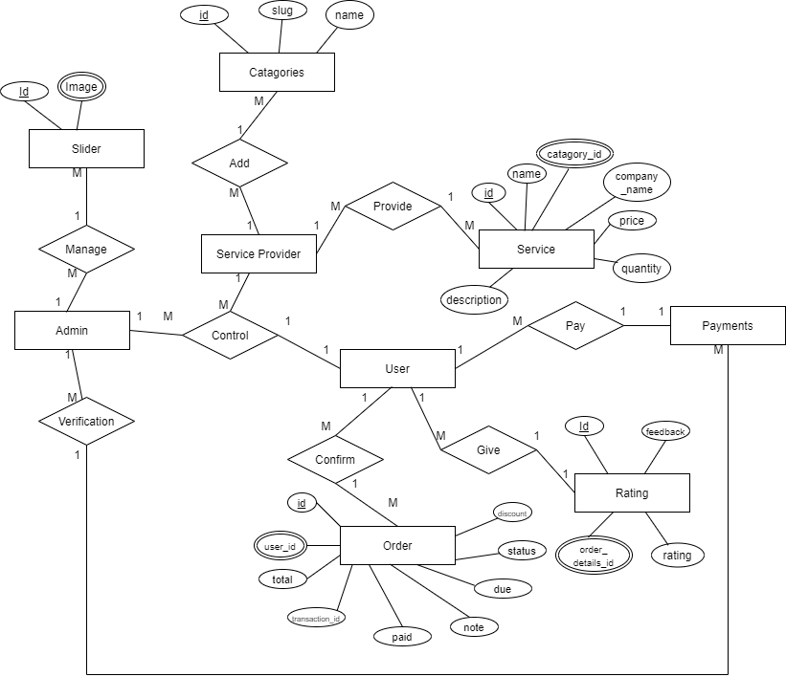
Fig 5.1: Entity Relationship Diagram

5.3: Data Flow Diagram-Level 0:

A DFD level 0 also known as Context diagram which shows a data system as a whole and emphasizes the way it interacts with internal entities
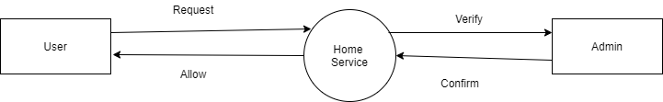
Fig 5.2: Data Flow Diagram Level 0

5.4: Data Flow Diagram-Level 1:
A level 1 Data Flow Diagram is more detailed than level 0 Data Flow Diagram but not as detailed as level 2 Data Flow Diagram. It breaks the main process into the subprocesses that can then be analyzed and improve on a more intimate level.

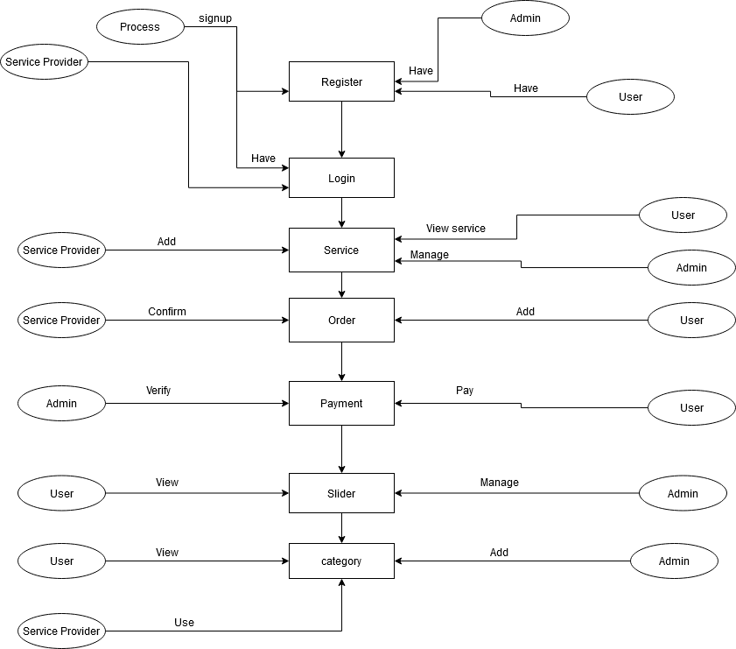
Fig 5.3: Data Flow Diagram Level 1

5.5: Implementation of Front-end Design:
Improvement of the user side of WA is called front-end advancement and front-end itself is then comprehended as each substance user can see and can connect with the system. It is commonly a mix of Hypertext Markup Language, Cascading Style Sheet and JavaScript. Every one of these dialects is deciphered and controlled by an internet browser bringing about a website page interface user can cooperate with. Set of all accessible pages is called site.

5.6: Project Interfaces

Home Page:
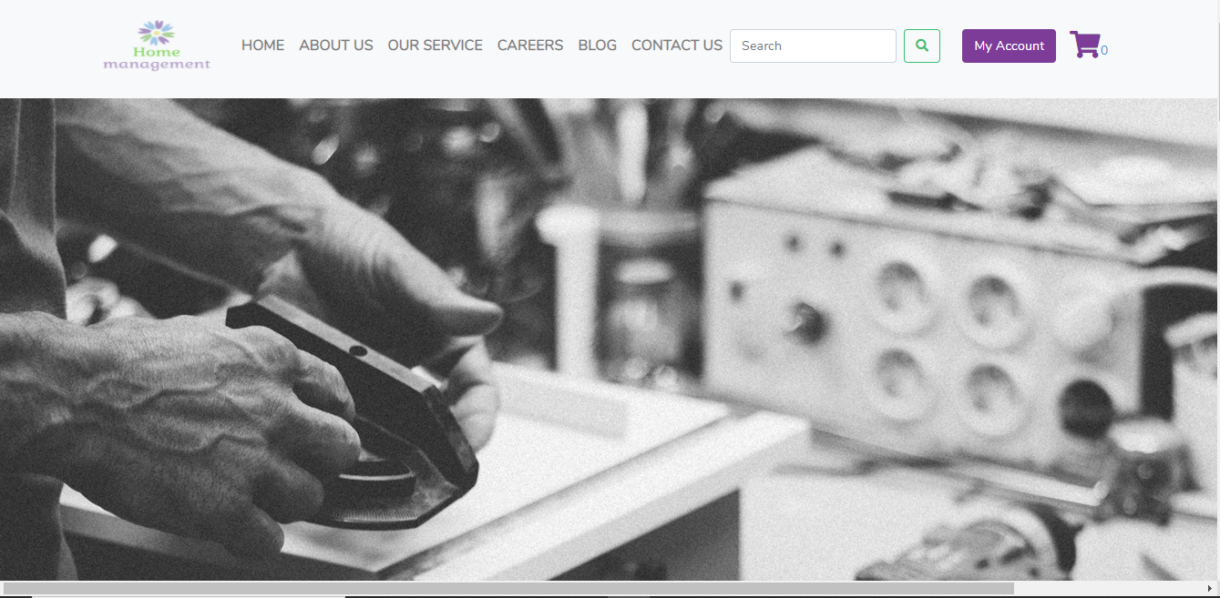
Fig 5.4: Home Page of the system
Output: This is the output of our Web Application

Login:
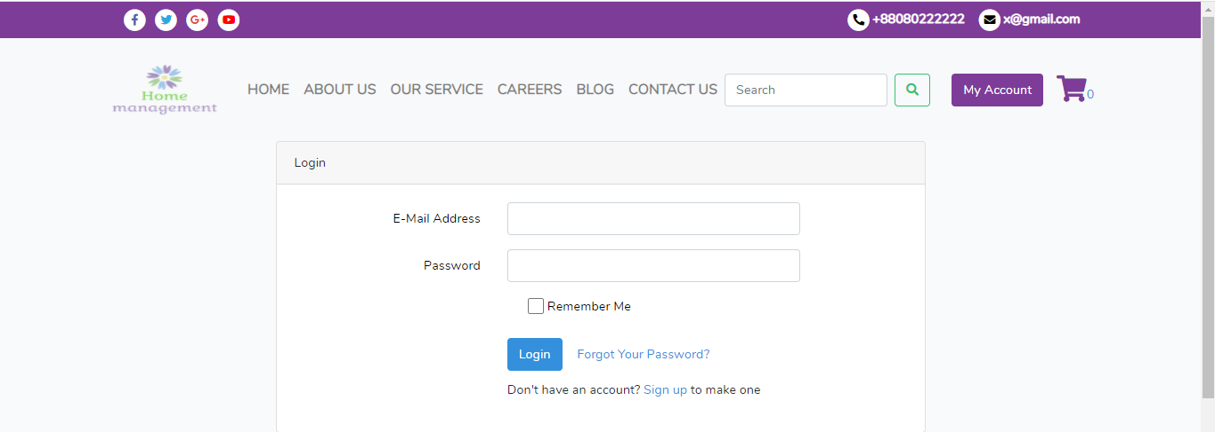

Fig 5.5: Login Page of the system

Output: This is the Login Page of our Web Application

Seller Registration:

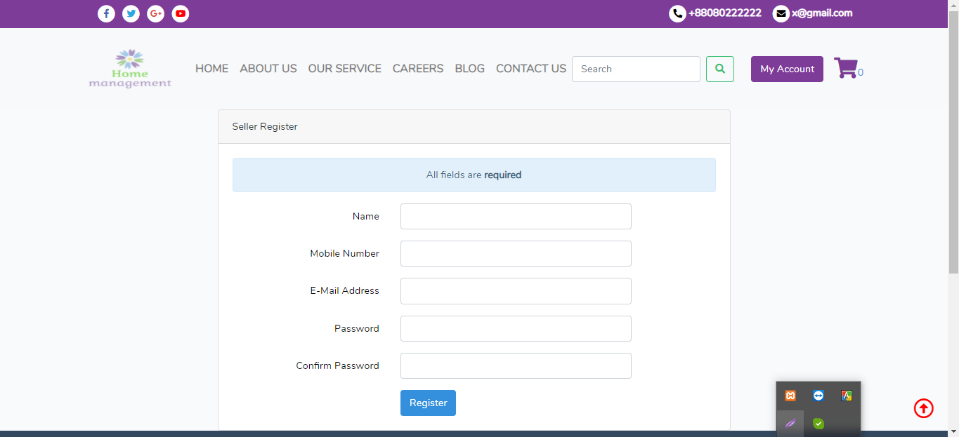
Fig 5.6: Seller Registration Page of the system

Output: Seller Will make registration from here

User Registration:
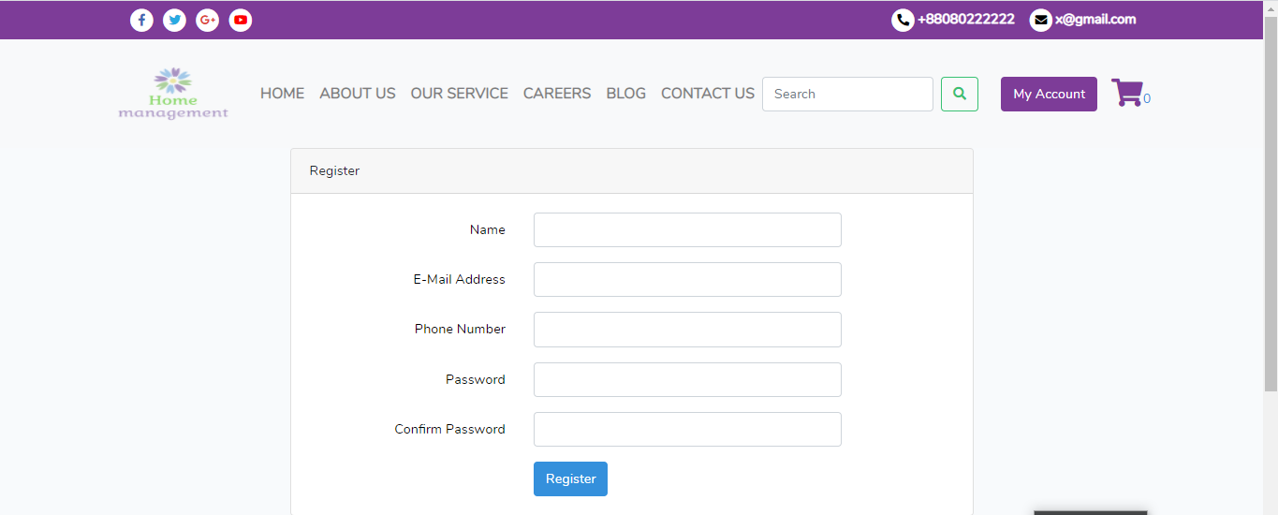

Fig 5.7: User Registration Page of the system

Output: User Will make registration from here

Take Service:

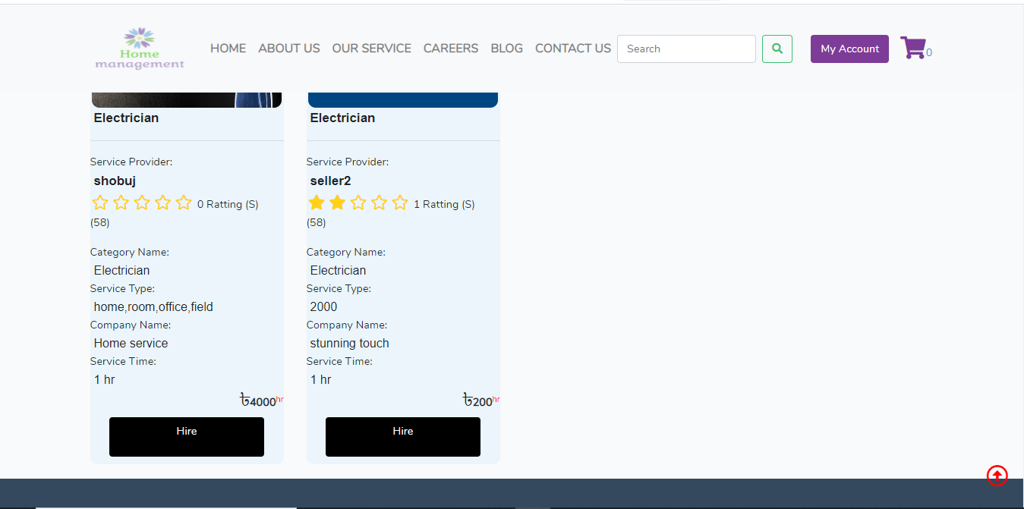
Fig:5.8: Service Taking System By hiring a Service Provider

Output: User is hiring a service provider

Add to Cart:

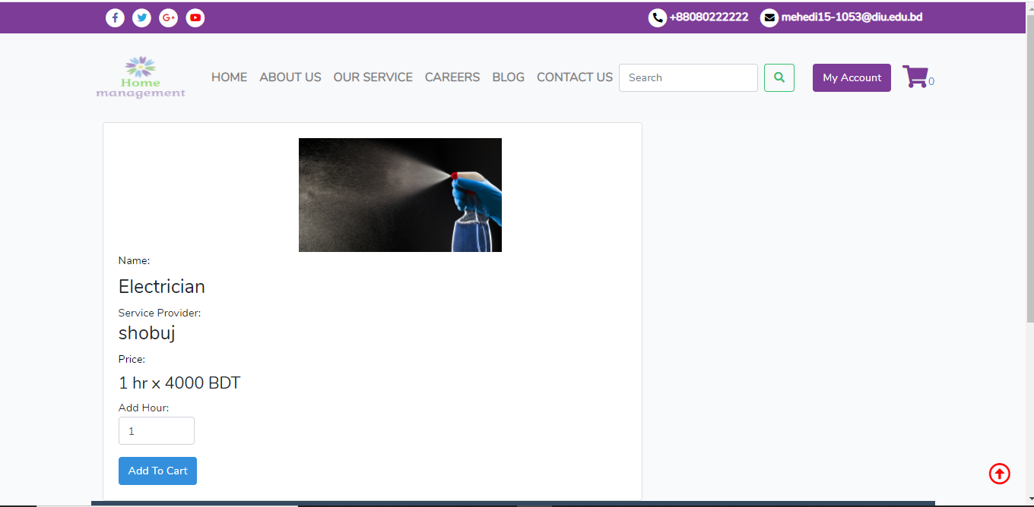
Fig 5.9: Add to Cart System

Order Proceed:

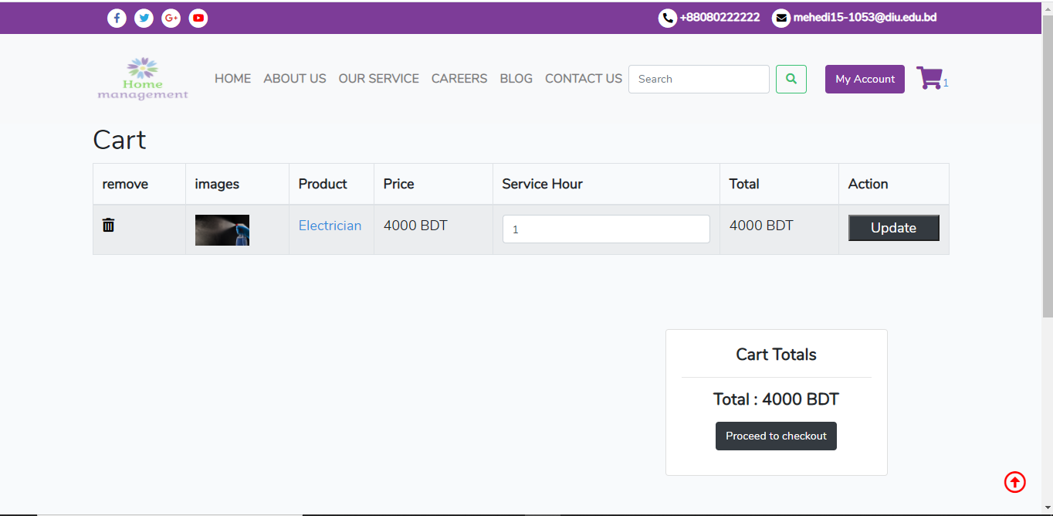
Fig 5.10: Proceed for the checkout
Output: User will proceed the order and go for payment

Order Details and Address:

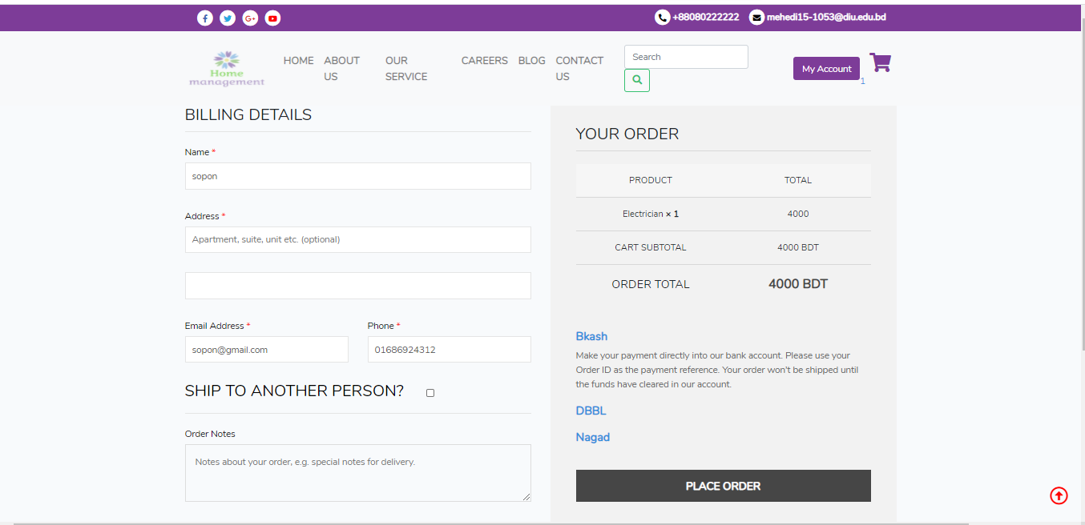
Fig 5.11: Order details

Output: User will provide his address for the shipment of services

Payment:

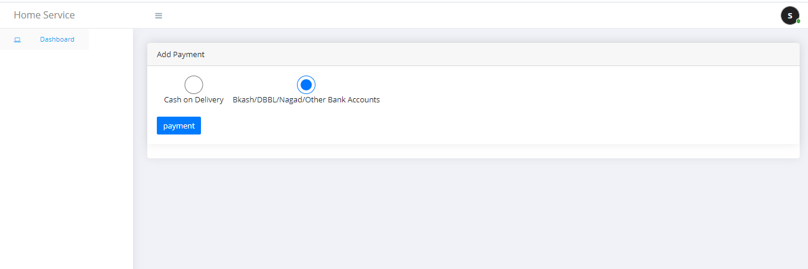
Fig 5.12: Payment for the user to receive a service

Output: User will choose payment system for the service

Gateway Payment System:
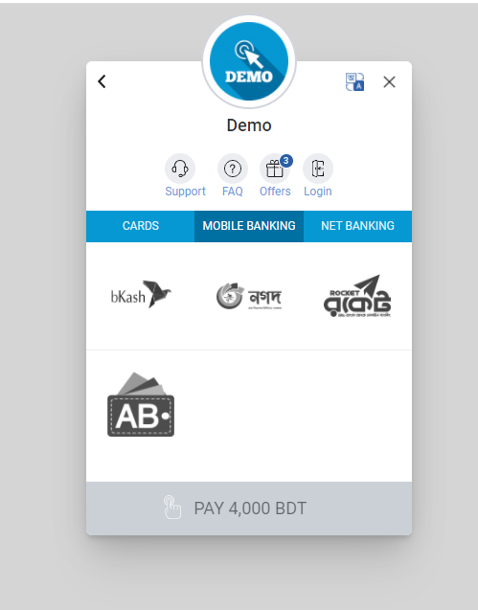 Fig5.13: Gateway Payment System for the user

OTP for BKash Payments:
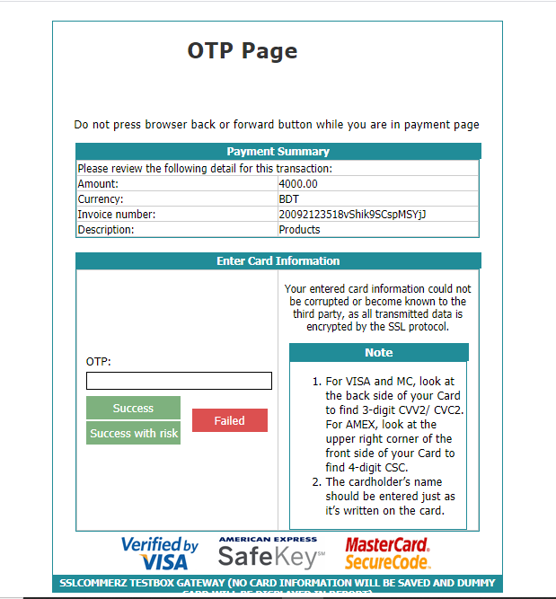
Fig 5.14: OTP for the Bkash payment system

Payment confirmation:

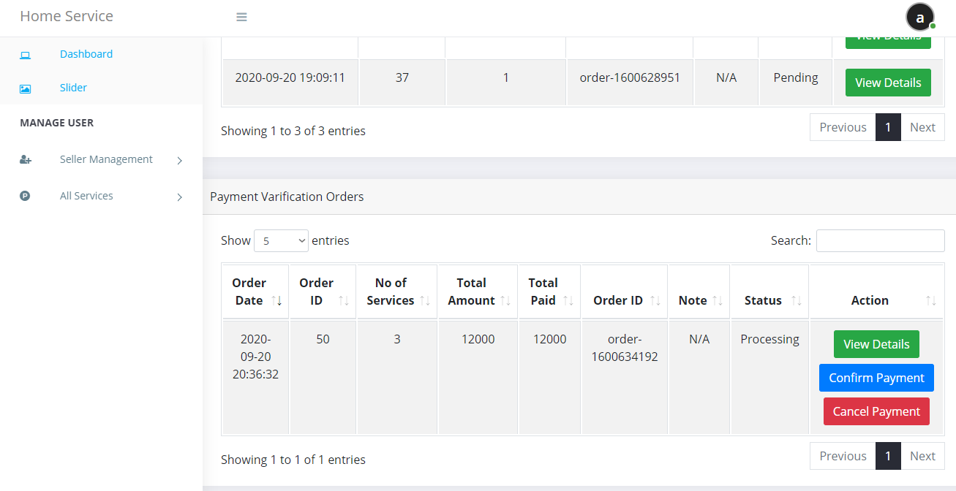
Fig 5.15: Payment confirm by admin

Output: Admin will confirm the payments

Order Confirm by Service provider:

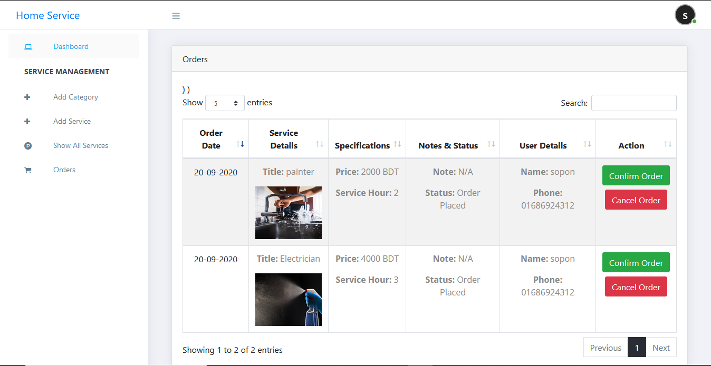
Fig 5.16: Order Confirm by Service provider

Service shipped by service provider:
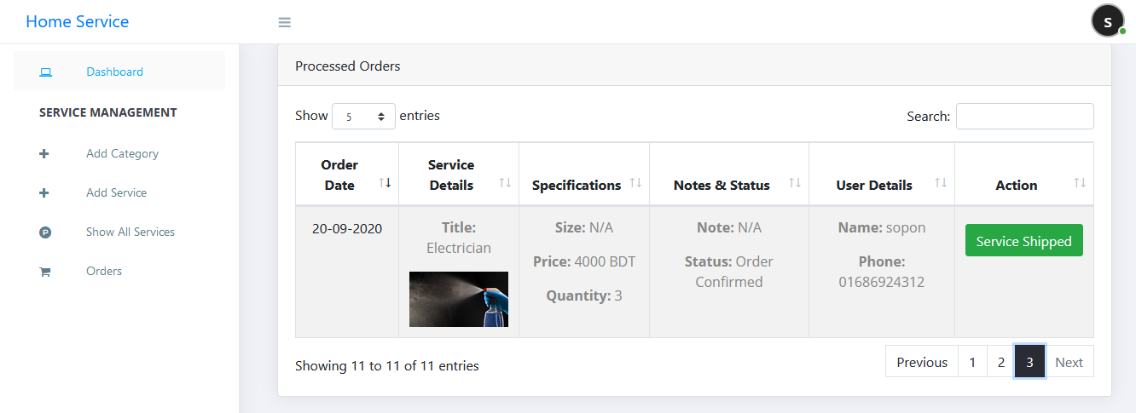
Fig 5.17: Service shipped by service provider

User Review System:
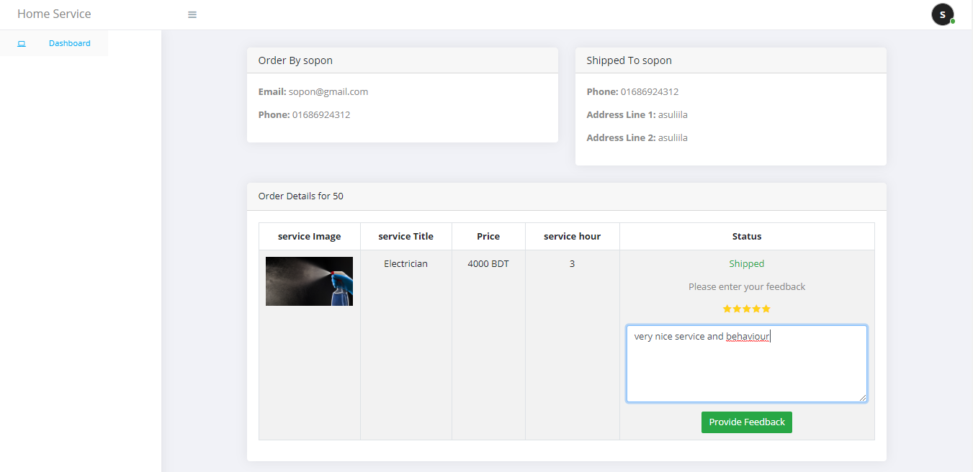
Fig 5.18: User Review System

Output: User will able to provide review to the service provider

Home Rent Service:

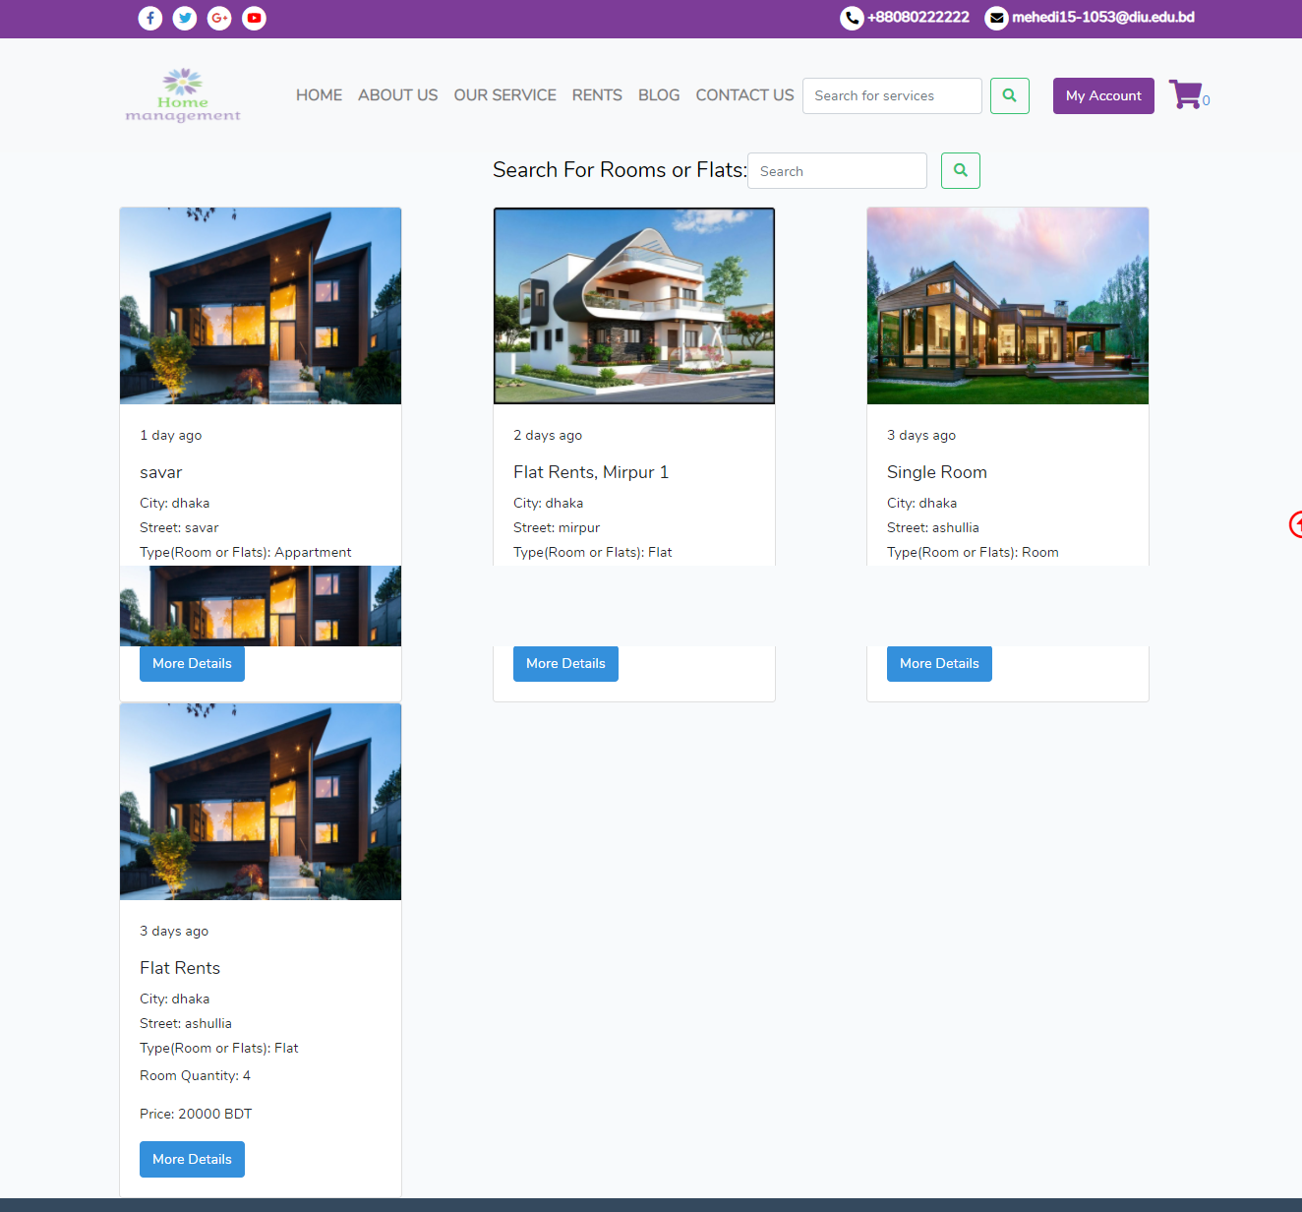
Fig 5.19: Home Rent Service

Output: Home Rent Service for the user

Home Details:
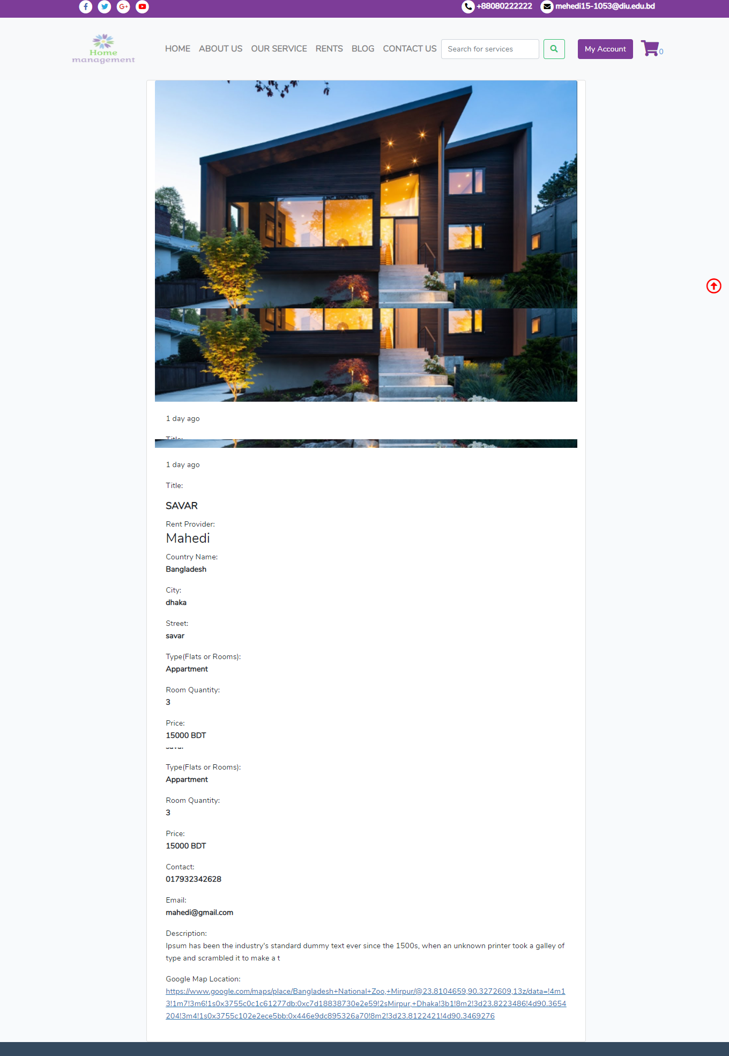
Fig 5.20: Details of a Home

Output: Flat or Home details

5.7: Implementation on Interaction:
Programming structure made as nowadays are winding up increasingly extreme, by and by and tremendous they tend to forsake the shopper to deal with the fluctuated idea of the system alone. Actualizing the service bundle style into the code and type style is that the most significant a piece of the service bundle. These can be the occasion for some portion of the apparatus. During the part codes are composed and fundamental needs are collected to make the service bundle. There is a major interest for systems with singular setting sensitive encourage.
The project is completed with Laravel with other technologies like HTML, CSS, JS etc. For ensuring the usage and other technology feature assurance white box testing and also black box testing.

5.8: Main System Testing
Being the landing page of the readying entry was tried for acceptable network to the information. Inappropriate suggested linkage to the information was instantly corrected and confirmation was created to visualize that information was created enough recovered and exhibited while not mistakes.

5.9: Database Testing
Database testing was irritated tested for network and capability. The check began with the setup organize, wherever activities were warranted that the proper info illustration was created.

5.10: Test Result and Reports

The standard of the framework was awfully near the required outcome. Throughout this structure, the advancement was drained modules. Each module was dead severally and tried. Extraordinarily prepare involves troubleshooting, that was done and every one blunder settled. The total framework was coordinated by connation each module to figure with the principle framework. At the end of the mixture the total framework was tried and confirmed OK.

CHAPTER 6
IMPACT ON SOCIETY, ENVIRONMENT AND SUSTAINABILITY

6.1: Impact on Society
Our project is a web application so it can be a platform for the service provider. So, the unemployment can be reduced. The service provider will get a job and can support their family. Once again, the user will be lazy as they can get all the services sitting on their home. So, it has a great impact on our health. Actually, two types of impact are available but we have to choose good things for our betterness.
6.2: Impact on Environment
We are working with a web application that’s why we don’t need to use our environment. We can serve the people from our home. All activities will be applicable through online and virtually. The users are able to use this sitting on home by using a computer or mobile phone also. We don’t want to destroy our environment and environment is very essential for the living lives. We provide services through online and the service provider who will go your home for providing the service will be very much neat and clean and well dressed up also. They will really obey the rules and regulation also for save our environment. So, we are thinking that it will not damage our environment. Also, we will maintain all requirements for saving our environment.
6.3: Ethical Aspects
We have developed our application for the betterness of our user and our society. We maintain all the requirements of ethical rules. We never break any rules and regulation to continue this project which will make an effect on our society or country. We are ethically legal and all the data provided by the user and the service provider will be kept save. Only the user and the service provider will be able to edit their profile that’s why there is no possibility of break out the information about a user or a service provider. We are hoping that we are able to continue this for reaching our goal.

6.4: Sustainability plan
Our have a big future plan with our project. We will add most important features in future.
1. Custom home design (Inside & Outside)
2. Calculate Raw materials to build a home
3. Maid Service/Hourly Help (Dish wash, cloth wash)
4. Build Android & ISO App

CHAPTER 7
CONCLUSION AND FUTURE WORKS

7.1: Conclusion
We are living in the modern era and cope up with technology. As our project is a web-based application and mobile phone and computer is like friends now. So, users are able to use this whenever he wants. We want to provide a better service so that we can minimize sufferings of the users. Hope we will be successful and can reach our goal.

7.2: Future Works

- Custom home design (Inside & Outside)
- Calculate Raw material to build a home
- Cost to create home
- Maid Service/Hourly Help (Dish wash, Cloth wash)
- Build Android & ISO Application

7.3: References
- https://amarsheba.com/ (Service application for BD)
- https://www.handy.com/ ( Home Service application for USA)
- https://www.sheba.xyz/ ( Service Application for BD)
- https://www.drooto.com.bd/ (Home Appliance repair service in BD)

