An Intelligent In-Vehicle Smart Driving aid on Real-world Driver Performance
By
Anik Datta
162-15-1051

Shakilur Rahman Shuvo
162-15-1040

Mehedi Hasan Bhuiya
162-15-1058

Prithweeraj Halder
162-15-7939

This Report Presented in Partial Fulfillment of the Requirements for the Degree of Bachelor of Science in Computer Science and Engineering

Supervised By
Md. Mahfujur Rahman
Lecturer
Department of CSE
Daffodil International University

Co-Supervised By
Dr. S M Aminul Haque
Associate Professor & Associate Head
Department of CSE
Daffodil International University


Daffodil International University
DHAKA, BANGLADESH
12 JULY, 2020
APPROVAL

This Project/internship titled ‘’ An Intelligent In-Vehicle Smart Driving aid on Real-world Driver Performance’’, submitted by Anik Datta, ID No: 162-15-1051, Shakilur Rahman Shuvo, ID NO:162-15-1040, Prithweeraj Halder, ID NO:162-15-7939 and Mehedi Hasan Bhuiya, ID NO:162-15-1058 to the Department of Computer Science and Engineering, Daffodil International University has been accepted as satisfactory for the partial fulfillment of the requirements for the degree of Bachelor of Science in Computer Science and Engineering and approved as to its style and contents. The presentation was held on 12 July, 2020.

BOARD OF EXAMINERS

_____________________
Dr. Syed Akhter Hossain Chairman
Professor and Head
Department of Computer Science and Engineering
Faculty of Science & Information Technology
Daffodil International University

_____________________
Dr. S M Aminul Haque Internal Examiner
Associate Professor & Associate Head
Department of Computer Science and Engineering
Faculty of Science & Information Technology
Daffodil International University

_____________________
Mr. Ohidujjaman Internal Examiner
Lecturer(Senior Scale)
Department of Computer Science and Engineering
Faculty of Science & Information Technology
Daffodil International University

_____________________
Dr. Mohammad Shorif Uddin External Examiner
Professor
Department of Computer Science and Engineering
Jahangirnagar University
DECLARATION

We hereby declare that this project has been done via us under the supervision of Md. Mahfujur Rahman, Lecturer, Department of CSE Daffodil International University. We additionally declare that neither this project nor any phase of this project has been submitted somewhere else for award of any degree or diploma.
.
Supervised by:
Md. Mahfujur Rahman
Lecturer
Department of CSE, Daffodil International University

Co-Supervised By
Dr. S M Aminul Haque
Associate Professor & Associate Head
Department of CSE, Daffodil International University

Submitted by:

Anik Datta
162-15-1051
Department of CSE, Daffodil International University

Shakilur Rahman Shuvo
162-15-1040
Department of CSE, Daffodil International University

Mehedi Hasan Bhuiya
162-15-1058
Department of CSE, Daffodil International University

Prithweeraj Halder
162-15-7939
Department of CSE, Daffodil International University

ACKNOWLEDGEMENT

First, we express our heartiest thanks and gratefulness to almighty God for His divine blessing makes us possible to complete the final year project/internship successfully.

We are very much thankful to our advisor Md. Mahfujur Rahman, Lecturer, Department of CSE, Daffodil International University who guided us nicely to do this work. His patience and mentality always give us a spirit of how can we complete this work. He provides all types of resources related to this. So, we can get the actual theme to fulfill our work. We also give thanks to our Co- advisor Dr. S M Aminul Haque Associate Professor & Associate Head, Department of CSE, Daffodil International University who always suggest us about our research. Also he guides us nicely for doing research-oriented work.

We would like to express our heartiest gratitude to Dr. Sayed Akther Hossain, Professor and Head, Department of CSE, Daffodil International University for his kind help to finish our project and also to other faculty members and the staff of CSE department of Daffodil International University.

We would like to special thanks to our team members who always cooperate with this work. Finally, we thank our family for their guidance and give us support to complete this work.

ABSTRACT

In the present world, most of the cities have intelligent transport and traffic systems. The current trend of drivers violating traffic laws and driving at high speeds can be noticed due to which road accidents are constantly happening and cars and people are being harmed.. This proposed system helps the driver to obey traffic rules and regulations. Today most of the automobiles have an on board automotive driver assistance gadget aiming to alert drivers about riding environments. In this report we want to talk about this kind of system, when the driver drives the vehicle, this system detects the road side sign and also detects humans, other vehicles etc. Depending on detection, it passes through the notification to the driver. If suddenly the vehicle is in an accident then this device through the notification of the nearest hospital and police station depends on location tracking technology.

TABLE OF CONTENTS

CONTENTS:
Board of examiners
Declaration
Acknowledgements
Abstract

CHAPTER
CHAPTER 1: INTRODUCTION
1.1 Introduction
1.2 Motivation
1.3 Rationale of The Study
1.4 Research Questions
1.5 Expected Outcome
1.6 Report layout
CHAPTER 2: BACKGROUND
2.1 Introduction
2.2 Related Works
2.3 Research Summary
2.4 Methodology
2.5 Scope of the Problem
2.6 Challenges
CHAPTER 3: Requirement analysis
3.1 Introduction
3.2 Architecture of Proposed System
3.3 Flowchart
3.4 Data Flow Diagram for the Proposed System
3.5 Use case Diagram
3.6 use case description
3.7 Collect Data
3.8 Calculating stopping distance
CHAPTER 4: Algorithm and result
4.1 Algorithms
4.2 Training procedure
4.3 Outcomes

CHAPTER 5: Conclusion
5.1 Conclusion
5.2 Future work
5.3 Reference
CHAPTER 1

Introduction

1.1 Introduction

The number of vehicles in today's world is increasing day by day. The road accident is rising day by day, particularly in urban areas. Every moment, it took a lot of lives. No equipment has been invented to prevent an incident. We don't even know when, when an incident happens in our lives. Much of the time, the life of the victim rests on the mercy of others. Often, people don't want to get involved in some sort of criminal case by supporting the victim. Often people don't have enough time to help the victim. There are so many reasons that people don't want or can't help the victim. In the meantime, the perpetrator has taken his last breath. Since the patient is unable to reach the hospital on time. Much of the time, the victims 'house people don't know the news at the same time. Tracing the location of the accident in the metropolitan area isn't easy. We’re working to fix this whole difficult situation
.
We are now working on an automated accident detection and rescue system using Machine Learning, which will be alerted on time by the related persons. The closest police station and traffic control system are both alerted on the occurrence of the incident in real time. Nearest ambulance also notifies where the accident occurred via the internet. Without further consideration, we will guarantee that the victim arrives at the hospital on time.

1.2 Motivation

A lot of people die every year in road accidents. The worth of human life is nothing to be associated with. Our motto is "No more lives in road accidents". We should use technology to change our lifestyle. Our world is evolving day by day, we will have to collectively use technology to find a solution to this situation. In this project we use Machine Learning to ensure that the victim's lives are saved.

1.3 Rationale of the study

Bangladesh has crossed over from the least developed countries (LDCs) to meet all three criteria and to be accepted economically and socially as developing countries. The country is thriving through information and communication technology (ICT). Government and personal organizations are gradually developing fashionable technologies such as industrial automation. In addition to business and technological development, our style is also developing. In every aspect of our life, we have a tendency to participate in fashionable technologies for a sensible and convenient life.

We will contribute to the continued growth of our education system by using smart accident detection in our vehicles. In fact, the most critical city traffic jam issue will be reduced along with other specific issues for all people in the world. The goal of this study is to make the accident detection system smarter and to provide a solution to loss of valuable life.

1.4 Research questions

For our country, road accidents are vital structures. Public health is also a significant part of our national concern. Most people don't know the precise place and time when an incident happens. Victim survival also relies on some kind of compassion. Every year about 1.3 million people die for road accidents. Around 2400 people died in road accidents in Bangladesh last year (2019).Sometimes ambulances can not reach the accident spot , that's why victims can not reach the hospital in time. So victims died on the accident spot for not reaching the ambulance on time.
The driver who drives an ambulance is the most significant stakeholder in this scheme. Driver must know exactly where the accident spot is situated. The use of a smartphone makes driving through the location more user-friendly.

1.5 Expected Outcome

1. Control on over-speeding
2. Do not allow the driver to disobey the traffic law.
3. Send vehicles location and accident notification to nearest hospital and police station.
4. Alarm on any kind of traffic violence
5. User information about vehicles and drivers.
6. Inform police station with location when driver breaks traffic rules

1.6 Report Layout

This study consists of five chapters, and this part will provide all five chapters:

1. In chapter one, there is an introduction, motivation, the rationale of the study, research questions, and expected outcome of the study.

2. In chapter two, it describes some topics like related work, research summary, the scope of the problem, and challenges.

3. In chapter three, the requirements analysis is built with the proposed system, flowchart, data flow diagram, use case diagram, and description, collect data, calculate distance.

4. In chapter four, describes some algorithms like Faster R-CNN, YOLO, CNN, Mask R-CNN and why we use Faster R-CNN

5. Lastly, chapter five fulfills the study with a conclusion, references, and future study.
CHAPTER 2

Background

2.1 Introduction

We are living in modern society, our lives are involved in the internet from computer to computer or a mobile phone. In the demand of modern civilization, we are all connecting more things to the internet. This kind of concept is called the internet of things.
In the modern era humans are connecting with another human using modern technology.
The IOT introduced machine to machine communication. On the internet one machine contacts another machine, not direct human involvement through the internet.
Nowadays all of the things in our life are going to be modern. Our daily necessity factors are going to modern.so if everything are modern why we are not using any kind of modern vehicles. So, our study aims to develop An Intelligent In-Vehicle Smart Driving aid on Real-world Driver Performance.
.

2.2 Related work

Currently there is a lot of research on object detection, some of which have been very useful in our research. Such as pedestrian detection, vehicle detection, traffic sign detection, speed detection, vehicle number plate detection, etc. have been studied.
In Velibor Ilić’s paper they have tried to analyze the road traffic from real time video by five object classes using YOLO algorithm but five object classes are not enough to analyze the road traffic properly.
Research on Vision-based Intelligent Vehicle Safety Inspection and Visual Surveillance in this research paper proposed a system that can recognize the license plate accurately. But if any car is at high speed then it is a problem to detect doubtable objects.
D.M. Gavrila’s research paper presents the structure based object detection based totally on distance transforms. The method makes use of a template hierarchy to capture the range of object shapes. They present experimental effects on the real-time detection of traffic signs/lights and pedestrians from a transferring vehicle.If there is a pillar or tree in front of the proposed gadget during object detection, it faces concern to locate the object.
Hakil’s research paper introduced a novel lightweight CNN(Convolutional neural Network) which is competent for road object detection for both smaller and larger objects. The limitations of lightweight CNN is it's representative power is small. For this reason variance of data becomes more diverse.
In this study they used the Mask r-cnn for computer vision which does not perform much better than Faster r-cnn.
2.3 Research summary

In our study we are intended to find an easy solution of An Intelligent In-Vehicle Smart Driving aid on Real-world Driver Performance. We all know the economical and other conditions in our country. Our country is not very rich. So, it is not possible to replace all the vehicles into smart vehicles because it will be costly. For the internet connection, we use a Wi-Fi module. We will use GPS sensors for getting the current location of vehicles.

2.4 Methodology

In this paper, we are proposed a device that will collect speed limits from various traffic signs, if our vehicle speed are out of limit then our device give a alarm to the driver to reduce the speed, and wait few second .If after a few seconds the speed of vehicle does not decrease then our system will take full control of the vehicle and reduce the speed of vehicle. The device collects information by detecting signs using the front camera. We also proposed that, Our system will help the driver to obey the traffic rules. Our device collects information from various traffic sign around the road using the front camera, and notify the driver to abide by the traffic rules as per the information.

In this paper we describe our proposed system to detect all traffic signs and rules and control the vehicle in necessary situations. Unfortunately if an accident occurs then our device will send a notification SMS to the nearest hospital and police station. Our system sends SMS with GPS location. We also proposed that our device have information about vehicles and drivers. In this paper, we proposed that our device follow all traffic rules and if the driver breaks traffic rules continuously, then our device sends SMS on the nearest police station with location by GPS tracker. All the system control by microcontroller.

It is difficult to follow all traffic rules in Dhaka city. It is also difficult to maintain all system in this country.

2.5 Scope of problem

We are developing a device that is useful for people in modern life. This device helps to save human life. It reduces the risk of the victim's life after an accident.
Less waiting time:
If the victim does not use this device, after an accident the victim does not know when ambulances are coming. If a victim uses this device he knows ambulances are coming, because this device automatically informs the ambulance.

Easy to track:

The ambulance and police can easily track the accident spot using a GPS sensor.
Help to following rules:
Our device helps drivers to follow the traffic rules.
Low cost:
Normally, our project costs are lower than other systems.

2.6 Challenges

Data store in server:
For this kind of system, we need a huge amount of data to store in the database. This is most challenging to collect data for this system.

Poor network:
Network service is very poor in our country. There is a problem with getting a network in every place. It is not possible to find a network everywhere.

Unpredictable traffic jam:
We face a lot of traffic jams in our country. When accidents occur, the ambulance cannot reach the place timely for this kind of traffic jam.

Expired vehicles:
Most of the vehicles in our country are very old. We will not be able to use our device in the case of expired and outdated vehicles.

Irresponsible driver and pedestrian:
Most of the road accidents in our country are due to the unconsciousness of drivers and pedestrians. Just as drivers disobey traffic laws and drives as they please, pedestrians also cross the road without seeing the traffic signals.

Damaged traffic lights:
Most of the traffic lights in our country give wrong traffic signals or are damaged.

Breaking traffic laws:
Not properly enforcing road laws and traffic laws are also a Challenge.

CHAPTER 3

Requirements analysis

3.1 Introduction

Here we talk about requirement analysis. First we made a basic architecture of our system and divided the system into different segments. For each segment we made different requirement analysis. In this chapter we write our requirements analysis here.

3.2 Architecture of Proposed System

We can divide our proposed system into two parts one is before the accident and the other is after the accident.

3.2.1 Pre accident program

In pre-accident programs, cameras and sensors mounted on the front of our vehicle will give an idea of the situation around the vehicle, such as what the traffic sign is in front and what the object is in front and the distance from the object to the vehicle. That information will be transmitted to our microcontroller. Our device will help the driver to drive according to that environment and be aware of the environment.

3.2.2 Post accident program

In post-accident programs In the event of an accident, the sensors mounted in front of the vehicle will identify the accident and send the location of the accident to the database and the database will be sent via SMS to the nearest police station and hospital for help.
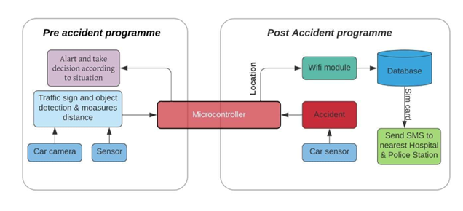Fig3.1: Architecture of Proposed System

3.3 Flowchart

Our device will be turned on as soon as the driver first starts the car and from then on our device will start. Our device will start detecting objects and traffic signs as soon as it is turned on and the next step will be to measure the distance car and object. In the next step, our device will constantly calculate whether there is a possibility of an accident and will alert the driver if there is a possibility of an accident.If there is a possibility of an accident, it will check if the car is moving at excessive speed and if it is moving at excessive speed, it will immediately alert the driver and then it will reduce the excessive speed of the vehicle.And if the car is not moving at excessive speed then our TV will see if there is any traffic signal in front and will warn the driver to drive according to that signal for one minute. Even then, if the driver drives in violation of the traffic law, our device will take full control of the vehicle and drive the car according to the traffic law or force the driver.And in case of an unfortunate accident, our device will send the location in the database where the accident took place and the nearest police station and hospital will be called for help from the database.
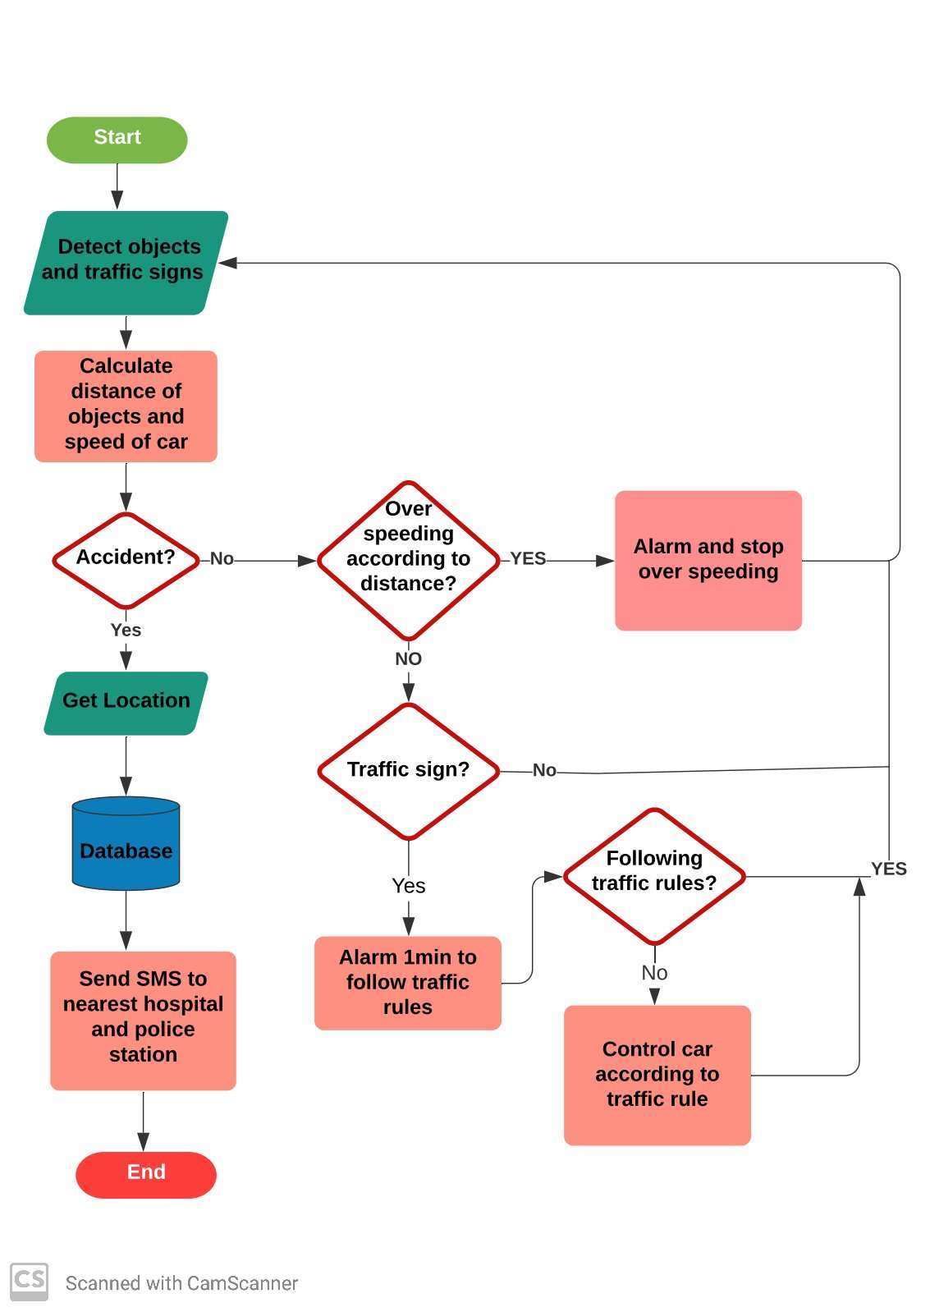

Fig3.2: Flowchart of Proposed System

3.4 Data Flow Diagram for the Proposed System

In this figure shows the data flow diagram. First one driver start car, and while running car, system check traffic sign and other object ,helps driver to take decision and police station and hospital get notification about accident and only police station get notification about breaking traffic rules.
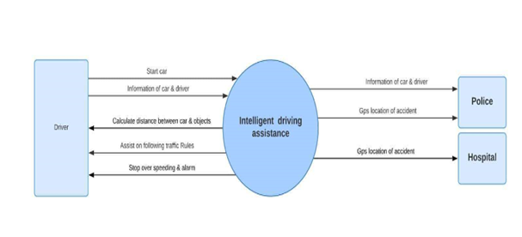
Fig3.3: Data Flow Diagram

3.5 Use case Diagram

In the figure showing the use case diagram. Here driver drive the car, recognize the traffic sign and checking over speeding .police station and hospital get the message of any violence situation

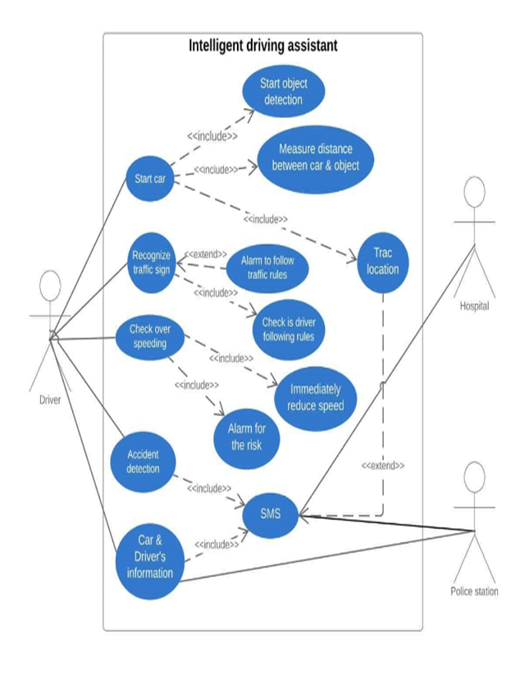
Fig3.4: Use Case Diagram

3.6 Use case description

Use case description for accident detection

Use case name | Accident detection
Trigger | Accident is occurred
Pre-condition | The whole system are active
Basic path | Accident detection system send data to microcontroller
Post condition | Microcontroller sends massage to the server.
Exception path | Fails to update

Follow traffic rules

Use case name | Following the traffic rules
Trigger | Set front camera on vehicle
Pre-condition | Front cameras detect signs properly.
Basic path | Front camera send data to microcontroller
Post condition | Microcontroller take decision depend on receive data

Sending update to the server
Use case name | Sending update to the server
Trigger | When the place of accident change
Pre-condition | Vehicle are connected to server
Basic path | Microcontroller process the data and send it to server
Post condition | Update successfully
Exception path | Fails to update

Show accident place

Use case name | Show accident place on map
Trigger | Device are connected to server
Pre-condition | GPS sensor must be turn on
Basic path | GPS sensor send location to the server
Post condition | Server show the accident place

3.7 Data Collection

1. Collect from google: we collect images for our dataset from google. Here are a lot of images. We collected our expected image .
2.Taking photo: we collect our findable image by clicking photographs.

3.8 Calculating Stopping Distance

Stopping distance = braking distance + reaction distance
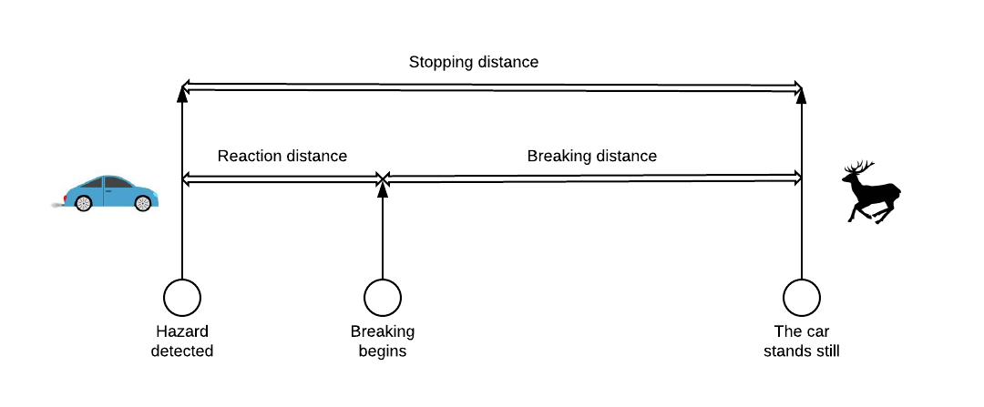
Fig3.5: Stopping distance

Reaction distance:

]Reaction time normally is 0.55–2.1 seconds. We should consider 0.5s or 1s as reaction time.

Calculating reaction distance:

Formula: d = (s * r) / 3.6
d = reaction distance (m)
s = speed (km/h)
r = response time (s)
3.6 = constant (km/h to m/s).

Braking distance:

Formula: d = s**2 / (250 * f)
d = braking distance (m)
s = speed (km/h)
250 = constant.
f = coefficient of friction.
0.7 on dry asphalt and 0.1 on ice and 0.4 for moist roads.

Stopping distance
Stopping distance under dry conditions where response time is 1sec and coefficient of friction is 0.7.

Speed (km/h) | Reaction distance (m) | Braking distance (m) | Total stopping distance (m)
20 | 5.56 | 2.29 | 7.85
40 | 11.11 | 9.14 | 20.25
60 | 16.67 | 20.58 | 37.25
80 | 22.22 | 36.58 | 58.80
100 | 27.78 | 57.14 | 84.92
120 | 33.33 | 82.29 | 115.62

Table 3.1: Stopping distance under dry conditions

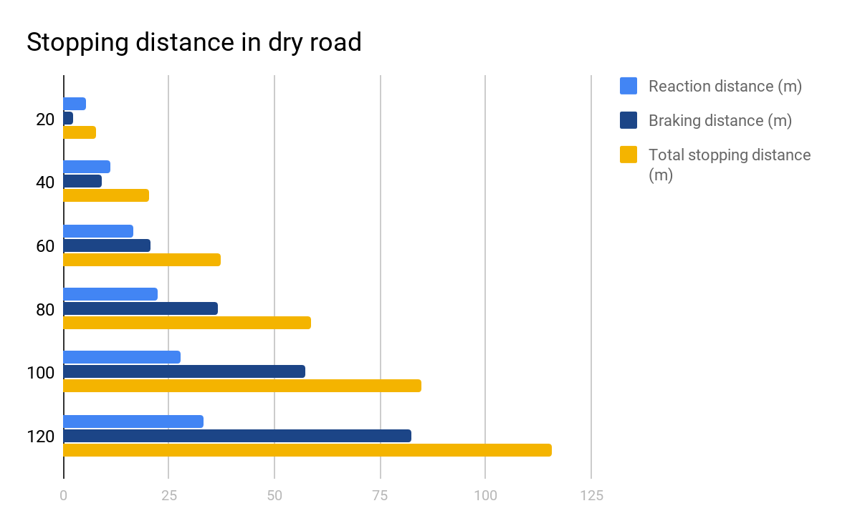

Bar Chart 3.1: Stopping distance under dry conditions

Speed (km/h) | Reaction distance (m) | Braking distance (m) | Total stopping distance (m)
20 | 5.56 | 4.0 | 9.56
40 | 11.11 | 16.0 | 17.11
60 | 16.67 | 36.0 | 52.67
80 | 22.22 | 64.0 | 86.22
100 | 27.78 | 100.0 | 127.78
120 | 33.33 | 144.0 | 177.33

Table 3.2: Stopping distance under wet conditions

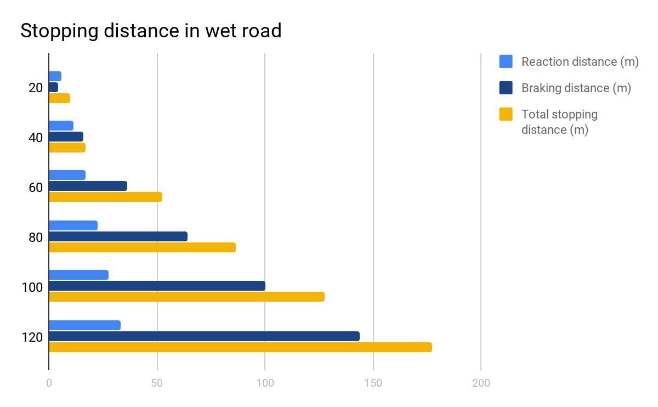

Bar Chart 3. 2: Stopping distance under wet conditions

Different reaction time and conditions of the road produce different data.

CHAPTER 4
Algorithm and Result

4.1 Algorithms

Faster r-cnn:

A Faster R-CNN object detection network consists of an extraction network of features and is usually a retrained CNN. This is followed by two sub-networks that can be trained. The first could be an object-generating Regional Proposal Network (RPN), thus, the second is assigned to predict the specific class. So the primary discriminator for Faster R-CNN is added RPN after the convolutional layer. It is trained directly to generate regional proposals without the need for any external framework such as Selective Search.
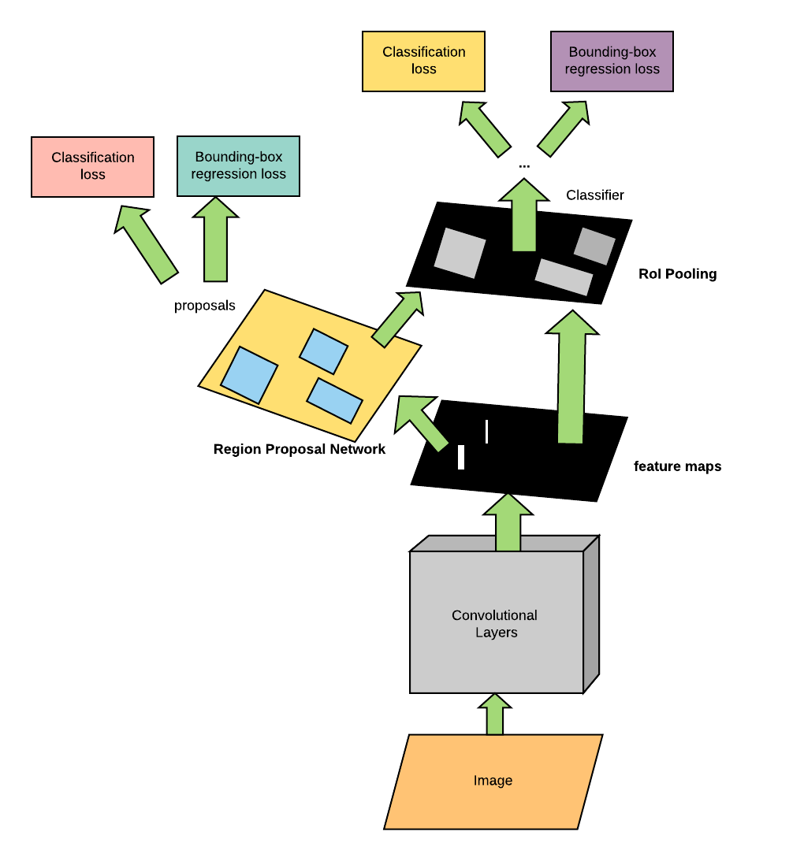
Fig4.1: Unified Network of Faster r-cnn

Architecture and Design

As the extraction function, ROI pooling, and classifier are similar because of the previous versions, we will concentrate the bulk of this piece to understand the architecture of RPN and the principle of anchor boxes and non-maximum suppression. The remaining specifics are similar to the previous versions.

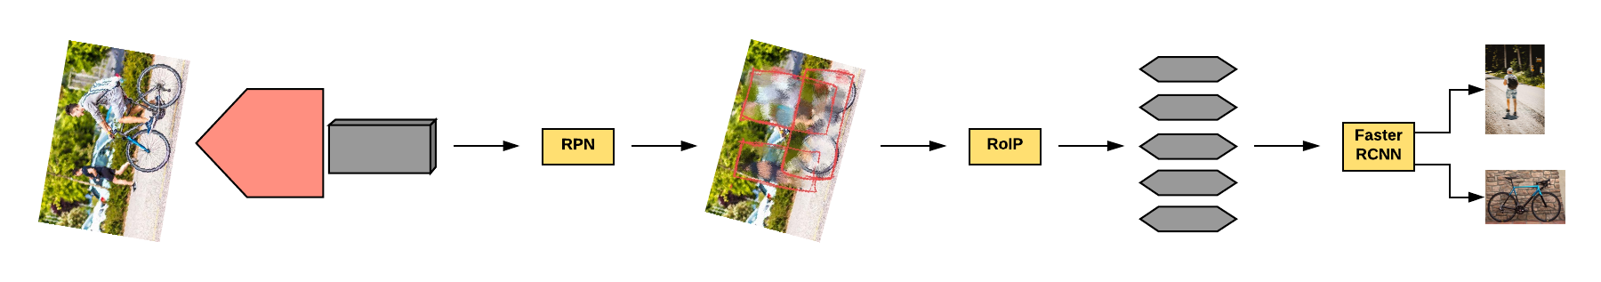
Fig4.2: Different layers of Faster r-cnn

The different layers of Faster R-CNN are better and faster than its ancestor. In today's world, Faster R-CNN is one of the most popular frameworks accessible for researchers in object detection.

Yolo:

YOLO(You Only Look Once) is known as a real-time object detection algorithm, which includes innovative ideas from computer vision. YOLO works so much better on detecting the object of various autonomous vehicle technology than other algorithms. Object detection is a typical problem to understand what and where the objects are given in an image or in a video. Object detection is much more complicated than labeling, it helps to identify the objects but it doesn't indicate the spot where the object is located. But YOLO solves this problem differently.

YOLO is a network that uses a single neural network on the entire image for dividing into regions or areas and predicting boundary boxes for real-time object detection. YOLO acquires high precision in real-time detection and predicts only one forward propagation movement. Non-max suppression identifies each and every object only once then outputs known objects with bounding boxes. But YOLO calculated several bounding box and class probabilities by one single CNN. YOLO detects the output directly and tries to cover a fully detected image and trains it properly. This model has various advantages over other methods of detecting objects: YOLO is very fast with lower accuracy.

CNN:

Convolutional neural network(CNN) is a kind of artificial neural network which helps to designed pixel data and is used for image recognition. CNN's are one kind of Artificial intelligence and effective image processing which helps to perform creative and descriptive works in depth-training by using image and video recognition machines and Natural Language Processing(NLP). A neural network is a kind of hardware or software system modeled after a neuronal processed the human brain.

Modern neural networks should be fed into small photo bits and this network is not ideal for image processing. CNN calls the "neurons," the area responsible for the visual stimulation treatment of humans and other animals, something of the frontal lobe. The neuron layers are designed to cover the entire field of vision, eliminating the partial issue of image processing by the neural networks. CNN can provide layers of local and global to calculate the streamline. In order to reduce processing requirements, CNN uses a tool that is similar to a multi-layer sensor. CNN layers consist of an input and output layer, a hidden layer that contains different types of convolutional layers, pooling layers, and completely linked standardization layers.CNN can provide layers of local and global to calculate the streamline.

MASK R-cnn:

Mask R-CNN is a deep neural network that solves a segmentation instance problem of a computer. On the other way we can say that it helps to separate various types of objects in a video or image. If we give a picture then it will detect the bounding boxes, classes, and masks for the object.

There are two stages in Mask R-CNN. Firstly, it creates a proposal on the regions in which an input image types object can remain. Secondly, with the help of the proposal of the first phase stage, it predicts an object class, clears the bounding box, and produces a pixel mask. The backbone structure is related to both stages of Mask R-CNN, where the backbone structure is called a deep neural FPN-style network. Backbone has a part called bottom-up pathways that is used to extract features from raw images. Another part of the backbone is the top-bottom route where it produces a pyramid map function that is similar in size. The other one is the lateral connection route that creates a connection between convolution and inserting operations of the two pathways are lateral relations. Anchors have a different bind for the different levels of feature maps, where RPN use anchors to decide the size of the bounding box of a feature map will get an object.

In the second stage, feature maps are assigned to several different areas that are conducted by another neural network. It scans areas. produces object groups, bounding boxes, and masks. RPN also works here the same as in the first stage.

4.2 Why Faster r-cnn is better? Why did you choose Faster r-cnn:

Faster r-cnn is a very popular object detection algorithm. We chose faster r-cnn for object detection. Because it is faster and it fixed the problem using Region Proposals Network(RPN).Test time speed of faster r-cnn for per image 0.2 seconds. Faster r-cnn is faster than Mask r-cnn, Fast r-cnn and r-cnn. And most importantly it;s mAP is higher than other algorithms.
Table shows the difference between Faster r-cnn and other algorithms and why Faster r-cnn is better.
Faster r-cnn | Mask r-cnn | r-cnn | Yolo
Faster r-cnn architecture uses Region Proposal Network (RPN). | Mask r-cnn generates proposals about the region. | r-cnn uses selective search. | A single convolutional network.
Object detection accuracy is better than r-cnn and Mask r-cnn. | Accuracy is less than faster r-cnn. | Accuracy is less than Faster r-cnn and Mask r-cnn. | Accuracy is less than Faster r-cnn.
Faster r-cnn is much faster than Mask r-cnn and r-cnn | Slower than Faster r-cnn. | Slower than Faster r-cnn and Mask r-cnn | Faster than Faster r-cnn and Mask r-cnn.

Table4.1: Difference between algorithms

4.2 Training procedure

We used Google colab and Tensorflow version 1.x* for the training procedure.
Import in colab:

First we uploaded data in google drive. Run the following script in a colab shell to make connections to drive in to google colab using the following code.

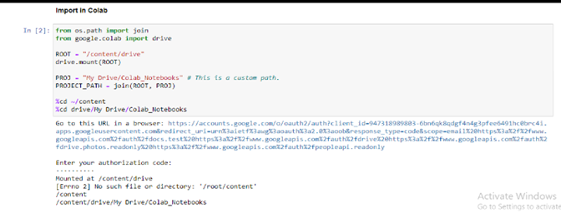

Compile Protobuf(Protocol Buffer):

We use Protobuf to compile all .proto files in TensorFlow. This helps TensorFlow to train parameters and configure models.
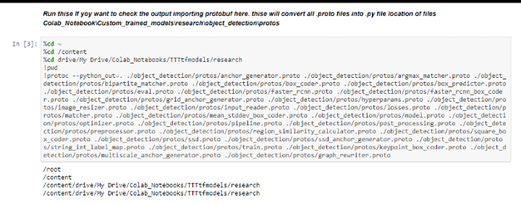

Python setup:

Setting up python to interpret at execution time on python VM.
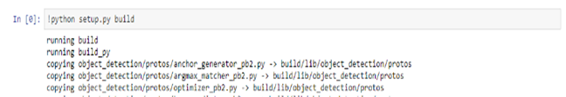

Gather and Label Pictures:

We collected 60 images for 19 object classes to create our dataset. We used cameras and Google to collect images. For each object class there are some single images and images with other objects that will be used to objectify in different situations.
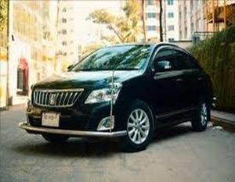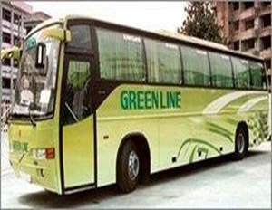
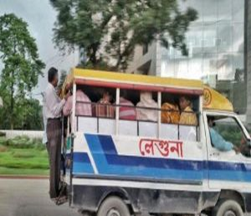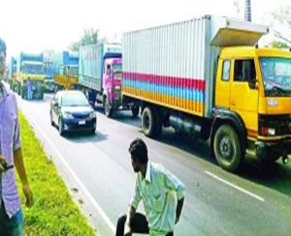
Fig4.3: Image data set

While collecting the pictures we made sure that the pictures do not get too big. It takes a long time to train because the pictures get bigger. We used the resizer.py to resize all pictures .

When we get all our desired images, we will put one-fifth of the total images in the /test directory and the rest in the /train directory.

Label Pictures:

we leveled our images with Lebelimg software. As each image is leveled, a .xml file is created which stores all the information in that image and this will help us to create a TFRecords later.

Generate Training Data:

Now we have created the .csv file with all the information in the .xml file using the following command lines.
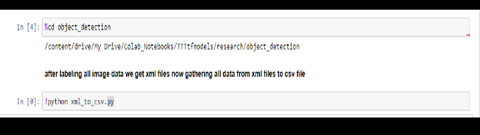
Here two .csv files named train_labels.csv and test _labels.csv will be created.

Creating TFrecords file:

With the following commands we have created two separate test.record and train.record files from the train_labels.csv and test _labels.csv files which will help us to train our model later.
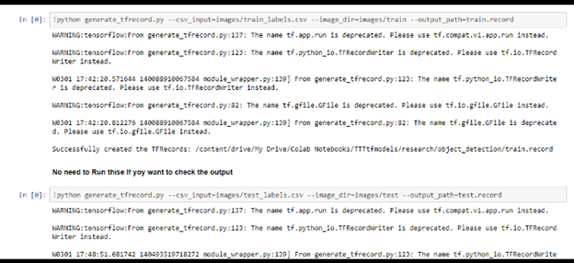

Creating Label Map and Configuring Training:

Before starting the training we create the label map and training configuration file.
.
Label map:

In the labelmap.pbtxt file we have written the following texts with the help of a text editor.

item {
id: 1
name: 'leguna'
}
item {
id: 2
name: 'person'
}
item {
id: 3
name: 'cng'
}
item {
id: 4
name: 'bus'
}
item {
id: 5
name: 'zebra_crossing'
}
item {
id: 6
name: 'car'
}
item {
id: 7
name: 'traffic_signal_yellow'
}
item {
id: 8
name: 'traffic_signal_green'
}
item {
id: 9
name: 'traffic_signal_red'
}
item {
id: 10
name: 'rickshaw'
}
item {
id: 11
name: 'traffic_sign_speed_20'
}
item {
id: 12
name: 'truck'
}
item {
id: 13
name: 'pickup'
}
item {
id: 14
name: 'microbus'
}
item {
id: 15
name: 'cargo'
}
item {
id: 16
name: 'bike'
}
item {
id: 17
name: 'auto'
}
item {
id: 18
name: 'traffic police'
}
item {
id: 19
name: 'stop'
}

Configure training

Then we configured the object detection training pipeline.

Set python path:

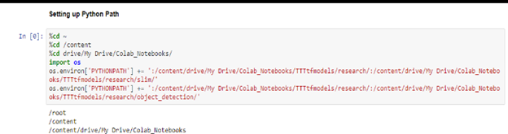

Setting up Python Path for start Training.
Training start:

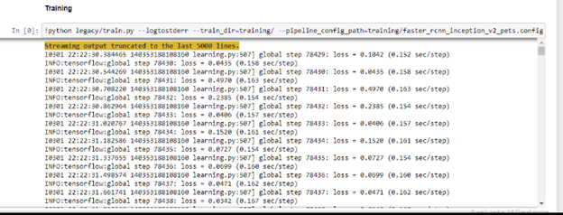
We have started our training with the help of the above commands. With the help of the Faster-r-cnn-Inception-V2 model, the loss at the beginning of training was 3 and after a while it dropped to 0.8 and after 3.30 hours of training the amount of loss came down to 0.012. It saves a checkpoint 5 minutes after the start of training.

EXporting training data:

We have exported our trained model through the following command.
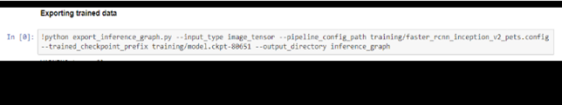
This creates a frozen_inference_graph.pb in \inference_graph folder.

4.3 Out comes:
We observed some promising things while checking our results, like we were capable of detecting objects with nearly equal efficiency in day and night time or in low light.
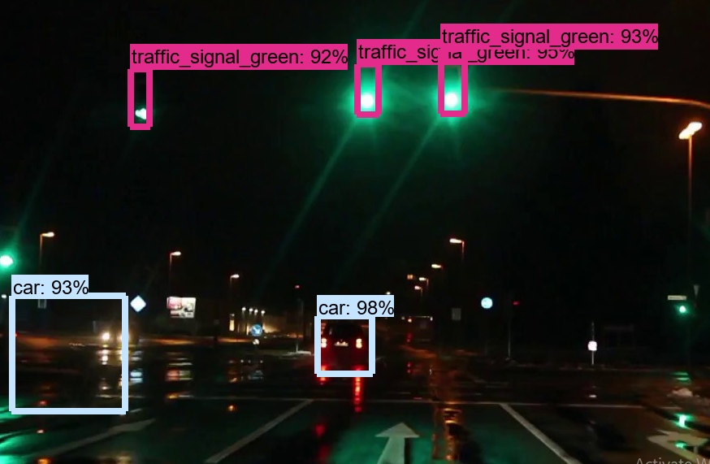
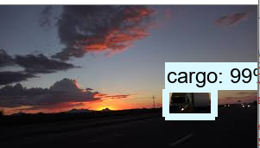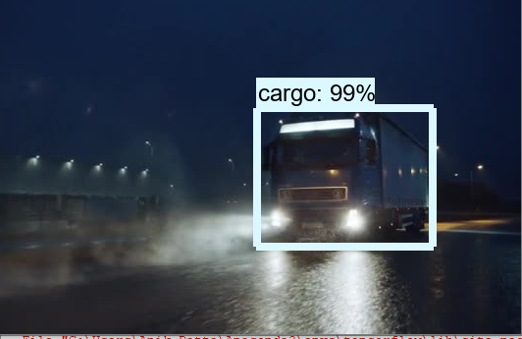
Fig4.4: Detection in low light
Our neural network has been able to detect objects efficiently with moderate and low traffic on the road. And succeeds in detecting all types of small-to-large-medium objects in all of the above situations.
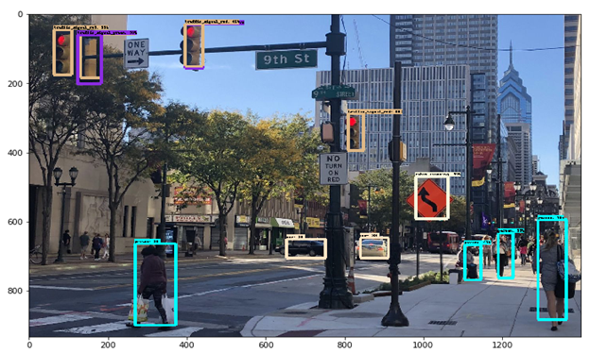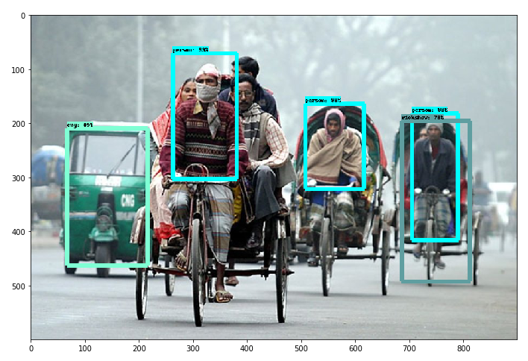
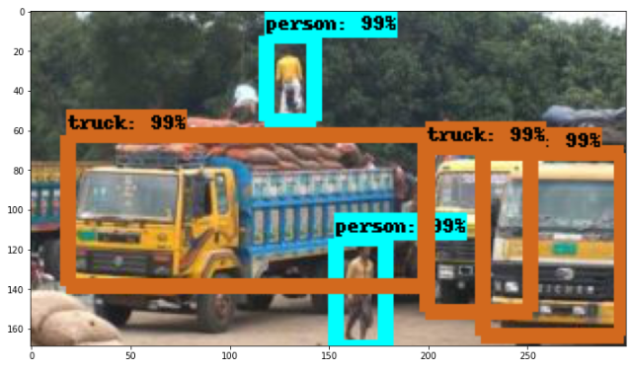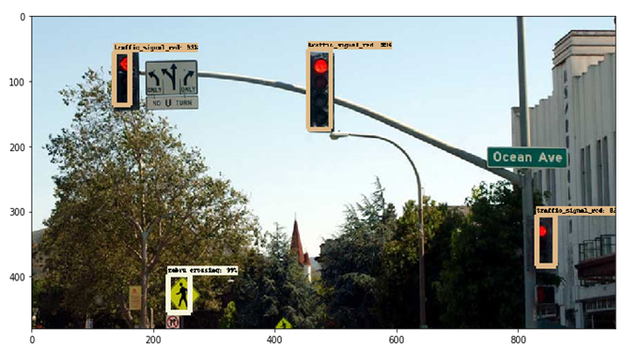
Fig4.5: Detection in moderate and low traffic
Our proposed neural network can detect and analyze objects well even when the objects are not very close, even during high traffic on the road.
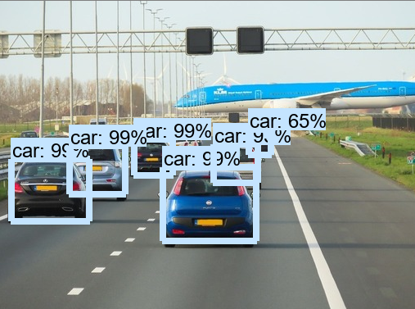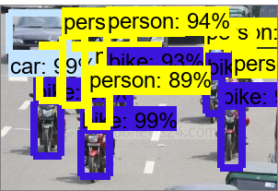
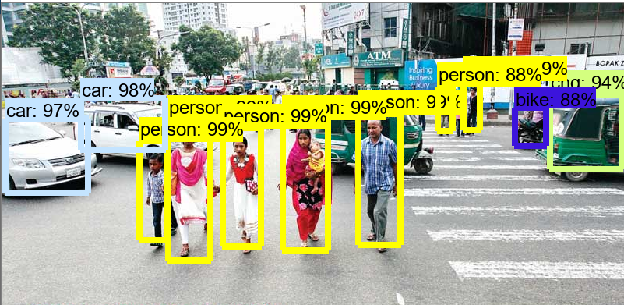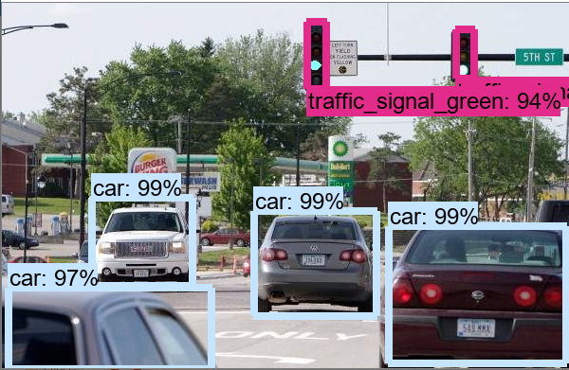
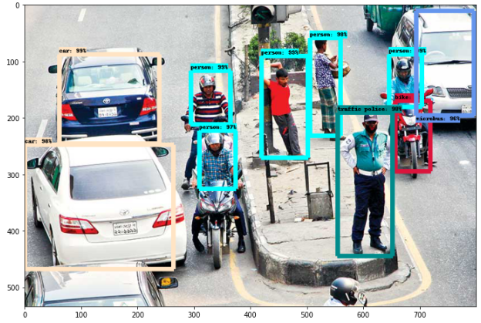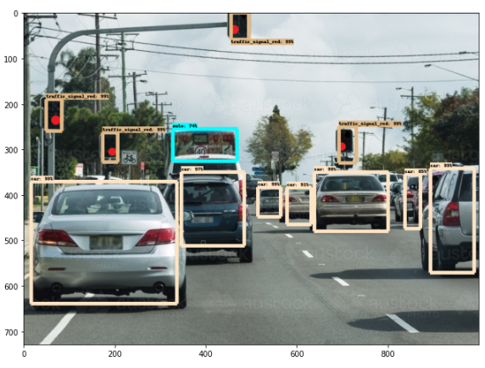

Fig4.6: Detection in high traffic

Confusion matrix:

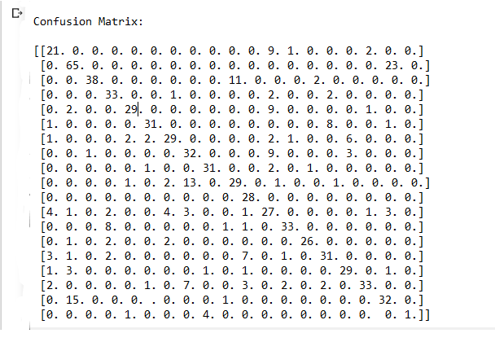
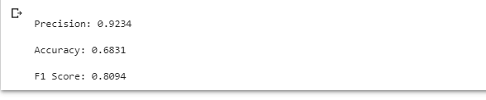
Fig4.6: Confusion matrix, precision, accuracy, F1 score

But it only gets into trouble when the objects are too close together and cling to each other in a crowded state. When detecting objects on high traffic or in close proximity to the road, objects in the front make it difficult to detect the objects behind because the objects in the front cover the objects behind and therefore our proposed neural network can only accurately detect objects in the front.

CHAPTER 5

Conclusion

5.1 Conclusion

In recent years there are so many papers published on object detection. We also try to add some new information in object detection with the help of machine learning. Here we made a data set for our software that will be used in our device helping to reduce road accidents and also in vehicles for controlling speed and force to obey the traffic laws. In this paper we collect various traffic signs images to detect objects from real time video feed. We also collect data from the vehicle's speed and vehicle's location. Do not allow the driver to disobey the traffic laws. If accidents occur, devices try to send the vehicle's location to the nearest hospital and police station.

5.2 Future work

1. The whole world has stopped for this pandemic and for this some of our work is still incomplete. In the future, we will make this idea a reality.

2. We will further increase our data set.

3. We will try to increase the frame rate further when collecting data from real time videos.

4. We will make objectification more accurate.

5. We will use simpler methods to detect objects.

5.3 Reference.
[1] Girshick, Ross. "Fast R-CNN." 2015 IEEE International Conference on Computer Vision (ICCV), 2015. doi:10.1109/iccv.2015.169.
[2] H C, Deepika. "An Overview of You Only Look Once: Unified, Real-Time Object Detection." International Journal for Research in Applied Science and Engineering Technology, vol. 8, no. 6, 2020, pp. 607-609.
[3] Alamsyah, Derry, and Muhammad Fachrurrozi. "Faster R-CNN with Inception V2 for Fingertip Detection in Homogenous Background Image." Journal of Physics: Conference Series 1196 (2019), 012017. doi:10.1088/1742-6596/1196/1/012017.
[4]Artamonov, N. S., and P. Y. Yakimov. "Towards Real-Time Traffic Sign Recognition via YOLO on a Mobile GPU." Journal of Physics: Conference Series 1096 (2018), 012086. doi:10.1088/1742-6596/1096/1/012086.
[5] Liu, YuQiang, and Kunfeng Wang. "Vehicle classification system based on dynamic Bayesian network." Proceedings of 2014 IEEE International Conference on Service Operations and Logistics, and Informatics, 2014. doi:10.1109/soli.2014.6960687.
[6] Mane, D.T., and U.V. Kulkarni. "A novel fuzzy convolutional neural network for recognition of handwritten Marathi numerals." International Journal of High Performance Computing and Networking 15, no. 3/4 (2019), 158. doi:10.1504/ijhpcn.2019.10027712.
[7] Ren, Shaoqing, Kaiming He, Ross Girshick, and Jian Sun. "Faster R-CNN: Towards Real-Time Object Detection with Region Proposal Networks." IEEE Transactions on Pattern Analysis and Machine Intelligence 39, no. 6 (2017), 1137-1149. doi:10.1109/tpami.2016.2577031.
[8] Shaifee, Mohammad J., Brendan Chywl, Francis Li, and Alexander Wong. "Fast YOLO: A Fast You Only Look Once System for Real-time Embedded Object Detection in Video." Journal of Computational Vision and Imaging Systems 3, no. 1 (2017). doi:10.15353/vsnl.v3i1.171.
[9] Yoo, Sunghwan, Masoom A. Haider, and Farzad Khalvati. "Estimating Optimal Depth of VGG Net with Tree-Structured Parzen Estimators." Journal of Computational Vision and Imaging Systems 3, no. 1 (2017). doi:10.15353/vsnl.v3i1.175.
[10] Tripathi, A., V. Ajay Kumar, T., Kanth Dhansetty, T. and Selva Kumar, J., 2018. Real Time Object Detection using CNN. International Journal of Engineering & Technology, 7(2.24), p.33.
[11] Thecartech.com. 2020. [online] Available at: <http://thecartech.com/subjects/auto_eng/Stopping_distances_for_cars.htm> [Accessed 9 July 2020].
[12 ]He, K., Gkioxari, G., Dollar, P. and Girshick, R., 2020. Mask R-CNN. IEEE Transactions on Pattern Analysis and Machine Intelligence, 42(2), pp.386-397.
[13] Alegion.com. 2020. Faster R-CNN. [online] Available at: <https://www.alegion.com/faster-r-cnn> [Accessed 9 July 2020]..
[14] SearchEnterpriseAI. 2020. What Is Convolutional Neural Network? - Definition From Whatis.Com. [online] Available at: <https://searchenterpriseai.techtarget.com/definition/convolutional-neural-network> [Accessed 9 July 2020].
[15] Redmon, Joseph, Santosh Divvala, Ross Girshick, and Ali Farhadi. "You Only Look Once: Unified, Real-Time Object Detection." 2016 IEEE Conference on Computer Vision and Pattern Recognition (CVPR), 2016. doi:10.1109/cvpr.2016.91.
[16] Korkortonline.se. 2020. Stopping Distance, Reaction Distance And Braking Distance. [online] Available at: <https://korkortonline.se/en/theory/reaction-braking-stopping/> [Accessed 9 July 2020].
[17] Dai, W., and J. Ge. "Research on vision-based intelligent vehicle safety inspection and visual surveillance." 2012 Eighth International Conference on Computational Intelligence and Security, 2012. doi:10.1109/cis.2012.56.
[18] Abbas, Syed M., and Shailendra N. Singh. "Region-based Object Detection and Classification using Faster R-CNN." 2018 4th International Conference on Computational Intelligence & Communication Technology (CICT), 2018.
[19] "Table of contents." 2018 IEEE Conference on Multimedia Information Processing and Retrieval (MIPR), 2018.
[20] Corovic, Aleksa, et al. "The Real-Time Detection of Traffic Participants Using YOLO Algorithm." 2018 26th Telecommunications Forum (TELFOR), 2018.
[21] Dai, Weijun, and Ji Ge. "Research on Vision-based Intelligent Vehicle Safety Inspection and Visual Surveillance." 2012 Eighth International Conference on Computational Intelligence and Security, 2012.
[22] Lim, Byeonghak, et al. "Real-Time Lightweight CNN for Detecting Road Object of Various Size." 2018 IEEE Conference on Multimedia Information Processing and Retrieval (MIPR), 2018.
[23] Kido, Shoji, et al. "Detection and classification of lung abnormalities by use of convolutional neural network (CNN) and regions with CNN features (R-CNN)." 2018 International Workshop on Advanced Image Technology (IWAIT), 2018.

