Risk Prediction of Chronic Kidney Diseases (CKD) using Data Mining Approach
BY
Md. Nayeem Hosen
ID: 162-15-1069
AND

Md. Tanzil Islam
ID: 162-15-1066

This Report Presented in Partial Accomplishment of the Specifications for the Degree of Bachelor of Science in Computer Science and Engineering

Supervised By

Md. Reduanul Haque
Senior Lecturer
Department of CSE
Daffodil International University

Co-Supervised By

Amit Chakraborty Chhoton
Lecturer
Department of CSE
Daffodil International University



DAFFODIL INTERNATIONAL UNIVERSITY
DHAKA, BANGLADESH
15THOCTOBER 2020

APPROVAL

This Project titled “Risk Prediction of Chronic Kidney Diseases (CKD) using Data Mining Approach”, submitted by Md. Nayeem Hosen and Md. Tanzil Islam to the Department of Computer Science and Engineering, Daffodil International University, has been accepted as satisfactory for the partial accomplishment of the requirements for the degree of B.Sc. in Computer Science and Engineering and certified as to its method and contents. The presentation has been held on Thursday 15th October 2020.

BOARD OF EXAMINERS

___________________________
Dr. Syed Akhter Hossain Chairman
Professor and Head
Department of Computer Science and Engineering
Faculty of Science & Information Technology
Daffodil International University

___________________________
Mr. Narayan Ranjan Chakraborty Internal Examiner
Assistant Professor
Department of Computer Science and Engineering
Faculty of Science & Information Technology
DaffodilInternationalUniversity

_________________________
External Examiner
Professor and Chairman
Department of Computer Science and Engineering
Jahangirnagar University

i

DECLARATION

We hereby certify that, this project has been executed by us under the supervision of Md. Reduanul Haque, Senior Lecturer, Department of CSE Daffodil International University. We also certifythat this project or any part of this project has been submitted elsewhere for award of any degree.

Supervised by:

Md. Reduanul Haque
Senior Lecturer
Department of CSE
Daffodil International University

Co-Supervised by:

Amit Chakraborty Chhoton
Lecturer
Department of CSE
Daffodil International University

Submitted by:

Md. Nayeem Hosen
ID: -162-15-1069
Department of CSE
Daffodil International University

Md Tanzil Islam
ID: -162-15-1066
Department of CSE
DaffodilInternationalUniversity
ii

ACKNOWLEDGEMENT

We are highly appreciative and thankful to Md. Reduanul Haque, Senior Lecturer, Department of CSE, Daffodil International University, Dhaka. Wisdom & highest credit to our supervisor in the realm of “Data Mining” to bring out this project. His expertise supervision, boundless endurance, steady reassurance, faithful and active guidance, helpful advice, expert judgment, understanding several substandard drafts, and fixing them at all frames have made it possible to achieve this project.

We would like to express our deepest honor to Dr. Syed Akhter Hossain, Professor and Head, Department of CSE, and Dr. S. M. Aminul Haque, Associate Professor and Associate Head Department of CSE for his kind help to finish our project.

Lastly, we want to thank amidst due respect to the endless support and patients of our parents.

ABSTRACT

A consecutive rise in a particular amount of patients with Chronic Kidney Disease Final Stage. In that case where kidney replacement and medical treatment are demands, which means the kidney should be transplant or dialysis. So that requires the risk factors prediction of chronic kidney disease (CKD), If the patients know about the risk factors they will aware of the risks of CKD and get early medical treatment. In our country, the rate of chronic kidney diseases is increasing day by day. The present situation in Bangladesh mostly people in rural areas is not aware of Chronic Kidney Disease. For lack of vast knowledge and less awareness about CKD, they suffer from the disease. Sometimes it takes too long for the detection of the disease. As a result, they got enormous damages to their kidney. When the functionality of a kidney decreases exceedingly then it is considered as a stage of four or five which is not a good sign for a CKD patient. If a patient is in stage five conditions, the patient needs to transplantation of the kidney that is not so convenient. So, if that patient can identify the diseases in the early stage, the damage could have reduced by medicine and medical treatment. In this project, we have predicted the risk factors of chronic kidney diseases. Thus, in most cases, the risk of CKD can be used to be reduced in an early stage.
iii

TABLE OF CONTENTS
iv
CONTENTS | PAGE
Board of examiners | i
Declaration | ii
Acknowledgements | iii
Abstract | iv
CHAPTER
CHAPTER 1: Introduction | 1-2
1.1Introduction | 1
1.2 Motivation | 1-2
1.3 Objectives | 2
1.4 Expected Output | 2
CHAPTER 2: Background Study | 2-4
2.1 Chronic Kidney Diseases | 2
2.2 Stages of Chronic Kidney Diseases | 3
2.3 Related Works | 3-4
CHAPTER 3: Research Methodology | 6-8
3.1 Working Procedure | 4-6
3.2 Data Collection | 6
3.3 Data Pre-Processing | 7
3.4 Data Analysis | 7-8
CHAPTER 4: Experimental Results | 8-17
4.1 Results | 8-17
4.2 Summary | 17
CHAPTER 5: Conclusion | 18
5.1 Summary of the Study | 18
5.2 Future Work | 19
REFERENCES | 19
List of Figures
Figures | PAGE NO
Figure 1: Flow chart of Working Procedure | 4
Figure 2: Sample of Dataset | 6
Figure 3: Pearson correlation coefficient | 10
Figure 4: Decision Tree | 11
Figure 5.1: Likelihood Distribution of Age | 12
Figure 5.2: Likelihood Distribution of grf | 13
Figure 5.3: Likelihood Distribution of pcv | 14
Figure 5.4: Likelihood Distribution of rbcc | 15  v
Figure 5.5: Likelihood Distribution of hemo | 15
Figure 6: Features Ranking | 17

List of Tables
Tables | PAGE NO
1.Chi-Square Test | 9
2. Significant Risk Factors | 18

List of Abbreviation
grf | Growth Hormone-Releasing Factor
pcv | Packed Cell Volume
rbcc | Red Blood Cell Count
hemo | Hemoglobin
wbcc | White Blood Cell Count
sod | Sphincter of Oddi Dysfunction
bu | Bandelette urinaire

vi
CHAPTER 1
Introduction

1. 1 Introduction

Chronic kidney disease (CKD) is a condition characterized by a gradual loss of kidney function over time. It’s also known as chronic kidney failure. The kidney helps us to remove the waste product that produces inside our body. Not only but also filter the excess fluids, toxins from our blood. These waste and fluids are excreted in urine by the kidney. The kidney also releases a hormone that controls blood pressure and the production of red blood cells. It produces an active form of vitamin D for which we get strong and healthy bones. Therefore, we can understand that kidney plays a vital role in our body. But when our kidney is not in good condition, all these functions in our body cannot execute properly. And that is turned into chronic kidney diseases (CKD).
Chronic kidney disease has no reliable treatment to cure devastating kidney disease in humans since ancient times. The evolution of new technologies in CKD research is slowly upgrading, but in the current situation, there is a need for more advanced solutions to treat CKD so that medical science can prevent mortality in CKD patients.
There is a lot of ways to distinguish the risk factors of CKD. The common convenient technique to predict risk factor that is a data mining technique. In this research, we have used a population-based case-control study and applied data mining algorithms. By using this data-mining technique to predict the risk factor of chronic kidney research possibly be helpful to prevent Kidney failure.
The rate of chronic kidney diseases is increasing day by day. Many people do not get early treatment at pre-stage when kidneys are in good condition. So it's possible to predict the risk factors and get treatments before it causes some serious problems. Therefore, in this work, we have tried to identify those risk factors by using data mining.

1.2 Motivation
1

Chronic kidney disease (CKD) leads to a large number of people worldwide and causes a significant general medical issue and a financial test. There is no solution for kidney failure, however, the treatment is conceivable to live a long and pleasant life. Having a kidney disorder is not a punishment. Individuals with kidney failure carry on with their lives and keep on doing the things they love. This work will help us to learn more about the risk factors of the kidney’s function and the chance of a person to be affected by the chronic kidney.

1.3 Objectives

- To predict chronic kidney diseases using data mining.
- To increase the accuracy of chronic kidney disease prediction.
- To find out the significant and non-significant risk factors of chronic kidney diseases.

1.4 Expected Outcome

- To predict the risk factors of chronic kidney diseases
- To identify the significant risk factor of CKD
- To build a predictive model with a good accuracy

CHAPTER 2
Background Study

2.1 Chronic Kidney Diseases

In human body five organs that are considered major for survival. Kidney is one of the major organs of human body. It helps us to remove the waste product that produce inside our body. Not only that it also filters the excess fluids, toxins from our blood. These waste and fluids are excreted in urine by the kidney. These waste and fluids are excreted in urine by the kidney. The kidney's main works as a follow it releases erythropoietin, enzymes such as kallikreins also that control blood pressure and the production of red blood cells. So, we can understand that kidney play a vital role in our body. But when our kidney is not in a good condition, all these functions in our body cannot execute properly. And that is called chronic kidney diseases (CKD). It is also known as chronic kidney failure. When a chronic kidney disease occurs, we lost our kidney functions gradually.
2

2.2 Stages of Chronic Kidney Diseases

chronic kidney diseases have five stage. This stage indicates the condition of the kidney.
- CKD First Stage: If the GFR rate is grater then 90 mL/min then the functioning of the kidney is very high. The percentage of the kidney function is greater than 90%.
- CKD Second Stage: The GFR rate between 60 to 89 mL/min is responsible for the mild decrease of kidney function. The kidney function percentage remains 60% to 89%.
- CKD Third Stage: The GFR between 30 and 59 mL/min. That means there is some injury in kidneys so that it’s not working properly.
- CKD Fourth Stage: The GFR between 15 and 30 mL/min. It means kidneys are slightly or badly damaged and are not working accurately as it should. The fourth stage of chronic kidney disease should be taken as a serious matter because it is the last stage before kidney failure. Here intense decrease in kidney function and the kidney function percentage remains 15–29 mL/min.
- CKD Fifth Stage: The GFR rate is less than 15 mL/min. The kidney's functions working ability decrease at 15% This stage is also known as kidney failure and CKD patients are at high risk.

2.3Related Works
- It merits referencing now that both albuminuria and decline in eGRF were utilized as 2 essential markers for the new arrangement of CKD proposed by the Kidney Diseases Outcome Qualities Initiative of the national kidney Foundation and presented broadly after a slight change by the KDIGO (Kidney Diseases: Improving Global Outcomes) worldwide network [1].
3
- Persistent kidney diseases influence a large number of people worldwide and comprise a significant general medical condition and a monetary test [2]. These were utilized to consider, order, and analyze malignant growth, liver and coronary illness informational indexes with fluctuating pieces and portion boundaries. Consequences of Random Forest and Support Vector Machines were looked at the four changed informational index, for example, bosom malignant growth malady dataset, liver sickness dataset, and coronary illness dataset.
- The outcomes with various portions were tuned with legitimate boundary determination. Results were better dissected to set up better learning forecast methods. It is presumed that changing outcomes were seen with the Support Vector Machine grouping procedure with various portions capacities [3].
- The utilized WEKA 3.6.5 apparatus for use to locate the best strategy among the over three calculations for Kidney stones Diagnosis. This principle reason for their postulation work was to propose the best instrument for clinical analysis, similar to kidney stone recognizable proof, to decrease the finding time and improve productivity and precession. From the exploratory outcomes they closed, the back engendering (BPA) altogether improved the regular characterization procedure for use in the clinical field.[4]

CHAPTER 3
Research Methodology

3.1 Working Procedure

Below the diagram is indicating the flow of our work.
4
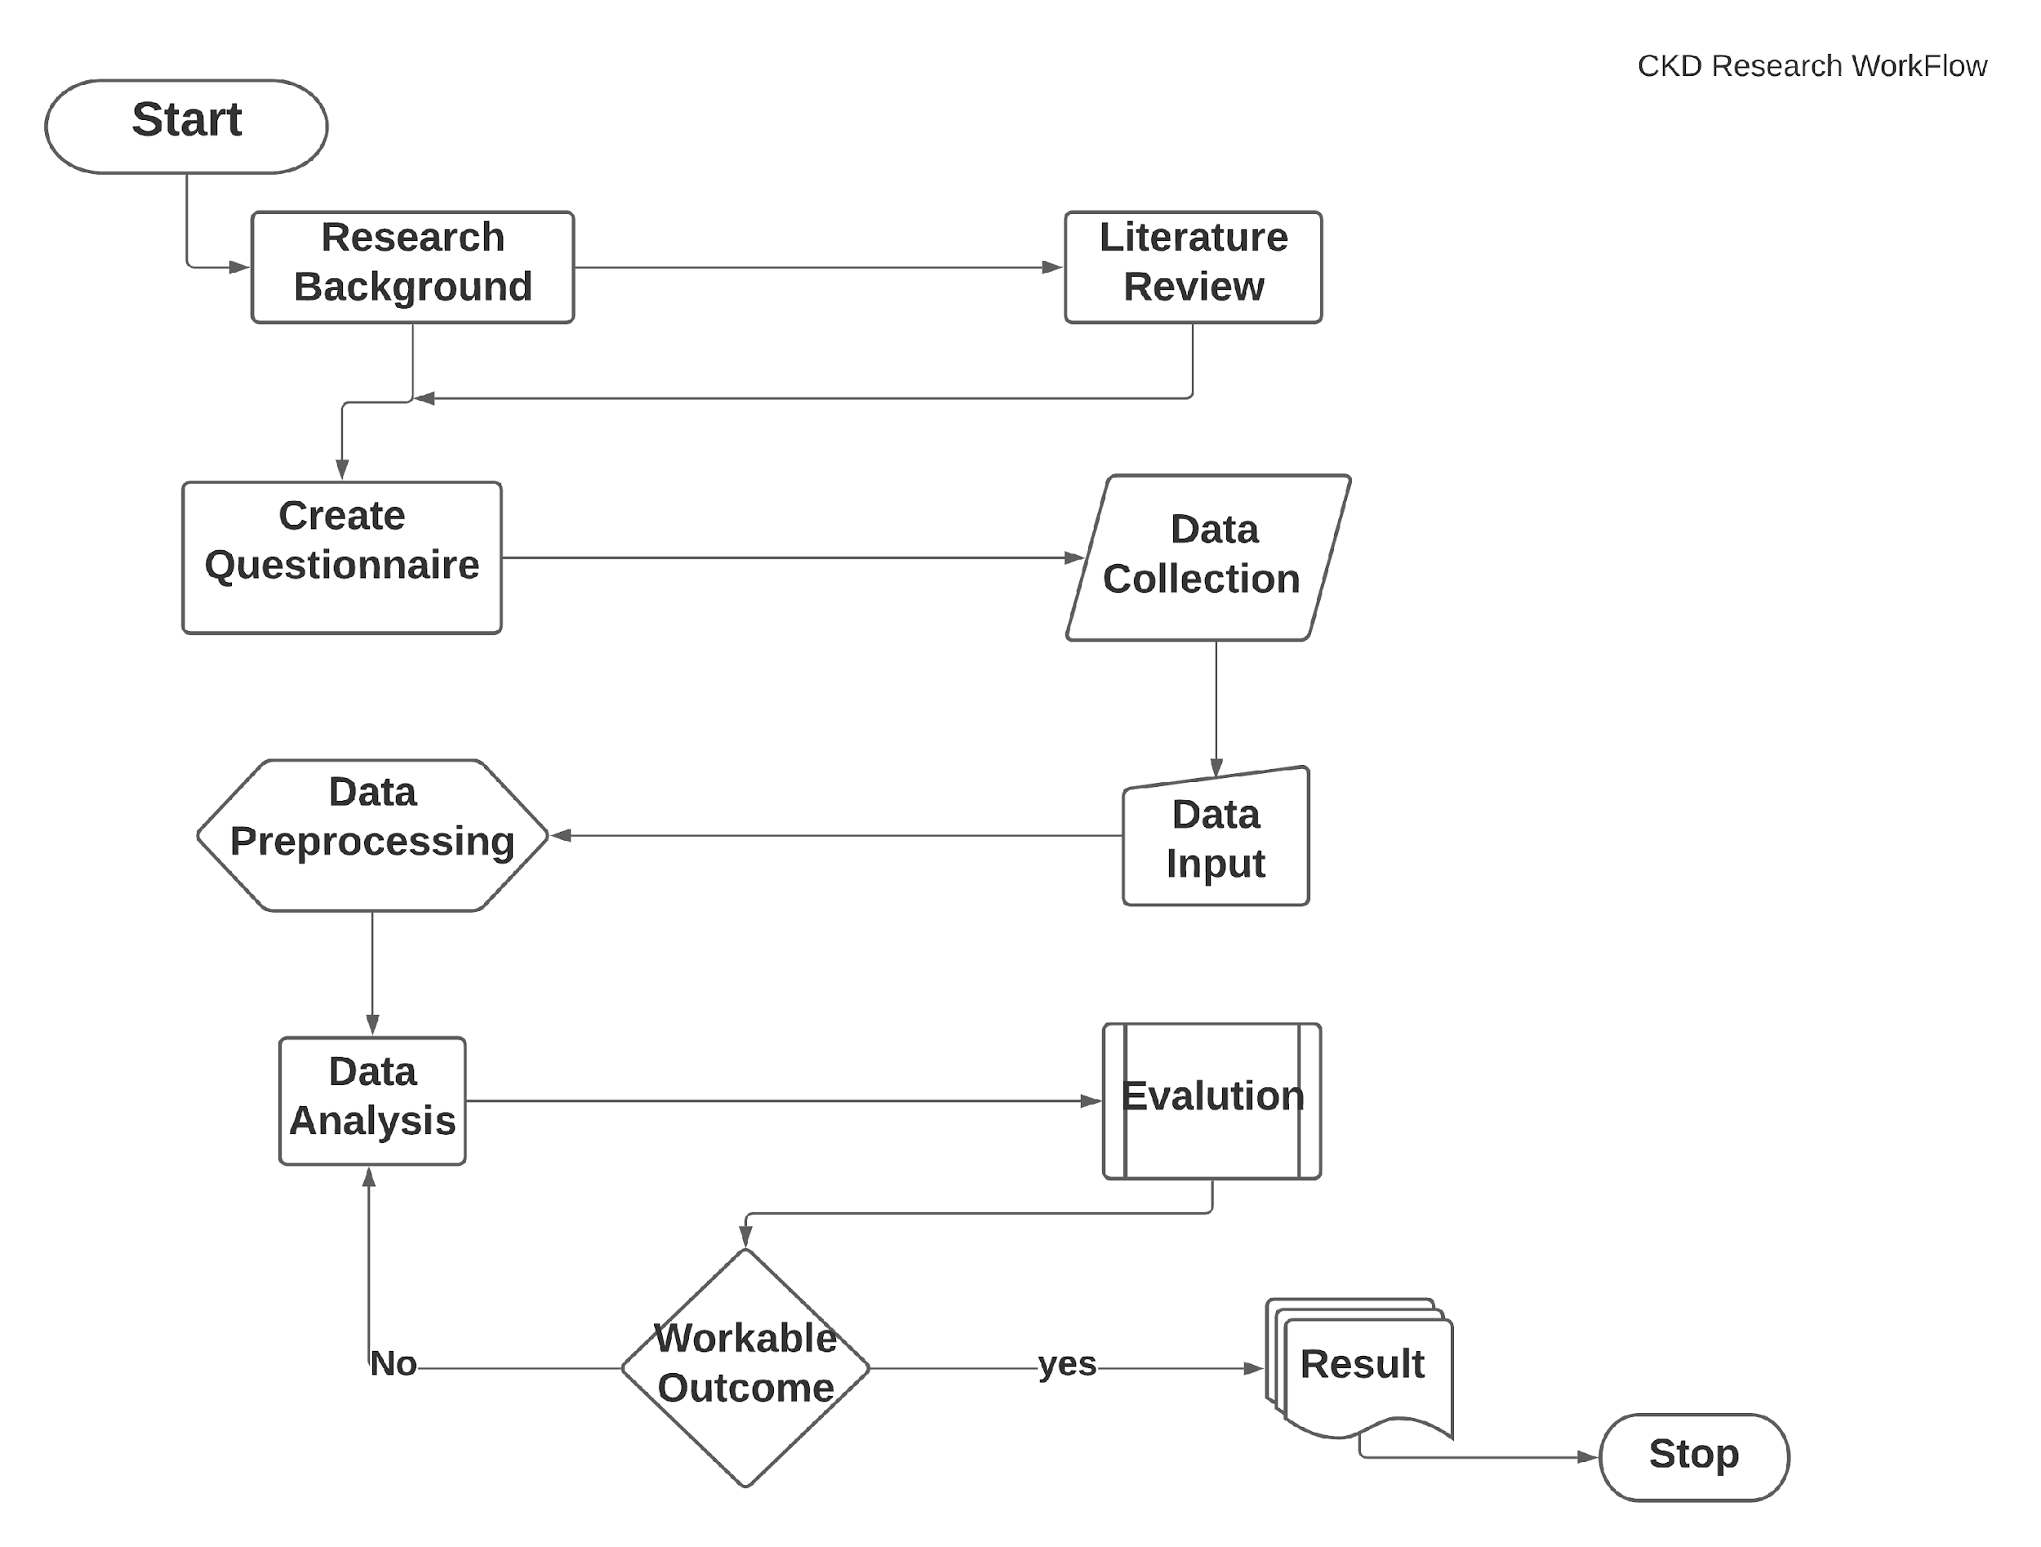
Figure 1: Flow chart of Working Procedure

- From the research background, we have identified the title of the work and selected the field of data mining. As the title of our project, we choose this ‘Risk Prediction of Chronic Kidney Diseases (CKD) using Data Mining Approach'.
- After selecting the title, we have reviewed literature papers which is related to our work. From this reviewed literature, we get some directions and ideas so that we can start our work also make the hypothesis.
- The first work of this project was to create a questionnaire to collect data. The questionnaire was create based on our previous study. In the questionnaire, there were many questions added like age, hypertension, blood pressure, BMI, etc.
- Then we have collected around 200 patient’s data. In that data set some value were missing and some were containing noise value.
- Before going to the data analysis, we have preprocessed the data. Without data validation, we may not get the accuracy. So, we fill out the empty cell of the data set by the mean of the column the related column. We have smoothed the noisy value of the data set. Transformation of string to numeric and data discretization was also applied in the data set.
- After completing the data preprocessing step, we moved on to data analysis. In this step, we have applied several algorithms of data mining to analyze the data. Like the Chi-Square test, Pearson correlation coefficient, Decision Tree, Likelihood Dissemination, etc.
5
- Applying those algorithms, we have got some output from the results. Then we evaluate these results.
- Then we have checked the outcome whether these results are workable or not. If the results do not satisfy the workable outcome step, we do not take the results and go to the data analysis step. If it's fulfilled the workable outcome then we take the output of the results. This step will continue until we get our desired output.
- After getting the desire output, we stopped our work process.

3.2 Data Collection

From the Previous study we have gather information and create a questionnaire for the data collection. In the questionnaire both case and control type question were added. The age, blood pressure, hypertension etc. were also included in the questionnaire. After creating the questionnaire, the collect data through this questionnaire. We have formatted the data set into csv format have collected 200 patient data. There are Some sample of the data set.

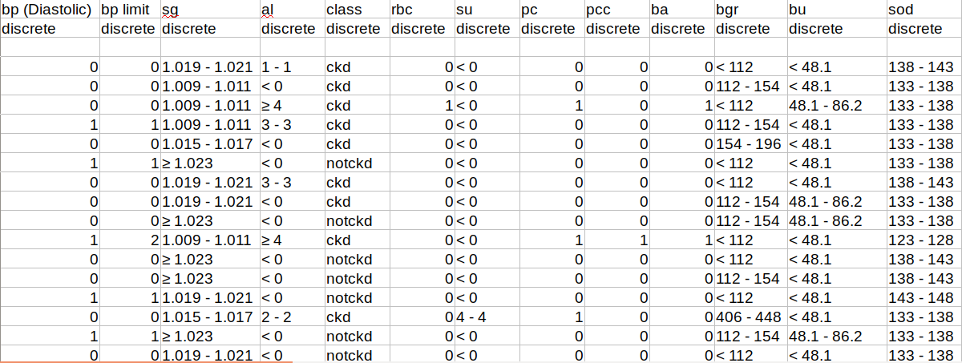Figure 2: Sample of Data set
6
3.3 Data Preprocessing

After collecting the data set, we preprocessed the data because in real-time data set, data often missing or contain garbage value. So, we fill out the missing value by the mean of its attribute column, smooth the noisy values. Data encoding was also applied to convert the data from string to numeric. Some attributes like age, specific gravity, blood glucose regulator, hemoglobin, etc. were organized in a continuous format.

3.4 Data Analysis
After preprocessed the data now we have implemented some algorithm to extract the information like:
- Chi-Square test
- Pearson correlation coefficient
- Decision Tree
- Likelihood Dissemination

For the features ranking we have use
- Information Gain
- Gini Index
- Gain Ratio
- X^2

Here is the description of those algorithm

Chi-square Test:
- A Chi-Square (χ2) is a test that compares two variables to find if they are related and also compare the actual observed data.
- A Chi-Square (χ2) test relates to statistical significance for categorical variables. Chi-square tests are widely used in hypothesis testing.
7
- Chi-Square (χ2) test in hypothesis testing is accustomed-to test the hypothesis. It's also finding the distribution of supervision/recurrence at different levels.

Pearson correlation coefficient:
- It shows the direct connection between two arrangements of information.
- Pearson’s correlation coefficient is the test insights that gauges the factual relationship between two consistent factors.
- It is known as the best strategy for estimating the relationship between factors of intrigue since it depends on the technique for covariance.

Decision Tree:
- It is an outline or a graph that individuals use to decide a game-plane or show a likelihood.
- It is a regulated learning method that has a pre characterized target variable and is frequently utilized in grouping issues.
Likelihood Dissemination:
- A likelihood conveyance is a measurable capacity that portrays all the potential qualities and probabilities that an irregular variable can take inside a given range.
- It is for an arbitrary variable depicts how the probabilities are over the estimation of the irregular variable.

CHAPTER 4
Experimental Results

4.1 Results:
This result section represented the output and results of Chi-Square test, Pearson correlation coefficient, Decision Tree, Likelihood Dissemination, Association Rule Mining algorithms. And we have also shown the output of features ranking.
8
The Chi-square Test algorithm showed that growth hormone-releasing factor, packed cell volume, stage and red blood cell count have the highest priority.

TABLE 1: Chi-Square Test values of factors
Chi-Square | Parameters
660.145 | grf
499.287 | pcv
494.313 | stage
487.675 | rbcc
472.896 | hemo
472.124 | wbcc
466.477 | sod
460.446 | bgr
454.335 | bu
436.598 | htn

The strong relationship of the factors is found by the Pearson correlation.
9
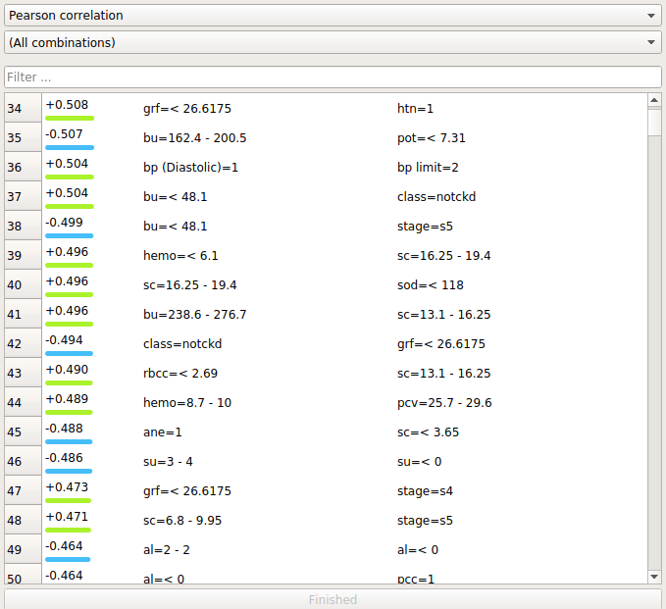
Figure 3: Pearson correlation coefficient

The decision tree showed the total factors which are divided into significant and non-significant category.
10
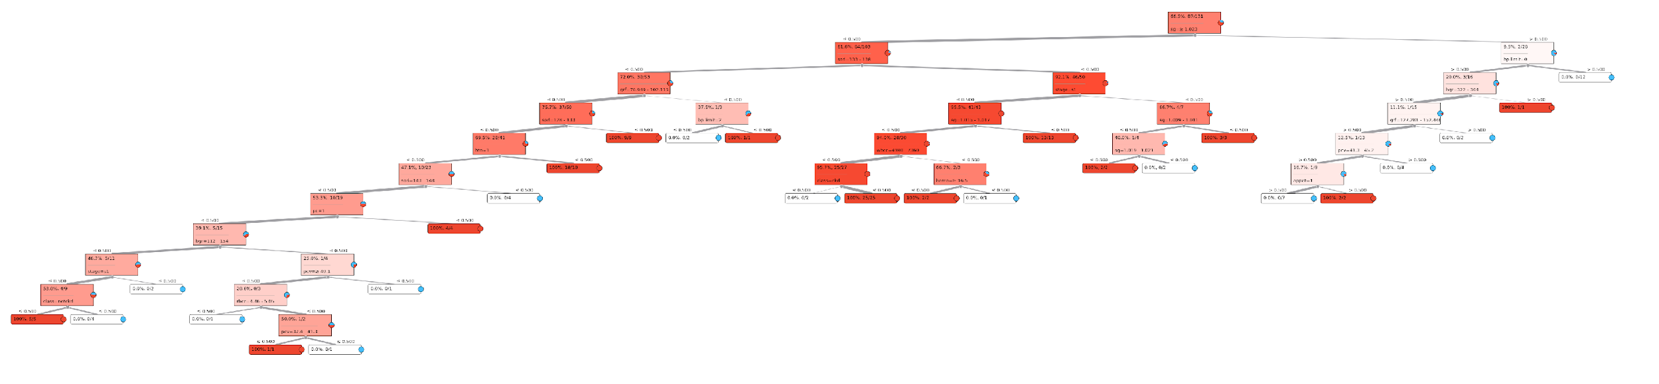
Figure 4: Decision Tree

We have taken the target variable as an effect of chronic kidney diseases. In the Likelihood Dissemination algorithm output, the red bar indicates the effected class. Here are some results of the Likelihood Dissemination algorithm.

11
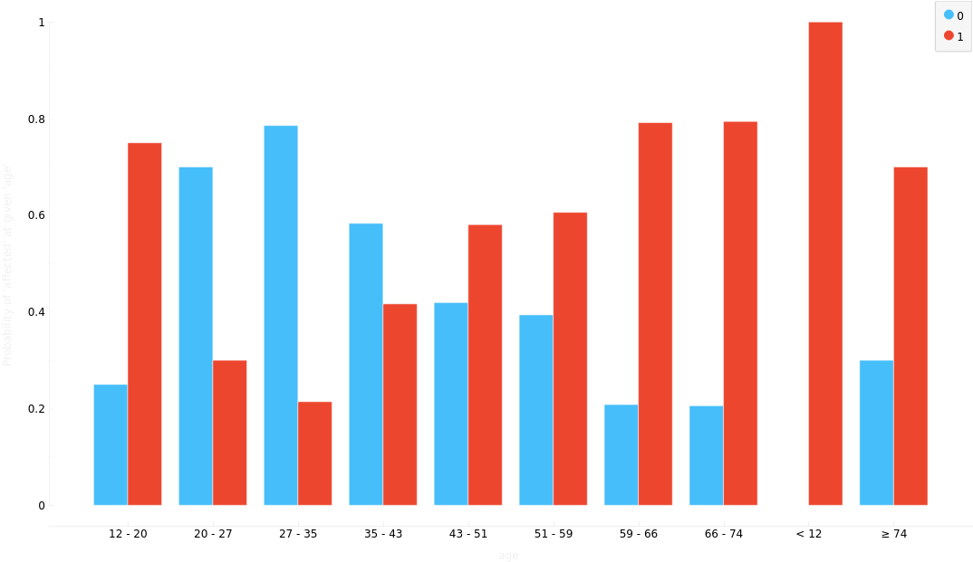
Figure 5.1: Likelihood Dissemination of Age

12
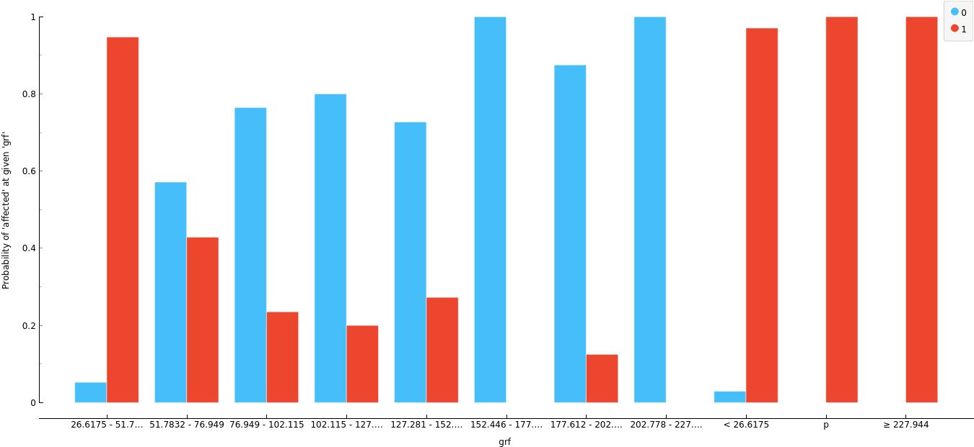
Figure 5.2: Likelihood Dissemination of Grf

13
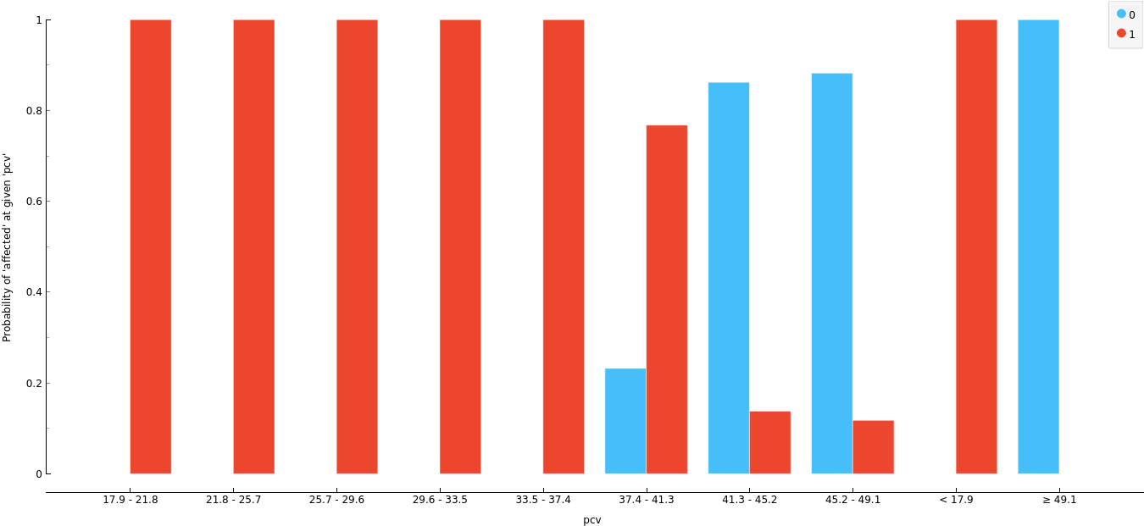
Figure 5.3: Likelihood Dissemination of pcv

14
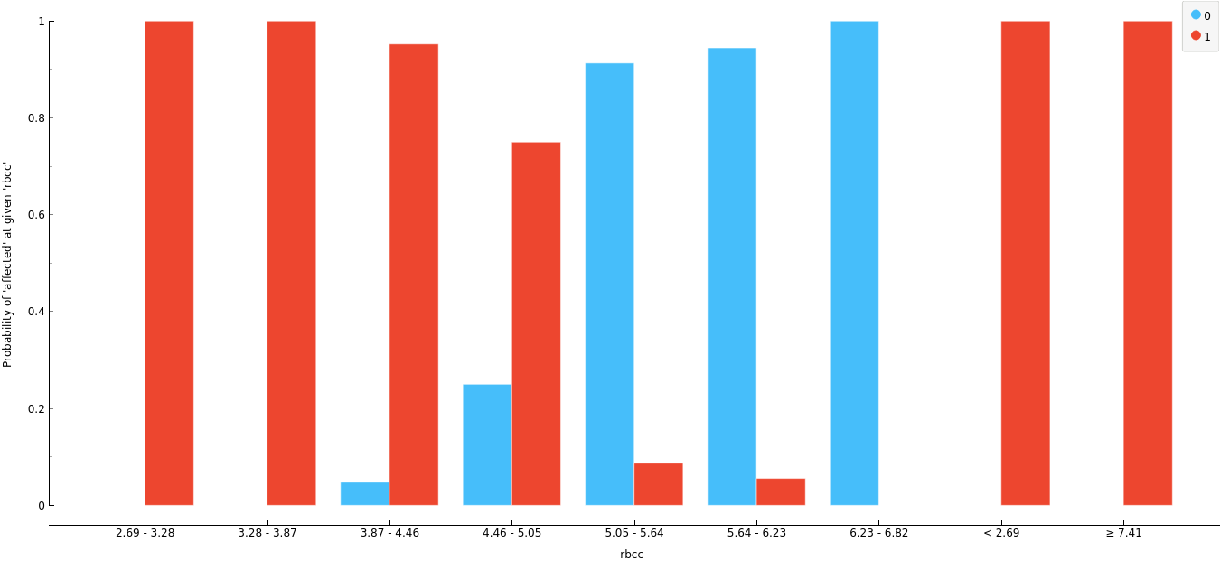
Figure 5.4: Likelihood Dissemination of rbcc

And here is the Likelihood Dissemination of hemo factor.
15
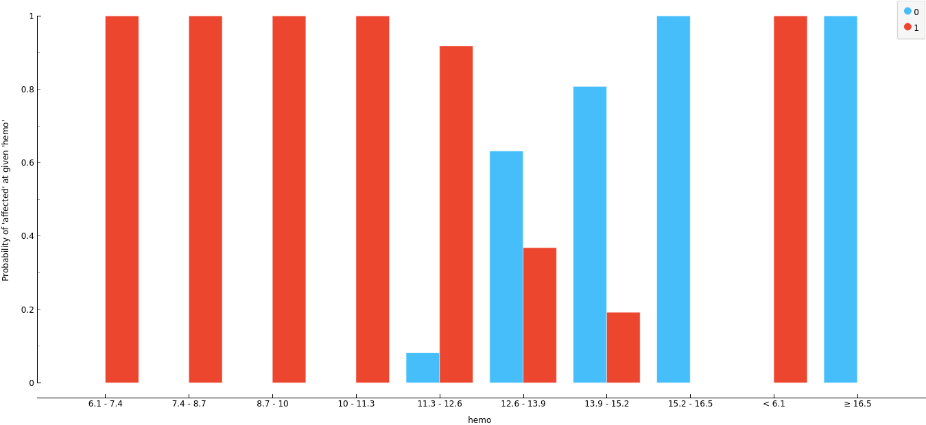
Figure 5.5: Likelihood Dissemination of hemo

By the gain information, chi-square and gain ratio we have get this output of the features.
16
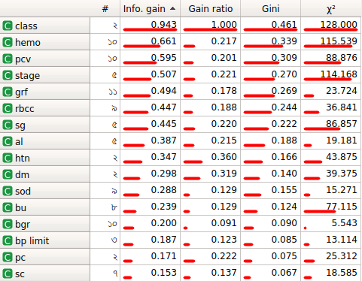
Figure 6: Features Ranking

4.2 Summary
After comparing all the outputs and results we have come to the conclusion and that is the table which is given below is the most significant risk factors of CKD.

17
TABLE 2: Significant Risk Factors
Parameters | Chi-Square | Pearson’s Correlation | Decision Tree | Likelihood Dissemination
grf | 660.145 | +0.724 | 72%, 38/53 | 1
pcv | 499.287 | +0.864 | 50.0%, 12 | <17.9 = 1
stage | 494.313 | +0.724 | 92.1%, 46/50 | 1
rbcc | 487.675 | +0.490 | 28.6%, 0/3 | 1
hemo | 472.896 | +0.641 | 66.7%, 2/3 | 1
wbcc | 472.124 | +0.401 | 94%, 28/30 | >=24020 = 1
sod | 466.477 | +0.159 | 75.7%, 37/50 | 1
bgr | 460.446 | +0.574 | 39.1%, 5/15 | >=448 = 1
bu | 454.353 | +1.00 | 65%, 3/8 | >=352.9 =1

Chapter 5
Conclusion

5.1 Summary of the project
In Bangladesh, the people of middle-class families are not concern about kidney diseases. It is increasing day after day. So, the identification of the risk factors can reduce the rate of affected people from that disease. It's hard to say that there is no cure for kidney failure, but with medical treatment, it is possible to increase life expectancy. The patient will think having kidney failure is a death sentence. Having kidney failure live active lives and continue to do the things they wanted to do. This research will help us to learn the kidney prediction and the chance of a person to be affected by chronic kidney disease. Through this project, people can know the significant risk factors and can take the necessary steps for the cure from chronic kidney diseases.
18

5.2 Future Work
In future we will create a supervised machine learning model which can predict the diseases with a good accuracy.

Reference
- [1] Levey AS, Eckhardt K-U, Tsukamoto Y, Levin A, Coresh J, Rossert J, De Zeeuw D, Hostetter TH, Lameire N, Eknoyan G: Definition and classification of chronic kidney disease: a position statement from Kidney Disease: Improving Global Outcomes (KDIGO). Kidney Int 2005; 67: 2089–2100.
- [2] Collins AJ, Foley RN, Herzog C, Chavers B, Gilbertson D, Herzog C, et al. US Renal Data System 2012 annual data report. American Journal of Kidney Diseases.2013; 61(1): E1–E459. doi: 10.1053/j.ajkd. 2012.11.031 PMID: 23253259Using machine learning techniques, namely Support Vector Machine [SVM] and Random Forest [RF].
- [3] Ashfaq Ahmed K, Sultan Aljahdali and Syed Naimatullah Hussain,(2013) “Comparative Prediction Performance with Support Vector Machine and Random Forest Classification Techniques”, International Journal of Computer Applications Volume 69– No.11, May page no 12-16using neural network techniques, Back Propagation Algorithm (BPA), Radial Basis Function (RBF) and one non-linear classifier Support Vector Machine (SVM) and compared in accordance with their efficiency and accuracy
- [4] Abhishek, Gour Sundar Mitra Thakur, Dolly Gupta, (2012) “Proposing Efficient Neural Network Training Model for Kidney Stone Diagnosis”, International Journal of Computer Science and Information Technologies, Vol. 3 (3), page no 3900-3904
- [5] Kawsar Ahmed1, Abdullah-Al-Emran2 *, Tasnuba Jesmin1, Roushney Fatima Mukti2, Md Zamilur Rahman1, Farzana Ahmed3 doi: https://doi.org/10.7314/APJCP.2013.14.1.595
19
19

