Multifunctional 12 degree of freedom IoT Humanoid Robot.

By
Md.Azizul Haque Chowdhury
ID: 172-15-1566

Md. JoshebMia
ID:172-15-1579

Imtiaz Ahmed Shuvo
ID:172-15-1589

This Report Presented in Partial Fulfillment of the Requirements for the
Degree of Bachelor of Science Computer Science and Engineering.

Supervised By

Tajim Md. Niamat Ullah Akhund
Lecturer
Department of CSE
Daffodil International University

Co-Supervised By

Amit Chakraborty Chhoton
Lecturer
Department of CSE
Daffodil International University


DAFFODIL INTERNATIONAL UNIVERSITY
DHAKA, BANGLADESH
08/06/2020

APPROVAL

This Project titled “Multifunctional 12 degree of freedom IoT Humanoid Robot.” submitted by Md. Azizul haque chowdhury, ID:172-15-1566 and Md. Josheb Mia, ID:172-15-1579 and Imtiaz ahmed shuvo,ID:172-15-1589 to the Department of Computer Science and Engineering, Daffodil International University has been accepted as satisfactory for the partial fulfillment of the requirements for the degree of Bachelor of Science in Computer Science and Engineering and approved as to its style and contents.

BOARD OF EXAMINERS

______________________________
Dr. Syed Akhter Hossain Chairman
Professor and Head
Department of Computer Science and Engineering
Faculty of Science &amp; Information Technology
Daffodil International University

______________________________
Dr. Md. Ismail Jabiullah Internal Examiner
Professor
Department of Computer Science and Engineering
Faculty of Science & Information Technology
Daffodil International University

______________________________
Md. Reduanul Haque Internal Examiner
Senior Lecturer
Department of Computer Science and Engineering
Faculty of Science & Information Technology
Daffodil International University

______________________________
Dr. Mohammad Shorif Uddin External Examiner
Professor and Chairman
Department of Computer Science and Engineering
Jahangirnagar University

DECLARATION
We hereby declare that this project has been done by us under the supervision of Tajim Md. Niamat Ullah Akhund, Department of CSE, Daffodil International University. We also declare that neither this project nor any part of this project has been submitted elsewhere for award of any degree of diploma.

Supervised By
____________________________
Tajim Md. Niamat Ullah Akhund
Lecturer
Department of CSE
Daffodil international university

Co-Supervised By
______________________________
Amit Chakraborty Chhoton
Lecturer
Department of CSE
Daffodil international university

Submitted By
_____________________________
Md. Azizul Haque Chowdhury
ID: 172-15-1566
Department of CSE
____________________________
Md. Josheb Mia
Id:172-15-1579
Department of CSE

_____________________________
Md. Imtiaz Ahmed Shuvo
ID: 172-15-1589
Department of CSE

Acknowledgement

At first we would like to express my gratitude and heartiest thanks to the omnipotent Allah for his everlasting support that helps us to effectively achieve this mission. We would like to express our special thanks to Tajim Md. Niamat Ullah Akund, Lecturer, Department of CSE Daffodil International University, Dhaka for his guidance, inspiration and mentality, continual and friendly supervision, constructive criticism, valuable suggestion, careful looks over on all the drafts and correction at all the stages have made possible complete this project. We would like to express us heartiest to Dr. S.M Aminul Haque, Associate Professor, Department of CSE, We would like to thank our families, and especially our relatives and elder brothers for their continued help and encouragement during the entire duration of this project. for their good support for completing our project and also to those of the faculty and the workers of the Department of CSE at Daffodil International University.

Abstract

“Biped Robot” - A Remote Sensing IoT Altimeter Enabled Robot. This is a robotics undertaking and we named it “Biped Robot”. The word “Biped Robot” comes from the word helper. As our robot could be a human helper, that’s why we named it like this. To build this robot we use a human body chassis which has 2 legs and 12 Degree moved. By these legs “Biped Robot” can makes a circulate like forward-backward, left-proper and movement like 360˚ via following its consumer training. It also can circulate via rough surface. It may be managed over remotely and for this we use Bluetooth Module HC-05. It can be controlled with the aid of any RC automobile driving android app from an android smartphone. Its primary feature is measure air-pressure, altitude, humidity and temperature of an area (current place of “Biped Robot”) with its onboard sensors like BMP180 and DHT11. Our robot also has sonar system with HC-SR04 ultrasonic sensor. With this sonar system can measure distance between its paths obstacles. We use “Node MCU” to run its all fundamental operations. After accumulating data, it's going to ship the accumulated data to a cloud server (Thing Speak server) and Blynk app installed android phone or android PC. We wish “Biped Robot” might be a completely helpful hand of its users. In this text we demonstrate our project evaluation and inner-external structure of our Humanoid-like robot “Biped Robot.”.

Table of contents

Chapter 1: Introduction
1.1 Introduction……………………………….……………………………………………..1
1.2 Motivation ………………………………………………………………………………1
1.3 Objective ………………………………………………………………………………..1
1.4 Expected Outcome………………………………………………………………………1
1.5 Report Layout …………………………………………………………………………..2

Chapter 2: LITERATURE REVIEW

2.1 IoT (Internet of things)………………………………………………………………….3
2.2 Biped Robot……………………………………………………………………………..5
2.3 Humanoid robot…………………………………………………………………………6
2.4 Multifunctional Root…………………………………………………………………….9

Chapter 3: Requirement Specification and Methodology
3.1 Introduction……………………………………………………………………………..10
3.2 Requirements……………………………………………………………………………10
3.3 Arduino …………………………………………………………………………………11
3.4 Arduino IDE…………………………………………………………………………….11
3.5 C++ Language ………………………………………………………………………….12
3.6 Servo motor……………………………………………………………………………..12
3.7 Humanoid Robotic Checis……………………………………………………………....13
3.8 Servo Controller…………………………………………………………………………13
3.9 Lithium batteries………………………………………………………………………...14
3.10 Breadboard……………………………………………………………………………..15
3.11 Jumper ware……………………………………………………………………………16
3.12 Glue gun………………………………………………………………………………..16
3.13 Node MCU 8266……………………………………………………………………….17
3.14 DHT11………………………………………………………………………………….17
3.15 BMP 180………………………………………………………………………………..18
3.16 HC-05 Bluetooth Sensor………………………………………………………………..19
3.17 Wi-fi …………………………………………………………………………………. 19
3.18 Oled display………………………………………………………………………………20
3.19 Server …………………………………………………………………………………….21

Chapter 4: Experimental Result and Analysis
4.1 Introduction ……………………………………………………………………………… 22
4.2 Robot design …………………………………………………………………………….. 22
4.3 Features …………………………………………………………………………………...23
4.6 Flow chart………………………………………………………………………………….23
4.5 Algorithm…………………………………………………………………………………..24
4.7 Block Diagram……………………………………………………………………………..25
4.8 Result……………………………………………………………………………………….25
4.9 Conceptual Circuit Diagram………………………………………………………………..26

Chapter 5: Conclusion………………………………………………………………………..27

References ………………………………………………………………………………..28& 29

List of figures

Fig:3.3 Arduino……………………………………………………………………………..11
Fig 3.4: Arduino IDE……………………………………………………………………….11
Fig 3.5:C++ Language……………………………………………………………………...12
Fig 3.6: Servo motor………………………………………………………………………..12
Fig 3.7: Humanoid robotic checis………………………………………………………….13
Fig 3.8: Servo controller……………………………………………………………………13
Fig 3.9: Lithium betteries…………………………………………………………………..14
Fig 3.10: Breadboard……………………………………………………………………….15
Fig 3.11: Jumper wire………………………………………………………………………16
Fig 3.12: Glue gun………………………………………………………………………….16
Fig 3.13: Node MCU 8266…………………………………………………………………17
Fig 3.14: DHT11……………………………………………………………………………17
Fig 3.15:BMP 180…………………………………………………………………………..18
Fig 3.16: HC-05 Bluetooth Sensor………………………………………………………….19
Fig 3.17:Wifi ……………………………………………………………………………….19
Fig 3.18 :Oled Display……………………………………………………………………...20
Fig 3.19:Server……………………………………………………………………………...21
4.2 Fig: Robot design……………………………………………………………………… 22
4.6 Fig: Flowchart…………………………………………………………………………..23
4.7 Fig: block diagram………………………………………………………………………25
4.9 Fig: circuit diagram……………………………………………………………………...26

Chapter 1
Introduction

1.1Introduction:
The humanoid robot is a robot which capable of human work and can simplify human work for make better technological advancement. This robot could be make 12 particular movements.
This robot could be able to collaborate with humans and perform tasks for them and could be a helpful hand of humans. It will go in any remote places where human can not go or risky to go and will send its collected data in a cloud databases and notify human user.

1.2 Motivation:
1.To set the remarks on the fields of “Robotics and Artificial Intelligence” for better world and better opportunity.
2.Implementation of IoT in humanoid robots will help mankind in great extent.
3.IoT can be seen as revolutionary technology of future which have potential to make every job easy and almost everything accessible for human beings and make human life better.

1.3 Objective:
1.It will move in 12 Degree of freedom.
2.It will help people and will be Biped.
3.It will collect some sensor data and send those in a cloud database and notify.
1.4 Expected outcome:
1.This robot will be helpful hand of human to enhance the human capability and can be used to simplify the human work.
2.This will collect various sensor value and send then in a cloud database.
3.It can predict that survived area with the collected data.
Pictorial presentation an easy way to focus the whole image to present content and more.

1.5 Report layout:

CHAPTER 1: INTRODUCTION (About the Project, Motivation, Objective, expectedoutcome, Reportlayout)

CHAPTER 2: LITERATURE REVIEW (Developing the Site, Works and Background Studies)

CHAPTER3: REQUIREMENTS (Requirements, specification)

CHAPTER 4: IMPLEMENT AND RESULT (Development Methodology, Used Language andTechnique, Diagram)

CHAPTER 5: SUMMERY, CONCLUSION, RECOMMENDATION AND IMPLEMENTATION (Summary of the Study, Conclusion, Recommendations, Implication for Further Study)
1.1. Fig layout

Chapter 2
LITERATURE REVIEW

2.1.1 IoT(Internet of things)
[1] Ubiquitous sensing generated by technology from the Wireless Sensor Network (WSN) cuts through many fields of everyday life. This includes the opportunity to evaluate, interpret and understand environmental causes, spanning from vulnerable habitats and natural resources to industrial landscapes.The integration of such systems through a communicating-actuating network enables the IoT, through with sensors and actuator merge seamlessly with the environment around us, and the knowledge is exchanged through networks to build a normal operating image (COP). Fuelled by the latest launch of a range of network supporting innovations such as RFID tags and scanners, NFCs and embedded sensor and actuator nodes, the IoT is the next groundbreaking technology to turn the Internet into a truly connected Digital Network.As we move from www (static web pages) to web2 (social web networking) to web3 (ubiquitous web computing), dynamic, intuitive queries enhance the need for data-on-demand use. This paper offers a cloud-centric perspective of worldwide use of the Internet of Things. It discusses the key supporting technologies and areas of implementation that are expected to propel IoT work in the immediate future. A cloud design is implemented utilizing Aneka, focused on connections between the private and public clouds. We conclude our IoT dream by drawing on the need for community-oriented software integration between WSN, the Cloud and global technological science.

[2] Internet of Things ( IoT) is a digital technological concept developed as a worldwide network of computers and sensors that communicates with each other and is often recognized as the Internet of Everything or the Industrial Network. It essay discusses five IoT solutions expected to provide effectively IoT goods and services and describes three IoT areas for business apps used to boost consumers satisfaction. IoT is one of the most relevant fields of future development which draws tremendous attention from various sectors. It examines also the net present value method and the actual approach widely used to justify projects in technology and shows how the real option for IoT investment can be used. Finally, this article addresses five issues of technology and organization. Enterprises will invest in IoT to refurbish manufacturing workflows, increasing inventory control and increased production costs. Both John Deere and UPS use IoT fleet tracking technology to reduce costs and improve consistency of delivery. This ensures a more accurate and real-time view of the movement of materials and items. IoT converts business processes from production and storage to distribution and store shelving.

[3] The Internet of Things ( IOT), which offers open access to selected data sub-sets for the generation of a host of digital services, will transparently and efficiently rate a large number of different, heterogeneous terminal systems. The general architecture of the IoT is therefore a very complex task , mainly because of the very broad range of devices that can be used for connecting layer technologies and services. In this paper , we focus on a network that is urban IoT, distinguished by its specific application domain, and is still a wide range of applications. In addition, urban IoT's are built to promote the concept of Smart City that aims to utilize state-of-the-art connectivity infrastructure to include community and citizen value-added services. This paper therefore provides an extensive review of the technologies, Protocols and frameworks that allow community IoTs. The report will also describe and analyze the technological approaches and best practice guidelines adopted by the Padova Smart City initiative, which has been carried out in collaboration with the municipality of Padova on the IoT island in ItalySensors, drive systems, machines, vehicles and so on are intended to facilitate IoT's development of a variety from applications leveraging the tremendous possible amounts and diverse data produced by these sensors to provide new services for people, enterprises and the public authorities. From the machine point of view, because of creativity and sophistication, it still needs the creation of an IoT network along with the required backend series and application network.That aim can be accomplished by developing an urban IoT., a networking network that offers unified, quick and cost-effective to a variety of resources, thereby unleashing possible the responsibility for the
Citizens.

[4] The on going Internet revolution along with the rising robotics in many everyday life activities.The Internet of Things (IOT) is basically an interconnection of many devices. Since robot are used to support humans in various thing by combining robots and the Internet of Things, we can achieve better than we can achivement. This project explores to the technical suport in the area of IoT-aided robotics, transparent challenges and focused implementations. Robotics is a division of mechanical engineering , electrical engineering and computer science that deals with the creation of robotics, Sensory input and information processing. A robotic arm is a kind of mechanical arm, usually programmable, with features identical to the human the arm may be the entire number of the unit or may be part of a more complicated machine. When the Earth Con-divisions and stability constraint are met, selection is desirable walking pattern involving tiny torque and speed joint powertrains. The IoT is a network of physical objects, vehicles, houses and other technological devices. Tools, sensors , actuators and networking access, facilitating data collection and data sharing.

[5] Robots play a crucial function in the factory control and management network we have today. These robots have expand their uses and capacities as technology advances and helping hand. Working robots must function together to render the task more effortless and uncomplicated for people . This paper provides four separate motions, i.e. forward, backward , left, correct, to track robots.. For weed cutting, the method of gripping using buttons is required. The consumer makes these movements using the MEMS Sensor. Whenever the hand moves in a certain direction, the MEMS recognizes the mechanical movement of the hand. MEMS translates this mechanical hand movement into electrical equivalent signals and then sends it to the Raspberry Pi. Daily development of human-machine contact has made citizens aware of technologyInstead of providing abstract approaches, everybody required practical tools. Anyone could quickly make use of gesture recognition coding. Many useful devices such as −trackball, phone, joystick and touch tablet are used in practice1 for gesture recognition.. This ensures that the overwhelming majority of the device elements, including its and communication equipment, are based on the single part located at the center of the board under the 256 MB memory chip. Forward, Backward, Right, Left and Arm motions through IOT are the gestures used to push the robot in all conceivable directions in the region.

2.1.2 Biped Robot
[6]This paper focuses on the issue of foot rotation during the single support step in biped robots. Foot-rotating shows postural instability and can be closely looked at and completely stopped in a balanced lywalk in a safe environment. The foot rotation indicator (FRI) is mounted, where the net ground reaction force would work to stop the foot.The FRI point will stay inside the A robot to adapt with foot movement to ground conditions, andKeeps its torso movement stable. When the Earth Con-Divisions and stability constraint are met, selection is desirable walking pattern involving tiny torque and speed joint power trains.We can produce different types of foot movement to adapted to parameter conditions to ground. Finally, the ac — correlation the tuator and walking patterns are represented via simulation studies and the efficacy of the methods proposedThe foot ground joi nt is one-sided as there are no attracting powers and underacted as there are no control inputs. The on going Internet revolution along with the rising robotics in many everyday life activities.The Internet of Things (IOT) is basically an interconnection of others devices .Formal, unilateral and inactive are the basic features of the legged locomotive and the same time, the root causes.

[7] We present an algorithm for the preparation of safe navigation strategies for biped robots traveling in an environment crippled by obstacles. A forward dynamic programming approach is used to determine a series of feasible footsteps from a discreet set of plausible statically stable, one-step movements. In comparison to conventional mobile robot navigation approaches, our technique is a global strategy that takes into consideration the special capacity of legged robots, such as bipedal humanoids, to traverse barriers by walking over them. Heuristics built to reduce the amount and difficulty of phase motions are used to represent cost functions that are used to scan the step-by - step transformation graph.. The prelim-inary results of the experimental implementation of the algorithm are shown using the H6 humanoid navigation-ing model on the obstacle-lit office floor.This will result in increased demand for useful applications and algorithms to boost humanoids efficiency and autonomy.Some of these techniques, however, are applicable to wheeled robots that must still avoid obstacles. In the other side, legged robots (including biped humanoids) have a remarkable capacity to step over or across hurdles.

[8] This paper introduces a modern approach to adjusting power to monitor the centre to mass configuration and trunks orietation of a biped robot in a fashion.The controller calculate the required which force and torque needed to regain equilibrium when the robot 's attitude has been altered by an unexpected Subsequently, this wrench is disassembled as force to predefined contact point by means of a restricted optimization that seeks to obtain the optimal of and other torque and at the same time that the contact forces' Euclidean standard. The definition of force distribution as a sisuation of optimal is taken from the grasping literature and requires analysis of the force distribution. restrictions on traction between the touch points and the earth. Great efficiency for a walking robot can simplyfly be describe as being able to travel from start to point without crashing. Moreover a controller that enables the robot to adapted to unpredictable external interference forces is often ideal. Some groups have recently been involved in utilizing a specific torque.

[9] The biped robots are more mobile than conventional wheeled robots can quickly tip over. To get to walk Stable in different environments , for example on rough terrain, up and down.It is necessary for downhill slopes, or in regions with obstacles.A robot to adapt with foot movement to ground conditions, and keeps its torso movement stable. When the Earth Con-divisions and stability constraint are met, selection is desirable walking pattern involving tiny torque and speed joint powertrains. In this paper we formulate first the limitations of the criteria for foot motion.Varying the restriction values we can produce different types of foot movement to adapt to parameters conditions to ground. Finally, the ac — correlation the tuator and walking patterns are represented via simulation studies and the efficacy of the methods proposed examples of simulation and experimental results confirm this.

[10] This paper introduces a new approach to produce ,a biped robot with plain leggings, going up and down with the upper body. First of all, we describe two new indexes, the index of the knee stretch and the index of the knee torque. When enough movement DOFs are needed for control of the ZMP, a robot reduces its body height, when extra moving DOFs are present, the body raises and the knee joint is expanded. The basic principle of the suggested procedure is that.
The human movement is achieved by expanding the articulations of the feet. In turn, energy output becomes increased when the torque and energy usage needed to bear body weight at knee joints are low. When the Earth Con-divisions and stability constraint are met, selection is desirable walking pattern involving tiny torque and speed joint powertrains .Computer modeling and tests utilizing a humanoid robot show the feasibility of the proposed process.

2.1.3 Humanoid robot
[11] A humanoid robot was created for "Honda R&D Co., Ltd" named P2 in 1998. P2 will travel upward, backward, horizontally to the left and the center, and even diagonally. The robot is able to move in either direction and travel up and down the stairs.It can maintan its balance in a rough ground surface. It has its own integrated functions and can move on an autonomously planned route and can plain and quick Functions with wireless teleoperations. Though, P2 came an1998 but the initiative action was taken in 1986 for research and developments of this humanoid robotic. The aim was to build a mobile robotic who could be able to collaborates with humanoids and execute human activities. Their first thought was to build a robot that could be a helpful hand of humans and they named it “Domestic Robot.” In that time (1986) Honda believes that a human like robot will be more practical and suitable as a solution. But, in 1986 two legged human like robot was too difficult to realize. So, Honda started a research on biped robot named “A study of the biped walking equipment.”
Based on its research and experiments, Honda created their robot's original design. The location of the joints, their angles of rotation, dimensions and the center of the joints were not easy to set
gravitation. The leg joints kept minimum which required for walking. 3 hip joints, knee joints 1 and ankle joints 2. There were 12degrees of liberty on two leg’s.

[12]Work in humanoid robots is now on track to diverge into different category. Work in areas such as artificial intelligence, hardware production, biped locomotion realization, and environmental connectivity is gaining a rapid development period with the aid of rapid growth in technology.In the past, robotics was restricted to the industry doing work such as welding and installing parts (automotive and computer devices) to specifically identify requirements and optimal design parameters with regard to economic consequences, competitiveness and efficiency.As the e-conomic paradigm changes from mass production to small-volume batch production, people 's concept of robot has slowly diverged. It has since reached a state where the machine will be able to perform a wide range of functions that will help people in their everyday lives Because the humanoid is quite complex , costly and fragile, it is difficult to build the artificial body itself, to incorporate the hardware structure and to perform real-time operation and equilibrium monitoring depending on the sensory input coma. The aim of this project is to build a safe and nice looking humanoid system that enables various theories and algorithms to be applied, such as dynamic walking, human interaction, AI (Artificial Intelligence), visual & image recognition, and navigation.Mechanical architecture and exterior art should be closely linked provided that this project focuses on developing the robot with a human-like and human-friendly appearance and action.The humanoid Zero Moment Point (ZMP) equation can be extended to find a useful relationship between the robot's natural frequency and size, meaning that if the robot 's size is low, the natural frequency will be large, and vice versa. Another research issue is determining the robotic component 's optimum scale, weight and mass distribution. Next, we had their height predefined and given a huge torso to make their center of gravity (COG) high.

[13]Aim of this thesis is to create a robotic device to imitate dances humanoid. This paper explains the mechanism by which the real biped humanoid robot generates body motion.Motions in human dance is acquireded by a gesture capture device. then they derive symbolispresentation that is composed of basic motion: critical posture a arm’s movements and primitive steps in legs movements. According to these primitive motion robot joint angle sequence is produced.Traditional dancing a known as inviolable culturals properties. Nevertheless, due to a lack of successors some of them are disappearing. They try to preserve these dances with the aid of machine and robotic technology.It inspired us to create a robot device for imitating human dance.
But the movement a restricted in the upper body, holding the ways on a stander. A robot performs the top dances like leg movements in our research and is able to keep his balance independently.

[14] In this paper they describe the humanoid, KHR-2 (KAIST Humanoid Robot–2), Mechanical architecture, integration of systems and a dynamic walk.KHR-2 has a total of 41 DOFs, which enables it to mimic various humanoid likes motion. Effective controls of all of them join axes.Usage of a servo-motor controller as thesubcontroller, whereas the sensory system used a Sensor with 3-axis force / torque and inertia sensor. The main controller attached at the back of KHR-2 communicates through CAN (Controller Area Network) protocol in real timewith the subcontrollers.
Windows-XP as operating system this used,
Whereas for commercial software in Windows environment, RTX HAL extension was used to realize real-time control capability.Humanoid robot work diverges into different categorize including Artificial Intelligence, Robot hardware development, biped locomotion realization, and human-robot interaction. As these work progresses, many researchers have begun to concentrate on human-friendly robot, motivated in part by rapid technological growth.Their goals, specifications and design parameters were well defined within a context based on economics, productivity, and efficiency. Now the roles of ideal robots have changed, and continue to evolve.
Robots are expected to perform various functions including walking, speaking, comprehension.

[15] Robotics have two research approaches; firstly, the development of task-oriented robots operating in confined settings; and secondly, the development of interaction-oriented robots that work in accessible settings with humans. They execute various tasks, such as installation of vehicle parts, behavior, etc. The aim of the robot we build, in contrast, is not to perform specific tasks. The basic duty of the human being in our society is the cooperation and knowledge of the lives of each other. We strive to create a computer, who functions as a companion in our daily lives.. Our robot respects this dimension of our life and utilizes interactive mechanisms to convey rich knowledge to people. We think that the robots that are now working as our partners should be a modern contact intelligence network.

[16] Moving in the footprints of Honda's bikes, automobiles and power plants, Honda took on a major mobility mission in 1986—the creation of a two-legged humanoid robot capable of walking. The core idea behind Honda's R&D robot was to build more competitive autonomy and let robotics work in peace with humans.
The research continued with the creation of a suitable robot form for use of any human society the device will have to be able to move through items in a space to travel up and down the stairs.
Nevertheless, if a practical two-legged walking method should be implemented, the device would need to be able to move on rough terrain and operate in a wide variety of conditions.
Honda set itself this optimistic target, which was thought to be incredibly challenging at the time, and developed a groundbreaking modern technique to build a two-legged or bipedal walking robot. This is an summary of Honda's research and production of humanoid robots to accomplish this optimistic goal.

[17] Robotic heroes and heroines in scientific fiction and cartoons like Star Wars in the USA and Astor Boy in Japan fascinated us so that we were inspired by many robotic scientists. Such robots will interact with us and do a variety of complex real-world functions, unlike special purpose devices. What is missing in the robotics of today that keep them from having this type of capability?. We support the need for cognitive developmental robotics (CDR) in order to understand the cognitive functions a smart robot needs to implement in a physical entity. Nonetheless, only cognitive developer robotics have started and their concept, theory of design and technique have not yet been established. We are analyzing the CDR's capacity to comprehend humans and devices in this article. We believe this encourages many scientists to investigate and discuss this contentious modern idea – not only in robotics but also in other disciplines. Existing methods also involve specifically a robot control device in a robot 's mouth arising from the inventor 's experience of robot mechanics. The framework will be the robot's own method of perception, and is based on CDR environmental experiences. The CDR may seem inconsistent since both the CDR and the conventional approach will produce idenical outcomes, yet only in terms of the mission 's performance will we measure them. Nonetheless, we think that both the human-like action of the CDR is a positive, and it can serve as a test bed for cognitive hypotheses.
2.1.4 Multifunctional Robot

[18] KHR-1 was built for work on biped walking. It has 21 hand and headless DOFs, with 12 Beam DOFs, 1 torso DOF, and 8 wings DOF. The aim of KHR-2 (41 DOF) was to create the humanoid that is civilized in presence and activity on the living floor. KHR-3 strives to have more natural features, movements and a human-friendly nature. The paper presents the mechanical design of KHR-3. The paper covers the design concept, the design of the lower body, the design of the upper body and the selection of joint actuators.
The frame's rigidity is improved, and thorough design of joints and connecting frames has been updated or revamped.
Work in humanoid robots is now on track to diverge into different categories. Work into fields like artificial intelligency, hardware production, biped locomotive construction and environmental connectivity is growing rapidly by means of rapid technological growth. Robots have been restricted to the industry over the years, for example welding and installation of parts (automotive and computer equipment) for a specific purpose.

[19] We will control the operation of a humanoid robot for free-space, upper body movements with pre-recorded human motion & trajectory tracks. However, nowadays, humanoid robots have a far greater degree of mobility, range of joint action and realistic joint veloties than the average human subject. In this paper we speak about a set of strategies to restrict the human motion of the upper body movement to the achievements of the humanoid robot in Sarcos.
We measure the accuracy of the tests by comparing both visually and quantitatively, the human actor's motion with that of the robot.
The theme parks such as Disneyworld and Universal Studios are already popular with humanoid robots, with substantial investment in a new atraction. The creation of humanoid entertainment robots for smaller attractions, for example, entertainment locations (e.g. Disneys Quest, Dave and Busters, etc.) and museums or restaurants.The existing technical limitations of humanoid robots, however, prohibit direct application of the recorded motion, When human actors use only a portion of their natural joints and travel at lower velocities than usual in human motion.

[20] The authors, through studies on an anthropomorphic bipedal walking robot, The emphasis was on the humanoid bipedal system, which would play an active role in human life. The frame's rigidity is improved, and thorough design of joints and connecting frames has been updated or revamped.The authors have developed the human-sized 35 humanoid humanoid robot "WABIAN and the human-sized 41 functioning DOF humanoid robot WABIAN-R.WABIAN-R.You will take natural biped forward and behind, dynamical hand and arm dance, dynamic load carrying with your heads, and cooperative dynamic walking with trunk tails, through these devices and through the control process.

Chapter-3
Requirements

3.1 Introduction:
The study approach shall analyze particular approaches or strategies for the collection and retrieval of knowledge on the test. Laboratory is basic knowledge and general fairness and trustworthiness of the study.

3.2 Requirements

1.Arduino
2.Arduino IDE
3. C++ Language
4. Servo motor
5. Humanoid Robotic Checis
6. Servo Controller
7. Lithium batteries
8. Breadboard
9. Jumper ware
10. Glue gun
11. Node MCU 8266
12. DHT11
13.Bmp 180
14. HC-05 Bluetooth Sensor
15.Wifi
16. Oled display
17.Server

3.3 Arduino: Arduino is an open-sources use for the prototype of electronics programs. It is both are physically programmable board and a machine, or IDE ( Integrated Programming Environment) running on your device, where you can write and upload the actual board computer code. This was initially designed for beginners with little background with electronics and engineering but is now considered a valuable platform for people at all ability levels. The Arduino board has continued to develop simple 8-bits circuit boards for tools of iot systems, 3D printing, portable, integrated settings with modern requirements and challenges.

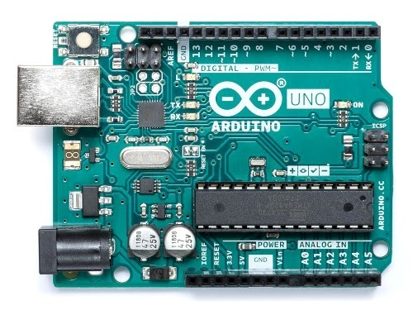
fig 3.3: Arduino
3.4 Arduino IDE: Arduino IDE is open source software primarily used to type the code in the Arduino module and compile it into it. It is an official Arduino program that makes it too easy to compile code that a ordinary person with no prior technical experience will wet his feet with the learning processThis is used to write and attach programs to boards that are Arduino compliant and to other computer boards, with the help of a third party core. Under GNU General Public License, version 2, the IDE source code is released. It can be used on OSes like MAC , Windows and Linux on Java Platform, with built-in features and commands which play a crucial role in the debugging , editing and compiling of code.

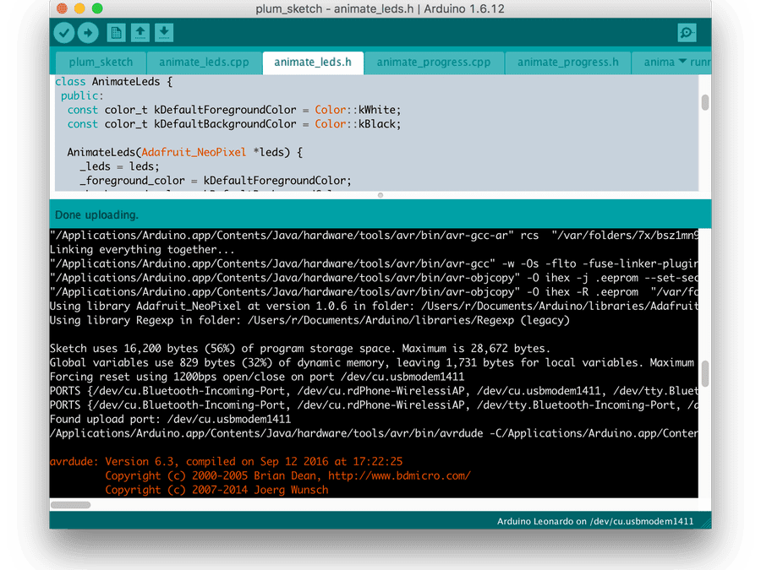

Fig 3.4: Arduino IDE

3.5 C++ Language: C++ is a general language used in computing since the 1990s.
It was built under the name "C with lessons" by Bjarne Stroustrup.
It is a version of C which includes elements for objects , classes and functions.
As can be seen in the following illustration, it is considered one of the largest programming languages. C programming.com deals both with C and C++, and is a well regarded helpful guide to C++, with all beginner-friendly guides, more technical posts and the book C++ Spring.

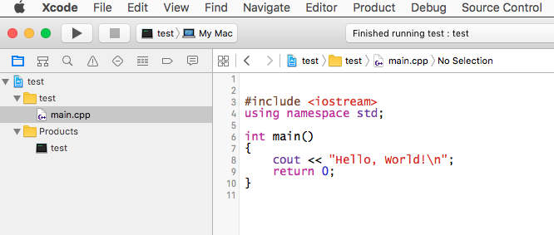
Fig 3.5:C++ Language

3.6 Servo motor: A servomotor is a linear or rotating actuator which enables accurate control of angle or angular direction, speed and distance. It also requires a fairly controlled assembly, mostly dedicated to the use of a servomotor ..
Servo Motors are not a single form of motor, but the term servo engine is generally used as a motor to be used in a loop control device. Servomotors are typically used to provide high-performance alternatives to the step-engine. They are found in applications such as roobot systems, CNC devices, or automatic manufacturing. Stepper engines have some intrinsic location power as they have incorporated performance measurements.
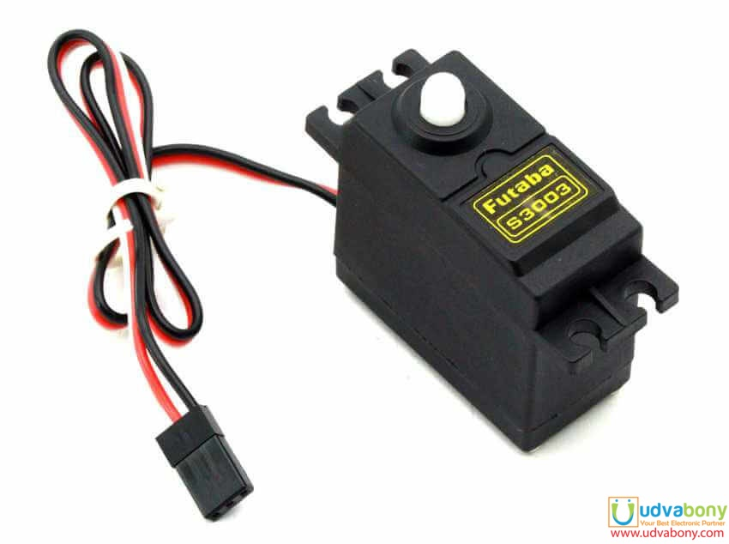
Fig 3.6: Servo motor

3.7 Humanoid Robotic Checis: This Biped robot is a professional small humanoid robot made of complete aluminum components, special non-ferrous oxidation process on the floor, smooth edges that do not harm the paws, unbleached, beautiful and strong metal that prevents long-term decoloration.This robot comprises one head, one main part of the body, two arms, and two legs. It could end walking, turning, side slide movements and be able to make more complicated moves. It could climb stairs if interfaced with related sensors, do line tracking etc.

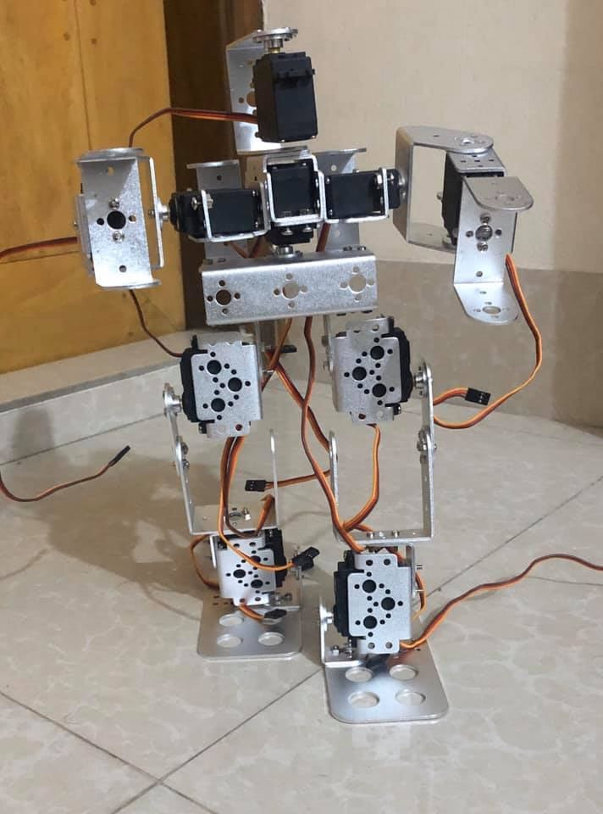
Fig 3.7: Humanoid robotic checis

3.8 Servo Controller: A servo controller is the heart of a servo system a high quality servo system consists of an engine, feedback unit, and controller. Usually, the circuit control involves a controller that produces the motor's motion profile and a motor drive that supplies the motor power based on the motion controller's commands. Servo systems are close loop systems with several advantages over open loop systems, including improvement of transient response times, reduction of stable state errors and reduction of system sensitivity to load parameters.There are a couple of important factors to consider when selecting an application for a servo controller. The first thing is to know which form of motor you want to control. Is the servomotor an ac- or dc-engine.This will help to determine the type of switching the motor needs, and whether the controller can accommodate them.

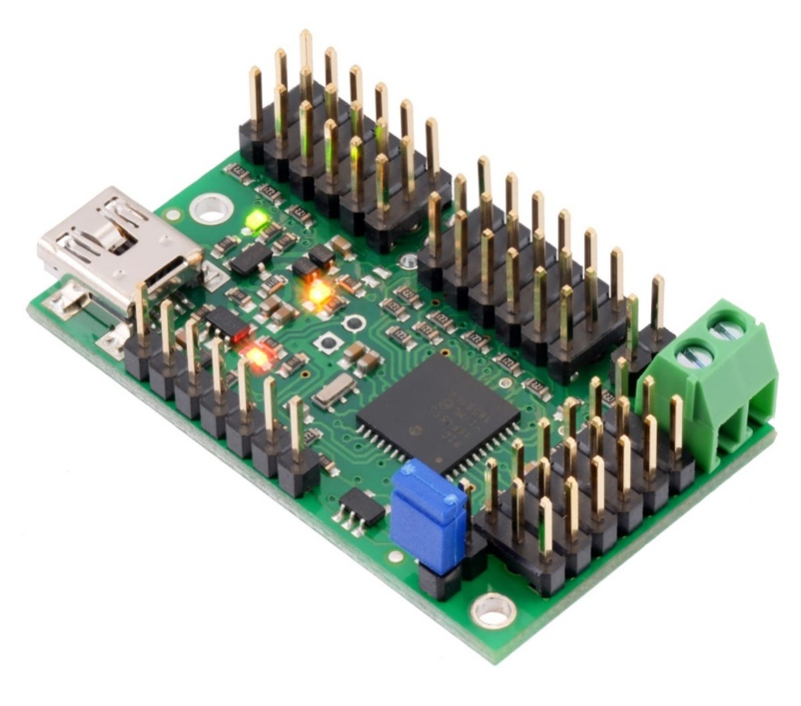
Fig 3.8: Servo controller

3.9 Lithium batteries: Lithium batteries are large anodised metallic lithium batteries A secure shielding coating grows spontaneously on the lithium and acts as a separator. Lithium batteries are particularly appealing for use in many aerospace applications, domestic lightweight military equipment, and industrial applications such as one othher hand held of computers , cell phones, personal paging services, cardiac pacemakers, and digital camera.. Lithium batteries are the most expensive, have the best power source for up to 20 years and can be processed. Alkaline batteries are lighter than lithium and offer a decent power source for a service life of 10 years. The most expensive rechargeable batteries are in the long term and are ideal for use in often-used low-drain devices. 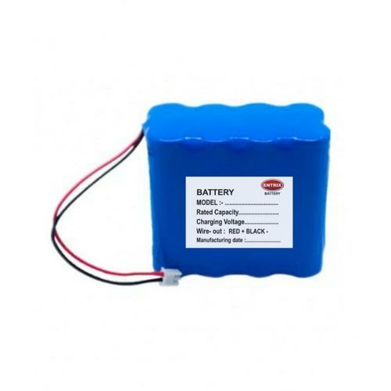
Fig 3.9: Lithium betteries

3.10 Breadboard: A breadboard is a foundation building for electronic prototyping. A breadboard is a solderless foundation for electronic circuit creation and wire cable for projects with Arduino-like microcontroller boards .. As normal, it can be overwhelming when you first start using one. It is reusable, because there is no need to solder the solderless breadboard. This allows the development of temporary prototypes and the use of circuit design experiments. Therefore solderless breadboards are also popular among students as well as in technical education.
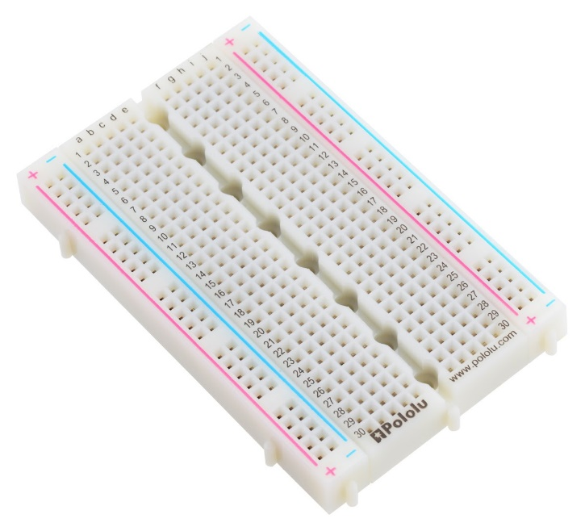
Fig 3.10: Breadboard

3.11 Jumper wire : An electrical jump wire is also called a "jumper wire" or jumper. This is the type of wire that is used to interconnect breadboards or other prototypes, or to test circuit components, both internally, and with other equipment or components, without the use of a solder.Specific jumping wires are mounted by installing the "top cables" on the slots offered in a breadboard, header circuit board or measuring unit. "jumper wire" generally refers to a conducting cable that links two points of one network. Although jumper wire is simple and inexpensive to buy, the struggle for students to create themselves can also be a pleasant activity. To do so, insulated cables and strippers need to be made. Be careful, however, not to nick the wire when the isolation has been removed.
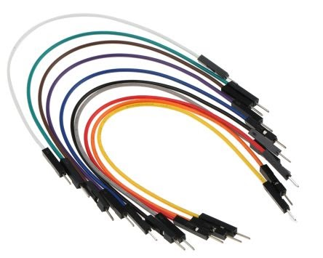
Fig 3.11: Jumper wire

3.12 Glue gun:Glue guns are the mainstay of the construction community, making it possible for thousands of projects. They deal with everything from paper and lace through to wood and metal. Getting started is cheap, and it could not be simpler to use using a glue gun with readily available glue sticks.A glue gun is a portable device where a strong glue stick is fed into. The glue is melted by a heating element in the gun's body and the adhesive flows through the smooth, cone-shaped tip of the glue gun as the glue stick is pushed through the device.Glue guns come in all sizes, from a mini-gun to commercial pistol-grip versions just a few inches in length. Although some manufacturers sell battery-powered glue pistons, most models are plug-in units operated by regular outlets in the home.

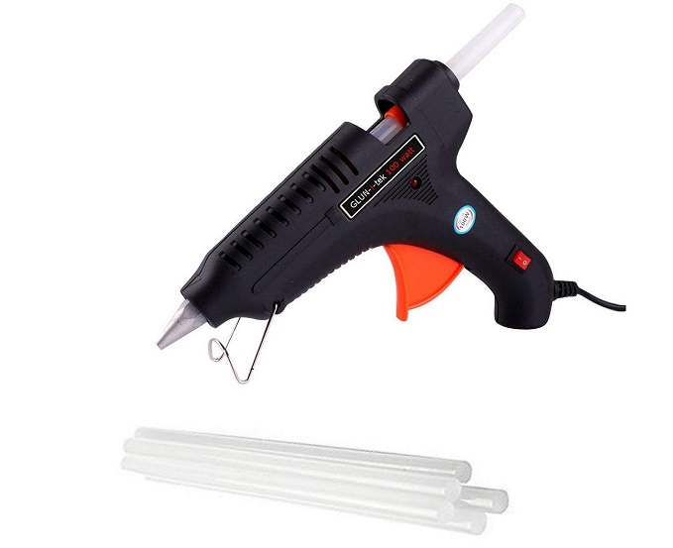
Fig 3.12: Glue gun

3.13 Node MCU 8266: NodeMCU is an open source Lua-based firmware for Espressif's ESP8266 WiFi SOC which requires an SPIFFS file-based on-board board. NodeMCU is set to C and placed on NON-OS SDK espressive.
Initially, the firmware was created as a platform for the common NodeMCU creation modules based on ESP 8266, but the software is now funded by the community and the firmware will now operate on any ESP board ... The typically used prototyping hardware is a circuit board that functions as a dual in-line package (DIP), integrating a USB controller with a smaller surface-mounted board that contains the MCU and antenna. Choosing the DIP format makes prototyping easy on breadboards.

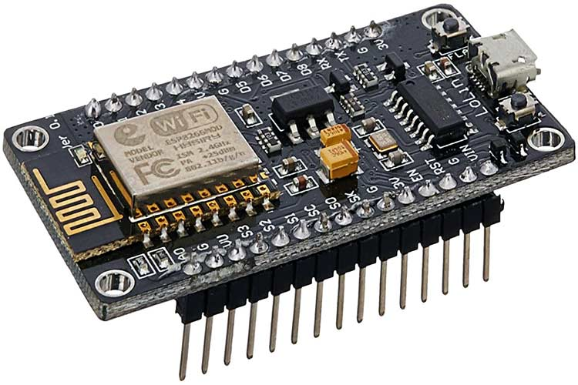

Fig 3.13:Node MCU 8266

3.14 DHT11: The DHT11 is a wireless sensor for temperature and humidity, which is both simple and ultra low cost. It uses a capacitive humidity sensor and a thermistor to measure the surrounding air and spits a digital signal on the data pin (no necessary analog input pins). Its use is relatively simple, but for collecting data, careful timing is required. By utilizing the optical signal buy technology for sensing temperature and humidity, providing good precision and
Outstanding reliability in the long run. A resistive humidity calculation is given in this sensor.
Module and part NTC, link to an 8-bit high-performance microcontroller, providing outstanding efficiency, quick response and anti-interference cost-efficiency and performance.

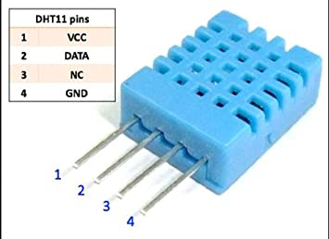

Fig 3.14 : DHT11
3.15 BMP 180: Of calculating barometric pressure and temperature, this Bosch precision sensor is the perfect low cost measurements solution. The intensity should even be seen as a height meter because the altitude changes! The I2C pins include a 3.3V switch, I 2C stage shifter, then pull up tension soldering the Sensor into a PCB. The BMP180 is the next generation sensor that replaces the BMP085 from Bosch. The good news is that it is totally like the BMP085 in firmware and software terms. You can use our BMP085 tutorial as a drop-in replac, as well as any sample code / libraries..

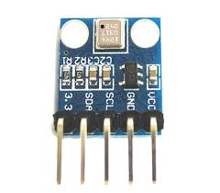
Fig 3.15:BMP180

3.16 HC-05 Bluetooth Sensor: The HC-05 module is a simple Bluetooth SPP module for the transparent set-up of serial wireless systems. The Bluetooth HC-05 is a master and slave module that can be used, making it a perfect wireless solution. This Bluetooth serial port module has the top certified improved data rate Bluetooth V2.0+EDR 3Mbps. The HC-05 Bluetooth module is a module slave.A factory configuration to default to slave. Arduino is regulated with a smart phone and Arduino is operated with a laptop or PC. To avoid overloading this tutorial, I will learn how to set up the HC-05 Bluetooth module and how to communicate Bluetooth between two distinct arduino boards as masters and slave devices in the next tuteorial.Only at COMMANDS can configure the module's Master or Slave function.

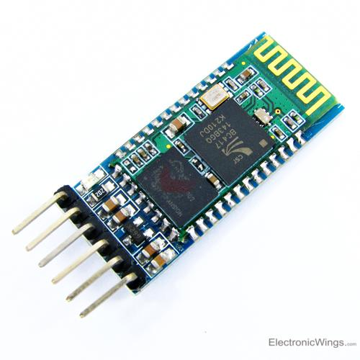
Fig 3.16: HC-05 Bluetooth Sensor

3.17 Wifi: Wireless LAN is the name of a broadband networking device that offers high-speed broadband Internet and network connectivity via radio waves. A widespread misunderstanding is that the word Wi-Fi is short for "wireless fidelity." The Wi-Fi word showing IEEE 802.11x is currently on the market. Wi-Fi networks provide no direct wired link between transmitter and receiver use radio frequency technologies – a frequency that is synonymous with radiowave transmission throughout the electromagnetic spectrum. If the antenna is supplied with RF-current, a space-spread electromagnetic field is created..


Fig 3.17:Wifi

3.18 Oled display: OLED is a flat light emitting system between two conductors by the application of a set of organic thin films. The device may often be used as a flat light emitting. As electrical current is introduced a luminous light is produced. OLED's are emissive screens without backlight and is thus thinner and heavier than LCD's (which need a white backlight). In addition to being thin and effective, OLED displays have the greatest picture quality ever, they can even be rendered translucent, foldable, even, stretchable in future. OLEDs reflect the potential of display technology.

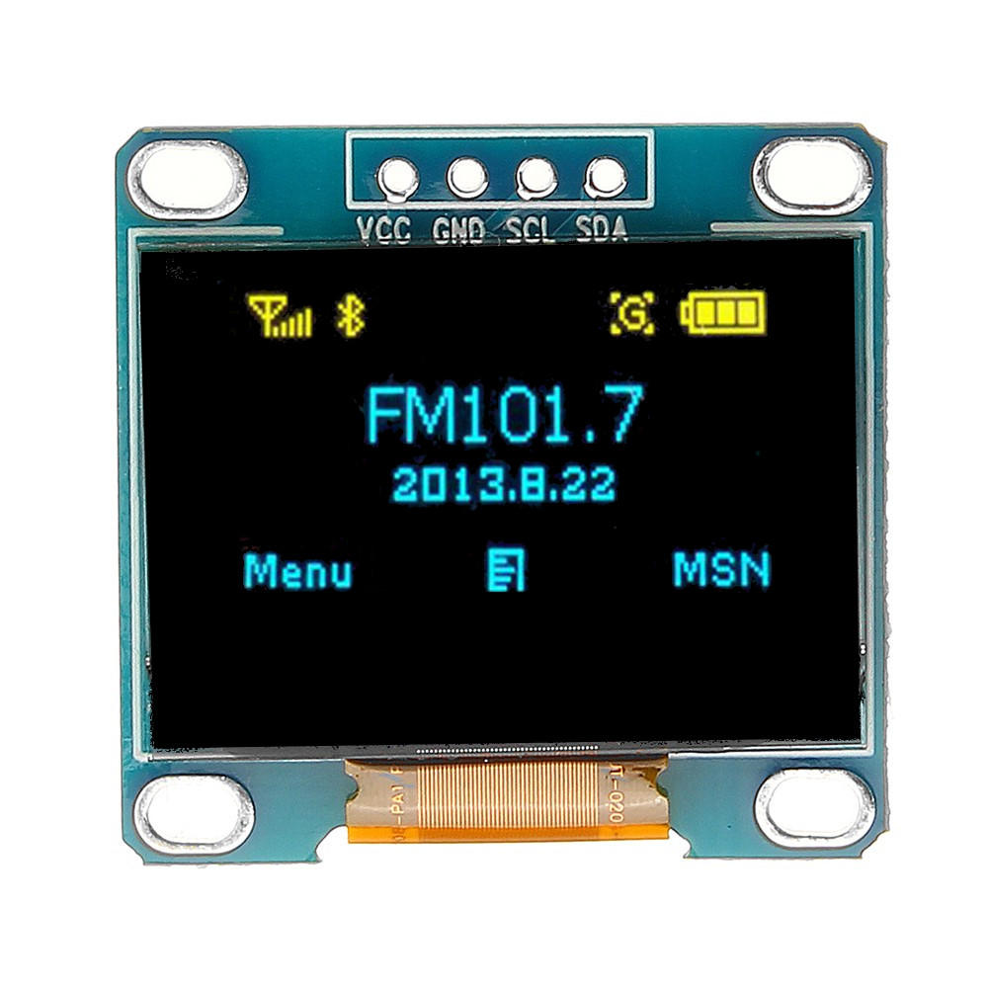

Fig 3.18: Oled display

3.19 Server: A server is a device that supplies knowledge to other computers. This will send details over the Internet to computers operating on a local area network ( LAN) or wide region (WAN). Several server forms, like web servers, mail servers as well as file servers are available. The Web server may operate the Apache HTTP Server or the Microsoft IIS system , for example, and offer Internet connectivity to websites. Every form runs software that is unique to the servers A mail server can operate applications like Exim or iMail, which can transmit and receive SMTP services via e-mail. A server of files can use Samba or the integrated file-sharing services of the
operating system to transfer files over a network.
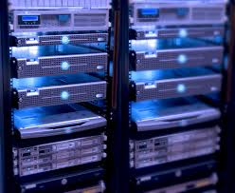
Fig 3.19:Server

Chapter-4
Implementation and result

4.1 Introduction:
The research methodology is the particular methodologies or techniques used for the identification , collection, processing and analysis of point information. In a research paper the methodology zone empowers the scrutinizer to survey the general authenticity and trustworthiness of an examination in a general sense.

4.2 Robot design:

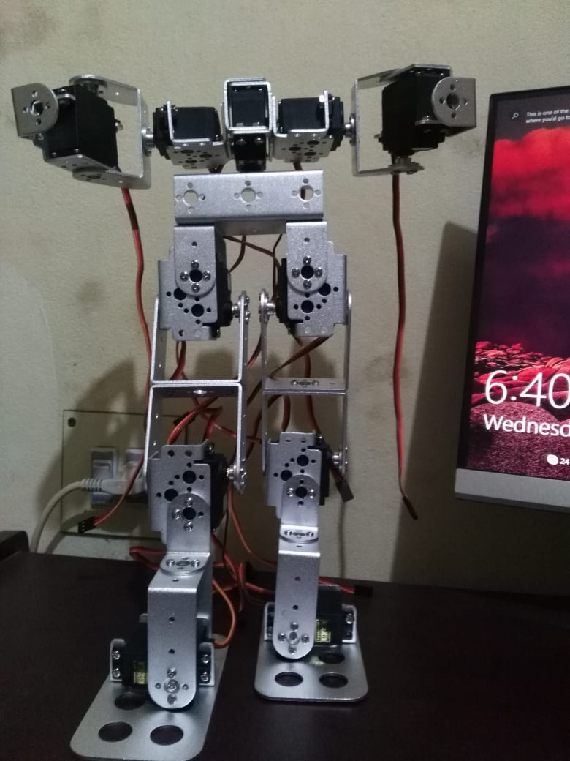
4.2 Fig: Robot design

4.3 Features:

1.This Robot can walk
2.It can collect data
3.It can sense the presence of different types of gas
4.It can go to places where people can't go
5.temparature check
6.humudity check
7.Lcd display

4.6 Flow chart :
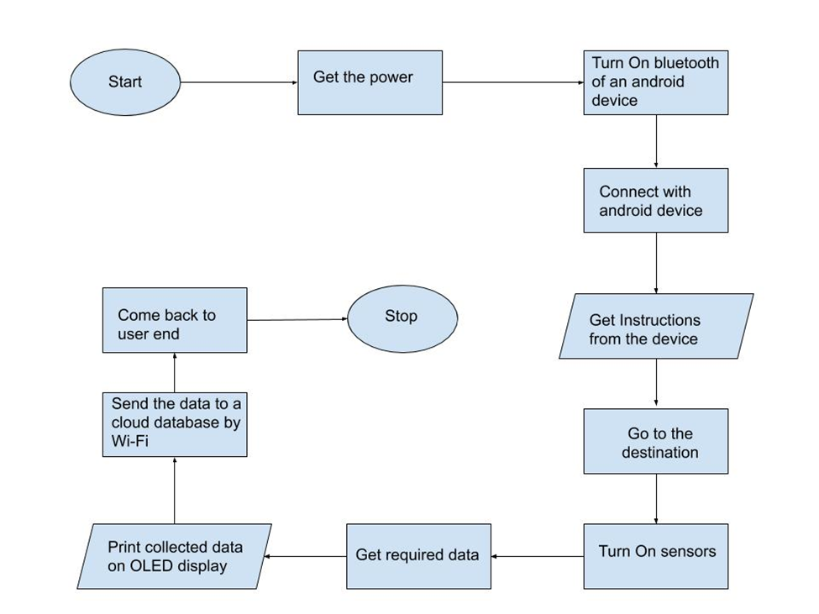4.6 Fig:Flowchart

4.5 Algorithm:

1.Power On.
2.Turn on the Bluetooth of your android phone or pc.
3. Connect the robot with your android phone or PC.
4.Give instructions from the phone or PC
  - Forward
  - Backward
  - Left
  - Right
5. Go to the targeted area by the instructions.
6.Turn On sensors.
7.Collect data by built-in sensors
  - Air-pressure Sensor
  - Gas collecting Sensor
  - Temperature Sensor
8. Show the collected data on OLED display.
9 Send the data to a cloud database with Wi-Fi.
10 Come back to the user end.
11. Stop.

4.7 Block Diagram:

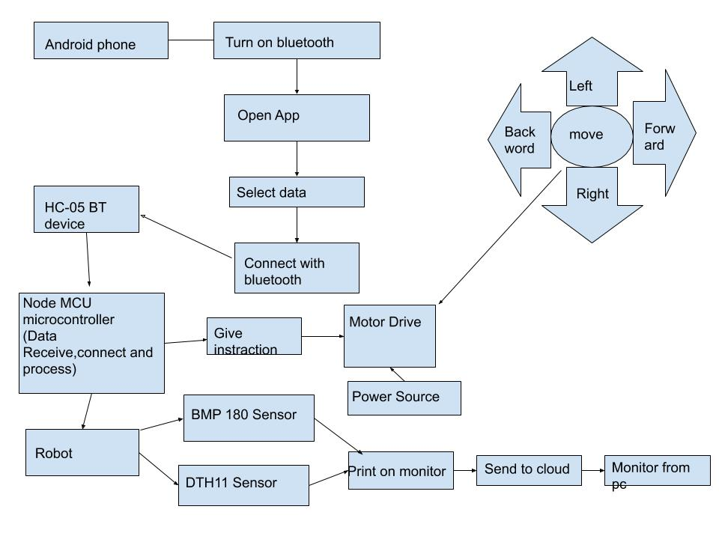

4.7 Fig:block diagram

4.8 Result:
This project we have to tested 100 times.

1)project complete 90%
2)Successful power on status
3)receive the right instruction on Android phone and pc
4)when we check temperature Success 90 %
5)when we check the presence of gas Success 70%
6)Some problems arise when we want to walk it.

4.9 Conceptual Circuit Diagram:

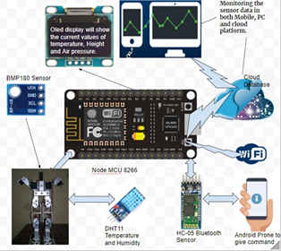

4.9 Fig: circuit diagram

In our project , we used Node MCU8266 microcontroller. we also used one android device ,one HC-05 bluetooth sensor, one BMP 180 sensor, one DTH11 sensor, one Oled display and a robot chassis.

Works :
Node MCU 8266 microcontroller controls all. BMP180 and DTH11 sensor can measure altitude ,temperature and air-pressure. HC-05 bluetooth sensor used for data transmission. And Oled display shows current values of temperature, air-pressure and altitude.

Full system working:
First we need an android device. Robot’s power on.
Then the Android device has to turn on its Bluetooth and open the app and connect via Bluetooth
Node MCU 8266 microcontroller can receive data ,control and process.
A user will be able to control the robot as he wishes.The user will be instructed to use Bluetooth and node MCU 8266 microcontroller with his Android device.
And the microcontroller will receive the instruction and the robot will control it according to that instruction. A user can rotate the robot from front to back and from right to left.This robot has 2 sensors. These sensor can collect different types of data.BMP 180 and DTH 11 Sensor.BMP 180 can measure altitude and air-pressure and DTH11 can measure tempurature and humidity.
And Oled display will show the current values of altitude ,air-pressure, tempurature and humidity.will send its collected data in a cloud databases and notify human user. User can access the data and monitoring the sensor data in both mobile, pc and cloud data base.

Chapter-5

CONCLUSION AND
FUTURE WORK

We have completed our final project design and production successfully. Our "Biped Robot" robot is successful in measuring air pressure, temperature, and humidity as well as altitude temperature. Obstacles of its mission path can be successfully identified by the sonar sensor. It is accurate to 95% data in our project, we want to work in the future with an inferred laser system. We 're now unable to complete this robot with an inferred laser device due to the account issue. We hope to be able to modify this robot with an inferred laser system as well as a movement detection system in the future. Finally, we want our robot to be using AI technology.

References:

[1] Gubbi, J., Buyya, R., Marusic, S. and Palaniswami, M., 2013. Internet of Things (IoT): A vision, architectural elements, and future directions. Future generation computer systems, 29(7), pp.1645-1660.

[2] Lee, I. and Lee, K., 2015. The Internet of Things (IoT): Applications, investments, and challenges for enterprises. Business Horizons, 58(4), pp.431-440.

[3] Zanella, A., Bui, N., Castellani, A., Vangelista, L. and Zorzi, M., 2014. Internet of things for smart cities. IEEE Internet of Things journal, 1(1), pp.22-32.

[4] Gawli, K., Karande, P., Belose, P., Bhadirke, T. and Bhargava, A., 2017. Internet of things (IoT) based robotic arm. Int. Res. J. Eng. Technol, 4(03).

[5] Patil, A.D., Kadiri, H.I., Joshi, A.S. and Wani, A.B., 2016. IoT based remote access human control robot using mems sensor. Int. J. Comput. Sci. Mob. Comput, 5(3), pp.816-826.

[6] Goswami, A., 1999. Postural stability of biped robots and the foot-rotation indicator (FRI) point. The International Journal of Robotics Research, 18(6), pp.523-533.

[7] Kuffner, J.J., Nishiwaki, K., Kagami, S., Inaba, M. and Inoue, H., 2001, October. Footstep planning among obstacles for biped robots. In Proceedings 2001 IEEE/RSJ International Conference on Intelligent Robots and Systems. Expanding the Societal Role of Robotics in the the Next Millennium (Cat. No. 01CH37180) (Vol. 1, pp. 500-505). IEEE.

[8] Ott, C., Roa, M.A. and Hirzinger, G., 2011, October. Posture and balance control for biped robots based on contact force optimization. In 2011 11th IEEE-RAS International Conference on Humanoid Robots (pp. 26-33). IEEE.

[9] Huang, Q., Yokoi, K., Kajita, S., Kaneko, K., Arai, H., Koyachi, N. and Tanie, K., 2001. Planning walking patterns for a biped robot. IEEE Transactions on robotics and automation, 17(3), pp.280-289.

[10] Kurazume, R., Tanaka, S., Yamashita, M., Hasegawa, T. and Yoneda, K., 2005, August. Straight legged walking of a biped robot. In 2005 IEEE/RSJ International Conference on Intelligent Robots and Systems (pp. 337-343). IEEE.

[11] Hirai, K., Hirose, M., Haikawa, Y. and Takenaka, T., 1998, May. The development of Honda humanoid robot. In Proceedings. 1998 IEEE International Conference on Robotics and Automation (Cat. No. 98CH36146) (Vol. 2, pp. 1321-1326). IEEE.

[12]Park, I.W., Kim, J.Y., Lee, J. and Oh, J.H., 2005, December. Mechanical design of humanoid robot platform KHR-3 (KAIST humanoid robot 3: HUBO). In 5th IEEE-RAS International Conference on Humanoid Robots, 2005. (pp. 321-326). IEEE.

[13] Nakaoka, S., Nakazawa, A., Yokoi, K., Hirukawa, H. and Ikeuchi, K., 2003, September. Generating whole body motions for a biped humanoid robot from captured human dances. In 2003 IEEE International Conference on Robotics and Automation (Cat. No. 03CH37422) (Vol. 3, pp. 3905-3910). IEEE.

[14] Kim, J.Y., Park, I.W., Lee, J., Kim, M.S., Cho, B.K. and Oh, J.H., 2005, April. System design and dynamic walking of humanoid robot KHR-2. In Proceedings of the 2005 IEEE international conference on robotics and automation (pp. 1431-1436). IEEE.

[15] Ishiguro, H., Ono, T., Imai, M., Maeda, T., Kanda, T. and Nakatsu, R., 2001. Robovie: an interactive humanoid robot. Industrial robot: An international journal.

[16]Hirose, M. and Ogawa, K., 2007. Honda humanoid robots development. Philosophical Transactions of the Royal Society A: Mathematical, Physical and Engineering Sciences, 365(1850), pp.11-19.

[17] Asada, M., MacDorman, K.F., Ishiguro, H. and Kuniyoshi, Y., 2001. Cognitive developmental robotics as a new paradigm for the design of humanoid robots. Robotics and Autonomous systems, 37(2-3), pp.185-193.

[18] Park, I.W., Kim, J.Y., Lee, J. and Oh, J.H., 2005, December. Mechanical design of humanoid robot platform KHR-3 (KAIST humanoid robot 3: HUBO). In 5th IEEE-RAS International Conference on Humanoid Robots, 2005. (pp. 321-326). IEEE.

[19] Pollard, N.S., Hodgins, J.K., Riley, M.J. and Atkeson, C.G., 2002, May. Adapting human motion for the control of a humanoid robot. In Proceedings 2002 IEEE international conference on robotics and automation (Cat. No. 02CH37292) (Vol. 2, pp. 1390-1397). IEEE.

[20] Yamaguchi, J.I., Soga, E., Inoue, S. and Takanishi, A., 1999, May. Development of a bipedal humanoid robot-control method of whole body cooperative dynamic biped walking. In Proceedings 1999 IEEE International Conference on Robotics and Automation (Cat. No. 99CH36288C) (Vol. 1, pp. 368-374). IEEE.

