Smart Seeder: An IOT based Multi-functioned Drone for Seeding

by
Name: Adittya Borman
ID:172-15-1593

Name: Lutful Hasan
ID: 172-15-1564
AND
Name: Makibul Hasan
ID: 172-15-1570

This Report Presented in Partial Fulfillment of the Requirements for the Degree of Bachelor of Science in Computer Science and Engineering

Supervised By

Name : Tajim Md.Niamat Ullah Akhund (TNU)
Designation
Department of CSE
Daffodil International University

Co-Supervised By

Name : Hasin Rehan (HR)
Designation
Department of CSE
Daffodil International University


DAFFODIL INTERNATIONAL UNIVERSITY
Dhaka, Bangladesh
july 2020

APPROVAL

This Project title “Smart Seeder: An IOT based Multi-functioned Drone for Seeding”, submitted by Adittya Borman, ID no: 172-15-1593, Lutful Hasan, ID no: 172-15-1564 and Makibul Hasan, ID no: 172-15-1570 to the Department of Computer Science and Engineering, Daffodil International University, has been accepted as satisfactory for the partial fulfillment of the requirements for the degree of B.Sc. in Computer Science and Engineering and approved as to its style and contents. The presentation has been held on 12-07-2020

Board of Examiners

Dr. Syed Akhter Hossain Chairman
Professor and Head
Department of Computer Science and Engineering
Faculty of Science & Information Technology
Daffodil International University

Dr. Md. Ismail Jabiullah Internal Examiner
Professor
Department of Computer Science and Engineering
Faculty of Science & Information Technology
Daffodil International University

Md. Reduanul Haque Internal Examiner
Senior Lecture
Department of Computer Science and Engineering
Faculty of Science & Information Technology
Daffodil International University

Dr. Mohammad Shorif Uddin External Examiner
Professor and Chairman
Department of Computer Science and Engineering
Jahangirnagar University

Declaration

We hereby declare that, this project has been done by us under the supervision of Name: Tajim Md. Niamat Ullah Akhund , Designation, Department of CSE Daffodil International University. We also declare that neither this project nor any part of this project has been submitted elsewhere for award of any degree or diploma.

Supervised by:

Name: Tajim Md.Naimat Ullah Akhund
Designation
Department of CSE
Daffodil International University

Co-Supervised by:

Name : Hasin Rehan
Designation
Department of CSE
Daffodil International University

Submitted by:

Adittya Borman
ID: -172-15-1593
Department of CSE
Daffodil International University

Lutful Hasan
ID: -172-15-1564
Department of CSE
Daffodil International University

Makibul Hasan
ID: 172-15-1570
Department of CSE
Daffodil International University

ACKNOWLEDGEMENT

First we express our heartiest thanks and gratefulness to almighty God for His divine blessing makes us possible to complete the final year project/internship successfully.

We really grateful and wish our profound our indebtedness to Supervisor Tajim Md. Naimat Ullah Akhund, Designation, Department of CSE Daffodil International University, Dhaka. Deep Knowledge & keen interest of our supervisor in the field of “Field name” to carry out this project. His endless patience ,scholarly guidance ,continual encouragement , constant and energetic supervision, constructive criticism , valuable advice ,reading many inferior draft and correcting them at all stage have made it possible to complete this project.

We would like to express our heartiest gratitude to Dr. S.M Aminul Haque and Head, Department of CSE, for his kind help to finish our project and also to other faculty member and the staff of CSE department of Daffodil International University.

We would like to thank our entire course mate in Daffodil International University, who took part in this discuss while completing the course work.

Finally, we must acknowledge with due respect the constant support and patients of our parents.

Abstract

The spread technology has spread everywhere. Now the use of technology in all cases is going out day by day. Because the use of technology is increasing the speed and production of work. The whole world face to food problem huge amount to every country. So we have need that more food in our world. That’s why we need improved our agriculture sector. In this Digital world technology have been improved in the agriculture. Smart Seeder involves the IOT is the better resources from the application in the field. because the smart seeder an IOT based multi-functioned seeding in the field, and in this system operated by the GPS smart connected by the internet to the drone. This technology is the fully IOT (internet of things) based helped the farmers living standards and very highly provide the more crops, and the world food problem is solved the digital this way. But it is not a success because we do not have enough suitable technology. So, thus, this study needs further research.

Table of Contents

Name Page
Chapter 1: Introduction
1.1 Introduction 9
1.2 Motivation 9
1.3 Objectives 10
1.4 Expected outcome 10

Chapter 2: Literature Review

2.1 Background 11-19

Chapter 3: Requirement and Methodology

3.1 Ardupilot MCU 20
3.2 11.1V LIPO Battery (wild Scorpion 2200m AH 3S Battery) 21
3.3 ZMR250 Carbon Fiber Quadcopter Frame 22
3.4 Genuine Emax 1806 2280KV Motor 23
3.5 4in1 BLHeILS 25A ESC 25
3.6 APM 2.8 Flight Controller 26
3.7 Gem fan 5 Inch Propeller Pair (CW/CCW) 27
3.8 Fly sky CT6B Channels Radio Set 28
3.9 5V/2.5a BEC 29
3.10 Imax B3 Charger 30
3.11 PDB 31
3.12 XT60, Silicone Wire, Heat Shrink Tube 32
3.13 ESP8266 34
3.14 DHT11: Temperature and Humidity Sensor 34
3.15 S02-AF 35

Chapter 4: Result outcome
4.1: Result outcome 39
4.2: Project View 40-45
Chapter 5: Conclusion 46

References 47

List of Figure

Name Page

Fig 3.1: Ardupilot MCU 21
Fig 3.2:11.1V LIPO Battery (Wild Scorpion 2200 MAH 3S Battery) 22
Fig 3.3:ZMR250 Carbon Fiber Quad copter Frame 23
Fig 3.4: Genuine Emax 1806 2280KV Motor 25
Fig 3.5: 4in1 BLHelLS 25A ES 26
Fig 3.6: Gem fan 5 Inch Propeller Pair (CW/CCW) 27
Fig 3.7: Fly sky CT6B 6 Channel Radio Set 28
Fig 3.8:5V/2.5A BEC 29
Fig 3.9: Imax_b3 charger 30
Fig 3.10: Power Distribution Board 31
Fig 3.11: Heat-shrink Tube 32
Fig 3.12: Flow Chart Diagram 33
Fig 3.13:ESP8266 34
Fig 3.14: DHT 111 34

Fig 3.15: S02-AF 35

Fig 3.16: flow chart diagram 36

Fig 3.17: stock diagram 37

Fig 3.18: Working diagram 38

CHAPTER 1

Introduction

1.1 Introduction:

This world-wide farming faces many problems and challenges. The UN FAO ( United Food and Agriculture Organization ) will expects the production of food must raise 70% of the forty years to increasing demand due to economic or rising and growth of population . Population of growth is the main problem and main challenge of global world and global agriculture. Year 2050 around seven billion people to approximately nine billion people in the world. So we can must be increase our growth field and the crops. Then we can use digital technology in the agriculture field for more crops. So we use smart seeder IOT drone in the field, it’s reduce the time and seeds in the field very perfectly also it can reduce the human works and the less cost for the human. It will pour the seeds of the crops in a field in correct positions and its help to grow more crops. This drone that will be controlled by the Ratio remote and smart mobile phone. It can also collect data about the field and end those to a database. When the drone any kind mistake by the happen in the field then as soon as possible notification send the remote and mobile phone.

  - Motivation :

Now this world day by day population is increase and also we need to food more. So we must be grow more crops in the field. Modern agriculture to smart thinking apply in the field. So we can use IOT (Internet of things) and smart seeder IOT drone for farming use in the agriculture sector. So when this drone apply grow more crops and many benefits of farmer. Apply the smart seeder then we expected the more crops in the field.

- Old system seeding is very costly and time consuming.
- Seeding is very hard work for farmers.
- Ordinary Seeding takes huge time and not cost effective.
- Ordinary Seeding is not well organized.
- Farmers need some notifications about seeding which is not available in ordinary system.

In the order solve this problem, we have inspired to make such a system.

  - Objective :
- The drone will be able to do the work of an automated seeder.
- The drone will be controlled via Radio remote and mobile.
- The drone will send the notification to cloud server and mobile.

  - Expected Out Come :

- The drone will be smoothly controlled by Radio Remote and Mobile.
- It will send the proper notification throw internet and mobile.
- It will sow the seeds in an organized way.
- The system will be fully automated.
- It will be cost effective and long lasting.
- It will reduce human work.

CHAPTER 2

Literature Review

2.1 Background:

Authors of [1] have said, that The Smart Seeder IOT Drone for Farming is the Digital most benefit for more crops. It can collect some data about the field and send those to a database. It will pour the seeds of crops in a field in correct positions .That will reduce the human work and help to grow more crops .This is also handling all seeds very smartly .ordinary seeds huge time also .
This drone is very expensive but it’s long lasting. When farmers buy this drone its works allots 8-10 years then cost very less for farming. This drone maintain very easy because of drone will work automated by the radio remote and the mobile .This drone works also all the weather when hot or cold and rain or sunlight, its most becomes benefits for that. This drone do not want rest but when the farmers works it need to rest so it’s so much time save for this drone .
So this drone works much better for more crops because the drone works very smoothly. This drone development the farmer works and digital technology for our country to more development our successfully for farming. This smart IOT drone technology not only development our farming, its help others also provide the smart thinking to change the old seeding technology.
Authors of [2] have said that, this drone works amazing for smart farming. The drone setup some application and seeds the on the fields perfectly. The drone works much fast than human works and also grow much better crops .this drone control much easy and if any kinds of mistake seeds in fields then give the notification signal to mobile or radio remote
The drone fly around the field and search location seeds properly in the fields and seeding right place. The drone also found the notification on the fields if any mistake of seeding. This smart drone development our farmer and the technology. This smart drone became the works any weather in the field and also any time, it so much helpfully the farmers. This drone also that very environment friendly. The drone security very easy maintain this. The drone can be works whole day in farming. This drone use to farming the crops more and increases the success the plant. Also it helps our technology side. When all the farmers apply this technology plant growth with a high success rate. This IOT drone published very openly to farmers get that helping his crops apply smart thinking, and forget old the system seeding in fields.

The drone use UAVs agricultural and development the farming, this drone is very modern technology for our country more progress this agricultural department. This drone is design 3D CAD (Computer Aided Design). This drone control by the human. This drone is very powerfully to design and also seeding right place. this send right notification in mobile or radio remote if any fault happen but this drone normally fast and high speed work on field , also very smoothly situation control on field .

This drone is numerical modeling. So the future drone is design would be development more crops and also grow, and the test under conditions the field and which time grow more crops, which field more efficient crops that notification is given the drone.
This seeder system give modern thinking and many limitation overcome go to next step and development our farming. This seeder access always works very fast to other human works system. So lt of benefits for this drone seeder system. This drone seeds suitable any time in field. This modern technology we should apply every agriculture.
Authors of [3] have said that, the population is day by day growth in our world, so our lots of food also need. Many farmers are more grow crops illegal system apply. Such as deathly medicine use in field grow up early crops. Crop production day by day many digital or smart technology use in farming, its very product quality is very high, also that past need more instrument need to seed. This is really provide many cost high and seeds are not organized. So soon as we need possible progress to our agriculture .so it’s only happen when this smart seeder drone apply in field and grow more crops , also can provide our food , this system absolutely safe apply in field .
Aerial apply
This time drone flying spraying in the field of the crop. Also that drone know the present conditions crop send the notification mobile. Also this drone can be control by the without the human when some specially degree given this drone when its works own.
(1) Drone can be know the environment which time crop grow most,
(2) Drone can be works own freedom not depend on human so its help the crops,
(3) Which time need to water in crops the can be provided.

Advantages:
1. Energy costs this way do not happen all of works done by the drone.
2. This drone sensor much faster than human to found the problem of crops.
3. The drone works cost much less than human works.
4. The drone works much faster than human works.
5. The drone works very smoothly in all the weather.
6. The drone can be test the field on crops conditions then can be take the next step.
7. This drone works very safe to grow crops.
In this case
We give the examples how to development our agriculture system in smart drone applications. Also that drone how to help our crops much faster than human works and the cost also. This drone lots of advantages, and also safe for the field. This drone all of the problem and seeds maintain very smartly very easy. This drone control also very easy to farmers because of the drone controlled by the mobile and radio remote.
Authors of [4] have said that, this smart seeder begins the farming and long time in fields apply drone. This seeder also face the problem of the field but this problem its can solve also very fast by control. This drone long time service of the seeder in field and very smoothly works fly in sky.
Innovation farming in world present. There are “undone science” (Freckle et al., 2010, very smart thinking, follow that from field in seeds who can collect data.
That smart innovations Canada and other many apply the most of the powerful digital technology use in the field.
So this way grows the crops are very useful for the and also healthy for the man , this way most of country are use them drone smart seeder and also the government are help the farmers to use for them this way . This way crops much faster than other way old or human way that why Canada and their country government very interest for this way.
every government day by day much improvement their farming thinking and digital way and also smart apply , so this way apply farmers and much better success their farming sectors , and much less expensive to other old way or human way , it’s also reduce the human works , less time way
every government Corporations find farming thinking about their farming to reduce our cost when they get solution then apply this so smart seeder one of them . Then the government help the people grow improved farming and also help the financial.
Authors of [5] have said that, Digital and smart Modern agriculture plant, animal and machine monitoring so as to ensure optimal functioning. Most of current time of field’s robotization is it very need to collect data system perfect automated very fast apply for animal and plant which can be status provide very short time provided the required data .
Mainly there are purpose of the alternatives has two side in apply in field: (Internet of Things) the drones and the devices, (plants for perfectly) so the many ways, audiovisual firstly, in the field’s data collect making when over crops fight by the sensors.
The drone fast select the place seeds the crops in the filed then the drone very smoothly works in in this world the very fast time devices of IOT military was apply this drones . then the drone works very smartly and when this drone was success then thinking the drone apply the IOT for farming, when they works also very successful in farming so every government very interest about apply every farming’s sectors this drone and of the fast there is appearance made so many types of ways complete construction of the models. : This was only click photos and fly this, not strong military sectors. Then they think apply better works in farming sectors.
The smart IOT drone which can be communication and exchange data automatically by the internet and the control by the mobile phone or remote. This way the world environment will be must safe and its will very good concepts thought control of the devices.
1.1. The drone devices of IOT collect data and store data in the very short time.
1.2. IOT drone will communication the interconnected to the management networks control in the mobile or remote,
1.3. The drone will works data so many process and store the database IOT center, the cloud, the local server.

1.4. Present data and its real-time process and analysis in terms development the basis for making good business decisions.
1.5. This way farming also very advantage the human waste own crops in fields walking.
1.6. Smart seeder farming very benefit most of its in crops.
Those are very useful to farming sectors in this digital process. This two sectors apply much helping the farmers works much easy and smoothly and very safe to grow much fast to other old sectors or human process.
Authors of [6] have said that, a trend of the agriculture new and digital smart seeder IOT drone for farming day by day much faster in our world. This is system of the process information and technology update farmers. The drone get information the field and get notification to the mobile how to perfectly works. When the drone made any kinds of the mistake then the as soon as possible get send the notification into mobile and remote control. This way very safe to crops grow up because smoothly works into field and works also very fast so it’s very important .this communication system is wireless networks and provides the information to the mobile very fast. This drone can fly how much those are decide human remote control or mobile wireless.
After a network protocol has been selected, a wireless network configuration needs to be chosen. There are three main network configurations, which are (Digi International Inc., 2014). Those are select networking system protocol. point -to- point network is specific to specific place point it selected , point -to- multipoint network is one specific to one or multi place selected place , peer to peer network is one place another place to selected .
This way there are two items that could be done to improve the maximum message speed. First, the sent messages numbers could be declared a number type that has a smaller number of bits than a double or 26 bit unsigned integer.
For the purpose of the monitoring the central control station, a wireless communication and information system was designed Lab VIEW. The program was tested with two UAV’s but could be expanded to run in infinite number of UAV’s at once. This wireless communication system could send complete messages back and forth at 200 Hz consistently. When the 200Hz over the communication and the information data is missing in the mobile or remote. Because of the program will set the drone and capacity will be 200Hz. So when the system under 200Hz works get notification any information to mobile, works very perfectly in fields. Smart seeder IOT drone for farming very usefully.
Authors of [7] have said that, day by day our population much higher so now we need development our agriculture sectors. So we much apply very smart thinking in field how development our agriculture sectors. now we can thinking digital smart IOT drone apply in the agriculture , and those drone controlled by the remote or mobile , so when this kinds drone apply the field our agriculture improve much high , and also much easy , when the drone problem face the field as soon as give notification to the mobile or remote .
This drone works very smoothly in the field and perfectly and much faster than any other human works or old system. How to works the drone:
Collect the data in the field
Ground and land test
Corn sowing
Corn spatter and Spot spatter
Corn Mapping and Surveying
Works time to time in the field
Correct seeds in the field
Works multiple in the field
Drone works very smartly
Proper notification via the mobile phone or remote
Smartphone development or radio remote control by the connecting and control devices IOT.
This papers we have to presented by smart IOT drone for farming how apply the drone in the field and also benefit our agriculture sectors.
And how connect by the drone in the mobile or radio remote control and how works any mistake by the drone or notifications send as soon as possible to.
So we have must apply this system in our agriculture sides and its cost much less than other system way.
Authors of [8] have said that, now day’s advances very low cost and powerful the devices connected interne such as the updated cameras, sensors, smartphones, etc.
1. Smart meter
2. Volvo autopilot
3. Garmin vivo fit 2
4. Proteus pill
Those are or many think smart internet to services our lifestyle and improved smart thinking create some new technology.
1. Discover a new devices IOT send the data needs they can be and found it.
2. Store these IOT devices and their data.
3. When it’s to development and the analyzed needed data IOT by the target.
4. When the any kinds of the currently devices services to products targets become waste.
5. And those data must be save when again some need modify.
So GDP IOT in every country its much development agriculture sectors.
In the word human our need safe grows more crops provide our food and healthy crops. Also this kinds apply government interest much better than now days because of its very helping the development smart IOT drone for farming.
In this paper we found the how to apply in smart IOT drone for farming, and how works in the field and control by the mobile or remote. Communication by internet in digital system.
Authors of [9] have said that, Digital technology much better improve our agriculture and benefit grow our more crops. This way grow crops expensive much less to other way. When fast rime when this apply digital way agriculture in the field so many problem face to farming but now day its problem solve then it can benefit our grow crops in smart IOT drone for farming.
Authors of [10] have said that, the smart seeder IOT drone for farming is needs a smart Farming Technologies and smart idea. Because it needs to some data about field. We can use the data present situation, analysis, apply the new digital technology in the fields and provide the farmers less time in the fields and helps grow more crops. And also this ways apply the drone very easy.
This way drone can be fast seeds in the fields and notification send by the mobile phone or remote. This drone specific management of the field. Smart seeder specific collect some the some data in the field and seeding very perfectly in the fields. This drone has be controlled by the remote and mobile phone. This drone is digital so it can works automated and smartly.
So the drone have use must smart technologies for smart works. Acquisition, Data analysis and evaluation technologies added here for a smart device.
Authors of [11] have said that, this is way the digital agriculture technology apply to in the field , and the development IOT drone for farming projects , this projects development how to grow more crops and also very friendly to environment . This is way to find digital agriculture in the field, this is also very easy to understand the farmers control by the drone.
A digital technologies can be a digital agriculture.
Authors of [12] have said that, a smart farming drone can be growing up crops easily. Is save many times and energy and lever cost. Many country already using it and they are success by smart farming drone. So we also can using this idea for our farmer. It will be save growing cost and save money. Our neighbor country already using this technologies. So we are also developing our technologies.
The world all most every country agriculture is the back bone, so we need grow more crops in the every country. So we need apply now day’s digital way in the field.
Authors of [13] have said that,
- The primary sector apply this drone is very usefully in our country and our world.
- Smart seeder is management in the field very smartly.
- This smart drone connect from the internet
- Seeds properly in the field this smart seeder
- Farmers can be use this drone every field for seeds
- This is internet based devices
Authors of [14] have said that, this is smart seeder works by drone and the drone has been control by the remote and mobile phone.
- Smart seeder interconnect between internets.
- This drone seeds very fast to other way.
- Farmers can be use very easily.
- This drone collect some data in the field very firstly.
- This is the digital technology so it can be cost low.
- Works much better than others.
- This is development also found the most benefic for it.
Authors of [15] have said that, Summary: Internet of Things (IOT) technology has revolutionized every aspect of each and every land.
The human nowadays thinking about very smartly do the every works.
Internet of things (IOT) is the refers of network based
Create own network configure to work in the field
This is Develop of farming of the smart seeder IOT Drone
Turning to agriculture during the day increases day by day and also the cost is the very highly for farmers.
This papers purpose this smart seeder to development how to farmers in the field.
This drone helps the farmers live data give in the field.
Always needed to internet when the drone its works
This is the latest technology in the apply in the field
This drone when its use its must be grow more corn in the field
This drone is use very easy controlled by the remote
This smart seeder an IOT multi-functioned in the land
This way seeding time is very short.
Authors of [16] have said that, in any economy, the practice of abstract smart farming is of paramount importance
To increase our world population day by day so we must needed food to our world population. When not increase our food then this world many of the people died for the hunger. So we must need smart thinking to grow more corn in the field. In this digital world internet has been improvement to many things, so we apply the digital way to grow corn in the land. How help to the people to smart seeder:
- Smart seeder grow more corn to other old way.
- This way cost very low.
- Smart way to time seeds very shortly
- It’s must reduce the human works
- This drone works multiple
- Drone seeds proper in the land
- Measurements of the land at the farm show suitability
- Determining tempter and humidity in silo as well as at different times instantaneously
- A smart seeding system implemented by internet.
- This way so many reducing the animal illness.

Authors of [17] have said that, Agriculture Drone usage is increasing in agriculture
And more popular. The paper has presented a fancy approach to distinguish between different field plow techniques
An RGB-D sensor.
The system presented can be easily integrated
Inside the commercially available unmanned aerial vehicle (UAV)
There are two separate, plow techniques to successfully classify
Measurement algorithms have been developed. Experimental tests
Show that the proposed method is capable of providing a good one
Field plow jewelry classification.

Authors of [18] have said that, nowadays internet is very easy works in the agriculture.
In this digital world internet much improvement in the field that’s why most of the country apply the digital way the smart seeding. This way seeding multi-functioned benefit to the farmers. Also grow more crops in the field.
This way technologies control automated operations.
Needed to Wi-Fi or mobile data to get notification in the field.
This drone control by the remote or mobile phone.
This is monitoring from mobile app and website.
Data analysis
Further analysis
Controlling smartly
Technology or imminent value
Wisdom is considered
More enabling to properly activities as the works

CHAPTER 3

Requirement and Methodology

Requirement:

3.1. ArduPilot MCU
Hardware:
1. ARM Cortex microcontroller base
2. Edge, drone controller with video streaming system.
3. Minnow board.
ArduPilot implement has been very effectively in the so many airplanes. Issue designer location control easily user can such as
- Use
- Configure
- Mapping
- Search
- Recuse
- Program
- Simulate
- Surveying areas
ArduPilot the first rending covert by the fixed aircraft and the based was thermopile sensor.
Apply of the ArduPilot:
- Helicopters
- Ground rovers
- Boats
- Submarines
- Multirotor Drone
- Antenna trackers
- Pusher.
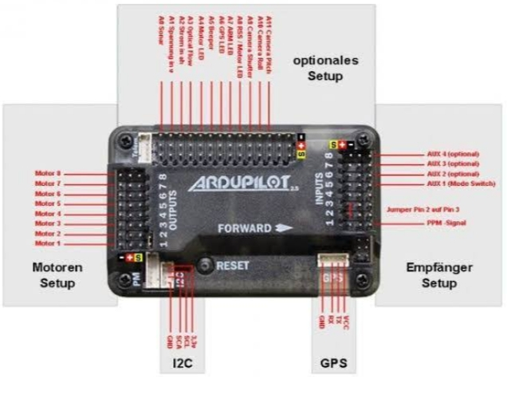
Fig3.1:Ardupilot MCU

3.2. 11.1V LIPO Battery (Wild Scorpion 2200mAh 3S Battery)

Specification ::
1.Battery capacity: 2200mAh
2.Continuous Discharge Rate: 30C
3.Max Discharge Rate: 40C
4.Battery section: 3S (11.1V)
5.Cell Unit: 3 Cells
6.Weight: Approx. 190g
7.Charge Plug: JST-XH
8.Discharge Plug: JST
9.Rechargeable Battery
10.Dimension: 23.5 x 35 x 68 mm

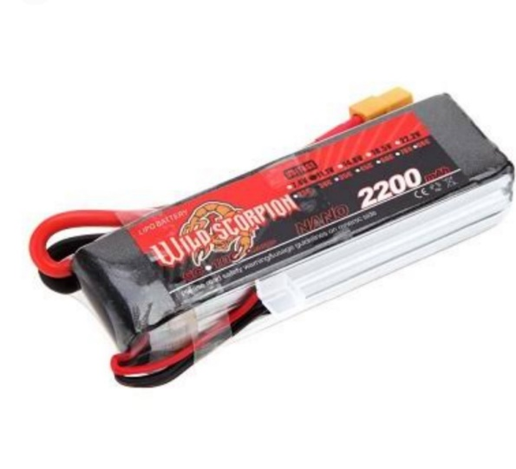
Fig3.2:11.1 LIPO Battery

3.3. ZMR250 Carbon Fiber Quad copter Frame

Specifications:
1.Chasis Plate Thickness: 2mm
2.Arm plate thickness: 4mm
3.Main material: carbon fiber
4.Diagonal size: 250mm
5.Weight: 145g (with screws)
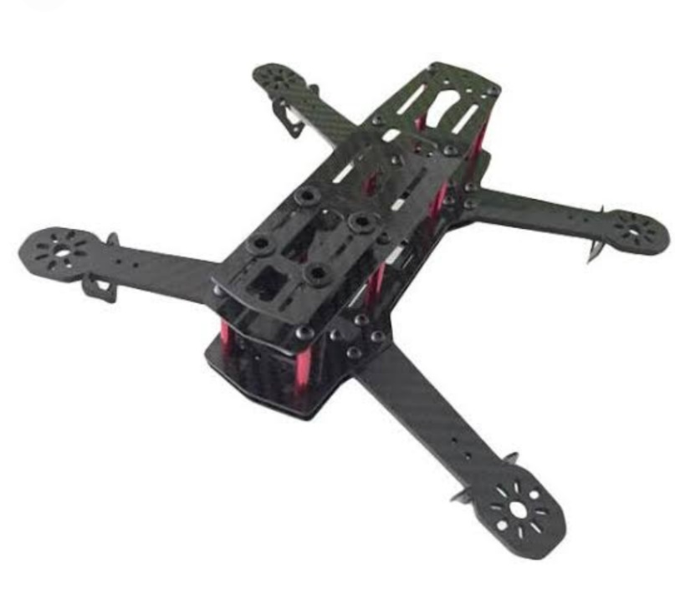
Fig3.3: ZMR250 Carbon fiber

3.4. Genuine Emax 1806 2280KV Motor

Emax MT1806 motor is available with threaded shaft in CW and CCW rotation. Your quad needs 2 CW motor and 2 CCW Motor. Choose an option as per your needs.

Description

1.Brand Name: Emax
2.Item Name: MT1806 motor
3.KV: 2280
4.No. of cell: 2 - 3S
5.Framework: 12N14P
6.Shaft: 2mm
7.Diameter: 26.7mm
8.Length: 23mm
9.Weight: 18G
10.Propeller: 5 - 6 inch

Package Included:
1. 1 x EMAX MT1806 KV2280
2. 1 x motor accessories

Specification:
1. KV:2280
2. MAX thus: 460G
3. NO.OF CELL:2-3S
4. Framework: 12N14P
5. Propeller :5'-6'
6. Length:26.7 MM
7. Shaft:2MM
8. Diameter:23 MM
9.HSN Code: 95030090
10. Motor Type: Out runner
11. KY: 2280 KV
12. Shaft Diameter: 5.0 mm

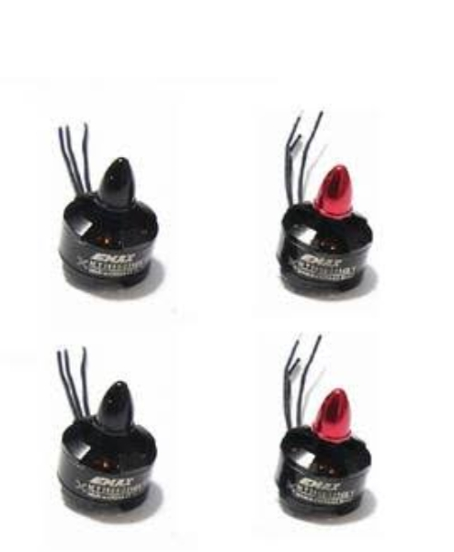
Fig 3.4: Genuine Emax 1806 2280 KV Motor

3.5. 4in1 BLHelLS 25A ESC

Specifications
- Input: 2-4s LIPO
- Constant: 25 Amps
- Burst: 35 Amps
- Weight: 20g w/ wires
- Dimensions: 27x27x2mm (6mm tall including connectors) (31mm wide with motor tabs)
- Mounting Dimensions: 20x20mm
- Motor wire: 70mm
- Signal wire: 140mm
- MCU: BusyBee2 MCU at 48MHz
- PCB - 4 Layer Blind Pole PCB - 3oz Pour
- Mosfet: N-Channel
- BEC: OPTO (none)
- Supports Damped mode, Oneshot125 and Multi shot, DSHOT

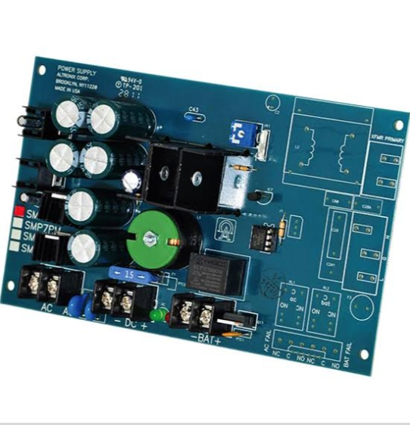
Fig3.5: 4in1 BLHeILS 25A ESC

3.6. APM 2.8 Flight Controller

Features :
- Straight Needle
- Adriano Compatible!
- 12-16 V input voltage
- Dimensions LxWxH: 85 x 45 x 15
- No micro SD card slot
- Sensors 3- Axis Gyrometer accelerometer

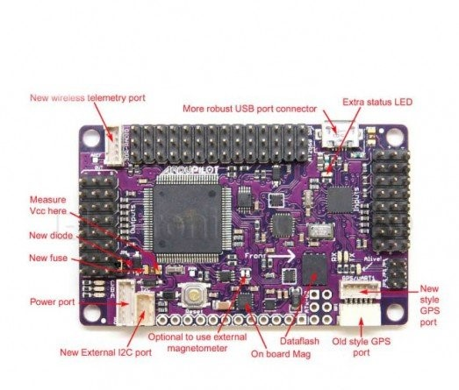
Fig 3.6: APM 2.8 Flight Controller

3.7 Gem fan 5 Inch Propeller Pair (CW/CCW)

Specification:

1. Brand name: Gem fan
2. There are no adapter rings
3. Hub thickness 7.5
4. Hub OD Dieter 13.3
5. Materials poly carbonate

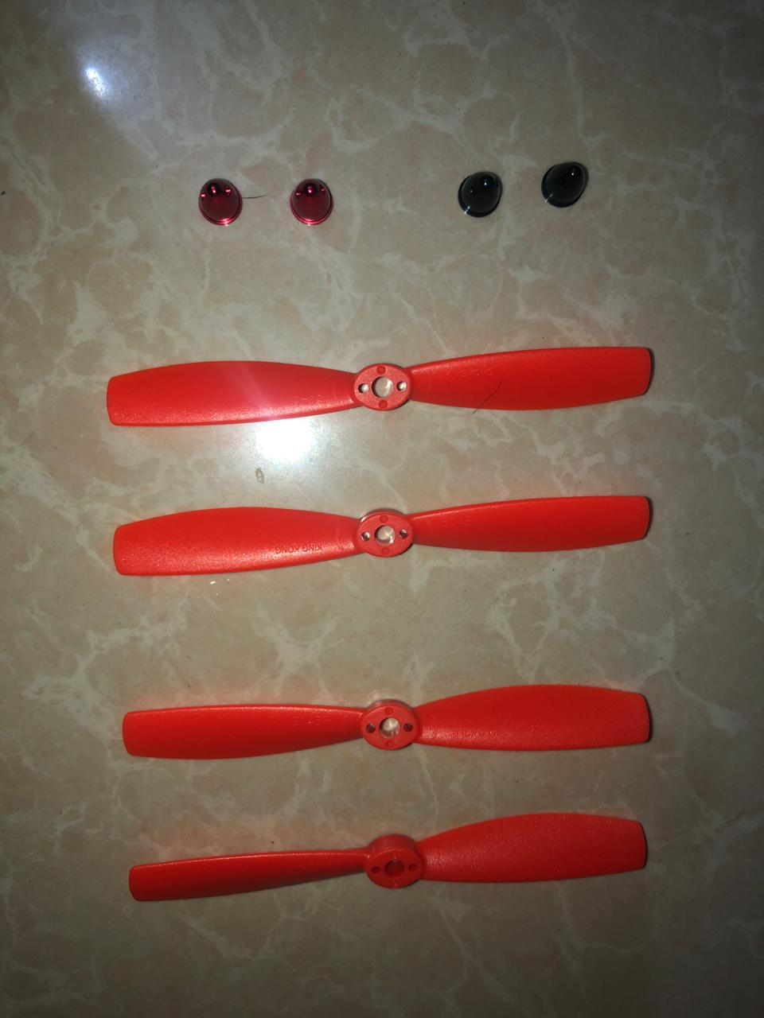
Fig 3.7: Gemfan 5 Inch Propeller Pair (CW/CCW)

3.8 Fly sky CT6B 6 Channel Radio Set

Features:
- Super active and passive anti-jamming capabilities.
- Very low power consumption.
- High receiving sensitivity.
- 8 model memory, digital control.
- Can be programmed by PC with included software.
- Full range 2.4GHz 6-channel radio.
- 4-Model
- 4 Types (Airplane, Heli90, Heli120, Heli140).
- Integrated

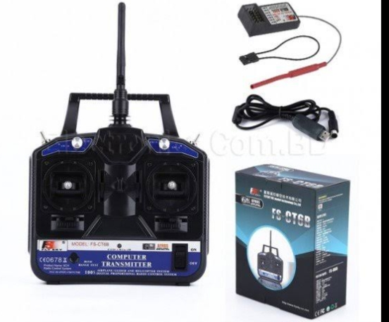

Fig 3.8: Fly sky CT6B Channel Radio Set

3.9. 5V/2.5A BEC

This small synchronous switching step-down (or buck) controller takes an input voltage of up to 38 degrees and efficiently reduces it to 5V .The board measures only 0.7 × × 0.7 measures but it allows a common continuous output current at 2.5. . The general capabilities of 85% to 95% make this controller suitable for powering medium loads such as sensors or small motors. High efficiency is maintained at light loads by dynamically changing the switching frequency, and an alphabetical shutdown pin enables it to be in a low-power position with a current drawing of macro several hundred Step-down voltage regulators produce lower output voltages ranging from D24V25FX family input voltage to 38V between85% and 95%, which is much more efficient than linear voltage controllers, especially when the difference between input and output voltage is larger than the available output current input. A function of voltage and efficiency (see general efficiency and output current section below), but the output current Typically 2.5 can be as high. At light load, the switching frequency changes automatically to maintain high efficiency. These controllers have a current drawing of less than 1 mA (no load), and a pin that can be used to keep the boards in a low-power state allows the constant current to be about 10 µA to 20 µA per volt.

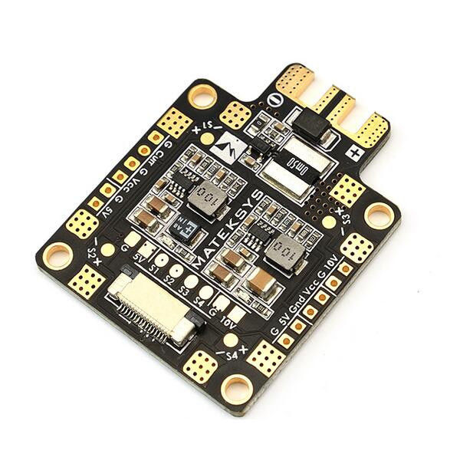
Fig 3.9: 5V/2.5A BEC.

3.10: Imax_b3 charger

This simple charger will do the job: plug in the compatibility connector, charging only 2s or 3s batteries without the need for further adjustment. Dual color LEDs indicate the status of each cell: red - in charge progress, green - the cell is fully charged.
Important! Never leave the charger and battery without monitoring while charging. A faulty charger or damaged battery can cause a fire, causing damage to property or human health or life.
Main benefits
1. Charging current: 850 mA
2. Input voltage: 110 - 240V
3. Cells on the battery: 2 or 3
4. Charging Power: 10W
Package included
1. The invader
2. Power cord

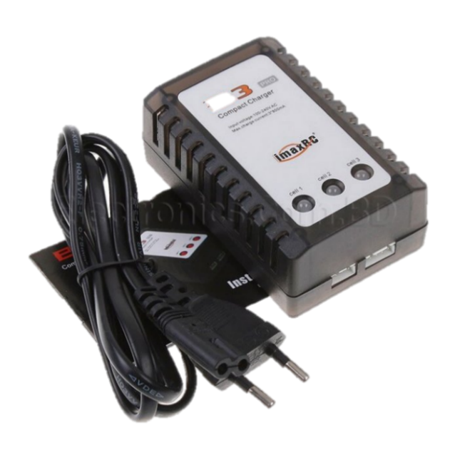

Fig 3.10: Imax_b3 charger.

3.11: PDB
Features:
1. Power Distribution Board is the quad copters.
2. Distributions power from the flight battery to quad copters ESC.
3. Distributions ESC PPM signals.
4. comes pre-assembled, no soldering required.
Technical Specifications:
1. x power distributions board
2.4- Wire harness for ESC PPM signals
3.2x 15cm battery power cable

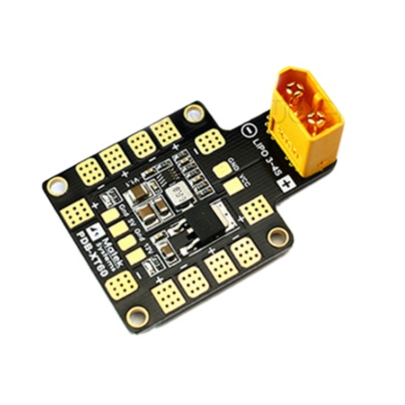
Fig 3.11: Power Distribution Board.

3.12. XT60, Silicone Wire, Heat-Shrink Tube

XT60:
Real XT60 is made by Amass for the XX. TGY connectors are manufactured at the same factory. All the others knocked out. Any one of the three will have a registered trademark next to the identifier.
Silicone Wire:
Silicone rubber insulated cables have a suitable temperature of up to 200oC for high temperatures and low temperature of -1 ° C. Silicone rubber cables also have excellent flexibility. Silicone rubber insulation does not offer the same mechanical toughness and cut-through resistance compared to other elastomers, but it can be compensated for by adding a glass fiber braid and silicone varnish.

Heat Shrink Tubing is a compressible plastic tube used for heating heat, which of different types and chemical makeups, depending on the exact composition of each type [1] Microscopically-thin-wall pipes have rigid, heavy-wall pipes from nearby, precise designs of each type and chemical additives that make it environmentally diverse. Makes it suitable to meet the variety of needs. Heat-shrinkage pipes are increased by their expansion ratio, comparing the difference between expansion and recovery rate.
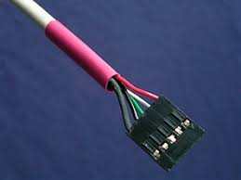

Fig 3.12: XT60

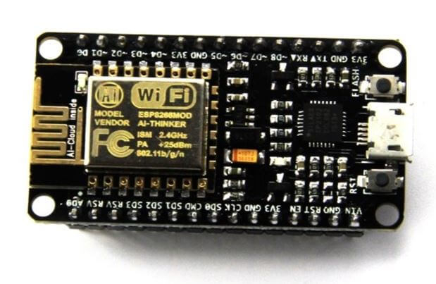
3.13: ESP8266:

Fig 3.13: ESP8266

3.14: DHT11-Temperature and Humidity Sensor:

Applications:
- Measure degree and coldness
- Native atmosphere position
- Proper climate control
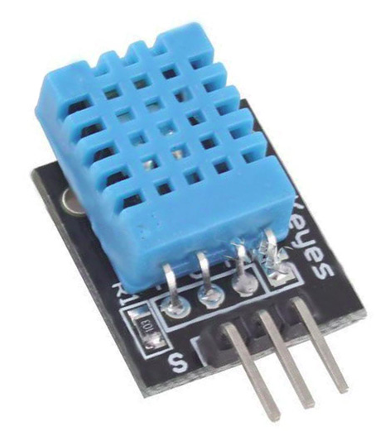
- The Environment monitoring

Fig3.14: DHT11 Temperature and Humidity Sensor

3.15: So2-AF:

  - Current is the straightway assembly sulfur dioxide
  - Hydrogen sulfide is the used for land protection environment and many big manufactured.
  - This is the gas target could be test by the current value.
  - This way process are relief electric charge and generates current.

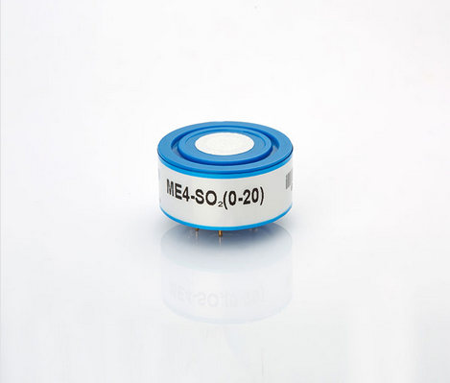

Fig3.15: S02-AF

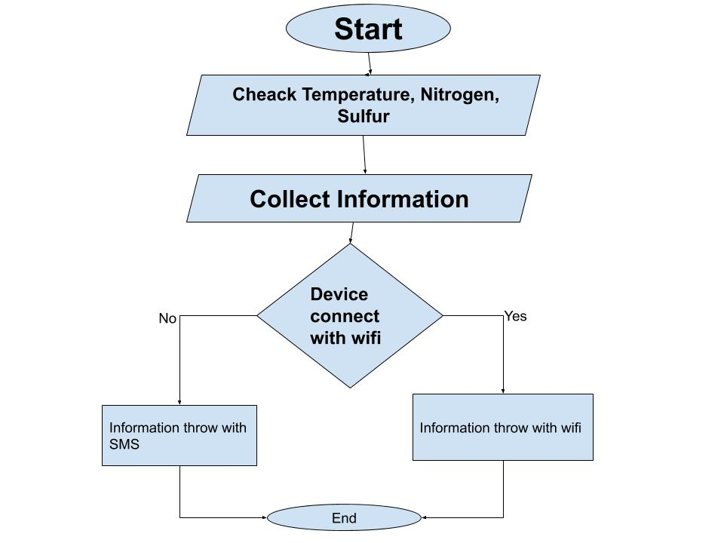

Fig 3.16: Flow Chart Diagram
Working process: This drone is a multifunction drone. It has different functions for different tasks. It can be check temperature, sulfur and nitrogen of any field. It then collects data from the field and sends it to farmer with SIM module or Wi-Fi. If the drone connects to a Wi-Fi range, it sends data over Wi-Fi. Otherwise it is transmitted by SIM module.

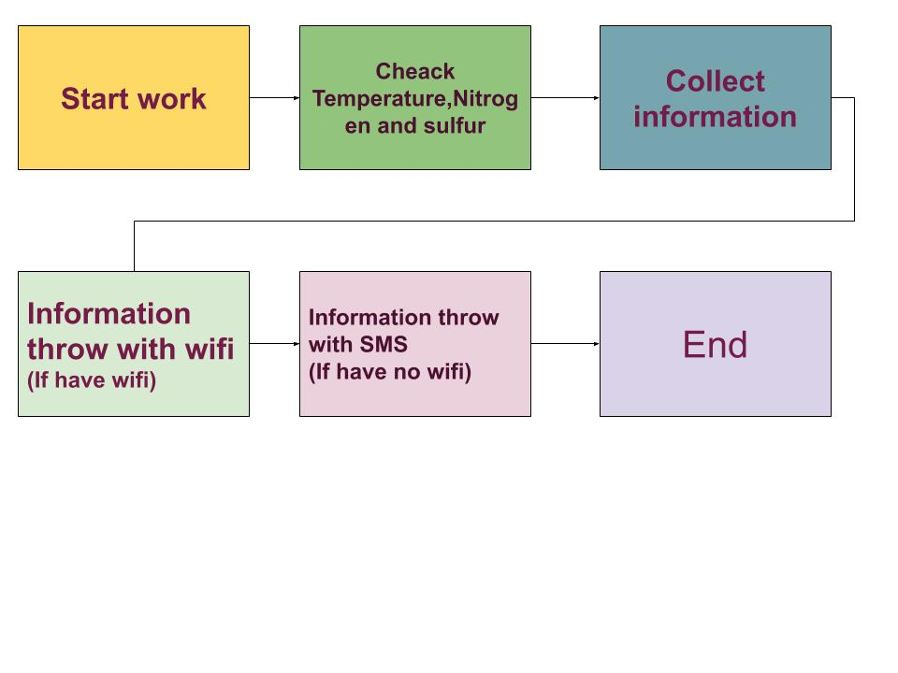 Fig3.17: Stock Diagram

Step1: Start work
Step2: Check Temperature, Nitrogen and sulfur
Step3: Collect information
Step4: Information throw with Wi-Fi 9(if have Wi-Fi)
Step5: Information with SMS (if have no Wi-Fi)
Step5: End

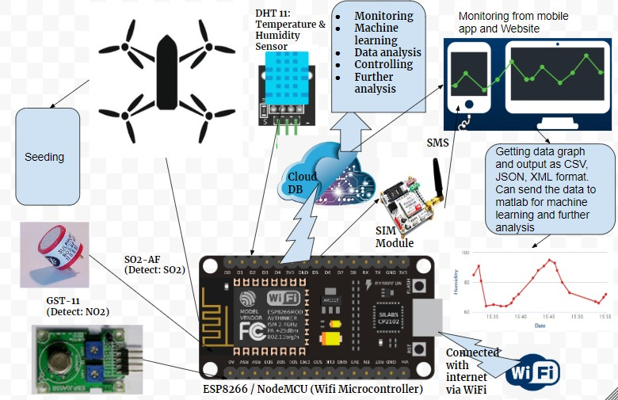

Fig 3.18: Working Diagram
Working process: We connect GST-11 here to detect the amount of nitrogen in the soil. And sulfur detection sensors of So2-AF model have been used to detect the amount of sulfur. Set up the detect temperature. This device collects land information with the help of sensors and saves it to the database. It has a Wi-Fi controller system for complete wireless control. For that we connect a Wi-Fi device for smart controlling. And it has added a SIM module for sending data from the database. Here if the device is connected to Wi-Fi, it will provide information through its Wi-Fi otherwise it will provide information using the SIM module. And it can be monitored from mobile applications and web sites.

CHAPTER 4

Result & Outcomes

4.1 Result Out Comes:

- This drone is multi-functioned working very smoothly and smartly ,
- It will controlled by Mobile phone and Radio Remote.
- This drone control very easy.
- It will send the proper notification throw internet and mobile phone or radio remote.
- The drone seeding of crops very properly in the field.
- This system will be automated fully.
- Cost will be less for human works and this drone will be long lasting.
- Human work will be reduce.
- This drone working very fast for human work.
- This drone can works all the weather.
- Apply this drone in the field, so works properly then grow more crops.
- Products and services will development faster, because of the interconnected between farmer and devices to their communication with each other.

Project View:
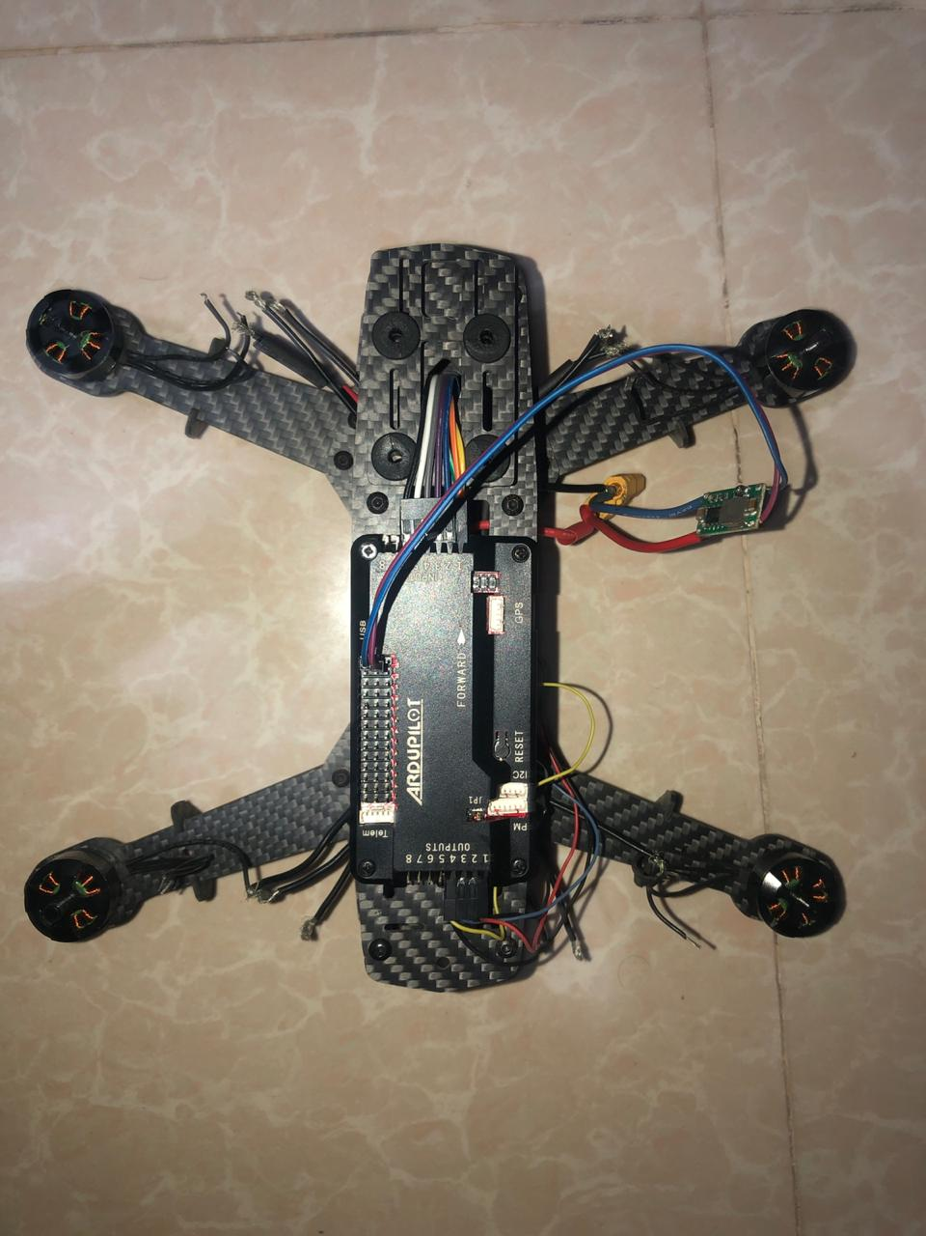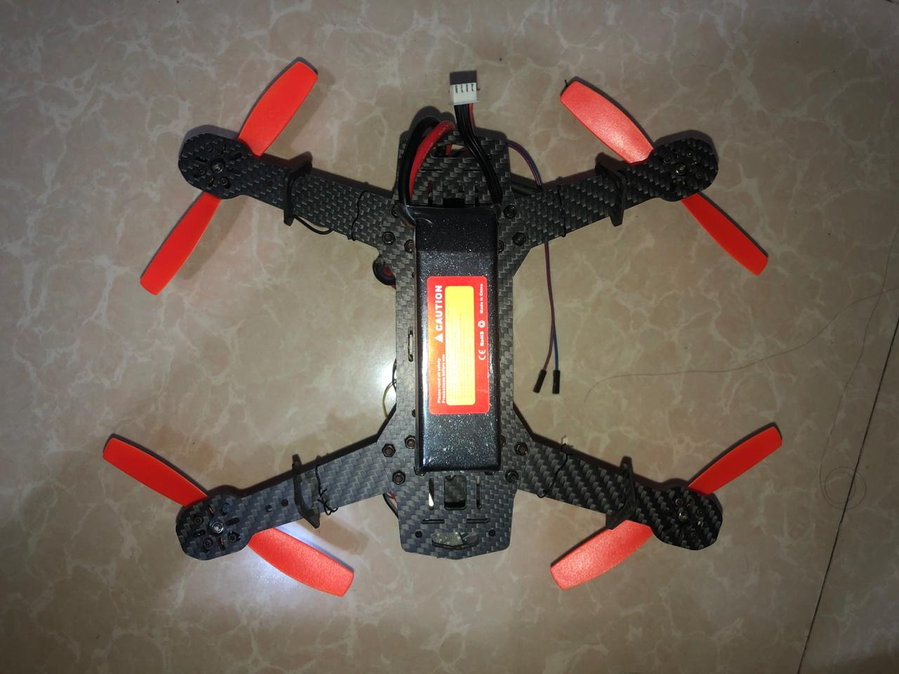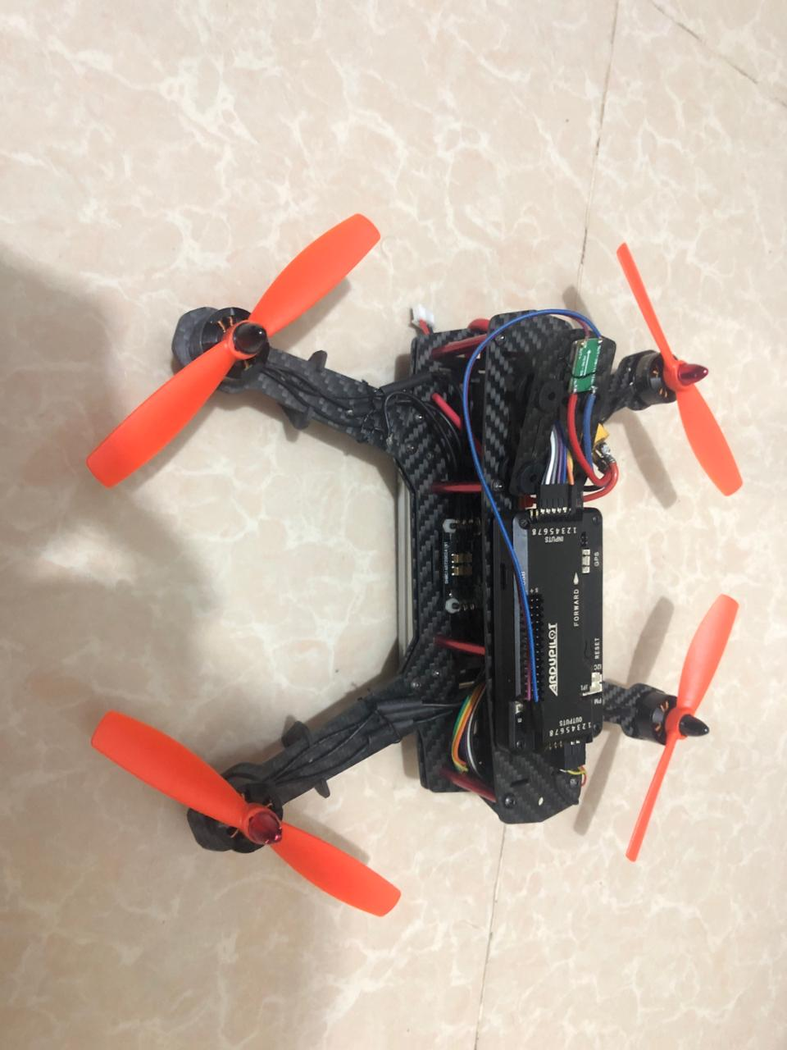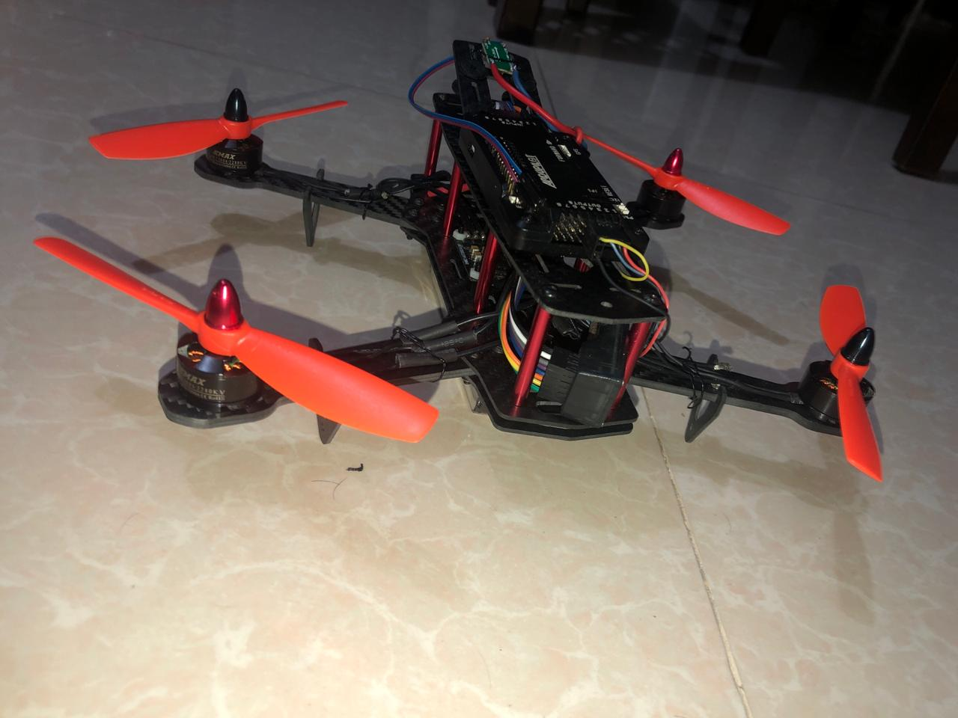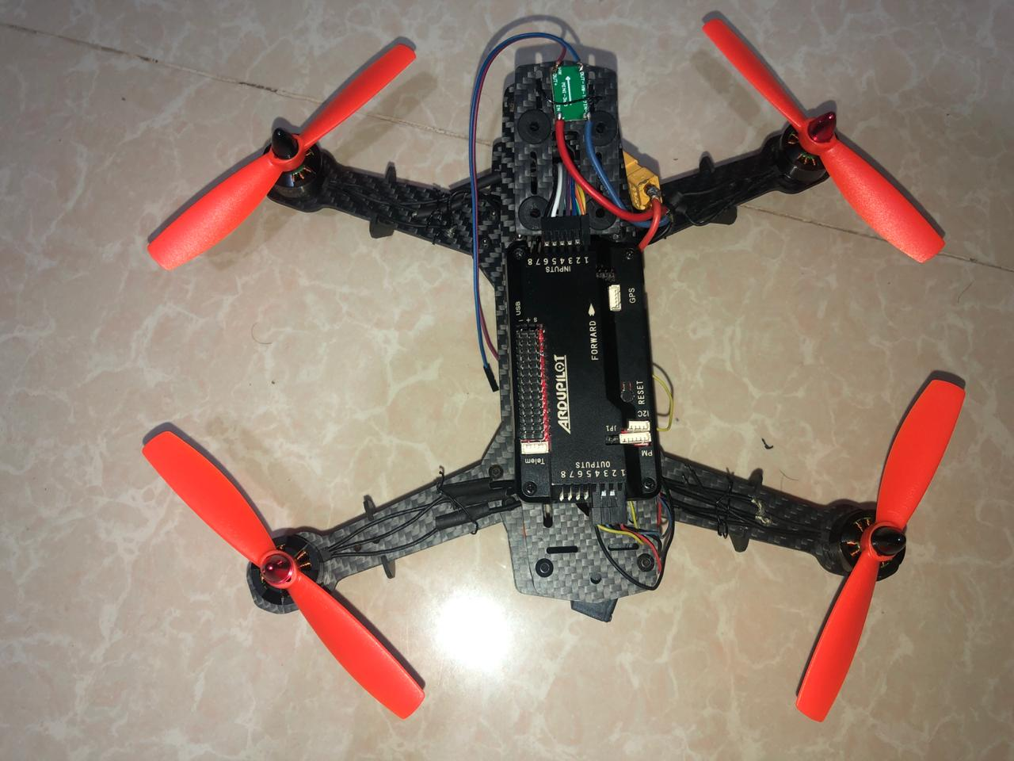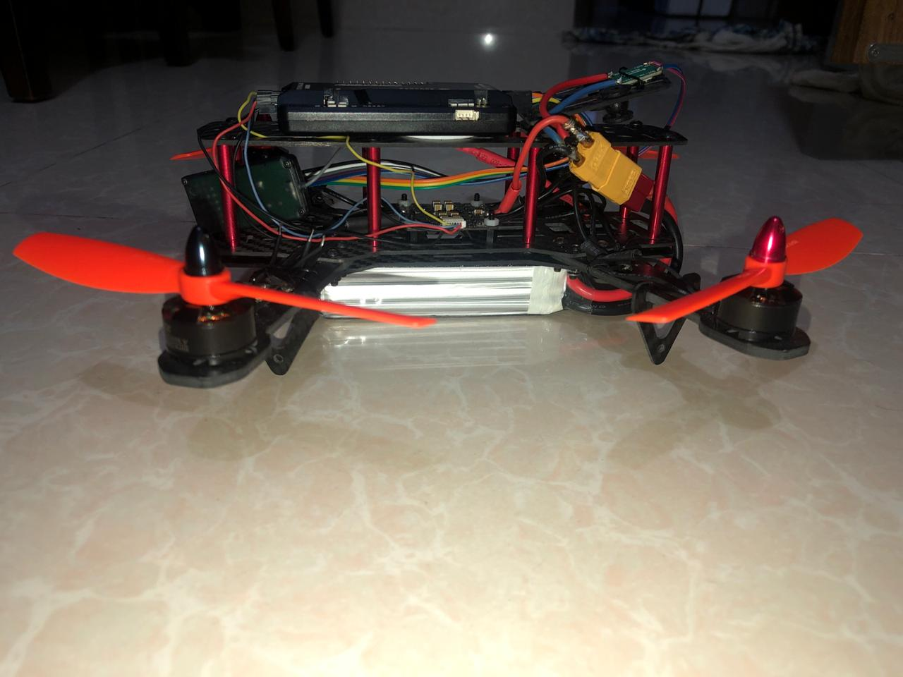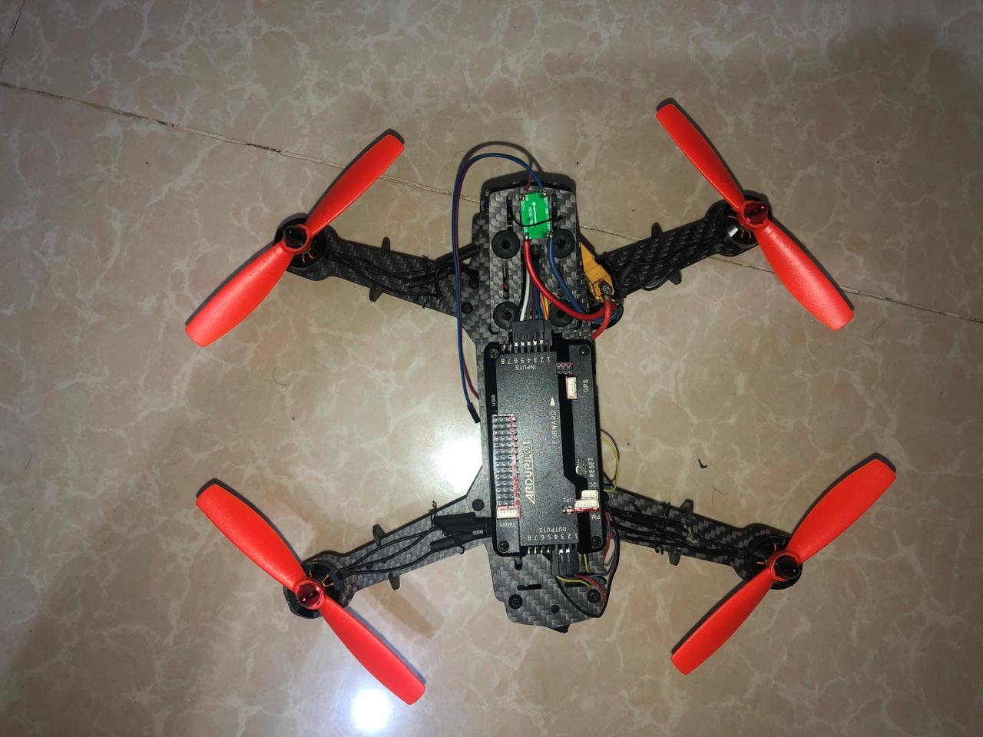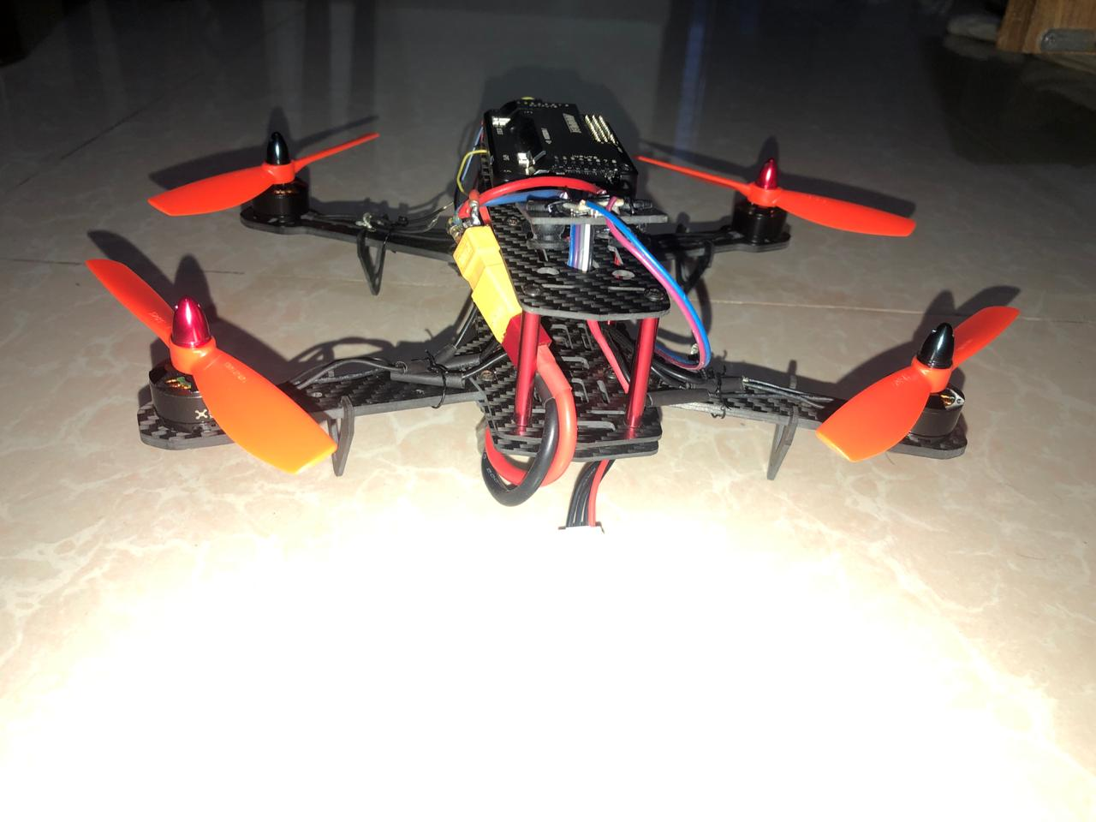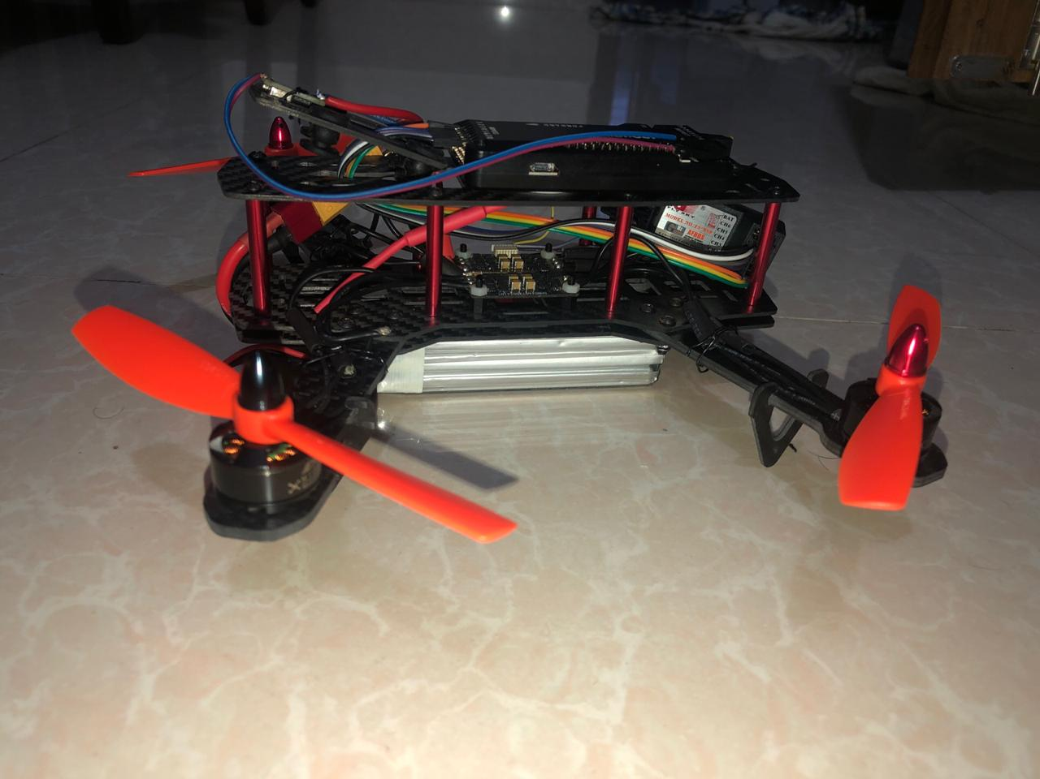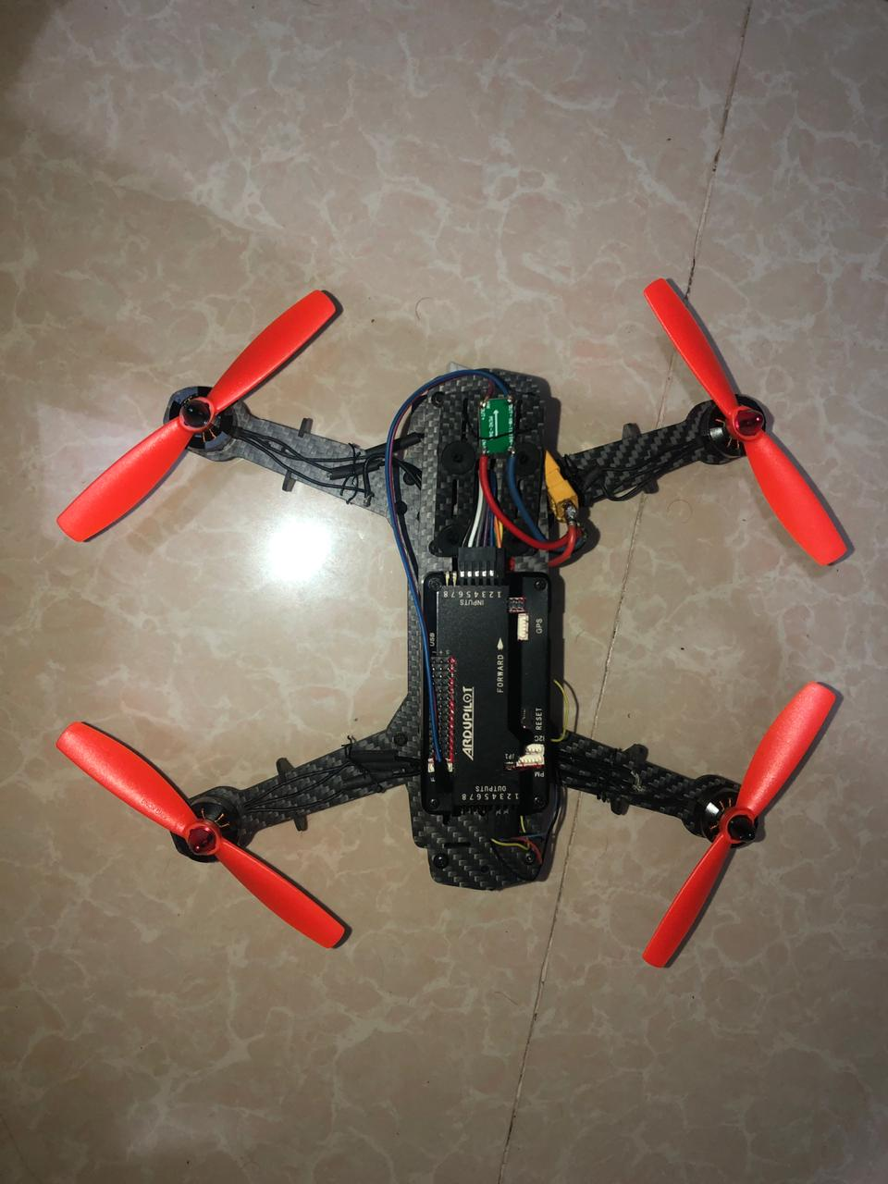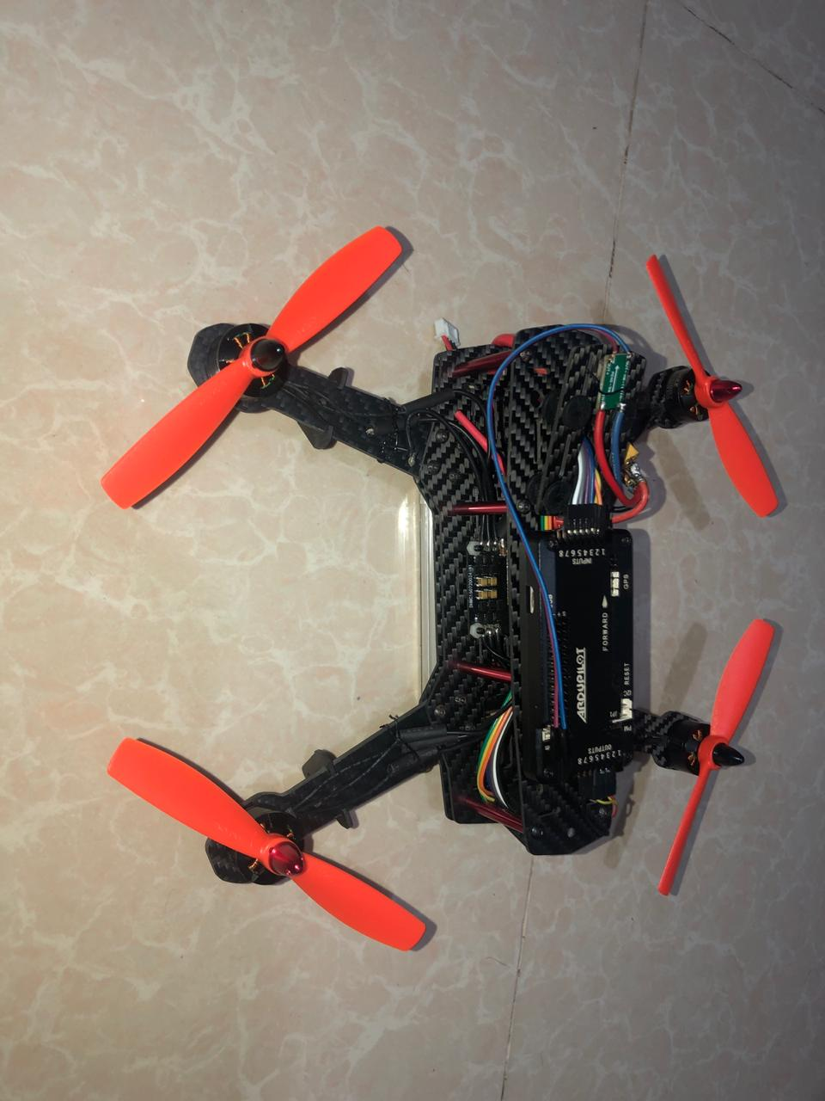

CHAPTER 5

Conclusion

This project used by the drone. Our project complete then we apply this drone in the agriculture field then our project work is successfully. This drone capable carry weight around 650-700 gm. and its works very smartly by the drone. Overall our project Smart Seeder: An IOT based Drone for Seeding is works less time of human works and also financial cost is very low. But this project also so many work cannot done because of corona pandemic situation. After this project, we can say that our project is very much multi-functioned helpful the farmer and also agriculture field.

References

[1] Natu, A.S. and Kulkarni, S.C., 2016. Adoption and Utilization of Drones for Advanced Precision Farming: A Review. International Journal on Recent and Innovation Trends in Computing and Communication, 4(5), pp.563-565.
[2]Felismina, R., Silva, M., Mateus, A. and Malça, C., 2017. Development of a Universal Seeder System to Be Applied in Drones. Journal of Advanced Agricultural Technologies Vol, 4(2).
[3]Burema, H. and Filin, A., Bee Robotics Corporation, 2016. Aerial farm robot system for crop dusting, planting, fertilizing and other field jobs. U.S. Patent 9,382,003.
[4]Bronson, K., 2018. Smart farming: including rights holders for responsible agricultural innovation. Technology Innovation Management Review, 8(2), pp.7-14.
[5]Petkovics, I., Petkovic, D. and Petkovics, A., 2017. IoT devices VS. drones for data collection in agriculture. DAAAM International Scientific Book, 16, pp.63-80.
[6]Schwindt, J., Flippo, D. and Sharda, A., Developing a wireless communication system for the KSU Biological and Agricultural Engineering Ag Drone Robot.
[7]Ryu, M., Yun, J., Miao, T., Ahn, I.Y., Choi, S.C. and Kim, J., 2015, November. Design and implementation of a connected farm for smart farming system. In 2015 IEEE SENSORS (pp. 1-4). IEEE.
[8]Georgakopoulos, D. and Jayaraman, P.P., 2016. Internet of things: from internet scale sensing to smart services. Computing, 98(10), pp.1041-1058.
[9]Zhang, A., Jakku, E., Llewellyn, R. and Bake, E.A., 2018. Surveying the needs and drivers for Digital Agriculture in Australia. Farm Policy Journal, 15(1), pp.25-39.
[10]Balafoutis, A.T., Beck, B., Fountas, S., Tsiropoulos, Z., Vangeyte, J., van der Wal, T., Soto-Embodas, I., Gómez-Barbero, M. and Pedersen, S.M., 2017. Smart farming technologies–description, taxonomy and economic impact. In Precision Agriculture: Technology and Economic Perspectives (pp. 21-77). Springer, Cham
[11]Relf-Eckstein, J.E., Ballantyne, A.T. and Phillips, P.W., 2019. Farming Reimagined: A case study of autonomous farm equipment and creating an innovation opportunity space for broadacre smart farming. NJAS-Wageningen Journal of Life Sciences, 90, p.100307.
[12]Kumar, R.R., Sanjeeva, P. and Kumar, B.V., 2018. Transforming the Traditional Farming into Smart Farming Using Drones. In Proceedings of the Second International Conference on Computational Intelligence and Informatics (pp. 589-598). Springer, Singapore.
[13]Das, V., Sharma, S. and Kaushik, A., 2019. Views of Irish Farmers on Smart Farming Technologies: An Observational Study. AgriEngineering, 1(2), pp.164-187.
[14]Balasubramaniam, A., Reshma, S. and Janardanan, A., 2018. Enhancing the Proficiency of the Drone with an Application of Ocean Farming. Procedia computer science, 133, pp.725-732.
[15]Nayyar, A. and Puri, V., 2016. Smart farming: IoT based smart sensors agriculture stick for live temperature and moisture monitoring using Arduino, cloud computing & solar technology. In Proc. of The International Conference on Communication and Computing Systems (ICCCS-2016) (pp. 9781315364094-121).
[16]Agrawal, H., Prieto, J., Ramos, C. and Corchado, J.M., 2016, September. Smart feeding in farming through iot in silos. In The International Symposium on Intelligent Systems Technologies and Applications (pp. 355-366). Springer, Cham.
[17]Tripicchio, P., Satler, M., Dabisias, G., Ruffaldi, E. and Avizzano, C.A., 2015, July. Towards smart farming and sustainable agriculture with drones. In 2015 International Conference on Intelligent Environments (pp. 140-143). IEEE.
[18]Bacco, M., Berton, A., Ferro, E., Gennaro, C., Gotta, A., Matteoli, S., Paonessa, F., Ruggeri, M., Virone, G. and Zanella, A., 2018, May. Smart farming: Opportunities, challenges and technology enablers. In 2018 IoT Vertical and Topical Summit on Agriculture-Tuscany (IOT Tuscany) (pp. 1-6). IEEE.

