Pain Detection From Body Parts Using EEG Sensor & DHT11 Sensor

BY

MD. RAJU AHMED ID: 172-15-9890

This Report Presented in Partial Fulfillment of the Requirements for the Degree of Bachelor of Science in Computer Science and Engineering

Supervised By

Mr. Md. Reduanul Haque
Senior Lecturer Department of CSE
Daffodil International University Co-Supervised By
Md. Sabab Zulfiker Lecturer Department of CSE

Daffodil International University


DAFFODIL INTERNATIONAL UNIVERSITY

DHAKA, BANGLADESH
15th October 2020

APPROVAL

This Project titled “Pain Detection From Body Parts Using EEG Sensor & DHT11 Sensor", submitted by Md. Raju Ahmed to the Department of Computer Science and Engineering, Daffodil International University has been accepted as satisfactory for the partial fulfillment of the requirements for the degree of Bachelor of Science in Computer Science and Engineering and approved as to its style and contents. The presentation has been held on 10th December 2019.

BOARD OF EXAMINERS

Dr. Syed Akhter Hossain Chairman
Professor and Head
Department of Computer Science and Engineering Faculty of Science & Information Technology Daffodil International University

Dr. S M Aminul Haque Internal Examiner Associate Professor & Associate Head
Department of Computer Science and Engineering Faculty of Science & Information Technology Daffodil International University

Mr. Ohidujjaman Internal Examiner
Lecturer (Senior Scale)
Department of Computer Science and Engineering Faculty of Science & Information Technology Daffodil International University

Dr. Mohammad Shorif Uddin External Examiner Professor
Department of Computer Science and Engineering at Jahangirnagar University

DECLARATION
We hereby declare that this project has been done by us under the supervision of Mr. Md. Reduanul Haque, Senior Lecturer, Department of CSE Daffodil International University. We also declare that neither this project nor any part of this project has been submitted elsewhere for the award of any degree or diploma.

Supervised by:

Mr. Md. Reduanul Haque
Senior Lecturer
Department of Computer Science and Engineering Daffodil International University

Co-Supervised by:

Md. Sabab Zulfikar
Lecturer
Department of Computer Science and Engineering Daffodil International University

Submitted by:

Md. Raju Ahmed
ID: 172-15-9890
Department of Computer Science and Engineering Daffodil International University

ACKNOWLEDGEMENT
First, we express our heartiest thanks and gratefulness to Almighty God for His divine blessing makes us possible to complete the final year project/internship successfully.

We grateful and wish our profound indebtedness to Mr. Md. Reduanul Haque, Senior Lecturer, Department of CSE Daffodil International University, Dhaka. Deep Knowledge & keen interest of our supervisor in the field of “IoT” to carry out this project. His endless patience, scholarly guidance, continual encouragement, constant and energetic supervision, constructive criticism, valuable advice, reading many inferior drafts, and correcting them at all stage have made it possible to complete this project.

We would like to express our heartiest gratitude to Dr. Syed Akhter Hossain, Professor, and Head, Department of CSE, for his kind help to finish our project and also to other faculty members and the staff of CSE department of Daffodil International University.

We would like to thank our entire course mate at Daffodil International University, who took part in this discussion while completing the course work.

Finally, we must acknowledge with due respect the constant support and patients of our parents.

ABSTRACT

“Pain Detection from Through Body Parts Using with EEG Sensor & DHT11 Sensor” A non-contact capacitive biopotential electrode is provided with a circuit of common-mode noise suppression. To create a common body-wide reference line, the sensor network uses a single conductive layer, removing the need for an explicit signal ground link. With a differential gain of 46 dB over a 1-100 Hz bandwidth, each electrode senses the local bio-potential. The precision of the EEG source position depends on sufficient sampling of the possible area of the floor, reliable measurement of the conducting volume (head model), and an effective and well-understood inverse technique. The present study aims to investigate the effects of sampling density and coverage on the ability to identify sources accurately, Humidity and temperature are metrics widely used for tracking activities, including indoor tracking’s, such as smart home, in an indoor environment. In this report, the output of a portable indoor sensor system connected to the smartphone-based humidity and temperature monitoring user interface will be planned, developed, and demonstrated. The key sensors used in this project are the DHT11 sensor, the Soil Moisture sensor, the LDR sensor, and the pH sensor, which provide the precise value of temperature, humidity, water content, light intensity, and soil ph. EEG signals during EEG-fMRI concurrent recordings. Unlike most modern methods for extracting objects, we suggest a process based on the learning structure of dictionaries. Thanks to the influence of fortifying dictionaries in applications such as image denoising, the BCG removal task is also expected to succeed. This is explored in the suggested technique where a dictionary is acquired from the original.

TABLE OF CONTENTS

CONTENTS | PAGE NO
Board of examiners | ii
Declaration | iii
Acknowledgment | iv
Abstract | v
CHAPTER
CHAPTER 1: INTRODUCTION | 1-2
1.1 Summary | 1
1.2 Statement of Problem | 1
1.3 Objectives | 1
1.4 Background | 2
1.5 Social Impact | 2
CHAPTER 2: LITERATURE REVIEW | 3-8
2.1.1 IoT (Internet of Things) | 3-4
2.1.2 Monitoring in IoT enabled devices | 4-5
2.1.3 Technology of Robotics | 5-7
2.1.5 Sensing EEG Technology | 7
2.2 Problems discovered in prior works | 8
2.3 Solutions to our processes | 8

CHAPTER 3: Analysis of Specifications | 9-13
3.1 Arduino Microcontroller | 9

3.2 Arduino IDE | 9-10
3.3 EEG sensors | 11
3.4 EMG sensor | 12
3.5 ECG sensor | 13
3.6 DHT11 Sensor | 14
3.7 C++ Language  3.8 Methodology | 15  15

CHAPTER 4: IMPLEMENTATION AND RESULT ANALYSIS 16

4.1 Block Diagram/Architecture 17
4.2 Results Discussion 18
4.3 Conceptual Circuit Diagram 19

CHAPTER 5: Conclusion 20

5.1 Ultimate views of Pain Detection 21-22

Reference 23

Chapter 1

Introduction

Our project is “Pain Detection from Through Body Parts Using with EEG Sensor & DHT11 Sensor.” It's a medical sector IoT-based growth initiative. The Internet of Things (IoT) is transforming the way we communicate and win in the computer and robotics business. The Internet of Things has a network where a lot of objects around us are on the network and operate like an embedded device. Radio frequency identification (RFID) and sensor network systems make the system transparent to the convergence of information and communication devices. Typical EEG sensors, which measure these fields, record electrical potential on the scalp. Their accurate calculation is based on direct, low-resistance communication between the sensor and the scalp. This is typically done by the application between the sensor and the scalp of an electrically-conductive gel.

Statement of Problem

The goal of new pioneers in the field of robotics is to create and grow robots that are capable of working in human society and are useful for helping in daily life. The creation of such a robot that can communicate with humans is thus the central point of research into robotics. In many fields today, such as engineering, surgery, behavioral science, the only remaining issue concerns the existence of knowledge for the continuous detection of EEG patterns in real-time or near real-time. Any individuals with comparatively little EEG experience may be equipped to correctly identify any patterns. There is a review of new approaches to reducing the difficulty of EEG analysis and expanding the scope of interpretive knowledge.

Objectives

Bittium Brain Status is a portable lightweight EEG amplifier that is used to diagnose patients with altered mental status, such as epileptic state, along with a disposable, simple and fast to use Brain Status electrode headband. Brain Status makes rapid assessment both in field settings and in hospitals, allowing the patient's recovery process easier. Collected data status will be sent to a Human body and a cloud EEG Sensor.

Background

(EEG) is a type of electrophysiological control to capture brain electrical activity. Usually, with the electrodes mounted around the scalp, it is noninvasive, but occasionally invasive electrodes are used, as in electrocorticography, also called intracranial EEG. We want to decrease life risk and find out the simplest methods for a specific job. Thus, our EEG can replace people to save their life and do a specific job for its user. The EEG signal reported from the scalp consists of numerous cycling sinus waves at various frequencies. The EEG is broken down into these multiple sinus waves by Fourier analysis and the spectral power (in mean square microvolts) is measured.

Social Impact

A basic human character is a simplicity. People live in a community that tries to do all their jobs in the fastest manner they can. Our robot is going to be a very helpful hand to human civilization. It would be a huge help for individuals to perform things with it. In very distant areas, people can take the robot and gather data from those areas without losing their life.

Chapter 2

Literature Review

IoT
In the machine and robotics industry, the Internet of Things (IoT) alters the way we connect and conquer. In the Internet of Things, there is a network where many objects around us are on the network and operate like an embedded device. Radio Frequency Identification (RFID) is becoming an important identification technology for items such as baggage, parcels, goods and the like to be monitored. RFID systems have identifying capabilities not present in more traditional detection applications, such as recognition schemes with optical indices (e.g. bar codes). Cloud computing can provide virtual infrastructure for integrated surveillance devices, storage devices, analytics tools, simulation applications, and customer service. A receiver 610 and a baseband processor 612 to transmit and process modulated signals obtained from RFID tags are ideally included in the RF receiver assembly 608.
Methods of computer optimization have been an important pulse design technique as they offer the only proven means of reliably measuring a time-dependent Hamiltonian that produces an overall desired result. For any defined initial state, this target may be either a par-titular end density operator or an average Hamiltonian with a specific functional type. The electrode has a distal end and a proximal end and consists of a stainless-steel tubular shaft with a matching distal end, a radio frequency heat lesion electrode with a thermocouple sensor at its tip to control lesion temperature and designed to be injected into and to create heat lesions in the spinal cord tissue. An electrode is modified to cause radio frequency heat lesions in the tissue of the living body and to have a thermocouple sensor built-in that can feel the elevated body tissue temperature.

The Small Network Management Protocol (SNMP) offers ways to handle the increasing complexities of networks for network administrators. There are several various kinds of equipment running on networks, such as repeaters, modems, switches, routers, and laptops. Numerous components of hardware and software that influence network output can be included in each system. Each type of device can be generated by any number of devices network component vendors. However, cloud-based computing introduces numerous challenges to the emerging specifications of the Internet of Things (IoT). A solution to these cloud storage issues is being developed by Fog. Fog is a clever system of computation and networking that will bring various computing resources closer to end-users together with Cloud-to-Things. This covers smartphone and wireline device and hardware crosses, special cases such as "Cloudlets" in data planes and special cases such as "Crowd-sensing" in control planes.
Fog is an architecture which supports various Internet of Things (IoT), Fifth Generation (5G) wireless systems, and embedded Artificial Intelligence (AI) applications as well. Several Fog technologies are now available, such as-Fog computing, Fog networking, Fog storage, Fog control, and collectively Fog.
[3]
In-depth, the proposed IoT protocols define the minimum behavior. In addition to the previously mentioned minimum actions, an IoT node could provide additional in situ and/or ex-situ knowledge depending on the type of application and capability of the organization and microcontroller. Many of these users with access privileges to an IoT computer are referred to as registered users. Also, the cloud also makes it easy to connect easily with IoT devices that do not have a static IP address. This is mentioned in detail in Sect. [4]
Monitoring in IoT enabled devices
As the network size continues to expand exponentially, the number of nodes in the related network has grown proportionately. With the introduction of the Internet of Things (IoT), it is expected that the current network system will be connected to several more computers. As a result, control for managers is likely to become more complex, as networks begin to become more heterogeneous. Also, with the size to which devices would be connected to the network, the addressing for IOTs will be more complicated and thus control is likely to become an uphill challenge due to the handling of broader ranges of addresses. This paper would shed light on what form of control systems can be applied and their general usefulness in the Internet of Things (IoT). Thus, working on IoT-aided robotics systems extends short-range communication capabilities to a wider scale. [5]
The purpose of the final experiment is to recreate the specific scenario of how the final deliverables will possibly be used. For this, on the actual hardware devices, we ran the proposed protocol. Our architecture consists of one IoT node, one client node, and a disk. The Client Node is an Android framework we have built that requires protocol implementation unique to a client node. Such as quadrotor search and rescue, traffic control, fire detection, and hazardous site inspection, there are many civilian uses. It is quite helpful for capturing scenes of violence, gathering information, and tracking law enforcement. Quadrotor also performs very unique tasks in aerial imaging, videography, and land evaluations. By facilitating autonomous control of those quadrotors, it will be much more stable and easier to use. [6]

The author aims to introduce an underwater drone rig with a Raspberry Pi attached to a number of tracking sensors for air and water quality. It uses sensors for temperature, humidity, and gas for air quality monitoring, and has launched a water hydrophone sensing device. It is designed to provide additional sensors for monitoring water temperatures, such as turbidity, DO, conductivity, and pH. [7]
Technology of Robotics
The IoT paradigm robotics platform makes it possible to introduce applications in both civilian and military areas. Also, some IoT-based systems may also be safety-critical systems. The service sector visits unexpected IoT technology implementations. The Human-Robot Interface (HRI) is very challenging for socially assistive robotics deployment in many fields such as robotics, medicine, health sciences, neuroscience, and so on. New solutions for health and learning robotics are being designed for vast numbers of customers. The population of the World is rising older and it can be said that by the middle of the twenty-first century, the number of people over the age of 85 will be three and a half times higher than it is today. Many of them can be required to need physical and cognitive assistance. And a perfect measure for supporting people would be socially assistive health robotics. [8]

Potential field methods (PFMs) for the avoidance of obstacles have given their location and have been more widespread in the principles of developers and researchers in robotics and mobile robotics over the past few decades. A few scholars, including Andrews, Hogan, and Khatib, have disclosed the concept of imaginary powers operating on robots. For obstacle avoidance applications for mobile robots, for its good concept and features, which is very elegant and simple, the PFMs are the most liked method. Simple PFMs can be applied without any claims and refining for fast and appropriate performance. In 1985, the PFMs used by researcher Thorpe to allow off-line path planning, and in the following year, he and his fellow researcher developed a simpler theoretical field approach that combines global and local path planning. In 1989, a PFM device was developed and deployed called the Virtual Force Field (VFF) on a mobile robot named CARMEL. [9]

We build a hierarchical overlay that is self-organizing and scales to a wide number of sensors and allows multi-resolution collaboration. To ease the development of applications on top of the infrastructure, we design reliable Network Programming Interfaces; these interfaces are easily implemented in the network layer. In a fiber optic bundle, the working and protective lines are given. Accordingly, if the working line fails, due to a fiber cut, for example, the corresponding protect line often will also fail. Therefore, Interval switching is often compared to merely switching data from the damaged working line to the line of safety. However, all systems can be used in accordance with each other, whereby an effort is first made to use the protected line when the related working line fails, and then span switching is used to divert communications if the protection line is itself unreliable. Once the universe is viewed, the machine decides the laws of force and the actual robots of the machine operate through the equations of force in a distributed way. [10]

The author constructs an algorithm to construct personalized training forces based on current neuro-adaptive control experiments to "trick" motivations into shifting their target-directed reaching movements to a preselected movement as an enhancement after effect. The emergence of a standardized protocol will also assist IoT producers in a multitude of areas by minimizing spending in research and development of IoT protocols that minimize manufacturing costs and can also support the production process. This permits future-proof OEMs to make their devices and will encourage interplay between IoT devices in the future, making these devices desirable from the point of view of end customers. Such standardized protocols can also support end-users, as this makes for a broader spectrum and hence paves the way for customized IoT environments, which can also be adapted to user-specific implementations. Nevertheless, the final experiment found that 44 percent of the main behavioral shift also existed in the training neighborhood after-effects and created the unpracticed direction of travel to goals that were 60 different from the objectives used for training. These studies indicate that the ability to use these techniques can be beneficial in teaching motor skills and neuro-rehab to brain-injured patients. [11]

Over the last few decades, researchers and scientists have been focusing on discovering solutions to the technical needs of advanced robotics. This is helping technology to advance in the technology world. Human interests persisted in the evolution of robotics. In the early 1960s, the technology revolution happened as automated robots were introduced into the human protection factory. Day after day, the passage of time and the development of robots to create a new era. In developing robots of this kind that can satisfy human social needs, the latest advances in robotics research are. Robotic manipulators, handheld robots, and biologically inspired robots are the three distinct fields of robotics that are transforming our way of life. [12]

Sensing EEG Technology
Electroencephalograms (EEGs) are electrical impulses that can be measured on the surface of the skin but originate in the brain. For many medical uses, the non-invasive aspect of EEG acquisition renders it a versatile sensing modality. Today, however, EEG acquisition schemes are constrained by a range of essential variables. A standard EEG array consists of 20 or more electrodes, over a hundred in many situations. In order to ensure proper electrode positioning, the first challenge is that a qualified technician is required. The second problem is that, particularly during long-term documentation, the vast volume of cabling involved will cause patient distress. The third difficulty is that this cabling, spread across the scalp, affects the mechanism. Signals from the electroencephalogram, which usually have an amplitude of multiple microvolts, involve direct skin contact. This touch will, however, be dry, which removes the need for conductive gels. This photonic electrode system's electrical bandwidth ranges from below 0.1 Hz to several tens of kHz and is largely controlled by signal processing electronics, not by the Protrude itself. Inside an enclosure of 1 inch in diameter, the integrated sensor integrates amplification, bandpass filtering, and analog to digital conversion. The measured input-referred noise over the 1-100Hz frequency spectrum is 2μVrms at a 0.2 mm sensor distance and 17μVrms at 3.2 mm distance. [1]

Problems discovered in prior works

Many researchers and engineers have previously built multiple devices using EEG sensors. Many of their systems were successful and featured well. We assume the issue consists of these technologies that are paradigm and uncertainty sensing.

Solutions to our processes
It is wiser and quicker to grasp the essence of emerging technology. We have answered these issues in our project and have attempted to make an EEG sensor-enabled muscle detection device as easy as possible. In design, we aim to make things more accessible and easier.

Chapter 3

Analysis of Specifications

Arduino Microcontroller: Centered on easy-to-use hardware and applications, Arduino is an open-source electronics platform based on easy-to-use hardware and software. Inputs can be read by Arduino boards-light on a sensor, a finger on a switch, or a post on Twitter and converted into an output-triggering engine, turning on an LED, publishing something online. Posting online for something. It's a good platform and it turns out to be really popular with those who are new to electronics. It helps to create simple, complex electronics projects for developers. A very simplified model of the C++ language used in the Arduino IDE that breaks down the functionality of the microcontroller into a more on-hand package.

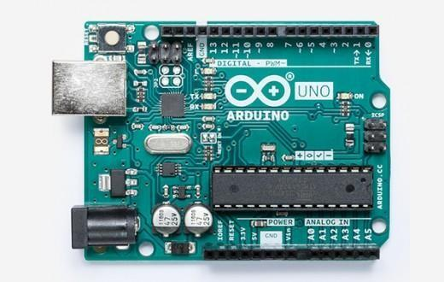

Arduino IDE: The Arduino Integrated Programming Framework-or Arduino Program (IDE)-includes a code writing text editor, a message box, a text monitor, a typical feature button toolbar, and a set of menus. To import programs and work with them, it attaches to the Arduino and Genuine hardware. If opened, this is the Arduino IDE. It opens into a blank sketch where you can

automatically begin programming. First, to allow us to upload data, we should configure the board and port settings. Use the USB cable to connect the Arduino board to the PC. Written programs compiled on it and connected to a stub main) (program into an executable cyclic govt software with the GNU toolchain included with the IDE delivery.

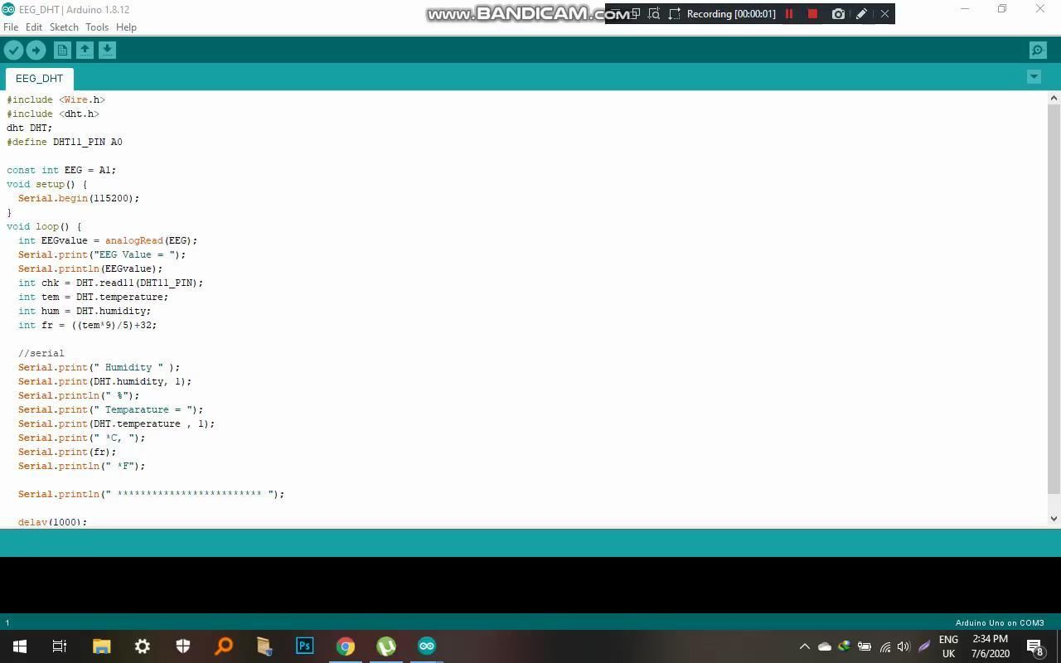

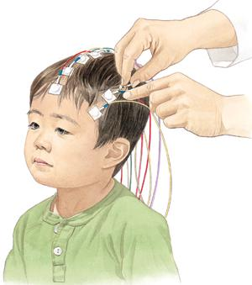
EEG Sensors: EEG stands for electroencephalography, an electrophysiological procedure in which the electrical activity of the brain is recorded. EEG tracks variations in electrical activity produced by the brain. The ionic current within and within some brain cells called neurons is due to variations in voltage. The electrical activity of the brain is evaluated by an EEG test. EEG scans are performed by placing EEG sensors on your scalp-small metal disks also called EEG electrodes. The electrodes pick up and record the brain's electrical activity. That recorded EEG signals are amplified, digitized, and then transmitted for storage and data processing to a computer or mobile device.

An outstanding way to study cognitive processes is to examine EEG data: it will help physicians develop a psychological diagnosis, researchers understand brain functions dependent on human actions, and individuals enhance their effectiveness and well-being.
EMG Sensor: Electromyography (EMG) is a medical technique to determine the fitness of muscles (motor neurons) and the nerve cells that regulate them. EMG findings may reflect nerve dysfunction, muscle dysfunction, or problems with nerve-to-muscle signal delivery. Electromyography (EMG) is a medical technique to determine the fitness of muscles (motor neurons) and the nerve cells that regulate them. EMG outcomes can show nerve dysfunction, muscle dysfunction, or nerve-to-muscle signal transmission problems.

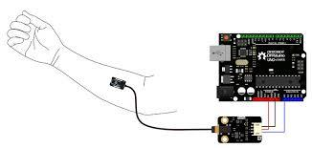

Use your muscles to control all kinds of actuators (engines, servos, lights) Interact with your own muscles, with the environment. This sensor comes with everything you need to get your Arduino or Raspberry Pi to start sensing muscle activity.

ECG Sensor: In order to search for multiple cardiac problems, an electrocardiogram (ECG or EKG) captures an electrical pulse from your muscle. To monitor your heart's electrical impulses, which cause your heart to beat, electrodes are mounted on your chest. On a connected screen display or printer, the signals are displayed as waves.

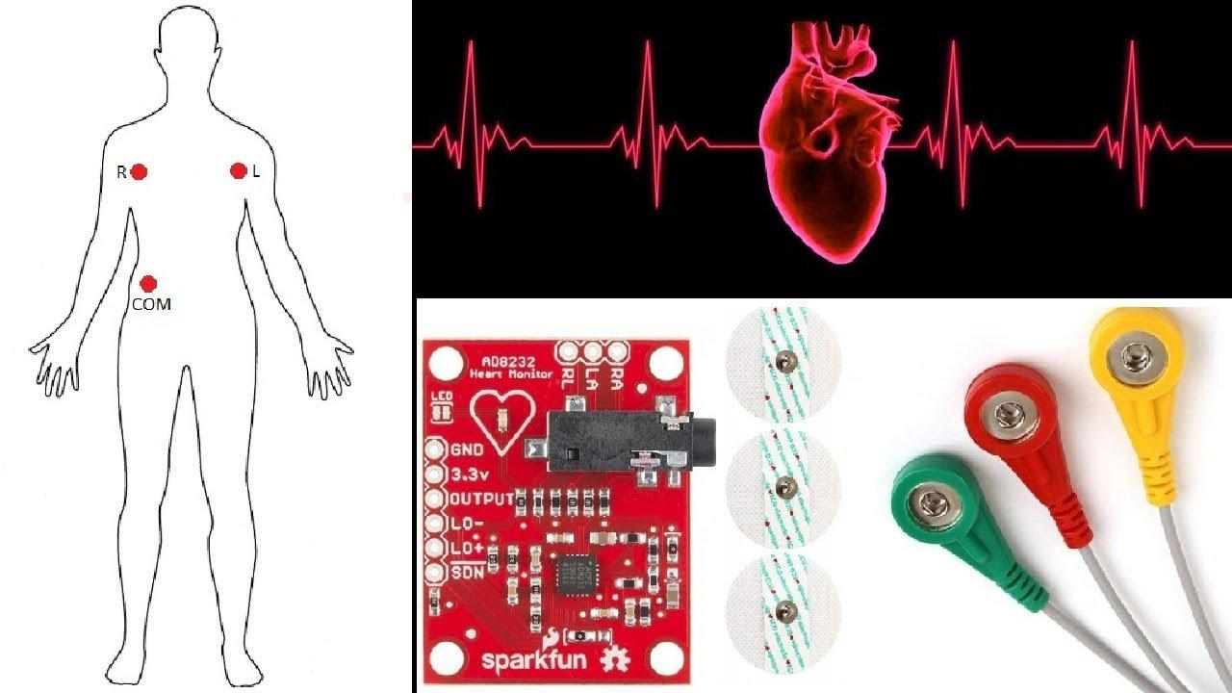

A significant signal conditioning unit for ECG and other biopotential measurement applications is the AD8232. It is designed to collect, amplify, and filter tiny biopotential signals in the presence of noisy conditions such as those generated by motion or remote electrode location.

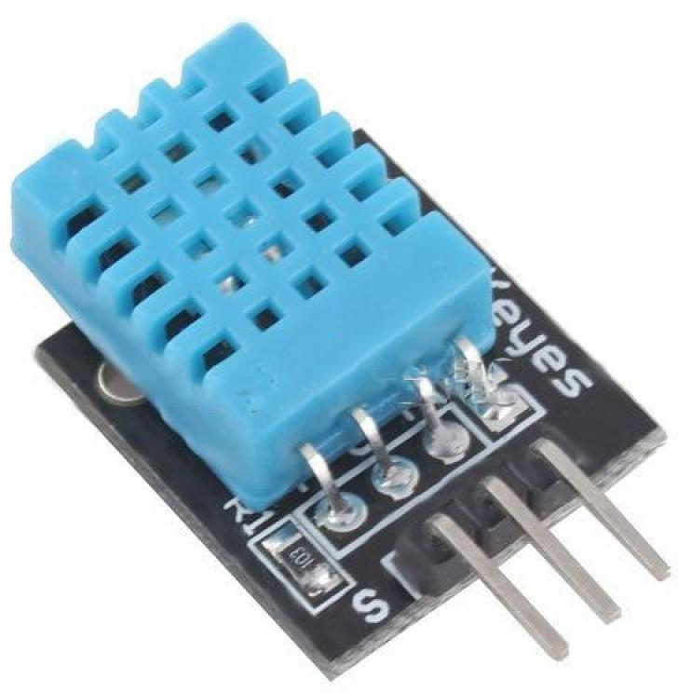
DHT11 Sensor: The DHT11 is a temperature for the digital signal output and Moisture sensor that is already being calibrated. Digital technology with temperature and humidity acquisition Sensor engineering. The sensor has a resistive moisture content Part measurement and NTC temperature sensor Component. The high-performance 8-bit link Single-chip microcontroller delivers excellent sensor quality, Super-fast response, high cost-effective anti-jamming capability.

DHT11 provides an I / O port connecting to msp430. The 40s Bits of temperature and humidity data send to microcontroller Data are checked by CRC at all times. So, the precision of information is safeguarded. The power consumption of DHT11 is fairly good Small voltage, 5V power source, and the average limit the value is roughly 0.5 mA. DHT11 uses data format for a single bus. In other words, one single data Port completes two-way input/output transmission. 1 Single Package is 5 Bytes (40 Bits). The touch period is less than 3 Ms. The specific format shows in the figure below. A Total Transmission of data comprises 40 bits, first big bits. Data format: data integral of 8-bit humidity + humidity of 8-bit Decimal data + integer data with 8-bit temperature + 8-bit Decimal Temperature Data + 8-bit Calibration. The first four bytes sum.

C++ Language: C++ is a well-known object-oriented programming (OOP) language, created by Bjarne Stroustrup, and is a C language extension. Coding C++ in a "C form" or "item-oriented style" is therefore possible. It can be written in either way in certain eventualities and is therefore a strong instance of a hybrid language. C++ is known to be an intermediate-level language because it encapsulates any aspect of the language of excessive and coffee degree. Initially, the language became known as "C with instructions," because it had all the houses in the C language with an additional idea of "instructions," but in 1983 it was renamed C++.



Methodology: Electroencephalography (EEG) is a method of electrophysiological control for measuring brain electrical activities includes capturing, processing, and decoding voltages that derive from brain gray matter reported on the human scalp. Electroencephalography (EEG) was the first clinical neurodiagnostic assessment that revealed abnormal brain function following traumatic brain injury. All subjects were post-injury for over 12 months and had a history of zolpidem response and regular use of the drug for behavioral facilitation.
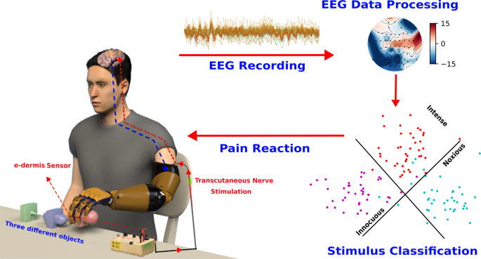

Chapter 4

IMPLEMENTATION AND RESULT ANALYSIS

Procedure for Working:
Body temperature can be calculated.
- It will alert whether body temperature decrease or rise.
- The usefulness of a multi-objective approach to decrease the number of channels used with a substantial lack of classification precision.
- It will transfer the generated data over Wi-Fi to cloud storage.
- Set the suggestions for successful outcomes in the area of medical science.
- Implementation of easy to understand and simplified systems.
- The level of enthusiasm of the person gains Trolley on his / her psychophysiological progression Be taken into consideration when determining the research topic and Where to establish A research project.

Block Diagram/Architecture

Start

Temperature collect and then process
Data Process excel file

EEG sensor
And DHT 11 sensor data process
Data analysis

Temperature and data result

Result show in Display

End Process

Results Discussion:

In this work, we have implemented the control of the various electrical appliances for a complete We get pain a lot of the time, EEG Sensor is used to detect it. If we have an accident or have pain in the hands or feet, whether the cells that are there are torn or not, it is normal. Determines it with humans, and uses DHT11 Sensor to measure body temperature and humidity. The future endeavor of this research is to add a speech recognition module along with an android application. It will also ensure a more user-friendly user interface for the elderly and disabled people.

Conceptual Circuit Diagram: -
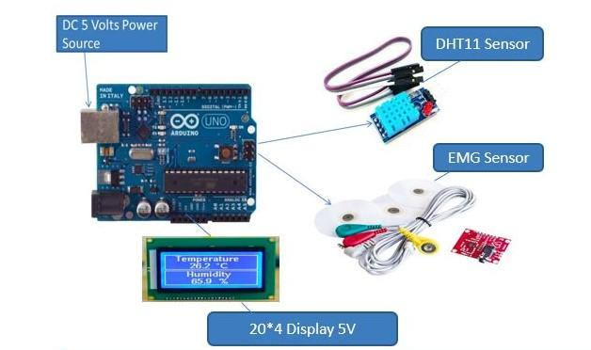
Chapter 5
Conclusion

We have completed our final design and construction of the plant successfully. Using the EEG Sensor & DHT11 Sensor, our Through Body Parts Pain Tracking robot also measures moisture and sensor temperature. It will accept obstacles on the project road with success. Right, Dada at 95 percent. We want to work in the future with overt laser devices in our project. Owing to issues with reports, we are now unable to complete this robot with inferred laser modules. We hope to be able to upgrade this robot in the future with both a motion detector system and a sonar system. Finally, we want our robot to use AI apps. In the field of neural signal processing, miniaturized EEG (mini-EEG) sensor systems are becoming increasingly prevalent and pave the way for chronic neuromonitoring applications.

Ultimate views of Pain Detection from Through Body Parts Using with EEG Sensor & DHT11 Sensor

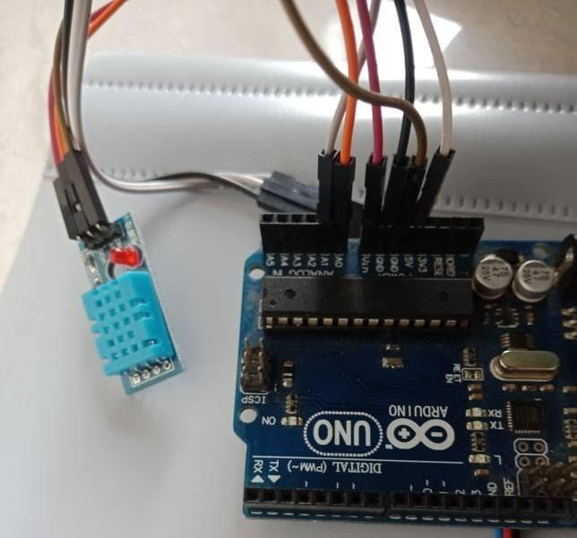
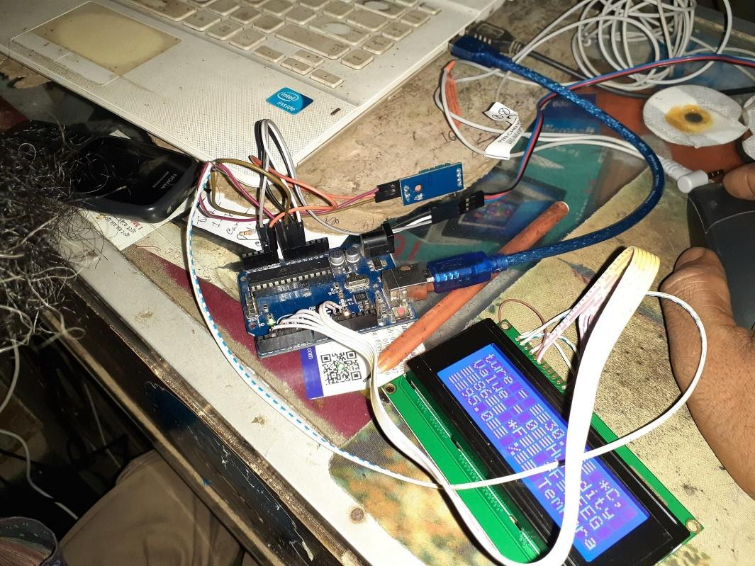
Pain Detection from Through Body Parts Using with EEG Sensor & DHT11 Sensor

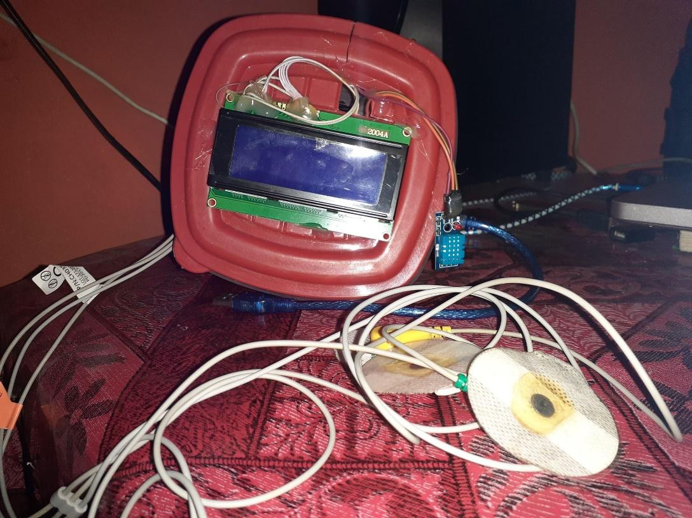

Reference:

[1] Gubbi, J., Buyya, R., Marusic, S., and Palaniswami, M., 2013. Internet of Things (IoT): A vision, architectural elements, and future directions. Future generation computer systems, 29(7), pp.1645-1660.

[2] Lee, I., and Lee, K., 2015. The Internet of Things (IoT): Applications, investments, and challenges for enterprises. Business Horizons, 58(4), pp.431-440.

[3] Chiang, M., and Zhang, T., 2016. Fog and IoT: An overview of research opportunities. IEEE Internet of Things Journal, 3(6), pp.854-864.

[4] Kelly, S.D.T., Suryadevara, N.K., and Mukhopadhyay, S.C., 2013. Towards the implementation of IoT for environmental condition monitoring in homes. IEEE sensors journal, 13(10), pp.3846-3853.

[5] Grieco, L.A., Rizzo, A., Colucci, S., Sicari, S., Piro, G., Di Paola, D. and Boggia, G., 2014. IoT-aided robotics applications: Technological implications, target domains, and open issues. Computer Communications, 54, pp.32-47.

[6] Coelho, G., Kougianos, E., Mohanty, S.P., Sundaravadivel, P., and Albalawi, U., 2015, December. An IoT-enabled modular quadrotor architecture for real-time aerial object tracking. In 2015 IEEE International Symposium on Nanoelectronic and Information Systems (pp. 197-202). IEEE.

