

INTERNSHIP REPORT
On
PERFORMANCE EVALUATION: A STUDY ON SOUTHEAST BANK LIMITED

Submitted To

Md. Anhar Sharif Mollah Assistant Professor
Faculty of Business Administration Faculty of Business & Entrepreneurship

Submitted By

Rumman Hasan Fahim ID:161-11-273
Faculty of Business Administration Faculty of Business & Entrepreneurship Daffodil International University

© Daffodil International University

LETTER OF TRANSMITTAL
27 December, 2019 To,
Md. Anhar Sharif Mollah Assistant Professor
Department of Business Administration Faculty of Business & Entrepreneurship Daffodil International University

Subject: Submission of internship report on “Performance Evaluation: A Study on Southeast Bank Limited”.

Dear Sir,

With due respect, The Study would like to inform you that, The Study have completed my internship report on topic: “Performance Evaluation: A Study on Southeast Bank Limited” . The Study have collected information from all available sources in a realistic way. While preparing report, The Study have tried to follow your instruction based on systematic manner.
I sincerely hope that this report meets your approval and also expects that The Study will get your kind consideration regarding acceptance of this report.

Sincerely Yours,
........................
Rumman Hasan Fahim ID: 161-11-273
Major: Finance
Faculty of Business Administration

© Daffodil International University | ii

SUPERVISOR’S DECLARATION

It offers me immense delight to certify that the projected record titled “Performance Evaluation: A Study on Southeast Bank Limited” has been finished by Rumman Hasan Fahim ID: 161-11-273, BBA program, Faculty of Business & Entrepreneurship, Daffodil International University, Ashulia, Savar, Dhaka underneath my supervision and steering. As some distance asThe Studyknow, this is an authentic work, which has not been published in any journal or submitted to any group or branch for any diploma or degree.

I do hereby accept it a fully recommend Internship report for evaluation.

………………………….. Md. Anhar Sharif Mollah Assistant Professor
Department of Business Administration Faculty of Business & Entrepreneurship Daffodil International University

STUDENT’S DECLARATION

Here by The Study declare that the work submitted in that Internship Report was done by me and was not previously submitted for academic qualification to any other University / organization. The pieces The Study have submitted do not violate existing copyrights and no part of this report has been copied from work done previously.

I also undertake to compensate the Ministry for all losses and damages caused by violation of previous duties.

…………………… Rumman Hasan Fahim ID: 161-11-273
Major: Finance
Department of Business Administration Faculty of Business & Entrepreneurship

ACKNOWLEDGEMENT

The opportunity has already come and gone to offer my most profound thanks and accommodation to the all-powerful Allah yet for whose help The Study would not have the capacity to finish an immense undertaking of setting up this report.
I might want to express my profound feeling of thankfulness towards one of my Supervisor Md. Anhar Sharif Mollah Assistant Professor, Department of Business Administration, Faculty of Business and Entrepreneurship, Daffodil International University for allowing me a chance to finish my entry level position report on truth, no aficionado can accomplish immaculateness without the assistance of a researcher. Additionally, an understudy can never be flawless without the assistance of a decent educator. A decent educator might be a milestone for any understudy. The Study am significantly obliged to The Study might want to unequivocal my profound feeling of thankfulness towards one of my Supervisor Md. Anhar Sharif Mollah Assistant Professor, Department of Business Administration, Faculty of Business and Entrepreneurship, Daffodil International University for allowing me a chance to Complete my entry level position report and his proposals and rules Were extremely an incredible assistance to me.
Especially, The Study am also thankful to who gave me the opportunity to allow me in this organizational arena. The Study would also like to express my heart full thanks to all officers and also my friends and Elder Brother for their excellent support and proper guidance in completing my internship report.

© Daffodil International University | v

Table of Contents

LETTER OF TRANSMITTAL ..................................................................................................... | II
SUPERVISOR’S DECLARATION .................................................................................... .......... | III
STUDENT’S DECLARATION..................................................................................................... | IV
ACKNOWLEDGEMENT ................................................................................................. ............. | V
CHAPTER ONE
INTRODUCTION ................................................................................................................ ........... | 1
1.1INTRODUCTION ......................................................................................................................... | 1
1.2 RATIONAL OF THE STUDY......................................................................................................... | 2
1.3 OBJECTIVES OF THE STUDY ...................................................................................................... | 2
1.4 METHODOLOGY OF STUDY ....................................................................................................... | 3
1.4.1 Collection of Data: ............................................................................................................ | 3
1.5 LIMITATIONS OF THE STUDY .................................................................................................... | 3
CHAPTER TWO
COMPANY OVERVIEW ............................................................................................................ ... | 4
2.1 BACKGROUND OF “Southeast Bank Limited.”: ...................................................................................
4
2.2 MISSIONS ................................................................................................................................. | 5
2.3 VISIONS ................................................................................................................................... | 5
2.4 FUNCTIONS OF Southeast Bank Limited ............................................................................................. | 5
2.5 MANAGEMENT INFORMATION SYSTEM (MIS) OF SEBL .............................................................. | 6
2.6 MAJOR DIVISION OF SEBL: ........................................................................................................ | 6
CHAPTER THREE
LITERATURE REVIEW ........................................................................................................... .... | 7
3.1 INTRODUCTION ........................................................................................................................ | 7
3.2 THEORIES OF BANK PROFITABILITY ......................................................................................... | 7
3.3 PERFORMANCE MEASUREMENT IN BANKS................................................................................ | 7
3.4 FINANCIAL STATEMENTS ANALYSIS ......................................................................................... | 9
3.4.1 Types of Financial Analysis ............................................................................................... | 9
3.4.2 Basics of financial statements .......................................................................................... | 10
3.4.3 Common-size statements ................................................................................................. | 11
CHAPTER FOUR
ANALYSES ................................................................................................................................... | 12
4.1 RATIO ANALYSIS ................................................................................................................... | 12
4.1.1 Liquidity Ratio: ............................................................................................................... | 12
4.1.1.1 Current Ratio: ........................................................................................................... | 12
4.1.1.2 Net Working Capital................................................................................................. | 13
4.1.1.3 Acid Test Ratio: ....................................................................................................... | 14
4.1.2 Activity Ratio: ................................................................................................................. | 15
4.1.2.1 Operating Expenses to Revenue (OER):.................................................................... | 16
4.1.2.2 Total Asset Turnover Ratios: .................................................................................... | 16
4.1.2.3 Operating Expenses to Assets Ratio: ......................................................................... | 17
4.1.3 Debt Ratio: ..................................................................................................................... | 18
4.1.3.1 Debt Ratio: ............................................................................................................... | 19 ©
Daffodil International University vii

© Daffodil International University | vi

4.1.3.2 Times Interest Earned Ratio: 19
    - Profitability Ratio 21
      - Investment to Deposit Ratio: 21
      - Net Profit Margin 21
      - Return on Asset (ROA) 23
      - Return on Equity (ROE): 24
      - Earnings per Share 25
      - Price Earnings Ratio: 26
CHAPTER FIVE FINDINGS 27
5.1 FINDINGS 27
CHAPTER SIX
CONCLUSIONS AND RECOMMENDATIONS 27
  - CONCLUSION 288
  - RECOMMENDATIONS 29
REFERENCES 30

© Daffodil International University | vii

Chapter One Introduction

  - Introduction

Banks are an outdated form of financial institution that channels excess funds from surplus units to deficit units in the name of interest. The banking business between the depositor and the receivable surplus unit and the borrower and the deferred unit called the bank must be established on the basis of the tort-payer relationship. Here, the opportunity cost of money is considered as the value of works for interest works for the development of an economy, the bank makes a huge contribution and a modern economy cannot be imagined without the services of the bank. The economic development of a country requires a streamlined, smooth, easy-to-reach and efficient affordable investment process. The work of a single bank is not only limited to its geographical area but it has reached beyond the borders of the country. Thus, the banking business has been transformed into a global business and the rest of the business depends on the strength of the banking business. In the perspective on the IMF, "the ongoing financial emergency has indicated many weaknesses in the financial framework around the world, which raises many issues to link the security of banks' elements with insecurity dangers to potential future uncertainties.

The bank regulatory authority is directly responsible for assessing the effectiveness of each banking business to detect any defects, the regulatory authority must identify any upcoming challenges related to the performance of all banks. For this reason, the regulatory authorities sought a clear statement to highlight the performance of any financial activity on the basis of which the performance is evaluated. The regulatory required statements provide comprehensive information that reflects the performance. Nevertheless, onsite investigations are also needed to find accuracy and to rule on the quality performance of banking companies. The adequacy and effectiveness of a bank can be briefly summarized by financial ratios.

  - Rational of the Study

As the central bank of Bangladesh, Banking Bangladesh (BB) acts as the legal authority to regulate and monitor the banking system of Bangladesh. To fulfill this important role, BB thoroughly evaluates the overall performance of the banking system, as well as its strengths and weaknesses, to find the security and suitability of each individual banking company.
Bangladesh Bank operates its offsite monitoring program based on camel rating. At present risk-based supervisory activities are implemented to assist banks from the edge of the central bank so that they can keep up with the modern, diverse, most complex, vulnerable and most competitive baking environment. Significant, risk-based monitoring activities and risk-based ratings from inspections are reflected in the Camels Ratings Management section, focusing on efficiency in managing multiple issues in the banking business.
The financial ratio is used as a monitoring system to determine the overall position of a bank, where Bangladesh Bank can take necessary measures where necessary. The study looks at all related factors, including financial ratios. All ratios will be summarized so that each component of CALELS has a clear idea about it. Since the Camels rating result is kept secret, stakeholders of a bank are unaware of the actual performance of a banking company. Along this line, a detailed discussion of financial ratios is required for the public
In order to concentrate on the qualities and weaknesses that should be taken in this study, the performance of Southeast Bank Limited should be analyzed. It will encourage regulatory authorities, stakeholders, and the general public to think and concentrate on the strategies needed to assure their interests.

  - Objectives

The study will help to show how financial ratio is applied by bank to assess the performance of Southeast Bank Limited in a complete format. Specific objectives of the study are:
    - To measure the performance of Southeast Bank Limited.
    - To find out the strength and weakness of the bank in financial aspect in particulars.
    - To recommend some measures for better functioning of financial system of the bank

  - Methodology

1.4.1 Collection of Data:
This study has been undertaken on the basis of secondary data (i.e., published data or processed

data). For this purposes, a good number of sources have been used.

The sources include:
- Annual Report of the bank
- Insight – Monthly Magazine of the bank
- Books and Web sites

  - Limitations of the Study

Each study needs to involve a high level of data collection, database creation, literature audit, and data analysis. In this study, the best endeavors have been made to gather, organize, analyze and interpret the most relevant information and finally to achieve the best aftereffects of the study. Nonetheless, this study addresses a portion of the particular barriers mentioned underneath:
- Primary and unpublished data were not considered for the study.
- The accuracy of the data cannot be ascertained mainly as secondary information gathered from annual reports.
- The profundity of analysis is limited to data gathered from various sources.
- Camels analysis cannot be utilized in this report because the bank's qualitative measures utilized by the bank for each component of Camillus are unique in relation to those of various analysts with the goal that we utilize financial ratios to evaluate the bank's adequacy.

Chapter Two Company Overview

2.1 Background of “Southeast Bank Limited .”:

Southeast Bank Limited is a private commercial Bank, which launched its activities in Dhaka in 1995. The Bank concentrates its activities in its area of expertise and has achieved good market reputation for efficient customer service. The Bank is committed in providing training/retraining to its staff to keep them up to date with modern practices in their respective fields of work. The Bank also tries to fulfill its share in community responsibilities. By such measures the Bank intends to grow and enhance shareholders’ value.
Southeast Bank Limited pledges to maximize customer satisfaction through services and build a trusting relationship with customers, which has already stood the test of nineteen years.
Southeast Bank Limited is a scheduled commercial Bank under private sector established under the ambit of Bank Company Act, 1991 and incorporated as a Public Limited Company under Companies Act, 1994 on 12 March 1995. The Bank started commercial banking operations effective from 25 May 1995. During this short span of time the Bank has been successful to position itself as a progressive and dynamic financial institution in the country.
Southeast Bank Limited has been licensed by the Government of Bangladesh as a Scheduled Bank in the private sector in pursuance of the policy of liberalization of banking and financial services and facilities in Bangladesh.
The present Charmin is Mr. Alamgir Kabir, FCA who is also a renowned business person of the country. The present Managing Director is Mr. Shahid Hossain who has long experience in Commercial Banking System. The Bank has made significant progress with in a very short period of time due to its very competent Board of Directors, Dynamic management and introduction of various customer friendly deposit and loan products.

The Authorized Capital of the bank is Tk. 10,000.00 million and Paid-up Capital is Tk. 8,732.86 million. The bank maintains a secured capital adequacy ratio which is 10.90% of the Risk Weighted Assets as of December 31, 2013.

Mission & Objective:
There have some missions of Southeast Bank Limited, which are as follows:
- Fast customer service.
- Maintain sustainable growth
- Follow strong business ethics

- Offer quality financial services with latest technology
- Provide smooth return on shareholder’s equity
- Attract and retain qualified human resource.
- Maintain Corporate Social Responsibility

Visions

Build a long-term sustainable financial institution through financial inclusion and deliver optimum value to all stakeholders with the highest level of compliance

  - Functions of Southeast Bank Ltd

Some general functions of Southeastt Bank Limited are as follows:

    - Mobilization of savings of the people earning and safe keeping of all types of deposit account.
    - Making advances, especially for productive activities and generally for other commercial and socioeconomic needs.
    - Providing banking services to common people through the network of branches.
    - Handling of export and import trade and foreign remittances and with especial support to export activities.
    - Introducing modern banking services in the country.

2.11 Management Information System (MIS) of SEBBL

The Management Information System (MIS) of Southeast Bank Limited is at a developing stage. The bank is correct presently using MIS report only for customer account-related information and Bank financial position. The bank as of late introduces online banking administrations at front office operations which facilitate any Branch Banking, SMS Banking, ATM Banking, Phone Banking, and Internet Banking to all customers. Be that as it may, one, all branches of the bank as of late are using centralized Banking software for their daily transaction processing and routine reporting. Credit chance management is also available in centralized banking software. The bank has a disaster recuperation site (DRS) in

place replicating the data center and its DR site is outfitted with compatible hardware and telecommunications gear to help the live frameworks in case of any disaster.
Notwithstanding, the Bank is to create current MIS for utilization of management and other offices for lucky availability of vital data for planning and decision-making purposes at the appropriate time to augment profitability.
2.13 Major division of SEBL:

Southeast Bank Ltd. They run smooth operations through various departments there. All banking activities are properly managed through these departments. Following are the main sections of Southeast Bank Limited's underline charts:

Major Division of SEBL :
Division of SEBL
Human Resource Department Research & Planning Development & Marketing Information Technology Central Account Audit & Inspection Training center. Foreign Exchange Service Loan & Advance General Service
Import Business Credit A/C Opening & Closing Import Business Retail Banking Dispatch
Foreign Remittance Local Remittance Clearing Section
Financial Control & Account department (FCDA) Cash Department.

CHAPTER THREE LITERATURE REVIEW
  - Introduction

A healthy and vibrant economy requires a financial framework that moves assets from individuals who save to individuals who have gainful investment openings. The financial framework is unpredictable in both structure and function all through the world. It includes many various sorts of institutions': banks, insurance companies, mutual assets, stock and

bond markets, and so on. According to Spong(2000), efficiency and competition are solidly linked. In an engaged banking framework, banks must operate viably and utilize their assets admirably on the off chance that they are to keep their customers and remain in business.
Zerayehu et al., (2009) also argued that survival in today's aggressive environment totally depends upon performance and improvement. Competition has implications for profitability, innovation, pricing, and availability of decision, consumer welfare, and the allocation of assets in the economy.

Technics of Bank Profitability

According to the literature, the bank performance study began in the late 1980s and / or early 1990s. These experiments spin around different theories. For example, the signal theory, which elaborates on the relationship between capital and profit, suggests that high capital is a positive signal for the bank's value market. (Berger, 1995) According to the literature, the bank performance study began in the late 1980s and / or early 1990s. These experiments spin around different theories. For example, Signal Theory, which elaborates on the relationship between capital and profit, suggests that higher capital is a positive signal for the bank's value market. Contrary to the above argument, the ModiglianiMiller theorem concludes that there is no correlation between capital structure (obligation or financing financing) and the market value of the bank (Modigliani and Miller, 1958). In other words, there is no relationship between the ratio of assets and the expenditure of funds or profits under the free market. Yet, when it comes to validating the ideal market value of money markets, it is not surprising in the real world because of agency issues, inconsistent information issues, the presence of transaction costs, etc. Therefore, there may be a perceived negative relationship between capital and profit when the ideal market does not hold up. Ommerren, (21), Wolveni and Schifo (25) argued that market power theory (MP) maintains that bank profitability is a viability of the outside market, while competence structure (ES) theories and balanced portfolio theory mainly capture the performance of the bank's internal competencies and Management is influenced by decisions. Regardless of the presence of multiple models addressing bank-explicit aspects, none of the models is acceptable enough to elicit bankexplicit behavior, the researchers stated, serially.

Performance Measurement in Banks

According to Aburim (23), the importance of bank profit can be assessed at a smaller scale and macro degrees of the economy. At the miniaturized scale level, profits are a necessary condition of a focused banking institution and a cheap wellspring of assets. This isn't only a consequence yet, in addition, the requirement for fruitful banking during the growing competition in financial markets. In this manner, the main aim of each bank management is to maximize profits as an essential prerequisite for conducting business. Various literature formed by academics also claims that profitability is the primary concern or final performance results showing the net impacts of bank arrangements and activities in a single fiscal year. In fact, various factors like inflation, accounting strategies, abnormal state competition, and so on can have an impact on the profitability of the bank. At the appropriate time, various sorts of ratios are examined and various measures of profitability of commercial banks are recommended. For example, net interest margin (NIM), return on assets (ROA), and return on equity were identified in the literature after Ahmed (2003). According to

Akinola (25), the profit system includes pre-tax profits (PBT), tax-after-profit (TPA), and more, capital return rate (CRR). Some others, according to Francis (25), think about profitability, also used average bank assets (RHA), net interest margin (NIM) and average profit (RHA) to measure profitability. Nevertheless, due to differing views among scholars about the magnitude of one index over the other as measures of profitability, there is no clear sliced stand as to which best fits. Nonetheless, most kinds of literature confine the profitability measure only to the three widely utilized measures namely return on Assets (ROA), Return on Equity (ROE), and Net Interest Margin (NIM). Accordingly, two or three scholars select either of the three and some others preach to pick three of them at once. In line with the above discussion, the researcher has utilized ROA as a measure of profitability for this particular study owing to the limitations of NIM and ROE. NIM is accounted for to have two major limitations. To start with, it doesn't measure the total profitability of the bank as the greater part of them earn charges and other non- interest income through administrations like brokerage and store account Administrations that don't take into account operating expenses, for example, personnel and facilities expenses or credit costs. In addition, the net interest margin of the two banks cannot be compared as both the banks have their own one of kind activities, client base structure, and so on. It also hints at a ton of restrictions. Initially, it does not make sensitive hazards. An erosion of ROE shows that a dangerous element represented by leverage can help ROE in a substantial way. Second, the more dangerous assets and their dissolution status are unable to communicate. Third, even the best performing banks failed to discriminate the banking crisis, especially as a result of their stability from the others. Fourth, even more should be interpreted as a momentary index and a snapshot of the current health of organizations. It does not take into account any long-term strategy or long- term damage to the organization by the organization. When there is uncertainty surrounding the medium-term profitability of the organization, its weaknesses are often more pronounced in weight. (ECB, 20) Flamini et al., (20) further argued that further analysis ignores financial output and the risks associated with it. From now on, ROA is considered as a key intermediary for bank profit, ©Daffodil International University 9 rather than variable cost (ROI) and net interest margin (NIM). ROA measurement includes all of a business' assets including those which arise out of contribution by investors. Also, the inclusion of liabilities makes ROA considerably logically valuable as an internal measurement apparatus, particularly in evaluating the performance of various departments or divisions of a company.

Financial Statements Analysis

Analysis of financial statements is the way toward evaluating the relationship between component parts of financial statements to obtain an unrivaled understanding of the uncompromising stance's and performance. The focal point of financial analysis is on key figures in the financial statements and the significant relationship that exists between them. The principal task of the financial analyst is to pick the information relevant to the decision under consideration from the total information contained in the financial statements. The second step is to arrange the information in a way to feature significant relationships. The final advance is the interpretation and drawing of inferences and conclusions. In brief, financial analysis is the methodology of selection, relation, and evaluation. (Khan, M Y, 2007).
Financial performance analysis is, therefore, the way toward identifying the financial qualities and weakness of a firm by appropriately establishing the relationship between the things of the balance sheet and the profit and mishap account. The financial performance analysis involves careful selection of data from financial statements to forecast the financial health of the firm. This is accomplished by examining patterns in key financial data, comparing financial data across firms, and analyzing key financial ratios. It also involves the assessment of an association's past, present, and anticipated future financial condition

Types of Financial Analysis
Financial analysis can be both internal and external.
Internal financial analysis:
Internal financial analysis (also known as managerial financial analysis) is necessary to meet the needs of any company. It is intended to estimate liquidity or results for the period of the last financial year. Internal analysis of normal yields is a tone of administrative decision - a combination of different steps to adapt to specific problems within the business. Internal analysis is usually performed by a financial department within a company and changes regularly due to changes in macro and microeconomic environment. Due to the nature of the data sources for internal analysis (internal accounting books and reports) the results are always accurate.
External financial analysis:
No external analyst has access to internal financial information and thus, external financial analysis is required to continue, when an enterprise is not related to the management of a company, to an external one. The main goals and destinations of the external analysis may differ from its managed analog. Determining creditworthiness and potential investment outcomes by the investor can meet the requirements of external financial analysis. Similarly, financial liquidity or dissolution may be of interest to any bank. To make a big decision,

potential business partners want to know the most available information about the profitability of the investment and any firm and risk limits associated with potential gains and catastrophes. External financial analysis is based on conventional accounting statements and with the goal of estimating permissible disappearances, evaluating business performance and the financial stability of any company. Not at all like-kind analysis, its strategies are fundamentally the same as the study of changes and chapters' structural changes after some time, for example, the determination and interpretation of various financial ratios. Appropriate application of financial analysis allows answering many questions regarding the financial health of the business. (Pandey, 2006)

Basics of financial statements
A company's financial reporting system uses its specially defined accounting statements and rules for their enforcement. The control and use of financial reporting is integrated by national or (and) international accounting standards. Here are four main financial statements:
- A balance sheet • An income statement • Cash flow statement and • Statement of shareholders’ equity

Common-size statements
A common size statement is a statement wherein all things are distributed as a percentage of the base figure, valuable for analyzing patterns and changing the relationship between things in the financial statement. These percentage figures clearly reveal the relative importance of each gathering thing within the organization's single location. Common size ratios are utilized to compare financial statements of various size companies or of the same company over various periods. By expressing the things in proportion to some estimate related measure, standardized financial statements can be created, revealing patterns and providing insight into how the various companies compare. A common size analysis scales the financials into a percentage of sales for the income statement and a percentage of total assets on the balance sheet. The scaling impact features the most important cost areas and can reveal issue areas that may not have been seen already. It also provides a way to compare year-to-year variations in financials. The common size ratio for each line on the financial statement is calculated as seeks after: Common Size Ratio= Item of Interest / Item Reference The ratios often are communicated as percentages of the reference amount. Common size statements usually are prepared for the income statement and balance sheet, expressing information as seeks after: √ Income statement items- expressed as a percentage of total revenue √ Balance sheet items-expressed as a percentage of total assets Hettihewa, Samantala (1997).

Analyses

Chapter Four

In this chapter, information related to the research destinations is generated from SEBL, all data secondary data that has already been distributed to secondary data sources, primarily at bank sites. Data will be analyzed using Microsoft Exceeding Expectations 2016 and also this section study presents the results from our data analysis, the study quickly examines the effectiveness of bank liquidity position. The second part demonstrates the overall profitability of the bank, and the third part examines the position of managing the obligation after analyzing the condition of asset management, and finally the comments speak to the market value of the bank.

Ratio Analysis

We analyze here,
    - Liquidity Ratio
    - Activity Ratio
    - Debt Ratio
    - Profitability ratio

Liquidity Ratio:
      - Current Ratio:
The current ratio, one of the most important financial ratios, measures the ability to meet shortterm liabilities. The higher the current ratio, the better the firm's liquidity position. It is published as: (Current Assets/Current Liabilities)

Year | Ratio
2017 |  | 1.05 :1
2016 |  | 1.01 :1
2015 |  | 1.04 :1
2014 |  | 1.03 :1
2013 |  | 1.07 :1

Table: Current Ratio of SEBL

Graphical Presentation:
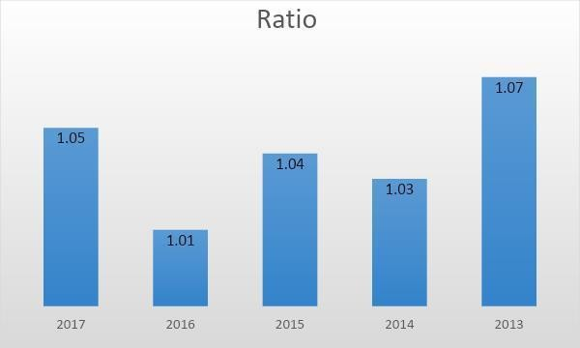

Figure: Current Ratio of SEBL

Interpretation:

The current ratio is higher; is considered as the most liquid. However, SEBL, the current ratio is good because it maintains current assets of 1.05tk compared to 1tk current liabilities where generally the banking industry maintains 2: 1 current ratio. This graph shows that the current ratio has increased to 2013 and decreased the following year.

Net Working Capital
Net working capital, though, is actually a measure of the liquidity ratio calculated by which a ratio is a general measure of a firm's overall liquidity.Net Working capital=Current AssetCurrent Liabilities

Year | Net working Capital
Year | (taka in Millions)
2017 | 3147.34
2016 | 2604.31
2015 | 3365.65
2014 | 3423.33
2013 | 3238.93

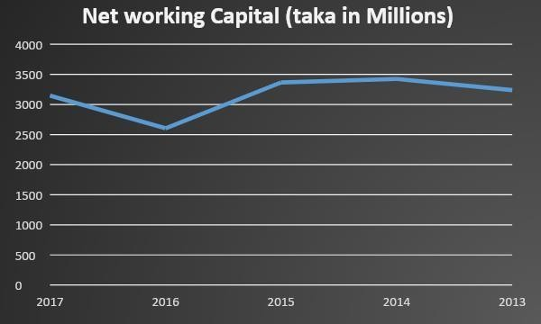
Table: Net Working Capital of SEBL Graphical Presentation:

Interpretation:

Net working capital of SEBL has declined somewhat in the last two years. However, the bank faced difficulties in fulfilling its current obligations. Therefore, the bank should increase its current assets.

Acid Test Ratio:
A rigorous index that determines whether a firm has enough short-term assets to deduct immediate liabilities without sales. The acid-test ratio is much more stringent than the working capital ratio, mainly because the working capital ratio allows for the inclusion of inventory assets. It is published: Acid Test Ratio :( Cash, Short-term Investments & Receivable / Current Liabilities)

Year |  | Ratio
2017 |  | 0.34 :1
2016 |  | 0.36 :1
2015 |  | 0.35 :1

2014 | 0.29 :1
2013 | 0.33 :1

Table: Acid Test Ratio of SEBL

Graphical Presentation

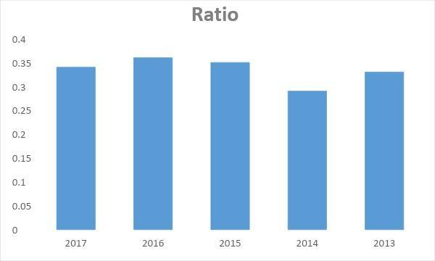

Figure: Acid Test Ratio of SEBL

Interpretation:
Companies with a ratio of less than 1 cannot pay their current liabilities, and they should be viewed with ultimate caution. In addition, if the acid-test ratio is much lower than the working-capital ratio, it means that the current ratio is the standard ratio 1: 1, highly dependent on inventory. However, the ratio of SEBL to acid test is weaker than quality. To improve this ratio, TBL needs to increase cash, short-term investments and receivables, and reduce current liabilities.

Activity Ratio:
Companies with a ratio of less than 1 cannot pay their current liabilities, and they should be viewed with ultimate caution. In addition, if the acid-test ratio is much lower than the working-capital ratio, it means that the current ratio is the standard ratio 1: 1, highly

dependent on inventory. However, the ratio of SEBL to acid test is weaker than quality. To improve this ratio, SEBL needs to increase cash, short-term investments and receivables, and reduce current liabilities.

Operating Expenses to Revenue (OER):
A ratio that compares cost to net sales in comparison is the ability to show a company's management skills. Count as: Operating Expenses to Revenue =Total Operating Expenses

Expenses/ Operating Income (revenue)

Year | Ratio
2017 |  | 57.16%
2016 |  | 62.94%
2015 |  | 57.81%
2014 | 44.00%
2013 | 36.04%
Table: Operating Expenses to Revenue Graphical Presentation:
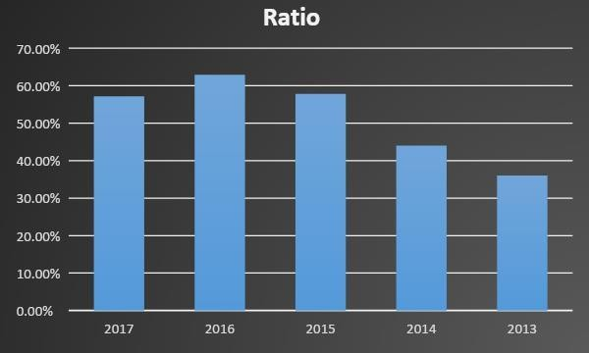

Figure: Operating Expenses to Revenue Interpretation:
The survey knows that this ratio measures the operating efficiency of the bank by measuring the part if the total operating expenses and the ratio of operating income of the bank are high, the operating efficiency is low. SEBL's operating expenses are lower at 2013 but this is increasing later.

So it can be said that the operating efficiency of SEBL is not in a better position than in previous years that they are not in a good position to reduce their operating expenses.

Total Asset Turnover Ratios:
The total asset turnover indicates the efficiency with which the firm is able to use all its assets to generate sales. Calculated as: Total Asset Turnover= Operating Income/Total Asset

Year | Ratio
2017 |  | 4.23%
2016 |  | 3.48%
2015 |  | 3.95%
2014 | 5.34%
2013 | 4.48%

Table: Total Asset Turnover of SEBL

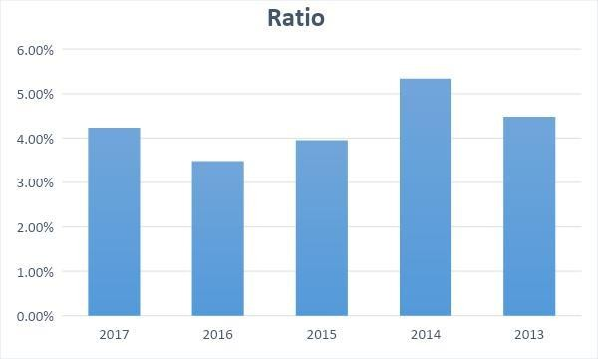

Figure: Total Asset Turnover of SEBL

Interpretation:
The turnover ratio of banks' total assets, which is 4.48 to 5.34 times in 2013-2014 years the more we know total asset turnover, the more efficient it is and 4 to 6 times the standard position but it depends on the industry. SEBL's total asset turnover ratio fluctuates from year to year, but rising at 2017, which is a good sign for the bank.

Operating Expenses to Assets Ratio:
The expense ratio for any asset fund is the total percentage of fund assets used for administrative, management, advertising and all other expenses. A ratio of 1% to annual expenditures means that the fund will be deducted 1% of total assets each year. Count as: Operating Expense to Assets (OEA) =Total operating Expenses/ Total Assets

Year | Ratio
2017 | 2.42%
2016 | 2.19%
2015 | 2.28%
2014 | 2.35%
2013 | 1.74%

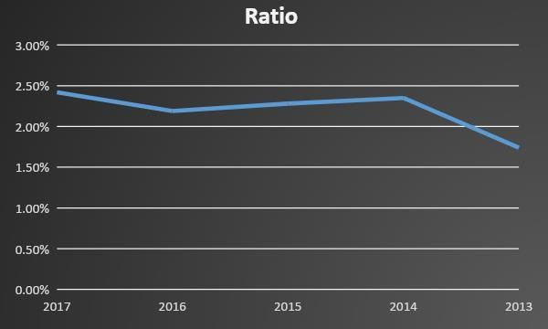
Table: Operating Expense to Assets of SEBL Graphical Presentation:

Figure: Operating Expense to Assets of SEBL

Interpretation:
It is important to consider the expense ratios when selecting funds, as they can significantly affect income. From the chart we can see that there is a tendency for operating expenses relative to the ratio of assets. In 2013, the ratio is only 1.74% but it has increased to 2.42% in 2017 years. This means that the cost of operation is increasing compared to the previous year.

Debt Ratio:
      - Debt Ratio:
The debt ratio measures the preparation of total assets provided by the firm’s creditors.

Debt ratio= Total Liabilities/Total Assets

Year | Ratio
2017 |  | 0.945
2016 |  | 0.947
2015 |  | 0.936
2014 | 0.927
2013 | 0.930

Table: Debt Ratio of SEBL

Graphical Presentation:

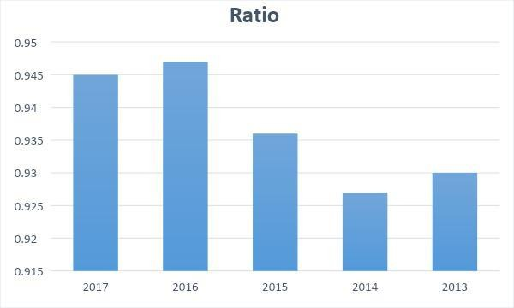

Figure: Debt Ratio of SEBL

Interpretation:
The higher the ratio, the higher the risk will be associated with the firm's activities. Accordingly, high debt to asset ratios indicate a firm's ability to take on less debt, thereby reducing the firm's financial flexibility. This graph shows that; the ratio of the debt was increasing year after year. Ratio is the ratio of total assets paid by the firm or suppliers. Their debt to debt ratio is indicative of a rising trend that indicates a negative sign.

Times Interest Earned Ratio:
Interest earning ratio, sometimes called interest coverage ratio, measures the firm's ability to pay contractual interest. Times Interest Earned Ratio =Earnings before Interest and Taxes/Interest Expense

Year | Ratio
2017 |  | 1.16
2016 |  | 1.10
2015 |  | 1.20
2014 |  | 1.37
2013 |  | 1.40

Table: Times Interest Earned Ratio of SEBL Graphical Presentation:
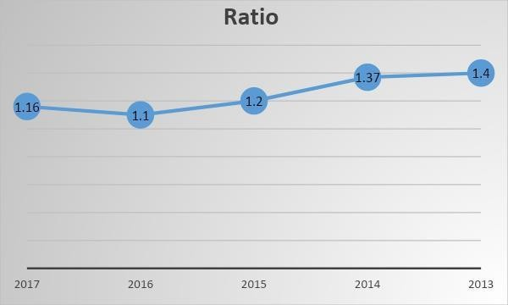
Table: Times Interest Earned Ratio of SEBL

Interpretation:

The time-to-interest ratio for SEBL is satisfactory but has been declining somewhat over the past three years. Thus, a high ratio should be maintained by reducing the operating cost of SEBL to achieve sufficient returns to meet interest obligations. A high ratio may indicate that a company has an unwarranted debt or is paying off excessive debt on the revenue used for other projects. It is losing the opportunity to come at the right time to pay interest.

Profitability Ratio:

Investment to Deposit Ratio:
It is expressed as:

Investment to Deposit Ratio=Total Investment/Total Deposit

Year | Ratio
2017 |  | 0.303
2016 |  | 0.306
2015 |  | 0.328
2014 |  | 0.198
2013 |  | 0.225

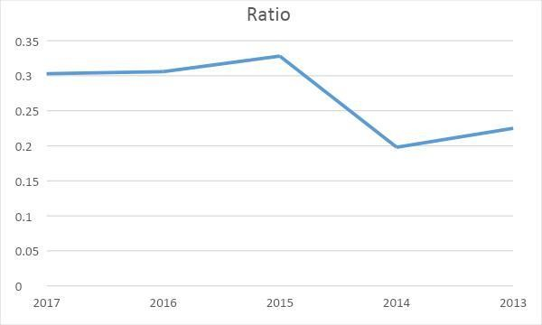
Table: Investment to Deposit Ratio of SEBL Graphical Presentation:
Figure: Investment to Deposit Ratio of SEBL

Interpretation:

Investment in the ratio of deposits shows that the amount of money used as a deposit investment. SEBL's investment in deposit ratio is increasing year after year. That means the

bank is using their deposits properly

Net Profit Margin:
Gross profit margin measures the percentage of sales dollars after all expenses, including taxes. The higher the firm's net profit, the better. Net profit margin is a commonly cited measure of a company's success in sales related earnings: Net Profit Margin=Net Profit after Tax/Operating Income

Year | Ratio
2017 | 0.165811
2016 | 0.147800
2015 | 0.200434
2014 | 0.267133
2013 | 0.352562

Table: Profit Margin Ratio of SEBL Graphical Presentation:
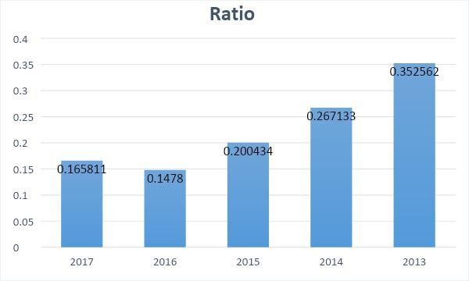
Figure: Profit Margin Ratio of SEBL

Interpretation:

The bank's net profit margin (0.35-0.16) at 2013-2017 indicates that the profit margin is decreasing day by day and this is not a good situation. SEBL's net profit margin is declining,

indicating that banks' profit margins are declining. The profit margin ratio value is 0.075, from the above graph we can see that the SEBL profit margin ratio is higher than the value but it is decreasing in nature.

Return on Asset (ROA):
Return Assets (ROA), often referred to as the firm's return on total assets, measures management's overall effectiveness in making a profit with its available assets. The proportion is better Return on Asset (ROA) =Net Profit after Tax/Total Asset

Year | Ratio
2017 |  | 0.60%
2016 |  | 0.30%
2015 |  | 0.75%
2014 | 1.31%
2013 | 1.50%

Table: Rate of Return on Assets of SEBL Graphical Presentation:
Interpretation:

Return on Asset (ROA) as an indicator of management efficiency, indicates management's ability to convert an organization's assets into net income. In the previous 5 years, banks will

return on assets from 1.50% to 0.60%. Thus SEBL derives less profit from assets. This is not good for the bank. However, the RO has risen even higher in the 2014 than in the 2013, which is a good bet for the bank. To improve the ratio, SEBL needs to increase net income and control average gross assets.

Return on Equity (ROE):
Return on equity measures the return received on an investment by the owner (both preferred and general stockholder). Generally, higher returns indicate better owner status. Return on Equity=Net Profit after Tax/ Shareholders Equity

Year | Ratio
2017 | 10.61%
2016 | 7.00%
2015 | 13.14%
2014 | 18.57%
2013 | 22.27%

Table: Return on Equity of SEBL Graphical Presentation:

Figure: Return on Equity of SEBL

Interpretation:
ROE is the measurement of the rate of return flowing to the bank's shareholders. It measures the net advantage that the investors have gotten from investing their capital in the bank.

Higher ROE indicates the favorable position that the company is productive in generating income on new investment. The banks return on value deviates from 7% to 22.27%. In the preceding 5 years and the most astounding value can be seen in 2013 and the least value can be seen during 2017, which isn't desirable. The positive side is the ratio is increased by 3.61% from the preceding year. So the management should strive to increase the arrival associated .

Earnings per Share
Earnings per share (EPS) of the firm are generally present or potential stockholders and interested in management. The earnings per share represents the dollar number earned for the outstanding shares of each common share. Earnings per share are calculated as below: Earnings per Share =Earnings Available for Common Stock Holder/No of shares of Common Stock Outstanding

Year | EPS
2017 |  | 2.15
2016 |  | 1.34
2015 |  | 2.75
2014 |  | 3.14
2013 |  | 3.5

Table: EPS of SEBL

Graphical Presentation:
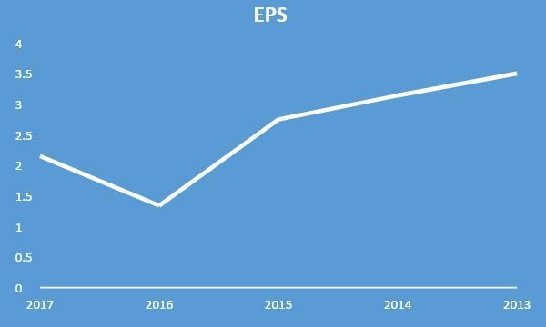

Figure: EPS of the SEBL

Interpretation:

EPS has stated that it acquires for each outstanding share of the common share price. EPS is viewed by investors intentionally because it is an important indicator of corporate achievement. The graph shows that the income of each part of SEBL in 2013 is higher than in 2016 and 2017 as it is now, 2013 years was the desired year for SEBL.

6.1.4.6 Price Earnings Ratio:

The Price or Earnings (P / E) ratio is often used to determine the share price of an owner's valuation. P / E represents the amount of money an investor's firm is willing to pay for each dollar of income. The higher the P / E ratio, the higher the investor confidence in the firm's future. Price to earnings (P / E) ratio is calculated as follows: Price Earnings Ratio=Market Price per Share/Earnings per Share

Year | Ratio
2017 | 8.50
2016 | 14.55
2015 | 7.04
2014 | 5.79

Table: Price Earnings Ratio of SEBL Graphical Presentation:
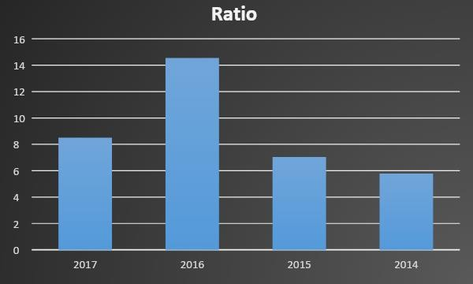

Figure: Price Earnings Ratio of SEBL

Interpretation:

The graph shows that the SEBL's price-to-earnings ratio was good, representing 14.55% in 2016. Last year, the 2017 earnings ratio dropped to just 8.5% which is not satisfactory. To improve the ratio, SEBL has to raise the market price per share and reduce the earnings per share. This graph shows the ratio of price to earnings that FY is increasing from 2015 to 2016

Chapter -5

Findings Conclusions and Recommendations

Findings

Each study includes certain findings; my report is no exception. During my internship I had the opportunity to observe some of the things that were not noticed by Southeast

Bank Limited (SEBL). They are given below: ⎪ The liquidity condition of Southeast Bank Limited is quite satisfactory. Its liquidity ratio is closer to its standard level and it has a higher debt-to-equity ratio than total assets, thus posing a risk on average. ⎪ The bank's ROA has increased to 0.60% in 2017 than the year 2016 which is within moderate satisfactory level because it was greatly improved in the year 2013 and 2014. ⎪ The bank's return on equity is in a decreasing pattern. In the earlier year 2013 and 2014, the ratio was exceptionally satisfactory. It decreased in 2016 however in 2017 it increased to 10.61%. ⎪ Its operating expenses have increased to 8731.92 million from 7482.67 million in 2017 because of the increase of branches and workers. And for this its net interest margin, net operating margin are also decreasing. ⎪ The debt ratio has increased step by step. The debt ratio measures, the proportion of total assets provides by the firm’s creditor. Their debt ratio was increasing to 0.945 in 2017 that indicates a negative sign for the bank. ⎪ EPS has been closely watched by investors as it is an important indicator of corporate success. The analysis shows that the earnings per share of SEBL was 2013 and higher than 2016 for 2017 years. Reducing the net profit margin means the bank's operating results are diminishing. 2013 years shows that EPS is up at 3.5, which is a good sign

for the company. ⎪ The banks that make money on total assets are quite satisfactory and in 2017 its fixed asset turnover is 4.23% which indicates a good asset management of SEBL. ⎪ Market price analysis shows that the market performance of the bank is increasing which is indicated by increasing the market value per share from Rs 100 to Rs 193.92. ⎪ Overall, SEBL's financial position is quite satisfactory compared to other public commercial banks. Despite the adverse economic conditions of the past few years, SEBL has achieved decent performance in all key areas of banking activities.

Conclusion

Southeast Bank Limited (SEBL) is setting new standards for banking in hours of dire economic conditions. As part of the legislature's long-term financial transformation and modernization plan, the bank was transformed into an open limited company. SEBL prepares resources to stay strong in key areas of management. In terms of Treasury activities, SEBL remains the key player in the currency market to maximize profits through pricing of large amounts of currency and marketing rates and expectations, while Treasury transactions are being strengthened to facilitate increasingly sophisticated items and transactions required for administration. In spite of the fact that it has a wide range of system and confidence from the clients, it has a few issues those issues decrease its income. The authority isn't that adaptable and it takes time to make a decision. Southeast Bank Limited has always tried its level best to perform financially. Their financial performance against the banking industry is extremely satisfactory. Without trying to do well in some cases, Southeast Bank Limited once faced some financial problems. Part of the issues are the profitability and the declining pattern of dissolution, the shortage of representatives, the current technological benefit shortage, and more. These problems are aroused from time to time due to economic slowdown, interest rate fluctuations, emerging capital markets, inflation in the money market. By battling all these problems and competing with other banks every minute, the bank is trying to improve. In the wake of this issue, we believe that Southeast Bank Limited will grow even more lately. From a practical standpoint, I can boldly declare that from the very first day I truly enjoyed my internship at this bank. Furthermore, this internship program that is mandatory for my B.B.A program has definitely helped me to think more about my career. I have tried my best to include the research report with relevant information.

Recommendations

This report is prepared on the basis of financial reporting analysis. The report attempts to provide details about financial performance. While preparing the report, it is understood that financial performance is not a common issue, rather it is the parent of all analysis of a bank. Throughout my internship period, each part of this section has become easier to understand. Nevertheless, it will again recommend some of the components that are useful for managing

financial liquidity.

√ Liquidity position of the Bank should be improved by reducing current liabilities

√ To concentrate more to increase return on asset by ensuring maximum utilization of its assets.
√ A reasonable credit policy should be implemented, so that the main portion of profit does not spend in payment of fixed charges.
√ Increase operational efficiency by reducing cost and wastage and improves operating and management efficiency. The supply of working capital should be adequate.
√ SEBL should be considered that the deposit is showing a lower tendency to change.

√ To ensure the continuous upward movement of net interest income by raising efficiency and proper utilization of deposit.
√ The evaluation process and form of training needs to be further modernized.

√ The number of branches can be increased to create employment opportunities.

√ Banks should use regular ratio analysis and take measures to improve the unadjusted ratio.
√ Appoint qualified, trained and experienced management personnel.

√ Government regulations should be flexible and the policy should be realistic.

√ Accountability and motivation for performance should be established.

References:

Kumbirai, Mabwe, and Robert Webb. "A financial ratio analysis of commercial bank performance in South Africa."African Review of Economics and Finance 2.1 (2010): 30-53.
Sherman, H. David, and Franklin Gold. "Bank branch operating efficiency: Evaluation with data envelopment analysis."Journal of banking & finance 9.2 (1985): 297-315.
Gorener, Ali, Hasan Dincer, and Umit Hacioglu. "Application of multi-objective optimization on the basis of ratio analysis (MOORA) method for bank branch location selection." (2013).
Elyasiani, Elyas, Seyed Mehdian, and Rasoul Rezvanian. "An empirical test of association between production and financial performance: the case of the commercial banking industry."Applied Financial Economics 4.1 (1994): 55-60.
Herman, Edward S., and Carl F. Safanda. "The Commercial Bank Southeast Department and the Wall."BC Indus. & Com. L. Rev. 14 (1972): 21.
Siddiqui, Anjum. "Financial contracts, risk and performance of Islamic banking."Managerial finance 34.10 (2008): 680-694.
Aktar, Serena, Muhammad Kamruzzaman Sachu, and Md Emran Ali. "The impact of rewards on employee performance in commercial banks of Bangladesh: an empirical study."IOSR Journal of Business and Management 6.2 (2012): 9-15.
Chowdhury, Tanbir Ahmed, and Kashfia Ahmed. "Performance evaluation of selected private commercial banks in Bangladesh."International journal of business and management 4.4 (2009): 86-97.

