
\

.

Job Satisfaction of Employees of JL SWEATERS LTD.



Internship Report
On
Job Satisfaction of Employees of JL SWEATERS LTD.

Submitted To
Dr. Md. Abdur Rouf
Associate Professor of Accounting and Director, MBA Program
Department of Business Administration
Faculty of Business & Entrepreneurship
Daffodil International University.

Submitted By

Shaker Nehad Nahin
ID: 192-14-140
Program: MBA
Major in HR Management
Faculty of Business Administration
Daffodil International University

Date of Submission: 07/10/2020
Letter of Transmittal
Date: 07/10/2020
To
Dr. Md. Abdur Rouf
Associate Professor of Accounting and
Director, MBA Program
Department of Business Administration
Faculty of Business & Entrepreneurship
Daffodil International University

Subject: Submission of Internships report on “Job Satisfaction of Employees of JL SWEATERS LTD.”

Dear Sir,

It is a great pleasure to submit my internship report on the internship titled “Job Satisfaction of Employees of JL SWEATERS LTD.” This report was assigned by me during my study period in JL SWEATERS LTD.”

I tried my best prepare for this report. Any shortcomings or flaw may arise I am very much beginner in this aspect. I will wholeheartedly welcome any clarification and suggestion about any view and conception disseminated in my report.

I have gathered valuable experiences from practical life situations in the process of preparing the report would like to thank you for your kind hearted cooperation with me in preparing the report.

Sincerely yours,

------------------------
Shaker Nehad Nahin
ID: 192-14-140
Program: MBA
Major in HR Management
Faculty of Business Administration
Daffodil International University

Certificate of Approval


This is to endorse that this report entitled “Job Satisfaction of Employees of JL SWEATERS LTD.” submitted to Daffodil International University in association with the institution’s internship program is an authentic record of work done by “Shaker Nehad Nahin” under my supervision at the “JL SWEATERS LTD.”, HR Division (Head Office).

Supervisor

----------------------------------
Dr. Md. Abdur Rouf
Associate Professor of Accounting and
Director, MBA Program
Department of Business Administration
Faculty of Business & Entrepreneurship
Daffodil International University.

Declaration

I hereby declare that the internship report entitled “Job Satisfaction of Employees of JL SWEATERS LTD.” submitted in partial fulfillment of the requirement for the degree of Master’s of Business Administration (MBA) at Daffodil International University.

I also confirm that this report is uniquely prepared by me after the completion of 3 months internship at JL SWEATERS LTD.

-------------------------------------------------------------
Shaker Nehad Nahin
ID: 192-14-140
Program: MBA
Major in HR Management
Faculty of Business Administration
Daffodil International University

Summary
This study is the result of my internship program ran for the past three months placed at the JL SWEATERS LTD. Zirabo,Savar is one of the reputed organization in Bangladesh. It has already developed reputation among the users. Therefore, the branch has all level of employees of the company. Since my internship program guided to understand the level of job satisfaction, I had to gain the practical area of responsibilities and of accountabilities of the employee so that I could cooperate with them to assess their views about and relations with the organization. I tried best to ask the staffs of the JL SWEATERS LTD. Zirabo, Savar directly and indirectly to gather my information.
However, I had a good access to the company publications. My task was designed to understand the level of job satisfaction of the employee of the JL SWEATERS LTD. Zirabo, Savar. To prepare this report I used primary and secondary data. The objectives of the report were understood level of job satisfaction of the employees of the JL SWEATERS LTD. Zirabo, Savar. So, the research was designed to achieve it. From the previous studies on this subject I have practically and empirically learnt that job satisfaction largely depends on the number of interrelated components such as workplace, salary, training, lack of gender discrimination, neutral promotion policies. Despite differences in opinions made by the employees of the organization on what the study was conducted, what the study finds is that they are highly satisfied in their job.

Acknowledgment

First & foremost of all, I would like to convey my heartiest gratitude and total devotion to Almighty God for blessings me with the ability, strength, patience as well as keeping me active in performing my thesis report tasks successfully.

A Special Debt Is Due To My Respectable Teacher, Dr. Md. Abdur Rouf, Associate Professor of Accounting and Director, MBA Program, Department of Business Administration, Faculty of Business Administration who has been my academic supervisor for the course of MBA. He was king enough to allocate her valuable time to provide me with her humble guidance, motivation thoughts, ample & applicable directions for the successful preparation of this report.

I am also extremely grateful to the all officials of JL SWEATERS LTD Zirabo, Savar are working who have sacrificed their valuable time in providing us necessary information and made detailed comments that have contributed to the planning of this report and internship program. In addition, I gladly acknowledge the valuable cooperation and assistance I have received from the staffs of the JL SWEATERS LTD. It will be really injustice if I do not thanks to them because without their cooperation we cannot do anything.

I am also grateful to my Family for their continuous all sorts of supports throughout the preparing report.

--------------------------------
Shaker Nehad Nahin
ID: 192-14-140
Program: MBA
Major in HR Management
Faculty of Business Administration
Daffodil International University

Table of Contents
Sl. No | Title | Page no.
 | Cover Page  Inner Cover  Letter of transmittal  Certificate of Approval  Declaration  Summary  Acknowledgement  Table of Content | i  ii  iii  iv  v  vi  vii  viii-ix
 | Description
 | CHAPTER ONE: INTRODUCTION | 01-06
1.1  1.2  1.3  1.4  1.5  1.6 | Background of the Study  Origin of the Report  Scope of the study  Objectives of the study  Methodology of the study  Limitations of Study | 2  2  2  2-3  4  4
 | CHAPTER TWO: PROFILE OF THE JL SWEATERS LTD. | 05-10
2.1  2.2  2.3  2.4  2.5  2.6  2.7 | History of the JL SWEATERS LTD  Company Profile of JL SWEATERS LTD  Factory Details  List of Machinery  Mission of JL SWEATERS LTD  Vision JL SWEATERS LTD  Product Gallery of JL SWEATERS LTD | 6  6-7  7  8-9  9  9  10
 | CHAPTER THREE: MANAGEMENT SYSTEM OF JL SWEATERS LTD | 11-15
3.1  3.2  3.3  3.4  3.5  3.6 | Organizational of JL SWEATERS LTD  JL SWEATERS LTD ( Woven Division )  HR Compliance JL SWEATERS LTD  Section wise Manpower  Management Medium  Management Standard | 12  13  14  14  14  15

 | CHAPTER FOUR: THEORETICAL ASPECTS OF JOB SATISFACTION | 16-20
4.1  4.2  4.3  4.4  4.5  4.6  4.7  4.8  4.9 | Employee  Definitions of Job Satisfaction  Importance of job satisfaction  Importance to employee and organization  Employees role in job satisfaction  Factors of job satisfaction  Effects of low job satisfaction  What is the impact of job satisfaction?  4What job satisfaction people | 17  17  17-18  18  18  19  19  20  20
 | CHAPTER FIVE: ANALYSIS AND FINDING | 21-36
5.0  5.1  5.2 | Questionnaire Survey analysis  Data analysis  Findings of the Study | 22  22-35  36
 | CHAPTER SIX: RECOMMENDATIONS & CONCLUSION | 41-43
6.1  6.2 | Recommendations  Conclusion | 38  39
 | CHAPTER SEVEN: BIBLIOGRAPHY | 40-43
 | Appendix  Questionnaire | 40-43
 | References | 44

Chapter- 01
Introduction

  - Background of the Study
Employee are the key factor of JL Sweaters. This organization can’t achieve this success without the employee on single satisfaction going make to motivate employee for making productivity. I had the opportunity to work in one of the most important company who earn overseas money by export product, this company name JL SWEATERS LTD. It is a big sector in our country for contributes foreign income. Now I get my report topic is Job Satisfaction of Employee of JL SWEATERS LTD.

1.2 Origin of the Report
As a participant of MBA Program of Faculty of Business & Entrepreneurship, Daffodil International University I have to submit internship report for partial fulfillment of the MBA Program. Our honorable teacher by DR. MD. ABDUR ROUF, Assistant Professor, Faculty of Business & Entrepreneurship authorized this report for internship program. As per the instruction my teacher, I have become interested to submit a report on “Job Satisfaction of Employee of JL SWEATERS LTD.”

1.3 Scope of the study
Job satisfaction of a Garments industry is vast thing and very important. Moreover, all Garments industry keep trying secret information on competitive market So the basically tried to identify the job satisfaction by study followed by JL SWEATERS LTD. The study was also tried to identify and analyze the various expenses incurred by the JL SWEATERS LTD. in a secretarial year.

1.4 Objectives of the study
Broad Objective:
The broad objective of the study is to asses this overall job satisfaction of the employees of JL SWEATERS LTD.

Specific Objective:
Specific objectives of the study are as follows:
- To measure the overall employees job satisfaction of JL SWEATERS LTD.
- To identify the employee’s satisfaction on level of various factors of Job Satisfaction.
- To identify the causes of employee job dissatisfaction.
- To make suggestion for improving job satisfaction of JL SWEATERS LTD.

1.4.1 Sources of Data
There is one source of data. The sources are given below:

- Secondary Data
This source of data contains all the information and that are already exists somewhere. The secondary data are collected from annual report of JL SWEATERS LTD. web site of the JL SWEATERS LTD and brochures of the JL SWEATERS LTD.

1.4.2 Sample Design:

1.4.2.1Selection of the study area:
JL SWEATERS LTD, Zirabo, Savar, Dhaka was considered as the study area of the research. The researcher objective was to job satisfaction level of the employees. Since the researcher area of internship study was HRM, the researcher tried to get idea, observe and understand the job satisfaction level of employee of the factory. To get the ideas about job satisfaction of employees’ researcher tried to assess the status of job satisfaction of the JL SWEATERS LTD.

1.4.3Total sample strength of the study:
In the study all 100 employees of JL SWEATERS LTD. Zirabo, Savar was considered as the total sample strength of the study which is a complete census.
1.4.4 Variables Covered:
The following variables have been used to conduct the analysis of this report:
- Salary
- Work environment
- "Nature of job
- Supervision
- Management style
- Co-worker relationship
- Opportunity of self-development
- Promotional opportunity
- Decision making authority
- Security of job
- Opportunity to explore one's ability etc.
1.5 Methodology of the study

The study has been conducted on personal interview of the employees of JL SWEATERS LTD. Who are working Zirabo, Savar, Dhaka. Bangladesh. as well as a questionnaire used to be collected various information related with job satisfaction and observation method is used in various sensitive issues to know the actual behavioral aspects of employees.

1.6 Limitations of Study
Nothings ahead of limitation. The major limitations of the study are as follows:

- Information in the company is confidential and critical. The main barrier in preparing this report was data confidentiality.
- Although the employees of JL SWEATERS LTD. have been helpful, they didn’t have enough time to provide, as they very busy with their assign works. So I face some problem when I work in JL SWEATERS LTD, Zirabo, Savar.
- Employee felt hesitation to provide their opinion on Job Satisfaction.
- Lack of experience to prepare Internship report properly.
- Money limitation.

Chapter-02
Profile of the JL SWEATERS LTD.

2.1 History of the JL SWEATERS LTD.

By forming trade union, Due to the higher price Retailers started searching for place where they can produce their product at a cheaper price. Developing economics
The entire operations of JL are carried out from four of its own premises. These premises are designed with the most modern and futuristic factory specifications. On the verge of embarking upon producing woven fabrics very soon, now it has got 14 successful going concerns to independently engage itself in knitting, dyeing, printing, embroidering, sewing, accessory manufacturing, packaging, washing, clearing & forwarding, and logistics. On an aggregate floor space of more than 1.73 million square feet in different production units, a few more than 17,500 people are now working in JL. Every month, they are producing about 2.5 million pieces of knit and knitted fleece garments in its vertical knit division, and about 1.9 million pieces of shirts and blouses in its woven division.

Till date, almost all the social, industrial and environmental standards and certificates required and applauded locally and internationally are achieved by JL. So, having the best kind of ETP is not just enough for JL; rather, in order for delivering the task professionally responding to the global call, JL now has gone green.

2.2Company Profile of JL SWEATERS LTD.
Head Office | : | 133-134, Zirabo, Savar, Dhaka. Bangladesh.
Phone | : | (880-2) 7744001-8
Fax | : | (880-2) 7741830
E-mail | : | info@JLfashions.com
Chairman | : | Mr. Delwar Hossain
Managing Director | : | Mr. Md. ShamsulAlam
Dy. Managing Director | : | Mr. Md AbulKashem
Contact Person | : | Md. AbulKashem (Dy. Managing Director) E-Mail: kashem@JLfashions.com  Moslehuddin Ahmed (Executive Director) E-Mail: muahmed@JLfashions.com
Year of Establishment | : | 1997
Production Capacity/Monthly | : | 1.2 Millions Pcs
Total Turnover | : | US$ 50.00 million (2011)
No. of Workers | : | 4290 Persons
Main Product | : | Woven Shirts (Men’s/ Ladies/ Boys & Girls)
Main Market | : | USA, Canada & Europe, Japan
Buyers/Brands | : | USA: Gap, Wal-Mart, Kohls, PVH, Wrangler, Jc-Penney, Sears K-Mart Costco, Macy, EB, US Polo, BNR etc  UK: Mackays Stores, Marks & Spencer, Debenhams, Shop Direct, Next etc.  Germany: C&A, Metro, Aldi etc.  Canada: Wal-Mart  Italy: United Colour of Benetton  France: Celio  Europe : H&M, Kigili, Pierre Cardin, CV etc.  Japan : ITOYOUKADO, TAKA-Q etc.
Suppliers (Fabrics) | : | Penfabric, Pentley (Malaysia), P.T. Argo Pantes, P.T. Unilon (Indonesia), Taksang (HK), Jiangshu Textiles (China), Arvind/ BVM (India), Monno Fabric, Beximco Textile, Unicom Textile (Bangladesh) etc.

2.3 Factory Details
 | JL Fashions Ltd. | Angshuk Ltd. | JL Shirts Ltd. | JL Apparels
Location | 133-134,Zirabo,  Savar, Dhaka – 1340,  Bangladesh. | 133-134,Zirabo,  Savar, Dhaka – 1340,  Bangladesh. | 133-134,Zirabo,  Savar, Dhaka – 1340,  Bangladesh. | 128, Zirabo,  Savar, Dhaka – 1340,  Bangladesh.
Telephone Nos. | (880-2) 7744001-8, 7741830-31 | (880-2) 7744001-8, 7741830-31 | (880-2) 7744001-8, 7741830-31 | (880-2) 7744001-8,
Fax Nos. | (880-2) 8155640 | (880-2) 8155640 | (880-2) 8155640 | (880-2) 7741830
Total Floor Space | 126000 sft. | 90000 sft. | 140000 sft. | 56000 sft.
No. of Lines | 08 | 04 | 10 | 08
Capacity/Month | 2,20,000 Pcs | 110,000 Pcs | 2,70,000 Pcs | 2,20,000 Pcs
Nos. of Workers | 1160 | 580 | 1390 | 1160

2.4 List of Machinery
Names of Machine | JL Fashions  Ltd.(Unit 1&2) | Angshuk Ltd. | JL Shirts Ltd.  (Unit – 01 & 02,03) | JL Apparels Ltd
Plain Machine (Juki) | 272 Nos. | 132 Nos. | 387 Nos. | 230 Nos.
5 Thread Over lock (Juki) | 24 Nos. | 13 Nos. | 36 Nos. | 20 Nos.
3 Thread Over lock (Juki) | 02 Nos. | 01 Nos. | 03 Nos. | 02 Nos.
Feed of the Arm (Juki) | 12 Nos. | 09 Nos. | 21 Nos. | 10 Nos.
Double Needle (Juki) | 12 Nos. | 08 Nos. | 16 Nos. | 14 Nos.
Kansai Special | 06 Nos. | 04 Nos. | 09 Nos. | 06 Nos.
Button Hole (Juki) | 17 Nos. | 09 Nos. | 22 Nos. | 12 Nos.
Button Stitch (Lock Stitch) (Juki) | 18 Nos. | 12 Nos. | 24 Nos. | 13 Nos.
Barteck (Juki) | 02 Nos. | 01 No. | 03 Nos. | 02 Nos.
Band Knife (CKS ) | 01 No. | 01 No. | 02 Nos. | 01 No.
Cutting Machine (KM) | 03 Nos. | 03 Nos. | 08 Nos. | 04 Nos.
Snap Button (Honrey) | 08 Nos. | 02 Nos. | 10 Nos. | –
Thread Sucker (Local) | 02 Nos. | 01 No. | 03 Nos. | 02 Nos.
Collar Forming (Nagaishing) | 02 Nos. | 02 Nos. | 04 Nos. | 02 Nos.
Cuff Forming(Nagaishing) | 01 No. | 02 Nos. | 02 Nos. | 02 Nos.
Fusing (Machine) Kannegiesser | 02 No. | 01 No. | 03 Nos. | 01 No.
Front Placket Fuse (Nagaishing) | 02 No. | 01 No. | 02 Nos. | 01 No.
Steam Boiler 9 Local) | 02 No. | 01 No. | 03Nos. | 01 No.
Steam Iron (Silver Star) | 28 Nos. | 15 Nos. | 38 Nos. | 24 Nos.
Vacuum Table ( Local) &Hashima | 28 Nos. | 15 Nos. | 38 Nos. | 24 Nos.
Metal Detector (Lock) | 01 No. | 01 No. | 01 No. | –
Generator (FG WILSON ) | 02 No. | – | – | 01 No.
Compressor (Swan &jukai) | 02 Nos. | 02 Nos. | 03 No. | 01 No.
Neck Press (Nagaishing) | 02 No. | 01 No. | 02 Nos. | 01 No.
Arm Hole Fuse (Nagaishing) | 02 Nos. | Nil | 05 Nos. | –
Side Seam Fuse (Nagaishing) | 01 No. | Nil | 03 Nos. | –
Slv. Placket Creasing (Nagaishing) | 01 No. | Nil | Nil | –
Fabric Inspection Machine (UZU) | 01 No. | 01 No. | 01 No. | –
Label Cutting Machine (Local) | 02 No. | 01 No. | 03 Nos. | 02 Nos.
Thread Rewinding Machine (Local) | 02 No. | 01 No. | 02 Nos. | 02 Nos.
Belt Binding Machine (Toyo) | 01 No. | 01 No. | 02 Nos. | 01 No.
Button Pull test (Nagaishing) | 01 No. | Nil | Nil | –
Saddle Stitch (Yamata) | 04 | – | – | 02nos
Picot & Fagoting machine (kansai) | – | – |  | 02 Nos.
Yoke press & Collar notcher (NG) | 02 | 01 no | 01+02=03 Nos. | –
TOTAL | 468 Nos. | 243 Nos. | 665 Nos. | 383 Nos.

G. Total-462+242+621 + 383=1705 Nos.

2.5 Mission of JL SWEATERS LTD.
JL is committed to venture out into the changing and challenging global market as a leading enterprise in the world apparel industry by satisfying its valued customers.

2.6 Vision JL SWEATERS LTD.
- To maintain the technology-led command in the industry;
- To promote development ensuring unprejudiced and equal opportunities for all;
- To continue growing nurturing competence in professionalism seeking win-win terms; and
- To go green as much as possible.
- To make new brunches
- Make new training Institute

2.7 Product Gallery of JL SWEATERS LTD
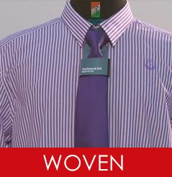
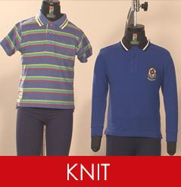
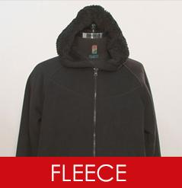

Chapter-03
Management System of JL SWEATERS LTD.

3.1 Organizational of JL SWEATERS LTD.
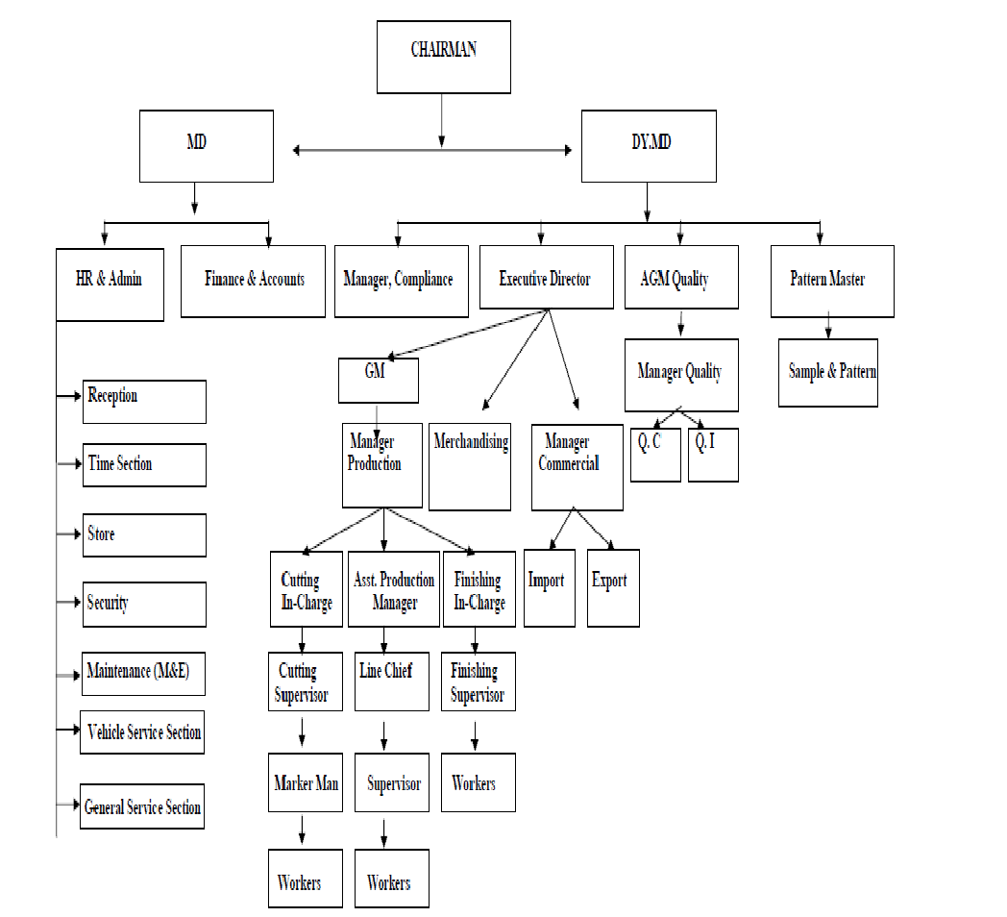
3.2 JL SWEATERS LTD (Woven Division )
Production Flow Chart
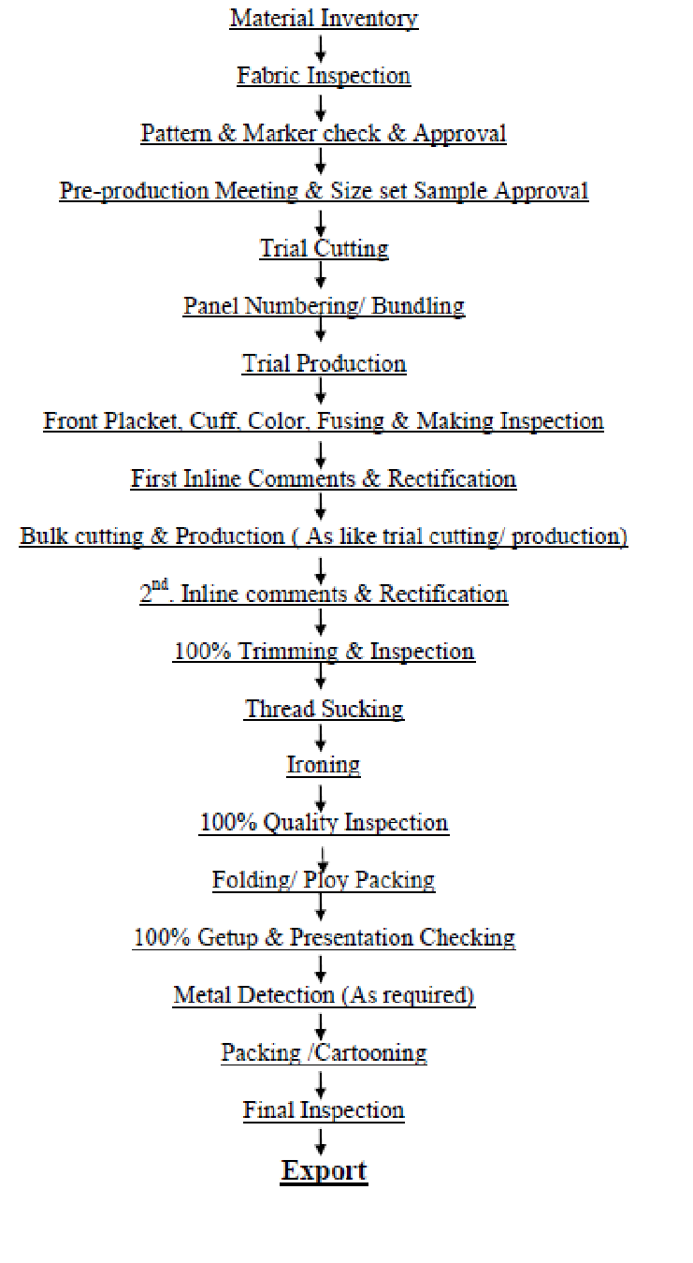

3.3 HR Compliance JL SWEATERS LTD.
JL believe strong mission to promote the company address to legal standards and in house policies. They are also responsible for enforcing regulation in all aspects. HR Compliance Believe promote the organization strongly by there mission. This provide basic help and quality of product improving. A very important factor considering the humanity of the group. Interpersonal the top management of JL maintain a very good relation with work force. They make to feel the work place as their second home.

3.4 Section wise Manpower

Department | Manpower
Administration | 55
Commercial | 42
Finance and Accounts | 30
Merchandising | 25
Store | 65
Knitting | 140
Dyeing & Finishing | 457
Garments | 3391
Mechanical | 85
Sub Total | 4290

3.5 Management Medium
- Intercom Telecom
- Fax
- E-mail
- Written letter & Papers
- Oral

3.6 Management standard
- Consumer sample is propel to GM
- Identical is done by lab in charge
- Sample is designed by dyeing master
- Sample is send to buyer for support
- Accepted sample is returned and taken as STD. Sample for bulk production.
- Asst. dyeing master gives household tasks to production officer
- Then manufacture officer, with the supervisor for bulk production
- On line and off line excellence check is done by lab in charge and dyeing master
- After dyeing finishing in charge controls the finishing process with supervision
- Of manufacture officer
- After finishing material is checked by dyeing master
- Finally GM check the result with dyeing master and decision is taken for release.

Chapter-04
THEORETICAL ASPECTS OF JOB SATISFACTION

4.1 Employee

Employee is someone work for a company or person who gets paid. Workers don’t need to work full time to be considered.
Employee they simply need to be paid to work by an employer

4.2 Definitions of Job Satisfaction

There are so many difference definitions about job satisfaction write in below,

“Job satisfaction is defined as a pleasurable, emotional, state resulting from appraisal of one’s job. An effective reaction to one’s job”.

“Job satisfaction is general attitude, which is the result of many specific attitudes in three areas namely:
Specific job factors
Individual characteristics
Group relationship outside the job”.

“Job satisfaction is defined, as it is result of various attitudes the person hold towards the job, towards the related factors and towards the life in general”.

4.3 Importance of job satisfaction
Being dissatisfied with jobs could lead to extreme stress and bring down morale of the entire organization and increase in absenteeism and decrease in Productivity is two major signs dissatisfaction within the work environment.

Employees represent organizations. They hold the power to help and organization achieves its objectives. So, it is crucial to learn about them, align the Organization's long term vision with the future career development of employees and understand their performance and where there person lie.

Every organization different and that is why it is necessary to evaluate human resource practices regularly, try and test methods to identify what work and what don’t,

it is also important to realize that all employees are different, Whilst increase in competition may work for some, others may be more interested in varied and interesting job duties. An effective labor management programmer takes into account these issues and also goes beyond the basics.

4.4 Importance to employee and organization

Employee is Valuable Organizational assets and also employees are the important for key of success in today’s competitive world the key of success on customer satisfaction. The result serving customer needs has become priority for many organizations. An organizations customers properly when they fail to the need the internal customer.
Employees are value asset of and organization and the key of success. Employee need to understand that a content and motivated employee has a higher probability of making significant contribution to the organization.

4.5 Role in employee job satisfaction

Job satisfaction and motivation become very important. Conventional human resource theories, developed some 50 years ago by Maslow and Herzberg, suggest that the satisfied employees tend to be more productivity, creative and committed to their employees. People are essential to productivity Improvement strategy is dependent on employee commitment managers can help employees achieve overall job satisfaction which with the employees international motivation drive increase performance on the job.

4.6 Factor of job satisfaction
There are five factors of job satisfaction give in below:

1. Intrinsic aspect of job
It makes the good spectacle of the job satisfaction on greatly motive themselves to grow the organization.

2. Supervision
In this aspect supervisor get make good relationship for the job satisfaction on the organization superior.

3. Working conditions
In make the place for the employer stay comfort to work and clean all the thinks of the place. Every wherefore they feel good to work here

4. Wage and salaries
This was prepare by done that work on that spent to wage and salaries

5. Opportunities for advancement
Under this aspect the potential worker can get the opportunity for advancement

4.7Effects of low job satisfaction

4.7.1 High Absence
Have workloads, stressful meetings presentations and feelings of being unappreciated can causes employees to avoid going into work personal stress can lead absenteeism.
4.7.2. High turnover
Toxic culture one of the most common yet often misunderstood causes of employee turnover is poor culture fit. People want their work to have meaning or at least some kind of purpose. Too much work and subsequently, too much stress is also a major factor Bordon on the other hand a lack of challenging or engaging work is also a major causes of employee turnover. People don’t leave there jobs they leave there managers.

4.8What the impact of job satisfaction?

Turnover can be one of the highest costs attributed to the HR department. Retaining worker helps create a better environment, and makes it easier to recruit quality talent and save money.
Irrespective of job title and pay grade, employees who report high job satisfaction tend achieve higher productivity.
Keeping employees safe and satisfied can lead to higher sales lower cost and stronger bottom life.
When employees feel the company has their best interest at heart they often support It’s mission and work hard to help achieve its objectives.

4.9 Job satisfaction people need?

- Appreciating for work
- Good relationship with colleges
- Good work life balance
- Good relationship with superiors
- Company’s financial stability
- Learning and career development
- Job security
- Attract Fixed salary
- Interesting job content
- Company value

Chapter- 05
Analysis and Finding

5.0 Questionnaire Survey analyses

5.1 Data analysis:

In this section the data analysis of Job Satisfaction of as Employee of JL SWEATERS LTD in this section the data analysis of job satisfaction of as Employee of JL Sweaters LTD. Employee attribute various job satisfaction of JL Sweaters LTD. Specific question consist of each dimension consist of Its own. The results of this study are as follows:

Part-A: Socio-demographic characteristics of the Respondents
Table:1- Age category
Age | Responses | Percentage
20 to 25 years | 20 | 20%
26 to 30 years | 30 | 30%
31 to 35 years | 20 | 20%
36 years and above | 30 | 30%
Total | 100 | 100%
Source: Primary Data

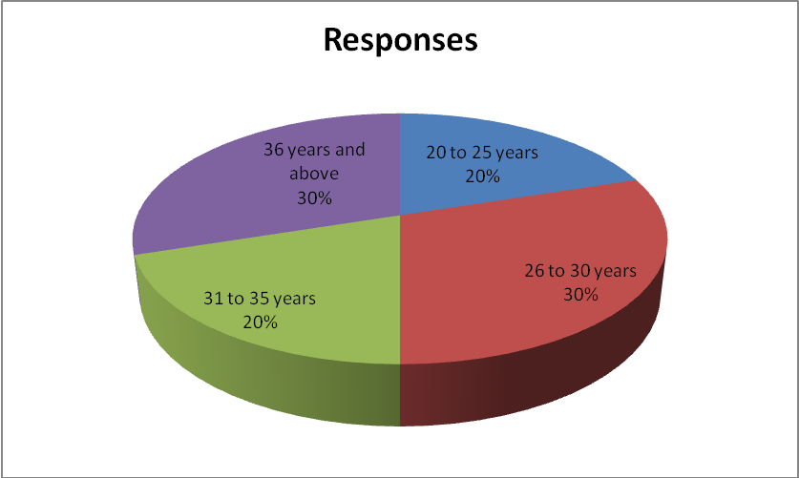

Interpretation
The graph shows that 20% respondents were 20 to 25 years old, 30% respondents were 26 to 23 years old, 20% respondents were 31 to 35 years old and 30% respondents were above 36 years and above.

Table 2: Gender

Gender | Responses | Percentage
Male | 80 | 20%
Female | 20 | 20%
Total | 100 | 100%
Source: Primary Data

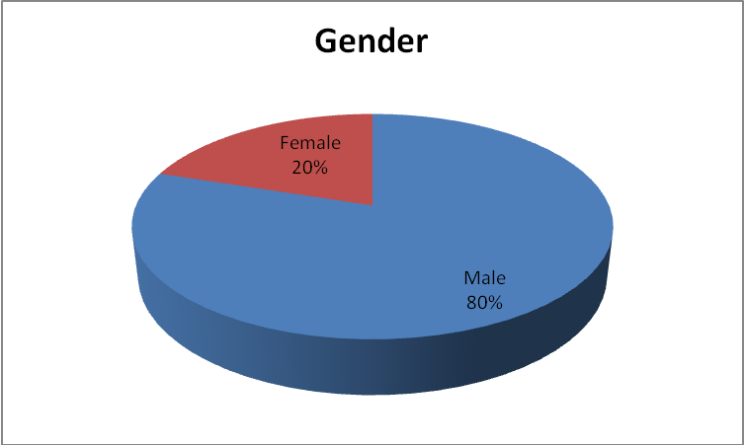
Interpretation
Out of 100 respondents surveyed, most of the respondents (80%) were male, and rests of the respondent (20%) were Female.

Part-B: Results related to Job Satisfaction of Employee of JL SWEATERS LTD.

Table 3: Are you an active employee of JL SWEATERS LTD.?

Opinion | Responses | Percentage
Yes | 98 | 98%
No | 2 | 2%
Total | 100 | 100%
Source: Primary Data

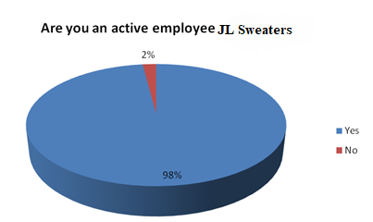
Interpretation
Out of 100 respondents surveyed, most of the respondents (98%) were active, and rests of the respondents (2%) were not active.

Table 4: Does your work give you a feeling of personal satisfaction?

Opinion | Responses | Percentage
Yes | 60 | 60%
No | 40 | 40%
Total | 100 | 100%
Source: Primary Data

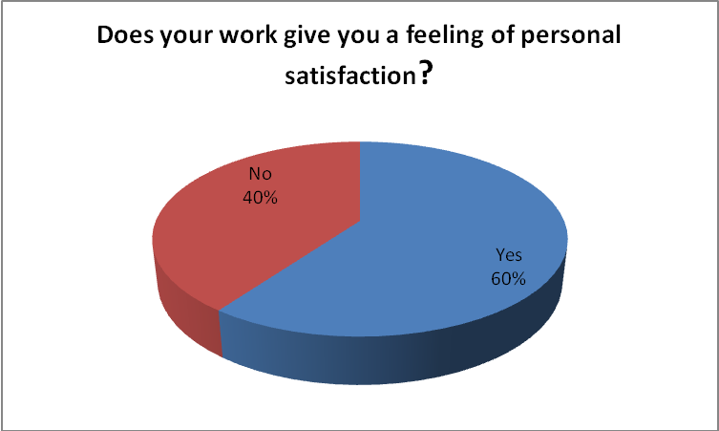
Interpretation
Out of 100 respondents surveyed, most of the respondents (60%) were satisfied and rests of the respondents (40%) were dissatisfied.

Table: 5 How long have you been working for this organization?
Opinion | Responses | Percentage
Less than 1 year | 20 | 20%
1 to 2 years | 30 | 30%
2 to 4 years. | 20 | 20%
4 years and above. | 30 | 30%
Total | 100 | 100%
Source: Primary Data

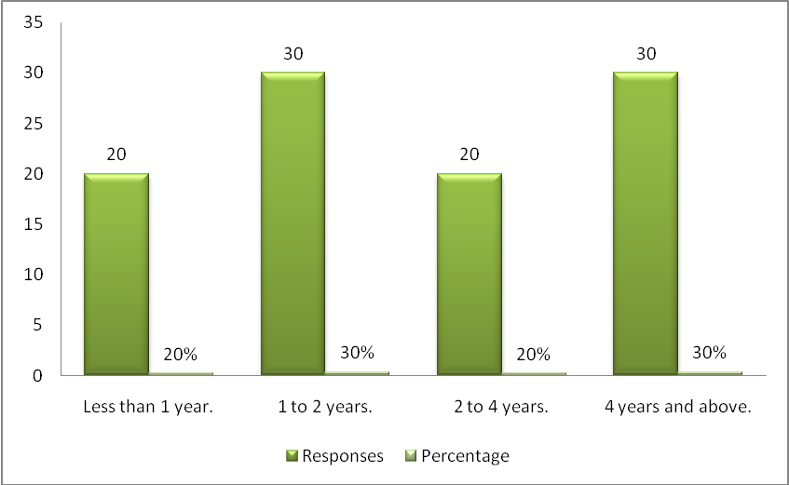

Interpretation

From the bar-chart we show that 20% respondents were less than 1 year, 30% respondents were 1 to 2 years, 20% respondents were 2 to 4 years and 30% respondents were above 4 years and above.

Table 6: Your work is according to your qualification and skills

Opinion | Respondents | Percentage %
Strongly Agree | 18 | 18%
Agree | 22 | 22%
Neutral | 10 | 10%
Disagree | 38 | 38%
Strongly Disagree | 12 | 12%
Total | 100 | 100
Source: Primary Data

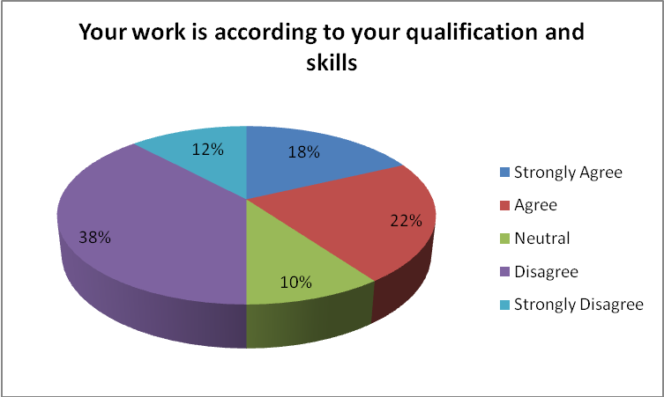

Interpretation
From the result of survey, its found that the Strongly Agree (18%) in second position there are Agree (22%), third position there are neutral (10%), fourth position there are disagree (38%) and Strongly disagree (12%). So work is according to your qualification and skills of the poor.

Table 7: Employees are satisfied with the top management

Opinion | Respondents | Percentage %
Strongly Agree | 30 | 30%
Agree | 12 | 12%
Neutral | 5 | 5%
Disagree | 38 | 38%
Strongly Disagree | 15 | 15%
Total | 100 | 100%
Source: Primary Data

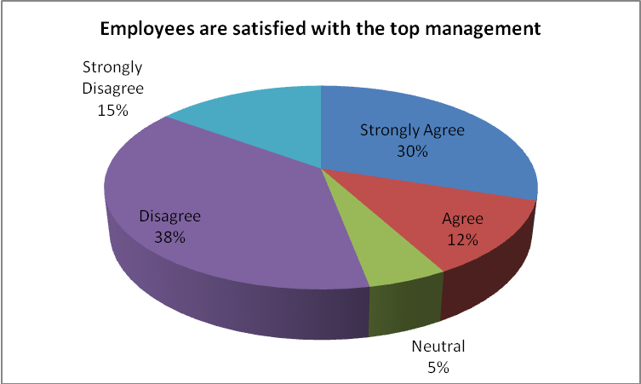

Interpretation
From the result of survey, its found that the Strongly Agree (30%) In second position there are Agree (12%), third position there are neutral (5%), fourth position there are disagree (38%) and Strongly disagree (15%). So employees are satisfied with the top management of the poor.
Table 8: Working hour is satisfactory at JL SWEATERS LTD.

Opinion | Respondents | Percentage %
Strongly Agree | 55 | 55%
Agree | 12 | 12%
Neutral | 10 | 10%
Disagree | 10 | 10%
Strongly Disagree | 13 | 13%
Total | 100 | 100%
Source: Primary Data

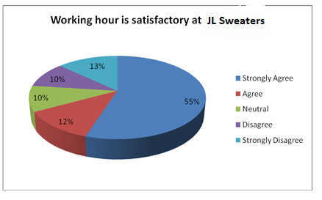

Interpretation
From the result of survey, its found that the Strongly Agree (55%) In second position there are Agree (12%), third position there are neutral (10%), fourth position there are disagree (10%) and strongly disagree (13%). So working hour is satisfactory at JL SWEATERS LTD of the very good

Table 9: Supervisor treats the employees fairly whenever they perform good job

Opinion | Respondents | Percentage %
Strongly Agree | 18 | 18%
Agree | 22 | 22%
Neutral | 10 | 10%
Disagree | 38 | 38%
Strongly Disagree | 12 | 12%
Total | 100 | 100
Source: Primary Data

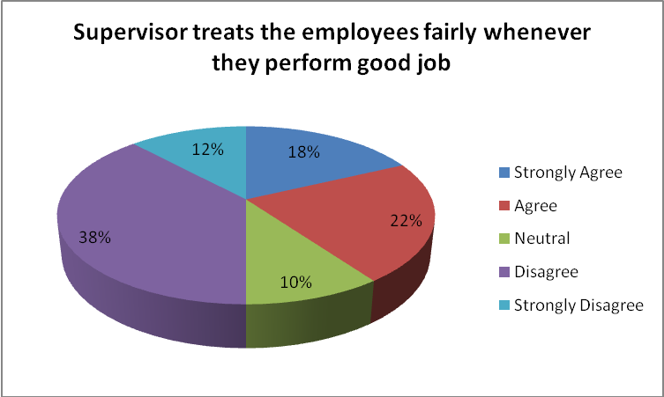

Interpretation
From the result of survey, its found that the Strongly Agree (18%) In second position there are Agree (22%), third position there are neutral (10%), fourth position there are disagree (38%) and strongly disagree (12%). So Supervisor treats the employees fairly whenever they perform good job of the poor.

Table 10: Company provides satisfactory salary to the employee

Opinion | Respondents | Percentage %
Strongly Agree | 40 | 40%
Agree | 12 | 12%
Neutral | 25 | 25%
Disagree | 10 | 10%
Strongly Disagree | 13 | 13%
Total | 100 | 100%
Source: Primary Data

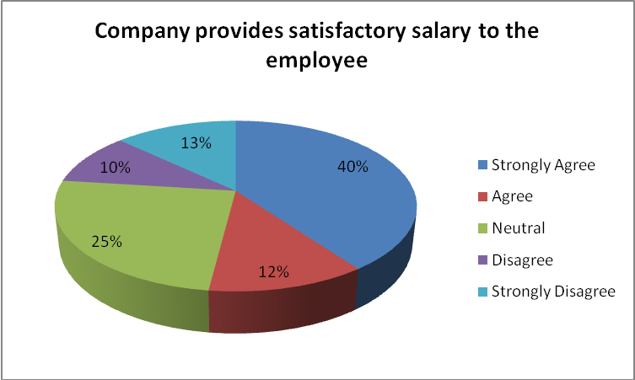

Interpretation
From the result of survey, its found that the Strongly Agree (40%) In second position there are Agree (12%), third position there are neutral (25%), fourth position there are disagree (10%) and strongly disagree (13%). So Company provides satisfactory salary to the employee of the superior.

Table 11: The work environment is safe and sound in JL SWEATERS LTD.

Opinion | Respondents | Percentage %
Strongly Agree | 42 | 42%
Agree | 18 | 18%
Neutral | 15 | 15%
Disagree | 10 | 10%
Strongly Disagree | 15 | 15%
Total | 100 | 100%
Source: Primary Data

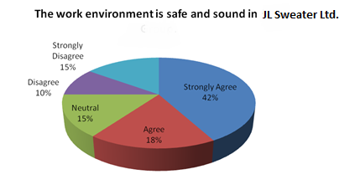

Interpretation
From the result of survey, its found that the Strongly Agree (42%) In second position there are Agree (18%), third position there are neutral (15%), fourth position there are disagree (10%) and strongly disagree (15%). So work environment is safe and sound in JL SWEATERS LTD of the very good.

Table 12: The overall facilities in JL SWEATERS LTD. is comparatively better

Opinion | Respondents | Percentage %
Strongly Agree | 45 | 45%
Agree | 20 | 20%
Neutral | 10 | 10%
Disagree | 15 | 15%
Strongly Disagree | 10 | 10%
Total | 100 | 100%
Source: Primary Data

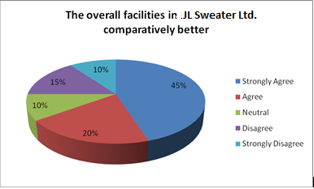

Interpretation
From the result of survey, its found that the Strongly Agree (45%) In second position there are Agree (20%), third position there are neutral (10%), fourth position there are disagree (15%) and strongly disagree (10%). So overall facilities in JL SWEATERS LTD is comparatively better of the very good.

Table 13: JL SWEATERS LTD. keeps motivating the employee to perform better.

Opinion | Respondents | Percentage %
Strongly Agree | 40 | 40%
Agree | 12 | 12%
Neutral | 25 | 25%
Disagree | 10 | 10%
Strongly Disagree | 13 | 13%
Total | 100 | 100%
Source: Primary Data

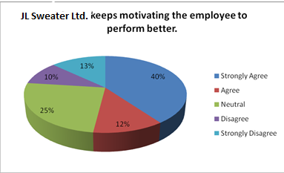

Interpretation
From the result of survey, its found that the Strongly Agree (40%) In second position there are Agree (12%), third position there are neutral (25%), fourth position there are disagree (10%) and Strongly disagree (13%). So JL SWEATERS LTD. keeps motivating the employee to perform better of the superior.

Table 14: Employees have enough opportunities for professional growth.

Opinion | Respondents | Percentage %
Strongly Agree | 55 | 55%
Agree | 12 | 12%
Neutral | 10 | 10%
Disagree | 10 | 10%
Strongly Disagree | 13 | 13%
Total | 100 | 100%
Source: Primary Data

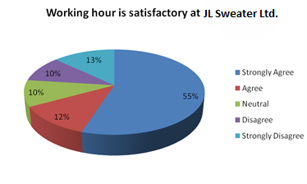

Interpretation
From the result of survey, its found that the Strongly Agree (55%) In second position there are Agree (12%), third position there are neutral (10%), fourth position there are disagree (10%) and Strongly disagree (13%). So Employees have enough opportunities for professional growth of the very good.

5.2 Findings of the Study

Our study has been run based on the employees of JL SWEATERS LTD. Based on their responses to the question as well as on the investigations; the following facts can be taken into consideration.

- It has been found that identify that majority respondents were Active of the organization
- Most of the respondents were satisfied at work gave a feeling personal satisfaction
- It can be inferred that majority respondent’s work is according to their qualification and skills.
- It can be said the majority respondents are satisfied with the top management.
- It can be identified that majority respondents working hour is satisfactory at JL SWEATERS LTD. of the very good.
- It can be said that majority respondent’s supervisor treats the employees fairly whenever they perform good job of the poor.
- It can be assumed that the company provides satisfactory salary to the employee of the superior.
- It has been identified that work environment in JL SWEATERS LTD. is safe and sound.
- It can be identified that overall facilities in JL SWEATERS LTD. is comparatively better than any other company.
- Top management of JL SWEATERS LTD. keeps motivating the employee to perform better of the superior.
- Majority respondents have enough opportunities for professional development.

Chapter- 06
Conclusion & Recommendation
6.1Recommendations

Based on the findings we hope JL SWEATERS LTD. should keep focus on following matters:
- JL SWEATERS LTD. should improve work according to employee’s qualification and skills.
- JL SWEATERS LTD. should more careful to the top management of the organization.
- Supervisor of JL SWEATERS LTD. should make a friendly relationship with employees.
- JL SWEATERS LTD. should give more attention to personal accomplishment and recognition of the employee to increase the level of job satisfaction.
- JL SWEATERS LTD. can give attention to decorate green office so that employee can stay with comfort and relax to work there as a green place.
- Managers of JL SWEATERS LTD. should concern about the facility and demand of junior level of employee rather than selective officers by removing biasness.
- JL SWEATERS LTD. should consider modern development regarding new development aspect of job satisfaction

6.2 Conclusion
Every organization tries best to satisfy their employees. JL SWEATERS LTD must identify and measure the level of job satisfaction of the employees and its relative importance. JL SWEATERS LTD has its operational wing to identify job satisfaction factors to improve the level of satisfaction which is vital to any company.
From the study we have found that the overall job satisfaction of JL SWEATERS LTD is satisfactory. Employee is at the positive level showing an average overall job satisfaction. Generally the job satisfaction of employee significantly depends on salary, efficiency in work, fringe benefit, supervision quality and employer relations. The remaining three factors, leadership style and work ability do not have significant statistical evidence to improve the job satisfaction of JL SWEATERS LTD. HRM of JL SWEATERS LTD should give concentration to future that would be determined by a combination of creative thinking and solid strategy. Therefore, dynamic leadership should constantly focus on the changing moment of scenario, competitor's movement and the needs of the employee. However, an ample scope is open to further study on the basis of larger sample.

Appendix
Sample of Questionnaire
“Job Satisfaction of Employees of JL SWEATERS LTD”
Dear respondents, the purpose of this survey is to collect data for an internship report which is largely based on the quest to find out the job Satisfaction of Employees of JL SWEATERS LTD. It would be a big help for me if you kindly take a moment and go through the questionnaire and answer them according to your own experience. All the information of yours will be kept as highly confidential.
Name: Marital Status:
Gender: Age:
Work Category:

- Are you an active employee of JL SWEATERS LTD?
- Yes.
- No.

- Does your work give you a feeling of personal satisfaction?
- Yes.
- No.

- How long have you been working for this organization?
- Less than 1 year.
- 1 to 2 years.
- 2 to 4 years.
- 4 years and above.

- Your work is according to your qualification and skills.
Strongly Agree | Agree | Neutral | Disagree | Strongly Disagree

- Employees are satisfied with the top management.
Strongly Agree | Agree | Neutral | Disagree | Strongly Disagree

- Working hour is satisfactory at JL SWEATERS LTD.

Strongly Agree | Agree | Neutral | Disagree | Strongly Disagree

- Supervisor treats the employees fairly whenever they perform good job.

Strongly Agree | Agree | Neutral | Disagree | Strongly Disagree
 |  |  | v

- Company provides satisfactory salary to the employee.

Strongly Agree | Agree | Neutral | Disagree | Strongly Disagree

- The work environment is safe and sound in JL SWEATERS LTD.

Strongly Agree | Agree | Neutral | Disagree | Strongly Disagree

- The overall facilities in JL SWEATERS LTD. is comparatively better.

Strongly Agree | Agree | Neutral | Disagree | Strongly Disagree

- JL SWEATERS LTD keeps motivating the employee to perform better.

Strongly Agree | Agree | Neutral | Disagree | Strongly Disagree

- Employees have enough opportunities for professional growth.

Strongly Agree | Agree | Neutral | Disagree | Strongly Disagree

- What comment/recommendation do you have in your mind that you want to share?
…………………………………………………………………………………………………………………………………………………………………………………………………..

References
- Books:
- AL-Hussami M (2008). A Study of nurses' job satisfaction: The relationship to organizational commitment, perceived organizational support, transactional leadership, transformational leadership, and level of education. Eur. J. Sci. Res., 22(2): 286-295.
- Arnolds, C.A., &Boshoff, C. (2001). The challenge of motivating top management: A need satisfaction perspective [Electronic version]. Journal of Industrial Psychology, 27(1), 39-42.
- Griffin MA, Patterson MG, West MA (2001). Job satisfaction and team work: the role of supervisor support. J. Organ. Behav., 22: 537-550.
- Chiu KR, Luk VW, Tang TL (2002). Retaining and motivating employees, Compensation preferences in Hong Kong and China. Personnel Rev., 31(4): 402-431.
- E. A Locke (1980)The Nature and Causes of Job Satisfaction. M.DDunnette (Ed.), Handbook of Industrial and Organizational Psychology, Chicago, Rand McNally. pp.1297-1349
- Herzberg F, Mausner B, Snyderman BB (1959). The motivation to work.New York Wiley.pp. 157.
- JJ.P. Wanous and E.E. Lawler (1972) Measurement and Meaning of Job Satisfaction. Journal of Applied Psychology, pp95-105
- Mulinge M, Muller CW (1998). Employee Job Satisfaction in Developing Countries: The Case of Kenya. World Dev., 26(12): 2181-2199
- Spector, P. E. (2000). Industrial & organizational psychology (2nd ed.). New York: John Wiley & Sons.
- Others
- AJL SWEATERS LTD. Annual Report 2015- 2016
- Journals
- Documents

- Website:
Website: https://www.JLfashions.com

Thank You for giving your valuable time.

