Assess the Area of Green Space in Selected Locations for urban Sustainability by Using GIS

Presented By
MD. MAHBUBUL ALAM ID: 162-47-188 SULIMAN
ID: 163-47-022



Department of Civil Engineering
Daffodil International University

January, 2020

Assess the Area of Green Space in Selected Locations for urban Sustainability by Using GIS

A thesis submitted to the Department of Civil Engineering Daffodil International University, Bangladesh in partial fulfillment of the requirements for the degree of Bachelor of Science (B.Sc.) in Civil Engineering

Course Code: Course Title:
CE 400
Project and Thesis

Prepared by: Md. Mahbubul Alam
Md. Suliman
ID: 162-47-188
ID: 163-47-022

Supervisor:

Mr. Md. Masud Alom Assistant Professor
Department of Civil Engineering

Approval

This thesis titled " Assess the Area of Green Space in Selected Locations for urban Sustainability by Using GIS" Submitted by Md. Mahbubul Alam (162-47-188), Session: Summer 2016, Suliman (163-47-022), Session: fall 2016, has been accepted as satisfactory in partial fulfillment of the requirement for the degree of Bachelor of Science in Civil Engineering on 10January ,2020.

…………………………………………….. Mr. Md. Masud Alom
Supervisor Assistant Professor Department of Civil
Engineering Permanent Campus, DIU

………………………………………………

Dr. Mohammad Hannan Mahmud Khan Assistant Professor and Associate Head Department of Civil Engineering Permanent Campus, DIU

Candidates Declaration
This is hereby declared that this thesis or any part of it has not been submitted elsewhere for the award of any degree
Supervised by:

……………………………………….
Mr. Md. Masud Alom
Assistant professor
Department of Civil Engineering

Submitted by:

…………………………………..

Md.Mahbubul Alam
ID.162-47-188
Department of Civil Engineering Daffodil International University

………………………………..

Suliman
ID:163-47-022
Department of Civil Engineering Daffodil International University

Acknowledgements

Thanks to almighty Allah for his graciousness, unlimited kindness and with the blessing of whom the good deeds are fulfilled. I would like to express my deepest sincere gratitude to our supervisor Mr. Md. Masud Alom, Assistant Professor, Department of Civil Engineering, Daffodil International University (DIU) for giving us a unique opportunity to work on such an important topic. His continuous guidance, invaluable suggestion, affectionate encouragement, generous help and invaluable acumen are greatly acknowledged. His keen interest on the topic and enthusiastic support on my effort was a source of inspiration to carry out of study. I consider myself fortunate to work under his supervision.

Dedications

This thesis dedicated to all of our Parents who inspired us for made this effort possible.

Abstract

Green space and air quality are correlated. The amount of ceased particulate matter in air hugely depends on the amount of green space in an urban area. Dhaka city is a quickly urbanizing city. The quality of air of the city is reducing every day. Many reasons for this reducing tendency. The relation between the green space and air quality of Dhaka city has been tried to determine in this research. The air quality data had been not collected because no available instrument and time. The amount of green area had been found by georeferencing green area from GIS. Green area of Mohammadpur, Uttara, Tongi and Narayanganj are fluctuating with time. Within 15 years green areas in Mohammadpur and Narayanganj are decreased but reverse case is happened in tongi and Uttara region. This is not good sign for establishing sustainable environment in Dhaka city. This study will be helpful for city regulators and government and they will be motivated to formulate the specific policy to widen the green space and then create social benefits in Dhaka city.

Table of content
Chapter -1 Introduction Page

  - Introduction 1
  - Problem definition 2
  - Objectives 3
  - Significance of the Study 4
  - Limitation 5
C
hapter-2 Literature Review 6-7
2.1 | Introduction | 6
2.2 | Literature review | 7

Chapter -3 Methodology 8
  - Methodology 8
  - Flowchart Methodology 8
  - Study area 10
  - Uses of Arc GIS 12

Chapter -4 | Data Analysis and result | 13-15
4.1 | Data Analysis | 13
4.2 | Result | 15
4.3 | Recommendation | 19
Chapter -5 | Conclusion
 | Conclusion | 20
 | Reference | 21

List of Figures:

Figure | Figure Caption | Page
3.1 | Google image of Mohammadpur | 10
3.2 | Google image of Uttara | 10
3.3 | Google image of Tongi | 11
3.4 | Google image of Narayanganj | 11
4.1 | Count of green space | 13
4.2 | Percentage of green space | 17

List of Table:
Table Table Caption Page
3.1 Selected study area 9
  - Green Spaces of different study area 14
  - All data in selected area 16
  - Comparison of green area with standard value 18

1.1 Introduction:
Chapter-1 Introduction

Dhaka is the capital city of Bangladesh, which is one of the fastest rising megacities in the world there are living more than 20 million people. Already everyone suffers many problems. For example: air pollution. Exposure to air pollution is the main environmental threat to human health in Dhaka city. Particulate emission is one of the vital issues for increased death rate and respiratory problems for the urban dwellers. Reducing green space is another environmental degradation. If it is not possible to protect the green space and do not improve the quality of air it will affect long term to our environment. it may also cause harm to other living organisms such as animals and food crops, and may damage the natural or built environment. Both human activity and natural processes can generate air pollution. We have to control air pollution because it necessary for our life and Environment. If we can use gas instead of wood, we have to encourage to people they will plant trees. Green space must be important for animal and plant residence. But it is also important for biodiversity and our life. Green space always gives pure air quality, good environment. now say green space is very important of environment.

1.2. problem definition

Dhaka, capital of Bangladesh, is the most densely populated city in the whole world. More than twenty million people live in Dhaka city. Day by day the number is increasing and most part of Dhaka is badly affected by air pollution. It causes serious air pollution and thus worsens the overall environmental condition.

  - Objective:

The objectives of the study are as follows:

- To calculate the amount of Green Space in the selected study areas.
- To compare the green area with the specification of department of environment (DOE).
- To observed the importance of green space for urban sustainability in Dhaka city.

  - significance of the study

The percentage of green area in Dhaka city is diminishing fast.in many ways, the parks and playgrounds are encroached upon illegally by powerful people. Unplanned urbanization, new construction, unconsciousness of population. This study will be helpful for city regulators and government and they will be motivated to formulate the specific policy to widen the green space and then create social benefits in Dhaka city. The Air quality and Green Space to compare of department of environment (DoE). Finally, there will be some recommendations to improve the Green area and quality of air.

1.5. Limitation:

- Difficult to get clear image from the source.
- For the limitation of time we cannot select more study area which may give us clear idea about the present condition of green areas of Dhaka city.
- No previous data is available at the department of environment (DoE).

Chapter -2 Literature Review

2.1. Introduction:
Air pollution in Dhaka is a high priority concern as it is seriously affecting the quality of life in the city and represents a major public health issue. Various development partners are supporting projects to tackle the deteriorating air quality in Dhaka. Environmental Benefits Healthy properly maintained green space provides significant benefits to the environment in terms of water and air quality.

2.2 Literature review:
Rumana Rashid et. Al. Analyzing the cooling potential of greenery application on building to maintain sustainability, reducing energy consumption, Urban HeatIsland (UHI) effect in dense Dhaka city and Global warming, human wellbeing and healthy, wealthy life of urban resident

Ansari (2008) in his research he discussed the opportunities and challenges of the urban and peri
-urban forestry and greening (UPFG) in Dhaka City, the capital of Bangladesh in a case. the conceptual overview of UPFG, overall description of the present status of green resources in and around Dhaka city as well as current efforts for greening were the background to propose the ways to transforming the mega city Dhaka into a greener tropical metropolis in the long run

Itir Sonuparlak(2011) said that a10 percent increase in urban tree coverage inmix-size cities, like Leicester, can absorb about 12 percent of carbon emissions, contributing to cleaner air. The study is yet another addition to the argument that any sound urban planning or transit policy to improve air quality must be supplemented with green space

Bell et, al. (2008) Report of green space Scotland noted effect of green space on health and wellbeing, social and community value of green space, economic value and impact of green space, environment and green space, planning and design space

Chapter -3 Methodology

  - Methodology:

First of all, we use Google earth software and Google Map. After that we selected boundary area by using above software. Now we had got our actual area. This method using to calculate percentage of green space area and air pollution

  - Flowchart Methodology:


Site selection

Generate Idea through literature review

Draw boundary line using by Google Earth & Google Map Calculate green space area with the aid of Arc GIS 10.4

Observe the change of green area with time Data presentation

  - Study Area:
We select four areas in Dhaka city covering (DCC) industrial, residential zone. The name and type of the areas are given below.

Name of area | Area type
Mohammadpur | Residential
Uttara | Residential
Narayanganj | Industrial
Tongi | Industrial

Table3.1: Selected study area.

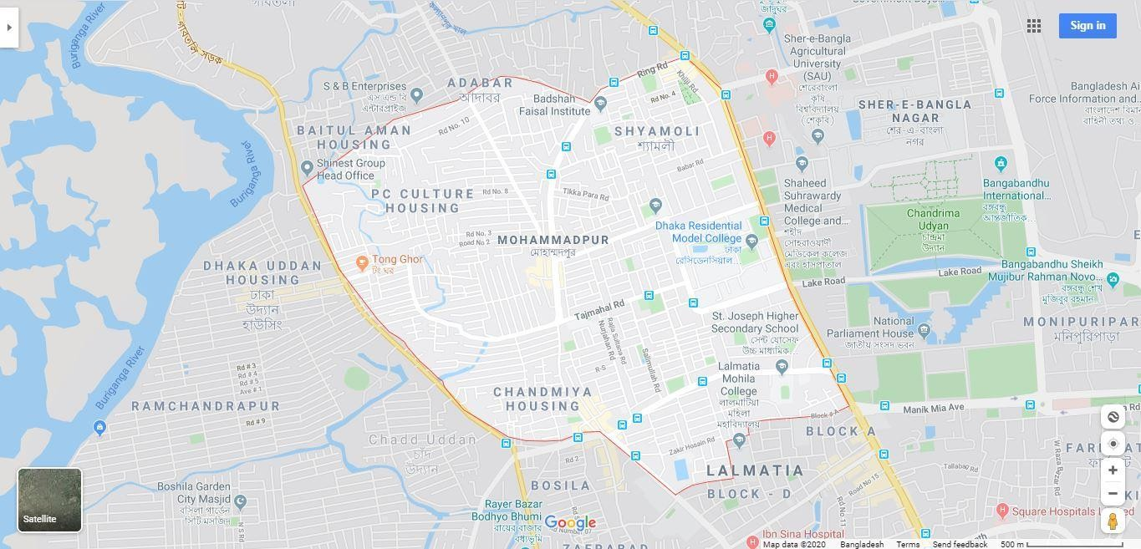

Fig 3.1: Google image of Mohammadpur

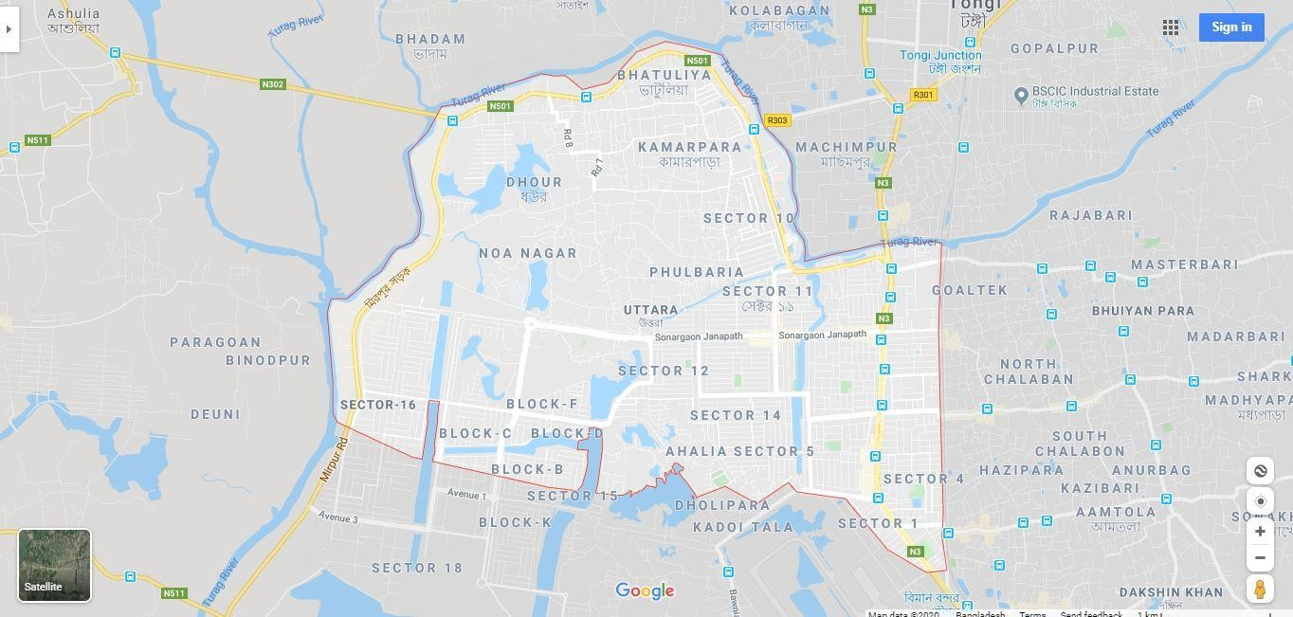

Fig3.2: Google image of Uttara.

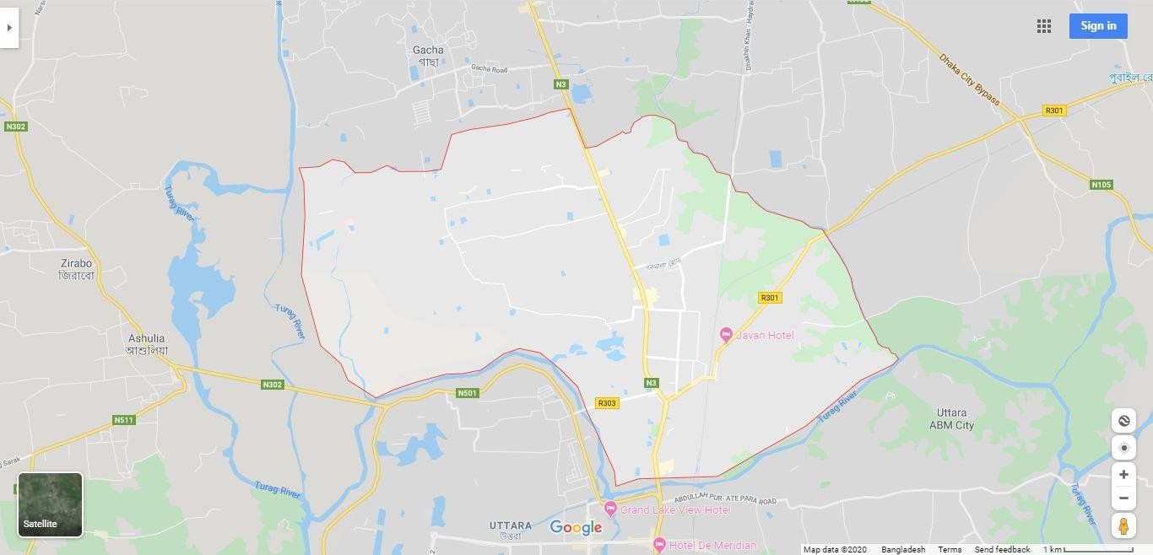

Fig 3.3: Google image of Tongi

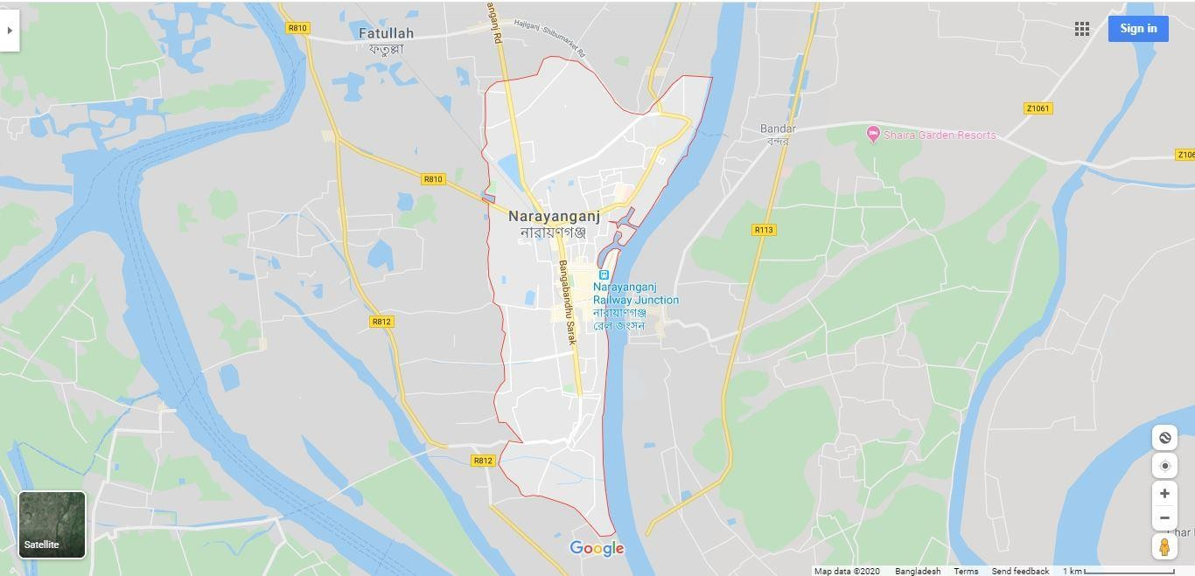

Fig 3.4: Google image of Narayanganj.

  - Uses ofArcGIS:

Later we use the ArcGIS application. We work four selected study area. In the four-boundary area select by google map. we extracted the coordinates using Google Maps. Then, we find out our study area from Google Map and Georeferencing by ArcGIS Application. We create a SHP file of Dhaka City Map Using ArcGIS application. Then we put the area inside the SHP file that we create in ArcGIS. After that we draw a polygon line in selected area. using the above system coordinates by importing XY data in ArcGIS Application. One Polygon line for upward direction and another one downward direction.

Chapter -4
Data Analysis and Result

  - Data Analysis:

Calculation of Green space by ArcGIS
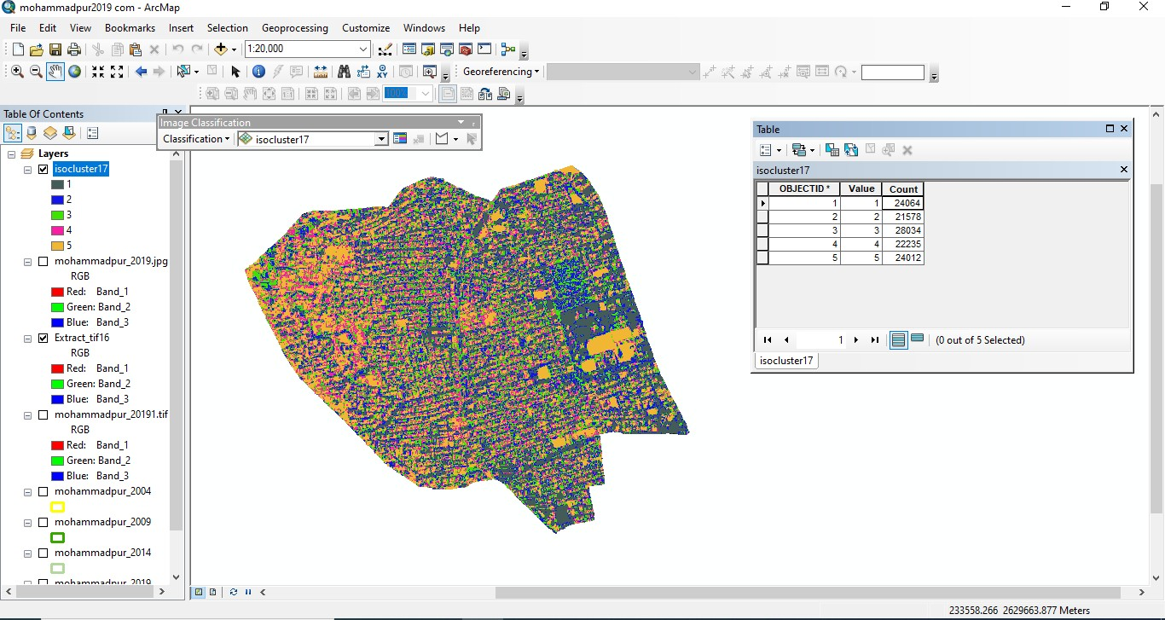

Fig 4.1: Count of green space.

From this study total green space area is calculated which is tabulated below

Name of Area | Area km^2 | Green Space km^2 | Type of Area
Mohammadpur | 3.833881 | 0.024064 | Residential
Uttara | 17.212156 | 0.029208 | Residential
Narayanganj | 7.392961 | 0.007815 | Industrial
Tongi | 28.546173 | 0.089511 | Industrial

Table:4.1 Green Spaces of different study area

  - Result:
Dhaka is the most air polluted city in the world. There are lives more than twenty million people. Air polluted cause many ways. The major source of air pollution are transportation engines, industrial process and the barning of solid waste. Unconsciousness of people, new construction and one of the most important way for green space. If remains air quality in pure that way we have ensure more than 20% green space in our country according to department of environment (DOE). we analyzed green space in Dhaka city specially Mohammadpur, Uttara, Tongi, Narayanganj decreasing day by day on the other hand air pollution is increasing day by day. Now say that green space is very important for environment specially Dhaka city.

Study location | Total area Km^2 | Green space in the study area  (km^2) |  |  |  | Green space by  % of total area |  |  |  | Change | Required green space of (DoE)
Study location | Total area Km^2 | 2004 | 2009 | 2014 | 2019 | 2004 | 2009 | 2014 | 2019 | Change | Required green space of (DoE)
Mohammadpur | 3.833881 | .043669 | .030466 | .025917 | .024064 | 25.98 | 18.67 | 18.87 | 20.06 | Fluctuating | Minimum 20% of total area
Tongi | 28.546173 | .065306 | .043299 | .028170 | .089511 | 21.25 | 27.01 | 16.40 | 33.0 | Fluctuating | Minimum 20% of total area
Uttara | 17.212156 | .011002 | .022751 | .068698 | .029208 | 14.47 | 20.13 | 14.91 | 21.90 | Fluctuating | Minimum 20% of total area
Narayanganj | 7.392961 | .019079 | .004751 | .003552 | .007815 | 25.0 | 5.10 | 13.0 | 14.08 | Fluctuating | Minimum 20% of total area

Table 4.2: all data in selected area.

Above the all data we get using by GIS. First of all we create kml, mxd,shp and temp file. After that select boundary area using by google earth. Next all data input GIS by above method. We got green space to georeferencing by GIS. We see that all study areas are fluctuating. It’s not stable condition for environment. This reason we can say Peoples should be encouraged to plant trees and green spaces on the roofs within their house.

Percentage of green area in different location

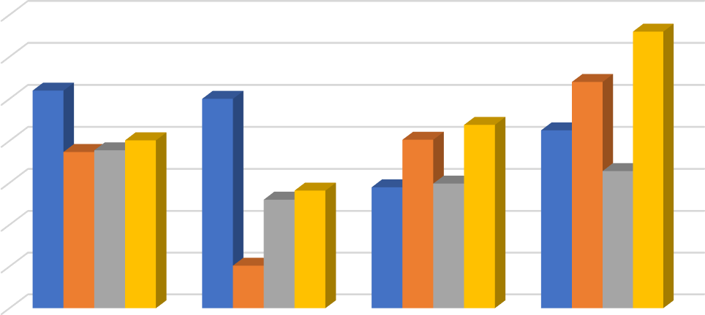
2004 2009 2014 2019
35

30

25

20

15

10

5

0
mohammadpur
Narayanganj
Uttara
Tongi

Fig 4.2: Percentage of green space.

Study location | Green space by % of total area | Required green space department of environment (DOE)
Study location | 2019 | Required green space department of environment (DOE)
Mohammadpur | 20.06 % | Minimum 20 % of total area
Tongi | 33.0 % | Minimum 20 % of total area
Uttara | 21.90 % | Minimum 20 % of total area
Narayanganj | 14.08 % | Minimum 20 % of total area

Table 4.3: Comparison of green area with standard value.

In spite of our tree areas present green space is allowable according to department of
environment (DOE) except Narayanganj but it’s not enough to our city because green space fluctuating with time.

  - Recommendation:

- Respective authorities and other NGOs should come forward to conscious general people for tree plantation.

- government may invest more money for tree plantation in various open place in Dhaka city.

- More research may be conducted with others zones of Dhaka city (except ours selected study areas).

- Planning is an initial element of successful urban greening programs.
- Public awareness and public participation can be important for providing security of the green areas and preventing any misuse of green spaces by establishing local community.

Conclusions:
Chapter -5 Conclusion

The following conclusions can be drawn from this study:

- From this study it is clear, green space of some study areas are increasing and some areas are decreasing. It may be reason of new construction, unconsciousness of populations.

- Green area of Mohammadpur, Uttara, Tongi and Narayanganj are fluctuating with time. within 15 years green areas in Mohammadpur and Narayanganj are decreased but reverse case is happened in tongi and Uttara region. This is not good sign for establishing sustainable environment in Dhaka city.

- This study will be helpful for city regulators and government and they will be motivated to formulate the specific policy to widen the green space and then create social benefits in Dhaka city.

References:
- Rashid, Rumana., Ahmed, Mohd. Hamdan Bin. and Khan, Md. Sayem. Natural Green Application technology on Building in Dense Dhaka City is provide a sustainable, energy saving, comfortable and healthy environment.

- Ansari, M.N.A. (2008). Opportunities and challenges of urban and peri-urban forestry and greening in Bangladesh: Dhaka city as a case, Unpublished MSC Thesis, Department of Landscape Management, Design and Construction, London.

- Sonuparlak, Itir. (2011). Urban Green Space Key in Improving Air Quality.
RetrievedJanuary18,2013, from
http://thecityfix.com/blog/urban-green-space-key-in-improving-air-quality/

- Bell et, al. (2008). Thompson and P. Travlou (2003). Contested views of freedom and control: Children, teenagers urban fringe woodlands in Central Scotland. Urban Forestry and Urban Greening 2(2):87-100(14

