

Internship Report on
Capital Structure of Islami Bank Bangladesh Limited

Submitted To
Mr. Md. Anhar Sarif Mollah
(Assistant Professor)
Faculty of Business & Entrepreneurship
Daffodil International University

Submitted By
Mily Akter
ID: 171-11-384
Major in Finance
Department of Business Administration
Daffodil International University

Submission Date: 16-11-2020

Letter of Transmittal

November 16, 2020
Mr. Md. Anhar Sarif Mollah
Assistant Professor
Faculty of Business & Entrepreneurship
Daffodil International University
Subject: An Internship Report on Capital Structure of Islami Bank Bangladesh Limited
Dear Sir,
I would like to thank you for giving me the opportunity to prepare for the Internship on this topic, "capital structure at Islamic Bank Bangladesh Limited". I have prepared a report introducing the different models in Banking & capital structure of a bank, financial & prospect point of view. I have tried my best to make a good report and keep the necessary documents in place to prepare a complete report. Without clear guidance from you, it is not possible for me to prepare this notice.

I hope you will assess me a complete list of limitations and errors of this study, and confidently believe you will find this study very interesting and informative.

Sincerely,
Mily
………………..
Mily Akter
ID: 171-11-384
Major in Finance
Department of Business Administration
Daffodil International University

Certificate of Approval

This is to certify that Mily Akter, ID: 171-11-384, is a regular student of BBA program, Department of Business Administration, Faculty of Business & Entrepreneurship, Daffodil International University. She has successfully completed the internship report titled An Internship Report on Capital Structure of Islami Bank Bangladesh Limited as a requirement of BBA Program.

The report is recommended for submission.

………………………….

Mr. Md. Anhar Sarif Mollah
Assistant Professor
Faculty of Business & Entrepreneurship
Daffodil International University

Acknowledgement

I would like to express my special gratitude to Allah Almighty for giving me the time and energy to make the announcement on time. I apologize a lot to the crowd for their great comments and cooperation. I would like to thank my Mr. Md. Anhar Shrif Mollah, she was so kind to watch over, teach and guide me to complete my report. I’m fortunate about ending this journey by another great experience. Islamic Bank Bangladesh Limited, one of the leading banks in banking sector, gave me a chance to work with their operation team and to gain the practical knowledge I needed most at this stage. Special thanks to Mir Rahmatullah, SVP, Branch Manager and Golam Mostofa, VP, Operations Manager, for giving me this opportunity. This report, along with all interpretations of the Banking Practices Guidelines for the Management and Functioning of Banking Operations, will not be available without assistance. and the involvement of officers involved in the IBBL. They are happy to provide all the knowledge and interpretation of these alerts easily with the purpose of our BBA program. As writers, researchers and writers whose notes, notes, notes and notes were written to help me prepare my work plan.

Executive Summary

The capital structure, the combination of debt and equity of a business, is important because borrowing money costs the business. Capital structure is also important due to the different tax implications of debt versus equity and the impact of corporate taxes on a company's profitability. Firms need to be cautious in their lending activities to avoid excessive risk and the possibility of financial hardship or even bankruptcy.
A firm's debt /equity ratio also affects the firm's financing costs and shareholder value. The debt /equity ratio is a measure of a company's leverage calculated by dividing its total liabilities by its equity. Indicates what percentage of equity and debt the company is using to finance its business.
A high debt-to-equity ratio generally means that a company has been aggressive in financing its growth with debt. This can result in volatile gains as a result of the additional interest expense.
The target (optimal) capital structure is simply defined as the mix of debt, preferred stock and common stock that will optimize the company's stock price. As a company raises new capital, it will focus on maintaining this target capital structure.

Table of Contents
S.N | Contents | Pages
 | Letter of Transmittal | ii
 | Certificate of Approval | iii
 | Acknowledgement | iv
 | Executive Summary | V
Chapter: 01 (Introduction)
1.1 | Introduction | 02
1.2 | Origin of the Report | 02
1.3 | Significance of the Study | 02
1.4 | Scope of the Study | 02
1.5 | Objective of the Study | 03
1.6 | Methodology of the Study | 03
1.7 | Limitation of the Report | 04
Chapter: 02 (An overview of the IBBL)
2.1 | An overview of IBBL | 06
2.2 | Objective of IBBL | 06
2.3 | Features of IBBL | 07
2.4 | Vision of IBBL | 07
2.5 | Mission of IBBL | 08
2.6 | Strategic objective | 08
2.7 | Products & Services of IBBL | 09-10
2.8 | SWOT analysis of IBBL | 10
Chapter: 03 (Banking Industry Overview in Bangladesh with PBL)
3.1 | Introduction | 12
3.2 | Capital Structure | 13-18
3.3 | Corporate Attributes | 19-20
3.4 | Category of IBBL | 20
3.5 | Corporate Financial Information | 20-25
Chapter: 04 (Discussion & Analysis)
4.1 | Findings | 27
4.2 | Recommendation | 28
4.3 | Conclusion | 29
4.4 | Reference | 30

Chapter-One



Introduction

1.1Introduction
The internship report is a basic requirement to fulfill BBA program of Daffodil International University. The proposed topic is " Capital structure Analysis of Islami Bank Limited". The topic has been assigned by Mr. Md. Anhar Sharif Mollah and supervised by him also.

1.2 Origin of the report
This report completes part of a two-month internship for BBA students at Daffodil International University (DIU). During my time at the time I joined Islami Bank Bangladesh Limited at the Shyamoli Branch. My College Superintendent Abdullah-al Masum informed me that the content of my paper would be "Investment of Islami Bank Bangladesh Limited" and prepared this statement in the organization.

1.3 Significance of the study
Islami Bank Bangladesh Ltd. is the largest bank in Bangladesh in the private sector. There are some numbers of Financial Institutions that can compete with IBBL. The Financial Institutions aim to achieve the goal of Islamic business by establishing a framework for an Islamic Code of Conduct. Regarding the use of money Islam has its own clear instructions from some special instruction. Abstinence (Riba), restricted exercise & other challenges are important tips in this process. Thus the Islamic Financial Institution operates under Islamic guidelines.

1.4 Scope of the study
The capital of these organizations is related to the structure, background, products and services and financial operations of Islamic Bank Bangladesh Limited and all its importance covers the capital structure. risk management of IBBL. This information helps us to better understand the market opportunities of IBBL. In this report I have focused on all the qualitative which include profiles of IBBL, Investment mechanism like Bai mechanism, Partnership or Share mechanism and Leasing or Ijara mechanism, Different types of investment planning, such as home equity planning, real estate investment planning, transportation planning, automotive planning, medical investment planning, planning small business, urban development plan etc.

1.5 Objective of the study
- Analyze the capital structure of Islami Bank Limited.
- To know the paid up capital and reserve information of the bank.
- To know the equity amount of the bank.
- To know the current position of equity and debt capital.
- To identify strength and weakness of lending and investments of overall banking system.
- To give recommendation to solve the problem.

1.6 Methodology of the study
A methodology is a process or process by which research is being used to gather information that needs to be combined with research to achieve the conclusion of a study. It covers both primary and secondary data.
Primary Sources of Data:
Primary sources of data include the following:
- Direct Interviews & Conversation
- Official records
- Practical deskwork
- Direct observations

Secondary Sources Data:
I have collected secondary data from the following sources:

- Annual Report of Islami Bank Bangladesh Limited.
- Training pages provided by Islami Bank Education and Research Institute (IBTRA).
- Files & Folders of IBBL
- Memos & Circulars of IBBL
- Various publications on Bank,
- IBBL Website
.

1.7 Limitation of the Report
- The main basis of this study is the uncertainty of the data, which is required for study. There is a lot of information that a bank employee cannot provide due to security and other responsibilities.
- All branches of the bank have not been physically visited and all stakeholders of the bank have not been interviewed.
- No in-depth and in-depth information is available to compile this report.
- Lack of experience.
- Learning all the bank jobs about capital in just 60 days is very difficult.
- Data and information used in this study are mostly from secondary sources.
- Larger research is not possible due to restrictions and restrictions imposed by the bank.

The report faces these limitations which will affect the progress but with constant diligence, I try to minimize the disadvantages of these limitations.

Chapter-Two

An Overview of the IBBL

An overview of Islamic Bank

Islami Bank Bangladesh Limited (IBBL) is an Islamic banking company based in Bangladesh. It was founded in 1983, March 13 as a limited liability company. IBBL had 350 branches, including 59 AD branches,03 offshore banking units and more than 13,500 employees. IBBL maintain its 621 ATMs, 33 IDBL as well as its 6,000 ATM network throughout the country. In 2015, it served $3903.21million for each transfer of $ 15,316.75 million. It has 36.91% of local shareholders and 63.09%of foreign shareholders. It was the first bank in south Asia to provide Shari's based banking. The bank is listed on both Dhaka Stock Exchange Ltd and Chittagong Stock Exchange limited. However, eight Islamic banks operating in Bangladesh are:
- Al- Arafah Islami Bank Limited
- Import Company Limited of Bangladesh Limited
    - ICB Islami Bank
    - First Security Islami Bank Limited
    - Islami Bank Bangladesh Limited
    - Shahjalal Islami Bank Limited
    - Social Islami Bank Limited
    - Union Bank Limited

Objective of “Islamic Banking”

- To provide financial assistance now in parallel with Islamic Shariah
- To promote economic development and prosperity in the principles of Islamic justice
- Distribution of income is not limited to a small amount of money
- To help ensure a fair distribution of funds.
- To conduct interest-free banking.
- To create a consolidation shines do not spend money on interference to the debt-debt consolidation contract.
- Borrow money at a loss.
- To contribute to the achievement of the ultimate goal of Islamic economics.

Features of 'Islamic Banking

- All his activities were done without interest according to Islamic Shariah.
- Investments are made by various sources according to Islamic Shariah.
- The investment-income bank has partnered with Mudaraba depositors as a comparison to ensure a reasonable repayment of their deposits.
- Its purpose is to promote health protection and also to promote fairness and integrity in the business of all activities.
- He extended Grants - Financial and financial assistance to the poor, hopeless and low-income groups of people for their economic support especially in remote areas. City.
- The bank is responsible for the life insurance of Tk.1,00,000 for its client to protect their MMPS and MMDS.
- The bank is responsible for the life insurance of Tk.1,00,000 for its client to protect their MMPS and MMDS. Its aim is to achieve balance growth & equitable development of the country through diversified investment operations particularly in the priority sectors and in the less developed areas.

Vision of IBBL

IBBL Vision is always striving to achieve the best performance of the financial services industry, considering it as an Islamic company with a reputation and excellence. In order to achieve our goal, we identified the following strategic objectives:
- Our mission is to develop and manage modern business strategies, to ensure the voice and improvement of the economy in accordance with Islamic principles and to become a strong organization and Work with professionals, working for the benefit of people, as accountability, transparency and fairness to ensure financial stability.
- IBBL will try to promote savings in the form of direct investment.
- We will also try to encourage special investments in projects, which will often lead to higher performance.

Mission of IBBL
- To develop Islamic Banking by introducing health management practices.
- To ensure integrity and fairness in all business operations.
- In order to achieve equitable growth and development by utilizing different functions especially in key functions and low-improvement areas.
- To support economic and financial development for low-income communities, especially those in rural areas.

Strategic Objectives
- To ensure customer satisfaction.
- To monitor the health of banks.
- To establish a set of management principles and to implement the latest reforms to achieve the successful development of Islamic banking is a stable financial institution.
- To take care of the beneficiaries.
- To ensure diversity by Sector, Large, Targeted Business & Regional Value Investment and expand thinking based on Retail and SME / Women market investments.
- Invest in push and pull and market share.
- Want to work hard to become an employer of choice and supervision & development skills in leadership.
- To pay more is important in human capital in addition to financial capital.
- To avoid zero tolerance of negligence in matters of Shariah compliance and governance issues.
- To train & develop human resources on an ongoing basis & provide adequate logistics services to customers.
- Make the best of the service for minimizing community and regional improvements.
- To support the team to become a member for all activities.
- To ensure the improvement of the patient and satisfied.
- To promote sound quality and improve future employees.
- To achieve international success.

2.7 Products and Services of Islamic Bank Bangladesh Limited

Deposit Schemes:
- Al-Wadeah Current Account(AWCA)
- Mudaraba Savings Account(MSA)
- Mudaraba Hajj Savings Account(MHSA)
- Mudaraba Term Deposit Account(MTDR)
- Mudaraba Special Notice Account(MSNA)
- Mudaraba Special Savings (Pension) Account(MSSA)
- Mudaraba Hajj Savings Account(MHSA)
- Mudaraba Savings Bond Account(MSBA)
- Mudaraba Waqf Cash Deposit Account(MWCDA)
- Mudaraba Monthly Profit Deposit Account(MMPDA)
- Mudaraba Muhor Savings Deposit Account(MMSA)
- Students Mudaraba Savings Account(SMSA)
- Mudaraba Farmers Saving Account(MFSA)
- Mudaraba NRB Savings Bond (MSNB)
- Mudaraba Foreign Currency Deposit Account(MFCD).

Investment Scheme:
Home Purpose Durables (HDS)

- Investment Scheme for Doctors (ISD)
- Transport Investment Scheme(TIS)
- Car Investment Scheme(CIS)
- Small Business Investment Scheme(SBIS)
- Micro Industries Investment Scheme(MIIS)
- Agricultural Implement Investment Scheme(AIIS)
- Real Estate Investment Program (REIP)
- Real Estate Investment (Commercial & Working Capital)
- Agricultural Investment of IBBL
- NRB (Non Resident Bangladesh) Entrepreneurs Investment Scheme (NEIS)
- Women Entrepreneurs Investment Scheme (WEIS)

Foreign Exchange Scheme:
- Central Crediting of Funds,
- Payment from 3rd Bank sent by TT & PO,
- Payment Options - Online and Web-based,
- Central Bank Debt Management,
- SMS Notification, SMS Push Pull Service,
- Maintain payments to NRD & NRT.

Special Service:
- Locker Services
- AT Services
- M-cash
- I Banking
- Online services.

SWOT Analysis of IBBL:
Strength:
- It has a special saving scheme known as DPS for a lower income group of people.
- IBBL are trained employees in a such way that they can deliver higher quality service.
- Authorities is devoted and legit to serve their obligation.
- Authorities is devoted and legit to serve their obligation.
- IBBL is dedicated to their serve client and focus how they can delight their client

Weakness:
- There is no provision or laws against taking discrepancy charge in L/C.
- lack of online service.
- Method of granting security against loan is much risky as compared with other charging security.

Opportunities:
1. The business is growing new devoted business people.
2. expanded their promotional activity for SME loans and new product.
3. IBBL charges lesser than its competitors such as ATM card.
4. Bringing change in conventional banking such as interest free service.

Threats:
1. The growth rate of competitors in the market.
2.changing customer needs.
3.competitors are providing better online service.

Chapter- Three



Capital Structure
Of Islami Bank Bangladesh Limited

3.1 Introduction
Return on equity (ROE), companies can use a variety of strategies and procedures. One way is capital investment. The combination of capital and ROE is truly a priority for every company. The purpose of this paper is to examine the impact of capital investment on Islamic bank performance in Asia. The best way to check the performance of each bank is through a financial statement. Because the financial statement is directly linked to the work of the bank. Some researchers have found that financial data has a positive effect on bank performance. Some analysts have argued that the business model and operation of a bank has been closely related. Some researchers give the argument for the differences used in capital models to measure the performance of companies such as DEBT RATIO, LEVEL, VOLUME MULTIPLIER RATIO AND DEBT EQUITY RATIO and so on.
In order to demonstrate the benefits of setting up a business and operating a different bank. Budget structure is the most important factor in finance. The process for determining the investment model is often difficult for any bank. Modigliani and Miller (1958) argued for the most appropriate model in the area of ​​finance. In order to determine the highest level of good business model, the financial manager faces a number of challenges. The goals of high-end design are to maximize the value of the organization by minimizing the cost. Because running companies run smoothly the business deserves many forms of loans. Financial tools are the most important factor for measuring the SWOT finances (strength, weakness, timing, and threat). On other design tools are the most important determinants. for companies. Mujahid, Zuberi et al. (2014). The investment process is a combination of quantity and equity investment that completes the investment. Because funding is a model for building capital that is used for acquiring assets or development. Because this capital model has put content into costs, assets are better and costs are longer. Nasimi (2016).

3.2 Capital Structure

Corporate Information of Capital IBBL
Particular | BDT(TK.)
Authorized Capital | 20000.00 million
Paid-up Capital | 16099.91 million
Equity | 79079.70 million
Reserve Fund | 40941.78 million
Deposits | 946291.53 million
Investment(Including Investment in share) | 953150.85 million
Foreign Exchange Business | BDT(TK.)
Import | 399884 million
Export | 234443 million
Remittance | 305514 million

Paid-up Capital & Reserve
The Bank's Authorized Capital is € 20,000.00 million and the Paid-up Capital is € 16,099.91 million as at 31/12/2019. The paid-up capital was Taka 67.50 million in 1983. The Bank's Reserve Fund has grown steadily. On December 31, 1983, it was 0.36 million Taka and stood at
Date | Amount of TAKA
31/12/2019 | 16099.91 million
31/12/2018 | 16099.91 million
31/12/2017 | 16099.91 million
31/12/2016 | 16099.91 million
31/12/2015 | 16099.91 million
31/12/2014 | 16099.91 million
31/12/2013 | 14636.28 million
31/12/2012 | 12509.64 million
31/12/2011 | 10007.71 million
31/12/2010 | 7413.12 million
31/12/2009 | 6177.60 million
31/12/2008 | 4752.00 million
31/12/2007 | 3801.60 million
31/12/2006 | 3456.00 million
31/12/2005 | 2764.80 million
31/12/2004 | 2304.00 million
31/12/2003 | 1920.00 million
31/12/2002 | 640.00 million
31/12/2001 | 640.00 million
31/12/2000 | 320.00 million

Equity
According to the capital adequacy policy prescribed by Bangladesh Bank, the country's central bank, the banks retained 12.95% equity on its risk-weighted assets against which the bank's total equity as of 12/31/2019 was 79,079.70 million. This was:
Date | Amount of TAKA
31/12/2019 | 79079.70 million
31/12/2018 | 69618.58 million
31/12/2017 | 57958.08 million
31/12/2016 | 50556.47 million
31/12/2015 | 47845.33 million
31/12/2014 | 48569.86 million
31/12/2013 | 45511.90 million
31/12/2012 | 38803.30 million
31/12/2011 | 32318.63 million
31/12/2010 | 28400.03 million
31/12/2009 | 23619.81 million
31/12/2008 | 18572.08 million
31/12/2007 | 14957.74 million
31/12/2006 | 10425.96 million
31/12/2005 | 8331.14 million
31/12/2004 | 6691.12 million
31/12/2003 | 5266.47 million
31/12/2002 | 3540.52 million
31/12/2001 | 2993.24 million
31/12/2000 | 2671.06 million

Year | Amount of Equities(BDT)
2014 | 6433.60 M
2015 | 8375.79 M
2016 | 9697.54 M
2017 | 10759.84 M
2018 | 11770.74 M
Equity Capital of Islamic Bank (2014-2018)

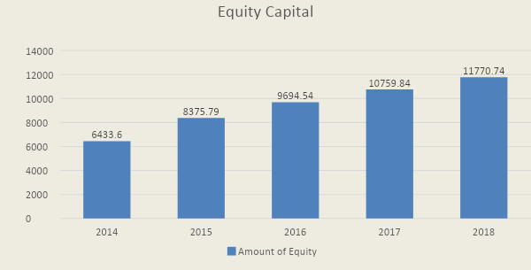
Analysis: We can see that the equities have increased continuously between 2014 - 2018. This is a good sign of IBBL. Because equity capital has no obligation to pay. As a result, the bank will free from the risk of bankrupt. On the other hand, the dilution of the company has increased because equity investors typically have the right to vote on important company decisions.

Year | Amount of Debt Capital(BDT)
2014 | 155420.14 M
2015 | 196299.71 M
2016 | 246604.94 M
2017 | 290608.81 M
2018 | 332375.69 M
Debt Capital of Islamic Bank (2014-2018)

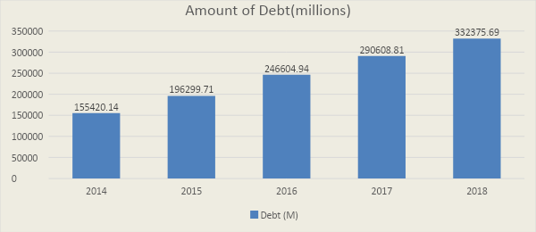
Analysis: IBBL had increased its debts capital deliberately. On the chart we can see difference between taking loan on 2014 to 2018. This indicates that the investment is increasing day by day and the bank is trying to strong its capital structure. But in this process the company’s risk has been increased.

Year | Share issues (BDT)
2014 | 4114.38 M
2015 | 4114.38 M
2016 | 6788.78 M
2017 | 6788.74 M
2018 | 7128.17 M
Share issue of Islamic Bank Ltd. (2014-2018)

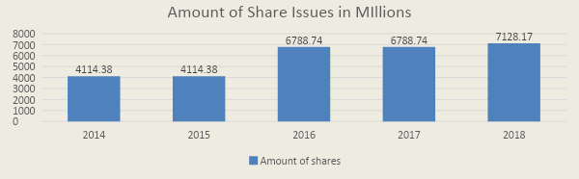
Analysis: IBBL is increasing the amount of share use after 2 years. This indicates that the bank is much concern about collecting money from shareholders. If the bank collects more money it can be invested to earn more profit. Shareholders are the real owner of the company in that sense the if the bank’s issuing share has increased the more authority will be transferred to the shareholders.

3.3 Corporate Attributes

Branches of Islamic Bank (2014-2018)
Year | Number of Branches
2014 | 294
2015 | 301
2016 | 305
2017 | 342
2018 | 350

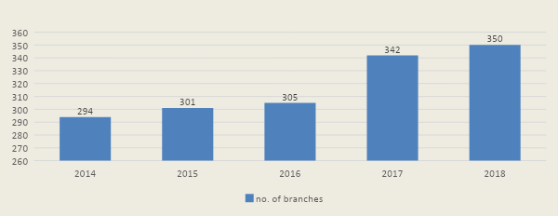

Analysis: IBBL is expending the banking service country wide. The branch has been set up in different district. The bank should more focus on set up branch. The bank should establish branch in rural areas to give the banking facilities among the rural people.

Category / Islamic Bank
The Islamic Bank started its operation on 25th October 1989 as a conventional bank. During the year 2008, the company has successfully completed its IPO for 1,15,00,000 Ordinary shares of Tk. 1,15,00,00,000. The company got tremendous responses from the General public, institutions and Non Resident Bangladeshi category investors. The shares of the company have been listed with both Dhaka and Chittagong Stock Exchanges.

3.4 Corporate Financial Information

Net profit of Islamic Bank:
Year | Company's Net Profit (Million)
2014 | 766.48 M
2015 | 694.28 M
2016 | 853.54 M
2017 | 1410.33 M
2018s | 1389.92 M

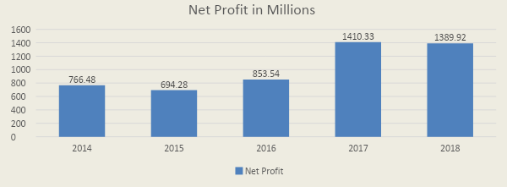
Analysis: A company’s net profit represents how much the company earns money from the investment. Every company’s common goal is to maximize the profit. IBBL is not so much successful in this way. The profit of the bank was down fallen in 2015 as well as in 2018.

Return on Assets of Islamic Bank:
Year | Return on Assets (Million)
2014 | 0.42%
2015 | 0.38%
2016 | 0.31%
2017 | 0.51%
2018 | 0.41%

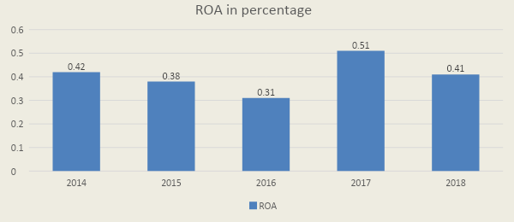

Analysis: Return on assets represents after investing the money a company how much capable of returning the investment. The graph chart represents that in 2017 Islamic Bank had returned their assets more comparatively from the previous and next two years.

Return on Equity of Islamic Bank:
Year | Return on Equity (Million)
2014 | 11.74 %
2015 | 8.29 %
2016 | 8.80 %
2017 | 13.11 %
2018 | 11.81 %

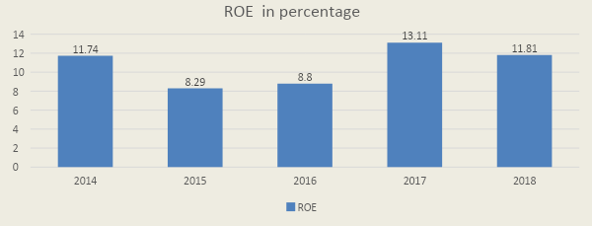
Analysis: IBBL gave most importance on return on asset and equity in 2017.We can easily notice on the graph that in 2017s the company’s return was most than previous and next two years. The bank should focus much to return their equity. If the bank is able to return their equity more the bank will invest the money to the profitable sector.

Return on Investment of Islamic Bank:
Year | Return on Investment (Million)
2014 | 0.68 %
2015 | 0.46 %
2016 | 0.05 %
2017 | 0.62 %
2018 | - %

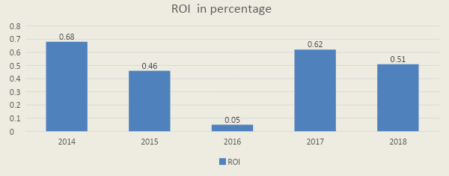
Analysis: IBBL should give more importance on return on investment. We can easily notice on the graph that in 2016 the company’s return was most less than previous and next two years. The bank should focus much on return their investment.

Earnings per Share of Islamic Bank:
Year | Return on Investment (Million)
2014 | 1.89
2015 | 1.02
2016 | 1.26
2017 | 2.08
2018 | 1.89

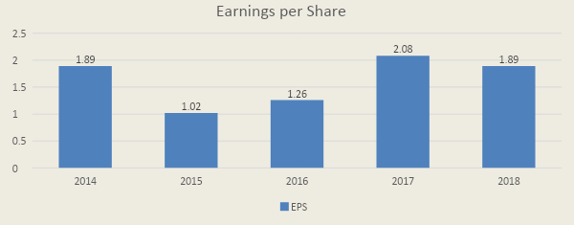
Analysis: In the modern concept of finance every company’s common goal is to maximize the value of the share rather than maximizes the profit. IBBL is not much successful to increase the EPS value in 2015 and 2016. Bit in 2017 the EPS improvement represents that the bank is very much dedicated to their objectives. It is a good sign for any organization

Chapter-Four



Findings, Recommendations & Conclusion

Findings

The main objective of the report is to analysis the capital structure of Islamic Bank Bangladesh Limited (IBBL). The study of capital structure of Islamic Bank Bangladesh Limited reveals the following major findings:
    - We can see that the equities have increased continuously between 2014 to 2018. This is a good sign of IBBL.As a result, the bank will free from the risk of bankrupt. Because equity capital has no obligation to pay.
    - This indicates that the investment is increasing day by day and the bank is trying to strong its capital structure. But in this process the company’s risk has been increased. Can see difference between taking loan on 2014 to 2018.
    - IBBL is increasing the amount of share use after 2 years. This indicates that the bank is much concern about collecting money from shareholders.
    - IBBL is expending the banking service country wide. The branch has been set up in different district. The bank should more focus on set up branch. The bank should establish branch in rural areas to give the banking facilities among the rural people.
    - IBBL is not so much successful in this way. The profit of the bank was down fallen in 2015 as well as in 2018.
    - Return on assets represents after investing the money a company how much capable of returning the investment. The graph chart represents that in 2017 Islamic Bank had returned their assets more comparatively from the previous and next two years.
    - IBBL gave most importance on return on asset and equity in 2017.We can easily notice on the graph that in 2017s the company’s return was most than previous and next two years. The bank should focus much to return their equity.
    - IBBL should give more importance on return on investment. We can easily notice on the graph that in 2016 the company’s return was less than previous and next two years. The bank should focus much on return their investment.
    - IBBL is not much successful to increase the EPS value in 2015 and 2016. Bit in 2017 the EPS improvement represents that the bank is very much dedicated to their objectives. It is a good sign for any organization.

Recommendation
Islamic Bank Limited has some problems in capital structure and investment. I would like to offer some recommendations for overcoming IBBL problems.
• It should improve its asset management techniques.
• Market for different investment modes should be watched time to time return the
market share.
• They need to increase their net profit.
• They need to focus on return on equity.
• EPS is not good, so its need to be improved.
•Their risk has been increased, its need to be reduced.
• Efforts should be made to increase bank's investment under Mudarabah & Mishawaka modes.

CONCLUSION
The Islamic banking system has enormous potential and prospects in Bangladesh. The Islamic banking concept introduced by the Islamic Bank Bangladesh Ltd. has popularized the Shariah based banking system so much that the most proliferated and distinguished banks both national and multinational open their Islamic banking wings such as Standard Chartered, Export Import Bank of Bangladesh Limited, The City Bank, Dhaka Bank, etc., are successfully conducting Shariah based banking business. Private banking is a strong source of economy. It is gaining popularity due to its immense importance. Banking activities are modernized with the technological advancement of commercial transactions. Private Banks apply modernized techniques and sophisticated banking tools to attract the customer and achieve their goal. Entering the Bangladesh Private Banking scenario, IBBL constantly seeks to overcome the obstacles regarding typical business-oriented ideas and propose innovative solutions limited to the needs of its customers to reap maximum benefits.
The main philosophy of the IBBL bank is to decrease interest and expenses or pay fixed interest on loans or deposits and at the same time establish an egalitarian society based on the principle of social justice and equity instead of interest on deposits drawn by predators, IBBL bank offers proof of depositions as an agreed report. Where, conventional interest-based banks pay fixed interest on savings and deposits and grant interest-bearing loans for any purpose. Islamic banks can provide efficient banking services to the nation if they are supported by appropriate banking laws and regulations. This will help them introduce PLS modes of operation, which are very conducive to economic development. It would be better if Islamic banks had the opportunity to work as a single system in an economy.

Reference
- https://www.islamibankbd.com/abtIBBL/abtIBBLCorpInfo.php
- https://www.islamibankbd.com/abtIBBL/paidup_capital.php
- https://www.islamibankbd.com/abtIBBL/equity.php
- https://www.islamibankbd.com/abtIBBL/price_sen_discluser.php
- https://www.islamibankbd.com/index.php
- https://en.wikipedia.org/wiki/Islami_Bank_Bangladesh_Ltd
- https://www.islamibankbd.com/upload_dir/shareholder_info/Affairs%20of%20the%20issuer%20alongwith%20of%20its%20business.PDF

