

THESIS PAPER
ON
IMPACT OF TECHNOSTRESS ON PERSONAL WELLBEING AND PRODUCTIVITY

THESIS PAPER
ON
IMPACT OF TECHNOSTRESS ON PERSONAL WELLBEING AND PRODUCTIVITY

SUPERVISED BY,
Mr. Md. Ejaj-ur-rahman
Senior Lecturer
Department of business studies
Faculty of Business & Entrepreneurship
Daffodil International University

SUBMITTED BY,
Mou Shan Rahman
ID: 163-11-374
Batch: 46
Program: BBA
Major: Human Resource Management
Department of Business Administration
Faculty of Business and Entrepreneurship
Daffodil International University

Submission Date:

LETTER OF TRANSMITTAL

23 July, 2020
Mr. Md. Ejaj-ur-rahman
Senior Lecturer
Department of business studies
Faculty of Business & Entrepreneurship
Daffodil International University

Subject: Submission of Thesis paper on Impact of Technostress on personal wellbeing and productivity

Dear Sir,
It's my incredible joy to put my thesis paper for your benevolent endorsement. My thesis paper is on "Impact of Technostress on personal wellbeing and productivity". The observation and aftereffects of the investigation are typified in this report. In addition to my cautious investigation, this report has been an advantageous audit permitting me to go for an inside and out examination of the genuine situation. My 3 months' internship has been an incredible occasion to improve my finding out about technostress. I feel that I have taken in a great deal from this chance.
I would be consistently accessible for noting any question with respect to this report. I demand your thoughtful reason for the missteps that may occur in this report rather than my best exertion.

Expressing gratitude toward you
Sincerely
__________________
Mou Shan Rahman
ID: 163-11-374
Batch: 46
Department of Business Administration
Faculty of Business and Entrepreneurship
Daffodil International University
LETTER OF APPROVAL

This is to clarify that the report on " Impact of Technostress on personal wellbeing and productivity” has been prepared as a part of completion of BBA Program major in HRM from Daffodil International University, carried out by Mou Shan Rahman, ID: 163-11-374 of BBA Program under my supervision. The information provided in this report will not be used for any other purposes. As far as I know, she has prepared this thesis paper by herself and has not copied or borrowed from anywhere without proper referencing and acknowledgement. I wish his success and prosperity in the future.

With best regards,
__________________
Mr. Md. Ejaj-ur-rahman
Senior Lecturer
Department of business studies
Faculty of Business & Entrepreneurship
Daffodil International University

ACKNOWLEDGMENT

At the absolute starting point, I might want to thank the Almighty Allah for every one of His gifts which helped me to finish this report effectively.

I might likewise want to thank everyone who generously furnished me with information and gave me direction for making this report. From the start, I might want to express gratitude toward Daffodil International University for edifying me over the time of my single man in Business Administration.

I might want to express gratitude toward Mr. Md. Ejaj-Ur-Rahman, Senior Lecturer, Daffodil International University for furnishing me with the correct direction to finish the thesis paper. Along with that, I might want to thank the other person who helped in finishing my allotted undertakings and helped me learning the systems.

At last, I might want to thank all the resources and tutors all through my 4-year Bachelor of Business Administration Program at Daffodil International University. All these helped me to improve perspective on the current world and to conquer any test given to me.

EXECUTIVE SUMMARY

After the completion of my BBA program, I was set in the ICT sector for the internship program under the direction of my supervisor Mr. Md. Ejaj-Ur-Rahman. I expected to present this report, which would remember an outline of the Impact of Technostress for personal wellbeing and productivity. I was appended to an elaboration of the project I should conduct during the internship time frame.

The objectives of the study are to study & to analyze Impact of Technostress for personal wellbeing and productivity, to identify the problems of Technostress & to recommend to overcome the problems. Both primary & secondary data are used to prepare this report.

This report is divided into five chapters. The first chapter of this study deals with introduction that presents the objectives, Methodology, Scope of limitation of the study. In order to understand the Impact of Technostress for personal wellbeing and productivity which the study is carried on, the second chapter of the study deals with some theoretical concept about the Impact of Technostress for personal wellbeing and productivity. The third chapter is about the analysis of the Impact of Technostress for personal wellbeing and productivity. The fourth chapter is about the different types findings, recommendation and conclusion on the Impact of Technostress for personal wellbeing and productivity which are drawn by analysis of whole study.

TABLE OF CONTENT

CHAPTER NUMBER | PARTICULARS | PAGE NUMBER
CHAPTER - 1 | Introduction | 01
 | Introduction | 02
 | Origin Of The Study | 02
 | Objectives Of The Study | 02
 | Scope Of The Study | 03
 | Methodology | 03
 | Sources Of Data Collection | 04
 | Limitation Of The Study | 04
CHAPTER - 2 | Technostress | 05
 | About Technostress | 06
 | The Symptoms Of Technostress | 06-07
 | The Causes Of Technostress | 08
 | Aspects Of Technostress | 08
 | Five Conditions Are Classified As "Technostress Creators | 09
CHAPTER - 3 | Analysis | 10-43
CHAPTER - 4 | Findings, Recommendation And Conclusion | 44
 | Findings | 45
 | Recommendation | 46
 | Conclusion | 46
CHAPTER - 5 | References | 47-49

CHAPTER - 1
INTRODUCTION

INTRODUCTION
Technology is turning into an essential aspect of each dimension of the present society. Technostress is a cutting edge ailment caused because of failure to adapt to the new innovations in a solid way. These maladies show themselves in the process to acknowledge and embrace PC technology proficiently in the work environment. The individuals who battle to acknowledge PC technology often feel pressure to acknowledge and utilize PCs. On the other hand, innovative headway and revolution in the organization have improved productivity and adequacy as well as decreased the issue of weariness and exhaustion in the working environment. The headway of technology has likewise been a predominant power in improving and upgrading the showing teaching method in schools and colleges. Simultaneously, the fast difference in technology causes technostress among academicians in a wide range of educational institutions.

ORIGIN OF THE STUDY
A thesis paper readied as a necessity for the completion of the BBA program. The essential objective of the thesis was to give an encounter to the understudy and an open door for the translation of hypothetical conceptions, in actuality, situations.

To satisfy this purpose, I set up a report, as an assistant in such a manner under the supervision of the supervisor.
This thesis paper named "Impact of Technostress on personal wellbeing and productivity". Based on technology experience for this period, I have arranged my thesis paper under the supervision and direction of Mr. Md. Ejaj-Ur-Rahman, Senior Lecturer, Department of business contemplates, Daffodil International University.

OBJECTIVES OF THE STUDY
There are some objectives of the study. Those objectives are given below.
- To explain about technostress.
- To explain the positive and negative side of technology.
- To identify symptoms with and causes of technostress.
- To identify technology affected wellbeing highly.
- To identify the advantages and disadvantages of technology.
- To find out the effect of technostress in real life.
SCOPE OF THE STUDY
Thesis experience assumes a fundamental function for each understudy to actualize their hypothetical information and get viable information from research. An understudy can execute this thesis paper involvement with his future work territory.I have many scope to study on this topic but due to short time and some reasons I cannot research broadly. But in this short time I collect information from seniors, relatives, colleagues and other known people. I arranged this thesis paper under the supervision of Mr. Md. Ejaj-Ur-Rahman, Senior Lecturer, Department of business examines, Daffodil International University. In this report, the general perspective on the technostress. This examination centers predominantly around "Impact of Technostress on personal wellbeing and productivity". In this exploration, anyone can gather information as a secondary from this report.

METHODOLOGY

- Selection of the Topic: The topic was chosen by my respectable supervisor and it was completely talked about with him and Create an all-around organized thesis paper can be prepared.

- Sample size: The absolute sample size was 66 and I have a contract with 66 individuals. There were 56.3% male and 43.8% female. I was contracted with them and collected all the information through questionnaires.

- Research Design: This research paper total design based on “Impact of Technostress on personal wellbeing and productivity”.

- Data Used in the research: The report has been made based on Primary Sources and the secondary sources of data collection. Secondary sources like websites, papers, and so on.

SOURCES OF DATA COLLECTION
There are two sources of data collection. Primary sources and secondary sources. But I collect all information from both sources.

Primary sources:
- Questionnaire.
- Contract Via mobile phone.

Secondary sources:
- From websites.
- Journal.
- Research paper.
- Books, etc.

LIMITATION OF THE STUDY
- Lack of adequate data. There was a lack of important data about what I needed. This is necessary and alchemical information.
- Data is not refreshed.
- Lack of information.
- The absence of self-information regarding report planning was similarly an obstacle to setting up a higher report.
- The helpful information that was seen was within a framework, which is not effective for this test.

CHAPTER - 2
TECHNOSTRESS

ABOUT TECHNOSTRESS
Technostress is a pessimistic mental connection among individuals and the introduction of new advancements. Where ergonomics is the investigation of how people respond to and genuinely fit with machines in their environment, technostress is an aftereffect of adjusted propensities for work and collaboration that are being achieved because of the utilization of present-day information advancements at the office and home situations.

Individuals experience technostress when they can't adjust to or adapt to information advances in a solid way. They feel enthusiastic about being connected and sharing constant updates, feel compelled to respond to business related information progressively, and participate in practically ongoing performing multiple tasks. They feel constrained to work quicker in light of the fact that information streams quicker, and have a brief period to spend on continued reasoning and imaginative investigation.

Craig Brod, a pioneer in the field of technostress research, expresses that technostress is "a cutting edge malady of adaptation brought about by a failure to adapt to the new PC advancements solidly. “The absolute soonest technostress academic examinations in the field of Management Information Systems show that technostress is a bothersome phenomenon brought forth by the utilization of registering and communication gadgets, for example, PCs, tablets, and smartphones. It is reliant on sexual orientation, age, and PC education. Ladies experience lower technostress than men, more established individuals experience less technostress at work than more youthful individuals, and those with more prominent PC education experience lower technostress.

THE SYMPTOMS OF TECHNOSTRESS
At the point when an individual encounters a technostress, it tends to be overpowering. Studies have compared technostress to addictive conduct, in any event, referring to comparative side effects of needing and withdrawal.

Manifestations of technostress can show up through physical, emotional, mental, or different methods. Some incorporate the accompanying.

Physical Symptoms
- Headache
- Difficulty sleeping
- Sore muscles in neck, back, and shoulders
- Inability to relax
- Illness
- Insomnia

Mental Symptoms
- Increased work errors
- Difficulty concentrating
- Low morale/confidence
- Mental exhaustion
- A negative attitude toward computers

Emotional Symptoms
- Panic/anxiety
- Helplessness
- Feelings of isolation and frustration
- Irritability
- Anger

Other Issues
- General burnout
- Less time for sustained thinking
- Decreased time and opportunity for creative problem solving
- Work/life imbalance
- Reduced job satisfaction

THE CAUSES OF TECHNOSTRESS
- The snappy movement of innovative change
- Absence of legitimate preparing
- An expanded remaining task at hand
- Absence of standardization inside advancements
- The unwavering quality of equipment and software

ASPECTS OF TECHNOSTRESS
- Physical angles are eye strain, spinal pains, migraines, solid shoulders, neck torment, joint agony, dry mouth and throat, muscle tension, stomach uneasiness, console related injuries, chest torment, fast pulse, fractious inside condition, expanded circulatory strain, and trouble in relaxing.

- Emotional angles like peevishness, loss of temper, having a high condition of nervousness when isolated from a PC monitor, sentiments of aloofness, frustration, absence of appreciation, depression, blame, feeling dreadful, a neurosis that prompts dodging PCs and negative mentalities.

- Conduct angles consist of feeling excessively good with PCs, overspending on PCs, sleep deprivation, uncooperativeness, and reluctance, utilizing PC terms in non-PC conversation, smoking, social withdrawal for the terminal time, cruising PC stores, and drinking liquor.

- Mental viewpoints are made out of information over-burden to discover, break down, assess, and apply it in the correct context with resources, underwork and routine positions lead to frustrations when underemployed or when the work is done includes only routine operations, employer stability, where individuals have a dread that PCs may supplant human jobs, professional desire created by mechanical competency, de-motivation because of prolonged times of any innovative movement, vulnerability about occupation job brought about by an expanded time working with technology.

FIVE CONDITIONS ARE CLASSIFIED AS "TECHNOSTRESS CREATORS”

- "Techno-overload" describes situations where the use of computers forces people to work more and work faster.

- "Techno-invasion" describes being “always exposed” where people can potentially be reached anywhere and anytime and feel the need to be constantly connected. The regular work-day is extended, office work is done at all sorts of hours, and it is almost impossible to "cutaway."

- "Techno-complexity" describes situations where the complex computer systems used by workforce people spend time and effort in learning and understanding how to use new applications and to update their skills. People find a variety of applications, functions, and jargon intimidating and consequently feel stressed.

- "Techno-insecurity" is associated with situations where people feel threatened about losing their jobs to other people who have a better understanding of new gadgets and computing devices.

- "Techno-uncertainty" relates to the short life cycles of computer systems. Continuing changes and upgrades do not give people a chance to acquire experience with a particular system. People find this unsettling because their knowledge becomes rapidly outdated and they are required to re-learn things very rapidly and often.

CHAPTER - 3
ANALYSIS

ANALYSIS

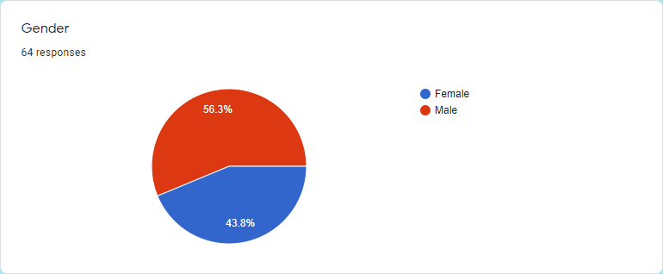
The total number of respondent’s average gender was male 56.3% and female 43.8%.
In this statement, we can see the maximum response male than female.

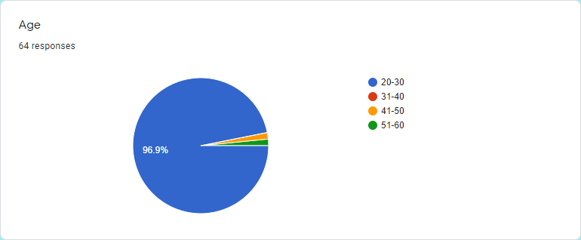
Total number of respondent’s average age were (20-30) 96.9%; (31-40) 0%; (41-50) 1.6%; (51-60) 1.6%.
In this survey Maximum age responses were 20-30 and that percentages are 96.9%. And the lowest number of responses is 1.6% which is ages 51-60.
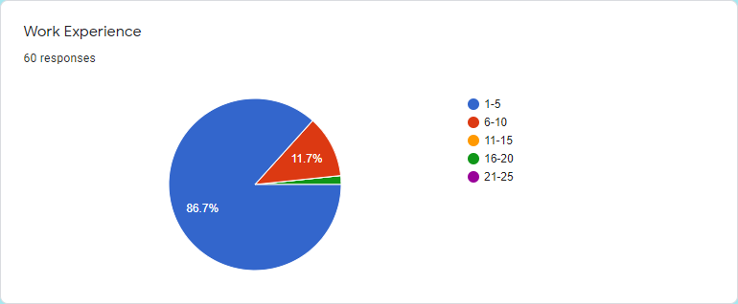
Total number of respondent’s average work experience were (1-5) 86.7%, (6-10) most 11.7%, (11-15) 0% (16-20) 1.7%, (21-25) 0%.
Most of the personal experience was 1-5 and that percentage is 86.7%. The other side's lowest work experience is 16-20 and that percentage is 1.7%.

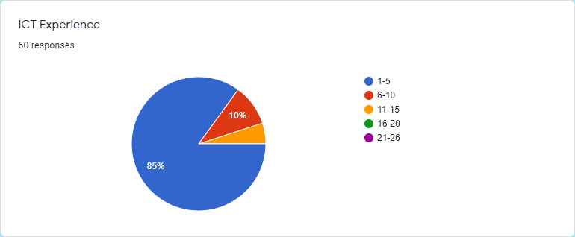
Total number of respondent’s average ICT experience were (1-5) 85%, (6-10) 10%, (11-15) 5%, (16-20) 0%, (21-26) 0%.
Most of the personal experience was 1-5 that shows 85% and the lowest 11-15 that shows 5%.
Now we can see most of the people are lower skillful.
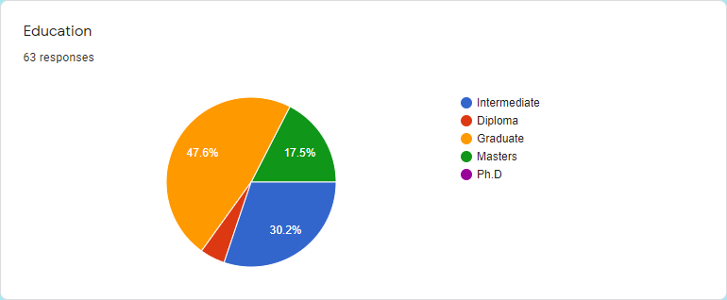
Total number of respondent’s average education were intermediate-30.2%, Diploma-4.8%, Graduate-47.6%, Masters-17.5%, Phd-0%.
In this chart, we can see most of the people are graduates. And the percentage is 47.6%. And the second-highest most of the people are intermediate, the percentage is 30.2%.

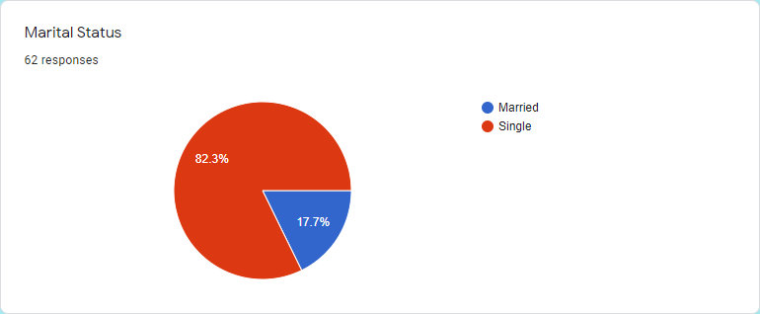
The total number of respondent’s average marital status was single-82.3%, married-17.7%.
In this statement, we can see most of the people are single and a few percent of people are married.
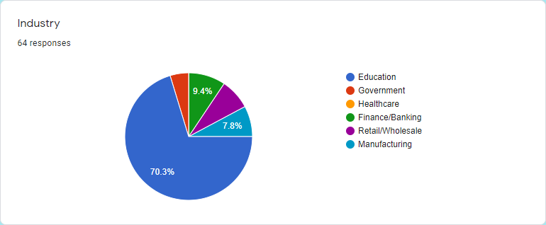
Total number of respondent’s average work were Education-17.3%, Government-4.7%, Healthcare-0%, Finance/Banking -9.4%, Retail /Wholesale-7.8%, Manufacturing- 7.8%.
In this analysis, we can see most of the people are involved in the education sector. And some people are involved in the government sector. And other people involved in a different sector.

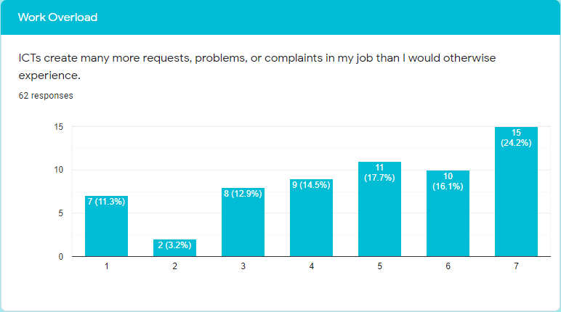
In this statement between 100% respondents, response strongly disagree11.3%, disagree 3.20%, moderately disagree 12.9%, neutral 14.5%, And moderately agree 17.7%, agree 16.1%, strongly agree 24.2%.
Now we can see in this statement most of the people say they face the problem. And some people say they cannot face any problem. Lastly, we can say ict creates many problems for the maximum person.
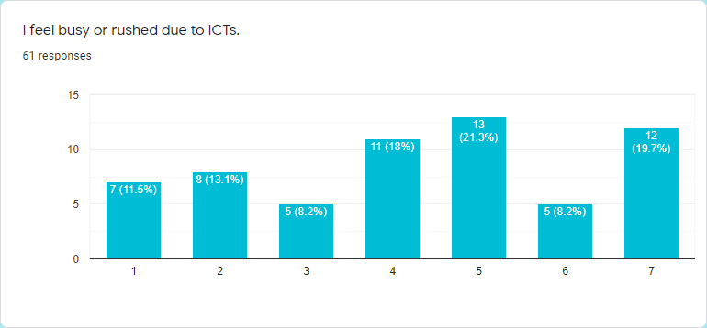
In this statement between 100% respondents, response strongly disagree 11.5%, disagree 13.1%, moderately disagree 8.2%, neutral 18%, And moderately agree 21.3%, agree 8.2%, strongly agree 19.7%.
Now we can see the maximum number of people feeling busy or rushed due to ICTs. But some people are neutral.
And a good number of people say they cannot feel busy or rushed due to ICTs.

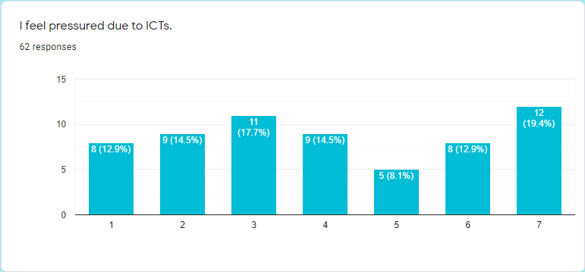
In this statement between 100% respondents, response strongly disagree 12.9%, disagree 14.5%, moderately disagree 17.7%, neutral 14.5%, And moderately agree 8.1%, agree 12.9%, strongly agree 19.4%.
We can see in this graph people's responses averagely. Some people feel pressure and some cannot feel the pressure. But some people cannot decide, whether they feel pressure or not.
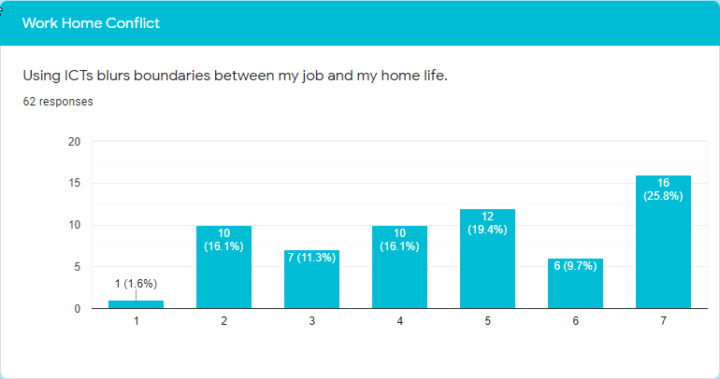
In this statement between 100% respondents, response strongly disagree 1.6%, disagree 16.1%, moderately disagree 11.3%, neutral 16.1%, And moderately agree 19.4%, agree 9.7%, strongly agree 25.8%.
In this analysis, most of the people agree with this, when they use ICT that blurs boundaries between the job and home life. But some people disagree with this.

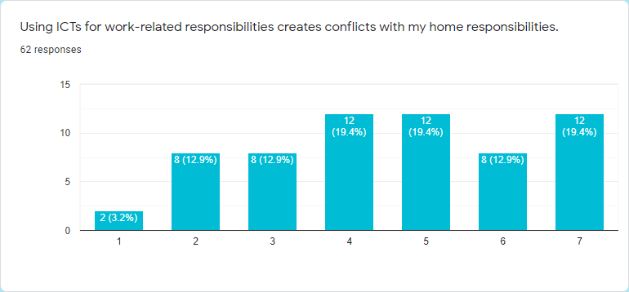
In this statement between 100% respondents, response strongly disagree3.2%, disagree 12.9%, moderately disagree 12.9%, neutral 19.4%, And moderately agree 19.4%, agree 12.9%, strongly agree 19.4%.
Now we can see most of the people agree with this. Because they find some reason when they use icts for work-related responsibilities creates conflicts with their home responsibilities. But a good number of people are neutral with this statement.

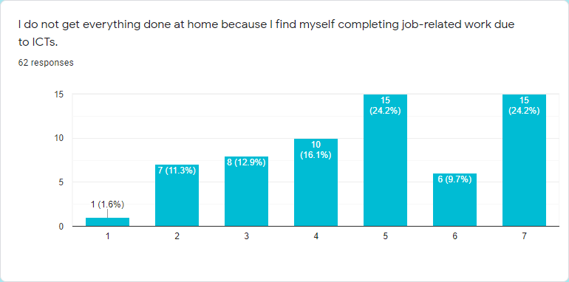
In this statement between 100% respondents, response strongly disagree1.6%, disagree 11.3%, moderately disagree 12.9%, neutral 16.1%, And moderately agree 24.2%, agree 9.7%, strongly agree 24.2%.
This graph shows a large number of people showing their response’s with this statement as agreed. They do not get everything done when they are at home. But few people disagree with this because they get everything done at home. After all, they find themselves completing job-related work due to ICTS.

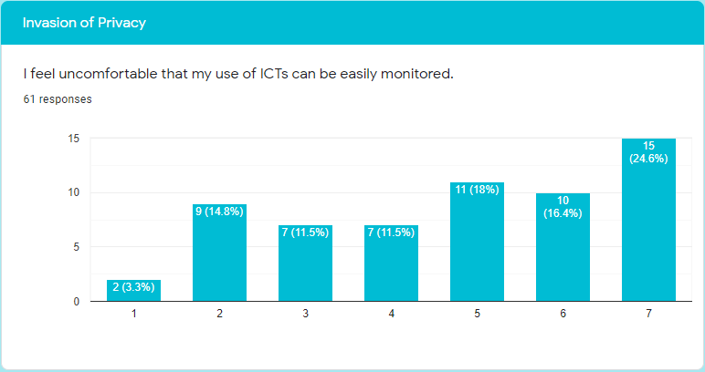
In this statement between 100% respondents, response strongly disagree 3.3%, disagree 14.8%, moderately disagree 11.5%, neutral 11.5%, And moderately agree 18%, agree 16.4%, strongly agree 24.6%.
We can see a huge number of people agree with this analysis. Because most want their privacy. Something is personal. So they can not want, someone can easily be monitored when they use ICT. So most of the people agree with this. And few numbers of people disagree with this.

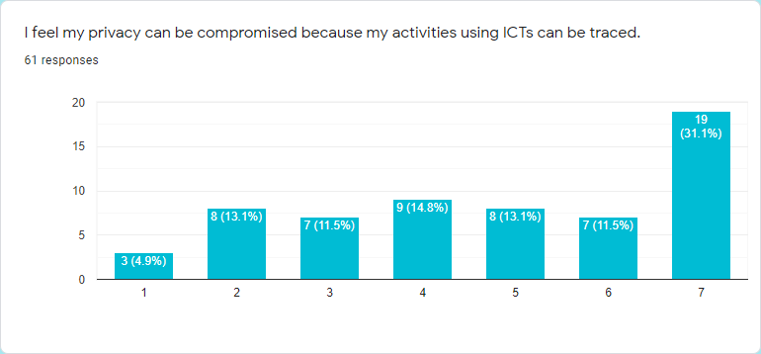
In this statement between 100% respondents, response strongly disagree 4.9%, disagree 13.1%, moderately disagree 11.5%, neutral 14.8%, And moderately agree 13.1%, agree 11.5%, strongly agree 31.1%.
In this graph we can see, most 0f the people highly agree with this statement. But a lower number of people disagree and are neutral with this. But some people lowly disagree with this.

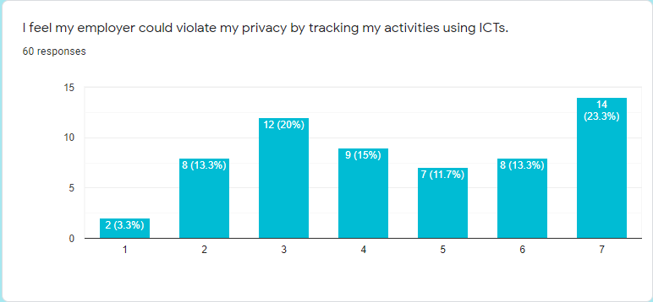
In this statement between 100% respondents, response strongly disagree3.3%, disagree 13.3%, moderately disagree 20%, neutral 15%, And moderately agree 11.7%, agree 13.3%, strongly agree 23.3%.
We can see in this graph people responses averagely. But a lower number of people strongly disagree with this. But on the other side most of the people strongly agree with this statement. And a good number of people are neutral.

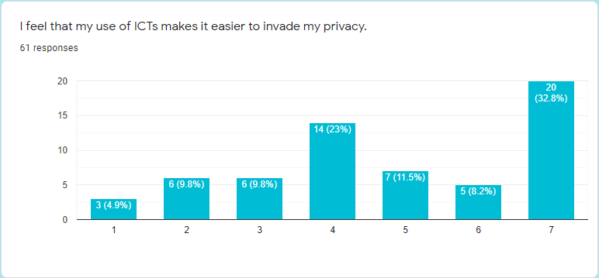
In this statement between 100% respondents, response strongly disagree4.9%, disagree 9.8%, moderately disagree 9.8%, neutral 23%, And moderately agree 11.5%, agree 8.2%, strongly agree 32.8%.
This response shows many people agree with this and some people disagree with this. But most of the people strongly agree with this. And a lower number of people strongly disagree with this. And a good number of people are neutral. Because they cannot have decided use ICT invade the privacy or not.

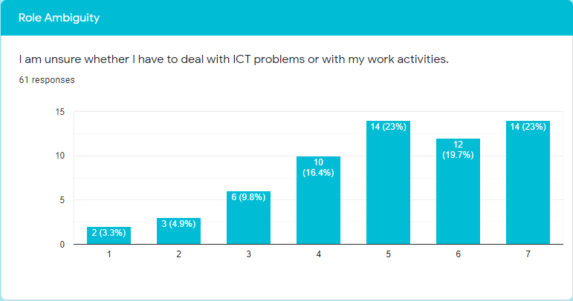
In this statement between 100% respondents, response strongly disagree3.3%, disagree 4.9%, moderately disagree 9.8%, neutral 16.4%, And moderately agree 23%, agree 19.7%, strongly agree 23%.
In this graph we can see some people agree and some people disagree. But most of the people agree with this. And a good number of people are neutral. And few people disagree with this. But some people strongly disagree with this.

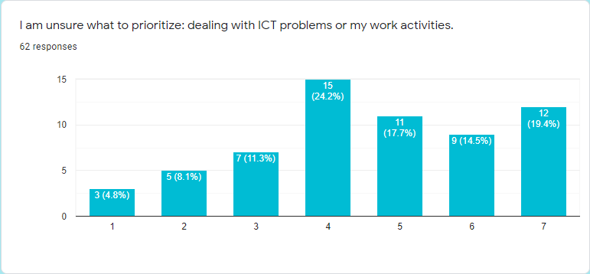
In this statement between 100% respondents, response strongly disagree4.8%, disagree 8.1%, moderately disagree 11.3%, neutral 24.2%, And moderately agree 17.7%, agree 14.5%, strongly agree 19.4%.
In this analysis we can see some people agree and some people disagree. But most of the people agree with this. And a good number of people are neutral. And few people disagree with this. But some people strongly disagree with this.

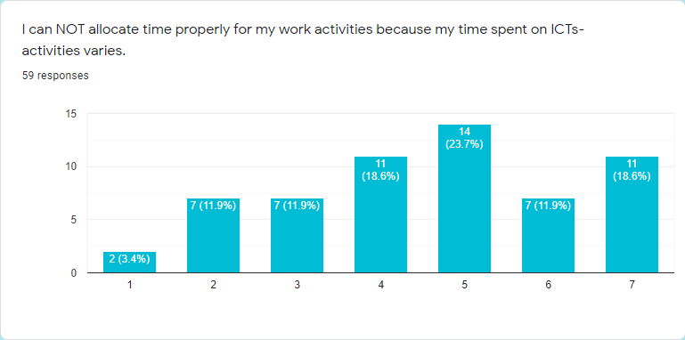
In this statement between 100% respondents, response strongly disagree3.4%, disagree 11.9%, moderately disagree 11.9%, neutral 18.6%, And moderately agree 23.7%, agree 11.9%, strongly agree 18.6%.
In this analysis we can see most of the people agree with this. And a good number of people are neutral. And few people disagree with this. But some people strongly disagree with this.

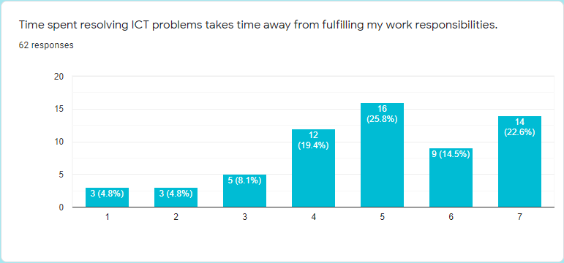
In this statement between 100% respondents, response strongly disagree4.8%, disagree 4.8%, moderately disagree 8.1%, neutral 19.4%, And moderately agree 25.8%, agree 14.5%, strongly agree 22.6%.
In this analysis maximum response agrees. And a good number of people are neutral. And few people agree. In this few people's response strongly agrees. So we can say maximum people's time spent resolving ICT problems takes time away from fulfilling my work responsibilities.

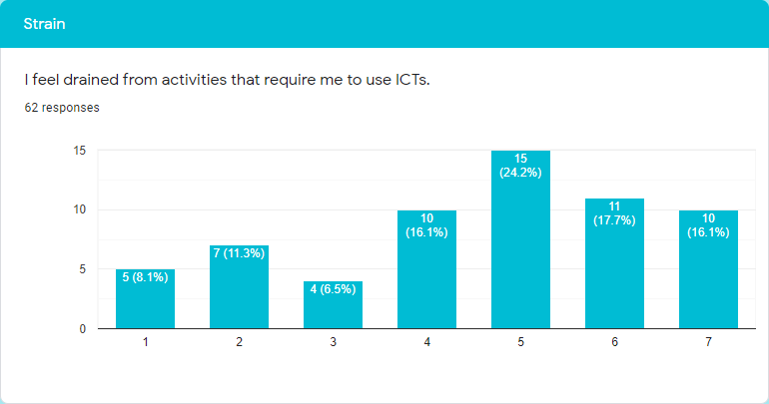
In this statement between 100% respondents, response strongly disagree 8.1%, disagree 11.3%, moderately disagree 6.5%, neutral 16.1%, And moderately agree 24.2%, agree 17.7%, strongly agree 16.1%.
In this analysis maximum response agrees. And a good number of people are neutral. And few people agree. So we can say maximum people feel drained from activities that require me to use ICTS.

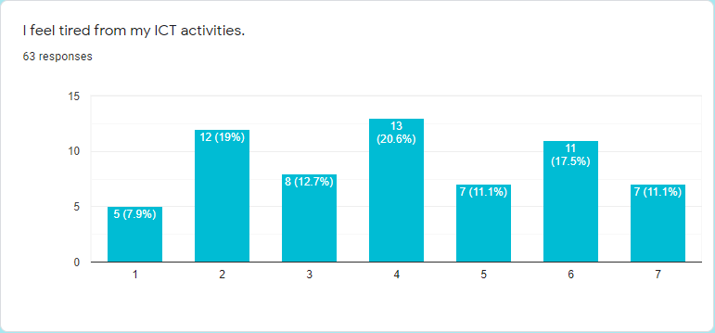
In this statement between 100% respondents, response strongly disagree7.9%, disagree 19%, moderately disagree 12.7%, neutral 20.6%, And moderately agree 11.1%, agree 17.5%, strongly agree 11.1%.
In this analysis we can see people respond averagely. And few people are neutral. So lastly we can say people averagely feel tired from their ICT activities.

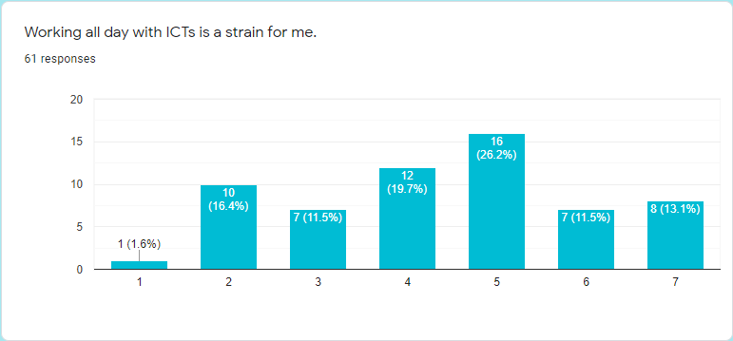
In this statement between 100% respondents, response strongly disagree1.6%, disagree 16.4%, moderately disagree 11.5%, neutral 19.7%, And moderately agree 26.2%, agree 11.5%, strongly agree 13.1%.
We can see most of the person's response agrees with this statement. And some people disagree with this. But on this side some people strongly agree with this. But some people are neutral with this statement.

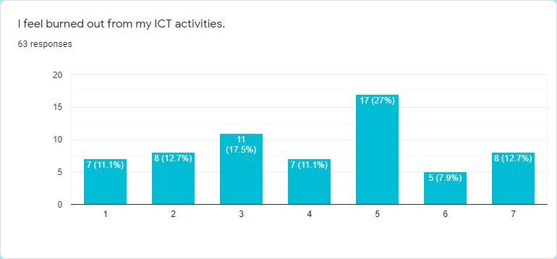
In this statement between 100% respondents, response strongly disagree11.1%, disagree 12.7%, moderately disagree 17.5%, neutral 11.1%, And moderately agree 27%, agree 7.9%, strongly agree 12.7%.
In this statement we can see people respond averagely. Some people agree and some people disagree. But maximum people strongly agree with this statement. Because they feel burned out from their ICT activities.

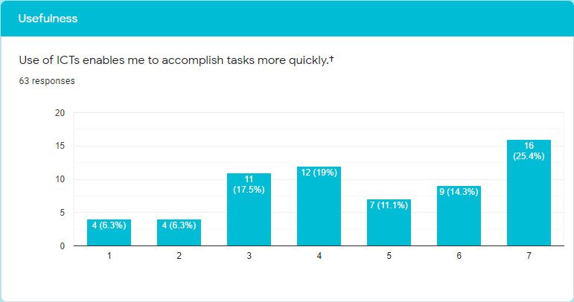
In this statement between 100% respondents, response strongly disagree 6.3%, disagree 6.3%, moderately disagree 17.5%, neutral 19%, And moderately agree 11.1%, agree 14.3%, strongly agree 25.4%.
In this analysis we can see the maximum response people agree. And on this side most of the people responding strongly agree with this statement. And some people disagree. But a good number of people neutral

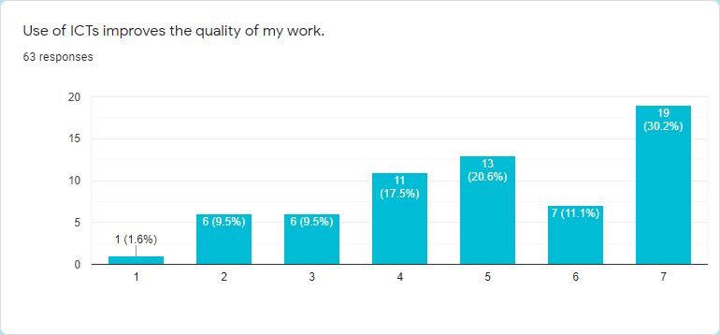
In this statement between 100% respondents, response strongly disagree 1.6%, disagree 9.5%, moderately disagree 9.5%, neutral 17.5%, And moderately agree 20.6%, agree 11.1%, strongly agree 30.2%.
Now we can see 60% of people say ICT improves the quality of work. But some people on this side strongly agree with this. Some people strongly disagree with this. And its percentage is 1.6%. And a good number of people are neutral.

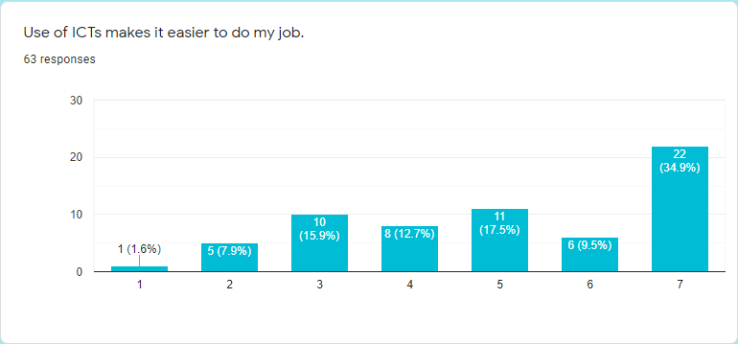
In this statement between 100% respondents, response strongly disagree 1.6%, disagree 7.9%, moderately disagree 15.9%, neutral 12.7%, And moderately agree 17.5%, agree 9.5%, strongly agree 34.9%.
In this graph we can see 60% of people agree with this statement. When they use ICT, it makes it easy to do their job. And 24% of people say ICT cannot make it easier to get a job. And few people are neutral.

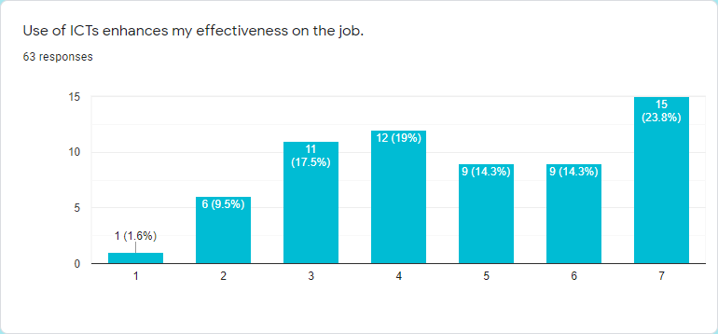
In this statement between 100% respondents, response strongly disagree 1.6%, disagree 9.5%, moderately disagree 17.5%, neutral 19%, And moderately agree 14.3%, agree 14.3%, strongly agree 23.8%.
In this analysis we can see 50% people agree with this statement. When they use ICT, it enhances their effectiveness on the job. And some people say ICT cannot enhance their effectiveness on the job. But on this side some people strongly disagree. And a good number of people are neutral.
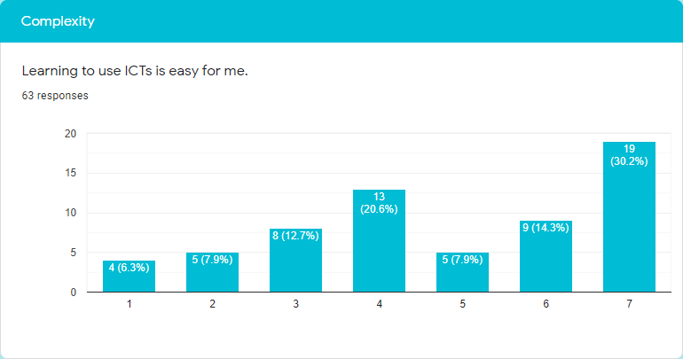
In this statement between 100% respondents, response strongly disagree 6.3%, disagree 7.9%, moderately disagree 12.7%, neutral 20.6%, And moderately agree 7.9%, agree 14.3%, strongly agree 30.2%.
In this analysis we can see 50% of people say learning to use ict is easy for them. Some people disagree, learning to use ICT is not easy for them. On this side some strongly disagree. But a good number of people don’t say anything.

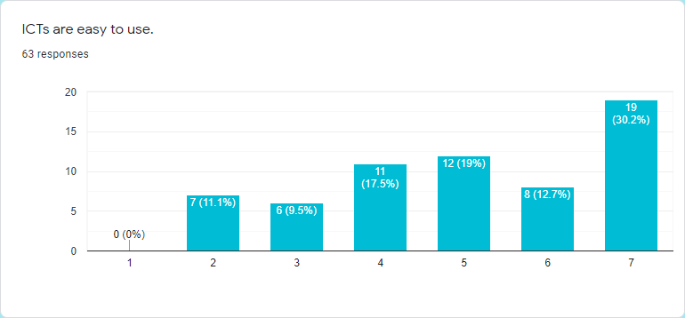
In this statement between 100% respondents, response strongly disagree 0%, disagree 11.1%, moderately disagree 9.5%, neutral 17.5%, And moderately agree 19%, agree 12.7%, strongly agree 30.2%.
We can see in this analysis approximately 62% of people say ICTs are easy to use. And some people say ICTs are not easy to use. On this side 0% people strongly disagree with this. But a good number of people are neutral.

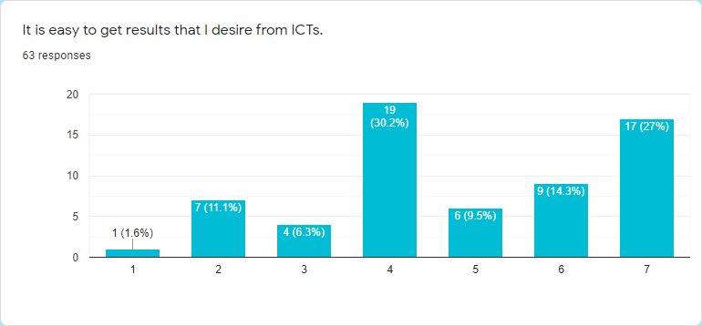
In this statement between 100% respondents, response strongly disagree1.6 %, disagree 11.1%, moderately disagree 6.3%, neutral 30.2%, And moderately agree 9.5%, agree 14.3%, strongly agree 27%.
We can see approximately 50% agree with this. On this side 27% of people strongly agree with this statement. Some people disagree with this but this side only 106% people strongly disagree with this. But a huge number of people are neutral. Lastly we can say a huge number of people respond. It is easy to get the results that I desire from ICTs.
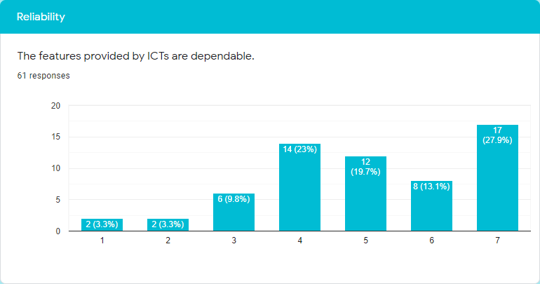
In this statement between 100% respondents, response strongly disagree 3.3%, disagree 3.3%, moderately disagree 9.8 %, neutral 23%, And moderately agree 19.7%, agree 13.1%, strongly agree 27.9%.
We can see few people are disagreeing with this statement. They say the features provided by ICTs are not dependable. On this side some people disagree strongly. And a good number of people agree with this. They said they are dependable. And some people are neutral.

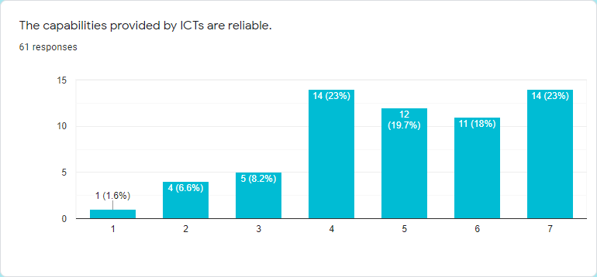
In this statement between 100% respondents, response strongly disagree1.6%, disagree 6.6%, moderately disagree 8.2%, neutral 23%, And moderately agree 19.7%, agree 18%, strongly agree 23%.
Now we can see approximately 60% of people say the capabilities provided by ICTs are reliable. On this side 23% strongly agree with this analysis. And some people disagree, which is included 1.6% people strongly disagree.

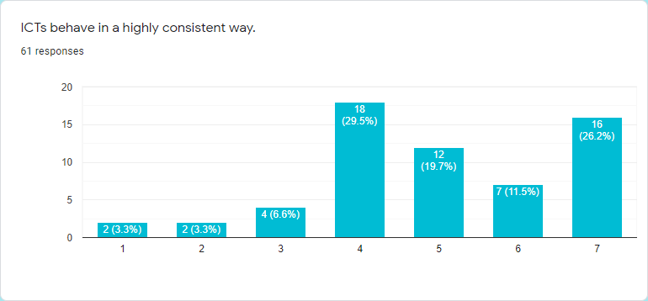
In this statement between 100% respondents, response strongly disagree3.3%, disagree 3.3%, moderately disagree 6.6%, neutral 29.5%, And moderately agree 19.7%, agree 11.5%, strongly agree 26.2%.
Approximately 60% of people agree with this, including 26.2% people are strongly agreeing with this. And around 30% people are neutral. And some people disagree with this. And its percentage is13%.
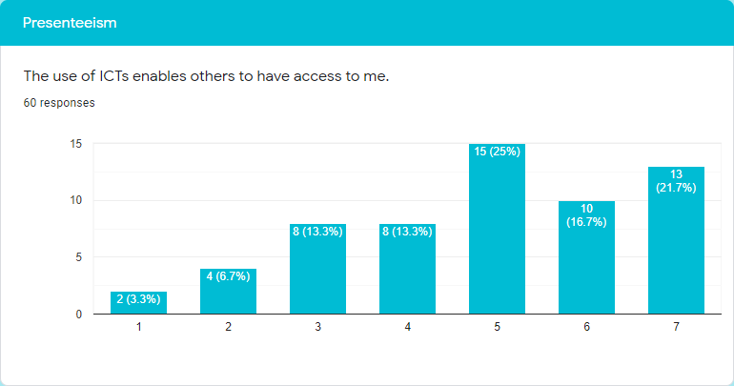
In this statement between 100% respondents, response strongly disagree3.3%, disagree 6.7%, moderately disagree 13.3%, neutral 13.3%, And moderately agree 25%, agree 16.7%, strongly agree 21.7%.
About 62% of people agree the use of ICTs enables others to have access to them. In this percentage moderately agree 25%. And on the other side 23% people disagree with this statement. And the percentages of strongly disagreeing are 30.3%.

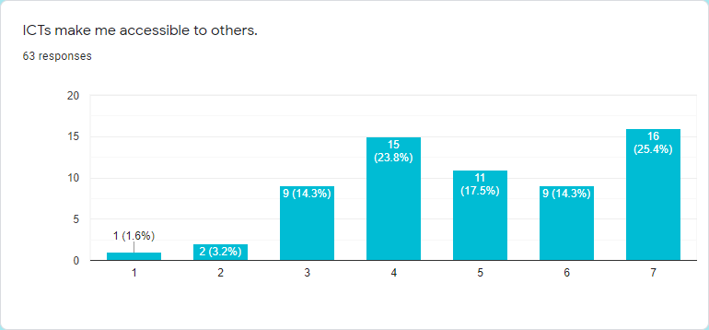
In this statement between 100% respondents, response strongly disagree1.6%, disagree 3.2%, moderately disagree 14.3%, neutral 23.8%, And moderately agree 17.5%, agree 14.3%, strongly agree 25.4%.
In this analysis we can see most of the people say ICTs makes them accessible to others and they agree with this. And 25.4% of people strongly agree with this statement. And a good number of people neutral which percentage is one fourth. And few people disagree with this and some people in this side strongly disagree which is a small group of people.

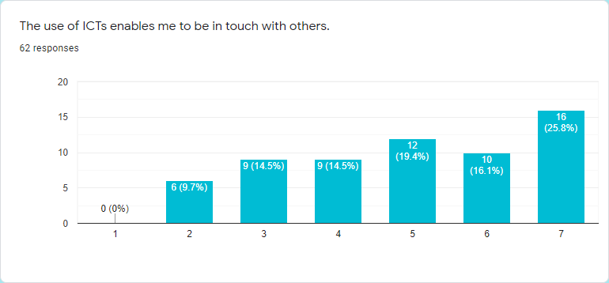
In this statement between 100% respondents, response strongly disagree 0%, disagree 9.7%, moderately disagree 14.5%, neutral 14.5%, And moderately agree 19.4%, agree 16.1%, strongly agree 25.8%.
We can see 60% people agree with this and strongly agree with this 25.8% people. And just a few people say they don’t agree with this. But some people are neutral.

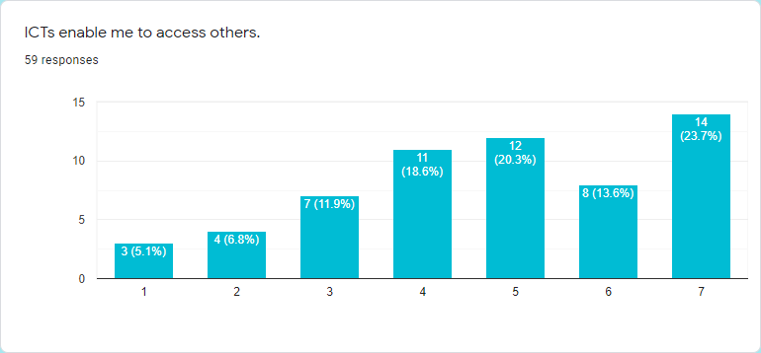
In this statement between 100% respondents, response strongly disagree 5.1%, disagree 6.8%, moderately disagree 11.9%, neutral 18.6%, And moderately agree 20.3%, agree 13.6%, strongly agree 23.7%.
Same time we can see some people disagree with this statement and 5.1% people strongly disagree with this statement. And a large number of people are neutral. Approximately 60% of people agree with this. They say ICTs enable them to access others.
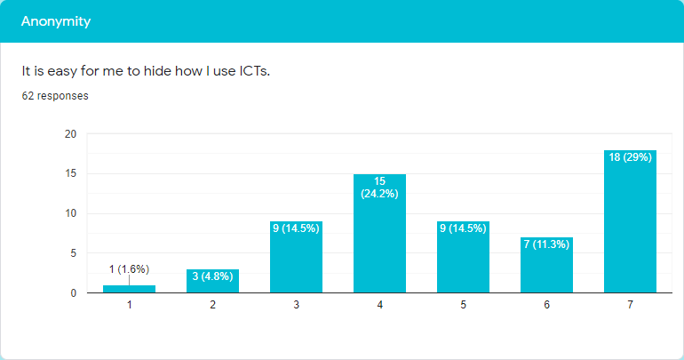
In this statement between 100% respondents, response strongly disagree1.6%, disagree 4.8%, moderately disagree 14.5%, neutral 24.2%, And moderately agree 14.5%, agree 11.3%, strongly agree 29%.
In this analysis few persons disagree with this but a small number of people strongly disagree. And a huge number of people are neutral. But maximum people say it is for them to hide how they use ICTs.
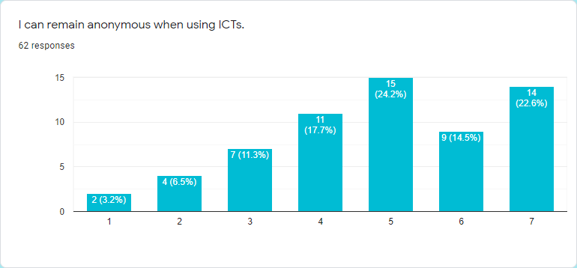
In this statement between 100% respondents, response strongly disagree 3.2%, disagree 6.5%, moderately disagree 11.3%, neutral 17.7%, And moderately agree 24.2%, agree 14.5%, strongly agree 22.6%.
Maximum people agree with this statement that they can remain anonymous when using ICTs. But some don’t agree with it but on this side only 3.2% people strongly disagree. And in this analysis a medium number of people is neutral.

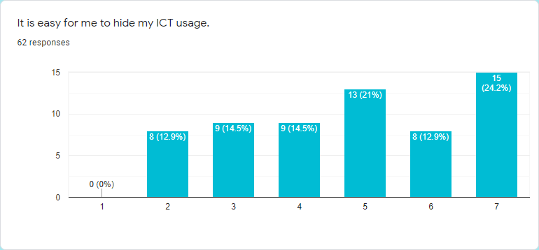
In this statement between 100% respondents, response strongly disagree 0%, disagree 12.9%, moderately disagree 14.5%, neutral 14.5%, And moderately agree 21%, agree 12.9%, strongly agree 24.2%.
Approximately 60% people agree with this statement and some people strongly agree with this which percentage is 24.2%. But some people disagree with this, and 0.0% of people do not strongly agree with this. But few people are neutral.

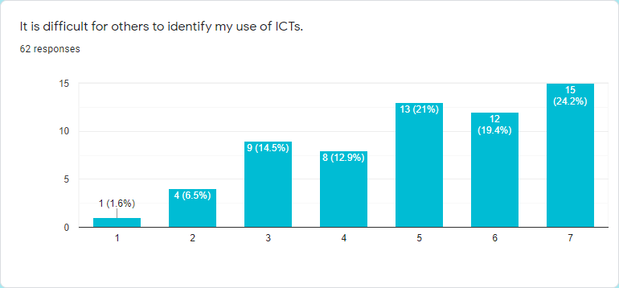
In this statement between 100% respondents, response strongly disagree 1.6%, disagree 6.5%, moderately disagree 14.5%, neutral 12.9%, And moderately agree 21%, agree 19.4%, strongly agree 24.2%.
In this analysis 65% people agree with this statement and strongly agree 24.2% out of 65%. But some people disagree with this, in this total number of disagreements only 1.6% people strongly disagree. And some people are neutral.

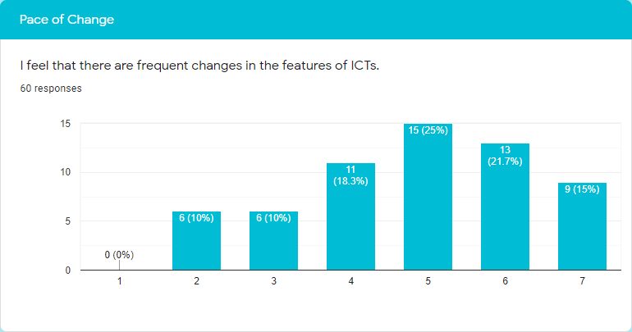
In this statement between 100% respondents, response strongly disagree 0%, disagree 10%, moderately disagree 10%, neutral 18.3%, And moderately agree 25%, agree 21.7%, strongly agree 15%.
Most of the people agree with this statement. In this agreement, just moderately agree 25% people and that is huge. And a good number of people are neutral. But a small number of people disagree with this. That percentage is only 20%. In this disagreement 0.0% people strongly disagree.

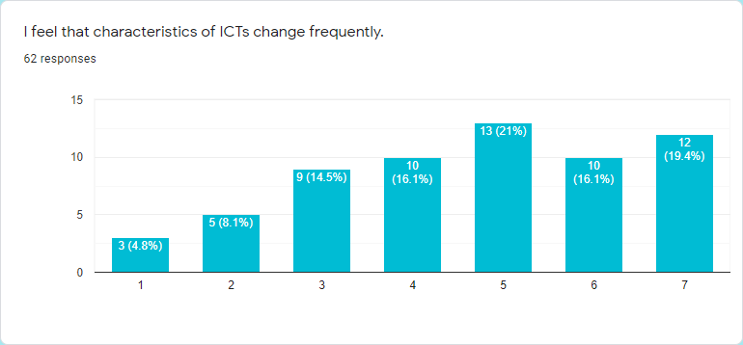
In this statement between 100% respondents, response strongly disagree 4.8%, disagree 8.1%, moderately disagree 14.5%, neutral 16.1%, And moderately agree 21%, agree 16.1%, strongly agree 19.4%.
Maximum people say they feel that characteristics of ICTs change frequently and they say they agree with this, which percentage is 56%. And some people disagree with this, but only 4.8% of people strongly disagree. And a good number of people are neutral.

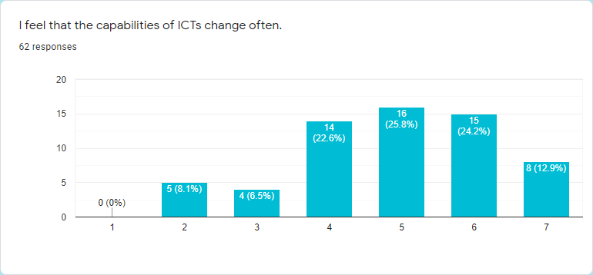
In this statement between 100% respondents, response strongly disagree 0%, disagree 8.1%, moderately disagree 6.5%, neutral 22.6%, And moderately agree 25.8%, agree 24.2%, strongly agree 12.9%.
In this analysis we can see up to 60% people say they agree with this statement. They agree because they feel that the capabilities of ICTs change often. But some people say they didn’t feel that the capabilities of ICTs change often. And a huge number of people are neutral.

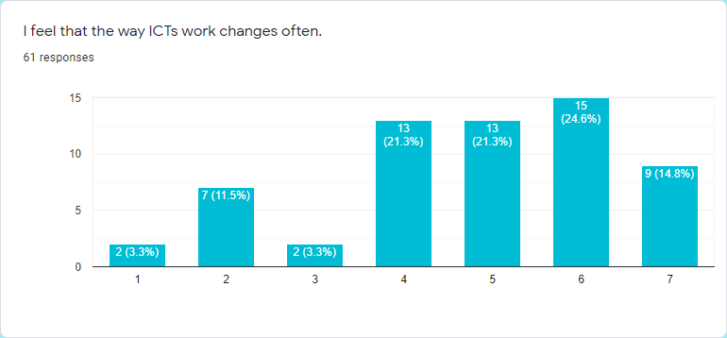
In this statement between 100% respondents, response strongly disagree 3.3%, disagree 11.5%, moderately disagree 3.3%, neutral 21.3%, And moderately agree 21.3%, agree 24.6%, strongly agree 14.8%.
Most people agree with this because they feel that the way ICTs work changes often. And in this positive vive 24.6% people just agree. But other people disagree with this statement. Only 3.3% strongly disagree, moderately disagree 3.3%. And we can see a good number of people neutral that is high between disagree.

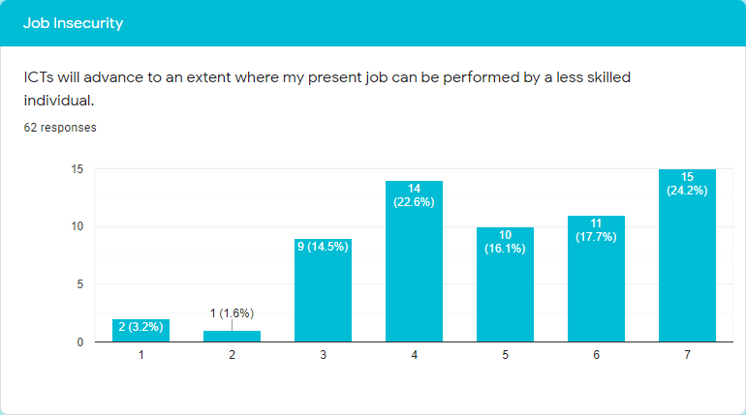
In this statement between 100% respondents, response strongly disagree 3.2%, disagree 1.6%, moderately disagree 14.5%, neutral 22.6%, And moderately agree 16.1%, agree 17.7%, strongly agree 24.2%.
In this analysis we can see most of the people agree with this. And that percentage is approximately 55%. And a huge number of people were neutral, they didn’t give any kind of opinion. And just a few people disagree with this statement. In this disagreement only 1.6% people moderately disagree.

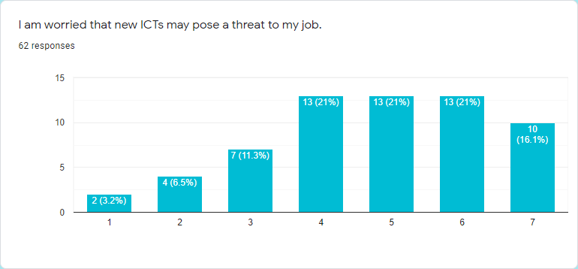
In this statement between 100% respondents, response strongly disagree 3.2%, disagree 6.5%, moderately disagree 11.3%, neutral 21%, And moderately agree 21%, agree 21%, strongly agree 16.1%.
Approximately 60% of people agree with this statement. They said they are worried that new ICTs may pose a threat to their job. And some people didn't give any kind of opinion. And just some people disagree with this and in this disagree just a few people strongly disagree which percentage is 3.2%.

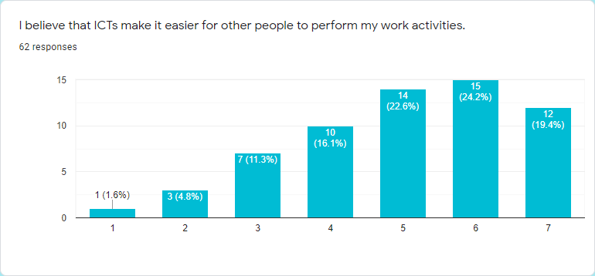
In this statement between 100% respondents, response strongly disagree1.6%, disagree 4.8%, moderately disagree 11.3%, neutral 16.1%, And moderately agree 22.6%, agree 24.2%, strongly agree 19.4%.
In this case we can see approximately 70% people agree with this statement. Strongly agree 24.2% people that is a huge number of people. Only a few people agree with this statement. On this side only 1.6% people strongly disagree.

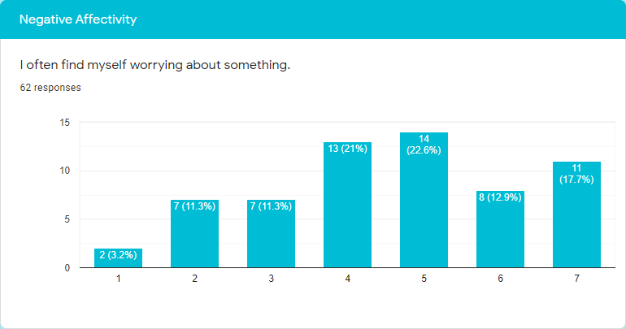
In this statement between 100% respondents, response strongly disagree 3.2%, disagree 11.3%, moderately disagree 11.3%, neutral 21%, And moderately agree 22.6%, agree 12.9%, strongly agree 17.7%.
We can see in this graph people find themselves worrying about something, in this graph approximately up to 50% people agree with this but moderately agree with a good number of people. But on the other side some people disagree with this. And 21% people are neutral.

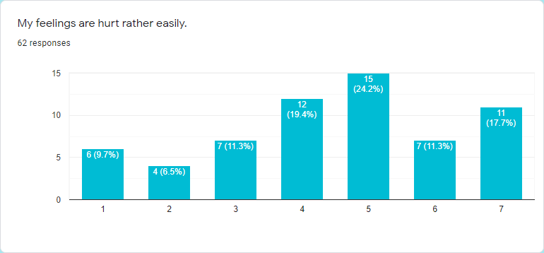
In this statement between 100% respondents, response strongly disagree 9.7%, disagree 6.5%, moderately disagree 11.3%, neutral 19.4%, And moderately agree 24.2%, agree 11.3%, strongly agree 17.7%.
In this analysis 50% people say their feelings are hurt rather easily. On this side 24.2% people just moderately agree. And some people are neutral. And some people moderately disagree with this statement.

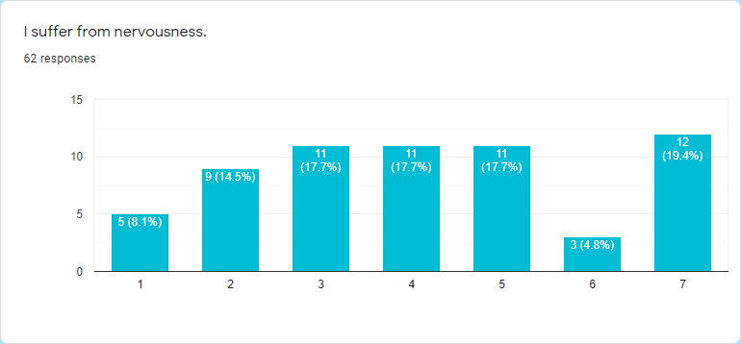
In this statement between 100% respondents, response strongly disagree 8.1%, disagree 14.5%, moderately disagree 17.7%, neutral 17.7%, And moderately agree 17.7%, agree 4.8%, strongly agree 19.4%.
In this analysis we can see people averagely respond, agree and disagree. But some people only just agree with this statement which is 4.8%. And 17.7% of people are neutral.
Lastly we can say people averagely respond they suffer from nervousness.

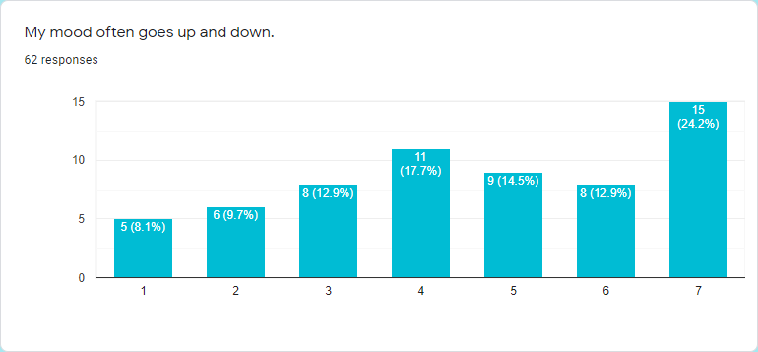
In this statement between 100% respondents, response strongly disagree 8.1%, disagree 9.7%, moderately disagree 12.9%, neutral 17.7%, And moderately agree 14.5%, agree 12.9%, strongly agree 24.2%.
Maximum people’s mood often goes up and down. And its percentage is approximately 50%. And few people disagree with this. And a good number of people are neutral with this statement.

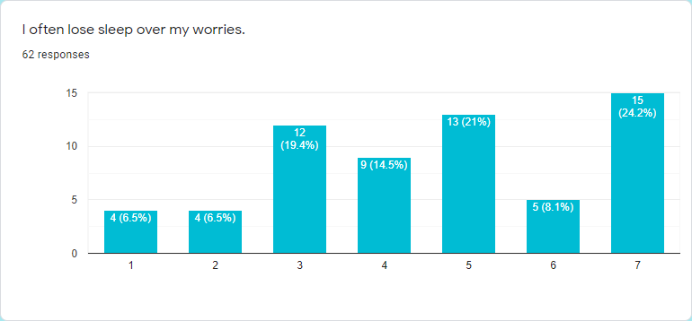In this statement between 100% respondents, response strongly disagree 6.5%, disagree 6.5%, moderately disagree 19.4%, neutral 14.5%, And moderately agree 21%, agree 8.1%, strongly agree 24.2%.
In this analysis we can see some people often lose sleep over their worries, they agree with this statement. Up to 52% of people agree with this. On this side 24.2% people strongly agree which is very high. And 32% of people say they didn’t often lose sleep over their worries. But few people are neutral.

CHAPTER - 4
FINDINGS, RECOMMENDATION AND CONCLUSION

FINDINGS
There are some benefits of technology.
Multitasking can be done. It takes a lot of time to do a lot of work. There is not much time available so being able to do a lot of work in less time is called multitasking.
Technology related becomes a good idea. Working on maintaining many devices results in better technology related ideas.

But there are some problems in technostress. Some problem is given below

- Most people find themselves very busy when they use ICT because ICT has a lot of work pressure. If the focus shifts from then the work can be wrong and the work has to be redone which is a matter of time.

- Many people think that when they use ICT they feel nervous because of which they cannot work easily and make mistakes at work.

- Most people think that the use of ICT creates a wall between their personal life and work life so that they cannot do any work properly for which they face various problems.

- Many people think that ICT is so easy to use that it is very easy for someone else to find out about another person. So people can also find out about the personal information they have using ICT.

- Most of the people think that new features are constantly being added to the ICT so that they are facing various problems. As a result, they are not able to work properly.

RECOMMENDATION
Here are some recommendations on the basis of findings. Those are given below:

- Since people think they are too busy to do ICT work so they should take a break from work and refresh their minds, then they will not feel busy.

- Since most people feel nervous about working in ICT so that they need to arrange a development class. As if they don’t feel nervous about working.

- Since most people think that ICT builds a wall in their personal life and their working life, they should finish their work on time. Do not do office work at home. Then no more walls will be built in these two lives.

- Since ICT is very easy to use, people should not share their personal information. Keeping personal information as secure as possible will make it easier for others to find out.

- Most people think that new features have been added to ICT which is unknown to most people. So training needs to be arranged for them so that they can learn about new features and work better.

CONCLUSION
Technostress is the Psychological gender between people and the introduction of technologies. How people show the opposite process of technostress. However, recent research has shown that there are positive aspects to technostress in addition to its negative ones. They specialize in multitasking due to high pressure. Can work fast, information flows fast and very little time is spent explaining sustainable thinking and creative analysis.
Techno stress will be in our lives but we have to accept it so that it does not have a bad effect on us.
There are many mental and physical problems for technostress, and this matter cannot be avoided at this time if anyone wants. We can arrange one or two training sessions with our official purpose. Which creates adequate protection and prevention measures such as the application of certain strategies.

CHAPTER - 5
REFERENCES

REFERENCES

- Brod, C., Technostress: The human cost of the computer revolution. (Reading: Addison-Wesley, 1984).

- Davis-Millis, N., Technostress and the organization: A manager's guide to survival in the information age. In the 67th Annual Meeting of the Music Library Association, 14 February,1998, Boston, Massachusetts. Retrieved from http://web.mit.edu/ninadm/www/mla.htm

- Francis, Olalude Oluwole, Work Values, Achievement Motivation and Technostress as Determinants of Job Burnout among Library Personnel in Automated Federal University Libraries in Nigeria. Library Philosophy and Practice (e-journal). (2013) Paper 919. http://digitalcommons.unl.edu/libphilprac/919

- Tarafdar, M. T. Q., Ragu-Nathan, B.S., & Ragu-Nathan, T.S., The impact of technostress on role stress and productivity, Journal of Information Management Systems 24(1) (2007) 301- 328.

- Spector, P.E., Measurement of human service staff satisfaction: Development of the job satisfaction survey. American Journal of Community Psychology 13(6) (1985) 693-713.

- Ayyagari, R., Grover, V., and Purvis, R.L., Technostress: Technology an antecedents and implications, MIS Quarterly, 35(4) (2011) 831-858

- Tu, Q., Wang, K., and Shu, Q., Computer-related technostress in China, Communications of the ACM 48(4) (2005) 77-81.

- Ayyagari, R., Grover, V., and Purvis, R.L., Technostress: Technology antecedents and implications, MIS Quarterly 35(4) (2011) 831-858.

- Ragu-Nathan, T. S., Tarafdar, M., Ragu-Nathan, B. S., and Tu, Q., The consequences of technostress for end users in organizations: Conceptual development and empirical validation, Information Systems Research 19 (4) (2008) 417-433.

- Ameen, K., Perception and self-assessment of university librarians regarding collection management (CM): A case of Pakistan. Collection Building 24(4) (2008) 167- 173.

- Raftar, M. Technostress takes toll on internet users. Akron Beacon Journal D8 (1998)

- Ayyagari R, Impact of Information overload and taskTechnology fit on Technostress, In Proceedings of the Southern Association for Information Systems Conferenc (Atlanta, GA, USA March 23rd-24th, 2012), pp18-22

- Rajesh Kumar, Roshan Lal, Yashu Bansal, Saran.K.Sharma, Technostress in relation to Job satisfaction organisational Commitment among IT Professional, International Journal of Scientific and Research Publications 3(12) (2013) 1-3.

- Agbu Jane-Frances O. and Olubiyi Kayode Simeon, (2011), Technostress in the age of information communication technology: A case study of distance education, Educational Research 2(11) (2011) 1654- 1660.

- Corbett, J. M., Martin, R., Wall, T. D., & Clegg, C. W., Technological coupling as a predictornote of intrinsic job satisfaction: A replication study, Journal of Organizational Behavior 10(1) (1989) 91-95.

- Wang, K. Tu, Q. & Shu,Q., Technostress under Different Organizational Environments: An Empirical Investigation”, Computers in Human Behavior 24 (2008) 3002–3013.

- Ahmet Naci Çoklar, Yusuf Levent Sahin, Technostress Levels of Social Network Users Based on ICTs in Turkey, European Journal of Social Sciences 23(2) (2011) 171-182.

