

Internship Report on
Financial Performance Analysis of Beximco Pharmaceuticals Limited

Submitted To

Professor Dr. Mostafa Kamal

Department of Business Administration
Faculty of Business & Entrepreneurship
Daffodil International University

Prepared By

Aysha Airin Prianka
ID: 171-11-444
Major in Finance
Bachelor of Business Administration
Department of Business Administration
Faculty of Business & Entrepreneurship
Daffodil International University

Submission Date: 22-09-2020

Letter of Transmittal

20 August 2020
Professor Dr. Mostafa Kamal
Department of Business Administration Faculty of Business & Entrepreneurship Daffodil International University
Subject: Submission of the Internship Report Titled “Financial Analysis on Beximco Pharmaceuticals Limited”.
Dear Sir,
It is my immense pleasure to present to you the internship report entitled “Financial Analysis of Beximco Pharmaceuticals Limited”. My main incentive has been to prepare this practice report according to your guidelines and according to your instructions. I have done my best to get the job done at your facility. I hope I have done a satisfactory job considering my level of experience and skills and have been able to relate the fundamentals to realistic applications.
Also, I am very grateful for the opportunity you have given me to express my abilities and I sincerely hope you enjoy the work that I have done.
Sincerely,
………………………
Aysha Airin Prianka ID: 171-11-444 Program: BBA Major in Finance Department of Business Administration Faculty of Business and Entrepreneurship Daffodil International University

CERTIFICATE OF SUPERVISOR

This is to certify that Aysha Airin Prianka, ID: 171-11-444 is a regular student of Daffodil International University under the Department of BBA. She has successfully completed her internship report on “Financial Analysis on Beximco Pharmaceuticals Limited” for the award of the degree of Bachelor of Business Administration (BBA) under my supervision.

To the best of my knowledge and as per her declaration, the report is an authentic work on the issue and has not been submitted to anywhere for awarding any degree. She is permitted to submit the Internship Report and I wish her best success & prosperity.

……………….................…..

Professor Dr. Mostafa Kamal
Department of Business Administration
Faculty of Business & Entrepreneurship
Daffodil International University

Acknowledgement

I am grateful to several people, especially those who took the time to share their ideas and suggestions for improving the report. First of all, I would like to express my sincere thanks to my Internship Supervisor, Dr. Mostafa Kamal, Professor, Dept. of Business Administration at Daffodil International University. I am grateful not only for your continued support in preparing the report. My thanks also go to the Human Resources Division of Beximco Pharmaceutical Limited for giving me the opportunity to work with the company. I also especially thank Senior Vice President and Director of the Beximco pharmaceutical limited, and also my on-site supervisor, Mr. Shamim Ahmed, Deputy Senior Vice President and Deputy Director of Beximco pharmaceutical limited, for continually supporting me with resources and knowledge throughout my internship program at the company. I am also grateful to all the Beximco pharmaceutical limited employees for their active participation in answering all my inquiries during my internship and they have made this trip a real success. It was a privilege for me and it is a true honor to work with such a wonderful team.

Table of Contents
Chapter | Topic | Page
 | Letter of transmittal | ii
 | Certificate of supervisor | iii
 | Acknowledgement | iv
01  Introduction of the study | 1.1 Introduction | 07
01  Introduction of the study | 1.2 The Report Part | 08
01  Introduction of the study | 1.3 Origin of The Report | 08
01  Introduction of the study | 1.4 purpose of the study | 08
01  Introduction of the study | 1.5 Scope of The Report | 09
01  Introduction of the study | 1.6 Objective of The Study1 | 09
01  Introduction of the study | 1.7 Methodology | 10
01  Introduction of the study | 1.8 Limitations of The Study | 10-11
02  Industry Overview | 2.1 Industry Overview | 12-13
02  Industry Overview | 2.2 Industry Outlook | 13
02  Industry Overview | 2.3 Local Market Overview | 13-14
03  Company overview | 3.1 Historical Background | 15-16
03  Company overview | 3.2 Company profile of Beximco Pharmaceuticals Ltd | 16
03  Company overview | 3.3 Mission | 17
03  Company overview | 3.4 Vision | 17
03  Company overview | 3.5 Company objectives | 17
03  Company overview | 3.6 Core values | 17
03  Company overview | 3.7 Commitment to Quality | 17
03  Company overview | 3.8 Customer Satisfaction | 17
03  Company overview | 3.9 Accountability | 17
03  Company overview | 3.10 Corporate Social Responsibility | 17
03  Company overview | 3. 11 Key Milestones | 18-19
03  Company overview | 3.12 Board and Management | 19-20
03  Company overview | 3.13 Product | 21
03  Company overview | 3.14 Position of Beximco Pharmaceutical Ltd. in overall Bangladeshi Pharmaceutical Industry | 21-22
03  Company overview | 3.15 Organization Hierarchy | 22-23
03  Company overview | 3.16 Department of BPL and their activities | 24-27
04  Theoretical Aspects | 4.1 Financial performance analysis | 28
04  Theoretical Aspects | 4.2 Balance sheet | 28
04  Theoretical Aspects | 4.3 Income statement | 28
04  Theoretical Aspects | 4.4 Ratio Analysis | 28-30
05  Financial Performance Analysis and Interpretation of Beximco Pharmaceuticals Ltd. | 5.1 Current Ratio | 31-32
 | 5.2 Quick Ratio | 32-33
 | 5.3 Receivable Turnover | 33-35
 | 5.4 Inventory Turnover | 35-36
 | 5.5 Assets Turnover | 36-37
 | 5.6 Gross & Profit Margin | 37-38
 | 5.7 Net Profit Margin | 38-39
 | 5.8 Return on Investment/ Asset Ratio | 39-40
 | 5.9 Return on Equity (ROE) | 40-41
 | 5.10 Debt to Asset Ratio | 41-42
 | 5.11 Time interest earned | 42-43
 | 5.12 Earnings per share (EPS) ratio | 43-44
 | 5.13 SWOT Analysis | 45-46
06  Findings, Recommendation, Conclusion. | Findings | 47
06  Findings, Recommendation, Conclusion. | Recommendation | 48
06  Findings, Recommendation, Conclusion. | Conclusion | 49

Chapter-01
Introduction of the study

1.1 Introduction
Bangladesh is an industry friendly country. There are many industries in Bangladesh. Both domestic and foreign investors have vast opportunity to fund or make industries. Beximco Pharmaceutical Limited is the most famous company in Bangladesh. Since its inception in 1979, Mil has continued to strive to maintain a leading position in the Bangladeshi pharmaceutical industry, even in the new centuries. Taking care of health in society does not compromise them. They provide the highest quality medicines at affordable prices to meet the needs of millions of people in the country. Regular introduction of innovative products tailored to the needs of its customers has been the key to the company's success over the years.
Since we have successfully maintained the quality of our products since the beginning of our journey in the late seventies, this has earned the trust and confidence of the community. Intelligent approach to manufacturing, race and D and marketing becomes a strategic goal in 2010 and beyond. A company's performance appraisal is usually related to how well a company manages its assets, shareholder's equity and liabilities, revenues and expenses. Financial ratio analysis is an excellent tool for evaluating the performance of any company. To determine the financial position of Beximco Pharmaceutical Ltd. and to determine how well Beximco Pharmaceutical Ltd. has performed, its operations and management and the extent to which the company has been successful in utilizing its assets and making a profit.
Use ratio analysis to easily measure Beximco Pharmaceutical Limited's performance, measurement position, asset management conditions, investment condition, and profit, market value and loan coverage situation for performance appraisal. Do It analyze how the company uses its assets and ways to control its costs? It determines the maximum coverage of liquid assets up to short-term liabilities and also calculates its ability to pay. It measures the overall performance and efficiency of Beximco Pharmaceuticals Limited. It determines the market condition of Beximco Pharmaceutical Limited.

1.2 The Report Part
I am a student of Bachelor of Business Administration (BBA), major in Finance as I am a finance background student, it is necessary to know about the financial position of a company or its position in the market. The industries and business build the economy of a country. The Finance background student like me should know the importance of ratio analysis and the financial position. In my four-year BBA studies, I have only learned the theoretical aspects but by doing this project, I am able to connect me with the real scenario of a company. University has provided me this type of opportunity to do something real life stuffs. There are many private and multinational business organizations if we do not understand their market position it will be a loss for us as we are business background student. The university provide us opportunity to know any business organization by providing Internship or Project for 3-4 months. I have chosen the project report as I think this theoretical knowledge will help me more to make a report on this interesting subject “Financial Performance Analysis on Pharmaceuticals companies”. There are many industrial sectors in Bangladesh but most prominent growth is in the pharmaceutical industry. I have gathered a lot of experience when doing this project report. I hope this report will help others to know about the financial positions and importance of ratio analysis. That is why I have chosen the topic “Financial Performance Analysis on Pharmaceuticals companies”. I am very much thankful to my honorable faculty for giving me this opportunity.

1.3 Origin of The Report
The project program is a particular report that is of “Financial Performance Analysis on Pharmaceuticals Companies”. University provide the opportunity to the students to gain some real-world knowledge. I have learned a lot when doing this report. I have gathered information of how actual companies work. This project paper is required to complete for the students of BBA. This is a four months project. When any student complete 120 credits out of 123 credits, he or she is eligible for this. Student can choose internship or project any of this.

1.4 Purpose of The Study
The purpose of the study is to analyze the financial performance of Beximco Pharmaceuticals Ltd (GLP)”in the pharmaceutical industry. It will adapt to financial conditions in different segments, such as liquidity, profitability and solvency, while also improving the financial stability and soundness of the various services provided to GLP shareholders.
The researcher can help management by providing a perspective in the future to make appropriate decisions about the quality of investments and funding. Everyone knows a substitute for practical knowledge, which is more advantageous than the theoretical aspect.

1.5 Scope of The Report
The basic area for the report is to analysis the activities of ratio and performance of management for the selected companies. The overall view and attention have given to understand each company’s financial position, mechanism. The other important aspects are present with clarification along with the depth of study.

1.6 Objective of The Study
Broad objective: The objective of the study is to understand and analysis the financial performance and showing how they utilize their assets properly by investing in more profitable projects. The specific objectives of this study are:
Specific objective:
- Figuring the performance of a company using its own assets in generating revenue.
- To show the company's performance and ability to meet its responsibilities.
- Find out the problems regarding financial strategy and providing some recommendation regarding the issue.

1.7 Methodology
This report is prepared based on the experience gathered while doing the project. I have studied about the pharmaceuticals industry of Bangladesh, selected some leading companies, studied their annual reports and prepared this report. I have tried to apply my theoretical knowledge to find out the ratios. I hope this will be enough to find out the real picture of the pharmaceutical industry of Bangladesh based on the selected companies.

Primary Data: There is no primary data used for preparing the report.
Secondary Data:
Annual report of Beximco Pharmaceuticals (2015-2019).
∙ Official website of the companies. Online newspapers such as The Daily Star and The Financial Express.
∙ Other journals and web papers relating to the topic.
∙ Product details of the companies.

c) Data Collection Techniques: To complete the report I use the secondary data because most of the secondary data were collected by reviewing and studying the relevant reports and documents.

Rationale of the study
In the modern business world, placements help students demonstrate the skills and efficiency of their supervised experience and also enable them to demonstrate acceptable life experiences and professional, personal, and interpersonal behaviors. Therefore, the internship program is very beneficial for every student to understand the business environment and gain real-life experience. This program helps bridge the gap between theoretical and practical experience.

1.8 Limitation of The Study

Internship report is set up with every one of the endeavors and with loaded with accessible data however Currently we use the main report analysis method for performance evaluation of pharmaceutical companies I have faced a lot of limitation while doing this project report. To get a performance rating coupon we need to choose a suitable ratio. Sometime we cannot find items for ratio analysis such as common shareholders' equity, weighted average number of shares, market value of shares, book value of shares, charge on interest, etc.
Also, there was time limitation. Four months’ time is not enough to understand overall of any company. However, it helped me a lot to understand about the pharmaceutical industry. Some of those limitations are highlighted below:

- One of the limitations is shortage of time. Within this short time collect all information and selected necessary information to complete the project.
- unable to collect to specific information.
- There is limit information present.
- Because of exist confidential data I had trouble to find.
- Bexmco Pharmaceuticals Limited is not disclosing all the information as per the policy required to prepare its report for a clear reason.
- Because there is a lack of information to make some assumptions which may lead to some errors or personal errors in the report.
- Sometimes it is difficult to understand some of the accounting and financial terms that can be included in the preparation of a report.
- To be aware ratio analysis is widely used as a performance indicator because of Limitation.
- In a business accounts show only the monetary aspects not show management or staff strengths or weaknesses. It means ratio analysis ignores this aspect of the performance as well
- Frequent failure of electricity creates a great disturbance in making this report. Lack of experience of the researcher.
- Analysis was based mainly on financial statement.
- Every organization has their own particular mystery that is no revealed with others. Data is gathered through scrutinizing the work force however they are not allowed to uncover much data in view of mystery

Chapter – 02
Industry Overview

2.1 Industry Overview

The pharmaceutical industry is one of the most advanced sectors in Bangladesh with the latest technology. The pharmaceutical industry has grown over the last three (03) decades and the country is pharmaceutical self-sufficient while 98% of its demand has been met by domestic producers. Skilled human and professional resources create new formulas and drugs to save lives. The government is paying more attention to this sector and many companies get incentives from the government for their research and development. Since the announcement of drug policy in 1982, the sector has grown from TK 173 million to more than 12,000 crores (or 1.5 billion) today. Bringing industry to compete in the global market Award for significant investment in capacity (both infrastructure and human resources) is awarded to the private sector. The pharmaceutical industry helps alleviate social ills through corporate social responsibility. Bangladeshi medicines are also exported to many countries and regulated markets in Europe, the United States and Australia which are known for their strict regulations and high standards. Given its export potential, Pharma was announced with the aim of diversifying its export portfolio and reducing its dependence on RMG (Readymade Garments). Pharmacy has received a lot of attention to become a major export sector. However, RMG Pharmaceutical is especially known as a technically deep industry and requires significant investment in research and development compared to other sectors. s A pharmaceutical company relies on its intellectual capital which requires specific skills to handle every step of the way. The 1982 drug policy created opportunities for local industries to develop and become self-reliant, with local companies increasing their production from 30 to 90 today, which is the current foreign currency. This means big savings. Country every year. Bangladesh has a highly developed pharmaceutical industry which, over time, can successfully transition from import to export. Although it exports a fraction of its total production, Bangladesh attracts foreign buyers and has a good reputation as a producer of standard pharmaceuticals. Bexmco4 Pharmaceuticals Limited and Square Pharmaceuticals Limited successfully completed the US FDA audit in January 2015 and are awaiting approval. Although the country has great potential for pharmaceutical exports, the progress made in infrastructure development and competitiveness must be taken seriously. The industry does not yet have the bio quality testing facilities required for products to enter markets in developed countries. A centralized disqualification facility can benefit the industry by saving a lot of foreign currency and improving the quality of medicines significantly. This advantage was generalized in Bangladesh with the TRIPS waiver, which allowed the LDC country to produce the patented drug in December 2015 and even export it to other LDC countries.
There is no real benefit for the industry at the end of the liberation period due to lack of proper use, adequate infrastructure such as API (Active Pharmaceutical Ingredients) for mass drug production, technology parks, bio-availability testing laboratory centers., industry and universities, etc. There is a significant lack of communication behind the industry. Although we develop old and traditional APIs on a commercial scale, they are developing new and patented pharmaceuticals and increasing demand. Many ways and many more. We focus on improving our manufacturing processes and chemical capabilities to make them more competitive in the global market. To develop the skills, we need to start college, we need to enhance our education system with advanced courses related to our experience with adequate laboratory facilities. Therefore, there is a need for a research program on industrial alliances and cooperation between national universities abroad. Promote research in general medicine, reverse engineering and new drug development. If we don't have the capacity at the university level, we won't be able to compete in the global market at the next level. In 2015, about 60 billion pharmaceutical products were removed from patents opened to general manufacturers around the world. Bangladesh is ideally placed to take advantage of common drug opportunities with cost advantages and skilled labor to profit company.

2.2 Industry Outlook

Market Size: In 2018, the market size of pharmaceutical industry in Bangladesh is 20511.8 crore that is 15.6% compound annual growth rate in previous five years. Only 3% of drugs are imported and 97% comes from local companies. At present, there are 300 Pharmaceuticals Company is operating. The positive development and good quality enabled Bangladesh to export local manufactured medicines in global market.

2.3 Local Market Overview

The pharmaceutical industry of Bangladesh’s market is the market place of generic medicines. Companies sell medicines as private or Government Company. Both are bound to provide and maintain the standard of healthcare facilities. The domestic companies have more control over the drug industry and government encourage local companies very much. Bangladeshi local pharmaceuticals cover and meet the demand of 98% and rest is fulfilled by MNC’s. The Square and Beximco hold 30% market together. The top ten market players of the pharmaceuticals industry are:

No | Name | Market share | No | Name | Market share
1. | Beximco | 8.3 | 6. | Healthcare | 5.2
2. | Square | 17.0 | 7. | Opsonin | 5.1
3. | ACME | 3.5 | 8. | SKF | 4.1
4. | ACI | 4.4 | 9. | Aristo pharma | 4.4
5. | Reneta | 5.2 | 10. | Others | 31.9
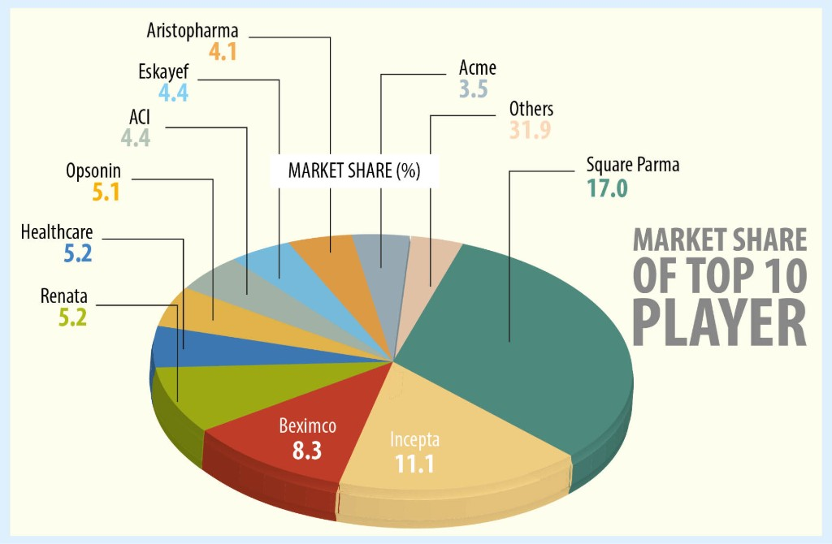

Figure: top ten pharmaceutical companies in market share

Expose Bangladesh currently exports drugs to about 86 countries and hopes to export to 140 countries in the next few years. According to the Export Promotion Bureau (EPB), the revenue of the pharmaceutical sector was around 542 million with an increase of more than 31% in the first month of the financial year 2018-19. In addition, the sector is expected to grow at an annual rate of 15% to 5.11 billion by 2023, with more investment by local companies seeking to gain a larger share of the global market.

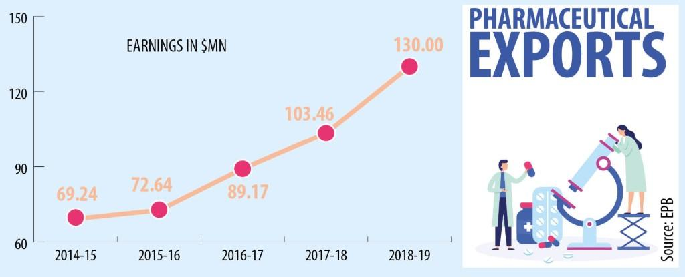
Figure 3: Pharmaceuticals Export & Export Growth
Chapter – 03
Company overview

3.1 Historical Background
Beximco Pharmaceuticals Limited is a leading manufacturer of pharmaceutical products and active pharmaceutical ingredients (APIs) based in Dhaka, Bangladesh and is a member of the Beximco group. Founded in the late 1970s, Beximco Pharma started out as a distributor, importing products from global multinational companies such as Bayer in Germany and Apocalypse in the US and selling them on the local market, which later became a license. Developed and distributed under Over the years, the company has grown steadily and today has become one of the country's leading exporters of drugs, winning the National Export Trophy (Gold) four times (04) times. According to global standards, the company's manufacturing facilities have been recognized by leading global regulators and have so far expanded its geographic profile on all continents. Beximco Pharma currently has a portfolio of more than 500 products covering all major benefit categories and has managed to differentiate itself by offering unique technology-based products. With an excellent workforce of about 3,000 people, the underlying principle on which it was founded was the same that "it makes our people cheaper by making advanced generic drugs." From the start, the company was very successful in generating ever-increasing demand for its products, which in turn legitimized local manufacturing. It completed registration in 1976 and began manufacturing and marketing licensed products from Bayer AG Germany and Apogean Inc. USA in 1980. After the first few years of struggle, it broke its foundations with the launch of its product in 1983. Beximco Pharma was listed on the Dhaka Stock Exchange (DSE) in 1985 as a limited liability company. The journey continues and after overcoming obstacles, challenges meet and the fact that currently in the process of transforming Beximco Pharma into it is resolved. It has now grown to become one of the leading pharmaceutical companies in the country, supplying about 10% of the country's total pharmaceutical needs. In the process, it was added to the Chittagong and London stock exchanges. Today, Beximco Pharma manufactures and markets its own branded generic drugs in the national and international markets for nearly all diseases from hypertension to diabetes, AIDS to cancer. It produces various forms of food in a wide range of world-class manufacturing facilities, including tablets, capsules, dry syrups, powders, creams, ointments, suppositories, anesthetic fluids in bulk, metered dose annealing, etc., with world-class high-quality standards. Compliance with the existing Organization (WHO) approved Good Manufacturing Practices (CGMP). Beximco Pharma also establishes contracts for major international brands from leading multinational companies. Beximco Pharma has a strong market focus and expects sustainable future growth by increasing business capabilities and developing better brands and product markets. In particular, the company wants to create strong export markets in the United States and Europe. To meet future demand, the company has invested more than 50-50 million to build a state-of-the-art manufacturing facility, which meets UK USFDA and MHRA standards. The new facility will also allow large pharmaceutical companies to enter into contracts, particularly with Europe and the United States.

3.2 Company profile of Beximco Pharmaceuticals Ltd
Corporate Headquarters: | 17 Dhanmondi R/A, Road No. 2  Dhaka 1205, Bangladesh.
Operational Headquarters: | 19 Dhanmondi R/A, Road No. 7  Dhaka 1205, Bangladesh.
Factory: | 126 Kathaldia, Tongi, Gazipur
Year of Establishment: | 1976
Commercial Production: | 1980
Status: | Public Limited Company
Business Lines: | Production and marketing of pharmaceutical products  Finished products and active drugs  Material (API)
Authorized Capital in Taka:  (According to annual report 2012) | 9,100 million
Paid-up Capital in Taka:  (According to annual report 2012) | 2,517 million
Net Turnover in Taka:  (According to annual report 2012) | 1,198 million
Stock Exchange Listing: | Dhaka, Chittagong.
Number of Employees: | 2,700
Overseas Offices & Associates: | UK, USA, Pakistan, Myanmar, Singapore, Kenya, Yemen, Nepal, Cezch Republic.
Export Markets: | Bhutan, Cambodia, Germany, Hong Kong, Iran, Iraq, Malaysia, Russia, South Korea, Srilanka, Thailand, Ukraine, Vietnam.

3.3 Mission
Beximco Pharma is committed to improving human health and well-being by providing cutting edge and affordable medicines that fully comply with world class standards. It continuously strives to improve its core competencies to eliminate unnecessary medical needs of patients and provide excellent results for its shareholders.
3.4 Vision
Beximco Pharma will become one of the most trusted, renowned and successful pharmaceutical companies in the region, with the aim of strengthening R&D capabilities, building partnerships and building a global presence.
3.5 Company objectives
Our goal is to carry out transparent business operations within a legal and social framework that aims to achieve the mission reflected in our vision.
3.6 Core values
Our core values define who we are. They help us make decisions and understand our individual and corporate aspirations

3.7 Commitment to Quality
Beximco Pharma adopts the best technology for every job to ensure the highest quality of its products.
3.8 Customer Satisfaction
It is committed to satisfying the needs of its customers, both internally and otherwise. The strength for them to realize their potential.
3.9 Accountability
It encourages focus on everything they do and adheres to the best practices. He is responsible for his own actions and responsibility to promote business reputation.
3.10 Corporate Social Responsibility
Actively participate in initiatives that benefit the community and contribute to the welfare of its people. The company is very careful in managing its operations with the utmost attention to safety and the environment.

3. 11 Key Milestones
Year | Milestones
2016-17 | Became the first Bangladeshi company to start exporting medicines to the US.  - Approved for two ANDAs (Sotalol tablets and Metformin ER tablets) by the US Food and Drug Administration (U.S. FDA).  - Developed by the company as the first foreign joint venture with a joint venture with BioCare Industry (M) Sdn Bhd based in Malaysia.  - Daclatasvir has been slightly licensed by the UN Patent Pool Company to produce Bristol-Myers Squibb hepatitis C vaccine.
2015-16 | GMP approved by U.S. FDA is the first Bangladesh company  - Announcement of the hepatitis C vaccine, Sovaldi and Harvoni  - Approved product approved by Health Canada as the first Bangladesh company  - Entered Gulf pharma market (Kuwait) as the first Bangladesh company  - Won National Export Trophy (Gold) for 5-time records
2014 | GMP certified by Taiwan Food & Drug Administration (TFDA) and Health Canada is the first Bangladesh company  - Exported drugs to Australia and Romania as the first Bangladesh company.
2013 | Has started out of ophthalmic products to Europe as the first Bangladesh company.
2012 | Announced Salbutamol HFA inhaler (Azmasol) in Singapore as the first Bangladesh company.
2011 | GMP certified by AGES, Austria (for European Union)
2010 | Enter the US market by obtaining the New Drug Application (ANDA)which is the only pharmaceutical company in Bangladesh.
2009 | GMP approved by ANVISA, Brazil as the first Bangladesh company
2008 | The first Bangladesh company is a GMP Accredited by the Drug Administration (TGA), Australia, and the Gulf Central Committee for Drug Registration, to the GCC state; Technology replaces Roche's ARV drug Saquinavir
2006 | The first CFC to provide HFA free air for the first time in Bangladesh
2005 | Only companies in Bangladesh are listed on the Alternative Stock Exchange (AIM) of the London Stock Exchange (LSE) by offering GDRs.
2003 | The first company to introduce ARV in Bangladesh
1993 | Russia became the first exporter of industrial products
1992 | Operations start with APIs
1985 | Names in the Dhaka Exchange
1983 | Solve one type of pattern
1980 | Started product development of Bayer AG, Germany and Upjohn Inc., USA, under contract agreement
1976 | Company involved
Table 1: Key Milestones of Beximco Pharmaceuticals Limited

3.12 Board and Management
Beximco Pharmaceuticals Ltd. is governed by the Board of Directors, the Board of Directors and the Executive Committee. Leaders have a responsibility to take responsibility. It has ten members including Chairman, A S F Rahman and Vice President, Salman F Rahman. The Five-member Executive is led by Mr. Osman Kaiser Chowdhury who is also on the Board of Directors. The Board of Directors is responsible for both the operation and operation of the company. The group is also responsible for approving finances, approving uses or changes, reviewing new plans, compliance and more. The team is led by Mr. Nazmul Hasan (MP), Managing Director (MD) who is in charge of all business management. This committee reviews and oversees day-to-day operations and reports job options to the Executive Committee.

The Board of Directors

A.S.F Rahman | Chairman
Salam F Rahman | Vice Chairman
Nazmul Hasan (MP) | Managing Director
Iqbal Ahmed | Director
Mohammad Abul Qasem | Director
Dr. Abdul Alim Khan | Director
Abu Bakar Siddiqur Rahman | Director
Advocate Ahsanul Karim | Director
Md. Asad Ullah, FCS | Company Secretary

The Executive Committee

Osman Kaiser Chowdhury | Member of the Board of Directors
Nazmul Hassan MP | Managing Director
Ali Nawaz | Chief Financial Officer
Afsar Uddin Ahmed | Director, Commercial

The Management Committee

Nazmul Hassan MP | Managing Director
Osman Kaiser Chowdhury | Member of the Board of Directors
Rabbur Reza | Chief Operating Officer
Ali Nawaz | Chief Financial Officer
Afsar Uddin Ahmed | Director, Commercial
Lutfur Rahman | Director, Manufacturing
Zakaria Seraj Chowdhury | Director, International Marketing
A R M Zahidur Rahman | Executive Director, Production
Shamim Momtaz | Executive Director, Manufacturing
Mohd. Tahir Siddique | Executive Director, Quality
Jamal Ahmed Choudhury  (Source: Annual Report of BPL -2012) | Executive Director, Accounts & Finance

3.13 Product
Beximco Pharma now produces more than 300 types of drugs available in more than 500 different formulations and detailed information on all major therapies including antibiotics, anesthetics, medications. Prevents diabetes, respiratory, cardiovascular, cardiovascular, cardiology, dermatology, gastritis and more. Neoceptin-R in its composition. More than ten of the BPL brands have annual sales in excess of BDT 100 million each.

Block Buster product

Napa | Bestselling drug in Bangladesh  The pharmaceutical market in terms of units.
Neoceptin-R | In terms of price, it is the best-selling medicine in the Bangladeshi pharmaceutical market.
Bextrum/Bextrum Gold | Emerged as the most praised and high  Dietary supplement sales in Bangladesh  Market in just one year.
Amdocal | Cardiovascular medicine sold the most in BD  Price terms.
Tofen | Oral anti-asthma drugs are selling the most in BD  Price terms.
Azmasol  (Source: Annual Report of BPL-2012) | The best-selling mastered dose annealer  Bangladesh in terms of price.

3.14 Position of Beximco Pharmaceutical Ltd. in overall Bangladeshi Pharmaceutical Industry
Ten companies have a market share of more than 60%, while there are 250 (registered and unnamed) companies operating in pharmaceuticals in Bangladesh. Of Bangladesh's top ten pharmaceutical companies, eight are regional companies, while only two are multinational corporations (MNC's). The top three local markets, such as Square, Incepta and Beximco Pharmaceuticals, share market share of approximately 37% to 37% of the total national pharmaceutical market.
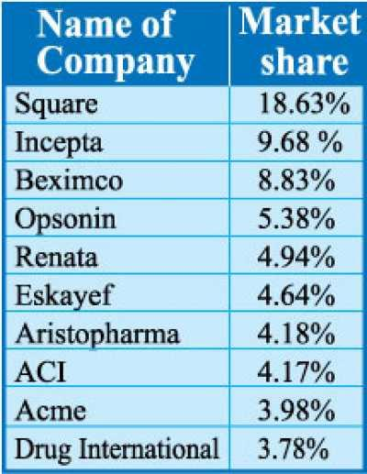

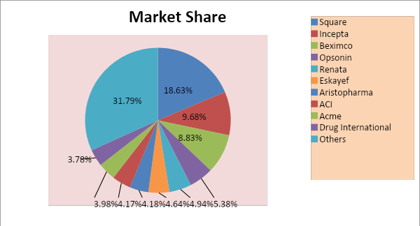

3.15 Organization Hierarchy
Above Beximco pharmaceutical company generally follow this hierarchy structure in their organization.

Executive Director

Manager
Deputy Manager
Assit. Manager
Sr. Officer

Finance and Accounts

Purchases Dept.
Senior Manager
Manager
Senior Officer
Officer

Chairman
Vice Chairman

Managing Director

Sales Dept

Officer

Marketing Dept.
Director

Sr.Manager
Manager
Deputy Manager
Sr. Officer

MR

GM

DGM
Sr. Sales Mag
RSM

ASM

Chief Financial Officer (CFO)

Chief Operating Officer (COO)

Human Resource Department
Sr. Manager
Manager
Sr. Officer
Officer

Core- HR

ADMIN
Manager

Assit Mang
Sr. Officer
Officer

Officer

Sr. Assit. Officer

Assit. Officer

3.16 Department of BPL and their activities
Beximco Pharmaceuticals Ltd.
Beximco Pharmaceuticals Limited is one of only four companies in Beximco Chemical Division which has a market cap of Rs. 2.453 billion during 2000.
In 1980, when BPL was first developed by Bayer AG, Germany started with a small manufacturing facility in the Tongi area of Dhaka. This includes after the United States. Currently, BPL represents 15% of the domestic business.
The 1990s marked a turning point. Not only did it meet 90% of domestic demand for two main commodities, ampicillin and amoxicillin, but has also begun to sell them in overseas markets, including Korea. South, Malaysia.

Departmentalization
BPL runs its business through extensive departmentalization as needed. This is for the special effects of the piece. As the leading pharmaceutical company in the country, it employs large numbers of people in various departments to grow its business. The following main departments coordinate the activities of GLP, BIL and PCL. Planning Department
- Purchasing department
- Sales department
- Department of Sales Education and Training
- Medical Services Department
- Company research and development department
- International Marketing and Chemicals Department
- MIS department
Department of Finance and Accounting
(Source: Knowledge Center, Library of Beximco Pharmaceuticals Ltd)

Planning Department
The planning department is committed to ensuring that all raw materials are available on the market within three months of meeting incidents or unpleasant conditions. Break down the annual sales forecast on a monthly basis based on the sales forecast from the CPM planning department and prepare a production, purchase and restocking plan. It also initiates negotiations for the purchase. This refers to purchasing a supplier quote
The Planning Department ensures the smooth running of the entire GLP. This has to do with the following:
- The production planning and
- Inventory planning
- Raw material procurement.

Purchase Department
The procurement department deals with all purchases of BPL. In addition to purchases, it also keeps track of the company's costs. The department works in coordination with the planning department for negotiations and pricing.

Sales Department

The commercial department has been completely separated from the marketing department to suit the management of today's business world. Coordinates forecasts in coordination with the marketing department and it is the responsibility of the sales department to determine the estimated annual sales volume. The medical representative is the most distant organizational unit. They will create demand for products. They are trained before being sent to the field.

Training Department

The training department is to provide training to the medical representatives of the company. It is important to improve the quality of employment-related work. The training curriculum varies from group to group. The department basically offers 4 types of training programs:

- Induction Training Program (for MRs)
- Supervision Management Program (for FS)
- Advanced supervision management
- Refresher programs (for everyone involved in sales based on how and when).

MIS Department
The MIS department is the department that deals with the total automation of BPL. It supports company and factory hardware and network. Maintain regularity of automation and keep pace with global IT. The MIS department also maintains a radio link between the factory and the headquarters.
Although previously managed separately, the software department was recently merged with the MIS department. This software section is intended to target software solutions based on organizational requirements. It also supports the needs of other companies in the chemical division. MIS facilities are available 24 hours a day.
MSD
MSD stands for Medical Services Department. It is a unique department in the sector as BPL was created for the first time to create easy relationships with the end users of pharmaceutical companies, through professional communication with doctors. It organizes seminars in different parts of the country on various topics such as diseases and their treatment. Publish a special quarterly "Medical Newsletter" and send free current news to registered doctors. The newsletter contains important recent medical articles. It also provides news gathered from the Internet and provides free navigation for doctors. In this way it helps the medical community as well as enhancing the image of the external company.

Business Research & Development Department

The sector was started with the aim of working on market development both domestically and internationally. It helps in product development and marketing of new products. The product development process is as follows:

Market Research
Molecular
Structure
Development Sample
Analytical Method Dev.
Stability
Profile
Improving quality assurance (at every stage of the factory) and quality control is another concern of this department. It recommends SOP (Standard Operating Guidelines), which is the largest part of GMP (Good Manufacturing Practice). It is worth mentioning that in practice BPL adheres to the highest standards of quality as recommended by the WHO. Procurement and material management coordination are also among the responsibilities of this department

International Marketing
The department is involved in the international promotion and marketing of BLP finished goods and basic chemicals. It analyzes national analysis in terms of its health, economic, market and growth conditions, legal restrictions on entering the market with products, etc. To find out the feasibility of marketing a product. So far it has 18 export shops.

Multimedia Department

BPL is the only pharmaceutical company with multiple tests. This department assisted in the promotion of BPL. Create medical videos for doctors. Colors, sizes, graphics, writing, etc. Some texts are carefully selected to easily attract the target audience. He has set up some kiosks set up in some hospitals to teach and educate students. The department also provides audio equipment to other departments and helps to edit notices.

Finance and Accounts Department
There are three sections in this department.

- Treasury section
- Accounts section
- Cost and budget section

Banks with banks and debtors. He is also in charge of the budget and administration.

The Accounts section is there to manage all data and transactions. It is automated with the help of software called MAPX.

The Cost and Finance section describes costs and prepares investments. Section H estimates the value and value of the product. The annual budget begins in October. The budget is monitored quarterly (internally) and semi-annually (by top management). It compares and displays budgets and actual sales and spending.

Chapter- 04
Theoretical Aspects

4.1 Financial performance analysis
An evaluation of a company’s financial performance is essential to the success of an organization. There is usually a translation of the balance sheet and a translation of the income statement. Using these two resources, one can perform comparative measurements and different measurement models which are important tools for assessing a company’s financial performance. Sources of data for financial ratios
Statement data is based on accounting procedures and accounting standards by the organization. Derived from the values used to calculate the financial ratio
4.2 Balance sheet
In a financial statement, a statement or financial statement shows the financial position of an organization, business venture or company. Assets, responsibilities and panel assets are listed on a specific day, such as the end of the investment year. A balance sheet is a statement that applies to the same area during the business year. The company’s balance sheet consists of three sections: capital, accountability and equity.
4.3 Income statement
A statement of income, a statement of income and loss, a statement of income, a statement of employment or a statement of employment are also statement of income. a company statement that shows that the income is converted into actual income. It represents the income for a period, and the costs and expenses associated with these taxes, including taxes and duties. The purpose of the income statement is to inform executives and investors whether a company is earning or losing money over time Learn.
4.4 Ratio Analysis
For example, is a way to translate companies' financial information. The purpose of the benchmark is to compare the risks of a business venture with the financial information of a company venture, an analysis of earnings, a measure of revenue.

- Liquidity Ratio
Math can easily measure a company’s ability to meet its obligations, its ability to meet its obligations, and when it becomes a payment. This model makes a correlation between cash and other current assets and current expenses. Usually use the current symbol.

- Quick Ratio

- Activity Ratio
Activity ratio is used to assess eligibility, which the company manages and uses its assets. This ratio is also called the ratio of turnover because it indicates the rate at which assets change or sales take place. An appropriate balance between assets and sales is usually reflected in its assets.
The Activity ratio we can satisfy on the three ratios, those are:
- Receivable turnover.
- Inventory turnover
- Assets turnover

- Profitability Ratio
The comparison results represent the organization’s ability to define foreign exchange sales at various levels of measurement. This percentage includes income after considering all income and expenses, including interest and non-performing taxes. This percentage describes the company's ability to avoid difficult situations, which can occur in many areas, such as falling prices, rising coasts and declining sales. The value proposition we can guarantee about five comparisons, these are below Gross Profit Margin Ratio.

- Net profit Margin Ratio
- Return on Investment/ Asset Ratio
- Return on Equity Ratio

- Debt Coverage Ratio
The loan rate is calculated to determine the long-term financial status of the company. This ratio indicates the mixing of funds provided by owners and lenders, the way assets are financed, the threshold of earnings that are raised or benefited from the use of debt and ultimately the limited stakeholders on the company. To the extent of control.

The Debt-coverage ratio we can satisfy on the three ratios, those are:

- Debt to total assets.
- Time interest earned.

- Market value ratio
The final ratio is the market value ratio. This is also called the share ownership ratio. He referred to the stockholders in the analysis of current and future investments in a company. In this ratio, shareholders are interested in some variables that affect the value of their value. So that the shareholder can analyze the possible future value of the stock market.
There is a ratio under this ratio.

- Earnings per Share (EPS) ratio

Chapter – 05
Financial Performance Analysis and Interpretation of Beximco Pharmaceuticals Ltd.

5.1 Current Ratio
The current measurement is calculated by dividing the current product by the current load. If a company’s assets double its current defenses, then the company is generally considered short-term energy. If the current liabilities exceed the current assets, then the company may have trouble fulfilling its short-term responsibilities.

Current Ratio = Current assets /Current liabilities

Year | 2015 | 2016 | 2017 | 2018 | 2019
Current ratio | 1.79 | 2.86 | 2.68 | 1.26 | 1.04

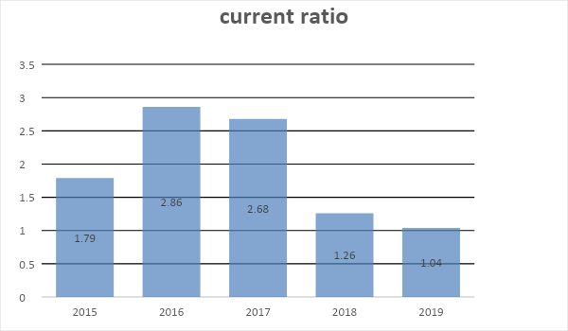
Analysis: The current ratio measures the company’s ability to pay off its current liability. Here we can see that current ratio was highest in 2016 with compare in preceding years. From this graph, we can assume that Beximco has more cash than liabilities. They have good current ratio in 2016 and 2017. Therefore, in 2016 they have 2.86 times more than liabilities and in 2017 it is 2.68 times. In 2015 there are 1.79taka current asset against 1-taka liability. It has increased in 2016 as 2.86 and in 2017 it decreased and more decreased which means it is not better for the company. In 2019 but not as low as it was in 2015. Further, we can analysis its ability to pay liability with industry average, which is good in 2016. The company was doing better that year. From the comparison, we can say that Beximco Pharma is doing well in these previous consecutive years.
5.2 Quick Ratio
Measurement of the company's performance and ability to meet its responsibilities. Rapid symbols, commonly known as acid-base liquids, are obtained by calculating the composition of available resources and subsequently dividing by current function. Rifle gauges are considered to be a sign of a financial company or a weak force (more numbers mean stronger, less means weaker).
Quick Ratio= (Current Assets-Inventory)/ Current Liabilities
year | 2015 | 2016 | 2017 | 2018 | 2019
Quick ratio | 1.25 | 1.15 | 1.94 | 1.66 | 0.76

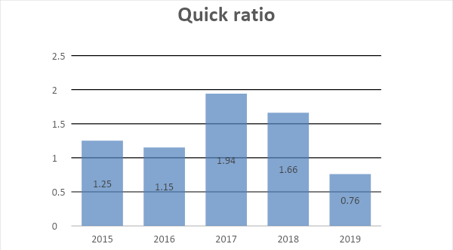
Analysis: As from the graph, we can assume that Beximco had good position in 2017 and relatively good position in 2018 in terms of the ratio. The graphical presentation shows the company’s Acid test ratio. In 2015, there is 0.988-taka current asset except inventories against 1-taka liability. If we compare with other years, it was 1.288 in 2016 and was higher in 2017. However, it declined in 2019 but was better than 2015. We can say that it doing better. The company has increased its liquid assets to pay its liability. If we compare with the industry average, The Beximco had good position in 2016 to 2019; the industry average was low in 2019. The Beximco is doing well than its competitors.

5.3 Receivable Turnover
Receivable Business Ratio Indicates the Receivable Rate. This indicates that the outline of the recipients wanted to continue the company's sales phase. These are just some of the goal setting shareware that you can use.

Receivable turnover in days = Account Receivable x 360/Sales

year | 2015 | 2016 | 2017 | 2018 | 2019
Average collection period | 43 | 41.43 | 28.03 | 45 | 51

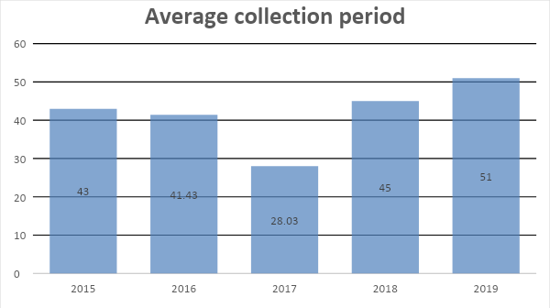
Analysis: The graphical presentation shows the company’s average collection period. In 2019, the ratio was higher than other years. Relatively low in 2017. In 2017, the company took 28.03 days for its average collection, which is better than the industry average. However, in other years the company’s average was good than the industry average. Therefore, it indicates that Beximco pharmaceuticals is able to collect its receivables easily.

Receivable turnover = 360 days / Average collection Period
year | 2015 | 2016 | 2017 | 2018 | 2019
Receivable turnover | 8.47 | 8.81 | 13.01 | 8.06 | 7.08

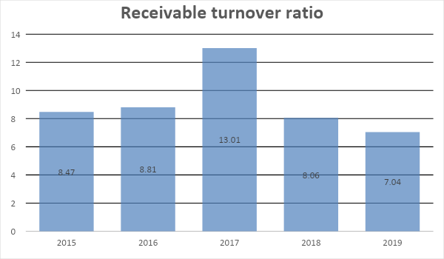
Analysis: In 2017, the ratio was higher. Graphical presentation of the payment company. In 2017, the company collected 13.01 times the number of borrowers by year, which is better than the industry average. It has refused to do business in the next years, which are 2018 and 2019. That indicates that the company is unable to collect its debts against the sale. Moreover, we can identify its acceptance. This is not as good as the average business for companies.

5.4 Inventory Turnover
The ease of application of companies can be determined by this percentage. His comparison shows how many times it takes to change the product of sales of a model. The result of the success of the company's products.
Inventory Turnover = Cost of goods sold/ Avg. inventory
year | 2015 | 2016 | 2017 | 2018 | 2019
Inventory turnover ratio | 2.488 | 2.62 | 4.103 | 2.66 | 2.28

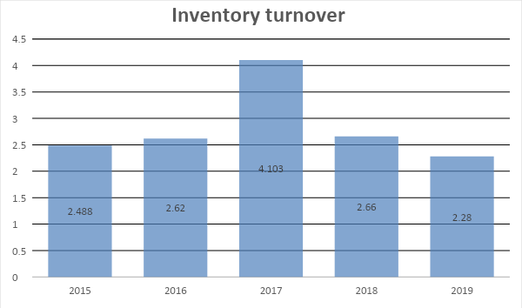

Analysis: The graphical presentation shows the company’s inventories turnover ratio. The graph shows that the ratio is higher in 2017. In 2017, the company can collect 4.103 times the inventories through the year. It is decline slowly. Compared with the industry average, business and competitors it is not well.
5.5 Assets Turnover
Investment portfolio is a measure of financial performance that measures the performance of a company using its own assets in generating revenue or sales revenue.
The exchange rate of an asset indicates the ability of a company to sell its assets correctly. Unnecessary investments must be made by companies for expensive financing. By acquiring Skyscraping Turnover, one of the companies reduces the cost and increases the final value of the property. Assets Turnover = Sales / Average Total Assets
Average Total Assets = (Beginning Total Assets + Ending Total Assets)/2

Year | 2015 | 2016 | 2017 | 2018 | 2019
Asset turnover | 0.93 | 0.43 | 0.66 | 0.48 | 0.24

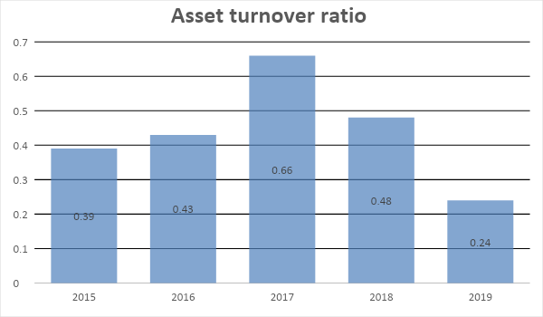
Analysis: From the graphical presentation, total assets turnover is increasing in frequent years. In 2017, the ratio was higher. In 2017, it was 0.66 and relatively declined after that. However, the company is efficient to generate revenue comparing to industry average.

5.6 Gross & Profit Margin
Profit margins provide information on the ratio of sales to the success rate of a company. The ratio seller gives you an idea of the success of the sale after the price of the goods has gone down.
It can be used as an indicator of good organization of manufacturing action and there is a relationship between manufacture and sale of goods.

Gross Profit margin = Gross Profit / Sales*100

Year | 2015 | 2016 | 2017 | 2018 | 2019
Gross Profit margin | 45.54% | 46.27% | 46.09% | 46.32% | 46.74%

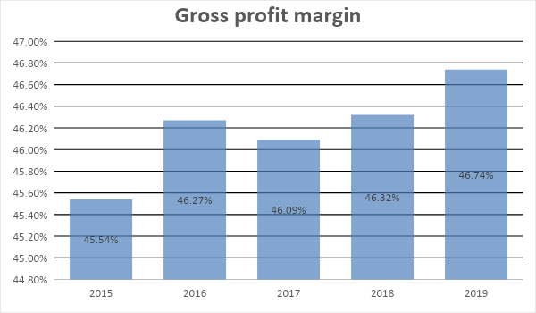

Analysis: Interest income is a profit margin that compares the profitability of the business over the profit for the sale. This percentage measures how a company sells its products or services. From the diagrams, from 2016, to 2019, the comparisons are generally almost identical but with differences in content. Total earnings are in the average cost and the difference is not too much in the year, which shows that the company is half profitable to generate revenue, but according to Medium-sized businesses and competing companies perform better.

5.7 Net Profit Margin
Profit margin measures the percentage of each sale after deduction, including taxes. The higher the fixed income the better.
Net Profit Margin=Net profit after tax/operating income
Year | 2015 | 2016 | 2017 | 2018 | 2019
NET PROFIT MARGIN | 13.64% | 15.07% | 14.71% | 14.36% | 14.72%

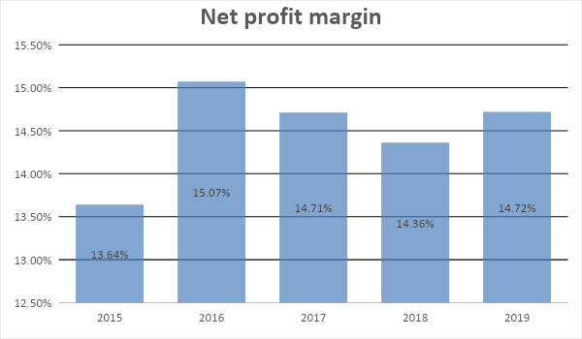
Analysis: From the diagram, the profit margin is in the average cost and the difference is not more than a year, which shows that the company is able to generate revenue, but as a medium and competitive market, companies can do better. Based on this comparison in 2016, the business performance was good.

5.8 Return on Investment/ Asset Ratio
Calculate the success of a company by taking advantage of it to gain self-control over the financing of these assets. As a result, the financing process is fragmented by work and tricks are invested.

Return on Investment = Net Profit after Taxes / Average Total Assets*100

Year | 2015 | 2016 | 2017 | 2018 | 2019
RETURN ON ASSETS (ROA) | 5.41% | 6.53% | 9.80% | 6.83% | 6.71%

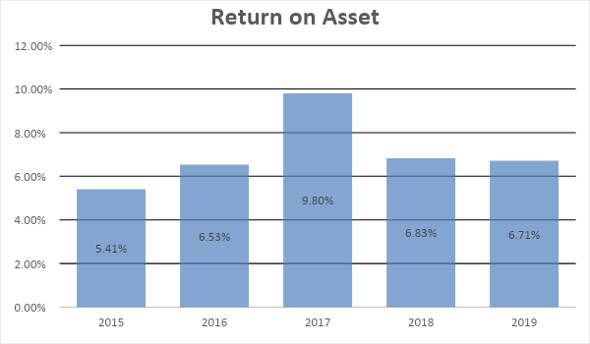

5.9 Return on Equity (ROE)
The return on equity measures the return on investment. In general, higher returns are better for owners.
Return on Equity=Net Profit after Tax/ Shareholders equity
Year | 2015 | 2016 | 2017 | 2018 | 2019
RETURN ON EQUITY (ROE | 7.51% | 9.01% | 13.04% | 9.25% | 9.80%

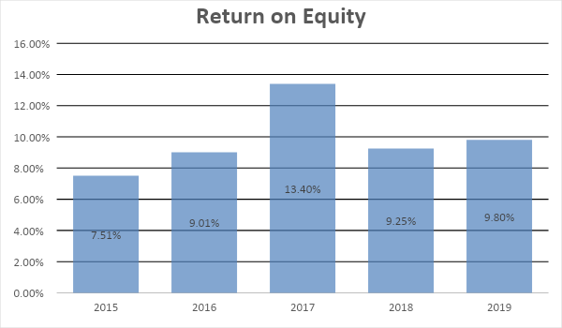

Analysis: From the graphical presentation, return on common equity was high in 2017 but it declined in 2018. There is a deviation that indicates the company is not performing good to generate revenue against equity. But as a medium-sized business and competitors, companies are not doing well and operating costs are high. In 2017, ROE was good for the industry.

5.10 Debt to Asset Ratio

Debt settlement compares how much of a company's total income comes from a loan.

Debt to total asset = Total Liabilities / Total Asset

Year | 2015 | 2016 | 2017 | 2018 | 2019
Debt to total asset | .359 | .366 | .338 | .352 | .357

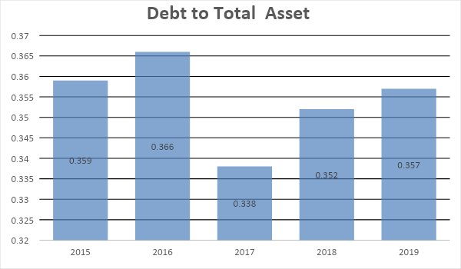

Analysis: The debt to total asset ratio is a coverage or solvency ratio. It measures the percentage of assets and compares the total debt to asset needed to pay liquidity to its long-term debt. The result was almost same.

5.11 Time interest earned
This ratio indicates the security margin between financial obligations and net income thus providing an indication of the protection available to lenders. Failure to meet this obligation may result in legal action by the company's creditors, which may result in bankruptcy.

Time interest earned (TIE) = Profit before interest and Tax / Interest charged

Year | 2015 | 2016 | 2017 | 2018 | 2019
Times interest earned | 1.55 | 2.76 | 2.76 | 3.46 | 3.89

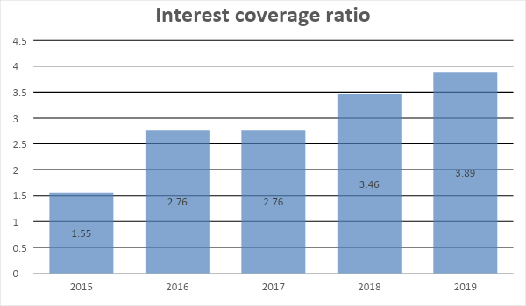
Analysis: The interest rate rating measures a company's ability to repay its debts on time. It calculates companies' ability to afford the interest on debt. The more the ratio, the more stable is the ability to pay off its debts, and the less financial risk is maintained in 2019 the result was highest.
5.12 Earnings per share (EPS) ratio
This ratio indicates the security margin between financial obligations and net income, thus providing protection to creditors. Failure to meet this obligation may result in legal action by the company's creditors, which may result in bankruptcy.

Price earnings ratio = Market price of stock / Earning per share

Year | 2015 |  | 2016 | 2017 | 2018 |  | 2019
Market price of stock | 155.80 |  | 135.10 | 93.60 | 55.90 |  | 47.20
EPS |  | 3.50 | 4.18 | 3.93 |  | 3.77 | 4.01
Price earnings ratio |  | 44.51 | 32.32 | 23.82 |  | 14.83 | 11.77

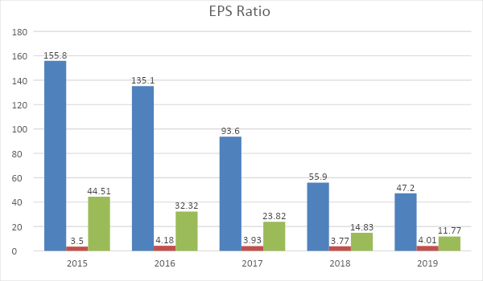
Analysis: As the organization developed well it got a share increased one day. We see that after 215 EPS increases; in 2019 it reaches Tk 4.01. It is a good omen for the company's reputation and investors will be willing to invest in this company. But at the same time the P / E ratio is declining. This is a bad sign for Beximco. So companies need to know their P / E ratio.

5.13 SWOT ANALYSIS
Strengths
- BPL currently manufactures about 452 products with different dosage forms under different brand names. Many of its products enjoy the status of brands leaders in the market.
- Sales of the formulation products increased by 2.55% and export by 6.65%.
- Beximco Pharma has successfully captured the local pharmaceutical market and enjoys a commending share of 9% of the entire market.
- BPL believes that the use of different type of information system.
- BPL using different type of technology for move their company to carrying innovation forward.

Weakness
- 1BPL has a narrower product line and number of products than its principle competitor in the market.
- The company produces so many product variations for that reason some time feels confuse what to suggest BPL product.
- BPLs distribution network is not working as good as its competitor in the urban area. Opsonin, Acme is doing well in this area than BPL.
- Warehouse management system is not well so there are always they face store problem for storage problem.

Opportunities
- The WTO agreement extended in 2016 instead of 2005 for the LDC only in pharmaceutical company.
- The company start to produces kind of injectables comparing. The injectables market is a large one so they can easily compete their rival companies.
- Access to nine new global markets in Asia, the Middle East, the Pacific Islands, Africa and Central America. List 107 new products in foreign market.
- In Bangladesh pharmacies are considered to be growing companies. So there are a lot of opportunities in this field.
- New dimensions of therapies are discovered it will create extra chances expend the business.

Threats
- In Bangladesh the copyright act is not applied by the government appropriately which creates continually threats for the company as its competitors easily copy its products.
- Because of political unrest and poor infrastructure facilities BPL faces problems in Local marketing.
- BPL also facing treats forms its Indian counterparts as they are offering their products at lower price than it.
- After 2015 they face lot of challenge for TRIPS purpose.
- Overall sales declined by 2.84%.

Chapter – 06

Findings
As the objective of my paper is to make a comment on the Financial performance analysis of Beximco Pharmaceuticals limited, I try my best to collect data for my analysis. After analyzing the performance of Beximco Pharmaceuticals limited, reveals the following major findings:
- Beximco slightly lose its capacity to pay their current obligation by using their current assets.
- Beximco’s current assets are greater than their current liabilities. it indicates, Beximco has positive sign to maintain liquidity.
- In 2017 the company took 28.03 days for its average collection but in 2019 the average collection period (51 days) was higher than others years.
- The receivable turnover ratio of 2019 was not good enough compared to 2017 and it found that Beximco pharmaceutical limited might not done well.
- Efficiently, Beximco generate revenue compare to industry average.
- Inventory turnover is decline slowly which may results in increase in sales. it’s a positive sign.
- In 2019 gross profit margin was 46.74% means that 46.76 of total revenue become profit. It indicates efficient processes in a company
- Slightly Beximco is able to effectively controls its cost by maintain efficient management
- Their return on investment is increasing day by day which indicates, Beximco efficiently using its assets base to generate sales.
- Compare with its own, there is a deviation that indicate the company is not performing good to generate revenue against equity
- Its debt to assets ratio indicates a stronger financial structure.
- Its ability to afford the interest on debt is more stable since 2016.

Recommendation

It is not easy to suggest some additional tips to improve the performance of an organization like BPL. Although I was trying to find some flaws in the work and so on. From what I can see, I would like to make the following recommendations:
- BPL should utilize their assets properly by investing them in more profitable projects as their liquidity is higher than actual need.
- They should increase their dividend payout ratio, to maximize the wealth of shareholders.
- They should be careful about the market price of share, because the price of share would decrease.
- BPL should make a proper budget plan for further investment.
- BPL needs to strike a healthy balance between debt and equity; too much debt financing would mean a high financial risk, while too little debt financing would mean that the company may have difficulty raising sufficient funds.
- BPL needs to be more efficient in collecting receivables. It should review its credit policy and make any necessary adjustments to encourage prompt payment.
- Further improve its return on investment (ROE), the company needs to take advantage of profitable investment opportunities and be more efficient at managing its expenses.
- Though BPL has qualified employee in Finance and Accounting department, but the organization should recruit some new employee to run this department smoothly.
- They should minimize their financing expenses to make higher net profit.
- They should minimize the average collection period and maximize the average payable period.

Conclusion
In Bangladesh, the pharmaceutical sector is a highly developed high-tech sector that is contributing to the economies of countries. The pharmaceutical industry is one of the fastest growing and most intelligent industries in Bangladesh. There are about 26,265 licensed pharmaceutical companies operating in Bangladesh pharmaceutical industry. The market is very competitive. BPL has achieved great success in gaining the trust and confidence of physicians and patients across the country.
While there is no doubt that Beximco Pharma is a venture capital firm in the Bangladesh pharmaceutical industry, it rarely lacks some financial and accounting facilities. Because the finances are not good enough to compare the companies available. In this case, they have to be careful about the cost. There, non-productive assets should be invested in the productive sector and its liability should be minimized. The report assesses BPL's past, current and expected performance, as well as comparative analysis of relevant competitors such as Square Pharmaceuticals Limited. My focus is on getting organizations to evaluate their current operations, evaluate the state of the economy, and decide what they want to do. I believe Beximco Pharma will one day of the solar galaxy.

Reference:
- Annual report of Beximco Pharmaceuticals Limited (2015-2019)
- Bangladesh Association of Pharmaceutical Industries
- Newspaper, Journal, Magazine
- World Pharmaceutical Association
- Fundamentals of Financial Management, by Brigham and Houston
Website:
- http//www.beximco-pharma.com
- http://www.bpl.com.bd/financial_statement
- http//www.pharmaceutical-industry.info
- http://ims-global.com
- http://www.dse.com

