Android Application For Healthcare Services

by
Shahriar Rahman Shihab
ID: 171-15-1164

This Report Presented in Partial Fulfillment of the Requirements for the Degree of Bachelor of Science in Computer Science and Engineering

Supervised By

Dr. S. M. Aminul Haque
Associate Professor
Department of CSE
Daffodil International University

Co-Supervised By

Md. Reduanul Haque
Senior Lecturer
Department of CSE
Daffodil International University



DAFFODIL INTERNATIONAL UNIVERSITY
Dhaka, Bangladesh
05 DECEMBER 2020

APPROVAL

This Internship titled “Android Application For Healthcare Services”, is done by Shahriar Rahman Shihab ID: 171-15-1164 to the Department of Computer Science and Engineering, Daffodil International University, has been accepted as satisfactory for the partial fulfillment of the requirements for the degree of B.Sc. in Computer Science and Engineering and approved as to its style and contents. The presentation has been held on 15 October 2020.

Board of Examiners

Dr. Syed Akhter Hossain Chairman
Professor and Head
Department of CSE
Faculty of Science & Information Technology
Daffodil International University

Dr. S. M. Aminul Haque Internal Examiner
Associate Professor
Department of CSE
Faculty of Science & Information Technology
Daffodil International University

Md. Reduanul Haque Internal Examiner
Senior Lecturer
Department of CSE
Faculty of Science & Information Technology
Daffodil International University

Mr. Name External Examiner
Designation
Department of CSE
name University

DeclaratioN

We thusly declare that, this internship has been done by us under the supervision of DR. S. M. Aminul Haque, Associate Professor, Department of CSE Daffodil International University. I also declare that neither this internship nor any part of this internship has been submitted elsewhere for award of any degree or diploma.

Supervised by:

Dr. S. M. Aminul Haque
Associate Professor
Department of CSE
Daffodil International University

Co-Supervised by:

Md. Reduanul Haque
Senior Lecturer
Department of CSE
Daffodil International University

Submitted by:

Shahriar Rahman Shihab
ID: 171-15-1164
Department of CSE
Daffodil International University

ACKNOWLEDGEMENT

First I express my heartiest thanks and gratefulness to almighty God for His divine blessing makes us possible to complete the final year internship successfully.

I really grateful and wish my profound my indebtedness to Dr. S. M. Aminul Haque, Associate Professor, Department of CSE Daffodil International University, Dhaka. Deep Knowledge & keen interest of our supervisor in the field of “Android” to carry out this project. His endless patience ,scholarly guidance ,continual encouragement , constant and energetic supervision, constructive criticism , valuable advice ,reading many inferior draft and correcting them at all stage have made it possible to complete this project.

We would like to express our heartiest gratitude to Dr. Sayed Akhter Hossain, Professor, and Head, Department of CSE, for his kind help to finish my internship and also to other faculty member and the staff of CSE department of Daffodil International University.

I would like to thank my entire course mate in Daffodil International University, who took part in this discuss while completing the course work.

Finally, i must acknowledge with due respect the constant support and patients of our parents.

Abstract

The primary goal of this internship were, get flavor of the industry level android application development experience and learning the application architecture. Individual programming language are used to creating this type of application. For User Interface(UI) design used .xml and logic are written in java. And for data storing purpose used MySQL, SQLite, Room. Some architecture component that I learned this internship are ViewModel, LiveData and Room. There are likewise other programming language that are utilized to create dynamic elements of application. Mobile application can be used in anywhere in the world. These application makes our life more easier. PlexusD gives me the opportunity to learn these things and it was a great experience for me which will help me a lot to built a successful carrier. In this report, I will described my all the experience that I catch of this internship period.

TABLE OF CONTENTS

CONTENTS PAGE NO
Board of examiners ii
Declaration iii
Acknowledgement iv
Abstract v
List of Figures viii
List of Tables x

CHAPTER
CHAPTER 1: INTRODUCTION 1-2
  - Introduction 1
  - Motivation 1
  - Internship Objectives 1
  - Introduction to the Company 2
  - Report Layout 2

CHAPTER 2: ORGANIZATION 3-5
2.1 Introduction 3
2.2 Product and Market Situation 3
2.3 Target Group 4
2.4 SWOT Analysis 4
2.5 Organizational Structure 5

CHAPTER 3: TASKS, PROJECTS AND ACTIVITIES 6-30
3.1 Project Task and Activities 6
3.2 Challenges 30

CHAPTER 4: COMPETENCIES AND SMART PLAN 31
4.1 Competencies Earned 31
4.2 Smart Plan 31

CHAPTER 5: CONCLUSION AND FUTURE CAREER 32
5.1 Discussion and Conclusion 32
5.2 Scope for Further Career 32

APPENDICES
APPENDIX A: Internship Reflection 33

REFERENCES 34

LIST OF FIGURES
FIGURES | PAGE NO
Figure 2.1: Organizational Structure | 5
Figure 3.1: Main layout(blank) in medicine alert application | 7
Figure 3.2: Pup-up dialog(blank) in medicine alert application | 7
Figure 3.3: Pup-up dialog(filled) in medicine alert application | 8
Figure 3.4: Main layout(filled) in medicine alert application | 9
Figure 3.5: Display notification in medicine alert application | 9
Figure 3.6: Main layout(blank) in appointment reminder application | 11
Figure 3.7: Date picker dialog in appointment reminder application | 12
Figure 3.8: Time picker dialog in appointment reminder application | 12
Figure 3.9: Main layout(filled) in appointment reminder application | 13
Figure 3.10: Display notification in appointment reminder application | 13
Figure 3.11: Main layout(re-open) in appointment reminder application | 14
Figure 3.12: Main layout in CRUD application | 16
Figure 3.13: Insert operation in CRUD application | 16
Figure 3.14: View stored data in CRUD application | 17
Figure 3.15: Update operation in CRUD application | 17
Figure 3.16: Before and After Update operation in CRUD application | 18
Figure 3.17: Delete operation in CRUD application | 18
Figure 3.18: After Delete operation in CRUD application | 19
Figure 3.19: Main activity(blank) in Note application | 20
Figure 3.20: Insert activity in Note application | 21
Figure 3.21: Main activity(filled) in Note application | 21
Figure 3.22: Update activity in Note application | 22
Figure 3.23: Before and After updating in Note application | 22
Figure 3.24: Before and After deleting in Note application | 23
Figure 3.25: Login activity(blank) in User authentication application | 24
Figure 3.26: Register activity in User authentication application | 25
Figure 3.27: Login activity(filled) in User authentication application | 25
Figure 3.28: Profile activity in User authentication application | 26
Figure 3.29: Main activity(blank) in Widget application | 27
Figure 3.30: Insert activity in Widget application | 28
Figure 3.31: Main activity(filled) in Widget application | 28
Figure 3.32: Homescreen view in Widget application | 29

LIST OF TABLES

TABLES | PAGE NO
Table 3.1: Database in medicine alert application | 10
Table 3.2: Database in appointment reminder application | 14
Table 3.3: Database in CRUD application | 19
Table 3.4: Database in Note application | 23
Table 3.5: Database in User authentication application | 26
Table 3.6: Database view in Widget application | 29

CHAPTER 1
INTRODUCTION
  - Introduction
Internship is a platform from where I learned a lot of things in a limited period of time. This internship gives me a flavor about the real workplace. I learned how to face real life projects and the approaches how to solve them. This knowledge will help me to build a successful professional career in my future workplace. I learned a lot of programming and theoretical things from my university, but this internship helped me to learned how these knowledge apply to solved a real life problem. I learned a lot about Object-oriented programming(OOP) and mobile application design and development from my university, but this internship gives me the way how to implement them in real life. From this internship I learned about android architecture component and also learned how to apply them in application. Here, I described my activeness from my internship.

  - Motivation

- Increase the working ability in under pressure.
- Get guidance from experts about my skills.
- This will improve my communication skill.
- To get a sense for industry level working.
- Better understanding about my role and learning new things about industry level working that I didn't know before.

  - Internship Objectives

- Gaining additional experience about the organization strategy.
- Improve my application development knowledge and communication skills.
- To gain experience in team based work with professional environment.
- Taking note of challenges when developing a real life mobile application.
- To learn how to solve the problems that arise during development.
  - Introduction to the Company
PlexusD is a health tech company which was set up in 2017. It provides healthcare service by using mobile application and website. It connect doctors and patients by using mobile application or website and provide hassle free healthcare services. Also created a organized, effective and efficient environment for both the doctors and patients providing health services. Patients can taking their primary treatment with general physician or specialist doctor from anywhere anytime using PlexusD mobile application. The patients will get the e-prescription and diagnosis report from physician/doctors by this mobile application anywhere anytime.
They always try to give obstacle free healthcare services and reduce the gap between doctors and patients. As this, PlexusD continuously trying to add new feature in application for serving better services. And always trying to develop new mobile application for healthcare section.

  - Report Layout
Here I describe about my work that I already done my internship period. Here I express my whole work through different chapters. At the beginning, I described introduction, motivation, objectives and briefly describe about company. After that, I tried to narrate about the organization, product and market situation and organization structure. Then I describe my all work that I did in my internship period and narrate the challenges that I faced. I have also discuss about my plan and scope about my future career.

CHAPTER 2
ORGANIZATION
2.1 Introduction
I learned a lot of things from my university during this 4 year. I have completed lot of courses from my university. From these courses I have realized that android mobile application design and development is the perfect choice for me. I learned the basic of programming and how to design and development android mobile application. Then PlexusD gives me the opportunity to elaborate my knowledge about android mobile application development. Here I learned how to how to solve real life projects. From there I have learned about offline notification system, app widget, architecture component and so on.
Now I can understand how to solve real life projects. That’s why I like to thank my university and PlexusD.

2.2 Product and Market Situation
Everyday smartphone user growing rapidly. As this, increasing the demand of mobile application also high day by day. We will get and access million of service within short period of time by using these mobile application. Android is one of the top best operating system and its app store is really giant, this is why I chose it. It is very difficult to find a section that has no android application. The revenue generated by android app has skyrocketed. In and every moment it increases. In android, some monetization models are created rapid popularity in the business world. Recently some statics show that the market of the mobile application and revenue will grow higher and higher.

2.3 Target Group
Android gives us one of the largest application store. This app store has many categories for applications. User can choose their application from app store as per their app category. Also has some age based target group in this store. In my internship, I working with a health tech company. They mainly develop health related mobile application. The main target audience are patients and doctors of this type of mobile application. But these app provide some basic medical guideline and also provide some general guideline for general disease like fever. And some app contains question answering system direct to doctor. So all of the people can use this type of mobile application.

2.4 SWOT Analysis
Strengths  - Skilled developer  - Innovative product and service  - Rich quality of services  - User centric design and development | Weakness  - Poor marketing  - Low research ability  - Latest trends knowledge and service  - Less developer team
Opportunities  - Fast quality marketing  - Increases research ability  - Work with trending technology  - Increase developer team | Threats  - Less budget  - Competitive market situation  - Security  - Pricing

2.5 Organizational Structure
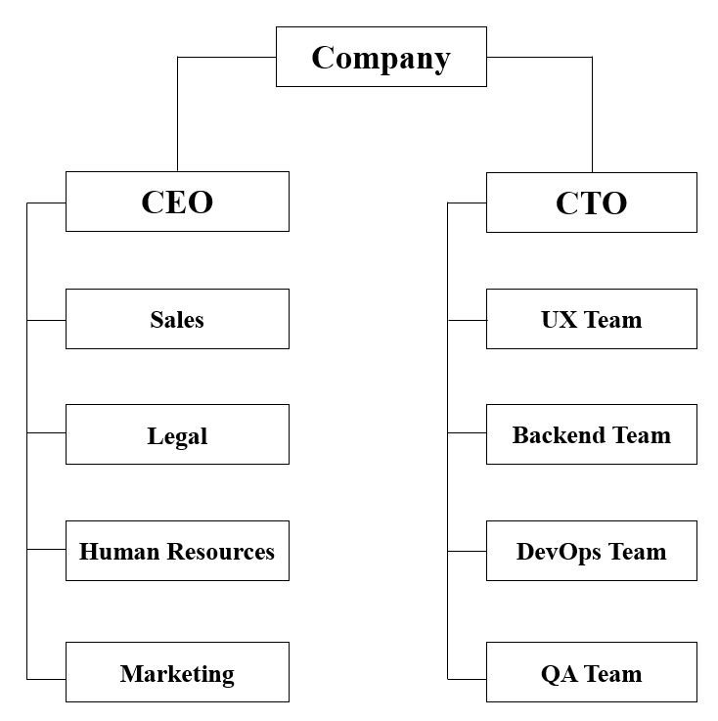
Figure 2.1: Organizational Structure

CHAPTER 3
TASKS, PROJECTS AND ACTIVITIES
3.1 Project Task and Activities
In this internship I completed some android mobile application project. Basically, I worked there as an intern android developer. There I worked under a supervisor, he was the senior android developer that company's. Now I will describe all the tasks that I completed my internship period.
Languages and tools I used to developed these projects are,
Tools: Android Studio and DB Browser(SQLite)
Languages: JAVA and XML

Task 1: Android Medicine Alert Application
Project description:
This application will notify(with sound) user time to time for taking their medicine. The user can stop/start the notification service whenever he/she wants. The notification service will be stop and delete all recorded information from database automatically according to the day given by the user. User can delete and reset their notification service anytime using “RESET” button if he/she wants.
- This application will also work after device reboot and device switch off/on.
Application UI with explanation:
The elements that I used for UI design are,
- LinearLayout
- TextView
- ToggleButton
- EditText
- Button
- ImageButton
- ImageView
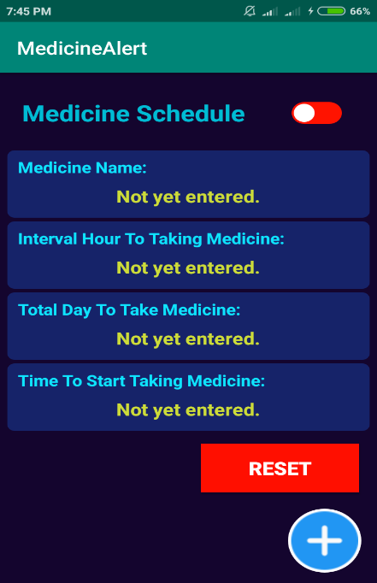
Figure 3.1: Main layout(blank) in medicine alert application
Figure 3.1 shows the main layout of this application. After opening this application user will be see this. After click the add button(bottom right corner in layout) in this layout user will be show a pop-up dialog for creating alert.
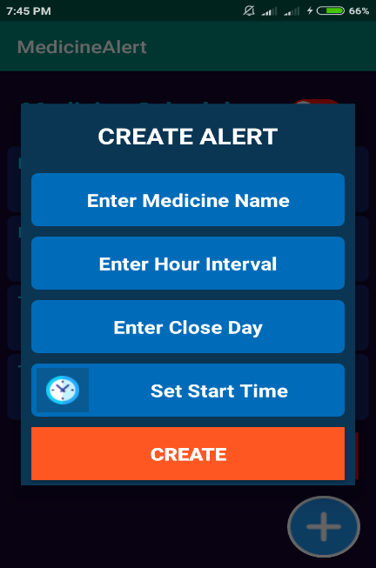
Figure 3.2: Pup-up dialog(blank) in medicine alert application
Figure 3.2 shows a blank pop-up dialog for creating alert. In here, user will be enter all required information for set a medicine alert. At first, user will enter the name of the medicine that he/she want to take. Then, he/she will enter the number of interval hour for taking his/her medicine. Then he/she will enter the number of day that how long he/she will take the medicine. Now, the user will press the clock icon and that will pop up a clock. After this, he/she will set the time that when he/she want to start taking medicine. After fulfill all the information the layout is look like below this:
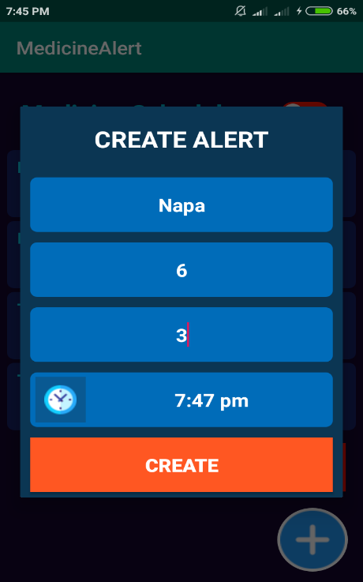
Figure 3.3: Pup-up dialog(filled) in medicine alert application
Figure 3.3 show the layout after all the information is provided by user. Now, user will click the "CREATE" button that all the information will set the main layout along with storing database.
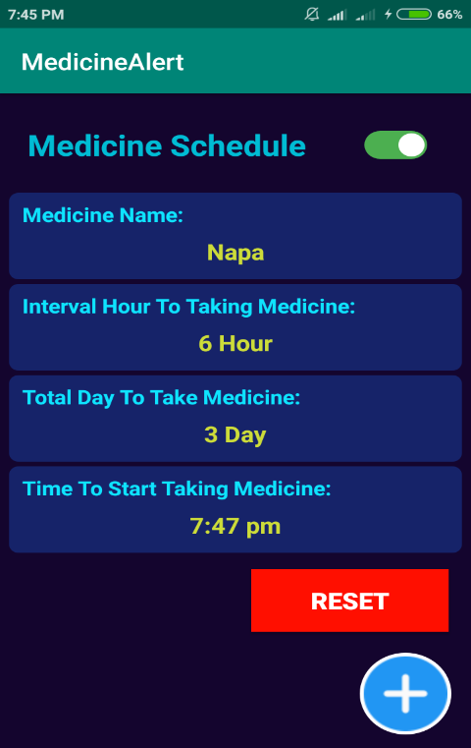
Figure 3.4: Main layout(filled) in medicine alert application
Figure 3.4 show the main layout after set all the information. Now user will click the toggle button(top right corner in layout) for start the service. After clicking it, it will transformed from red to green color. Now the AlarmManager will set and PendingIntent will fire according to given schedule.
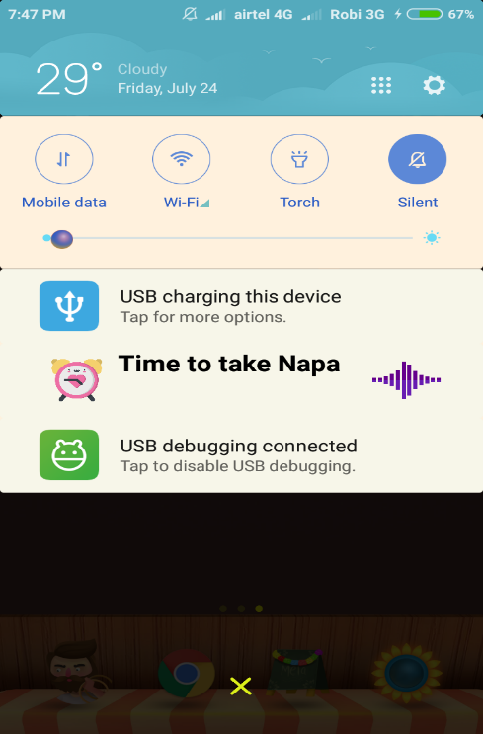
Figure 3.5: Display notification in medicine alert application
Figure 3.5 show the notification that is appear every time when your medicine taking time will happen. User will be also hear a sound with this notification.
Table 3.1: Database in medicine alert application
Table 3.1 show the database that I used in this application. In this application I used SQLite database.
Other component that I used in this application are,
- AlarmManager
- PendingIntent/Intent
- IntentService
- Dialog
- Time Picker Dialog
- Notification
- MediaPlayer
- RemoteViews
- Calendar

Task 2: Android Appointment Reminder Application
Project description:
This application will notify(with sound) user appointment time according to the date and time set by the user. This application has a cancel button - by using it, user can cancel their notification service anytime or after notify. This application also has a delete button - by using it, user will clear or delete date and time set by the user.
- This application will also work after device reboot and device switch off/on.
Application UI with explanation:
The elements that I used for UI design are,
- LinearLayout
- TextView
- ImageButton
- ImageView
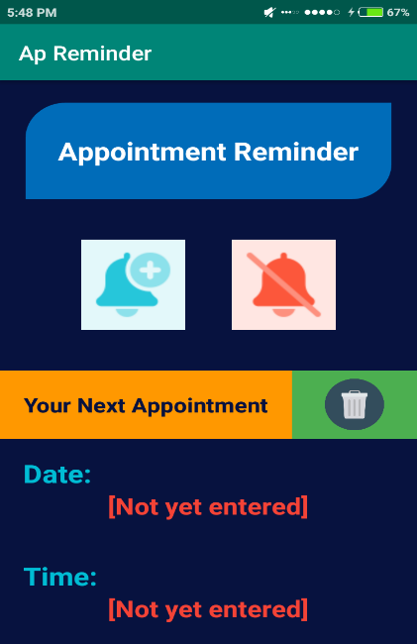
Figure 3.6: Main layout(blank) in appointment reminder application
Figure 3.6 shows the main layout of this application. After opening this application user will be see this. After click the add button(blue ImageButton) in this layout user will be show a date picker dialog for set appointment date.
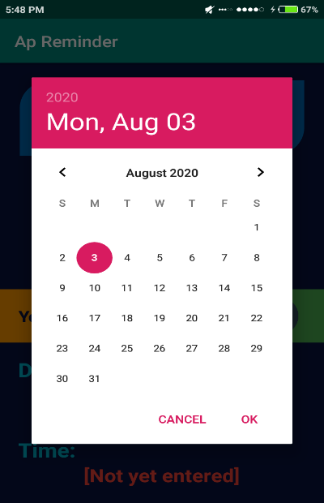
Figure 3.7: Date picker dialog in appointment reminder application
Figure 3.7 shows the date picker dialog and user will select their appointment date by this. After selecting date, user will click “OK” button in dialog and see a pop up time picker dialog for setting appointment time.
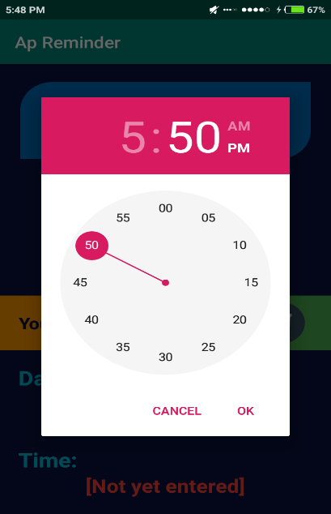
Figure 3.8: Time picker dialog in appointment reminder application
Figure 3.8 shows the time picker dialog and user will select their appointment time by this. After selecting time, user will click “OK” button in dialog. After clicking “OK” button the dialog will close and selected date and time will set in main layout. And user will watch a toast message in main layout that “Alarm Set Done!”. Now the AlarmManager will set and PendingIntent will fire according to given schedule. For date and time picker dialog I used a external library instead of using by default picker.
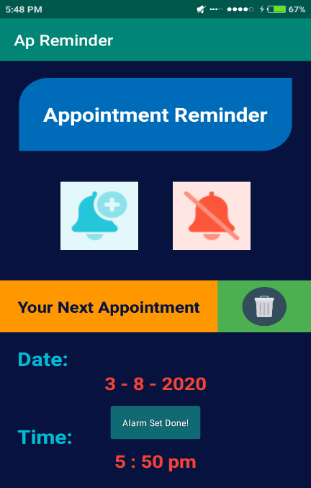
Figure 3.9: Main layout(filled) in appointment reminder application
Figure 3.9 shows the looks at the main layout when after it is filled with date and time given by the user. If the user want to cancel service just press the cancel button(orange ImageButton). After click this button PendingIntent will be cancel.
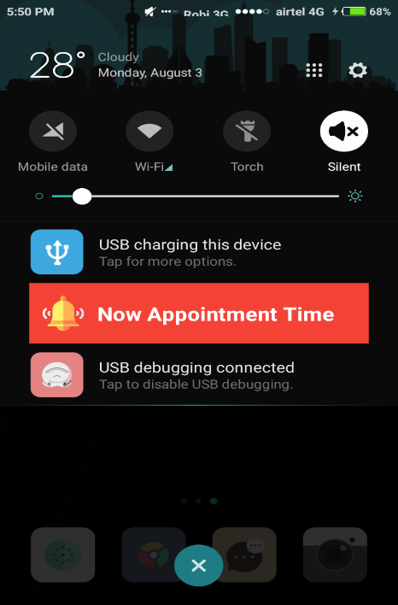
Figure 3.10: Display notification in appointment reminder application
Figure 3.10 show the notification that is appear every time when appointment time will happen. User will be also hear a sound with this notification. Now user will click the notification and open the main layout.
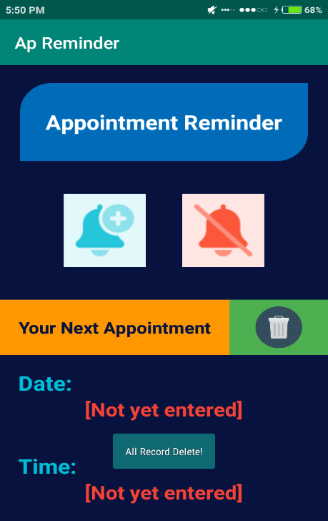
Figure 3.11: Main layout(re-open) in appointment reminder application
After clicking the notification, user will transferred at the figure 3.11. Now click delete icon to delete all recorded information from database and clear the layout and watch a toast message that “All Record Delete!”.
Table 3.2: Database in appointment reminder application
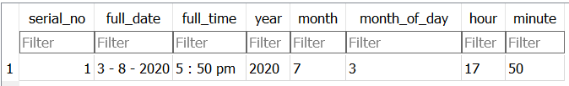
Table 3.2 show the database that I used in this application. In this application I used SQLite database.
Other component that I used in this application are,
- AlarmManager
- PendingIntent/Intent
- IntentService
- Notification
- MediaPlayer
- RemoteViews
- Calendar
- Date and Time Picker Dialog

Task 3: Learning and implementing in android architecture component
In here, I learned about viewmodel, livedata and room. Why these are required and how to apply these in android application. After learning the basic implementation of these things, I have implement three mini projects using all of these component.
These projects are,
- CRUD operation of Room
- Note application
- User authentication application
Now I will describe all of these projects.

CRUD operation of Room
In this application I will showed, how to insert, update, delete data and view all of the stored data in a list. I made this using viewmodel, livedata and room.
Application UI with explanation:
The elements that I used for UI design are,
- LinearLayout
- TextView
- Button
- EditText
- RecyclerView
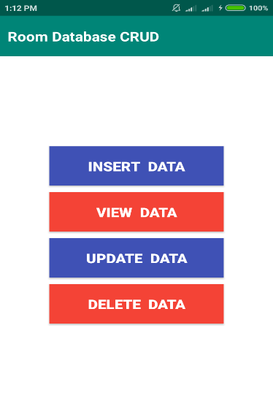
Figure 3.12: Main layout in CRUD application
Figure 3.12 shows the main layout of this application. This layout contain four button. Every button performs different operation. Note that, Student ID is the primary key in here.
INSERT DATA:
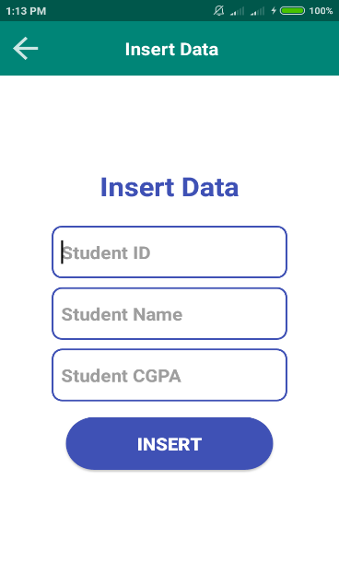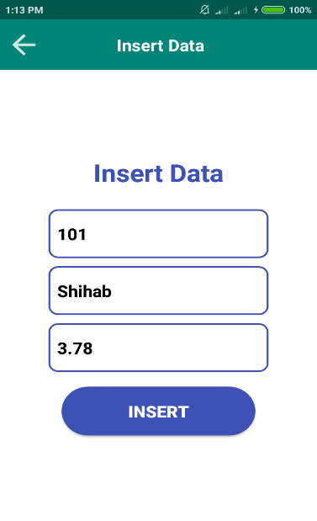
Figure 3.13: Insert operation in CRUD application
Figure 3.13 shows that, how to insert data in room database. After entering required information, press “INSERT” button for inserting data in database.
VIEW DATA:
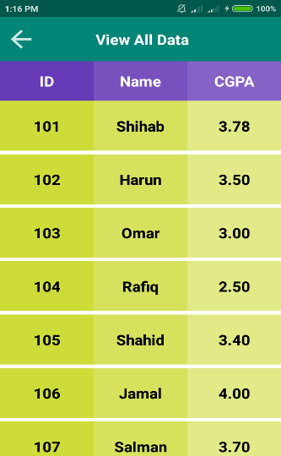
Figure 3.14: View stored data in CRUD application
Figure 3.14 shows the list of all stored data from database. For viewing the data list I used RecyclerView.
UPDATE DATA:
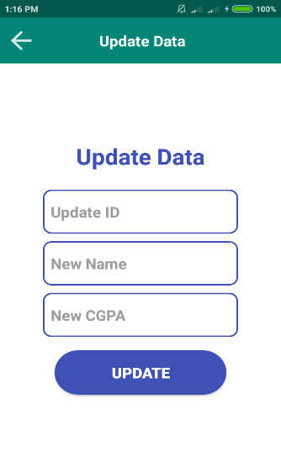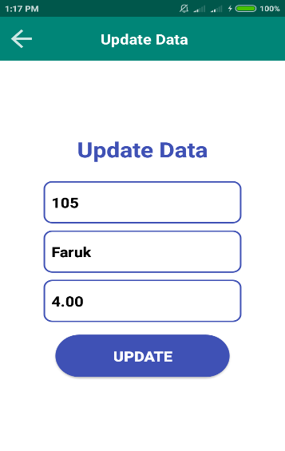
Figure 3.15: Update operation in CRUD application

Figure 3.15 shows that, how to perform update operation. At first, enter “Update ID” that’s mean enter student id. Because student id is the primary key. Then enter other information that want to update and press “UPDATE” button. After updating press the “VIEW DATA” button and can see the modification.
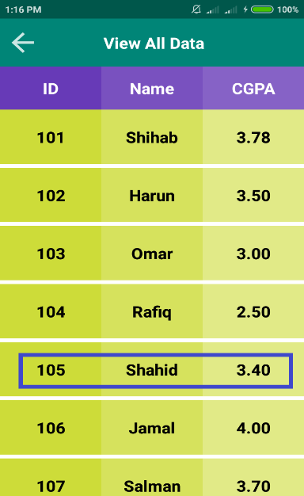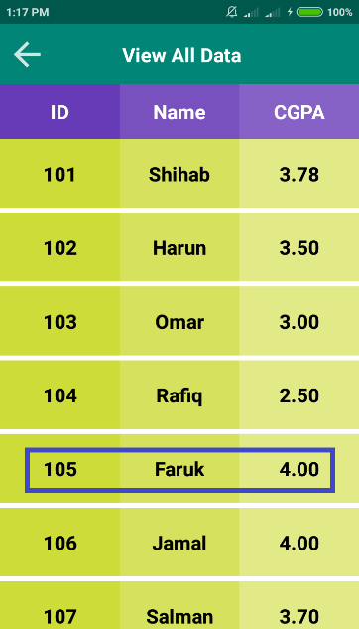
Figure 3.16: Before and After Update operation in CRUD application
Figure 3.16 shows the comparison between before and after update operation.
DELETE DATA:
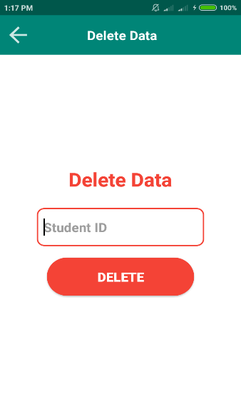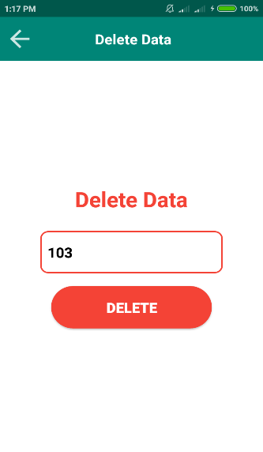
Figure 3.17: Delete operation in CRUD application

Figure 3.17 shows that, how to perform delete operation. Enter “Student ID” because student is the primary key. And then press “DELETE” button. After deleting press the “VIEW DATA” button and can see the changes.
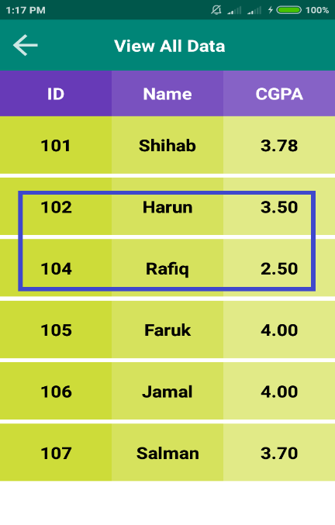
Figure 3.18: After Delete operation in CRUD application
Figure 3.18 shows that ID no 3 is missing. Because we deleted it.
Table 3.3: Database in CRUD application
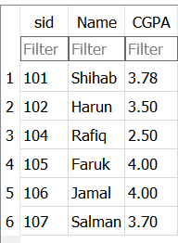
Table 3.3 show the database that I used in this application. In this application I used Room database.

Note application
In this application I showed, how to insert and save notes, how to display all the notes in list of view, how to edit and delete operation perform in notes list. I made this using viewmodel, livedata and room.
Application UI with explanation:
The elements that I used for UI design are,
- RecyclerView
- LinearLayout
- ImageButton
- TextView
- Button
- EditText
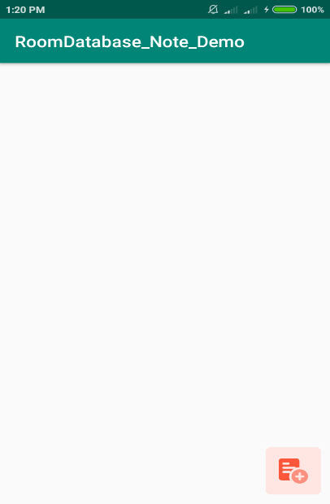
Figure 3.19: Main activity(blank) in Note application
Figure 3.19 shows the main activity of this application. User will see their save notes in this activity. At first click to add button(bottom right) it will transferred user to insert note activity.

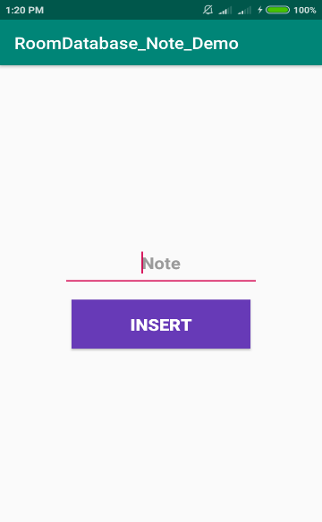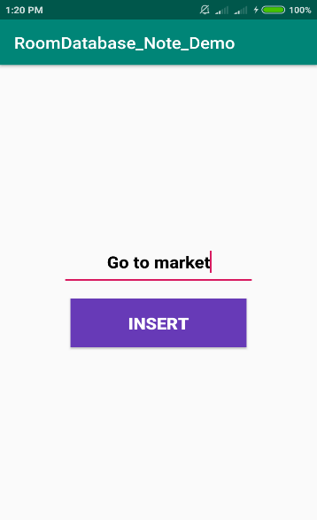
Figure 3.20: Insert activity in Note application
Figure 3.20 shows the insert activity of this application. User will type their note and press “INSERT” button for save it. User will view all of their saved note in main activity.
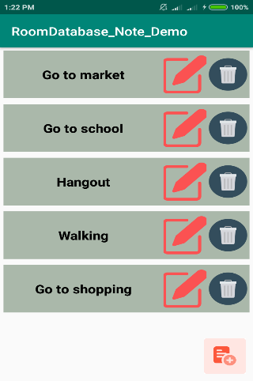
Figure 3.21: Main activity(filled) in Note application
Figure 3.21 shows the list of saved note. For this view i used recyclerview. Now user can modify and delete their saved note if they want. For modifying a note user will need to press modify button(red) in the list. And for deleting a note user will need to press delete button(blue). After pressing delete button it will be automatically delete.
Now i will show these two,

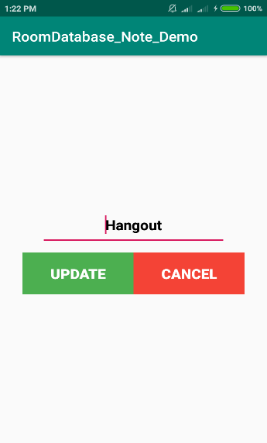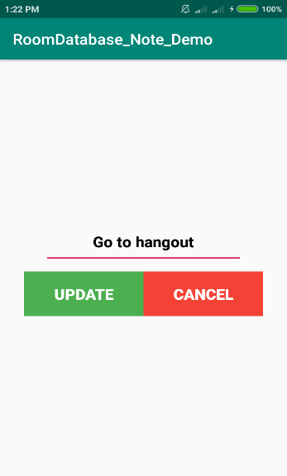
Figure 3.22: Update activity in Note application
Figure 3.22 shows the update activity in this application. After pressing modify button user will transferred update activity and also pass their existing saved note and user will see it in edittext. For confirmation this, user will need to press “UPDATE” button. If user want to not modify his note just press “CANCEL” button.
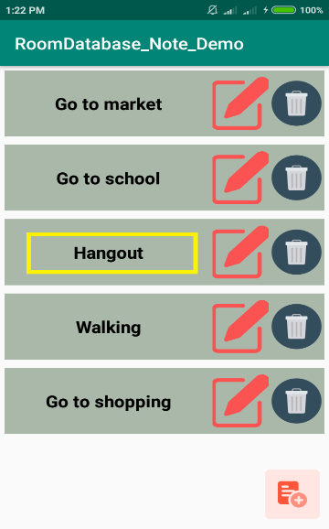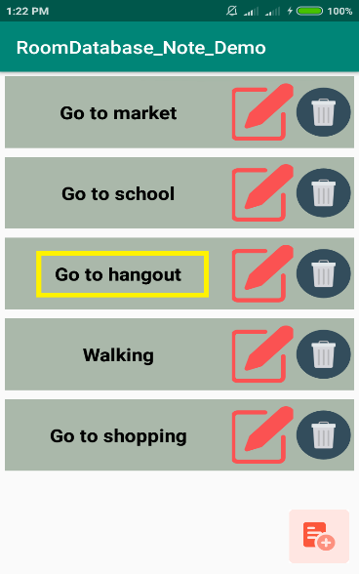
Figure 3.23: Before and After updating in Note application
Figure 3.23 shows the comparison between before and after update operation in saved note.

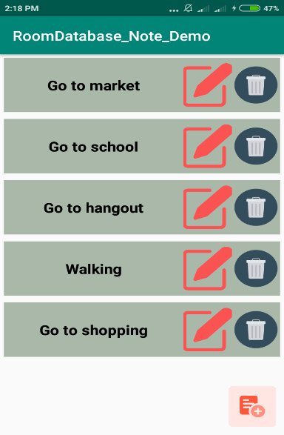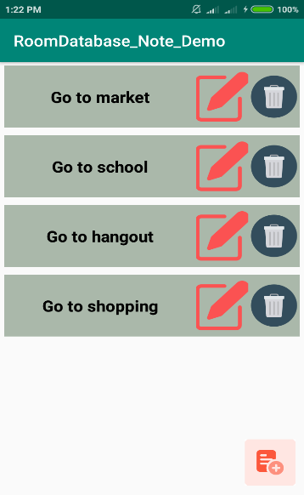
Figure 3.24: Before and After deleting in Note application
Figure 3.24 shows the comparison between before and after delete operation in saved note.
Table 3.4: Database in Note application
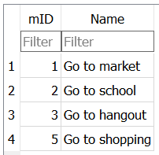
Table 3.4 show the database that I used in this application. In this application I used Room database.

User authentication application
In this application I will showed, how to perform register and login using room database. I made this using viewmodel, livedata, room and sharedpreferences.
Application UI with explanation:
The elements that I used for UI design are,
- RelativeLayout
- LinearLayout
- CardView
- EditText
- ImageView
- Button
- TextView
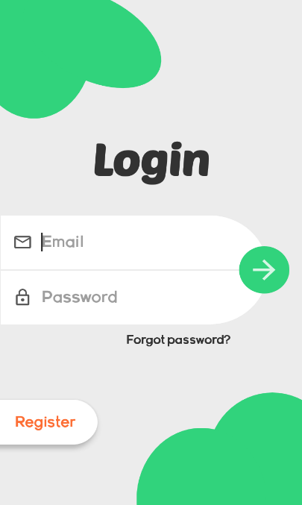
Figure 3.25: Login activity(blank) in User authentication application
Figure 3.25 shows the login activity of this application. User need to completed their register first. For completing this, user need to click "Register" button.

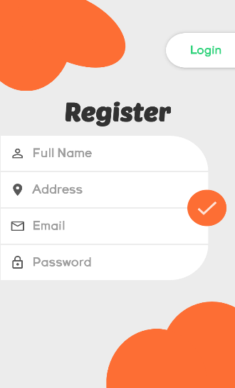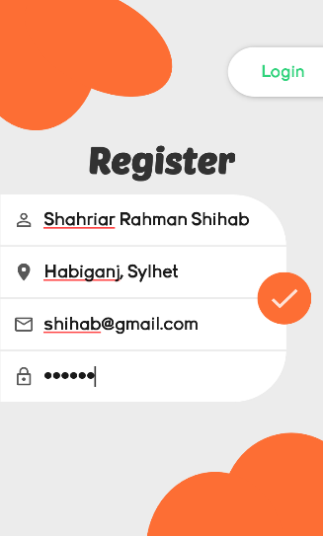
Figure 3.26: Register activity in User authentication application
Figure 3.26 shows the register activity of this application. For completing registration process, user will need to filled all the boxes. And then press "OK" button(orange button). After completing successful registration process user will transferred to login activity.
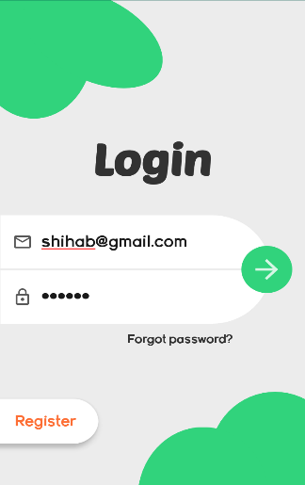
Figure 3.27: Login activity(filled) in User authentication application
Figure 3.27 shows the process how a user will login. User will provide required login information and press "OK" button(green button). After successful login user will view their profile.

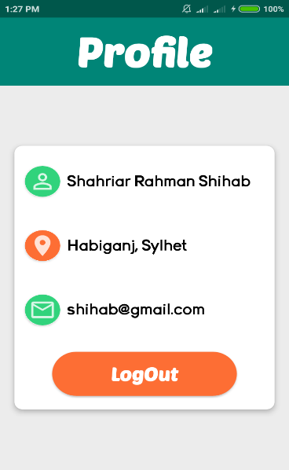
Figure 3.28: Profile activity in User authentication application
Figure 3.28 shows the user profile activity with their information. User will view their profile until logout. If they press “LogOut” button, they will transferred to login activity.
Table 3.5: Database in User authentication application
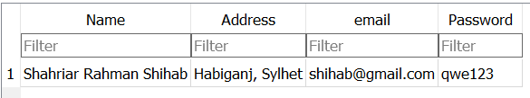
Table 3.5 show the database that I used in this application. In this application I used Room database.

Task 4: Android Student Info Widget Application
Project description:
This is a simple student info widget android application. This application will display a list of student info in mobile homescreen from SQLite database. By using this application, at first inserted and save multiple student Name and CGPA in database. Then display the list of saved data from Widget to mobile homescreen. The saved data will also be displayed after opening application.
Application UI with explanation:
The elements that I used for UI design are,
- LinearLayout
- CoordinatorLayout
- TextView
- ListView
- FloatingActionButton
- EditText
- Button
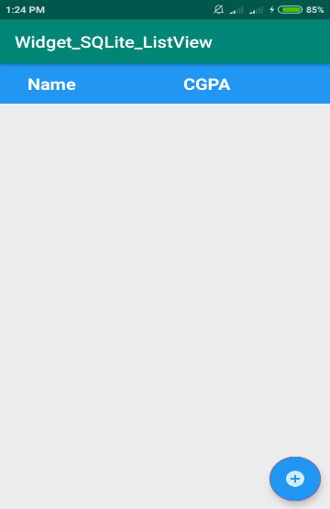
Figure 3.29: Main activity(blank) in Widget application

Figure 3.29 shows the main activity of this application. After opening this application user will see this activity. At first, user will click add button to go insert data activity.
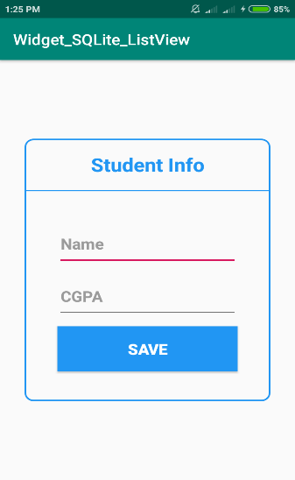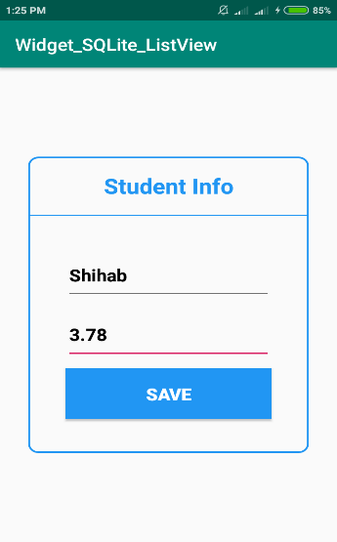
Figure 3.30: Insert activity in Widget application
Figure 3.30 shows the data insert activity. In here, put the required information and click “SAVE” button for stored in database.
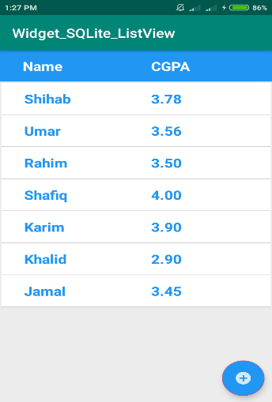
Figure 3.31: Main activity(filled) in Widget application
Figure 3.31 shows the list of data that are already user inserted in database. In here, I used listview. User can also view this list in their homescreen from widget.

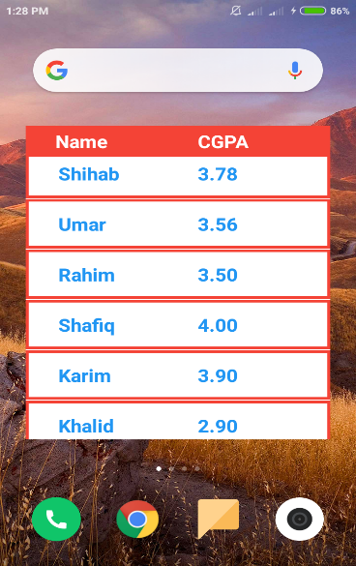
Figure 3.32: Homescreen view in Widget application
Figure 3.32 shows the list of data in homescreen. For viewing this, user will select this application from widget.
Table 3.6: Database view in Widget application
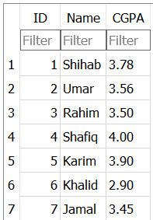
Table 3.6 shows the database in this application. In this application, I used SQLite database.

Other component that I used in this application are,
- AppWidgetProvider
- AppWidgetManager
- RemoteViews
- RemoteViewsService
- RemoteViewsFactory

3.2 Challenges
It is difficult to learn all about android mobile application design and development within this short period of time. It is not easy to make something new and unique. I tried my best to solve the problems that I face with my creativity. Mobile application developers face many difficulties during their project. I have also faced these difficulties. I needed to take good care so that, it would be look as wonderful, just as easy to understand and usable is likewise ordinary. As the technology updating day by day it is difficult to work closely with it. Work at the PlexusD company with new people and new environment is a big challenge for me. I have learned a lot of things from my university and PlexusD company. So it is also challenging to remember all the things.

CHAPTER 4
COMPETENCIES AND SMART PLAN

4.1 Competencies Earned
To accomplish something perfectly is not an easy task. In this internship, my target was not only achieving programming skills but also aim was to improve my organizational skills. So after completing my internship,
- I earned about how to work in professionally.
- Learned how to develop a project professionally.
- I learned how to communicate in professional way.
- Way to identify and solve a problem that arises during development.
- Learned new development strategies that I didn't know before.

4.2 Smart Plan
After completing my internship I did some plan to enhance my skills. These are,
- I need to research various mobile applications and try to improving my quality of design and development.
- I will be more careful when planning a new project.
- I will be more careful when i design an UI.
- I will be more aware about using update or latest version component when i developing new project.
- I will be always enhance my knowledge to learning new things about design and development purposes.

CHAPTER 5
CONCLUSION AND FUTURE CAREER

5.1 Discussion and Conclusion
This internship gives me the big opportunity to learn new things to improve my skills. This knowledge will help me to solve application design and development related problems. This internship taught me how to communicate with others and maintain formal discipline. Here I completed some real life project and learned some new thing about application development that really make me confident. The knowledge that I achieved from PlexusD that will help me in my future career and also helps me to work other company.

5.2 Scope for Further Career
As a fresher it is very harder to get a good job. Now the job sector is very much competitive. It is very difficult to get a good job without real life experience. Internship gives me the chance to gather experience which helps me to build a bright career. And it also increases my confidence level to getting a job of my skills.

APPENDIX A
Internship Reflection
My internship at Android mobile application design and development has considerably improved my knowledge of the workings of the mobile application development worlds. After this internship I gain some skills that will be useful throughout my career. Programming is not only practical things, this internship helped me to learn more about theoretical things about design and development. This internship helped me learn how to build a mobile application while maintaining its quality. This internship increased my research capability. Because, during this internship period I look out many mobile application, try to understanding their structure and quality. I didn’t do that before this internship. This internship developed my communication skill and improved punctuality. So finally I say that, this internship increased my confidence level in all sides in application development.

REFERENCES
[1] Introduction to the Company, available at << https://www.plexusd.com/site/about/>>
[2] Product and Market Situation, available at << https://www.smashingmagazine.com/2017/02/current-trends-future-prospects-mobile-app-market/>>
[3] Target Group, available at << https://bmcresnotes.biomedcentral.com/articles/10.1186/1756-0500-7-573/>>
[4] SWOT Analysis, available at << https://www.investopedia.com/terms/s/swot.asp/>>
[5] Application UI with explanation, available at << https://developer.android.com/reference />>
[6] Smart Plan, available at << https://gradaustralia.com.au/career-planning/five-steps-to-writing-a-smart-career-plan/>>

