An efficient approach to detect weed in the maize field using Deep Learning
by
Muhammad Tanvir Hasan
ID: 171-15-1327
AND
Nahid Hasan Lipu
ID: 171-15-1430
AND

Md Shajeeb Miah
ID:171-15-1290

This Report Presented in Partial Fulfillment of the Requirements for the Degree of Bachelor of Science in Computer Science and Engineering

Supervised By

S.M. Aminul Haque
Associate professor
Department of CSE
Daffodil International University

Co-Supervised By

Mushfiqur Rahman
Lecturer
Department of CSE
Daffodil International University



DAFFODIL INTERNATIONAL UNIVERSITY
Dhaka, Bangladesh
December 2020

APPROVAL

This Project titled “An efficient approach to detect weed in the maize field using Deep Learning”, submitted by *Muhammad tanvir hasan* and *Nahid hasan Lipu* and *Shajeeeb Miah* to the Department of Computer Science and Engineering, Daffodil International University, has been accepted as satisfactory for the partial fulfillment of the requirements for the degree of B.Sc. in Computer Science and Engineering and approved as to its style and contents. The presentation has been held on *5th December 2020*.

Board of Examiners

(Name) ^{[Font-12, Bold]} Chairman
Designation
Department of CSE ^{[Font-12]}
Faculty of Science & Information Technology
Daffodil International University

(Name) Internal Examiner
Designation
Department of CSE
Faculty of Science & Information Technology
Daffodil International University

(Name) External Examiner
Designation
Department of -------
Jahangirnagar University

Declaration

We hereby declare that, this project has been done by us under the supervision of S.M. Aminul Haque, Associate Professor, Department of CSE Daffodil International University. We also declare that neither this project nor any part of this project has been submitted elsewhere for award of any degree or diploma.

Supervised by:

S.M. Aminul Haque
Associate Professor
Department of CSE
Daffodil International University

Co-Supervised by:

Mushfiqur Rahman
Lecturer
Department of CSE
Daffodil International University

Submitted by:

(Muhammad Tanvir Hasan)
ID: 171-15-1327
Department of CSE
Daffodil International University

(Nahid Hasan Lipu)
ID: 171-15-1430
Department of CSE
Daffodil International University

((Md Shajeeb Miah)
ID: 171-15-1290
Department of CSE
Daffodil International University

ACKNOWLEDGEMENT

First we express our heartiest thanks and gratefulness to almighty God for His divine blessing makes us possible to complete the final year project/internship successfully.

We really grateful and wish our profound our indebtedness to S.M. Aminul Haque, Associate Professor, Department of CSE Daffodil International University, Dhaka. Deep Knowledge & keen interest of our supervisor in the field of “Field name” to carry out this project. His endless patience ,scholarly guidance ,continual encouragement , constant and energetic supervision, constructive criticism , valuable advice ,reading many inferior draft and correcting them at all stage have made it possible to complete this project.

We would like to express our heartiest gratitude to -----, -----, and Head, Department of CSE, for his kind help to finish our project and also to other faculty member and the staff of CSE department of Daffodil International University.

We would like to thank our entire course mate in Daffodil International University, who took part in this discuss while completing the course work.

Finally, we must acknowledge with due respect the constant support and patients of our parents.

Abstract

In agriculture one of the significant difficulties is to control weed, for controlling weed it is essential to distinguish weed appropriately. The objective of this examination is to assemble a model that can recognize the weed precisely. In picture characterization Convolutional Neural Network (CNN) makes gigantic progress, CNN extract the feature of the picture, and utilizing this feature information it performed classification, CNN brings great classification result when the dataset size is huge if the size dataset is little, there can happen an overfitting issue. So Deep CNN's (DCCN) with transfer learning has engaged, VGG-16 which is pre-trained on ImageNet by transfer learning technique, just the last couple of layers of VGG-16 model were supplanted regarding the picture classes, thus, VGG-16 can accomplish great classification result bring about the little size of the dataset. In this paper we utilized a dataset that contains two sorts of pictures, one is maize and another is weed and the dataset contains more than 24 thousand pictures. In this paper we proposed a model utilizing VGG-16 architecture, this model will take a picture with no hand-create feature extraction then the model will classify the picture by getting picture information and here we change the VGG-16 last three-layer as indicated by our model after the preparation stage this model accomplishes over 99% of validation accuracy.

TABLE OF CONTENTS
CONTENTS | PAGE
Board of examiners | iii
Declaration | iv
Acknowledgements | vi
Abstract | vii
CHAPTER
CHAPTER 1: Introduction | 1-6
1.1 Introduction | 1
1.2 Related Work  1.3 Motivation  1.4 Objectives  1.5 Research Question  1.6 Expected Outcome  CHAPTER 2: Transfer Learning in DCNN  CHAPTER 3: Methodology  3.1 Methodology  3.2 Proposed Algorithm  CHAPTER 4: Data Collection  4.1 Data Collection  4.2 Data Augmentation  CHAPTER 5: Result and Discussion  CHAPTER 6: Conclusion | 2  3  4  5  6  7-8  9-14  9  14  15-18  15  16  19-23  24
REFERENCES | 25

LIST OF FIGURES
FIGURES | PAGE NO
Figure 1: Model view of VGG-16 (Simonyan, 2014). | 8
Figure 2: Workflows of training using transfer learning on maize and weed image dataset for classification using VGG-16. | 10
Figure 3.1: Summary of VGG-16. | 11
Figure 3.2: Summary of VGG-16. | 12
Figure 4: Summary of proposed model. | 13
Figure 5: Images of maize. | 17
Figure 6: Images of weed. | 18
Figure 7: Showed model accuracy and loss after 14 epochs. | 20
Figure 8: Showed model accuracy and loss after 50 epochs. | 21
Figure 9: Visualization of model training and validation loss. | 22
Figure 10: Visualization of training and validation accuracy. | 23
Figure 11: Show the evaluation result of the test set. | 24

CHAPTER 1

Introduction

1.1 Introduction
In recent years, maize cultivation has emerged as extra popular in Bangladesh. In 2019, maize creation for Bangladesh was 4,100 thousand tons. Maize creation of Bangladesh expanded from 1,552 thousand tons in 2010 to 4,100 thousand tons in 2019 developing at a normal yearly pace of 11.72% (knoema, 2019). “The negative impacts of weeds on yields incorporate rivalry to water, light, supplements, and space, expanded creation costs, trouble in collecting, devaluation of item quality, increment danger of irritations and infections, and lessening in the business estimation of developed regions” (Mauro Antônio RizzardiI, 2004). It is emergent to have strategies that evaluate and investigate the appropriation of weed invasion rapidly and monetarily, and that's just the beginning a handy strategy is needed than the precise perception of harvests. A few examinations have been completed as of late focusing on the mechanization of this cycle of recognizable proof and grouping of weeds.

1.2 Related Work
Actualized a specialist framework dependent on picture division and this framework doesn't need any preparation it can straightforwardly apply to the extraordinary picture of maize and weed, for discovering picture thresholding this framework utilized Otsu's strategy and this master framework gets the ideal outcome utilizing AES technique (Montalvo M, 2013). Executed a picture preparing calculation to distinguish the presence of weeds in a particular site of harvests, this calculation is finished by two stages, first is wiping out those regions that are too little, second is determined the average value of yield this value is taken as the threshold for yield and weed arrangement, this calculation recognizes 96% of weeds in harvests (Tejeda, 2019). “Built-up a programmed model that utilizes an open-source realistic engine for making information algorithmically, this model gets 91.3% of exactness in yield and weeds recognition utilizing RGB Basic SegNet” (Di Cicco, 2017). Utilized a blend of wavelet features in a neural organization to give a texture-based discriminator to segment the weeds from the principal crop, this ANN model separates the weeds from sugar beet (classification rate of 93.3%) (Bakhshipour, 2017). This model utilized semantic division for exact mapping of weeds, they isolated vegetations from foundation soil, stone, dead plants, and minority class pixels are labeled in the background-segmented image, the model utilized Maximum Likelihood Classification for foundation division and utilized VGG16 and ResNet-50 for feature extraction (Asad, 2019). Built-up an Unmanned Aerial Vehicle for taking a distant picture and they utilized weed planning by object-based image analysis (OBIA) strategy which permitting them to consolidate spectral, contextual, and morphological data, among another element, for weed planning they utilized three consecutive steps, one is a classification of crop rows, second is the separation between crop plants and weeds dependent on their relative positions, and third is weed coverage mapping using a grid structure (Peña, 2013). Nowadays, deep learning algorithms like convolutional neural networks (CNN) have gotten pervasive in the area of artificial intelligence. CNN or Deep CNN (DCNN) can collect information from a picture very efficiently, it is used convolutional and pooling layer for gathering information from a picture. In weed identification, the CNN technique has been applied effectively (dos Santos Ferreira, 2017). CNN relies on the dataset size if the dataset is little there can happen an overfitting issue, in this kind of circumstance transfer learning can be successful. Transfer learning utilized the model which is pre-trained, and only the last couple of layers are prepared according to the category in the new dataset. In this work, we will utilize the notable pre-prepared CNN's model VGG-16 (Simonyan, 2014) for maize and weed image identification.

1.3 Motivation
Maize is one of the most significant yields in agribusiness. Bangladesh accomplished 22th situation on the planet for maize development, yet because of weed maize's misfortune it's efficiency and weed diminishes rancher's advantage, additionally, maize can eliminate a large portion of the chronic sicknesses, to lessen weed issue and expanding maize profitability we are proposing this work.

1.4 Objectives
These days Deep learning turns out to be more famous for extract information from pictures, with the assistance of Deep Learning, it is simpler to distinguish the weed from a picture, and in this paper, our principal objective is to assemble a model which can group weed from maize, therefore we will utilize the VGG-16 model design, and we will prepare the model with the dataset for recognizing weed in the maize field and need to fabricate a model which can give most extreme proficiency.

1.5 Research Question
Which methodology will be utilized for understanding weed location in the maize field?
What is the system of dataset assortment?
Which Deep learning procedure will be utilized to take care of this issue?
How to stay away from the model overfitting issue?
How to assemble a dependable model and defeat the difficulties?

1.6 Expected Outcome
In this work, we will utilize the VGG-16 Model and changing the Vgg-16 last couple of layers, we will prepare the model utilizing the dataset with an adaptive number of times so that this model can gain proficiency with all the feature accurately, in the wake of preparing we expected that, this model will give great exactness in weed identification in the maize field.

CHAPTER 2
Transfer Learning in DCNN

In Figure.1 (Simonyan, 2014) displayed the basic view of the VGG-16. The first convolutional layer gets a picture equivalent to 224*224 pixels. In this manner, the input picture passed via a bunch of convolutional layers with a filter size of 3*3 pixels, and the stride size of the convolutional layer is 1 pixel. Here use 5 max-pooling layers and, the size of the filter is 2*2 pixels. The maximum pooling stride is taken as 2 pixels. Here used three fully connected layers (dense), and the number of parameters is 4096, 4096, and 1000 separately. In the dense layer, the current neuron takes information from the previous neuron. Here 1000 means that the number of classes existing in the ImageNet Large-Scale Visual Recognition Challenge (ILSVRC). And all hidden layers used Rectifier linear Unit activation (ReLu) function and, Soft-Max is the last activation function. (Simonyan, 2014).

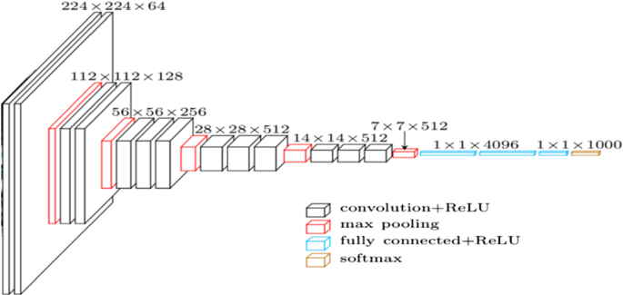
Figure 1: Model view of VGG-16 (Simonyan, 2014).

CHAPTER 3
Methodology

3.1 Methodology
The VGG-16 is prepared on more than 1,000,000 pictures. It is skilled to classify pictures from 1 to 1000 classes [10]. These 1000 classes are organized in the VGG-16 last three layers. For a more up to date grouping task, these should be finetuned (Kaur, 2019). The methodology for adjusting is to remove all the layers of the organization aside from the last three. For making a new classifier, it is required to subbing the last 3 layers with a dense layer, and a soft-max activation function with an output layer of classification. The dense layer size is equivalent to the size of the category in the dataset (Kaur, 2019).

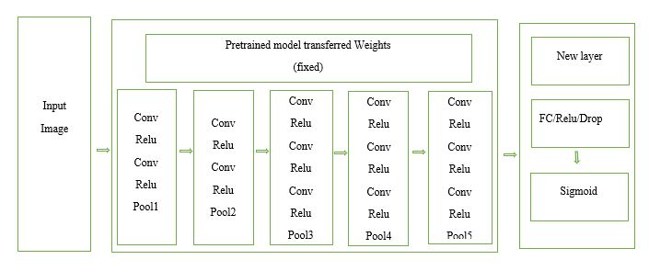
Figure 2: Workflows of training using transfer learning on maize and weed image dataset for classification using VGG-16.

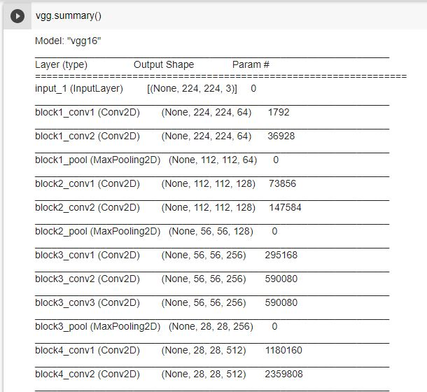

Figure 3.1: Summary of VGG-16.

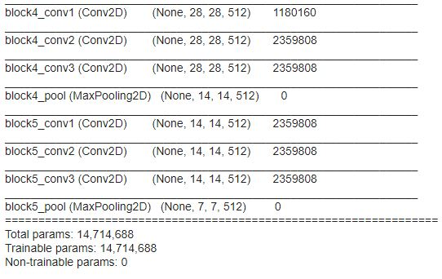
Figure 3.2: Summary of VGG-16.

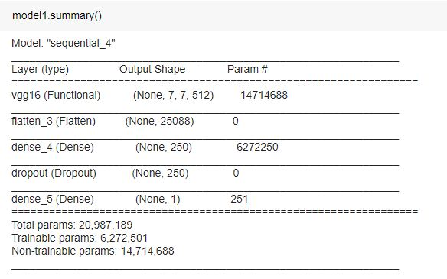
Figure-5 Summary of proposed model.

3.2 Proposed Algorithm

In this work, the dataset has two classes, i.e., maize & weed, in this approach VGG-16 network architecture will use for image classification, proposed algorithm.

Algorithm:

Step1: collecting images from (Brahimi, 2018), (AlexOlsen, 2019).
Step2: Labelling the images according to their belonging class.
Step3: Using data augmentation for creating virtual images.
Step4: Resize the input images according to the size VGG-16 input layer.
Step5: Splitting dataset for training and testing, 80% for training, and 20% for testing.
Step6: Modify VGG-16 network, modify only last three layers [11], here used fully connected layer, dropout to reduce overfitting, sigmoid for binary classification.
Step7: Train the Network.
Step8: Test the network.
Step9: Generate validation report.

CHAPTER 4
Data Collection
4.1 Data Collection
In this work two datasets are used, one is weed and another is maize image dataset, weed database is publicly available at (Brahimi, 2018) and the maize image is publicly available at (AlexOlsen, 2019), we used a total of 6780 maize images and 17535 weed images, for training purpose we labeled maize and weed image, for training we used 5446 maize and 14032 weed images and for testing we used 1334 maize and 4837 weed images.

4.2 Data Augmentation
Data Augmentation is a method that is utilized for producing more data utilizing existing data, this strategy includes a tad of change for the dataset like zooming, shearing, flipping moving, and so on are applied to the current information, in CNN if the size of the dataset is little CNN tends to overfit, so with the assistance of Data Augmentation it is conceivable to diminish overfitting issue, in this paper, we use ImageDataGenerator class from Keras library for making data to lessen over the fitting issue.

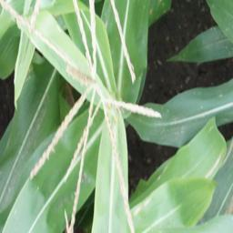
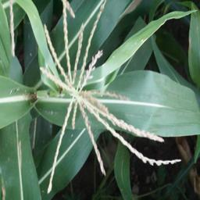
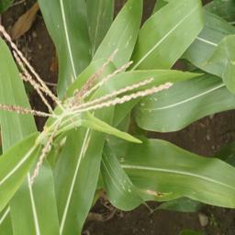
Figure 5: Images of maize.
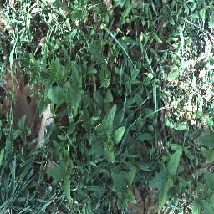
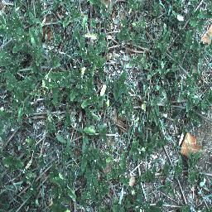
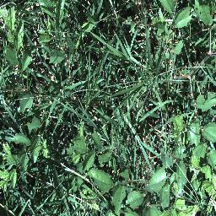
Figure 6: Images of weed.
CHAPTER 5
Result and discussion
In this work, we utilized two sorts of pictures, one is maize and the second is weed. This strategy includes the VGG-16 model network [10]. Parting the datasets into training and validation sets of 80% and 20% individually, the model is prepared for 50 epochs with Adam as an optimizer, in the wake of setting up the model, the model is assessed utilizing the validation dataset and the model accomplishes over 99% of accuracy, this outcome shows the effectiveness of the VGG-16 network architecture.

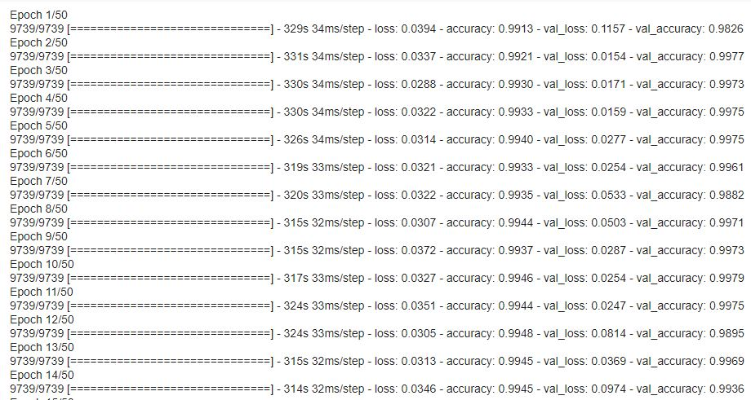
Figure 7: Showed model accuracy and loss after 14 epochs.

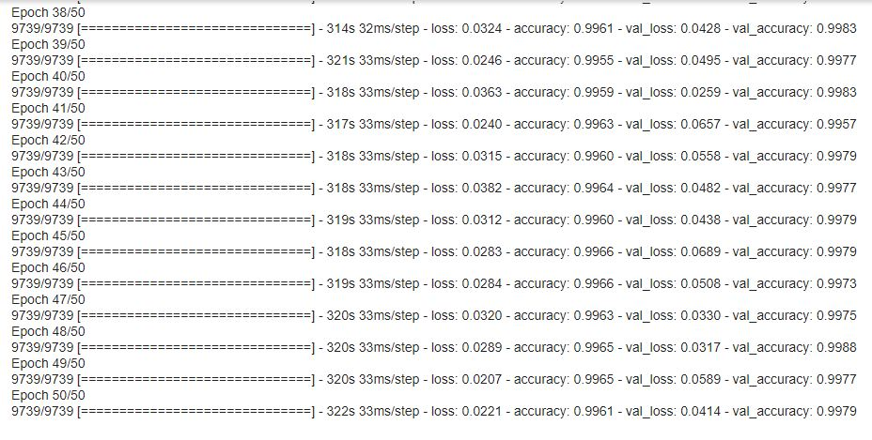
Figure 8: Showed model accuracy and loss after 50 epochs.

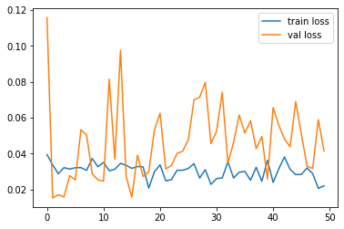
Figure 9: Visualization of model training and validation loss.

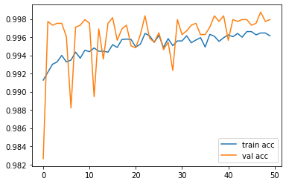
Figure 10: Visualization of model training and validation accuracy.

CHAPTER 6
Conclusion
We proposed a model that will recognize weed and maize. Despite the fact that this exploration has been restricted in the size of the dataset, later on, we can work with a huge dataset and can add all the newer modules for improving the general execution of the model. Notwithstanding, in this exploration, we utilized a pre-prepared VGG-16 model which gives great execution in the little dataset and this model looks encouraging and accomplishes over 99% validation accuracy.

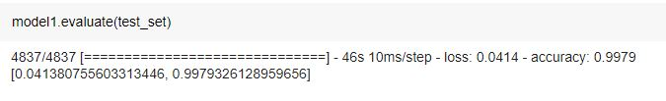
Figure 11: Show the evaluation result of the test set.

References
AlexOlsen. (2019, 5 10). AlexOlsen. (github.com) Retrieved 11 1, 2020, from https://github.com/AlexOlsen/DeepWeeds
Asad, M. H. (2019). Weed detection in canola fields using maximum likelihood classification and deep convolutional neural network. Information Processing in Agriculture.
Bakhshipour, A. A. (2017). Weed segmentation using texture features extracted from wavelet sub-images. Biosystems Engineering, 157, 1-12.
Brahimi, T. W.-H. (2018, 4 19). Image set for deep learning: Field images of maize annotated with disease symptoms. (OSFHOME) Retrieved 11 1, 2020, from https://osf.io/p67rz/
Di Cicco, M. C. (2017). Automatic model based dataset generation for fast and accurate crop and weeds detection. 2017 IEEE/RSJ International Conference on Intelligent Robots and Systems (IROS), 5188-5195.
dos Santos Ferreira, A. D. (2017). Weed detection in soybean crops using ConvNets. Computers and Electronics in Agriculture, 143(1), 314-324.
Kaur, T. a. (2019). Automated brain image classification based on VGG-16 and transfer learning. In 2019 International Conference on Information Technology (ICIT), 94-98.
knoema. (2019, 12 26). Bangladesh - Maize production quantity. (Bangladesh - Maize production) Retrieved 11 25, 2020, from knoema: https://knoema.com/atlas/Bangladesh/topics/Agriculture/Crops-Production-Quantity-tonnes/Maize-production
Mauro Antônio RizzardiI, N. G. (2004). Métodos de quantificação da cobertura foliar da infestação de plantas daninhas e da cultura da soja. The Scientific Electronic Library Online, 34(1), 13-18.
Montalvo M, G. J. (2013). Automatic expert system for weeds/crops identification in images from maize fields. Expert Systems with Applications, 40(1), 75-82.
Peña, J. M.-S.-G. (2013). Weed Mapping in Early-Season Maize Fields Using Object-Based Analysis of Unmanned Aerial Vehicle (UAV) Images. PloS one, 8(10), e77151.
Simonyan, K. a. (2014). Very deep convolutional networks for large-scale image recognition. arXiv.org > cs > arXiv:1409.1556.
Tejeda, A. I. (2019). Algorithm of Weed Detection in Crops by Computational Vision. 2019 International Conference on Electronics, Communications and Computers (CONIELECOMP), 124-128.

