DOCTOR ENGINE (A Health Care Assistant)
by
Tanjil Hasan
ID: 161-15-1015

Shiblur Rahman Lipu
ID: 171-15-1210

Atikur Rahman
ID: 171-15-1227
&
Istiaqe Ahmed Khan
ID: 171-15-1348

This Report Presented in Partial Fulfillment of the Requirements for the Degree of Bachelor of Science in Computer Science and Engineering

Supervised By

Dr. S. M. Aminul Haque
Associate Professor,
Department of CSE
Daffodil International University

Co-Supervised By

Md. Ohidujjaman
Senior Lecturer
Department of Computer Science & Engineering
Daffodil International University


DAFFODIL INTERNATIONAL UNIVERSITY
Dhaka, Bangladesh
December 2020

APPROVAL
This Project/internship titled “Doctor Engine (A Healthcare Assistant)’’, submitted by Tanjil Hasan, ID No: 161-15-1015, Shiblur Rahman Lipu, ID NO:171-15-1210, Atikur Rahman, ID NO:171-15-1227 and Istiaqe Ahmed Khan, ID NO:171-15-1348 to the Department of Computer Science and Engineering, Daffodil International University has been accepted as satisfactory for the partial fulfillment of the requirements for the degree of Bachelor of Science in Computer Science and Engineering and approved as to its style and contents. The presentation has been held on 05 December, 2020.

BOARD OF EXAMINERS

Dr. Sayed Akhter Hossain Chairman
Professor and Head
Department of Computer Science & Engineering
Faculty of Science & Information Technology
Daffodil International University

Dr. S M Aminul Haque Internal Examiner
Associate Professor
Department of Computer Science & Engineering
Faculty of Science & Information Technology
Daffodil International University

(Name) External Examiner
Designation
Department of -------
Jahangirnagar University

DECLARATION
We hereby declare that this project has been done by us under the supervision of S.M. Aminul Haque, Associate professor, Department of CSE Daffodil International University. We also declare that neither this project nor any part of this project has been submitted elsewhere for award of any degree or diploma.

Supervised by:

Dr. S M Aminul Haque
Associate Professor
Department of Computer Science & Engineering
Faculty of Science & Information Technology
Daffodil International University

Co-Supervised by:

Md. Ohidujjaman
Senior Lecturer
Department of CSE
Daffodil International University

Submitted by:

(Tanjil Hasan) (Shiblur Rahman Lipu)
ID: 161-15-1015 ID:171-15-1210
Department of CSE Department of CSE
Daffodil International University Daffodil International University

(Atikur Rahman) (Istiaqe Ahmed Khan)
ID: 171-15-1227 ID: 171-15-1348
Department of CSE Department of CSE
Daffodil International University Daffodil International University

ACKNOWLEDGEMENT

First, we express our heartiest thanks and gratefulness to almighty God for His divine blessing makes us possible to complete the final year project/internship successfully.
We are very much thankful to our advisor S.M. Aminul Haque, Associate professor, Department of CSE Daffodil International University who guided us nicely to do this work. His patience and mentality always give us a spirit of how can we complete this work. He provides all types of resources related to this. So, we can get the actual theme to fulfill our work. We also give thanks to our Co- advisor Md Ohidujjaman, Sr. Lecturer, Department of CSE Daffodil International University who has always suggested us about our research. Also, he has guided us nicely for doing research-oriented work.
We would like to express our heartiest gratitude to Dr. Sayed Akther Hossain, Professor and Head, Department of CSE, for his kind help to finish our project and also to other faculty members and the staff of CSE department of Daffodil International University. We would like to special thanks to our team members who always cooperate with this work. Finally, we thank our family for their guidance and give us support to complete this work.

ABSTRACT

Brain Hemorrhage has gotten to be an extreme issue in the world. Brain Hemorrhage is also called ‘Brain Stroke’ in our country. Basically, there are three types of strokes

Hemorrhagic Stroke

Ischemic Stroke

Transient Ischemic Attack (TIA).

Most of the people (87%) are affected by Ischemic stroke. To distinguish this hemorrhage, we got to do a lab test at therapeutic. But that's exceptionally costly for our country individuals. So, we choose to do something for them. After huge research, we developed a project which can detect this type of hemorrhage using deep learning neural network based algorithm. To do that we collected raw data (CT Scan Copy) from a number of hospital, we preprocessed it with a help of radiologist and finally trained our model to nail our goal which is detecting hemorrhage stroke. Right now, we have achieved 90 up percentage accuracy in total.

TABLE OF CONTENTS
CONTENTS | PAGE
Board of examiners | I
Declaration | II
Acknowledgements | III
Abstract | IV
CHAPTER 1: | 1-2
1.1 Overview | 1
1.2 Motivation | 1
1.3 Objectives | 2
1.4 Related Works | 2
CHAPTER 2: | 3-4
2.1 Comparative Analysis | 3
2.2 Scope of the problem | 4
2.3 Challenges | 4
CHAPTER 3: | 5-10
3.1 Data Flow Diagram | 5
3.2 Use Case Diagram | 6
3.3 Use Case Description | 7-10
3.4 Front End Design | 10
CHAPTER 4: | 11-14
4.1 Data Collection | 11
4.2 Implementation Requirements | 11
4.3 Data Pre-processing | 12
4.4 Testing Implementation | 13
4.5 Result | 14
CHAPTER 5: | 15-27
5.1 Python Libraries | 15
5.2 Algorithms  5.2.1 Training  5.2.2 Doctor Engine with GUI  5.2.3 Function  5.2.4 Image Class  5.2.5 Predict  5.2.6 Pre-processing: Conversion | 16-26  16-20  21-24  24  25  25  26
5.3 Training Procedure | 27
5.4 Outcomes | 27
CHAPTER 6: | 28
6.1 Conclusion | 28
6.2 Future Works | 28
CHAPTER 7: | 29
References | 29

LIST OF FIGURES
FIGURES | PAGE NO
Figure 3.1.1: DFD | 5
Figure 3.2.1: Use Case Diagram | 6
Figure 3.4.1: Front End Design | 10
Figure 4.4.1:Testing with Train vs Online CT Scan Files | 13
Figure 4.4.2: Testing with Train vs Online CT Scan Files | 14

LIST OF TABLES
TABLES | PAGE NO
Table 2.1.1: Comparative Analysis | 3
Table 3.3.1: Use Case Description | 7-10
Table 5.1.1: Python Libraries | 15

CHAPTER 1
Introduction
  - Overview
One of the most widely studied topics today is brain stroke. Strokes are defined by the World Health Organization which is an acute, focal or diffuse, dysfunction of the brain, originating for vessels and lasting for a period longer than a day. Stroke is the third leading disease of death in the United States. According to the WHO (World Health Organization)
There are 15 million people suffer stroke worldwide every year, in which 5 million people die every year and another 5 million peoples are permanently disabled. People are very apathetic about stroke but it is a dangerous disease that pushes people towards death. The man is having a brain stroke but he can’t catch that he has a stroke. It is happening to many people now and its treatment is expensive. Because of the high cost of stroke treatment, people often try to avoid it but stroke can lead to death. It is a matter of concern for us that the number of strokes is increasing in Bangladesh and all over the world. Currently there is a lot of work being done on brain stroke. Our software will make it easier for patients to diagnose stroke and doctors will be able to monitor patients more easily. We used a lot of images of the brain for brain stroke in this project and used a lot of pictures of what causes a brain stroke and from those pictures our software will be able to understand brain stroke.
We hope our project will benefit people a lot more.

1.2 Motivation
- We dream to bring wrong treatment into Level Zero
- We want to reduce pressure from the patient
- We want to see a world being benefited by our innovation
- We want to gift the underworld a better healthy life

1.3 Objectives
- Identify the brain damage that causes stroke
- Doctors will be able to find out the cause of the stroke
- As soon as possible to solve the Brain stroke from the picture

1.4 Related Works
In this section, we first outline research related to addressing brain stroke, and then review literature related work on brain stroke in computer science.
Stroke occurs when blood vessels in the brain burst and when blood supply to the brain is blocked.15 million people suffer stroke every year. 650,000 stroke deaths every year in Europe.
Stroke is the third leading reason in Bangladesh. According to the World Health Organization, Bangladesh has the 84t number of deaths due to brain stroke in the world. To mitigate the negative impacts of brain stroke worldwide, a number of recent research initiatives have focused their attention on Brain Stroke problems. One of them is BCI (Brain-Computer Interface in Stroke Rehabilitation) in stroke while BCI is a computer-based system that translates brain signals into command for an output device to perform a desired action.
Another Work is diagnosing strokes with imaging CT, MRI, and Angiography. Brain Attack which is prevent in stroke and treatment options. Now a days alteplase is the standard treatment for ischemic stroke, Virtual Reality and Computer Technology Improve Brain stroke rehabilitation. New computer program can be identifying the type of brain damage and calculate the probability of recovery and recommend the most effective ways to observe the patient.

CHAPTER 2
Background
2.1 Comparative Analysis

Paper Name | Working Idea | What’s new?
Ischemic Stroke detection using Image processing and ANN | Ischemic stroke detection using MRI image, with a six-phase algorithm along with neural networking being applied at the ending phase. | Hemorrhagic stroke detection using a training data set and a test data set to make the system learn and then predict the result.
Detection of Brain Stroke from CT Scan Image | Detection of different types of brain strokes by analyzing CT scan images manually, with no machine learning. | Including machine learning along with image processing for system learning and better prediction.
Medical image analysis methods in MR/CT-imaged acute-subacute ischemic stroke lesion: Segmentation, prediction and insights into dynamic evolution simulation models. A critical appraisal | Using image analysis method of 2D/3D images along with mathematical model for detecting ischemic stroke. | Precise training process to detect hemorrhagic stroke with the help of neural networking.
Ischemic Stroke Detection System with a Computer-Aided Diagnostic Ability Using an Unsupervised Feature Perception Enhancement Method | Ischemic stroke detection system with a computer-aided diagnostic ability using a four-step unsupervised feature perception enhancement method. | No manual enhancement method introduced
2.1.1 Comparative Analysis

2.2 SCOPE OF THE PROBLEM
- Hemorrhage tests take a long time to get the report because of the pressure of the patient at the hospital.
- Most of the hospitals in our country give the hemorrhage test report that wasn’t idealized all the time.
- The Hemorrhage test machine isn't accessible at each clinic because of high cost.

2.3 CHALLENGES
- In the primary stage, it's very challenging to find out the dataset about this disease.
- To get 100% accuracy is a big challenge.
- After Complete this project, it’s exceptionally troublesome to reach this venture within the therapeutic division since of a satisfactory issue.
- If we want to convert it from software to hardware, then It will be exceptionally challenging for us since to the tall costing issue.

Chapter 3
Requirement Specification
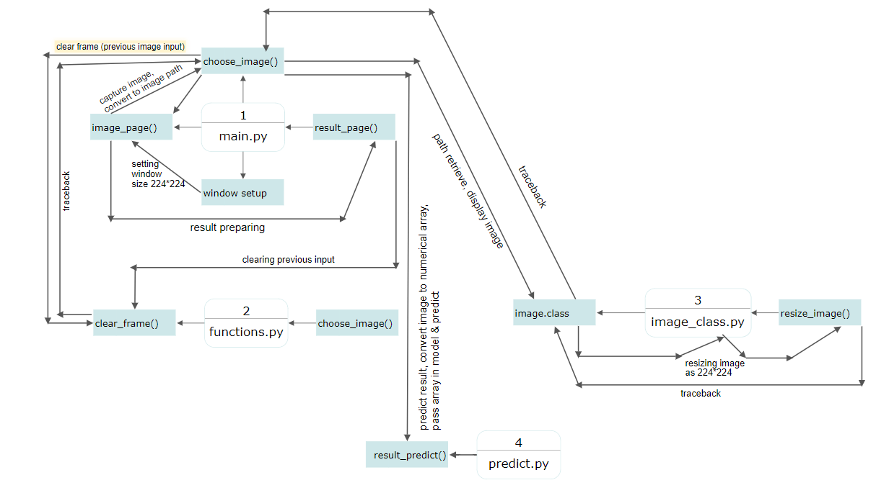
3.1 Data Flow Diagram
3.1.1 DFD
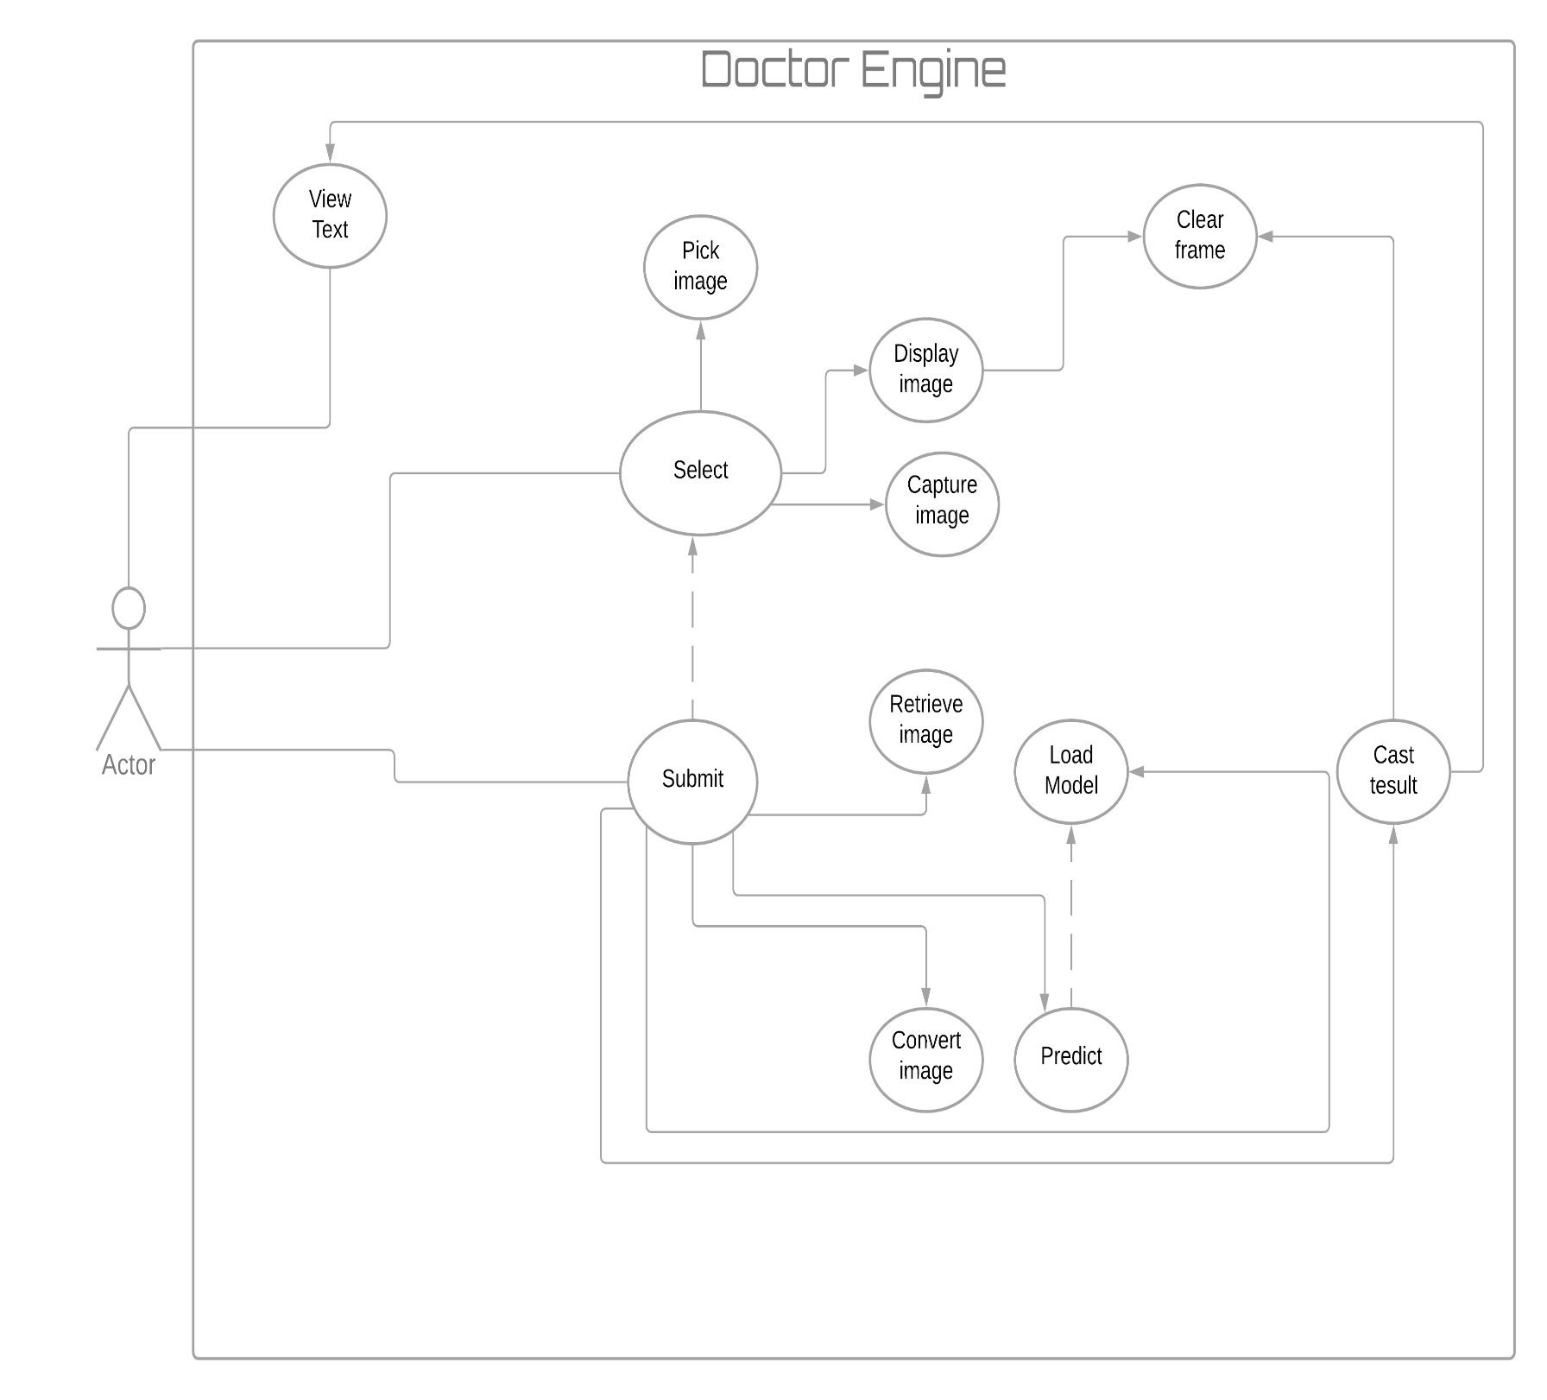
3.2 Use Case Diagram

3.2.1 Use Case Diagram

3.3 Use Case Description
Use Case ID |  | DE1
Use Case Name |  | View Text
Created By | Tanjil Hasan | Last Modification By
Date Created | 30.11.2020 | Last Modified By
Actor | User
Description | It displays all the necessary strings on the user interface.
Task flow | It prints the title along with some, necessary messaged
Tools | Tkinter Module

Use Case ID |  | DE2
Use Case Name |  | Pick Image
Created By | Tanjil Hasan | Last Modification By
Date Created | 30.11.2020 | Last Modified By
Actor | User
Description | Grabbing image from the local storage.
Task flow | - Image Grabbing  - Copy it’s path
Tools | Custom Algorithm

Use Case ID |  | DE3
Use Case Name |  | Display Image
Created By | Tanjil Hasan | Last Modification By
Date Created | 30.11.2020 | Last Modified By
Actor | User
Description | Displaying the selected Picture
Task flow | - Collect the path from pick image  - Locate the image  - Show the Image
Tools | Tkinter, Custom Algorithm

Use Case ID |  | DE4
Use Case Name |  | Capture Image
Created By | Tanjil Hasan | Last Modification By
Date Created | 30.11.2020 | Last Modified By
Actor | User
Description | Path receive and Make it useable for further Purposed
Task flow | - Take up the path  - Return the path  - Store it to global variable
Tools | Custom Algorithm

Use Case ID |  | DE5
Use Case Name |  | Clear Frame
Created By | Tanjil Hasan | Last Modification By
Date Created | 30.11.2020 | Last Modified By
Actor | User
Description | Destroying windows and clear frame
Task flow | Clear GUI all the previous session
Tools | Tkinter, custom Al

Use Case ID |  | DE6
Use Case Name |  | Retrieve Image
Created By | Tanjil Hasan | Last Modification By
Date Created | 30.11.2020 | Last Modified By
Actor | User
Description | This will rescue the image
Task flow | - Load the image using the path  - Store it into a variable
Tools | Custom Algorithm

Use Case ID |  | DE7
Use Case Name |  | Convert Image
Created By | Tanjil Hasan | Last Modification By
Date Created | 30.11.2020 | Last Modified By
Actor | User
Description | Converting the image data into array
Task flow | - Resize the image into 224 x 224  - It breaks image to numerical form  - Converts into an array  - Reshape them into a specific form
Tools | Numpy, matplotlib, python3,PIL

Use Case ID |  | DE8
Use Case Name |  | Load Model
Created By | Tanjil Hasan | Last Modification By
Date Created | 30.11.2020 | Last Modified By
Actor | User
Description | This module will load the model
Task flow | - Allocate the model in (.h5) extensions  - Load model into a variable for the usage
Tools | Keras, tensorflow, Custom Model

Use Case ID |  | DE9
Use Case Name |  | Predict
Created By | Tanjil Hasan | Last Modification By
Date Created | 30.11.2020 | Last Modified By
Actor | User
Description | Here it provides prediction results
Task flow | - Passes the array to the model(.h5) file  - Store prediction results in new array  - Array[0] indicates normal , array[1] indicates stroke result
Tools | Keras, tensorflow, Custom Model

Use Case ID |  | DE10
Use Case Name |  | Cast Result
Created By | Tanjil Hasan | Last Modification By
Date Created | 30.11.2020 | Last Modified By
Actor | User
Description | It prints the dialogue containing result
Task flow | - It compares the array result with condition  - Satisfied condition provides the exact string output
Tools | Keras, tensorflow, Custom Model

3.3.1
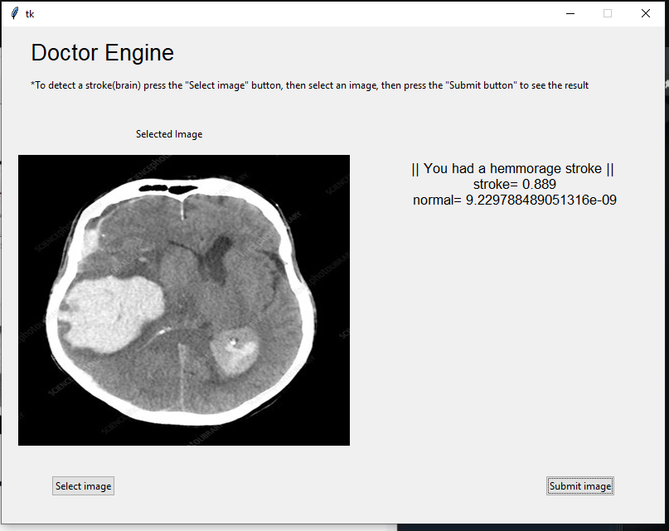
3.4 Front End Design
3.4.1 Front End Design
Chapter 4
Implementation and Testing
4.1 Data Collection
For data collection, we collected data from three different medical facilities in nearby areas:
- BSMMU Medical College & Hospital, Dhaka
- Ibn Sina diagnostic & Consultation Center, Savar
- Super Medical Hospital, Savar
From BSMMU, we received scanned brain images that has tumor, or any type of strokes. From Ibn Sina diagnostic & Consultation Center we received name wise sorted scanned brain images that has any type of tumor or strokes. Data collected from our last resource, Super Medical College was unfortunately not sorted and also included CT scanned images other than only brain stroke images.

4.2 Implementation Requirements
1. Spyder
2. AI
3. Machine Learning
4. CNN
5. Neural Network
6. Image Processing

4.3 Data Preprocessing
For preprocessing the data collected from three different medical facilities resources, we had to follow below procedures:
- We sorted out the collected data and separated only brain stroke cases.
- For brain stroke cases, we then sorted the remaining data in two different classes, one is hemorrhagic stroke case and other is normal case.
- So, for three different medical facilities we are getting total 6 classes of data, hemorrhagic stroke case for three hospitals and normal stroke case for three hospitals.
- We, now, take all the data and reduce it to only two class, hemorrhagic stroke case and normal case.
- But apart from these, the data we collected from different medical hospitals came at different sizes, quality and dimensions, so, maintaining a common required size for all the data/ scan copies together, we wrote a custom algorithm having the size 224*224 for every scanned image.

4.4 Testing Implementation
For testing implementation, we tested the whole project with some online images to compare the result with trained data sets to prove the system’s ability to correctly predict.
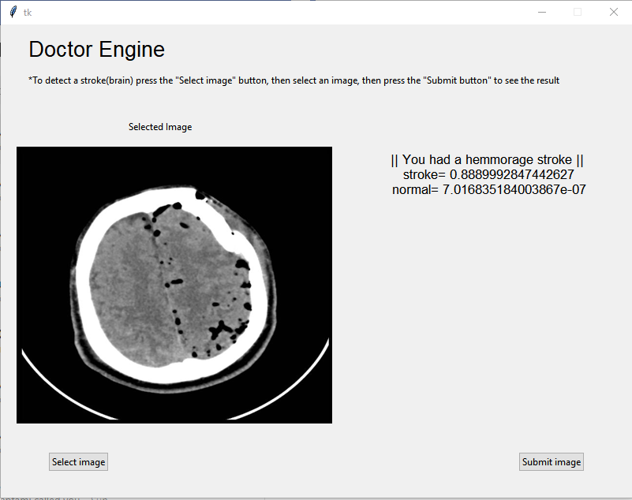
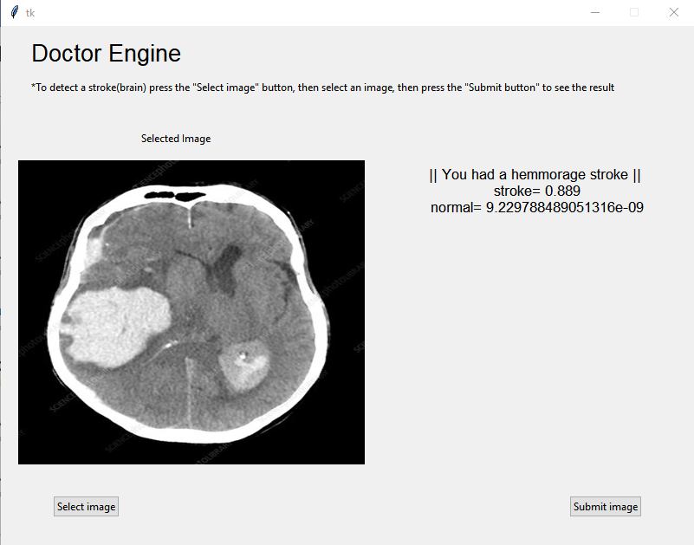
4.4.1 Trained vs online data set for hemorrhage stroke matching

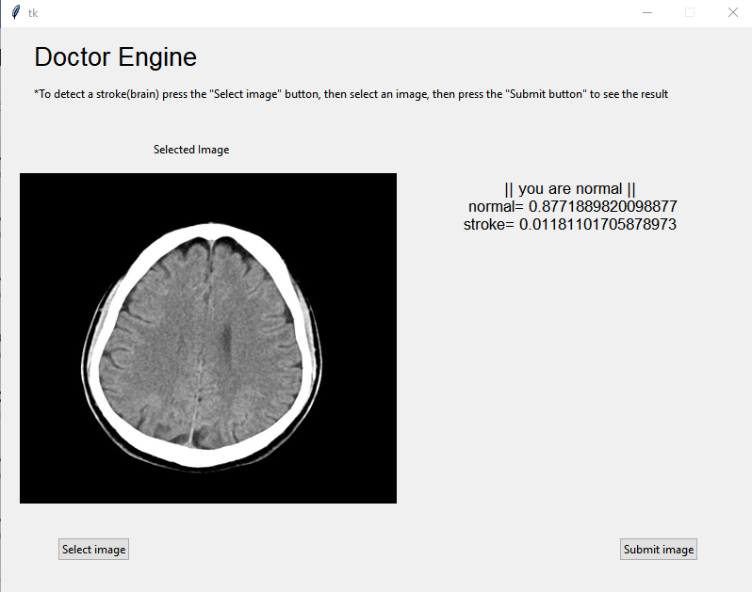
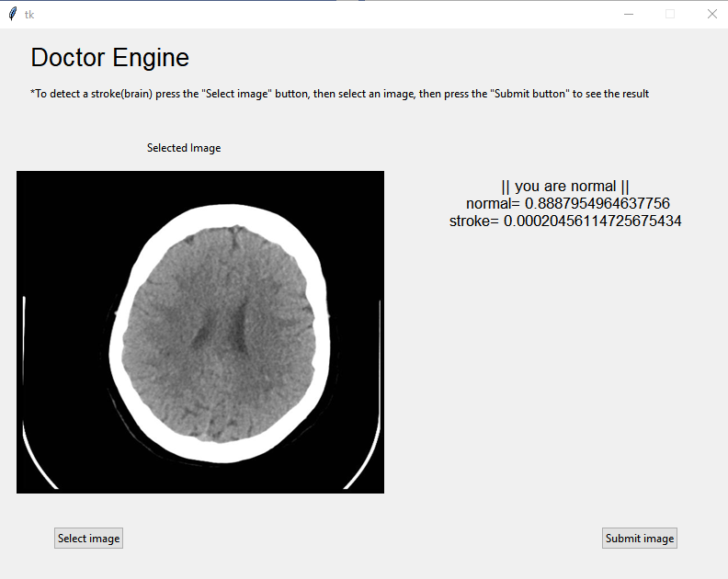
4.4.2 Trained vs online data set for hemorrhage stroke matching

4.5 Test Result
We have tested the whole program and according to the operations we can see that our detection accuracy in 94.19%, so we can reliably use this system as to predict hemorrhages with any brain scanned images.

Chapter 5
Algorithms
5.1 Python Libraries
Keras | Model | VGG16
Keras | Layers | Dense
Keras | Layers | Dropout
Keras | Layers | Activation
Keras | Layers | Flatten
Keras | Layers | Conv2D
Keras | Layers | Maxplogin2D
Keras | Layers | ZeroPadding2D
Keras | Layers | BatchNormalization
Keras | Preprocessing | ImageDataGenerator
Keras | Optimizers | RMSprop
Keras | Callbacks | ModelCheckpoint
Keras | Callbacks | EarlyStopping
Tkinters
Numpy

PIL | Image
PIL | GLOB

5.1.1 Libraries
5.2 Algorithms
5.2.1 Training
Import vgg16 of keras
# VGG16 was designed to work on 224 x 224 pixel input images sizes
img_rows <- 224
img_cols <- 224
#Loads the VGG16 model
vgg16 <- VGG16(weights <- 'imagenet',
include_top <- False,
input_shape <- (img_rows, img_cols, 3))
Import vgg16 of keras (application Module)
# VGG16 was designed to work on 224 x 224 pixel input images sizes
img_rows <- 224
img_cols <- 224
# Re-loads the VGG16 model without the top OR FC layers
vgg16 <- VGG16(weights <- 'imagenet',
include_top <- False,
input_shape <- (img_rows, img_cols, 3))
# Here we freeze the last 4 layers
# Layers are set to trainable as True by default
ENDFUNCTION
for layer in vgg16.layers:
layer.trainable <- False
ENDFOR
FUNCTION addTopModel(bottom_model, num_classes, D=256):
ENDCLASS

"""creates the top OR head of the model that will be
placed ontop of the bottom layers"""
top_model <- bottom_model.output
top_model <- Flatten(name <- "flatten")(top_model)
top_model <- Dense(D, activation <- "relu")(top_model)
top_model <- Dropout(0.3)(top_model)
top_model <- Dense(num_classes, activation <- "softmax")(top_model)
ENDCLASS

RETURN top_model
ENDFUNCTION

import Sequential of keras
import Dense, Dropout, Activation, Flatten of keras
import Conv2D, MaxPooling2D, ZeroPadding2D
import BatchNormalization
import Model of keras Models
num_classes <- 2
ENDCLASS

FC_Head <- addTopModel(vgg16, num_classes)
ENDCLASS

model <- Model(inputs=vgg16.input, outputs=FC_Head)
OUTPUT model.summary()
from keras.preprocessing.image import ImageDataGenerator
train_data_dir <- '/train Folder Location'
validation_data_dir <- '/test folder Location'
train_datagen <- ImageDataGenerator(
rescale=1./255,
rotation_range=20,
width_shift_range=0.2,
ENDIF
height_shift_range=0.2,
ENDIF
horizontal_flip=True, fill_mode='nearest')
validation_datagen <- ImageDataGenerator(rescale=1./255)
# Change the batchsize according to your system RAM
train_batchsize <- 16
val_batchsize <- 10
train_generator <- train_datagen.flow_from_directory(
train_data_dir,
target_size=(img_rows, img_cols),
batch_size=train_batchsize,
class_mode='categorical')
ENDCLASS

validation_generator <- validation_datagen.flow_from_directory(
validation_data_dir,
target_size=(img_rows, img_cols),
batch_size=val_batchsize,
class_mode='categorical',
ENDCLASS

shuffle=False)
import RMSprop
import ModelCheckpoint, EarlyStopping
checkpoint <- ModelCheckpoint("/path to save the model(.h5)",
monitor="val_loss",
mode="min",
save_best_only <- True,
verbose=1)
earlystop <- EarlyStopping(monitor <- 'val_loss',
min_delta <- 0,
patience <- 3,
verbose <- 1,
restore_best_weights <- True)
# we put our call backs into a callback list
callbacks <- [earlystop, checkpoint]
# Note we use a very small learning rate
model.compile(loss <- 'categorical_crossentropy',
optimizer <- RMSprop(lr <- 0.001),
metrics <- ['accuracy'])
# Note we use a very small learning rate
model.compile(loss <- 'categorical_crossentropy',
optimizer <- RMSprop(lr <- 0.001),
metrics <- ['accuracy'])
nb_train_samples <- 3297, nb_validation_samples <- 1000, epochs <- 10
batch_size <- 32
history <- model.fit_generator(
train_generator,
steps_per_epoch <- nb_train_samples // batch_size,
epochs <- epochs,
callbacks <- callbacks,
validation_data <- validation_generator,
validation_steps <- nb_validation_samples // batch_size)
model.save("/path to save the model(.h5)")

5.2.2 DOCTOR ENGINE WITH GUI
import tkinter
import ImageClass
ENDCLASS

import filedialog
import functions
from tkinter
import predict
root <- tk.Tk()
root.geometry("800x600")
root.resizable(width='false', height='false')
main_frame <- tk.Frame(root, background='lightblue')
main_frame.place(relx=0, rely=0, relheight=1, relwidth=1)
imagePath <- tk.StringVar()
FUNCTION
choose_image(display_frame, result_frame):
image_path <- tk.filedialog.askopenfilename(filetypes=[("Image File", '.jpg')])
functions.clearFrame(display_frame)
functions.clearFrame(result_frame)
try:
e <- ImageClass(display_frame, image_path)
e.pack(fill='both', expand='yes')
except AttributeError:
pass
imagePath.set(image_path)
ENDFUNCTION

OUTPUT imagePath.get()
FUNCTION image_page(image_page_frame):
functions.clearFrame(image_page_frame)
s <- ttk.Style()
s.configure('TFrame')
image_page_upper_frame <- ttk.Frame(image_page_frame, )
image_page_upper_frame.place(relx=0, rely=0, relwidth=1, relheight=0.20)
image_page_labels(image_page_upper_frame)
image_page_middle_frame <- ttk.Frame(image_page_frame, )
image_page_middle_frame.place(relx=0, rely=.20, relwidth=1, relheight=.65)
selected_image <- ttk.Label(image_page_middle_frame, text='Selected Image')
selected_image.place(relx=0.2, )
s.configure('image_page_image_frame.TFrame', background='white', )
image_page_image_frame <- ttk.Frame(image_page_middle_frame, style='image_page_image_frame.TFrame')
image_page_image_frame.place(relx=0.025, rely=0.09, relwidth=0.5, relheight=0.9)
image_page_result_frame <- ttk.Frame(image_page_middle_frame, )
image_page_result_frame.place(relx=0.595, relwidth=0.375, relheight=1)
image_page_lower_frame <- ttk.Frame(image_page_frame, )
# image_page_lower_frame.config(highlightbackground="gray", highlightcolor="gray")
image_page_lower_frame.place(rely=.85, relwidth=1, relheight=0.15)
select_image_button <- ttk.Button(image_page_lower_frame, text='Select image',
command=lambda: [choose_image(image_page_image_frame, image_page_result_frame)])
select_image_button.pack(padx=60, side='left')
submit_image_button <- ttk.Button(image_page_lower_frame, text='Submit image',
command=lambda: [result_page(image_page_result_frame, imagePath.get())])
submit_image_button.pack(padx=60, side='right')
ENDFUNCTION
FUNCTION image_page_labels(frame):
doctor_engine <- tk.Label(frame, text='Doctor Engine', font='Arial 20')
doctor_engine.place(relx=0.04, rely=0.1)
instruction <- tk.Label(frame, text='*To detect a stroke(brain) press the "Select image" button, then select an image, '
'then press the "Submit button" to see the result')
instruction.place(relx=0.04, rely=0.5)
ENDFUNCTION
ENDFUNCTION
FUNCTION result_page(result_page_frame, path):
functions.clearFrame(result_page_frame)
result1=predict.resultPredict(path)
OUTPUT 'printing in result page' + result1
result_page_label <- tk.Label(result_page_frame, text=result1,font='Arial 13')
result_page_label.place(relx=0.04, rely=0.1)
ENDFUNCTION
image_page(main_frame)
root.mainloop()

5.2.3 Function
import tkinter
import ImageClass
ENDCLASS
from tkinter import filedialog
FUNCTION clearFrame(selectedFrame):
widget.destroy()
ENDFUNCTION
ENDFOR
FUNCTION choose_image (imageFrame):
image_path <- tk.filedialog.askopenfilename(filetypes=[("Image File",'.jpg')])
imagePath <- image_path
OUTPUT imagePath
clearFrame(imageFrame)
e <- ImageClass(imageFrame, image_path)
e.pack(fill='both', expand='yes')

5.2.4 Image Class
import tkinter
import Image, ImageTk
CLASS ImageClass(tk.Frame):
FUNCTION __init__(self, master, path, *pargs):
tk.Frame.__init__(self, master, *pargs)
path <- path
image <- Image.open( path)
img_copy= image.copy()
background_image <- ImageTk.PhotoImage( image)
background <- tk.Label(self, image= background_image)
background.pack(fill='both', expand='yes')
background.bind('<Configure>', _resize_image)
ENDFUNCTION

FUNCTION _resize_image(self,event):
new_width <- event.width
new_height <- event.height
image <- img_copy.resize((new_width, new_height))
background_image <- ImageTk.PhotoImage( image)
background.configure(image <- background_image)
5.2.5 Predict
import load_model
import image
import preprocess_input
import numpy as np
FUNCTION resultPredict(imagePath):
model <- load_model('C:/Users/USer/Documents/DE TEST/TEST_PROJECT/var 02/flowers_vgg2.h5')
img <- image.load_img(imagePath, target_size=(224, 224))
x <- image.img_to_array(img)
x <- np.expand_dims(x, axis=0)
img_data <- preprocess_input(x)
classes <- model.predict(img_data)
ENDCLASS
p <- classes[0]
ENDCLASS
stroke=float(p[0])
positive=float(p[1])
IF stroke>=0.70:

result <- '|| You had a hemmorage stroke ||\n stroke= '+str(stroke)+'\n normal= '+str(positive)
ELSEIF positive>=0.70:
result <- '|| you are normal ||\n normal= '+str(positive)+'\nstroke= '+str(stroke)
ELSE:
result <- "!!!!!!!!!!!!! INVALID IMAGE!!!!!!!!!!!!!!!\nUpload The Real CT SCAN OF BRAIN"
ENDIF
RETURN result

5.2.6 Pre-processing: Bulk Image Conversion
from PIL import Image
import glob
image_list=[]
resized_images=[]
for filename in glob.glob('C:/Users/USer/Desktop/Datasets/stroke/*.jpg'):
OUTPUT filename
img=Image.open(filename)
image_list.append(img)
ENDFOR
for image in image_list:
image=image.resize((224,224))
resized_images.append(image)
ENDFOR
OUTPUT 'done'
for (i,new) in enumerate(resized_images):
new.save('{}{}{}'.format('C:/Users/USer/Desktop/224-224/sss',i+1,'.jpg'))
ENDFOR
ENDFOR
OUTPUT 'done'

5.3 Training Procedure
There are 3297 images in two classes as trained folder and 1000 images in two classes as test folder. The whole training procedure is completing in this way:

- Epoch count starts, 103 sets at one time, at first Epoch count, a low percentage is being trained, which will gradually be bigger.
- Each and every time Epoch is performing, it’s getting new data to learn, and more accuracy to earn.
- At max accuracy point, the Epoch stop taking any more input.

5.4 Outcomes

- We have constructed a desktop Application capable of detecting Hemorrhage stroke
- It can be integrated with the CT Scan machine which can automated the process identifying the hemorrhage stroke.
- The necessity of a Radiologist in the medical sector can be eliminated with this.

Chapter 6
Conclusion
6.1 Conclusion
In recent years there are so many papers published on brain hemorrhage. We also try to add some new information in brain hemorrhage with the help of machine learning. We use a device which helps to detect brain hemorrhage patents and also can suggest prescription. In this paper we collect various data set to detect brain hemorrhage. We also collect data from the various medical and internet sources.

6.2 Future work
Because of the way the virus has stopped all over the world, some of our work is still incomplete. In the future, we will make this idea a reality. We will further increase our data set. We will try to increase the frame rate further when collecting data from real patients. We will make detection more accurate. We will use simpler methods to detect brain hemorrhage.

Chapter 7
Reference

- Shivangi Gupta, Archit Mishra, and R. Menaka, “Ischemic Stroke detection using Image processing and ANN”,10.1109/ICACCCT.2014.7019334, May 2014
- Md. Solaiman Mia, “Detection of Brain Stroke from CT Scan Image”,10.13140/RG.2.2.26552.49922, June 2018
- Islem Rekik,Stéphanie Allassonnière,Trevor K.Carpenter and Joanna M. Wardlaw, “Medical image analysis methods in MR/CT-imaged acute-subacute ischemic stroke lesion: Segmentation, prediction and insights into dynamic evolution simulation models. A critical appraisal”,10.1016/j.nicl.2012.10.003, October 2017
- Yeu-Sheng Tyan, Ming-Chi Wu, Chiun-Li Chin, Yu-Liang Kuo, Ming-Sian Lee and Hao-Yan Chang,"Ischemic Stroke Detection System with a Computer-Aided Diagnostic Ability Using an Unsupervised Feature Perception Enhancement Method ", doi.org/10.1155/2014/947539, July 2014

