Identification of corona virus from X-ray images: A machine learning approach
by
Md.Rashid Arif
ID: 171-15-1199

Md.Hasibul Hasan
ID: 171-15-1400

And
Faridul Islam Tanjil
ID: 171-15-1279

This Report Presented in Partial Fulfillment of the Requirements for the Degree of Bachelor of Science in Computer Science and Engineering

Supervised By

Dr. S.M. Aminul Haque
Associate professor
Department of CSE
Daffodil International University

Co-Supervised By

Mushfiqur Rahman
Lecturer
Department of CSE
Daffodil International University



DAFFODIL INTERNATIONAL UNIVERSITY
Dhaka, Bangladesh
December 2020

APPROVAL

This Project titled “Identification of corona virus from X-ray images A machine learning approach”, submitted by Md.Rashid Arif, ID:171-15-1199, Md.Hasibul Hasan, ID: 171-15-1400, And Faridul Islam Tanjil, ID: 171-15-1279 to the Department of Computer Science and Engineering, Daffodil International University, has been accepted as satisfactory for the partial fulfillment of the requirements for the degree of B.Sc. in Computer Science and Engineering and approved as to its style and contents. The presentation has been held on 09-11-20.

Board of Examiners

(Name) Chairman
Designation
Department of CSE
Faculty of Science & Information Technology
Daffodil International University

(Name) Internal Examiner
Designation
Department of CSE
Faculty of Science & Information Technology
Daffodil International University

(Name) External Examiner
Designation
Department of -------
Jahangirnagar University

Declaration

We hereby declare that, this project has been done by us under the supervision of Dr. S.M. Aminul Haque, Associate professor, Department of CSE Daffodil International University. We also declare that neither this project nor any part of this project has been submitted elsewhere for award of any degree or diploma.

Supervised by:

Dr. S.M. Aminul Haque
Associate professor
Department of CSE
Daffodil International University

Co-Supervised by:

Mushfiqur Rahman
Lecturer
Department of CSE
Daffodil International University

Submitted by:

Md.Rashid Arif
ID: 171-15-1199
Department of CSE
Daffodil International University

Md.Hasibul Hasan
ID: 171-15-1400
Department of CSE
Daffodil International University

Faridul Islam Tanjil
ID: 171-15-1279
Department of CSE
Daffodil International University

ACKNOWLEDGEMENT

First we express our heartiest thanks and gratefulness to almighty God for His divine blessing makes us possible to complete the final year project/internship successfully.

We really grateful and wish our profound our indebtedness to Supervisor Dr. S.M. Aminul Haque, Associate professor, Department, Department of CSE Daffodil International University, Dhaka. Deep Knowledge & keen interest of our supervisor in the field of “Deep Convolution Neural Network” to carry out this project. His endless patience ,scholarly guidance ,continual encouragement , constant and energetic supervision, constructive criticism , valuable advice ,reading many inferior draft and correcting them at all stage have made it possible to complete this project.

We would like to express our heartiest gratitude to Dr. S.M. Aminul Haque, Mushfiqur Rahman, and Head, Department of CSE, for his kind help to finish our project and also to other faculty member and the staff of CSE department of Daffodil International University.

We would like to thank our entire course mate in Daffodil International University, who took part in this discuss while completing the course work.

Finally, we must acknowledge with due respect the constant support and patients of our parents.

Abstract

In late December 2019, China announced the novel COVID-19 coronavirus. And after that, it spread all around the world, taking the place of a pandemic. In the meantime, there are many testing kits available but it takes time to get test results so we need to fast disease detection. for that reason, there is some work done on neural network models. all those images are performed on CXR data that are publicly available. In this study, we also work on five different pre-trained models(resnet-50, Inception V3, Inception Resnet V2, Resnet-101, Resnet-152) for the classification and detection of these diseases and we also have compared their accuracy on different epoch values. After evoluted all the models throughout the accuracy, recall, f1-scores we have got that resnet-50 perform 100% accuracy, Recall 100% and Precision 100% with 30 epoch value and also Resnet-101 perform 100% accuracy on epoch value 40. Those two models have given better results to compare with the other models.

TABLE OF CONTENTS
CONTENTS | PAGE
Board of examiners | 2
Declaration | 3
Acknowledgement | 4
Abstract | 5
CHAPTER
CHAPTER 1: INTRODUCTION | 10-13
1.1 Overview | 10
1.2 Problem Definition | 11
1.3 Motivation | 12
1.4 Objectives | 12
1.5 Contribution | 13
CHAPTER 2: LITERATURE REVIEW | 13-14
2.1 Literature Review | 13
CHAPTER 3: METHODOLOGY | 14-24
3.1 Deep Transfer Learning Architecture | 14
3.1.1 Convolutional Layer | 15
3.1.2 Pooling Layer | 16
3.1.3 Fully Connected Layer | 17
3.2 Pre-Trained Models | 18
3.2.1 ResNet50 | 19
3.2.2 InceptionV3 | 20
3.2.3 Inception-ResNetV2 | 21
3.2.4 ResNet101 | 21
3.2.5 ResNet152 | 22
3.3 Performance Metrics | 23
CHAPTER 4: MATERIALS AND RESULT ANALYSIS | 24-33
4.1 Dataset | 24
4.2 Results and Discussion | 26
4.2.1 Experimental Analysis of Accuracy | 26
4.2.2 Experimental Analysis of Precision | 27
4.2.3 Experimental Analysis of Recall | 29
4.2.4 Experimental Analysis of F1-Score | 30
4.2.5 Performance results for the best epoch Value | 32
CHAPTER 5: CONCLUSION AND FUTURE SCOPE | 33-34
5.1 Conclusion | 33
5.2 Limitation | 34
5.3 Future scope | 34
CHAPTER 6: REFERENCES | 34-39
6.1 References | 34

LIST OF FIGURES
FIGURES | PAGE NO
Figure 1.1.1:The affected cases of COVID-19 worldwide by country | 10
Figure 3.1.1: Convolutional layer | 16
Figure 3.1.2: Pooling Layer | 17
Figure 3.1.3: Fully Connected Layer | 18
Figure 3.2.1: Schematic diagram of pre-trained models for normal and COVID-19 patient | 19
Figure 3.2.2: Architecture of Resnet50 | 20
Figure 3.2.3: Inception V3 | 20
Figure 3.2.4: Inception ResnetV2 | 21
Figure 3.2.5: Architecture of Resnet101 | 21
Figure 3.2.6: Steps of Resnet152 | 22
Figure 3.3.1: Confusion/Performance Matrix | 23
Figure 4.1.1: Covid-19 X-ray Images | 25
Figure 4.1.2: Normal X-ray images | 25
Figure 4.2.1: Graphical representation of Accuracy of all models | 27
Figure 4.2.2: Graphical representation of precision of all models | 28
Figure 4.2.3: Graphical representation of Recall of all models | 30
Figure 4.2.4: Graphical representation of F1-Score of all models | 31

LIST OF TABLES
TABLES | PAGE NO
Table 4.1.1: The number of pictures per dataset | 24
Table 4.2.1: Accuracy of applied models | 26
Table 4.2.2: Precision of applied models | 27
Table 4.2.3: Recall of applied models | 29
Table 4.2.4: F1-score of applied models | 30
Table 4.2.5: Best performer models with best EPOCH values | 32

CHAPTER 1
Introduction

1.1 Overview
One of the biggest challenges that face in the 21st century is the Corona Virus (covid-19). It started as a simple infectious disease of Severe acute respiratory syndrome (SARS-CoV-2) in China in the last of 2019 [1]. After some days it transforms into a pandemic with its high contagiousness and it suddenly spreads very quickly all over the world. Till October 2020 around 42.7million people affected and 1.15million people passed away by Covid-19 [2]. The affected cases of COVID-19 worldwide by country are shown in Fig. 1.1.1 [7].
These diseases can affect every age of people and it can spread from animals to the human body [3][4]. Coronavirus is a broad group of viruses that cause by SARS-CoV(Severe Acute Respiratory Syndrome) and MERS-CoV (Middle East Respiratory Syndrome) arising from colds. This new form of disease (COVID-19) that has not been previously observed in the human body was first discovered in 2019 [5]. The most common symptoms for Covid-19 are Fever, Coughing, Shortness of Respiration, Breathing problems, Loss of scent or flavor. And in some cases, we can see Tiredness, Chills with shaking occasionally, Aches of the body, Headaches, Soreness of throat, Runny nose / Congestion, Nausea, Diarrhoea [6].

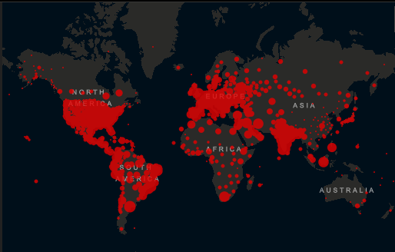
Figure 1.1.1: The affected cases of COVID-19 worldwide by country.

The total death all over the world is 2.69%. Till now the highest mortality rate in the USA, India, Brazil, Russia, and Spain [2].

1.2 Problem Definition
Nowadays this virus is conducting human life in risky situations. Because This Virus spread from human to human by droplets [8][9]. To prevent rapid spreading in the absence of Applicable Vaccine and proper medicine we need to detect these diseases very quickly in the early stages and Immediate diagnosis and medication, as well as isolation to limit the transmission of the virus.

The primary standard test used for identification is RT-PCR (Reverse Transcribe-Polymerase Chain Reaction) testing, approved by WHO and granted as the ideal tool for detecting the worldwide for Covid-19 virus. [6][10].
But The low RT-PCR sensitivity, however, causes several patients of COVID-19 to be unknown. It is also stated that the test results are collected over a period of a few hours to two days [11-13]. Moreover, the RT-PCR procedure may have to be tested several points for some patients to be diagnosed with COVID-19 [14][15]. In the beginning, inability to detect this infection causes the sufferer not to get adequate treatment on time also raises the risk of this epidemic spreading to a larger community given the fastest infectiousness of the existence of the virus.The reality that the amount of RT-PCR test kits is inadequate currently, it takes a long time to collect the results and the high probability that health care employees will be harmed during the test means must need other testing methods alternative to RT-PCR test.

Radiography analysis has also become an alternative diagnostic tool that has been used for COVID-19 detection, Whether CT (Computed Tomography) or CXR (Chest X-ray) imaging is done and studied by radiologists for visual markers consistent with viral SARS-CoV-2 disease in chest radiography [16]. CT images are very high detailed images than CXR images. But due to Consider some terms in this CoV test the best images will be CXR images. Because of

- CXR imaging allows for fast triage.
- In many clinical places, CXR imaging is easily accessible and affordable.
- The presence of portability of CXR results showed imaging can be carried out inside insulation chambers, thus effectively decreasing the chance of transmission of coronavirus.

With the help of Chest X-ray images and advanced Deep Learning Algorithms, we can detect the Covid-19 virus numerically at the early stage in any place.

1.3 Motivation

Corona virus is spreading very fast because of the lack of corona positive person identification. Normally this virus stays in the human body for some days without any symptoms. Also motivated By Expensive and Lack of testing kits, Complex procedure, and physically present when it is tested. Inspired by the research community's open source and open access activities, This research presents a deep convolutionary architecture of the neural network designed for defining coronavirus cases from open-source and publicly accessible CXR photos, with a more commonly available and relatively CXR imaging technique. To achieve a higher prediction accuracy for X-ray datasets for this reason ,we have used some pre-trained model of Inception-ResNetV2, ResNet101, ResNet152, and InceptionV3.

1.4 Objectives
This diseases spreading very rapidly. To detect as many as patients to stop over spreading this disease we are working on it. Also to identify the risk factors of corona virus diseases. And to reduce the costing and complex procedures during test of corona virus. To prevent the spread of these diseases and minimize the sudden death of patients we are working on it. Some work has already done so also to identify the best epoch for the best model to get the highest accuracy we are working on this paper.

1.5 Contribution
But In this study, Our main participation is to work with five different models with three different combination of epochs and propose an efficient deep learning-based model with higher accuracy. We are going to discussed an automated COVID-19 prediction using deep neural network models with CXR images.

CHAPTER 2
Literature Review

2.1 Literature Review
It can be seen from previous empirical research that it is more easy for CNN to label complex images data. There is a lot of work that has been done recently in this field which shown that Arman Haghanifar, Ali Narin, and many others take a vital part in automatic coronavirus identification with chest CXR images. Here mentionable some are

Arman Haghanifar et al [17]. They have worked on a model based on DenseNet that is constructed with the initial weights set by the CheXNet model. In their paper they use DenseNet-121 with different epoch values on different data sets in 100 images they get 96.72%. But it does not consider the best accuracy for best epoch value for a single model that is very important.

Ali Narin et al [18]. In their paper, they also work on a huge dataset and five models(ResNet50, ResNet101, ResNet152, InceptionV3, and Inception-ResNetV2) with 5 folds and three binary classifications. They proposed that among the models ResNet50 has a heights accuracy of 99.7%. They also did not mention the epoch value for the best accuracy result. The change of accuracy depends on epoch value and its effect on run time execution.

Ahmad Waleed Salehi et al [35].In this paper, they try to grasp this novel virus epidemiology as well as the main prevention from spreading of SARS-CoV_2. They evaluate the machine and deep learning-based structures performance of coronavirus images for classification. But we see the same thing here. They didn’t show any kind of epoch variation which affects the performance most.
Heidari et al [36].For development and research, a new computer-aided diagnostic system for CXR images is suggested in this study to diagnose Covid-19 infected pneumonia.
They demonstrate here that a crucial part of generating a deep learning computer-aided design(CAD) of CXR images is to apply two moves of image preprocessing and produce a pseudo-color image. So that they can increase accuracy in the identification of contaminated COVID-19 pneumonia. But here above all the analysis, they didn't touch the epoch variation part which impacts on accuracy.

In this research, a deep learning-based model was suggested to classify the coronavirus using the CXR image dataset. Epoch plays a key role in proposing a deep learning-based platform. But the aforementioned studies did not consider the epoch value. The study explains the role of epoch and finds a suitable epoch value that significantly increases the effectiveness of the recommended model. The research primarily suggests an efficient model focused on deep learning with greater accuracy. we are going to discussed an automated COVID-19 prediction using deep neural network models with CXR images.

CHAPTER 3
Methodology

3.1 Deep Transfer Learning Architecture:
Deep learning, inspired by brain structure, is included in machine learning as a sub-branch. Nowadays Deep learning techniques are using in vast areas of our life and we are getting very impressive results in all sectors also in the medical sector for image processing. It getting useful patter and information from medical data by applying deep learning methods in medical sectors. Deep learning models are using successfully in many sectors like the classification of data, lesion detection, segmentation of data in medical sectors. Study of signal and image data with image processing methods are X-ray Images(CXR) ,Computed Tomography (CT),Magnetic Resonance Imaging (MRI), by using deep learning models. For this reason, disease analysis, detection, and diagnosis are very efficient for brain tumors, breast cancer, skin diseases, diabetes mellitus [19-24].

There are a lot of sectors in deep learning study. The image processing problems are solved by the Convolutional neural network which is the sector of the deep neural network [25]. If we talk about how CNN models work, we input image data, and the image is recognized by computers, and it converts the image in a matrix format that can be processed later. The system can classify the categories of images by recognizing the difference in image patterns. When we input image data to train the model learn from test image and make the different labels of images. after that when we enter the test set image data it can predict the output of the image. And can predict all images in different categories. The CNN mainly analyze and predict image with the help of three different layers of CNN. Those are the convolutional layer which is the first layer of CNN, pooling layer which is for feature maps, and fully connected layer that extract the data. The CNN pooling layer will provide extraction from the input images in the convolutional layer and is the fully connected layer. It can classify all the images into different categories. All layers are described briefly in the following.

3.1.1 Convolutional Layer:
One of the three-layers is the Convolutional Layer. Which is the base layer of CNN models. It features patterns from image data. In this process, the input image passed through a filter. A function map consists of the values originating from filtering. By applying in this layer it can extract high and low-level features from image data with the help of some kernels [26]. To identify the input pattern matrix the Kernel uses 5*5 and 3*3 transform matrix. A filter modifies the shifting movement over the image with the help of the Stride parameter that compresses the images for CNN.

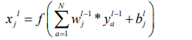

Here ya represent the a-th feature map in the layer, xj is the j-th feature map layer. Wj indicates the j-th kernal and Bj indicates as a bias of j-th feature map. N is the number of total features in layer and (*) is the vector process for convolution [27].

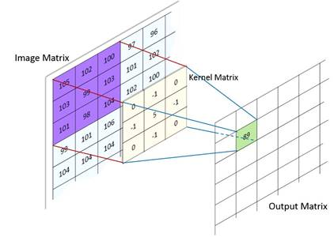
Figure 3.1.1: Convolutional layer

3.1.2 Pooling Layer:
The second layer after the convolutional layer is the pooling layer. Add mathematical computations and create new feature maps to reduce the amount of image pooling layer feature maps. There are some pooling layers in CNN but here we are using only two. Max pooling and Global average pooling layer. The maximum pooling layer always takes maximum values of the image matrix and makes a new feature map of the image and it reduces the output neurons. After that, the global average pooling layer is used before the fully connected layer. It reduces the data signal from the matrix. The dropout layer is the other intermediate layer that avoids overfitting and divergence in the network [28]. After finishing the pooling layer step it is trained for classification.

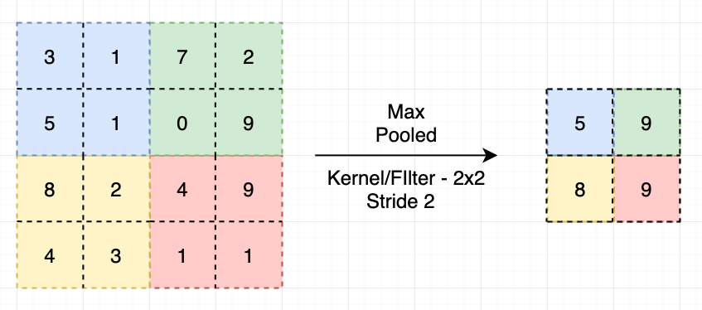
Figure 3.1.2: Pooling Layer

3.1.3 Fully Connected Layer:
The fully connected layer is the last and most relevant layer on CNN. This is a multilayer backpropagation. Two functions used in this layer for fully connecting all features and the other is for predicting the output. The two activation functions ReLU(Rectified Linear Unit) and softmax use for predicting the output image in a fully connected layer. The mathematical of these two are respectively given below:
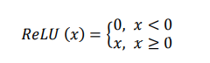
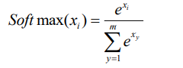

Where the input data and the number of classes are xi and m respectively [27].

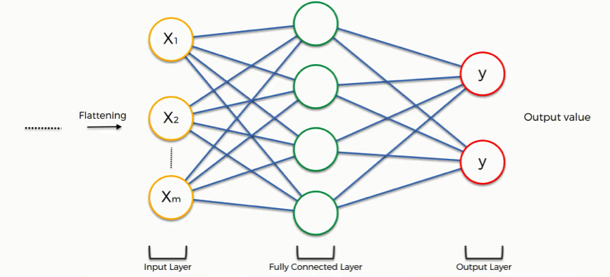
Figure 3.1.3: Fully Connected Layer

3.2 Pre-Trained Models
In this study, we are dealing with the COVID-19 dataset. But here researchers are facing a big challenge. And that is, they find an insufficient number of the open dataset, while they were dealing with medical data. Whereas deep learning working with the learning methodology of AI So, sometimes it needs a huge amount of data. But here is another problem stand on this site, that is Labeling this dataset by any experts is quite time-consuming as well as very much expensive. On the other side When we talking about the transfer learning methodology we see that this type of methodology needs a more limited calculation cost and it enables less dataset for the training of data. The information passed to the algorithm to be trained in the transfer learning process, which was accomplished on a large dataset by the pre-trained model.

To classify of CXR images of COVID-19, here we developed deep CNN based ResNet152, ResNet50,InceptionV3,Inception-ResNetV2 andResNet101 models. When we apply ImageNet data, the lack of data and training time can be resolved, and we have used a transfer learning method for this explanation. We used traditional CNN including pre-trained ResNet152, InceptionV3, ResNet101, ResNet50, and Inception ResNetV2 models to forecast standard, COVID-19 here we used conventional CNN including pretrained ResNet152, InceptionV3, ResNet101, ResNet50, and Inception ResNetV2 models.Here in figure 4 represent all the thing clearly. For open access as well these things publicly accessible at https://github.com/afiksourav/covid-19-detection-.git
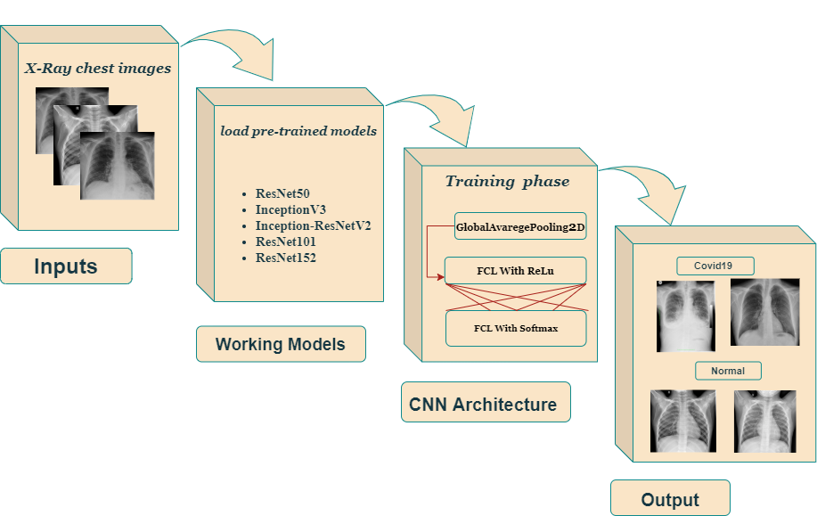
Figure 3.2.1: Schematic diagram of pre-trained models for normal and COVID-19 patient

3.2.1 ResNet50
The full version is the Residual neural network variant of the ResNet model. The Resnet(Residual neural model) is an improved variant of the CNN(convolutional neural network). One of the better aspects of it's when the network becomes larger and more complicated, this eliminates the distortion that happens. Furthermore, for making training quicker in the ResNet model, bottleneck blocks are used [29]. As an imageNet dataset ResNet50 trained 50 layer network. If we describe imageNet, it is a database of photographs of more than 14million images for visual recognition contents belonging to more than 20,000 categories [30].
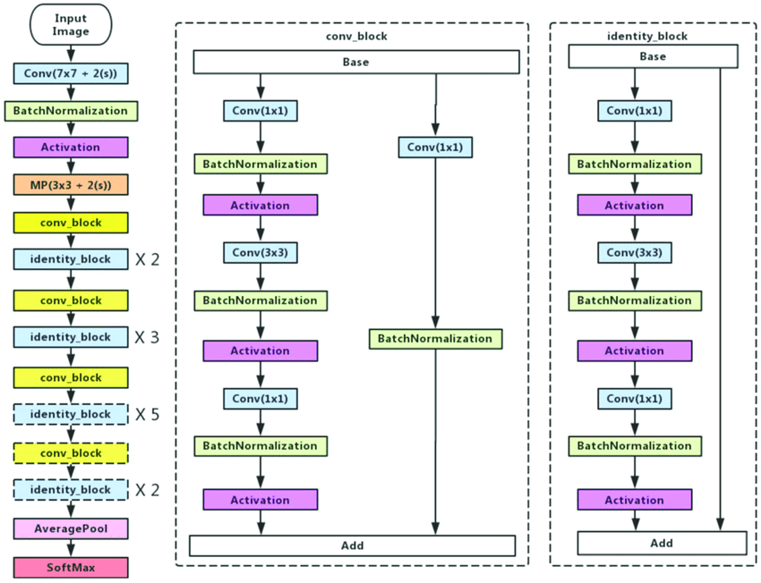
Figure 3.2.2: Architecture of Resnet50
3.2.2 InceptionV3
There is another type of convolutional neural network model is inception V3. This requires many convolution measures and most pooling treads. It comprises a completely linked neural network on the last level. The ImageNet dataset trains the network, like the model ResNet 50 [31].
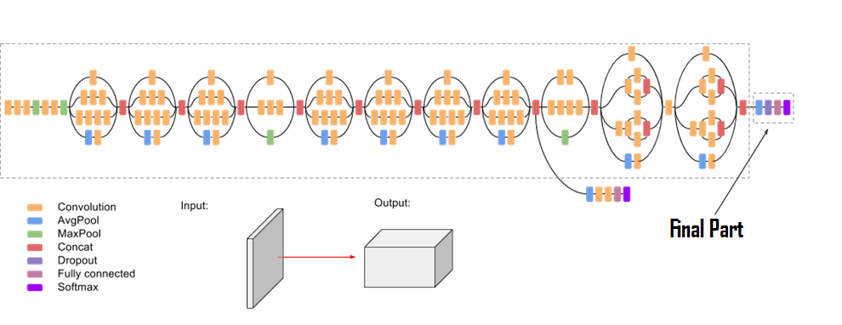
Figure 3.2.3: Inception V3

3.2.3 Inception-ResNetV2
The model includes a deep convolutional network, implementing the Inception-ResNetV2 structure trained on the ImageNet-2012 dataset. A list of approximate class probabilities is the output, and a 299-299 picture is the input to the model [32].
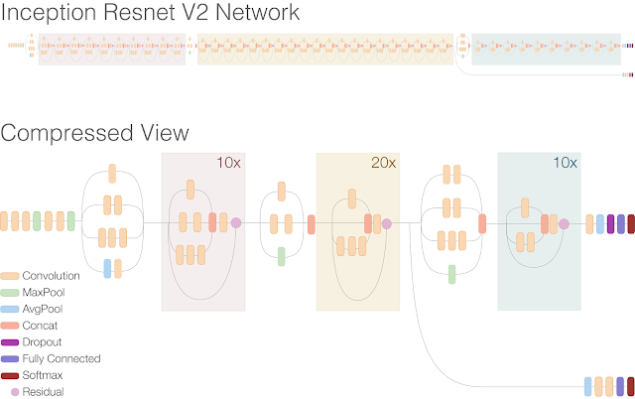
Fig ure 3.2.4: Inception ResnetV2

3.2.4 ResNet101
For accumulated ResNet building blocks, ResNet101 contains 101 layers. From the database of ImageNet, anyone can load a pre-trained edition of the network with more than one million images [33]. For this purpose, for a wide variety of images, the network has learned rich function representations. 224x224 is the input size of the network image.
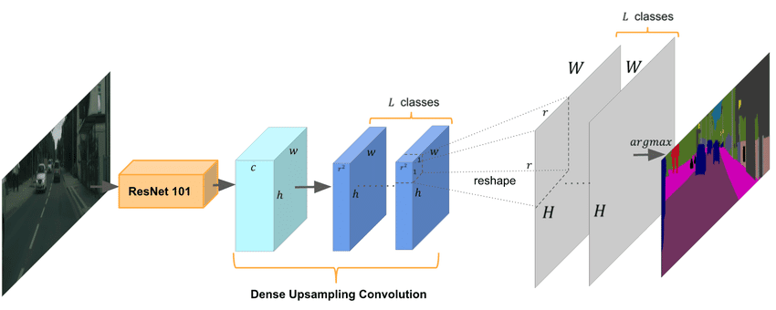
Fig ure 3.2.5: Architecture of Resnet101

3.2.5 ResNet152
As with ResNet101 for accumulated ResNet building blocks, resnet151 contains 151 layers and also anyone can load a pre-trained edition of the network, from the database of ImagNet [34]. Like ResNet101 here 224x224 is the input size of the network image.
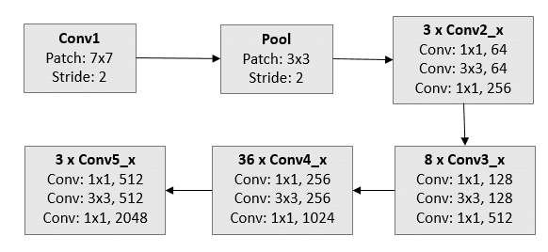
Figure 3.2.6: Steps of Resnet152.

3.3 Performance Metrics:
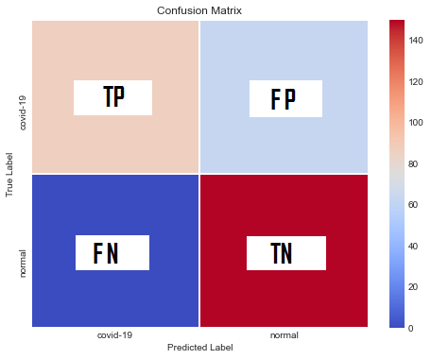
Figure 3.3.1: Confusion/Performance Matrix.

Performance metrics is a method for summarizing the results of a classification algorithm. How effectively and efficiently the algorithm is working or not. If you have an unequal number of findings our CNN classification accuracy can be misleading. By using the performance matrix/ Confusion matrix we can find the true values and false values of our prediction.

X = (B + A) / (B + A + D + C) (1)
Y = A / (A+ C) (2)
Z = A / (A + D) (3)
P= 2 * ((Y * Z) / (Y + Z)) (4)
Q= B / (B + C) (5)

Here in equation(1-5) A means True positive, B means True Negative, C means False-positive and D means False Negative, X=Accuracy, Y=Precision, Z=Recall, P=F1-Score, Q=Specificity. From Our dataset, it is True Positive is COVId-19 positive patients and also our model perfectly-identifies that they are COVID-19 Positive. FP is the normal patient that misbalanced as a COVID-19 positive patient through our CNN model. TN is a normal patient that has not COVID-19 and also our model has labeled them as a normal patient. And the last one is FN are COVID-19 positive patients but our model detects them as a normal patient.

CHAPTER 4
Materials and Result Analysis

4.1 Dataset

In this analysis, a total of 1300 CXR images were collected from the open-source GitHub repository. Our analyses were based on a dataset consisting of train 500 covid positive CXR images and 500 NORMAL CXR images. Furthermore, tests for 150 covid positive CXR images and 150 normal CXR images. A visual table 4.2.1 & 4.1.2 is given below:

Table 4.1.1: The number of pictures per dataset.
Dataset | Covid-19 chest X-ray dataset | Normal chest X-ray dataset
Train Data | 500 | 500
Test Data | 150 | 150

Covid-19 X-Ray Image
All images of our dataset resized at 224x224 pixel .figure 4.1.1 and figure 4.1.2 represent respectively CXR images of covid positive patients and normal images are given below.

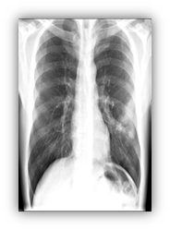 | 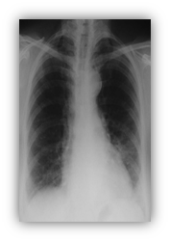 | 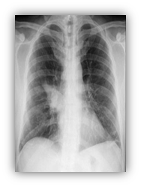 | 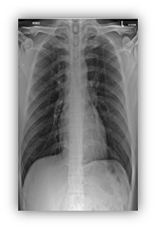

Figure 4.1.1: Covid-19 X-ray Images

Normal X-Ray Image

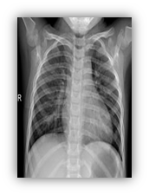 | 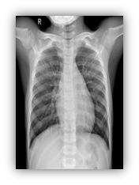 | 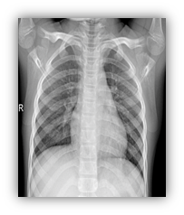 | 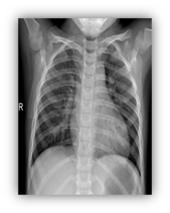

Figure 4.1.2: Normal X-ray images

4.2 Results and Discussion
In this article, the implementation of deep transfer learning models is carried out using a computer device with 16 GB RAM with an Intel Core i7-7700 CPU built on Windows 10 (64 bits). Chest X-ray images were used, for the prediction of the COVID-19. For the prediction of the COVID-19, CXR images were used. We conducted two distinct groups (COVID-19, normal). Five different deep learning model was employed on the dataset such as ResNet50, InceptionV3, ResNet152, ResNet101 and Inception-ResNetV2 models with a batch size of 2, test size 2 , learning rate 0.00001 and three different(20,30,40) epochs. A total of 300 CXR images was employed to test the model as a test dataset, where 150 CXR images were positive and 150 CXR images were negative. Any of the performance measures, such as log loss, precision, accuracy, recall, ROC-Curve, and f1-score, were considered in order to identify the best performer model of all the models used. All the results and performance of all the concerned models of CNN are described in the section below.

4.2.1 Experimental Analysis of Accuracy

Table 4.2.1: Accuracy of applied models
Epoch | Resnet-50 | Resnet-101 | Inception V3 | Resnet-152 | Inception Resnet-V2
20 | 99 | 99 | 98 | 88 | 77
30 | 100 | 99 | 98 | 89 | 79
40 | 100 | 100 | 87 | 95 | 78

The accuracy values of different models are displayed in Table 4.2.1 according to the epoch value. It is observed that for epoch 40, all models except Inception Resnet-V2 provide the worst accuracy. For epoch values 20 and 30, which are 99 percent and 98 percent respectively, Resnet-101 and Inception V3 display equal accuracy. If the epoch value is 30 Resnet-50 and Resnet-101, the accuracy is 100% and 99% respectively. Overall, Resnet-50 for epoch 30 and Resnet-101 for epoch 40 is the highest performer model, giving 100 percent accuracy. So we see that the best fit epoch value is 30 for Resnet-50 and 40 for Resnet-101 in this experiment.

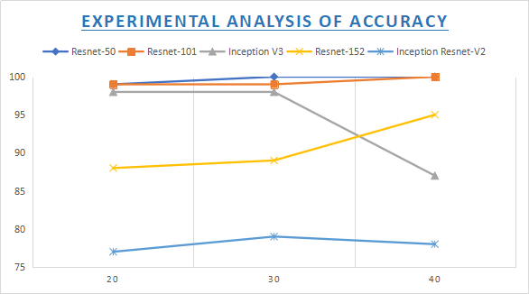
Figure 4.2.1: Graphical representation of Accuracy of all models

Figure 4.2.1 is a graphical representation of Table 4.2.1. Figure 4.2.1 illustrates that Inception Resnet-V2 is the least performing model. However the highest performing models are Resnet-50 and Resnet-101, where the best fit epoch value is 30 for Resnet-50 and 40 for Resnet-101.

4.2.2 Experimental Analysis of Precision

Table 4.2.2: Precision of applied models
Epoch | Resnet-50 | Resnet-101 | Inception V3 | Resnet-152 | Inception Resnet-V2
20 | 99 | 99 | 98 | 90 | 83
30 | 100 | 99 | 98 | 91 | 85
40 | 100 | 100 | 90 | 95 | 85

Table 4.2.2 demonstrates the precision values of different models according to epoch value. While epoch value 20 is considered, it is found that all the models except Inception V3 provide the least precision, where Inception V3 shows the least performance when the epoch value is 40. Resnet-101 and Inception V3 show the same precision for epoch value 20 and 30, which is 99% and 98% respectively. Inception Resnet-V2 and Resnet-152 show the best performance for 30 and 40 epoch values respectively. However, Resnet-50 and Inception Resnet-V2 produce the same and best precision for epoch value both of 30 and 40, which is 100% and 85% respectively, while Resnet-101 show the best performance for epoch value of 40. Overall, it is found that the least performer model is Inception Resnet-V2 and the best performer model is Resnet-50 and Resnet-101, where the best fit epoch value is 30 and 40 for Resnet-50 and 40 for Resnet-101.
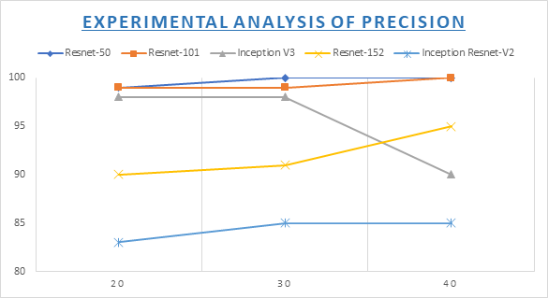
Figure 4.2.2: Graphical representation of precision of all models
Figure 4.2.2 is a graphical presentation of table 4.2.2. Figure 4.2.2 depicts that the least performing model is Inception Resnet-V2. However, Resnet-50 and Resnet-101 are the best performing models, where their best fit epoch value is 30 and 40 for Resnet-50 and 40 for Resnet-101.

4.2.3 Experimental Analysis of Recall
Table 4.2.3: Recall of applied models
Epoch | Resnet-50 | Resnet-101 | Inception V3 | Resnet-152 | Inception Resnet-V2
20 | 99 | 99 | 98 | 88 | 77
30 | 100 | 99 | 98 | 89 | 79
40 | 100 | 100 | 87 | 95 | 78

The Recall of the impact of five models (Resnet-50, Resnet-101, Inception V3, Resnet-152, Inception Resnet-V2) with three epoch values are shown above in Table 4.2.3. When the epoch value of 20 is observed, it is noticed that all models are performing very well. In epoch 40 inception v3 and inception resnet-v2 we have seen that they perform very least but they perform best in epoch 30. resnet 152 perform very well respectively 88, 89, and 95 for epoch 20, 30, and 40. Resnet-50 and Resnet-101 are done ultimate recall in epoch 40. It gives us 100 percent in epoch 40. but when the epoch was 30 then Resnet-50 perform 100 percent Recall but in epoch 30 Resnet-101 performed 99 percent. So, We can state that The least performer model is found to be Inception Resnet-V2. Resnet-50 and Resnet-101 are the highest performer model where the best test epoch value is 30 and 40 for Resnet-50 and 40 for Resnet-101.

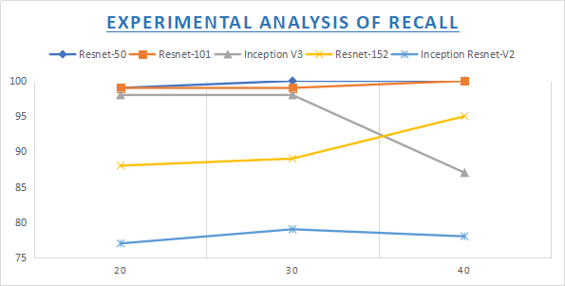
Figure 4.2.3: Graphical representation of Recall of all models

Figure 4.2.3 is a graphical representation of Table 4.2.3. Figure 4.2.3 shows that Inception Resnet-V2 is the least performing model. However, the highest performing models are Resnet-50 and Resnet-101, where the best match epoch value is 30 for Resnet-50 and 40 for Resnet-101.

4.2.4 Experimental Analysis of F1-Score

Table 4.2.4: F1-score of applied models
Epoch | Resnet-50 | Resnet-101 | Inception V3 | Resnet-152 | Inception Resnet-V2
20 | 99 | 99 | 98 | 87 | 75
30 | 100 | 99 | 98 | 89 | 78
40 | 100 | 100 | 87 | 95 | 76

According to epoch value, Table 4.2.4 displays the F1-Score values of various models. Although epoch value 20 is considered, it is observed that all models have the least F1 score except Inception V3, where Inception V3 shows the least output when the epoch value is 40. For epoch values 20 and 30, Resnet-101 and Inception V3 show the same F1-Score, which are 99 percent and 98 percent respectively. The best result for 30 and 40 epoch values is demonstrated by Inception Resnet-V2 and Resnet-152. However, for both 30 and 40, Resnet-50 generates the same and highest F1-Score for epoch value, which is 100%, while Resnet-101 indicates the best result for the epoch value of 40. Overall, Inception Resnet-V2 is the least performing model, and Resnet-50 and Resnet-101 are the highest performing ones, where the best match epoch rating is 30 and 40 for Resnet-50 and 40 for Resnet-101.

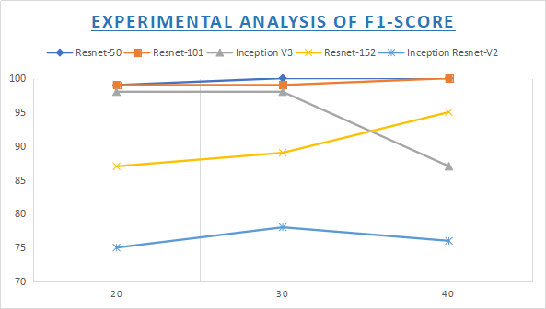
Figure 4.2.4: Graphical representation of F1-Score of all models
The schematic presentation of Table 4.2.4 is in Figure 4.2.4. Figure 4.2.4 shows that Inception Resnet-V2 is the least performing model. However, the highest performing versions are Resnet-50 and Resnet-101, where the best fit epoch value is 30 and 40 for Resnet-50 and 40 for Resnet-101.

4.2.5 Performance results for the best epoch Value

Table 4.2.5: Best performer models with best EPOCH values
 | Epoch | Accuracy | Precision | Recall | F1-Score
Resnet-50 | 30 | 100 | 100 | 100 | 100
Resnet-101 | 40 | 100 | 100 | 100 | 100
Inception V3 | 20 | 98 | 98 | 98 | 98
Resnet-152 | 40 | 95 | 95 | 95 | 95
Inception Resnet-V2 | 30 | 79 | 85 | 79 | 78

Here, We have seen from Table 4.2.5 Resnet50 has given 100 percent accuracy for epoch 30 and Resnet101 has given 100 percent accuracy for epoch 40. Inception V3 has given 98 percent accuracy for 20 epochs. Resnet-152 performed 95 in 40 epoch and in the last Inception Resnet-V2 performed 79 accuracy at epoch 30.Those are the best accuracy for respected epochs.
This is noticeable from Figure (4.2.1) to Fig. (4.2.4) that the Resnet-50 and Resnet-101 achieve the highest testing accuracy and the lowest losses. So we can claim that in epoch 40, Resnet-50 and Resnet-101 models have similar results. Therefore the most fitting model can be found to be these two models for the 1300 X-Ray images dataset. But it was 100 percent accurate in Resnet-50 when performing epoch 30 at the same dataset as well. And it was 99 percent in the case of resnet-101 when it was in epoch 30, but we can see that we have 100 percent accuracy when we increase the epoch from 30 to 40. Therefore when considering the run time, we can assume that the Resnet-50 is the best model for our dataset. Also noticed was the absolute high or excessive low actuation that is usually seen in all graphs. So while the number of epochs increased particularly when the epoch was between 30 and 40 in our dataset, the train and validation distributions converged.

In detecting COVID-19, deep learning models are successful when the results are examined in general. In Table (4.2.1-4.2.5) for detecting disease values are shown by working with our dataset F1-score,recall,precision and accuracy. In the Resnet-50 model, the best accuracy outcome is achieved along with our dataset. The precision, accuracy, recall, and F1-score values received were 100 percent, 100 percent, 100 percent, and 100 percent along with our dataset.
We can see from the above discussion and outcome that at epoch 30 and 40, ResNet50 offers the same best results. At the same time, at epoch 40, ResNet101 offers the best results. So, for 1300 chest X-ray images dataset and five CNN models analytical study, ResNet50 shows the best appearance for 30,40 epoch value randomly and ResNet101 show the best appearance for 40 epoch value. In the future study, we will try to add more chest X-ray image dataset to make the CNN models more efficient and comprehensive.

CHAPTER 5
Conclusion and Future Scope

5.1 Conclusion
We all know that COVID-19 is an infectious epidemic and today, all over the planet, this pandemic is rising increasingly. It is really necessary for this emergency health situation that a single positive COVID-19 case does not go unidentified. First of all, here we get CXR images from COVID-19 positive patients and healthy people. We then deliver a deep transfer learning-based approach to rapidly and automatically predict COVID-19 positive patients from chest radiography images. By performing these procedures, diagnostic time is minimized and financial losses are reduced. When we compare the performance of the five models, the findings of the best performance of the five models used with our datasets suggest that the highest accuracy was attained by ResNet50 and ResNet101 pre-trained model accuracy. But here we remark that we have seen a large difference in accuracy as we change the epoch. For covid-19 identification, that ResNet50 perform the best. Since it has the best at 30 epoch accuracy where ResNet101 gives it the best at 40 epoch accuracy. Due to its high performance and potential to detect COVID-19 at an early stage, it will enable doctors to make choices in clinical practice and save more lives. In the future by increasing the amount of research data that is against the latest Covid-19 impacted people dataset, this successful outcome can be checked.

5.2 Limitation
The experiment was very high for identifying better accuracy. Because of limited memory or RAM will not offer a perfect accuracy and possibility to garbage value so, we need to have a high configurable pc. Though we have work on five models and each model have three epoch so, we need to manually set all the code each time. On the other hand for experiment time we use a huge dataset. Three different epochs are maintained so toughly. In addition to super speed, it requires a highly configurable GPU machine.

5.3 Future scope
The entire planet is slipping behind in this pandemic case. For this cause, at the moment, some of our proposals may not be fulfilled. We will be improving our research in the future which will make this proposal a possibility. In the future, we will be increasing our dataset by adding more different types of chest x-ray images and more levels of datasets besides Covid19 and normal datasets. We will also attempt to introduce some new CNN models and in the updated form of our analysis, we will be trying to explain the variation of changing accuracy by applying more epoch.

CHAPTER 6
REFERENCES

References:
[1] Stoecklin, S. B., Rolland, P., Silue, Y., Mailles, A., Campese, C., Simondon, A., Mechain, M., Meurice, L., Nguyen, M., Bassi C., Yamani, E., Behillil, S., Ismael,S., Nguyen, D., Malvy, D., Lescure, F. X., Georges, S., Lazarus, C., Tabaï, A., Stempfelet, M., Enouf, V., Coignard, B., Levy-Bruhl, D. and Team, I. First cases of coronavirus disease 2019 (COVID-19) in France: surveillance, investigations and control measures, January 2020. Eurosurveillance, 25(6) :2000094, 2020.

[2] World Meter, Coronavirus :<< https://www.worldometers.info/coronavirus / >>, last accessed on 03-10-2020 at 1:00 AM.

[3] World Health Organization. (2020). Coronavirus disease 2019 (COVID-19): situation report, 51

[4] Millán-Oñate, J., Rodriguez-Morales, A. J., Camacho-Moreno, G., Mendoza-Ramírez, H., RodríguezSabogal, I. A., & Álvarez-Moreno, C. (2020). A new emerging zoonotic virus of concern: the 2019 novel Coronavirus (COVID-19). Infectio, 24(3).

[5] World Health Organization, Coronavirus :<< https://www.who.int/health-topics/coronavirus/>>, last accessed on 14-10-2020 at 1:00 AM.
[6] World Health Organization, Coronavirus:<< https://www.who.int/health-topics/coronavirus/diseases/>>, last accessed on 14-10-2020 at 1:30 AM.
- Johns Hopkins University & Medicine, available at <<https://coronavirus.jhu.edu/map.html/>>, last accessed on 25-11-2020 at 12:37 AM.

[8] Riou, J., & Althaus, C. L. (2020). Pattern of early human-to-human transmission of Wuhan 2019 novel coronavirus (2019-nCoV), December 2019 to January 2020. Eurosurveillance, 25(4).

[9] Arabi, Y. M., Murthy, S., & Webb, S. (2020). COVID-19: a novel coronavirus and a novel challenge for critical care. Intensive care medicine, 1-4.

[10] Wang, W. et al. Detection of SARS-CoV-2 in different types of clinical specimens. JAMA (2020).

[11] Fang, Y., Zhang, H., Xie, J., Lin, M., Ying, L., Pang, P., & Ji, W. (2020). Sensitivity of chest CT for COVID-19: comparison to RT-PCR. Radiology, 200432.

[12] Li, Y., Yao, L., Li, J., Chen, L., Song, Y., Cai, Z., & Yang, C. (2020). Stability Issues of RT‐PCR Testing of SARS‐CoV‐2 for Hospitalized Patients Clinically Diagnosed with COVID‐19. Journal of Medical Virology.

[13] Li, D., Wang, D., Dong, J., Wang, N., Huang, H., Xu, H., & Xia, C. (2020). False-negative results of real time reverse-transcriptase polymerase chain reaction for severe acute respiratory syndrome coronavirus 2: role of deep-learning-based CT diagnosis and insights from two cases. Korean journal of radiology, 21(4), 505-508.

[14] Ai, T., Yang, Z., Hou, H., Zhan, C., Chen, C., Lv, W., ... & Xia, L. (2020). Correlation of chest CT and RTPCR testing in coronavirus disease 2019 (COVID-19) in China: a report of 1014 cases. Radiology, 200642.

[15] Sheridan, C. (2020). Fast, portable tests come online to curb coronavirus pandemic. Nat Biotechnol.

[16] Ng, M.-Y. et al. Imaging proﬁle of the COVID-19 infection: Radiologic ﬁndings and literature review. Radiol. Cardiothorac. Imaging2 (2020).

[17] Haghanifar, A., Majdabadi, M.M. and Ko, S., 2020. Covid-cxnet: Detecting covid-19 in frontal chest x-ray images using deep learning. arXiv preprint arXiv:2006.13807.

[18] Narin, A., Kaya, C. and Pamuk, Z., 2020. Automatic detection of coronavirus disease (covid-19) using x-ray images and deep convolutional neural networks. arXiv preprint arXiv:2003.10849.

[19] Kassani SH and Kassani PH. A comparative study of deep learning architectures on
melanoma detection. Tissue and Cell, 58:76-83, 2019.

[20] Yildirim O, Talo M, Ay B, Baloglu UB, Aydin G, and Acharya UR. Automated detection
of diabetic subject using pre-trained 2D-CNN models with frequency spectrum images
extracted from heart rate signals. Computers in Biology and Medicine, 113:103387, 2019.

[21] Dorj UO, Lee KK, Choi JY, and Lee M. The skin cancer classification using deep
convolutional neural network. Multimedia Tools and Applications, 77(8):9909-9924, 2018.

[22] Celik Y, Talo M, Yildirim O, Karabatak M, and Acharya UR. Automated invasive ductal
carcinoma detection based using deep transfer learning with whole-slide images. Pattern
Recognition Letters, 133:232-239, 2020.

[23] Ribli, D., Horváth, A., Unger, Z., Pollner, P., and Csabai, I. Detecting and classifying
lesions in mammograms with Deep learning. Scientific Reports, 8:4165, 2018.

[24] Saba T, Mohamed AS, El-Affendi M, Amin J, and Sharif M. Brain tumor detection using
fusion of hand crafted and deep learning features. Cognitive Systems Research, 59:221-230,
2020.

[25] Jmour N, Zayen S, and Abdelkrim A. Convolutional neural networks for image
classification. International Conference on Advanced Systems and Electric Technologies
(IC_ASET), Hammamet, Tunisia, pp. 397-402, 2018.

[26] LeCun Y, Bengio Y, and Hinton G. Deep learning. Nature, 521:436-444,
https://doi.org/10.1038/nature14539, 2015.

[27] Narin, Ali, Ceren Kaya, and Ziynet Pamuk. "Automatic detection of coronavirus disease (covid-19) using x-ray images and deep convolutional neural networks." arXiv preprint arXiv:2003.10849 (2020).

[28] Srivastava N, Hinton G, Krizhevsky A, Sutskever I, and Salakhutdinov R. Dropout: A
Simple Way to Prevent Neural Networks from Overfitting. Journal of Machine Learning
Research, 15:1929-1958

[29] Wu Z, Shen C, and Van Den Hengel A. Wider or Deeper: Revisiting the ResNet Model
for Visual Recognition. Pattern Recognition, 90:119-133, 2019.

[30] Russakovsky O, Deng J, Su H, Krause J, Satheesh S, Ma S, and et al. ImageNet Large Scale Visual Recognition Challenge. International Journal of Computer Vision, 115:211-252,
2015.

[31] Ahn JM, Kim S, Ahn KS, Cho SH, Lee KB, and Kim US. A deep learning model for the
detection of both advanced and early glaucoma using fundus photography. PloS ONE,
13(11):e0207982, 2018.

[32] Byra M, Styczynski G, Szmigielski C, Kalinowski P, Micha lowski L, Paluszkiewicz R,
and et al. Transfer learning with deep convolutional neural network for liver steatosis
assessment in ultrasound images. International Journal of Computer Assisted Radiology and
Surgery, 13(12):1895-1903, 2018.

[33] Russakovsky O, Deng J, Su H, Krause J, Satheesh S, Ma S, and et al. ImageNet Large
Scale Visual Recognition Challenge. International Journal of Computer Vision, 115:211-252,
2015.

[34] Russakovsky O, Deng J, Su H, Krause J, Satheesh S, Ma S, and et al. ImageNet Large
Scale Visual Recognition Challenge. International Journal of Computer Vision, 115:211-252,
2015.
[35] Salehi, A.W., Baglat, P. and Gupta, G., 2020. Review on machine and deep learning models for the detection and prediction of Coronavirus. Materials Today: Proceedings.

[36] Heidari, M., Mirniaharikandehei, S., Khuzani, A.Z., Danala, G., Qiu, Y. and Zheng, B., 2020. Improving the performance of CNN to predict the likelihood of COVID-19 using chest X-ray images with preprocessing algorithms. International journal of medical informatics, 144, p.104284.

