Internship Report on Online Class Observation and Conduction in English during the Outbreak of Covid-19



Daffodil International University
Date of Submission: 7th December 2020

Report on
“Online Class Observation and Conduction in English during the Outbreak
of Covid-19”
A report submitted to the Faculty of Humanities and Social Sciences in partial fulfilment of
the requirements of the degree of Bachelor of Arts in English.
Course Title: Project Paper
Course Code: ENG - 334
Semester: Fall, 2020

Supervised by
Nahida Akter Poly
Lecturer
Department of English
Faculty of Humanities & Social Sciences
Daffodil International University

Prepared by:
Umma Habiba Nafsi Zahan Lima
ID: 172-10-445
Bachelor of Arts in English
Daffodil International University

i
Certification of the Supervisor
I hereby certify that the intern, Umma Habiba Nafsi Zahan Lima, bearing the ID no: 172-10-445 has undertaken the course Project Paper (ENG334) with me. In the course she conducted one online class of Batch 1.3 of English Department of the same university and observed two online classes of two interns. The intern was in touch with me by taking guidelines from me on a regular basis, showed me her progress and gave me her work updates about the Project during this whole process. Therefore, she fulfilled all the requirements and completed all the procedures of the course and the intern is qualified to submit this report and she must present her findings of the report in front of the Panel of Evaluators.

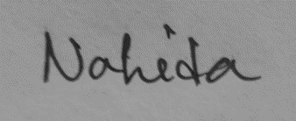
_________________________________________
Signature of the Supervisor

ii
Acknowledgements
I intend to express my gratitude to my Almighty Allah who has given me the strength and opportunity to complete this project work titled “Report on Online Class Observation and Conduction in English During the Outbreak of Covid-19”. Then I want to mention the name of my supervisor Ms. Nahida Akter Poly, Lecturer, Department of English, Daffodil International University, who was always very supportive to me. I am especially thankful to my supervisor for her valuable suggestions and effective guidelines that helped me a lot to make my project a successful one. I am also thankful to my parents, friends and family for their care, support and inspiration. Further I am grateful to the course teachers and students of the Daffodil International University who were the part of my project.

iii
Declaration
I hereby declare that this project paper entitled “Report on Online Class Observation and Conduction in English During the Outbreak of Covid-19” submitted to the Department of English of Daffodil International University is an evidence of an original work completed by me under the guidance and supervision of Ms. Nahida Akter Poly, lecturer, Department of English. The project work is submitted as a part of the partial accomplishment of the requirements for the award of the degree of B.A. (Hons) in English for the course “Project Paper (ENG-334)”. I also ensure that the results embodied in this project have not been submitted to any other university or institution for any degree or diploma, other than Daffodil International University.

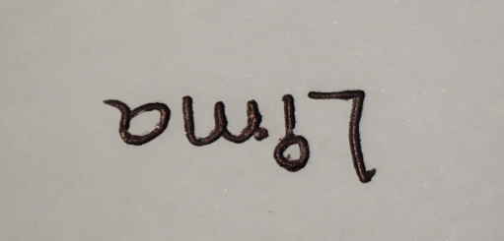
_____________________________
Signature of the Intern

iv

Abstract
This project paper aims to depict the present scenario of Online Class Observation and Conduction in English at Daffodil International University during the Covid-19 pandemic. The research is based on the experience that I gathered during my internship by observing and conducting classes to complete the requirements of the course titled “Project Paper (ENG-334)” offered by the Department of English, Daffodil International University. I tried my best to fulfill all the requirements of the project, based on the experience that I have gathered from one activity under the English Language Teaching course (ELT), named STS (Students Teaching Students) and also from my voluntary teaching in Hornby Trust Project by BELTA (2019-2020). The main purposes of the project are to analyze the things concern with effective online English language teaching process such as - the medium of instructions, teacher’s capability and efficacy on English, student’s English language proficiency, engagement and participation in a class etc. As an intern I have applied several teaching methods including CLT and GTM. I also followed several required steps such as- two class observations, filling up observation checklists, class conduction and self-reflection etc. This paper provides some recommendations for the English language facilitators and also analyzes the strengths and weaknesses of the observed teachers as well as advantages and disadvantages of online classes.

v
Table of Contents

Contents | Page No.
Title | i
Declaration by the Intern | ii
Certification of the Supervisor | iii
Acknowledgments | iv
Abstract | v
Table of Contents | vi
Chapter – 1: Introduction | 1
Chapter – 2: Objectives | 2
Chapter – 3: Methodology | 3-4
Chapter – 4: Institution Details | 5-6
Chapter – 5: Class Observation Report | 7-8
Chapter – 6: Teaching Experience | 9-10
Chapter – 7: Overall Findings | 11-13
Chapter – 8: Recommendations | 14-15
Chapter – 9: Conclusion | 16
Appendices
Appendix 1: Class Observation check list | 17-22
Appendix 2: Lesson Plan | 23-25
Appendix 3: Photographs | 26-32
Appendix 4: Class Recording Link | 33
Plagiarism Report | 34

vi

Chapter - 1
Introduction
Now a days English has become the only language which can be used widely. Like other progressive countries, the Ministry of Education of Bangladesh is also giving emphasize on learning English. During the COVID-19 pandemic situation, to ensure an alternative education system for every student, has really became very challenging, as government has declared that every educational institution should remain closed until the world overcomes the pandemic. But life has to move on. To cope up with this situation, the world moved on to the online educational platform as a substitute of offline classes in schools, colleges and universities. Previously for the project paper, the interne students used to visit any school or college to observe and conduct two classes, and prepare their report under the title “Scenario of English Language Teaching in a Bangladeshi School”. Now as we intern students have taken class in an online platform called Google Meet, the project paper title is also changed to “Report on Online Class Observation and Conduction in English during the Outbreak of Covid-19" under the course Project Paper (ENG-334).
Like all project paper students, I also had to conduct one online class and observe two of my peer’s classes. Based on these experiences, I prepared my teaching experience, observation report and other reports. My respected supervisor Ms. Nahida Akter Poly mailed me the instruction paper with two sample paper that helped me to understand my work properly. Throughout this project she helped me in all possible way with her precious advices and guidelines. I conducted my class with third semester students of PC-C of the course “Romantic Poetry” on the poem “The Rime of the Ancient Mariner” part-1. As I am also a student of the same department of this university, I had a golden opportunity to complete two of my semesters in an online platform. So, it was not that much difficult for me. Through this project, I got an opportunity to utilize my learning and experience to handle university students and to conduct a university class.
Chapter - 2
Objectives of the Teaching Practicum
This report mainly focuses to illustrate the present scenario of “Online Class Observation and Conduction in English During the Outbreak of Covid-19”. The particular objectives of this study are:
- To analyze the interaction between teachers and students in online classroom
- To analyze the advantages and disadvantages of online classes
- To identify the teaching methods and techniques used in online for teaching English
- To identify how to encourage the students to concentrate on the online class and also to encourage the students to participate
- To monitor the ultimate outcome of these methods and techniques
- To analyze the online teaching materials
- To understand teachers’ potential level complying with online-teaching
- To find out student’s reading, writing, listening and speaking abilities, their lacking and interest.

Chapter - 3
Methodology
Methodologies used to complete this work on ‘Online Class Observation and Conduction in English during the Outbreak of Covid-19’, can be sequentially noted as:
3.1 Selecting the Host Institution
Before the COVID-19 outbreak, intern students had to choose an educational institution to conduct their classes. But due to the pandemic situation, I did not need to do so, as the authority of Daffodil International University hosted the online internship. It has not only added a new dimension in this internship but also helped us to get acquainted with upcoming technologically advanced era. I feel very fortunate to get chance to complete my internship in my own university.
3.2 Having a Facilitator
I am very lucky to have Ms. Nahida Akter Poly as my supervisor. She is a lecturer in Daffodil International University. She patiently facilitated me with her kind advice throughout the journey of my class conduction and observation. I received all the required information regarding this study through phone calls and online meeting sessions with her. After checking my capability, she fixed two different dates for the class observations and one specific date for class conduction. She also introduced me to the students before my class started.
3.3 Selecting Classes
My facilitator gave me the chance to choose any language or literature course offered by Department of English, Daffodil International University. I preferred to choose a literature course titled ‘Romantic Poetry (ENG-221)’. Then she fixed my class with the third semester students of PC-C section, where two of my peers observed my class conduction. My supervisor also selected two of my peers’ class where I was observer.
3.4 Class Observation and Self-Reflection
My advisor designed a schedule for me, at first to observe one class and then conduct my own class. On 14th November at 8:30 AM I observed my first class of ‘Presentation Skill Development’ course on ‘Speaking Outline and Using Language’ and completed my checklist. The same day at 2:30 PM I had to conduct my class according to my facilitator’s instruction and prepared my self-reflection report. After eleven days, on 25th November, I observed another class of ‘Introduction to Poetry’ course on ‘Literary Devices’ for completing my second checklist.
3.5 Assessment
Before starting every section, I asked my students to share their thoughts and ideas about the topics to analyze the depth of their knowledge. After finishing the section, I again assigned them some short tasks so that they can use their acquired knowledge practically. Finally, at the end of my class I took a short quiz on the basis of the class discussion through Google Form. I was impressed with the performance as many of them got over 5 out of 10. I also provided a Google Form link where they gave their feedback about my class.

Chapter - 4
Institutional Details
Name: Daffodil International University
Location: Permanent Campus in Ashulia and Main Campus in Dhanmondi
Total Number of Faculties: 5
Total Number of Departments: 25
Academic Staff number: 859
Administrative Staff Number: 780
Students: 21,752
Number of Teachers: 859
Teacher’s Qualification: Master’s Degree and PhD
Logo of the University:
Daffodil International University (DIU) is now considered as one of top graded privet universities in Bangladesh. Daffodil Group has established the university in 1998, with the approval of the Ministry of Education under the Private University Act of 1992 and its amendment. On 24th January, 2002, Daffodil International University started its journey with the motto, “Landmark to Create the Future”. The chairman of this university is Md. Sabur Khan, Abdul Hamid, President of Bangladesh is Chancellor and Professor Dr. M. Lutfar Rahman is Vice chancellor. The University had three campuses previously. But now a days, the Uttara campus has shifted with the permanent campus situated at Ashulia. This university is well known for its technologically advanced digital classrooms, excellence in academic results and achievements and for different cultural and social working clubs. Recently, the researchers of Daffodil International University of Bangladesh have designed an Artificial Intelligence technology that can diagnose COVID-19 by using x-ray results. The university is also well known for its 150 acre (approx.) “Green Campus” which is situated at Savar, Dhaka.

Chapter - 5
I have observed two classes of my peers’. The first class was of the course “Presentation Skill development (ENG-221)”. And the second class I observed of the course “Introduction to Poetry (ENG-121). Because of the COVID-19 pandemic situation, I had to observe the classes through the platform called Google Meet.
Class Observation Report - 1
The class was conducted by Ishrat Jahan Kona, ID: 172-10-448. She is in the 11th semester of the Department of English at Daffodil International University. The class was on “Speaking Outline and Using Language” with the 3rd semester students of PC-A. Her scheduled class was on 14th November 2020 (Saturday), and time was from 8:45 AM to 10:38AM. In the class, 20 students were present out of 34.
The facilitator entered the online class and our supervisor introduced her with the students. Without and warm up session, she directly went to the main lesson. Before delivering her lecture, she declared that, the three most interactive students will get a special gift from her. Then she presented the pdf book from her mobile phone. She read some parts from the pdf and made them understand the meaning. She also gave them guidelines how to do outlining. Sometimes she asked her students to read out from the pdf book loudly. But as her screen presentation quality was not good enough, students had difficulty to read from the screen. So, she herself continued reading and explaining. She used some examples only from the book to make her topic clear to all. But the good thing is that she sometimes shared her own experiences and asked her students to share their topic related experiences too.
While she was taking her class, she asked her students, if they were understanding the topic or not. Students also co-operated with her and asked questions. She answered almost all their questions. When she was teaching the term ‘metaphor’ and ‘A note on inclusive language’, her explanations and examples were not good enough for students to understand the topics properly. But still she encouraged students for asking questions.
She took 1 hour and 30 minutes to finish her topic discussion. For next 15 minutes she gave students time to ask for any clarification related to the topic if they needed any and then summarized the whole lesson. While she was summarizing, students also participated by sharing their own understanding regarding the class topic. After that, the teacher asked some topic related questions to the students to check their understanding. Few students answered her questions properly and few students couldn’t. She did not take student’s feedback about the class. But for the last time, she encouraged them to ask her if they had any query or confusion. As she was already running out of time, she had to conclude her class.
Overall, it appeared to be an interesting class to me. From the beginning till the end, her class was meaningful. Her voice quality was clear. She tried to capture the full attention of her students and her attempt was a successful one.

Class Observation Report -2
The second class that I have observed was on the course “Introduction to Poetry”. The class was conducted by Sumaiya Binte Habib, ID: 173-10-458. She is in the 10th semester of English department at Daffodil International University. The class was on “The Literary Devices” with the 3rd semester students of PC-B batch. Her scheduled class was on 25th November 2020 (Wednesday), and the time was from 2:42 PM to 3:22 PM. In the class, 12 students were present out of 34.
After entering into the class, the facilitator waited for some more students to join. When 12 students joined, the course teacher introduced her with everyone. Intern also gave a short introduction of herself to the students and welcomed them to her class. Then she presented her PowerPoint slides from her laptop. She asked students if they had already done with their ‘Introduction to Poetry’ course or not. They said they all had done this before. Like my first peer, she also directly went to her topic discussion without having any proper warm-up session. She started her discussion with the definition of poetry. Then she recited a poem to all of them as an example of poetry. Then she gave her outline about what she was going to teach (free verse, alliteration, personification, rhyme and imagery).
After that, one by one she deductively explained the definitions of all the mentioned literary devices with examples. Sometimes she also encouraged them to ask questions and also asked if they were understanding or not. While explaining the things she encouraged the students to give some topic related examples. The teacher added a few activities to check student’s understanding. She put some lines from the poem in a slide and asked students to find out the relevant literary devices from those lines. She encouraged all her students to participate and interact with her. But they did not ask any questions to their teacher. Only a few students gave the answers to the questions of the teacher throughout the whole class.
She finished her topic discussion within 35 minutes. She did not summarize her lesson even did not take any quiz for checking overall understanding. For next 5 minutes she gave students time to ask for any clarification related to the topic if they need. Then she immediately finished the class with a quotation about poetry. She had 20 minutes more to continue her class.
For me this was an average type of class, as the students and the teacher both were less interactive with each other. Students were not that much engaged. Though sometimes her voice was not clear and she was very nervous, she conducted her whole class in English.
Chapter - 6
Teaching Experience
Before taking class, I prepared my lesson plan according to the instruction of my supervisor. I showed my lesson plan to her. She made necessary corrections. Once my lesson plan was approved, my supervisor. Ms. Nahida Akter Poly fixed a date for my class conduction.
Self-Reflection Report
I have conducted a class of Romantic Poetry (ENG-224) on 14th November, 2020 (Saturday). Because of the COVID-19 pandemic situation, I had to take my class by using an online class taking platform called Google Meet. The class was scheduled from 2:30 PM to 3:50 PM. My students were in level one term three (PC-C section). They are total 36 in number and 14 students were present in my class.
At the very beginning of the class, my respected supervisor introduced me with the students. They warmly welcomed me. Then I waited 2 minutes, for other students to join my online class. When 14 students joined the meeting, I again introduced myself with all. Then I presented my power point slides to them. Before going to the main lesson, they had a warm-up session with me, where I showed them some pictures and they had to make a meaningful word by using the clues. I also showed them some puzzled letters. They rearranged them and made a meaningful word. After solving all the puzzles, they discovered their discussion topic of the class. This game took about 7 minutes. Some of the students commended that, they had found the game very interesting.
After this session, I moved to another section of my lesson. My discussion topic was first 45 lines of the poem “The Rime of the Ancient Mariner” part-1 by Samuel Tailor Coleridge. Before explaining the poem, I discussed the poet’s biography, features of romanticism, some basic information about the poem and introduced them with the main characters of the poem so that they can understand the poem very easily. For doing so, I at first asked them to share their knowledge about what do they know about S. T. Coleridge. Though they said they did not know anything about the poet, after getting some hints from me, some of the students shared some important information about the poet. Then I added some more details. Then I again asked “what do you know about the romantic era?” I observed that most of the student had idea about it. So, I just refreshed their memory and summarized the topic. Then I showed them the cover picture of the poem and asked them to share their thought about the picture. Some of them told it seems to be something spooky and mysterious. I appreciated them for the right answer. Then I summarized the plot of the poem very shortly and introduced them with the characters of the poem.
Finishing the introduction section, I recited the first four lines of the poem from my power point slides, explained them with meaning and analyzed the literary devices present there. I added a few relevant illustrations of the poem to make it more imaginative for the students. I added pictures for every possible new words. I taught them the meaning of some unknown words and some old English. For next four lines, I asked them to recited. But this time, I asked them to find out the rhyme scheme and other literary devices present in that part. They successfully did so. During the discussion, I asked them questions to engage them in the class and understand the lesson properly. They all concentrate in my class eagerly. I explained each and every thing of first 45 lines of the poem.
After finishing every section, they ensured me that, they had no problem in understanding the whole topic. Then I took a quiz on my lecture by using Google Form that I had created by myself. And this was my quiz link that I have provided to my students: (https://docs.google.com/forms/d/18r9F3iTtWKw_pyNzCNpptL9KHEb0UkqEstXZ3b6g2n8/edit?usp=sharing). There were ten questions and each carried one point. Out of 14 students 7 of them attended the quiz by using the link. Some of them did a very good job. And it satisfied me. I congratulated the top scorer and appreciated all of them.
Before ending the class, I shared a Feedback Form link with them, which was about my teaching methods. Finally, I again asked them if they could clearly understand the topic or not and asked them to share their opinion about my class. They said that the class was very interesting and all my examples were very good and relatable.
I had two observers Ishrat Jahan Kona (172-10-448) and Ishrat Jahan (173-10-458). They are also project paper students. They observed my class and provided me with some comment which were very helpful for me. While I was taking the class, they also told me that, I had enough confidence and the class was amazing and my voice was fully clear and my time management skill was good. Though, it was my first-time online class conduction, besides students I also enjoyed it. For this class I made a lesson plan. And I am happy that I finished the class successfully according to my plan.

Chapter - 7
Overall Findings
7.1 Class Observation Findings
I got chance to observe two of my peers’ online classes that helped me a lot. By gathering experience from one of my peers and by using my previous experiences of my course related online classes I conducted my class successfully. From my class conduction I have noted several important features of online English language teaching during my observation period. Those things are:
7.1.1 Lesson Preparation
Every good teacher needs a proper lesson plan to conduct his/her class successfully. While doing my English Language Teaching (ELT) course, I came to know about this. There I also learned how to prepare a good lesson plan. I practically used this lesson plan for my Student Teaching Student (STS) and then also for Hornby Trust Project under BELTA. In both of my class observation, my peers have made good lesson plans which were organized and main topic oriented. But they could not implement it successfully because of their bad time management.
7.1.2 Lesson Delivery
Every teacher has his/her own way of teaching. Every student is different from each other. The same teaching method may not work for every individual student, not even applicable for different courses. In my first-class observation, I find out that, most of the time the teacher was using Grammar Translation Method. The second teacher used Communicative Language Teaching method for conducting her class. In first class the teacher Ishrat Jahan Kora also used Communicative Language Teaching method sometimes.
7.1.3 Lesson Materials
The lesson materials used in two classes were totally different form each other. In first class the teacher Ishrat Jahan Kona just simply presented a word file (taken from online) throughout her class. On the other hand, in my second-class observation, the teacher Sumaiya Binte Habib presented a PowerPoint slide where she also added some pictures, poem and activities to make her class more attractive.
7.1.4 Class Time Management
Though the content of both of the teachers were good enough, they were not sincere about time. In the first-class teacher took extra 52 minutes which was a huge time. On the other hand, the second teacher finished her class within 40 minutes where she had to conduct her class for 1 hour. She could have used her 20 minutes time productively by engaging her students in different lesson related activities.
7.1.5 Student Engagement
The students of the first class from PC-A batch were more communicative and active in the class. They answered all the questions of their teacher without any delay. They seemed more enthusiastic and participating. On the other hand, in the second class the students seemed less interested in the discussion topic. May be because they knew all about the topic before. But all the efforts of both the teachers were worth praising.
7.2 Self-Reflection Findings
To conduct my class, I wanted to use only Communicative Language Teaching method. But as we Bangladeshi students are used to with Grammar Translation method, I used both Communicative Language Teaching method and Grammar translation method according to the student’s necessity. I cannot say that the methods I used were the best ones, but all the students said that they liked the way of my teaching and they understood the whole lesson.
7.2.1 Lesson Plan
I have used all my previous knowledge about taking classes and the guidelines and instructions of my supervisor to prepare and organize my lesson plan. Like other intern I also took her approval for the lesson and materials I used. I made the lesson plan mainly focusing on the class objectives and student engagement which I find effective for online class conduction.
7.2.2 Lesson Delivery
To conduct the class, for most of the time, I followed the Grammar Translation Method and tried to play the role of a good facilitator in the classroom. I also asked them questions throughout the topic discussion to make the lesson easier for them to understand and to storm their brain. I also used CLT where I felt necessary. Throughout the lesson delivery, I maintained a friendly classroom environment and good communication with the students.
7.2.3 Lesson Materials
For my lecture delivery I have used different types of topic related study materials. Such as – PowerPoint slides where I have added so many pictures, YouTube video link, text and Google Form links etc.
7.2.4 Time Management
After observing one of my peer’s class I was very concern about my lesson and time management as she was failed to conclude her class within the given time. Then I segmented my lesson into several sections such as: self-introduction, warm up, background information, explanation, activity, quiz and feedback to avoid problems related to wasting time. But unfortunately, I took extra 20 minutes to conduct my class. In total I took 1 hour and 20 minutes to conduct my class with my student’s concern.

7.2.5 Student Engagement
In my first-class observation, students were very enthusiastic and participating. That made me quite confident about my students. But unfortunately, in my class students were less in number. Even less interactive compared to my first-class observation. Except two or three students, I had to push my students a lot to make them participating and engaging in the class. In the Google Form quiz and feedback link, responses were not that satisfactory as only about half of the students participated. But the good thing was that, whoever participated, did really good and said good things about the class.
7.3 Advantages of Online Class
Being positive, so many advantages of the online classes can be listed. The class can be attended while staying at home without taking any health risk. Regular study does not hamper because of the COVID-19 outbreak. They can attend classes when they are sick. The recording is also available for further study if anyone misses the class. It also helps to promote the motto, “Go Paperless” to save the earth.
7.4 Disadvantages of Online Class
The main problem with online classes is the network issues. Sometimes students and the teachers get disconnected during the middle of the topic discussion. When they reconnect, they lose their concentration. For the students who stay in remote areas find it very difficult to attend the classes because of poor network coverage. Secondly, buying mobile data is costly for some students. Even to attend the online class students need a costly electric device like- android mobile, laptop or desktop. It should also be noted that, virtual learning is not as effective as the physical institutional learning. Some critical events such as- playing music in the background, ringing phones etc. can heavily hamper the class.

Chapter - 8
Recommendation
After two class observations and one class conduction I have noted some issues with online English language teaching classes. If we can solve them, the class can be more effective, interactive and educative. My recommendations are listed below:

- Proper lesson plan:
Sometimes the lesson plan does not get proper priority over the content knowledge. But without a well-planned lesson plan a class will not be organized enough.

- Interesting warm-up:
None of my peer did put any warm up session. they could have added some interesting warmup so that they could catch the attention of the students.

- Presenting real life examples:
Most of the time bookish example seems boring and less interesting. Real life example helps to make a class more communicative and easier to relate with life. By doing this, student learns how to use their knowledge in everyday life. Once the students can do so, possibilities are very high that they will never forget the topic.

- Brainstorming:
If only the teacher delivers his/her lesson and students listen, their brain does not work much and they do not think creatively. So, it is important to ask some creative questions to the students to do their brain storming. The teacher also can add some brain storming activities and homework.

- Proper Technological knowledge and backup:
During online classes, anyone can be disconnected at any time. So, the teachers and students should know how to deal with the situation. And everyone should have a backup like- backup mobile data, properly charged devices etc.

- Teacher and Student Talking Time Management:
In offline classes, teacher-student interaction is easier than the online classes. Even it is also easier to ensure the student engagement in off line classes. Sometimes it happens that, students are attending the class. But putting their camera and speaker in mute mood, they do other works that are not related to the class activities. So, in online classes, Student talking time should be increased and teacher talking time should be decreased to ensure the most effective and engaging class.

- Avoid Memorizing:
Memorized knowledge does not last long. Student cannot implement their memorized knowledge properly. A good teacher should always encourage his/her students to understand and adopt the content, not to memorize it.
Chapter - 9
Conclusion
In our educational sector online class has become a new normal because of COVID-19 outbreak. Students like me are very happy as we are blessed with the technological advancement. Before this situation we might not think about online class conduction. I learned many important and significant things about Online English Language Teaching, from this project. By observing and conducting online classes at Daffodil International University, I had the opportunity to know the advantages and disadvantages of Online Teaching procedure. I have also become aware of which things ought to be kept away from and which things should be embraced for the improvement of Online English Teaching. This internship gave me an opportunity to experience the hardship that a teacher does for his/her students and made me feel more respectful towards them. I feel like, this internship is a constructive guideline for me, as I dream to be a successful facilitator in future. At the end, again I want to thank my supervisor for her always supportive attitude and constructive guidelines.

Appendix – 1
Observation checklist - 01
Daffodil International University
Department of English
Internship on “Online Class Observation and Conduction in English during the Outbreak of COVID-19”
Checklist for Class Observation
Institution: Daffodil International University | No. of Students Present: 20 out of 34
Teacher’s Name: Ishrat Jahan Kona | Room No: Google
Course Title & Code: Presentation Skill Development (Eng-221) | Section: PC (A)
Meet Peer/Observer: Umma Habiba Nafsi Zahan Lima | Date and Time: 14-11-2020, 8:45 AM to 10:38 AM

Objectives of the lesson (as perceived):
- To understand how to outline
- To use outlining as a presentation strategy
- To use language effectively according to the situation.
- To develop presentation skill
Were the objectives achieved and to what extent (in your view)?
The objectives were somehow achieved, there were also some confusions and technical issues.

S/N | Review Section | In what ways? (Specific examples/ clarifications)
1 | SUBJECT MATTER CONTENT  (shows good command and knowledge of subject matter; demonstrates breadth and depth of mastery; tries to develop a knowledge seeking behavior among students) | Over all the facilitator had a good knowledge except the topic “A note on inclusive language”. She tried to explain all the topic clearly but sometimes she herself was confused about the topic.
2 | ORGANIZATION  (organizes subject matter; states clear objectives; emphasizes and summarizes main points, meets class at scheduled time, starts and finishes the lesson properly with an attractive warm up and a conclusive end- how the objectives of the lesson met/ what they have learned today) | The class started 15 minutes late because of less student attendance. The facilitator did not have any self-introduction and warm up session. She tried to make all the topic clear and the main points were also highlighted. She also tried to summarize the topics at the end, but things got confusing. She could not finish the class on time and took extra 52 minutes. She should give more attention in her lesson organization.
3 | RAPPORT  (holds interest of students; is respectful, fair, and impartial; provides feedback, encourages participation; interacts with students, shows enthusiasm, both teacher and students are ready for the class not only on subject matter but also in manner, etiquette and attitude) | She was fair and impartial towards her students. She also encouraged students to give feedback, properly interacted with students and gave answers to all the queries of the students. Here she used an interesting strategy to hold student’s attention on lesson by saying that most interactive student will be rewarded.
4 | TEACHING METHODS  (uses relevant teaching methods, aids, materials, techniques, and technology; includes variety, balance, imagination, group involvement; encourages questions from students and responds with interest; is open to ideas; uses real life examples that are simple, clear, precise, and appropriate; stays focused on and meets stated objectives) | Her teaching method was good. Mostly she used GTM. She tried to focus on the main topic. She only used the pdf version of the text book, where she could also use some videos, images or other short notes to make the lesson easier. It is also noticeable that, most of the time she just used only some bookish example, where real life examples could make the class more spontaneous.
5 | PRESENTATION  (establishes classroom environment conducive to learning; ensures learners’ interests, maintains eye contact; uses a clear voice, strong projection, proper enunciation, and standard English) | She conducted her lecture both in English and Bangla with clear audio by using pdf text. Her overall presentation was good.

MANAGEMENT
Was the time spent properly?
Yes, during online class she spent her time properly.

What were the main stages of the lesson? What tasks and activities did the teacher do during each stage? (Optional: Draw a diagram to show main stages of the lesson and time spent on each)

Introduction (3 minutes) > topic discussion (1 hour and 30 minutes) where the teacher thought about speaking outline and asked students’ questions > summarizing the lesson (15 minutes) > quiz, where teacher asked some topic related questions and students answered them randomly (7 minutes) > ending the class (2 minutes)

CRITICAL EVENT (If took place)
Was there any ‘critical event’ in the lesson? (A point where communication broke down and there was confusion). How did the teacher handle the situation?
While she was presenting her screen from her mobile, sometimes students complained that they cannot read what she was presenting properly as all things seems too blur. To handle this situation, she herself read the whole lesson.

Strengths observed:
1) Engaged the students nicely
2) Voice was clear and confident
3) Maintained good communication with students
Suggestions for improvement:
She could:
- use laptop for clear presentation quality
- add some practical or real-life example for better understanding of the students,
- keep the class limit not more than 1 hour and 10 minutes so that students do not get bored.
Overall impression of teaching effectiveness:
She tried her best. As a novice I think she has done a very good job.
Observation Checklist - 02
Daffodil International University
Department of English
Internship on “Online Class Observation and Conduction in English during the Outbreak of COVID-19”
Checklist for Class Observation
Institution: Daffodil International University | No. of Students Present: 14 out of 34
Teacher’s Name: Sumaiya Binte Habib | Room No: Google
Course Title & Code: Introduction to Poetry (Eng-221) | Section: PC (C)
Meet Peer/Observer: Umma Habiba Nafsi Zahan Lima | Date and Time: 25-11-2020, 2:42 PM to 3:22 PM

Objectives of the lesson (as perceived):
- To know about the literary devices
- To understand the use of these devices in literature
- To develop analytic skill

Were the objectives achieved and to what extent (in your view)?
The objectives were achieved but the class was too short and less interactive.

S/N | Review Section | In what ways? (Specific examples/ clarifications)
1 | SUBJECT MATTER CONTENT  (shows good command and knowledge of subject matter; demonstrates breadth and depth of mastery; tries to develop a knowledge seeking behavior among students) | The teacher was well prepared about the topic. As the students were already introduced with all these things in their previous semester, they had understood the lecture very easily.
2 | ORGANIZATION  (organizes subject matter; states clear objectives; emphasizes and summarizes main points, meets class at scheduled time, starts and finishes the lesson properly with an attractive warm up and a conclusive end- how the objectives of the lesson met/ what they have learned today) | The class started 12 minutes late because of less student attendance. The facilitator did not have any warm up session. She tried to make all the topic clear and the main points were also highlighted. She finished the class 20 minutes earlier without testing their overall topic understanding.
3 | RAPPORT  (holds interest of students; is respectful, fair, and impartial; provides feedback, encourages participation; interacts with students, shows enthusiasm, both teacher and students are ready for the class not only on subject matter but also in manner, etiquette and attitude) | The teacher was very fair and impartial to all. She also encouraged students to give examples. But as there was only a few students, they she did not get the expected interaction. And I felt like, the students were not ready for the class.
4 | TEACHING METHODS  (uses relevant teaching methods, aids, materials, techniques, and technology; includes variety, balance, imagination, group involvement; encourages questions from students and responds with interest; is open to ideas; uses real life examples that are simple, clear, precise, and appropriate; stays focused on and meets stated objectives) | Her teaching method was a little bit monotonous. She followed deductive teaching method (first gave the definition and then examples). She tried to focus on the main topic. She used PowerPoint for lecture delivery.
5 | PRESENTATION  (establishes classroom environment conducive to learning; ensures learners’ interests, maintains eye contact; uses a clear voice, strong projection, proper enunciation, and standard English) | She conducted her whole lecture in English. Sometimes her voice was not clear. Her overall lecture delivery was good.

MANAGEMENT
Was the time spent properly?
No, she spent first 40 minutes of her class time properly. Last 20 minutes time not utilized at all.

What were the main stages of the lesson? What tasks and activities did the teacher do during each stage? (Optional: Draw a diagram to show main stages of the lesson and time spent on each)

Introduction (4 minutes) > topic discussion (35 minutes) where the teacher taught about literary devices with examples and asked some questions > ending the class (1 minute)

CRITICAL EVENT (If took place)
Was there any ‘critical event’ in the lesson? (A point where communication broke down and there was confusion). How did the teacher handle the situation?
No. Any ‘critical event’ did not take place in the class time.

Strengths observed:
- She has a good comment in English.
- Clear knowledge about her content
Suggestions for improvement:
She could:
- Add some more common or well-known lines for giving example for better understanding of the students
- Use the time effectively by doing some helpful topic related exercise or playing games.
Overall impression of teaching effectiveness:
She gave it a good effort. It was her first attempt. So, I think her teaching was pretty impressive.

Appendix – 02
Lesson plan
Daffodil International university
Course | Romantic Poetry (ENG 224)
Teacher/ Facilitator | Umma Habiba Nafsi Zahan Lima
Enrolled Students | 14th Batch, PC-C  Total students: 36
Lesson topic | First 45 lines of the poem “The Rime of the Ancient Mariner” (Part I) by S. T. Coleridge
Objectives of the lesson | - To learn new vocabulary  - To know about the poet  - To learn the features romantic poetry  - To understand the critical meaning of the poem  - To develop listening skill  - To develop analytical skill
Date | 14 November, 2020
Learning resources | - Pictures  - PowerPoint  - E-text  - YouTube video
Teaching method | CLT and  GTM
Estimated time of lesson | 1 hour

Lesson Overview
Purpose | Teacher’s activity | Student’s activity | Time
Warm up | Teacher will show some pair of pictures and some crumbled letters to make words related to the discussion topic. | Students will link the clues from the pictures and will guess the words. For crumbles letter, they will rearrange them to make a meaningful word. | 7 minutes
Introduction to the poet | Teacher will share some necessary information about the poet by following story telling method. | Students will also contribute by share their knowledge, listen to the teacher and will perceive the knowledge about the poet. | 8 minutes
Poem introduction | Teacher will briefly introduce the poem, shorty summarize the part one of the poem and introduce them with the important character of the poem. | Students will listen carefully and sometimes they will also share their personal experience with teacher. | 5 minutes
Topic discussion | Teacher will explain 1st 45 lines of part 1 of the poem line by line with meaning. Discussion about literary devices will be also included. | Students will observe the class and will recite some lines with explanation and analyze them as per the teacher’s instruction. | 20 minutes
Activity | Students will be asked some word meaning and short questions. Teacher will also ask if they have any confusions or not. | Students will answer them by turning on their speaker or by writing on the comment box. | 5 minutes
Quiz | Teacher will take a small quiz on the discussion topic by using Google Form | Students will take the quiz | 8 minutes
Feedback | Students will be given a Google Form to give their feedback on the class. | Students will share their opinion about the teaching methods and class conduction. | 5 minutes
Conclusion | Teacher will conclude the class | Students will take a leave | 2 minutes

Appendix – 03
Photographs

Class Observation-1
Teacher: Ishrat Jahan Kona (172-10-448)
Date: 14th November, 2020 (Saturday)
Picture - 1
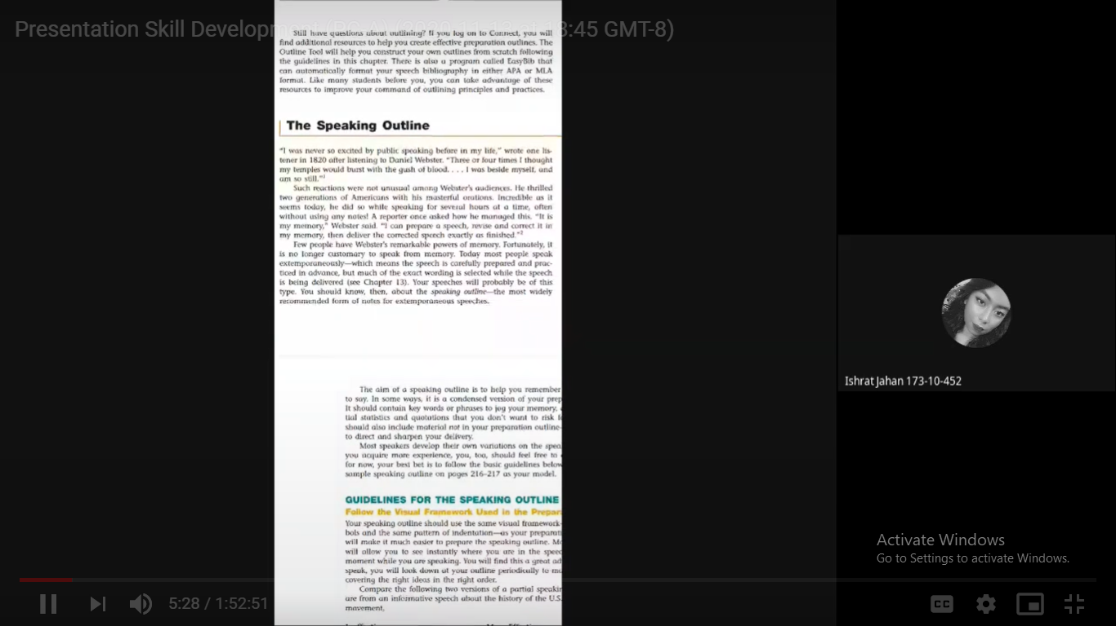
She is Introducing the discussion topic
Picture -2
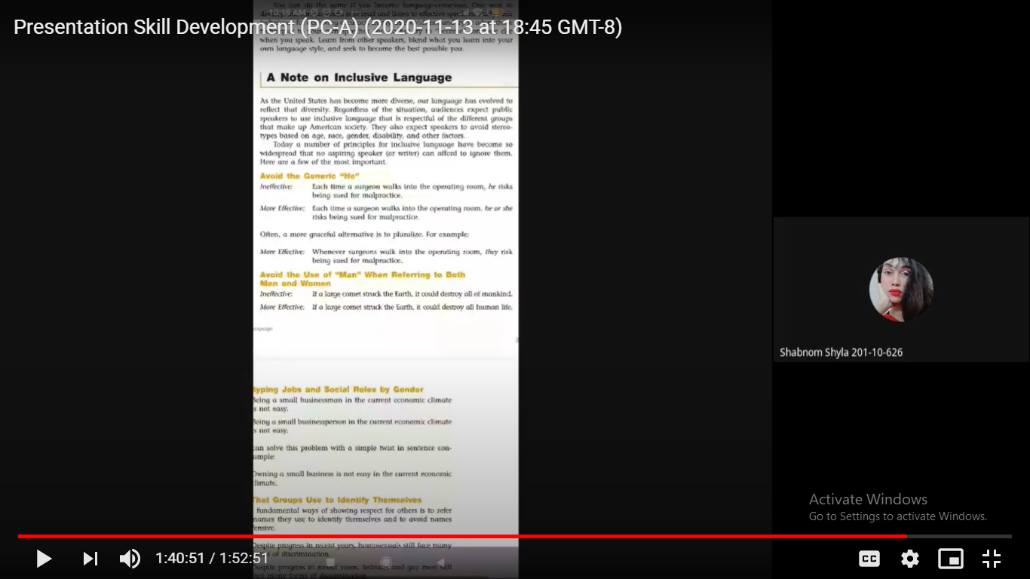
Topic discussion
Picture - 3
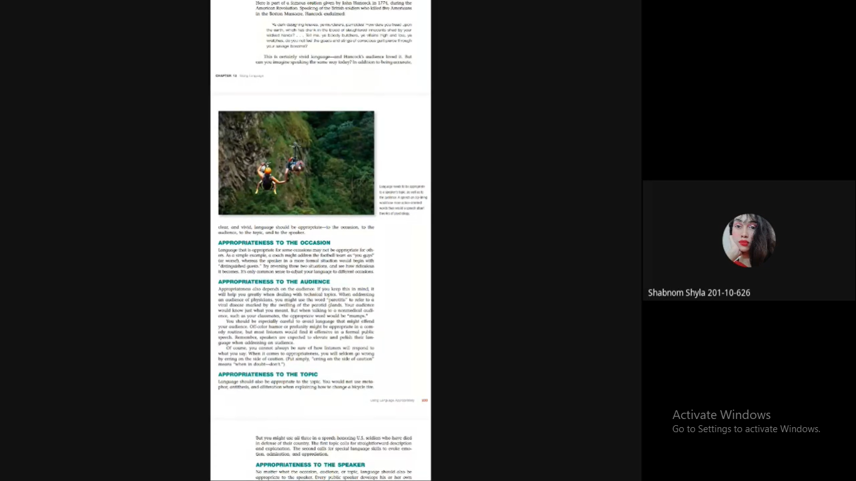
Student – Teaching Interaction
Class observation – 2
Teacher: Sumaiya Binte Habib (173-10-458)
Picture - 1
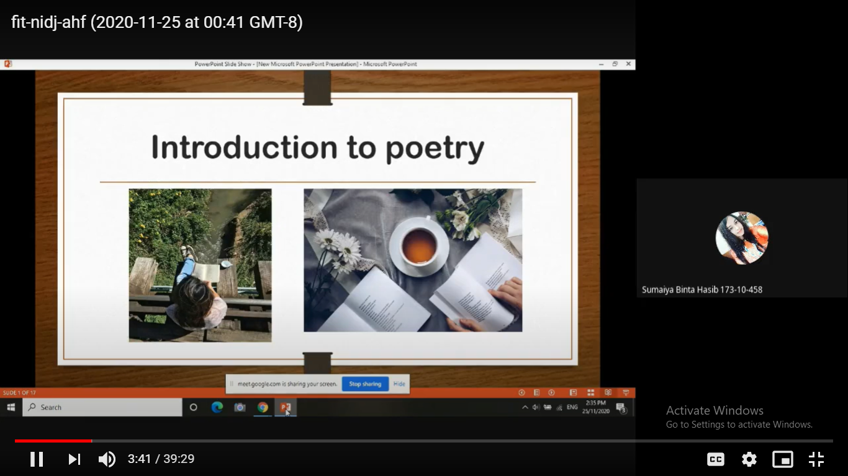
Her topic introduction
Picture – 2
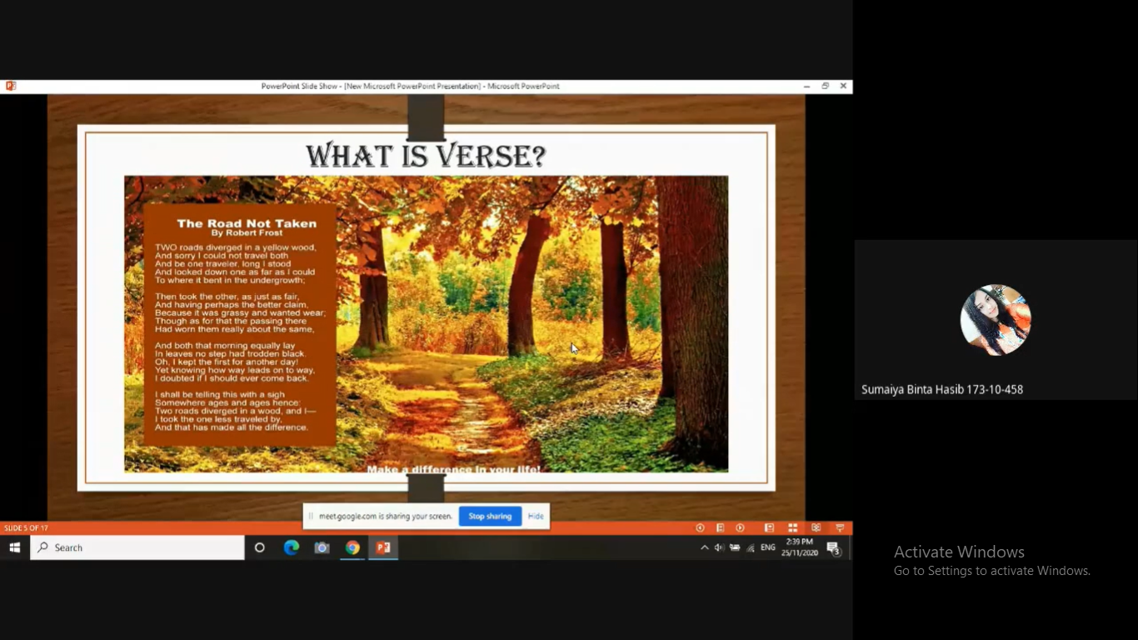
She is giving examples
Picture - 3
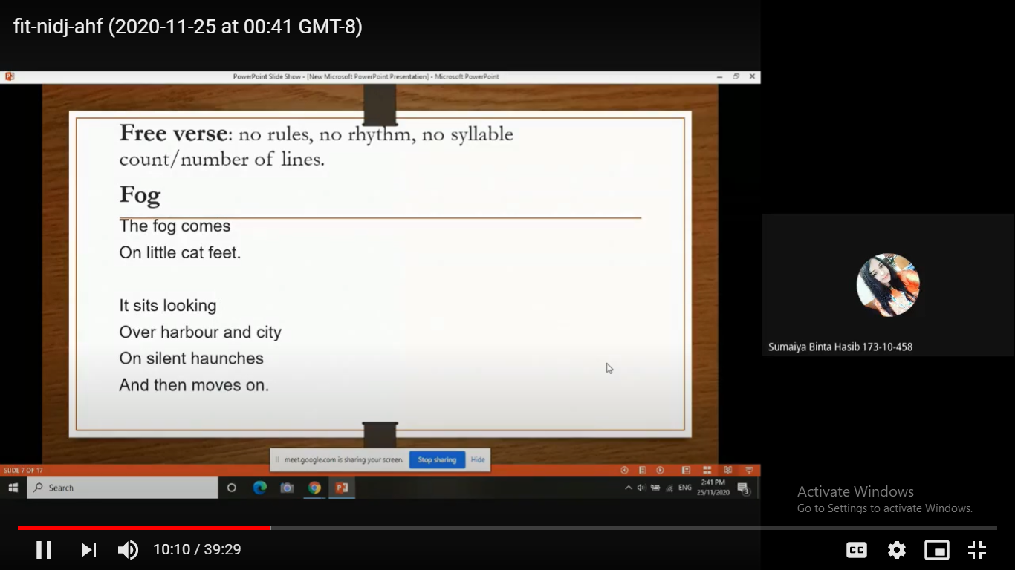
Her topic discussion
Picture - 4
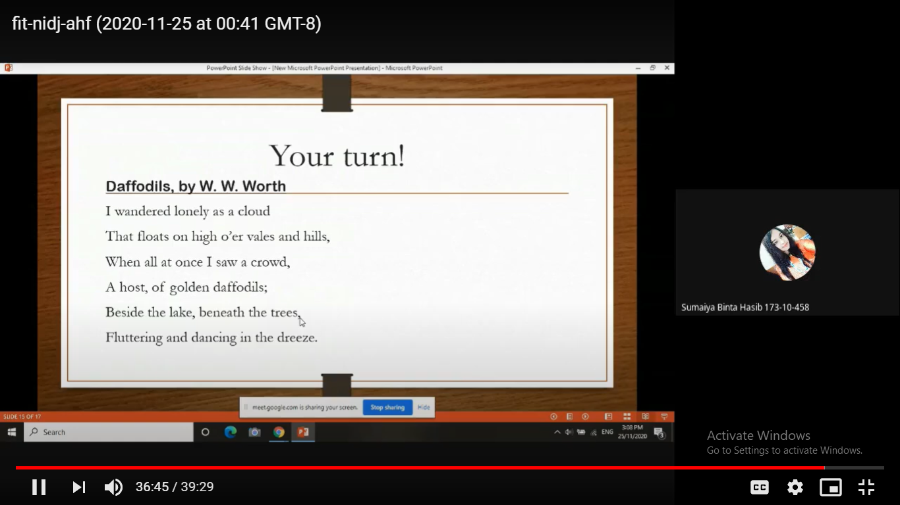
Her assigned class activity

My class conduction
Name: Umma Habiba Nafsi Zahan Lima
ID: 172-10-445
Date: 14th November, 2020
Picture – 1:
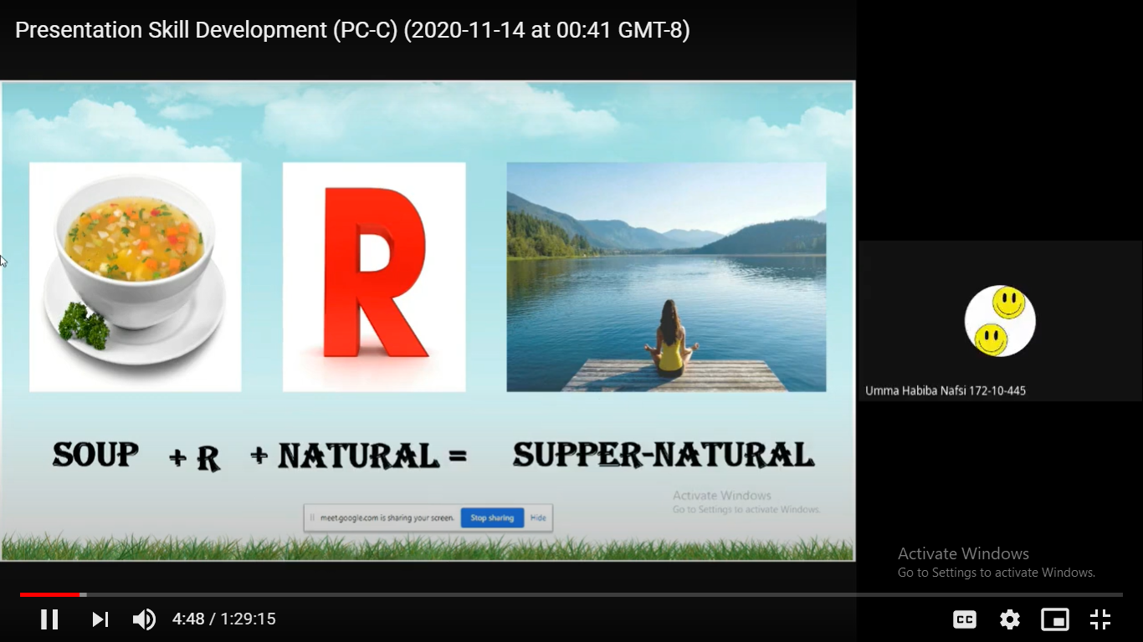
Warm-up session
Picture – 2: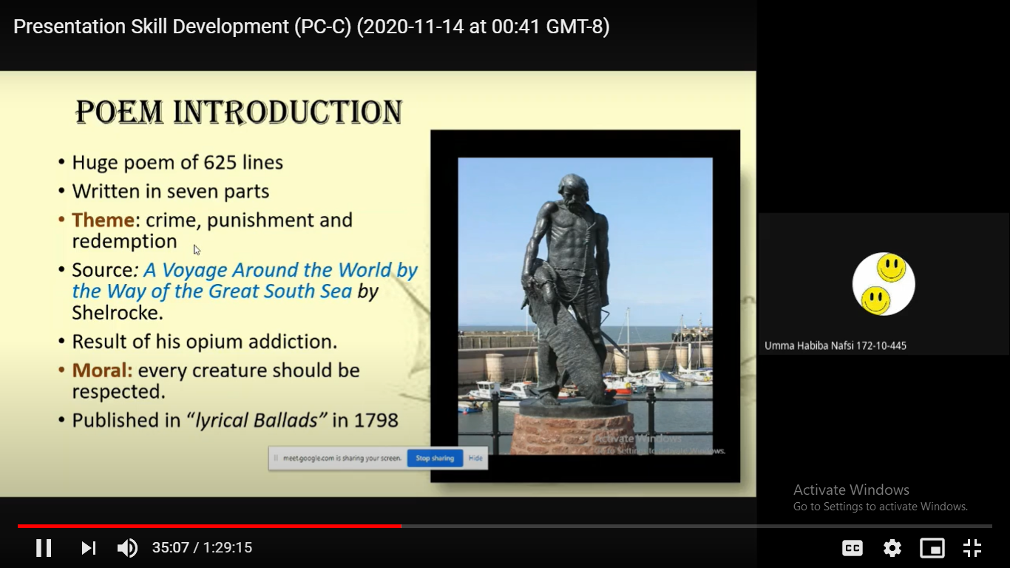
Poem introduction
Picture – 3:
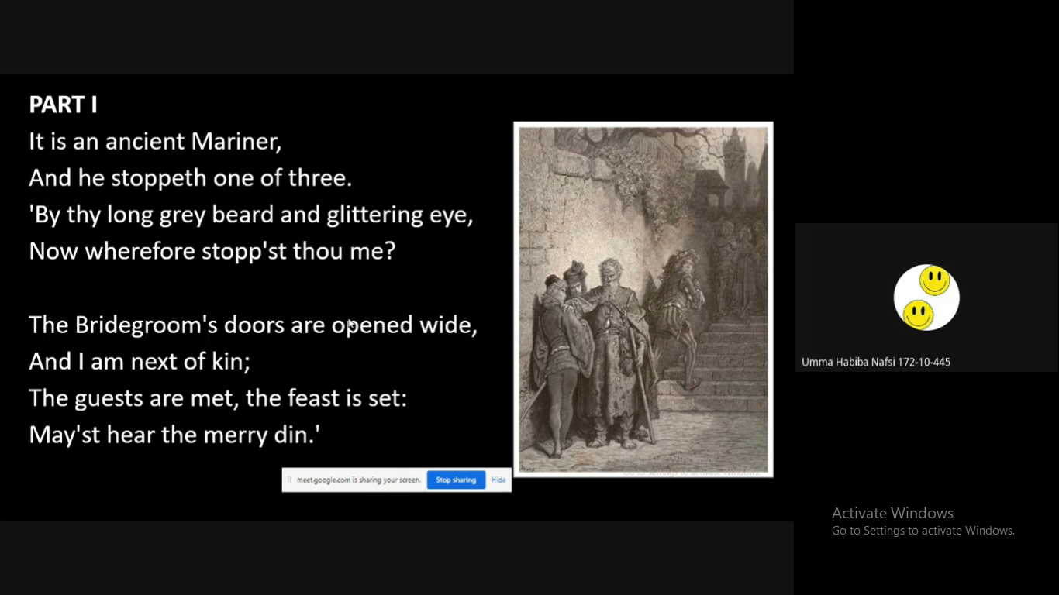
Explaining the poem and showing the illustration
Picture – 4: 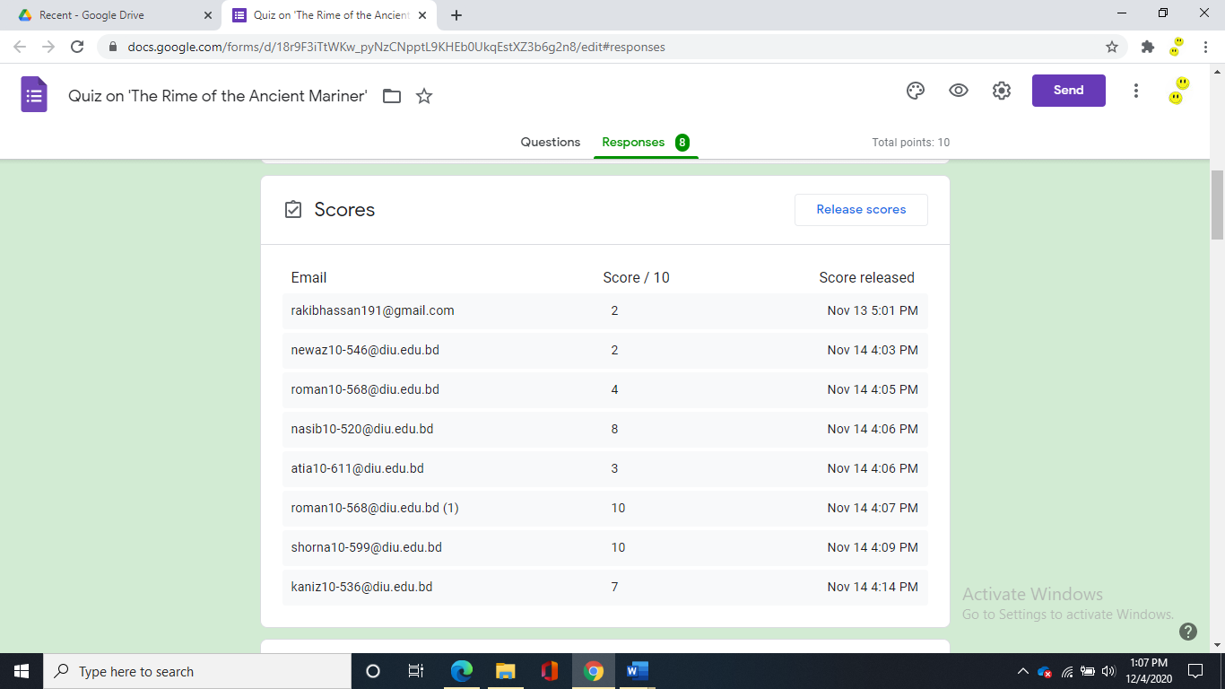
Quiz responses on Google Form
Picture – 5:
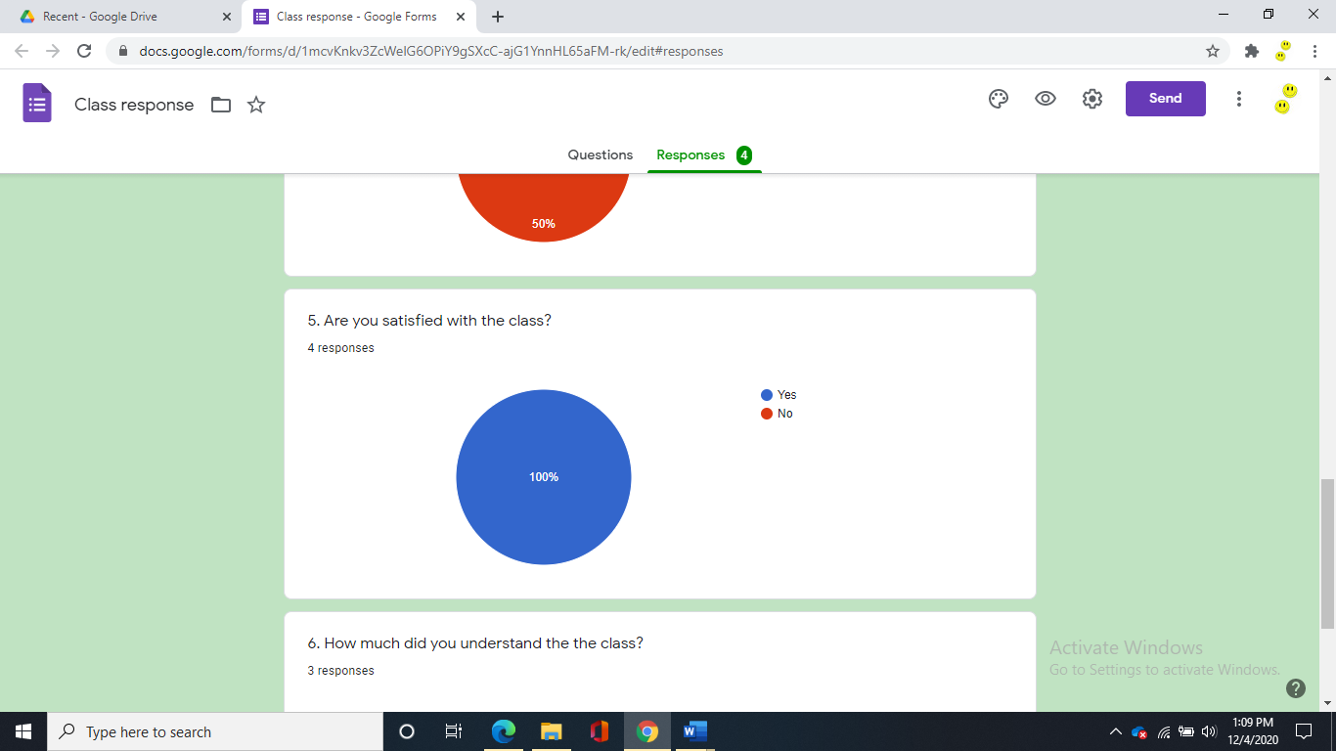
Class feedback (from the students)
Appendix - 4
Google Meet Recording Links

1st Class observation link:
https://drive.google.com/file/d/15j3wabHmiM91MJjoOP2GwulzX8PNl-ST/view?usp=sharing

2nd Class observation link:
https://drive.google.com/file/d/137CfXyxmNLJlK1s3_x0ygw7skYLPyGtx/view?usp=sharing

My class conduction link:
https://drive.google.com/file/d/1aZo7r-Y35gy7hiqfGuDmLaQvWqXgCKBF/view?usp=sharing

Plagiarism Result

