ENG: 334-Project Paper

Report on “Online Class Observation and Conduction in English During the Outbreak of Covid -19”


Daffodil International University
24.12.2020

Report on “Online Class Observation and Conduction in English During the Outbreak of Covid -19”
A report submitted to the Faculty of Humanities and Social Science in Partial
accomplishment of the requirements of the degree of Bachelor of Arts in English

Course Code: ENG- 334
Course Title: Project Paper
Fall 2020
Submitted by
Monisha Gope
ID: 163-10-418

Supervised by
Fatema Begum Laboni
Assistant Professor, Department of English, Daffodil International Universality
Daffodil International University
24.12.2020
Declaration
I hereby declare that the project work entitled “Report on Online Class Observation and Conduction in English during the Outbreak of Covid-19” submitted to the Department of English. Daffodil International University is a record of an original work accomplished by me under the guidance and supervision of Mrs. Fatema Begum Laboni, Assistant Professor, and Department of English. The project paper work is submitted in the partial accomplishment for the requirements for the award of the degree of B.A. (Hons) in English for the course “Project Paper (ENG-334)”. I also ensure that the result embodied in this project have not been submitted to any other institution other than Daffodil International University.

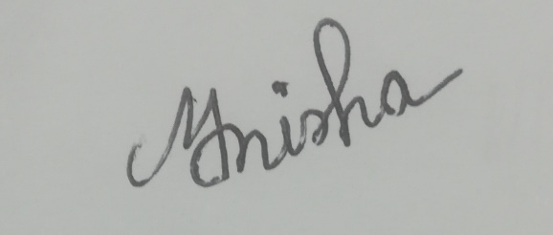
---------------------------------------------------------
Signature of the Inter
Certification

I hereby accredit that the intern Monisha Gope bearing the ID no 163-10-418 has undertaken the course Project Paper (ENG-334) with me. Concerning the course requirement, she selected two different online English Language courses of Daffodil International Universality, maintained a regular communication with me as the facilitator of the courses, observed one class of each course and conducted one online class according to her choice between the two selected courses as well. Around this entire process, she kept in touch with me thought taking guidelines from me on a regular basis, showed me her work and updated me with her day to day actions on accounts of the course. After experiencing the contribution and standards of her work, I therefore certify that she has met all the requirements and completed all the due procedures of the course, and the intern is qualified to submit this report.

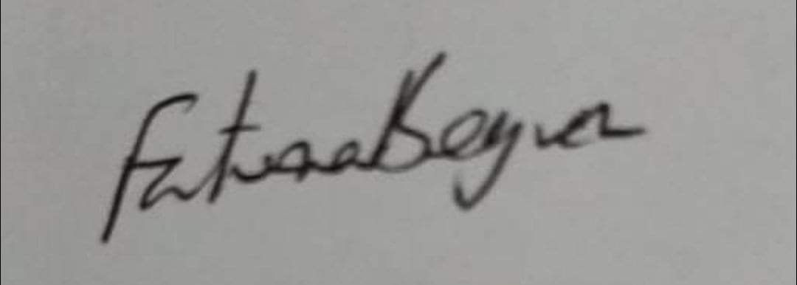

----------------------------------------------------------
Signature of the Supervisor

Acknowledgements

At first I want to convey my gratitude to the Almighty Allah for inflicting me and give me enough patience and strength to complete this project paper titled “Report on Online Class Observation and Conduction in English during the Outbreak of Covid-19”.Then I am thankful to my supervisor: Mrs. Fatema Begum Laboni, Assistant Professor, and Department of English, Daffodil International Universality, whose effective guidance and valuable suggestions made my project a successful one. Without her necessary support it would not be so easy to complete this work. At last I am thankful to the teachers and students of Daffodil International Universality who supported me indirectly for the successful completion of this task.

Abstract

This report is about “Online Class Observation and Conduction in English during the Outbreak of Covid-19”. It was an effort to know about the English teaching – leaning condition of Daffodil International University on an online platform during the outbreak of Covid-19.As part of it, I had to use Google Meet for observing and conducting the task. I have completed the task by forming teaching methods, assessment and feedback. The aim od this project paper is to investigate how teachers embody instruction and manage students in the classroom, get their responses, and how the materials are used in teaching English pointing out the lesson objectives and plans. In this whole process there were a variety of steps that an intern needs to follow such as filling in observation checklists, planning lesson, designing assessments and feedback and many others. Though this project work, I had a chance to earn some practical knowledge which will be beneficial for aspiring teachers of English in regards to English language teaching.

Table of contents
Contents | Page No.
Title Page | II
Declaration | III
Certification | IV
Acknowledgement | V
Abstract | VI
Table of Contents | VII
Chapter-01: Introduction | 1
Chapter-02: Objectives | 2
Chapter-03: Methodology | 3-4
Chapter-04: Institutional Details | 5
Chapter-05: Class Observation Report | 6-7
Chapter-06: Teaching Experience | 8-9
Chapter-07: Overall Findings | 10-12
Chapter-08: Recommendations | 13
Chapter-09: Conclusion | 14
Appendices | 15
Appendix 1: Lesson Plan | 16-17
Appendix 2: Photographs | 18-20
Appendix 3: Observation Checklists | 21-29
Appendix 4: Google Meet Links | 30
Plagiarism Report | 31

Chapter 01
Introduction
Nowadays the language teaching process plays an essential role for learning English language
and also building global communication. Not only that, this process also helps us be more fluent
and proficient in English. Being a student of English Department at DIU, I got an opportunity to
do the course Project Paper (ENG- 334). As all educational institutions were closed by the
Government due to the outbreak of Covid-19, I completed this research using the online platform
otherwise I was supposed to observe and conduct classes at a Bangladeshi School.

Goal of this project paper was to investigate the online functions of our university. As the report is on "Online Class Observation and Conduction in English during the Outbreak of Covid-19” the classes I observed and I used conducted at Google Meet. That whole process was facilitated following my supervisor Mrs.Fatama Begum Laboni’s instructions. At first she discussed the whole process of conducting and observing classes through Google Meet and I also kept in contact with her several times via what’s app group for this course. I conducted one class and also observed two of my peers' classes. My peers also observed my class in a similar way. It was a great lesson for us and helped us learn how to cope up at any kind of situation during the time at 1pm.

Chapter 02
Objectives

This report aims to illustrate the current scenario of “Online Class Observation and Conduction in English during the Outbreak of Covid-19”. The specific objectives of this study are:

- To analyze the online interaction between teachers and students
- To find out the methods and techniques of online teaching in English
- To monitor the result of these methods and techniques
- To examine the online teaching material
- To imply useful and practical teaching methods
- To determine students online learning development

Chapter 03
3.1 Methodology
In this critical situation the authority of our university decided to give us the opportunity of talking class though an online platform. The report is a concise inquiry about the online class circumstances in DIU arranged due to the COVID situation. This report contained research of reaching methods, observation of classes, exploration of student’s impressions, and analysis of taking classes.

3.2 Selecting the Host Institution
For the issues of Covid-19, I supposed to but could not visit any school as all education institutions were closed by the government to avoid mass contact. However, to cope up with this situation, the authority of my university arranged classes through an online platform. This gave us the opportunity to conduct classes online in this current situation. Then, I completed my internship form my own university. The name of my institution is Daffodil International University.

3.3 Having a facilitator
As my own university was the means of conducting and observing classes, my facilitator of internship was my supervisor; Mrs. Fatema Begum Laboni, Assistant Professor, and Department of English, DIU. She helped me with the selection of classes and also gave instruction about that whole task through online meeting and texts. The meetings and messages helped us finish the project paper work within the due time.
3.4 Selecting classes
After the meeting with my supervisor along with other interns under her guidance for Fall 2020, I was allowed to conduct a class of the course ENG-313 Introduction to American Literature and my class was Nov 22nd on 1.00p.m.- 1.50p.m.
3.5 Classroom Observation and self-Reflection
My facilitator designed a schedule for me to observe two classes first and then conduct one. On Nov 14th I observed my first class of Romantic Poetry (ENG-224) and completed my checklist. Exactly after four days I observed another class of Introduction to American Literature (ENG-313) on Nov 18th completing the checklist. Later in the following week my facilitator informed me though Facebook messenger that she had scheduled my Introduction to American Literature (ENG-313) course class conduction on Nov 22nd .Therefor, my study features the discoveries of two class observations and one class conduction.
3.6 Assessment
I assessed the students asking them questions regarding topic and talking feedback from them. I tried to understand students’ psychology to prepare myself to teach them properly and effectively. I formed a dear conception of their needs. It helped me to decide how to teach them. Accordingly, I chose my teaching methodology. Everyone was very enthusiastic and responded properly. I tried my level best to do excellent. Moreover, I attempted to create a friendly environment in my class.
Chapter 04
Institutional Details
Name: Daffodil International University
Location: Ashulia Permanent Campus, Dhanmondi City Campus and Uttara
Number of Faculties: 5
Number of Departments: 25
Academic Staff: 859
Administrative Staff: 780
Number of Students: 21,752
Summary:
Daffodil International University (DIU) is recognized as one of top graded university in Bangladesh. The university has been established by Daffodil Group with the approval of the Ministry of Education under the Private University Act of 1992 and its amendment in 1998. Daffodil International University came into being on 24th January 2002 with its motto, “Landmark to Create the Future” Md. Sabur Khan is the chairman of this university. Chancellor is Abdul Hamid, President of Bangladesh and Vice chancellor is Professor Dr. M. Lutfar Rahman. The university is known for its excellence in academic results, numerous clubs and communities and modern educational tools and technology. Recently, researches at Daffodil International University of Bangladesh have developed an Artificial Intelligence technology that can diagnose COVID-19 by using x-ray results. The University is also known for its approx. 150 acre “Green Campus” at Savar, Dhaka.

Chapter 05
Class Observation Report
The first class I observed was on Nov 14th and second one was on Nov 18th. I observed my two peers’ classes. They Umma Habiba Nafsi Zahan Lima ID 172-10-445 and Farhana Easimin ID172-10-446. The classes they took were under the courses Romantic Poetry (ENG-224) and Introduction to American Literature (ENG-313) of English department.

5.1 Class Observation 01
My first observed class was on “Romantic Poetry” and topic name was “Ancient Mariner” by Samuel Taylor Coleridge. The class started 2.30 p.m. with a warm –up game which the played with some students. Then she played another creative game which was related to poetry. She asked to the topic. Then she asked how they conducted those things in their daily life and some students responded to that. Umma Habiba Nafis Zahan Lima conducted this class and 14 students out of 36 students attended the class.After That teacher showed a power point slide about poetry to the student and described it elaborately. Her grammar and pronunciation were up to the mark. She described to the students how they can related their life. Then she suggested students some digital dictionary names which can be useful for learning vocabulary.
The teacher was very organized from the beginning of the class. She met all of her class objectives and declared clearly to the students. The way the teacher explained and gave real life examples, it transparently represents her knowledge and skill of class content. There was a moment when the communication was disrupted by a background music of a student, while the students were answering questions and solving the class activity. The teacher being very smart and friendly, tackled the situation with a cleaver move. The teacher gave them a link google from to answer the questions and concluded the class at 4.00p.m. The class could been a prefect one if the students talking time was more than the teacher’s talking time.
5.2 Class Observation 02
The second class I observed was 17th Nov 2020 and the topic name was “Because I could not stop for death” by Emily Dickinson. There were almost 11 students’ presents and it was conducted by Farhana Easmin. The class held on 8.30a.m. To 9.30 a.m. The objectives of the lesson were to make the students understand the pome and give them brief idea about the topic and give short background idea.
Farhana began her class at scheduled time. It was on online class held on Google meet. She used little bit of English language for communication with the students. At first she welcomed the students and ask some question from death. She gave a clear concept from death and gave an idea about the topic. After that, she showed PowerPoint slide and described the first section and asked questions to the students to check what they understood. Frequently she asked questions based on her topic. Students clearly understood her lecture properly. After finishing her lecture she gave the students an online quiz Google Form. But while online both the teacher and students must be concerned about their devices. Because in online platform many students cannot concentrate properly because of poor ne connection, breaking of voice and echo etc. but she focused all matters properly.
Overall, she did well in her teaching but her pronunciation was not perfects, sometimes sound quality was poor. She organized her speech well but full class she speak in Bangla. She replied to all the questions the students had. She held the attention of the students from the beginning to the end of the class and ensured the learning environment of the class.

Chapter 06
Teaching Experience
I prepared myself and planned my lesson with the assistance of my supervisor for conducting class. When my supervisor was happy with my plan, I selected the drills methods of the class. Finally I conducted the class on time and succeeded in a sense that I provided maximum help, knowledge and tips regarding the students’ learning of selected topics and the class went exhalent the way I designed.

6.1 Self-Reflection Report
On 22nd November 2020 Sunday I conducted one class of Introduction to American Literature (ENG-313) and level of student are 14th batch in pc, under the supervisor of Mrs.Fatama Begum Laboni. Before I starting the class my supervisor introduced me to the students. They all welcomed me curiously in their online class. I introduced myself to them. I started class at 1.00 pm and finished at 2.00 pm and 28 out of 40 students were present that day. It was an online class on Google Meet.
Before going to take the class I saw the students’ two pictures, one is new borne baby and another is death body. Then I asked question ‘what do you think in your life? Because the pictures and question were related to my topic as well my subject matter. I focused on the major them of connecting idea with pictures. I encouraged all the students to make a creative idea about the pictures and what they will learn from my lesson. After all things were provide the students could understand what they would learn that day. My supervisor assigned me with one poem titled “Because I could not stop for death” by Emily Dickinson from Introduction to American Literature course. The poem were very interesting.
When I started my topic discussion part were interesting to list ion to my lecture. During my lecture I saw them to PowerPoint and video. I gave them a brief summary and analysis of the poem. First I told anyone please read 1st stanza and student read. Then I read line by line from text and focused on pronunciation, vocabulary, meaning of the poem, compare and contrast, analytical skill and listing skill etc. After completing my discussion pome I provide online quiz in Google Form so that I could understand their knowledge about the poem. In conclusion I checked all answers and I provide feedback. I asked all the students to talk about their confusion if they had any. I gave some suggesting about how to improve more analytically giving detailed answer which would help them to increase more knowledge.

However, I really enjoyed my class conduction and I completed the whole process timely as well. I never thought of getting this opportunity to teach university students. The main reason behind taking university online class is the prevailing situation of COVID-19. Though it was quite difficult to take class though an online platform, it was a new experience for me as a student. Another important thing to comment on is the internet connection. Because it’s online class conduction and every student depends on an internet source including me, I was a bit scared, although I had data backup. Finally by the support of God and my supervisor I executed my lesson plan successfully.

Chapter 07
Overall Finding
7.1 Class Observation Finding
I found out several important features of online English teaching throughout my class observation period. Those are:
7.1.1 Lesson Preparation
I was well aware of the fact that a teacher needs to make a lesson plan before conducting class due to my previous experience of voluntary teaching and ELT course. After interviewing the course teacher, I got to know that a teacher needs to put a lot more effort in online lesson preparation compared to physical one. In the first class observation, I found the lesson plan well organized but the scenario was completely opposite in the second class observation though the teacher was the same person for both of the course.
7.1.2 Lesson Delivery
I knew that every teacher has their different way and style of delivering lessons. But in my internship, I found out that the same teacher for different courses can have different styles and approach of lesson delivery. Though the teacher was using Communicating Language Teaching method mostly for both the classes in the first class she was following the behavioral approach and emphasized memorizing drill in the second class.
7.1.3 Lesson Materials
There was a significant difference in presenting the lesson materials between the classes. In the first class the teacher took online materials and presented them in a PowerPoint slide along with pictures and activity to make the class an attractive lesson. On the other, in the second class the teacher present a simple word of a huge word list which was also take from online. But the second was not as lucrative as the first one.

7.1.4 Class Time Management
The teacher was very well organized and was pretty good at time management which allowed her completed all phrases of her class on the first class observation day. On the other hand the same teacher could not meet all her goals due to the lack of popper time management and technical issues in the warm up session.
7.1.5. Students’ Involvement
The respective students of both courses were very enthusiastic, participating and very much engaged in the classes. The students of first class observation were using a bit more native language compared to second observation class. But the spirit to be engaged of both groups is wroth praising.
7.2 Self-Reflection Findings
For conducting classes, I tried to apply the most effective methods and approach. However, I cannot guarantee that the methods I followed were the best but I can certainly assure these will definitively help the students in regard to online English learning.
7.2.1 Lesson Plan
I sincerely prepared myself to conduct the class. I designed and organized my class with the guidance and instructions of my supervisor. I even took her approval for the lesson materials I used. I made a lesson plan to be focused on the class objectives and tried heart and soul to conduct an effective online class.
7.2.2 Lesson Delivery
I mostly followed the Communicative Language Teaching method and played the role of a facilitator in the classroom. I helped the students but only when they were stuck. I also followed the GTM method for the phase of presenting the structure of the contend and translated some sentences for the ease of the students.

7.2.3 Lesson and Time Management
After observing two classes, I was very concerned about my lesson and time management. As a result, I divided my lesson into several stages such as; greeting, warm up, examples, pre-test, explanation, activity, post-test, feedback to avoid problems related to wasting time. Apart from that, I also maintained a friendly environment throughout the class.
7.2.4 Students’ Involvement
The students of my observed classes were very engaged. That is why I was quite confident about my students. But unfortunately, I had to push a lot to make the students participate, speak and engage in the class. The google form responses were not that satisfactory as well compared to the number of attendees.
7.3 Advantages of Online Class
Students can attend classes staying at home without taking any risk and maintaining social distance. They do not have to stop the study due to the COVID-19. They can even attend classes when they are sick. Another significant advantage of online class is the motto of sustainable earth “Go Paperless” has been followed without any obstacles.
7.4 Disadvantages of Online Class
First and foremost is the network issue. My facilitator and I both met internet disruption in the middle of the class and students getting connected and disconnected is a common problem throughout the class. Even some students living in remote areas find it very difficult because of low network coverage. Secondly, the over-period internet package of mobile data users. Last but not the least, critical events that occur due to the students’ distraction such as; playing music in the background, ringing phones etc. heavily hampers the class.

Chapter 08
Recommendation
I have acquired an immeasurable amount of knowledge and experience of online teaching in English throughout my internship in Daffodil International University. Based on these experience I would like to make some recommendations for the betterment of online teaching in English-

- The teacher should always think of attractive and entertaining warm up ideas as a warm up session is the ice braking phrase of a class. On top of that online class seems to be more of an isolated one so the teacher should make sure of a lucrative warm up to grab students’ full attention from the very beginning of the class.

- The teacher should double check any online games to avoid technical problems during the class. Because games are widely and happily acceptable by all student but technical difficulties in those games can come out as a huge turn off for the students.

- Students’ talking time should be increased to the level of 70-75% of class and teacher talking time should be decreased at a level of 25-30% of the class to ensure the most effective and engaging class which also creates an environment of the students to learn mostly by their peers and themselves.

- Google meet links of the classes should be provide right after finishing the class in the Blended Learning platform so that if a student is absent, sick, facing any network issue or even if he gets disconnected in the middle and missed some parts of a class does not lag behind.
Chapter 09
Conclusion
Online educating and classes are the new normal of the COVID-19 pandemic. I am really grateful because I did not have to stop and I was able to complete my paper and study because of this normal. I have learned many intriguing and significant things with respect to the adequacy of Online English Language Teaching from my internship. By observing and conducting online classes at Daffodil International University, I have had the option to distinguish the advantage and disadvantage of Online Teaching procedure. I have found out about the things that ought to be kept away from and the things should be embraced for the improvement of Online English Teaching. However, these discoveries can be distinguished as a constructive guideline for me, as I plan to be an educator in future. Nonetheless, I am so thankful to my supervisor and others identified with this venture who helped me altogether to finish this project effectively.

Appendices
Appendix 1- Lesson Plan
Appendix 2 – Photographs
Appendix 3 – Class Observation Checklist
Appendix 4 – Google Meet Links

Lesson Plan
Daffodil International University
Lesson overview
Course |  | ENG313: Introduction to American Literature
Teacher/Facilitator |  | Monisha Gope
Enrolls Student Number |  | 40
Section |  | PC-A, UC
Lesson Topic |  | Because I could not stop for death
Lesson Objectives |  | Student will be able to learn new vocabulary and improve reading, listening skill.
Class Description |  | Online class
Teaching Method |  | - CLT  - GTM(partially, whenever students need)
Resources |  | - Online picture for vocabulary  - Power point for description of the lesson  - Google form worksheet for practice
Date |  | November 22,2020
Estimated Duration | 40-50

Phases | Teacher’s Activity | Student’s Activity | Time
1 | The teacher will warm up students with an entertain visual vocabulary riddle and help students to find out the correct answer of the riddle. | Students will resolve the riddle based on their existing vocabulary find out the topic name. | 5-6  minutes
2 | The teacher will ask students about the topic and then in traduce them to the topic. | Students will express their knowledge about the topic in the class. | 10-12  minutes
3 | The teacher show a PowerPoint slide on the topic | Listen to the teacher’s brief lecture for better understanding. | 10-15 minutes
4 | The will share some picture and video | Students will be active in the class | 8-10  minutes
5 | The teacher will give a google forms at the end of the class. | Students will attempt the short quiz in that time. | 10-12  minutes

Assessment:
The homework, test, students participation and students activity in class are the lead to make the assessment a precise one.

Photographs
Class Obseravation-1

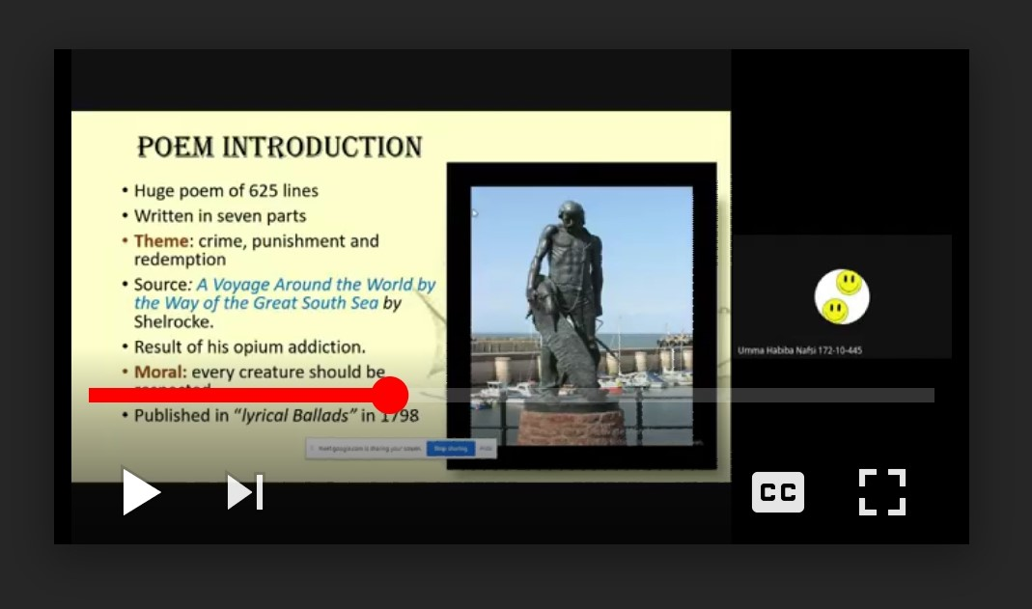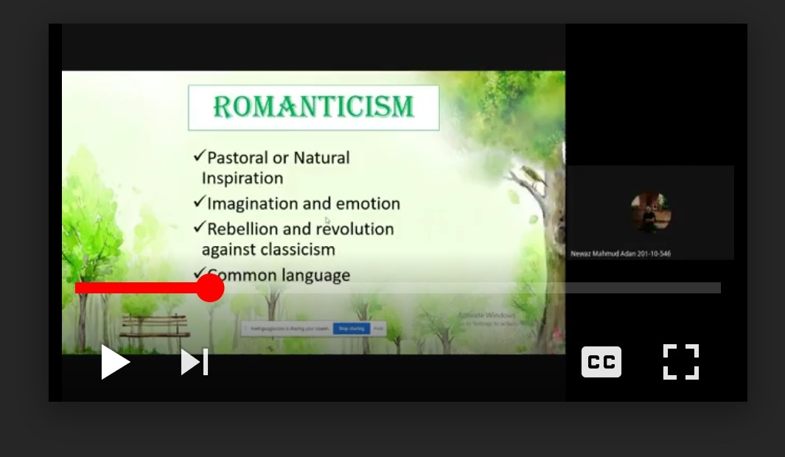
Class Observation -2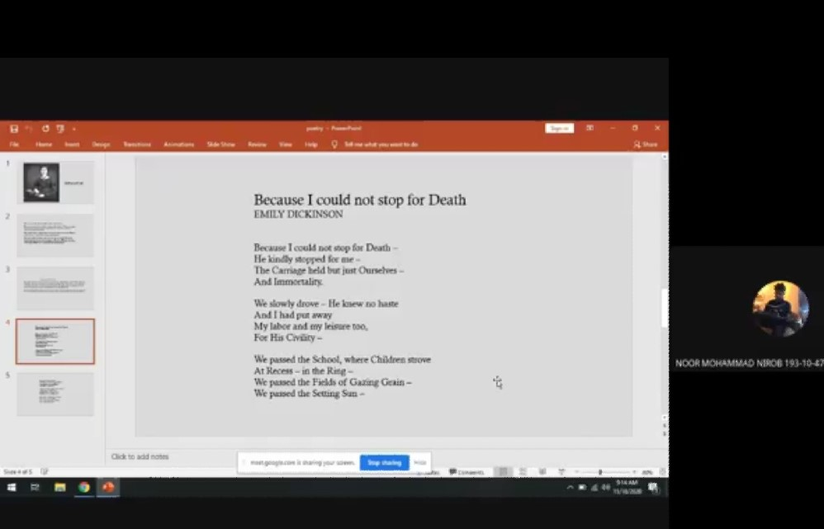
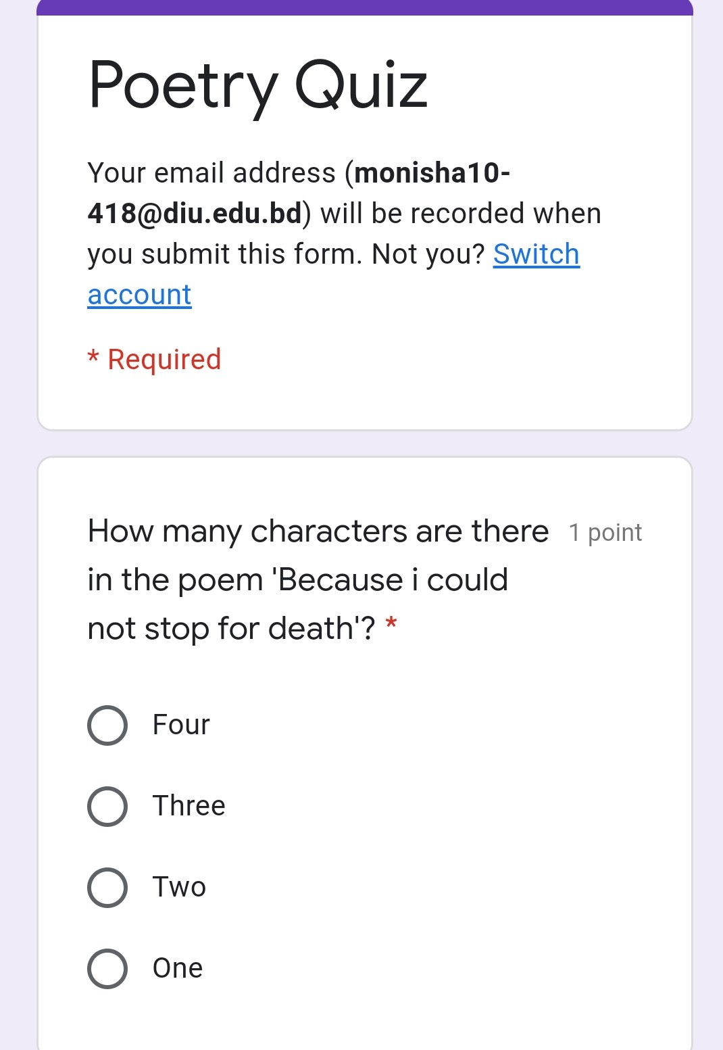
Class Conduction: 
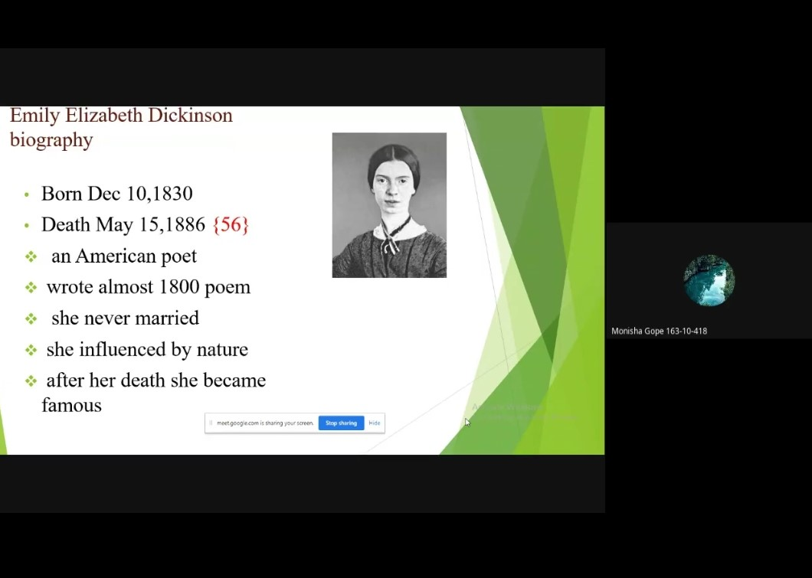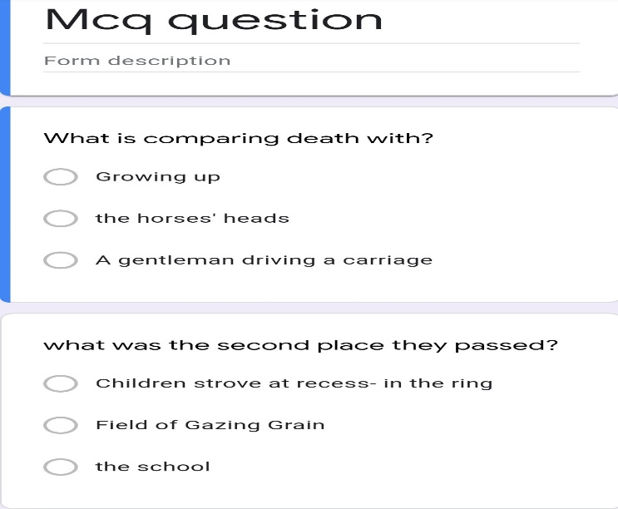
Observation Checklist
Checklist: 01
Daffodil International University
Department of English
Internship on “Online Class Observation and Conduction in
English during the Outbreak of Covide-19”

School / College: Daffodil International University
Teacher’s Name: Umma Habiba Nafsi Zahan Lima Class: 14th batch
Section: PC-C No of students Present: 14
Course Title & Code: ENG 224, Romantic Poetry
Rome No: Online Peer/Observer: Monisha Gope Date and Time: 14.11.2020 at 2.30pm
Objectives of the lesson (as perceived)
- To teach vocabulary
- To get some information about the poet
- To develop analyze skill
- To analyze the poem with features.

Were the objectives the objectives achieved and to what extent (in your view)?
The objective were achieved. He has completed all objectives in the class.

S/N | Review Section | In what ways? (Specific examples/ clarifications)
1 | SJECT MATTER CONTENT  (shows good command and knowledge of subject matter; demonstrates breadth and depth of mastery; tries to develop a knowledge seeking behavior among students) | The teacher had a good command and knowledge of the contents. She tried a behavioral approach of clapping on correct answers to develop the knowledge seeking behavior among the students.
2 | ORGANIZATION  (organizes subject matter; states clear objectives; emphasizes and summarizes main points, meets class at scheduled time, starts and finishes the lesson properly with an attractive warm up and a conclusive end- how the objectives of the lesson met/ what they have learned today) | The teacher conducted the class in a power balanced way. She had a good time management skill in the whole class. Started with good warm up session and ended the class in an organizing way by assigning homework along with the very clear objective statement.
3 | REPORT  (hold interest of students; is respectful fair, and impartial; provides feedback, encourages participation; interacts with students, shows enthusiasm, both teacher and students are ready for the class not only on subject matter but also in manner, etiquette and attitude) | The teacher asked questions from the very beginning and encouraged everyone to reply. She was randomly picking students for the pre- reading session and Q/A session to be fair enough. Students were thoroughly attentive. The teacher also maintained a healthy friendly atmosphere.
4 | TEACHING METHODS  (use relevant teaching mthods, aids, materials, techniques and technology; includes variety, balance, imagination, group involvement; encourages questions from students and responds with interest; is open to ideas; uses real life examples that are simple, clear, precise and appropriate; stays focused on and meets stated objectives) | The teacher followed a little bit of GTM method whenever the students were stuck. But she showed her mastery in CLT too. The teacher was well- equipped with slides and pre- reading online materials. She stuck to the objectives but had an excellent precision of using real life example.
5 | PRESENTATION  (establishes classroom environment conducive to learning; ensures learns’ interests, maintains eye contact; uses a clear voice, strong projection, proper enunciation and standard English) | The teacher always maintained verbal interaction. She had a good control of clear pronunciation and energetic voice. Overall she performed really well.

MANAGEMENT
Was the time spent properly?
Yes, she spent his time well.
What were the main stages of the lesson? What tasks and actives did the teacher do during each stage? (Optimal: Draw a diagram to show main stages of the lesson and time spent on each)
She gave a short video and asked question on the video. | 5 minutes
She gave a brief discussion about the topic. | 30 minutes
She asked questions and tried to solve their problem. | 5 minutes
Students gave a quiz | 5 minutes
She tried to listen to the students’ problem | 12 minutes
She finished the class by thanking all and provided feedback. | 3 minutes

CRITICAL EVENT (If took place)
Was there any ‘critical event’ in the lesson? (A point where communication broke down and there was confusion). How did the teacher handle the situation?

There was a point when a student was playing music in the background and other students were distracted due to music. But the teacher professionally handled the situation. She eased the moment saying “We all are bored but the music just recharged us with energy. Now we are ready for our next task”

Strengths observed:
- Time management
- Effective material choosing ability
- Energetic voice
- Critical situation tackling ability
- Knowledge of different methods

Suggestions for improvement:
The teacher should decrease the amount of teacher talking to me in class and design the class materials based on the student’s area of expertise so that the students can keep them motivated talk more frequently in class without any push.

Overall impression of teaching effectiveness:
The teacher kept the time management and class organization first in the priority list. She had an energetic voice and her fluency of English language along with the smooth delivery of the content proved her marvelous knowledge of the contents. Overall she illustrated her precision of class conduction, handling a critical situation in the middle of the class with friendly yet mature behavior.

Observation Checklist
Checklist: 02
Daffodil International University
Department of English
Internship on “Online Class Observation and Conduction in
English during the Outbreak of Covide-19”

School / College: Daffodil International University
Teacher’s Name: Farhana Easmin Class: 15th batch
Section: PC- A No of students Present: 11
Course Title & Code: Introduction to American Literature (ENG-313)
Rome No: Online Peer/Observer: Monisha Gope Date and Time: 17.11.2020 at 8.30pm
Objectives of the lesson (as perceived)
- To learn perceive meaning of the poem
- To get some information about the poet
- To analyze the poem with features

Were the objectives achieved and to what extent (in your view)?
In my point of view, yes, the objectives were achieved. Because she focused on the lecture and content.

S/N | Review Section | In what ways? (Specific examples/ clarifications)
1 | SJECT MATTER CONTENT  (shows good command and knowledge of subject matter; demonstrates breadth and depth of mastery; tries to develop a knowledge seeking behavior among students) | The teacher had a good command and knowledge of the contents. She tried a behavioral approach of clapping on correct answers to develop the knowledge seeking behavior among the students.
2 | ORGANIZATION  (organizes subject matter; states clear objectives; emphasizes and summarizes main points, meets class at scheduled time, starts and finishes the lesson properly with an attractive warm up and a conclusive end- how the objectives of the lesson met/ what they have learned today) | The subject matter was pretty organized but unfortunately due to the technical issues in the very beginning of the warm up session the teacher was unable to conduct the class in an organized way. And the warm up session could not take place.
3 | REPORT  (hold interest of students; is respectful fair, and impartial; provides feedback, encourages participation; interacts with students, shows enthusiasm, both teacher and students are ready for the class not only on subject matter but also in manner, etiquette and attitude) | The teacher providing was great. But she showed normal enthusiasm and did not interact with students. She encouraged students to participate. She needs to improve her fluency in class.
4 | TEACHING METHODS  (use relevant teaching mthods, aids, materials, techniques and technology; includes variety, balance, imagination, group involvement; encourages questions from students and responds with interest; is open to ideas; uses real life examples that are simple, clear, precise and appropriate; stays focused on and meets stated objectives) | The teacher followed a little bit of GTM method whenever the students were stuck. But she showed her mastery in CLT too. The teacher was well- equipped with slides and pre- reading online materials. She stuck to the objectives but had an excellent precision of using real life example.
5 | PRESENTATION  (establishes classroom environment conducive to learning; ensures learns’ interests, maintains eye contact; uses a clear voice, strong projection, proper enunciation and standard English) | The teacher always maintained verbal interaction. She had a good control of clear pronunciation and energetic voice. Overall she performed really well.

MANAGEMENT
Was the time spent properly?
Apart from the technical issues in the beginning, the teacher spent the time properly.
What were the main stages of the lesson? What tasks and actives did the teacher do during each stage? (Optimal: Draw a diagram to show main stages of the lesson and time spent on each)

She gave a short video and asked question on the video. | 5 minutes
She gave a brief discussion about the topic. | 20 minutes
She asked questions and tried to solve their problem. | 5 minutes
Students gave a quiz | 10 minutes
She tried to listen to the students’ problem | 7 minutes
She finished the class by thanking all and provided feedback. | 3 minutes

CRITICAL EVENT (If took place)
Was there any ‘critical event’ in the lesson? (A point where communication broke down and there was confusion). How did the teacher handle the situation?
No, she handled the class patiently.

Strengths observed:
- Good class control skill
- Choice of quality online materials
- Energetic voice

Suggestions for improvement:
Need to develop pronunciation, need to be more fluent in speaking, need to remove her nervousness.

Overall impression of teaching effectiveness:
Overall she did well to completed her teaching, fulfill her objectives, ensure learning and students were positive.
Google Meet Links

Observed Class Link:
https://drive.google.com/file/d/1aZo7r-Y35gy7hiqfGuDmLaQvWqXgCKBF/view?usp=drivesdk

https://drive.google.com/file/d/1xONKyEk2n3opOlzHk4hDtRiuqVHLvjGf/view

Conducted Class Link:
https://drive.google.com/file/d/1sIJQn6JcKpLaKb5EjE6KXv9eQk7L1u_0/view?usp=drivesdk

Plagiarism Report

