

Faculty of Engineering
Department of Textile Engineering

Study on the effect of physical properties of different knit fabrics on shrinkage (%) after normal wash.

Course Code: TE-4214 Course Title: Project (Thesis)
Submitted By
Name | ID
Shahanaj Parveen Moni | 162-23-4686

Supervised By
Sharmin Akter
Lecturer
Dept. of Textile Engineering
Daffodil International University
A thesis submitted in partial fulfillment of the requirements for the degree of Bachelor of Science in Textile Engineering
Advance in Apparel Manufacturing Technology
December, 2020

ACKNOWLEDGEMENT
First of all, I would like to express my heartiest thank and gratefulness to almighty Allah.
I would like to express a sense of gratitude to my beloved parents for all types of supports.
I would also like to express my regards and gratitude to the management of Apparels Village Ltd. for giving me the opportunity to complete the industrial training. My deepest gratitude goes to general manager, HR, Admin & Compliance of Apparels Village Ltd. for their permission to conduct my industrial training and also they provided me all the necessary fabrics and gave me allowance to conduct all the necessary tests, without which it would be impossible. Their generous support is greatly appreciated.
I am also grateful to Mr. Saddam Hossain, Assistant Merchandiser, Apparels Village Ltd. for his support & guidance throughout the training period. I am also thankful to all the employees of Apparels Village Ltd. for their co-operation, support & valuable advice.
I also like to express my gratitude to my supervising teacher Sharmin Akter, Lecturer, Daffodil International University for helping me throughout this paper. Finally I would like to acknowledge that I am responsible for every incompetence and omission, which doubtlessly remains.

DECLARATION

I hereby declare that, this thesis paper has been done by me under the supervision of Sharmin Akter, Lecturer, Faculty of Engineering, Department of Textile Engineering, Daffodil International University. I also declare that, neither this thesis paper nor any part of this thesis paper had been submitted elsewhere for the award of any degree or diploma.


Shahanaj Parveen Moni
ID: 162-23-4686
Dept. of Textile Engineering
Daffodil International University

DEDICATION

“This thesis paper is dedicated to my beloved parents, and also dedicated to my honorable teachers; may they live long”.

Table of Contents
Contents Page No.
1 Introduction………………………………………………………………………………… 2
2 Literature Review……………………………………………………………………… ……4
3 Materials and Methods…………………………………………………………………….. 9
3.1 Materials………………………………………………………………………………….. 9
3.1.1 Fabrics properties………………………………………………………………………. 9
3.1.2 Used Chemicals & Auxiliaries …………………………...……………………………10

3.1.3 Machines & Tools……………………………………………………………………...10

3.2 Methods…………………………………………………………………………………..12
3.2.1 Standard Testing Condition …………………………………………………………....12
3.2.2 Sample preparation………………………..…………………………………………... 12
3.2.3 Recipe for normal wash ………………………………………………………….. …...13
3.2.4 Normal washing process…………………………………………................................. 13
3.2.5 Process flow chart of normal wash …………………………………………………… 14
3.2.6 Test specimen attachment ……………………………………………………………...15
3.2.7 Fabrics shrinkage measurement process……………………………………………….16
3.2.8 Data Table……………………………………………………………………………...17
4 Discussion of Results……………………………………………………………………… 22
5 Conclusions………………………………………………………………………………... 23
List of tables
Table 1: Fabrics properties……………………………………………………………………... 9
Table 2: Used Chemicals & Auxiliaries ………………………………………………………10
Table 3: Used machines……………………………………………………………………….10
Table 4: Recipe for normal wash ………………………………………………………... …...13
Table 5: Data table……………………………………………………………………………17

List of figures
Figure 1: Structure of single jersey (Plain) fabric. …………………………………………….. 6
Figure 2: Structure of 1x1 Rib fabrics.........................................................................................7
Figure 3: Structure of 1x1 Interlock fabrics................................................................................7
Figure 4: 1x1 Plain fabric before washing……………………………………………………15
Figure 5: 1x1 Plain fabric after washing……………………………………………………...15
Figure 6: 1x1 Rib fabric before washing……………………………………………………...15
Figure 7: 1x1 Rib fabric after washing………………………………………………………..15
Figure 8: 1x1 Interlock fabric before washing………………………………………………..15
Figure 9: 1x1 Interlock fabric after washing………………………………………………….15
Figure 10: Effect of fabric’s GSM on shrinkage of 1x1 Plain fabrics after normal wash…….18
Figure 11: Effect of fabric’s GSM on shrinkage of 1x1 Rib fabrics after normal wash………18
Figure 12: Effect of fabric’s GSM on shrinkage of 1x1 Interlock fabrics after normal wash...19
Figure 13: Effect of fabric’s structure on shrinkage of 150 GSM fabrics after normal wash…19
Figure 14: Effect of fabric’s structure on shrinkage of 160 GSM fabrics after normal wash...20
Figure 15: Effect of fabric’s structure on shrinkage of 180 GSM fabrics after normal wash…20
Figure 16: Effect of fabric’s stitch length on shrinkage after normal wash...............................21
Figure 17: Effect of yarn’s count of fabric on shrinkage after normal wash………………….21

ABSTRACT
This thesis paper is an experimental investigation of the effect of physical properties of different knit fabrics on shrinkage (%) after normal wash. Three 1x1 Plain; three 1x1 Rib and three 1x1 Interlock fabrics of 150, 160 and 180 GSM were taken in this study. They all are 100% Cotton weft knitted outerwear fabrics. Then, they were washed by normal washing method to investigate the effect of physical properties, namely: fabric’s GSM, fabric’s structure, fabric’s stitch length and yarn’s count on shrinkage (%) of different knit fabrics. It is observed that, fabric’s GSM, fabric’s structure, fabric’s stitch length and yarn’s count all have significant impact on shrinkage (%) of knit fabrics. With the increase of the value of fabrics’ GSM, shrinkage (%) decrease. So, fabrics with more GSM value are more dimensionally stable. 1x1 Plain fabrics show maximum shrinkage (%); 1x1 Rib fabrics show medium shrinkage (%), and 1x1 Interlock fabrics show minimum shrinkage (%) after normal wash. Fabrics’ other properties may influence it. With the decrease of the value of fabrics’ stitch length, shrinkage (%) decrease. It is further noted that, higher twisted yarn causes more shrinkage than lower twisted yarn.

Chapter-1: Introduction
At present, Knitted garments have become excessively popular in the world due to their characteristics like softness, drape ability, elasticity and comfort ability. Knitted garments like T- shirts, polo shirt and other inner & outer garments have excellent comfort properties due to their structures. The field of knitwear sector is developing rapidly day by day, because it shows variant number of advantages to the manufacturer such as lower production cost, good productivity, and high-profit margin and covering a variety of product types from basic to fashion garments. Dimensional stability is very important to keep up the aesthetics of knitwear to the end users. “There are many factors such as fibre characteristics, yarn parameters, machine parameters etc which influence the dimensional characteristics of knitted fabrics. But there are many quality-related problems such as sewing defects, fabrication defects; shade or colour variation and sizing defects etc are facing in the knitwear industries. Another important problem is dimensional stability of knit products which means shrinkage of fabrics. Shrinkage problem exhibits both in woven and knit fabric. But the shrinkage of knit fabrics is more due to its structure. This is a serious problem which is originating from dimensional changes in the fabric. During knitting process, the change of the dimension of the knitted fabric is occurred if yarn is exposed to various tensions” [1]. “There are several factors which influence the change of dimensions of garments. They are yarn twist, fabric construction, yarn tension, stitch length, fabric structures, stitching parameters etc. Here, fabric structure is most important factor which affects the dimensional changes of garments with the process of washing. Furthermore, dimensional stability is not only got into the sizing after washing but also influences seam puckering, in knitwear garments due to its loose structures. There were many factors have been studied to find out the causes that notify the dimensional problems in knitwear products or garments or fabrics, where different types of knitted structures are used for clothing purposes that have the varying ability to shrink”[2]. That is the main objective in this work to determine the effect of fabric structures on dimensional change of knit garments. For this reason, different types of knitted structures and a normal washing technique are selected in this study.

Chapter-2: Literature Review
Author: Ahmed Asif, Moshiur Rahman, Farial Islam Farha: They worked for the knitted structures of garments which influence on the dimensional stability of knitwear fabrics. They investigated, “With the increasing of stitch parameter, the shrinkage percentage is higher in width direction where the decreasing of shrinkage percentage is lower in length direction after laundering. They also observed that single lacoste is lower shrinkage percentage than double lacoste in width direction but higher shrinkage than double lacoste in length direction” [3].
Author: Anand SC, Brown KSM, Higgins LG, Holmes DA, Hall ME and Condrad D: They worked for the effect of washing on dimensional stability of knitted fabrics. They observed, “Higher shrinkage ability is shown in length wise direction of knitted fabrics after washing with detergent. They also observed that in width wise direction maximum shrinkage is shown after first washing but no change in dimensions after further washing with detergent of plain structure of knitted fabrics. They also observed that, single jersey knitted fabrics show more dimensional change than interlock and fleece” [4].
Author: Syeda Sanjida Wasim, Jamal Uddin Ahmed, MD. Al-Amin: They worked for the effect of width wise fabric structure on shrinkage ability of weft knitted fabric. They observed, “The highest shrinkage is shown in length direction of single lacoste and double lacoste structure, where there was no shrink ability in length direction of triple lacoste structure. Elsewhere, highest shrinkage was shown in width direction of triple lacoste structure, where Lower shrinkage was shown in width direction of plain structure and single lacoste structure among four within tolerance limit (± 5%)” [5].
Dimensional Stability: “The dimensional stability of fabric refers to the change of fabric size when it is used or reprocessed due to the properties of a material and the potential thermal contraction force in the process of processing. The fabric with good dimensional stability is worn and washed for many times, the original pleating and shape are unchanged, and the dimensions don’t shrink or elongated, which don’t affect the user experience. The fabric with poor dimensional stability is usually shown as shrinkage, such as shrinkage in sewing, ironing, washing and so on. Among them, the wash shrink is the problem that consumer pays close attention to very much” [6].
Shrinkage: “When a piece of fabric or an apparel product change its actual size (dimension) and become shorter than its actual size (either lengthwise, neither width wise nor both) after the process of washing (laundering) is called fabric shrinkage. It may occur due to the process of wetting and heating. The fabric shows poor dimensional stability, if the shrinkage percentage is higher” [7].
Structure of Single Jersey fabric: “Like a plain weave for a woven fabric, Single Jersey is the simplest form of knitted fabric. It is a straightforward construction using only knit stitches on the face of the fabric. The crown of the loop will be towards the back of the fabric, and only the two legs will be visible in the form of a ‘V’”.
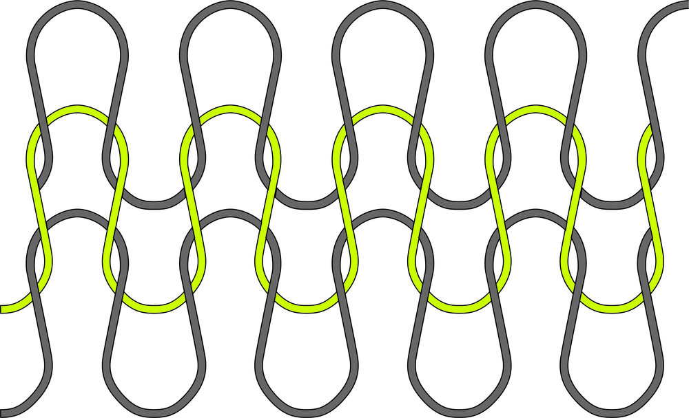
Figure 1: Structure of single jersey (Plain) fabric.
Characteristics of single jersey fabric: “Single jersey typically has approximately twice the stretch in the width direction compared to the length direction. Cut fabrics will unravel from both ends very easily. Fabric thickness is approximately two‐yarn diameters. Jersey fabrics will curl at the edges. The sides will curl to the back, while the top and bottom edges will curl to the face. If a yarn is broken in a plain jersey fabric, a run will form vertically as the broken loop drops the loops below and above it. The plain jersey knit produces a relatively light-weight fabric and has a very high rate of production” [8].
Structure of 1x1 Rib fabrics: “1 x 1 Rib is production of by two sets of needles being alternately set or gated between each other. Relaxed 1 x 1 rib is theoretically twice the thickness and half the width of an equivalent plain fabric, but it has twice as much width-wise recoverable stretch. In practice, 1 x 1 rib normally relaxes by approximately 30 per cent compared with its knitting width. 1 x 1 rib is balanced by alternate Wales of face loops on each side; it therefore lies flat without curl when cut. It is a more expensive fabric to produce than plain and is a heavier structure; the rib machine also requires finer yarn than a similar gauge plain machine. Like all weft-knitted fabrics, it can be unrobed from the end knitted last by drawing the free loop heads through to the back of each stitch. It can be distinguished from plain by the fact that the loops of certain Wales are withdrawn in one direction and the others in the opposite direction, whereas the loops of plain are always withdrawn in the same direction, from the technical face to the technical back” [9].
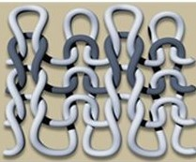
Figure 2: Structure of 1x1 Rib fabrics.
Structure of 1x1 Interlock fabrics: “Interlock knit fabric is a type of double knit. Interlock knit fabric is ribbed on both the front and the back side of the fabric. These knits look smooth on both sides, and have little elasticity in the width, but good elasticity in the length. These fabrics are made by interlocking two ribbed fabrics that are each made with a single yarn. They are firm and hold their shape better than knits such as jerseys. They require a nap layout. They can get runs in the fabric from the end last knitted. Ripped seams can leave marks and holes in the fabric. Creases are almost impossible to remove. They do not curl at the raw edges”[10].
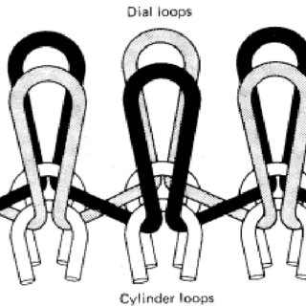
Figure 3: Structure of 1x1 Interlock fabrics.

“‘GSM’ means ‘Gram per square meter’ which indicates the weight of fabric in gram per one square meter. By this property of fabric we can compare which is heavier and which is lighter. The GSM of fabric is one kind of specification of fabric which is very important for understanding and production of fabric and garments” [11]. “In fabric structure it is very crucial to know, how much yarn is in length wise and width wise? To know the number of yarn in a specific fabric CPI and WPI are counted for this. And it is counted in course and Wales direction. CPI means yarn is in course per inch and WPI means Wales per inch” [12]. “Stitch length is the length of yarn in a knitted loop” [13]. “Shrinkage is a parameter of testing textile fabrics to measure changes in length and width after washing or any treatment of fabrics. Shrinkage failing materials are dimensionally unstable and they can cause deforming of the garments or products made out of those materials. Shrinkage is tested at various stages, but most importantly before cutting the fabric into further sewn products and after cutting and sewing prior to supplying the products to buyers and end users. It is a required parameter to quality control to ensure the sizes of the products. It helps to avoid any complaints regarding deformation or change in dimensions after domestic laundry”[14].

Chapter-3: Materials and Methods
3.1 Materials:
3.1.1 Fabrics properties: Three 1x1 Plain; three 1x1 Rib and three 1x1 Interlock fabrics were taken in this study. They all are 100% Cotton weft knitted outerwear fabrics. The fabrics’ parameters are given in Table 1.
Table 1: Fabric’s property
Design | SL. NO. | GSM | Count (Ne) | S. L. (mm) | CPI | WPI
1x1  Plain | 01 | 180 | 40 | 2.80 | 55 | 40
1x1  Plain | 02 | 160 | 40 | 2.80 | 55 | 36
1x1  Plain | 03 | 150 | 44 | 2.85 | 63 | 42
1x1  Rib | 01 | 180 | 26 | 2.65 | 53 | 36
1x1  Rib | 02 | 160 | 28 | 2.70 | 53 | 34
1x1  Rib | 03 | 150 | 30 | 2.70 | 58 | 36
1x1  Interlock | 01 | 160 | 24 | 1.40 | 47 | 43
1x1  Interlock | 02 | 160 | 26 | 1.45 | 47 | 44
1x1  Interlock | 03 | 150 | 26 | 1.50 | 50 | 47

3.1.2 Used Chemicals & Auxiliaries:
Table 2: Used Chemicals & Auxiliaries
SL. | Chemical Name | Function
01 | Detergent | To remove impurities, mineral oil & size material from the fabrics.
02 | Acetic Acid | To neutralize the fabrics from  Alkaline condition & control pH
03 | Flax Softener | To make the fabric’s surface smooth.

3.1.3 Machines & Tools

Table 3: Used machines.
SL | Machine Name | Function | Figure
01 | Washing Machine | To wash the garments | 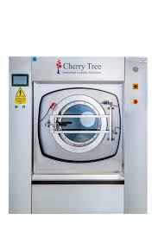
02 | Hydro extractor | To remove excess water from the wet garments | 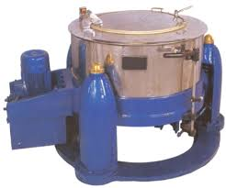

03 | Boiler | To produce steam | 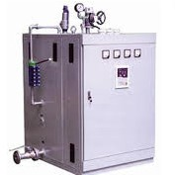
04 | Dryer | To remove moisture from the garments | 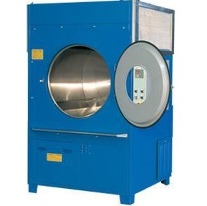
05 | Measuring Tape | To measure the length of materials | 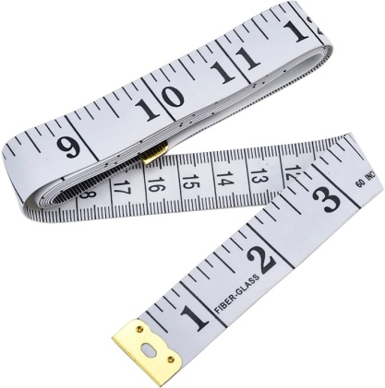

3.2 Methods:
3.2.1 Standard Testing Condition: Test specimens were conditioned for 48 hours in a standard atmospheric condition of 20 ± 2 °C temperatures and 65 ± 2% relative humidity. ISO: 6330 method was followed to wash all the test specimens.
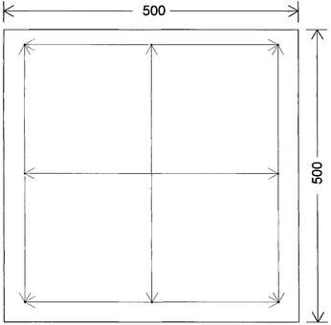
3.2.2 Sample Preparation: “At first, select smooth and crease free fabric test specimens which size should not less than 500 mm x 500 mm because smaller pieces are not acceptable. Then lay the fabrics to the relaxation mood on the table in ambient conditions, so that it will be smooth and tension free. Sample was marked along the length and width direction apart from 350 mm. After that, draw around the edge of the marked area of the sample. The space of marks should be not less than 350 mm; marks from the edge of cloth should be not less than 50 mm” [15].

3.2.3 Recipe for normal wash:

Table 4: Recipe for normal wash
SL | Chemical | Amount
01 | Detergent | 0.5gm/L
02 | Acetic acid | 0.5gm/L
03 | Flax Softener | 0.6gm/L
04 | Liquor ratio | 1: 10
05 | Time | 5 to 10 minutes for washing.  & 40-50 minutes for drying.
06 | Temperature | Room Temperature
07 | Sample | As per required

3.2.4 Normal washing process: “At first pre treated garments samples are loaded on the washing machine. Then samples are washed by the addition of detergent. Here maintain the room temperature and washing time at 10-15 minutes. Then drop the samples from the machine. Second step is softening. Samples are loaded on the machine for the smoothness of the fabric surface with the addition of flax softener. And then, added acetic acid for neutralization of fabric after washing .Then drop the samples and unload the samples on to the trolley. Third step is hydro extraction. In this step sample fabrics are loaded on the hydro extraction machine for removing excess water from the wetted fabrics. Here about 60-65% of water is removed by this hydro extraction process. Fourth step is drying. After hydro extraction sample fabrics are loaded on the steam dryer for remaining moisture from the fabric. In this process, Temperature is about 60-70°c and time is 30-40 minutes maintained. After drying quality is checked and measured the fabric again for determining the change of dimensions. Finally calculate the shrinkage % of the test samples”[15].

3.2.5 Process flow chart of normal wash:
Collect pretreated fabrics

Load the fabrics

Run the machine

Wash the fabrics as per recipe at room temperature for 10 to 15 mints

Drop the liquor

Unload the fabrics on the trolley

Remove excess water from the fabrics by using hydro extractor

Drying the samples at 60-70°c for 30 mints

Cold drying at room temperature

3.2.6 Test specimen attachment: One test specimen from each design is given below:

1 x 1 Plain fabric:

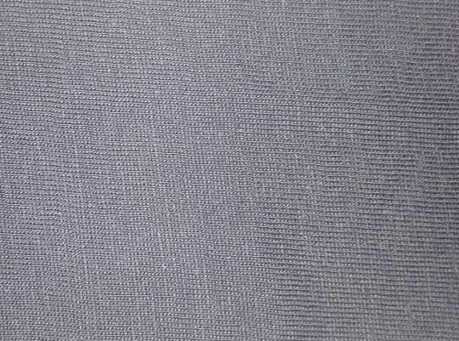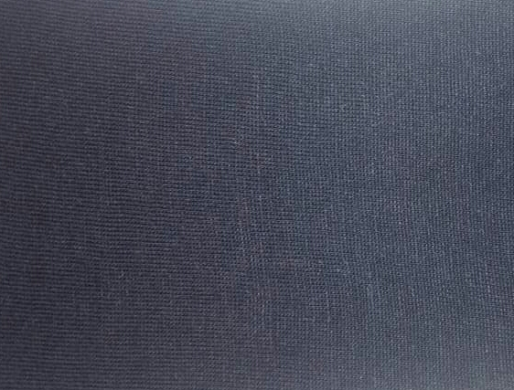

Figure 4: Before washing Figure 5: After washing

1 x 1 Rib fabric:

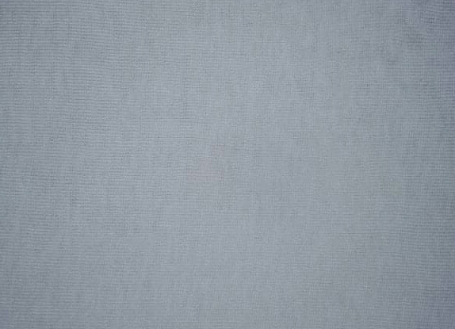

Figure 6: Before washing Figure 7: After washing

1 x 1 Interlock fabric:

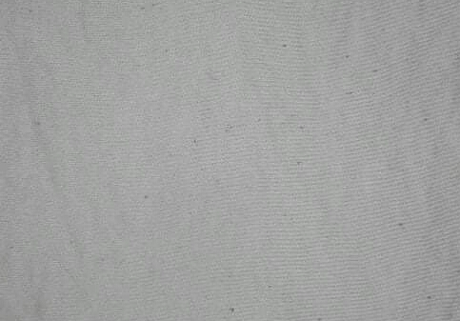

Figure 8: Before washing Figure 9: After washing
3.2.7 Fabrics shrinkage measurement process: “According to ISO 6330:2012 test methods for the determination of dimensional change for fabric, garment or other textile articles when subjected to an appropriate combination of washing and drying. The sample is conditioned in the standard atmospheric condition and measured before washing and drying. After washing, drying, conditioning and measuring the sample, the change in dimension are calculated”[16].

Equation to calculate dimensional change:
Dimensional Change (%) = $\frac{Length of fabric before washing-Length of fabric after washing}{Length of fabric before washing} x 100$

Here,
(-) sign indicates shrinkage of fabric, and
(+) sign indicates elongation of fabric.

3.2.8 Data Table:
Table 5: Data table
Design | SL. NO. | GSM | Stitch  Length  (mm) | Count  (Ne) | Before wash |  | After wash |  | Shrinkage (%)
 |  |  |  |  | Length  wise | Width  wise | Length  wise | Width  wise | Length  wise | Width  wise
1x1 Plain | 1 | 150 | 2.85 | 44 | 350 | 350 | 312.5 | 321.5 | 10.7 | 8.1
1x1 Plain | 2 | 160 | 2.80 | 40 | 350 | 350 | 319.3 | 329.7 | 8.8 | 5.9
1x1 Plain | 3 | 180 | 2.80 | 40 | 350 | 350 | 321.2 | 330.5 | 8.2 | 5.6
1x1 Rib | 1 | 150 | 2.70 | 30 | 350 | 350 | 334.2 | 336.3 | 4.5 | 3.9
1x1 Rib | 2 | 160 | 2.70 | 28 | 350 | 350 | 335.2 | 336.9 | 4.2 | 3.7
1x1 Rib | 3 | 180 | 2.65 | 26 | 350 | 350 | 337.7 | 338.5 | 3.6 | 3.3
1x1 Interlock | 1 | 150 | 1.50 | 26 | 350 | 350 | 337.8 | 340 | 3.5 | 2.8
1x1 Interlock | 2 | 160 | 1.45 | 26 | 350 | 350 | 339.8 | 346.5 | 2.9 | 1
1x1 Interlock | 3 | 180 | 1.40 | 24 | 350 | 350 | 344.5 | 347 | 1.6 | 0.9

Figure 10: Effect of fabric’s GSM on shrinkage (%) of 1x1 Plain fabrics after normal wash.

Figure 11: Effect of fabric’s GSM on shrinkage (%) of 1x1 Rib fabrics after normal wash.

Figure 12: Effect of fabric’s GSM on shrinkage (%) of 1x1 Interlock fabrics after normal wash.

Figure 13: Effect of fabric’s structure on shrinkage (%) of 150 GSM fabrics after normal wash.

Figure 14: Effect of fabric’s structure on shrinkage (%) of 160 GSM fabrics after normal wash.

Figure 15: Effect of fabric’s structure on shrinkage (%) of 180 GSM fabrics after normal wash.

Figure 16: Effect of fabric’s stitch length on shrinkage (%) after normal wash.

Figure 17: Effect of yarn’s count of fabric on shrinkage (%) after normal wash.
Chapter-4: Discussion of Results
Fabric’s GSM: The variance of the value of shrinkage (%) of fabrics with different GSM reveals that fabric’s GSM has a great impact on fabric’s shrinkage (%). In my investigation, fabrics with highest GSM in each design show less shrinkage (%) and fabrics with lowest GSM in each design show highest shrinkage (%). With the increase of the value of fabrics’ GSM, shrinkage (%) decrease.
Fabric’s structure: The variance of the value of shrinkage (%) of fabrics with different structure reveals that fabric’s structure has also impact on fabric’s shrinkage (%). 1x1 Plain fabrics show maximum shrinkage (%); 1x1 Rib fabrics show medium shrinkage (%), and 1x1 Interlock fabrics show minimum shrinkage (%) after normal wash. Fabrics’ other properties may influence it.
Fabric’s stitch length: Fabric’s stitch length has significant impact on fabric’s shrinkage (%). fabric with highest stitch length shows maximum shrinkage (%) and fabric with lowest stitch length shows minimum shrinkage (%). With the decrease of the value of fabrics’ stitch length, shrinkage (%) decrease.
Yarn’s count (Ne): Yarn, which is used to manufacture fabrics, has also impact on fabric’s shrinkage (%). Fabrics made of yarns with higher count show more shrinkage (%), and fabrics made of yarns with lower count show less shrinkage (%). So, higher twisted yarn causes more shrinkage than lower twisted yarn.

Chapter-5: Conclusions
The effect of physical properties, namely: GSM, fabric’s structure, fabric’s stitch length and yarn’s count on shrinkage (%) of different knit fabrics can be realized by comparing the value of shrinkage (%) of different fabrics after normal wash. It is noticeable that, fabric’s GSM, fabric’s structure, fabric’s stitch length and yarn’s count all have significant impact on shrinkage (%) of knit fabrics. With the increase of the value of fabrics’ GSM, shrinkage (%) decrease. 1x1 Plain fabrics show maximum shrinkage (%); 1x1 Rib fabrics show medium shrinkage (%), and 1x1 Interlock fabrics show minimum shrinkage (%) after normal wash. Fabrics’ other properties may influence it. With the decrease of the value of fabrics’ stitch length, shrinkage (%) decrease. It is further noted that, higher twisted yarn causes more shrinkage than lower twisted yarn.

Limitations of the study:
In this study, I could manage to get only nine test specimens. More specimens could help to get more accurate results. I also could not be able to come in contact with my supervisor because of pandemic corona virus.
References:
[1] M. Karba, J. Gersak, Z. Stjepanovic, “The Influence of Knitting Parameters on Dimensional Changes of Knitted Fabrics in the Process of Relaxation,” In Proceedings of the 2nd International Textile Clothing & Design Conference, pp. 200-205, 2004.
[2] https://www.academia.edu/10055466/ Effect of sewing parameters and wash type on dimensional stability of knitted garments.
[3] “Effect of Knitted Structure on the Properties of Knitted Fabric”. Ahmed Asif, Moshiur Rahman, Farial Islam Farha: International Journal of Science and Research (IJSR)ISSN (Online): 2319-7064 Index Copernicus Value (2013): 6.14 | Impact Factor (2013): 4.438. “@ Daffodil International University” 27
[4] “Effect of laundering on the dimensional stability and distortion of knitted fabrics”. Anand
SC, Brown KSM, Higgins LG, Holmes DA, Hall ME and Condrad D (2002). Autex Research
Journal2 (2) 85-100.
[5] Syeda Sanjida Wasim, Jamal Uddin Ahmed, MD. Al-Amin; International Journal of Textile Science p-ISSN: 2325-0119 e-ISSN: 2325-0100 2017; 6(6): 143-147 doi:10.5923/j.textile.20170606.01.
[6] Ly, N., Denby, E. and Hoschke, B., 1988. A Quick Test for Measuring Fabric Dimensional Stability. Textile Research Journal, 58(8), pp.463-468.
[7]https://www.onlinetextileacademy.com/types-of-shrinkage-in-fabric-fabric-shrinkage contraction.
[8] Texhour. 2020. Single Jersey Structure And Its Characteristics | Texhour. [online] Available at: <http://texhour.com/single-jersey-structure-and-its-characteristics> [Accessed 21 November 2020].
[9] Practical guide, 2020. Rib structure.
[10] Roessner, D., Drean, J. and Osselin, J., 2011. Interlock Fabric Implant Tearing Measurement. Experimental Techniques, 36(4), pp.49-56.
[11] https://textilelearner.blogspot.com/2012/09/gsm-of-fabric-working-procedure-of.html?m=1.
[12]http://textilefashionguide.blogspot.com/2012/06/cpi-and-wpi-epi-and-ppimeasuring.html?m=1.
[13]https://textilecalculation.blogspot.com/2015/02/relation-between-stitch-lengthsyarn.html?m=1.
[14] https://en.m.wikipedia.org/wiki/Shrinkage_ (fabric).
[15] Shimo, S., 2020. Fabric Shrinkage Test | Types Of Shrinkage | Causes And Influencing Factors Of Shrinkage. [online] Textile Study Center. Available at: <https://textilestudycenter.com/fabric-shrinkage-test-types-of-shrinkage-causes-and-influencing-factors-of-shrinkage/> [Accessed 23 November 2020].
[16] Garments Tech. 2020. DIMENSIONAL STABILITY TO WASHING AND DRYING TEST FOR FABRICS AND GARMENTS « Garments Tech. [online] Available at: <https://garmentstech.com/dimensional-stability-to-washing-and-drying-test-for-fabrics-and-garments/> [Accessed 23 November 2020].

