Project Paper
On
“Online Class Observation and Conduction in English during the Outbreak of Covid-19”
Prepared by:
Sufia Sharmin
ID: 172-10-211
8th Batch
Department of English
Faculty of Humanities and Social Science
Under the Supervision of
Mohammad Elius Hossain
Assistant professor, Department of English
Faculty of Humanities and Social Science

Daffodil International University
Submission date: 15-12-2020

This project paper on “Online Class Observation and Conduction in English during the Outbreak of “Covid-19” is submitted to the Department of English, Daffodil International University, for the fulfillment of Bachelor of Arts Degree (B.A.).

©Daffodil International University

Declaration

I would like to declare that this project paper has been completed under the valuable supervision of Mr. Mohammad Elias Hossain, Assistant Professor, Department of English, Daffodil International University. At the same time I want to add that this project paper or any part of it has not been displayed for any kind of certificate, except the present one.

Sufia Sharmin
ID: 172-10-211
Department of English
Daffodil International University

ii
©Daffodil International University

Certificate
This is to certify that Sufia Sharmin, bearing ID: 172-10-211, is a student of the department of English, Daffodil International University, Ashulia Campus. I am glad to state that she has accomplished this Project Paper under my supervision, and worked hard for preparing this paper.
All sorts of information and findings presented in this paper seem to be authentic. I wish this industrious lady a better future.

Mr. Mohammad Elias Hossain
Assistant Professor
Department of English
Daffodil International University

iii
©Daffodil International University

Acknowledgment

Before all else, I would like to express my gratitude towards Almighty Allah for keeping me healthy in this pandemic period. I am very thankful to my supervising teacher Mr. Mohammad Elius Hossain for his valuable guidance, kindness, providing project related information and support. . I am also thankful to my two classmates Shafiuddin Al Shaikat and Rased Rana for making the opportunity to observe their classes. I am overwhelmed watching the active participation of the students on that class I conducted. So a big thanks to them also. May Allah bless us.

iv
©Daffodil International University

Abstract
I completed my project paper during the pandemic time. All kind of educational institutions are closed. So I could not visit any school or college for class observation physically. Daffodil International University gave us the opportunity to complete the project paper through online. I observed two class and conducted a class based on English language. My teaching experience and the experience of class observation have been presented in detail later with particular mention of strength and weakness. Towards the end of the paper, I would like to recommend some suggestion for the improvement of the online teaching learning situation.

v
©Daffodil International University

Contents | Page
Declaration | ii
Certificate | iii
Acknowledgments | iv
Abstract | v
Table of Contents | vi
Chapter - I: Introduction | 07
Chapter - II: Objectives | 08
Chapter - III: Methodology | 09
Chapter - IV: Institution Details | 11
Chapter - V: Class Observation Report | 13
Chapter - VI: Class Conducting Report | 18
Chapter - VII: Overall Findings | 19
Chapter - VIII: Recommendations | 20
Chapter - IX: Conclusion | 21
Chapter - X: Bibliography | 22
Appendices
Appendix 1: Checklist I | 23
Appendix 2: Checklist II | 28
Appendix 3: Photographs | 33
Table Contents

Vi
©Daffodil International University

Chapter- I
Thanks to the authority for making the opportunity so that we can complete our project paper successfully. According to the instructions I was supposed to observe two class from my teammates. So I observed their class very attentively so that I could make my project paper more informative. I conducted a class carefully, the active participation of the students gave me the courage to give my best. Special thanks to the students and my teammates for helping me to complete my project paper and also our valuable supervisor Mr. Mohammad Elius Hossain to guide me. Therefore I successfully completed my course curriculum

7
©Daffodil International University

Chapter- II

Objectives
The main objectives of the project work was to find out online class observation and conduction during pandemic:
- Online Class Observation and Conduction in English during the Outbreak of Covid-19” at tertiary level
- Observing teaching techniques
- Observing teaching styles
- Finding the strengths and weaknesses of online class

8
©Daffodil International University

Chapter- III
Methodology
Selecting an Institute:
QS Asia University Ranking 2021 has recognized Daffodil International University as one of the top 450 university in Asia and 4th position among more than 700 universities. During this Outbreak of Covid-19” all educational institutions was closed. So as a student of Daffodil International University I grab the opportunity to accomplish my project paper at my university.
Selecting Class:
My supervisor suggested me to choose from any of the three courses he was teaching. I decided to take a class with the second semester students of Daffodil International University. The course name was English for Academic Purposes. I selected two classes for observation and one class for teaching.
Selecting Facilitator:
My honorable teacher Mohammad Elius Hossain created the opportunity to observe language related class. As new rules were added so my supervisor try to make us flexible with the flow. Sir introduced me with the students before conducting the class. I am very thankful for helping me to complete my Internship project. I would like to thank him for keep supporting us.

9
©Daffodil International University

Using checklist: For the class observation I used one semi- structure checklist to catch up the seniors teaching learning process.
Classroom Observation:
I observed two language based classes. My respected sir, Mr. Mohammad Elius Hossain, notified me the schedule of the classes. I had completed my first-class observation on 29th November 2020 at 4.00 p.m. and then I had completed my second-class observation on 6th December 2020 at 4.15p.m. Both of the class was taken by two of my classmate. I used my checklist for both classes for batter observing.

10
©Daffodil International University

Chapter- IV
Institution Details
Daffodil International University topped again in Bangladesh by ‘UI GreenMetric World University 2020’. It also achieved a prestigious position in “QS Asia University Ranking 2021” based on the outstanding performance and initiatives. QS Asia University Ranking 2021 has recognized Daffodil International University as one of the top 450 university in Asia and 4th position among more than 700 universities. It was founded 2002 and starts its journey from Dhanmondi. The founder and chairman of the Daffodil International University is Mr. Sabur Khan.
Present Structure:
This university offers undergraduate and post graduate program. University work schedule is separated into two shifts; day shift and evening shift. In each section there found about 30-40 students. Daffodil International University organized the biggest gathering on 28th January for celebrating the foundation day.
Students Numbers: This University has 24 thousand plus students where they studying in EEE, CSE, Textile, English, Pharmacy, and Food Engineering.

11
©Daffodil International University
Faculties:
- Faculty of Science and Information Technology
- Faculty of Business and Entrepreneurship
- Faculty of Humanities and Social Science
- Faculty of Applied Health Science
- Faculty of Engineering
Teachers Qualification: There are more than 70 teachers who work in this university. All of them are highly educated, some of them completed their PHD degree. The teachers are very friendly and supportive.
Uniform: There is no dress code for girls but had to be elegant. For boys slippers and collarless t shirt is banned.
Cultural Activities: Occasions are just the excuses to express the love and respect. Before pandemic they organized many social cultural program. During the pandemic it also organizing online based cultural program. They have BNCC club, debate club, dance club, ELC, Business club etc.
Fees Payment Procedure: This University offers three installment for paying the tuition fees. Waivers are provided to the students based on their result. There is also special 10% waiver for Covid- 19.” To keep this waiver students have to maintain a minimum average of result. A student can pay through bKash/ bank/ one card payment/ rocket and also in the accounts physically.
12
©Daffodil International University

Chapter-V
Class Observation Report
According to the instruction I was supposed to observe two class. Because of the pandemic crisis I observed through online. To reduce the death because of covid-19 all educational institutions are closed so there is no other option rather than online.
Class Observation-1
The teacher and maximum students were present on time. The class was conducted through video conference. The material of the class was google meet and Power Point slides. The active participation of the students made the class alive.
It holds on November 29, 2020. The class started at sharp 4.00 pm. The course name was English for Academic Purposes. The topic of the class was The Basis of News Report Writing. This class was conducted by one of my teammate. The duration of the class was one and half hour. Teacher took in total 30 minutes for warming up and discussed how life is going on in this pandemic situation. The teacher introduced the class topic.
My teammate then started to discuss more in detail about news report writing. First he describe the key features that we need to focus on while writing any news report.
13
©Daffodil International University

To make it clearer he started to give examples. His definition of the text helped to understand the students. News report writing was new for some students. So after giving them theoretical lecture he showed a structure how to write a proper report. That was his first class conduction but the way he taught it was hard to understand. He made his power point slide enrich of information based on news report writing
He tried to make the lesson lively so that student didn’t feel bore. The students of the class were maintain courtesy, manner, etiquette and their active participation made the class real. Though this was an online class but it was not one sided boring lecture. He tried to involve the students so that they didn’t get sleep.
Strength Observe:
- Clear voice
- Tried to deliver correct pronunciation conducting the class
- Tried to make a lively class
- Tried to involve the students more and more so that they didn’t feel bore
- Didn’t get tried if the student asked a question twice
- Tried to provide resourceful slide with structure
- Tried to give more example to make topic clear
14
©Daffodil International University

Weakness Observe:
- Eye contract was missing so the students could distract
- Due to poor network connection some students get disconnected
- Poor net signal sometimes could make the voice unclear
- Because of the busy server sometimes it is problematic to log into Google Meet
- While sharing the slide unable to find the active participant
- There is chance to make plagiarism

15
©Daffodil International University

Class Observation-2
My second class observation was also the same course English for Academic Purposes. It was taken by my another teammate. It took place on December 6, 2020 at 4.15pm. The topic was Argumentative essay and contrast and comparison essay. As it was his first ever class so he was a bit nervous. He covered it up soon. He told the students to read the slides and after finishing their reading he discussed about that. Than he talked about how to do compare and contrast. He also discussed how logically and specifically we can write an essay. Students kept supporting him as he was a bit nervous. To make the topic clearer he asked some question and students tried to answer properly. At the same time he also corrected the wrong answers. He followed his lesson plan to make the class effective.
At first the course teacher introduce the topic than my teammate started to discuss about the topic with example.
Strength Observe:
- Clear voice
- Tried to deliver correct pronunciation conducting the class
- Tried to make a lively class
- Tried to involve the students more and more so that they didn’t feel bore
- Didn’t get tried if the student asked a question twice
16
©Daffodil International University

- Tried to provide resourceful slide with structure
- Tried to give more example to make topic clear
Weakness Observe:
- Eye contract was missing so the students could distract
- Due to poor network connection some students get disconnected
- Poor net signal sometimes could make the voice unclear
- Because of the busy server sometimes it is problematic to log into Google Meet
- While sharing the slide unable to find the active participant

17
©Daffodil International University

Chapter- VI
Class Conduction Report
To meet the requirements of this project paper I needed to conduct a class. My supervisor suggested me to choose from any of the three courses he was teaching. I decided to take a class with the second semester students of Daffodil International University. The course name was English for Academic Purposes. When I had done my second semester, we had not done this couse because it was newly added to the curriculum for BA (Hons) Program. The reason of choosing this course was that I wanted to learn about this course through teaching in it.
Lesson Plan for English for academic purposes
Topics: Essay Writing
Terminal Objectives:
•By the end of the lesson students will have learned how to write essay smartly.
• have watched a lecture slide.
Profile of the students: Second semester student of Daffodil International university.
Materials & Equipment: Slide, laptop/ computer/Phone, Internet.
Class duration: 1 hour
Trainee teacher: Sufia Sharmin
Stage | Procedure | Language focus | Time
1. |  Ice breaking   talking about the concept and features of essay writing | Essay writing | 15 minutes
2. | A puzzle for guessing the topic | Essay | 2 minutes
3. | How to write an essay more effectively that can be helpful for improving marks. |  Vocabulary   Synonym   Paraphrase | 20 minutes
4. |  Reading lecture slide   Explanation | Practice on how to use words differently to avoid monotone | 15 minutes
4. |  Reading lecture slide   Explanation | Practice on how to use words differently to avoid monotone | 15 minutes
5. | Question and answer session | Making sure to clear all confusion | 8 minutes

Teaching Experience:
I conducted an online class with the second semester students of the Department of English of Daffodil International University. The total duration of the class was 1 hour and 30 minutes. According to instruction, I was supposed to have an hour class. My respected supervisor sir took about 20 munities to greet the students, to inquire about their health conditions and introduce me to them. I was confident before taking the class but when I tried to share my power point slides and my laptop did not work properly, I started to get nervous. At the beginning my voice cracked sometimes due to anxiety but the warmth of the students made me confident again. Before taking the class I had prepared my lesson plan and did study on essay writing as it is a whole new topic to me for class conduction. I tried to make the class exciting so that the students did not feel sleepy. During the whole class, I tried to make them engage with reading, share their problems or understandings. At the end of the class, they asked for some suggestions on how can they improve their marks and they feel unlucky not having any physical class on the campus. However this class would be added to the best moments of my life.
18
©Daffodil International University

Chapter-VII
Overall Findings:
According to the instruction I had to observe two classes and conduct one class. I conducted the class with my full strength. I faced some difficulties and tried to overcome them.
Teaching Experience Findings:
- Lesson plan: Lesson plan helps us to find out the view of the class, how that class is going to be conducted. This is the brief plan of the whole class. It is very important to have a lesson plan for better teaching experience.
- Lesson Delivery: Online class became boring when we monotonously continue the class and not giving any chance to share the ideas of the students. To have a successful class we can make the class interesting and make the students more and more engage to keep their nerves active.
- Use of Language: Translanguaging can be a better option for conducting online class. It is important to make the students using easy words. If they can have some clear ideas they can write spontaneously. Using complex words can make them nervous and they may lose interest of reading. So making things easy can be a better option to grab the attention of the students.
19
©Daffodil International University

Chapter-VIII

Recommendation
I was really impressed by the hard work of those teachers. The environment of online classes was quiet and pleasant. All in all, I did not have any question about the institute
- Modern tools must be ensured in an online classroom.
- Video conferencing would have been needed in the classroom.
- They should be providing laptops to new students so that they could be able to attain an online class.
- Slow and clear voice needed in the classroom.
- Back up should be kept to have smooth communication.
- Proper guideline needed.

20
©Daffodil International University

Chapter-IX

Conclusion
After concluding the internship, I gained some experience about “Online Class Observation and Conduction in English during the Outbreak of Covid-19”. In my opinion online class was only communication-based where teachers couldn’t show practical examples in the classroom. The classes were not enjoyable because it was difficult to hear audio continuously. Because of online based education a student need to look at the monitor for a long time that can cause various health problem. During the outbreak of Covid-19 the online class was very much needed for students in Bangladesh to continue their educational purposes.

21
©Daffodil International University

Chapter-X
Bibliography

- R. C., Clifton, G. T., Peace, K. M., Propper, B. W., Hale, D. F., Alseidi, A. A., & Vreeland, T. J. (2020). Using technology to maintain the education of residents during the COVID-19 pandemic. Journal of Surgical Education.
- Tu, C. H., & McIsaac, M. (2002). The relationship of social presence and interaction in online classes. The American journal of distance education, 16(3), 131-150.

22
©Daffodil International University

Appendices
Appendix-1
Checklist-1:
Daffodil International University
Department of English
Internship on “Online Class Observation and Conduction in
English during the Outbreak of Covid-19"”
Checklist for Class Observation
Institute name: Daffodil international University
Teacher’s Name: Shafiuddin Al Shaikat
Batch: 17th Section: PC-A No. of Students Present: 35
Course Title & Code: English for Academic Purposes (ENG 123)
Room No: Online Class Peer/Observer: Sufia Sharmin
ID: 172-10-211
Date and Time: November 29, 2020
Objectives of the lesson (as perceived):
i. The basis of news report writing
ii. Key features of newspaper report writing
Were the objectives achieved and to what extent (in your view)?
23
©Daffodil International University
The student achieved all the extent about the topic after giving definition of the main topic. Then the student knew about its structure and learned about the basis of news report writing.

1 | SUBJECT MATTER CONTENT  (shows good command and knowledge of subject matter; demonstrates breadth and depth of mastery; tries to develop a knowledge seeking behavior among students | Teacher was knowledgeable and newly experienced about subject matter of the topic. He taught the topic nicely sometimes he was taking about the topic related question from students.
2 | ORGANIZATION  (organizes subject matter; states clear objectives; emphasizes and summarizes main points, meets class at scheduled time, starts and finishes the lesson properly with an attractive warm up and a conclusive end- how the objectives of the lesson met/ what they have learned today) | The subject was so organized. For Instance: he made Power point slide about the subject and some objectives were included in a very organized way.
3 | RAPPORT  (holds interest of students; is respectful, fair, and impartial; provides feedback, encourages participation; interacts with students, shows enthusiasm, both teacher and students are ready for the class not only on subject matter but also in manner, etiquette and attitude) | The teacher and student relation were so pretty because both are friendly. Indeed, the class was not robotic. It was always enjoyable with manner, etiquette and attitude.
4 | TEACHING METHODS  (uses relevant teaching methods, aids, materials, techniques, and technology; includes variety, balance, imagination, group involvement; encourages questions from students and responds with interest; is open to ideas; uses real life examples that are simple, clear, precise, and appropriate; stays focused on and meets stated objectives) | Elective method was using in his class. Actually, it was video conferencing and power point presentation. However, it was online session. He provided some question and always tried to read out the text. He used real life example while he taught this lesson.
5 | PRESENTATION  (establishes classroom environment conducive to learning; ensures learners’ interests, uses a clear voice, strong projection, proper pronunciation, and standard English) | The presentation style of the teacher was so nice and fluent. Teacher and students bonding are so pretty for the reason attractive environment was staying into the classroom. The teacher uses proper pronunciation and standard English in the classroom

25
©Daffodil International University

MANAGEMENT
Was the time spent properly?
What were the main stages of the lesson? What tasks and activities did the teacher do during each stage? (Optional: Draw a diagram to show main stages of the lesson and time spent on each)
The teacher used time properly. During the First stage he Introduce the topic which was the basis of news report writing. And gave some examples for all student to clear the subject matter. Then He showed some sub topic under the main topic of the class. After that he requested to read out the topic and help to the student to understand the topic by explaining.

CRITICAL EVENT (If took place)
Was there any ‘critical event’ in the lesson? (a point where communication broke down
and there was a confusion). How did the teacher handle the situation?
In the middle of the lecture he got disconnected because of load shedding. He kept back up, he bought mb to complete the class but he was failed to join the class again. The course teacher handled the situation.

Strength Observe:
- Clear voice
- Tried to deliver correct pronunciation conducting the class
- Tried to make a lively class
- Tried to involve the students more and more so that they didn’t feel bore
- Didn’t get tried if the student asked a question twice
- Tried to provide resourceful slide with structure
26
©Daffodil International University

- Tried to give more example to make topic clear

Suggestions for improvement:
I have no suggestion for the teacher
Overall impression of teaching effectiveness:
It is very much effective and important for online learners.

27
©Daffodil International University
Checklist: 2 Appendix-2
Classroom Observation Report-2
Daffodil International University
Department of English
Internship on “Online Class Observation and Conduction in
English during the Outbreak of Covid-19"”
Checklist for Class Observation-2
Institute name: Daffodil international University
Teacher’s Name: Rased Rana
Batch: 17th Section: PC-A No. of Students Present: 32
Course Title & Code: English for Academic Purposes (ENG 123)
Room No: Online Class Peer/Observer: Sufia Sharmin
ID: 172-10-211.
Date and Time: December 6, 2020
Objectives of the lesson (as perceived):
1) Argumentative essay
2) Contrast and Comparison essay
Were the objectives achieved and to what extent (in your view)?
After listening and giving more information end exercise students learn about how to write argumentative essay along with contrast and comparison essay
28

©Daffodil International University

S/N | Review Section | In what ways? (Specific examples/ clarifications)
1 | SUBJECT MATTER CONTENT  (shows good command and knowledge of subject matter; demonstrates breadth and depth of mastery; tries to develop a knowledge seeking behavior among students | Teacher was knowledgeable and newly experienced about subject matter of the topic. He taught the topic nicely sometimes he was taking about the topic related question from students.
2 | ORGANIZATION  (organizes subject matter; states clear objectives; emphasizes and summarizes main points, meets class at scheduled time, starts and finishes the lesson properly with an attractive warm up and a conclusive end- how the objectives of the lesson met/ what they have learned today) | The subject was so organized. For Instance: he made Power point slide about the subject and some objectives were included in a very organized way.
3 | RAPPORT  (holds interest of students; is respectful, fair, and impartial; provides feedback, encourages participation; interacts with students, shows enthusiasm, both teacher and students are ready for the class not only on subject matter but also in manner, etiquette and attitude) | The teacher and student relation were so pretty because both are friendly. He always motivated students for participating to the class for example: One student Late to enter the classroom for a specific reason at the moment he welcomed to the student with smile. Indeed, the class was not robotic. It was always enjoyable with manner, etiquette and attitude.
4 | TEACHING METHODS  (uses relevant teaching methods, aids, materials, techniques, and technology; includes variety, balance, imagination, group involvement; encourages questions from students and responds with interest; is open to ideas; uses real life examples that are simple, clear, precise, and appropriate; stays focused on and meets stated objectives) | Elective method was using in his class. Actually, it was video conferencing and power point presentation. However, it was online session. He provided some question and always tried to read out the text. He used real life example while he taught this lesson.
5 | PRESENTATION  (establishes classroom environment conducive to learning; ensures learners’ interests, uses a clear voice, strong projection, proper pronunciation, and standard English) | The presentation style of the teacher was so nice and fluent. Teacher and students bonding are so pretty for the reason attractive environment was staying into the classroom. The teacher uses proper pronunciation and standard English in the classroom

30
©Daffodil International University

MANAGEMENT
Was the time spent properly?
What were the main stages of the lesson? What tasks and activities did the teacher do during each stage? (Optional: Draw a diagram to show main stages of the lesson and time spent on each)
The teacher used time properly. During the First stage he Introduce the topic which was argumentative essay. And gave some examples for all student to clear the subject matter. Then He introduced another topic contrast and comparison essay. After that he requested to read out the topic and help to the student to understand the topic by explaining.

CRITICAL EVENT (If took place)
Was there any ‘critical event’ in the lesson? (a point where communication broke down
and there was a confusion). How did the teacher handle the situation?
There was a little critical situation. For example: some of the student could not understand the topic. He helped the student later on.

31
©Daffodil International University

Strengths Observed:
- Clear voice
- Tried to deliver correct pronunciation conducting the class
- Tried to make a lively class
- Tried to involve the students more and more so that they didn’t feel bore
- Didn’t get tried if the student asked a question twice
- Tried to provide resourceful slide with structure
- Tried to give more example to make topic clear
- Suggestions for improvement:
I have no suggestion for the teacher
- Overall impression of teaching effectiveness:
It is very much effective and important for online learners.
- ©Daffodil International University

32
©Daffodil International University

Photographs
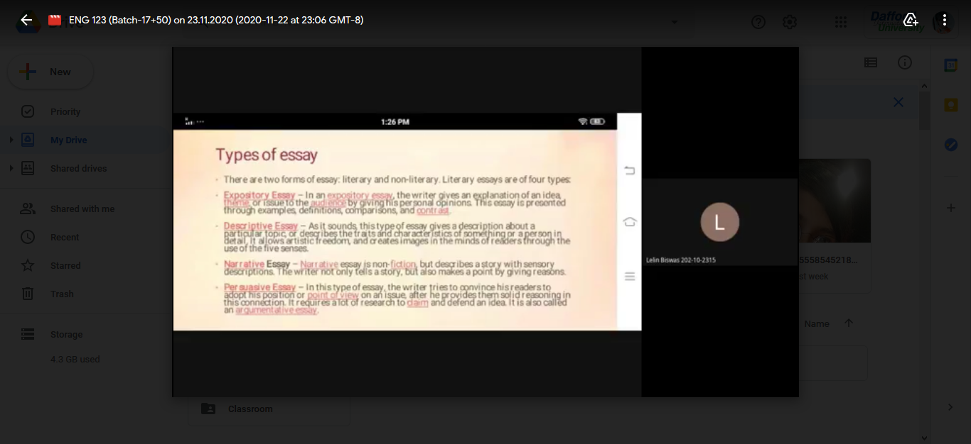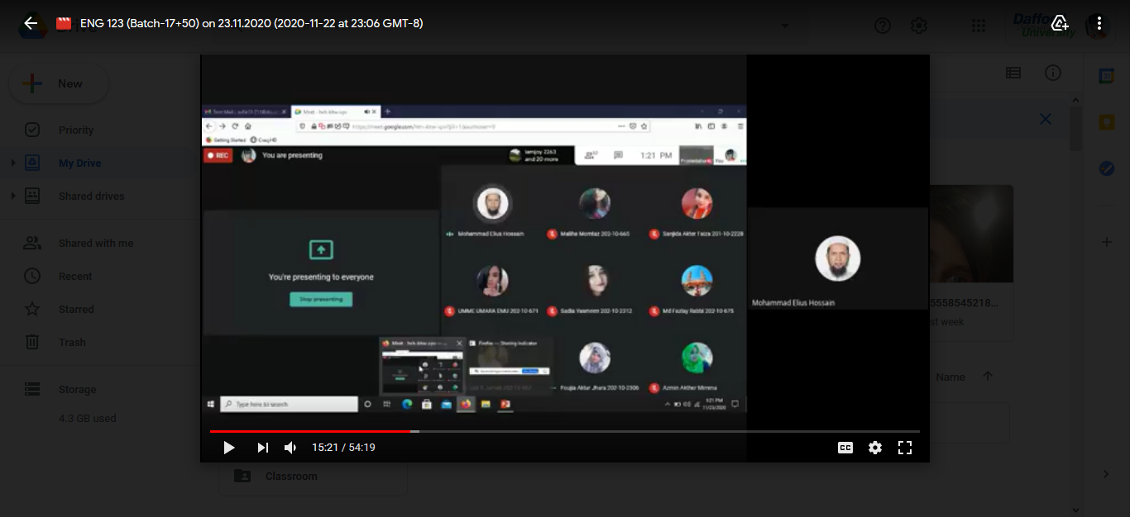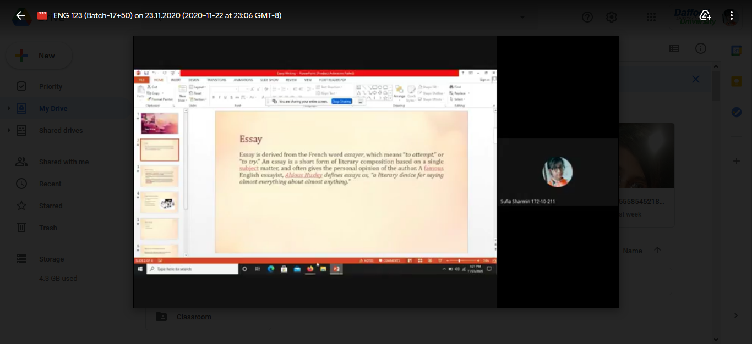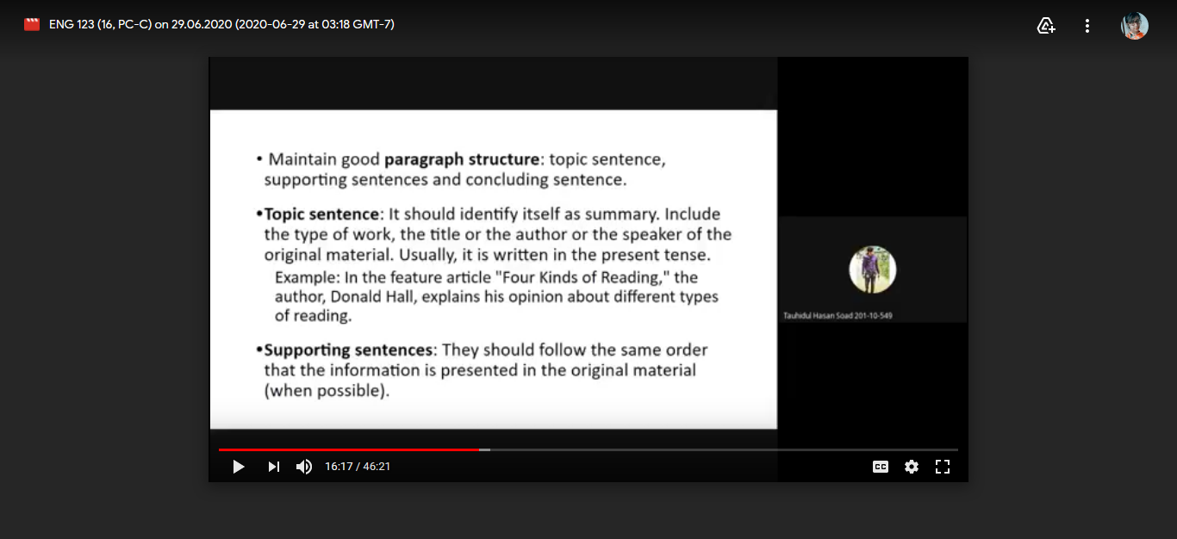
33
©Daffodil International University

