An Internship Report on
“Online Class Observation and Conduction in English during the Outbreak of Covid-19”
Prepared By
Uyenu Marma
ID : 172-10-1615
Department of English
Faculty of Humanities and Social Science

Under the Supervision of
Md. Abdul Momen Sarker
Assistant Professor
Department of English
Faculty of Humanities and Social Science



Daffodil International University
Date of Submission: 21 December 2020

This Internship Report is submitted to the department of English, Daffodil International University, for the partial fulfillment of Bachelor of Arts (BA) in English

i

Declaration:
I, hereby, declare that, this internship project has been completed under the supervision of Md. Abdul Momen Sarker, Assistant Professor, Department of English, Daffodil International University. I also declare that neither this project paper nor a part of this project paper has been submitted elsewhere for award or any other degree.

..................................
Uyenu Marma
ID : 172-10-161
Department of English
Faculty of Humanities and Social Science

ii

Certificate:
This is to certify that, Uyenu Marma, ID: 172-101615, is a student of English Department of Daffodil International University, Ashulia Campus. She has completed her internship project under my supervision.

I wish her success in her life.

........................................
Supervised By
Md. Abdul Momen Sarker
Assistant Professor
Department of English
Faculty of Humanities and Social Science

iii
Acknowledgement
At the very beginning, I would like to thank the Almighty God for giving me the ability to finish the task successfully. I am also thankful to my honorable supervisor Md. Abdul Momen Sarker, Assistant Professor in English Department for supporting, guiding and helping me while writing my internship report. This internship would be much difficult for me if I did not get proper instructions from my supervisor. I am also thankful to my parents and other teachers of English Department who always helped me during report writing.
His endless patience, scholarly guidance, encouragement and constructive criticism have inspired and motivated me to timely complete my project paper.

Table of Contents
Contents | Page Number
Declaration | ii
Certificate | iii
Acknowledgement | iv
Table of Contents | v
Abstract | vi
Chapter- I: Introduction | 1-2
Chapter- II: Objectives | 3-4
Chapter- III: Methodology | 5-6
Chapter- IV: Institution Details | 7-8
Chapter- V: Class Observation Report | 9-11
Chapter- VI: Experience of Class Conduction | 12-13
Chapter- VII: Overall Findings | 14-16
Chapter- VIII: Recommendation | 17-18
Chapter- IX: Conclusion | 19-20

Appendix
Appendix-1: Check List | 22-26
Appendix-2: Photos | 27-29

v

Abstract
The aim of the project paper is to present the current scenario of higher education during the outbreak of Covid-19. To maintain the normal flow of education, the universities in Bangladesh are using different online platforms. This paper will emphasize to point out how much this medium is effective for the students. This project paper aims to show the approaches through which teachers are trying to reach students in classes online. This paper also aims to find out the strengths and weaknesses faced by the students and teachers both in teaching-learning. Some recommendations, critiques and suggestions have also been sought in the paper with a view to strengthening the strengths and overcoming the weaknesses of online teaching-learning approach. And the paper is developed in quantitative research framework.

vi

Chapter – I

Introduction:
The Covid-19 pandemic has created global crisis that has had a deep impact on every sector of our life. Especially, in our education system, the outbreak of Covid-19 has changed the whole method of conducting classes. This is also a new experience for students.
Though Bangladesh is a developing country, still there are fewer facilities to use any modern technology for the people. Therefore, both students and teachers adopt with this kind of technology. It is a bit difficult as it comes with the problems like health issues, internet problems, financial problems etc. But it is also a matter of fact that in the situation we are in now, online class is the most appropriate solution to maintain the natural flow of education. In a parallel, the problems, teachers and students are facing, cannot be avoided. There is also the problem of basic training. As every teacher and student is not trained well to use this kind of technology in a developing country like Bangladesh. On the other hand everyone cannot afford the necessary devices to use this technology. So, a question mark remains on the topic of online education.
English is not only a language; it is an international language. To maintain a good communication with other countries it is obligatory. As a result, higher education system has been made in a way that English is emphasized in the whole process. To know, how much online classes are efficient and useful for this system, an attempt has been made through this paper.

Chapter-II

Objectives
The objectives of the proposed internship are:
- To come up with a view on the “Online class and conduction in English during the outbreak of Covid-19”
- To find out the advantages and disadvantages which both the students and teachers are facing when participating or conducting online classes
- To find out real teaching strategies and processes practically in the classroom through online class
- To gather knowledge and experience
- To observe the overall atmosphere of the online classroom

Chapter-III

Methodology
- Selecting Institution:
Daffodil International University’s Department of English is chosen for this internship. At first, permission is taken from respected teachers for observation of two classes and conduction of one class. Then two classes are observed and one class is taken.
- Selecting Classes:
Two classes are chosen to observe from different batches and one batch is chosen to take a class.
- Selecting Facilitator:
Our supervisor, respected teacher, Md. Abdul Momen Sarker is the facilitator for this paper. He helps me to select the batches and also introduces me with the students of the class.
- Observing Classes:
Two classes are observed with the permission of the course teachers. Some points like: Time managements of the teacher, the method of teaching, students’ response etc. are given attention while observing the classes.
- Using Check List:
A check list is made to collect information from the class observations.
- Class Conduction:
A class is taken to understand the activities of an online class in detail. Also the problems while conducting a class noted down. Our facilitator, Mr. Md. Abdul Momen Sarker, helps me in this step. The duration of the class is 20 minutes.

Chapter-IV

About the Institution

The institution, which I have chosen for my paper, is Daffodil International University. This university is one of the most famous private universities of Bangladesh. This university was established in the year of 2002 with the approval of UGC and Ministry of Education. This university has total five faculties and under these faculties, there are 25 departments in total. Daffodil International University has three different campuses. The main campus of this university is at Dhanmondi. This University has a vast permanent campus which is known as the “Green Campus” because of its greenery. The third campus is at Uttora. The University offers both undergraduate and Master’s Programs.

Chapter-V

Class Observation Report:
Two different classes are observed with the permission of course teachers. The classes are from two different batches of English department. One class is related English Literature and another one is Translation.
Class Observation-1
A Summary of the Class Observation:
Name of the Teacher: Fatema Begum Laboni
Batch No.:10th (PC-A)
Course Name: Translation
Number of the Student: 40
Duration: 1 Hour and 30 Minutes
Date: 13th November, 2020
Observer: Uyenu Marma
The teacher starts the class with a very enlightening voice and he gives a welcome speech. After that, she starts her lecture. She opens on her screen a poem to translate Banalata Sen by Jibanananda Das. Before translating at first she asks some students, “who is Banalata Sen”. After that she starts asking to translate line by line and she also tells students to write down on comment section. All students participate in that work. The class is seemed like physical class room. After finishing translation of one line she checks all students give there comment and she gives the feedback of them, Then she tells for translating next line. The way she takes the class is very good and I can see that the students are also very connective.

Some points that I like:
- The teacher has a cheerful voice that is very pleasant to hear.
- She makes the class full on active and keeps connective.
- The whole class environment is cheerful.
- She encourages the students who are less attentive in the class.

Class Observation- 2
Teacher’s Name: Abdul Momen Sarkar
Course Name: Introduction to Drama
Batch No.: 17th
Number of Student: 26
Date: 17th November 2020
Duration: 1 hour 30 minutes
Observer: Uyenu Mrma

The teacher starts his class by welcoming the students. After asking about their whereabouts he starts the class. At the beginning of the class, he speaks about the previous topic. After that he starts his class by opening PDF book of Arms and the Man and from that PDF he opens act-ii on his computer screen. Then he starts reading out the text line by line as well as he explains it properly very well. He also asks questions and opinions of the students time to time. The students also throw questions time to time. During the class he always tries to be connected with students, which he has done perfectly.

Some Strong Points:
- The great spoken skill.
- The teacher has the power to engage the students into the lesson.
- There is a wonderful learning environment through the whole class.

Chapter-VI

Teaching Experience:
Name of The Institution: Daffodil International University.
Name of the lecturer: Uyenu Marma
Number of the Students: 25
Duration: 20 minutes
Department: English
Objectives:
To discuss about act-ii of Arms and the Man.

Before starting my class the original course teacher introduced me in front of the students. Then I started my class with warm welcome. At the beginning of the class I introduced the topic and that was act-ii of Arms and the Man. Then I shared my screen and opened the act-ii from PDF book then I started to read out the text and explained them line by line. Even I asked to the students to ask questions if they could not understand my explanation and some students asked me questions. I tried to listen them first and after that I tried to explain it with my hundred percent efforts. I hope they could understand my lecture. The class was so cooperative as well as attentive. Then I said goodbye to them and ended my class.
Success in teaching:
The whole class is very cooperative with me and that’s why I can easily explain my point to them.

Failure in teaching:
As it is a new experience for me, some mistakes also happen. In some points, I cannot give proper explanation.

Chapter-VII

Overall Findings:

Findings from class observation:
Some points are focused when observing the classes, like:
1. Subject Matter Content: Both teachers have good command over the topic. The process of speech delivery is also good for them. Both teachers encourage the students to speak up and ask questions.
2. Organization: Both teachers start the class timely and finish it in time with a proper finishing.
3. Environment of the classes: The environment of both classes are lively. With the encouragement of the teachers, the students also willingly give their opinion related to the topics. The absentminded students are also encouraged attending the class properly and there is no lacking in the teaching style also.
4. Use of language: Both teachers use English in the class. One teacher uses Bangla English both because that is translation class she has to use.
5. Different activities: One teacher introduces many activities to engage the students with the class and the other teacher uses questioning technique to engage some inattentive students in his class.
6. Teaching material: One teacher used PDF book and another one showed from Google search in the class.

Findings from class conduction:

What I wanted to achieve:
I want to make the students interested on the topic. Also, I want to create a clear understanding of the lesson. My expectation is, the students will understand my lesson and will cooperate with me. They will ask me questions to know more about the lesson.

What I feel is not successful:
At the beginning I am nervous a little bit and I cannot start the class as I planned.

Chapter-VIII

Recommendations:
• As we all know it is an online based classroom, right now most of the students are in rural area. They do not get proper information because of the network inconvenience. So, the teacher should provide some alternatives for their students.
• The time teachers conduct their classes they should take care of their student whether they are attentive in the class or doing something else by the chance. They should make sure the well learning of their students.
• They should give some homework for the next class that the students can make the proper use of time rather than the wasting of time browsing Facebook and other social media.

Chapter-IX

Conclusion

After observing and taking classes my experience is good. It is a great opportunity for me during my internship to get real situation of English Language Teaching in Bangladesh. It is extraordinary to observe two classes and it is a chance to discover my qualities. I might want to do this kind of work further for my own advancement.
I am very happy to conduct online class in my University. I am thankful to my teachers because they share their knowledge to me and make me able to teach someone. This work has helped me to achieve my objective for better teaching experience. It also helps me to learn about the current English teaching system which inspires me to work and applied teaching method. I get my limitations and which I have overcome through practical field work. I have also observed the limitations and qualification of the teachers in the institution. The field work is enjoyable and I think this will be helpful for me in my future life.

Appendix

Appendix-1
Checklist for Class Observation – 1
Name of the University: Daffodil International University
Teacher’s Name: Fatema Begum Laboni
Batch: 10th Section: PC-A No. of Present Student: 40
Course Title: Translation.
Observer: Uyenu Marma
Date: 13th November 2020 Time: 10.00 pm

Objective of the Lesson:
- Teach the students the technique of translating poem
- To make students a good translator

Were the objective achieved and to what extent:
I think the teacher has achieved her objective. The way she describes each part and the way the students respond in the class, I think students understand the whole lessons.
Students are able to understand that how they have to translate one language to another language. It is really demanding for students to be more attentive in the class while teacher is really working hard for them. I personally have noticed that the teacher puts her hard effort to make the class understandable. So, the objectives are achieved successfully.

SL | Review Section | In What Way?
1 | Subject Matter Content | Teacher tries to interact with the entire student. She has a good command and her teaching plan is good. Her way of teaching clearly presents breadth and depth of mastery. Her teaching style is very unique itself and that is what proves that she tries to develop a knowledge seeking behavior among her students.
2 | Organization | She organizes the class with a different way. She gives writing task to the students. She has her subject material ready all the time. She elaborates every single thing to her students and summarizes the key points that helps the student in a broad sense. She finishes her lessons on time and makes sure that everyone got his lessons properly.
3 | Rapport | The communication among the teacher and students is good. Teacher gives the students some task time to time and students have participated in those tasks willingly.
4 | Teaching Method | The teacher uses mixed method to teach, which  contained:  - Communication based teaching method  - Writing based teaching method
5 | Presentation | She has really a clear voice which can attract students. Her teaching is really good. There are no lacks in her speaking. She has a great command over the lesson.

Management:
The whole class is well maintained and wand we can divide the whole class into three sections:
1. Introduction of the topic: At first of the topic, the teacher takes some times to introduce the topic to the class. It takes probably 6-7 minutes. She asks that who is Banalata Sen anyone knows or not which makes the whole task a little bit interesting.
2. The main lecture: The teacher speaks about the way how to translate poem. She also showed the verities of translation technique and how each one is different from others. By giving some tasks to the students, she engaged them with the class properly. The response of the students is also very good.
3. Ending: The teacher ends the class with question-answering season. After that she wishes the students a wonderful day and ended the class.

Strength Observed:
- Good command over the class
- Good translation skill
Suggestion: I don’t think the teacher needs any suggestion to improve.

Overall Impression:
Overall I am satisfied by the teacher. When I am listening him I am also enjoying his teaching technique.

Class Observation – 2
Name of the Institution: Daffodil International University
Department: English
Name of the Teacher: Md Abdul Momen Sarker
Batch: 17th
Total Students: 26
Date: 17th November 2020
Duration: 1hour 30 minutes Observer: Uyenu Marma

Objectives:
- Explanation of act-ii the play Arms And The Man
- How can improve understanding on literature.

Where the objectives achieved and to what extent:
In my opinion, the objectives are achieved. Students are able to understand the text during teaching. Even, if they do not understand anything the teacher helps instantly to understand the topic. It is really demanding for students to be more attentive in the class. It is a literature based class so it is very important to students to understand line by line the whole text; even I think they can understand too. And the teacher is successful in his teaching goal.

SL | Review Section | In What Way?
1 | Subject Matter Content | The spoken skills of the teacher is good. Also his speech is arranged and easy to understand. The whole topic he presents in an attractive way.
2 | Organization | The punctuality of the teacher is good. The class starts timely. With pleasant voice he attracts the students and involves them into the class.
3 | Rapport | He is able to reach to every students and finds so many things. He spreads a positive vibe in the classroom and makes everyone happy at the end of the class.
4 | Teaching Method | The teacher uses mixed method to teach, which  Contained:  - Communication based teaching method  - Lecture based teaching method
5 | Presentation | The teacher uses PDF book on his computer screen to make the lesson attractive. The teacher has a good presentation skill and he makes the students more attentive.

Management:
The whole class is well managed and we can divide it into three parts:
1. Starting with a revision: The teacher starts the class with a revision of the previous class. He wants to make the students remember the content of the previous class. After that he starts the class.
2. The lecture part: In the class the teacher uses PDF book on his computer screen and makes the whole lesson a bit more interesting. He explains the text very well. As literature is a little bit difficult to understand by reading text that’s why he explains the text line by line which is very good for the students.
3. Ending: After giving the answers of the students, the teacher bided them a goodbye.

Strength Observed:
- Good Teaching skill
- The teacher has a good understanding on literature.

Suggestion: No suggestion I needed.

Overall impression:
Overall I think I have enjoyed the class. The teacher is good in presenting his topic and the students also are attentive to the class.

Appendix-2
Photos:

Class Observation -1

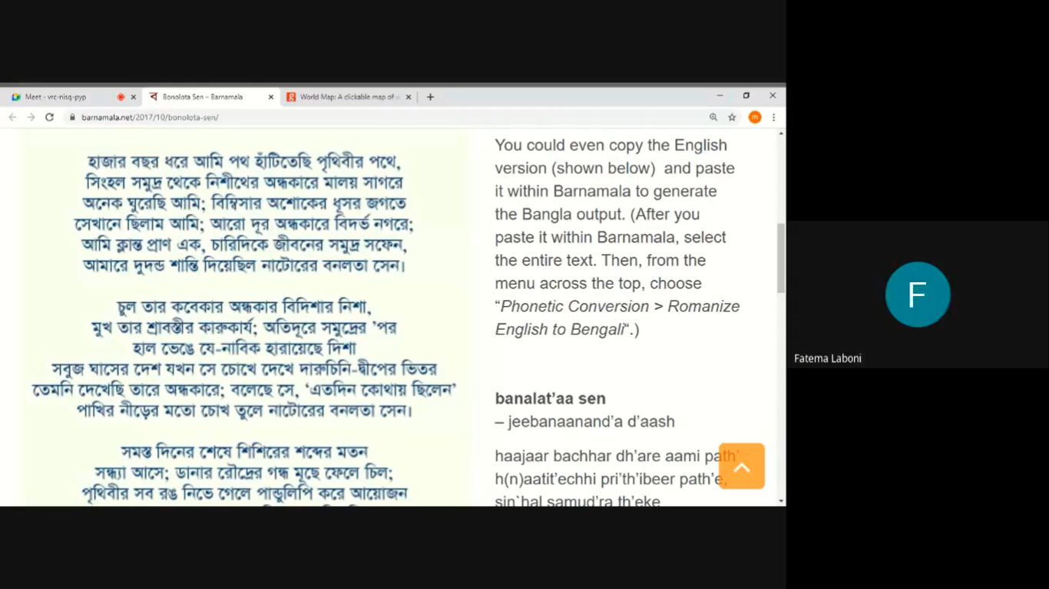

Class Observation -2

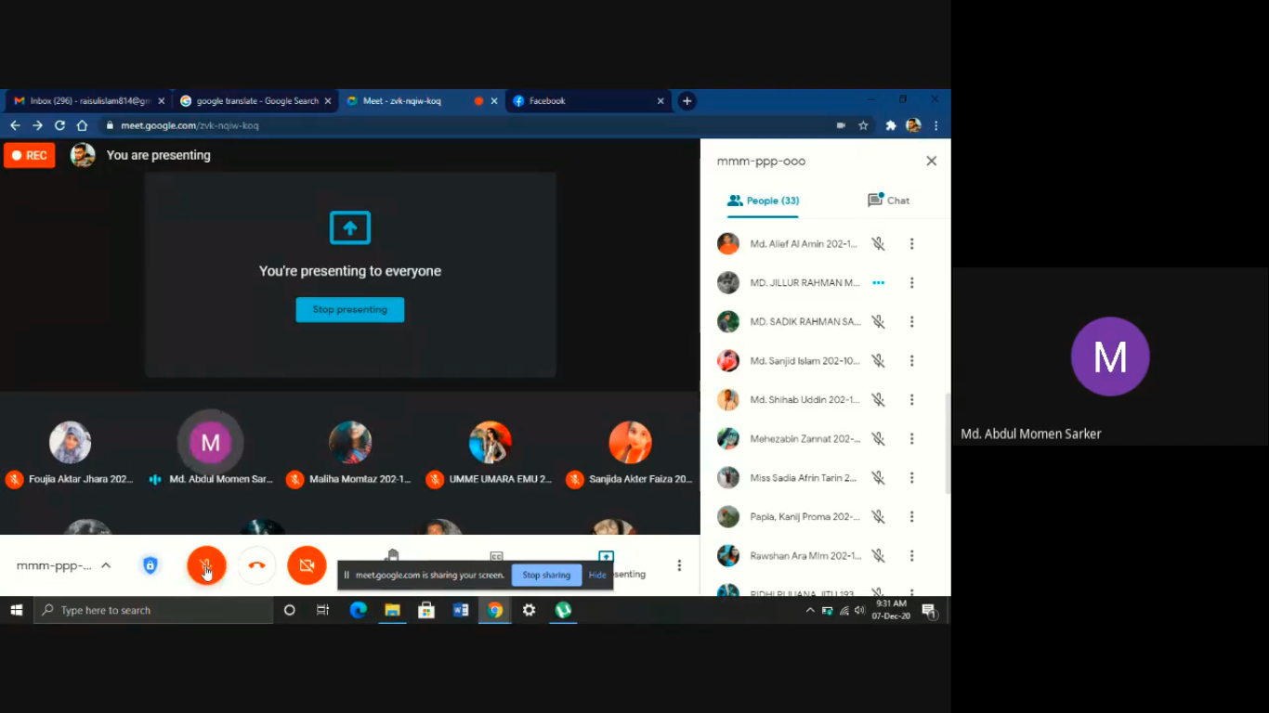

Class Conduction:

