An Internship report
On
“Online class observation and conducting during the outbreak of
COVID -19’’
Course title: Project paper
Course code: ENG334
Prepared by: Amyau Marma Urmi
ID: 173-10-217

Under the Supervision of
MD. Rafiz Uddin
Lecturer, Department of English
Faculty of Humanities and Social Science
Date of Submission: 23.12.2020

This Internship report is submitted to the department of English, Daffodil International University, for the partial fulfilment of Bachelor of Arts (BA) in English Degree.

i
Declaration

I hereby declare that this internship project work entitled “Report on online class observationand conducting during the outbreak of COVID-19’’ has been completed under the supervision of Md. Rafiz Uddin , Lecturer, Department of English, Daffodil International University. I also declare that this project work is submitted in the partial fulfilment of the requirement for the award of degree B.A ( Hons) in English.

.....................................
AmyauMarmaUrmi
ID: 173-10-217
Department of English
Daffodil International University

ii
Certificate
This is certifying that AmyauMarmaUrmi bearing Id 173-10-217 is a student of English department of Daffodil International University, Ashulia campus. She had taken one online class of 1st-semester students on the Course ENG111 “Basic Grammar and Writing’. During this whole process, she was in contact with me, she has done as I taught her to do. She gave me refreshes about the undertaking work. She satisfies the conditions and finishes the task of Project paper.
I wish her success in her future life.

...........................
MD. Rafiz Uddin
Lecturer, Department of English
Daffodil international university

iii
Acknowledgements
I might want to offer my thanks to MD. Rafiz Uddin Lecturer, Department of English, for his interminable help to satisfy my "Temporary job venture during the flare-up of Covid-19''. His understanding, Guidance, consolation and advice have made it conceivable to finish this undertaking paper. I might want to thank the first year, first semester students, who were exceptionally steady, co-operative and benevolent conduct. At last, I might want to thank every one of my companions, who had added to the Project with their significant suggestions and valuable time.

iv
Abstract

The reason for this report was an endeavour to think about the current coherence of online class perception and conduction in English during the flare-up of COVID - 19. To finish the paper I set myself up in a few different ways relying upon the components: class perception
Showing way, appraisal, recomposed. The principal rationale of this report is to know how instructors take the classes, show the understudies which parts are utilized in sentence structure educating and how the educators interval the students and to know the techniques of improving their syntax educating.
This paper incorporated some errand-like; proposal dependent on the exercise plan, discoveries and the checklist from the perception that explore the shortcoming and qualities of the noticed teacher.E-learning in delivering course materials of BOU and other academic institutes to promote distance education in Bangladesh. In this paper, we discuss the current situation and prospects of ICTs in Bangladesh for the expansion of open and distance education.

[Keywords: Covid-19, online classes, methodology, technique, responses,co-operative]

v
Table of contents
Content | Page no.
Title | i
Declaration by intern | ii
Certification of the supervisor | iii
Acknowledgement | iv
Abstracts | v
Table of contents | vi
chapter i : Introduction | 1
chapter ii :Objectives | 2
chapter iii: Methodology | 3-4
chapter iv: Institution details | 5
chapter v : Report of class observation | 6-7
chapter vi : Teaching experience | 8
chapter vii :Overall findings | 9-12
chapter viii :Recommendations | 13-15
chapter ix: Conclusions& Reference | 16-17
Appendices  Appendix 1: class observation checklist | 18-31
Appendix 2: lesson plan | 32-33
Appendix 3: class recording picture | 34-37

vi

Chapter1
Introduction
English is a global language.Learning English in Bangladesh is compulsory in almost every level of education.Children learn English from their childhood, from the primary level of school to tertiary level of education but still, the majority of the people can’t speak, read or write accurately. It can often be seen that students memorize to learn to get good marks and pass in the examination.In most of the educational institutions of Bangladesh, there is less place of creative skills and experiences for the students. This is the reason that the students can’t comprehend grammar in the target language. Maximum Associations need employees who can speak furthermore, compose a standard type of English. That is the reason these days an ever-increasing number of students are choosing English to learn at their college level.In this pandemic circumstance likewise, a decent number of students got themselves concede in the English department.Teachers are using more creative and communicative ways to teach in online classes by using different applications like- Zoom, Skype, Google meet, Blended Learning Center (BLC) etc. Teachers, students, authorities experienced blended learning and decided the further steps to implement it in private universities of Bangladesh. (Hani, M., 2018).
Some renowned instructing techniques that are continued in Bangladesh for advanced education are Audio Lingual method, Silent method, Direct Method, Grammar Translation Method, Suggestopedia, Total Physical Response, Eclectic Method, Communicative Language Teaching, etc.The project focused on establishing the values of English grammar and language.

Chapter 2
Objectives
The primary objectives to identify the teaching resources and the present situation of English grammar teaching and learning.
- To observe the method of Teaching.
- Assume the present situation of language teaching in Bangladesh through online based.
- To learn how to apply teaching techniques through online.
- To know the teacher’s attempts to engage students in reading understanding comprehension.
- To find out the strategy or how teachers adjust the contextual factors in language grammar.
- To find out the impacts of using technical application upon the learner.
- To find a student's ability, reading and speaking skills in English.

Chapter 3
Methodology
- Selecting an Institution
Due to COVID outbreak, almost all educational institutions were closed. It was impossible to manage the physical class in a school or other educational institutions. There are some institutions, where online classes were being held. As my university daffodil international university held online classes, I took the opportunity to select a batch and took an online class.
- Selecting Class
I observed particularly two classes and learned things related to the methods on how to take classes, how to approach the students and how to manage the time. After that particular class, I took a class of 1st year, 1st-semester students which were selected by my supervisor. I took a 45 minutes class on the course “Basic grammar and writing ’’.
- Selecting a Facilitator
MD. Rafiz Uddin, Lecturer of English department, Daffodil International University was my supervisor for my project paper .once again I would like to thank him for making the process of the project paper to fulfil with all necessary information.
- Classroom Observation
I have to follow the schedule of other intern classes which was provided by my supervisor. I observed two classes of grammar online. I attend from beginning to the end both the classes with my checklist for observation. I noted the necessary information and techniques during the class and the duration for each class was 45 minutes.

- Testing students and Self-assessment
I kept writing notes on how the interns were teaching and how students were responding and interacting with each other, which helped me to collaborate to write my report in a proper and compatible way. I also had a chance to observe other things related to teaching methods including managing time and classes over the particular topic.

Chapter 4
Institution Details
Daffodil International University is a private university located in Dhammondi, Dhaka, Bangladesh and the permanent campus is located at Ashulia , Savar. It was established on 24 January 2002. DIU is a top-ranked private university among all the universities in Bangladesh. DIU is the first university in Bangladesh to have signed the UN’s Commitment to Sustainable Practices of Higher Education Institutions. According to the SCOPUS indexed publications in 2019, DIU has been positioned 4th among all universities and 1st among all private universities in Bangladesh. The University offers bachelors, masters, and doctoral certificates through its 23 offices, themselves coordinated into 5 resources. The college encourages online confirmation for candidates from far off territories. There are additionally numerous clubs and networks in the college. The University gives 20% to 100% waiver to the students dependent on the outcome under the general board. They likewise give grants to various Universities in numerous nations. They likewise give a decent transportation office. Wi-Fi and library offices are too accessible. The University additionally runs a venture 'One Student one PC'. Under this venture, Daffodil International University has circulated more than 25000 free PCs among the understudies.
Campus: Dhanmondi, Ashulia& Uttara
Chairman: Md. Sabur Khan
Chancellor: Abdul Hamid, President of Bangladesh
Vice-Chancellor: Prof. M. Lutfar Rahman, Ph.D
Academic stuff: 859
Administrative stuff: 780
Students: 21752
Undergraduates: 20521

Chapter 5
Class Observation Report One
I observed the first class was online based on 1st year, 1st-semester students of English department on 9December 2020. The class was taken by Riya Moni. She started the class at 10:00 am and finished at 10:45 am. The topic of the class was “Determiners’’. During the class, 32 students were present .the teacher started the class with a greeting along with an attractive warm-up. After that, she started to discuss the topic and gave descriptions of the types of determiners with examples. Also, she asked the students whether the example is similar to the topic or not. She got a fairly positive response from the students. Then she gave them a task to complete within 5 minutes. After that, she moved on to another topic. The students were very cooperative with the intern and did the tasks that were given. Some of the students asked questions to clarify their confusions and she responded.
I found the intern confident and well aware of the topic. So, she was quite fluent and sometimes she spoke in her native language to make students understand the topic. After that, she gave them a final task as they don’t have any kind of confusion or questions about the topic.
- The abstract of the whole class can be shown below:
Warm-up ---------------5 minute
Discussion of the first stage ----------- 7 minute
Discussion elaborately -----------13 minutes
The task is given------------ 10 minutes
Correcting answer -------- 6 minutes

Class Observation Report Two
Next, I observed another class on the same day, on the topic Modifiers and the class was taken by MuniaKhisa . She started the class at 10:45 am and ended at 11:30 am. She started the class with greetings and a good warm-up to which the students responded politely. She moves towards the topic. She was a bit nervous while explaining the topic. During the lecture, there were not enough examples and materials to the related topic. She presented the students with some tasks, only a few students responded due to the teacher’s lack of liveliness. Although she finished the class on time. There were no questions. She was a bit hesitant but the overall method was proper.

- The abstract of the whole class can be shown below:
Warm-up ---------------4 minute
Discussion of the first stage ----------- 5 minute
Discussion elaborately -----------10 minutes
The task is given------------ 10 minutes
Correcting answer -------- 6 minutes

Chapter 6
Teaching Experience
I took one class of 1st year, 1st semester of English department as per instruction of my superior. He managed the whole class for me according to their schedule. So, I prepared a lesson plan and showed it to my supervisor for correction and she permitted me to conduct the class. Then he created a meet link and invited me on a meet platform where I was going to take the class.
On Saturday, 5 June 2020 I directed a “Basic grammar and writing’’ class on the topic, “Linking word”. I started my class at 10:45 am and finished at 10:45 am. The total number of students in that class was 32. At the very beginning of the class, I greeted the students and introduced myself to them. theni warmed up the class by asking them about their aim, hobbies, motive why they admitted in English department and their response were positive,as it was my first class as a teacher and an online-based class I was a little bit nervous but when I got a good response from the students, I felt much comfortable.
After that, I approached them gently asking about the topic whether they were familiar with it or not. They replied positively. Then I presented a PowerPoint slide and discussed the first section of the related topic and gave some examples.After finishing section one I moved on to the second sections and discussed briefly and asked them to give more examples related to the topic. They were able to respond properly and didn’t have any confusion so far. I also used Standard English and was quite loud and clear. Sometimes I used my native language to explain the examples briefly and for better understanding and also kept a friendly behaviour.
At the end of the lecture I gave them some final tasks and asked to give answers. Most of them responded and they were right. Thus I finished the class within 45 minutes.
Overall, I tried to make the class full of activity by encouraging them to improve their grammar and English skills. The students were very co-operative and followed instructions.

Chapter 7
Overall findings
1. Class observation findings
I observed two classes of 1st year, 1st-semester students which were taken by my two fellow interns. I noticed that they were punctual about timing. They started and finished the class on time. Both of them were very friendly towards the students and had a good understanding. The number of students was very impressive; they translated English text into bangles for student’s better understanding. I felt the cooperation of the student and teacher was very warm and healthy. Performance of the student was very good and they were very attentive.
  - Lesson formation
The intern teachers formed the lesson properly, started and finished the class in the proper time according to the lesson plan. They had a clear idea about how they were going to teach the students and achieve their lesson goals.
  - Lesson delivery
First, the intern-teacher warmed up the students with interesting things like asking them about their hobbies, passion. Sometimes they used Bangle for student’s better understanding.
  - lesson management
The intern-teacher showed a good command of the rules and explained elaborately the topic properly and exactly. They used many examples.
  - classroom management
As it was an online-based class the teacher arranged the class in Google meet the students attended the class via their devices. Intern Teachers also managed the classes by presenting their slides to the topic, showed many examples and gave them some tasks where the students also responded correctly.

1.5 Students involvement
The students interacted via the microphone and shared their thoughts in the comment section. From the beginning of the class, students were much involved as the teacher was encouraging them to ask questions.

1.6 Use of technology
The whole process was based on technology the teachers used their devices like; mobile, laptop, computers to create links for the classes to be held. The students also attended the classes via their own devices and experienced the internet in a whole new way.

1.7 maintain rapport
Though the teachers and the students were limited to the dimensions of their device good rapport was maintained throughout the classes. There was a good sense of understanding and trust.

1.8 use of language
Using a friendly tone of speech, the class teachers encourage the students to talk about their problems. They showed the students a friendly manner. Language and words of the teacher were generous, warm and conversational and cheerful.

- Self-reflecting findings
Students were excited to have a new teacher. I felt very good and comfortable with the students. I took one grammar class. I discovered several significant things related to the students like how to deal with them, how to make them properly, how to gain their attention, how to manage the classroom environment and how to maintain good rapport with the students.
2.1 Lesson preparation
With a methodological lesson plan and other materials, I prepared for the class. I was planning to make the students more active and attentive and also create an enjoyable environment. So I made an interesting warm-up where they had to explain their aim and motive why they were admitted in the English department. I also prepared a colourful slide for them. I gave them some tasks related to the topic to make the lesson more effective.
2.2 Lesson delivery
I was well prepared for the class. I gave proper instructions and descriptions about the topic to the students along with the activities after the warm-up session. I used easy language to make them understand the students were very cooperative and completed all tasks which were given at the class.
2.3 Lesson management
They gave their answers by turning on their microphone on their device, while I asked them some questions showing my slide. I didn’t divide lessons into groups or pair activities so they gave individually the answers and they were correct.
2.4 Students involvement
The students were very cooperative. Whenever I ask those questions they don’t take that much time to respond. They were attentive in the class from beginning to end of the class.

2.5 Maintaining Rapport
As I was not in front of them physically I couldn’t maintain a good rapport with the students. But I tried hard to maintain the class as well as the students with stuff that I was supposed to do. I made the lesson easier for them so that they can easily catch the lesson properly and they answered without any hesitation.
2.6 Use of Language
I interact with the students with very friendly behaviour and warm voices. I kept my voice tune clear. I talked in easy language and sometimes I talked in the native language to make them understand my words.

Chapter 8
Recommendation
As I observed two classes of two different teachers, they were very calm and maintained good communication with the student and did their job very professionally and nicely. They were well prepared and were friendly with the students. There are some issues which should be improved.
- Attractive warm-up: they did put warm up in their lesson plan before starting the classes. It could have been more attractive and interesting.

- Presenting real-life example: a teacher also needs to talk outside of the book and give real-life examples to make the lesson relatable. Once they make relatable life examples, possibilities are very high that students will never forget the topic. If the teacher just reads and gives activity only from the book it makes the lesson boring.

- Brainstorming: it is a significant part of learning. We have to provide them more creative and challenging activities in a group or a pair to make the lesson livelier to keep them involved with the students and to make them creative, teachers must include brainstorming activities.

- Proper use of technology:Since it was an online-based class, the use of technology was obvious. By this process students have the advantages of technology, can learn other new things and get to know the proper use of technology. So I recommend every teacher should be concerned about this issue and use technology in their classrooms.

- Give them the scope to be creative: English modern era we all know the value of a creative person and how rare quality it is. So teachers need to train the students to be creative and give them the scope to explore and use their time creatively. For that, the teachers can give the works that include thinking outside the box.

- Making an interacting situation: Classroom should be a place of study, comfort and creativity. So there should be a fair amount of interaction between teachers and students. The assessment will be excellent if there is a big scope for students to express feelings, to talk and to interact with peers or with the teacher. Only teacher-student centred classrooms are not the solution to a successful class for the students. It will make a class very successful if there is a lot of scopes for a student to speak and communicate.

- Maintaining Rapport: Maintaining rapport with the students is very crucial. To make a lesson successful the teacher must listen to their students’ opinions and give them time. To handle a lesson this must. As a teacher he or she needs to give more space to the students, to show their creativity, to express their thinking and also listen to their problems cordially.

- Maintaining sound behaviour: I often noticed many teachers react rudely. We need to remember that every student is not the same. Some of them are slow learners and that is fine. The teacher needs to treat them in a friendly manner and not to disappoint them in front of their friend. Humiliating in front of the class may cause low self-esteem.

- Expanding vocabulary: Proper and Good vocabulary makes the language/speech enrich and powerful. So to learn second language students must concentrate on vocabulary learning. To improve their vocabulary teachers can recommend particular blogs and essays and any other sources from the internet.

- Avoid memorizing: A teacher must teach a student a lesson in an understandable way so that they do not need to memorize it. A student should not be shown the path of memorizing.

- Proper trainingfor the teachers: Bangladeshi teachers do not have much training about how to build up a record with a student or how to talk to them in an easy language to make them understand a difficult word or sentences in English. Teachers like to teach their students as they were taught and apply zero new techniques.

- Relaxing and stress-free learning: The teacher should not pressurize the students to learn. If the pressure is put on them, they will learn the lesson but it will harm their brains. Because of the stress and pressure, the students will forget their lessons very fast even after understanding it. Putting a little fun into the study and lesson can help the students to learn effectively and will not forget the Lesson.

Chapter 9
Conclusion
The study reflects indicating my experience, understudies' aptitudes similarly to their learning cycle. I saw the students have some syntactic issues. As I saw and took classes of the first year, first semester students, they are not consistently stressed over their talking and listening also. They endeavour to recall the standards of language structure. They feel confused when talking in English with the teachers anyway some of the educators had the alternative to make them don't spare a moment to talk and be pleasing. Through my insight, I got the opportunity to see the teacher's procedures for instructing. I am really happy that I found the occasion to see two classes of them. I sort out some way to cause the understudies to feel roused by class and through this, I pick up capability with the ways to deal with being a successful instructor.E-learning in delivering course materials of Bangladesh Open University (BOU) or other institutes to promote distance education in Bangladesh. (Islam, M.T. and Selim, A.S.M., 2006).

References
1. Islam, M.T. and Selim, A.S.M., 2006. Current status and prospects for e-learning in
The promotion of distance education in Bangladesh. Turkish Online Journal of Distance Education, 7(1).
2. Hani, M., 2018. Blended Learning in Tertiary Level of Bangladesh: Private Universities in Focus (Doctoral dissertation, East-West University).
3.LINGGA PITALOKA, N., WAHYUNI ANGGRAINI, H. ., KURNIAWAN, D. ., ERLINA, E., & PUTRA JAYA, H. . (2020). Blended Learning in a Reading Course: Undergraduate EFL Students’ Perceptions and Experiences.

Appendices
Classroom observation checklist One

Daffodil International University
Department of English
“Internship report on online class observation and conducting in
English during the outbreak of COVID-19”
Checklist of class observation
University:Daffodil International University
Teacher’s name: Riya Moni Class: 1st Semester, 1st year Section: P.C.A
No. of students present: 32 Course title & code: Basic Grammar and Writing ( ENG111)
Room no: Online Observer/peer: AmyauMarmaUrmi Date & time: 9.12.20(10am10:45am)
Objectives of the lesson (as perceived) :
i .Definitions of Determiners.
ii. Types of Determiners and examples.
iii. Completing the given exercises.
Were the objectives achieved and to what extent (in your view)?
The Intern Teacher trains the students in the event that they thought about determiners. At that
Point she showed them how to use determiners in a sentence. She likewise gave them tasks to finish and the students did this pleasantly. So unmistakably the objectives were achieved.

SN | Review Section | In what ways? ( Specific examples/ clarifications
1 | SUBJECT MATTER CONTENT  (shows good command and knowledge of subject matter; demonstrates breadth and depth of mastery; tries to develop a knowledge seeking behavior among students) | 1) Showed good command about the exercises.  2) Developed knowledge seeking behavior.
2 | ORGANIZATION  (organizes subject matter; states clear objectives; emphasizes and summarizes main points, meets class at scheduled time, starts and finishes the lesson properly with an attractive warm up and a conclusive end how the objectives of the lesson met/ what  They have learn today) | 1) Met the class on time and finished.  2) Tried to explain the objective clearly.  3) Warm-up was quite good.
3 | RAPPORT  (holds interest of students; is respectful, fair, and impartial; provides feedback, encourages participation; interacts with students, shows enthusiasm, both teacher and students are ready for the class not only on subject matter but also in manner, etiquette and attitude) | 1) She was not fair to students and friendly.  2) Could hold the interest of students.  3) Provided proper feedback.  4) Interact with students with a warm voice and show enthusiasm.  5) Both teacher and students were ready for the class.

4 | TEACHING METHODS  (uses relevant teaching methods, aids, materials, techniques, and technology; includes variety, balance, imagination, group involvement; encourages questions from students and responds with interest; is open to ideas; uses real life examples that are simple, clear, precise, and appropriate; stays focused on and meets stated objectives) | 1) She tried to encourage them by asking questions.  2) Used some techniques and technology in class.  3) Couldn’t make any group give a task.  4) Used real life examples that were simple and clear.  5) Students responded with interest.  6) Stay focused on the topic.
5 | PRESENTATION  (establishes classroom environment conducive to learning; ensures learners’ interests, maintains eye contact; uses a clear voice, strong projection, proper enunciation, and standard English) | 1) She could make the classroom environment very friendly and conducive to learning.  2) Ensured learner interest and used a clear voice.  3) Used standard English while teaching.

Management
Was the time spent properly? Yes.

What were the main stages of the lesson? What tasks and activities did the teacher do during each stage? ( Optional: Draw a diagram to show main stages of the lesson and time spend on each)

[Discussed about the topic within 10 minutes]
↓
[gave them tasks for 15 minute]
↓
[gave examples of each stages for10 minutes]
↓
[asked them if they have any confusions and solved 10]

CRITICAL EVENT (If took place)
Was there any ‘critical event’ in the lesson? (a point where communication broke down and there was confusion). How did the teacher handle the situation?
There was no critical event in the lesson.

Strengths observed:
1) The Intern teacher grabbed the attention of the students very nicely.
2) Her voice was soft, clear and confident.
3) She could teach them many new things.
Suggestions for improvement:
- Teachers could use less colorful images on the slide which do not divert the attention of the students.
- Could ask them for giving examples in one or two sections.

Overall impression of teaching effectiveness:
Teaching process was good enough and effective.

Classroom Observation Checklist two

Daffodil International University
Department of English
“Internship on a report on online class observation and conducting in
English during the outbreak of COVID -19”
Checklist for class observation

University:Daffodil International University
Teachers name: MuniaKhisa class: 1st Semester, 1st yearSection: P.C.A
No of student Present: 32Course title &code:Basic Grammar and Writing ( ENG111)
Room no: Online Observer/peer: AmyauMarmaUrmiDate and time: 9.12.20(10am10:45am)
Objectives of the Lesson(as perceived)
i .Modifiers and its uses.
ii. Finding out confused words
iii. Giving examples of Modifiers.
Were the objectives achieved and to what extent (in your view)?
The Intern Teacher asked the students to find out many confusing words and ask to give some examples of Modifiers.

S/N | Review Section | In what ways? ( Specific examples/ clarifications)
1 | SUBJECT MATTER CONTENT (shows good command and knowledge of subject matter; demonstrates breadth and depth of mastery; tries to develop a knowledge seeking behavior among students) | 1. Showed good command about the examples.  2. She tried to develop knowledge about the topic.
2 | ORGANIZATION(organizes subject matter; states clear objectives; emphasizes and summarizes main points, meets class at scheduled time, starts and finishes the lesson properly with an attractive warm up and a conclusive end how the objectives of the lesson met/ what they have learned today) | 1. Met the class on time.  2. Warm-up was not that much attractive as teacher was fair.  3. Couldn’t be able to explain properly.  4. Students learned very few things in the class.
3 | RAPPORT (holds interest of students; is respectful, fair, and impartial; provides feedback, encourages participation; interacts with students, shows enthusiasm, both teacher and students are ready for the class not only on subject matter but also in manner, etiquette and attitude) | 1.Sometimes she was unable to grab the attention  2. Could hold the interest of students.  3. Could less interact with the Students
4 | TEACHING METHODS (uses relevant teaching methods, aids, materials, techniques, and technology; includes variety, balance, imagination, group involvement; encourages questions from students and responds with interest; is open to ideas; uses real life examples that are simple, clear, precise, and appropriate; stays focused on and meets stated objectives) | 1. Only used PowerPoint slides as it was an online based class.  2. Practical examples were given.  3. No group works.
5 | PRESENTATION (establishes classroom environment conducive to learning; ensures learners’ interests, maintains eye contact; uses a clear voice, strong projection, proper enunciation, and standard English) | 1. Speech was not proper.  2. Asked questions to them.  3. Couldn’t ensure learner’s interest.  4. Tried to use a clear voice and standard English.

Management
Was the time spent properly? Yes

What were the main stages of the lesson? What tasks and activities did the teacher do during each stage? ( Optional: Draw a diagram to show the main stages of the lesson and time spent on each)
[Discuss the topic for 10 minutes]
↓
[gave examples for 15 minutes]
↓
[asked them questions for 10 minutes]
↓
[gave them find out proper words for 10 minutes]

CRITICAL EVENT (If took place)
Was there any ‘critical event’ in the lesson? (a point where the communication broke down and there was confusion). How did the teacher handle the situation?
There was no critical event in the lesson.

Strengths observed:
1) Her voice was loud, clear and confident.
2) Proper English.
3) She could teach them many new things.

Suggestions for improvement:
- Teacher could be friendlier.
- Could make the lesson more interesting to them.
- Could ask them for giving examples in one or two sections.
Overall impression of teaching effectiveness:
Teaching process was good enough and effective.

Observation Checklist for My Teaching:
Daffodil International University
Department of English
“Internship on report on online class observation and conducting in
English during the outbreak of COVID-19”
Checklist for class observation
University: Daffodil international university
Teachers Name: AmyauMarmaUrmi Class: 1st Semester, 1st Year Section: P.C.A
No of student present: 32 Course title and code: Basic Grammar and Writing ( ENG111)
Room no: Online Observer/peer: Riya and Munia Date and Time: 5.12.20(10am-10:45am)
Objectives of the Lesson(as perceived)
i .Discussion about the topic.
ii. Give examples related to the topic.
iii. Ask questions and give tasks.
Were the objectives achieved and to what extent (in your view)?
Asked questions and answered.

S/N | Review section | In what ways? ( Specific examples/ clarifications)
1 | SUBJECT MATTER CONTENT (shows good command and knowledge of subject matter; demonstrates breadth and depth of mastery; tries to develop a knowledge seeking behavior among students) | 1) Provided great order on the point.  2) Developed information looking for conduct.
2 | ORGANIZATION(organizes subject matter; states clear objectives; emphasizes and summarizes main points, meets class at scheduled time, starts and finishes the lesson properly with an attractive warm up and a conclusive end how the objectives of the lesson met/ what they have learned today) | 1) Met on schedule.  2) Warmed-up.  3) Tried to clarify targets plainly.
3 | RAPPORT (holds interest of students; is respectful, fair, and impartial; provides feedback, encourages participation; interacts with students, shows enthusiasm, both teacher and students are ready for the class not only on subject matter but also in manner, etiquette and attitude) | 1) Understandable for Student’s.  2) Tried to be friendly with students.  3) Grabbed interest pleasantly.
4 | TEACHING METHODS (uses relevant teaching methods, aids, materials, techniques, and technology; includes variety, balance, imagination, group involvement; encourages questions from students and responds with interest; is open to ideas; uses real life examples that are simple, clear, precise, and appropriate; stays focused on and meets stated objectives) | 1) Use a clear and Colorful PowerPoint slide.  2) Responded with interest.  3) Used genuine models.  4) Stayed focused on the topic.
5 | PRESENTATION (establishes classroom environment conducive to learning; ensures learners’ interests, maintains eye contact; uses a clear voice, strong projection, proper enunciation, and standard English) | 1) Couldn’t have eye to eye connection during the web class.  2) Intelligible and clear voice.  3) Used standard English.

Management
Was the time spent properly? Yes

What were the main stages of the lesson? What tasks and activities did the teacher do during each stage? (Optional: Draw a diagram to show main stages of the lesson and time spent on each)
[Discuss the topic for 10 minutes]
↓
[gave examples for 15 minutes]
↓
[asked them questions for 10 minutes]
↓
[gave them find out proper words for 10 minutes]
CRITICAL EVENT (If took place)
Was there any ‘critical event’ in the lesson? (a point where communication broke down and there was confusion). How did the teacher handle the situation?
There was no critical event in the lesson.

Strengths observed:
1) Her voice was loud, clear and confident.
2) Proper English.
Suggestions for improvement:
- Could ask the students more questions.
Overall impression of teaching effectiveness:
Teaching process was good enough and effective.

Lesson plan
Topic: Linking words
Time: 45minutes
Course | project paper
Teacher | AmyauMarmaUrmi 173-10-217
Students | semester: 1st
Lesson topic | Linking words
Aim of the lesson | - To make clear about the linking words.  - To make clear concepts, use of appropriate linking words in a sentence.  - To make clear how to connect words to fulfill sentences and make it meaningful.
Date | 5 december,2020
Learning resources | Powerpoint slide , Audio
Estimated time for Lesson | 45 minutes

Warm up
Discussion about the point throughout everyday life and thought process to concede in English department.

Presentation
Topic | Teaching process | Activity | Time
Linking words  definitions | Introduced the topic defining definitions. | Asking them about the topic whether it is clear or not. | 10 minutes
Examples of linking words | Provide them some examples of linking words. | Give them a task to share their own examples related to the topic. | 10 minutes
Types of linking words & example | Discussing the types of linking words and its examples. | Give them some tasks for exercises of connecting words or linking words. | 15 minutes
Exercise & answer solving | Provide them some exercise related to the topic. | Students will be offered a task and after that answer will be corrected by the teacher . | 10minutes

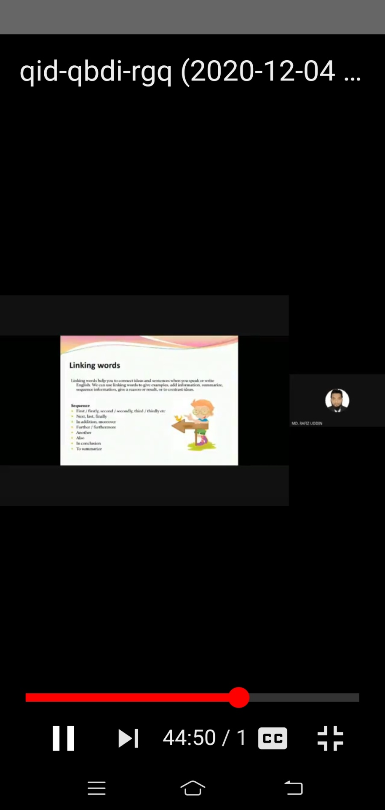
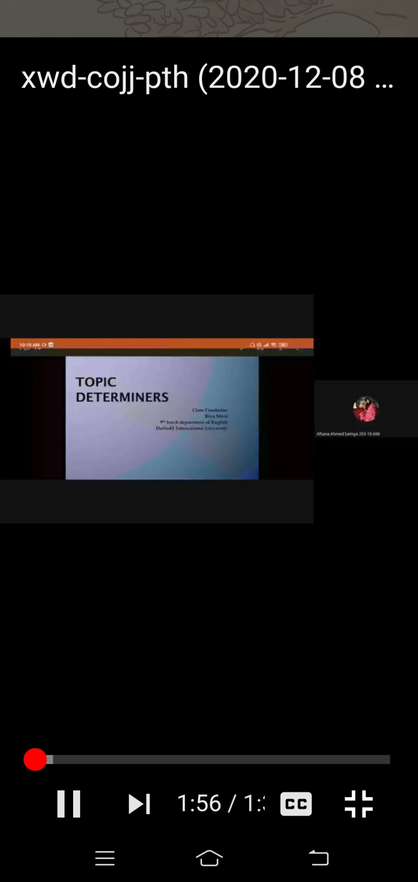
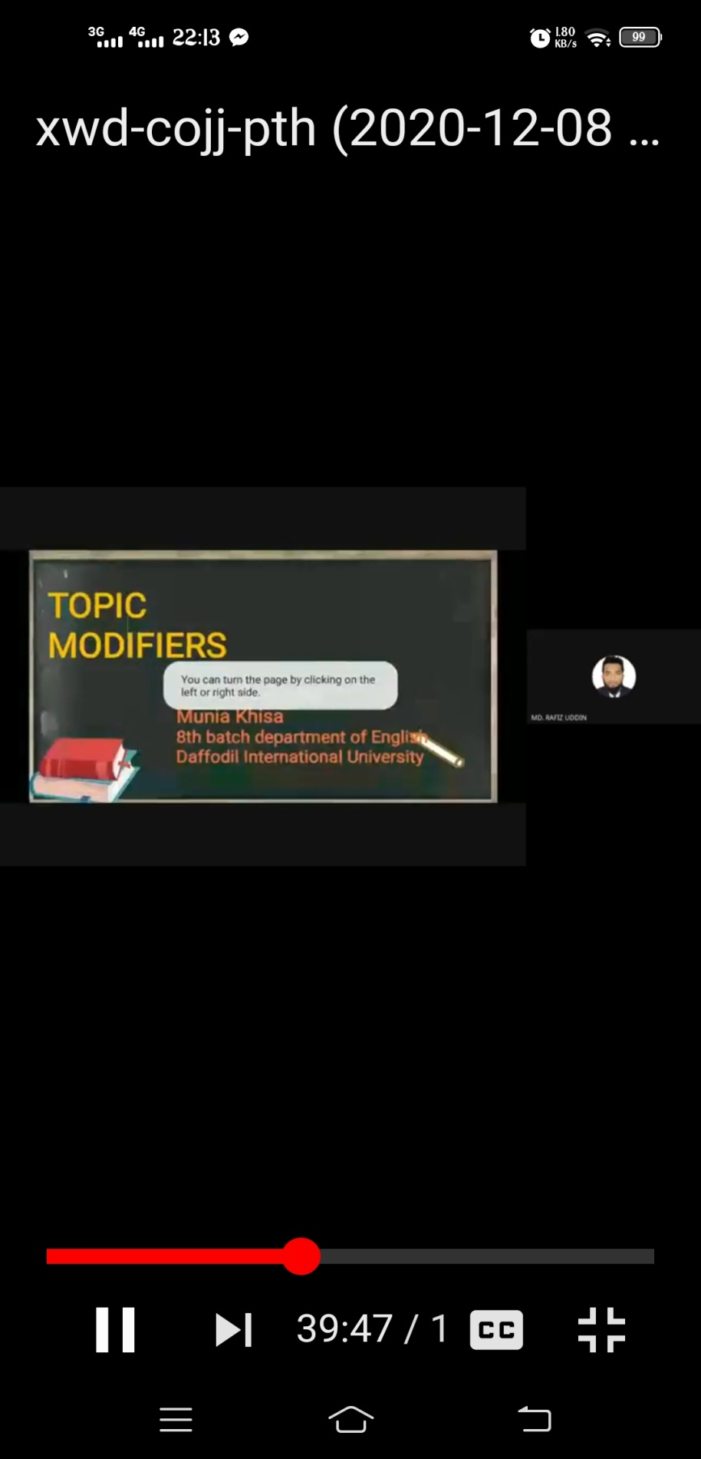

End

