

Internship Report On
“Online Class Observation and Conduction in English during the Outbreak of Covid-19"

Submitted To:
Name: Dipty Rahaman

Lecturer, Department of English
Daffodil International University

Submitted By:

Name: Keya akter
ID: 173-10-226
Batch: 42th
Department of English
Daffodil International University

This Report is Submitted in Partial Fulfillment of the Requirements for the Degree of B.A (Honors) in English
DEPARTMENT OF ENGLISH
DAFFODIL INTERNATIONAL UNIVERSITY
FALL-2020, Date of Submission: December 17, 2020

Declaration
I do hereby, declare that, this Internship Report submitted to the department of English,
Daffodil International University is an original & unique work for the fulfillment of my course “Project Paper” in the program of B.A (Honors) in English. The internship report on “Online Class Observation and Conduction in English during the Outbreak of Covid-19" is an actual work based on my practical experience and it was written under the supervision of Dipty Rahaman, Lecturer of the English Department. I tried to follow all the instructions that was given by my supervisor to complete this report.

Keya Akter
ID: 173-20-226
Batch: 42th
Department of English
Daffodil International University

Certificate of Approval

It is my pleasure to certify that this internship report submitted to the department of English, Daffodil International University is a unique and original piece of work done under my supervision by Keya Akter, ID: 173-10-226. This Report is submitted in Partial Fulfillment of the Requirements for the Degree of B.A (Honors) in English. I recommended this report for submission to the Department of English, Daffodil International University and wish him good luck for prosperous future and every achievement in his life.

Dipty Rahaman, Lecturer
Department of English
Daffodil International University

Acknowledgements
First of all, I would like to thanks the Almighty Allah for giving the potentiality to complete the necessary tasks successfully. My internship report would not be completed properly if I didn’t get any support and guidance from my supervisor Dipty Rahaman Lecturer, Daffodil International University. I would like to thanks him for being with me in the entire journey of completing the internship. I’m also very much gratitude to my beloved
department of English, Daffodil International University for permitting me to observe and
conduct some classes to fulfill my internship report on “Online Class Observation and Conduction in English during the Outbreak of Covid-19".
Finally, I would like thanks to my parents for everything they have done for me from the beginning of my life.

Abstract
This internship report is prepared based on “Online Class Observation and Conduction in
English during the Outbreak of Covid-19". For the completion of my work, I’ve to observe and conduct some classes through online google meet in 12th batch, Department of English, Daffodil International University (DIU). At first, I observed two classes which is conducted by Dipty Rahaman Lecturer, DIU. After keen observation and getting some necessary ideas regarding the topic, I’ve conducted a class with the help of respected teacher & students. I found there are some different methods, techniques and rules which are applied by the teachers to develop the English skills. And also, I found some shortcoming in conducting online classes.
This report would be a crystal-clear picture of conducting online classes in English in
Bangladesh, especially during the outbreak of Covid-19.

Table of contents

Contents | Page No.
Declaration | 1
Certificate of approval | 2
Acknowledgments | 3
Abstract | 4
Chapter-1: Introduction | 7
Chapter-2: Objectives | 9
Chapter-3: Methodology | 11
Chapter-4: Institution details | 13
Chapter-5: classroom Observation Report | 15
Chapter-6: Teaching Experience | 17
Chapter-7: Overall Findings | 22
Chapter-8: Recommendations | 24
Chapter-9: Conclusion | 26
Appendix - 1
Checklist - 1 | 28 – 33
Checklist - 2 | 34 - 39
Appendix – 2
Photographs | 41 – 43

Chapter-1: Introduction

Introduction

In 2020 Coronavirus has brought about closed down of scholastic organizations the whole way across the world. All around the world over 1.2 billion understudies are out of the study hall. On March 18, 2020 Bangladesh education ministry announced all instructive organizations to stay shut due to Covid 19 episode simply like different nations. Be that as it may, as the educators were stressed over the investigation of understudies so they began to take online classes everywhere on the world. This pandemic circumstance caused surprising changes in training framework with an unmistakable ascent on computerized online stage. Beginning on the web classes were difficult in Bangladesh the same number of our old instructors are one moment and known with advance innovation yet they endeavored to stay up with the world. Things are presently unique in relation to past actual classes. We noticed and made a report dependent on the circumstance of online classes in English during this Coronavirus flare-up.
English language is a global mode of correspondence and generally spoken everywhere in the world. English has likewise gotten the reputation of vehicle of guidance in Instruction in many colleges and advanced education foundations of the world. In Bangladesh English is unknown dialect and learning English is mandatory for all level understudies and pretty much every understudy began taking in this from the main day of their school life. Because of our nation's poor instructive frameworks, the greater part of the understudies is not familiar at talking and don't have adequate information on English. Because of numerous explanations behind models, absence of productive instructors, legitimate materials, appropriate foundation, techniques and a lot more we are confronting the troubles in the learning area of English. Instructing and learning of English in the schools, universities and colleges are not being done in the manner that it should be finished. In the greater part of the cases, the sentence structure learning has been given accentuation; the reading material substance are instructed and learnt without comprehension. So, the public authority has just found a way to investigate the issues and discover the arrangements. This undertaking paper attempts to unfurl the issues experienced by the understudies, survey an image of educator understudy collaboration and conduct, and assess the degree of execution of understudies in the class at the tertiary level.

Chapter-2: Objectives
Objective of the study

I. To know the effectiveness and benefits of online teaching and learning during this Covid-
19 outbreak situations.
II. To know the proper uses of teaching methods, strategies and lesson plan during taking online classes.
III. To observe the management skills of teachers and environment of classes.
IV. To observe the students’ response and participation while teaching.
V. To find out the weaknesses of teaching and learning on online classes in English and talking about the possible ways of getting out from these problems.

Chapter-3: Methodology

Methodology

I have followed blended method approach for conducting this research. I have followed an agenda also. I was allowed to notice two classes and to direct a class. I have followed the steps given in below for conduct the class.

1. Choosing an institution and Class: A renowned university was picked for the class perception. The two classes I had picked was from same department students, both were from English department. I had taken permission from the facilitator and my supervisor for the observation and class conduction.
2. Observing Classes: Two classes were observed at the same university. Both were grammar classes. It was reviewed from the observed classes, how was the communication in online classes among teacher and students, how the time was overseen, how the teacher spoke with the students while taking classes on the online and a lot of other things. As online classes added another turn in our each side of online classes were noticed while observation.
3. Class Conduction: I had to take a class in English department. Observing the other two classes helps a lot for experiencing this class conduction. The length of the class was 35 minutes. The class was taken through the "Google Meet" application.
4. Utilizing Agenda: An agenda was utilized to observed classes and gather information about the overall things and the agenda is attached as appendix at the end of the paper.
5. Time management: Time management in the classroom was closely observed.

Institution details

Institution details

The institution where the classes were observed and taken is a very reputed University of Bangladesh. It was established in the year of 2002 and now they are a big family of more than 20000 members. This renowned private University offers bachelor's, master's degrees through its 23 departments, organized into 5 faculties. Many opportunities are provided to the students such as scholarship, waiver based on their result, various club and learning opportunity according to their interest, using lab for practical experiment and many more. All of the teachers are very experienced and many of them have done their PhD from reputed University of Bangladesh and abroad. Teachers are aware of advance teaching and learning method. The aim of the University is providing proper education to the students and make them efficient and skillful for future.

Classroom Observation No.1

Classroom Observation No.1

I observed the English Grammar class of the students of English department in a well-known or renowned private university of Bangladesh on Thursday at 2.300pm. So in that class there was 20-25 students in total and that class was their one of the mandatory course of Fall-2020 semester. “The name of the teacher assisting the researcher is not mentioned here in order to maintain confidentiality”. The teacher first started the class with welcoming everyone and took sometimes for little introduction section with students, only for made students comfort zone with her.
After introduction section the teacher stated their objective of the lesson verbally and also presented a power point slide for well understanding and interested. Because with that power point slides the lesson was more effective for students. Then the teacher opened the slides and asked the students that was the slide could watched properly or not .then with some students responded the teacher started their lesson topic. The topic of that class was “past tense”. So firstly, the teacher asked the students to answer what is tense and what they know about the past tense. The teacher gave few minutes for answering about the topic. Few minutes later some of students responded that what they know about that.
The teacher had taken the class in target language but sometime she also used her native language because in this class there have few students who’s were belong from Bengal or native version school and college. So, for that reason sometimes they feel complexity for understanding target language. The teacher used the Method process for taught them. In her presented slides she described all definitions of past tenses and also added the structures, few examples. She gave some time for students that didn’t understand the questions.
So, in total the class was well, the teacher tried to solve every questions answers. She was very caring about students. Still, there were some inconvenience things but she tried her best for the students. According to the researcher the teacher had some lacking in her communication. Because every time she trying to connected the students but every time she failed. And the other thing that she did not give any homework to students. Excluding those things it was a good class section for me.

Classroom Observation No. 2

Classroom Observation No. 2

The second class, I observed was a class of English department in the same University on Saturday at 1.00pm. There were 21 to 26 students in total. It was the first class for the teacher with them. The respective teacher started the class with her introduction after that the teacher stated their objective of the lesson verbally. The class topic was "Degree". The respective teacher was so much formal or method and she always speaks in the target language in the classroom.
Firstly, the teacher asked them that if they know about this topic and then she opened up the doc file which she made for the learning objective. The teacher was not able to get attention of learners because it was her first class and it also comfortable for students. But she tried to run the conversation with students. Then she started to teach the topic degree. The teacher followed the method process for teaching them. She put everything on her doc file. That's why she was just read the DOC file and explain everything to student and in the ending the teacher asked some question to them for understanding that what they actually understand.
So, overall, the class was not so well because the teacher was so much formal she always used the target language student was not so comfort with her but the teacher tried to her best for running their conversation as well. She also tried for gave all information about the class objective overall it was an average class.

Teaching experience

Teaching experience

As a part of my project paper I conducted a online class.it was a very private university of Bangladesh on Saturday on 1.00pm. I was take the class of English department and their 24 student were present in the class total duration of the class was 35 minutes the topic of the class was type of present tense. at first I gave my intro to students for gave comfort song to students and then I gave the listen objective after that I was presented my PowerPoint presentation for the betterment of their understanding then firstly I give the explanation of tense and also act student about that after that I started the description of present tense and its different types along with a structure had been showing it in the slide and interaction with students happened by asking them for example of every tense then I give few minutes for elaboration and few minutes more for listening to the examples from students were much comfortable with me and they were very cooperative.
During the class time students seemed very communicative and participative. They were well-behaved and cooperative with the teacher. Time was managed effectively and lesson objectives were completed properly.
Overall findings
After observing two classes and conducting one, the researcher came across the following findings:
1. Organizations: The organizations of class timetable and objectives of the lessons were expressed very successfully. Both teachers had followed the student centered approach for teaching so students were able to express their thoughts very comfortably. But Both teachers were not able to take the control of classes . because one teacher had problems in communication and she little bit low confidented.
2. Subject matter content: Both teachers had great order in their subject and they had picked effective lesson plans for the students and answered students question patiently. Due to selecting learning activities students were able to answer all the questions at the end of the class. The teachers used native language and English to make the lesson easy and understandable the students. But one teacher did not do this so it might be good and problematic for some students. As both of classes were on grammar topic, I think it will be easier for all students if the teacher use native language rather than target language to speak while taking classes.
3. Use of elements and teaching techniques: Because of this corona pandemic situation the
classes I observed both were online classes so the only element they used to teach, was
PowerPoint presentation on the topics. But the slides were extremely useful and loaded with related
Examples which assisted the students with being more connected.
One teacher gave students the opportunity of self-learning, so that students could build the
interest on the topic and learn by themselves. Other teacher just explained the examples from the slides. Both teachers used brainstorming session. Another thing were
common for both, made the students communities.
4. Exercise Conveyance: Teachers had the option to convey the objective of the lessons following a proper time the executives. One thing might have added greater happiness to the class that is humor. Even if teachers had used real life examples but something felt missing.

Overall Findings

Overall Findings

What I needed to accomplish:
I needed to ensure students comprehend what I was instructing to them and guarantee the objectives of the lesson are being conveyed to them appropriately. I was glad they comprehended the subject and their investment improved the class. I valued them who gave me models toward the finish of each subject, revised them who furnished wrong responses and urged them to pose inquiries.
Barely any Down back I Saw During conducted Class:
I believe being certain and having directing voice are some necessary characteristics each teacher ought to have. I was effective due to having certainty and unmistakable voice however by one way or another, I was somewhat anxious as it was my first time accepting a class as a teacher. Different things like cooperation with students, PowerPoint introduction and giving the talk all had been done very effectively.
And those following things:
1. Students considers English as a very difficult subject and they are very much afraid of
it. But it's not for all because almost every student in this generation they known well English language.
2.Students cannot hear properly because of the poor internet connection.
3. Teacher shared recorded classes to the students.
4. There is very friendly and cooperative relationship found between the teacher and
students.
5.Sometimes students failed to join the class.
6.Because of only listening the lecture, sometimes students become bore. That's why teachers used the PowerPoint presentation slides based on lessons.

Recommendation

Recommendations

I. In language classes each student should attempt to talk in English for training and the teachers encouraged and support for this.

II. Long classes are exhausting or boring so the class season of online classes should be restricted to 60 minutes.

III. In some cases native language can help student better. So, the most ideal approach to convey address on the online or disconnected is to utilize both Bengali and English.

IV. Teacher should be comfortable with new advance technologies like Zoom, Meet, Module, Google
Classroom and so on Since a ton of changes are occurring in online classes so the teachers necessary to likewise assist students with adjusting new advances.

V. More spotlight should be put on student-student collaboration instead of teacher-student cooperation for better showing learning experience.

Conclusion

Conclusion
This internship gave me a way to gather teaching and learning experiences especially in online class. It has given me the excellent opportunity to observe and conduct classes and dealt with students. In online education there are some disadvantage that students sometimes can’t get proper network, they may not understand the topic clearly but if teacher emphasis on this issue this problem can be solved. As teacher shared the recorded video after the class so students can easily recover their problems regarding the topics. During the outbreak of Covid-19 without online platform there is no way to continuing education and if the problems can solve by the authority online education can be more effective than the face-to-face education. In my firm conviction, this report has demonstrated the comprehensive image of the ongoing circumstances of online class conduction in English in Bangladesh during the outbreak of Covid-19. In addition, this report will guide the teachers to a fruitful way for the future betterment of teaching English in online platform.

Appendix-1 checklist 1 & 2
Checklist -1
Institution: Daffodil International University
Teacher’s Name: ______________________________
Batch: 12th Course: Basic Grammar And Writing
Number of student present: 35
Date: 30th November, 2020
Evaluator: Keya Akter
Topic: Past tense
Time: 1:00 pm to 2:30pm

LESSON PLAN AND EXECUTION
 |  |  |  | Completely |  | Mostly |  | Some what | Little bit
- The instructor got the attention of learners early |  |  |  |  |  | Yes
- The instructor stated purpose in interesting way |  |  |  |  |  |  |  | Yes
- The instructor asked stimulating questions
- The instructor highlight the important points |  |  |  | Yes
- The information was presented for given time period |  |  |  | Yes
- The instructor linked content with application |  |  |  | Yes
- The stated objectives were met |  |  |  |  |  | Yes
- The instructor encouraged student responsibility for further learning |  |  |  |  |  |  |  |  | Yes
Comment
TEACHING TECHINIQUES

 | Completely | Mostly | Some what |  | Little bit |  | Not at all
1. The instructor was maintained control of class |  | Yes
2. The instructor asked the students to answer questions |  | Yes
3. The speaker used brainstorming | Yes
4. The students generated responses |  | Yes
5. The instructor used audiovisuals |  |  |  |  |  |  | Yes
6. The instructor used eye contact |  | Yes
7. The instructor avoided standing in a stiff manner or hiding behind a podium
8. the voice quality of instructor was adequate |  |  | Yes
9. The instructor showed interest in the subject |  | Yes
10. Overall, the instructor tried to help the learners learn the subject | Yes
Comment:

CLASS MANAGEMENT
 | Completely | Mostly | Some what | Little bit | Not at all
1. Teacher presence in the class was appropriately approachable not stifling |  | Yes
2. Teacher established a rapport with the class before starting the lesson |  |  |  | Yes
3. Teacher took the time to introduce the lesson to the class | Yes
4. Lesson material was meaningful, motivated, contextualized |  | Yes
5. Use of examples or reference |  | Yes
6. Use of activities to engage thee students  (group work, peer evaluation) |  |  |  |  | Yes
7. Effective balance of STT (students talk time) and TTT(teachers talk time) |  | Yes
8. Time maintenance was effective |  |  | Yes
Comments:

LEARNING ENVIROMENT
 | Completely | Mostly | Some what | Little bit | Not at all
1. The class atmosphere was warm, open and accepting |  | Yes
2. Classroom facility was adequate and furnished with necessary equipment
3. Classroom environment was appropriate to facilitate
4. The seating arrangement is suitable, not over crowded
5. Peer feedback and feedback from teacher was supportive and constructive on students behavior with teacher |  | Yes
Comments:

USE OF ENGLISH LANGUAGE
 | Completely | Mostly | Some what | Little bit | Not at all
1.The teacher speaks in the target language in the classroom
2. The teacher offers opportunities of native language use
3. The teacher used familiar words related to what students teaching in the class
4. The teacher presents information about some very familiar topics using native language
Comments:

PRESENTATION SKILLS OF THE TEACHER

 | Completely | Mostly | Some what | Little bit | Not at all
1. Teacher’s voice is enough audible for all the students | Yes
2. Teacher’s pronunciation is clear enough to understand | Yes
3. Teacher is able to keep pace while giving lecture |  | Yes
4. Teacher gives adequate pauses while giving lecture |  | Yes
5. Teacher is able to make eye contact with all the student
Comments:

TEACHING MATERIALS

 | Completely | Mostly | Some what | Little bit | Not at all
1. Materials are designed according to the age level | Yes
2. Materials fulfills the objective of the lessons provided | Yes
3. Materials includes lessons which are interesting and can motivate the learner |  | Yes
4. Materials are used effectively | Yes
Comments:

TREATMENT OF FEEDBACK
 | Completely | Mostly | Some what | Little bit | Not at all
1. Teacher provided effective feedback to each activity |  | Yes
2. Teacher provided feedback after the activity is finished |  | Yes
3. Teacher provided feedback individually |  | Yes
4. Teacher gave feedback to the whole class |  | Yes
Comments:

Additional comments:

Checklist -2
Institution: Daffodil International University
Teacher’s Name: ______________________________
Batch: 12th Course: Basic Grammar And Writing
Number of student present: 35
Date: 3th December, 2020
Evaluator: Keya Akter
Topic: Degree
Time: 10:00 am to 11:30pm

LESSON PLAN AND EXECUTION
 |  |  |  | Completely |  | Mostly |  | Some what | Little bit
- The instructor got the attention of learners early |  |  |  |  |  | Yes
- The instructor stated purpose in interesting way |  |  |  |  |  |  |  | Yes
- The instructor asked stimulating questions
- The instructor highlight the important points |  |  |  | Yes
- The information was presented for given time period |  |  |  | Yes
- The instructor linked content with application |  |  |  | Yes
- The stated objectives were met |  |  |  |  |  | Yes
- The instructor encouraged student responsibility for further learning |  |  |  |  |  |  |  |  | Yes
Comment
TEACHING TECHINIQUES

 | Completely | Mostly | Some what |  | Little bit |  | Not at all
1. The instructor was maintained control of class |  | Yes
2. The instructor asked the students to answer questions |  | Yes
3. The speaker used brainstorming | Yes
4. The students generated responses |  | Yes
5. The instructor used audiovisuals |  |  |  |  |  |  | Yes
6. The instructor used eye contact |  | Yes
7. The instructor avoided standing in a stiff manner or hiding behind a podium
8. the voice quality of instructor was adequate |  |  | Yes
9. The instructor showed interest in the subject |  | Yes
10. Overall, the instructor tried to help the learners learn the subject | Yes
Comment:

CLASS MANAGEMENT
 | Completely | Mostly | Some what | Little bit | Not at all
1. Teacher presence in the class was appropriately approachable not stifling |  | Yes
2. Teacher established a rapport with the class before starting the lesson |  |  |  | Yes
3. Teacher took the time to introduce the lesson to the class | Yes
4. Lesson material was meaningful, motivated, contextualized |  | Yes
5. Use of examples or reference |  | Yes
6. Use of activities to engage thee students  (group work, peer evaluation) |  |  |  |  | Yes
7. Effective balance of STT (students talk time) and TTT(teachers talk time) |  | Yes
8. Time maintenance was effective |  |  | Yes
Comments:

LEARNING ENVIROMENT
 | Completely | Mostly | Some what | Little bit | Not at all
1. The class atmosphere was warm, open and accepting |  | Yes
2. Classroom facility was adequate and furnished with necessary equipment
3. Classroom environment was appropriate to facilitate
4. The seating arrangement is suitable, not over crowded
5. Peer feedback and feedback from teacher was supportive and constructive on students behavior with teacher |  | Yes
Comments:

USE OF ENGLISH LANGUAGE
 | Completely | Mostly | Some what | Little bit | Not at all
1.The teacher speaks in the target language in the classroom
2. The teacher offers opportunities of native language use
3. The teacher used familiar words related to what students teaching in the class
4. The teacher presents information about some very familiar topics using native language
Comments:

PRESENTATION SKILLS OF THE TEACHER

 | Completely | Mostly | Some what | Little bit | Not at all
1. Teacher’s voice is enough audible for all the students | Yes
2. Teacher’s pronunciation is clear enough to understand | Yes
3. Teacher is able to keep pace while giving lecture |  | Yes
4. Teacher gives adequate pauses while giving lecture |  | Yes
5. Teacher is able to make eye contact with all the student
Comments:

TEACHING MATERIALS

 | Completely | Mostly | Some what | Little bit | Not at all
1. Materials are designed according to the age level | Yes
2. Materials fulfills the objective of the lessons provided | Yes
3. Materials includes lessons which are interesting and can motivate the learner |  | Yes
4. Materials are used effectively | Yes
Comments:

TREATMENT OF FEEDBACK
 | Completely | Mostly | Some what | Little bit | Not at all
1. Teacher provided effective feedback to each activity |  | Yes
2. Teacher provided feedback after the activity is finished |  | Yes
3. Teacher provided feedback individually |  | Yes
4. Teacher gave feedback to the whole class |  | Yes
Comments:

Additional comments:

Appendix – 2: photographs

Photograph 1 – class observation

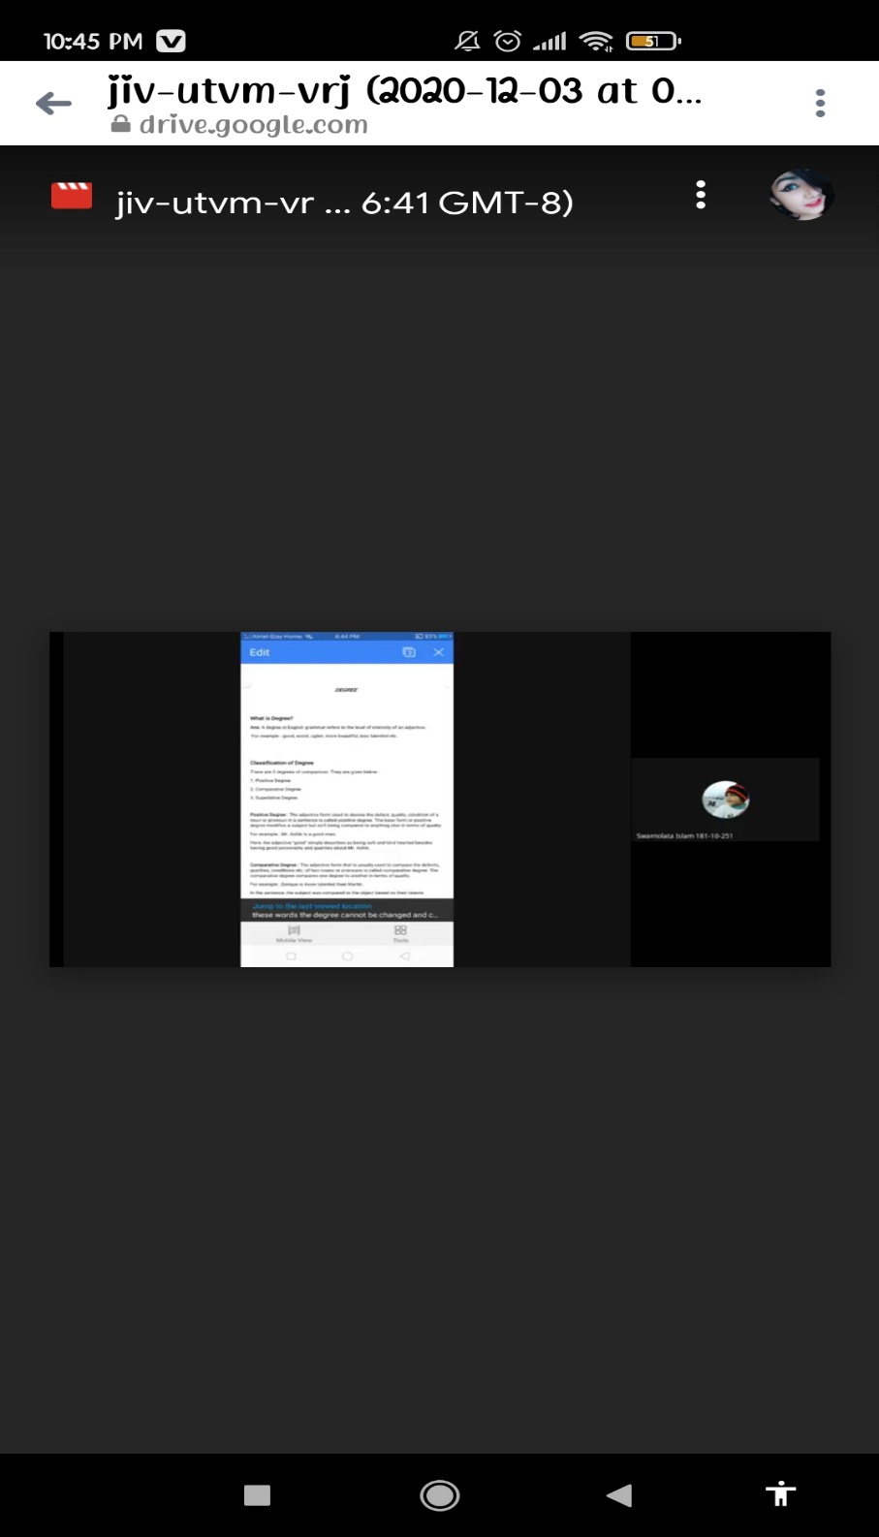

Photograph 2 – class observation

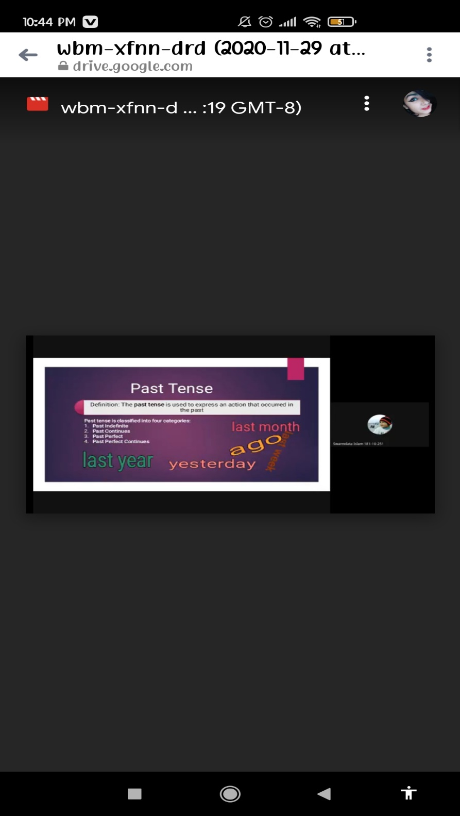

Photograph 3 – class conduction

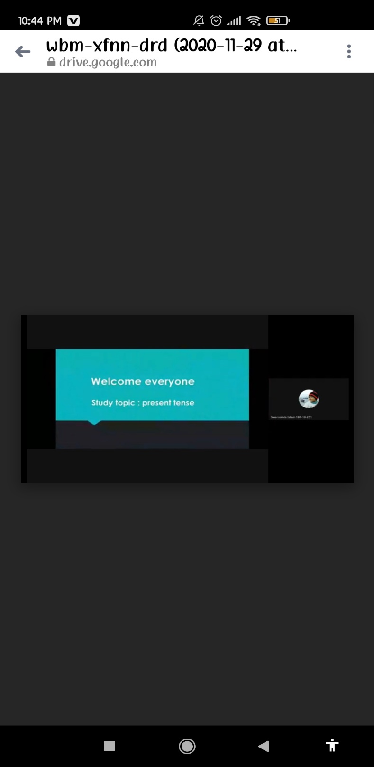

The End

