An Internship Report on
‘’Online class Observation and Conduction in English during the Outbreak of Covid-19’’

Prepared by
Md. Jillur Rahman Millat
ID: 172-10-212
Department of English
Faculty of Humanities and Social Science
Daffodil International University
Under the supervision of
Md. Abdul Momen Sarker
Assistant Professor
Department of English
Faculty of Humanities and Social Science
Daffodil International University



Date of Submission: 26 December, 2020
----------------------------------------------------------------------------------------------------------------This Internship Report is submitted to the Department of English, Daffodil International University, for the Fulfillment of Partial Requirement for the Degree of Bachelor of Arts (BA)

Declaration
I, hereby, declare that, this internship project has been finished under the supervision of Md. Abdul Momen Sarker, Assistant Professor, Department of English, Daffodil International University. I additionally announce that neither this project paper nor a portion of this project paper has been submitted somewhere else for award or then again some other degree.

_________________________________________________________________________________
Md. Jillur Rahman Millat
ID: 172-10-212
Department of English
Faculty of Humanities and Social Science
Daffodil International University
Certificate
I am satisfied to confirm that the project paper on "The online class during the COVID-19 Pandemic in English language teaching" prepared by Md. Jillur Rahman Millat, ID: 172-10-212, Department of English, has been granted for viva. To the best of my experience and according to his statement, it is an authoritative part of work which is finished under my observation. The Project report is presented by Md. Jillur Rahman Millat for additional academic admiration which is recommended by me. I wish his success in his future life.

Supervised by
Md. Abdul Momen Sarker
Assistant Professor
Department of English
Faculty of Humanities and Social Science
Daffodil International University

Acknowledgement
I might want to explicit my gratitude to my supervisor Md. Abdul Momen Sarker, Assistant Professor, Department of English, Daffodil International University, for his interminable help and direction to complete my project paper. His interminable tolerance, definitive direction, consolation, counsel, significant advices, enlightenment, reading deficient drafts and revising them in all stages have made possible to finish this project paper. Without his constant direction I could have not prepare my project paper report effectively.
I am grateful to the authority of English Department for allowing me to conduct my internship work in this University. I am truly thankful to all the regarded teachers for continually assisting me all the time with my problems.
At last, I should thank the students of English Department for their participation and understanding to conduct my class successfully.

Table of Contents

Contents | Page No.
Declaration | ii
Certificate | iii
Acknowledgement | iv
Table of Contents | v
Abstract | vi
Chapter-I: Introduction | 1-2
Chapter-II: Objectives | 3-4
Chapter-III: Methodology | 5-6
Chapter-IV: Institution Details | 7-8
Chapter-V: Class Observation Report | 9-12
Chapter-VI: Teaching Experience | 13-14
Chapter-VII: Overall Findings | 15-17
Chapter-VIII: Recommendations | 18-19
Chapter-IX: Conclusion | 20-21

Appendix
Appendix-1: Check List | 22-28
Appendix-2: Photographs | 29-31

Abstract
The purpose of this project paper is to provide an overview of the situation of Online Classes in English and the techniques of teaching during the Outbreak of Covid-19 pandemic in Bangladesh. Online classes have been added a new dimension in technology. Though our typical life has been halted because of this Corona crisis however, online platform has assisted us to continue the education process. Fundamentally, in this paper we attempt to discover the strengths and weaknesses of online classes in English and we review the fundamental situation of students that how they are learning in this situation. We have chosen two classes to observe the teaching methods and the strategies of educators and a class for conduction so that we could get a clear idea from the English language teaching and learning situation of online classes. This project intends to know the teaching methods that teachers are utilizing in this Corona pandemic situation for online classes of English language and their outcome. How far the objectives are being fulfilled is also a significant part of the study.
This paper is written to bring up all the weaknesses of English language learning techniques so we can reorder them further with all the strengths, qualities and potential techniques. Moreover, a few suggestions are given to the part of "Overall Findings" as per the two observations and the experience of class conduction.
This paper have been developed as part of a quantitative study, and attempts to, on the basis of the findings, find out the solutions of the troubles encountered in online teaching-learning classes.

Chapter – I
Introduction

Introduction
The Covid-19 pandemic has made worldwide difficulty that has deeply affected each area of our life. Particularly, in our education system, the outbreak of Covid-19 has changed the entirety technique for conducting classes. This is also another experience for students but more interesting for them.
All around the world, over 1.2 billion students are out of the classroom. On March 18, 2020 Bangladesh education ministry announced all educational institutions to stay closed due to Corona virus outbreak like other nations. However, as the teachers were stressed over the study of students so they began to take online classes everywhere on the world. This pandemic situation caused surprising changes in education system. Starting online classes were difficult in Bangladesh as many of our old educators are not so fast and known with advance technology but still they worked hard to stay up with the world. Things are currently not the same as past actual classes. We noticed and prepared a report dependent on the situation of online classes in English during this Covid-19 outbreak. English language is a global medium of communication and broadly spoken everywhere on the world. English has additionally become the medium of guidance in Education in most of universities and advanced education institutions of the world. In Bangladesh, English is a foreign language and learning English is necessary for all level students and pretty much every student began to learn this from the primary day of their school life. Because of our nation's poor instructive frameworks the greater part of the students are not familiar at speaking and don't have adequate information on English. Because of many reasons such as absence of effective educators, appropriate materials, proper infrastructure, techniques and a lot more we are confronting the challenges in the learning area of English. Instructing and learning of English in the schools, colleges and universities are not being done in the manner that it should be finished. In a large portion of the cases, the sentence structure learning has been given emphasis; the course reading substance are instructed and learnt without comprehension. So the government has just found a way to look over the issues and discover the solutions. This project paper attempts to unfurl the issues experienced by the students, review an image of teacher-student collaboration and conduct, and assess the level of performance of students in the class at the tertiary level.

Chapter – II
Objectives of the Study

Objectives of the Study
- To know the effectiveness and advantages of online class system during this Covid-19 outbreak situation
- To know the best uses of teaching methods, techniques and lesson plan in online classes
- To observe the management aptitudes of instructors and environment of classes
- To notice the students’ reaction and support while teaching
- To find out the shortcomings of educating and learning on online classes in English and discussing the potential methods of getting out from this issues

Chapter – III
Methodology

Methodology
I have followed mixed method approach for leading this project. I have followed a checklist and, I was allowed to observe two classes and to conduct a class. I have followed the steps given in below for leading the class.
1. Selecting an Institution and Class: Daffodil International University’s Department of English was chosen for the class observation and to conducting a class. I had chosen the two classes from different batches to observe and one batch was chosen for conducting a class. Permission was taken from the facilitator and my supervisor for the online class observation and class conduction.
2. Observing Classes: Two classes were observed with the permission of the course teachers at the same university. It was reviewed from the observation, how was the interaction in online classes between educator and students. Time management of the teacher, the method of teaching, students’ response etc. were noticed while observing the classes and a lot more things.
3. Selecting Facilitator: Abdul Momen Sarkar, Assistant professor, was the facilitator for this project paper.
4. Class Conduction: I needed to take a class in Textile Engineering office. Observing the other two classes assisted a great deal with experiencing this class conduction. The length of the class was 15 minutes. Using the "Google Meet" application, I took the class.
5. Using Checklist: A checklist was utilized to observe classes and collect data about the overall things of classes and the checklist was attached as appendix at the end of this project paper.
6. Time Management: Observing the time management was noticeable.

Chapter – IV
Institution Details

Institution Details
The institution, where the classes were observed and taken, is a prestigious University of Bangladesh. The name of the institution is Daffodil International University. It was founded in 2002 with the approval of the UGC and the Ministry of Education and now, it has about 20000 students. This reputed private University offers Bachelor's degrees, Master's degrees through its 23 departments and they are organized into 5 faculties. The University has a large and beautiful campus known as the green campus for its green environment.
Remarkable opportunities are given to the students such as scholarship, waiver based on their result. The institution has provided Corona waiver to the students during this situation. All of the teachers are capable and experienced and a large number of them have done their PhD from reputed University of Bangladesh and abroad. Teachers know about advance educating and learning technique. The main target of the University is to give proper education to the students and make them proficient for future.

Chapter – V
Classroom Observation Report

Classroom Observation Report
Teacher’s Name | Course Title
Md. Abdul Momen Sarker | Introduction to Drama
Ms. Dipty Rahman | Contemporary Literary Theory

Name of Institution : Daffodil International University
Observer : Md. Jillur Rahman Millat
Date of Observation :
1st Class: 30th November (8:45am - 10.00am), 2020
2nd Class: 2nd December (2:30pm – 3:50pm), 2020
Classroom Description :
For conducting and observing classes, ‘Google Meet’ was used in Online Classroom.
Student’s Information
1.Academic Level of the Students:
1st Class: 3rd semester of 1st year.
2nd Class: 8th semester of 3rd year.
2. Language Level of the Students: The secondary level of language.
3. Average Age of Students: 18-21 years.
4. Number of Students:
The students who attended the first class 33/40 and the second class was 18/24.
Lesson Topics:
1st Class: The lesson topic of this class was to discuss the summary and theme of the drama,
Arms and The Man by George Bernard Shaw.
2nd Class:
The lesson topic of this class was to discuss the main ideas of “Gender”.
Teaching Materials :
1st Class: PDF Book and other online sources.
2nd Class: PDF Book and PPT file.

Class Observation-1
The teacher began his class with pleasantly welcoming his students. Then he started his lecture by following a PDF book on computer screen. The students could understand his lecture for his proper speech cooperative learning. For better understanding of the students, sometimes the teacher provided his lecture in Bangla but most of the time he provided his lecture in proper English. He gave the class record to BLC for the students who missed the class. In the entire class, a few students were selected randomly by the teacher and told them to read a verse for the class. By doing that he made it sure that the students were listening his lecture attentively. After completing the entire discussion, there was question-answering session and then the teacher finished the class.

Strengths of the Teacher:
- The teacher use his voice effectively- speak with inflection
- The teacher is a good language teacher with extraordinary presentation skill
- The teacher had an incredible possession over English language
- The teaching is organized with subject matter
- There was a superb learning environment through the entire class

Class Observation-2
Firstly, the teacher welcomed her students and told them what she was going to teach them. The teacher was very enthusiastic and friendly in answering questions to the students. Before starting the new lecture, she repeated the theme of previous lecture for better understanding of her students. The teacher followed the PDF book for giving lecture and used real life examples for better understanding. She shared her computer screen to show them the PDF book to the topic. The teacher then asked students whether they had understood or not and gave tasks to students then. She was very clever to ask questions randomly so that everyone could understand her. She was aware of the condition of her students. She used DIU BLC to share all the materials including class records so that those who missed the class could watch it later.

Strengths of the Teacher:
- The teacher had the ability to make the students more attentive to the lecture
- The teacher was expert in both of the language, English and Bengali
- The teacher was extremely punctual
- The teacher had the ability to teach help the students to develop their thinking skills over the topic of lecture
- The teacher attempted to connect the students with the lecture for their better understanding

Chapter – VI
Teaching Experience

Teaching Experience
Name of the Institution: | Daffodil International University
Academic Level of the Students: | 3rd semester of 1st year
Number of the present Students: | 27
Date: | 6th December, 2020
Materials: | PDF file and DOC file
Class Duration: | About 15 minutes
Lesson’s Objectives: | To discuss about the summary and theme of George Bernard Shaw’s Arms and The Man , Act 2

At first, the students were warmly welcomed and provided lesson objectives. I showed Doc file by sharing my screen. Then I started to discuss the summary and theme according to vital scene. Sometimes, I asked questions randomly to get their attention. During the class time students appeared to be communicative and participative. Students additionally participated in the discussion and offered their thoughts energetically. I enjoyed the class with a great teaching experience. I organized the class time effectively and finished lesson objectives properly.
Success in Teaching:
The entire class was helpful with me and that is the reason I could clarify my perspective to them pleasantly. I was able to explain some important themes by using real life examples for the betterment of their understanding. From their feedback, I felt that they enjoyed and understood my lecture.
Failure in Teaching:
A few students couldn't join the class due to internet problem. I also missed to explain some important explanations. In some points, I was unable to provide appropriate examples. Additionally, I used Bengali language mostly to explain some themes properly and a few mistakes were occurred in my pronunciation for my nervousness.

Chapter – VII
Overall Findings

Overall Findings
- Organizations:
The organizations of class timetable and goals of the lessons were managed properly. The two teachers had understood their approaches so that students could give their opinions comfortably. The two teachers had the ability to take the control of classes rapidly. Overall the classroom management was optimal.

- Subject Matter Content:
The two teachers had good knowledge in the subject matter and they had selected efficient lesson plans for the students to develop valuable study skills such as summarizing and extracting central theme from texts and answered patiently to the students question quietly. For choosing advantageous learning activities, students were able to answer willingly all the questions in the end of the class and they enjoyed to answer the questions.

- Use of Materials and Teaching Technique:
Because of this Corona pandemic situation, the classes I observed, both were online classes and so they used the materials- PDF and PPT files to teach the students. The PDF and the PPT file were extremely educational and there were so many examples of real life experiences which assisted the students with being more connected. One teacher gave the chance to the students of self-learning, with the goal that students could get the interest on the lesson and learn without help from anyone else. Other teacher clarified the lesson with the real life experiences, examples and utilized storyboard to make the lesson simpler and asked for examples from students after each point. The two teachers utilized meeting to generate new ideas. Both of them made the students participative and dynamic by their efficient lessons.

- Use of Language:
The teachers utilized native language and English to make the lecture simple and understandable to the students. As both of classes based on literature and it would be helpful to learn target language for the students because of using target language rather than Bengali language.

- Students Engagement and Environment:
Students were enough associated with the teacher during class. But I felt that physical classes were more effective where teacher could understand the students more than online classes. Eye contacts were too missing in online classes which are another approach to stay connected to the students. Online classes are additionally successful however I felt the class time of online classes should be 1 hour rater than 1.30 hours. Since I observed that after an hour students began to lose their interest to stay connected with the class.

- Lesson Delivery:
Teachers provided the objectives of the lesson maintaining a perfect time management. One thing might have added greater happiness to the class that is humor. Sometimes, one of the teachers delivered speech so fast, which was difficult for the students to understand the lecture.

Finding from Conducted Class

What I wanted to achieve:
I needed to ensure the understanding of the students what I was providing to them and I wanted to ensure the objectives of the lecture are being given to them appropriately. They perceived the topic properly and their participation improved the class.

Few Drawbacks I Noticed During Conducted Class:
I believe being confident and having commanding voice are some obligatory characteristics of each teacher should have. I was successful for having confidence and commanding voice but, I was a little bit nervous as it was my first time to conduct a class as a teacher. Other things, like communications with students and giving the lecture all had been done very effectively.

Chapter – VIII
Recommendations

Recommendations
- Students should attempt to speak in English for practicing and the teachers should support them
- Online classes should be restricted to 60 minutes
- Sometimes, utilizing target language can help the students for their better English language learning. That's why, teachers should speak in English language most of the time in classes
- Teacher should be comfortable with new technologies like Zoom, Meet, Module, Google Classroom and BLC for taking online class

Chapter – IX
Conclusion

Conclusion
In this situation of Covid-19 pandemic, online classes really turns into a source of continuous learning process for students and a way of using new technologies as well. Online based education system doesn't need any travelling overhead. And so, teachers and students are able to continue teaching or learning process sitting at their home. Online education system is the most secure method of learning and teaching in the present situation. The goal of this project paper is to observe the situation of English language classes on online and discover the favorable circumstances and detriments of online learning. It is an extraordinary experience for me to observe two classes of honors level in a reputed University of Bangladesh. The teachers have utilized the showing procedures and techniques for online classes are truly admirable. I think that this project paper will be able to find out the problems and improve the process of English Language Teaching in online classroom even in physical classroom.

Appendix–I
Checklist

Checklist- I
University: Daffodil International University Department: English
Instructor evaluated: Md. Abdul Momen Sarker Course Title: Introduction to Drama
Number of students present: 33 Date: 30th November
Evaluator(s): Md. Jillur Rahman Millat Time: 8:45am - 10:00am
Topic: The summary and theme of the drama, Arms and The Man by George Bernard Shaw.

Objectives of the lesson (as perceived):
- To make the students have a proper idea about the theme and summary of the drama, Arms and The Man
- To make the students think of their own ideas about the lesson and share their ideas in English.

Were the objectives achieved and to what extent (in my view)?
As I would like to think the goals of the class were perfectly achieved. Students got the clear concept regarding the topic as they replied when the teacher asked them topic related questions. Teacher gave a lot of proper examples to make them understand the main theme of the topic. The students reacted eagerly with their own examples from their real life experiences.

S/N | Review Section | In what ways?  (Specific examples / clarifications)
1 | SUBJECT MATTER CONTENT | The teacher started the class with pleasantly welcoming the students and getting some information about them how they were comfortable with the online class. He remained pertinent with the topic and gave them proper examples that are pertinent to the students and it helped the students to learn quicker and better. By the essential teaching system, the students were able to develop their sense of learning.
2 | ORGANIZATION | The teacher had an awesome slide pertinent to the topic, which had an amazingly clear concept. The teacher had the ability to complete the whole expected lesson that he planned for the day in exact time. There was no badly arranged situations that happened.
3 | TEACHING METHODS | The teaching method was truly effective. The teacher followed mixed method to conduct the class, which contained;  - Content Language Integrated Learning  - Lecture based teaching method
4 | RAPPORT | It was obvious that the teacher had an exceptionally clear thought regarding the entirety of his students and their capacities. He kept inquiring as to whether they had perceived or not. He clarified his topics over and over with no hesitations and the students also asked questions with no hesitations and answered happily.
5 | PRESENTATION | The teacher had very clear voice and he expressed everything without hesitations. He illustrated his slides appropriately to the students twice and trice sometimes for their betterment of understanding. He additionally wrote about the topic in the message box to ensure students were getting the lesson appropriately.

Management:
The entire class was well maintained and the entire class divided into three sections:-
1. Introduction: At first, the instructor took a few times to introduce the lecture with the class. It took about 15 minutes. He utilized her extraordinary style to make the entire lecture interesting.
2. The main lecture: The instructor discussed the significance of the selected content. He additionally described the verities of summary, theme and how each one was not the same as the others. The educator engaged them with the class appropriately and the participation of the students was excellent.
3. Ending: The instructor finished the class with a season of question-answering. After that the teacher wished the students a great day and finished the class.

Strengths observed:
The educator knew very well the entirety of his students which made him to convey his lesson to his students in an effective way.

Suggestions for improvement:
Everything went pleasantly with his good knowledge about subject matter of his lecture. Just thing I would suggest him to give additional time to the weak students.

Overall impression:
My overall impression of his teaching technique was quite well. I learned numerous significant things about instructing from observing his class.

Checklist- II
University: Daffodil International University Department: English
Instructor evaluated: Ms. Dipty Rahman Course Title: Title: Contemporary Literary Theory
Number of students present: 18 Date: 2nd December
Evaluator(s): Md. Jillur Rahman Millat Time: 2:30 pm – 3:50 pm
Topic: To discuss the main ideas of “Gender”.

Objectives of the lesson (as perceived):
- Show the students the best way to improve their English-Speaking Skills
- Give the students practice materials to improve their reading, writing and speaking skills
- Assist the students to be confident and assist them with disposing of their nervousness

Were the objectives achieved and to what extent (in my view)?
I think teacher had accomplished his objectives well indeed. He utilized examples with all aspects of his lecture. He also utilized real-life experiences as examples that was very helpful for the students for their better understanding. The participation of the students was appreciable in the discussion based on content, it was evident that they the lecture.

S/N | Review Section | In what ways?  (Specific examples / clarifications)
1 | SUBJECT MATTER CONTENT | The instructor began the class with agreeably inviting the students and getting some data about them how they were alright with the online class. She stayed appropriate with the subject and gave them real-life examples that are relevant to the students and it assisted the students with better learning. By the fundamental showing framework, the students had the option to develop the skills of learning.
2 | ORGANIZATION | The educator had a great slide pertinent to the topic, which had an amazingly clear thought. The instructor had the capacity to finish the entire expected lesson that he planned for the class. There was no badly arranged situations that occurred.
3 | TEACHING METHODS | The instructor followed blended method to lead the class, which contained;  - Content Language Integrated Learning  - Lecture based teaching method
4 | RAPPORT | The teacher had an incredibly clear notion regarding the entirety of her students and their capacities. She kept inquiring as to whether they had perceived or not. She clarified her topics over and over with no hesitations and the students also asked questions with no hesitations and answered happily.
5 | PRESENTATION | The instructor had exceptionally commanding voice. She described her slides properly to the students. Her presentation techniques were really good.
Management:
The educator dealt with the entire class systemically. There are four principle part of the class:
- Revising the main theme of the previous lecture: Teacher took a speedy test to remind the students about the lecture. It additionally assisted the instructor with finding out the students who were inattentive in previous class.
- Introducing the class content: After taking a test, the instructor gave a little introduction about the content of the class.
- The discussion part: The educator talked about the selected content. She moreover portrayed the main ideas. The instructor connected the students with the class properly and the students participated to share their ideas about the content that made the class more effective.
- Ending: With a synopsis of the entire class and taking question-answering session, the teacher say farewell to the students for that day.

Strengths observed:
The instructor showed photographs and played videos that made the lecture more interesting. She was able to explain the topic in an interesting way.

Suggestions for improvement:
I would suggest her to use target language more than native language.

Overall impression:
Her knowledge about the content is profoundly noteworthy. Observing her class was helpful for conducting a class as a teacher.

Appendix–II
Photographs

Class observation – 1
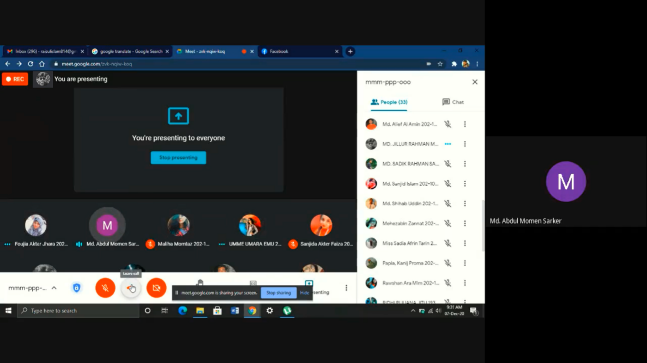

Class observation – 2
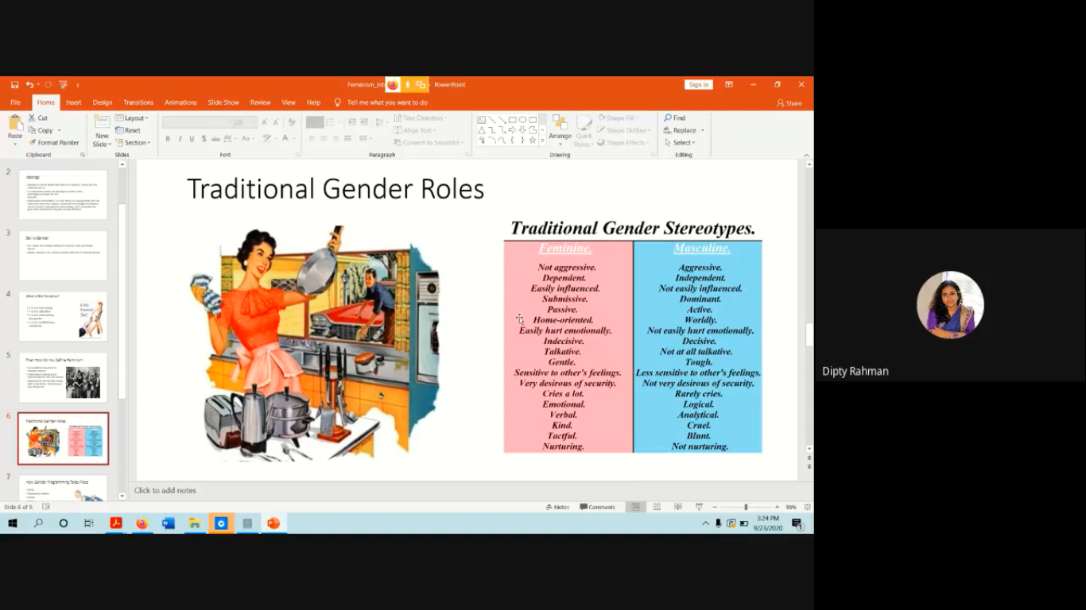

Class conduction:




