

An Internship report on
“Online Class Observation and Conduction in
English during the Outbreak of Covid-19”

Submitted to:
Al Mahmud Rumman
Lecturer, Department of English,
Daffodil International University.
Submitted by:
Arfin Mim
Id: 171-10-1474; Batch: 9th,
Semester: Fall- 2020,
Course code: ENG 334,
Course title: Project Paper,
Department of English,
Daffodil International University.

Date: 26/12/2020

Declaration
I Arfin Mim, declare that, this internship project has been done by me under the supervision of respected Mr. Al Mahmud Rumman, Lecturer of English department, Daffodil International University. I also declare that the following report has not been previously used in any other institution for a degree.

Yours Sincerely,

---------------------
Arfin Mim
Id: 171-10-1474
Batch: 9th PC-A
Department of English,
Daffodil International University.

Certificate of Approval

This is to certify that, Arfin Mim, ID: 171-10-1474 is a student of the English Department, Daffodil International University, Ashulia Campus has accomplished her Internship Report entitled "Online Class Observation and Conduction in English During the Outbreak of Covid-19" under my supervision in the semester of Fall 2020 and worked sincerely to prepare his report.
All of information written in the project are original. I wish her all the best in her future endeavors.

........................
Supervised by
Mr. Al Mahmud Rumman
Lecturer, Department of English,
Daffodil International University.

Acknowledgement
At first, I would like to thank the Almighty for giving me the opportunity and the ability to complete my project paper successfully. I would like to express my heartfelt gratification to my supervisor Mr. Al Mahmud Rumman for his continuous support, encouragement, guidance for my project paper. I am blessed to have him as my supervisor. Many thanks to you Sir. I am also thankful to 8th and 9th batch especially Tonmoy,Shabil,Nishi for their cooperation while taking class and observing their class.

Arfin Mim
Id: 171-10-1474
Batch: 9th,
Department of English,
Daffodil International University.

Abstract
The main purpose of the project paper is to observe and improve online classes in English during the Outbreak of COVID-19, instructive organizations like schools, colleges, the university needed to begin online classes to stay connected with the students. It is almost a new way to teach through the online platform for Bangladeshi students and teachers. So, for this reason, we need to give the best quality of teaching to the students through an online class. Teaching techniques are illustrated in this project paper to make English teaching effective for students who are weak at English and to make them interested to learn global language English from coming out of the traditional way of the teaching method. The internship report represents my observations of two online classes and teaching experience of two classes through the online platform of Google Meet. While taking classes I found the positive and negative side of an online class. Many students face problems understanding what the teacher is saying due to load shedding or poor internet connection. They face excessive pressure to continue their study. On the other hand, due to COVID-19, everyone is at home so for their better mental health, it is very important to communicate and act in their daily activities. I have observed five classes of other teachers who know their methods.

Table of contents

Contents | Page no.
Cover page | 1
Declaration by the Student | 2
Certificate | 3
Acknowledgments | 4
Abstract | 5
Table of Contents | 6
Introduction | 7-8
Objectives | 9
Methodology | 10-11
Institution Details | 12-14
Class Observation Report | 15-18
Lesson plan | 19-21
Teaching Experience | 22-24
Overall Findings | 25
Recommendations | 26
Conclusion | 27
Reference | 28
Photographs | 29-31

Introduction
Language is an amazing medium by which the general public can set up its reality in a more extensive manner. Coronavirus has drawn out a radical change in the instructive framework not just in Bangladesh yet rather in the whole world. The English language is a foreign language in Bangladesh and learning English in Bangladesh is mandatory in pretty much every degree of training. It is an organized framework, where an individual makes significant correspondence to connect with each other in a Language given network. The general public can have different sorts of language, similar to the first language which can likewise be considered as a native language, a second language which can be generally be spoken in view of globalization or in light of any more extensive viewpoint. Among all the dialects English is a lively and worldwide language. To check the perspective on English language showing practice in Bangladesh, we need to notice the meaningful picture of scholastic establishments.

As a piece of graduation, my Internship Report named "Online Class Observation and Conduction in English during the Outbreak of Covid-19"; depends on my perception of five online classes of English language speaking and writing and of my experience of showing two online classes of English speaking and writing. During the perception of the class, a checklist gave by the supervisor has been utilized the assessing the presentation and instructing method of the instructors and the result of the students. In the wake of noticing the classes, a few issues have been found. To defeat these issues, a few proposals have been given that may assist with making English language instruction compelling.

Chapter – II: Objectives
The goals of the Report:
1. To notice the online classes and conduction in English during the flare-up of COVID19.
2. To know the favorable position and detriment of web-based educating learning.
3.To the preferred position and impediment of an online class.
4. Learn the educating procedures.
5.Learn the all-showing technique for all intents and purposes. Discover the learning framework in the current circumstance.
6.To discovers the great and terrible sides of an online class.

Methodology
Observing of Online Classes:
As indicated by the rules of the temporary position report, I need to notice five online classes of English. With the assistance of my supervisor, I noticed five classes of different teachers. During this observation, various focuses were noted down following a checklist. In this perception, the main thing I learned is instructing expertise.
Selection of Topic:
I took two classes on both speaking and writing. For the speaking session, I choose fun topics like a game: Two Truth and a lie, Roleplay, Question and Answer, and for the writing part, I choose memory games. My purpose was to make them attentive in class with interesting topics. They will not feel pressure to do classes and they will think that they are just playing games where actually they are learning from playing games.
Class observation:
I have observed five classes of different teachers and they conducted the class in different methods. Nishi took two classes, in the first class, she took a class on grammar and she followed the grammar-translation method. In her second class, she took a class on listening skills. Then Tonmoy on his first-class took a class on reading skills and Shabil also took a class on reading and speaking. I enjoyed a lot, observing their classes. I found out many things from their classes. I learned from them.
Checklist:
A checklist was utilized to notice classes and to gather data.
Conducting online classes:
I took two classes on speaking and writing. I got 15 minutes to conduct a class. I tried to come up with the traditional way of English teaching so that students feel the interest to do classes. I started my class with greetings and I asked about the situation in this pandemic. Then for the ice-breaking session, I sang a song. After that, I moved on to my main topic. For the speaking part, I took different games for conducting classes like Two truth and a lie, Roleplay and question and answer sessions. Through this game, students became very much interested to speak without hesitation. I used the Communicative Teaching Technique (CLT) method in my classes. It is a method where both students and teachers interact with each other which is very helpful for speaking. It is like a student-centered classroom. So, they can share their all opinions with teachers.
Conclusion:
After conducting classes, I took notes on students’ weaknesses, where I need to improve them.

Institution Details
DAFFODIL INTERNATIONAL UNIVERSITY

Official name of the University: Daffodil International University (DIU)

Year of foundation: 2002 With the endorsement of UGC and Ministry of Education, Bangladesh

Grounds structures and areas:

102 Shukrabad, Mirpur Road, Dhanmondi, Dhaka-1207

(Main Campus and Administrative Building)

Datta Para, Chou Baria, Ashulia Model Town, Dhaka

Resources:

• Faculty of Science and Information Technology

• Faculty of Engineering

• Faculty of Business and Entrepreneurship

• Faculty of Humanities and Social Science

• Faculty of Allied Health Science

Programs

• Undergraduate and Masters

• International IT Programs

• Proposed Programs

• Short Courses

Employees

• 730 employees (full time)

• 148 employees (low maintenance)

Authorities: 264 Officials, 250 re-appropriating staff

Supporting Staff: 250 staff

Talk Theater and Class rooms: 250 homerooms, including current theater

Computerized Amenities: One Student One Laptop, Google Classroom, ISP, Informative site,

Training ERP, Virtual University System, DIU Forum, Blog, E-Library, Broadband Internet, WIFI offices, Digital savvy study hall, Internet Radio, Online TV, Data Center, DIU Apps, Hostel

Booking System, One Card Solution, Stem lab.

Library:

• 6 celebrated separate focal library building

• Uttara grounds library

• Permanent Campus Library

Classroom Observation Report 01

Teacher`s Name: Jarin Nishi
Name of Institution: XYZ
Observer: Arfin Mim
Date of Observation: 2 December (8.10-8.15pm), 10 December (5.10-5.15pm), 2020.
Classroom Description: It was the online study classroom and Google Meet was utilized as the method of leading and noticing classes.
Students Information:
- Academic Level of the Students: The students pretended to be in intermediate level students.  - Language: The students belong in the intermediate level of language level.  - Average Age of Students: The  average age of the students is 9-10 years old. | 4. Number of Students: 03
Lesson Objectives:
- Students will be able to communicate without hesitation.
- They will express their ideas and opinions.
- They will be able engage in the target language.
- The teacher will ignore students’ error and promote their communication.
- The teacher will make the environment less dominant than in a teacher-cantered method.
Teaching Materials:
- PowerPoint slides

Class observation 01
At first, the teacher started her class with greetings. Then she asked a few funny questions on historical persons and after that, she started her main class on tense. She introduced the topic and then after a discussion on tense she asked students if they have any questions or not. After finishing her class, she ended the session with homework and bedding goodbye.
The strength of the instructor:
1) The instructor was a master on that subject.
2) The instructor's voice was loud and sharp.
3) The instructor was exceptionally reliable.
4) The instructor was decidedly ready over the point and exercise.
5) The instructor attempted to connect with the students by class performing and posing inquiry.

Classroom Observation Report 02

Teacher`s Name: Md. Mehedi Hasan Tonmoy
Name of Institution: XYZ
Observer: Arfin Mim
Date of Observation: 10 December (8.15-8.30pm), 15 December (5.15-5.30pm), 2020.
Classroom Description: Due to COVID 19 , teachers are conducting class in google meet .
Students Information:
- Academic Level of the Students: The students pretended to be in intermediate level students.  - Language: The students belong in the intermediate level of language level.  - Average Age of Students: The  average age of the students is 9-10 years old. | 4. Number of Students: 03
Lesson Objectives:
- Students will be able to communicate without hesitation.
- They will express their ideas and opinions.
- They will be able engage in the target language.
- The teacher will ignore students’ error and promote their communication.
- The teacher will make the environment less dominant than in a teacher-cantered method.
Teaching Materials:
- PowerPoint slides

Class observation 02
At first, the teacher started the class with greetings and asked about their life for the ice-breaking session. Then for the main session, he showed a passage and asked students to read the passage. Then he asked questions to one-by-one students. The students answered the questions and he also showed them techniques of scanning, scamming for reading skills so that they can answer faster. After this, he asked if they have any questions.
The strength of the instructor:
The educator was timely in keeping up the class plan.
The instructor is energetic in responding to questions and connecting with the students.
The educator has great order over the theme and exercise.
The educator has the capacity to draw attention and was excited in the class.

Lesson Plan for Micro Teaching
(10/12/2020)

Teacher (Student) | Arfin Mim
Class profile and  size | Pre-intermediate level
Class profile and  size | 3 students
Class Duration | 15 minutes
Medium of instruction | English
Teaching-learning area/ Broad Topic/Micro topic | Integrated task: Speaking - Writing
Teaching materials | - Google classroom  - Google form  - PowerPoint slides  - Google Docs  - Play a song for Ice-breaking session
Learning Objectives: | - Students will be able to communicate without hesitation.  - They will express their ideas and opinions.  - They will be able engage in the target language.  - The teacher will ignore students’ error and promote their communication.  - The teacher will make the environment less dominant than in a teacher-cantered method.
Anticipated Challenges | - Students may feel bored in class as most of them are used to teacher-centered class.  - Time maintains  - Load shedding, internet connection problem may occur.  - Some students may not feel attentive.
Motivational factors | - Teacher always needs to appreciate their answers for motivating them to produce more answers. Ex: Excellent, thank you etc.  - Teacher will encourage students to ask more questions and speak in the target language.  - Teacher will make them engage with interesting speaking games, role play, question answers game.  - The teacher will give care to each student equally.
Backup Plan | - Load shedding may occur so teacher needs to use power bank to continue class.  - Internet connection may occur so the teacher will use modems or give pre-recorded class videos.  - The teacher will always record the class.
Feedback Process | - The teacher will note the errors during fluency activities.  - Teacher will ask students to do homework.  - The teacher will give feedback based on their activity, participations.
Learning Outcomes | As it is not a teacher cantered class, the students will speak without hesitation and discuss with each other. They will be attentive to the class as they are doing the learning with fun activities like speaking games, role play, memory games etc.
Activity | Student / teacher Interaction | Materials/  Techniques | Learning  Outcome | Timing
Greetings:  - Teacher will warmly welcome students.  - For ice breaking session teacher will play a song. | T → Ss  Ss → T | Play a song | Students will be happy to engage in the class. | 2 minutes
Speaking activity 1:  - Teacher will provide a PowerPoint slide. There will be examples of how to play “Two truth and a lie.”  - Students will play the game with each other.  - Feedback will be provided. | T → Ss  Ss → Ss | PowerPoint slides, games | Students will learn to speak without hesitation with playing interesting speaking games. They will feel motivated to engage in this task. | 6 minutes
Speaking activity 2:  - The teacher will provide an example of how to do role play.  - The teacher will make them pair to participate in the task.  - Feedback will be provided. | Pair work:  T → Ss  S → S | PowerPoint slide, role play | Students will be able to speak in a real-life situation. | 3 minutes
Writing Activity:  - The teacher will show few objects and students will remember them and write in the google form.  - Teacher will provide feedback. | T → Ss  Ss → Ts | Google form,  Writing | This play will make their memory sharp as well as their writing skill will be increase. | 3 minutes
Conclusion:  - Teacher will ask students if they have any questions.  - Teacher will appreciate students for their participation.  - Teacher will give home works to them.  - He/she will end the class noted with thanks. | T → Ss  Ss → T |  | Teacher will motivate them and this will help them to do more well in the class and he /she will give them homework which will make the students engage in class task and their writing skill will be develop. | 1 minute

Teaching Experience
Name of Institution: XYZ
Level of the Students: Intermediate level
Number of Students: 03
Duration: 15 Minutes
- Objectives of the Lesson:
- Students will be able to communicate without hesitation.
- They will express their ideas and opinions.
- They will be able engage in the target language.
- The teacher will ignore students’ error and promote their communication.
The teacher will make the environment less dominant than in a teacher-cantered method.

Success in Teaching:
- I grabbed the student’s attention and they enjoyed doing the class and also, they did not feel hesitation to speak English as they are doing it like a game.
Failure in Teaching

Due to online class, it is tough to understand whether students are understanding the topic or not.

Self-improvement:
• procured proficient correspondence conduct and manners
• figured out how to adjust with educator with various mentality and foundation
• comprehended the significance of individual control
• found out about time and stress the board
Current Technology
• figured out how to take an online class
• figured out how to utilize advanced materials in study hall
Study hall Management
• ability to answer understudy' questions
• ready to establish a climate to hold the students ' consideration
• took in what students need from the educator
Instructing Skill
• comprehended about the significance of social affair information
• grew how to associate the course book with genuine experience
• figured out how to make an exercise arrangement and present
Public Speaking Skill
• got aware of the significance of talking flawlessly
• acknowledged how to clarify any circumstance in both local and target language
• figured out how to improve English talking aptitude
Variation expertise
• figured out how to adjust in another climate with new individuals
• figured out how to deal with the troublesome circumstance
• figured out how to decipher students request into specialized challenges
• figured out how things really work
• took in a lot further comprehension of an idea through the demonstration of doing and individual experience.
Specialized Skills
• improved aptitudes of MS Power Point and MS Excel and MS word
• refreshed by utilizing the web

Findings from Conducted Class
- They have a decent online instruction framework, all around focused, and efficient.
- They made numerous Applications like-BLC (Blended Learning Centre) for learning simpler on online stages.
- They offer number of courses on the web. They have a scholarly schedule which they finish online for their schooling.
- The students are profited through online classes.
- The educators are co-usable and agreeable through these online classes. They made online classes simpler.
- The students are figuring out how to utilize innovation on an internet learning stage.
- Many of them, who lived in country territories are confronting numerous issues like-Network issues, Internet issues, Load shedding issues. That is the explanation at times they can't accomplish class on schedule and in some cases, they are feeling the loss of their group.
- Teachers are likewise confronting Network issues, Internet Problems, Load shedding issues that is the explanation at times they can't take their classes.
- Sometimes they are confronting assessments or tests on the web.
Recommendations
Educators should be more mindful to convey and communicate with the students through an online class. They should give students the greatest offices in light of this terrible situation. Educators ought to empower his/her students and attempt to comprehend their concern and co-work with them. Friendly Attitude Taking an online class, the maximum time the teacher and the students couldn’t able to see each other. They should be more friendly and polite towards each other. Here mutual understanding is necessary. Shyness and fear It is very important to remove the shyness and fear of the students. It can only be possible through making an ambient environment. Attractive question-answer session Lack of attention is a concerning problem in an online class. So, for making the classes attractive it is very important to have a question-answer session during class. Provide internet service as mentioned before, some students don’t have internet service frequently. So, if the authority can provide internet service to make sure that students attend class without any interruption. Training for online class Teachers as well as students is very new to an online class. They have a lack of knowledge in using goggle options. Training by the experts can remove all the lacking so that teachers can take the classes and students can attend the classes more frequently.

Conclusion
It was an incredible encounter for me to notice classes at the intermediate level. The educational experiences were stunning excessively on the internet during the pandemic Covid-19. All the instructors and students were supportive during class perception and instruction. There can be seen as diverse experience as too to different instructors or colleges. Next to the Government furthermore, the scientists, the educators, and students likewise need to keep up and observe the standards of English teaching. This paper won't change the framework, yet it assists with discovering the issues and improve the English language instruction online even in the reality.

Reference
Neeley, T.(2012). Global business speaks English. Harvard business review.
Ali & Walker 2014;
Adapted from Chowdhury & Kabir 2014; Rahman & Pandian 2018
Hamid & Baldauf 2008
Richards, J.C., & Farrell, T.S.(2011). Practice teaching: A reflective approach. Cambridge University press

Photographs
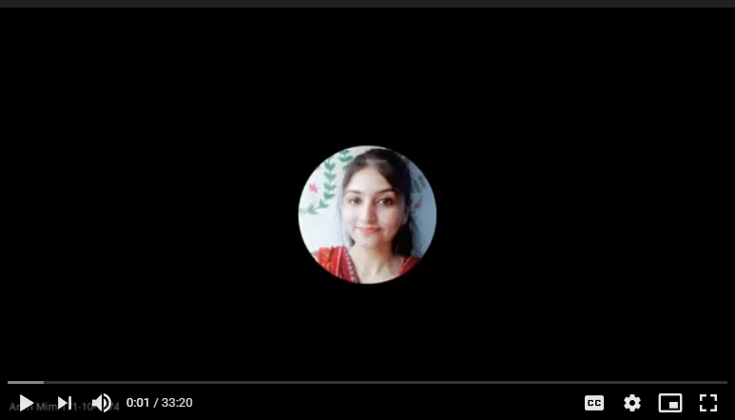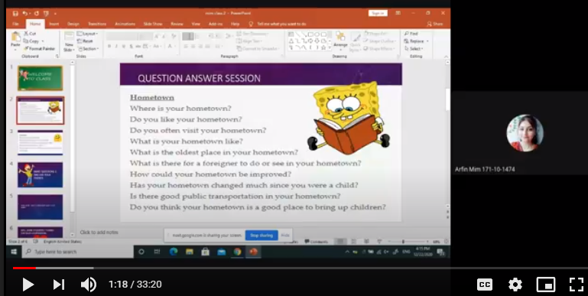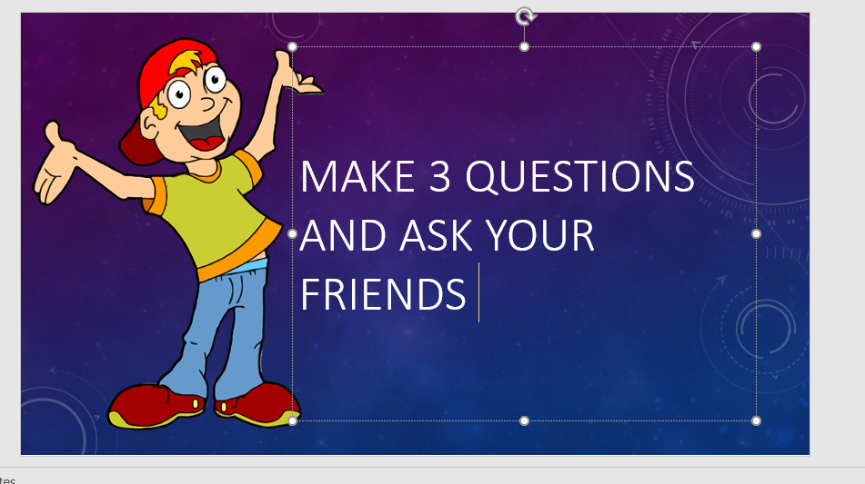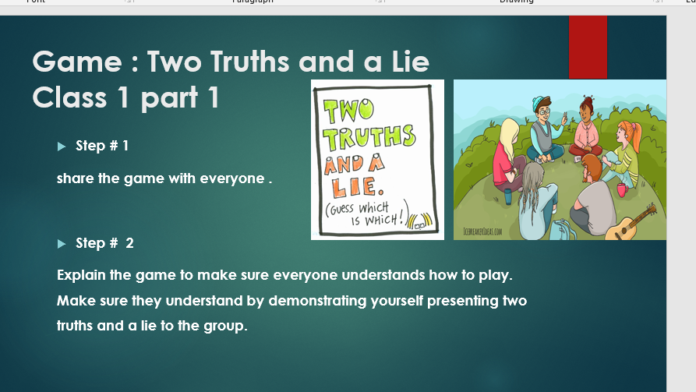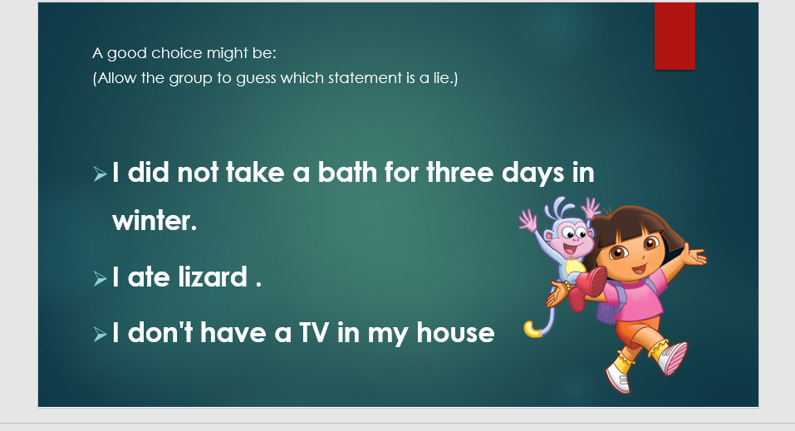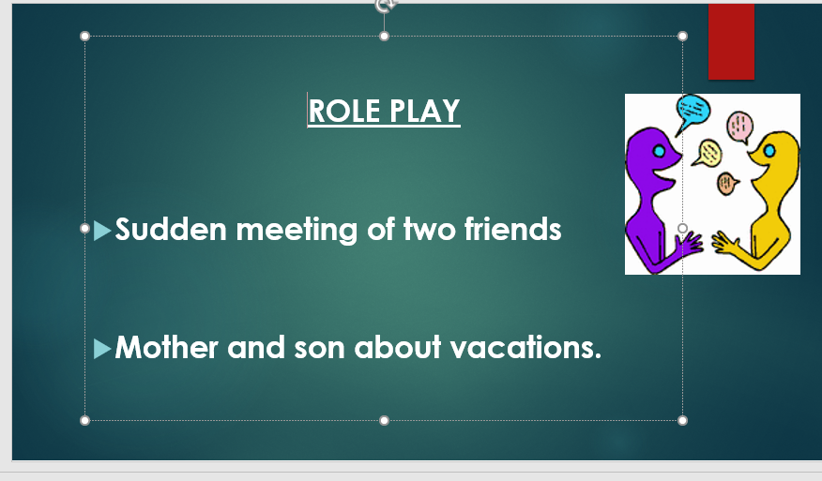

THE END

