

Daffodil International University
Dhaka, Bangladesh

Thesis Report
On
SHORT CIRCUIT ANALYSIS FOR POWER SYSTEM NETWORKS

Prepared By:

Zaki Ahamed
ID: 113-33-739

Department of Electrical & Electronic Engineering
Faculty of Engineering

Advisor

Md. Mahbub-Ud-Jaman
Lecturer
Department of Electrical & Electronic Engineering
Daffodil International University

This thesis has been submitted to the Department of Electrical and Electronic Engineering in partial fulfillment of the requirement for the degree of Bachelor of Science in Electrical and Electronic Engineering.

APPROVAL LETTER

This thesis report titled “SHORT CIRCUIT ANALYSIS FOR POWER SYSTEM NETWORKS”, submitted by Zaki Ahamed ID: 113-33-739 the Department of Electrical & Electronic Engineering, Daffodil International University has been accepted as satisfactory for the partial fulfillment of the requirements for the degree of Bachelor of Science in Electrical and Electronic Engineering and approved as to its style and contents. The presentation has been held on 20/01/2021 .

DECLARATION:

We hereby declare that this thesis is based on the result found by ourselves. This thesis is submitted to Daffodil International University for partial fulfillment of the requirement of the degree of B.Sc. in Electrical and Electronics Engineering.

Supervised by: Submitted by:
Supervisor  Md. Mahbub-Ud-Jaman  Lecturer  Departmen of Electrical & Electronic Engineering  Daffodil International University | Zaki Ahamed  ID: 113-33-739  Batch: 7th  Department of Electrical & Electronic Engineering  Daffodil International University

ACKNOWLEDGEMENT :

I would remain forever obliged to The Department of Electrical and Electronic Engineering, Daffodil International University, Bangladesh for giving me the scope to carry out this project. I would like to express my cordial gratitude to my project guide Md. Mahbub-ud-Jaman Department of Electrical & Electronic Engineering. Daffodil International University for his sincere efforts to make this project a successful one. It was his guidance and incessant motivation during the course of uncertainties and doubts that has helped me immensely to go ahead with this project. I would like to express my heartfelt thankfulness Md. Mahbub-ud-Jaman Lecturer of the Department, Electrical and Electrnic Engineering for his guidance and support. I am also grateful to the faculties of Electrical Engineering Department for offering their helpful hands during the course of my project.

ABSTRACT :-

For this paper study, a selection of styles of shorts is used for electrical power networks architecture on lines and buses. To ensure that all customers continue to receive power, which is at the heart of the power system existence, a short circuit problem is one of electrical energy engineering's most important and difficult task. To ensure that the power system is reliable and stable, the study and detection of these failures is needed. The magnitude of the loss depends on the position of the short circuit and the size of the fault present, the impedance of the device and its voltage. In this article, the system 's activity under fault conditions is analyzed and different forms of faults are evaluated. The IEEE30- bus has been tested with a control system simulator. All findings were gathered and debated.

Table of Contents
APPROVAL LETTER ii
DECLARATION: iii
ACKNOWLEDGEMENT : iv
ABSTRACT :- v
LIST OF FIGURES vii
Chapter 1 1
1.1 Introduction: 1
1.2 Problem statement : 1
1.3 Objective : 1
1.4 Ground Fault or a Short Circuit: 3
Chapter 2 3
Electrical fault 3
2.1 Introduction : 3
2.2 Transient fault: 4
2.3 : Asymmetric fault: 4
2.4 Symmetric fault: 5
2.5 Arcing fault: 6
Next, the fault location is adverse To obtain a more accurate result, these calculations should be performed separately for three separate time ranges: 6
2.6 Detecting and locating faults: 7
2.7 Batteries: 8
Chapter 3 8
Analysis 8
3.1 Introduction : 8
3.2 Single Line-to-Ground Fault: 9
3.3 Line-to-Line Fault: 10
3.4 Double Line-to-Ground Fault: 12
3.5 Three-Phase Fault: 14
Chapter 4 16
Case Studies and Simulation 16
4.1 Case Studies : 16
4.2 Simulation Line to ground fault: 17
4.3 Simulation Line to Line fault: 18
4.4 Simulation double Line fault: 19
4.5 Simulation three phase fault: 20
4.6 Result: 20
4.7 Conclusion: 20
References 21

LIST OF FIGURES

Figure No. | Name of the Figure | Page No.
Figure 1 | IEEE 30 bus base case load flow in edit mode | 2
Figure 2 | Setup in Power World in Run Mode | 2
Figure 3 | Transient fault | 4
Figure 3.1 | Asymmetric fault | 5
Figure 4 | General representation of a single line-to-ground fault | 9
Figure 5 | Sequence network diagram of a single line-to-ground fault | 9
Figure 6 | Sequence network diagram of a line-to-line fault | 10
Figure 7 | Sequence network diagram of a line-to-line fault | 10
Figure 8 | General representation of a double line-to-ground fault | 12
Figure 9 | Sequence network diagram of a double line-to-ground fault | 12
Figure 10 | General representation of a balanced three-phase fault | 14
Figure 11 | Sequence network diagram of a balanced three-phase fault | 14
Figure 12 | Power world simulators to calculate fault current the type single line to ground | 17
Figure 13 | Using power world program to calculate current in the type fault line to line | 18
Figure 14 | Using power world program to calculate current in the type fault double line | 19
Figure 15 | Using power world program to calculate current in the type fault three phase fault | 20

Chapter 1

1.1 Introduction:
The current flows through all the components of the electrical network under standard working hours, with pre-designed values appropriate for the ratings of these products. Any power network can be studied in normal / abnormal situations by measuring device voltages & currents. Faults may sadly arise due to natural causes or disasters when the process has an impact on a separate step, the ground or in both cases. A tree that falls on a transmission line may trigger a three-phase breakdown, in which both phases share a touch point called the defect location. On numerous occasions, isolation degradation, wind , may result in a defect.Faults may be described as the flow of a massive current via an inappropriate path that may cause huge damage to equipment, leading to power interruption, injury or death. Therefore, voltage rates may vary, which can impair machinery insulation if the voltage is below a minimum threshold or can fail to start up machinery. The device neutral's electrical potential gap would therefore grow Citizens and devices would then be at risk of unaccepted electricity. A fault inspection of the control grid was implemented to avoid such an occurrence.

1.2 Problem statement :
A fault analysis is called the assessment of network voltages and streams under various types of circuits, and will decide the security precautions required and the appropriate safety framework. The safety of the public must be guaranteed. The malfunction study contributes to sufficient safety parameters to be measured to pick the right fuse, intersection size and relay form . The magnitude of the fault depends on the position of the short circuit, the route of the fault present, the impedance of the devices and the voltage level.

1.3 Objective :
To hold the consumers' energy supply running, and is fundamental to the life of the power grid, To order to effectively accomplish this mission, fault analysis must be carried out at each site under different fault conditions. The objective is to determine the optimal protection system by determining error currents and voltages. In fact, a power system may consist of thousands of busses which, without computer programming, complicate the task of calculating these parameters.
In every transmission line there are two kinds of defects. Balanced defects and unequaled defects may occur. Furthermore, unbalanced errors can be categorized as single route to route defects, double route defects, and mixed route to route defects. The fault is calculated with the power word program in this pepper. Reality SIMULATION and Strength .
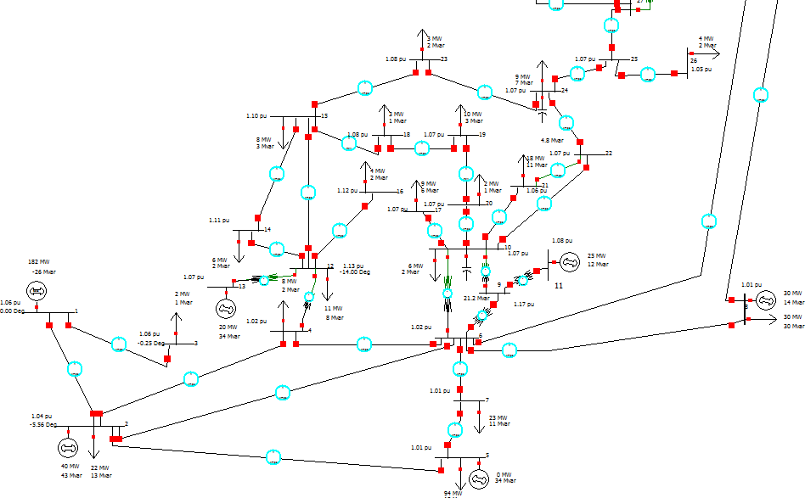

Figure 1: IEEE 30 bus base case load flow in edit mode.
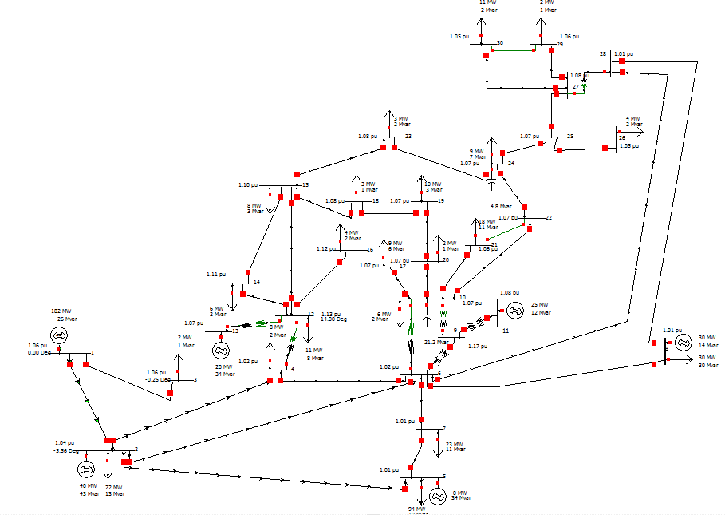

Figure 2 shows the setup in Power World in Run Mode

The Power World simulator was designed for the IEEE 30 bus base case load wind. Figure 1 demonstrates the installation in Edit Mode in Power World, and Figure 2 illustrates the installation in Run Mode in Power World.

1.4 Ground Fault or a Short Circuit:
Both short circuits and ground faults can happen if you flop to dismiss power to the circuit before working on it. Bare wires can inevitably touch the wrong places: Hot wire to neutral wire means a short circuit that causes sparks to fly; hot wire to grounding wire means ground fault and possible shock. To fudge these important problems, always dismiss the circuit before you start working on any section of it.
Common Causes of Ground Faults
Water prick into an electrical box can reason a ground fault, as water is a conductor of electricity.
Worn hot wires or hot wires that are not completely seated into their terminals may come into contact with ground wires or grounding devices or boxes.
Power tools or appliances without proper insulation can reason a ground fault if faulty wiring reason current to flow directly to ground. When working outdoors or below grade, always plug tools into GFCI outlets or use GFCI-protected extension cords.
Common Causes of Short Circuits
A slack connection on one of two wires in a junction box or outlet box may reason a short circuit.
A short circuit can happen slice when a wire slice off of a terminal on an electrical device, such as an outlet. When it contact another wire, a short circuit happen.
An implement may meeting an internal wiring problem, reasons a hot wire and neutral wire to accidentally touch.
Canker or turbulent may masticator the wire insulation and cause a short circuit between two wires within a cable bundle.

Chapter 2

Electrical fault

2.1 Introduction :
Some irregular electric current arises in an electrical power network. A short circuit, for example, is a fault in which current overrides the normal load. If a circuit is interrupted by some failure, an open circuit fault occurs. A failure can require one or more phases and soil in three-phase structures, or it may only occur within phases. Strom is running on the earth through a "land fault" or "rock fault." In certain cases, the possible short circuit current of a predetermined defect may be measured. Protective equipment can identify fault situations in power systems and operate circuit breakers and other instruments to minimize service interruption due to a malfunction.

2.2 Transient fault:

A temporary failure is not present again if electricity is interrupted and returned after a brief period, or an insulation defect that just briefly impacts the dielectrical properties of a system that are recovered for a limited time.

Delay 1 request

delay 2 request
Client server

Delay 4 request

respons

Figur 3: Transient fault

Most overhead power line faults are transient in design. During the event of a failure, the control device safety equipment is being utilized to separate the location of the fault. A partial fault would then be resolved and the power line restored to service. Typical examples of temporary faults include:
momentary tree contact
bird or other animal contact
lightning strike
conductor clashing
Transmission and distribution networks use an automated re-closing mechanism and is widely used on overhead lines in the case of a temporary failure to recover power. For underground networks, this feature is not so growing because faults are usually permanent. Throughout fault present, intermittent defects can often trigger harm either at the initial fault position or at other place in the network.
Persistent fault
Regardless of the power added, a constant fault is present. Mechanical disruption to the cable is the most common source of loss in underground power cables though often intermittent by lighting in nature.

2.3 : Asymmetric fault:
An asymmetric or unbalanced fault does not affect each of the phases equally. Common types of asymmetric fault, and their causes:
line-to-line fault - a short circuit among lines, reason by ionization of air, or when lines come into physical contact, for example due to a broken insulator. In transmission line faults, pretty 5% - 10% are asymmetric line-to-line faults.
line-to-ground fault - a short circuit among one line and ground, very mostly reason by physical concretion, for example due to lightning or other storm damage. In transmission line faults, pretty 65% - 70% are asymmetric line-to-ground faults
double line-to-ground fault - two lines come into concretion with the ground , also usually due to storm damage. In transmission line faults, pretty 15% - 20% are asymmetric double line-to-ground.
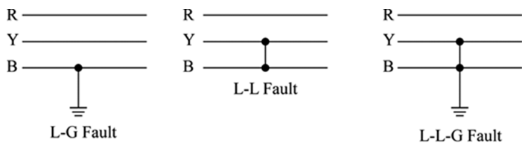

Figur 3.1: Asymmetric fault

2.4 Symmetric fault:
That process is similarly influenced by a symmetrical or balanced breakdown. Approximately 5% are symmetrical with transmission line faults. According to asymmetric mistakes, such faults are uncommon. Two forms of symmetric loss are row by row (L-L-L) and row by row by row by row (L-L-L-G). Symmetric flaws constitute 2% to 5% of all device flaws. But, even though the machine is intact, they will do very substantial harm to machinery.
Bolted fault
The worst is when the fault is negligible, providing the highest potential current in the short circuit. Both drivers are notionally seen as bound by a metallic driver to the deck. It is considered a "bolted malfunction." It would be rare to have a metal short circuit to the ground in a well-designed power network, however errors such as these may occur. A "bolted flaw," to speed up the function of safety equipment, is intentionally inserted in one form of transmission line protection.
Ground fault (earth fault)
Any failure to connect power circuit drivers unintended to the ground (Earth fault) may cause unreasonable circulating currents, or energize equipment housings with dangerous voltage. Some unique power delivery networks may be engineered to withstand and resume activities of a single ground fault. Cord codes can include an isolation tracking system for the delivery of an alarm to locate and correct the cause of the ground failure. In a network like this, a second ground failure may lead to overcurrent or part failure. Also in devices that are typically ground-based to reduce overvoltages,.
Realistic faults
Realistically, the resistance in a fault can be from close to zero to categorically high correlative to the load resistance. All possible cases need to be considered for a good analysis.

2.5 Arcing fault:
Where the voltage of the device is high enough, an arc can develop between the conductives of the power system and the ground. This arc can have a relatively large impedance (as compared to the system's usual operating levels) which may be challenging to identify with basic overcurrent security. For starters, on a circuit with a standard volume of one thousand ampere a multi-hundred ampere arc can not pass overcurrent circuit breakers, but may do massive harm to bus bars or cables until it becomes a complete short circulus. Additional protection systems for the detection of relatively small but unwanted currents escapes into the ground are available for use, industrial and commercial power. Electrical in industrial cabling.
Analysis
Symmetric faults are studied in the same manner as all other control systems anomalies, and several automated applications are currently used to automatically conduct this kind of study (see power flow studies). There is, however, an equally accurate and usually more instructive method.
Next there are few simplifying theories. Both electric generators in the network are expected to be in step and run at the device's nominal voltage. Electric motors should often be known as generators as they produce rather than drain electricity while a failure happens. For this base case, the voltages and currents are determined.

Next, the fault location is adverse To obtain a more accurate result, these calculations should be performed separately for three separate time ranges:
subtransient is first, and is connected with the maximum currents
transient comes between subtransient and steady-state
steady-state happen after all the transients have had time to colonize
The asymmetrical flaw brings down three-phase control expectations that the load of all three phases is equal. As a consequence, methods such as the one-line diagram can not be utilized explicitly, as only one step is taken into consideration. According to the linearity of power structures, though, the resultant voltages and currents are generally assumed to be superposition of symmetric components for three-phase experiments.
a positive-sequence component, in which the phases are in the equivalent mandate as the main system, i.e., a-b-c
a negative-sequence component, in which the phases are in the inverse mandate as the main system, i.e., a-c-b
a zero-sequence component, which is not really a three-phase system, but instead all three phases are in phase with each other.
The impedances of the transmission lines, generators and transformers per unit of zero, positive, and negative series must first be understood to distinguish the currents from an asymmetric fault. Such impedances are then used to create three different circuits. In a specific arrangement which depends on the form of fault being examined, the individual circuits are then joined together (this is seen in several textbooks for power systems). The network will then be analyzed using standard circuit design methods after the correct attachment of the sequence circuit. The solution consists in symmetrical components of voltages and currents, which must be converted.
For the selection of protective devices such as fuses and circuit breakers, the study of potential short-circuit current is required. In order to be secured sufficiently, the fault current must be strong enough to work the protective system as efficiently as feasible. However, the protective device must be able to withstand faulty current and to detach arcs without needing to damage itself or to retain the arc for a significant amount of time.
Based on the form of grounding device used, the source and earth structure of the network and their relation to the source, the frequency of fault currents is somewhat different .

2.6 Detecting and locating faults:
Overhead power lines are harder to detect as the fault is always visible, for example, a tree has dropped over the pole, or a power connection is missing and the drivers are on the road.
Failures in the positioning of the cables will either be carried out on the discharged circuit or in certain situations on the driven circuit. Fault placement strategies may be divided broad into terminal methods utilizing friction and currents at the ends of the cable and tracer methods involving examination around the cable duration. Terminal techniques may be used to identify the total fault region and to easily map a wide or submerged thread.
The fault site is usually detected by testing the wires in very basic cabling systems. Cable problems with the time domain reflectometer are detecting in complicated cabling networks (for example, aircraft cabling) where cables may be hidden. The time domain reflectometer dispatches a pulse down the cable, then analyzes the reflected signals, to assess deficiencies within the electric wire.
Sensitive galvanometers were included in traditional submarine cable instruments to monitor defect currents. The fault spot may be detected within many miles through measuring on both sides of a defective cable to enabling the cable to be grappled to fixed. The loop and the loop of Murray were.
Sometimes a power cable isolation failure does not appear at lower voltages. The high-energy high-voltage pult on the cable adds a thumper check package. The origin of the flaw is achieved by recognizing the echo of the fault discharge. While this check involves harm to the cable position, it is realistic because the defective location would in any case be re-insulated. A feeder may experience a grounding failure in a high resistance grounded delivery network, but the device stays operational. The faulty, but driven, feeder with a ring-type current transformer can be located that gathers all phase wires of the circuit. Only the circuit that involves a ground loss has a net unbalanced current. The system's grounding resistor can be adjusted between two values to make the ground fault current simpler to spot.

2.7 Batteries:
The exppectant fault current of great batteries, such as deep-cycle batteries used in stand-alone power systems, is mostly given by the creator.
In Australia, when this information is not given, the prospective fault current in amperes "should be considered to be 6 times the nominal battery capacity at the C₁₂₀ A·h rate," according to AS 4086 part 2 .

Chapter 3

Analysis

3.1 Introduction :
High test quality can be gain by find out oriented testing using analog fault modeling access. However, this access is computationally demanding and typically hard to apply to main scale circuits. In this work, we use an improved inductive fault analysis access to locate potential faults at setting level and calculate the correlative probability of each fault. Our proposed method outturn chargeable results such as fault coverage of each test, potential faults, and probability of each fault. We show that the computational requirement can be significantly reduced
by incorporating fault probabilities. These results can be used to improve fault coverage or to improve fault elasticity of the circuit .

3.2 Single Line-to-Ground Fault:
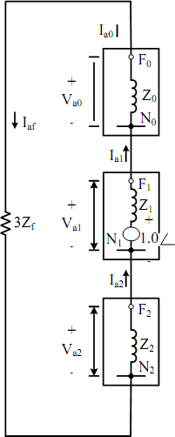
That is usually considered a short circuit mistake when a conductor slips to the ground or comes into touch with the neutral wire. The short circuit failure happens. Figure 4 indicates the general image of one line-to - ground flaw. Where F is the impedances $Z_{f}$ fault level. The network sequences structure as seen in Figure 5. Phase A is normally the failed step, for convenience in the measurement of the fault :
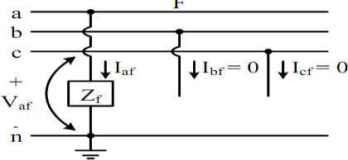

0

Figure 4 General representation of a single line-to-ground fault
Figure 5 Sequence network diagram of a single line-to-ground fault

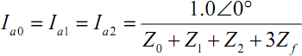
Since the zero-, positive-, and negative-sequence currents are equals as it can be observed in Figure 5. Therefore,

…….…..…. 1

………..2

Since

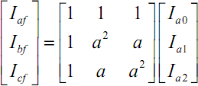 ………. ….3
Solving Equation the fault current for phase a is
…………..4

It can also be

…………….5

The voltage at faulted phase it can be obtained by substituting Equation 4 into Equation 5. Therefore,
…………………………………………..6
Iaf = Ia0+Ia1+Ia2 ………7
Iaf = 3Ia0= 3Ia1= 3Ia2 ………….8
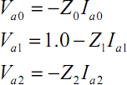
Vaf = Z f I af ………………….9

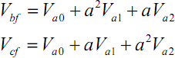
.………………………………….……...10

…………………………………………..11

3.3 Line-to-Line Fault:
Line to line fault Figure 6 display the current magnitude in-device when the bus number 23 is chosen, and in step B&C the fault voltage is smaller than other phases.
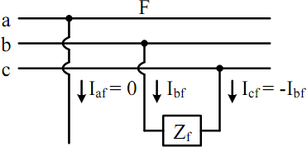
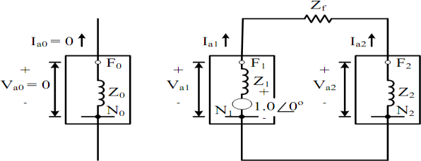

Figure 6 Sequence network diagram of a line-to-line fault

Figure 7 Sequence network diagram of a line-to-line fault

In Figure 6, F is the fault with impedance $Z_{f} .$ The general representation of line-to - line fault is shown The network sequence diagram is shown in Figure 6. Step b and c are generally deemed faulty; this ensures that the estimates for fault tests are simpler
From Figure 7 it can be noticed that

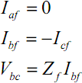
….………………………………12

And the sequence currents can be obtained as

……………………………………13
……………………………………..14

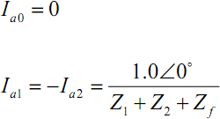

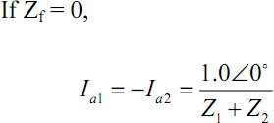

……………………………….15

With the results obtained for sequence currents, the sequence voltages can be obtained from
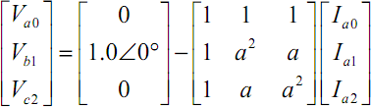

The sequence voltages can be found similarly by substituting Equations 13 and 14 into Equation 14
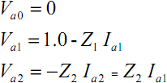
………………………………….16

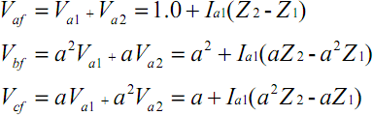
Finally, the line-to-line voltages for a line-to-line fault can be expressed as

……………….18

……………..17

The figure 13 show using power world program to calculate current in the type fault line to line .

3.4 Double Line-to-Ground Fault:
When we have chosen the bus number 23 and the voltage of B&C in fault condition is 0, the double line on ground failure figure 9 indicates the magnitude of current in each unit
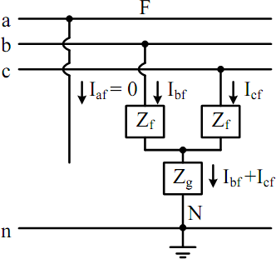
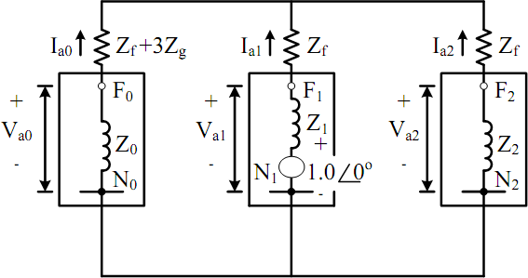
In the figure 8 , F is the fault with${ Z}_{f}$ impedances and the impedance from line to ground$Z_{g }$. The standardized description is given in Figure 8 . Illustration .

Figure :8 General representation of a double line-to-ground fault.

Figure : 9 Sequence network diagram of a double line-to-ground fault.

The network diagram indicates 8. The incorrect steps in step B and c are meant to be consistency in the equations of the malfunction.
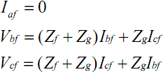
From Figure 9 it can be observed that

An alternative method is,
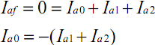
…………………………………..19

………………………………..20

If ${ Z}_{f}$ and $Z_{g }$ are both equal to zero, then the positive-, negative-, and zero- sequences can obtaine

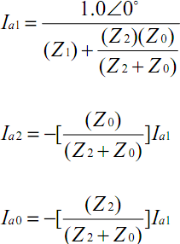
From Figure 9 the current for phase a is
…………………………………21

………………………………….22

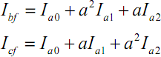
Now, substituting Equations 21 into Equation 2 to obtain phase b and c fault currents

The total fault current flowing into the neutral is

………………………………23

………………………………24
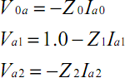
And the sequences voltages can be obtained by using Equation 15

…………………………….25

The phase voltages are equal to

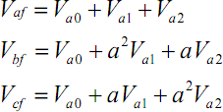
…………………………26
The line-to-line voltages can be obtained from

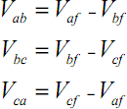
…………………………..27
The figure 14 show using power world program to calculate current in the type fault double line to ground.

3.5 Three-Phase Fault:
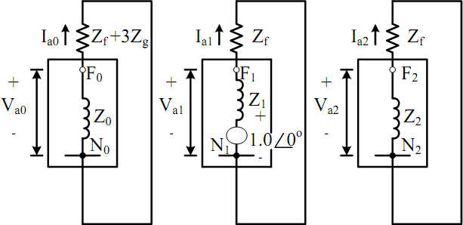
Figure 10 indicates the magnitude of current in each circuit by choosing the bus no. 23 and voltage in both phases under fault is 0.
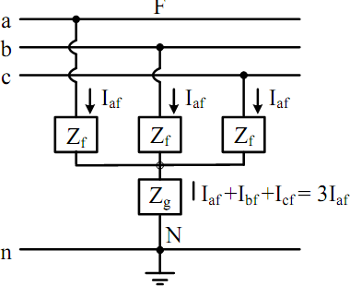
Figure 10 General representation of a balanced three-phase fault

Figure 11 Sequence network diagram of a balanced three-phase fault

An average representation of an equalized three-phase fault is seen in Figure 10, where F is the default point of $Z_{f}$and $Z_{g}$impedances. The network interconnection diagram sequences as shown in Figure 11.
Figure 11 reveals that the only one with a positive sequence network is the internal voltage source. The corresponding streams can therefore be expressed as for each sequence

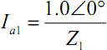

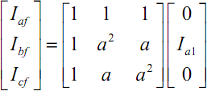

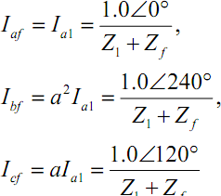

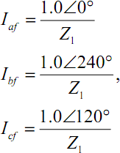

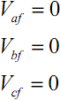

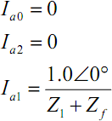
And the line voltages,
……………………………28
If the fault impedance $Z_{f}$is zero,

………………………..29

If equation is substituted into equation

……………………………30

. …………………………31

The phase voltages becomes,

…………………………………………………………………33

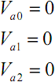

The figure 15 show using power world program to calculate current in the type fault three phase .

Chapter 4

Case Studies and Simulation

4.1 Case Studies and Conclusion :
There in study, the fault analysis of a 30-bus network, which was occupied by bus numbers 20 and 3, was done. The following conclusions have been made dependent on the data derived from the study:
• After the collapse of three-phase faults, voltage dropped to zero during broken bus processes. Bus No.4 with a step A, B and C zero voltage potential is the faulty truck.
• However, even the voltage at phase A is negative in a single line of ground failure. Moreover, only Step A is present-as we previously thought to be the faulty process of the mathematical model. It is the second biggest loss present of all forms

• Starting at Phase B

Table-1 show the result of voltage at bus bar [23] under single line to ground fault
Bus No. | NAME | PHASE A  VOLT | PHASE B  VOLT | PHASE C  VOLT | PHASE A  ANGLE | PHASE B  ANGLE | PHASE C  ANGLE
23 | 23 | 0.00000 | 1.27608 | 1.19202 | 0.00000 | -144.04 | 117.06

Tabl-2 show the result of voltage at bus bar [23] under line to line fault
NUMBER | NAME | PHASE VOLT A | PHASE VOLT B | PHASE VOLT C | PHASE ANGLE A | PHASE ANGLE B | PHASE ANGLE C
23 | 23 | 1.08320 | 0.54159 | -15.16 | -15.16 | 164.84 | 164.84

Tabl-3 show the result of voltage at bus bar 23 under double line to ground fault
NUMBER | NAME | PHASE  VOLT A | PHASE  VOLT B | PHASE  VOLT C | PHASE  ANGLE A | PHASE  ANGLE B | PHASE  ANGLE C
23 | 23 | 1.29446 | 0.0000 | 0.0000 | -13.57 | 0.00 | 0.00

Tabl-4 show the result of voltage at bus bar [23] under three phase fault
NUMBER | NAME | PHASE  VOLT A | PHASE  VOLT B | PHASE  VOLT C | PHASE  ANGLE A | PHASE  ANGLE B | PHASE  ANGLE C
23 | 23 | 0.0000 | 0.0000 | 0.0000 | 0.00 | 0.00 | 0.00

4.2 Simulation Line to ground fault:
Figure 12 calculate fault current the type single line to ground.

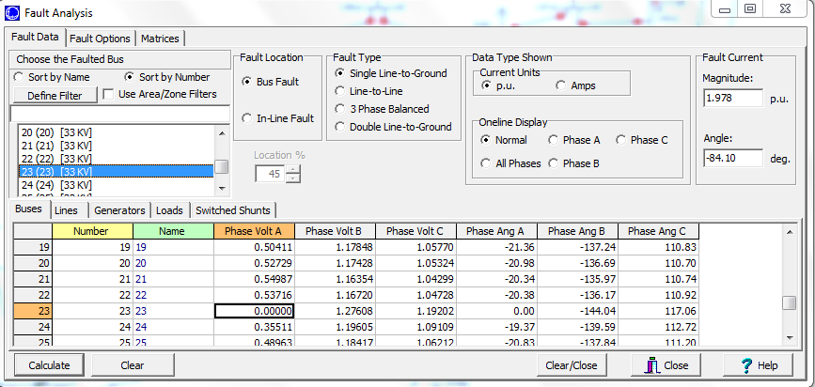

4.3 Simulation Line to Line fault:

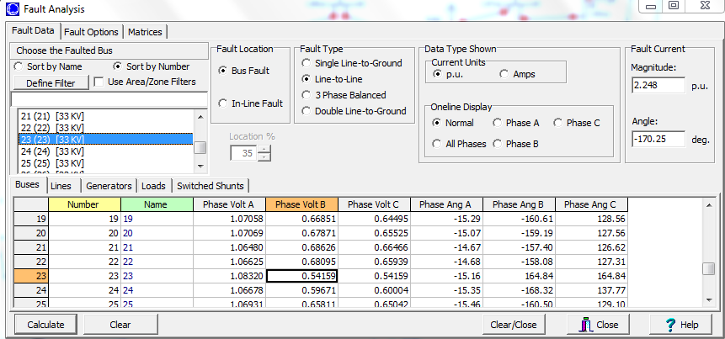

figure 13 : calculate current in the type fault line to line

4.4 Simulation double Line fault:

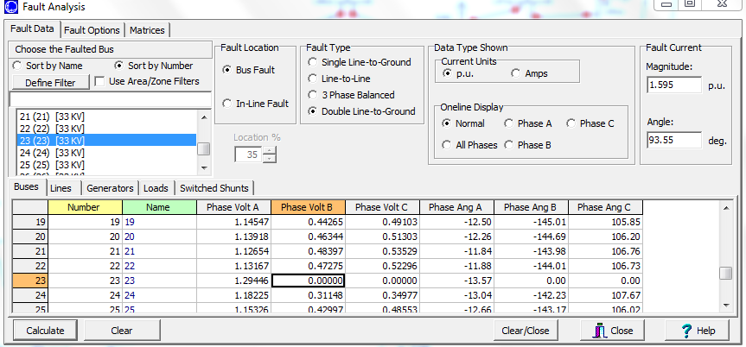

figure 14 : calculate current in the type fault double line

4.5 Simulation three phase fault:

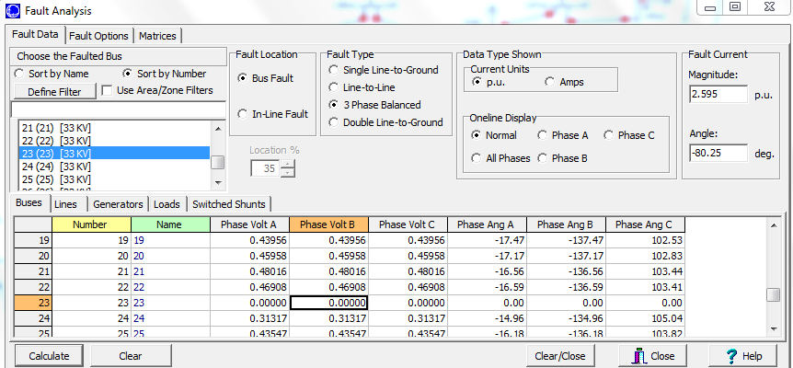

figure 15 : calculate current in the type fault three phase fault

4.6 Result:
In the above simulation, it can be seen that line-to-line fault is lowest for bus No. 23 and 33Kv, line-to-ground fault is more than that, double line-to-ground fault is more than that and three-phase fault is more than that.
4.7 Conclusion:
Short circuit studies are accomplished to condition the spread of the current flowing throughout the power system at several time intervals after a fault. The spread of the current through the power system after a fault several with time until it reaches a steady state condition. During the fault, the power system is called on to find, breakup and aside these faults .The assignment pictured on the materials is dependent on the spread of the current, which is a duty of the time of fault start. Such calculations are performed for various types of fault such as line to line fault, three-phase fault , single line to ground fault, double line to ground fault and at different location of the system. The thought short circuit results are used to select fuses, circuit breakers and protective relays. So from the simulation on both MiPower and PSCAD user can ideal any power system for design point of view and with proper modelling the result get access to be proper as proved with case study.

References
[1]. C. L. Wadhwa (2009), “Electrical Power Systems”, Chap 7, Chap 8
[2]. Dias, L. G. And M.E.El-Hawary “OPF Incorporating load models maximizing net
revenue”, IEEE Transactions on Power Systems, Vol. 8, No. 1, February 1993
[3] Saadat H.(2010), "Power System Analysis", Chap 9, Chap 10.
[4] MATLAB, Version 2015, Simulink.
[5] Milano, Federico, “Power System Analysis Toolbox”, July 2005
[6] M.A Pai, “Operation of Reconstructed Power System”, Chap 6
[7] Kothari, I.J. and Nagrath, D.P. (2007) Modern Power System Analysis. 3rd Edition, New York.
[8] Keyhani, A., Abur, A. and Hao, S. (1989) Short Circuit Analysis for Personal Computers. IEEE Transactions
[9] Aroop, B., Satyajit, B. and Sanjib, H. (2014) Short circuit Analysis on IEEE 23 bus System Using Mathlab. International
Journal of Engineering Research & Technology (IJERT), 3.
[10] Grainger, J.J. and Stevenson, W.D. (1994) Power System Analysis. McGraw-Hill, New York.
[11] Hadi, S. (2010) Power System Analysis. 3rd Edition, PSA Publishing, North York.
[12] Kabisama, H.W. Electrical Power Engineering. McGraw-Hill, New York.

