IOT Based Smart Restaurant
by
Mohammad Salim Hosen
ID: 162-15-1044

Md. Shadul Islam Rishad
ID: 162-15-1029

Md. Rifat Rahman
ID: 162-15-1049

AND
Md. Arifur Jaman
ID: 153-15-607

This Report Presented in Partial Fulfillment of the Requirements for the Degree of Bachelor of Science in Computer Science and Engineering

Supervised By

Md. Mahfujur Rahman Raju
Lecturer
Department of CSE
Daffodil International University

Co-Supervised By

Fatema Tuj Johra
Lecturer
Department of CSE
Daffodil International University



DAFFODIL INTERNATIONAL UNIVERSITY
Dhaka, Bangladesh
March 2020
APPROVAL

This Project titled “IOT Base Smart Restaurant” submitted by Mohammad Salim Hosen, Md. Shadul Islam Rishad, Md. Rifat Rahman and Md. Arifur Jaman to the Department of Computer Science and Engineering, Daffodil International University, has been accepted as satisfactory for the partial fulfillment of the requirements for the degree of B.Sc. in Computer Science and Engineering and approved as to its style and contents. The presentation has been held on 12 July 2020

Board of Examiners

Dr. Syed Akhtar Hossain Chairman
Professor and Head
Department of CSE
Faculty of Science & Information Technology
Daffodil International University

Dr. S M Aminul Haque Internal Examiner
Associate Professor & Associate Head
Department of CSE
Faculty of Science & Information Technology
Daffodil International University

MD Ohidujjaman Tuhin External Examiner
Lecturer
Department of CSE
Daffodil International University

Declaration

We hereby declare that, this project has been done by us under the supervision of Md. Mahfujur Rahman, Lecturer, Department of CSE Daffodil International University. We also declare that neither this project nor any part of this project has been submitted elsewhere for award of any degree or diploma.

Supervised by:

Md. Mahfujur Rahman
Lecturer
Department of CSE
Daffodil International University

Co-Supervised by:

Fatema Tuj Johra
Lecturer
Department of CSE
Daffodil International University

Submitted by:

Mohammad Salim Hosen
ID: 162-15-1044
Department of CSE
Daffodil International University

Md. Shadul Islam Rishad
ID: 162-15-1029
Department of CSE
Daffodil International University

Md. Rifat Rahman
ID: 162-15-1049
Department of CSE
Daffodil International University

Md. Arifur Jaman
ID: 153-15-607
Department of CSE
Daffodil International University

ACKNOWLEDGEMENT

Initially, we express our heartiest thanks and thankfulness to almighty God for His divine blessing makes us conceivable to finish the final year project successfully.

We extremely appreciate and wish our profound our indebtedness to Md Mahfujur Rahman, Lecturer, Department of CSE Daffodil International University, Dhaka. For his Deep Knowledge & huge interest of our supervisor in the field of “Software Developement” to carry out this project. His interminable tolerance, insightful direction, persistent support, steady and enthusiastic oversight, useful analysis, important guidance, reading many inferior draft and correcting them at all stage have made it possible to complete this project.

We would like to express our heartiest gratitude to Dr. Syed Akhter Hossain,
Professor and Head, Department of CSE, for his kind help to finish our project and also to other faculty member and the staff of CSE department of Daffodil International University.

We would like to thank our entire course mate in Daffodil International University, who took part in this discuss while completing the course work.

Finally, we must acknowledge with due respect the constant support and patients of our parents.

Abstract
Traditional restaurant management system is very complex, expensive and cumbersome. It is also very hard to manage restaurant resources and stuff. So, we decided to build a restaurant management system which will reduce complexity and also the cost to manage a restaurant. We have implemented a system where all the order would be made by our “FoodFire” app, Food will be served by “Automated Robot Car” and all the orders would be managed by our web admin panel named “FoodFire Admin”. The restaurant itself will be automated too. IOT devices of the restaurant can be handled by the android mobile app. Restaurant door will be automated sliding door which will open when anyone stand in front of the door. Water basin is customer friendly and for security purpose we have implemented fire security alarm. Our system will help to decrease management cost as restaurant will need less man power.

TABLE OF CONTENTS
Contents PAGE

Board of Examiners i
Declaration ii-iii
Acknowledgements iv
Abstract v
Table Of Contents vi - viii
List of Figures xi
List of Tables x

CHAPTER
CHAPTER 1
INTRODUCTION 1-3
1.1 Introduction 1
1.2 Motivation 2
1.3 Objectives 2
1.4 Expected Outcome 2
1.5 Report Layout 3

CHAPTER 2
BACKGROUND STUDY 4-5
2.1 Introduction 4
2.2 Related Works 4
2.3 Scope of Project 4
2.4 Challenges 5

CHAPTER 3 6-7
REQUIREMENT MANAGEMENT
3.1 Functional Requirements 6
3.1.1 Software Requirements 6
3.1.2 IOT Device Requirements 6
3.2 Non-Functional Requirements 6
3.3 Use case Description 7

CHAPTER 4
DESIGN SPECIFICATION 8-14
4.1 IOT Device Design 8
4.1.2 Line Follower Robot 9
4.1.3 Hand sensing water Tap 10
4.1.4 Fire Safety 10
4.1.5 Automatic Sliding Door 11
4.2 Software Design 12
4.3 User Interface Design 12
4.3.1 Mobile App Interface 13
4.3.2 Admin Panel Interface 14
4.4 Database Design 14

CHAPTER 5
IMPLEMENTATION 16-25
5.1 IOT Device Implementation 16
5.1.1 Lighting System 16
5.1.2 Line Follower Car 17
5.1.3 Fire Alarm 19
5.1.4 Hand Sensing Water Tap 20
5.1.5 Automatic Sliding Door 21
5.2 Mobile App Implementation 21
5.3 Admin Panel Implementation 25
CHAPTER 6
TESTING 29-29
6.1 Introduction 29
6.2 IOT Device Test 29
6.3 Software Test 29

CHAPTER 7
CONCLUSION AND FUTURE WORKS 31-32
7.1 Conclusion 31
7.2 Project Outcome 31
7.3 Future Works 32

APPENDIX 32

References 33

LIST OF FIGURES

Figure 3.1: Use case Diagram of FoodFire Restaurant 7

Figure 4.1.1: FoodFireIOT app Light Controlling Switch interface 8
Figure 4.1.2: Restaurant lighting system 9
Figure 4.1.3: Restaurant lighting system 9
Figure 4.1.4: Hand Sensing Water Tap 10
Figure 4.1.5: Restaurant lighting system 10
Figure 4.1.6: Automatic Sliding Door in Close State 11
Figure 4.1.7: Automatic Sliding Door in Open State 11

Figure 5.1.1: Circuit Diagram for Restaurant Lighting system 16
Figure 5.1.2: Mobile app to Control Lights 17
Figure 5.1.3: Line Follower Robot Working 19
Figure 5.1.4: Fire Alarm Circuit Design 20

LIST OF TABLES

Table 4.1: Firestore Database Design (Collection, Document and Fields) 15

Table 5.1: Admin Navigation Menus and Their Functionality 27

Table 6.1: IOT Devices Test 29

Table 7.1 Project Expected Outcome and Final Outcome 31

CHAPTER 1

INTRODUCTION

1.1 Introduction
“IOT Based Smart Restaurant” is a restaurant management system which is developed to minimize the complexity and managing cost of traditional restaurant management system. We have developed an android app which is used to make order so, customer has no need to call waiter and place the order anymore. We have used Java to develop our android app and used firebase database for real time data manipulation. To manage order, we have developed an admin panel. Admin panel is developed by ReactJS to show real time data from database. Whenever customer makes an order immediately the order is reached to the Admin Panel. Manager and Chef can interact with the admin panel to manage orders. As our restaurant is IOT based so we have implemented a Line Follower robot car to serve ordered food. We have used Arduino to program the Line Follower car. We have also enhanced the internal architecture of the restaurant using IOT. Restaurant IOT devices can be managed by mobile app. Android mobile app is developed for this purpose. Node MCU is used communicate with the app. Restaurant has fire safety alarm and customer friendly water saving water tap for basin. Smoke sensor and buzzer is used to develop fire safety system. Mini water pump and IR sensor is used to make customer friendly water tap. Restaurant has also automatic sliding door which enhance the beauty of the restaurant. Sliding door is developed using Arduino and motor.

1.2 Motivation
In this era life is getting simpler and comfortable. IOT has added a new dimension to it. Calling a waiter to make an order and waiting for food without knowing when it will arrive is very boring. So, we have decided to develop an app where customer can order by our app and can see order status in the mobile app. In this modern time world is moving towards the autonomous system. So, we have developed robot car to serve food as it will reduce cost for managing the restaurant.

1.3 Objectives
- To develop a convenient and customer friendly restaurant management system
- Develop a Food Ordering app to order food from mobile
- Construct a Line Follower Robot car to serve ordered food
- Control over restaurant resources from mobile device
- Integrating Mobile Payment system by our app
- Develop a time saving and cost saving system

1.4 Expected Outcome
- Better interaction between system and the users
- High quality service from the mobile app and Line Follower Robot
- Control over the restaurant resources trough internet
- Easy bill pay system
- Customer Satisfaction

1.5 Report Layout
- Chapter 1: Introduction
This chapter describes our project and why we have developed it. What is the motivation behind it and what will be the expected outcome?
- Chapter 2: Background
In section two we have contrasted our framework and other related framework previously structured. Examined about the extent of the issue and difficulties of our venture.
- Chapter 3: Require Management
In this section we have talked about utilitarian necessities and non-useful prerequisite of our task. We have additionally talked about use case in this part.
- Chapter 4: Design Specification
This part depicts about our eatery plan, iot gadgets structure and programming plan. It additionally shows UI structure.
- Chapter 5: Implementation
In this section we have talked about the execution of our iot gadgets and programming.
- Chapter 6: Testing
This chapter Describes about the testing of our system. IOT devices are tested during development and software is tested continuously and after completion of development.
- Chapter 7: Conclusion and Future Scope
Conclusion chapter includes project outcome and future works of our project.

CHAPTER 2

BACKGROUND STUDY

2.1 Introduction
Background study refers to the discussion about previous work done is this area, problems faced and challenges in our project. So, in this chapter we have discussed about related works to our project. We are going to describe some problems and challenges we have faced during the development of our project and so more.

2.2 Related Works
Many projects have been done regarding this topic. Some of them tried to develop online ordering through web app. Some people tried to develop robot to serve food. Some food ordering app available online and many restaurants have applied those application. But we have tried to integrate both app and robot together and tried to add almost every possible good in that. We have taken ideas from their work and tried to develop a more enhanced system. We hope that it would be great for business as well as it will give inspiration to our future generations to work on that area.

2.3 Scope of Project
In this modern time many IOT devices have been developed to make our life easier and comfortable. Life is getting closer to machine and world is moving towards autonomous world. So, we think our project will be very much fit with modern world. In future this type of project would be much popular. Our project can be further enhanced and could be used in almost all the restaurant with low cost and minimum complexity.

2.4 Challenges
- Interaction between mobile app and admin panel was a challenge where all data would be available in real time.
- Firebase database measure cost on each request. So, minimizing the request was a big challenge for us.
- Food serving with line follower was very hard.
- Project completion in time was very difficult.

CHAPTER 3

REQUIREMENT MANAGEMENT

3.1 Functional Requirements
Our system has many functional requirements. We have discussed here most important features of that. As we had to develop a mobile app, an admin panel and IOT devices we divided our requirements into two sections. Section (3.1.1) describes app and admin panel requirements and (3.1.2) describes IOT requirements.

3.1.1 Software Requirements
- Admin Module: admin can manage overall restaurant data. Admin can create, update and delete food menu. Admin can also manage food order and restaurant stuff.
- Chef Module: Chef can add and edit food menu. Chef can also finish an order.
- Customer Module (app): Customer can view food item, search food, order food and can see processing of the order. Customer can also create their profile
.

3.1.2 IOT Device Requirements
- Car Module: Line follower robot module to serve food.
- Door Module: Automatic sliding door opens when someone stand in front of the door.
- Lighting Module: Control over light through mobile app.
- Water tap Module: Water tap to flow water when detects hand sensor
- Fire Safety Module: For security purpose. Alarm when fire detected.

3.2 Non-Functional Requirements
Usability: To develop Nice and user-friendly system. Operating the system would be easy.
Performance: To make the System that behave effectively while performing the operations and response time is less. Realtime notification for ordering food.
Security: Security is of great concern while developing the system. Ensure limited access to the user. User have access where they are allowed to access. Apply other type of security to ensure security.

3.3 Use case Description
User case diagram show interaction between system and the users. We have four type of users who can interact with the system. A customer is user who can perform his respective task such as see food, order food, creating profile etc. A chef can manage order and create food menu and admin can perform almost all the action that a customer and chef can do. We have another user that interacts with the system. The line follower robot which serve foods.
We have simplified our use case for easy understanding. There are many uses cases available but we have tried to show main use cases in the diagram. Figure 3.1 shows the main use cases in the project.

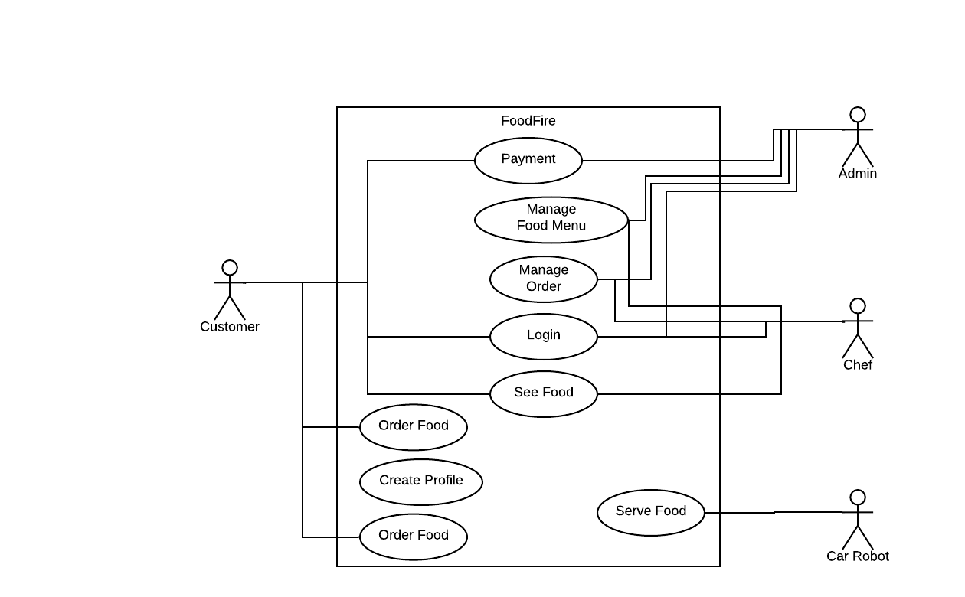
Figure 3.1: Use case Diagram of FoodFire Restaurant

CHAPTER 4

DESIGN SPECIFICATION

4.1 IOT Device Design
We have several IOT device available in our project. We have tried to design them as good as possible. We have a Line Follower robot to serve food, lighting system attached to the restaurant, hand sensing water tap and automatic sliding door. All of these things are part of to the restaurant. But we have developed each in modules and later integrate it to the restaurant.

4.1.1 Lighting System
Lighting system of the restaurant is attached to the restaurant model. All of the lights are connected to the Node MCU so that we can control lights from the mobile app. We have used an android app to perform this task. Our android app provides easy access to IOT device over internet. Figure 4.1.1 shows our android app interface which shows 6 light switches and Figure 4.1.2 shows the restaurant lighting system.
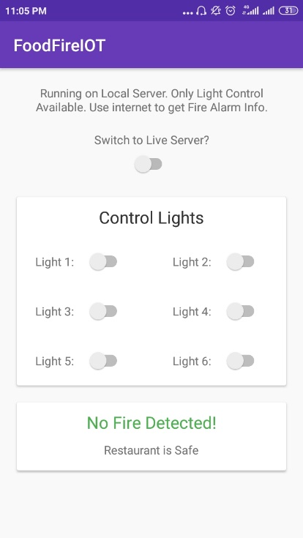
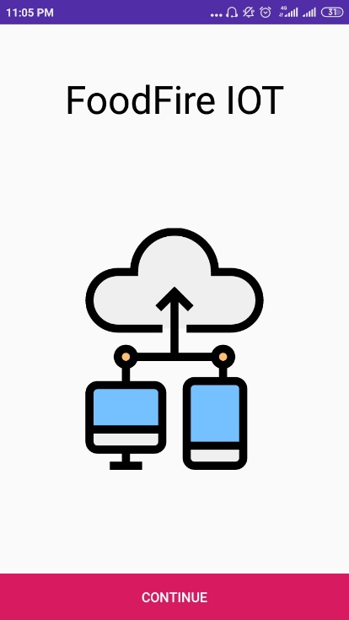

Figure 4.1.1: FoodFireIOT app Light Controlling Switch interface
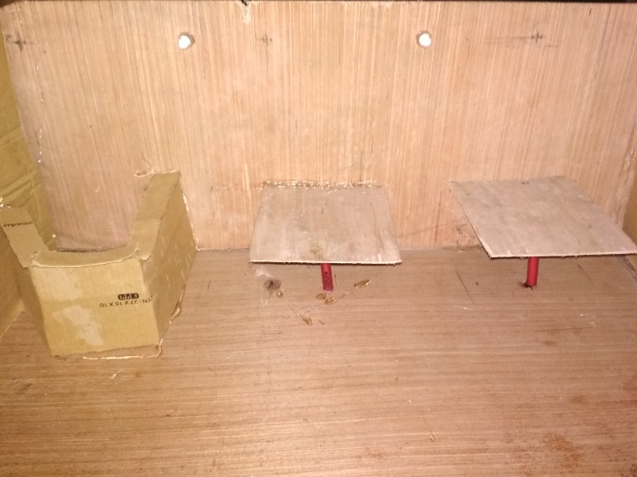
Figure 4.1.2: Restaurant lighting system

4.1.2 Line Follower Robot
We have made a simple obstacle avoidance line follower robot to serve food. We have used Arduino to program line follower and L298 motor driver to control motors.

Figure 4.1.3 show line follower robot
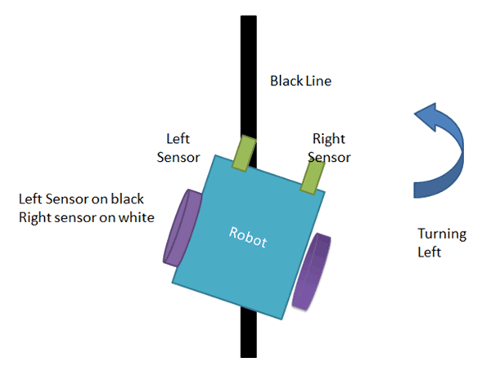
Figure 4.1.3: Restaurant lighting system

4.1.3 Hand sensing water Tap
Hand sensing water tap flows water when someone put his hand below the tap. We have used submersible pump, IR sensor and Arduino to construct hand sensing water tap. Following figure demonstrates hand sensing water tap. Figure 4.1.4 shows our hand sensing water tap.

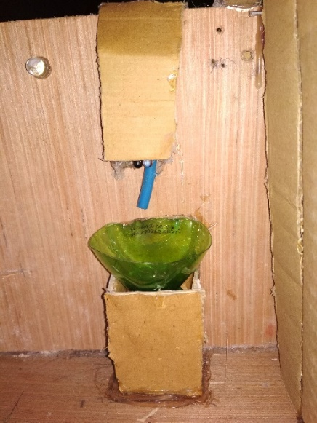
Figure 4.1.4: Hand Sensing Water Tap

4.1.4 Fire Safety
Fire safety is much of concern for a restaurant. We have developed an alarm system when the alarm is on and it sense fire it will buzz the alarm. We have used flame sensor and node mcu to develop fire safety module.

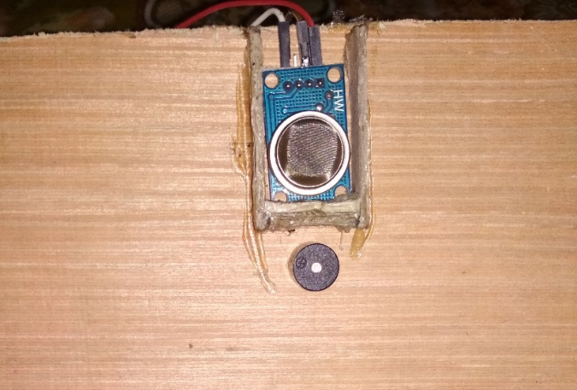
Figure 4.1.5: Restaurant lighting system

4.1.5 Automatic Sliding Door
Now a days everybody wants to integrate nice and autonomous door for their construction. Autonomous door is very popular in modern time and can be seen in many restaurant and shopping complex. So, we have implemented an automatic door using Arduino and motors.
Figure 4.1.6 shows our automatic sliding door when it is close and 4.1.7 show when it is open.

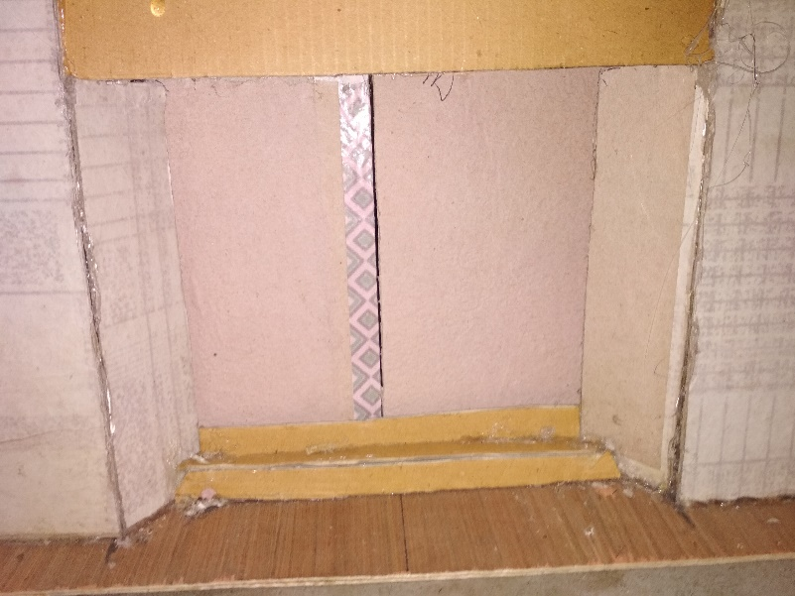
Figure 4.1.6: Automatic Sliding Door in Close State

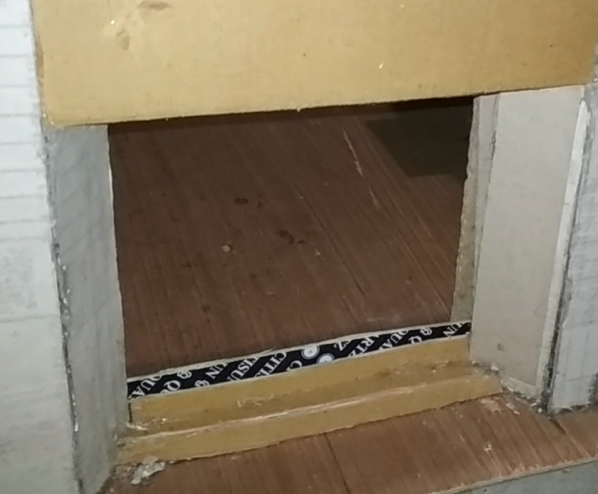
Figure 4.1.7: Automatic Sliding Door in Open State

4.2 Software Design
We had to develop two software and an android mobile app to make order and a web admin panel to manage orders. We have three type of users who will interact with the software system. Customer, Admin and Chef are different type of users and their responsibility is different. The ER diagram better describes user interaction with the software. Figure 4.2.1 shows ER diagram of our system.

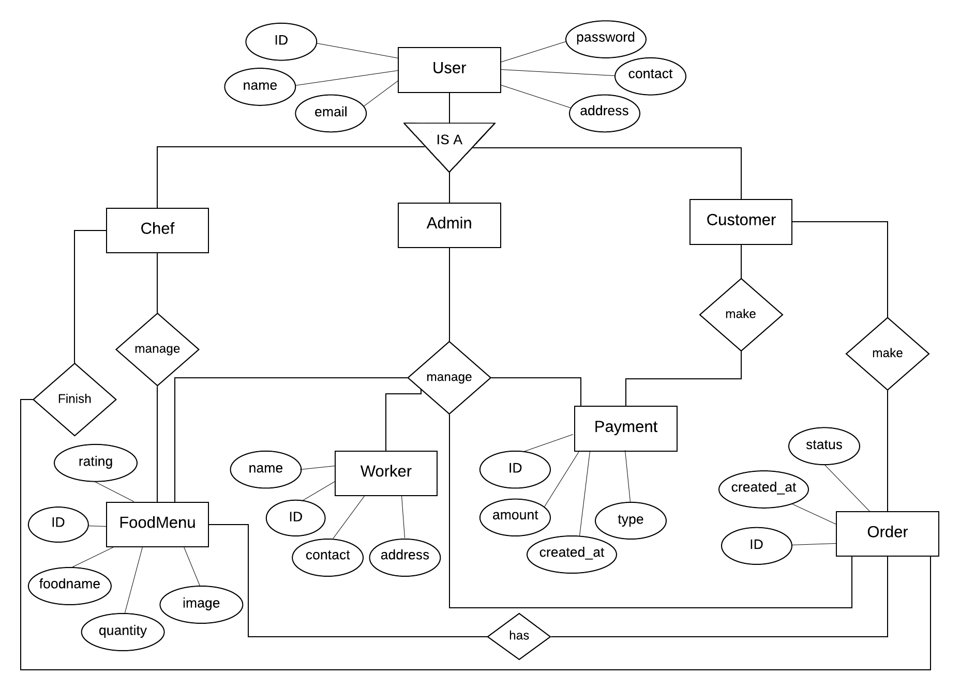
Figure 4.2.1: ER Diagram for our System

4.3 User Interface Design
Our software’s user interface is nicely designed and convenient to use. We care about customer so decided to keep the design very simple. We have used android xml to design mobile app interface and ReactJS, Material UI to design the admin panel. Admin panel can show real time notification of order arrives. Figure 4.3.1 shows Mobile App Interface and Figure 4.3.2 and 4.3.3 shows Admin Panel UI

4.3.1 Mobile App Interface
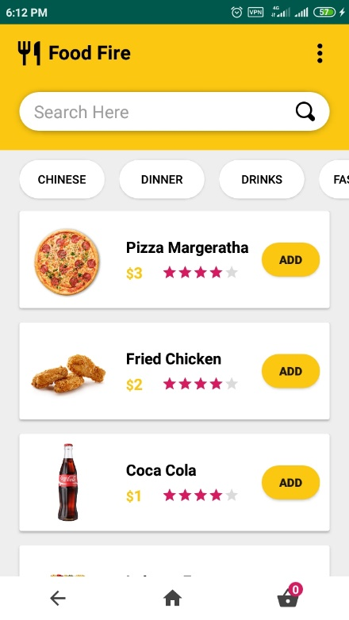
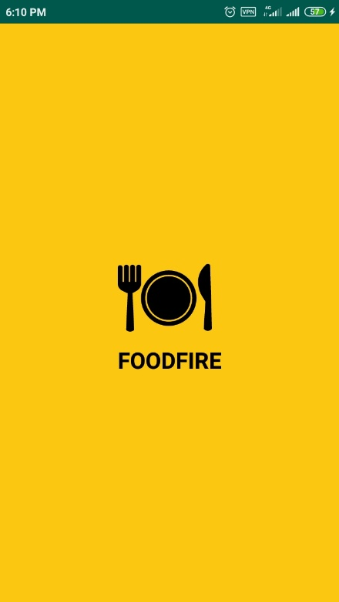

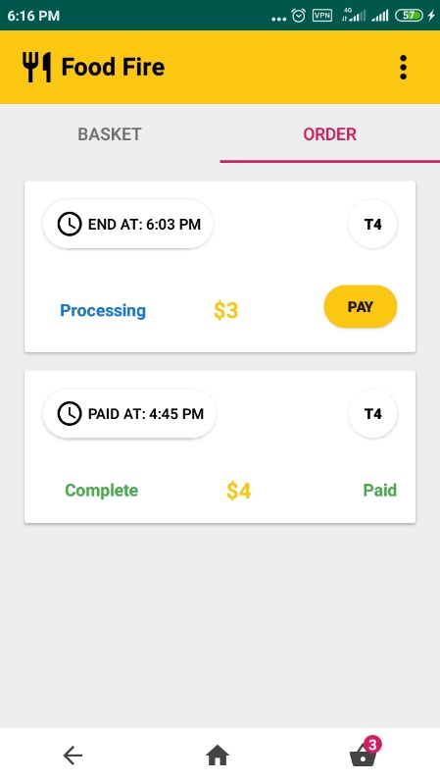
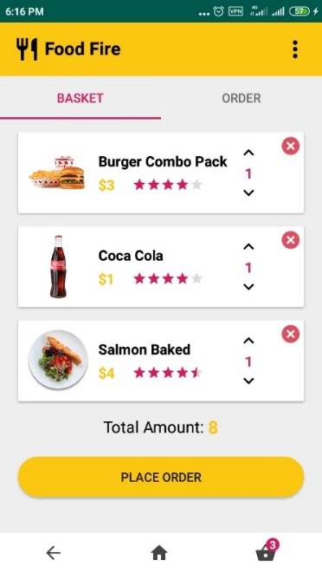

Figure 4.3.1: Mobile App UI

4.3.2 Admin Panel Interface
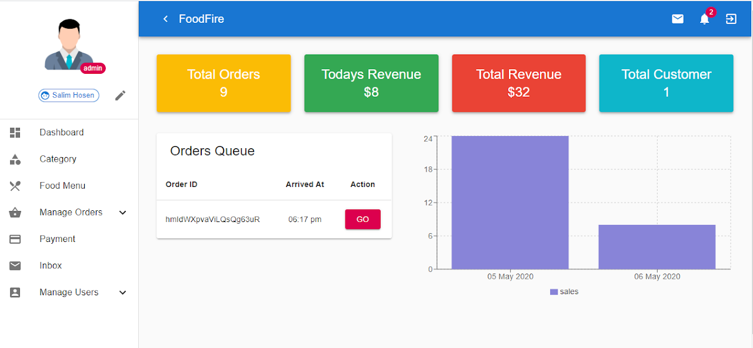
Figure 4.3.2: Admin Dashboard UI
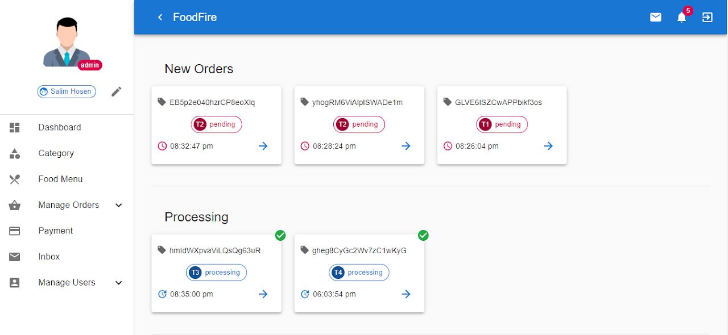
Figure 4.3.3: Admin Panel Order Page UI

4.4 Database Design
We have used firebase as our database. Firebase is a NoSQL Realtime database. We have used firebase to show real time data manipulation. When customer makes an order, it arrives immediately to the admin panel so that admin and chef can manage it. On making order it push a notification to the admin panel. On the other hand, when chef processes order or finish the order customer get notification. Customer also can track approximately how much time it needs to process the order. All of these are possible by the help of firebase real time database. We have implemented cloud firestore as the database. Table 4.1 shows the database design of our app.

Firebase stores data in json format. It stores data as collection and documents. SQL database person can assume collection as table, document as a row of data and Each field in a document as attribute. Table below describes our database collections and their fields.

Table 4.1: Firestore Database Design (Collection, Document and Fields)
Collection | Document | Fields
Categories | categoryId | name, created_at
Counter | Orders | Childs
Counter | Users | admin, chef, customer
Foods | foodId | foodId, name, category, price, rating, stock, image, description, created_at
Notifications | orderId | type, status, created_at
OrderDetails | orderId | foodIds(array), quantities(array)
Orders | orderId | cost, tableNo, userId, status, createdAt, finish, paid, payId, payTime, paymentType
Revenue | Date | revenue, day, month, year

CHAPTER 5

IMPLEMENTATION

5.1 IOT Device Implementation
We have five devices to implement lighting system, line follower robot, fire alarm, hand sensing water tap and automatic door. In this section we are going to show implementation of those devices.

5.1.1 Lighting System
For lighting module, we will use led lights and node mcu to talk to the internet. We are using battery to power up node mcu. For the sake of simplicity, we are using DC current because AC current needs two extra electronics relay and voltage converter. Node mcu runs on 3.7 voltage so, we have to keep in mind that extra voltage can burn up the node mcu.

Required Components
- LED lights
- Power Source
- Node MCU
- Arduino IDE
- Wires

Circuit Diagram:
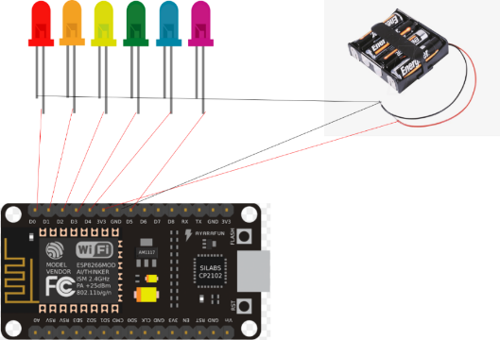
Figure 5.1.1: Circuit Diagram for Restaurant Lighting system

All the lights are connected to the node mcu board. Each pin the light connected to is responsible to control the light. Lights are controlled by the android app over internet. At first the board should be connected to the wifi then we have to perform any operation.. Figure 5.1.2 shows iot device control mobile app interface
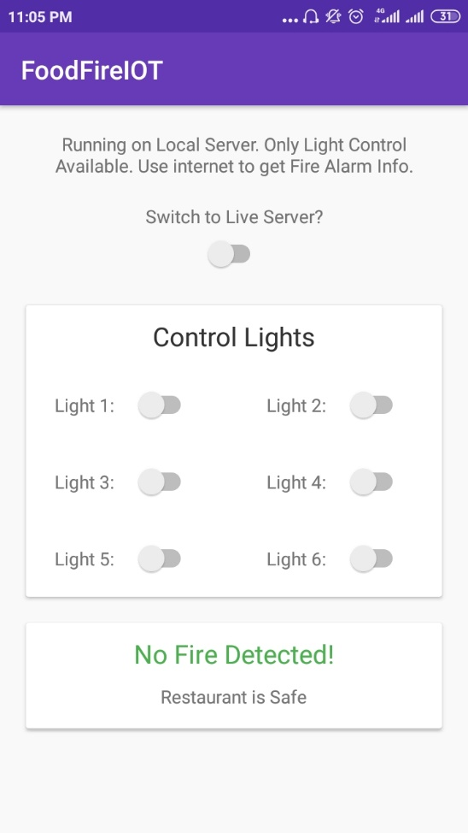
Figure 5.1.2: Mobile app to Control Lights

5.1.2 Line Follower Car
Line follower car is developed to serve food. We have used Arduino to control the line follower robot. Line follower robot has the ability to go specific table to serve order. This section shows implementation of line follower car

Required Components
- Arduino Board
- Motors
- L298 Motor Driver
- Ultrasonic sensor
- IR Sensors
- Power Source
- Wires
- Arduino IDE

We have used Arduino board to program the line follower car. L298 motor driver is used to change motor direction and speed. Ultrasonic sensor is used to detect obstacle and avoid them. When obstacle detected it change direction.

The motors are connected to the L298 motor driver. L298 motor drive can be used to control two motors. The L298 motor driver has 6 pins. enA and enB pins are used to control the speed of motor and other 4 pin is used to change the direction of motor.

Infrared proximity sensors placed on front of the robot. IR sensor can be used to detect lines. There are four possible sensor outcomes from the IR sensor
- If Both the sensors don't detect the line the motors start to rotate in the forward direction. As a result, the car moves forward.
- If only the left sensor detects the line which means that the car requires to turn in the left direction. The left motor starts to rotates backward and the right motor rotates forward. As a result, the car turns left.
- If Only the right sensor detects the line which means that the car requires to turn in the right direction. The left motor rotates forward and the right motor rotates backward. As a result, the car turns right.
- If Both the sensors detect the line. This means that the end has come. Both the motors stop rotating. As a result, the car stops.
Figure 5.1.3: Line Follower Robot Working

5.1.3 Fire Alarm
Smoke sensor is used to detect smoke. Led and buzzer are interfaced to indicate the fire alarm. Arduino is used to program the sensor so that they give expected result.
Required Components
- MQ-2 smoke Sensor
- Arduino
- LED
- Buzzer
- Connecting Wires
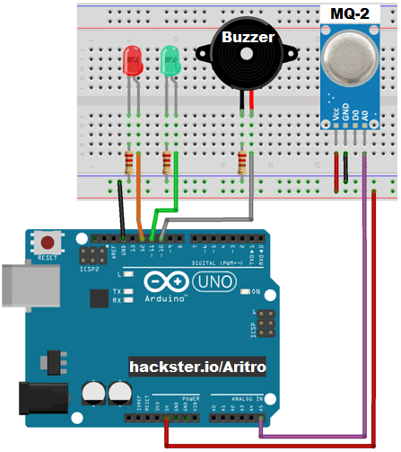
Figure 5.1.4: Fire Alarm Circuit Design

MQ-2 smoke sensor is connected to the Arduino analog pin A5 and buzzer is connected to the 10 and led is connected to 11 and 12 pin respectively. MQ-2 gas sensor can sense smoke and give data to Arduino board then Arduino board take action on analog read of flame sensor. When smoke is detected then buzzer and led is set to high so that they can make noise to announce the owner.

5.1.4 Hand Sensing Water Tap
Hand Sensing water tap is developed by the help of Arduino Board, Submersible pump and IR sensor. We have used IR sensor to sense hand but Ultra sonic sound sensor would be a better option. As the restaurant model is small in size we are using IR sensor. We connect IR sensor and mini pump with Arduino. When IR sensor detects hand the pump starts to flow water from tank.

Required Components
- Arduino UNO
- IR Sensors
- Submersible pump
- Connecting Wires
IR sensor is used to detect hand and fire the motor as soon as possible so that water starts to flow. When hand is below IR sensor water flows and when hand is removed from under the IR sensor water flow stops.

5.1.5 Automatic Sliding Door
Automatic sliding door is constructed so that it can be open when someone stands in front of it. It is developed on the basis of L298 motor driver and Arduino. Mechanical gear is also required to construct automatic door.

Required Components
- Arduino
- Motors
- Ultrasonic sound sensor
- PIR motion sensor
- L298 Motor Driver
- Connecting Wires

Ultrasonic sound sensor and PIR motion sensor is used to detect motion. When object is detected the motor rotates to open the door. And when no object is detected then motor again rotates reverse to close the door. Rotation is handled by the L298 motor driver.

5.2 Mobile App Implementation
Mobile app is used to order food by the customer. Currently we have implemented Android Version of our app. Using app user can login, register, see food menu, order food, update profile, contact for support and many more. Java is used as the language and Firebase Cloud Firestore is used as database.

Design of the app is shown on previous chapter 4.3.1 Mobile app UI design. In this chapter we are going to show implementation of our android app.

Requirements
- Android API 21 or Above
- Stable Internet Connection
- Must be a Member
Language Used
- Java
- XML

Technology Used
- Firebase Cloud Firestore Database
- Firebase Authentication
- Firebase Storage
- Java version 8 and above
- Adobe XD to Design UI

The flowchart below describes our app system and how it works. The main purpose of this flowchart is to show main process which is food ordering. We have shown a basic flowchart which will be very useful to understand the app working easily

Below Figure 5.2.1 Show the Flowchart of our food ordering app
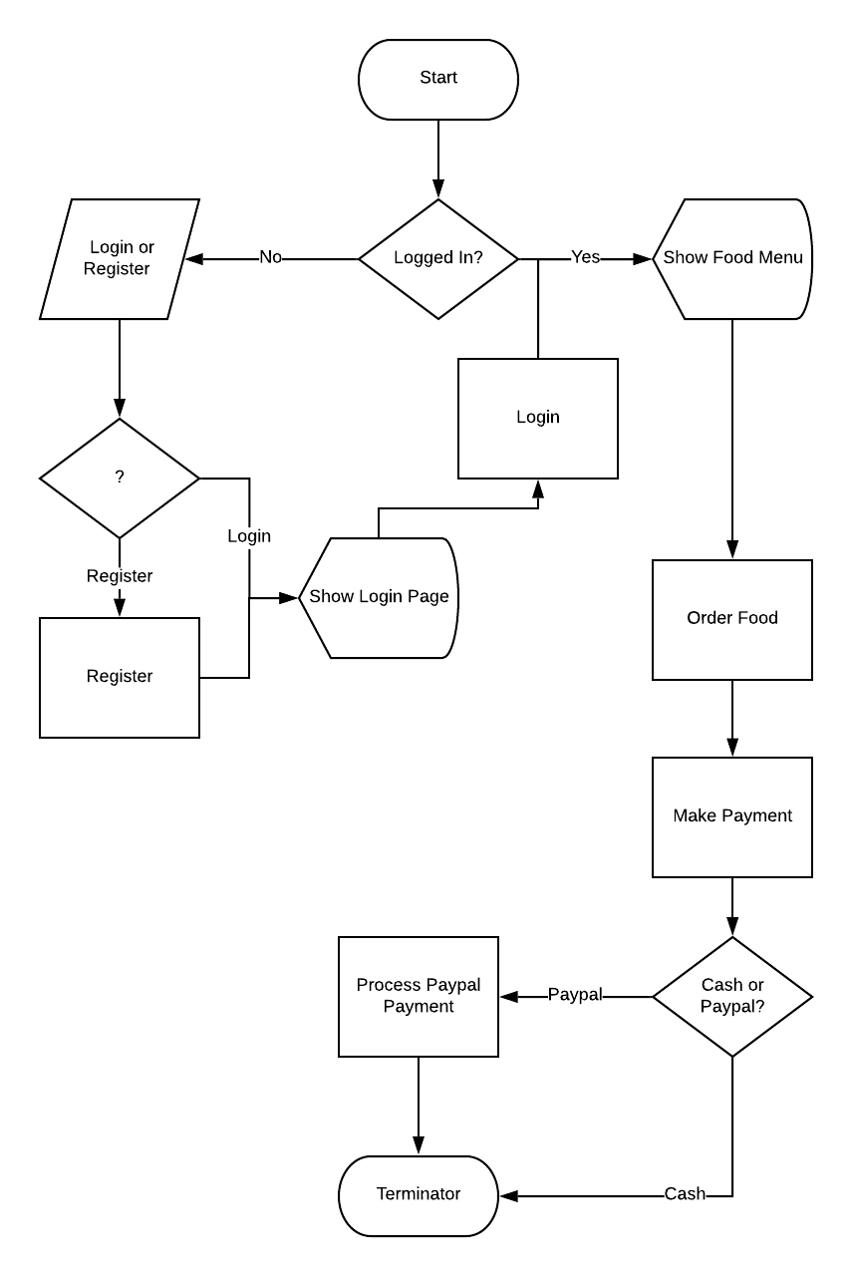
Figure 5.2.1: Foodfire mobile app Flowchart

When user will open the app customer will be prompted to the login page from there customer can login or register to use our app. Figure 5.2.2 shows login and register page of our App.
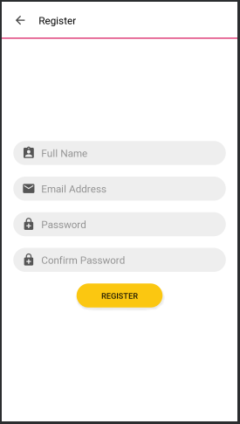
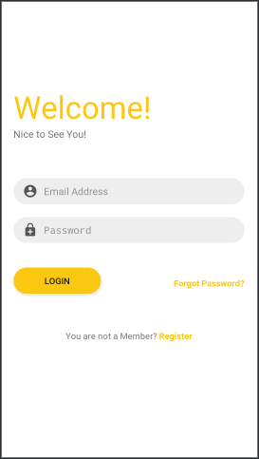
Figure 5.2.2: Login and Register UI

When a customer is successfully logged in customer can see food, search food, order food. Customer can also see his profile and update profile. Customers previous order can be found on the Previous orders from the dropdown menu. The dropdown menu with 3 dots also contains a Contact page by which customer can complain any ask for any query. The most important thing about our app is food ordering.

The food ordering process is shown below. Figure 5.2.3 shows about food ordering process.
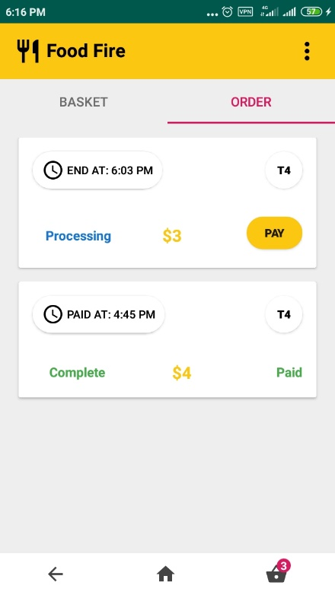
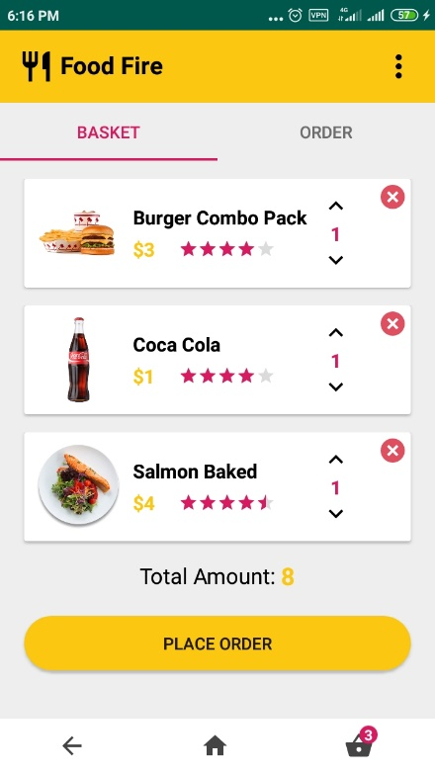
Figure 5.2.3: Food Order Process

After Placing the order customer can either pay by cash or by Paypal. We have integrated Paypal as payment gateway in our app. If customer clicks the pay button he will be prompted to Paypal payment system to pay the bill otherwise customer can pay the bill in cash to the restaurant cash counter.

5.3 Admin Panel Implementation
Admin panel is developed for interacting with orders and other restaurant resources. After placing the order chef or admin can see those orders. Both admin and chef have access to orders page. Chef is responsible for finishing the order and admin is responsible for managing the payment of the order. Admin Panel is a web application which can be run on browser. We hosted the application in google firebase hosting. It is node js application and can show real time updates of orders.
Browser Supports
- Internet Explorer 11
- And All major browsers

Language Used
- HTML
- CSS
- JavaScript

Library Used
- ReactJS
- Material UI
- Font Awesome

Database
- Firebase Cloud Firestore

Only admin and chef can login to the admin panel. Admin can access all the functionality but chef has some restriction to some pages. Chef can only add food items, manage orders and update his profile on the other hand admin can manage payment and all other functionality as well.

When admin or chef login into the admin panel he will be able to see the statistics of the orders and sales. Dashboard page also shows incoming orders from the app. Figure 5.4.1 shows admin dashboard.
Figure 5.4.1: Admin Dashboard

The figure above is the admin dashboard of our app. As you can see many navigation menus in the sidebar. All of this navigation menu leads to a page. Each page has its own functionality. Table 5.1 shows all the navigation menu available in the system and functionality of each menu

Table 5.1: Admin Navigation Menus and Their Functionality
Menu | Functionality
Dashboard | This page Describes statistical data of the restaurant such as total orders, total revenue, todays revenue, number of customers and a graph which shows monthly sales.
Category | Category page is used to create category to organize food menu in categories
Food Menu | In this page admin or chef can add new food item
Manage Orders | This page holds current orders and previous orders of the restaurant. Current orders are orders need to be served.
Payment | Payment is managed by the admin and only admin can access this page to manage payments. Two type of payments can be possible either cash or by paypal.
Inbox | Inbox shows all the message come for support. Admin can interact with those messages to support customers.
Manage Users | Manage Users page is used to create new user or manage existing users. This page is available only to admin.
Pen Icon | The pen like icon in the figure above is used to update profile of the user.
Message Icon | Message icon shows incoming message.
Notification Icon | Notification icon shows notification of orders.
Logout Icon | Logout icon is used to logout the user.

CHAPTER 6

TESTING

6.1 Introduction
Testing is a process where input is given and it passes when we get expected output. During Development it is a continuous process. We have done it continuously during developing our project. Each module is checked and tested individually. Both IOT devices and Software is tested continuously. IOT devices are tested individually either it is working perfectly or not. Software are tested using test cases.

6.2 IOT Device Test
IOT device test has been done when we have developed a device. As, we had to develop five devices we developed each and tested regularly. Test on particular device is like

Table 6.1: IOT Devices Test
IOT Devices | Test | Result
Light Control over internet | Are All Light working perfectly? | YES
Line Follower Robot | Can robot serve food to the destination? | YES
Fire Alarm | Is Fire Alarm Working Correctly? | YES
Hand Sensing Water Tap | Does Water Flows when detects hand? | YES
Automatic Sliding Door | Can door open when detects motion? | YES

6.3 Software Test
We have two software a mobile app and an admin panel. Each of them has been tested individually. Types of tests implemented on the software are Interface Test, Unit Test, Integration Test, System Test and Acceptance Test.

Interface Test: Interface test means user interface test. We have checked all the layout of our android design and admin panel. Everything is working correctly. All design works like a charm.
Unit Test: Unit test refers to perform test on each module. Whenever, a module is developed we have tested it and then developed another module.

Integration Test: Integration refers to the process of testing the connectivity or data transfer between a couple of units tested modules. All modules were integrated successfully.

System Test: It is a black box testing. It refers to the fully integrated application this is also called as the end to end scenario testing. To ensure that the software works in all intended target systems.

Acceptance Testing: To obtain customer sign-off so that software can be delivered and payments received. Types of Acceptance Testing are Alpha, Beta & Gamma Testing.

CHAPTER 7

CONCLUSION AND FUTURE WORKS

7.1 Conclusion
Our project had a lot of works. So many modules to build and integrate. After a successful integration the project is now complete. We hope that our project would reflect our works and hard working. We think our restaurant management system will help to manage a restaurant easily and it will behave well with the users. The system is built for the convenient of users. We hope, all type of user customer, Manager, Chefs would be able to interact with system easily and comfortably.

7.2 Project Outcome
We wanted to build a smart restaurant system and we did it. Project result is very pleasant to us. We wanted to make the system at our best and we did it. After Completion the project outcome was fulfilled. Let us Compare Project Expected outcome with final outcome

Table 7.1 Project Expected Outcome and Final Outcome
Expected Outcome | Final Outcome
Better interaction between system and users | Interaction between user and the system is better.
Quality service from app and robot | App works like a charm but robot should be further developed for better result.
Control over restaurant resources | Lighting system, water tap and gas sensor works well. Light and gas sensor data is available through app.
Easy payment method | Google pay has been integrated
Customer Satisfaction | This depends on customer feedback. Feedback is available in app.

7.3 Future Works
Though we have tried our best to develop the system as good as possible it stills need further development. There are many more we can do for the betterment of the system. The system might face security issues, it may need optimization and further development. So, we have planned some future works that we can do in the system
- Replace Line Follower robot with navigation robot that can find table itself. Obstacle avoidance would be at its best.
- Optimize android app and retest on basis of user feedback
- Try to implement strong security in the system.
- Mobile App based admin panel. Control restaurant data from anytime anywhere.
- Fingerprint attendance for the managers and stuff
- Food recommendation using data mining.
- Navigation robot can be further developed to AI robot

APPENDIX
The appendix is about project reflection. We started our work after our title defense. The main purpose of our project was to develop a restaurant management system which will reduce the cost and complexity of restaurant management. The project required many hardworking of ours. We needed to learn about IOT, Firebase, ReactJS, Material UI as we had no knowledge about them. Then after acquiring much knowledge we started to build the project. Finally, we have done what we wanted to do. We wanted to make an android app which will be able to order food. An IOT system which will automate users and an admin panel where restaurant manager can control restaurant resources easily.
We hope, by using this system, a Restaurant owner can effectively control his restaurant and minimize the cost of management.

References
[1] How to make line follower robot using arduino, available at <<https://www.instructables.com/id/Line-Follower-Robot-Using-Arduino-2/>>, last accessed on 18-05-2020 at 7:30 PM.

[2] How to make a line follower robot in 10 minutes, available at <<https://maker.pro/arduino/projects/make-line-follower-robot>>, last accessed on 02-04-2020 at 09:30PM.

[3] Smoke Detection using MQ-2 Gas Sensor, available at <<https://create.arduino.cc/projecthub/Aritro/smoke-detection-using-mq-2-gas-sensor-79c54a>>, last accessed on 15-01-2020 at 8:00 PM.

[4] , available at <<https://www.instructables.com/id/Automatically-water-your-small-indoor-plant-using-/>>, last accessed on 15-12-2019 at 12:30 PM.

[5] Automatically Water Your Small Indoor Plant Using Arduino + Pump, available at <<https://www.instructables.com/id/Automatically-water-your-small-indoor-plant-using-/>>, last accessed on 06-12-2019 at 10:30 AM.

[6] Automatic Door Opener using Arduino, available at <<https://circuitdigest.com/microcontroller-projects/automatic-door-opener-project-using-arduino>>, last accessed on 06-12-2019 at 6:30 PM.

[7] Android Fragment Lifecycle, available at <<https://www.journaldev.com/9266/android-fragment-lifecycle>>, last accessed on 28-11-2019 at 5:20 PM.

[8] How do I display an alert dialog on Android?, available at <<https://stackoverflow.com/questions/2115758/how-do-i-display-an-alert-dialog-on-android>>, last accessed on 25-10-2019 at 1:30 AM.

[9] PayPal SDK Integration in Android Applications, available at <<https://www.tothenew.com/blog/paypal-sdk-integration-in-android-applications/>>, last accessed on 06-09-2019 at 11:30 PM.

[10] State and Lifecycle, available at <<https://reactjs.org/docs/state-and-lifecycle.html>>, last accessed on 14-08-2019 at 9:30 AM.

[11] Promise, available at <<https://developer.mozilla.org/en-US/docs/Web/JavaScript/Reference/Global_Objects/Promise>>, last accessed on 07-08-2019 at 4:30 AM.

[12] Get realtime updates with Cloud Firestore, available at <<https://firebase.google.com/docs/firestore/query-data/listen>>, last accessed on 07-08-2019 at 2:30 PM.

[13] Build an ESP8266 Web Server – Code and Schematics (NodeMCU), available at <<https://randomnerdtutorials.com/esp8266-web-server/>>, last accessed on 05-06-2020 at 2:30 PM.

[14] Control ESP32 and ESP8266 GPIOs from Anywhere in the World, available at <<https://randomnerdtutorials.com/control-esp32-esp8266-gpios-from-anywhere/>>, last accessed on 05-06-2020 at 8:30 PM.

