DOORKNOCK - A BETTER E-COMMERCE

by
MOHAMMOD SHADIUL HUDA UTSO
ID: 171-15-1195

MD. MOHIAN MUSTAFA DIPTA
ID: 171-15-1434

MD. KHALID HOSSAN KHAN ANEEK
ID: 171-15-1237

This Report Presented in Partial Fulfillment of the Requirements
for the Degree of Bachelor of Science in Computer Science and Engineering

Supervised By

Md. Ohidujjaman Tuhin
Senior Lecturer
Department of CSE
Daffodil International University

Co-Supervised By

Tajim Md. Niamat Ullah Akhund
Lecturer
Department of CSE
Daffodil International University


DAFFODIL INTERNATIONAL UNIVERSITY Dhaka, Bangladesh
JANUARY 2021

APPROVAL

This Project titled “DoorKnock, a better e-commerce”, submitted by *Mohammad Shadiul Huda Utso*, *Md. Mohian Mustafa Dipta*, *Md. Khalid Hossain khan Aneek* to the Department of Computer Science and Engineering, Daffodil International University, has been accepted as satisfactory for the partial fulfillment of the requirements for the degree of B.Sc. in Computer Science and Engineering and approved as to its style and contents. The presentation has been held on *14-01-2021*

Board of Examiners

Professor Dr. Touhid Bhuiyan  Professor and Head  Department of CSE  Faculty of Science & Information Technology  Daffodil International University | Chairman
Dr. S. M. Aminul Haque  Assistant Professor & Associate Head  Department of CSE  Faculty of Science & Information Technology  Daffodil International University | Internal Examiner
Md. Ohidujjaman  Lecturer  Department of CSE  Faculty of Science & Information Technology  Daffodil International University | Internal Examiner
Dr. Mohammad Shorif Uddin  Professor  Department of CSE  Jahangirnagar University | External Examiner

DECLARATION

We hereby declare that this project has been done by us under the supervision of Mr. Ohidujjaman Tuhin, Lecturer, Department of CSE Daffodil International University. We also declare that neither this project nor any part of this project has been submitted elsewhere for award of any degree or diploma.

Supervised by:

Md. Ohidujjaman Tuhin
Senior Lecturer
Department of CSE
Daffodil International University

Co-Supervised by:

Tajim Md. Niamat Ullah Akhund
Lecturer
Department of CSE
Daffodil International University

Submitted by:

Mohammad Shadiul Huda Utso
ID: 171-15-1195
Department of CSE
Daffodil International University

Md. Mohian Mustafa Dipta
ID: 171-15-1434
Department of CSE
Daffodil International University

Md. Khalid Hossain Khan Aneek
ID: 171-15-1237
Department of CSE
Daffodil International University

ACKNOWLEDGEMENT

First, we express our heartiest gratefulness to the almighty God for His divine blessings make us possible to complete the final year project work successfully.

We really grateful and wish our profound our indebtedness to Md. Ohidujjaman Tuhin, Senior Lecturer, Department of CSE Daffodil International University, Dhaka. His endless patience, scholarly guidance, continual encouragement, constant and energetic supervision, constructive criticism, valuable advice, reading many inferior drafts and correcting them at all stage have made it possible to complete this project.

We would like to express our heartiest gratitude to Md. Ohidujjaman Tuhin, Md. Tajim Md. Niamat Ullah Akhund, and Head, Department of CSE, for his kind help to finish our project and also to other faculty member and the staff of CSE department of Daffodil International University.

We would like to thank our entire course mate in Daffodil International University, who took part in this discuss while completing the course work.

Finally, we must acknowledge with due respect the constant support and patients of our parents.

ABSTRACT

Mobile applications enable us to connect with people with a smartphone. Development of mobile technologies and the increasing number of internet users in recent times in Bangladesh has led to a massive increase in people's interest to do things online. That has driven the demand for different kinds of mobile applications that provide varieties of online solutions. In recent times every person using a smartphone uses their device to do various things online including online shopping.
The rapid development of internet technologies has unveiled greater economic growth in Bangladesh. There is no substitute for online shopping to make our daily busy lives easier. DoorKnock is an application that can help people to buy items of multiple categories, which is very convenient for busy people. The application has a very user-friendly interface that is easy to navigate.
The Covid-19 pandemic made governments impose lockdown that has led to shops shutting down as people suffered to get their daily commodities in person, online marketplaces provided them with essential needs. This remote solution of buying things online is safe during a pandemic and also made consumers realize how effective and convenient it is to shop online.
The main aim of this app project is to build a cross platform application that helps people buy things online in an easy and convenient way.

TABLE OF CONTENTS
CONTENTS PAGE
Board of Examiners ii
DECLARATION iii
ACKNOWLEDGEMENT iv
ABSTRACT v
CHAPTER 1 1
INTRODUCTION 1
1.1 Introduction 1
1.2 Motivation 2
1.3 Objectives 2
1.4 Expected Outcome 3
1.5 Report layout 3
CHAPTER 2 4
BACKGROUND 4
2.1 Introduction 4
2.2 Benchmark Analysis 5
2.2.1 Bagdoom 6
2.2.2 Kiksha 6
2.2.3 Pickaboo 6
2.3 Comparative Studies 6
2.4 Scope of the problem 7
2.5 Challenges 7
CHAPTER 3 9
Requirement Specification 9
3.1 Business Process Modeling 9
3.2 Requirement Collection and Analysis 9
3.2.1 Software 9
3.2.2 Hardware 10
3.3 Use Case Modeling and Description 10
3.4 Logical Data Model 12
3.5 Design Requirements 12
Chapter 4 13
Design Specification 13
4.1 Frontend Design 13
4.2 MVVM Architecture 13
4.2.1 File structure for MVVM Architecture 14
4.3 Implementation of Flutter Stacked Architecture 14
4.4 Backend Design 15
4.4.1 Backend Architecture 15
4.4.2 Folder Structure 16
4.5 MVC Architecture 16
4.6 Interaction Design and UX 17
4.7 Implementation Requirements 18
4.7.1 IDE 19
4.7.2 Flutter SDK 19
4.7.3 Android SDK 20
4.7.4 Flutter Plugin 20
4.7.5 Flutter Environment 21
4.7.6 Emulator Setup 22
Chapter 5 24
Implementation and Testing 24
5.1 Implementation of Database 24
5.2 Designing the Database 25
5.3 Storing and Reading data 28
5.4 Implementation of Frontend Design 29
5.4.1 Dependencies: 29
5.4.2 Implementation of main function 30
5.4.3 App Bar 30
5.4.4 Drawer 31
5.4.5 Sign in 32
5.4.6 Authentication Services 34
5.5 Testing Implementation 37
5.6 Test Results and Reports 38
CHAPTER 6 41
Impact on Society, Environment and Sustainability 41
6.1 Impact on Society 41
6.2 Ethical Aspects 41
6.3 Sustainability Plan 41
CHAPTER 7 42
Conclusion and Future Scope 42
7.1 Discussion and Conclusion 42
7.2 Scope for Further Developments 42
7.3 Conclusion 43
References: 43

CHAPTER 1

INTRODUCTION

1.1 Introduction
To the world, e-commerce is not new. World’s biggest e-commerce website amazon was founded back in 1994. But it is kind of new to people in Bangladesh as there have not been many sites selling products online. Those who did were not a big success as they couldn't satisfy their consumers enough and the consumers lost trust on those sites.
On the other hand, the number of internet users have been increasing rapidly. Here is table visualizing the incredible growth of internet subscribers in Bangladesh
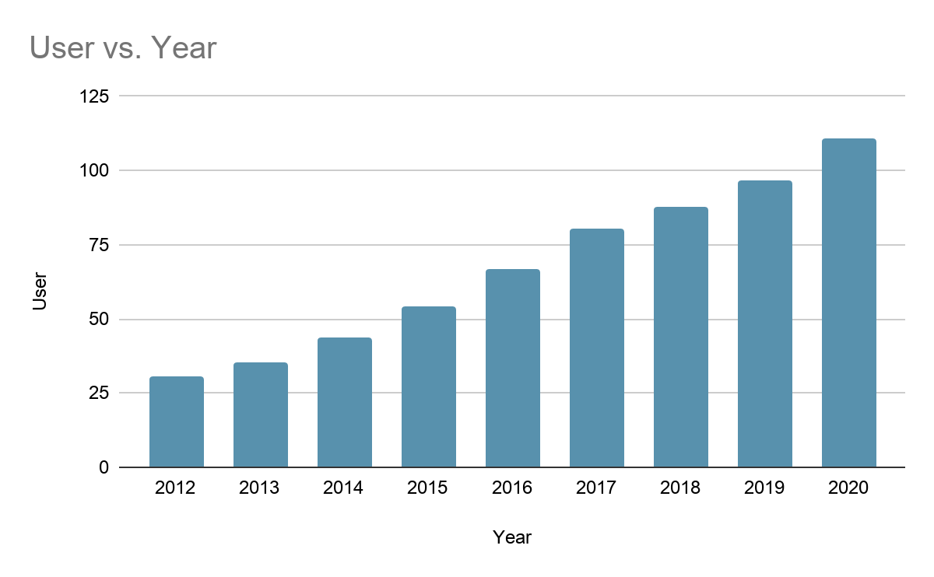
Table 1.1 Number of internet subscribers. (Users in millions)

This tremendous growth was possible because of cheap internet and affordable mobile devices that enabled Bangladeshis to connect with the internet.
In the 2013–2014-time frame, Bangladesh began its e-commerce journey. Banking, logistics, and payment methods have been enhanced over the years, allowing e-commerce to skyrocket in Bangladesh. The industry seems to be growing rapidly, although e-commerce is still at a very early stage in Bangladesh.
The Covid-19 pandemic caused governments to impose lockdowns on their citizens, but that did not stop their consumption. The pandemic has accelerated e-commerce growth and individuals have taken to online markets to buy the things they want. Online shoppers and online sales have increased by 70 to 80 percent compared to the general time, according to the Independent Bd.
Considering all the potentials e-commerce in Bangladesh has a bright future and to have a part in this we need to jump in straight way and DoorKnock allows us to have a shot at this opportunity. Our cross platform mobile application will be appealing to a wide range of users as its user-friendly interface and our commitment to quality will ensure the users of an amazing shopping experience.

1.2 Motivation
They have gone online because COVID-19 has forced consumers to stay at home. Therefore, e-commerce has seen rising demand in Bangladesh and around the globe. In comparison to the regular time, demand for online shopping has increased by 70 to 80 percent. More than ever, millions of individuals find it safe and convenient to buy products online now.
According to the German-based Statista research institute, Bangladesh's e-commerce market is estimated to reach $2.077 million in 2020 and $3.077 million by 2023.
With all this potential, the e-commerce industry did not deliver what it should have. Consumers often complain about the quality of the products and their product not being delivered in time and many other kinds of scams. Considering the huge opportunity and all the customer feedback we decided we would launch a mobile application that would allow consumers to have a satisfying experience with a user-friendly way to shop and get to buy quality products.
Our motivation is driven by the need to deliver the people of Bangladesh with world class shopping experience through our mobile application. And our neighboring countries are doing better than us in the e-commerce sector. These reasons pushed us to start developing the application and the COVID-19 pandemic has accelerated the need for us to make this application. And to compete with other apps of its category Making this app as a template for future e-commerce apps.

1.3 Objectives
Our objective for this project can be understood by the name of our project “DoorKnock”. We want to deliver products on the doorstep of consumers without them worrying about going out and shopping at ease from the safety of their home.
We want to develop a production ready e-commerce app with a stable backend. We are making the app as user friendly as possible with a beautiful user interface. We are using flutter (a cross platform framework made by google) for the frontend and PHP for the backend. We will achieve a beautiful and stable user-friendly e-commerce application. As the world is in midst of a pandemic the dependence on technologies to deliver smart solutions to our everyday problem is needed.
The fundamental point of the undertaking is to compete with other similar apps in the market and be a template for future e-commerce applications while delivering users with an exceptional experience where they can trust us as that is not present in the current e-commerce scenario of Bangladesh. To avoid being deceived and providing poor quality products, we are making this application for customers.
Bangladesh's e-commerce is still in an early stage of its development compared to many developed countries. Many applications let the orders be placed through online, but they take the payment in cash, they call this cash on delivery which is against the ideology of online shopping. That's why we are implementing sslcommerz to make payments online. And even if the order is placed online, sometimes the user has to call to ensure the order is placed. We are working to get rid of these unnecessary steps to ensure the user has a smooth experience.
There is some similar application in Bangladeshi market, but we tried to make a better application and a user-friendly interface the quality services.

1.4 Expected Outcome
We have designed the project to work on both android and iOS devices as we have used flutter which is a framework from google. This cross-platform ability will ensure a wide range of users. We expect to achieve these following outcomes:
- Easy access to install the .apk or. ipa as we plan to release the application on Appstore and play store.
- Have an appealing UI to explore through the application for the consumers.
- To have a user sign up system that will help them keep track of their inventory.
- Easy searching for items users wants.
- Reliable checkout method using SSLCOMMERZ

1.5 Report layout
We have addressed our inspiration, intent and what we expect from this application in the first chapter of this project paper. The second chapter will focus on the background of this project and we have enlisted many other studies of this field and we talked about the challenges that come with this application.
Following that we have chapter three and four where we discuss requirement specifications and design specification of the application. Then in chapter five we are talking about implementing and testing the application.
After that, chapter six is about our application's impact on society, the environment and sustainability. And we are finally talking about the future scope of the application and discussing further areas in which our project can be enhanced and summarized.

CHAPTER 2

BACKGROUND

We will discuss the background of this application in this chapter. We will discuss e-commerce and how, in the 21st century, technologies like this can make life easier for people.

2.1 Introduction
Bangladesh started its E-commerce journey back in 2013 but back then people did not feel comfortable buying things online as they wanted to have a look and feel of the product they are to purchase. Recent advancement of the technologies and the pandemic has given a boost to the E-commerce space of Bangladesh. About 111 million internet users and online payment systems and the lockdowns for the pandemic opened up a lot of potential for e-commerce ventures. A lot of people in Bangladesh starting to trust the e-commerce sites do their shopping and this has a lot of factors behind it

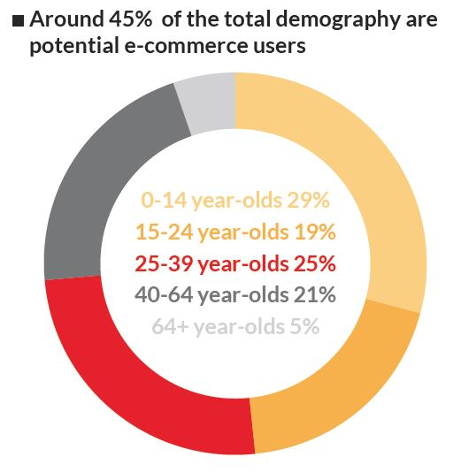
Table 1.2 Demography of e commerce users
As we can see from the graph the number of young people is driving the ecommerce sector to be successful ventures as they are putting their trust in us. It is our duty to uphold their trust.

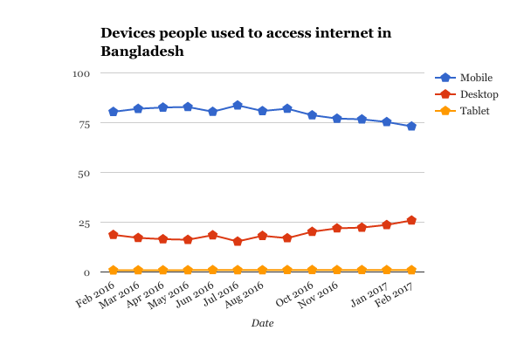
Table 1.3 Device people used
According to IDLC around 45 million users have smartphones as of December 2017. This is another driving factor behind the recent boom of e-commerce ventures. The traffic condition is another contributing factor as worsening traffic condition is motivating people to shop online.
And recent events such as COVID-19 is making people consider online shopping as a safer way to shop during this trying time.
Our application is focused on solving all these problems as we mean to make the shopping experience of the users a soothing one. We want to make the interface as user friendly as possible to navigate and give users a quality time to shop on our application as they face many challenges shopping online on other existing sites.

2.2 Benchmark Analysis
A lot of companies provide good shopping experiences for its consumers. If we do a quick google search, we can find a lot of similar works on the web. As technologies are evolving so is the way we handle many of our problems.

2.2.1 Bagdoom
It is one of most popular E-commerce websites in Bangladesh, they make sure to give every product that comes from the supplier a quality control check in their warehouse, and after receiving quality control certification their product is shipped to the consumers.
They also hold sessions with their supplier to make them more technologically able. These kinds of measures can dramatically enhance the experience of a consumer on their site.

2.2.2 Kiksha
Kiksha.com is working closely with their suppliers to have better storage management that will enable them to have better shipment of product without delay as managing the storage is a vital step to ship the product on due time. They are also working with online merchant panels to improve on their sales and figuring out ways to improve their inventory.

2.2.3 Pickaboo
Pickaboo is often seen on going on different social media platforms to answer queries of its consumers that enables them to better understand what the consumers want and by learning their faults they can fix those and consumers a better experience.
Many more related works that can be found on the web
- Daraz
- Penguin
- Evaly
- Rokomari
- Bikroy
- Sohoz

2.3 Comparative Studies
There are a lot of similar applications available in today's market in Bangladesh. But all the provide the same kind of services
App Name | Risk  free | Available in Appstore/play store | Free App | Fast Shipping
Evaly | ✖ | ✔ | ✔ | ✖
Penguin | ✔ | ✖ | ✖ | ✔
Pickaboo | ✖ | ✔ | ✔ | ✔
Bikroy | ✖ | ✔ | ✔ | ✖
DoorKnock | ✔ | ✔ | ✔ | ✔

This comparative table provides us with in depth comparison between existing e-commerce solutions and our application. It provides us with information about how risky it is to purchase from the company. How likely will it be shipped in time and if the app is free or app store or play store and their availability there.

2.4 Scope of the problem
We have noticed there are many aspects that are preventing the e-commerce space to grow in Bangladesh. Lack of customer satisfaction, bad reputation on quality of products, difficult to navigate mobile application and many other things. We figured if we address these problems, we can make a product that will be appealing to a lot of consumers in Bangladesh and that is why we built the application.
To make the E-commerce sector of Bangladesh a place for citizens to shop at without having to worry about anything we tried to develop this product.

2.5 Challenges
The ecommerce space in Bangladesh has many challenges that we must overcome to deliver an amazing product.
- Earning Credibility
E-commerce sites in Bangladesh have a reputation of not selling the products they advertise to sell. This trust issue from consumers end is a huge problem that the products they get delivered does not match to the product they saw at the time of purchase. That is why we need to ensure good quality control. Where consumers have trust in us.
- Logistics
Delivering a product to its rightful owner is an essential part of handing e-commerce solutions. This task of logistics is tricky in Bangladesh as the number of shipments often overwhelm the ecommerce companies. To ensure an amazing experience for the consumers we must tackle this challenge head on.
- Growing F-commerce
As of January 2019 Bangladesh, had 33.7 million active Facebook users. This huge number of users on Facebook meant that it is a big place to start a business. But people often get scammed on Facebook as it does not operate on a legal framework. These bad experiences make users stay away from ecommerce applications for their future shopping purpose.
- Funding
E-commerce in Bangladesh is at a very early stage of development compared to other developed countries and getting the capital to start e-commerce services is a tough job as lenders aren't familiar with this kind of business. Often companies with good potential fall of the race for a lack of funding for their venture.
- Human Resource
To become a full-fledged e-commerce company, we need people with the right set of skills to make this application a viable method for people to do their shopping online. But as this is a new sector there are not many people with those set of skills that are needed to operate an e-commerce company.

CHAPTER 3

Requirement Specification

3.1 Business Process Modeling
Each project requires design analysis so that it becomes much more user-friendly and includes our own in the same way. We just tried to navigate the ordered and well-designed scenario, and there was no complexity in it. We choose a high-end version of Android that can grab most of the device.
Below is a model of our project's business process.

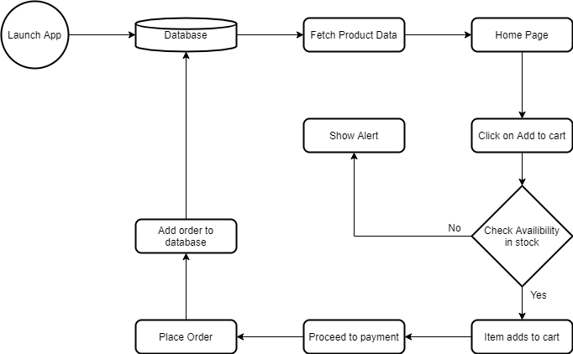

3.2 Requirement Collection and Analysis
We must meet so many requirements for our work. And we need some key requirements to build the application. Our specifications can be split into two types: software and hardware.

3.2.1 Software
The project involves structural research so that it becomes user-friendly and has one in the same manner. We just tried to navigate the ordered and well-designed scenario, and there was no complexity in it. We choose a high-end version of Android that can grab most of the device. Android 7.1.2 Nougat has been selected here. We need the accompanying software specifications for setting up the application:
- Operating System: Windows 8, Windows 7, Windows 10
- Language: Flutter SDK, Dart
- Tools: Visual Studio code IDE, Plug-in for VS Code
- Technologies utilized: Android, Dart

3.2.2 Hardware
We need the accompanying hardware specifications for constructing the application:
- Processor: P IV or higher RAM: 2 GB
- Space on plate(disk): least 512MB

For running the application:
- Device: Android adaptation 3.3.2 and higher
- Minimum space to execute: 20MB
- An advanced cell

3.3 Use Case Modeling and Description
Usage case diagrams are made up of musicians working, cases of use and their relations. The graph is used to illustrate an application's framework/subsystem. The basic utility of a system is captured by a solitary usage case map.

Usage case charts are used to assemble a framework's specifications, both internal and external consequences. For the most part, those prerequisites are systemic necessities. Therefore, as a system is broken down to assemble its functionality, use cases are ready and performers are separated.
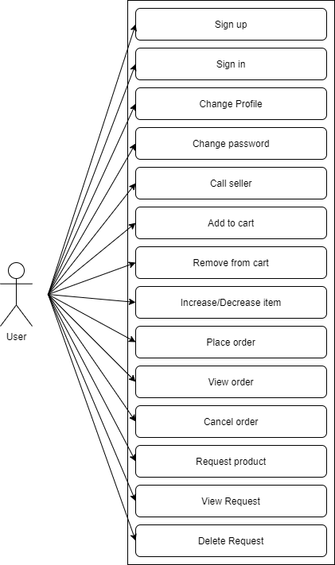

3.4 Logical Data Model
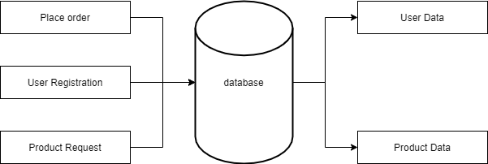

3.5 Design Requirements
A good design is important for designing this project. With a good project, any developer wants to do a good job and a good project relies a lot on its presentation. So, we are trying to make our "women's safety" project a user-friendly interface.

Chapter 4

Design Specification

4.1 Frontend Design
The frontend of our project is done with Google’s Flutter framework. Flutter is a cross platform frontend framework which is mainly widget based. Each element on the visible screen is a widget. For example: Button, Text Fields, Containers, Icons.
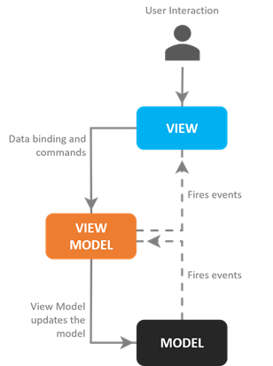

4.2 MVVM Architecture
Flutter is a very simple and easy to use framework but using it without a production grade architecture for large projects can lead to poor quality code and lack of work coordination for multiple sectors. One of the most used architectures used for frontend is MVVM architecture. MVVM Stands for Model View and View Model. As from the name of itself it has 3 core components, Model Classes which are for data modeling and handling data from database, View Classes which are used only for UI components without any business logic and the View Model Classes which are used for business logic for different classes.
There are lots of options to choose for a MVVM architecture because flutter is a rapidly growing framework, and a huge number of contributors are releasing and maintaining so many packages. There are packages like BLoC (Business Logic Component), Provider and Redux (Mostly used for State management) and many more. Flutter Stacked is a new but trending architecture package which is dependent with observable_ish and provider packages.

4.2.1 File structure for MVVM Architecture
The default location for storing flutter specific codes or in the other words for the dart codes it uses the lib folder. lib is the root folder for all the codes. For the rest of the codes there are specifying patterns to store them.
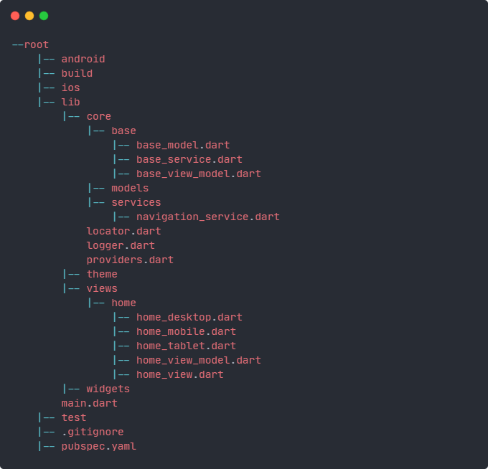

4.3 Implementation of Flutter Stacked Architecture
Flutter Stacked is a very simple architecture. Its foundation is based on 3 major parts, everything else is the developer's choice to implement. These parts are:
View: Shows the User Interface to the user. Single widgets also qualify as views, but if it is not a page then it is considered as a smart widget.
View Model: This Manages the state of the View, handles all the business logic, and any other services user interaction. It does everything by using services
Service: Service is a functionality or feature set. Services are used to code functionalities like database service, user authentication and many more.
Rules to follow:
- Views are restricted from using services directly, services can only be used from view models.
- Views should not contain any business logic. If the logic is only for the UI then we can use it inside the view class, but larger logic should be passed to the view model.
- View Models can be reused if the UI requires the same functionality, but that UI must be the direct child of the view model.
- One View Model should not know about other View Models

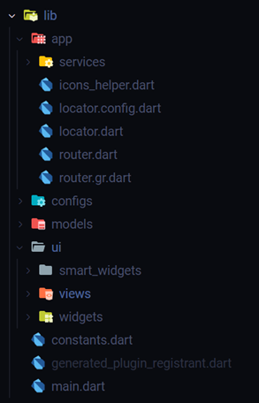

4.4 Backend Design
The frontend is only for users to interact with the data it receives from the backend. The frontend totally depends on the API it receives from the backend. The backend is built with PHP, an extremely popular backend server-side language and MySQL for databases.

4.4.1 Backend Architecture
Working with raw php is a very intensive task that is why there are a lot of frameworks like Laravel, CodeIgniter exists to get rid of the hassle. Choosing a framework was quite a hard task because there are so many options to choose from. But CodeIgniter is a good choice because it is easy to use and uses MVC architecture which is quite like the frontend MVVM architecture

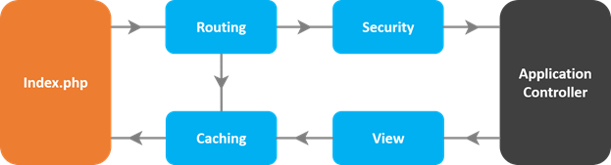

4.4.2 Folder Structure
CodeIgniter structure follows MVC pattern. The root folder is named application and inside it there are views, models and controllers with other libraries and services. This structure makes it easier to work with different files and it makes the task more organized.

4.5 MVC Architecture
Model View Controller pattern is a hugely used architecture for projects. It uses view to interact with the user and all the business logic is handled by the controller. The model class handles all the data modeling and database management. It also has services and helpers to extend the controllers functionality.
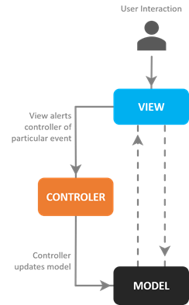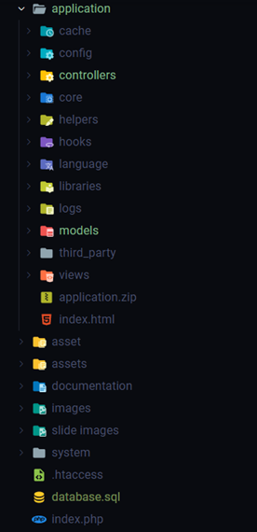

4.6 Interaction Design and UX
The design of User Interface and User experience is the first task before starting to code the application. So, changing UI and UX will increase the hassle of the developer. Also, consistency in design and user experience is necessary or else it will make the user confused. Also, a beautiful user interface will attract the user and increase the use of the app. Flutter is mostly known for its ability to make beautiful user interfaces and high performance for better user experience.
To make the project consistent and user friendly, rules that we followed are:
Simplicity: Keeping the app simple for the user. Cutting down all the unnecessary components that makes the user confused and using a standard and simple material design theme for familiarity for the user.
Responsive: The User Interface is responsive and adjusts itself automatically for different sizes of screens. The app adopts to both portrait and landscape mode for various size phones and tablets.
UI Consistency: Making the UI component consistent among all the screens to let the user easily get used to the interface. From the very first screen to the last every common element looks and behaves the same so the user will know what it will do.
Color: Avoiding excessive use of different colors to keep the UI consistent as well as better looking for the eyes. Used popular material palate to populate the color space for rendering eye catching UI.
Spacing and Scaling: Since the app will mostly run-on devices with touch as primary input the user interface and experience should have proper scaling and spacing to easily interact with different screen sizes.

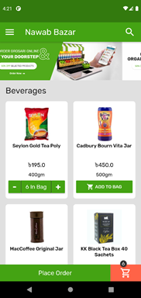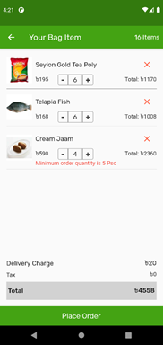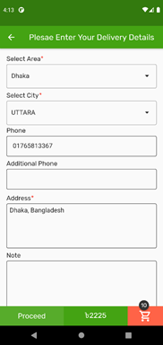

4.7 Implementation Requirements
For the development process of this project the following requirements needed to be fulfilled:
- IDE
- Android SDK
- Flutter SDK
- Flutter environment
- Flutter Plugin for IDE
- Dependencies

4.7.1 IDE
Integrated development environment for writing the code. There are many options to choose. Two of the most popular IDE’s for flutter development are Android Studio and Visual Studio Code.

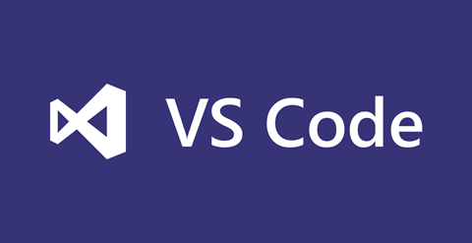

4.7.2 Flutter SDK
Flutter SDK is available at https://flutter.dev/docs/get-started/install . Flutter SDK is necessary to write and run dart code. The SDK also contains the compiler for dart so dart is auto installed with flutter SDK.
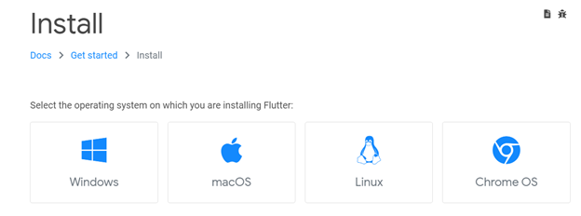

4.7.3 Android SDK
Android SDK is required to build and run flutter code for android devices. Flutter is cross platform, so it also supports iOS. But for android builds the android sdk must be set up. Using android studios sdk manager will help to automate the task.
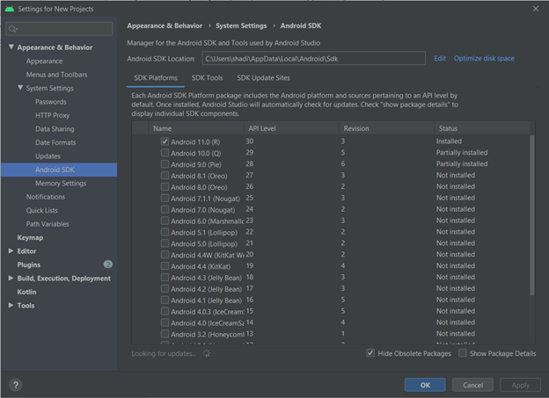

4.7.4 Flutter Plugin
Flutter and Dart plugin is required to start coding on the IDE. It has functionalities like snippets, autocomplete, debugging and many more. Flutter and Dart plugin are available for both Android studio and VS Code.
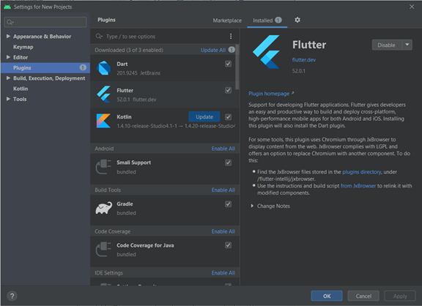
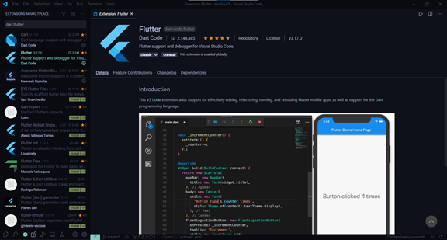

4.7.5 Flutter Environment
The machine should know about the flutter ad dart path add variables to start building and compiling the code. On the environment variable setup of windows operating system, the path of Flutter SDK should be set up.
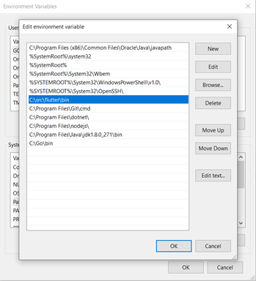
After all the setup is done, run the command ’flutter doctor’ to check everything is working.
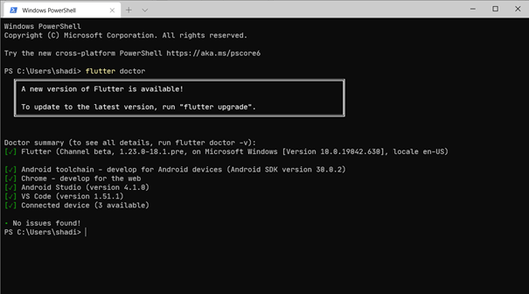

4.7.6 Emulator Setup
To run the app an emulator or physical device is necessary. Android studio comes with a virtual device manager to create emulators.
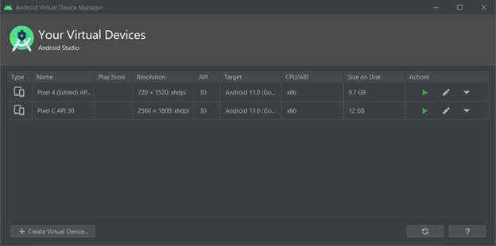
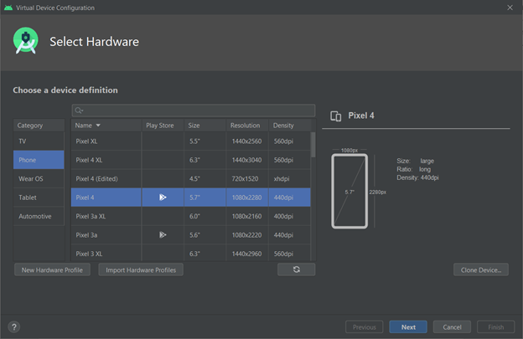

Chapter 5

Implementation and Testing

5.1 Implementation of Database
There are various types of databases to choose from. For No Sequel Database there are services like MongoDB, Firebase and for Sequel databases there are services like MySQL, SQLite and many more. Choosing MySQL is a straightforward decision because it uses No Sequel Database which is rock solid and fast for doing complex queries from a large list of rows and it is very compatible with PHP and CodeIgniter framework.
XAMPP is a backend stack which will handle database and backend servers. XAMPP has MySQL and Apache built in so one program will take care of both the database and its server.


5.2 Designing the Database
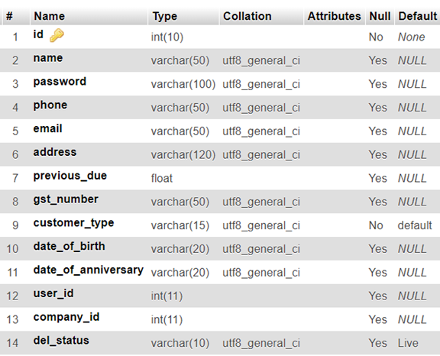
Customer Table
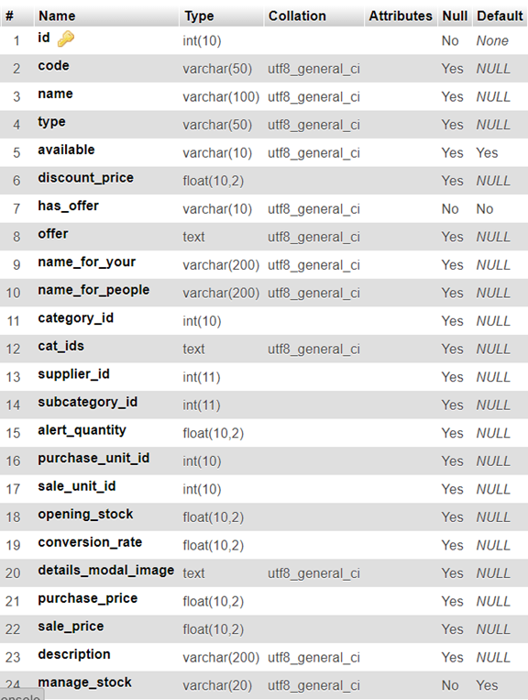
Products Table
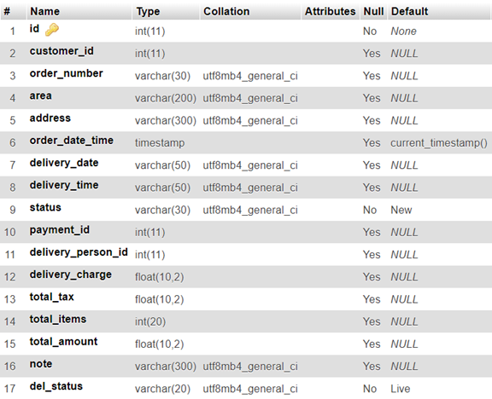
Order Table

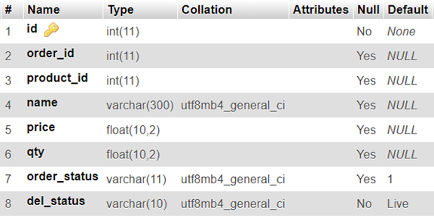
Order Items Table

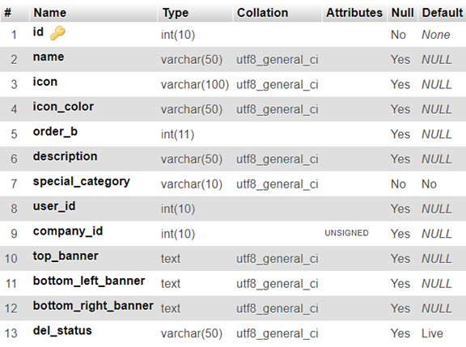
Product Categories

5.3 Storing and Reading data
The following function is an example of storing data into the database.
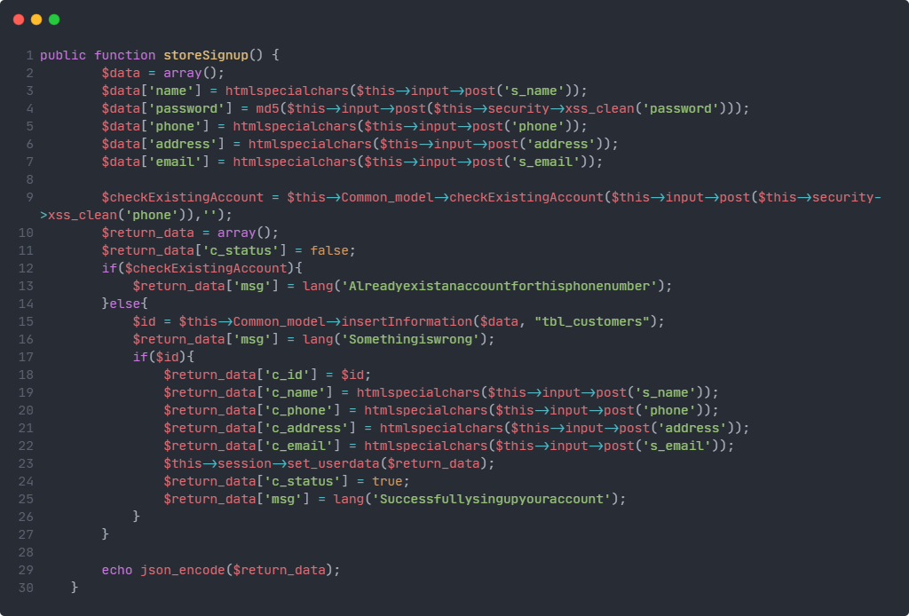
Store Sign Up Data
The following function reads data from the database for user login.
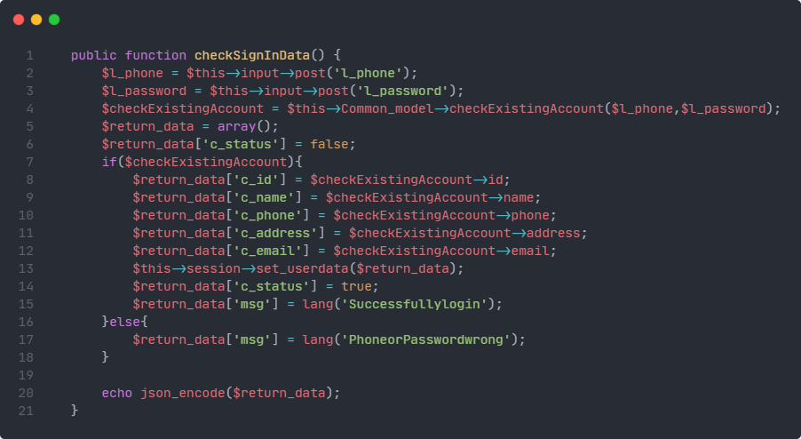
Check Sign in Data

5.4 Implementation of Frontend Design

5.4.1 Dependencies:
Mainly known as packages in the flutter community. Dependencies and packages are community contributed open-source libraries which extends the default library for better usability and functionalities.
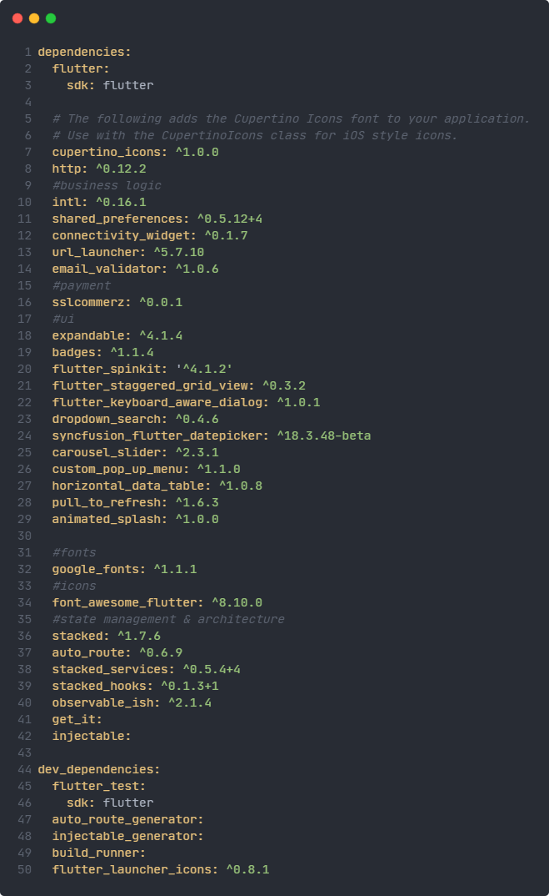
Run pub get to update or download all the required packages

5.4.2 Implementation of main function
Here is where the program will start. Like every other programming language, dart also starts from the main function. Inside the main function calling a runApp() function will start the material app.
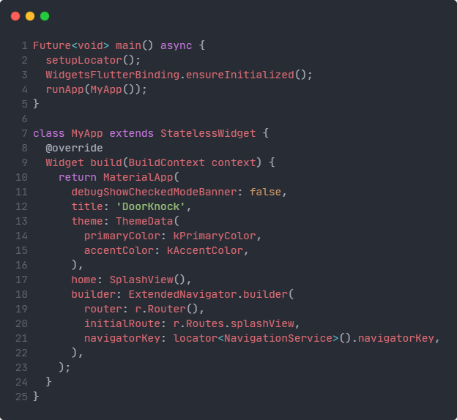

5.4.3 App Bar
The following code checks if the app bar is doing the searching work or not. If it is not searching, then it will show the app title.
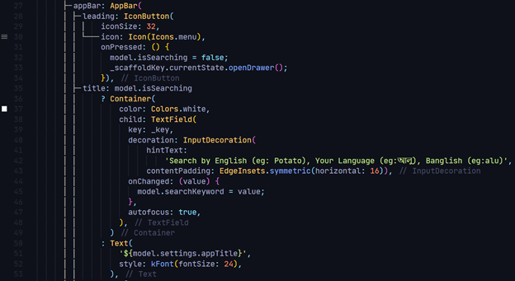

5.4.4 Drawer
Clicking on the hamburger menu on the left side of the app bar will open the drawer where there is an option to user authentication and product category selection.
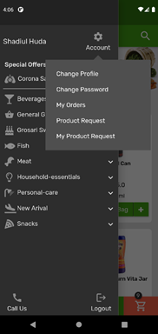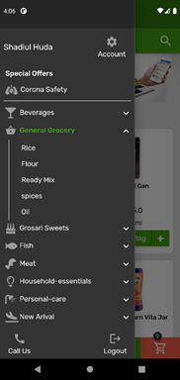

5.4.5 Sign in
Signing in into the app is an example of asynchronous programming. Signing into the app will let the user start purchasing products and order them. To let the sign in process start it first needs a model to load the user. The API returns a json array where specific user information is returned if the correct parameter is provided.
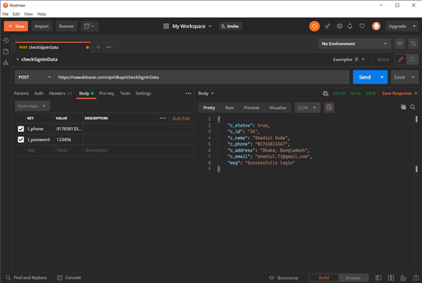
API data returned from the backend
This data needed to be assigned to the User Model class. The model will have a factor method which will populate the user class from the json data as per parameter.
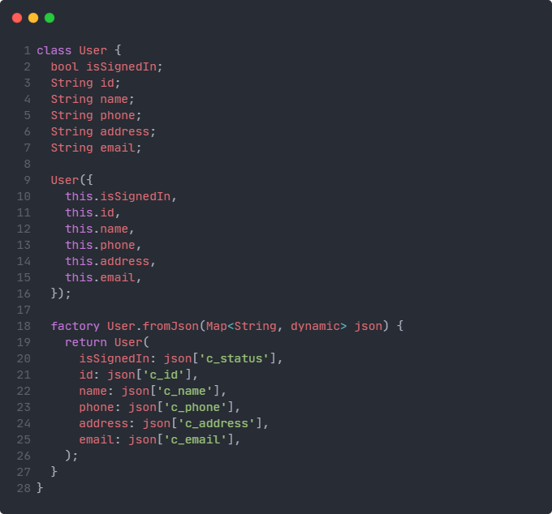
User Model Class
For handling user authentication through API, a service is required. Authentication Service will handle the communication. It will also use a shared preferences library to locally store user information for offline uses. The signIn() function will return the json and it will be provided to the factory function of the user class.
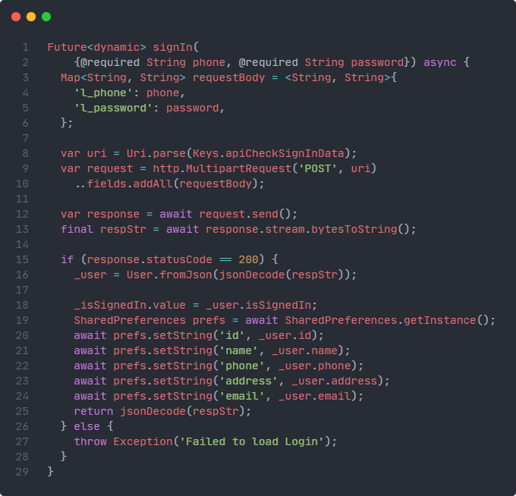

5.4.6 Authentication Services
To get user data the API must be called but before that for the parameter of the API it needs a form to get the phone number and password from the user.
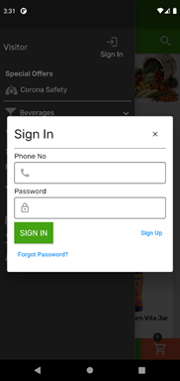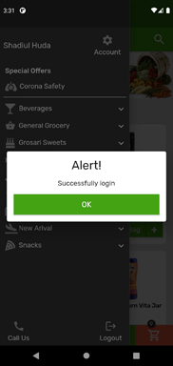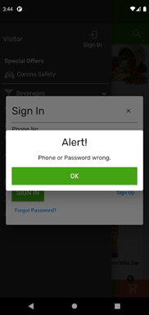
The ViewModel class of SignInView will handle all the business logic for its form and response. It should have an instance of authentication service. First it will check for form validation and then it will call the sign in method from the authentication service instance.
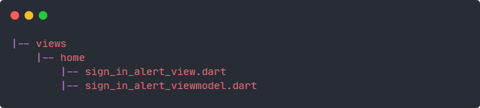
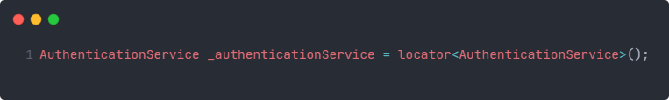

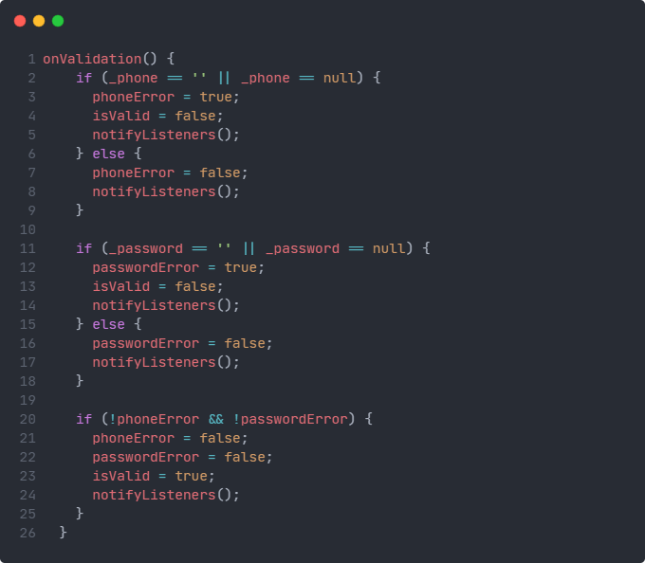
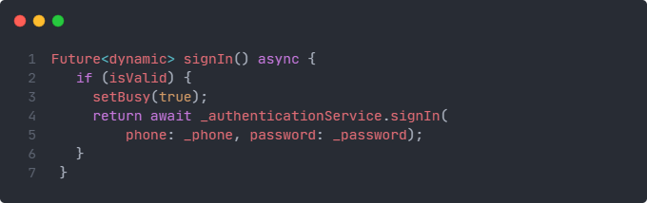 Sign in View Model Class

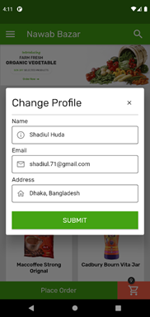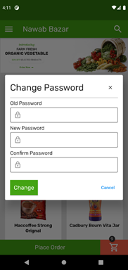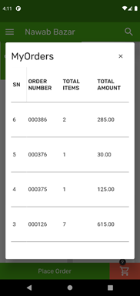
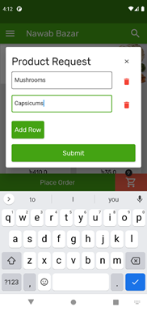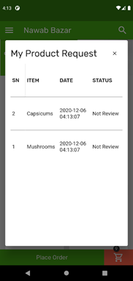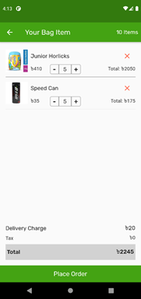
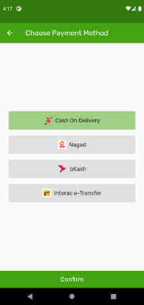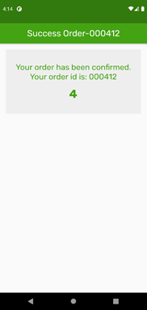

5.5 Testing Implementation
The project is populated with a huge number of UI components and backend logic to work with. All the logics should work perfectly to give the user a proper industry grade app experience. The Testing implementation will be done for both frontend and backend.
Since the frontend and backend are connected to each other so the business logic for both ends should work simultaneously. If one stops working the other one will also show incorrect results.
The frontend core functionality that must pass the test are:
- Products list
- Categories list
- Cart items
- Forms
- Buttons
- Alerts
- Cart
- Order Placement
- Drawer
- Navigation
- Services
The backend core services that must pass the test are:
- User Sign Up
- User Login
- User Change Profile
- User Orders
- Place Order
- Products
- Categories
- Item
The testing flow will be launching the app successfully, sign up the user then add some item to the cart. Later increase some item or remove some item from the cart and proceed to delivery details. After filling up the delivery details form the app should successfully place an order to the database.

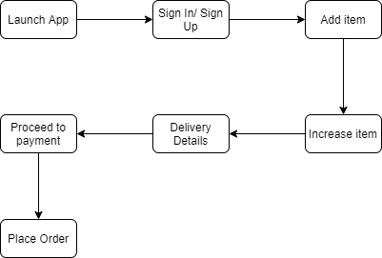

5.6 Test Results and Reports
Testing is done in a use case scenario. For every possible functionality it must pass through the process, taking it as the goal the testing phase began.
✔ = pass
✖ = fail
SN | Test Input | Expected Output | Actual Output | Result
1.1 | Click on app icon | Launch app | Launched the app | ✔
1.2 | Wait for network check | Return no internet screen if no internet or return home screen | Home Screen | ✔
1.3 | Click hamburger menu on app bar | Display the drawer | Opens Drawer | ✔
1.4 | Click on sign in button | Display Sign in dialog | Opens sign in form | ✔
2.1 | Click on sign in button without any form data | Show error message | Shows error for blank text field | ✔
2.2 | Click on sign in button with wrong phone and password data filled form | Show error message | Shows wrong phone or password | ✔
2.3 | Click on sign in button with proper phone and password data filled form | Show success message | Displayed success login alert | ✔
3.1 | Click on add to cart from any of the product card | Increase cart item count and replace add to cart with increase and decrease button | Cart item increased from 0 to 1 and button group appeared | ✔
3.2 | Click on place order | Navigate to cart screen | Opens cart screen with products added to the cart | ✔
4.1 | Click on place order | Show error message | Displayed alert with insufficient item added to cart | ✔
4.2 | Click on increase button multiple times | Increase cart item count and price | Cart item count increased to 5 and error text disappeared | ✔
4.3 | Click on place order | Navigate to delivery details screen | Opens delivery details from screen | ✔
5.1 | Click on proceed | Prevent from proceeding | Shows error text below all the empty fields | ✔
5.2 | Click on proceed with all the forms filled | Navigate to Payment method screen | Opens payment method picker screen | ✔
6.1 | Click on confirm button | Show error dialog | Displays error alert to select one payment method | ✔
6.2 | Click on a payment method | Change color of selected button | Color of selected button changed to light green | ✔
6.3 | Click on confirm button | Navigate to order complete screen | Opens order complete screen with payment id | ✔
6.4 | Wait for timer | Clear the navigation stack and open home screen | Counts for 5 seconds and navigates to home screen killing all the screen in the stack | ✔

CHAPTER 6

Impact on Society, Environment and Sustainability

6.1 Impact on Society
E-commerce will affect the society’s economy first. The economic system will change partially. Normally people go to market and can buy their needed product. Yet individuals do not need to go to the market with the aid of e-commerce. The basic economic transaction is the purchase of goods, and all other shift in this represents the control of the supply chain. The number of customers shopping online has usually grown, increasing the use of the internet.
Customers now visit too many blogs or check for the items they need on Google. And there are so many results they receive. Yet individuals do not have to take any sort of trouble with e-commerce.
People can be more productive. People get extra time for e-commerce to work productively. Which is important for the development of the society. Those who have disabilities, whether they are physically, and mentally challenged or old age people must struggle to go to market or shopping malls. This problem will be greater for those who are living greater distance from town.

Platforms for e-commerce are focused largely on internet networking. So, a website or smartphone device will require it. Web developers, marketing experts and search engine optimization specialists are wanted by companies.

6.2 Ethical Aspects
Almost every online payment system knows the customer identity. So, it is the most concerning matter to protect the identity of our customer. Monitoring e-mail and other activities make secure their identity. This type of monitoring customers raises some ethical issues about how an e-commerce provider can handle information securely and anonymously.
Some e-commerce platforms are doing email spamming which is totally unethical for a healthy economy. That spamming contains unwanted advertisement or other correspondence over the online system. Also, storing customer personal data is unethical.

6.3 Sustainability Plan
Sustainability does something that does not deplete renewable wealth and maintains the ecosystem equilibrium in the long run or internationally. So, for corporations, sustainability is the most important thing. Stakeholders who work more sustainably and ethically are inspired by sincere concern.

CHAPTER 7

Conclusion and Future Scope

7.1 Discussion and Conclusion
DoorKnock" is a mobile application that is user-friendly and very essential." An increased comprehension of users of formulas is the result of this initiative. With the aim of making things convenient and known with e-commerce and online shopping, we have launched this application.
Economic Feasibility:
• Developers can submit the app on Google play and earn from it.
• Can earn from advertising into the app.
• We can profit from retailers.

Behavioral Feasibility:
• Users can access this on any android or iPhone. Because this is built by cross-platform sdk.
• As users can search for desired items or commodities and application saves users data.
• It provides users with the best item without wasting lots of time finding and arranging them.

So, we think it is a very good program for people. As consumers use vast volumes of phones, the potential reach of this application is huge. We will be extending our operation outside of the country in the future.

7.2 Scope for Further Developments
We will develop this app in future for sure. There could be more important options in this application that can make this better. In the future we will be focused on developing our technology to make the user interface better.
Updated versions will continuously be uploaded in the marketplaces for users. This application is very important for people who are very busy in their daily life.
Everyone will be extremely dependable on technology in the future, and everyone will continue to like technology willingly. Our project would be more popular among girls and women at that time.
So fast in the future, we already have some plans to add some features to this app.
  - Promo code.
  - Selling option.
  - Using machine learning to suggest shopping list.
  - Using Artificial intelligence to suggest compatible other products.

7.3 Conclusion
During the testing implementation of our app we have tested the app with every possible functionality that we have mentioned before. The app was working without any flaw. We are very happy to develop such a useful application for the welfare of our society. As of now, the year is December,2020. The whole world has come to a stand-still due to the effect of COVID-19 pandemic. During this pandemic moment, the app is very much helpful for all sort of people as they will be able to get any of their necessary accessories of daily life with just some clicks. Maintaining social distancing is one of the safety measures to maintain properly. In order to maintain safe distance from people and following the health precautions, the app would be very helpful for the people of all kind.

We are hopeful for the app that the app has many features right now and in future more features will be coming forward then the app will be more user oriented.

References:
[1] Yan Jun Liu, Zu Peng Liu. Android Development and Mobile E-Commerce Research https://doi.org/10.4028/www.scientific.net/AMM.155-156.430
[2] Android guide, https://developer.android.com/guide, last accessed on may,27, 2018.
[3] https://idlc.com/mbr/article.php?id=136
[4]https://www.newagebd.net/article/114200/the-growth-of-e-commerce-during-the-pandemic-in-bangladesh
[5]https://www.thefinancialexpress.com.bd/views/views/e-commerce-in-bangladesh-where-are-we-headed-1578666791
[6] http://www.btrc.gov.bd/content/internet-subscribers-bangladesh-october-2020
[7] https://www.statista.com/study/48410/bangladesh/
[8] https://www.postman.com/use-cases/api-testing-automation/
[9] https://pub.dev

Plagiarism Report:

