

Department of Textile Engineering
Faculty of Engineering

Thesis report on

Comparison Between Carrier & High Temperature Disperse
Dyeing Method (compared the utility, color strength color fastness)

Course Code:TE-4214 Course Title: Project (Thesis)

Supervised By:

Md.Kamrul Islam
Lecturer
Department of Textile Engineering
Daffodil International University

Prepared By:

Name | ID
Arnab Golder | 141-23-3758
Sadequr Rahman | 172-23-365
Samiul Islam Sawon | 171-23-298

Advance in Wet Processing Technology
Fall-2020

DECLARATION

We sincerely declare that, this Project thesis has been done by under the supervision of Md Kamrul Islam, Lecturer, Department of Textile Engineering Faculty of Engineering Daffodil International University. We also announce that, neither this project nor any portion of this project has been submitted anywhere for award of any degree or diploma.

Submitted by:
______________________
Arnab Golder
ID:141-23-3758
Department of TE
Daffodil International University
______________________
Sadequr Rahman
ID:172-23-365
Department of TE
Daffodil International University
______________________
Samiul Islam Sawon
ID:171-23-298
Department of TE
Daffodil International University

©Daffodil International University

LETTER OF APPROVAL

This project made by Arnab Golder (141-23-3758), Sadequr Rahman(172-23-365),Samiul Islam Sawon (171-23-298) is authorized in partial fulfillment of the requirement for the degree of BACHELOR OF SCIENCE IN TEXTILE ENGINEERING. The students have completed their project work under my supervision. During the research period I found them sincere, hardworking and glowing.

Md Kamrul Islam
Lecturer
Department of Textile Engineering
Daffodil International University

©Daffodil International University

ACKNOWLEDGEMENT
At first our gratitude goes to the Almighty God to give us strength and ability to complete the Thesis and this report. We have respected teacher Md.Kamrul Islam Lecturer, Department of Textile Engineering, Daffodil International University” for his worthy suggestion, encouragement formative criticism and for providing all essential supports to complete our thesis.
We would like to express Md Mominur Rahman, Head of the Department of Textile Engineering, Daffodil International University” for their incessant leading about the project and advice to prepare a report about the project. We would like to express our thanks to Professors for providing us fundamental actuality to complete this thesis. We got the most luscious scope and consider it a rare chance to work under them. Last but not least, thanks go to our precious family for their never ending love and encourage at every stage of our life. Without their continuous corroboration we realize that we would not be a person we are right now.

©Daffodil International University

ABSTRACT

The goal of our undertaking was to look at among changed coloring strategies for polyester texture with scatter colors. From the outset, the polyester textures (weave and woven) were colored with scatter colors. Three techniques have been utilized for coloring polyester textures:

1. Aqueous coloring with a transporter (90°-100°C) (batch dyeing)
2. High-temperature (180°-210°C) fluid coloring (batch dyeing)

After coloring the colored example were exposed to several tests-

1. Color quickness to perspiration.
2. Color quickness to rubbing.
3. Color quickness to washing
4. Process effectiveness
5. Cost analysis

At long last from the general examination for various cycles, we found that the High Temperature and High-Pressure strategy is the most appropriate coloring technique utilized in industrial production.

©Daffodil International University

Table of contents:
Abstract 5

Chapter 1:

GENERAL INTRODUTION …………………………….……………8

Objectives of our Project……………………………….………………9

Chapter 2:

LITERATURE REVIEW………………………………………….10-11

2.1 EXPERIMENTAL ……………………………………………12-14

Chapter 3:

MATERIALS AND METHODS……………………….……………..15

3.1 List of dyes & chemicals ………………………………………….16

3.2.1 CARRIER DYEING METHOD ………….…………………17-18

3.2.2 Sample for Carrier Dyeing ………………………………...……19

3.2.3 Recipe for Carrier Dyeing ……………………………...……19-21

3.2.4 Procedure of Carrera Dyeing………………………………........22

3.2.5 Process flowchart of carrier method ……………………………22

3.2.6 Dyeing Curve …………………………………………...………23

3.2.7 After treatment ……………………………………….…………23

3.2.8 Advantage of Carrier Dyeing ……………………………...……24

3.2.9 Disadvantage of Carrier Dyeing ………………………..………24

3.3.1 High Temperature Dyeing Method…..…………………………25

3.3.2 Sample ……………………………………………………….…25

3.3.3 Recipe for High temperature…………………………………24-27

3.3.4 Process flowchart of High temperature ……………………….…28

3.3.5 Dyeing Curve …………………………………………………...28

3.3.6 Procedure High temperature ………………………………….…29

3.3.7 Reduction cleaning ……………………………………………..…29

3.3.8 Advantage of HT methodology temperature ……………………30

3.3.8 Advantage of HT methodology temperature ……………….…30
3.4 Different Color Fastness Tests…………………………………………30-37

©Daffodil International University

Chapter 4: Result and Discussions………………………..38-41

Chapter 5: Conclusion……………………………………..42-43

©Daffodil International University

CHAPTER-01
GENERAL INTRODUCTION

The project work, that builds understanding, talent & angle of the performing artist, that improves his data in boosting productivity & services. Thesis work provides United States large theoretical likewise as a lot of sensible knowledge; that helps United States to be accustomed to technical support of recent technology, skillness regarding varied process stages.

Our project work is Comparative Study Among completely different colouring strategies of Polyester material with Disperse Dyes. to finish this project work effectively we've to grasp regarding some small print, like: polyester, disperse dyes, colouring parameters, colouring strategies & therefore on. Now-a-days polyester is employed extensively in textile field. To be professional in polyester colouring it's necessary to grasp regarding the result of parameters on colouring polyester material with disperse dyes. therefore, our project work is a good one.

Disperse colouring is perhaps the simplest delineate as an industrial art, having an assured future. the complete gamut of change the disperse category of dyes that is one in all its vital blessings, is obtained by using a large vary of chromophores. The introduction of disperse dyes for Polyester fibres has given the skilled worker the likelihood of victimization only 1 sort of dye & easy application conditions, in situ of the advanced permutations necessary at just once.

We have ready this report sincerely as needed on completion of our project work in line with the rule given by our direction teacher, which can result in a powerful guideline & milestone for our future carrier.

©Daffodil International University

Objectives of our Project

- To Find out the color strength.
- To Find out the color fastness.
- To Find out the utlity.
- To search out the comparison.

©Daffodil International University

CHAPTER-02


LITERATURE REVIEW

©Daffodil International University
The coloring of polyester microfibers with each high energy and low energy disperse dyes has been investigated. The results show the speed of exhaustion on these fibers ar a lot of speedy than on regular polyester fibres with no corresponding increase within the color yield. With the low energy dye, a large fluctuation within the quantity of dye exhausted throughout coloring was determined. it's postulated that changes within the degree of crystallinity of small fibers might attribute to such phenomenon [3-4].

Since their emergence within the late Eighties, materials created by polyester microfibre before long found quality within the production of causative wear, performance dress, wind-proof and waterrepellent outwear, imitation peach skin and suede. In general, microfibre refers to fibre having a fineness of but one.0 denier and also the ones below zero.3 denier ar typically delineated as supermicro-fibres (Leadbetter & Dervan, 1992). materials made up of polyester microfibre ar skinny, light, compact with god draping and handle properties. In most cases, such materials ar factory-made by a mixture of fibres with totally different deniers so as to compromise their individual characteristic properties.[3]

It is accepted that a bigger quantity of dye is critical to provide a particular color depth for polyester microfibre than for the regular ones. This development is believed to be caused by the larger extent that will increase surface lightweight reflection and a shorter path for lightweight absorbance thanks to the smaller fibre diameter. For constant dye, each the exhaustion rate associate degreed temperature to achieve to an equal depth on fibres of various fineness ar similar, though a bigger quantity of dye is required for finer fibres (Akatani, 1994). the quantity of dye required to provide a particular color depth was found to be roughly proportional to the extent of the fibre (Jerg & Baumann, 1990). supported the several filament fineness of the microfibres, it's attainable to estimate the quantity of dye to provide an even depth (Chong, 1994). it absolutely was conjointly 'observed that with microfibres the utmost color yield is typically achieved at a relatively lower temperature than that with regular (Hoechst Mitsubibishi Kasei Co. Ltd,1993).
This paper describes an in depth study of the parameters that influence the coloring properties of polyester microfibre. Findings from this study offer a more robust understanding of the various behaviour of the coloring correctties between regular and microfibre polyesters and will kind a firm basis for the look of proper process ways and precautions necessary to realize smart coloring qualities. behaviour of the coloring correctties between regular and microfibre polyesters and will kind a European basis for the look of proper process ways and precautions necessary to realize smart coloring qualities.[3,6,7]

©Daffodil International University

2.1 EXPERIMENTAL

Material Polyester flat filaments with deniers of zero.52, 0.55, 1.04, 2.35 and rough filament with fineness of four.16 denier were used. Before coloring, additives were removed by treating the filaments with one gil of associate degree detergent and one gil of hydroxide at 90°C for half-hour followed by rinse with plight till the pH scale of the rinse water was neutral.

Following figure one shows the exhaustion of CI Disperse Blue eighty-seven (high energy dye) on polyester of various filament deniers throughout coloring and at the coloring temperature of 130°C for twenty minutes.

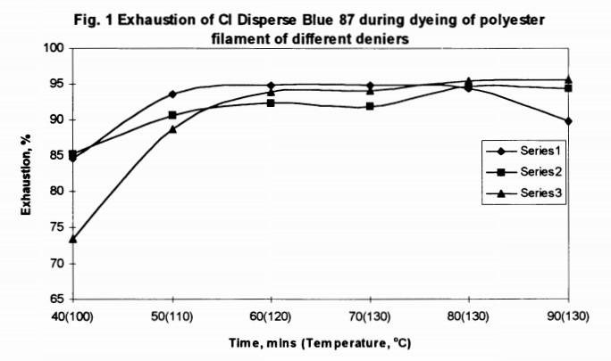

Fig. 1 Exhaustion of CI Disperse Blue during dyeing of polyester filament of different deniers

It may be determined that below identical coloring conditions, exhaustion of the dye on polyester of various deniers don't seem to be constant. it's apparent that coarser fibers adsorb ate dye a lot of slowly at lower temperatures and it earned a most exhaustion at 130°C. the utmost exhaustion remained a lot of or less constant throughout coloring at 130°C. With finer filaments, however, most exhaustion is earned at lower temperatures between 120-130°C and also the most exhaustion born and fluctuated at the coloring temperature of 130°C.
To more investigate the importance of dye exhaustion characteristics, this high energy dye along with a coffee energy dye (CI Disperse Blue 138) were accustomed dye a zero. S2 denier filament. Results shown on Fig. two indicate that the high energy dye achieved its most exhaustion at 120°C followed by a gradual decrease with solely slight fluctuation once the coloring was prolonged at 130°C. With the low energy dye, the exhaustion fluctuated rather more wide before reaching the ultimate coloring temperature at 130°C. the ultimate exhaustion was found to be a lot of below the utmost and is looking on the temperature and also the time at that the coloring is terminated. [3]
In a shot to seek outthe connection between the ultimate coloring temperature and also the most dye exhaustion of polyester microfibre, the 2 selected disperse dyes were accustomed dye a zero.52 den fibre below totally different temperatures and also the results ar shown on Fig. 2

©Daffodil International University

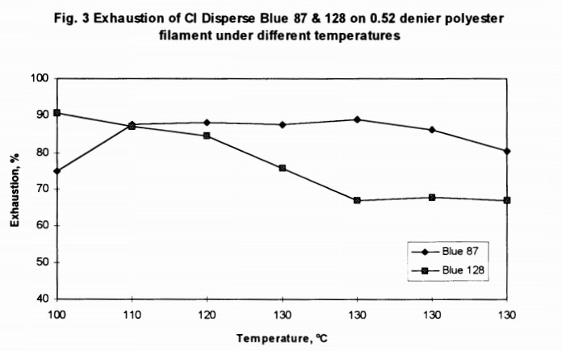

Fig. 2 Exhaustion of CI Disperse Blue on polyester filament under different Temperatures

It may be seen that regardless of the kinds of dye used, the utmost exhaustion were earned at temperatures starting from one hundred - 110°C. on the far side this vary, the exhaustion reduced with increasing temperature. The low energy disperse dye, that is characterized by the next rate of diffusion, showed a far higher dependency at the upper temperature vary. It seems that a lower coloring temperature would be a lot of favourable for this kind of dyes.
Fig. 4. shows the exhaustion of C.I. Disperse Blue 128 on zero.52 den. fibre at totally different time below the coloring temperatures of 100°C and 130°C severally.[2,7,3]

When unreal at 100°C, the exhaustion of the dye remained fairly constant once the coloring was prolonged. However, once unreal at 130°C, the exhaustion born throughout the prolonged amount though it rose once more at a latter stage. If coloring was to terminate at sixty min. when reaching 130°C, then the ultimate exhaustion achieved would be a lot of below its most.
Since crystallinity plays a crucial role within the exhaustion behaviour of polyester, the crystallinity of 4 selected polyester fibres were determined and also the results ar shown on Table one.

Results clearly indicate that the finer the polyester is, the upper the degree of crystallinity would become. Thus, crystallinity is perhaps not a significant contributive issue to the augmented rate of exhaustion of microfibres throughout coloring. it's believed that an outsized extent of those fibres for dye sorption is that the main cause to account for the quicker rate of exhaustion.
The higher than have incontestable that the exhaustion of a disperse dye would fluctuate throughout the coloring, notably once employing a low energy disperse dye unreal below hot temperature. For a coloring time of hr, the exhaustion of a coffee energy disperse dye at 100°C may well be a lot of over that achieved at 130°C. However, since the color yield achieved isn't entirely addicted to the exhaustion and is ruled by the degree of dye penetration, the color depth of those coloring were conjointly investigated. Fig. five shows the K/S values of coloring, exploitation constant dye, obtained for various time of coloring at 100°C and 130°C severally.

©Daffodil International University
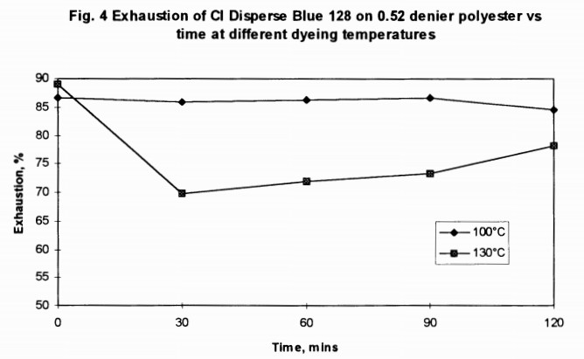
Fig. 3 Exhaustion of Disperse Blue on polyester vs time at different dyeing temperatures

Apparently, the color yield or K/S values for coloring at 130°C augmented with the primary half-hour when reaching the coloring temperature. the color yield achieved when half-hour is way over that achieved at 100°C and is regardless of the corresponding fluctuation within
the exhaustion throughout constant amount. On the opposite hand, once coloring was applied at
100°C, the color yield or K/S values vary solely slightly and that they coincided closely with the corresponding exhaustion. This development may be thanks to the changes within the degree of dye penetration throughout coloring at the indicated temperature. coloring at high temperatures might cause the natural action of dyes from the big surface of microfibre and at constant time might promote the diffusion of disperse dye into the fibre interior. In different words, the lower color yield achieved for coloring at 100°C despite the upper exhaustion is principally attributed to the inadequate dye diffusion. Indeed, more heat treatment at the next temperature for microfibre material unreal at 100°C will significantly improve its color yield.[3]
In the investigation of the changes in fibre crystallinity throughout coloring on fibres of various fineness, it's attention-grabbing to notice that fibre crystallinity conjointly fluctuates throughout each the heatingup and coloring phases of coloring. Fig. half dozen shows the changes in fibre crystallinity throughout coloring of fibres of various fineness. It clearly shows that finer fibres ar a lot of subjected to crystallinity changes than coarser fibres. Therefore, the changes in fibre crystallinity throughout coloring might offer the solution accounting for the fluctuation in dye exhaustion. Indeed, this might conjointly justify the larger degree of fluctuation in exhaustion in dye exhaustion. Indeed, this might conjointly justify the larger degree of fluctuation in exhaustion for the low energy disperse dyes since they're a lot of sensitive to the degree of fibre crystallinity.
Certainly, the changes within the fibre crystallinity throughout coloring would depend upon the temperature utilized in coloring.
Fig. seven shows the changes in fibre crystallinity throughout coloring once dyeings were conducted severally at 130°C and 100°C on a fine fibre of zero.52 den. Apparently, the changes in fibre crystallinity is incredibly exceptional only if coloring was conducted at 130°C. This correlates well with the changes in dye exhaustion throughout coloring (refer to Fig. 4)
In the DSC study, it absolutely was conjointly detected that once a zero.52 den fibre is unreal at 130°C - a temperature over the Tg of the fibre, it caused the Tg of the fibre to shift from 120°C to 160°C. this modification didn't occur once coloring was conducted at 100°C. it's believed that such modification is thanks to the rise within the quality of -the chain segments that resulted In organisation of the organic structure of the chemical compound. [1,7]

©Daffodil International University

CHAPTER-03


MATERIALS AND METHODS

©Daffodil International University

3.1 List of dyes & chemicals which are used in our project work

Sl no | Name | Commercial name | Supplier
1 | Disperse dye (yellow) | Hellocron HW- 6G | Siam Pro Dyechem Group
2 | Disperse dye (red) | Hellocron HW- 2G | Siam Pro Dyechem Group
3 | Disperse dye (Blue) | Hellocron HW- 2G | Siam Pro Dyechem Group

©Daffodil International University

3.2.1 CARRIER DYEING METHOD
It has been established that bound with hydrocarbons, phenols, amino acids, amides, alcohols, esters, ketones, nitriles etc. accelerate the speed of coloring polyester fibre with disperse dyes from liquid medium at temperature up to 100°C. These coloring assistants alter the dispersing properties of the dyes and therefore the physical characteristics of the fibre in order that a lot of dye will be transferred from the dye tub to the fibre. These area unit known as carriers and area unit necessary for coloring polyester fibres at the traditional pressure and temperature below 100°C to extend the coloring rate and to allow dye migration at intervals the fibre. Level coloring of disperse dyes depend upon the migration power of the dye that is plagued by nature and quantity of carrier, coloring time, temperature and therefore the shade

Factors thought-about for choosing a Carrier:

1. High carrier potency.
2. Handiness at low value.
3. Very little or no result on light-weight fastness of ultimate coloring.
4. Absence of unpleasant odor.
5. Non toxicity.
6. No degradation or discolouration of fibre.
7. Easy removal when coloring.
8. High stability beneath coloring conditions.
9. Compatibility with dyestuffs.
10. Easy dispersion within the dye tub.
11. Low volatility of the carrier together with low volatility within the steam.
12. Uniform absorption by the fibre.

Mechanism of Carrier Action:
In carrier methodology of polyester coloring, carrier is employed. Carriers swell the fibre and ultimately cause relaxation. They will operate by gap up the inner fibre structure and permit the dye molecules to diffuse sooner. They act as molecular lubricants reducing inter-molecular forces in operation within the fibre, thereby following the dye molecule to force its means in. Its action could also be represented as below:
1. It creates dye film on fibre surface.
2. Carrier takes dye within the fibre from dye carrier association.
3. It will increase the solubility of dye within the dye tub.
4. Carriers penetrate within the fibre chemical compound chain and thereby scale
back inter-chain attraction. therefore chemical compound chains become movable
so dye molecules could enter the chemical compound system of fibre.

©Daffodil International University
5. It will increase fibre swelling.
6. The absorbed carrier will increase the speed of dye uptake by making liquid co-fibre
7. It will increase the permeableness power of fibre.
8. It lubricates the thermally agitated fibre molecules.
9. 2-10 gm/lit carrier is employed looking on material and liquor quantitative relation and depth of shade.
10. the automated portion of carrier is postulated to own Van Der Waal’s force and attraction for hydrophobic cluster of it attracts water.
11. With increasing mass the carrier potency additionally will increase up to a definite limit.

The extreme crystalline nature of polyester fibres creates issues in getting dark shades by typical coloring ways even at warmth. The carriers area unit found to help the disperse dyes to enter the polyester chemical compound, enabling dark shades to be made. The carriers swell the polyester fibres, increase bury chemical compound house and let the dye molecules to enter the chemical compound system simply.

©Daffodil International University

3.2.2 Sample For Carrier Dyeing:

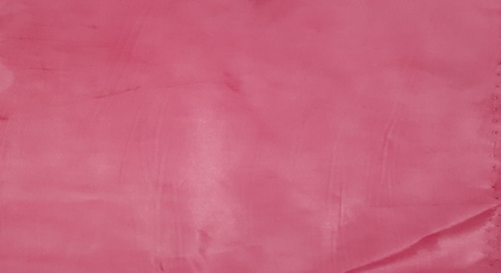
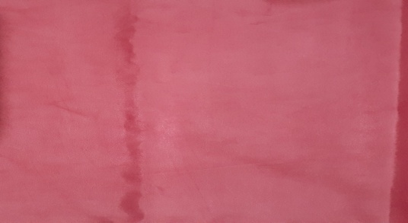

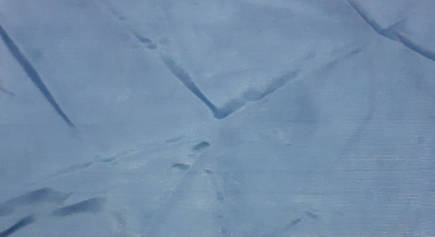
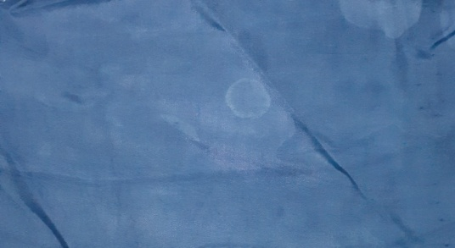

Dark Shade Light Shade

3.2.3 Recipe:

- Red deep shade:

Dyes(disperse)& Auxiliaries | Unit
Yellow | 12g/L
Red | 25g/L
Dispersing agent | 4g/L
Carrier | 2g/L
Levelling agent | 20ml/L
Sequestering agent | 3oml/L
Anti-creasing agent | 10ml/L
pH | 4-4.5
Time | 20min
Temperature | (100-120)◦C

©Daffodil International University

- Blue deep shade

Dyes(disperse) & Auxiliaries | Unit
Yellow | 2g/L
Red | 4g/L
Blue | 20g/L
Dispersing agent | 4g/L
Carrier | 2g/L
Levelling agent | 20ml/L
Sequestering agent | 3oml/L
Anti-creasing agent | 10ml/L
pH | 4.5-5
Time | 20min
Temperature | (100-120)◦C

Grading:

Color fastness of deep shade (Red & Blue)
1. Color fastness to rubbing rating grade (4)
2. Color fastness perspiration:
Acid rating grade (3-4)
Alkali rating grade (3-4)
Water rating grade (4-5)
3. Color fastness to wash rating grade (3-4)

- Red light shade

Dyes(disperse) & Auxiliaries | Unit
Yellow | 4.8g/L
Red | 10g/L
Dispersing agent | 5g/L
Carrier | 2g/L
Levelling agent | 30ml/L
Sequestering agent | 30ml/L
Anti creasing agent | 10ml/L
pH | 4.5-5
Time | 20min
Temperature | (100-120)◦C

©Daffodil International University

4. Blue light shade

Dyes(disperse) & Auxiliaries | Unit
Yellow | .8g/L
Red | 1.6g/L
Blue | 8g/l
Dispersing agent | 4g/L
Carrier | 2g/L
Levelling agent | 30ml/L
Sequestering agent | 30ml/L
Anti creasing agent | 10ml/L
pH | 4.5-5
Time | 20min
Temperature | (100-120)◦C

Grading:

Color fastness of light shade (Red & Blue)

1. Color fastness to rubbing rating grade (4-5)
2. Color fastness perspiration:
Acid rating grade (4)
Alkali rating grade (4)
Water rating grade (4-5)
3. Color fastness to wash rating grade (3-4)

©Daffodil International University

3.2.4 Procedure of Carrera Dyeing

- From the outset, a glue of color and scattering specialist is arranged and afterward water is added to it.
- Dye bathtub is unbroken at 60°C temperature and every one the chemicals in conjunction with the fabric square measure additional thereto. Then the tub is unbroken for fifteen min while not raising the temperature.
- pH of bathtub is controlled by carboxylic acid at 4-4.5.
- Currently temperature of dye bathtub is raised to (100-120)°C and at that temperature the tub is unbroken for Twenty min.
- Then temperature is down to 60°C and resist and reduction improvement is completed if needed. Reduction improvement is completed solely to enhance the wash fastness.
- Material is once more rinsed well once reduction improvement then dried.

3.2.5 Processes flowchart of carrier method:

Need treated 100% of polyester fabric
↓
Color is prepared
↓
Then added carrier & others chemicals
↓
Maintained pH
↓
Then raise temperature 60◦C
↓
Then add fabric
↓
Temperature raise 60◦C to 100◦C for 20min
↓
Draining water
↓
Cold wash
↓
Hot wash with 1% acetic acid
↓
Cold wash
↓
Drying

©Daffodil International University
3.2.6 Dyeing Curve:

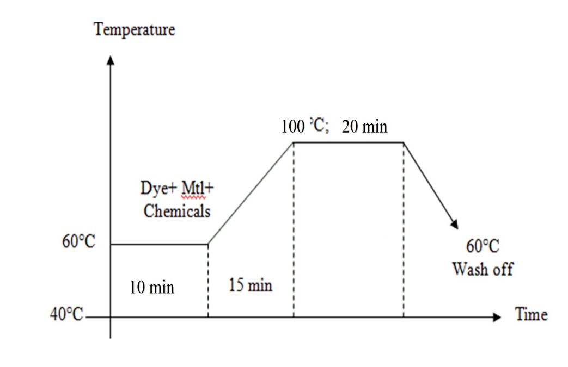

3.2.7 After treatment:

In case of dark shade coloring we've to use additional amounts of dye & chemicals. however these chemicals ought to be aloof from cloth when coloring. as a result of in disperse coloring the material surface becomes rough & for this reason to form the material surface swish a special
process is employed just in case of disperse coloring. This cleanup method is named reduction cleanup. A typical instruction for reduction cleanup is given below:

2gm/lit Hydrosulphite
2-3ml/lit NaOH (56.50Tw)

By reduction cleanup surface dye molecules or unfixed dye molecules area unit stripped & this successively ends up in level coloring. Reduction cleanup conjointly improves wash fastness property of textile materials.

©Daffodil International University

3.2.8 Advantages of Carrier Dyeing:

1. In standard coloring methodology, the very crystalline polyester fibres can't be artificial in deep shade. however by victimization carrier we are able to get medium to dark shade in boiling temperature.

2. Materials may be artificial with easy equipments at air pressure and temperature below 100°C.

3. Moderate level coloring of polyester cloth may be done.

4. Some carriers cut back the staining of wool whereas coloring polyester-wool blends.

5. Rate of coloring may be increased by victimization carriers.

6. may be artificial quickly by victimization carriers.

7.Improves fastness properties of cloth except light-weight fastness.

3.2.9 Disadvantages of Carrier Dyeing:

1.Carriers raise cost of coloring. Firstly, for coloring it's used that is expensive and second for its removal alkali is needed
.
2. Carriers area unit unhealthful and toxicant. It creates skin diseases
.
3. Some coloring machines might produce carrier spot
.
4. Carriers have an effect on the sunshine fastness property of artificial material. This impact is also reduced by treating the fabric with hot air for thirty min.

5. Some carriers area unit artificial specific. They posses completely different|completely different} efficiencies with different dyes; others are compatible with sure dyes.

©Daffodil International University

3.3.1 High Temperature Dyeing Method
In heat colouring technique either material or liquor ought to flow into. Otherwise dye molecules won’t penetrate within the fabric. they're going to continue surface solely. during this technique, temperature is unbroken in between 105-1400c & pressure is unbroken from zero to one hundred seventy kpa. This technique is additionally referred to as pressure colouring that is employed for extremely crystalline artificial fibres & their blends. this system causes the fibre to swell even over that achieved at 1000c temperature. in order that dye molecules penetrate the fibre compound system. It eliminates the necessity of carrier

3.3.2 Sample:

Dark Shade Light Shade

High Temperature and pressure method(HTP):

©Daffodil International University

3.3.3 Recipe:
- Red deep shade:

Dyes(disperse) & Auxiliaries | Unit
Yellow | 11.25g/L
Red | 22.50g/L
Dispersing agent | 4g/L
Levelling agent | 20ml/L
Sequestering agent | 3oml/L
Anti creasing agent | 10ml/L
pH | 4.5-5
Time | 10min
Temperature | (200-210)◦C

- Blue deep shade:

Dyes(disperse) & Auxiliaries | Unit
Yellow | 1.25g/L
Red | 3g/L
Blue | 16g/L
Dispersing agent | 4g/L
Levelling agent | 20ml/L
Sequestering agent | 3oml/L
Anti-creasing agent | 10ml/L
pH | 4.5-5
Time | 10min
Temperature | (180-210)◦C

Grading:

Color fastness of deep shade (Red & Blue)

1.Color fastness to rubbing rating grade (4-5)
2.Color fastness perspiration:
Acid rating grade (4-5)
Alkali rating grade (4-5)
Water rating grade (4-5)
3.Color fastness to wash rating grade (4-5)

©Daffodil International University

- Red lite shade

Dyes(disperse) & Auxiliaries | Unit
Yellow | 4g/L
Red | 9.5g/L
Dispersing agent | 4g/L
Levelling agent | 20ml/L
Sequestering agent | 3oml/L
Anti-creasing agent | 10ml/L
pH | 4.5-5
Time | 10min
Temperature | (180-210)◦C

4.Blue lite shade

Dyes(disperse) & Auxiliaries | Unit
Yellow | 0.50g/L
Red | 1.23g/L
Blue | 7.25g/L
Dispersing agent | 4g/L
Levelling agent | 20ml/L
Sequestering agent | 3oml/L
Anti-creasing agent | 10ml/L
pH | 4.5-5
Time | 10min
Temperature | (180-210)◦C

Grading:

Color fastness of lite shade (Red & Blue)

1. Color fastness to rubbing rating grade (4-5)
2. Color fastness perspiration:
Acid rating grade (4-5)
Alkali rating grade (4-5)
Water rating grade (4-5)
- Color fastness to wash rating grade (5)

©Daffodil International University

3.3.4 Processes flowchart of HTP method:

Need treated 100% of polyester fabric
↓
Color is prepared in bath
↓
Then added others chemicals
↓
Maintained pH (4.5-5.5)
↓
Then raise temperature 60◦C
↓
Then add fabric
↓
Temperature raise 60◦C to 210◦C for 10min
↓
Draining water
↓
Cold wash
↓
Hot wash with 1% acetic acid
↓
Cold wash
↓
Drying

3.3.5 Dyeing curve:
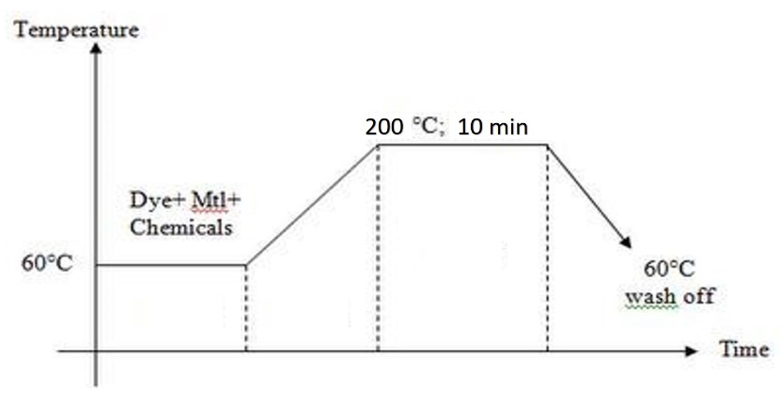

©Daffodil International University

3.3.6 Procedure:

1.Initially dye & chemicals are balanced as per recipe according to spectrophotometer.

2. hydrogen ion concentration is controlled by adding ethanoic acid

3. This condition is unbroken for quarter-hour at temperature 600c

4.Then dye bathtub temperature is raised to one300c & this temperature is maintained for 1
hour. inside this point dye is subtle in dye bathtub, absorbable by the fiber
& therefore needed shade is obtained.

5. The dye bathtub is cooled as early as doable when coloring at 600c.

6. the material is hot rinsed & reduction cleansing is finished if needed.

7. Then the material is finally rinsed & dried.

3.3.7 Reduction cleaning:

In case of dark shade coloring we've got to use a lot of amounts of dye & chemicals. however these chemicals ought to be faraway from cloth once coloring. as a result of in disperse coloring the material surface becomes rough & for this reason to form the material surface swish a special method is employed just in case of disperse coloring. This cleansing method is termed reduction cleansing. A typical instruction for reduction cleansing is given below:

2 gm/lit Hydrosulphite
2-3 ml/lit NaOH

By reduction cleansing surface dye molecules or unfixed dye molecules area unit stripped & this successively ends up in level coloring. Reduction cleansing additionally improves wash fastness property of textile materials.

©Daffodil International University

3.3.8 Advantage of HT methodology:

1. coloring time area unit oftentimes shorter

2. Higher temporary worker need No would like of carrier

3. most ninety-eight dye fixation

4. Loss of dye is a smaller amount

5. light-weight fastness and wet fastness is typically higher

6. higher exhaustion and deeper coloring may be made.

7. quicker diffusion of the dye within the fibre at elevated temporary worker

Different Color Fastness Tests

Color fastness to washing:

Principle:
A specimen/dyed material with such adjacent material (MFF) area unit laundered rinsed and dried. The specimen/composite sample is treated below applicable condition in a very chemical tub for counseled time. The abrasive action is accomplished by the utilization of a liquor quantitative relation and an applicable variety of steel balls. The amendment in color of the specimen (dyed sample) and also the staining of the adjacent material (MFF) is assessed by counseled gray scales (1-5)

Apparatus & Materials:
Wash wheel with a thermostatically controlled water tub & rating speed of (41±1) revolutions per minute stainless-steel instrumentality (capacity 54±4 ml)
Stainless steel ball (dia = zero.5 cm, weight = one gm) Bleached cotton material
Thermometer household appliance appliance
Color matching cupboard and ISO Scales

Color fastness test
There are different kind of fastness in different condition some of them are as follows:
- Crocking
Through this method transfer of color of fabric or garment is evaluated in dry and wet condition through crocking machine by using crock cloth and chromatic transference scale.
Function: Used to test the color fastness of fabric against rubbing.

©Daffodil International University

Test parameters:
• Sample size: Dyed fabric – (15.5 x5) cm
• White Test Cloth – 5.5 cm ́ 5.2 cm
• Method: ISO 103x2L: 2002
• Revolution: 10cycle/10sec
• Weight: 9N

Specification:
• Brand: Dilmenler.
• Model: M 238 BB
• Origin: Turkey
• Quantity: 1 set
• Test method: ISO 105-X12:1995
Testing procedure:
• Dyed specimens (10cm×4cm) are rubbed 10 times by the weighted finger covered with undyed cotton
cloth (5cm×5cm).
• For wet rubbing the cotton cloth is wetted out before being rubbed on the dyed sample.
• Then the cotton cloth is examined for dye which may have been removed and assessed using the grey
scales for staining.

2. Colorfastness to perspiration:
This is for determining the color loss of fabric through perspiration. Three specimen of color textile are soaked in simulated acid perspiration solution and allowed to dry slowly at a slightly elevated temperature in a circulating air oven for at least six hours.

Function: Used to test the color fastness of fabric against perspiration.
Specification:
- Brand: SLD ATLAS
- Model: M231
- ISO:105C 08
- Origin: USA
- Quantity: 1 set
- Sample size: 10Cm×4Cm

Perspiration solution:
Alkaline solution:

Chemical name | Amount in 1 ltr
Histidine mono hydrochloride monohydrate | 0.4g
Sodium chloride | 4.5g
Disodium hydrogen  orthophosphate(Na2HPO4H2O) | 2.6 g

©Daffodil International University
Acid solution:

Chemical name | Amount in 1 ltr
Histidine mono hydrochloride monohydrate | 0.4 g
Sodium chloride | 4.8g
Sodium di-hydrogen  orthophosphate(NaH2PO4H2O) | 2.1 g

Testing procedure: .
3. Color fastness to laundering;
- This test is basically for the evaluation of fabric color loss due to detergent solution and abrasive
- Action equivalent to five home laundering. Minimum five wash guarantee is given by all the reputed fashion brand for their product

4. Color fastness to water
Dyed, colored or printed fabrics resistance to water is tested through this method. De-ionized or distilled water is used for this test method because natural water is variable in composition at different places.

Specification:
• Model: M228B
• Origin: UK
• Quantity: 1 set
Solution:
• Sodium Perborate tetra hydrate. (1 g/l)
• ECE DETERGENT (B.(3.9g/l)
• Grade 3 water.
Rota wash- dia frame:
• A2S—3omin*40c*10 steel balls
• B2S—3omin*50c*25 steel balls
• C2S—3omin*60c*25 steel balls
Equipment’s:
• Sample: 10x4cm
• Multifiber: 10x4cm
• Throw the composite specimen in Grade -3 water to 30 minute & taping time to time in
properly wet the specimen.
• Liquor ratio: 1:50
• Acrylic Resin plate: 11 pes (Measuring 60mmx115mmx1.5mm)
• Perspire meter: Measuring 60mmx115mm
• Specimen: 10 pes
• Weight: 5kg & 12.5kpa
• Temperature: (37±2)oC
• Time: 4 Hours
• Dry Temperature: 60oC

©Daffodil International University
Reagent:

Reference detergent

Sodium Carbonate / soda H2O (Grade – 3) and

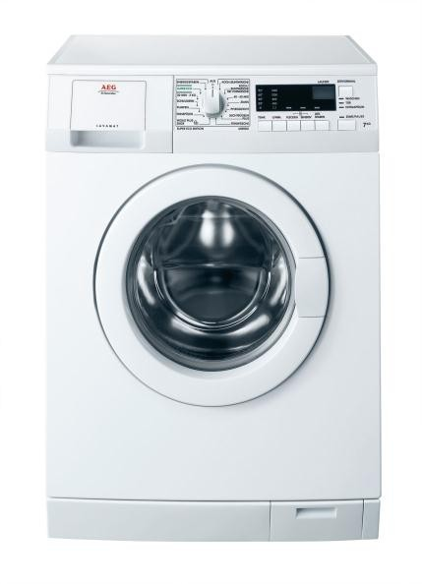

Fig: Washing Machine
Test Specimen:

Cut a sample of coloured product ten cm × four cm and sew it with same size multifibre material. this can be the composite take a look at sample

Test Procedure:

ISO counseled no ISO a hundred and five C 03
ISO counseled no. ISO a hundred and five C 03: Composite sample is treated in a very wash wheel for half-hour at (60±2)O C with five gm/l customary soap and a pair of gm/l soda.

Test | Temperature ^{O} C | Time (Minute) | Steel Ball | Chemicals
ISO – 105 – CO3 | 60 | 30 | 00 | Soap (5 gm/l) + Soda 2 gm/l
Evaluation: Compare the contrast between the treated and untreated sample with grey scales for changing color of dyed sample & and staining of adjacent fabric in a color matching cabinet.

©Daffodil International University
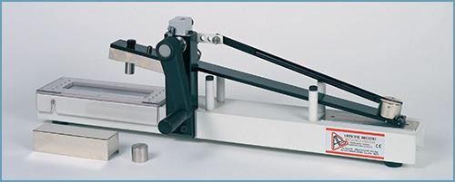

Fig: Rubbing Tester

Color fastness to rubbing:

Sample size:
Dyed fabric – 15 cm x 5 cm White Test Cloth - 5 cm x 5 cm

©Daffodil International University
Procedure

- White test cloth is put on to the grating and stag by steel wire.
- Crock cloth is placed under finger & tight by clip.
- The sample is run ten times manually for ten seconds. and the rubbing fastness of the sample cloth and degree of staining is accessed.
- For rubbing fastness (Wet), the rubbing cloth is placed in the water and socked and squeeze. The wet rubbing cloth is placed on to the grating and stag with stainless steel wire and run ten times manually then assess the staining on to the rubbing cloth and the rubbing fastness of the sample cloth is accessed.

Evaluation:
Evaluation is done by grey scale in a color matching cabinet and rated from 1 to 5.

Color Fastness to Water ( ISO 105 EO1)

Theory:
Color fastness to water is designed to measure the resistance to water of dyed, printed, or otherwise colored textile yarns and fabrics. The test method by which this test is carried out is AATCC 107-1991 or ISO 105 E01. This method is to assess the degree of cross staining which may occur when garments are left in contact when damp. The test measures the resistance to water of any colored textiles.
Apparatus:

  - Perspiration Tester
  - Oven
  - Multi fiber fabric
  - Greyscale
  - Color matching cabinet
  - Glass plate or Acrylic resin plates
  - Weight 12.5 kPa or 5kgpressure
  - Glass beaker
  - Stirring rod

©Daffodil International University

Reagent:
Distilled water or de-ionized water is used in this test method because natural (tap) water is variable in composition.

Sample Preparation:
Cut the specimen & multi-fibre at 10×4cm & sewn together. This is the composite test sample.
Working Procedure:
Wet in water at temperature & it'll suck water
↓
Place it in acrylic plates & place the burden on to the plates.
↓
Keep it in kitchen appliance & keep the temperature at 37± 2°C for 4hrs.
↓
Open the specimen & dry it within the air hot olympian 60°C.
↓
Change in color is assessed with the assistance of gray Scale

Test specimen:
• Sample material – fifty metric linear unit × fifty metric linear unit
• Multifibre material – fifty metric linear unit × a hundred metric linear unit
• Cut the multifibre into 2 piece
• Sandwich the take a look at specimen between 2 piece of multifibre
Testing Solution:
- Basic Solution:

©Daffodil International University

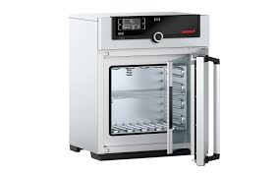
Fig: Per spirometer
1. Histidine mono hydricchloride hydrate (C6 H10ClN 3O2 .H 2O)-5.00 g/l
2. NaCl- 5.00 g/l
3. Disodium element phosphate phosphate HPO4 .2H2O -2.5 g/l
4. P H -8 (Adjust by zero.1 N NaOH)
Acidic Solution:
1.Histidine mono hydrochloride monohydrate (C6 H10ClN 3O2 .H 2O)-5.00 g/l NaCl- five.00 g/l
2.Disodium element phosphate phosphate HPO4 .2H2O -2.2 g/l
3.P H -5.5(Adjust by zero.1 N NaOH)
Method:
1. The composite specimen is place in a very peri dish (2 specimen of a sample).
2. Resolution (Alkaline & Acidic) is taken within the 2 peri dish. Here, M: L is taken 1:4.
3. Bubble is created out from the specimen by sound.
4.The specimen is place for half-hour.
5. A glass plate is placed on the composite specimen for quarter-hour at temperature.
6. Excess resolution is poured off.
7. Peri dish with composite specimen & glass plate is placed
8. The specimen is dried (Temp ≤ 600C)

Report:
Change of shade & degree of staining is measured by the gray Scale & Staining Scale.

©Daffodil International University

Chapther 04


©Daffodil International University

Color fastness to washing:

Test name |  | Carrier method |  | HT method
 |  | Deep shade | Light shade | Deep shade | Light shade
CF to Rubbing |  | 4 | 4-5 | 4-5 | 4-5
CF to perspiration | acid | 3-4 | 4 | 4-5 | 4-5
CF to perspiration | alkali | 3-4 | 4 | 4-5 | 4-5
CF to perspiration | water | 4-5 | 4-5 | 4-5 | 4-5
CF to wash |  | 3-4 | 3-4 | 4-5 | 5

Results are shown in chart below:

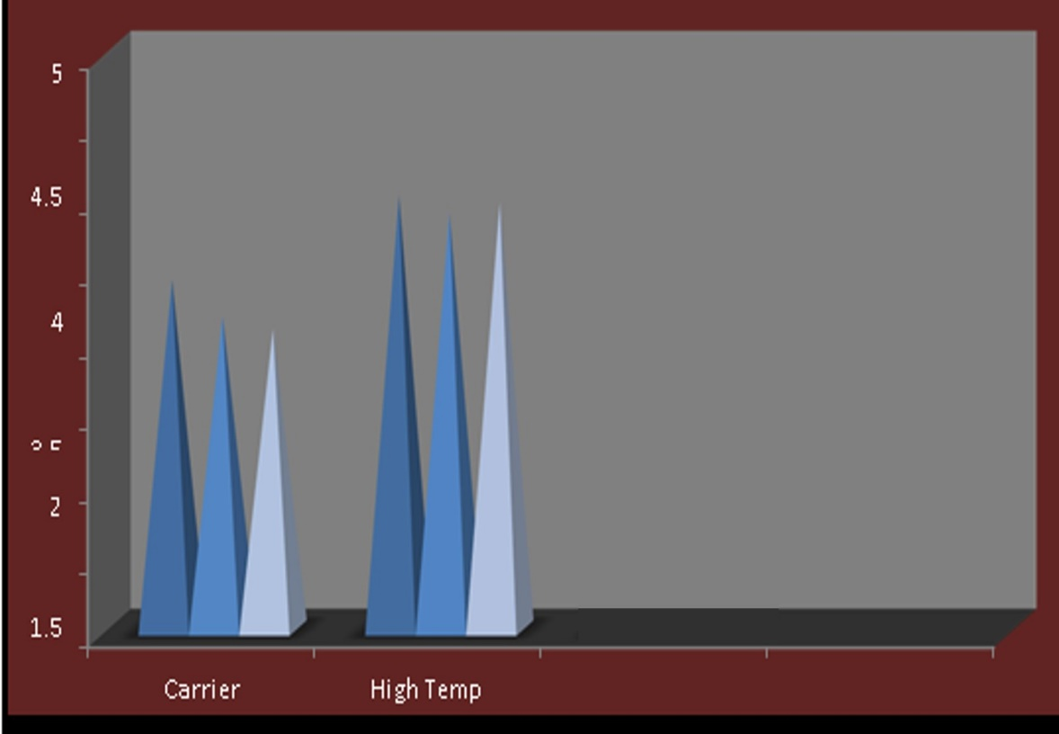

Fig. Comparisons of color fastness to wash

©Daffodil International University
Color strength:
Color strength means toughness of color. It depends of dyestuff dye particle and manufacture minimum use of different dyes to different manufacturers to make some shade in known as color strength.

Color strength comparison:

Hellocron | unit | Megaperse | unit
Recipe (Red deep shade) | - | Recipe (Red deep shade) | -
Hellocron yellow HW-6g | 11.25 g/l | Megaperse yellow YNA | 12 g/l
Hellocron Red HW-2g | 22.50 g/l | Megaperse Red RNA | 25g/l

Comment:
In this table we can see that dyes of hellocron brand is minimum used than dyes of megaperse brand to make some shade of Red deep. HT disperse dyeing is better than carrier dyeing method.

©Daffodil International University
Utility:
Utility of carrier and high temperature disperse dying method
HT disperse dying method:
- Use high energy consumption
- High stem required
- Costly dyes required
- Need to handle carefully
That’s why high temperature disperse dying is costly then carrier

Utility of carrier dyeing method:

- Not required high temperature stem
- Not required high energy consumption
- Not required high power consumption
- Carriers are not costly like disperse dye
That’s why carrier dyeing are not costly like high temperature disperse dyeing

*** All experiment are prepared in Sanjana Textile LTD and Daffodil International University Lab.

©Daffodil International University

CHAPTER-05
CONCLUSION

©Daffodil International University

From this comparative study among completely different coloring ways of polyester coloring with disperse dyes we are able to submit that-

1. Color fastness to laundry on HT technique is quite the others.

2. Color fastness to rubbing on HT technique is quite the others.

3. Thermosol technique needs only a few time for coloring.

4. Color fastness to perspiration on HT technique is quite the others.

5. AN odor downside happens just in case of Carrier coloring.

6. just in case of price comparison HT technique is a smaller amount dearly-won than others

Considering all condition, warmth high technique is that the best for industrial production. as a result of in carrier technique, carrier is expensive, toxicant & it should turn out odor downside, removal of carrier with alkali is additionally expensive. In pad thermosol technique, it needs special machine arrangement & during this case shade might modification thanks to sublimation at warmth.

But in warmth high technique, no carrier & thicker is employed. therefore, it's relatively low cost method. No special machine is needed i.e. same machinery will be used when coloring with another dyes in bulk production.

©Daffodil International University
REFERENCES

[1] https://www.researchgate.net/
[2] Handbook of textile and industrial dyeing vol. 1 -M.Clark.
[3] Total colour management in textile - Johin H.Xin.
[4] Industrial dyes –Klans Hunger.
[5] Textile Dyeing, N. N. Mahapatra.
[6] Fundamentals and Practices in Colouration of Textiles , J.N. Chakraborty

©Daffodil International University

