A PERFORMANCE STUDY OF SHEAR WALL FOR DIFFERENT POSITIONS IN BUILDING PLAN CONFIGURATION

A Project and Thesis submitted in partial fulfillment of the requirements for the Award of Degree of
Bachelor of Science in Civil Engineering

Submitted by
Md. Kaium Miah
ID: 163-47-224
Md. Masud Rana
ID: 162-47-197
Md. Bayezid Hosen
ID: 171-47-046

ABU HASAN
Lecturer

DEPARTMENT OF CIVIL ENGINEERING
FACULTY OF ENGINEERING

DAFFODIL INTERNATIONAL UNIVERSITY

January 2021

Certification
Thesis to certify that this project and thesis entitled “A performance study of shear wall for different positions in building plan configuration.” is done by the following students under my direct supervision and this work has been carried out by the min the Department of Civil Engineering under the Faculty of Engineering of Daffodil International University in sketchy fulfillment of the requirements for the degree of Bachelor of Science in Civil Engineering. The presentation of the work was held on January 2021.

Signature of the candidates

Name: Md Kaium Miah
ID: 163-47-224

Name: Md. Masud Rana
ID: 162-47-197

Name: Md. Bayezid Hosen
ID: 171-47-046

Countersigned

Name of the supervisor
Abu Hasan,
Lecturer,
Department of Civil Engineering
Daffodil International University

The project and thesis entitled “A performance study of shear wall for different positions in building plan configuration,” submitted by Name: Md. Kaium Miah, ID: 163-47-224, Name: Md. Masud Rana ID: 162-47-179, Name: Md. Bayezid Hosen ID: 171-47-046.
Session: Spring 2016 has been sketchy fulfillment accepted as satisfactory of the requirements for the degree of Bachelor of Science in Civil Engineering on 23 January 2021.

BOARD OF EXAMINERS

Dr.Engr. --- Chairman
Professor
Department of CE, DIU

Dr.Engr. --- Internal Member
Professor
Department of CE, DIU

Dr.Engr. --- Internal Member
Professor
Department of CE, DIU

Dedicated to

Our Parent

CONTENTS

Dedication iii

List of Figures vi

List of table vi

Acknowledgment vii

Abstract viii

Chapter 1: | INTRODUCTION | 1-4
1.1 | Introduction | 1
1.2 | Objectives | 2
1.3 | Methodology | 2
1.4 | Ground of study | 4

Chapter 2: LITERATURE REVIEWS 5-17
  - General 5
  - Provision for earthquake load in BNBC 6
  - Selection of lateral force method in BNBC 8
  - Non-linear static analysis procedure 8

Chapter 3: | METHODOLOGY & DATA COLLECTION | 18-23
3.1  3.2  3.3  3.4  3.5 | General Description of Structure  Load used  Model geometry  Column & beam size  Building modeling | 17  17  17  17  19

Chapter 4: | ANALYSIS & RESULT | 23-31
4.1 | General | 23
4.2 | Analysis Basis | 23
4.3 | Explanation of displacements | 24
4.4 | Displacements of EQX & EQY | 25

Chapter 5: | CONCLUSIONS | 32
5.1 | Conclusion | 32
5.2 | Limitations of the work | 32
5.3 | Future scopes of the work | 32
 | References | 33

LIST OF FIGURES

Figure | Figure Caption | Page
1.1 | Procedures of work | 3
2.1 | Normalized response spectra of 5% damping ratio | 7
2.2 | Seismic zoning map of Bangladesh. | 10
2.3 | Force determination for pushover hinge | 14
2.4 | Building performance level (ATC-40) | 16
3.1 | Column layout plan & 3D view | 19
3.2 | Corner shear wall& 3D view | 20
3.3 | Side shear wall 3D view | 21
3.4 | Middle shear wall& 3D view | 22
4.1 | Displacement of X direction without shear wall | 25
4.2 | Displacement of Y direction without shear wall | 25
4.3 | Displacement of X direction with corner shear wall | 26
4.4 | Displacement of Y direction with corner shear wall | 26
4.5 | Displacement of X direction with side shear wall | 27
4.6 | Displacement of Y direction with side shear wall | 27
4.7 | Displacement of X direction with middle shear wall | 28
4.8 | Displacement of Y direction with middle shear wall | 28
4.9 | Graph of displacement | 29
4.10 | Graph of drift | 30
4.11 | Graph of rebar percentage | 31

LIST OF TABLE

Table | Table caption | Page
2.1 | Seismic zone factor, z | 09
2.2 | Seismic source type | 11
2.3 | Seismic source factor | 12
2.4 | Seismic coefficient CA | 13
2.5 | Seismic coefficient CV | 13
2.6 | Soil profile type | 14
3.1 | Building frame system | 18
4.1 | Table of displacement | 29
4.2 | Table of drift | 30
4.3 | Table of rebar percentage | 31

ACKNOWLEDGEMENT

The authors wish to recognize the fact that development & publication of this thesis paper. All the group members are given efforts of their level best. The author would like to give thanks their cordial supervisor, Abu Hasan, Lecturer, Department of civil engineering, DIU. The authors are enjoyed so much working with supervisor. The authors wants to give thanks again him for the legal guidance & supporting. The author is also thankful to Dr. Mohammad Hannan Mahmud Khan, Assistant Professor & Associate Head, Department of civil engineering, DIU, for his inspiration & suggestions’.

Finally, we remain endangered to our families for supporting us by both mentally &financial to complete our dissertation work.

At first, the author would like to state that, by the gracing of almighty of ALLAH this thesis is successful

ABSTRACT

The consequences of lateral loads like earthquake loads, wind loads and blast forces are the highest considerations subject now a days. Provide enough strength and stability in counter to the lateral loads is one of the most difficult challenges faced by designers. To safeguard the structure against lateral loads provides shear wall in the structures as counteract object of lateral forces. The present papers describes the performance of shear wall for different positions in building plan configuration. The design and analysis of the building with RCC shear wall is carried out using software ETABS. Earthquake load and the various parameters like response factor, reduction factor, importance factor and Zone factor are taken from BNBC 2020. The target of this thesis is to determine the appropriate positions of shear wall in the building to get better strength and stability of the structure. To achieve the goal in four places were analyzed. Therefore, one model without shear wall and other three with shear walls in different positions. There are 10 storied building has been considered. Effects of varying positions of shear walls and comparison of the results of displacements, drift and rebar percentages is presented. Shear wall structure is an efficient seismic resistance structural system. Shear wall give stiffness & strength laterally and can easily control horizontal displacement. Shear wall plays an important role when two or more walls are attached. The results are optimal for seriously considering all of the factors.
CHAPTER 1
INTRODUCTION

1.1. Introduction

Bangladesh has her own building codes which is called BNBC. It was published in 1993 for the first time. There are many town centers have developed haphazardly causes of without proper guidelines. A strong earthquake affecting major town center like Dhaka, Chittagong and Sylhet etc. May result in damaged of massively.

Bangladesh is located in a close to the plate boundaries of the north moving Indian plate and the Eurasia plate to its north and east which is technically very active region. Therefore, in structural seismic impact consideration has become a very serious complication to building owners, engineers, architects and developers.

A building is constructed by specific performance objectives under the actions of the frequent seismic events that, it may experience for lifetime of this building. For this reason, very strong and emergent update method is needed to the evaluate this criteria achievement.

The engineers must have to need analyzed the building models accurately with demand by BNBC.To exceed a specific limits state and any kind of shaking May imposed and building can be sustained.ATC-40, FEMA-356 are proposed a number of methods for more rational analysis of the structure under the seismic loading. These are simplified non-linear static analysis capable of simulating the degradation of the structure.

1.2. Objectives:

The objectives as follows:
i. To analysis the structural elements under earthquake and wind load.
ii. To determinate RCC shear walls strength to withstand earthquake load.

1.3. Methodology

The research was conducted for the measurements which size of (75ft * 60ft). It will be located in Sylhet city.
Firstly, we made the design of 10 stories building. It’s a high rise building.so, supporting of shear walls is good for building. Our next step was set the columns & beam then, shear walls in different positions in this building as corner shear wall, side shear wall and middle shear wall. Total used number of shear walls is 12.
First set up in 4 corners which length is (3ft * 3ft), the set up in 4 middle segment of each side walls which are all 6ft length, and then at last set up in the middle segment of the building 4 sites which length is also 6ft.

Basically, analyzed the value of drift, displacement for set the shear walls for different positions of this structure. All the data input and analyzed used by ETABS 9.6 software.

.
FINAL RESULT

Figure 1.1: procedures of work.

1.4. Ground of study:

City: Sylhet, Bangladesh.
Wind speed: 61.1 m/s / 220 km/hr. / 136 mile/hr.
Exposure type: B
Wind word co-efficient: 1.5
Seismic zone: 04
Seismic zone factor: 0.36
Reduction factor= 6

CHAPTER 2
LITERATURE REVIEW
2.1 General:

Push over analysis has been sketched last 10-15 years to use of the non-linear static analysis from 1970. To estimate the strength of seismic demand actually follows this process and also tests the adequacy of new structural designs. Computational simplicity and effectiveness of analysis give several guidelines. (ATC-40 and FMEA 356) and also different types of design codes are used.

In the M. Mouzzoun et.al (2013) paper, mentioned of 5 story of seismic performance. Again, according to moroccal seismic code RPS2000.Calculate the dynamic properties of building materials and then analyzed for the first time. Fundamental period, natural frequencies, deformation modesetc. When analyzed in another building for the 2nd time caught the plastic hinges. Analysis performed by SAP2000. Result was, under several earthquake building stay in very great threat but, at the intermediate level it performs well.

In the A.kadid at.al (2008) paper, there was three kinds of framed buildings were analyzed used by SAP2000. The type of building was 5 story (low rise), 8 story (mid-rise) and 12 story (high rise). For the weak column and strong beam buildings were in great threat point due to Boumerdes earthquake.

In the MS Nivedita N. Raut at.al (2013) paper, a analyzed was performed that time about multi story buildings in urban India. Which are constructed mainly the basis of masonry most. The result was, most of the member of plastics hinges has beam than column. Displacement and base shear compared in verities places as like roof, ground, only frame and bar frame etc. In FEMA (356) journal, published their analyzed information and standard of non-linear pushover analysis.

2.2 Provision for Earthquake Load in BNBC

Bangladesh national building code BNBC provides two methods for determination of seismic lateral forces on primary framing systems. It has different provisions for analysis procedure & calculates of earthquake load.

2.2.1 Equivalent Static Force Method

An identical static load at different levels ratio to mass at level what is refers, the dynamic earthquake effect. For ground response there are 3 types of state provided by BNBC (0.075g, 0.015g and, 0.25g).

The total design base shear for a seismic zone is given by, V = W (2.1)

V =ZIC/ R

Where, Z = seismic zone co-efficient I = Structural importance co-efficient.
C = Numerical Coefficient = 1.25S/ T^{2/3}(2.2) S = Site Coefficient T = Time Period

Where, Ct(hn) 3/4 (2.3) Where, Ct = 0.083 for moment resisting frame = 0.073 for reinforced concrete frame and eccentric braced still frame = 0.049 for all other structural analysis.
hn = Height in meter above base level n
R = Co-efficient in response change.
W = Total seismic dead load.

For base shear V, Lateral force is considered.
V = Ft + ∑ I (2.4)
Where,
Fi = Lateral force applied at the first story and
Ft =Concentrated lateral force considered at the top of the building and addition to the force Fn.
2.2.2 Dynamic Response Method
2.2.2.1 Response spectrum method

There are two types of spectrum to be used in dynamic analysis according to BNBC. Site specific design spectra: if the geologic, tectonic, seismologic and soil characteristics associated with the specific site then chance for development.
Normalized response spectra:
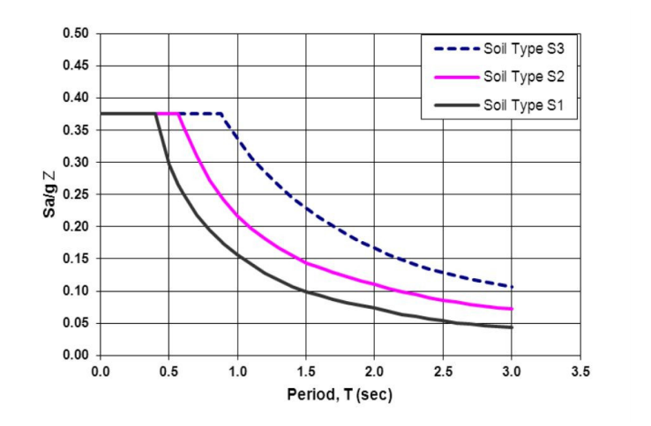
The normalized response spectra is only used when site specific design is absent. For getting different soil types and 5% of critical damping from the curves of normalized response spectrum.

Figure 2.1: Normalized Response Spectra for 5% Damping Ratio (Adopted from
BNBC 2020).

2.3 Selection of Lateral Force Method in BNBC

The Equivalent static force method and the dynamic reaction method Restrictions given below:
The following structures are used by the equivalent static force process:

I. All Structures, regular or irregular, in Seismic Zone 1 and Structure
Importance Category 4 in Seismic Zone 2, without case b (iv) below.
II. Regular structures should less than 75 meters in height with lateral force
Resistance provided by structural systems listed in BNBC without case b (iv) below.
III. Irregular structures should not more than 20 meters in height.

The dynamic response method can be used for all category of structure, but will be
used for the structure of the following types.

IV. Structures 75 meters or more in height except as permitted by case a (i) above.
V. Structures having a stiffness, weight or geometric vertical irregularity of
type I, II, III as defined in BNBC.
VI. Structures over 20 meters in height in Seismic Zone 3 not having the
same structural system throughout their height.
VII. Structures regular or irregular, located on soil type S4 as defined in BNBC.

2.4. Nonlinear Static Analysis Procedure
There are two methods are available for the analysis of concrete building.
Elastic or linear
In elastic or non-linear
Demand capacity ratios are used in code static lateral force procedure, code dynamic force procedure, code dynamic lateral force procedure and elastic procedure.
History analysis is considered too complex and invalid at the time of drawing. To estimate the maximum displacement, capacity spectrum and pushover curve are used.
The capacity demand and performance are the required of displacement coefficient.
About those elements discussed according to ATC-40.

2.4.1. Capacity
The individual components are very essential for the over all capacity as like strength and deformation of a structure. the pushover procedure used a series of sequential elastic limits. Some form of non-linear analysis. The displacement capacity is calculated of a superimposed approximately. To reduce resistance the mathematical model of the structure is modified. How the structures behave after exceeding their elastic limits that capacity curves approximately.

2.4.2. Demand (Displacement)
During an earthquake procedure ground motion can be changed for horizontal displacement and pattern of the structures that may vary with time.
To do judged impractical to determinate structural design requirements. At every time-step of motions tracked.
As a condition of design, lateral displacement is easier for direct use. Estimate the maximum expected response of the building during the ground motion time which called displacement demand of a structure.

2.4.3. Seismic Zone
Bangladesh is divided into four seismic zones as per BNBC 2020. The table below shows
The values of zone coefficients of Bangladesh.
Table 2.1: Seismic Zone Factor Z

Zone | 1 | 2 | 3 | 4
Z | 0.12 | 0.20 | 0.28 | 0.36



Figure 2.2: The seismic Zone Map of Bangladesh.

2.4.4 Seismic Source Type
As per ATC-40 (1996), three types of seismic source may be defined as shown in Table 2.2
Table 2.2: Seismic Source Type (ATC-40, 1996)
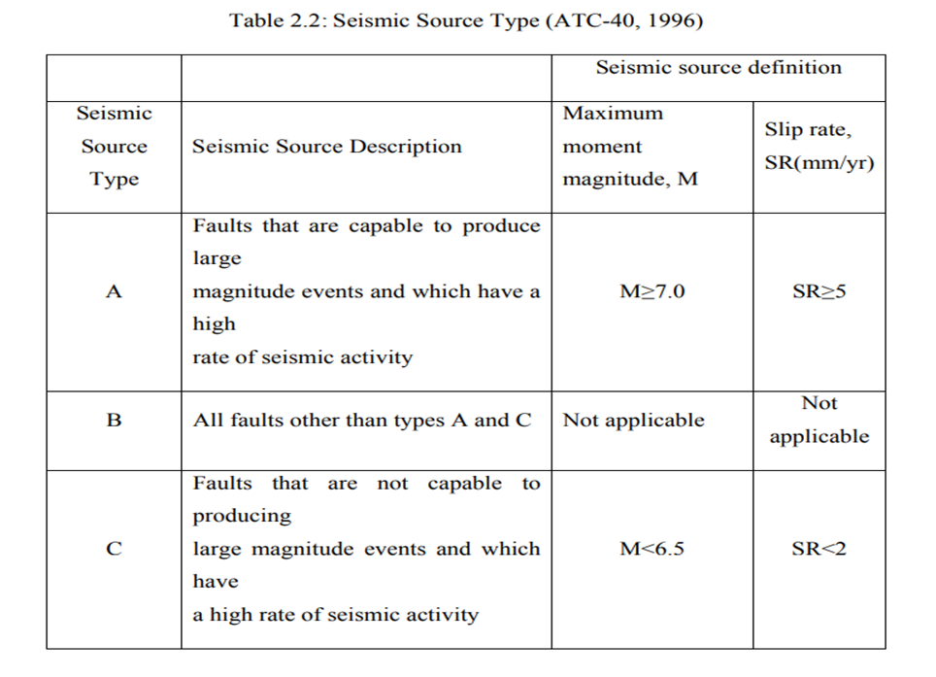
2.4.5. Near Source Factor

Not available Current data pertaining to the active faults close to Dhaka city. Estimate the seismic source distance from a specific site it is not possible to being considered in this thesis. But it may be safely assumed that all the sources are located at distance more than 15 km and the Table 2.3 (ATC-40, 1996) may be used to consider the Near-Source effects for the present study.

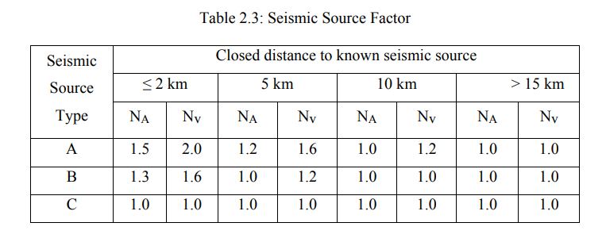

1. The near source factor may be used on the linear interpolation of values for distance other than those shown in the table.

2. The minimum distance between the site and the area described by the vertical projecting of source on the surface shall be taken from The closest distance of the seismic source (i.e., surface projection of fault plane). The surface projecting need not a depths of 10km or greater include portions of the source. The maximum value of the near-source factor considering all sources will be used for design.

2.4.6 Seismic Coefficients
For every earthquake hazard level, the structure is assigned a seismic coefficient CA in accordance Table 2.4 (ATC-40, 1996) and a seismic coefficient CV in accordance with Table 2.5 (ATC-40, 1996). Seismic coefficient CA represents the effective peak acceleration (EPA) of the ground. A factor of about 2.5 times the mean value of peak response of a 5 percent-damped short-period system in the acceleration domain by represents CA. The seismic coefficient CV represents 5 %-damped response of a 1- second system CV divided by period (T) defines acceleration response in the velocity domain. These coefficients are dependent on soil profile type. The product of seismic zoning coefficient-Z, atrocity of earthquake-E and near source factor-N (ZEN). The soil profile types are classified in Table 2.6.

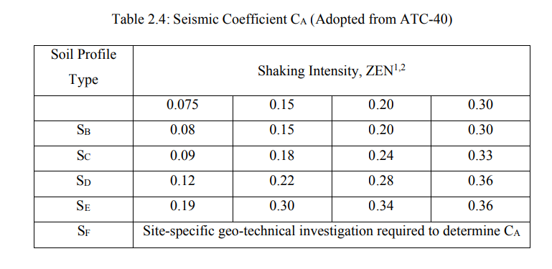
1. The value of E mention the product, ZEN, should be equal to the serviceability earthquake value 0.5&the design earthquake for 1.0and 1.25 for the maximum earthquake.
2. CA should be determined of Seismic coefficient by linear interpolation for values of the product ZEN other than those shown in the table.
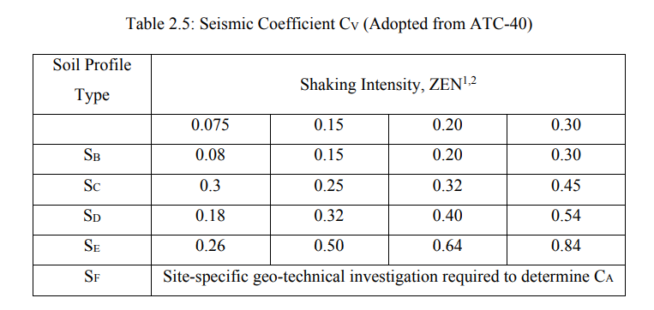

1. The value of E mention the product, ZEN, should be equal to the serviceability earthquake value 0.5 and 1.0 for the design earthquake, and 1.25 for the maximum earthquake.
2. CV should be determined of Seismic coefficient by linear annoyance for values of the product ZEN other than those shown in the table.
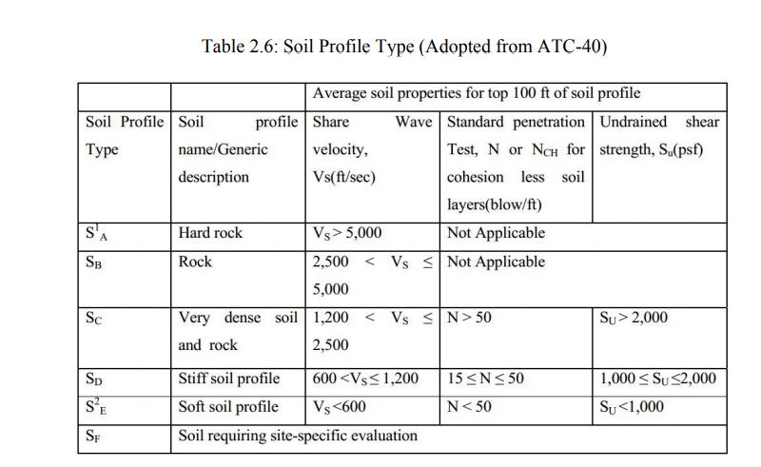

SA (Soil profile) is not applicable to site in Dhaka. SA type SE also include any soil profile with more than 10 feet or soft clay defined as a soil with PI > 20, WMC ≥ 40 and Su < 500 psf.

2.4.7 Frame Element Description
In SAP2000, a frame element is modeled as a line element having linearly elastic properties and nonlinear force-displacement characteristics of individual frame elements are modeled as hinges represented by a series of straight line sections. A generalized force-displacement characteristic of a non-decadent frame component.
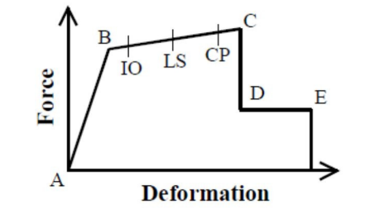

Figure 2.3: Force deformation for push over hinge.

2.4.8 Building Performance Levels and Ranges
Under any particular event the Performance of a building is dependent on a wide range of parameters. These parameters are defined (ATC-40, 1996; FEMA 356, 2000) qualitatively building gain safe during and after the event; the cost and feasibility of restoring the building to pre-earthquake condition; the duration of time the building is expelled from service to effect of economic, architectural, or historic impacts on the larger community. These performance characteristics are directly related to the extent of damage that would be sustained by the building. The federal emergency management agency in its report ‘pre-standard and commentary for the seismic rehabilitation of buildings (FEMA-356, 2000) defines the structural performance level of a building is select from four abstract of structural execution levels and two medium structural execution ranges. The discrete Structural Performance Levels are:

- Immediate Occupancy (S-1)
- Life Safety (S-3)
- Collapse Prevention (S-5)
- Not Considered (S-6)
The intermediate Structural Performance Ranges are:
- Damage Control Range (S-2)
- Limited Safety Range (S-4)

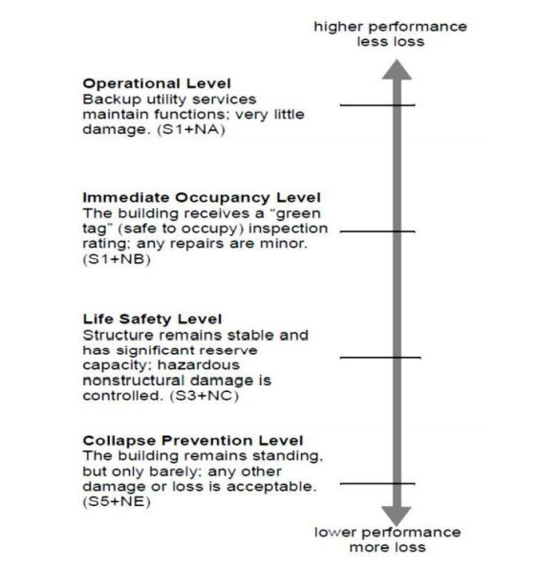

Figure 2.4: Building Performance Level (ATC-40)

By FEMA. Acceptance criteria for performance within the damage control structural performance range may be obtained Immediate Occupancy (IO) and Life Safety (LS) structural performance Levels. Acceptance criteria for performance. The performance levels and ranges, as per FEMA are described is the sections that follow:
1. Immediate Occupancy Structural Performance Level (S-1) 2. Damage Control Structural Performance Range (S-2)
3. Life Safety Structural Performance Level (s-3) 4. Limited Safety Structural Performance Range (S-4)
5. Collapse Prevention Structural Performance Level (S-5)
CHAPTER 3
Modeling of Structures

3.1General Description of Structure

This is a 10 storied building designed for Sylhet city. The structural elements under earthquake and wind load are considered. The strength of RCC shear wall in different positions in this building is determined in this study.

3.2 Load used
- Earthquake load= as per BNBC 2020
- Wind load= as per BNBC 2020
- Slab load = 84 psf.
- P.W= 450 lb-ft (on outer beam).
- P.W= 45 psf (on floor slab).
- F.F= 30 psf.

3.3. Model geometry
The structures analyzed are 10 storied building. Geometry of these structures are same.

3.4. Column and beam size
The following sizes of columns and beam are used in the study:
Column:
C₁= 22" * 22"
C₂= 25" * 25"
C₃= 28" * 28"
Beam: 12" * 12"

Table 3.1. Building frame systems (with bracing/ share wall)
Seismic Force–Resisting System | Response reduction factor, R | System Over strength Factor, Ω� | Deflection Amplification Factor, 𝑪�
1. Free braced frames, instant registration connections at columns. | 8 | 2 | 4
2. Free braced frames, Non-moment-resisting, connections at columns. | 7 | 2 | 4
3. Special steel concentrically braced frames. | 6 | 2 | 5
4. Ordinary steel concentrically braced frames. | 3.25 | 2 | 3.25
5. Special reinforced concrete shear walls | 6 | 2.5 | 5
6. Ordinary reinforced concrete shear walls | 5 | 2.5 | 4.25
7. Ordinary reinforced masonry shear walls | 2 | 2.5 | 2
8. Ordinary plain masonry shear walls | 1.5 | 2.5 | 1.25

N: B: used reduction factor, R= 6 for special reinforced concrete shear walls.

3.5. Building Modeling
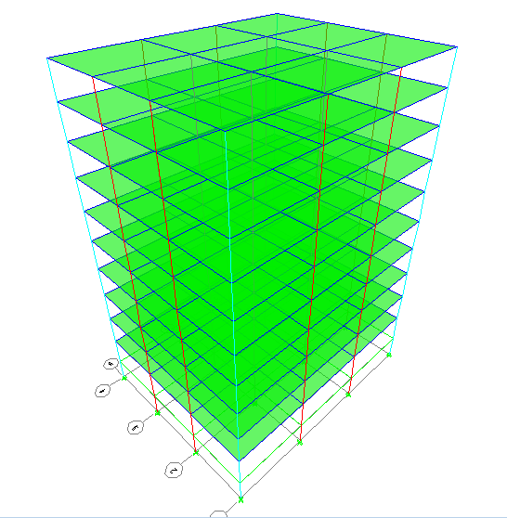
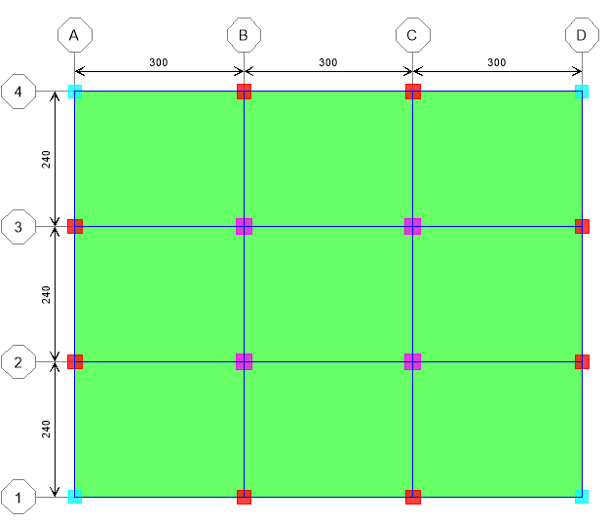
Figure 3.1: Column layout plan & 3D view

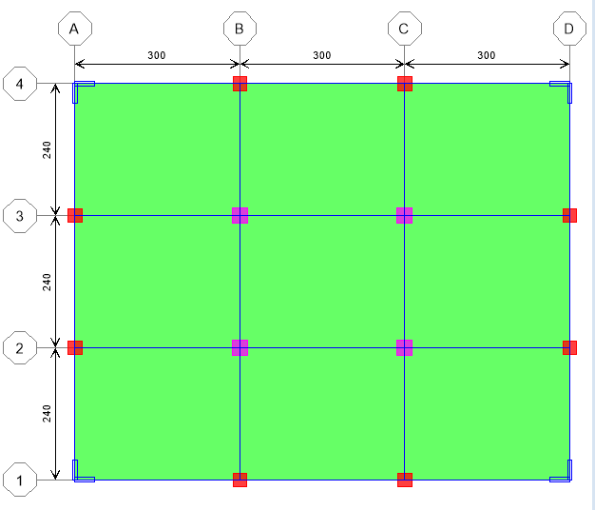

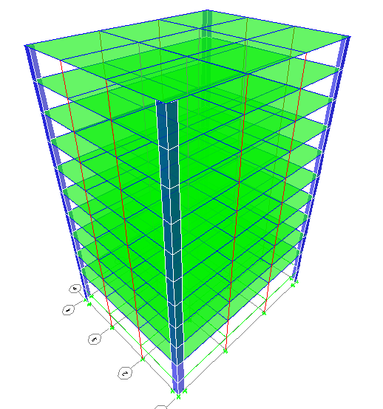

3.2: Corner shear wall&3D view.
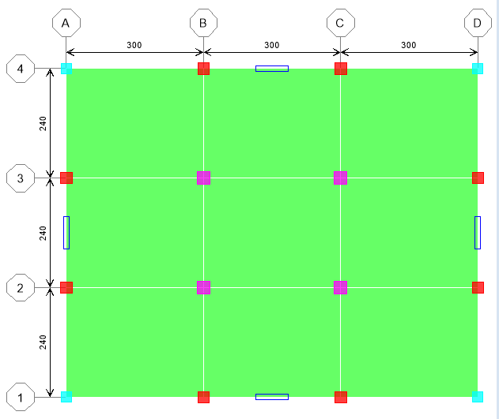

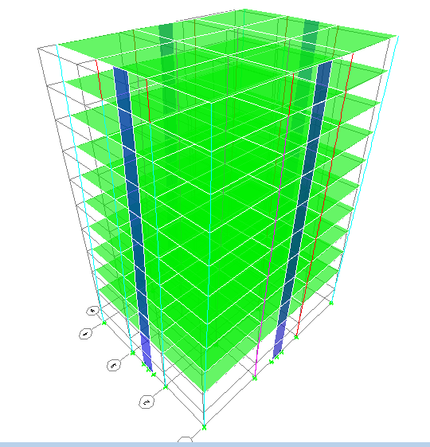

Figure 3.3 Side shear wall& 3D view.
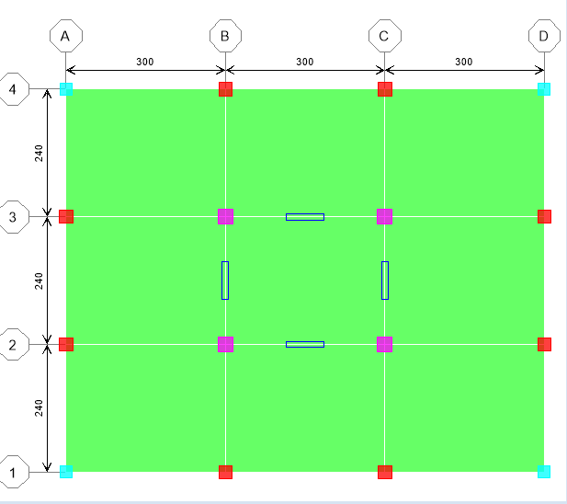

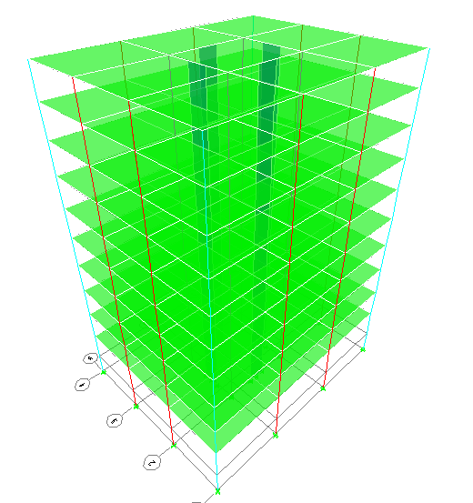

Figure3.4: Middle shear wall &3D view.
CHAPTER 4
Analysis & Result
  - General:
To get a final result do analysis is very essential. Software based thesis work completion is not possible without analysis. Varieties kinds of analysis need to be summarized. A final result outcomes from the summarization of the analysis.

  - Analysis Basis:.
    - Displacement check
    - Drift check
    - Rebar percentage(%) check
    - Variation in the current data
    - Compare displacement, drift & rebar percentages of every model.

  - Explanation of displacements:

In this figure 4.1 and 4.2 the displacement for model number where, no shear wall is been used. From grid number 1 we got the maximum displacement value 6.326of X direction & Y direction 5.056. In this figure 4.3 and 4.4 using shear wall at the corner position. Here in X direction got maximum displacement 5.441 & Y direction maximum displacement 4.245. In this figure 4.5 and 4.6 using shear wall at the side position. Here in X direction got maximum displacement 3.126& Y direction maximum displacement 3.007. In this figure 4.7 and 4.8 using shear wall at the middle position. Here in X direction got maximum displacement 2.489& Y direction maximum displacement 2.222.
From this above figure can easily defined that, if shear wall used at the middle position the least happens of displacement.
  - Displacements of X direction (EQX) & direction (EQY).
4.3.1. Displacement without shear wall
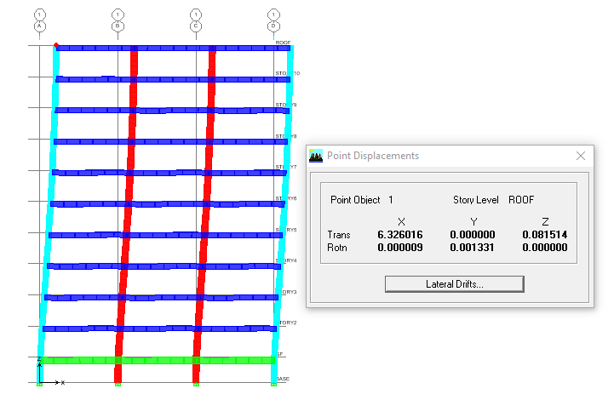
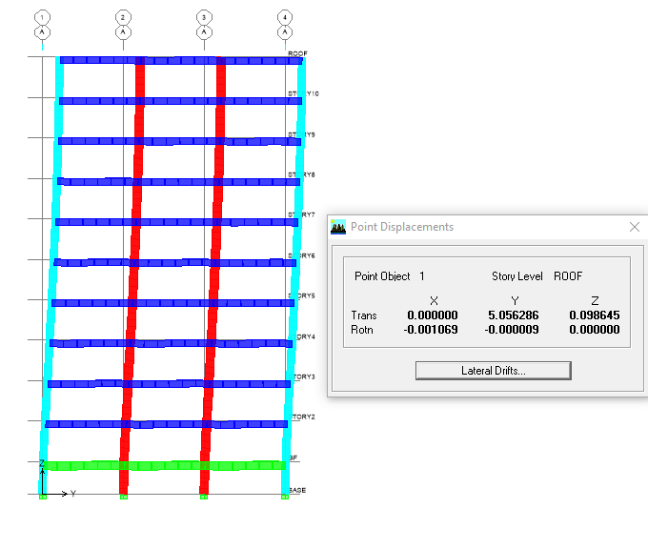
Figure: 4.1.Displacement of X direction.
Figure: 4.2. Displacement of Y direction

4.3.2: Displacement with corner shear wall:
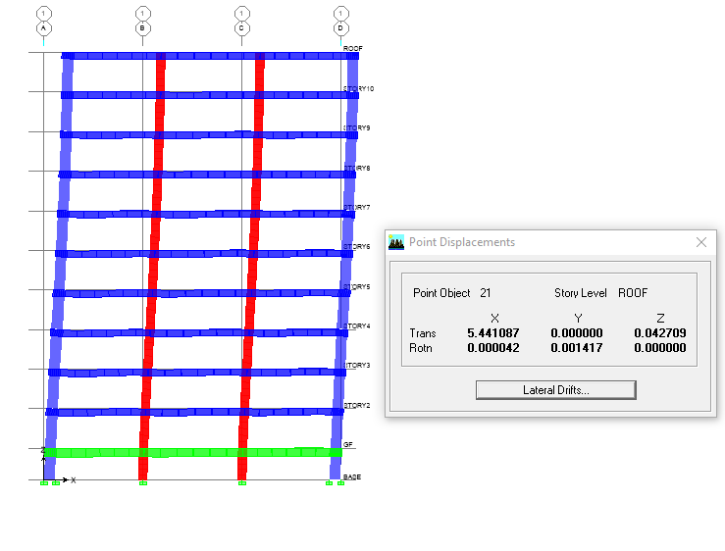

Figure 4.3: Displacement of X direction
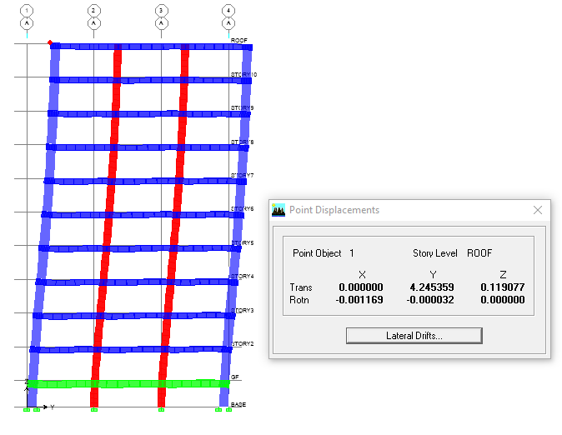

Figure 4.4: Displacement of Y direction

4.3.3: Displacement with side shear wall:
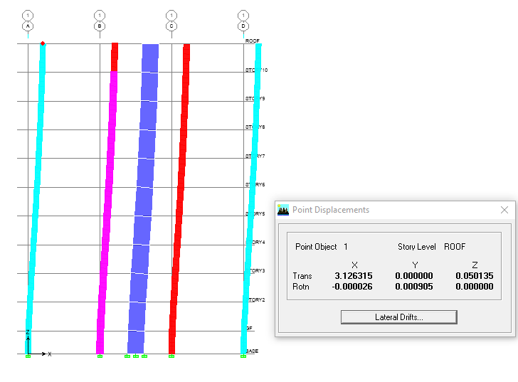

Figure 4.5: Displacement of X direction

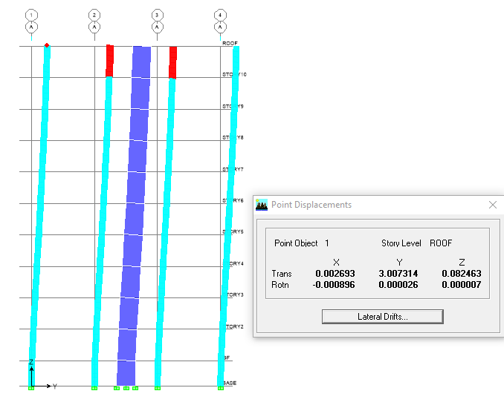

Figure 4.6: Displacement of Y direction
4.3.4: Displacement with middle shear wall:

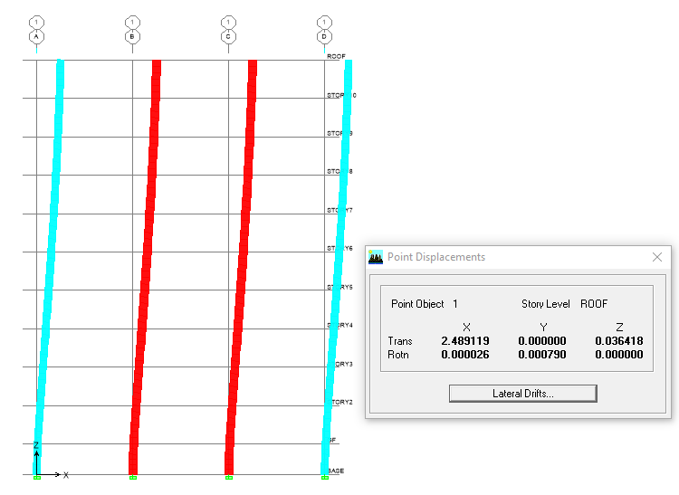

Figure 4.7: Displacement of X direction
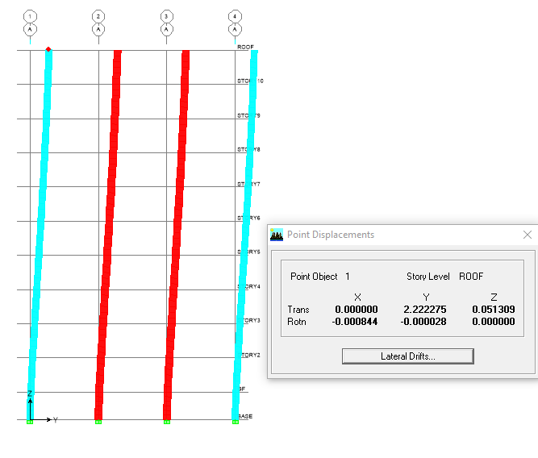

Figure 4.8: Displacement of Y direction
4.1. Table of displacement

Models | X direction(EQX) | Y direction(EQY)
Without share wall | 6.326 | 5.056
with corner share wall | 5.441 | 4.245
with side share wall | 3.126 | 3.007
with middle share wall | 2.489 | 2.222

Figure 4.9: Graph of displacement.

4.2. Table of drift:
Models | X direction(EQX) | Y direction(EQY)
Without share wall | 0.006967 | 0.005481
with corner share wall | 0.005959 | 0.004565
with side share wall | 0.003145 | 0.002883
with middle share wall | 0.002457 | 0.002064

Figure 4.10: Graph of drift.

4.3. Table of rebar percentage (%)

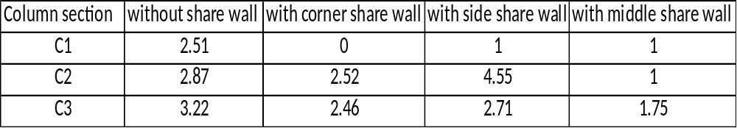

Figure 4.11: Graph of rebar percentage (%).

CHAPTER 5

CONCLUSIONS

5.1. CONCLUSIONS

The performance of the reinforced concrete structure were investigated using the shear walls at different position. As a result of work that was completed in this study. From the limited study of various 2D and 3D models of the shear wall building frames, displacements, drift and rebar percentages at the middle positions shear walls yield very good results. If shear wall use in the middle position can be found better stability of the structure.

5.2. Limitations of the work

It has a low stiffness and energy dissipation capacity.

For more accuracy need to changing column and beam size repeatedly.

Input data & combinations of load check repeatedly.

5.3. Future scopes of the work

To know the overall condition of Bangladesh can be analyze the other 3 seismic zone at the same process in future.

Further studies can be performed on composite and steel structures.

For more accuracy in the seismic analysis “Time History Analysis ‘’ can be done.

REFERENCES
[1] O. Esmaili, S. Epackachi, M. Samizdat and S.R.Mirghaderi, “Study of Structural RC Shear Wall System ina56-Story RC Tall Building,” The 14thWorld Conference onEarthquake Engineering, October 12-17, 2008, Beijing, China.

[2] R. Himalee and S.R.Satone, “Design And Analysis Of Multistoried Building With Effect Of Shear Wall,” Vol. 3, Issue 3,pp.223-232, May-Jun 2013.

[3] E. A. Syed and M. U. A. Mohd. “Study of Strength of RCC shear wall at different location on Multi Storied ResidentialBuilding,”ISSN:2248-9622, Vol 4, Issue 9, September 2014.

[4] Anuj Chandiwala “earthquake analysis of building configuration with different position of shearwall, “International Journal of Emerging Technology andAdvanced Engineering, ISSN 2250-2459, Volume 2, Issue12, December 2012.

[5] S. A. Ashish and S. D. Charkha, “Effect of change in shearwall location on storey drift of multi-storey residential building apply to lateral load,” IJERA, Volume 2, Issue 3,pp.1786-1793

[6] Reitherman, Robert (2012). Earthquakes and Engineers: An International History. Reston, VA: ASCE Press. ISBN 9780784410714. Archived from the original on 2012-07-26.

